EN
COMMISSION OF THE EUROPEAN COMMUNITIES
Brussels, 19.3.2007
SEC(2007) 339

COMMISSION STAFF WORKING DOCUMENT
Accompanying document to the
REPORT FROM THE COMMISSION TO THE COUNCIL AND THE EUROPEAN PARLIAMENT
on implementation of Council Directive 91/676/EEC concerning the protection of waters against pollution caused by nitrates from agricultural sources for the period 2000-2003
{COM(2007) 120 final}
COMMISSION STAFF WORKING DOCUMENT
ANNEXE 1: MAPS, FIGURES AND TABLES
MAP 1. Manure nitrogen fertiliser application (source: JRC, Mulligan et al., 2006). Reference year: 2000
MAP 2. Manure phosphate fertiliser application (source : JRC, Mulligan et al., 2006). Reference year: 2000
MAP 3. Total nitrogen application, manure and chemical fertiliser (source : JRC, Mulligan et al., 2006). Reference year: 2000
MAP 4. Total phosphate application, manure and chemical fertiliser (source: JRC, Mulligan et al., 2006). Reference year: 2000
MAP 5. Nitrogen surplus in the EU 15 at regional scale (Source: Capri database). Reference year: 2001.
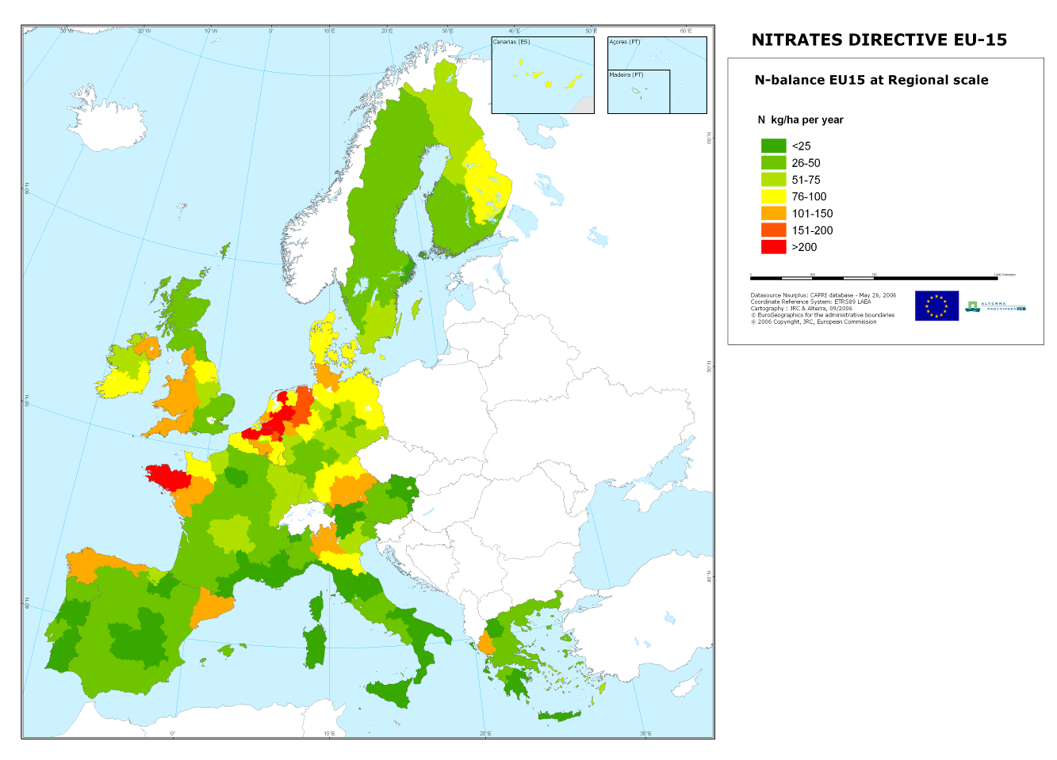
MAP 6. Estimation of nitrogen source apportionment in Europe (source: JRC, Grizzetti et Bouraoui, 2006)
MAP 7. Average nitrate concentrations in groundwater stations, reporting period 2000-2003
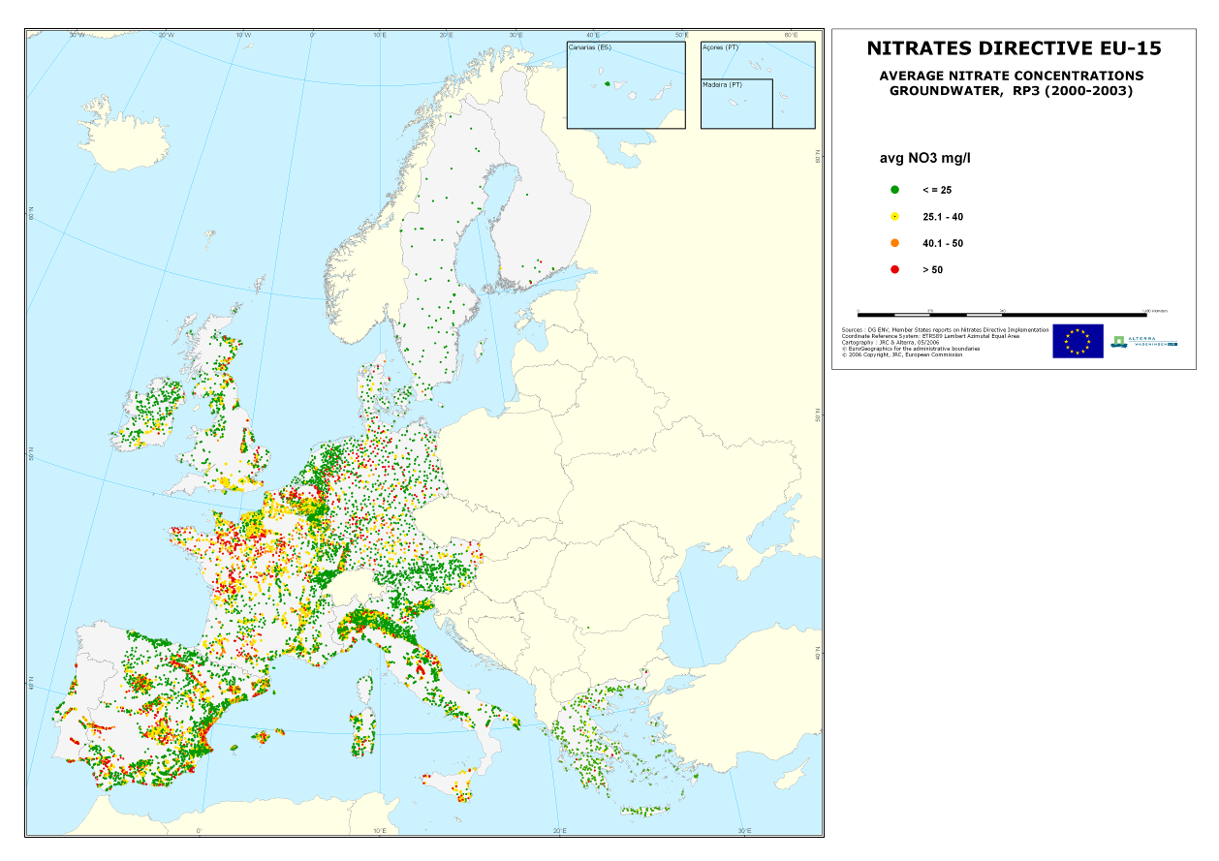
Map 8. Maximum nitrate concentrations in groundwater stations, (data exceeding 40 mg NO₃/l), reporting period 2000-2003
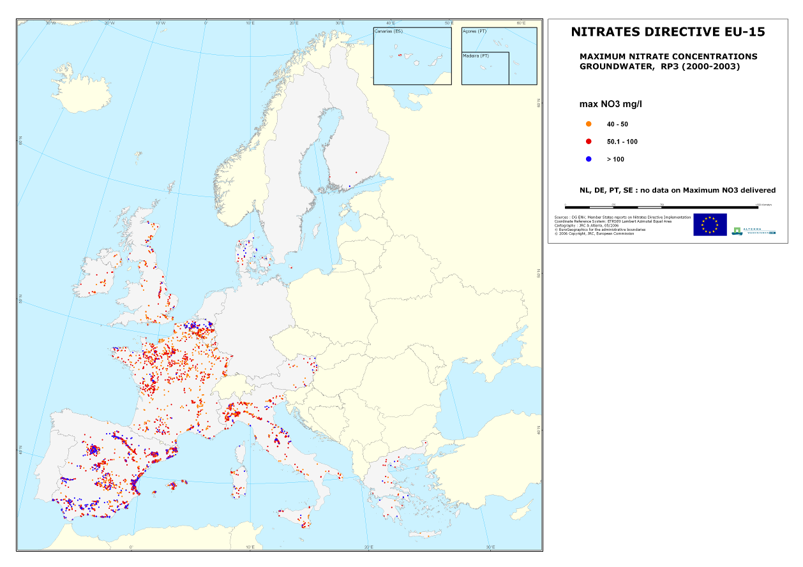
MAP 9. Trend in nitrate concentrations in groundwater between the reporting period 1996-1999 (RP2) and the reporting period 2000-2003 (RP3).
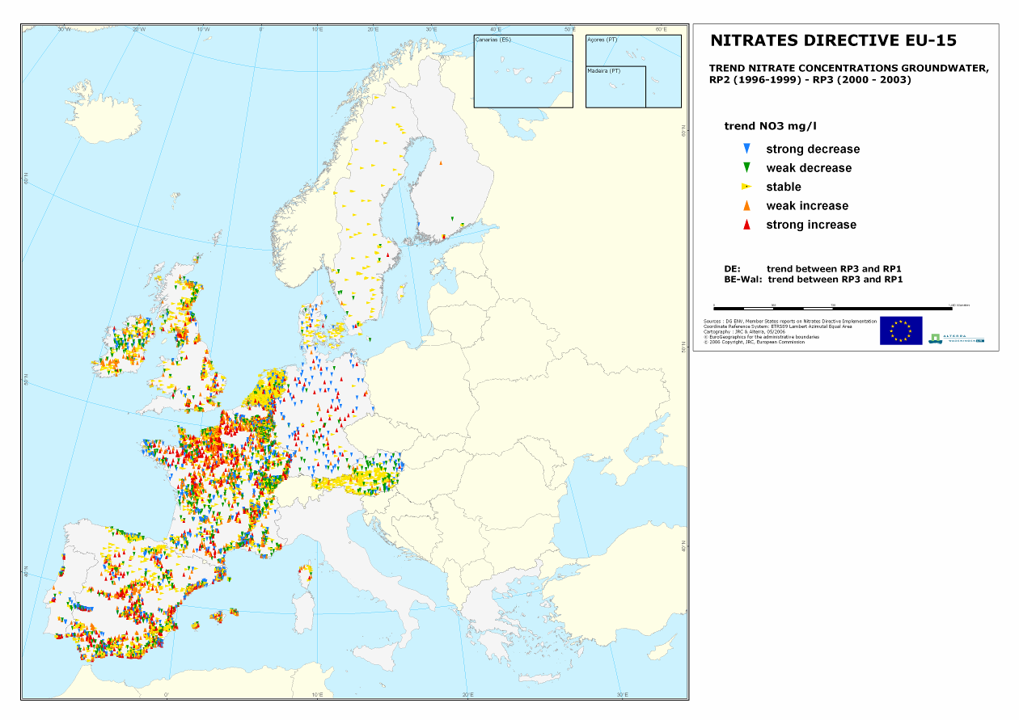
MAP 10. Yearly average nitrate concentrations in surface waters, reporting period 2000-2003. In case of the Netherlands the data are winter averages
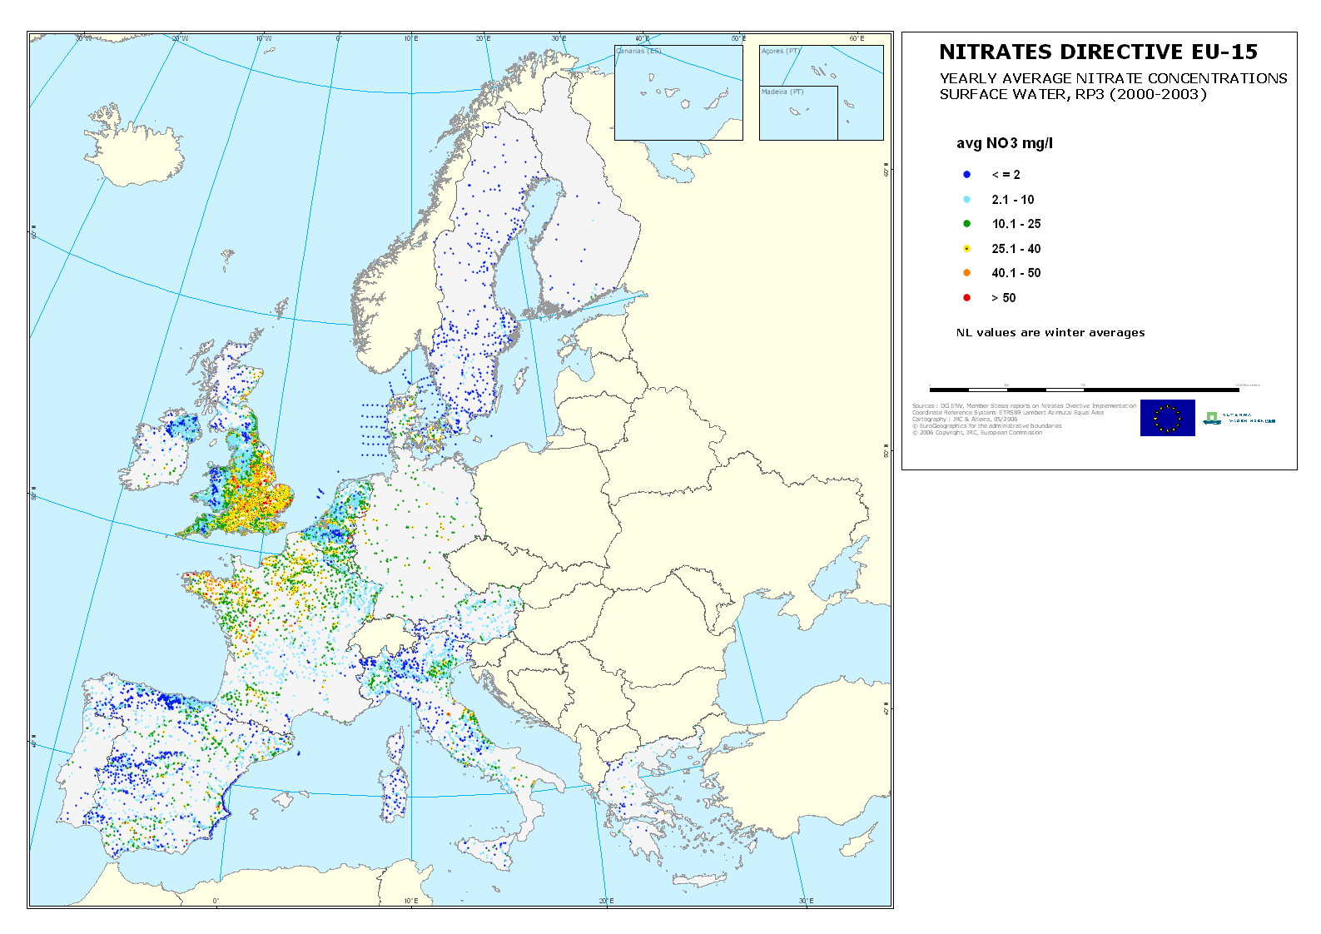
MAP 11. Maximum nitrate concentrations in surface waters, (data exceeding 40 mg NO₃/l), reporting period 2000-2003
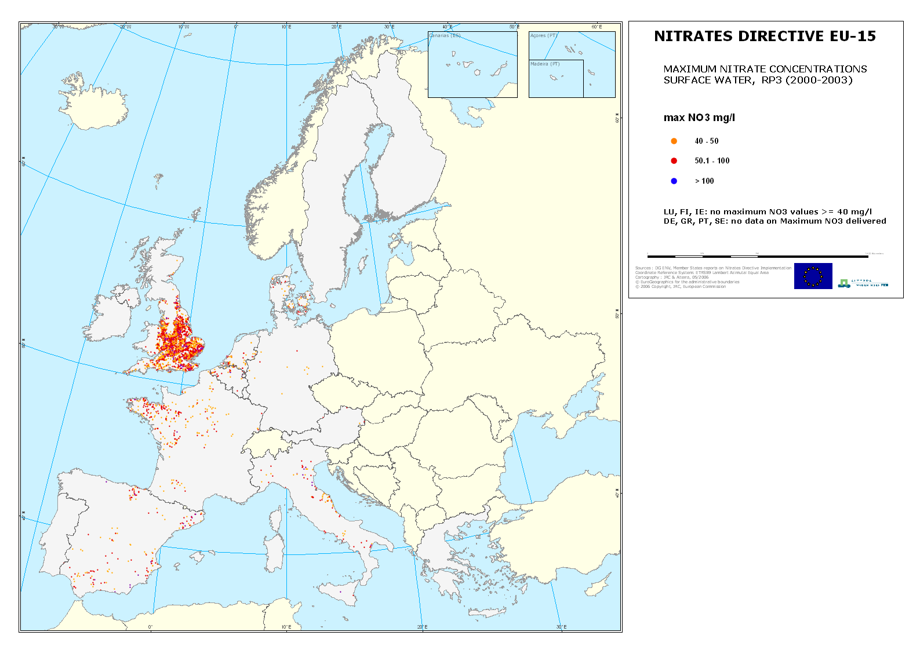
MAP 12. Trend in nitrates concentration in surface waters between the reporting period 1996-1999 (RP2) and the reporting period 2000-2003 (RP3).
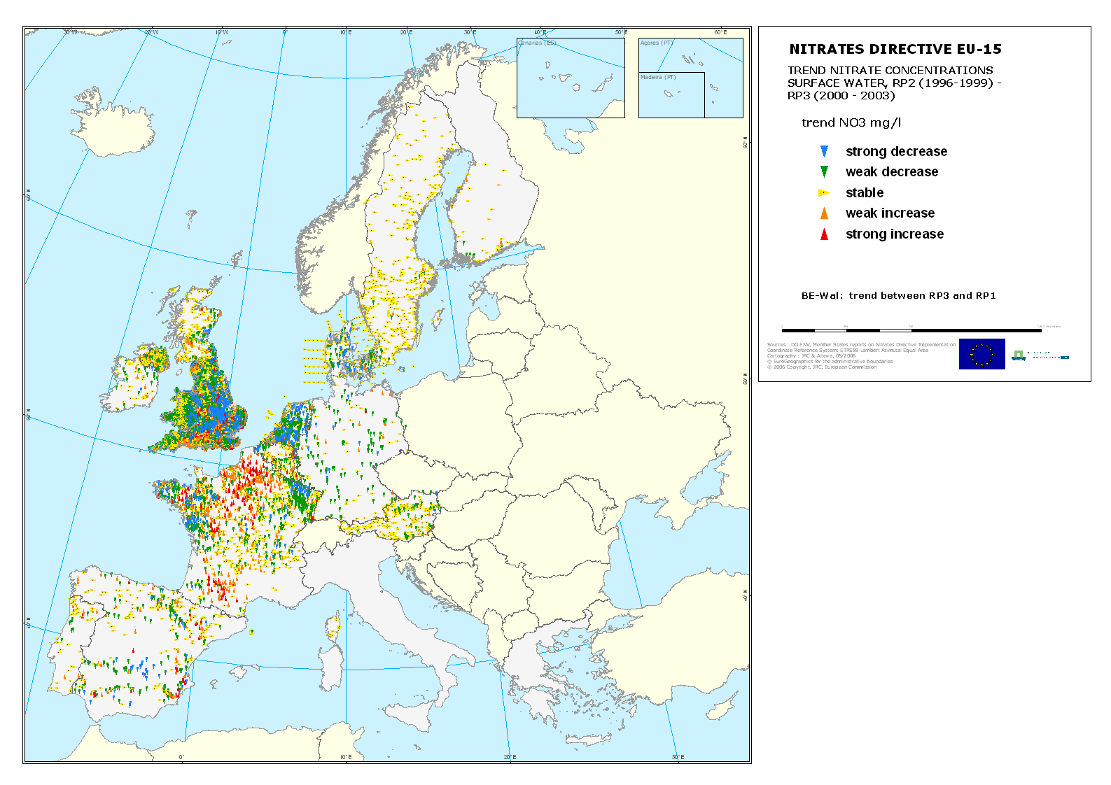
MAP 13. Satellite image of chlorophyll-a concentrations in marine ecosystems of the EU. (April 2005- November 2005. Source:http://reason.gsfc.nasa.gov/OPS/Giovanni/ocean.aqua.shtml). The red and brown areas show the highest phytoplankton development, one of the most visible symptoms of eutrophication
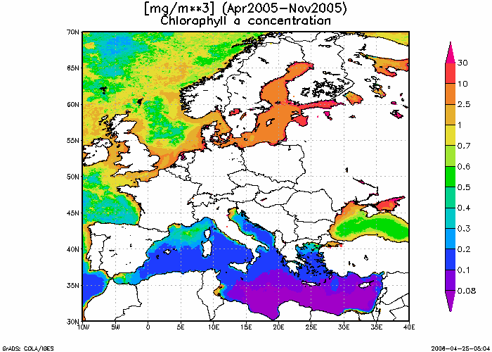
MAP 14. Nitrate Vulnerable Zone designation EU15
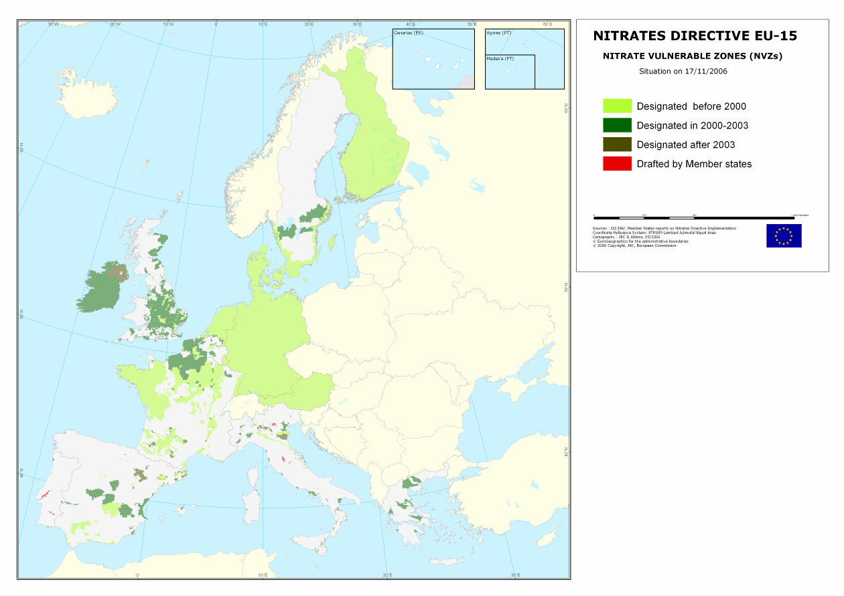
MAP 15. Nitrate Vulnerable Zone designation EU 25 (year 2006) and area requiring designation according to Commission assessment
*Designated nitrates vulnerable zones after 2003 are based on information made available to the Commission in digital form. The estimate of designated area does not include some designations communicated in paper form only
Figure 1. Ammonia emissions from agriculture in 1990 and 2002 (kg/ha). Source: EEA, 2005a) http://reports.eea.europa.eu/eea_report_2005_6/en
Figure 2. Quality classes of nitrate concentrations in groundwater. Data from the Member state reports supplemented with data from the geo-database.
Figure 3. Trends in average groundwater nitrate concentrations, based upon information in Member State reports supplemented with data from the geo-database.
* BE-FL, IT, and EL provided no information in their reports, DE provided only information on the ‘contaminated network’(De cont.)
** data for Sweden are from the geo-database
***France also provided data on trends between the first and the third reporting period
****NL data < 5m correspond to 14 aggregated figures reflecting nitrates concentrations in the first meter of groundwater or water leaving the root zone
Figure 4. Nitrate concentrations in fresh surface waters as reported by the Member States supplemented with data from geo-database
Figure 5. Trends in average fresh surface water nitrate concentrations based upon information from the geo-database*
*except for ES which is based upon information in ES-report.
** Greece communicated surface water data with the second and the third report, but it did not report on trends and data provided in electronic form did not allow for trend evaluation (different location of sampling stations in the two reporting periods). Data provided by Italy did not allow for calculation of trends
***France also provided data on trends between the first and the third reporting period
Table 1. Nitrate vulnerable zones in EU 15 Member States
Member State | Total area | Area NVZ  1999 |  | Area NVZ  2003 |  | Area NVZ**  2006 (July)
 | (km²)*1000 | (km²)*1000 | % | (km²)*1000 | % | (km²)*1000 | %
Austria* | 83,9 | 83,9 | 100,0 | 83,9 | 100,0 | 83,9 | 100,0
Belgium | 30,5 | 1,8 | 5,8 | 7,2 | 23,6 | 7,2 | 23,6
Denmark* | 43,1 | 43,1 | 100,0 | 43,1 | 100,0 | 43,1 | 100,0
Finland* | 338,1 | 338,1 | 100,0 | 338.1 | 100,0 | 338,1 | 100,0
France | 544,0 | 197,9 | 36,4 | 239,7 | 44,1 | 239,7 | 44,1
Germany* | 357,0 | 357,0 | 100,0 | 357,0 | 100,0 | 357,0 | 100,0
Greece | 132,0 | - |  | 14,0 | 10,6 | 14,0 | 10,6
Ireland* | 69,8 | - |  | 69,8 | 100,0 | 69,8 | 100,0
Italy | 301,3 | 5,7 | 1,9 | 18,4 | 6,1 | 24,9 | 8,3
Luxembourg* | 2,6 | 2,6 | 100,0 | 2,6 | 100,0 | 2,6 | 100,0
Netherlands* | 41,5 | 41,5 | 100,0 | 41,5 | 100,0 | 41,5 | 100,0
Portugal | 91,9 | 0,2 | 0,2 | 0,3 | 0.3 | 1,14 | 1,2
Spain | 506,0 | 26,0 | 5,1 | 55,4 | 11 | 63,9 | 12,6
Sweden | 441,3 | 41,6 | 9,4 | 67,1 | 15,2 | 67,2 | 15,2
UK | 244,0 | 5,8 | 2,4 | 79,9 | 32,8 | 93,7 | 38,4
TOTAL EU 15 | 3227,0 | 1145,2 | 35,5 | 1418,0 | 43,9 | 1447,6 | 44,9
*Implementation of an Action Programme on the whole territory; this does not necessarily mean that the whole territory is nitrate vulnerable according to paragraph 2 of Article 3 of the Nitrates Directive
**based on information made available to the Commission in digital form. The estimate of designated area does not include some designations communicated in paper form only
Table 2. Legal procedures (situation November 2006) for each Member State regarding each step of the implementation process
 | Member State |  | B | DK | D |  | EL | ES | F | IE | I | L | NL | Ö | P | FI | S | UK
 | Water monitoring |  | + | + | + |  | + | + | + | + | + | + | + | + | + | + | + | +
 | Designation of nitrates vulnerable zones |  | + | + | + |  | + | + | + | + | + | + | + | + | + | + | + | +
 | Codes of good practice |  | + | + | + |  | + | + | + | + | + | + | + | + | + | + | + | +
 | Action programmes |  | + | + | + |  | + | + | + | + | + | + | + | + | + | + | + | +
 | Report |  | + | + | + |  | + | + | + | + | + | + | + | + | + | + | + | +
+ Exercise performed but not necessarily approved by the Commission
Implementing an action programme on the whole territory
Shaded: |  | Infringement procedure ongoing  Ireland communicated to the Commission an action programme to be implemented on the whole territory)

ANNEX 2
Examples of recent progress in action programme revisions since 2003
Denmark introduced a limit of 140 kg N/ha from poultry manure in 2004 and further increased requirements on manure nitrogen efficiency.
The Netherlands in 2005 approved its third revised action programme and related implementing regulations. The programme introduced, for instance, the limit of 170 kg/ha N from livestock manure, minimum requirements on manure nitrogen efficiency, total nitrogen limits, manure and total phosphorus application standards for each crop and limitations for fertilisation on sandy and loessial soils. A generalized obligation for storage capacity of six months has been established and the scope of the rules on periods during which application of fertilisers is prohibited has been widened.
Austria increased minimum manure storage capacity from four to six months and strengthened manure excretion standards. The third Austrian action programme contains limit for total nitrogen application for both grass and arable land.
Ireland approved in 2006 its first action programme which established a coherent set of legally binding obligations for farmers relating to fertilisation practices including improving manure efficiency, manure excretion values, storage capacity for all manure types, prohibition periods for manure and chemical fertiliser application and minimum distances from water courses for the application of fertilisers. Moreover, the Irish action programme sets out the limit of 170 kg N per hectare for the application of livestock manure and limits both nitrogen and phosphate application.
Germany revised its Fertiliser Ordinance in 2006, ensuring compliance with the limit of 170 kg/ha nitrogen from livestock manure and including detailed binding provisions, for instance, on nitrogen balance in fertilisation, on application of fertiliser on slopes and near water bodies and legally binding values for nitrogen in manure and nitrogen losses. Moreover a minimum storage capacity of six months was established.
Belgium (both Flanders and Wallonia) in addition to the NVZ designation revision are now finalizing their revised action programmes, due to enter into force early 2007, including all the measures listed in Annex III and II of the nitrates Directive, for instance manure nitrogen and total nitrogen limits, compliance with the limit of 170 kg nitrogen per hectare from livestock manure, minimum storage capacity of six month, increased eventually to 9 months in the Flemish action programme and an evaluation system based also on soil sampling and mineral nitrogen analysis after cropping .
All the recently revised action programmes contain obligations for farmers regarding record keeping, sanctions for non-compliance and obligation of control on the competent authorities.
New action programmes have also been recently established in specific Regions in Italy, Spain and Portugal.
ANNEX 3
Commission Decisions on derogation requests submitted by Member States
A temporary derogation (expiring 1 August 2004) was granted to Denmark via Commission Decision 2002/915/EC.
The derogation allowed the application up to 230 kg/ha Nitrogen in cattle farms with 70% of the acreage cultivated with grass and other crops with high nitrogen uptake, long growing season and low leaching potential.
The Commission Decision established detailed conditions regarding fertilisation plans and accounts, manure and other fertiliser application, obligations on soil analysis, land cover and land management and set out specific obligations for the competent Authorities regarding monitoring and reporting to the Commission.
This derogation was renewed until 31 July 2008 (Commission Decision 2005/294/EC of 5 April 2005) following the adoption of an updated action programme by Denmark, taking into account the results of evaluation of the Second Action Plan on aquatic environment which showed the achievement of the reduction target of 48% for nitrate leaching in the period from 1985 to 2003.
Derogations were also granted to:
- The Netherlands: up to 250 kg per ha year nitrogen from grazing livestock manure, Commission Decision 2005/880/EC of 8 December 2005;
- Austria (up to 230 kg per ha year nitrogen from livestock manure in cattle farms (Commission Decision 2006/189/EC of 28 February 2006);
- Germany (up to 230 kg per ha year nitrogen from livestock manure in cattle farms (Commission Decision 2006/1013/EC of 28 December 2006)
ANNEX 4
References
Cardoso A.C., Duchemin J., Magoarou G. and Premazzi (2001). Criteria for identification of freshwater subject to eutrophication. Their use for the implementation of the Nitrates and Urban Waste Water treatment Directives.EUR 19810 EN).
EEA, 2005a. Agriculture and Environment in EU 15. The IRENA indicator Report. EEA Report No 6/2005.
EEA, 2005b. Source apportionment of nitrogen and phosphorus inputs into the aquatic environment. EEA Report No 7/2005.
Environment Resource Management (2001). Assessment of action programmes established by Member States (internal Commission document).
Grizzetti B. and Bauraoui F. (2006). Assessment of nitrogen and phosphorus environmental pressures at European scale. EUR 22526 EN.
Mulligan D., Bauraoui F., Grizzetti B., Aloe A. and Dusart J., 2006. An Atlas of Pan-European Data for Investigation of the Fate of Agro-chemicals in Terrestrial Ecosystems, JRC, ISPRA (in press).

OJ L319, 23.11.2002
OJ L 94, 13.04.2005, p. 34
OJ L324, 10.12.2005, p. 89
OJ L66, 8.03.2006, p. 44.
OJ L382, 28.12.2006, p. 1.

