EN
COMMISSION OF THE EUROPEAN COMMUNITIES
Brussels, 21.3.2007
SEC(2007) 374

COMMISSION STAFF WORKING DOCUMENT
Accompanying document to the
COMMUNICATION FROM THE COMMISSION
Trans-European Networks : Toward and integrated approach
{COM(2007) 135 final}
ANNEX 1
Trans European networks maps
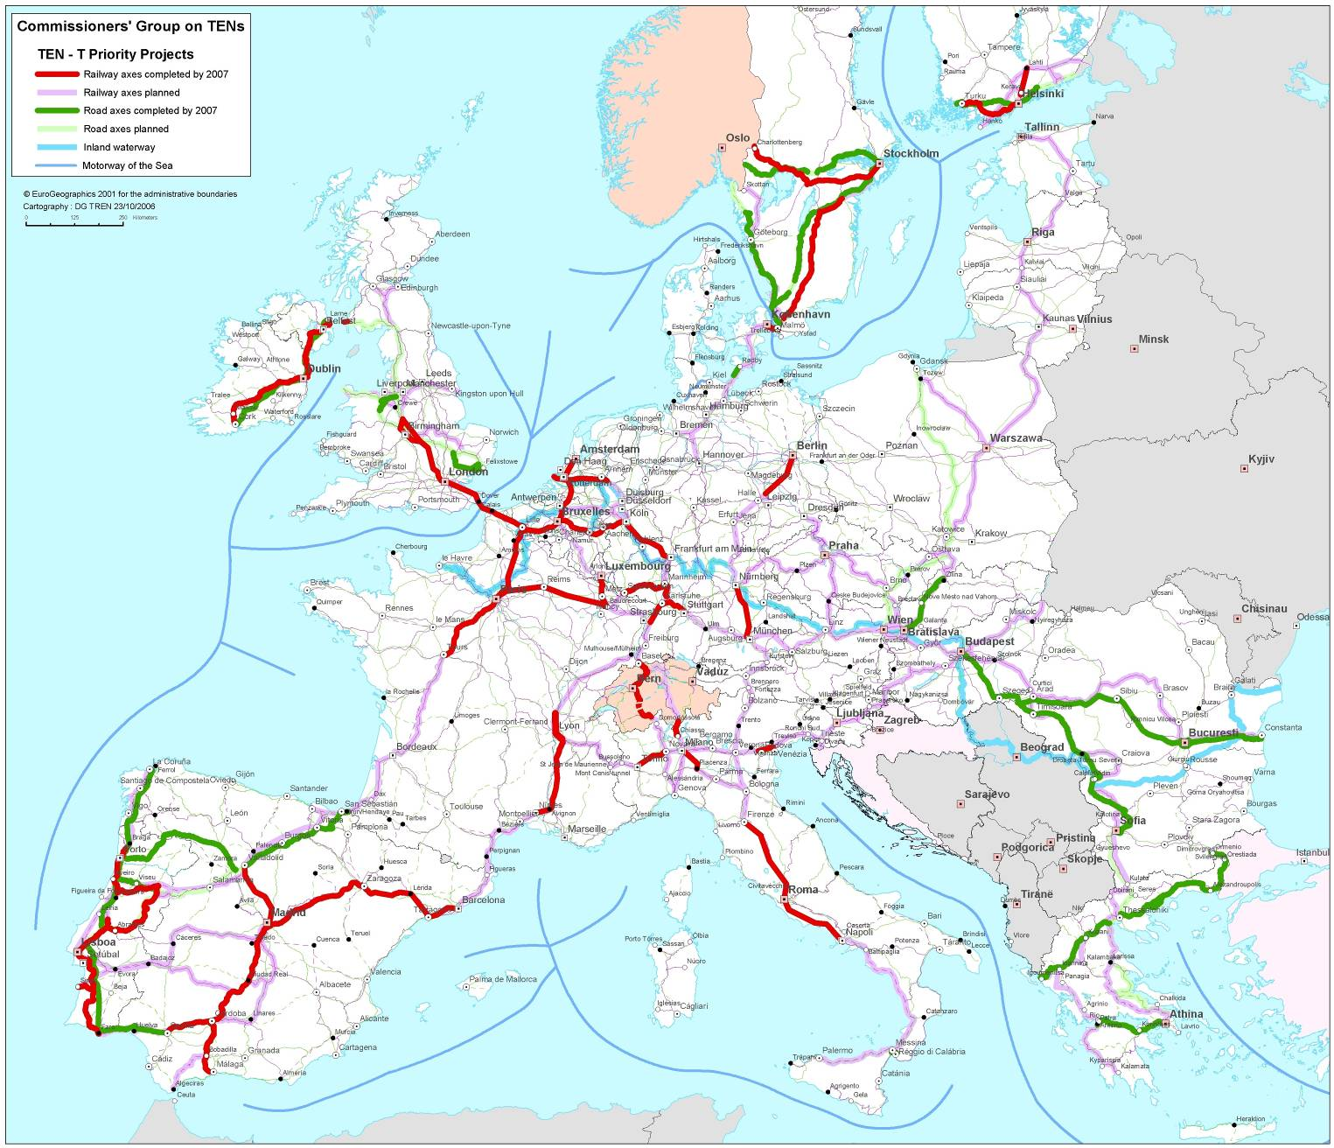
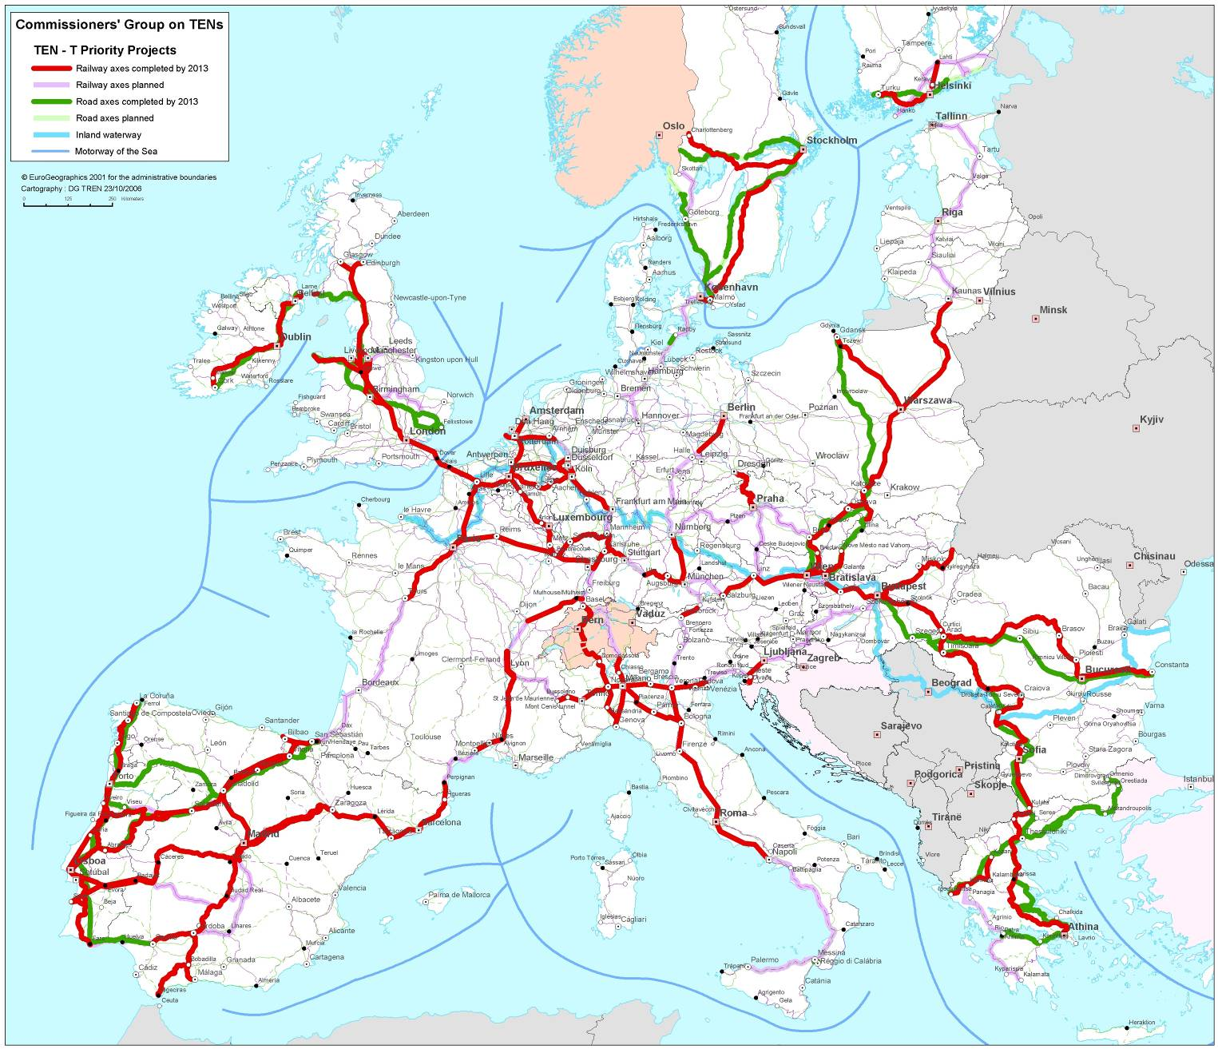
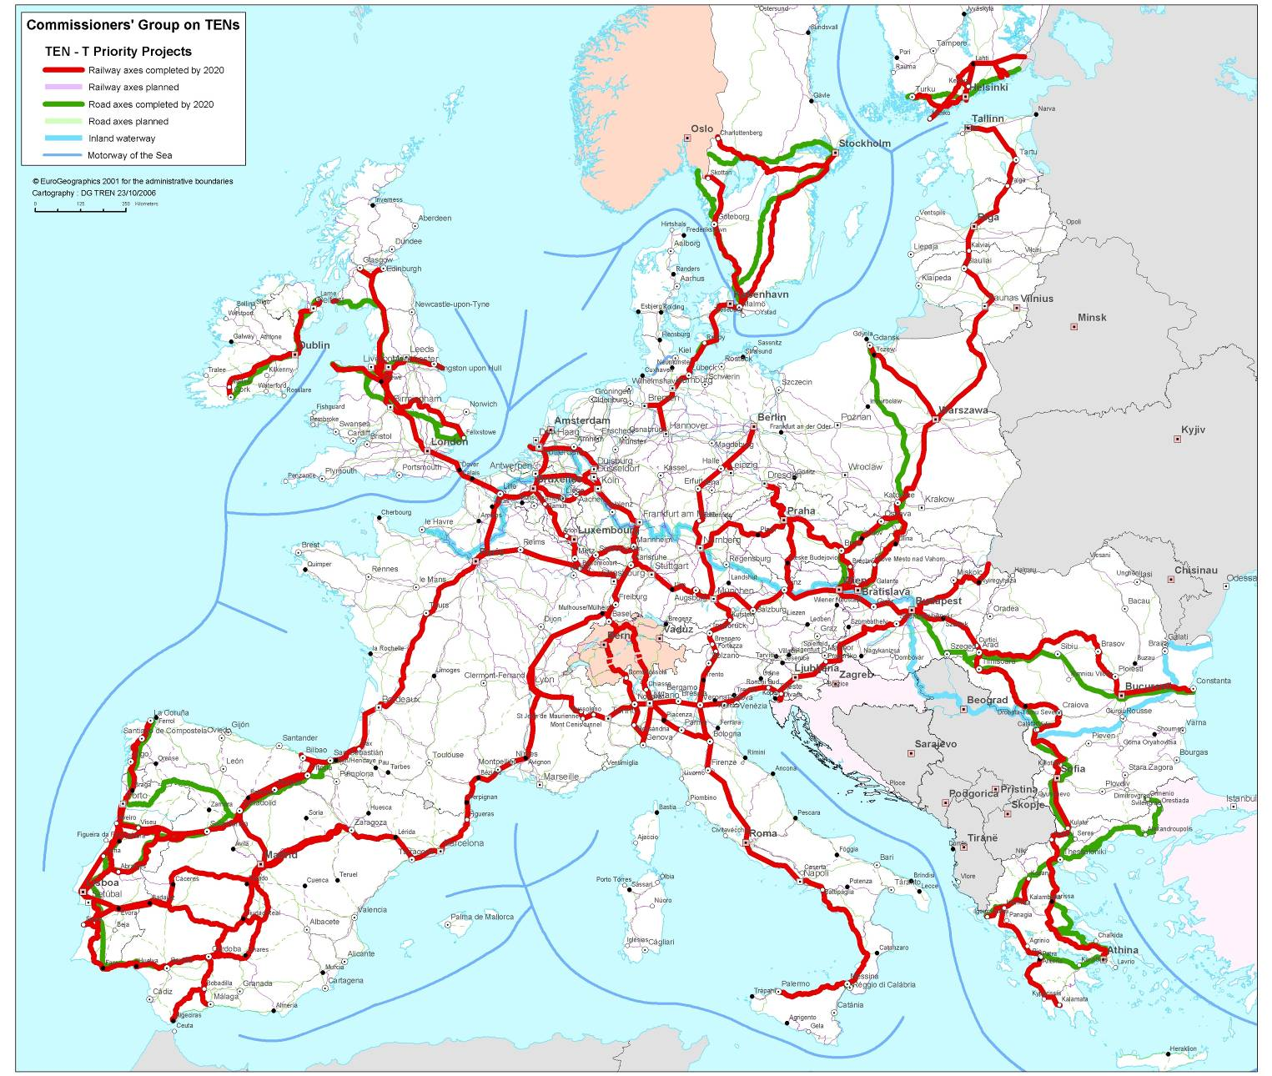
ANNEX 2
Guide to TENs and key environmental legislation
Summary:
This Guide is a short outline of five EC environmental directives particularly relevant for the Trans European Networks (TENs) for Transport and Energy and is targeted at Member States transport and energy authorities. It describes briefly the Directives on environmental impact assessment (EIA) of projects, environmental assessment of plans and programmes (strategic environmental assessment - SEA), the protection of flora and fauna, (the Habitats and Birds Directives) as well as the Water Framework Directive. The Guide also highlights the references to environmental protection in the relevant TENs legislation.
The environmental legislation forms an important part of the 'acquis communautaire' as does the legislation on the TENs. Many TEN projects encourage environmentally friendlier modes of transport or aim at interconnecting the energy networks of the Member States which can directly contribute to reduced national investments and thus to a lower environmental impact. Especially the 30 priority projects for transport and the 42 priority projects for energy are crucial for realising the TENs. It is therefore essential to find common agreement on how to bring forward the TENs and respect of the environment at the same time. The correct and pro-active application of EIA and SEA, for example through choice of route, and continuous consultation with the population concerned by such projects, is directly related to the successful implementation of the TENs.
The Habitats and Water Framework Directives also envisage mitigation and in a final stage, compensatory measures (in the case of the Habitats Directive), in the case of overriding public interests.
It is hoped that this Guide can offer an important contribution to a mutual understanding how the development of the TENs can be achieved whilst ensuring respect for the environment.
1. Respect of the environmental and TEN acquis
Member States, regions and project proposers must respect the environmental acquis for infrastructure related to any Community co-financing. For the TENs, the main concerns are related to potential negative impacts arising from TEN-T and TEN-E projects. On the other hand, the legislation on TENs requires Member States to implement especially the Projects of European Interest within a given timeframe.
What are the most important environmental Directives for the TENs?
All the environmental acquis applies to the TEN co-financed projects (air, noise, water, waste, etc.). However, experience has shown that five Directives are particularly relevant:
- Environmental assessment – Environmental Impact Assessment (EIA) Directive for project assessment, and Strategic Environmental Assessment (SEA) Directive for plan and programme assessment; these are both procedural directives requiring the evaluation of a wide range of environmental impacts and consultation with environmental authorities and the public (including cross border consultations). The Directives take account of the provisions of the Aarhus Convention on public participation and (for EIA only) access to justice in environmental matters.
- Nature – Birds Directive and Habitats Directive in particular in relation to impacts on the network of Natura 2000 sites and species benefiting from a strict protection regime (listed in Annex IV).
- Water – Water Framework Directive for infrastructures with potential risks of water resources deterioration.
The EIA and SEA Directives are largely intended to improve decision-making. They do not predetermine outcomes. The two Directives differ from each other in detail but broadly speaking, both require the description and assessment of the likely significant environmental effects of specified projects and certain plans/programmes respectively. These assessments must cover alternatives. There must be consultation on the environmental information and project application or draft plan/programme. The environmental information and results of consultation must be taken into account, and mitigating measures identified, in the decision (or final version of the plan/programme). The EIA Directive requires the environmental report to include an outline of the main alternatives studied and an indication of the main reasons for the choice made (taking into account the environmental effects). The SEA Directive requires an assessment of reasonable alternatives that bear in mind the objectives and the geographical scope of the plan/programme (including the "zero" option). Being at a more strategic level, these alternatives could include radically different ways of achieving the objectives of the plan or programme. These Directives do not contain provisions like those in the Habitats Directive (Article 6.4) and the Water Framework Directive (WFD) (Article 4.7c) on mitigation and compensatory (in the case of the Habitat's Directive) measures. The EIA Directive contains a provision dealing with exceptional cases. Recent guidance emphasises the exceptional nature of the circumstances in which this provision might be used (in line with the European Court of Justice's normal approach to interpreting derogations).
How are the environmental parts of TEN forms assessed when they are sent to the European Commission (DG TREN)?
DG ENV and DG TREN have concluded a Modus Operandi for the efficient assessment of many TEN-T and TEN-E projects at the same time. The application forms that the Member States have to fill in are those foreseen in Commission Regulation (EC) No 1828/2006 of 8 December 2006 setting out rules for the implementation of Council Regulation (EC) No 1083/2006.
What are the rules applying to non-EU Member States?
In addition to the above, there is a link between proposed infrastructure and respect for environmental acquis rules in countries in the geographical proximity of the EU: compliance in the case of Candidate Countries; approximation for potential Candidate Countries; and convergence for the remaining neighbouring countries. The respect for environmental acquis in Candidate Countries has its legal basis in the External Relations Council Conclusions on the accession strategy for the environment from 24 September 1998. In the potential Candidate Countries of south-east Europe, the Stabilisation and Association Process and/or Agreements are the legal basis. In Mediterranean countries, Russia and Newly Independent States (NIS), Association Agreements provide the legal basis.
How are environmental rules taken up in the TEN-E and TEN-T guidelines?
Article 8 of the TEN-T Guidelines stipulates that environmental protection must be taken into account by the Member States through the carrying out of an EIA (for projects) and an SEA (for plans and programmes) and through the application of the two nature directives. The Declaration of European Interest included in the Guidelines further emphasises Community legislation on environmental protection. The European Co-ordinators have a major opportunity to help with the implementation of environmental legislation and procedures in a co-ordinated fashion.
Article 8 of the TEN-T Guidelines and Article 9 of the TEN-E Guidelines both underline the importance of the results of environmental assessments (for projects, plans and programmes) that have to be taken into account before a funding decision is taken in accordance with the relevant Community legislation.
2. Mechanisms for implementing the environmental acquis
It must be underlined that the different environmental acquis are free-standing. Therefore, even if synergies are possible and encouraged by the Commission, it is necessary to check that the individual requirements of the EIA, SEA, WFD and the nature Directives are fully respected. In this section the mechanisms for implementing each key directive are considered one by one.
How does the EIA Directive for project assessment apply to the TENs?
The projects listed in Annex I of the EIA Directive require a mandatory environmental impact assessment. The following steps are required:
- Preparation of a report on the environmental effects of the project
- Preparation of a non-technical summary
- Consulting the public on the application for Development Consent and the environmental report as soon as the information can be provided [superfluous as all the steps are required and the EIA is mandatory]
- Consulting other Member States if cross border project
- Consulting environmental authorities
Then the subsequent steps are taken
- Development Consent (duly signed)
- Transmission of information to the public on the Development Consent, on the main reasons on which the Consent is based, and on a description of the main measures to avoid, reduce and, if possible, offset the major adverse effects.
The projects included in Annex II of the Directive require that a screening is carried out by the competent authorities to determine if an EIA is required or not. Such screening may be done on a case-by-case basis or by establishing thresholds or criteria but in either case must take account of criteria specified in Annex III to the EIA Directive (concerning project location, project characteristics, and potential impact). The determination must be made available to the public. Upon the developer's request and before the Development Consent is submitted, the competent authority are to give an opinion on the information to be supplied and to consult the developer before its gives its opinion.
Transport and energy projects fall under both Annex I or Annex II of the EIA Directive.
How does the SEA Directive apply to plan and programme assessment of the TENs?
Article 1 of the SEA Directive sets out the objectives of it while Article 2 provides the definition with respect of certain characteristics which plans and programmes must possess for the Directive to apply to them, and in Article 3 that sets out rules for determining which of those plans and programmes are likely to have significant effects on the environment and must therefore be subject to environmental assessment.
Article 3(2) of the SEA Directive states that SEAs are compulsory for transport and energy plans and programmes. These will include the plans/programmes drawn up by Member States for the parts of TENs in their territory but the Directive does not itself apply at European level. The following steps are required:
- Preparation of the Environmental Report (details of content provided in Annex I of the SEA Directive), including "reasonable" alternatives, and a non technical summary
- Public consultation on the Environmental Report and the draft plan/programme
- Consultation of the environmental authorities at the screening (= similar process to EIA) and scoping (= similar process to EIA) stages and on the Environmental Report
- Consultation of other Member States on draft plans/programmes and the Environmental Report if likely to have significant environmental effects on other Member States
The subsequent steps are:
- The Environmental Report and results of consultations (including any cross border consultations) must be taken into account in the preparation of the plan/programme
- Consultees must be informed of the adoption of the plan/programme and certain information made available (adopted plan/programme; summary of how environmental considerations have been integrated; how environmental information and results of consultation have been taken into account; reasons for the choice of alternatives; monitoring measures)
- Member States are to monitor significant environmental effects of the implementation of plans and programmes in order to identify at an early stage unforeseen adverse effects, and be able to undertake appropriate remedial action
The Commission services have already produced interpretative and methodological guidance on the EIA and SEA Directives related to scoping, cumulative impacts, exceptional cases in Article 2(3 ) of the EIA Directive; Implementation SEA Directive
How do the Nature Directives (Birds and Habitats) apply to the TENs?
Article 4 of the "Birds" Directive (79/409/EEC) requires Member States to designate "all their most suitable territories as Special Protection Areas (SPAs)". Article 3 of the "Habitats" Directive (92/43/EEC) likewise aims at the establishment and conservation of a coherent network of Special Areas of Conservation (SACs). All SPAs and SACs form part of a European network that is called 'Natura 2000'.
The protection and conservation regimes for Natura 2000 sites are set out in Article 6 of the Habitats Directive. This provides for proactive measures (positive conservation actions that may include management plans), preventative measures (requiring steps to avoid loss of value of sites) and procedural safeguards (to deal with plans and projects that may affect the overall integrity of the sites).
There is not any a priori prohibition of new activities or developments within Natura 2000 sites. This needs to be judged on a case by case basis. Articles 6(3) and 6(4) of the Habitats Directive, which apply to all Natura 2000 sites, provide for the appropriate assessment of development proposals which are likely to have an impact on designated sites. These provisions are based on existing good practice with respect to environmental impact assessment. However, it should be stressed that the EIA Directive contains procedural provisions designed to ensure that the consideration given to environmental issues is improved, while the Habitats Directive lays down substantive requirements regarding approval of a plan or project, which is intended to be served by the procedure envisaged in Article 6(3) and (4) of the Habitats Directive. The following sequential steps are involved in an Article 6 evaluation.
First step:
Is the Natura 2000 network fully established? If this is the case, the provisions of Article 6 of the Habitats Directive apply (see below). If this is not the case (i.e. SPAs for birds and SACs for habitats, have not been sufficiently designated by the Member State), Birds Directive, Article 4(4) provisions should be applied to the most suitable areas for birds (based on Important Birds Areas - IBAs), and the project must then avoid any possible negative effect on habitats of Community importance for which an insufficiency has been identified (precautionary principle).
Second step:
Article 6(3)
- As a basic step an appropriate assessment must be undertaken to determine if there will be a significant negative effect on the site. This assessment needs to have full regard to the conservation objectives of the site, and cumulative effects of all plans and projects that may have negative effect. If this assessment shows that the negative impact on the site will not be significant, the national authorities can approve the plan or project. Otherwise, there is a need for reconsidering mitigation measures and analyzing other possible alternatives. Only if this path is exhausted, the procedure of Article 6(4) should be used.
Article 6(4)
- If the conclusion of the assessment is that the integrity of the site will be adversely affected, then the proposed development may only proceed in the absence of alternative solutions such as other possible development locations or other project designs.
- Furthermore, there must be a demonstration that the project needs to be carried out for imperative reasons, of overriding public interest.
- Finally if each of the above-mentioned tests are met and the development is allowed to proceed, compensatory measures must be provided to offset the loss or damage to the site.
The compensatory measures must address as precisely as possible the negative effects arising from a plan or project on the affected species or habitats. The result of the compensation has normally to be operational at the time when the damage is effective on the site concerned with the project. Compensation is a measure of ‘last resort’ and can consist of:
- recreating a habitat on a new or enlarged site, to be incorporated into the Natura 2000 network;
- improving a habitat on part of the site or on another Natura 2000 site, proportional to the loss due to the project;
- in exceptional cases, proposing a new site under the Habitats Directive.
If the site hosts a habitat type or species listed as being of priority interest under the Habitats Directive (particularly rare and vulnerable habitats and species for which the EU has particular importance in the world) a smaller number of considerations to justify the overriding public interest apply and an opinion of the European Commission is required on the matter. Indeed, species listed in Annex IV of the Habitats Directive benefit in all territory of the EU, also outside Natura 2000 network from a strict protection regime regulated by Articles 12 and 13 of the Directive that might influence the infrastructure planning process.
The opinion of the general public may be sought in relation to the conclusions of the appropriate assessment under Article 6 of the Habitats Directive where this is considered necessary.
The Commission services have already produced interpretative and methodological guidance on the provisions of Article 6 of the Habitats Directive. Other guidance documents relevant to Natura 2000 and different sectoral interests are in preparation or planned. For example the Commission has undertaken to produce guidance on the management of estuaries which could be of interest to port authorities Such guidance is prepared in consultation with different relevant stakeholder groups.
How does the Water Framework Directive apply to the TENs?
Article 4.7 of the Directive describes the conditions under which "new activities" like the development of new infrastructures or works (e.g. new roads, new canals, deepening of navigation channels) downgrading the status of water bodies can be accepted. An interpretation paper of the provisions of this article was recently finalised.
A clear distinction is to be made between:
- Mitigation measures, which aim to minimise or even cancel the adverse impact on the status of the body of water, and
- Compensatory measures, which aim is to compensate in another body of water the “net negative effects” of a project and its associated mitigation measures.
Article 4.7 requires only mitigation, not compensatory measures. However, the Water Authorities have also the possibility to impose additional compensatory measures or requirements in the forthcoming river basin management plans (to be adopted by 2009). Thus, a cross-reading of the provisions of Article 4.7 and of the affected river basin management plans will be needed for a particular project.
3. Crossborder considerations
A key issue for the TENs and the environment is how to ensure that environmental procedures are carried out in an effective and legally compliant fashion for cross-border sections.
How can cross-border EIAs be carried out?
The EIA Directive in Article 7 outlines the steps to be taken for cross-border projects which are likely to have significant impacts on the environment in another Member State. In particular, the Member State in whose territory the project is intended to be carried out will need to send the affected Member State a description of the project and information on the nature of the decision and ask it whether it wants to participate in the EIA process. If this is the case, the Member State of origin must provide to the affected Member State certain information to enable it, its environmental authorities, and the public concerned to send their opinions to the Member State of origin.
The Espoo Convention on EIA in a Transboundary Context (signed in Espoo – Finland in 1991) sets out the obligations of Parties to assess the environmental impact of certain activities at an early stage of planning. It also lays down the general obligation of States to notify and consult each other on all major projects under consideration that are likely to have a significant adverse environmental impact across borders. The Espoo Convention entered into force in 1997. The European Community is a Party to the Convention and implements it through the EIA Directive. The Convention is important in the case of projects in or affecting Parties which are not EU Member States.
The steps of the Espoo Convention are similar to those of the EIA Directive, namely:
- Notification (information on proposed activity, nature of possible decision and deadline to answer) to affected party according to list of activities in Appendix I of the Espoo Convention
- Public consultation
Some Parties have entered into bilateral agreements with neighbouring states to provide a settled basis for matters not explicitly detailed in the Convention (and EIA Directive) such as time limits, language of communications, contact points etc.
How can cross-border SEAs be carried out?
The Commission signed the UNECE Protocol on Strategic Environmental Assessment to the Convention on Environmental Impact Assessment in a Transboundary Context, and UNECE guidance is currently being prepared. Guidance on the practical application of the Espoo Convention describes briefly how to carry out a joint EIA.. More generally, the BEACON research project (Building, Environmental Assessment CONsensus) was initiated by the Commission in 2003 and aimed at developing suitable methods for implementing the SEA Directive with the objectives, inter alia, of ensuring appropriate coordination, avoiding duplication of effort, and achieving simplification and acceleration of planning processes for cross-border projects and corridors while complying with the Directive. BEACON produced a source book which gives useful advice on carrying out SEAs of transport plans and programmes and this will help Member States to produce better plans and comply with the SEA Directive
In addition to the EIA and the SEA Directive, also the WFD contains provisions for international coordination of issues preventing the achievements of the WFD objectives in cross-border river basins.
4. References
- EIA Guidance on http://europa.eu.int/comm/environment/eia/home.htm
- SEA Guidance on http://www.europa.eu.int/comm/environment/eia/home.htm
- ESPOO on http://www.unece.org/env/eia/welcome.html
- BEACON on http://www.transport-sea.net/
- Nature Guidance on http://ec.europa.eu/environment/nature/home.htm
- WFD Article 4.7 guidance:
http://forum.europa.eu.int/Public/irc/env/wfd/library?l=/framework_directive/thematic_documents/environmental_objectives&vm=detailed&sb=Title
- WFD and Hydromorphology – Policy Paper on integration with navigationm hydropower and flood protection policies:
http://forum.europa.eu.int/Public/irc/env/wfd/library?l=/framework_directive/thematic_documents/hydromorphology&vm=detailed&sb=Title
5. Abbreviations
BEACON | Building Environmental Assessment Consensus
EIA | Environmental Impact Assessment
ESPOO | The Convention on Environmental Impact Assessment in a Transboundary Context
IBA | Important Birds Area (catalogue elaborated by Birdlife International)
SAC | Special Area of Conservation
SEA | Strategic Environmental Assessment
SPA | Special Protection Area
UNECE | United Nations Economic Commission for Europe
WFD | Water Framework Directive

Council Directive 85/337/EEC of 27 June 1985 on the assessment of the effects of certain public and private projects on the environment as amended by Directive 97/11/EC and Directive 2003/35/EC (OJ L 175, 5.7.1985, p. 40; OJ L 73, 14.3.1997, p. 5; OJ L 156, 25.6.2003, p. 17).
Directive 2001/42/EC of the European Parliament and of the Council of 27 June 2001 on the assessment of the effects of certain plans and programmes on the environment (OJ L 197, 21.7.2001, p. 30).
Council Directive 79/409/EEC of 2 April 1979 on the conservation of wild birds (OJ L 103, 25.4.1979, p. 1).
Council Directive 92/43/EEC of 21 May 1992 on the conservation of natural habitats and of wild fauna and flora (OJ L 206, 22.7.1992, p. 7).
Directive 2000/60/EC of the European Parliament and of the Council of 23 October 2000 establishing a framework for Community action in the field of water policy (OJ L 327, 21.12.2000, p. 1).
Commission Regulation (EC) No 1828/2006 of 8 December 2006 setting out rules for the implementation of Council Regulation (EC) No 1083/2006 laying down general provisions on the European Regional Development Fund, the European Social Fund and the Cohesion Fund and of Regulation (EC) No 1080/2006 of the European Parliament and of the Council on the European Regional Development Fund (OJ L 371, 27.12.2006, p. 1).
Council Regulation (EC) No 1083/2006 of 11 July 2006 laying down general provisions on the European Regional Development Fund, the European Social Fund and the Cohesion Fund and repealing Regulation (EC) No 1260/1999 (OJ L 210, 31.7.2006, p. 25).
Decision No 1692/96/EC of the European Parliament and of the Council of 23 July 1996 on Community guidelines for the development of the trans-European transport network (OJ L 228, 9.9.1996, p. 1).
Decision No 1364/2006/EC of the European Parliament and of the Council of 6 September 2006 laying down guidelines for trans-European energy networks and repealing Decision 96/391/EC and Decision No 1229/2003/EC (OJ L 262, 22.9.2006, p. 1).

