EN
COMMISSION OF THE EUROPEAN COMMUNITIES
Brussels, 4.4.2007
SEC(2007) 426
COMMISSION STAFF WORKING DOCUMENT
Accompanying document to the
COMMUNICATION FROM THE COMMISSION
TO THE EUROPEAN PARLIAMENT AND THE COUNCIL
pursuant to Article 17 of Regulation (EC) No 261/2004
on the operation and the results of this Regulation establishing common rules on compensation and assistance to passengers in the event of denied boarding and of cancellation or long delay of flights
(COM(2007) 168 final)
COMMISSION STAFF WORKING DOCUMENT
Accompanying document to the
COMMUNICATION FROM THE COMMISSION
TO THE EUROPEAN PARLIAMENT AND THE COUNCIL
pursuant to Article 17 of Regulation (EC) No 261/2004
on the operation and the results of this Regulation establishing common rules on compensation and assistance to passengers in the event of denied boarding and of cancellation or long delay of flights
1. Delay Quantitative Data
1.1. Eurocontrol: causes for delays
1.2. Evolution in number of delays
1.2.1. Between 2003 – 2005
1.2.2. Between 2002 – 2003
2. Complaints handling at NEB
For the period from February 2005 to September 2006, NEB received a total of 18 288 complaints, which focussed to a large degree on delays (34%) and cancellations (35%). Complaints relating to denied boarding were fewer in number (7.1%). Only 14% of these complaints have been successfully resolved and settled. The number of cases initiated for sanctioning by the NEB do not even cover 1% (0.8%) of the total number of complaints and NEB have started only very recently and occasionally to apply sanctions against air carriers (Annex 2).
The correspondence received by the Commission confirms this picture. In fact, about 70% of the complaints received (± 7 000) are within the scope of Regulation (EC) No 261/2004 (denied boarding, delays, cancellation) while 30% are linked to other issues relating to air transport (baggage handling, bad service, ticketing, etc.). In addition, complaints addressed to the Commission show a number of deficiencies with regard to the enforcement process.
3. Structure of NEB
In several Member States, the NEB rulings are not legally valid, but they can be used by the passenger in a civil court as evidence that the airline has not complied with the Regulation.
Different arrangements for enforcement exist in a number of Member States:
- In the UK, Finland and Hungary, there is a separate organisation responsible for complaints handling.
- In Estonia, Latvia, Luxembourg, Slovakia and Sweden, the organisation responsible for implementation of the Regulation is a general consumer authority and the Civil Aviation Authority is not involved.
- In one Member State (Ireland), the organisation responsible for implementing the Regulation is an independent economic regulatory authority, with a remit that overlaps with that of the Civil Aviation Authority.
Member States with complaints handling bodies, separate from the CAA can be divided into two categories.
- In Finland and Hungary, the complaints handling body is a general consumer authority which functions as the main body responsible for implementing the Regulation. In these Member States, the consumer bodies function as a dispute resolution mechanism and the role of the CAA appears to be nominal.
- In the UK, the body responsible for handling complaints (the AUC – Air Transport Users Council) is a specific air passenger representative body. Its role is more limited, as it cannot function as a dispute resolution mechanism, and the CAA has a more extensive role in ensuring compliance with the Regulation.
In two Member States the industry might have a certain (indirect) influence over the enforcement process.
- In Finland, complaints are ruled on by a Consumer Complaints Board which has both industry and consumer representatives.
- In the UK, the CAA is required to consult the industry about its budget, including resources allocated to the complaints handling body (the AUC).
4. Complaints handling procedure in Belgium (best practice example)
Legally trained staff are used to review each complaint and, if appropriate, also to hire technically qualified employees to undertake a detailed assessment in each case in order to make an informed ruling on whether or not a complaint is valid. They also refer complaints to the appropriate NEB in another Member State if they do not have jurisdiction themselves.
In the case of Belgium and Denmark, there are significant sanction schemes which could be applied, but this is considered unlikely to be necessary, because the process of ensuring that airlines comply in individual cases is so effective.
5. Human Resources allocated to complaints handling in the National Enforcement Bodies (FTE = Full Time Equivalents)
5.1. Number of staff working on Regulation (EC) No 261/2004 (when data available)
5.2. Number of staff per million passengers (when data available)
6. Scale of sanctions
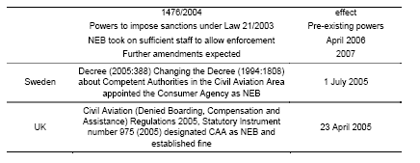
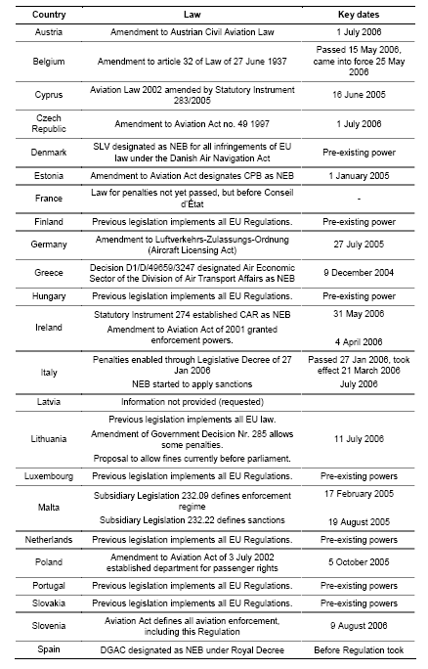
In Denmark, Hungary and the Netherlands, unlimited fines can be imposed for non-compliance.
The highest defined maximum penalties are in Spain (€ 4.5 million), although in practice the penalty imposed in Spain has to be in relation to the amount that the airline could have saved through non-compliance. Thus, any actual penalty would probably be well below the amount of € 4.5 million.
In certain other countries, the maximum penalties are much lower: in the most extreme case, Latvia, the maximum penalty is approximately € 215, significantly less than the amount that an airline would typically have to pay as compensation.
In Finland, Lithuania and Luxembourg, the NEB do not yet have the legal authority to impose penalties. These Member States are therefore not compliant with Article 16 of the Regulation, which states that the NEB should be able to impose dissuasive penalties.
Finland considers that the publication of airlines names on a blacklist is a sufficiently strong disincentive.

Information provided by Member States following a written consultation – the consultant, in charge of the independent study on Regulation (EC) No 261/2004 has information of a total of 31 543 complaints.
From 2005 to November (included) 2006.
These findings are in line with the Report on Air Passenger Rights Complaints 2005 published by The European Consumer Centres' Network (ECC) in November 2006 : http://www.eccdublin.ie/publications/reports/ecc_reports/ECC-Net_Airline_Complaints_05.pdf

