EN
COMMISSION OF THE EUROPEAN COMMUNITIES
Brussels, 21.5.2007
SEC(2007) 602

COMMISSION STAFF WORKING DOCUMENT
Annex to the
COMMUNICATION FROM THE COMMISSION TO THE EUROPEAN PARLIAMENT, THE COUNCIL, THE EUROPEAN ECONOMIC AND SOCIAL COMMITTEE AND THE COMMITTEE OF THE REGIONS
Commission Report on the Application of Council Regulation (EC) No 1407/2002 on State Aid to the Coal Industry
{COM(2007) 253 final}
COMMISSION STAFF WORKING DOCUMENT
Annex to the
Communication from the Commission to the European Parliament, the Council, the Economic and social Committee and the Committee of the Regions
Commission Report on the Application of Council Regulation 1407/2002/EC on State Aid to the Coal Industry

Table 1: Investment aid approved under Article 5 (2) Coal Regulation, in Million €
Year | United Kingdom | Poland | Slovakia | Total
2003 | 22 | 0 | 0 | 22
2004 | 29,5 | 0 | 0 | 29,5
2005 | 36,7 | 0 | 1,8 | 38,5
2006 | 0 | 0 | 4,1 | 4,1
2007 | 0 | 27,4 | 3,3 | 30,7
2008 | 0 | 21,3 | 3,2 | 24,5
2009 | 0 | 20,3 | 2,3 | 22,6
2010 | 0 | 15,9 | 0,7 | 16,6

Table 2: Production costs
 | Spain | Germany | Hungary
Total production volume in tons | 12 million | 22 million | 0,28 million
Average operating aid/tce | 141.3€ | 144 € | 108.6€

Table 3: Operating aid approved under Article 5 (3) Coal Regulation, in Million €
Year | Germany | Spain | Hungary | Bulgaria | Romania | Total
2003 | 1674 | 297 | n/a | n/a | n/a | 1971
2004 | 2069,3 | 285,2 | 43,7 | n/a | 57,1 | 2455,3
2005 | 1516,2 | 273,7 | 39,1 | n/a | n/a | 1829
2006 | 1712 | 393 | 36,5 | 1,1 | n/a | 2142,6
2007 | 1877 | n/a | 34,6 | n/a | n/a | 1911,6
2008 | 1773 | n/a | 30,8 | n/a | n/a | 1803,8
2009 | 1661 | n/a | 27,1 | n/a | n/a | 1688,1
2010 | 1392 | n/a | 25,3 | n/a | n/a | 1417,3
Note: Data for Spain, Bulgaria and Romania is incomplete.

Table 4: Closure aid approved under Article 4 Coal Regulation, in Million €
Year
 | France | Germany | Spain | Total
2003 | 201,7 | 965 | 271,6 | 1438,3
2004 | 118,6 | 413,9 | 254,7 | 787,2
2005 | 0 | 597,7 | 239,3 | 837
2006 | 0 | 0 | 119,7 | 119,7
2007 | 0 | 0 | n/a | 0
Note: Data for Spain is missing for 2007.

Table 5: Aid for inherited liabilities under Article 7 Coal Regulation, in Million €
Year | Germany | Spain | Slovakia | Poland | Czech Republic | Slovenia | Bulgaria | Romania | United Kingdom | France | Total
2003 | 780 | 550,4 | 3,2 | 902,8 | 14,72 | 2,2 | n/a | n/a | 14,4 | 714,7 | 2982,42
2004 | 556,4 | 573,1 | 1,7 | 912,6 | 14,72 | 2,2 | n/a | n/a | 0 | 769,3 | 2830,02
2005 | 602,4 | 581,6 | 3 | 369,1 | 14,72 | 15,3 | n/a | n/a | 0 | 0 | 1586,12
2006 | 806 | 585,2 | 2,5 | 294,1 | 14,72 | 17,5 | 3,8 | n/a | 0 | 0 | 1723,82
2007 | 677 | n/a | 2,5 | 40,4 | 14,72 | 18,5 | n/a | n/a | 0 | 0 | 753,12
2008 | 717 | n/a | 2,5 | 40,4 | 0 | 17,8 | n/a | n/a | 0 | 0 | 777,7
2009 | 631 | n/a | 2,4 | 40,4 | 0 | 18,1 | n/a | n/a | 0 | 0 | 691,9
2010 | 718 | n/a | 2,1 | 40,4 | 0 | 21,7 | n/a | n/a | 0 | 0 | 782,2
Note: Data for Spain, Bulgaria and Romania is incomplete.

Table 6: Total production of hard coal, in thousand tons
Note: EUROSTAT qualifies coal produced in Hungary and Slovakia, which is covered by the Coal Regulation, as lignite, and thus does not report it as "hard coal".

Table 6: Number of employees of the Coal industry in 2004
Source: EURACOAL, Coal industry across Europe 2005, p. 8.

Chart 1: Primary Energy Sources in the EU25
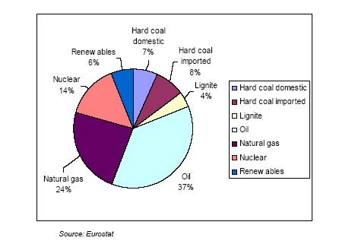

Chart 2: Electricity Sources in the EU25
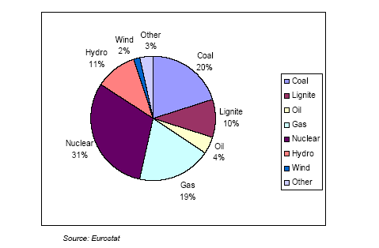

Chart 3: Development of renewable energy sources for electricity in the EU25
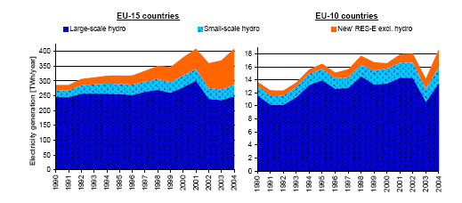

he Commission has authorized the plan for access to coal reserves of the Polish government; however, the Polish government still needs to notify the investment aid payments planned for 2007 to 2010 individually to the Commission.
The aid for Spain for 2006 has not yet been approved by the Commission. The figures are the figures indicated in the notification.
Source: Eurostat.
"tce" is ton of coal equivalent.
he Commission has authorized the annual payments for Germany and Hungary until 2006, for Spain until 2005. For Germany and Hungary, the Commission has also approved the plans for access to coal reserves for the years 2007 to 2010. The Spanish plan for the period 2006 to 2010 is currently under examination. Bulgaria and Romania need to notify their plans for access to coal reserves the latest on 30 April 2007.

