EN
COMMISSION OF THE EUROPEAN COMMUNITIES
Brussels, 13.6.2007
SEC(2007) 799

COMMISSION STAFF WORKING DOCUMENT
Annexes accompanying the
REPORT FROM THE COMMISSION TO THE COUNCIL
on the results of the aid authorised in Finland for
certain quantities of seeds and certain quantities of cereal seeds
{COM(2007) 323 final}
TABLE OF CONTENTS
ANNEX I – Commission Decision 2001/60/EC of 9 January 2001 3
ANNEX II – Commission Decision 2001/61/EC of 9 January 2001 4
ANNEX III – List of varieties of cereal seeds in receipt of national aid between 2000
and 2005 6
ANNEX IV – FINLAND Regions A, B and C1–C4 8
ANNEX V – List of varieties of grass/clover seeds in receipt of national aid between 2000
and 2005 9
ANNEX VI – Grass/clover seed varieties –production and aid in 2000–2005 10
ANNEX VII – Imports of seeds 11
ANNEX VIII – Comparison of Finland with EU-15 of grass/clover seed production for the period 2000–2005, as regards yields, average prices, market receipts and total receipts 12
ANNEX IX – Average prices paid to producers in the Member States in the period 2000–2005 and the weighed average for the EU-15 in EUR/100 kg 14
ANNEX X – SEED STOCKS FINLAND (requirement of Commission Regulation (EEC) No 3083/73 and (EC) No 2081/2004) 15
ANNEX XI – Estimated aid levels for seeds in 2005 16

ANNEX I
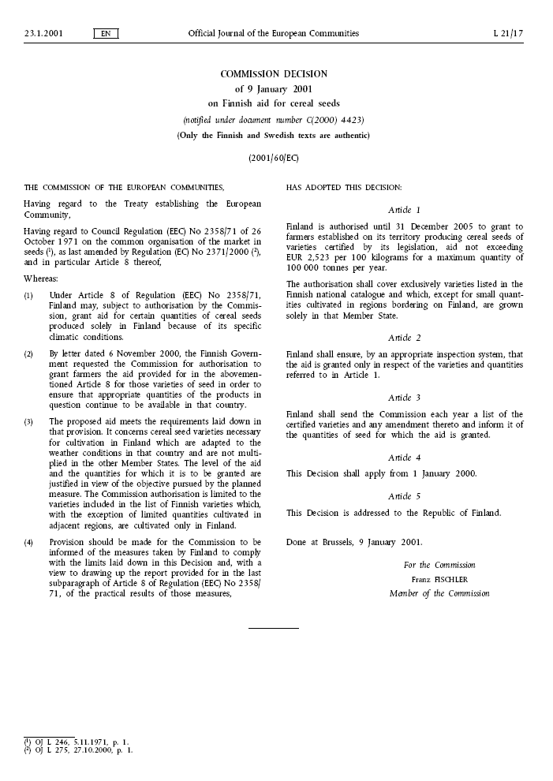
ANNEX II
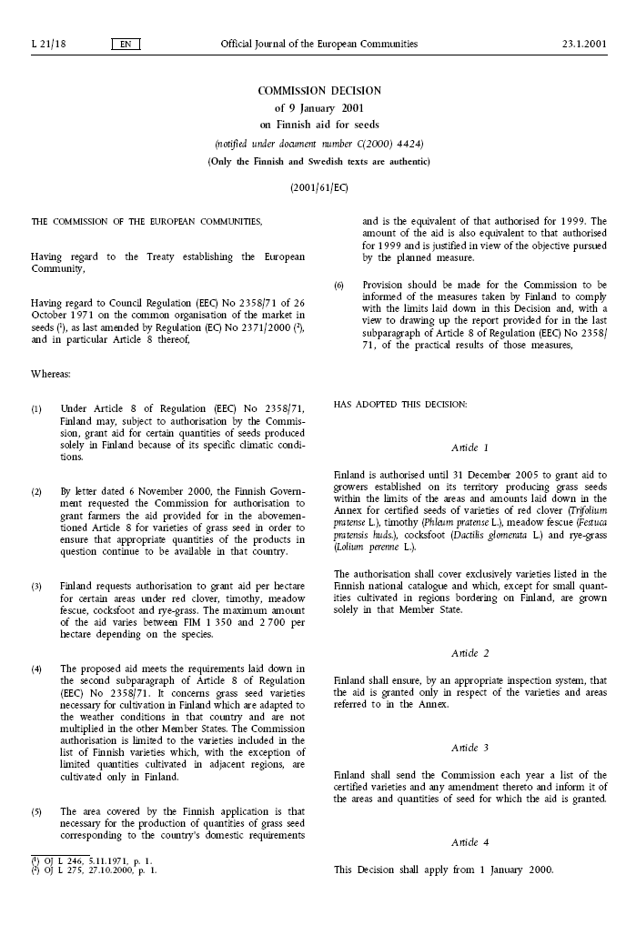
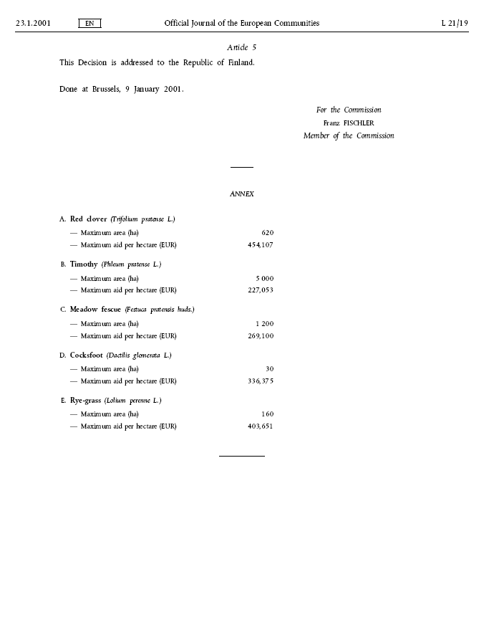
ANNEX III
List of varieties of cereal seeds in receipt of national aid between 2000 and 2005
 | 2000 | 2001 | 2002 | 2003 | 2004 | 2005
SPECIES | VARIETY | VARIETY | VARIETY | VARIETY | VARIETY | VARIETY
Oats | Aarre | Aarre | Aarre | Aarre | Aarre | Aarre
 | Aslak | Aslak | Aslak | Aslak | Aslak | Aslak
 | Belinda | Belinda | Belinda | Belinda | Belinda | Belinda
 | Freja | Freja | Fiia | Fiia | Fiia | Bessin
 | Katri | Katri | Freja | Freja | Freja | Fiia
 | Kolbu | Kolbu | Katri | Katri | Ivory | Freja
 | Leila | Leila | Kolbu | Kolbu | Katri | Ivory
 | Lisbeth | Lisbeth | Leila | Leila | Kolbu | Katri
 | Puhti | Puhti | Lisbeth | Lisbeth | Leila | Kolbu
 | Roope | Roope | Puhti | Puhti | Lisbeth | Leila
 | Salo | Salo | Roope | Roope | Marika | Lisbeth
 | Suomi | Suomi | Salo | Salo | Puhti | Marika
 | Veli | Svala | Suomi | Suomi | Roope | Puhti
 | Virma | Veli | Svala | Svala | Salo | Roope
 | Yty | Virma | SW Vaasa | SW Vaasa | Suomi | Salo
 |  | Yty | Veli | Veli | Svala | Suomi
 |  |  | Virma | Virma | SW Ingeborg | Svala
 |  |  | Yty | Yty | SW Vaasa | SW Ingeborg
 |  |  |  |  | Veli | SW Vaasa
 |  |  |  |  | Virma | Veli
 |  |  |  |  | Yty | Virma
 |  |  |  |  |  | Yty
Rye | Akusti | Akusti | Akusti | Akusti | Akusti | Akusti
 | Anna | Anna | Anna | Anna | Anna | Anna
 | Ensi | Elvi | Elvi | Elvi | Elvi | Elvi
 | Hankkijan Jussi | Ensi | Ensi | Ensi | Ensi | Ensi
 | Kartano | Hankkijan Jussi | Hankkijan Jussi | Hankkijan Jussi | Hankkijan Jussi | Hankkijan Jussi
 | Ponsi | Kartano | Kartano | Juuso | Juuso | Juuso
 | Riihi | Ponsi | Ponsi | Kartano | Kartano | Kartano
 | Voima | Riihi | Riihi | Ponsi | Ponsi | Ponsi
 |  | Voima | Voima | Riihi | Riihi | Riihi
 |  |  |  | Voima | Voima | Voima
 |  |  |  | Walet | Walet | Walet
Wheat | Aura | Aura | Aura | Aura | Aura | Aura
 | Gunbo | Gunbo | Gunbo | Gunbo | Gunbo | Gunbo
 | Hankkijan Ilves | Hankkijan Ilves | Hankkijan Ilves | Hankkijan Ilves | Hankkijan Ilves | Hankkijan Ilves
 | Otso | Otso | Otso | Otso | Lars | Lars
 | Tryggve | Tryggve | Tryggve | Rehti | Otso | Otso
 | Urho | Urho | Urho | Tryggve | Rehti | Rehti
 |  |  |  | Urho | Tryggve | SW Magnifik
 |  |  |  |  | Urho | Tryggve
 |  |  |  |  |  | Urho
Spring Wheat | Bastian | Anniina | Anniina | Amaretto | Amaretto | Aino
 | Heta | Bastian | Bastian | Anniina | Anniina | Amaretto
 | Mahti | Heta | Heta | Bastian | Bastian | Anniina
 | Manu | Kruunu | Kruunu | Heta | Heta | Bastian
 | Reno | Mahti | Mahti | Kruunu | Kruunu | Heta
 | Satu | Manu | Manu | Mahti | Mahti | Kruunu
 | Tjalve | Reno | Reno | Manu | Manu | Mahti
 |  | Satu | Satu | Reno | Reno | Manu
 |  | Tjalve | Tjalve | Satu | Satu | Reno
 |  |  | Zebra | Tjalve | Tjalve | Satu
 |  |  |  | Zebra | Zebra | Tjalve
 |  |  |  |  |  | Zebra

ANNEX III (cont’d)
List of varieties of cereal seeds in receipt of national aid between 2000 and 2005
 | 2000 | 2001 | 2002 | 2003 | 2004 | 2005
SPECIES | VARIETY | VARIETY | VARIETY | VARIETY | VARIETY | VARIETY
Barley | Arra | Arra | Arra | Arra | Arra | Arra
 | Artturi | Artturi | Artturi | Artturi | Artturi | Artturi
 | Arve | Arve | Arve | Arve | Arve | Arve
 | Botnia | Botnia | Botnia | Botnia | Botnia | Botnia
 | Erkki | Erkki | Erkki | Erkki | Edel | Edel
 | Filippa | Filippa | Filippa | Filippa | Erkki | Erkki
 | Hankkijan Pokko | Hankkijan Pokko | Hankkijan Pokko | Gaute | Filippa | Filippa
 | Inari | Inari | Inari | Hankkijan Pokko | Gaute | Gaute
 | Jyvä | Jyvä | Jyvä | Inari | Hankkijan Pokko | Hankkijan Pokko
 | Kilta | Kilta | Kilta | Jyvä | Inari | Inari
 | Kinnan | Kinnan | Kinnan | Kilta | Jyvä | Jyvä
 | Kustaa | Kunnari | Kunnari | Kinnan | Kilta | Kilta
 | Kymppi | Kustaa | Kustaa | Kunnari | Kinnan | Kinnan
 | Loviisa | Kymppi | Kymppi | Kustaa | Kunnari | Kunnari
 | Mette | Loviisa | Loviisa | Kymppi | Kustaa | Kustaa
 | Pohto | Mette | Mette | Loviisa | Kymppi | Kymppi
 | Rolfi | Pohto | Pohto | Luberon | Loviisa | Loviisa
 | Saana | Rolfi | Rolfi | Mette | Luberon | Luberon
 | Thule | Saana | Saana | Pohto | Maaren | Maaren
 | Tyra | Thule | Thule | Rolfi | Mette | Mette
 | Viivi | Tyra | Tyra | Saana | Pohto | Minttu
 |  | Viivi | Viivi | Thule | Rolfi | Pilvi
 |  |  | Viskosa | Tolar | Saana | Pinja
 |  |  |  | Tyra | SW Alina | Pohto
 |  |  |  | Viivi | Thule | Polartop
 |  |  |  | Viskosa | Tolar | Rolfi
 |  |  |  |  | Tyra | Saana
 |  |  |  |  | Viivi | SW Alina
 |  |  |  |  | Viskosa | Thule
 |  |  |  |  |  | Tolar
 |  |  |  |  |  | Tyra
 |  |  |  |  |  | Viivi
 |  |  |  |  |  | Vilde
 |  |  |  |  |  | Viskosa
 |  |  |  |  |  | Voitto

ANNEX IV
FINLAND Regions A, B and C1–C4
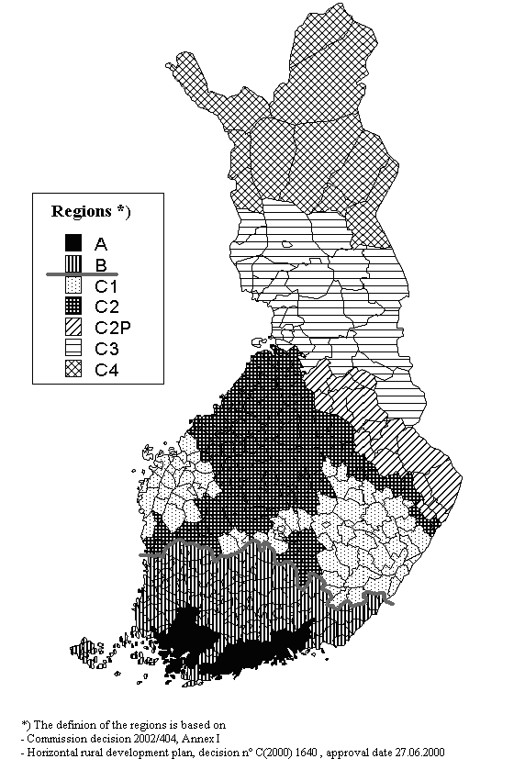
ANNEX V
List of varieties of grass/clover seeds in receipt of national aid between 2000 and 2005
 | 2000 | 2001 | 2002 | 2003 | 2004 | 2005
SPECIES | VARIETY | VARIETY | VARIETY | VARIETY | VARIETY | VARIETY
Cocksfoot | Apelsvoll | Apelsvoll | Apelsvoll | Apelsvoll | Apelsvoll | Apelsvoll
(Dactilis glomerata L.) | Haka | Haka | Haka | Haka | Haka | Haka
 | Tatu | Tatu | Tatu | Tatu | Tatu | Tatu
Meadow fescue | Antti | Antti | Antti | Antti | Antti | Antti
(Festuca pratensis huds.) | Boris | Boris | Boris | Boris | Boris | Boris
 | Fure | Fure | Fure | Fure | Fure | Fure
 | Ilmari | Ilmari | Ilmari | Ilmari | Ilmari | Ilmari
 | Kalevi | Kalevi | Kalevi | Inkeri | Inkeri | Inkeri
 | Kasper | Kasper | Kasper | Kalevi | Kalevi | Kalevi
 | Salten | Salten | Salten | Kasper | Kasper | Kasper
 |  |  |  | Salten | Salten | Salten
Rye grass | Norlea | Norlea | Norlea | Norlea | Norlea | Norlea
(Lolium perenne L.) | Riikka | Riikka | Riikka | Riikka | Riikka | Riikka
 | Svea | Svea | Svea | Svea | Svea | Svea
 |  |  |  |  |  | SW Corvus
Timothy | Alma | Alma | Alma | Alma | Alma | Alma
(Phleum pratense L.) | Botnia II | Botnia II | Botnia II | Botnia II | Botnia II | Botnia II
 | Grindstad | Grindstad | Grindstad | Grindstad | Grindstad | Grindstad
 | Hankkijan Tiiti | Hankkijan Tiiti | Hankkijan Tiiti | Hankkijan Tiiti | Hankkijan Tiiti | Hankkijan Tiiti
 | Iki | Iki | Iki | Haukila | Haukila | Haukila
 | Jonatan | Jonatan | Jonatan | Iki | Iki | Iki
 | Nokka | Nokka | Nokka | Jonatan | Jonatan | Jonatan
 | Saga | Saga | Saga | Nokka | Nokka | Nokka
 | Tammisto | Tammisto | Tammisto | Saga | Saga | Nuutti
 | Tammisto II | Tammisto II | Tammisto II | Tammisto | Tammisto | Saga
 | Tarmo | Tarmo | Tarmo | Tammisto II | Tammisto II | Tammisto
 | Tuukka | Tuukka | Tuukka | Tarmo | Tarmo | Tammisto II
 | Vega | Vega | Tuure | Tuukka | Tenho | Tarmo
 | Vähäsöyrinki | Vähäsöyrinki | Vega | Tuure | Tuukka | Tenho
 |  |  | Vähäsöyrinki | Vega | Tuure | Tuukka
 |  |  |  | Vähäsöyrinki | Uula | Tuure
 |  |  |  |  | Vega | Uula
 |  |  |  |  | Vähäsöyrinki | Vega
 |  |  |  |  |  | Vähäsöyrinki
Red clover | Betty | Betty | Betty | Betty | Betty | Betty
(Trifolium pratense L.) | Bjursele | Bjursele | Bjursele | Bjursele | Bjursele | Bjursele
 | Björn | Björn | Björn | Björn | Björn | Björn
 | Hankkijan Venla | Hankkijan Venla | Hankkijan Venla | Hankkijan Venla | Hankkijan Venla | Hankkijan Venla
 | Jesper | Ilte | Ilte | Ilte | Ilte | Ilte
 | Jokioinen | Jesper | Jesper | Jesper | Isomäki | Isomäki
 | Tepa | Jokioinen | Jokioinen | Jokioinen | Jesper | Jesper
 |  | Tepa | Tepa | Tepa | Jokioinen | Jokioinen
 |  |  | Varte | Varte | Tepa | Lone
 |  |  |  |  | Varte | Tepa
 |  |  |  |  |  | Varte

ANNEX VI
Grass/clover seed varieties –production and aid in 2000–2005
Table 1: Red clover (Trifolium pratense L.)
 | 2000 | 2001 | 2002 | 2003 | 2004 | 2005
1. Max area (ha) | 620 | 620 | 620 | 620 | 620 | 620
2. Max aid EUR/ha | 454,107 | 454,107 | 454,107 | 454,107 | 454,107 | 454,107
3. Total production (kg) | 53 274 | 124 640 | 67 978 | 62 358 | 4 239 | 52 000
4. Area approved after inspection (ha) | 552 | 666 | 629 | 467 | 448 | 487
5. Yield (kg/ha) | 97 | 188 | 108 | 134 | 10 | 104
6. Area (ha) corresponding maximum aid | 552 | 619 | 619 | 467 | 448 | 487
7. Per ha aid (EUR) | 454,11 | 422,15 | 447 | 454 | 454 | 454
Table 2: Timothy (Phleum pratense L.)
 | 2000 | 2001 | 2002 | 2003 | 2004 | 2005
1. Max area (ha) | 5 000 | 5 000 | 5 000 | 5 000 | 5 000 | 5 000
2. Max aid EUR/ha | 227,053 | 227,053 | 227,053 | 227,053 | 227,053 | 227,053
3. Total production (kg) | 2 151 169 | 3 780 556 | 3 540 671 | 2 594 073 | 1 319 456 | 1 908 245
4. Area approved after inspection (ha) | 5 525 | 7 179 | 7 680 | 7 035 | 5 585 | 5084
5. Yield (kg/ha) | 389 | 527 | 461 | 369 | 236 | 378
6. Area (ha) corresponding maximum aid | 4911 | 4999 | 4972 | 4923 | 4970 | 4932
7. Per ha aid (EUR) | 201,83 | 158,10 | 147,00 | 227,00 | 227,00 | 227,00
Table 3: Meadow fescue (Festuca pratensis huds.)
 | 2000 | 2001 | 2002 | 2003 | 2004 | 2005
1. Max area (ha) | 1 200 | 1 200 | 1 200 | 1 200 | 1 200 | 1 200
2. Max aid EUR/ha | 269,100 | 269,100 | 269,100 | 269,100 | 269,100 | 269,100
3. Total production (kg) | 423 078 | 732 234 | 467 712 | 454 094 | 318 099 | 700 400
4. Area approved after inspection (ha) | 1392 | 1649 | 1670 | 1734 | 1594 | 1589
5. Yield (kg/ha) | 304 | 444 | 280 | 262 | 200 | 441
6. Area (ha) corresponding maximum aid | 1131 | 1196 | 1198 | 1179 | 1195 | 1176
7. Per ha aid (EUR) | 218,64 | 195,10 | 193,00 | 269,00 | 269,00 | 269,00
Table 4: Cocksfoot (Dactylis glomerata L.)
 | 2000 | 2001 | 2002 | 2003 | 2004 | 2005
1. Max area (ha) | 30 | 30 | 30 | 30 | 30 | 30
2. Max aid EUR/ha | 336,375 | 336,375 | 336,375 | 336,375 | 336,375 | 336,375
3. Total production (kg) | 6 065 | 3 485 | 460 | 2 035 | 0 | 0
4. Area approved after inspection (ha) | 25 | 28 | 20 | 6 | 0 | 0
5. Yield (kg/ha) | 243 | 125 | 23 | 339
6. Area (ha) corresponding maximum aid | 25 | 28 | 20 | 6 | 0
7. Per ha aid (EUR) | 336,38 | 336,38 | 336,00 | 336,00
Table 5: Rye grass (Lolium perenne L.)
 | 2000 | 2001 | 2002 | 2003 | 2004 | 2005
1. Max area (ha) | 160 | 160 | 160 | 160 | 160 | 160
2. Max aid EUR/ha | 403,651 | 403,651 | 403,651 | 403,651 | 403,651 | 403,651
3. Total production (kg) | 45 249 | 44 288 | 31 374 | 38 240 | 13 483 | 42 600
4. Area approved after inspection (ha) | 96 | 68 | 81 | 86 | 75 | 75
5. Yield (kg/ha) | 471 | 651 | 387 | 445 | 180 | 568
6. Area (ha) corresponding maximum aid | 96 | 68 | 81 | 86 | 75 | 75
7. Per ha aid (EUR) | 403,65 | 403,65 | 403,65 | 403,00 | 403,00 | 403,00

ANNEX VII
Imports of seeds
Table 1: Imports of cereal seeds (kg)
 | 2000 | 2001 | 2002 | 2003 | 2004 | 2005
Barley | 29 500 | 15 790 | 67 000 | 314 450 | 58 480 | 4 900
Oats | 3 000 | 741 | 0 | 9 520 | 0
Rye | 1 000 | 13 450 | 13 000 | 0 | 12 500
Spring Wheat | 5 000 | 5 150 | 28 600 | 3 450 | 2 000
Autumn Wheat | 0 | 14 850 | 18 000 | 354 970 | 44 850
Total | 38 500 | 49 981 | 126 600 | 682 390 | 117 830 | 4 900
Table 2: Total of cereal seeds available on Finnish market (kg) excluding stocks
 | 2000 | 2001 | 2002 | 2003 | 2004 | 2005
Production | 57 308 772 | 55 434 443 | 60 178 667 | 64 179 629 | 67 723 135 | 70 531 482
Import | 38 500 | 49 981 | 126 600 | 682 390 | 117 830 | 4 900
Total | 57 347 272 | 55 484 424 | 60 305 267 | 64 862 019 | 67 840 965 | 70 536 382
Import/Production % | 0,067 | 0,090 | 0,210 | 1,063 | 0,174 | 0,007
Table 3: Imports of grass/clover seeds volume (kg)
 | 2000 | 2001 | 2002 | 2003 | 2004 | 2005
Red Clover | 35 400 | 22 875 | 38 150 | 37 955 | 68 828 | 63 000
Timothy | 347 000 | 11 350 | 0 | 350 | 46 055 | 3 219
Meadow Fescue | 221 200 | 50 650 | 47 068 | 26 517 | 107 952 | 6 000
Cocksfoot | 32 400 | 19 644 | 5 250 | 10 000 | 13 500 | 13 300
Rye grass | 76 300 | 63 450 | 51 152 | 75 709 | 94 899 | 66 000
Total | 712 300 | 167 969 | 141 620 | 150 531 | 331 234 | 151 519
Table 4: Total of grass/clover seeds available on Finnish market (tonnes) excluding stocks
 | 2000 | 2001 | 2002 | 2003 | 2004 | 2005
Production | 2 678 | 4 685 | 4 108 | 3 150 | 1 655 | 2 703
Import | 712 | 168 | 142 | 151 | 331 | 152
Total | 3 390 | 4 853 | 4 250 | 3 301 | 1 986 | 2 855
Import/Production % | 26,6 | 3,6 | 3,4 | 4,8 | 20,0 | 5,6

ANNEX VIII
Comparison of Finland with EU-15 of grass/clover seed production
for the period 2000–2005, as regards yields, average prices,
market receipts and total receipts (market + aid)
Table 1: Yield 100 kg/ha
Species | 2000 |  | 2001 |  | 2002 |  | 2003 |  | 2004 |  | 2005
Species | FI | EU-15 | FI | EU-15 | FI | EU-15 | FI | EU-15 | FI | EU-15 | FI | EU-15
Red clover | 1,0 | 3,8 | 1,9 | 3,2 | 1,1 | 3,5 | 1,3 | 3,3 | 0,1 | 2,6 | 1,0 | 3,6
Timothy | 3,9 | 4,4 | 5,3 | 5,3 | 4,6 | 4,5 | 3,7 | 4,3 | 2,4 | 3,6 | 3,8 | 2,8
Meadow Fescue | 3,0 | 7,0 | 4,4 | 7,5 | 2,8 | 6,1 | 2,6 | 6,6 | 2,0 | 5,3 | 4,4 | 5,8
Cocksfoot | 2,4 | 9,3 | 1,3 | 8,5 | 0,2 | 7,9 | 3,4 | 10,2 |  | 8,4 |  | 9,0
Rye grass (Lolium p. h.) | 4,7 | 10,9 | 6,5 | 15,1
Rye grass (Lolium p L.) |  |  |  |  | 3,9 | 11,4 | 4,5 | 12,7 | 1,9 | 11,9 | 5,7 | 11,6
Table 2: Average Price EUR/100 kg*
Species | 2000 |  | 2001 |  | 2002 |  | 2003 |  | 2004 |  | 2005
Species | FI | EU-15 | FI | EU-15 | FI | EU-15 | FI | EU-15 | FI | EU-15 | FI | EU-15
Red clover | 348,82 | 118,50 | 303,45 | 77,33 | 320,14 | 176,57 | 341,24 | 171,22 | 291,11 | 136,12 | 247,75 | 136,09
Timothy | 89,64 | 79,96 | 71,09 | 50,52 | 64,67 | 71,02 | 54,97 | 68,82 | 53,99 | 66,68 | 62,39 | 73,24
Meadow Fescue | 111,84 | 84,25 | 96,99 | 55,34 | n.a. | 65,86 | 92,93 | 78,71 | 87,78 | 81,89 | 96,08 | 92,46
Cocksfoot | n.a. | 80,47 | n.a. | 80,50 | 180,00 | 85,32 | n.a. | 73,25 | n.a. | 78,12 | n.a. | 88,02
Rye grass (Lolium p h) | 94,19 | 59,28 | 82,01 | 58,93
Rye grass (Lolium p L) |  |  |  |  | 82,47 | 74,64 | 71,70 | 81,65 | 71,82 | 79,79 | 79,22 | 70,48
* Weighed average for EU-15
Table 3: Market Receipts per ha (Price x Yield) EUR/ha
Species | 2000 |  | 2001 |  | 2002 |  | 2003 |  | 2004 |  | 2005
Species | FI | EU-15 | FI | EU-15 | FI | EU-15 | FI | EU-15 | FI | EU-15 | FI | EU-15
Red clover | 349 | 450 | 577 | 247 | 352 | 618 | 444 | 565 | 27 | 356 | 248 | 490
Timothy | 350 | 352 | 377 | 268 | 297 | 320 | 203 | 296 | 127 | 237 | 237 | 205
Meadow Fescue | 336 | 590 | 427 | 415 |  | 402 | 242 | 519 | 175 | 437 | 423 | 536
Cocksfoot |  | 748 |  | 684 | 36 | 674 |  | 747 |  | 658 |  | 792
Rye grass (Lolium p h) | 443 | 646 | 533 | 890
Rye grass (Lolium p L) |  |  |  |  | 322 | 851 | 323 | 1 037 | 136 | 947 | 452 | 818

ANNEX VIII (cont’d)
Table 4: EU Premium level in conformity with the Council Regulations (EC) No 1405/1999 and (EC) No 154/2002 and (EC) No 2323/2003 EUR/100 kg
Species | 2000 (1) | 2001 (1) | 2002 (2) | 2003 (2) | 2004 (3)
Red clover | 53,49 | 53,49 | 53,49 | 53,49 | 53,49
Timothy | 83,56 | 83,56 | 83,56 | 83,56 | 83,56
Meadow Fescue | 43,59 | 43,59 | 43,59 | 43,59 | 43,59
Cocksfoot | 52,77 | 52,77 | 52,77 | 52,77 | 52,77
Rye grass (Lolium p h) | 33,60 | 32,29
Rye grass (Lolium p L) |  |  | 30,99 | 30,99 | 30,99
1) Source: Council Regulation (EC) No 1405/1999
2) Source: Council Regulation (EC) No 154/2002
3) Source: Council Regulation (EC) No 2323/2003.
Table 5: Overview of the National, Community and the Total Aid in Finland EUR/ha
Species | 2000 |  |  | 2001 |  |  | 2002 |  |  | 2003 |  |  | 2004
Species | 1 | 2 | 3 | 1 | 2 | 3 | 1 | 2 | 3 | 1* | 2 | 3 | 1* | 2 | 3
Species | National aid | Yield x EU prem. | EU prem.+ National aid | National aid | Yield x EU prem. | EU prem.+ National aid | National aid | Yield x EU prem. | EU prem.+ National aid | National aid | Yield x EU prem. | EU prem.+ National aid | National aid | Yield x EU prem. | EU prem.+ National aid
Red clover | 454,11 | 53,49 | 507,60 | 422,15 | 101,63 | 523,78 | 447,00 | 58,84 | 505,84 | 454,00 | 69,54 | 523,54 | 454,00 | 4,99 | 458,99
Timothy | 201,83 | 325,88 | 527,71 | 158,10 | 442,87 | 600,97 | 147,00 | 384,38 | 531,38 | 158,90 | 309,17 | 468,07 | 202,03 | 197,13 | 399,16
Meadow Fescue | 218,64 | 130,77 | 349,41 | 195,10 | 191,80 | 386,90 | 193,00 | 122,05 | 315,05 | 182,92 | 113,33 | 296,25 | 201,75 | 86,93 | 288,68
Cocksfoot | 336,38 | 126,65 | 463,02 | 336,38 | 68,60 | 404,98 | 336,00 | 10,55 | 346,55 | 336,00 | 179,42 | 515,42 | n.a | n.a | n.a
Rye grass | 403,65 | 157,92 | 561,57 | 403,65 | 209,89 | 613,54 | 403,65 | 120,86 | 524,51 | 403,00 | 139,46 | 542,46 | 403,00 | 58,88 | 461,88
* Taking into account the aid unit coefficient where applicable.
Table 6: Total aid in Finland* and the average aid in EU15** EUR/ha
Species | 2000 |  | 2001 |  | 2002 |  | 2003 |  | 2004
Species | FI | EU-15 | FI | EU-15 | FI | EU-15 | FI | EU-15 | FI | EU-15
Red clover | 508 | 203 | 524 | 171 | 506 | 187 | 524 | 177 | 459 | 140
Timothy | 528 | 368 | 601 | 443 | 531 | 376 | 468 | 359 | 399 | 297
Meadow Fescue | 349 | 305 | 387 | 327 | 315 | 266 | 296 | 288 | 289 | 232
Cocksfoot | 463 | 491 | 405 | 449 | 347 | 417 | 515 | 538 | n.a. | 445
Rye grass | 562 | 366 | 614 | 488 | 525 | 353 | 542 | 394 | 462 | 368
* Table 5: Column 3
** Yield x EU premium
Table 7 – Total receipts (market + total aid) in Finland and in EU-15 EUR/ha
Species | 2000 |  | 2001 |  | 2002 |  | 2003 |  | 2004
Species | FI | EU-15 | FI | EU-15 | FI | EU-15 | FI | EU-15 | FI | EU-15
Red clover | 856 | 654 | 1 100 | 419 | 858 | 805 | 967 | 742 | 486 | 496
Timothy | 877 | 719 | 978 | 711 | 829 | 696 | 671 | 655 | 527 | 534
Meadow Fescue | 685 | 895 | 814 | 742 | n.a. | 668 | 538 | 807 | 464 | 669
Cocksfoot | n.a. | 1 239 | n.a. | 1 133 | n.a. | 1 091 | n.a. | 1 285 | n.a. | 1 103
Rye grass | 1 004 | 1 012 | 1 147 | 1 377 | 846 | 1 204 | 865 | 1 431 | 598 | 1 314
n.a.: not available.
ANNEX IX
Average prices paid to producers in the Member States in the period 2000–2005 and the weighed average for the EU-15 in EUR/100 kg
SPECIES | BE | DK | DE | ES | FR | IE | IT | LU | NL | AT | PT | SE | UK | FI | * EU Ave.
 |  |  |  |  |  | 2000
Trifolium pratense L. |  |  | 190,20 |  | 99,00 |  | 108,46 | 111,55 |  | 214,94 |  | 249,48 |  | 348,82 | 118,50
Phleum pratense L. |  | 74,46 | 65,96 |  |  |  |  | 84,28 |  | 86,39 |  | 76,49 | 147,68 | 89,64 | 79,96
Festuca pratensis Huds. |  | 93,38 | 80,27 |  |  |  |  |  | 92,39 | 103,30 |  | 75,42 |  | 111,84 | 84,25
Dactylis glomerata L. |  | 81,30 | 115,04 | 99,17 | 78,00 |  |  |  |  | 175,87 |  | 93,07 | 76,30 |  | 80,47
Lolium per. L. (Hte Pers.) | 57,02 | 63,59 | 53,17 | 77,53 | 49,00 | 100,00 |  | 57,51 | 57,99 | 110,93 |  | 52,93 | 65,03 | 94,19 | 59,28
 |  |  |  |  |  | 2001
Trifolium pratense L. | 53,49 | 229,29 | 188,00 |  | 47,00 |  | 105,00 |  |  | 214,94 |  |  |  | 303,45 | 77,33
Phleum pratense L. |  | 93,87 | 59,00 |  |  |  |  |  |  | 86,39 |  |  |  | 71,09 | 50,52
Festuca pratensis Huds. |  | 82,11 | 74,00 |  |  |  |  |  |  | 103,30 |  |  |  | 96,99 | 55,34
Dactylis glomerata L. |  | 79,79 | 98,00 | 99,17 | 78,00 |  |  |  |  | 175,87 |  | 113,43 | 114,86 |  | 80,50
Lolium per. L. (Hte Pers.) | 32,29 | 59,32 | 57,00 | 77,53 | 49,00 |  |  |  | 54,60 |  |  | 58,97 | 85,32 | 82,01 | 58,93
Lolium per. L. (N. Var.) | 29,32 |  | 48,00 |  |  |  |  |  |  |  |  | 47,24 |  |  | 8,34
Lolium per. L. (B. Pers.) |  |  |  |  |  |  |  |  |  | 110,93 |  |  |  |  | 0,00
 |  |  |  |  |  | 2002
Trifolium pratense L. |  | 305,59 | 172,00 |  | 98,96 |  |  | 92,00 |  | 194,00 | 270,00 | 279,43 |  | 320,14 | 176,57
Phleum pratense L. |  | 100,92 | 58,00 |  |  |  |  | 68,00 | 75,00 | 93,00 |  | 79,69 | 128,77 | 64,67 | 71,02
Festuca pratensis Huds. |  | 86,06 | 74,00 |  |  |  |  | 75,00 |  | 94,00 |  | 66,66 | 114,47 |  | 65,86
Dactylis glomerata L. |  | 86,56 | 100,00 | 99,70 | 80,23 |  |  |  |  | 161,00 | 255,00 | 127,40 | 77,27 | 180,00 | 85,32
Lolium per. L. |  | 83,42 | 64,00 | 78,50 | 51,00 |  |  | 50,00 | 71,10 |  | 209,00 | 102,89 | 85,85 | 82,47 | 74,64
 |  |  |  |  |  | 2003
Trifolium pratense L. |  | 323,24 | 189,00 |  | 104,51 |  |  |  |  | 210,33 |  | 279,43 |  | 341,24 | 171,22
Phleum pratense L. |  | 109,18 | 60,00 |  |  |  |  |  | 225,00 | 86,00 |  | 79,69 | 128,22 | 54,97 | 68,82
Festuca pratensis Huds. |  | 96,96 | 77,00 |  |  |  |  |  |  | 94,00 |  | 66,66 |  | 92,93 | 78,71
Dactylis glomerata L. |  | 68,30 | 111,00 |  | 84,23 |  |  |  |  | 148,00 |  | 127,40 | 81,20 |  | 73,25
Lolium per. L. |  | 92,08 | 72,00 |  | 56,00 | 53,00 |  |  | 77,91 | 97,00 |  | 102,89 | 88,13 | 71,70 | 81,65
 |  |  |  |  |  | 2004
Trifolium pratense L. | 285,00 | 321,22 | 189,00 |  | 106,51 |  |  | 61,01 |  | 207,67 |  | 216,28 |  | 291,11 | 136,12
Phleum pratense L. | 215,00 | 118,40 | 69,00 |  |  |  |  | 80,00 | 225,00 | 88,00 |  | 63,03 | 131,00 | 53,99 | 66,68
Festuca pratensis Huds. | 110,00 | 114,28 | 79,00 |  |  |  |  |  | 103,08 | 104,50 |  | 72,94 |  | 87,78 | 81,89
Dactylis glomerata L. |  | 73,77 | 85,00 |  | 85,23 |  |  |  | 108,29 | 148,00 |  | 65,35 | 90,00 |  | 78,12
Lolium per. L. | 92,00 | 89,98 | 69,00 |  | 61,01 | 61,01 |  | 55,00 | 72,73 | 97,00 |  | 73,78 | 94,00 | 71,82 | 79,79
 |  |  |  |  |  | 2005
Trifolium pratense L. | 280,00 | 289,45 | 202,00 |  | 109,21 |  |  | 102,00 |  | 208,50 |  | 234,22 |  | 247,75 | 136,09
Phleum pratense L. | 230,00 | 123,77 | 80,00 |  |  |  |  | 82,00 |  | 78,00 |  | 90,49 |  | 62,39 | 73,24
Festuca pratensis Huds. | 120,00 | 117,89 | 83,00 |  |  |  |  |  |  | 93,00 |  | 78,78 |  | 96,08 | 92,46
Dactylis glomerata L. |  | 89,59 | 82,00 |  | 87,16 |  |  |  |  | 145,00 |  | 88,36 | 87,00 |  | 88,02
Lolium per. L. | 76,00 | 73,70 | 68,00 |  | 60,70 | 50,00 |  | 60,00 | 66,31 | 95,00 |  | 64,94 | 90,00 | 79,22 | 70,48
Source: communicated by the Member States.
* EU Weighed average
ANNEX X
SEED STOCKS FINLAND
requirement by Commission Regulation (EEC) No 3083/73 and (EC) No 2081/2004
100 kg
VARIETY | Year
VARIETY | 2000 | 2001 | 2002 | 2003 | 2004 | 2005
Red clover (Trifolium pratense L.) | 482 | 485 | 373 | 287 | 54 | 9
Timothy (Phleum pratense L.) | 915 | 6 892 | 18 106 | 13 865 | 3 702 | 1 408
Meadow fescue (Festuca pratensis Huds.) | 1 114 | 2 521 | 2 497 | 1 635 | 684 | 1 283
Cocksfoot (Dactylis glomerata L.) | 220 |  |  |  | 69 | 38
Rye grass (Lolium per. L.) | 442 | 328 | 183 |  | 195 | 282
Source: communicated by Finland
ANNEX XI
Estimated aid levels for seeds in 2005
2005; grass seeds (aid €/ha) | Regions
2005; grass seeds (aid €/ha) | A | B | C1 | C2 | C2P | C3 | C4
Agri-environmental aid * | 117 | 117 | 117 | 117 | 117 | 117 | 117
LFA aid | 150 | 200 | 200 | 210 | 210 | 210 | 210
Article 142 Nordic Aid |  |  |  | 35 | 35 | 51 | 102
National additional agri-environmental aid* | 97 | 97
National additional LFA aid | 19 | 19 | 19 | 23 | 23 | 23 | 23
Total | 382 | 432 | 336 | 385 | 385 | 401 | 452
2005; wheat (aid €/ha) | Regions
2005; wheat (aid €/ha) | A | B | C1 | C2 | C2P | C3 | C4
CAP payment | 277 | 228 | 228 | 187 | 187 | 187 | 187
Agri-environmental aid * | 117 | 117 | 117 | 117 | 117 | 117 | 117
LFA aid | 150 | 200 | 200 | 210 | 210 | 210 | 210
Article 142 Nordic Aid |  |  | 69 | 99 | 99
National additional agri-environmental aid* | 86 | 86
National additional LFA aid | 19 | 19 | 19 | 23 | 23 | 23 | 23
Total | 649 | 650 | 633 | 637 | 637 | 538 | 538
2005; rye (aid €/ha) | Regions
2005; rye (aid €/ha) | A | B | C1 | C2 | C2P | C3 | C4
CAP payment | 277 | 228 | 228 | 187 | 187 | 187 | 187
Agri-environmental aid * | 117 | 117 | 117 | 117 | 117 | 117 | 117
LFA aid | 150 | 200 | 200 | 210 | 210 | 210 | 210
Article 142 Nordic Aid |  |  | 112 | 142 | 142
National additional agri-environmental aid * | 97 | 97
National additional LFA aid | 19 | 19 | 19 | 23 | 23 | 23 | 23
Total | 659 | 660 | 676 | 680 | 680 | 538 | 538
2005; barley, oats (aid €/ha) | Regions
2005; barley, oats (aid €/ha) | A | B | C1 | C2 | C2P | C3 | C4
CAP payment | 277 | 228 | 228 | 187 | 187 | 187 | 187
Agri-environmental aid * | 117 | 117 | 117 | 117 | 117 | 117 | 117
LFA aid | 150 | 200 | 200 | 210 | 210 | 210 | 210
Article 142 Nordic Aid |  |  |  | 30 | 30 | 46 | 97
National additional agri-environmental aid * | 4 | 4
National additional LFA aid | 19 | 19 | 19 | 23 | 23 | 23 | 23
Total | 567 | 568 | 564 | 568 | 568 | 584 | 635
* Farm type: plant production, additional measure: plant cover outside growing season or reduced tillage.
Source: communicated by Finland.

