EN
COMMISSION OF THE EUROPEAN COMMUNITIES
Brussels, 6.7.2007
SEC(2007) 968

COMMISSION STAFF WORKING DOCUMENT
Accompanying document to the
FIRST REPORT TO THE EUROPEAN SECURITIES COMMITTEE AND TO THE EUROPEAN PARLIAMENT
on convergence between International Financial Reporting Standards (IFRS) and third country national Generally Accepted Accounting Principles (GAAPs)
{COM(2007) 405 final}

US GAAP ANNNEX 1

Significant issues according to CESR advice

Other issues which were not significant or not identified in CESR advice but on which there is a convergence project

ANNEX 2
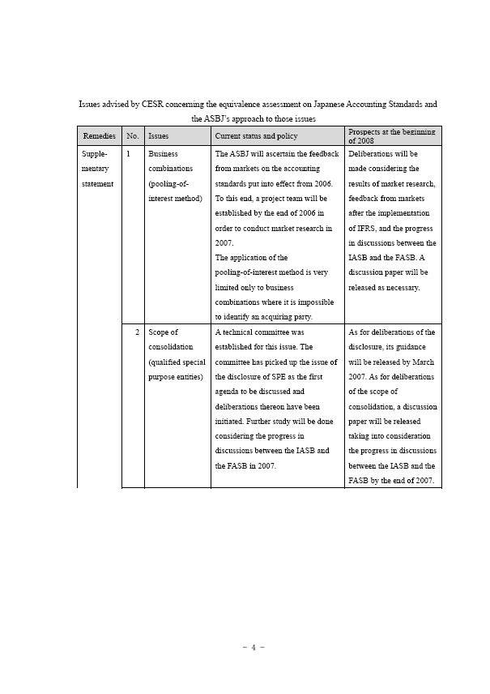

ANNEX 3:
Implementation Plan for Incorporating IFRSs into Canadian GAAP
Calendar of Implementation Goals (As of June 30, 2006)

2006 • Expose definition of publicly accountable enterprises
• Initial meetings with Canadian Securities Administrators to initiate dialogue about disclosure requirements for transition to IFRSs
• Initial discussions with the SEC to determine if it will consider an exemption for comparative year financial information, similar to that provided for countries adopting IFRSs in 2005
• Determine policy for what, if any, modifications can be made to an IFRS on adoption into Canadian GAAP
• Consider treatment of Canadian standards that will have no IFRS equivalent at the changeover

Standards anticipated to be adopted
Accounting Changes* (effective January 1, 2007)
Earnings per Share* (effective 2007)
Financial Instruments — Disclosures* (effective October 1, 2007)
* Standards anticipated to be adopted in substantially the same wording as IFRS counterpart

2007 • Define criteria for assessment during Progress Review
• Expose disclosures required prior to adoption
• Determine basis for exposing existing IFRS for adoption into Canadian GAAP

Standards anticipated to be adopted
Business Combinations* (effective January 1, 2009)
Going Concern*
Income Taxes* (effective 2008)
Inventories* (effective July 1, 2007)
Joint Ventures*
Liabilities and Equity*
* Standards anticipated to be adopted in substantially the same wording as IFRS counterpart

2008 • Complete progress review
• Announce changeover timing
• Finalize disclosures required prior to adoption
• Issue omnibus exposure draft of existing IFRSs

Standards anticipated to be adopted
Consolidations*
Government Grants*
Internally Developed Intangible Assets*
Fair Value Measurement*
* Standards anticipated to be adopted in substantially the same wording as IFRS counterpart

2009 • Determine rules of procedure for the exposure of IFRS after changeover
• Finalize process for translation to both official languages

Standards anticipated to be adopted beyond 2008
Financial Statement Presentation*
Impairment*
Insurance Contracts*
Research and Development Costs*
Revenue Recognition*
* Standards anticipated to be adopted in substantially the same wording as IFRS counterpart

Source: Accounting Standard Board of Canada

