EN
COMMISSION OF THE EUROPEAN COMMUNITIES
Brussels, 30.10.2008
SEC(2008) 2723

COMMISSION STAFF WORKING DOCUMENT
Progress Report on the European and Developing Countries Clinical Trials Partnership
(EDCTP)
{COM(2008)688}
{SEC(2008)2724}
TABLE OF CONTENTS
Executive Summary 4
I. Introduction 7
A. Establishment of the EDCTP Programme 7
B. Governance 8
1. EEIG General Assembly 10
2. Executive Secretariat 10
3. Partnership Board 11
4. European Network of National Programmes 11
5. Developing Countries Coordinating Committee 12
6. High Representative 12
II. The early years: 2003-2006 13
A. Projects financed from 2003 to 2006 14
III. EDCTP Independent External Review 21
IV. A new start: 2007-2008 22
A. Follow-up of the Van Velzen report 22
B. Operations, calls and grants 23
V. EDCTP funding / Member States co-funding overview 32
VI. Key Performance Indicators 40
A. Synergy of research and development funding 47
B. Third-party collaboration and funding 47
VII. The EDCTP medium- and long-term strategy and activities 48
VIII. EDCTP Forum 49
IX. Recent press releases and publications 49
X. Commissioner Potočnik's letter to the EDCTP Member States 50
XI. Joint DG Research / DG Development platform 50
XII. Health research strategy on the three main poverty-related diseases 51
XIII. Involvement of African Governments 51
XIV. Other Article 169 initiatives 52
Annexes 53
Annex 1: Independent External Review of EDCTP - Key Recommendations 53
1. To the EDCTP: 53
2. To the EDCTP Member States: 53
3. To the European Commission, in relation to future EDCTP activities: 54
4. To the European Commission, in relation to new Article 169 initiatives: 54
Annex 2: Members of the different EDCTP constituencies 55
Annex 3: Recent EDCTP press releases 60
Start of Phase II trial of intravenous artesunate for children with severe malaria 60
HIV/AIDS infected children can now benefit from a European and Developing Countries Clinical Trials Partnership (EDCTP) funded trial 61
ITM starts 4ABC trial to compare four new antimalarial treatments for African children 62
EDCTP approves € 80 M of funding to boost HIV/AIDS, TB and malaria research 63

Executive Summary
The European and Developing Countries Clinical Trials Partnership (hereinafter referred to as "the EDCTP Programme") was established in 2003 by Decision of the European Parliament and of the Council by 14 Member States and Norway (Switzerland joined the EDCTP in 2005). The objectives were to accelerate the development of new clinical interventions to fight HIV/AIDS, malaria and tuberculosis in the developing countries, particularly in sub-Saharan Africa, and to improve the quality of research in relation to these diseases. Created under the umbrella of the Article 169 of the Treaty, the EDCTP Programme aims at coordinating and jointly implementing activities at Member State level.
EDCTP is managed through a General Assembly where Member States are represented, a Secretariat under the Executive Director, and a High Representative. Advisory bodies include the Partnership Board (the scientific advisory board), the Developing Countries Coordinating Committee, and the European Network of National Programmes.
The Community has made a contribution to the EDCTP through a €200 million financial contribution under the 6th Framework Programme for Research and Technological Development (2002-2006) – FP6. The participating Member States provide 50% co-funding, both in cash and in kind, increasing the total EDCTP budget to €400 million. An additional €200 million funding from third parties is also envisaged.
The EDCTP Programme had an initial implementing phase (from 2003 to 2006) slower than initially foreseen. Over that period budget spending was abnormally low, calls for proposals were cancelled, and a 2004 report from the European Court of Auditors (PF-1828 (6046)) revealed several deficiencies. During the same period, the Secretariat was under four different Executive Directors, two of them being ad interim. As a consequence, in 2006 Commissioner Janez Potočnik requested a panel of high level experts to prepare an Independent External Review (IER) report on the European and Developing Countries Clinical Trials Partnership, the so called van Velzen report, which was published in July 2007.
The present progress report, published as a Commission Staff Working Document, is intended to inform on the achievements and current status of the first five years of the EDCTP Programme, from 2003 to 2008, following the recommendations of the Van Velzen report. The time elapsed since its publication in July 2007 has allowed the implementation of most of its recommendations to the EDCTP Secretariat, Member States and Commission.
Since 2007, the EDCTP Secretariat has redefined its scientific strategy, through stakeholder's meetings held on the different diseases and products, increased collaboration with Public-Private Partnerships, renewed calls for proposals, and simplified the co-funding.
Participating Member States have created a General Assembly Steering Committee, renewed their commitment to the EDCTP, reinforced African participation into the General Assembly, and are more and more accepting a unique central EDCTP evaluation.
The Commission is joining efforts of its relevant services in relation to EDCTP, working on a strategic research policy for Africa including EDCTP, and setting pre-conditions for future Article 169 initiatives, such as the necessity to ensure the pre-existence of national programmes and commitment to funding.
On the operational side, from September 2003 to May 2008, the EDCTP Programme has launched 33 calls and financed about 145 projects. Among these, 32 are clinical trials; 55 are training (MSc, PhDs and post doctoral) awards; 11 are supporting network activities; 14 are capacity building in ethics; 16 are Senior Fellowships; one project on strengthening the regulatory framework in Africa through collaboration with WHO; and one for the establishment and maintenance of a clinical trials registry. The projects are based in 26 different countries in sub-Saharan Africa, involving 123 institutions, and practically all participating Member States.
In particular, in 2007 the EDCTP launched 11 new calls for a total of €180 million (including €90 million of co-funding expected from Member States). In May 2008, and as partial outcome of these calls, the EDCTP General Assembly approved the financing of 8 new projects on malaria treatment, malaria vaccine, malaria in pregnancy, and tuberculosis vaccine; 8 new projects on capacity building for African ethical committees; 3 trans-disease regional networks of excellence (East, Central and West Africa), and 6 senior fellowships, for a total of about €87 million, including 50% co-funding from MS. The remaining calls are under evaluation.
As a result of all these calls, EDCTP has committed from 2003 to December 2007 €76.2 million (from EC, MS and third party funding) in grants, including a call co-funded by the Bill and Melinda Gates Foundation on HIV vaccines. In 2008, the EDCTP expects to increase this figure to over € 279 million.
However, since most projects are 3-year contracts, and some of them are just starting, the total EDCTP expenditure on research grants has been so far of €15.7 million. Out of the total commitment, 63% is going to African researchers. In 2007, 88% of the EDCTP budget was devoted to grants.
Member States co-funding has increased from less than €1 million in 2005, to €6 million in 2006, and up to €21 million in 2007. Data from January to April 2008 already show €67 million Member States' committed or pledged from Member States.
Third party contribution contributed or committed from different foundations, product-development public private partnerships and industries accounts so far for €34.1 million.
In the almost five years since its creation, the EDCTP has achieved several important landmarks:
Enhanced coordination of research activities and demonstrable capacity building
African researchers have an equal opportunity to their northern colleagues to develop proposals and become Principal Investigators
The EDCTP is urging African countries to establish national research budgets and to further contribute to the establishment of an African Fund for Health Research
EDCTP funding gives African researchers more ownership, provides better fora for discussion and knowledge exchange
Capacities and sites developed are fully owned by the institutions and countries, avoiding scientific colonization
Grantees have developed new research sites by accessing funding from other sources
EDCTP funding is instrumental in the approval of some major health policy changes, such as the development of HIV treatment for children.

I. Introduction
The European Commission has financed research on HIV/AIDS, malaria, and tuberculosis for many years. The projects supported until year 2002 involved mainly basic and preclinical research, and early clinical trials.
The prioritisation of the three main poverty-related diseases during the Fifth Framework Programme for research, technological development and demonstration activities (1998-2002) led to the development of vaccines and drug candidates against these three diseases, and the testing of these up to early clinical trials in Europe and Africa. When the Sixth Framework Programme (2002-2006) started, further development of these EU-financed products into advanced clinical trials (phases II and III) in Africa was very difficult: neither the European Union nor the African scientific community had the capacity to prepare for and perform large scale clinical trials in Africa.
At that time, Member States were undertaking individual research and development programmes or activities to address HIV/AIDS, malaria and tuberculosis without sufficient coordination at European level to allow a coherent approach for a fully effective research programme. Moreover, the enabling environment to conduct these clinical trials in Africa following the best practices in accordance with good clinical practice (GCP), good clinical laboratory practice (GCLP), sound ethical review and competent regulatory oversight was limited.

A. Establishment of the EDCTP Programme
The European and Developing Countries Clinical Trials Partnership (EDCTP) was established in September 2003 by 15 European countries with the aim to develop capacity building for clinical trials and new clinical interventions to address the needs of sub-Saharan Africa in the fields of HIV/AIDS, malaria and tuberculosis.
Created under the umbrella of Article 169 of the Treaty, the EDCTP aims at better integrating existing research from different European Member States in the field of poverty-related diseases. As such, one of the first EDCTP tasks was to identify these activities, so as to create a map of European research on HIV/AIDS, malaria and tuberculosis.
The EDCTP Programme was created to address three main strategic objectives:
1) Development of new interventions and products against poverty-related diseases. The fight against HIV/AIDS, malaria and tuberculosis needs both prophylactic (vaccine and microbicides) and therapeutic (drugs) tools to prevent infection and control disease progression.
2) Sustainable capacity building in Africa. Public health and research activities in Africa should be sustainable, so local populations can better control the pandemic. The coordination of development aid policy and research policy should aim at a better implementation of these separate policies into a long term strategy against the three diseases.
3) Coordination of European Member States research policies. Although the research activities of some European Union Member States in Africa have been remarkable, these could profit from a better collaboration and coordination. The coordination of European national research programmes and policies on poverty-related diseases for Africa, in line with Article 169 of the Treaty, will increase the efficacy of European interventions against these diseases.
The EDCTP is mainly funded through a € 200 million grant under the Sixth Framework Programme. The grant agreement (between EDCTP and the Commission) requires an equivalent amount of co-funding from Member States, increasing the total EDCTP budget to € 400 million. Therefore, Member States contribute to this co-funding budget both in cash and in kind. Additional funding from Third Parties (foundations, public-private partnerships, industry and other stakeholders) is envisaged for later clinical phases, especially in the case of industry, which could become involved in the EDCTP activities when a product moves closer to marketing authorisation.
The EDCTP was launched for an initial period of 5 years. In July 2007, after the publication of the Van Velzen report, the grant agreement was extended for two additional years, until 2010, without additional budget.
The EDCTP's own website, which includes details of calls for proposals and a wide variety of other information, is at http://www.edctp.org.

B. Governance
The EDCTP European Economic Interest Group (EDCTP-EEIG) is the legal form chosen for implementing the Programme and managing the funding. The EEIG consists of:
- A governing body, the General Assembly, in which all participating European Member States are represented
- An executive body, the Secretariat, which assures the day-to-day management.
- Partnership structures external to the EEIG, which comprise:
- The Partnership Board (PB), a scientifically independent expert panel that develops the strategic planning of the EDCTP
- The Developing Countries Coordinating Committee (DCCC), which consists of representative African scientists and ensures the input and commitment of the African countries and researchers
- The European Network of National Programmes (ENNP), which consists of representatives of the European national programmes and develops proposals to coordinate and joint national activities and funding.
The Partnership structures and the European Commission hold permanent seats as observers in the EEIG Assembly.
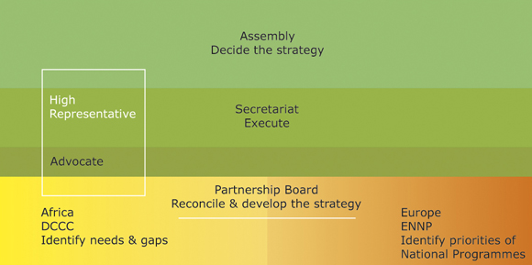

The EDCTP, created under the structure of a European Economic Interest Group (EEIG) where all participating Member States are represented in the General Assembly (GA), is at present (2007-2009) chaired by UK, and co-chaired by Denmark, France and Spain. The Assembly meets twice a year, although some decisions are taken by written procedure.
Recently, and following the recommendations of the Van Velzen report, a Steering Committee comprising the GA Chairperson, the three Vice-Chairs and the Executive Director has been established to take decisions under the mandate of the General Assembly. The Steering Committee also has the High Representative and the Chairpersons of the Partnership Board, Developing Countries Coordinating Committee and European Network of National Programmes as observers.
The EDCTP Secretariat is based in The Hague (The Netherlands) and is composed of 24 staff under the Executive Director, Dr. Charles Mgone (Tanzania), in office since February 2007. The Africa office is based in Cape Town (South Africa), where the High Representative (Dr. Pascoal Mocumbi, from Mozambique) is based. This office ensures an adequate commitment, ownership and stewardship of African governments, as well as the South-South coordination and networking among African researchers.
The EDCTP Programme receives input from different advisory boards: the Partnership Board, in charge of scientific advice, is currently chaired by Dr. Sodiomon Sirima (Burkina Faso); the Developing Countries Coordinating Committee, chaired by Dr. Andrew Kitua (Tanzania) is in charge of South-South networking; and the European Network of National Programmes, chaired by Laura Brum (Portugal), in charge of the North-North networking.
Although the EDCTP Programme was created as a true partnership between Africa and Europe, in the early period African representation was weak. However, in the last 2 years, this partnership has become more visible, since a higher African representation has been sought in all EDCTP constituencies (General Assembly and Partnership structures).
During the last year, the chairmanship of both the Developing Countries Coordinating Committee and the Partnership Board have changed, and are both now Africans, for the first time since the creation of the EDCTP Programme. This, together with an African Executive Director, and an African High Representative, facilitates the interaction North-South, since all constituencies work closely with the EDCTP Secretariat, advising the Executive Director, and they all participate in the General Assembly meetings.

1. EEIG General Assembly
The General Assembly is the ultimate and exclusive decision making body of the European Economic Interest Group, the legal structure of the EDCTP. It acts collectively and the full members are jointly and severally liable for the actions of the EEIG. The principal responsibility of the Assembly is to ensure that all necessary activities are undertaken to achieve the statutory objectives of EDCTP, and that its resources are properly and efficiently managed. It has the final and exclusive decision power concerning:
- General strategies and plans of action for EDCTP
- Annual action plans, including calls for proposals
- Annual budgets and accounts
- Appointment and dismissal of the Executive Director (ED), the Director of Finance and Administration (DFA), the High Representative (HR) and senior staff members of the Secretariat
- Selection of the location(s) of the Secretariat
- Commitments for collaboration, agreements and partnerships with third parties
- Public release of information on initiatives, achievements and results of EDCTP
- The appointment of the advisory bodies (Partnership Board, Developing Countries Coordinating Committee, European Network of National Programmes).

2. Executive Secretariat
The Executive Secretariat assures the day-to day activities of the EEIG, runs independent peer review systems, supports the Partnership Board's policy development and networking, supports the work of the EEIG Assembly, Developing Countries Coordinating Committee (DCCC), and European networking; handles liaisons and negotiations with partners, oversees funded programmes, and maintains operational and financial control systems.
The Main Office of the EEIG Executive Secretariat is situated in The Hague, the Netherlands. The Secretariat established a second office in Cape Town, South Africa, which represents EDCTP in Africa, and promotes the participation of developing countries in EDCTP. It provides support to activities of EDCTP constituencies in Africa, in particular the DCCC and the High Representative.
All financial data presented in this report has been kindly provided by the EDCTP Secretariat.

3. Partnership Board
The Partnership Board (PB) is a scientifically independent panel of experts as full members with voting rights. The EEIG-Assembly appoints its members, seeking a balance of African and European experts.
The PB designs the strategic framework of the EDCTP and advises the Assembly on technical and scientific matters relating to the EDCTP programme. The PB prepares proposals and recommendations to be submitted via the Secretariat to the Assembly, specifically with regard to:
- Strategic needs and priorities for new clinical interventions, training and capacity building
- Calls for project proposals and other procedures for implementing plans of action
- Criteria and procedures for peer reviews
- Annual action plans, including the calls foreseen for the year
- Results of evaluation sessions and priority lists of projects.

4. European Network of National Programmes
The European Network of National Programmes (ENNP) is an advisory body to the EDCTP-EEIG Assembly as well as to EDCTP's other constituencies on the integration of the National Programmes of the EDCTP member states into a joint programme. The ENNP consists of representatives of the European national programmes and develops proposals to coordinate and join national activities and funding. These representatives are called European Networking Officers (ENOs).
The tasks of the ENNP can be divided into external and internal tasks. The external tasks are:
- Analyse and compare national funding mechanisms
- Identify gaps, overlaps and potential synergies between national programmes
- Develop strategies and proposals for harmonisation and European networking
- Advise on mechanisms for cofunding
- Help implement these strategies
- Coordinate networking activities on behalf of member states.
Internal tasks:
- Promote the goals of EDCTP within the member states
- Assist in the allocation of funding for EDCTP-related activities
- Network with each other and if possible network the scientific communities in each country
- Foster links between scientists from their own and other countries
- Advise on how to promote broad participation of EDCTP member states in joint activities.

5. Developing Countries Coordinating Committee
The Developing Countries Coordinating Committee (DCCC) is an independent advisory body of prominent African scientists and health professionals appointed by the General Assembly and representing different regions/countries in Africa. The goal of the DCCC is to strengthen policy debate and input to strategy from African experts and countries. It ensures the input and commitment of African countries and researchers. The DCCC provides input to the strategy of EDCTP by aggregating and transmitting advice from scientists of developing countries to the Partnership Board, the Secretariat and the Assembly.
The DCCC develops strategies and actions to improve coordination between its members, and with other partners participating in EDCTP, including governments and international organisations. Such actions can include:
- Promoting the creation and networking of national programmes for clinical trials for HIV/AIDS, malaria and TB in Africa
- Creating and promoting an African Forum of concerned scientists and experts
- Liaising with health authorities and relevant Developing Countries national programmes
- Collecting opinions from and disseminating information to Developing Countries scientists
- Interacting with WHO and other regional organizations by mutually attending relevant meetings
- Interacting with the High Representative, the Secretariat, the PB, the ENNP and European national programmes.

6. High Representative
The EEIG-EDCTP Assembly may appoint one or more High Representatives. The High Representative (HR) is an internationally known, credited and respected person for his/her public service record. The HR is committed and devoted to the stated objectives and the modus operandi of the EDCTP Programme.
The High Representative is working closely with the Executive Director and the Secretariat in order to:
- Raise the visibility of the EDCTP
- Advocate and gain political support for the EDCTP, particularly in Africa
- Contribute to the EDCTP´s fund raising activities
- Represent the EDCTP in the above listed functions.
The HR has no executive functions, and cannot financially or legally commit to the EEIG or EDCTP. He is supported in his/her activities by the Secretariat, and he/she works in close cooperation with the Executive Director.
The EDCTP High Representative is Dr Pascoal Mocumbi.
Annex 2 lists the different representatives of the 16 EDCTP participating countries, the personnel of the EDCTP Secretariat, and the representatives of the PB, ENNP and DCCC.

II. The early years: 2003-2006
The EDCTP Programme is the first implementation of Article 169 ever. As such, it encountered difficulties in its initial operational work, since new structures had to be created, and new ways of work had to be found. In addition, the original EDCTP goal, the coordination of European National Research Programmes, the very nature of the Article 169, is an ambitious task. Consequently, the EDCTP Programme had a slow starting phase.
Since the establishment of the EDCTP Programme in September 2003 up to now, the EDCTP Secretariat had three different executive directors, and two interim executive directors.
The inexperience of the Secretariat was apparent in the early period. The two first calls for proposals published by the EDCTP in 2004 and 2005 were cancelled partially or totally, since the procedure for evaluating proposals was considered flawed. As a consequence, the first EDCTP Executive Director stepped down.
The creation from scratch of the EDCTP advisory boards, Partnership Board, Developing Countries Coordinating Committee and, later in 2005, the European Network of National Programmes was a major achievement of the first phase of the EDCTP Programme. Defining the roles of each of these was not an easy task, and several conflicts arose between the Partnership Board (the scientific advisory board) and the General Assembly, where scientists were also present.
In 2004, a report from the European Court of Auditors expressed concern with the EDCTP Programme management. Many aspects of the Programme were evaluated, and specific recommendations were put forward, concerning the evaluation procedure, administrative procedures, and co-funding. The report pointed out that a co-funding level of at least 50% was expected from participating Member States and further recommended that the Commission should limit its contribution to the EDCTP Programme to the same level attained by participating Member States (with a maximum Community contribution of € 200 million). The 2007-2010 Roadmap, agreed between the EDCTP and the Commission in 2006, indicates the relative Commission and Member States yearly contributions needed to meet the overall funding goal for the lifetime of the programme.
In fact, before the report from the Court of Auditors (2003-2004), the only budgetary contribution to the EDCTP Programme came from the Community funding. The participating Member States contribution, the so-called co-funding, was very low in the initial years of EDCTP, reaching significant levels only during 2007. In the following years, this MS co-funding still has to increase further to match the Community contribution.
The cancelling of the first two calls for proposals led to a clear budgetary anomaly. Although the grant agreement signed with the European Commission specified a maximum management budget of 7.5% of the Community contribution, in the early years most of the EDCTP programme funding was dedicated to sustaining the Secretariat, with little funding going to research-related activities. However, it is notable that subsequently, - with the publication of new calls for proposals, the proportion of budget committed to management has decreased and is currently between 5 and 6%, while budget devoted to financing research projects has increased.
During this initial period of the EDCTP, achieving the original goal of Article 169, the coordination of National Programmes, has been a difficult task for two main reasons. First, and most important, some participating Member States lacked a national programme on HIV/AIDS, malaria and tuberculosis, so this had to be created. In the second place, participating Member States with ongoing activities in the field had to achieve an internal coordination that required re-adjusting their national activities. Full co-ordination is a very ambitious goal that will take several more years.

A. Projects financed from 2003 to 2006
From September to December 2003, no calls were launched.
In 2004 the following calls were launched:
- Five clinical trial calls:
- Trials assessing the effectiveness and safety of simplified anti-retroviral drug regimens and monitoring in HIV;
- Trials of studies of surrogate markers of drug efficacy emphasising non-clinical predictors and relapse following anti-tuberculosis therapy;
- Phase II-III of drug regimens that shorten or simplify current treatment options in tuberculosis;
- Phase II-III drug trials for the treatment of severe malaria using artemisinin compounds;
- Phase II-III drug trials for the treatment of uncomplicated malaria using artemisinin compounds
- One call for senior fellowships.
Summary update of clinical trial projects from 2004 calls:
Programme Area | Grantee | Title | EC Funding | Member State funding | Reported 3rd party funding | African and European Collaborator Countries | Update
TB | van Helden | Surrogate markers to predict the outcome of anti-tuberculosis therapy. | €973,033 | N/A | TBD | South Africa  United Kingdom | Second annual and financial reports were received and approved and payments made in January 2007. Third annual and financial report was received in December 2007. Third payment was made in February 2008.
 | Gillespie | Rapid Evaluation of Moxifloxacin in the treatment of sputum smear positive tuberculosis: REMoxTB. | €3,157,240 | N/A | €8,750,000 | South Africa, Tanzania, Zambia | Revised clinical protocol was received and approved and a payment was made in June 2007.
 | Jindani | A controlled clinical trial to evaluate high dose rifapentine and moxifloxacin in the treatment of pulmonary tuberculosis. | €4,251,991 | €273,143 | €257,000 | Mozambique, Zambia, Zimbabwe, South Africa | Clinical protocol was approved and payment made in June 2007.
 | Merry | Determining the optimal doses of antiretroviral and anti-tuberculous medications when used in combination for the treatment of HIV/TB in co infected patients. | €1,026,952 | N/A | TBD | South Africa  United Kingdom | Amendment to grant agreement (paid for mass spectrometer) in the amount of 218,000.00 Euros in January 2007. In July 2007 clinical protocol and ethical clearances were received and the second payment was made.
Malaria | D´Alessandro | Evaluation of 4 artemisinin-based combinations for treating uncomplicated malaria in African children | €2,111,714 | €3,599,110 | TBD | Uganda, Nigeria, Gambia, Mozambique, Burkina Faso, Zambia, Rwanda, United Kingdom, Spain, Belgium, France, Denmark | Technical progress report was approved in March 2007 and Ethical clearances were received in May 2007. Submission of financial report was delayed until 2008.
 | Kremsner | Artusenate for severe malaria in African children | €5,365,420 | €1,371,200 | 10,740 | Gambia, Malawi, Ghana, Gabon, Kenya, United Kingdom, Austria, Germany | Clinical protocol was received in August 2007, ethical clearances in September 2007, and the second payment was made in October 2007.
HIV | Chintu | CHAPAS Trials: Children with HIV in Africa: Pharmacokinetics and Adherence of Simple Antiretroviral Regimens | €1,280,333 | N/A | TBD | Zambia, Netherlands, United Kingdom and Italy | The second annual technical and financial report was received in March 2007 and payments were made in May 2007. A contract amendment occurred in June 2007 altering the payment scheme. The third annual technical and financial reports are now due in February 2008.

In 2005, the following calls were launched:
- Four clinical trial calls:
- Capacity building for the conduct of phase I/II and Phase III trials of vaginal microbicides against sexual transmission of HIV;
- Identification of safe and efficacious ARV in combination with tuberculosis drugs in tuberculosis patients with HIV infection;
- Capacity building and site development for the conduct of phase III trials of TB vaccines in children under 1 year of age
- Capacity building and site development for the conduct of phase III trials of TB vaccines in high risk populations (these last two were merged)
- Three ethics calls:
- Support of an African coordinating office for ethics;
- Support for Courses and Seminars on Ethics;
- Support for the establishment and the strengthening of African National Ethics Committees or Institutional Review Boards
- Four Training Award calls:
- MSc Studentships,
- PhD scholarships,
- Career development fellowships
- Senior Fellowships.
- Four Networking calls:
- Providing incentives for joint capacity building programmes in Africa with two or more European institutions;
- Sponsorship of meetings or workshops of sustainable networks on an EDCTP relevant subject;
- Coordination and networking of research activities in Africa;
- Support to national networking of African scientists working on HIV/AIDS, Malaria and Tuberculosis in Africa
Summary update of clinical trial projects from 2005 calls:
Programme Area | Grantee | Title of Project | EC Funding | Member State funding | Reported 3rd Party funding | African and European Collaborator Countries | Update
TB | Bertilsson | Optimisation of tuberculosis and HIV co-treatment in Africa: Pharmacokinetic and pharmacogenetic aspects on drug-drug interactions between rifampicin and efavirenz. | €907,052 | €1,179,000 | TBD | Ethiopia, Tanzania, Sweden, Germany | This grant was signed and the first payment was made in January 2007. The clinical protocol was finalised and ethical clearances were received in January 2008.
 | van ‘t Hoog | Prospective epidemiological studies of TB in neonates and adolescents in Karemo Division, Siaya District, Western Kenya, in preparation for future vaccine trials. | €1,678,216 | €1,949,904 | TBD | Kenya, Austria, Netherlands | This grant arose from two projects that were merged. The projects are on TB vaccine development in babies and high-risk populations. This grant was signed and the first payment made in June 2007.
 | Musoke | Towards conducting phase III trials of novel TB vaccines in Ugandan infants and adolescents. | €1,850,000 | €1,849,287 | €1,9M (Aeras US) | Uganda, Sweden, Belgium | This grant arose from two projects that were merged. The projects are on TB vaccine development in babies and high-risk populations. The grant was signed and the first payment was made in August 2007.
 | Engers | Capacity building for the conduct of ICH-GCP level TB vaccine trials in high risk populations in Ethiopia and East Africa. | €988,856 | €2,000,825 | TBD | Ethiopia, Zambia, Madagascar, Denmark, Netherlands, Belgium | This grant arose from two projects that were merged. The projects are on TB vaccine development in babies and high-risk populations. This grant was signed and the first payment was made in August 2007. Clinical protocol was received in December 2007.
HIV | Van de Wijgert | Preparing for Phase II vaginal microbicide trials in Rwanda and Kenya: Preparedness studies, capacity building and strengthening of medical referral systems. | €2,000,000 | €2,178,443 | None | Rwanda, Kenya, Belgium, Italy, Netherlands | This grant was signed and the first payment was made in April 2007. Ethical clearances were received and the second payment was made in June 2007.
 | Hayes | Site preparation and capacity strengthening for trials of vaginal microbicides in Tanzania and Uganda. | €2,435,071 | €1,850,189 | 853,274 | Tanzania, Uganda, Netherlands, United Kingdom | This grant was signed and the first payment was made in May 2007.
 | McCormack | Establishing HIV microbicides clinical trial capacity in Mozambique and expanding an existing site in South Africa. | €2,436,622 | €1,115,707 | 3,164,481 | Mozambique, South Africa, United Kingdom, Spain | This grant was signed and the fist payment was made in May 2007. Ethical clearances and the research protocol were received and the second payment was made in May 2007.

In 2006 the following calls were launched:
- Two clinical trial calls:
- Joint call with BMGF: Capacity building in preparation for the conduct of preventive HIV vaccine trials
- Support of studies for the Prevention of Mother to Child Transmission (PMTCT) of HIV, including prevention of transmission during breast feeding.
Summary update of clinical trial projects from 2006 calls:
Programme Area | Grantee | Project Title | EC Funding | Member State funding | Reported Third party funding | African and European Collaborator Countries | Update
HIV/PMTCT | Katzenstein | Back-up with AZT/3TC or single dose FTC/TDF in order to avoid NNRTI resistance after single dose NVP for PMTCT. | €418,624 | €745,232 | €107,108 | Tanzania, Denmark, Sweden | This grant was signed and first payment made in October 2007.
 | Kisanga | Improving the balance between efficacy and development of resistance in women receiving single dose nevirapine. | €507,732 | €999,803 | TBD | Tanzania, Zambia, United Kingdom, Netherlands | This grant was signed and first payment made in October 2007.
 | Newell | Impact of HAART during pregnancy and breastfeeding on MTCT and Mothers Health: The Kesho Bora Study. | €1,303,062 | €1,408,316 | TBD | Kenya, South Africa, Burkina Faso, United Kingdom, France, Sweden | This grant was signed and first payment made in June 2007 Clinical protocol approved and ethical clearances received in December 2007. Second payment was made then.
 | Van de Perre | A phase III double blind placebo/controlled trial of the efficacy and safety of infant periexposure prophylaxis with lamivudine to prevent HIV-1 transmission by breastfeeding (PROMISE-PEP trial). | €2,000,000 | €10,199,421 | €600,000 | South Africa, Burkina Faso, Uganda, Zambia, France, Norway, Sweden | This grant was approved by the GA in 2006. Prolonged contract negotiations ensued as grantee needed to secure additional funding. Signing was done in April 2008 after putting the grant on hold to enable raise around €10,100,000 co-funding from Member States.
HIV Vaccines | Bakari | HIV Vaccine trial capacity building in Tanzania and Mozambique by continued exploration of optimal DNA priming and MVA boosting strategies | €2,590,191 | €1,147,645 | €377,927 | Tanzania, Mozambique, Sweden, Demark, United Kingdom | This grant was approved by the GA in June 2007. Prolonged contract negotiations due to recommendations to reduce budget and grantee concerns with contractual language. This grant was signed in March 2008.
 | Bekker | Feasibility of and capacity building for adolescent HIV vaccine trials in South Africa. | €2,001,835 | €1,048,000 | €1,640 | South Africa, Switzerland, France | This grant was approved by the GA in June 2007. Prolonged contract negotiations due to recommendations to reduce budget. This grant was signed in December 2007.
 | Hanke | Building Capacity of Infant HIV-1 Vaccine CT centres in Nairobi, Kenya and the Gambia. | €2,269,648 | €996,397 | €188,000 | Kenya, Gambia, United Kingdom, Sweden, Spain | This grant was approved by the GA in June 2007. Prolonged contract negotiations due to recommendations to reduce budget and grantee concerns with contractual language. Signing expected in early 2008.
 | Kaleebu | Strengthening long term clinical and lab research capacity, cohort development and collection of baseline data in Uganda and Mozambique for future vaccine trials | €2,217,715 | €817,817 | €1,277,282 | Uganda, Mozambique, Netherlands, United Kingdom | This grant was approved by the GA in June 2007. Prolonged contract negotiations due to recommendations to reduce budget and grantee concerns with contractual language. This grant was signed and first payment was made in November 2007.
 | Kapiga | Capacity development and strengthening in preparation for HIV vaccine trials in Tanzania and Burkina Faso. | €1,797,798 | €1,284,098 | €47,869 | Tanzania, Burkina Faso, United Kingdom, Italy, France | This grant was approved by the GA in June 2007. Prolonged contract negotiations due to recommendations to reduce budget and grantee concerns with contractual language. This grant was signed in February 2008.
 | Weber | African European HIV Vaccine Development Network. | €2,281,445 | €1,428,100 | €2,800,000 | South Africa, Tanzania, Mozambique, United Kingdom, Spain, Switzerland, Germany, Netherlands | This grant was approved by the GA in June 2007. Prolonged contract negotiations due to recommendations to reduce budget and grantee concerns with contractual language. This grant was signed in February 2008.

*Half of this budget was provided by the Bill and Melinda Gates Foundation, so it could be considered as Third Party Funding.
** In addition to the BMGF budget.

III. EDCTP Independent External Review
As stated above, the EDCTP Programme had an initial implementing phase (from 2003 to 2006) slower than foreseen. Over that period budget spending was abnormally low, and a 2004 report from the European Court of Auditors revealed some deficiencies. During the same period, the Secretariat had four different Executive Directors, two of them during an interim period.
As a result, and at the request of Commissioner Janez Potočnik, an Independent External Review (IER) was conducted between January and July 2007 to provide recommendations on how the EDCTP could better integrate Member States' national programmes and increase clinical trial and capacity building activities through a stronger partnership with Africa.
The review group was composed of:
- Adetokunbo O. Lucas, former Director of WHO Tropical diseases research programme
- Wim Van Velzen (Chair), MEP (1989-1999)
- Allyson Pollock, Director of the Centre for International Public Health Policy, University of Edinburgh
- Jean Stéphenne, President and General Manager of GlaxoSmithKline Biologicals
- Fernand Sauer (Rapporteur), former Executive Director of the European Medicines Agency.
The full IER report, also know as the Van Velzen report, is available at http://ec.europa.eu/research/health/poverty-diseases/doc/final_ier_report_12july2007_en.pdf, and presents a list of Key Recommendations to the EDCTP Secretariat, Member States, and to the Commission, as included in the Annex 1 to the present evaluation report.
The present progress report, published as a Commission Staff Working Document, follows a recommendation from the Van Velzen report, where the Commission should report to the European Council and Parliament about the current status of the EDCTP Programme, in anticipation of the 2008 evaluation (requested by the original co-decision) due at the end of the first five years of the EDCTP.
The time elapsed since its publication, in July 2007, has allowed the implementation of many of its recommendations to the EDCTP Secretariat, Member States and Commission.

IV. A new start: 2007-2008
The year 2007 showed several breakthroughs for the EDCTP, including the 2007-2010 Roadmap, the new EDCTP administrative structure, and the new calls for integrated grants:
The agreement with the Commission in late 2006 on the 2007-2010 Roadmap paved the way for a new co-funding per-programme mechanism, replacing the previous per-project co-funding. Indeed, in the years 2003-2006 the EDCTP had to find 50% co-funding for each project signed. This limited considerably the ability of researchers, Member States and EDCTP Secretariat to co-finance and sign contracts. The 2007-2010 roadmap allowed a so-called per-programme co-funding: from now on, individual contracts did not necessarily had to be co-financed at 50%. Yearly co-funding milestones were agreed, with the ultimate goal of achieving 50% MS co-funding at the end of the EDCTP Programme. This has greatly facilitated MS co-funding, proposal submission to researchers, and contract signature to the EDCTP.
In order to facilitate fulfilment of its function as the first implementation of the Article 169 of the European Treaty, the EDCTP Programme had to put in place various measures to ensure a sound and transparent funding mechanism as well as a robust administrative structure to serve all stakeholders. These included establishing a firm platform and instruments for delivering the programmes such as setting up of rules and regulations, standard operating procedures, quality control and quality assurance, and good governance. The establishment of these instruments has now been completed and was followed by the securing of African ownership, commitment and leadership with the goal of having a mutual partnership and a sustainable programme.
At first, the EDCTP Programme provided individual grants for various activities such as for the conduct of clinical trials, the support of networks and capacity building for personnel training and infrastructure improvements. Although such grants were very useful for ensuring a wide distribution of EDCTP activities and enhancing the profile and visibility of the partnership in Africa, they were extremely labour intensive for a small secretariat. Currently, the EDCTP Programme is consolidating activities by rolling out projects through integrated grants that have clinical trials as the core activity, with capacity development and networking as means of guaranteeing quality trials under best practices while ensuring utilisation and sustainability of the developed capacity. These activities are augmented by assisting the creation of an enabling environment through the establishment and support of an ethics review mechanism and regulatory framework. Many projects have been funded in this regard.

A. Follow-up of the Van Velzen report
Since early 2007, and following the recommendations from the Van Velzen report, the EDCTP Secretariat has redefined its scientific strategy, through stakeholder's meetings on HIV/AIDS drugs, microbicides and vaccines, malaria drugs, vaccines and malaria in pregnancy, tuberculosis drugs and vaccines as well as African networks of excellence. Moreover, the EDCTP has increased collaboration with Public-Private Partnerships which are now more involved in funded projects.
Participating Member States have created a General Assembly Steering Committee (GASC), where GA Chair and co-chairs are represented. The GASC, where the EDCTP Executive Director is also present, takes decisions on behalf of the General Assembly on current issues, as approval of project to be funded. In an answer to a letter from the Commission, the EDCTP Member States have renewed their commitment to the Programme, both politically and, in some cases, financially. The African participation into the General Assembly has being reinforced, though the attendance of chairs of all committees; and Member States are more and more accepting a unique central EDCTP scientific and ethics evaluation.
The Commission is joining efforts of its services in relation to EDCTP, working on a strategic research policy for Africa including EDCTP, and setting pre-conditions for future Article 169 initiatives, as pre-existence of national programmes and funding. The EDCTP has contributed to the European Programme for Action "to confront HIV/AIDS, malaria and tuberculosis through external action" in close collaboration with DG DEV and AIDCO. Through EDCTP efforts, there is a continuous support for the technical and political dialogue on human resources necessary for effective advocacy and action in this Programme for Action. This includes support for research capacity building and support to explore the potential for use of information technology for training, capacity building and service delivery in health. In addition these actions give support to country preparedness and capacity building for adaptation and large scale introduction of new pharmaceutical products and commodities. The collaboration among these different DGs in synergy with EDCTP is becoming an essential "research for development" tool.

B. Operations, calls and grants
In addition to the ongoing projects, EDCTP launched 11 new calls in 2007. The estimated EDCTP contribution to all calls in 2007 is approximately 90 million Euros with matching co-funding expected from Member States.
Calls for proposals published by the EDCTP in 2007:
THE 2007 EDCTP CALLS
Calls | Allocated funds | Launch Date | Deadline
TB Vaccine | 11,236,020 | 05 July 2007 | 05 November 2007
Ethics | 450,000 | 01 August 2007 | 05 November 2007
Senior Fellowships | 1,200,000 | 05 July 2007 | 12 November 2007
Malaria Vaccine | 14,405, 263 | 05 July 2007 | 19 November 2007
Malaria Treatment | 9,143,337 | 01 August 2007 | 26 November 2007
Networks of Excellence | 10,000,000 | 01 August 2007 | 03 December 2007
Malaria in Pregnancy | 9,143,337 | 01 August 2007 | 26 November 2007
TB Treatment | 14,286,674 | 22 November 2007 | 15 February 2008
HIV Treatment | 6,500,000 | 1 December 2007 | 01 April 2008
HIV Microbicides | 6,100,000 | 1 December 2007 | 01 May 2008
HIV Vaccine | 7,000,000 | 5 December 2007 | 30 May 2008
Total | 89,464,631

A total of 56 applications were received. Among these, 27 projects have been approved and others are undergoing different stages of peer-reviewed evaluation and approval. These latter include 5 on HIV treatment (of which 3 have been recommended for funding); two on microbicides, still under evaluation, and 5 on HIV vaccines (of which 3 have been positively reviewed on the basis of letters of intent and are to submit full proposals). The approved projects include the following:
Support of clinical trials, capacity building and networking in malaria vaccines:
Project code and coordinator | Participating countries and third parties | Project title | Budget requested | EC | MS | Third party
IP.07.31100.001  R. Chilengi | Denmark, UK, Germany, Tanzania, The Gambia, Gabon, Uganda, Burkina Faso, AMANET, EMVI | Fostering research capacity, networking and project management through phase I-IIB clinical trials of candidate malaria vaccine GMZ2 | €10,000,000 | €4,999,720 | €2,052,500 | €3,144,796

Support of clinical trials, capacity building and networking in malaria in pregnancy:
Project code and coordinator | Participating countries and third parties | Project title | Budget requested | EC | MS | Third party
IP.07.31080.002  C. Menéndez | Austria, Germany, Spain, France, Benin, Gabon, Kenya, Mozambique and Tanzania | Evaluation of alternative antimalarial drugs to sulfadoxine-pyrimethamine for intermittent preventive treatment in pregnancy (IPTp) in the context of insecticide treated nets | €6,338,582 | €2,999,953 | €3,338,629 | -
IP.07.31080.003  F. ter Kuile | Austria, Denmark, UK, BMGF, Zimbabwe, Burkina Faso, Ghana, Malawi, Mali, Mozambique and Gambia | Optimization of the existing dose and regimen of intermittent preventive treatment with sulfadoxinepyrimethamine for the prevention of malaria in pregnancy in the context of high coverage of insecticide treated nets and highly seasonal malaria transmission | €6,262,785 | €2,999,798 | €2,122,078 | €1,140,909
IP.07.31080.001  U. D’Alessandro | Austria, Belgium, Netherland, UK, DNDi, MMV, Burkina Faso, Ghana, Malawi, Rwanda, Tanzania and Zambia | Safe and efficacious artemisinin-based combination treatments for African pregnant women with malaria | €6,140,259 | €2,988,993 | €2,371,266 | €780,000

Support of clinical trials, capacity building and networking in malaria treatment:
Project code and coordinator | Participating countries and third parties | Project title | Budget requested | EC | MS | Third party
IP.07.31060.003  V Mwapasa | Austria, Belgium, Spain, Netherlands, UK, Zambia, Malawi, Mozambique, DNDi and MMV. | Special populations and label expansion studies with the fixed dose combinations artemether-lumefantrine, amodiaquine-artesunate, and dihydroartemisinin-piperaquine in Zambia, Malawi and Mozambique. | €7,457,044 | €2,226,582 | €2,259,192 | €2,201,270
IP.07.31060.002  A.Djimde | France, Sweden, MMV, Sima-Tau, Mali, Senegal, Republic of Guinea and Burkina Faso. | An integrated approach to clinical trials, capacity building and networking in West Africa. | €5,992,206 | €2,996,103 | Cofunding confirmed but amount not decided yet | Third party contribution confirmed but amount not decided yet

Support of clinical trials, capacity building and networking in tuberculosis vaccines development:
Project code and coordinator | Participating countries and third parties | Project title | Budget requested | EC | MS | Third party
IP.07. 2080.001  T M Doherty | Denmark, Netherlands, Ethiopia (AHRI) and Guinea-Bissau. | Conduct of ICH-GCP level Phase II TB vaccine trials in high-risk populations in Africa. | €11,920,070 | €4,778,034 | €6,774,922 | €367,114
IP.07.32080.002  M. Ota | Belgium, UK, South Africa, Senegal and Gambia | A proof-of-concept Phase IIb clinical trial to evaluate the protective efficacy of a booster MVA85A vaccination administered to healthy, HIV-infected adults in South Africa, Senegal and The Gambia. | €9,999,550 | €4,974,200 | €5,025,350 | -
IP.07.32080.003  G. Hussey | Sweden, Spain, Switzerland, Belgium, Austria, Ireland. Netherlands, KNCV, Aeras, South Africa, Kenya, Uganda, Mozambique and the USA |  | €8,116,029 | €3,174,142 | €4,941,888

Call for Support of clinical trials, capacity building and networking in HIV/AIDS vaccines development:
Project code and coordinator | Project title | Budget requested : EC | Budget requested: MS | Budget requested : Third party | PB Recommendation
IP.07.33112.003  G. Pantaleo | AfrEVacc II - African-European HIV Vaccine Development Network II. | €3,500,000 | €3,500,000 | €3,000,000 | To be invited to submit full proposal
IP.07.33112.001  L. Lyamuya | HIV vaccine trial capacity building in Tanzania and Mozambique by continued exploration of optimal DNA and MVA boosting strategies; TaMoVac II | €3,500,000 | €3,500,000 | - | To be invited to submit full proposal
IP.07.33112.004  B Ensoli | A Platform for AIDS Vaccine in Southern Africa (PAVSA) | €3,500,000 | €3,500,000 | €500,000 | To be invited to submit full proposal

As of June 2008, the calls on HIV/AIDS research are undergoing evaluation and final decision by the EDCTP General Assembly.
Support for the establishment and the strengthening of African National Ethics Committees or Institutional Review Boards:
Project code and coordinator | Project title | Budget requested : TOTAL | Budget requested : EC contribution
CB.07.41302.007 - UNCST -  Dr Maxwell Otim Onapa  Uganda National Council for Science and Technology | Strengthening the National Scientific and Ethical Review System and Process in Uganda | €49,140 | €49,140
CB.07.41302.008 – BRTI -  Dr Peter Robert Mason  Biomedical Research & Training Institute | Establishing an Ethics Research Unit | €49,273 | €49,273
CB.07.41302.012 – MOH Benin -  Dr Roch Appolinaire Houngnihin  Ministry of Health -Benin | Support project for the establishment and the strengthening of the Benin National Ethic Committee | €48,000 | €48,000
CB.07.41302.018 - NIMR2 -  Mr John Changalucha  National Institute forMedical Research | Establishment of a local Institutional Review Board (IRB) in Mwanza, Tanzania and strengthen collaboration between thelocal and national IRBs. | €49,966 | €49,966
CB.07.41302.017 – ETBIN -  Prof. Dr Beyene Petros  Ethiopian Bioethics Initiative | Strengthening the National Ethics and Health Research in Ethiopia | €59,000  (€9,000 will be secured from the matching fund from the Armauer Hansen Research Institute which hosts ETBIN). | €50,000
CB.07.41302.013 - RNEC -  Dr Kayitesi Kayitenkore  Rwandan National Ethics Committee | Strengthening of the National Ethics Committee | €47,516 | €47,516
CB.07.41302.001 – WABTP -  Prof. Dr Clement Adebamowo  West African Bioethics Training Program (WAB) | Strengthening the National Health Research Ethics Committee | €62,000  (€12,000 will be secured from the West African Bioethics Training Programme). | €50,000
CB.07.41302.005 – TANHER -  Dr Yohanna Mashalla  Tanzania Health Research Forum (TANHER-Forum) | Strengthening ethical standards and practices in the protection of participants in health research in Tanzania | €50,000 | €50,000

Senior Fellowships:
Project code and coordinator | Participating countries and third parties | Project title | Budget requested | Confunding / third party contribution (not a requirement for this call | Recommendation
TA.2007.40200.001  Harr Freeya Njai | Uganda, Gambia, UK | Characterization of neutralizing antibody responses in Chronic Clades A and D Human Immunodeficiency Virus Type 1 (HIV-1) infections and the relationship with established markers of disease progression – A longitudinal study in Rural Uganda | €199,998 | MRC/UVRI: €71,349 | Approved for funding
TA.2007.40200.011  Nicaise Ndembi | Uganda, Cameroon, UK | Frequency and determinants of dual infection with different strains of HIV-1 in low and high risk populations in Uganda | €194,269.68 | MRC/UVRI: €23,800 | Approved for funding
TA.2007.40200.012  Daniel Dodoo | Ghana, Tanzania, AMANET-EMVDA | Assessment of functionality of antibodies that associate with antibodies that associate with protection from clinical malaria using the in vitro P. falciparum growth inhibition assay | €192,500 | AMANET-EMVDA: €50,000 | Approved for funding
TA.2007.40200.005  Pauline Byakika-Kibwika | Uganda, Netherlands (NACCAP) | Effectiveness and pharmacokinetics of intravenous artesunate versus quinine for treatment of severe malaria in adults admitted to Mulago hospital, Kampala, Uganda | €196,800 | NACCAP: €40,700  SEWANKAMBO FUND UGANDA: €46,200  IRISH AID: €38,500  HRB IRELAND: €17,600 | Approved for funding on condition that GMP investigational product is available
TA.2007.40200.016  Christian Happi Tientcha | Nigeria, Cameroon | Validation of New Biomarkers for Monitoring Plasmodium falciparum Reduced susceptibility /Tolerance or Resistance to Artemisinin Derivatives and Partner Drugs in Nigeria | €200,000 |  | Standby project in case GMP investigational product is not available for Byakika-Kibwika
TA.2007.40200.010  Keertan Dheda | South Africa | Human lung innate immune pathways regulating the stasis and killing of M. tuberculosis in a high burden setting. | €199,870 |  | Approved for funding
TA.2007.40200.009  Mark Patrick Nicol | South Africa | The impact of rapid genotypic detection of multi-drug resistant tuberculosis on treatment outcome in a semi-rural region of South Africa. | €200,000 |  | Approved for funding

Networks of Excellence:
Project code and coordinator | Requested from EC | Requested from Member States | Total requested | Recommendation
Eastern Africa
IP.07.41700.001 Kaleebu | €2,499,200 | €3,223,348.7  UK, Denmark, Switzerland, Norway and Netherlands | €5,722,549 | Approved for funding and encouraged to merge with Kibiki
IP.07.41700.005  Kibiki | €2,499,970 | Netherlands | €2,499,970 | Encouraged to merge with Kaleebu
Central Africa
IP.07.41700.006  Ntoumi | €2,468,400 (100%) | Germany | €2,468,400 | Approved for funding
West Africa
IP.07.41700.007  Mboup | €2,499,920.5 | €737,741.4 (23%) UK | €3,237,662 | Approved for funding
Southern Africa
IP.07.41700.003  Walzl | €2,500,000 | €1,200,000 (32%) UK and Germany | €3,700,000 | Not approved for funding, but encouraged to merge and resubmit
IP.07.41700.004  Rustomjee | €2,500,035.8 | €54,364.2 Switzerland | €2,554,400
IP.07.41700.008  Mulenga | €2,499,970 |  | €2,499,970

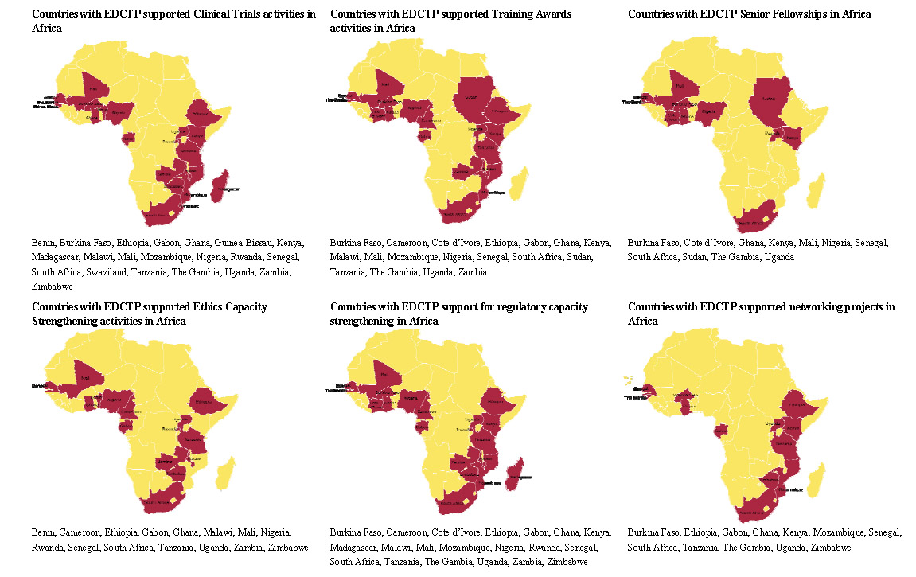
Graphical distribution of African partnerships in EDCTP-funded projects

V. EDCTP funding / Member States co-funding overview
EDCTP receives its funding from both the European Commission and the participating Member States, in a 50%/50% co-funding mechanism. The co-funding mechanism agreed in the 2007-2010 Roadmap allows the Commission to fund a higher than 50% contribution in the initial phases of the EDCTP Programme, but will force participating Member States to compensate with a higher than 50% co-funding at the end of the programme towards 2010.
Over the period from 2003 to 2007 the EDCTP has signed grants for a total of €76.2 million (EC, MS and third party funding contribution), including the contracts for the joint call with the Bill & Melinda Gates Foundation.
Over the same period, the EDCTP Member States have contributed to EDCTP €20.4 million in cash, and about €7 million in kind and direct payments to researchers for EDCTP projects, and pledged an additional 21,192,000 Euro. This includes the 6.7m Euro which the participating Member States provided to the joint call on HIV capacity building that was equally co-funded by Member States, EDCTP EC funds and funds from the BMGF.
YEAR | MS contribution | Third party contribution | EC funding to signed grants | EDCTP expenditure until May 2008
2003 | 0 | 0 | 0 | 211.059
2004 | 0 | 0 | 45.000 | 3.150.553
2005 | 824.546 | 0 | 8.276.000 | 4.304.858
2006 | 5.774.373 | 2.107.718 | 14.680.000 | 8.401.962
2007 | 20.833.809 | 1.807.653 | 21.921.000 | 13.040.518
2008 | 67.286.956  (committed until May) | 30.179.604  (up to May) | 101.617.000 (foreseen) | 8.313.672  (up to May)
TOTAL | 94.719.684 | 34.094.975 | 146.539.000 | 37.422.622

To date the EDCTP Programme has launched 33 calls and committed to fund 145 projects that include clinical trials, capacity development and support of scientific networks. With the exception of the 2007 calls, EDCTP has now completed contract negotiations and signing for all of these projects.
Among these 145 projects, 32 are clinical trials on HIV/AIDS, malaria and tuberculosis; 55 are training awards (MSc, PhDs and post doctoral awards); 16 are Senior Fellowships; 11 are for supporting networking activities; 14 are on capacity building in ethics; one on strengthening the regulatory framework in Africa through collaboration with WHO; and one for the establishment and maintenance of a clinical trials registry on HIV/AIDS, malaria and tuberculosis. These projects are based in 123 institutions and 26 different countries in sub-Saharan Africa (as shown in the accompanying graphic) and reflect the involvement of practically all participating Member States.
Co-funding in relation to the Roadmap projections. The figures, expressed in thousands of euros, compare the actual performance of EDCTP with respect to the projections made in the EDCTP Roadmap 2007 to 2010. The first part of the table shows all participating MS activities (including those not related to EDCTP, such as basic and preclinical research) on HIV/AIDS, malaria and tuberculosis. (Data from 2007 is still not available.) The second half of the table shows the activities of MS directly linked to EDCTP (clinical trials on the three diseases in sub-Saharan Africa where coordination of MS National Programmes do exist.)
MS financial contribution (thousands of Euros)
Year | 2004 | 2005 | 2006 | 2007 | 2008 | 2009 | 2010 | TOTAL
MS integrated activities Roadmap projections (estimates) | 46,386 | 51,239 | 57,108 | 89,421 | 82,674 | 80,876 | 75,645 | 483,351
MS integrated activities (Up to 2007) | 46,386 | 35,821 | 60,037 | 66,737
Roadmap estimate of MS funds committed to EDCTP initiatives | 309 | 975 | 5,088 | 9,916 | 10,420 | 10,760 | 8,948 | 46,419
MS Funds committed to EDCTP initiatives: (Actuals to 2007) | 0 | 778 | 7,519 | 20,833,808 | 67,286,956*

*Includes cash till end of April actually received and invoices to the Member State which will be received, plus additional committed MS funds to current and future projects (in cash, in kind and contributed directly to the grantees).
For the 11 calls that were launched in 2007, EDCTP has committed 90m Euro and to date EDCTP member states have given or pledged an additional 35.8m Euro towards these calls. It is expected that more funds will be realised from both Member States and third parties as the proposals come to the selection.
The average time-to-contract after closure of the call for proposals has been around 5 months in 2007, a sharp decrease from the previous years. EDCTP aims at bringing this time down to 3 months for future contract negotiations, although this depends very much on the grantees’ response time, which is now the main limiting factor.
It is encouraging that the participating Member State co-funding to EDCTP projects to date has far exceeded the co-funding as anticipated and projected in the EDCTP 2007-2010 Roadmap shown in table below.
The figures demonstrate that a number of participating Member States have allocated more of their national budget for the three poverty-related diseases to EDCTP initiatives. The participating Member States are currently on course to exceed the levels of co-funding of EDCTP activities anticipated in the 2007-2010 Roadmap.
It is anticipated that under the current EDCTP contract Member States will continue to set aside funding for the EDCTP Programme on an annual basis up to and including 2010. This funding will continue to be used together with any remaining EDCTP funds to launch further strategic joint calls. In addition EDCTP has allocated €5 million to integrating existing initiatives from individual Member States national programmes in order to develop Joint Programme activities.
Although the level of contributions varies among participating Member States and there is a need to encourage more participation from some of them, the overall performance is very encouraging. Table 3 below shows year by year co-funding contributions of participating Member Sates on EDCTP projects whereas table 4 shows the overall Member State funding in diseases of poverty (HIV/AIDS, malaria and tuberculosis) within the scope of EDCTP activities.
Some Member States do not have a significant research community working on the three poverty related diseases of HIV/AIDS, tuberculosis and malaria. Moreover, it must also be remembered that many participating Member States do not even have national programmes as such for these poverty-related diseases. Such national programmes as they exist are normally shared between the budgets of the Development Aid, Health, and Research ministries.
To streamline its activities, the EDCTP Programme is working towards a common funding mechanism, scientific review and administration of proposals. Currently Sweden and Ireland are contributing directly to an EDCTP common funding basket and allow review of proposals and grant administration to be done by EDCTP. Spain on the other hand has a two-track system which provides a significant amount of funding through a common basket, alongside further funding of Spanish researchers in EDCTP projects for which they require their own scientific review. The remaining countries employ other mechanisms for funding EDCTP initiatives, some with and some without common review of proposals and grant administration through EDCTP.
Although EDCTP Member State co-funding has dramatically increased in 2007, and pledges for years 2008-2010 are increasing, so far the level of co-funding achieved is only € 96 million out of the total € 200 million to be achieved by the end of 2010. This means that in the next 2.5 years, participating Member States still have to contribute € 104 million. Moreover, since most of the MS contributions are for their nationals participating in EDCTP-funded projects, the co-funding of African researchers is still an important issue to be solved in the future.
To help promote a common European approach to solve the co-funding issue, the General Assembly Chair and Vice-Chairs, the Executive Director and the Joint Programme Manager accompanied by Member States’ representatives are visiting the relevant Member State ministers and senior officials to discuss the future strategy of EDCTP and follow-up on the letter that was sent to them by the EC Research Commissioner encouraging the renewal of member state political and financial commitment to EDCTP. EDCTP is taking this opportunity to also explore how they might develop a mechanism of instituting political representation of European Member states and their African partners at the General Assembly.
Member State co-funding of EDCTP activities. Indicates Member State co-funding already contributed or committed to signed project grants or to the common funding pot. It does not include pledged money not yet committed to unsigned or future projects. Until April 2008, participating MS have contributed €40 million to the EDCTP budget, and have committed and pledged €70 million more for 2008 to 2010, totalling € 110 million. This contribution has dramatically increased in year 2007 and in the first quarter of 2008.
COFUNDING OF EDCTP PROJECTS BY THE PARTICIPATING MEMBER STATES
2005 |  |  |  | 2006 |  |  | 2007 |  |  | 2008/2009/2010 |  |  | TOTALS FROM THE INCEPTION |  |  | GRAND TOTALS
MEMBER STATE | CASH | DIRECT | IN KIND | CASH | DIRECT | IN KIND | CASH | DIRECT | IN KIND | CASH | DIRECT | IN KIND | CASH | DIRECT | IN KIND | GRAND TOTALS
Austria | 0 | 0 | 0 | 1,860 | 0 | 0 | 4,959 | 125,000 | 57,452 | 395 | 14,900 | 0 | 7,214 | 139,900 | 57,452 | 204,566
Belgium | 9,712 | 35,000 | 0 | 2,325 | 632,700 | 39,000 | 41,151 | 460,026 | 583,851 | 0 | 872,651 | 1,712,554 | 53,188 | 2,000,377 | 2,335,405 | 4,388,970
Denmark | 0 | 0 | 0 | 1,395 | 0 | 0 | 671 | 113,052 | 910,929 | 277 | 0 | 1,707,456 | 2,343 | 113,052 | 2,618,385 | 2,733,780
France | 0 | 0 | 0 | 4,650 | 82,000 | 2,000 | 2,783 | 361,824 | 142,812 | 1,146 | 4,849,965 | 530,357 | 8,579 | 5,293,789 | 675,169 | 5,977,537
Germany | 1,107 | 0 | 0 | 4,650 | 0 | 830,306 | 2,782 | 0 | 605,577 | 1,146 | 539,015 | 336,308 | 9,685 | 539,015 | 1,772,191 | 2,320,891
Greece | 0 | 0 | 0 | 2,325 | 0 | 1,766 | 0 | 0 | 919 | 1,625 | 0 | 0 | 3,950 | 0 | 2,685 | 6,635
Ireland | 1,395 | 0 | 0 | 1,395 | 2,650 | 2,650 | 551,292 | 0 | 3,866 | 754,540 | 0 | 0 | 1,308,622 | 2,650 | 6,516 | 1,317,788
Italy | 0 | 0 | 0 | 4,650 | 0 | 0 | 14,782 | 0 | 4,534 | 1,146 | 115,620 | 230,731 | 20,578 | 115,620 | 235,265 | 371,463
Luxembourg | 930 | 0 | 0 | 0 | 0 | 0 | 384 | 0 | 2,531 | 159 | 0 | 0 | 1,473 | 0 | 2,531 | 4,004
Netherlands | 0 | 0 | 0 | 186,487 | 0 | 725,178 | 1,181,883 | 0 | 990,538 | 651,509 | 0 | 1,192,629 | 2,019,879 | 0 | 2,908,345 | 4,928,224
Norway | 0 | 0 | 0 | 1,395 | 0 | 1,236 | 671 | 0 | 6,381 | 277 | 3,302,000 | 774,000 | 2,343 | 3,302,000 | 781,617 | 4,085,960
Portugal | 2,324 | 0 | 0 | 2,325 | 0 | 0 | 1,151 | 0 | 0 | 0 | 0 | 0 | 5,800 | 0 | 0 | 5,800
Spain | 0 | 0 | 0 | 1,034,077 | 33,000 | 810 | 1,078,362 | 476,308 | 178,288 | 1,078,363 | 0 | 314,421 | 3,190,802 | 509,308 | 493,519 | 4,193,629
Sweden | 1,860 | 0 | 0 | 1,090,738 | 0 | 3,410 | 2,702,318 | 0 | 225,069 | 37,204 | 0 | 1,174,510 | 3,832,120 | 0 | 1,402,989 | 5,235,109
Switzerland | 0 | 0 | 0 | 0 | 65,500 | 6,626 | 0 | 79,470 | 29,038 | 198,000 | 0 | 0 | 198,000 | 144,970 | 35,664 | 378,634
United Kingdom | 777,797 | 0 | 0 | 891,919 | 0 | 118,000 | 9,736,308 | 0 | 178,070 | 10,764,247 | 813,868 | 2,711,497 | 22,170,271 | 813,868 | 3,007,567 | 25,991,706
Total (Euro) | 795,125 | 35,000 | 0 | 3,230,191 | 815,850 | 1,730,982 | 15,319,497 | 1,615,680 | 3,919,855 | 13,490,034 | 10,508,019 | 10,684,463 | 32,834,847 | 12,974,549 | 16,335,300 | 62,144,696

Total EDCTP Member State expenditure on HIV/AIDS, malaria and tuberculosis. One of the original goals of the EDCTP was to create a map of current research on poverty-related diseases in Europe (inside the North-North partnership component of the initiative). The table summarises all European activities in the field, both related (clinical trials with ongoing coordination of MS National Research Programmes) or not (basic and preclinical research) with the EDCTP. Exact figures up to 2007, but estimates from 2008.For 2003-2005 definitions of valid activities may have differed from one MS to another. Reporting criteria were standardised in 2006.
OVERALL CONTRIBUTIONS OF PARTICIPATING STATES ON RESEARCH AND DEVELOPMENT
OF POVERTY-RELATED DISEASES
STATE | 2003 | 2004 | 2005 | 2006 | 2007 | 2008 | 2009 | 2010 | TOTAL
AUSTRIA | 45,900 | 502,813 | 96,900 | 43,700 | 233,466 | No data | No data | No data | 922,779
BELGIUM | 4,995,500 | 4,919,000 | 12,346,022 | 4,523,100 | 4,691,028 | 3,389,725 | 3,389,725 | 2,561,200 | 40,815,300
DENMARK | 6,700,000 | 7,345,000 | 8,140,000 | 4,915,000 | 4,774,652 | 7,887,062 | 7,887,062 | 7,000,000 | 54,648,776
FRANCE | 4,058,559 | 5,119,725 | 18,735,954 | 3,382,237 | 3,052,166 | 3,431,946 | 3,431,946 | 3,073,672 | 44,286,205
GERMANY | 16,488,004 | 15,190,097 | 18,769,417 | 2,878,306 | 1,988,759 | 2,541,841 | 2,541,841 | 2,234,754 | 62,633,019
GREECE | 0 | 0 | 3,447,635 | 1,766 | 919 | No data | No data | No data | 3,450,320
IRELAND | 5,501,000 | 5,398,000 | 6,251,614 | 879,119 | 555,158 | 17,321,000 | 17,285,000 | 17,125,000 | 70,315,891
ITALY | 19,927,023 | 6,233,302 | 6,798,000 | 11,279,168 | 7,228,402 | 90,815 | 90,815 | 73,905 | 51,721,430
LUXEMBOURG | 290,320 | 58,068 | 449,163 | 382,028 | 488,451 | No data | No data | No data | 1,668,030
NETHERLANDS | 21,041,312 | 19,880,348 | 21,053,000 | 4,111,523 | 3,108,421 | 2,613,633 | 2,613,633 | 2,087,500 | 76,509,370
PORTUGAL | 1,518,359 | 1,207,186 | 1,951,719 | 454,251 | 1,151 | No data | No data | No data | 5,132,666
SPAIN | 1,200,000 | 1,200,000 | 7,200,000 | 2,633,191 | 2,962,858 | 157,210 | 157,210 | No data | 15,510,469
SWEDEN | 7,953,919 | 8,827,902 | 13,620,620 | 3,329,289 | 5,756,904 | 5,637,634 | 5,637,634 | 5,184,000 | 55,947,902
UNITED KINGDOM | 18,934,000 | 19,947,000 | 24,887,000 | 16,990,600 | 26,653,994 | 16,737,309 | 14,975,309 | 6,896,474 | 146,021,686
NORWAY | 1,032,250 | 1,750,000 | 1,964,187 | 1,200,788 | 289,052 | 8,900,000 | 8,900,000 | 8,900,000 | 32,936,277
SWITZERLAND | - | - | - | 3,033,626 | 4,952,031 | 850,000 | 850,000 | 37,500 | 8,874,007
TOTAL (Euro) | 109,686,146 | 97,578,441 | 145,711,231 | 60,037,692 | 66,737,412 | 69,558,175 | 67,796,175 | 55,174,005 | 670,618,277

VI. Key Performance Indicators
In early 2007, the EDCTP Secretariat agreed with the European Commission and the General Assembly in defining Key Performance Indicators that could be used to assess progress in the different EDCTP activities. Indicators were divided in four categories: Grants (grants signed, clinical trials, capacity building and time to contract), Partnership (African countries, institutes and project coordinators), Co-funding, and Governance (percentage of budget devoted to administrative issues vs. research, and to African vs. European researchers).
KPI are updated monthly and published in the EDCTP website.
- Value of grants signed
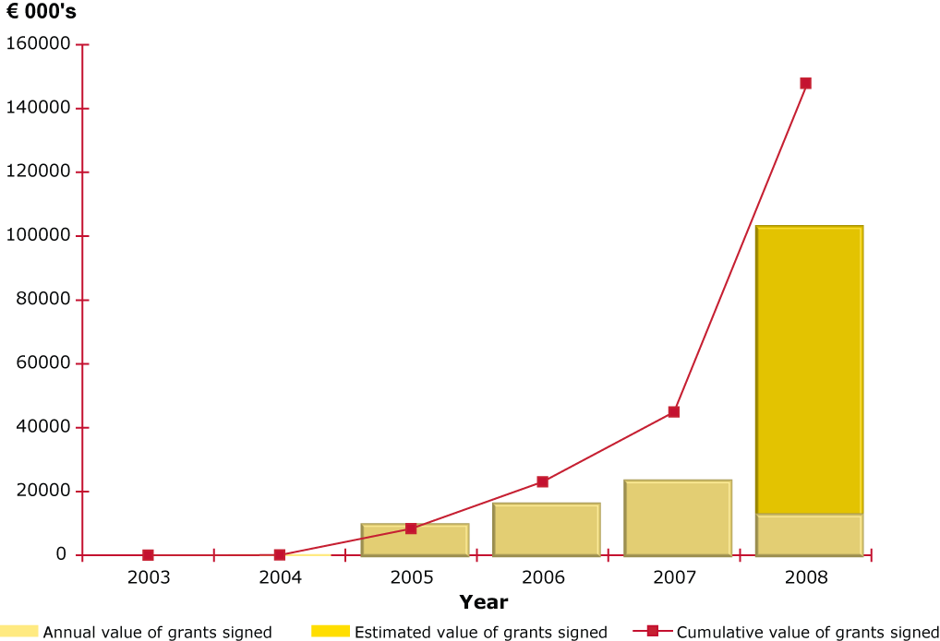
Funds committed or spend against time (EDCTP funds only, not including MS and Third party funding). 2008 data include values of grants signed in the first quarter of 2008. Estimated data refers to approved projects that are under negotiation.
- Clinical trials approved
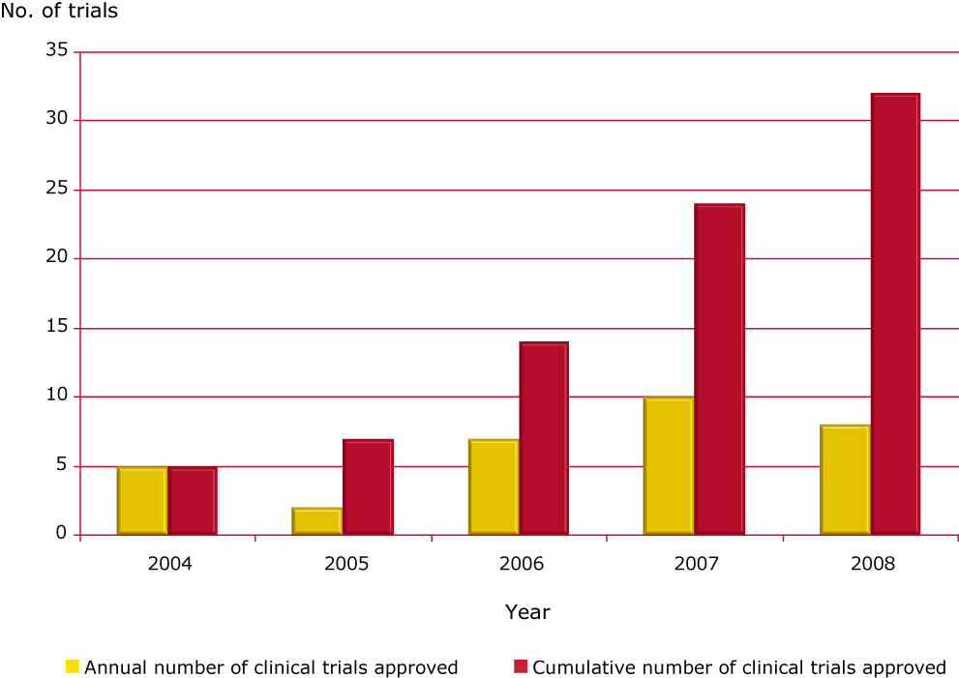
Number of clinical trials approved from 2004 until May 2008 further projects of the current calls will be approved later in 2008.
- Capacity building activities
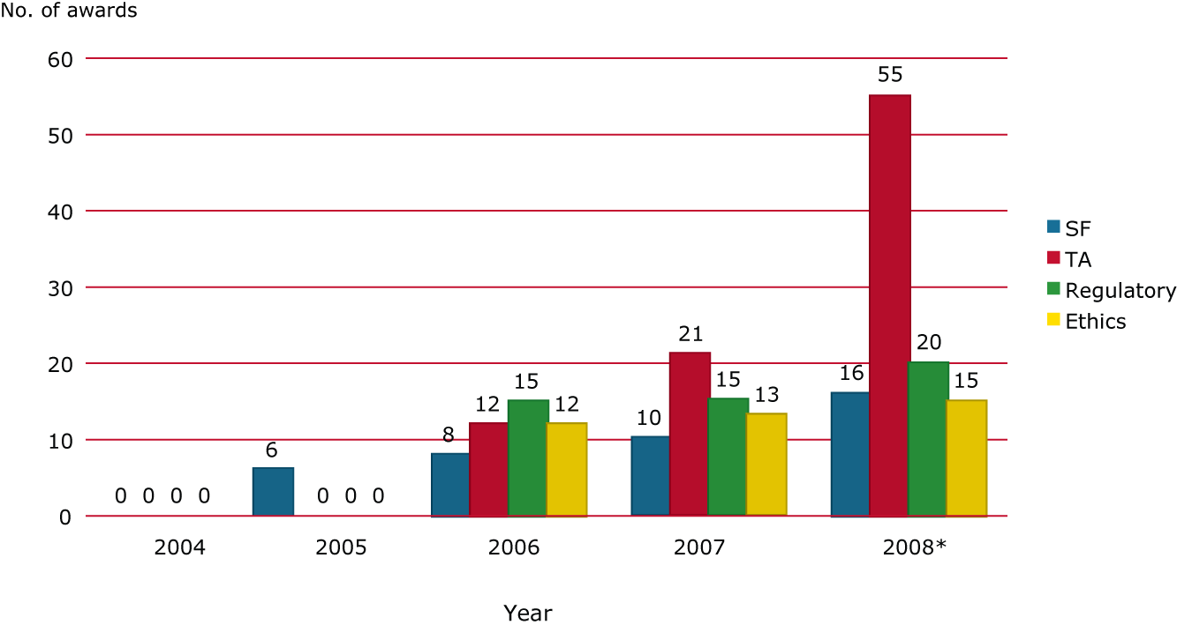
EDCTP supported capacity development activities in Africa:
- SF: Senior Fellowships projects
- TA: Training Awards projects, including Masters studentships, PhD scholarships and Career Development Fellowships
- Regulatory: Number of national regulatory authorities (NRA's) included in EDCTP-WHO collaboration capacity strengthening activities
- Ethics: number of projects for strengthening ethics framework activities
*Cumulative data until end of May 2008
- Contract negotiation period for new projects
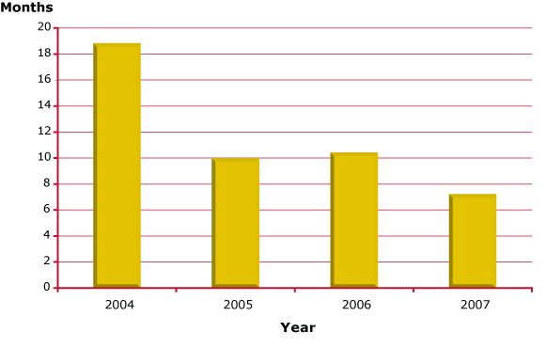
The period from the General Assembly approval of a proposal until the signing of the contract by the project coordinator. This time period includes actions by both EDCTP secretariat and the potential grantee. 2008 approved projects are under negotiation.
- Number of African countries involved in EDCTP ongoing projects
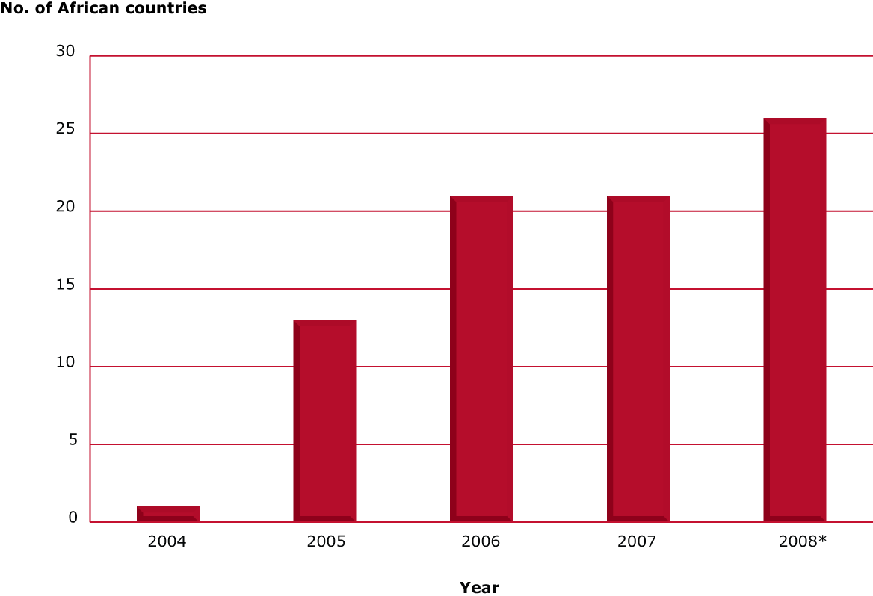
Number of African countries involved in EDCTP activities.
*Cumulative data until end of May 2008 including signed and approved projects
- Number of African institutions involved in EDCTP ongoing projects
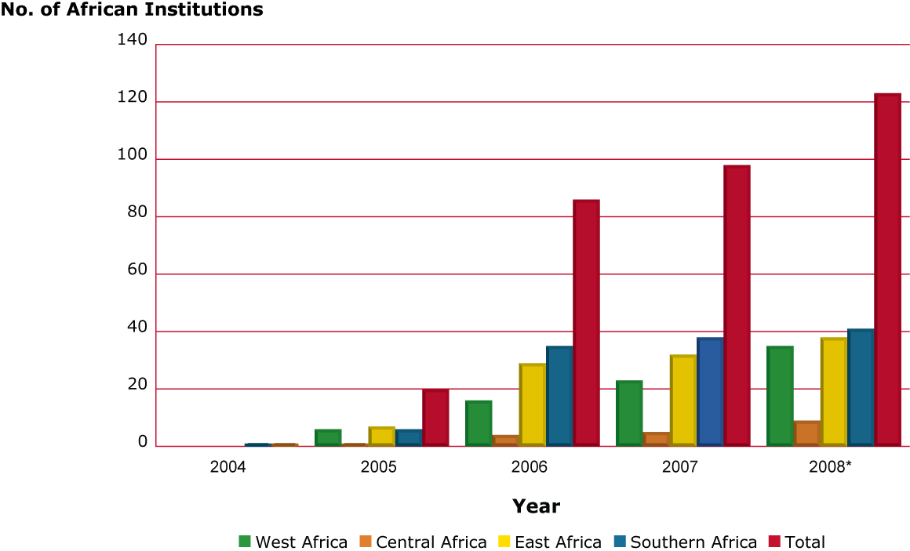
*Cumulative data until end of May 2008 including signed and approved projects.
- Number of African project coordinators per disease
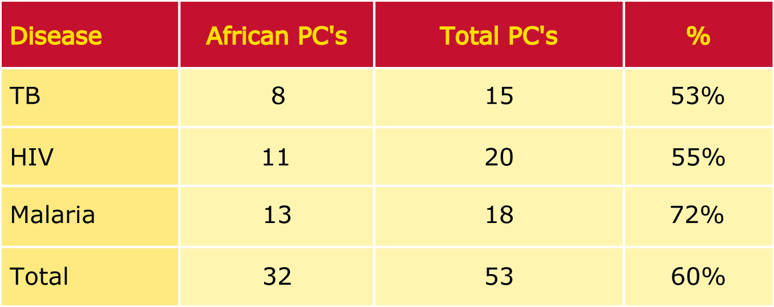
Number of African Project Coordinators involved in EDCTP projects including Clinical Trials, Senior Fellowships and Career Development fellowships until May 2008.
- Number of countries collaborating in EDCTP clinical trials
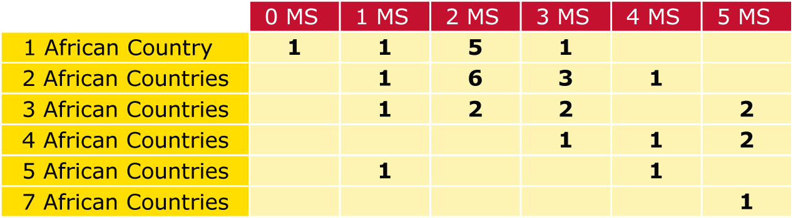
The table shows the number of approved clinical trials projects involving different proportions of African and European countries until May 2008.
- Annual MS co-funding of EDCTP activities (€)
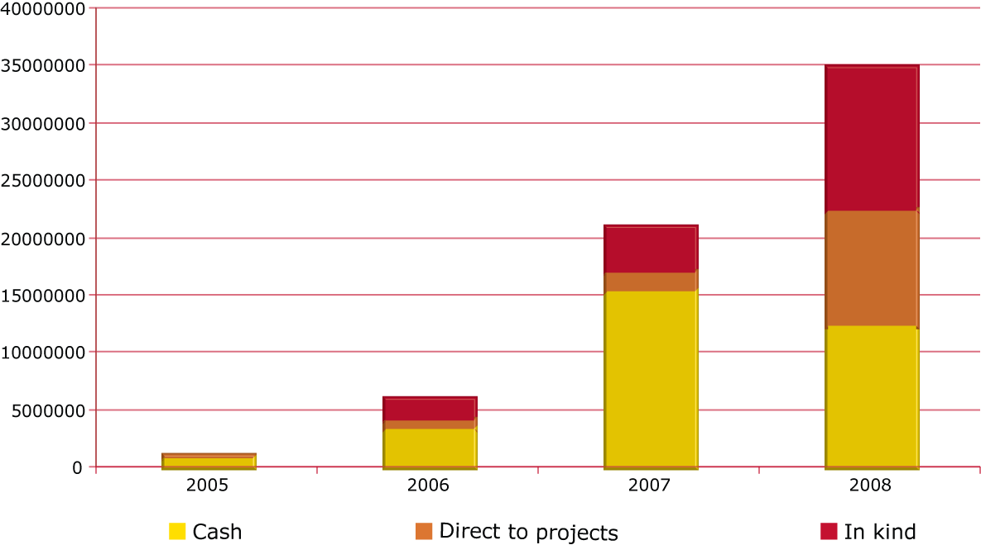
Composition and level of Member State (MS) co funding of EDCTP activities. 2008 data of contribution for direct to projects and in kind are estimated.
- EDCTP cash expenditure between grants and other costs
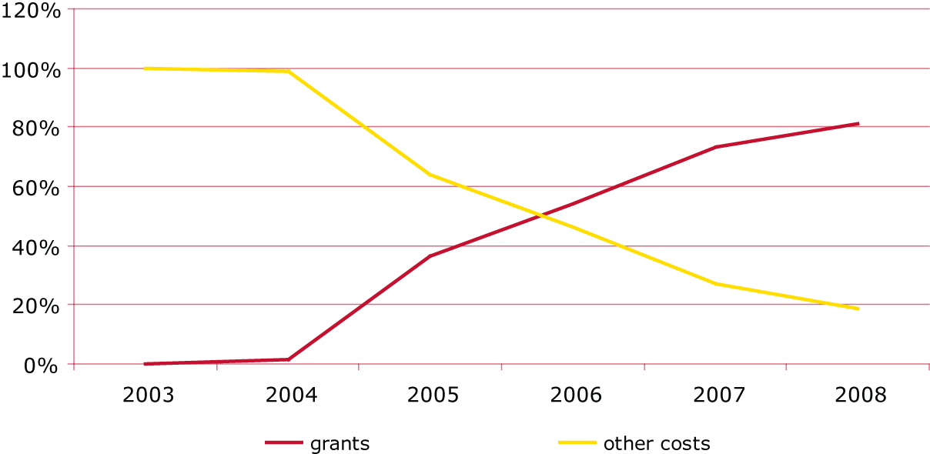
Split of EDCTP cash expenditure between grants and other costs (governance, support costs and programme activities). Data until end of March 2008.
- EDCTP costs split by area of cash expenditure in 2007
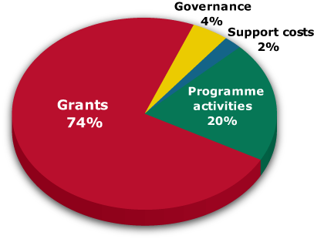
Breakdown of total EDCTP budget:
- Support costs: those incurred with the hosting institutions (NWO, MRC)
- Governance costs: costs of holding constituency meetings plus audit fees
- Programme costs: all other costs excluding grants, support costs and the governance costs. Including running of the secretary, the Forum and evaluations.
- Grants: funding allocated to awarded proposals.
- EDCTP expenditure divided between African and European countries
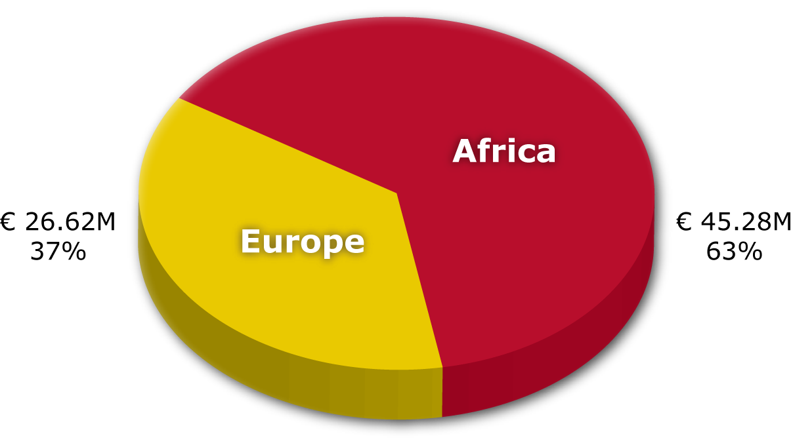
EDCTP total and committed expenditure from 2003 divided between African and European institutions and nationals. Data until end of March 2008.
- Overview of Member State, Third party and EC funding commitment to EDCTP projects
MS contribution: Member States annual contribution to signed projects. 2008 data include committed contribution to signed or approved projects until May 2008.
Third party contribution: third party annual contribution to EDCTP signed projects, if known. 2008 data include committed contribution to signed or approved projects until May 2008.
EC funding: values of signed grants (EC funds only). 2008 data include the value of signed grants in first quarter 2008, approved grants and estimate values of future grants for the full year 2008.

A. Synergy of research and development funding
The very nature of the diseases the EDCTP Programme is fighting, with the ultimate goal of poverty-alleviation in Developing Countries, calls for the collaboration of Development and Research Agencies. From the research point of view, it is not possible to start advanced clinical trials in sub-Saharan Africa without a preliminary and sustained capacity building effort. That is the reason why the EDCTP Programme was designed to rely on the support from both development and research stakeholders.
In this regard, European Development Agencies are getting involved in the EDCTP Programme, and the Directorates General for Development (DEV) and Aid and Cooperation (AIDCO) of the European Commission have also contributed ca. € 14 million to capacity building and health-related activities in research projects originally financed by the European Commission under the International Cooperation programme, and that now are being further developed under the umbrella of the EDCTP.

B. Third-party collaboration and funding
The EDCTP Programme has stepped up its efforts to work with industry and like-minded organisations. Recent activities include exploring buy-ins and participation of third parties in EDCTP calls and projects. Proposals that have been recently submitted in response to the current EDCTP calls include participation from different public-private partnerships or pharmaceutical companies, like the AERAS Global Tuberculosis Vaccine Foundation, Crucell, the Global Alliance for Tuberculosis Drug Development, the Bill & Melinda Gates Foundation (BMGF), Bayer Healthcare AG, Sanofi-Aventis, Sequella Inc, IDT (Integrated DNA Technologies), the International AIDS Vaccine Initiative (IAVI), the International Partnership for Microbicides (IPM), the European Malaria Vaccine Initiative (EMVI), the African Malaria Network (AMANET) and Archivel Farma SL, to name some. Up to date, total Third-Party funding amounts about € 34 million.
The EDCTP Programme is also supporting strengthening of National Regulatory Authorities. One of the projects funded has an initial grant of 250,000 Euros to the World Health Organisation (WHO) and co-funding from The Netherlands by the Netherlands-African Partnership for Capacity Development and Clinical Trials Intervention (NACCAP). This is being conducted through joint clinical trials evaluation and monitoring, training (Global Training Network) and establishment of the African Vaccines Regulators’ Forum (AVAREF). The establishment of AVAREF will contribute towards streamlining and harmonising the vaccine regulatory process in Africa. There are plans to use this platform and Article 58 (authorisation of pharmaceutical compounds for developing countries) of the European Medicines Agency (EMEA) to review and register in several African countries the malaria vaccine RTS,S being developed by GlaxoSmithKline (GSK) and the Bill & Melinda Gates Foundation (BMGF).
EDCTP plans to follow up these activities with further funding as well as to map all ongoing capacity building activities on ethics and competent authority activities. To meet this goal, the EDCTP General Assembly approved in May 2008 financing for 568,744 Euros to continue with this work and further expand the project to include monitoring of regulatory functioning and progress in Africa.
EDCTP’s endeavour to work with like minded-organisation has led to the launch of a joint call with the BMGF in December 2006. This call for capacity building for HIV vaccines yielded 6 projects in 8 African countries. In these projects, four out of six have African coordinators, and partnership includes collaborative efforts of 8 Member States.
Among ongoing clinical trials, third-party contribution to the phase II/III moxifloxacin TB trial amount to over € 8 million. This came from Global Alliance for TB Drug Development, Bayer AG and Sanofi-Aventis. Contributions to intravenous artesunate trials from the Malaria Medicine Venture (MMV) currently add to over € 1 million and will go up to € 3 million when the trials enter phase III.
Furthermore, negotiations are underway to see how the MMV can co-fund the current calls on malaria treatment and pregnancy associated malaria. EDCTP is also exploring into ways of working together with the Wellcome-Trust and the Canadian International Development Research Centre (IDRC) in the nodes of excellence call, and the US Center for Disease Control and Prevention (CDC) in possibly a new TB treatment call.

VII. The EDCTP medium- and long-term strategy and activities
The EDCTP has been created and is owned by European Union Member States. These MS provide the funds to the EDCTP initiative both directly, through the 50% co-funding mechanism, or indirectly, through the Community budget. The future of the EDCTP goes through the development of a stronger sense of ownership from the Member States, who should stress their political and financial support to this initiative, and make sure the EDCTP fits in their product development strategy, from basic research to advanced clinical trials in and for developing countries.
From its inception EDCTP had developed a strategy described in the so-called Joint Programme of Activities (JPA) which is annually revised to form annual work-plans through the Joint Programme B (JPB). In 2007 this has been supplemented with the Roadmap, a plan of action that has been agreed with the European Commission to guide activities through the no-cost extension period of 2008-2010. To fine-tune this strategy EDCTP with the help of a consultant has identified 12 key performance indicators that will be used to evaluate and monitor EDCTP activities as well as inform the stakeholders including European Members states, African partners, European Commission, the scientific communities, private sector and all other relevant parties. These will be reviewed monthly and published on the EDCTP website on a quarterly basis.
EDCTP is also in the process of developing a long-term strategy that will encompass activities to be undertaken beyond the current funding period. These will include working effectively with other players in all phases of clinical trials and possibly involving other diseases of poverty in addition to the current three. EDCTP is currently working with other like-minded organisations and private industry and anticipate expanding this in the current calls that it has launched. Partners that are currently working with EDCTP include the Bill & Belinda Gates Foundation and International AIDS Vaccine Initiative (joint call on HIV preventive vaccines), TB Alliance, Sanofi-Aventis, Bayer and Sequella (TB treatment), Malaria Medicines Venture (Treatment of severe malaria in children). Additionally, several companies such as Bayer and Glaxo-Smith-Kline are either supplying drugs for conducting clinical trials or act as clinical trials sponsors in various EDCTP funded studies.

VIII. EDCTP Forum
Every year since the implementation of the EDCTP Programme, the Secretariat is organising the EDCTP Forum, a meeting of all EDCTP stakeholders, from the different Constituencies (General Assembly, Partnership Board, Developing Countries Coordinating Committee, and European Network of National Programmes) to researchers involved in EDCTP projects or interested in the EDCTP objectives.
Last EDCTP Forum was held in Ouagadougou, Burkina Faso, from 22nd to 24th October 2007. During three days about 200 African researchers in the fields of HIV/AIDS, malaria and tuberculosis presented their latest results and prepared the future of the African research in this domain. Little by little, the EDCTP Forum is becoming the African meeting on the three major poverty-related diseases.

IX. Recent press releases and publications
In the last few months of 2007 and early 2008, several press releases on success stories deriving from EDCTP-funded research projects were released (see annex 3). This includes the start of a phase II trial of intravenous artesunate for the treatment of children with severe malaria, the start of a clinical trial to compare four new antimalarial treatments for African children, and the results of an ongoing EDCTP project that shows that HIV/AIDS infected children can now benefit from a new treatment. As a consequence of these latest results, the US Food and Drug Administration (FDA) gave a tentative approval to a fixed-dose anti-HIV drug specifically formulated for paediatric use in developing countries.
All EDCTP press releases are published though the EDCTP website (www.edctp.org), as are all news, calls for proposals, results of evaluations, annual reports, meetings, composition of the EDCTP governing and advisory boards, etc.).
The EDCTP recently participated in the Geneva Health Forum 2008 Towards global access to Health (25-28 May 2008). The forum brought together on an equal basis all actors involved in access to health. Under the flags of equity, partnership, and capacity building, it links policies and guidelines to actual practice in the field.
Recently published articles include:
The emerging shape of a global HIV research agenda: how partnerships between Northern and Southern researchers are addressing questions relevant to both. Fostering new models of science development and collaboration. Current Opinion in HIV & AIDS. 3(4):521-525, July 2008.
Mgone, Charles (http://www.co-hivandaids.com/pt/re/cohiv/abstract.01222929-200807000-00018.htm;jsessionid=LFhQHtKPh2QLFnFZBbKRxLzjpmhtz1SzGqJwcTjS21DF3J3yjrFj!1629792715!181195629!8091!-1).
Collaborative approach to clinical trials (May 2008). Charles Mgone and Pascoal Mocumbi. Health Partnerships Review 2008 (Global Forum for Health Research).
Additional EDCTP-related articles are available from the following EDCTP webpage: http://www.edctp.org/Articles.253.0.html.

X. Commissioner Potočnik's letter to the EDCTP Member States
Following the publication of the Van Velzen report, Commissioner Potočnik wrote in September 2007 to the EDCTP Member States informing them. Furthermore, he emphasised the importance of the political involvement and financial support of Member States, as owners of the programme, for the future of EDCTP.
Many responses have been received so far. Out of these, especial mention to the strong support to the EDCTP concept as stressed by Germany, Spain, Switzerland and United Kingdom.
In order to express the strong support of the European Commission to the EDCTP, Commissioner Potočnik visited the African office of the EDCTP on the 30 November 2007. He met the High Representative of the EDCTP, Dr. Pascoal Mocumbi, and the EDCTP personnel based in Cape Town. The Commissioner also met in his office with Dr Diana Dunstan the EDCTP-EEIG Chairperson, Prof. Charles Mgone, The EDCTP Executive Director, Dr Pascoal Mocumbi and Senior EC officials to discuss current developments and future plans of EDCTP.
A parallel letter was also sent to the European Parliament and to Commissioner Louis Michel, not only informing them about the Van Velzen report, but in the case of Commissioner Michel also requesting, in line with the IER report, the creation of a joint platform DG DEV/DG RTD.

XI. Joint DG Research / DG Development platform
Following the recommendation made in the Van Velzen report, DG Research and DG Development have accepted to establish a platform to reinforce dialogue with EDCTP. After an exchange of letters between Commissioners Michel and Potočnik to initiate the exercise, the Commission had the first formal meeting of this inter-service platform in early 2008. Several related meetings have followed.
In the meantime, the Commission services and the EDCTP constituencies are in regular working contact. Representatives of EDCTP and DG Research participated in the Member States Experts meeting on HIV/AIDS, Malaria and Tuberculosis (30-31 October 2007), hosted by DG Development, which dealt with preparations for monitoring and reporting on the EU Programme for Action on HIV/AIDS, malaria and included initial discussions on review of policy directions for the Programme for Action.
In April 2008 Commission services from DG DEV and DG RTD met to discuss for an update on the EDCTP activities and future perspectives. Both Directorates General agreed on the importance of the Programme and on the need to better coordinate development aid and research policies for poverty-related diseases in Developing Countries.
Commission staff from DG Research responsible for managing research on HIV/AIDS, malaria and tuberculosis regularly attends EDCTP stakeholder meetings for planning strategy and content of future EDCTP calls for proposals. In addition, the Commission services participate as observers in meetings of the EDCTP governance structures, the General Assembly and Partnership Board and in the annual EDCTP fora (the most recent being held in Burkina Faso, 22 to 24 October 2007).

XII. Health research strategy on the three main poverty-related diseases
Health research strategy in relation to HIV/AIDS, malaria and tuberculosis is under continuous reassessment as part of the process of review of the EU Programme for Action: Accelerated Action on HIV/AIDS, Malaria and Tuberculosis in the Context of Poverty Reduction, and taking into account other relevant policy discussions in the field (e.g. European Parliament, WHO, OECD etc). For example, the European parliament report on Major and Neglected Diseases in Developing Countries, called for "the activities of EDCTP to be expanded to include other neglected diseases as well as other phases of clinical development". In formulating future calls for proposals under the Health research theme (Cooperation Specific Programme) of the 7th Framework Programme such policy discussions will be taken closely into account. The future financing of the EDCTP Programme will be considered in this wider EU policy context.

XIII. Involvement of African Governments
Extensive discussions between the Commission (DG Development) with African governments concerning national health strategies capacity building and sustainability will continue in the context of the Programme for Action: research forms a key part of this policy framework (see Second Progress report on the EC Programme for Action: accelerated action on HIV/AIDS, malaria and tuberculosis in the context of poverty reduction. Calls under the Health research theme in FP7 will take account of such consultations.
The governance structures of the EDCTP Programme are currently being strengthened to improve consultation with African governments. The advocacy of the High Representative, Dr Pascoal Mocumbi, must be specially acknowledged in this regard.
Furthermore, DG Research will work with EDCTP to ensure that EU delegations in African countries are properly informed about the EDCTP Programme in their country or region. A specific report on the EDCTP is being prepared to be forwarded to the African delegations of the European Union.
XIV. Other Article 169 initiatives
One of the aims of the 2007 IER of the EDCTP was to learn lessons for planning future actions under Article 169 of the Treaty.
The Commission is working in four new Art. 169 initiatives identified in the FP7 specific programme adopted on 19 December 2006, being AAL and EUROSTARS the most advanced:
- AAL, joint research programme on technologies for "Ambient Assisted Living"
- BONUS-Art 169, joint programme on "Baltic Sea" research
- EMRP, joint research initiative on "European Metrology Research Programme"
- EUROSTARS, joint research programme on "research-performing SMEs"
Together with the discussions which took place previously between the Commission and representatives of the Member States, in particular with CREST, a number of essential prerequisites have been drawn up by the Commission for an efficient implementation of Article 169 of the Treaty.
Existence of a "Joint Programme": for the AAL, relevant research activities exist in most Member States (MS). A number of countries are in process of establishing new frameworks for this area. This will form the basis for their participation in the AAL Joint Programme. EUROSTARS will integrate existing research national Programmes supporting SMEs.
Clear and irrevocable political commitments from MS to the Joint Programme: For the AAL, Community support will be provided through annual financing agreements; only MS providing upfront commitments will be eligible for funding. For EUROSTARS, an agreement will be concluded with the Eureka Secretariat for the whole duration of the Programme.
Financial integration: For AAL and EUROSTARS, the Roadmap presented to Council and Parliament in November 2006 encourages MS to consider to create a "common financial pot".
Scientific integration: For the AAL and EUROSTARS initiatives, the participating MS shall ensure that the selection procedure to be set up shall follow the principles of scientific excellence.
Management integration: The AAL Joint Programme will be implemented by a dedicated legal entity which will be governed by a transparent governance structure.
Mid-term evaluation: The AAL and EUROSTARS Joint Programmes will be subject to an evaluation procedure, on the basis of the main indicators defined in the Commission proposals.
Protection of the financial interests of the Community: AAL and EUROSTARS have identified a dedicated implementation structure, responsible for the implementation of the Joint Programme. The AAL Association will make use of the Eureka Secretariat.
Principles for protection of Intellectual Property Rights (IPR): The AAL and the European Joint Programmes will entail clear principles on IPR in the agreements to be concluded with the AAL association and the EUROSTARS Secretariat.
Annexes

Annex 1: Independent External Review of EDCTP - Key Recommendations

1. To the EDCTP:
1.1. Define a clear, convincing and realistic EDCTP strategy with a common shared vision, clearly defined contributions from each partner and equitable sharing of results.
1.2. Make the General Assembly more political and create an Executive Steering Committee.
1.3. Expand association with major Product Development Public/ Private Partnerships for access to know-how and to provide visibility. Keep an inventory of and contacts with other similar programmes, to avoid unnecessary duplication.
1.4. Renew calls for appropriate projects to be submitted rapidly to attract the best public/private partnerships and to participate in major R&D initiatives such as MVI, IAVI and on TB.
1.5. Simplify and streamline co-funding, from a virtual to an actual common pot (by 2009), in order to reduce operational complexity and allow African initiation of EDCTP projects.

2. To the EDCTP Member States:
2.1. Interested Member States should renew their “EDCTP vows” in Council; accept reforms to EEIG structures, and directly finance an EDCTP “common funding pot”.
2.2. In the General Assembly, the decision making should be restricted to Member States who provide financial contributions with representation at the highest appropriate national level and to African representation; other member would become observers, starting in 2008.
2.3. The African presence in the General Assembly should be reinforced, with decision-making status for representatives from African countries or regional organisations.
2.4. Member States should refrain from imposing national criteria, and accept one integrated scientific and ethical evaluation conducted by EDCTP, utilising a pool of the best national experts.
2.5. Member States should enforce the Article 169 concepts in their own countries on a sustainable basis, involving national parliaments when required, and report back annually to the EDCTP and the Commission on progress in implementation.

3. To the European Commission, in relation to future EDCTP activities:
3.1. Report to the Council and Parliament about the current status, in anticipation of the 2008 review.
3.2. Create a joint DG Research / DG Development platform to engage in a dialogue with the EDCTP.
3.3. Reformulate health research strategy before any new decision to finance EDCTP from FP7, in particular on the three diseases.
3.4. Consult African Governments on EDCTP future and international health research under FP7.
3.5. Involve African Governments at an early stage to link capacity strengthening to national strategies, in order to ensure sustainability.
3.6. Submit a new funding proposal to the Council and Parliament, before FP 7 mid-term review, provided that:
- Interested Members States political/budgetary/administrative commitments are clear.
- The EDCTP programme integrates the relevant national ones, with a common funding pot.
- The EDCTP governance is properly adjusted and more open to African partners.
- The EDCTP performance complies with targets from the EDCTP Roadmap.

4. To the European Commission, in relation to new Article 169 initiatives:
4.1. Set out future Article 169 pre-conditions, preferably in a guidance communication.
4.2. For an Article 169 Programme to become and remain successful there must be pre-existing national programmes, strong commitment by Member States to provide funding and irreversible national support.
4.3. Before EU money becomes available, there must be: common work-plan; sound governance structure; fixed national financial contributions; clear evaluation criteria and procedures; clear deliverables; solutions for the liability issue.

Annex 2: Members of the different EDCTP constituencies
Representatives of the 16 EDCTP participating countries in the General Assembly:
Chair | Dr Diana Dunstan (Chairperson)  Medical Research Council UK
Austria | Dr Christiane Druml  Ethics Committee of the Medical University of Vienna and the Vienna General Hospital
Belgium | Prof. Bruno Gryseels  Director, Institute for Tropical Medicine
Denmark | Dr Søren Jepsen (Vice-chairperson)  State Serum Institute
France | Prof. Patrice Debre (Vice-chairperson)  Hôpital Pitié Salpêtrière
Germany | Dr Gabriele Hausdorf  Bundesministerium für Bildung und Forsching (BMBF)
Greece | Prof. Antonis Antoniadis  School of Medicine, Aristotle University of Thessaloniki
Ireland | Dr Teresa Maguire  Health Research Board
Italy | Prof. Stefano Vella  Istituto Superiore di Sanità
Netherlands | Dr Edvard Beem  ZonMw
Norway | Dr Bjørn Guldvog  Norwergian Directorate for Health and Social Affairs
Luxembourg | Carlo Duprel  Fonds National de la Recherche
Portugal | Ana Maria Faisca  Ministry of Science, Technology and Higher Education
Spain | Dr Carmen Audera Lopes (Vice-chairperson)  Director, Oficina de Proyectos Europeus, Instituto de Salud Carlos III
Sweden | Dr Hannah Akuffo  Swedish International Development Agency (SIDA)
Switzerland | Isabella Beretta  State Secretariat for Education and Research
United Kingdom | Kevin Moreton  Medical Research Council  (Note: Dr Dunstan remains the sole UK representative on the GA but Dr Moreton speaks for the UK while Dr Dunstan holds the Chair)

EDCTP Secretariat
- The Hague Office:
Prof. Charles Mgone
Executive Director
Simon Belcher
Director of Finance and Administration
David Coles
Joint Programme Manager
Dr Waley Salami
Projects Manager
Danielle Roordink
Networking Officer
Dr Remco de Vrueh
Networking Officer
Dr Marjolein Robijn
Project Officer
Dr Montserrat Blázquez - Domingo
Project Officer
Lara Pandya
Project Officer
Ilona van den Brink
Communications Officer
Christian Geib
Project officer
Lidwien van der Valk
Legal Adviser
Chris Bruinings
Senior Bookkeeper
Caroline Bijkerk
Travel Coordinator
Monique Wolf
Events Coordinator
Mary Jane Coloma-Egelink
Grants Accountant
Kevin Burke
Financial Assistant
Daniela Pereira-Lengkeek
Administrative Officer
Patricia Sáez
Administrative Officer
Sabina Stanescu
Administrative Officer

- The Cape Town Office:
Dr Pascoal Mocumbi
High Representative
Dr Thomas Nyirenda
Networking Manager
Dr Michael Makanga
Capacity Development Manager
Gail Smith
Administrative Officer

Members of the Partnership Board:
Specialist field | Members
TB | Dr Richard Adegbola (Vice-chairperson)  MRC Laboratories, The Gambia
Clinical trials/GCP | Dr Christian Burri  Swiss Tropical Institute, Switzerland
Industry | Prof. Juhani Eskola  National Public Health Institute (KTL), Finland
HIV/AIDS | Dr Shabbar Jaffar  London School of Hygiene and Tropical Medicine, United Kingdom
Malaria | Prof. Peter Kremsner  University of Tuebingen, Germany
HIV/AIDS | Dr Rosemary Musonda  Botswana Harvard School of Public Health, Botswana
TB | Prof. Joseph Odihiambo  Kenya Medical Research Institute, Kenya
HIV/AIDS | Prof. Eric Sandström (Vice-chairperson)  Karolinska University Hospital, Sweden
Malaria | Dr Sodiomon Sirima (Chairperson)  Centre National de Recherche et de Formation sur le Paludisme (CNRFP),  Burkina Faso
Members of the European Network of National Programmes:
Austria | Dr Brigitte Bloechl-Daum  Medical University of Vienna
Belgium | Dr Dirk van der Roost (Vice-chairperson)  Institute for Tropical Medicine
Denmark | Klaus Winkel  Statens Serum Institut
France | Dr Bernadette Murgue  Institut de Recherche pour le Développement
Germany | Dr Claudia Herok (Vice-Chairperson)  Bundesministerium für Bildung und Forschung
Greece | Dr Anna Papa Konidari  Aristotle University of Thessaloniki
Ireland | Dr Teresa Maguire (acting member)  St James' Hospital
Italy | Dr Giovanni Guidotti  National Institute of Health
Luxembourg | Dr Carlo Duprel  Fonds National de la Recherche
Netherlands | Dr Judith de Kroon  NACCAP
Norway | Kårstein Måseide  The Research Council of Norway
Portugal | Prof. Laura Brum (Chairperson)  Instituto Nacional de Saúde Dr Ricardo Jorge
Spain | Dr Rafael de Andrés Medina  Instituto de Salud Carlos III
Sweden | Prof. Olle Stendahl  Linköping University
Switzerland | Isabella Beretta  State Secretariat for Education and Research
United Kingdom | Dr Claire Newland  Medical Research Council
Members of the Developing Countries Coordinating Committee:
Malaria | Dr Andrew Kitua (Chairperson)  National Institute for Medical Research (NIMR), Tanzania
Malaria | Dr Christine Manyando (Vice-chair)  Tropical Diseases Research Centre, Zambia
TB | Dr Veronique Nintchom Penlap (Vice-chair)  University of Yaounde, Cameroon
HIV | Dr Simon Agwale  Innovative Biotech Limited, Nigeria
Malaria | Dr Herman Awono Ambene  OCEAC, Cameroon
TB/HIV | Dr Tumani Corrah  MRC Laboratories, The Gambia
HIV | Dr Walter Jaoko  University of Nairobi, Kenya
TB | Dr Hulda Swai  Council of Scientific Industrial Research, South Africa
Malaria | Prof. Alioune Dieye  Institut Pasteur de Dakar, Senegal
TB | Prof. Mecky Isaac Matee  Muhimbili University College of Health Science, Tanzania
HIV | Prof. Nkandu P Luo  Luo and Associates, Zambia
Malaria | Dr Mathieu Ndounga  Centre d'Etudes sur les Ressources Végétales (CERVE), Congo

The EDCTP High Representative is Dr Pascoal Mocumbi

Annex 3: Recent EDCTP press releases
Press Release 28 August 2007
Start of Phase II trial of intravenous artesunate for children with severe malaria
A multicentre Phase II trial of intravenous artesunate will begin recruitment of patients in September. The €5.3 M trial, funded by the European and Developing Countries Clinical Trials Partnership (EDCTP), and sponsored by Medicines for Malaria Venture (MMV) will be conducted in Gabon and Malawi. It will evaluate the efficacy of two intravenous artesunate dosing regimens in clearing Plasmodium falciparum parasites in children with severe malaria. The trial protocol has been approved by the ethics committees and national regulatory authorities in Malawi and Gabon.
Severe malaria kills more than one million African children each year. Antimalarial chemotherapy is the mainstay of treatment. In Africa, intravenous quinine is currently used to treat children with severe malaria but it is poorly tolerated and has several side effects. In some south-east Asian countries, artemisinin-based treatments are already used in preference to quinine. Intravenous artesunate is now recommended by the World Health Organization for the treatment of severe malaria in adults in low transmission areas, but there is little information on its efficacy in children in high transmission regions, such as Africa.
This phase II randomised, double-blind, dose-finding study of the efficacy, safety, tolerability and pharmacokinetics of intravenous artesunate in African children with severe malaria has two main objectives:
- To increase the body of evidence for the use of this drug in children in high transmission areas and show that the use of the potentially more toxic intravenous quinine can be avoided
- To simplify the dosing regimen of intravenous Artesunate from 5 to 3 injections.
On occasion of the start of the trial, Prof. Charles Mgone, EDCTP Executive Director said: "The most rational and effective way to combat a serious problem such as malaria in Africa is to combine all available resources. Working in collaboration with MMV, EDCTP is supporting this partnership of European and African scientists to find a safe, affordable and accessible treatment for malaria in children". “If we can show superior efficacy and/or safety and tolerability of the new artesunate regimen in African children, we are likely to see a major policy change in the treatment of severe malaria in African children,” said Dr. J Carl Craft, Chief Scientific officer of MMV. “I.V. artesunate has the potential to save countless young lives.”
Press Release 14 September 2007
HIV/AIDS infected children can now benefit from a European and Developing Countries Clinical Trials Partnership (EDCTP) funded trial
In August, the US Food and Drug Administration (FDA) gave a tentative approval to a fixed-dose anti-HIV drug specifically formulated for paediatric use. The fixed-dose combination scored tablet of lamivudine 30mg, stavudine 6mg and nevirapine 50mg (Triomune Baby) and double this strength (Triomune Junior) is manufactured by CIPLA pharmaceuticals. It is administered twice daily according to a simple weight-based table, allowing for easy prescribing. It can also be ‘snapped in half’ and dissolved in water for young children who cannot swallow tablets. As a result of this tentative approval, this FDC antiretroviral drug will be included in the World Health Organization (WHO) Prequalification Programme and will become available for distribution under the Presidents Emergency Plan for AIDS relief (PEPFAR) and Clinton Foundation programmes. Triomune Baby and Junior have already been approved in Zambia and are currently being used to treat children there. The research project leading to this development was financed by the European and Developing Countries Clinical Trials Partnership, EDCTP.
Treatment of HIV/AIDS in children is a great challenge in resource-constrained settings. One of the reasons for this is the difficulty and cost of giving paediatric formulations, particularly syrups, of anti-HIV drugs to children. The absence of appropriate paediatric formulations often necessitates administering divided adult tablets to HIV-infected children. This can lead to incorrect dosing, especially under-dosing, and increases the risk of rapid development of resistance to the drugs. The problem is compounded by underlying malnutrition in these children, and the lack of knowledge about how malnutrition affects drug levels in the body.
The pharmacokinetic study undertaken by Professor Chintu and colleagues (Zambia), together with researchers in The Netherlands and UK, is part of a larger ongoing randomised trial that is evaluating the necessity of lead-in treatment for one of the anti-HIV drugs (nevirapine) in the triple combination pill. Data generated from the pharmacokinetic (dosing) study were included in the submission for registration and contributed to the US FDA granting tentative approval for the registration of this drug for use in children. This will be the first FDC drug specifically designed for young children to be registered by the FDA.
Triomune Baby and Junior tablets are scored, crushable and water soluble for children who cannot swallow tablets. The fact that all three drugs are combined in one tablet (which is layered to ensure equal distribution of drugs if snapped in half), and that tablets can be stored, distributed, and administered easily to children represents a significant advance in HIV treatment for children in resource-limited settings. The tentative FDA registration paves the way for the drug to receive WHO prequalification status. Additionally, it will allow programmes such as PEPFAR and the Clinton Foundation, which make antiretroviral drugs available in many resource-constrained countries, to purchase the drug for widespread use in HIV-infected children.
Press Release 19 October 2007
ITM starts 4ABC trial to compare four new antimalarial treatments for African children
In collaboration with several African and European partner institutes, the Antwerp Institute of Tropical Medicine will coordinate a multicentre clinical trial to determine the safety and the efficacy of four new antimalarial treatments, so called Artemisinine-Based Combination Therapies (ACTs). The study, called 4ABC, will be carried out in seven African countries (Burkina Faso, Gabon, Mozambique, Nigeria, Rwanda, Uganda and Zambia). Financial support comes from the European & Developing Countries Clinical Trial Partnership (EDCTP) and the Belgian, British and German governments. Such a "head-to-head" comparison of ACT's has never been done before and is essential information to help malaria-endemic countries choosing the most appropriate treatment.
Every year between 1 to 2 million people, mainly African children, die of malaria. Following the spread of resistance of the malaria parasite to chloroquine and other common antimalarial drugs, childhood mortality in Africa has been increasing since the 1980’s.
Artemisinin derivatives are the most potent antimalarials available today. They can rapidly cure malaria but their action is short and therefore a combination with another antimalarial drug with a longer persistence in the blood is necessary. The use of ACTs should also prevent or slow down the emergence of drug-resistant malaria parasites.
Two of the tested ACTs have already been registered (Coartem, Coarsucam) while others are about to be registered (dihydroartemisin-piperaquine, chlorproguanil-dapsone+artesunate). Previous clinical trials were relatively limited in scale and never tested all these treatments at the same time.
The trial will test the safety and efficacy of these four ACTs in under-five children with uncomplicated malaria. This age group is the most vulnerable population segment in African endemic countries.
The data produced by the 4ABC trial will significantly contribute to the proper deployment of ACT and consequently to the improvement of health in many African countries. The first trial patients have been recently recruited in Mozambique, Burkina Faso and Uganda. Results are expected by the second half of 2008.
Press Release 29 May 2008
EDCTP approves € 80 M of funding to boost HIV/AIDS, TB and malaria research
The European & Developing Countries Clinical Trials Partnership (EDCTP) has approved over € 80 million for research into prevention of HIV/AIDS, tuberculosis and malaria in Africa. This sum is the highest amount of EDCTP funding approved to date. The approval marks an increase of European investment in research into the three poverty-related diseases and is expected to significantly enhance cooperation between European and African researchers.
European Science and Research Commissioner Janez Potočnik underlined the integration of policies achieved by the partnership: "This decision from the EDCTP General Assembly shows the commitment of the participating countries and the European Commission in the fight against the three main poverty-related diseases in and for Africa. We're confident that our cooperation with African researchers will make a difference".
Prof. Charles Mgone, EDCTP’s executive director presented the latest developments of the initiative at the Geneva Health Forum on the 28th of May. He expressed the significance of the approval when he said: “This is a very significant milestone for collaboration between north and south in the fight against the three main diseases of poverty namely HIV/AIDS, tuberculosis and malaria. It is also very gratifying to note that among the 26 projects approved for funding 22 have African scientists based in Africa as their principal investigators. This underscores EDCTP’s objective of fostering a genuine partnership and enhancing clinical research capacity in Africa.”
EDCTP is a partnership of 14 European Member States plus Norway, Switzerland and sub-Saharan countries. The Partnership aims to reduce the global burden of HIV/AIDS, TB and malaria by pooling resources for conducting clinical trials in sub-Saharan Africa. The current approval of funding consists of a contribution from the European Commission of € 40 M, to be matched by European Member States and third parties. The projects involve 12 European countries and 22 sub-Saharan African countries. Funding was approved in the following areas:
- Tuberculosis Vaccines
- Malaria Treatment
- Malaria in Pregnancy
- Malaria Vaccines
- Ethics review capacity
- WHO regulatory affairs
- Networks of Excellence
- Senior Fellowships
Additional funding in the areas of HIV treatment, vaccines and microbicides, TB treatment and Networks of Excellence is expected to be approved in the second half of 2008.
The projects on TB and malaria that will be funded combine clinical trials with capacity building and networking activities. By integrating these activities EDCTP aims to enhance sustainability of conducting clinical trials on the African continent. Additionally, a number of projects focus on creating and developing capacity for ethics review of clinical trials and of enhancing the regulatory framework needed for approval of medicines in Africa. This enables African countries to conduct high-quality and ethically sound clinical trials, and to assess the safety and efficacy of all medicines that enter the African market.

DECISION No 1209/2003/EC of the European Parliament and of the Council of 16 June 2003 on Community participation in a research and development programme aimed at developing new clinical interventions to combat HIV/AIDS, malaria and tuberculosis through a long-term partnership between Europe and developing countries, undertaken by several Member States. OJCE Nº L 169/1 of 8.7.2003.
Austria, Belgium, Denmark, France, Germany, Greece, Ireland, Italy, Luxembourg, the Netherlands, Portugal, Spain, Sweden, and the United Kingdom.
Article 169: "In implementing the multiannual framework programme the Community may make provision, in agreement with the Member States concerned, for participation in research and development programmes undertaken by several Member States, including participation in the structures created for the execution of those programmes."
Independent External Review Report: European and Developing Countries Clinical Trials Partnership (July 2007); also known as the Van Velzen Report; see http://ec.europa.eu/research/health/poverty-diseases/doc/final_ier_report_12july2007_en.pdf
Decision No 1513/2002/EC of the European Parliament and of the Council of 27 June 2002
Decision No 1982/2006/EC of the European Parliament and of the Council of 18 December 2006
Decision No 1209/2003/EC of the European Parliament and of the Council of 16 June 2003 on Community participation in a research and development programme aimed at developing new clinical interventions to combat HIV/AIDS, malaria and tuberculosis through a long-term partnership between Europe and developing countries, undertaken by several Member States. OJCE Nº L 169/1 of 8.7.2003
Austria, Belgium, Denmark, France, Germany, Greece, Ireland, Italy, Luxembourg, the Netherlands, Portugal, Spain, Sweden, and the United Kingdom, plus Norway
Independent External Review Report: European and Developing Countries Clinical Trials Partnership (July 2007); also known as the Van Velzen Report; see http://ec.europa.eu/research/health/poverty-diseases/doc/final_ier_report_12july2007_en.pdf
Independent External Review Report: European and Developing Countries Clinical Trials Partnership (July 2007), also named after the Chair of the expert group as the Van Velzen report; see http://ec.europa.eu/research/health/poverty-diseases/doc/final_ier_report_12july2007_en.pdf
Doc.8689/05-COM(2005) 179 final
Decision 2002/36/EC of the European Parliament and of the Council of 19 December 2001, and COM(2005) 179, Communication from the Commission to the Council and the European Parliament: A European Programme for Action to Confront HIV/AIDS, Malaria and Tuberculosis through External Action (2007-2011).
2005/2047 (INI)
COM(2004) 726

