EN
COMMISSION OF THE EUROPEAN COMMUNITIES
Brussels,
SEC(2008) 2851

COMMISSION STAFF WORKING DOCUMENT
Accompanying document to the
COMMUNICATION FROM THE COMMISSION TO THE EUROPEAN PARLIAMENT AND THE COUNCIL
on implementing European Community Environmental Law
THE IMPACT ASSESSMENT
{COM(2008) 773}
{SEC(2008) 2852}
COMMISSION STAFF WORKING DOCUMENT
Impact Assessment
Follow up on Commission Communication to Parliament and Council on
Implementing EC Environmental Law
1. Policy Background
In accordance with Article 211 of the EC Treaty, the Commission is responsible for ensuring that Member States observe and implement Community law properly. In particular, under Articles 226 and 228 of the Treaty, the Commission can initiate infringement proceedings against Member States for failure to meet their obligations under Community law.
With over 200 legal acts to monitor, this is a major task in the environmental field. These legislative measures cover all environmental sectors, including water, air, nature, waste, and chemicals, and others which deal with cross-cutting issues such as access to environmental information, and public participation in environmental decision-making.
There are a number of ways in which the Commission monitors the application of Community environment law. In addition to undertaking its own studies and assessments, the Commission also investigates complaints from European citizens, petitions from the European Parliament, and questions from MEPs. The Commission can also use reports submitted by Member States themselves (pursuant to reporting obligations under environmental Directives), as a means of detecting breaches of Community environment law.
If, after the initial investigation, the Commission considers that a breach of Community environment law has occurred, it will instigate formal infringement proceedings against the Member State concerned.
There are three categories of breaches of Community law. Firstly, “non-communication” cases, where a Member State has failed to adopt and communicate to the Commission national legislation implementing a directive, after the deadline for implementation has passed. Secondly, there are “non-conformity” cases, where the Member State has failed to implement a directive correctly. The final category is “bad application”, where a Member State is failing correctly to apply Community environment law in practice in a particular case.
The infringement procedure comprises several stages and is set out formally in Article 226 of the Treaty establishing the European Community. If the Commission considers that a Member State is failing to comply with Community environment law, it will issue, to the government of that Member State, a letter of formal notice. In this letter, it will request the Member State concerned, within two months of receipt of the letter, to submit its observations on the case. Where the Member State fails to do so, or where the Commission considers the response of the Member State to be inadequate, it will then issue a reasoned opinion. If the Member State then fails to comply with the reasoned opinion, usually within two months of the date of its issue, the Commission can refer the case to the European Court of Justice. In that case, the Court will then make a decision as to whether the Member State is complying with Community environment law.
The Commission has discretion as to whether or not to refer a case to the Court. For example, it may consider that whilst there is sufficient evidence of a breach of Community environment law, such action may not be appropriate or necessary if the Member State has undertaken to remedy the breach. The Commission will, in exercising its discretion, have regard to the duty on the Member States, under Article 10 of the Treaty, to fulfil the obligations of the Treaty and abstain from jeopardising the attainment of the objectives of the Treaty.
If the Court finds a Member State to be in breach of Community environment law, the Member State concerned must then take the measures necessary to comply with the judgement of the Court. If it fails to do so, it is open to the Commission to take further action against that Member State under Article 228 of the Treaty. The Commission can issue a further letter of formal notice and reasoned opinion, as under Article 226, on the basis of the failure of that Member State to comply with the judgement of the Court. If thereafter, the matter is referred to the Court, and the Court finds that the Member State has not complied with its initial judgement, it may impose a fine on the Member State, in the form of a lump sum or penalty payment or both.
2. Procedural issues and consultation of interested parties
Questions concerning the implementation and enforcement of Community environmental law are a regular item for discussion with all key stakeholders. The European Parliament takes a particular interest in these questions, and the Commission has regularly discussed the need to improve implementation and enforcement work in the environmental sector in the Environment Committee, but also in the Petitions Committee and the Legal Affairs Committee. Discussions are also held on a regular basis with national authorities through package meetings where, in the most recent meetings, the Horizontal Communication has been presented and the idea of a sectoral Communication on the implementation of EC environmental law has been outlined. The same dialogue has also been held with environmental groups, both at regular meetings which take place in Brussels and those that now take place in conjunction with package meetings in the Member States. Questions on environmental enforcement and the potential for improvements in the implementation of environmental laws have also been regularly discussed with environmental inspectors in IMPEL.
One of the main aims of the Communication on implementing EC environmental law is to update a wider audience as to the work being undertaken by the Commission, and to launch a debate as to whether the priority setting proposals and idea of setting up a pilot project for environmental front offices in the Commission delegations in two or three Member States are the best way forward. This Communication is therefore the starting point for a wider debate on how the limited resources of the Commission can best be used to ensure that the environment is protected.
3. The problem definition
Citizens' concern about the environment and support for action at the Community level has always been high. The Commission is very much aware of the concern that exists for protecting the environment throughout the European Community. Significant correspondence is received from citizens and environmental groups, bringing these concerns to the Commission’s attention. It is therefore not surprising, when it comes to the enforcement of Community law, that the largest caseload is consistently that handled by the Environment Directorate General of the Commission.
The European Parliament is also increasingly active in its support for better enforcement of Community environmental law and regularly brings environmental concerns to the attention of the Commission through its Petitions Committee. As can be seen from the following table, environmental petitions in the Parliament regularly form a significant part of the work of the Commission, which assesses these, providing the Petitions Committee with its conclusions.
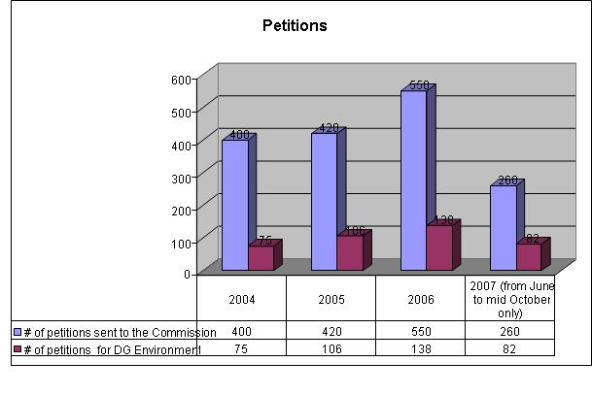
The task of handling environmental enforcement and implementation questions comes with a special set of needs. The significant numbers of complaints and petitions received by the Commission from concerned citizens, environmental groups and industry reflect the high expectations people have that the Commission will ensure the timely and effective enforcement of the legislation adopted in this sector. The cases raised are in themselves often very complex, requiring fine judgement, frequently with the support of scientific and other technical expertise. In the environmental sector, over 57% of the cases registered with the Commission for investigation concern the application of the nature protection directives, the directive on environmental impact assessment and directives in the waste sector. This is not surprising given that these are the directives that most come into play when proposals for new infrastructure developments are made. The other sectors that generate sizeable caseloads concern Community legislation on water protection and air quality, all of which have direct and tangible effects on people's quality of life.
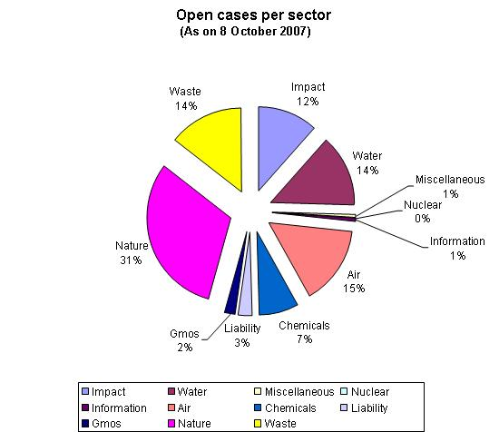
Questions are frequently asked as to why there are so many complaints to the Commission about the implementation of EC environmental legislation. The answer is that the protection of the environment is a matter close to the heart of most European citizens. This high level of interest translates into a high number of questions and complaints being sent to the Commission. Furthermore, the legislation being applied in this sector is often of a technical nature, requiring Member States to make a judgement call when deciding to give the green light to a new infrastructure development such as a new road, landfill or shopping centre. Much of the legislation adopted at the EC level provides a mechanism for more open and considered decision making processes, providing Member State authorities with checklists of requirements that they must ensure are met before giving development consent or issuing permits. This may include an assessment as to whether a proposed development is likely to impact on a nearby area designated as sensitive for its nature interest or to increase air pollution in an area already under pressure. Unlike legislation aimed at regulating products or markets, this kind of legislation is concerned more directly with matters impacting on the daily lives of citizens. The technical nature of the questions raised, and the fact that many of the decisions being challenged before the Commission are decisions of judgement by national authorities, also explains why providing a suitable response to such complaints and petitions can take time. Assessing whether a particular landfill is in compliance with all technical requirements or whether the decision to build near a protected nature site will or will not have negative impacts requires considerable technical input, frequently accompanied by numerous exchanges of mail or meetings with the national authorities concerned.
Against this background, account also needs to be taken of the fact that the Community has undergone considerable and rapid expansion over the last few years to twenty-seven Member States. This has increased not only the population of the Community to over five hundred million people, but also the number of official languages in which the Commission must engage. It has not surprisingly increased the Commission’s workload with regard to ensuring the correct application of the law throughout the enlarged Community. The internal resources of the Commission are in the process of adapting to this enlargement, but resource shortfalls still exist with regard to ensuring that the situation in the newer Member States can be fully investigated by staff with the requisite language skills.
The body of environmental law at the Community level has also increased, in certain cases tackling new and complex areas such as emissions trading. Their application to an enlarged Community has generated new challenges requiring internal legal expertise to be significantly supported at a technical level.
The adoption of the Aarhus Convention in 1998 and the subsequent development of a more coherent policy within the Commission on good governance and improved transparency have also led to a reorganisation of working methods within the Commission. Correspondence from the public is required to be answered within 15 working days, and information requests also require prompt handling, with the emphasis shifting towards a presumption of openness, and much of the infringement work of the Commission is now press-released once decisions reach a certain stage of maturity within the system.
In addition to this, increased focus and attention has been given to action on preventing breaches. In the environmental sector, this has been translated into action on a number of fronts described in the Communication on implementing EC environmental law.
Conformity checks on adopted legislation are also outsourced to provide support for the internal checking of compliance. This has in itself generated a considerable workload for the Commission. Conformity checking needs to be speeded up, and completed studies need to be given efficient and effective follow-up to ensure that the legislation adopted in each Member State provides an effective framework within which all players can exercise their rights to an improved environment in accordance with Community rules.
Work on the prevention of breaches, often before the adoption of legislation, but also in the period before directives are required to be transposed into national law by Member States, is essential, albeit time- and resource-intensive. The Commission therefore needs to strike the right balance with its limited resources in ensuring that additional work on the prevention of breaches does not eat into enforcement work.
4. Objectives of the Communication
The overall objective of the Commission is to protect and improve the environment by improving the way environmental legislation is implemented. Meeting this overall objective requires action on a variety of fronts and involving a wide range of players: the other institutions, in particular the European Parliament, national authorities, environmental groups, industry bodies and, of course, individual citizens. It will also require the Commission to be more strategic in its thinking on implementation, to make the best possible use of its limited resources in meeting this overall objective.
4.1 Specific objectives
4.1.1 More efficient handling of infringements
The objective of the Horizontal Communication is to identify improvements in current working practices so that infringement files can be handled more efficiently. As indicated in the Horizontal Communication, there are many reasons why infringement files are opened. In the end, relatively few issues are judged to require a ruling from the Court of Justice. Around 70% of complaints are closed before a letter of formal notice is sent, and around 93% are closed before a ruling from the Court. However, the process of resolving these cases is often lengthy: it takes an average of nineteen months to close a complaint before a letter of formal notice is sent and fifty months on average for a case to be closed after a reasoned opinion is sent but before its referral to the Court.
The objective of the Commission is to resolve implementation questions as quickly and efficiently as possible, in particular in key areas such as the timely adoption and communication of national implementing legislation and checking that what has been adopted is correct. Ensuring that the framework for compliance is right is essential and will often resolve difficulties downstream when it comes to the application of the law in practice.
4.1.2 Meeting expectations of the public: citizens, environmental groups and the European Parliament
Living in a healthy environment is at the heart of people's concerns. Citizens thus take a keen interest in environmental legislation and its implementation by national authorities. In many cases citizens do not fully accept that environmental legislation is being correctly applied in their country and turn to the Commission to resolve any problems. The Commission receives a high number of complaints from citizens. Members of Parliament are also very interested in ensuring good implementation of environmental legislation. It is thus essential to ensure that everyone's concerns are dealt with in a transparent and efficient way and that the Commission finds a way of becoming more open and accessible in addressing these concerns
The aim should be for the Commission to find ways to engage more directly with citizens, taking into account their concerns and also explaining as clearly as possible how these often technical rules apply in practice to the specific situations in which individuals find themselves. Generating more direct contacts with national and local authorities in the Member States may also help to provide clarification and improve implementation. Where the implementation framework is correct, the decisions taken are more likely to be in compliance with Community law. Making the Commission more accessible to interested parties in the Member States could help to resolve questions and disputes more quickly. It could also serve to provide the Commission in Brussels with better information about the state of implementation on the ground.
5. Policy options and initial analysis of individual options
5.1 No action
The no-action scenario would entail the Commission continuing to follow up all complaints and petitions in an equal manner, without any special emphasis being given to certain groups of cases. The focus would remain on assessments carried out in Brussels. The no-action scenario would still require the Commission to find additional internal resources to equip itself with the language skills necessary to answer questions from all Member States and to assess their national transposing legislation. A negative effect of continuing to work along these lines is that the important work of establishing an equal implementation baseline in all Member States may be disrupted by the need to handle numerous ad hoc complaints as and when these are registered. This baseline work will be particularly skewed for those Member States which receive higher numbers of complaints than others. As can be seen from the snapshot of case numbers below, numbers vary considerably between Member States.
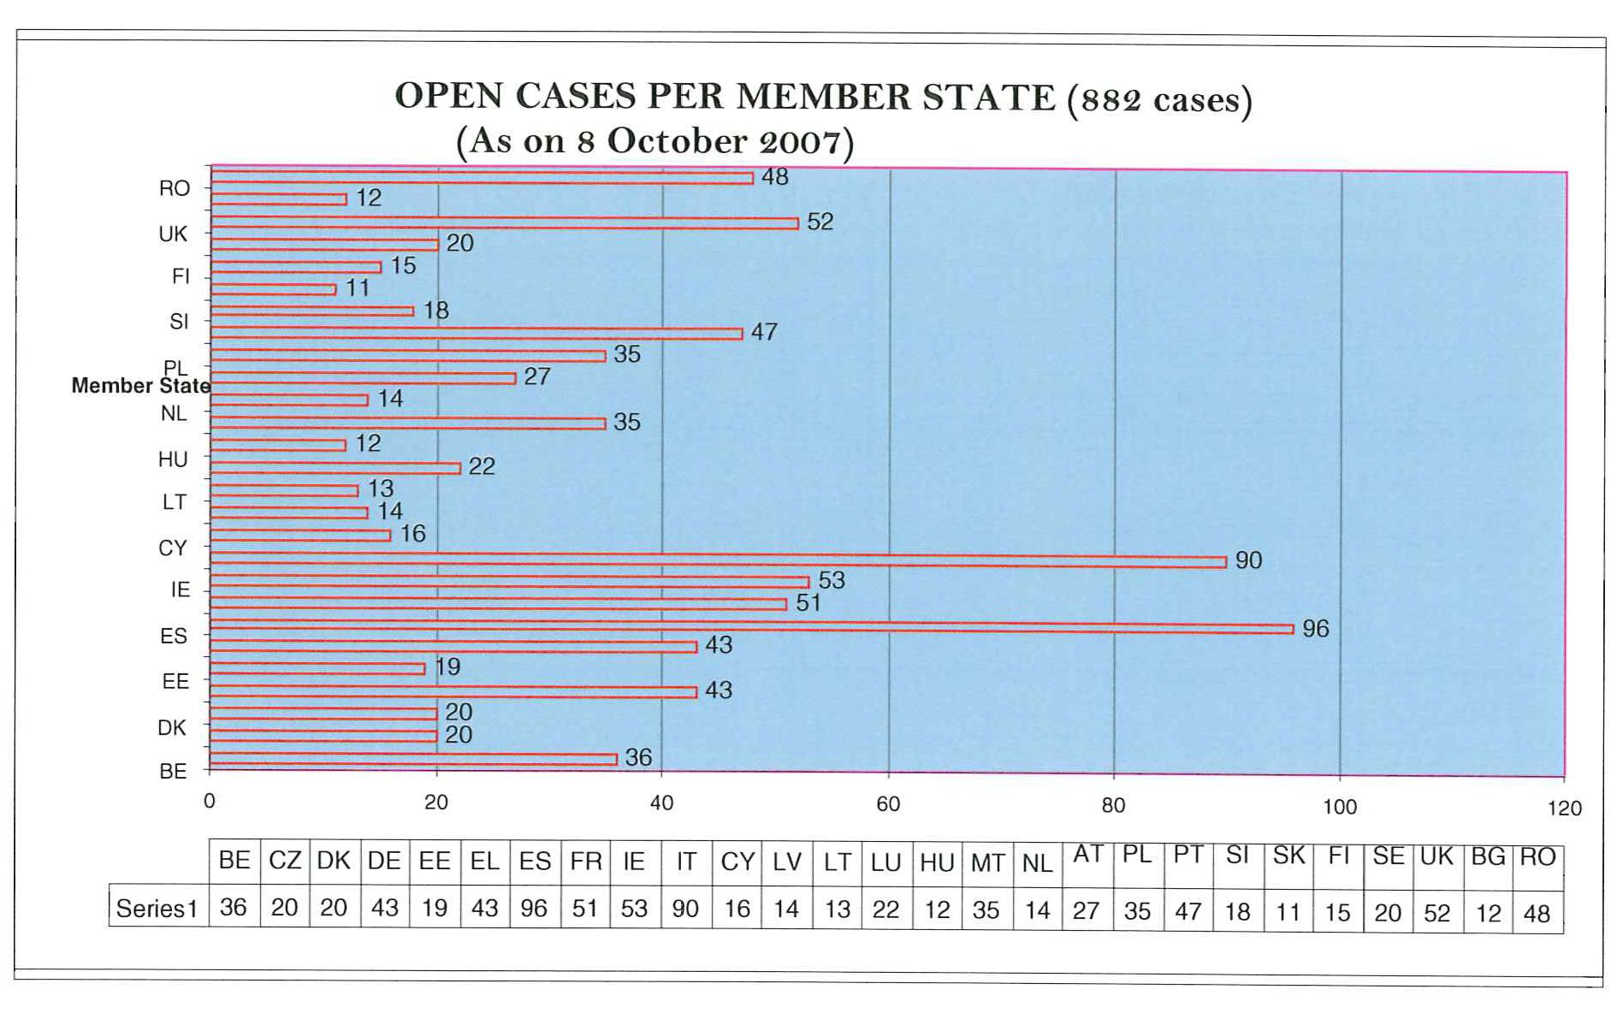
The numbers of cases registered with regard to individual Member States does not necessarily translate into an equivalent number of actual infringement cases being opened against that Member State.
Continuing to work along these existing lines has a number of disadvantages. An approach whereby case handling merely follows up complaints registered with the Commission, thereby swamping its limited resources, fails to tackle some of the more strategic enforcement goals such as ensuring that national transposing legislation is adopted in a timely and correct manner and providing an improved baseline for the application of the law in individual cases. This is particularly the case for those Member States with high numbers of complaints and petitions. The no-action scenario also fails to take account of the need to bring the Commission in Brussels closer to citizens and national authorities in the Member States. The difficulties entailed in continuing to work along existing lines without additional focus in key priority areas in an enlarged Union therefore leads to the conclusion that the no-action policy option is not a viable one. This option should therefore be discarded from further consideration.
5.2. Increasing emphasis on the prevention of breaches.
Over the last decade, increasing emphasis has been placed on the need to take action to prevent breaches of Community environmental law. Action has been taken on numerous fronts:
Various thematic strategies have been used to try to bring about improved coherence, resulting sometimes in the simplification of legislation.
Advice is given to Member States after adoption of Community legislation, but before the transposition deadline has expired.
Conformity-checking studies have been carried out for many environmental directives.
Environmental reporting systems are being rationalised.
Own-initiative technical studies have been commissioned.
The need for cross-compliance, in particular where projects receive EU funding, has been emphasised.
The Commission has drafted numerous guidance documents on the application of Community environmental law, in particular in the nature and water sectors.
Dialogue with authorities through package meetings is now frequently supplemented by training and awareness-raising seminars.
Dialogue with IMPEL and with stakeholder groups increasingly informs the work of the Commission on environmental implementation and enforcement.
The aim of this policy is to continue with these efforts and to make them even more of a priority in the coming years. Furthermore, the idea is that these preventative measures will be reinforced by the following additional actions:
The creation of permanent networks of Member State experts to work with the Commission to help smooth the implementation of new directives through the exchange of experience and early identification of problem areas.
An increased emphasis on Member States being required to provide correlation tables, showing the match between the provisions of directives and the corresponding national provisions.
Further emphasis on the production of guidance documents, explaining the implications of key environmental legislation or recommending certain action or approaches to be taken.
The setting-up of a working group with Member States on improving compliance with EC environmental law.
5.3. Assuring a local physical presence in the Commission representation offices of selected Member States.
The Communication on Implementing European Community Environmental Law suggests that the Commission’s role in dealing directly with information requests and complaints from the public might be supported by having a local physical presence in the Commission representation offices of four Member States as a pilot project. The aim of this new policy initiative would be to bring the Commission in closer contact with citizens in these Member State, enabling complaints and concerns to be resolved more efficiently and effectively. It would also provide a mechanism for keeping the Commission more directly informed of environmental concerns on the ground. Contacts with environmental groups, industry bodies and national authorities at the various regional levels would also benefit. In practice this would involve three or four Member States being selected on the basis that their language requirements are not easily addressed by Commission staff in Brussels, whose official working languages are English, French and German. A further criterion would be that the Member States chosen generate a considerable number of questions and complaints from their citizens to the Commission. The aim would be to set up this pilot project in 2008 and to assess its success in reaching out to citizens, environmental groups, business groups and national and local administrations to provide more direct answers to questions and to provide feedback on the implementation of EC environmental law to the Commission in Brussels.
This scheme will involve the deployment of some limited new internal resources. To be effective, staff will need to be versed in both their national environmental legislation and the Community’s environmental acquis. The idea is that initially one staff member will be deployed in four selected Member States.
5.4. The Commission to become more focused in its handling of important environmental cases
The Commission’s Horizontal Communication suggests that priority areas will include breaches consisting of a failure to adopt and notify required national laws and a failure to comply with rulings of the European Court of Justice. In the environmental sector, both categories are already a priority. Priority is also given to ensuring that national legislation is comprehensive and correct. The Communication on implementing European Community environmental law suggests that, in the environmental sector, the focus should in future extend to systemic breaches where contravention is geographically widespread or repeated, despite having been drawn to the attention of the national authorities. Furthermore, priority cases will include breaches of core responsibilities such as the designation of nature protection sites, breaches concerning big infrastructure projects, and interventions involving EU funding or a trans-frontier dimension. These cases will be handled in a more intensive and immediate manner.
Whilst focusing on these important priority cases, the Commission will continue to handle cases which do not fall into one of the above categories of important cases.
5.5. The Commission to take on an enhanced role which focuses on its own powers of investigating and prosecuting environmental cases before the Court of Justice
One option open to the Commission would be to focus its resources on bringing more actions before the European Court of Justice, pursuing these cases as quickly as possible through the pre-litigation steps. Currently only about 10% of cases registered with the Commission result in a case being lodged with the European Court of Justice. This idea has received some support in the European Parliament and also from sectors of the NGO community.
6. Comparing positive and negative effects of the different policy options
The first option, the no-action option, was discarded at the initial phase of analysis, and so this comparison will focus on the remaining four options outlined above.
Option 2 — Increasing emphasis on the prevention of breaches
Positive effects | Negative effects
The creation of a good baseline, with timely adoption of correct national implementing legislation, should assist in reducing difficulties and complaints about its application downstream. | A potential negative effect of these activities is that they could distract resources and focus from other important objectives such as increasing dialogue with the various stakeholders and focusing on important priority cases that need to be moved forward rapidly.
Measures such as internet-based guidance provide a wide audience with key interpretative tools for questions which might otherwise require individual attention, potentially warding off complaints and petitions.
Increased dialogue with Member States at package meetings and through focused awareness-raising events should help to reduce areas of confusion and conflict.
Reaching out to a wider group of stakeholders to draft guidance and increasing contact with Member State experts at an early stage in the transposition process should help to identify points of difficulty more quickly and provide clarification.
An increased insistence on the provision of conformity tables should focus Member States' minds on the details of implementation and improve the transparency of what has been adopted for the Commission, and for the wider public.
In the long term, the creation of an improved compliance baseline in all Member States should bear fruit, potentially reducing citizens' complaints and/or allowing questions to be resolved at the national level without recourse to the Commission being deemed necessary.
Option 3 — Having a local physical presence in Commission representation offices of selected Member States
Positive effects | Negative effects
This policy option should provide citizens, local authorities and industry with a focal point for questions. | This option will initially result in additional work for the Commission in Brussels in the start-up phase.
Questions currently being directed to Brussels, whether to the Commission or the European Parliament, can initially be answered closer to home, hopefully providing a more accessible face of the Commission and speedier responses. | It is essential that work between the Commission in Brussels and the offices in Member States be closely coordinated to avoid duplication and/or contradiction in positions taken.
In the long term, this approach should result in fewer questions having to be answered by the Commission in Brussels. | The need to find additional resources at a time when such resources are limited.
Information form the Member State on the state of implementation in the environmental sector can be filtered back better to Brussels.
There should be increased scope for identifying country-specific needs for training and workshops to improve understanding and implementation of environmental legislation focused on specific problem areas.
The presence of new staff in the Commission representation offices will also be able to assist fact-finding missions of the European Parliament.

Option 4 — The Commission to become more focused in its handling of important environmental cases
Positive effects | Negative effects
By focusing on priority areas such as the correct transposition of legislation and similar breaches across the Member States, it is hoped that in the longer term the baseline for compliance in the Member States will improve, with a resultant drop in complaints. Such a forecast is however difficult to quantify. | In the short term, the internal effects are likely to be a slightly increased workload, given that all cases will continue to be handled by the Commission, but with increased emphasis on the priority areas outlined.
Option 5 — The Commission to take on an enhanced role which focuses on its own powers of investigating and prosecuting environmental cases before the Court of Justice
Positive effects | Negative effects
After an initial shock, Member States would learn that a swift response was required once the pre-litigation phase of action under Article 226 of the EC Treaty was initiated. | Member State may be quicker to adopt a set position, which is as likely to be a defensive one as one of submission to the Commission’s arguments.
Court judgements may be obtained more quickly, clarifying difficult legal questions. | Many cases are currently resolved positively at an early stage in the pre-litigation procedures through dialogue between the Member State and the Commission. A more aggressive and litigious stance is likely to impact negatively on open dialogue where both parties are focused on protecting their legal positions.
 | If the emphasis is on speeding up litigation without establishing priorities for important cases, the results may not address the most urgent environmental protection needs.

6. Preferred policy option
The preferred policy option is a mix of options 2, 3 and 4. This would exclude recourse to options 1 and 5. The Commission is of the opinion that a mixture of options will make the best use of its resources in a more focused way, allowing action to be concentrated on preventative measures and at the same time homing in on important cases which will have the widest benefits for the environment. The new pilot scheme providing for a local physical presence in the Commission representation offices of three or four Member States will also enable the Commission to be more in touch with the concerns of citizens and should provide quicker responses to concerns raised at a local level. If the results are positive, this pilot scheme could be extended to other Member States.
The option of focusing on bringing cases to the Court of Justice does not help in reaching out to citizens in this more direct way, and is likely to result in Member States quickly adopting a more entrenched position rather than seeking to resolve matters in a constructive manner. In the long run, increased recourse to formal legal action is unlikely to bring about more tangible benefits for the environment than the course of action preferred by the Commission which, in any case, maintains recourse to the Court of Justice as an option.
The preferred policy option is therefore a combination of options 2, 3 and 4.
7. Monitoring and evaluation
The Communication on implementing European Community environmental law is a starting point for the debate on how best the Commission should tackle the challenge of implementation and enforcement of Community environmental law in an enlarged Community. In the coming year, the Commission will discuss the Communication with a wide audience, presenting it to the European Parliament, to Member States through package meetings and the environmental groups through its regular dialogues in Brussels, but also at its now regular meetings in the Member States. As foreseen in the Horizontal Communication, the Commission will be presenting an annual review of its priority-setting focus in its Annual Reports. This will also be an opportunity to evaluate stated priority areas and where necessary propose amendments to the existing approach. For the pilot project creating an enhanced presence in four national capitals, this wider debate will feed into the evaluation of their success and potential for future expansion to other Member States.

European Union network for the implementation and enforcement of environmental law. This network of national inspectors was formed in 1992.
See Eurobarometer 66, published in September 2007, which found that on average almost 3 out of 4 respondents believe that priority should be given in their country to protecting the environment even if it affects economic growth.
Council Directive 92/43/EEC on the conservation of natural habitats and of wild fauna and flora and Council Directive 79/409/EEC on the conservation of wild birds.
Council Directive 85/337/EEC on the assessment of the effects of certain public and private projects on the environment as amended by Directive 97/11/EC.
Convention on access to information, public participation in decision-making and access to justice in environmental matters.
The 2002 Communication on Better Monitoring of the Application of Community law, COM(2002)725; Regulation (EC) No 1049/2001 of the European Parliament and of the Council regarding public access to European Parliament, Council and Commission documents which is implemented by Decision No C(2001) 3714/9.
For example, the Commission has produced twenty-four guidance documents on key aspects of the Water Framework Directive, 2000/60/EC; six guidance documents on the Seveso II or Major-Accident Hazard Directive, 96/82/EC and several guidance documents on the Wild Birds and Habitats Directives, 79/409/EEC and 92/43/EEC.

