EN
COMMISSION OF THE EUROPEAN COMMUNITIES
Brussels, 14/11/2008
SEC(2008) 2868 final

COMMISSION STAFF WORKING DOCUMENT
REGIONS 2020
AN ASSESSMENT OF FUTURE CHALLENGES FOR EU REGIONS
COMMISSION STAFF WORKING DOCUMENT
REGIONS 2020
AN ASSESSMENT OF FUTURE CHALLENGES FOR EU REGIONS
TABLE OF CONTENTS
1. Introduction 3
2. Key challenges for European regions 5
2.1. Globalisation: Southern and South East Europe particularly exposed 5
2.2. Demographic change: Great diversity across the EU 8
2.3. Climate change: Southern Europe most at risk 11
2.4. Energy challenge: A weak core-periphery pattern 14
3. Conclusions 17
ANNEX 21

Introduction
Today's global financial and economic turbulence adds a high degree of unpredictability about the future of the world economy. In this context, it is even more important to examine the extent to which Community policies are adapted to future challenges that European regions will face in the coming years and what the role of Community Policies should be in responding to these challenges.
The reflection process on the future of cohesion policy takes place in the context of the budget review, following the mandate received in 2005/2006 "to undertake a full, wide-ranging review covering all aspects of EU spending, including the Common Agricultural Policy, and of resources, including the United Kingdom rebate, and to report in 2008/2009". In this context, the Commission launched a public consultation based on its Communication "Reforming the Budget, Changing Europe" adopted on 12 September 2007. This consultation paper presented the Commission's approach to the budget review. It sketched out the new policy challenges which could have a significant impact on where the Union directs its efforts in the future and, at the same time, made an assessment of the added value of EU spending, a condition for choices on future spending priorities. Among the challenges identified, the following four may be of particular relevance for European regions:
• Globalisation is driving scientific and technological progress, making the European dimension ever more important in boosting knowledge, mobility, competitiveness and innovation. The opening up of huge new markets creates vast new opportunities for Europeans, but it will at the same time test Europe's capacity to further adjust to structural change and manage the social consequences of that change. The transformation to a knowledge and service economy is as profound as the earlier changeover from agriculture to industry.
• Demographic change will transform the age and employment structure of our societies, raising important issues of both economic efficiency and inter-generational equity. Migratory pressure will have a particularly strong effect on Europe, due to its proximity to some of the world's poorest regions and those likely to be worst affected by climate change and natural resource constraints.
• The impact of climate change on Europe's environment and its society has become central to the European agenda, challenging policymakers to reflect on how best to respond with the policy instruments at the EU's disposal. This applies both to efforts to mitigate climate change by tackling the growth in greenhouse gas emissions and the need for measures to adapt to the consequences of climate change.
• Secure, sustainable and competitive energy represents one of society's main challenges. Limited supply, increased global demand and the imperative to cut emissions have led to a new realisation of the need to move towards a low-carbon economy in Europe.
Together these challenges will impact on the development of Europe's economies and societies over the coming years. This document seeks to explore the regional effects of these challenges in the medium-term perspective of 2020. It seeks to illustrate which regions are most vulnerable to these challenges, as a step towards a better understanding of the potential pattern of regional disparities that these challenges will generate.
Regional disparities in economic output and income in the European Union are far more extreme than in similar economies such as the US or Japan, particularly following recent enlargements. The richest regions are eight times richer than the poorest regions. The key cohesion challenge will therefore continue to be the integration and convergence of the new Member States, in spite of impressive GDP growth rates in recent years. Growth in the countries which have been the largest beneficiaries of the policy in the period 1994-2006 – Greece, Spain, Ireland and Portugal – has been marked, although development needs persist in some Southern European regions, Eastern Germany and peripheral areas. In short, the primary dimension of regional income disparities in the EU remains East-West, with a weaker North-South dynamic and core-periphery pattern at both EU and national levels. One question that this document seeks to address is whether the new challenges will further consolidate this pattern or generate new territorial disparities.
Such an exercise is, by its very nature, limited; it simplifies a complex reality and focuses on a single regional level. It cannot substitute for a detailed analysis of specific national and regional contexts, nor take into consideration the capacity of Member States and regions to respond. As with all prospective work, this exercise is based on assumptions which appear reasonable today, but which may or may not correspond to future reality.

Key challenges for european regions

Globalisation: Southern and South Eastern Europe particularly exposed
"Globalisation is increasingly shaping our lives by fostering the exchange of peoples, goods, services and ideas and by offering new opportunities to citizens and business. Greater trade flows and economic growth have increased prosperity, transforming the lifestyles of Europe's citizens and lifting millions worldwide out of poverty. But globalisation also confronts us with new economic, social, environmental, energy and security challenges."
Globalisation will create more opportunities for producers and entrepreneurs, who are in a position of enjoying larger markets and higher competition. Consumers will benefit from higher living standards through lower prices and a wider choice of goods. A general increase in economic activity and trade will enhance labour demand and real wages for skilled labour, create employment and increase economic growth. The dissemination of innovation and know-how will also increase productivity.
However, globalisation may also bring structural adjustment. Increasing competition can put additional pressure on local firms and, indirectly, on wages, especially for low-skilled labour. Many regions throughout the EU will therefore have to restructure their economy and promote continuous innovation – in products, management and processes, as well as human and social capital – to face the challenge of globalisation.
The persistent labour productivity gap between the EU and the United States is projected to remain, due to rapid technological progress in the US. Labour productivity growth will continue to accelerate in the emerging economies of China, India and Brazil. (The annual average productivity growth in emerging economies - although they are starting from a low base - is expected to be five or six times higher than that in the EU).
In order to turn the challenge of globalisation into an opportunity, the Lisbon Agenda requires European economies to increase productivity growth (both labour and resources), employment levels and the level of education of the workforce. General trends in the EU in recent years show a moderate labour productivity growth of around 1%, a fairly divergent trend in levels of education of the workforce and a gradually increasing employment rate as well as in the average age of retirement. This mixed picture is amplified at a regional level.
The regional challenges of globalisation
Levels of future labour productivity growth, employment and education have been combined in a globalisation vulnerability index (see figure 2).
The index ranks European regions with reference to each other. It does not provide any information on their position relative to international competitors.
- Many regions located in the North-West periphery of the European Union appear to be in a rather favourable position. These regions are largely in Finland, Sweden, Denmark, the UK and Ireland. They are expected to benefit from a workforce with a high level of educational attainment, a high level of employment, a high share of employment in advanced sectors and a high level of labour productivity.
- Most regions located in the Southern and Eastern parts of the Union, stretching from Latvia, Eastern Slovakia, Hungary, Bulgaria and Romania to Greece, Italy, Spain and Portugal, appear to be much more exposed to the challenge of globalisation. This vulnerability is predominantly due to the relatively large share of low value added activities in these regions and weaknesses in workforce qualifications, which may lead to difficulties in attracting investment and creating or maintaining jobs.
- No clear pattern emerges in Western and Central Europe, where there are often strong sub-national variations. Some areas are expected to perform less well than the EU average (e.g. some regions in the North of Germany) and others are projected to achieve higher-than-average levels of productivity, employment and educational attainment (e.g. parts of Austria, Germany, France).
- At the sub-national level, the analysis reveals that, in many Member States, regions with major urban centres and metropolitan areas should be relatively well placed to respond to the challenges linked to globalisation. These areas tend to benefit from a large share of highly educated residents, highly dynamic sectors and leading-edge economic activities. Yet, the concentration of economic activities in agglomerations may also create negative externalities (such as congestion, urban sprawl, drain on natural resources and ecosystem services) and may also lead to underutilised economic potential elsewhere.
A number of other factors will also strongly influence the extent of regional exposure and adaptive capacity to globalisation, such as R&D and innovation performance. However, due to data limitations (projected values at a regional scale) these variables have not been included in the index.
Figure 1: Regional exposure to globalisation over the medium term
Note: Index based on estimated productivity, employment rate, high education rate and low education rate in 2020.
Source: Eurostat
Potential regional effects
Globalisation brings ever faster change to which people and firms need to respond. There is a risk that globalisation will encourage further consolidation of path dependency at regional level. The high productivity growth rates seen in a number of regions will help consolidate their economies in a more favourable competitive situation. In contrast, as the comparative advantages of low-cost, low-wage production methods continue to shift to emerging economies, regions lacking the capacity to develop a knowledge-based economy are likely to become more exposed. A well educated workforce provides the necessary flexibility and mobility to actively counter negative effects of globalisation. Low employment rates and educational levels may increase the risk of growing social polarisation within regions.
Yet, there are many regions in the Union which are competitive and innovative, and which benefit from globalisation. This has been achieved by investing in advanced sectors with high productivity, by building up new skills and/or attracting new reservoirs of talent, and by promoting innovation potential through clusters, networks and through the strategic use of ICT. It is by better analysing and building on these development strategies that regions will be able to mobilise their potential and place their economy on a high-growth, sustainable development path.

Demographic change: Great diversity across the EU
Demographic ageing, i.e. the increase in the proportion of elderly people, is the result of significant economic, social and medical progress as well as public health policies. These have given Europeans the opportunity to live a longer life in relative comfort and security without precedent in our history. However, as was stressed by the Heads of State and Government at their informal Summit at Hampton Court in October 2005, it is also one of the main challenges that the European Union will have to face in the years to come.
The EU-27 population is projected to become both smaller and older, mainly as a consequence of declining fertility rates and increasing life expectancy. By 2050, there may be 48 million fewer 15-64 year olds and 58 million more people over 65. From 2017 a shrinking workforce will also reduce overall employment and act as a brake on potential growth in the Union.
Population growth in the EU will slow down considerably compared to key competitors, in particular the United States, China and India, by 2020. The EU will face one of the largest increases in old-age dependency ratios in the world after Japan. At the same time, in Europe's immediate neighbourhood, the Middle East and North Africa region will be home to the world's second fastest growing population, after sub-Saharan Africa.
Over the past decades, there has been considerable growth in worldwide migration flows. Economic differences between - and demographic changes within - developed and developing countries, against a background of trade, political problems and instability in countries of origin, have all contributed to a steady increase in international workforce mobility. Economic migrants respond to expectations and opportunities in target regions. European and national regulations determine admission and eventual integration into the labour market.
The ageing and shrinking of the population has fundamental repercussions for health and social security systems, for the economy and the labour market, and for public finance. Ageing leads to increased demand for health and long-term care and rising health care expenditure. Demographic change is therefore of far-reaching importance for the economy and society, since demographic decline strongly influences almost all relevant areas of policy action.
The regional challenges of demographic change
Three important processes – namely a shrinking working age population, an ageing society and population decline – will have a marked effect on many regions. These factors have been combined to create a demographic vulnerability index (figure 2). A number of conclusions can be drawn from this analysis:
- There is great diversity in terms of demographic dynamics and patterns across the EU, with regions that are particularly exposed to demographic decline located throughout the entire Union. Only a few Member States (such as Ireland, Malta, Cyprus) appear to be in a relatively favourable position with regard to demographic challenges.
- Around one third of European regions are projected to experience population decline in the period 2005-2020. Most of them will be located in Central Europe, Eastern Germany, Southern Italy and Northern Spain. Around 20 of these regions will face a population decline of more than 10%.
- The highest shares of old age population are likely to be found in Eastern Germany, North-West of Spain, Italy and some parts of Finland. In Central and Eastern Europe the impacts of ageing will be delayed owing to their younger population and lower life expectancy. However, significant increases in the old age population are expected in the longer term in these regions.
- The share of working age population is expected to be particularly low in several of the Finnish, Swedish and German regions. It is noteworthy that the magnitude of decline in the working age population shows significant variations. Around 40 regions will experience a decline of more than 10 % by 2020. Some regions in Bulgaria, Eastern Germany and Poland will be particularly hard hit, with a decline exceeding 25 % by 2020. These regions suffer from a combined effect of low fertility and high out-migration.
Other factors will also influence the demographic composition of regions, such as health status, disability and ethnicity. These variables are however not included in the index, in view of data limitations.
Figure 2: Regional exposure to demographic change over the medium term
Note: Index based on the estimated share of people aged 65 and over in total population, share of working age in total population and population decline in 2020
Source: Eurostat
Potential regional effects
In terms of socio-economic characteristics, regions in demographic decline are often characterised by relatively low income levels, high unemployment and a large proportion of the workforce employed in declining economic sectors. Moreover, they tend to have a relatively small proportion of young people, reflecting their migration to other areas as well as low fertility rates, and low population density, reflecting the rural nature of many of these regions. As a consequence, regions in demographic decline often have a low growth potential due to the shrinking labour force. This may intensify existing economic disparities in income.
The outmigration of young people will reinforce the natural aging process. Regions in demographic decline may face difficulties in financing essential public goods and services, such as health care, long-term care, housing and transport infrastructure as well as ICT infrastructure, in a sustainable manner in order to avoid increasing social polarisation and poverty.
Other regions, on the other hand, in particular metropolitan and some coastal areas, will gain population. Metropolitan regions are projected to face high inward migration of a working age population, as well as remaining primary destinations for international migration. A resulting challenge for these areas will be the integration of migrants into the labour force and society as a whole, as well as the adaptation of infrastructure in the case of high population growth. Social disparities tend to be high in metropolitan areas, reflecting high living costs. Rapid sub-urbanisation could increase pressures on ecosystem services in surrounding areas. Demographic change is therefore likely to reinforce regional disparities in economic growth potential, as well as increasing social polarisation and pressure on the environment in certain areas.

Climate change: Southern Europe most at risk
Tackling climate change is of vital importance for the well-being of future generations. In the long run, climate change will lead to an increase in average annual temperatures, alter rainfall quantities and patterns, and raise the sea level and the risk of coastal erosion. In the short and medium term, climate change will increase the occurrence of extreme weather events (storms, heavy rainfall, droughts, peak summer temperatures) which will lead to temporary situations resembling those conditions, which we can expect later this century.
Most European regions are anticipated to be negatively affected by future impacts of climate change, posing challenges to a number of economic sectors. In Southern Europe, climate change is projected to worsen existing conditions through declining precipitation and drought.
Therefore, the impact of climate change on Europe's environment, economy and society has become central to the European policy agenda. This applies both to efforts to mitigate climate change by tackling the growth in greenhouse gas (GHG) emissions, and to the need for measures to adapt to the consequences of climate change. 2007 marked an important year in the fight against climate change, when EU leaders committed themselves to cut EU emissions by 20 per cent by 2020, a target rising to 30 per cent if an international agreement committing other developed and advanced developing countries is reached. They have also committed to 20 per cent share of renewable energy in energy consumption and a 20 per cent increase in energy efficiency by 2020. The EU is committed to maintaining international leadership on the fight against climate change, including increase of clean energy production, and to keeping up the momentum of negotiations on the United Nations Framework Convention on Climate Change and its Kyoto Protocol. The objective is to secure an ambitious, global and comprehensive post-2012 agreement addressing climate change at Copenhagen in 2009 consistent with the EU's objective to limit global warming to 2 °C.
The regional challenges of climate change
Climate change will strain economic, social and environmental systems. The development of economic sectors which rely on ecosystem services and natural resources might become constrained. Tourism, large scale energy production, agriculture and fishery are examples of exposed sectors. Regions under threat of flooding, coastal erosion, land degradation and desertification and potential drought hazard are already seeing their economy, and their social and environmental situation, affected. To study the extent to which regions will be affected by the consequences of climate change, a climate change vulnerability index (see figure 3) was developed which combines the physical and economic effects of these underlying processes:
- More than one third of the EU population - a total of 170 million people - live in the regions most affected by climate change. Regions subject to the highest pressure are generally located in the South and East of Europe, the whole of Spain, Italy, Greece, Bulgaria, Cyprus, Malta and Hungary, as well as most of Romania and southern parts of France. This situation is mostly due to changes in precipitation and an increase in temperature, which have an impact on vulnerable economic sectors. River floods also contribute to the overall effect in Hungary and Romania.
- More limited pressures are expected in Northern and Western Europe, apart from lowland costal regions around the North Sea and the Baltic Sea with a high exposure to costal erosion through extreme weather events as well as sea level rise.
- The pressures from climate change are therefore not evenly distributed, and in some cases will be felt in regions with low GDP per capita, which thus have a lower capacity for adaptation to climate change.
Figure 3: Regional exposure climate change over the medium term
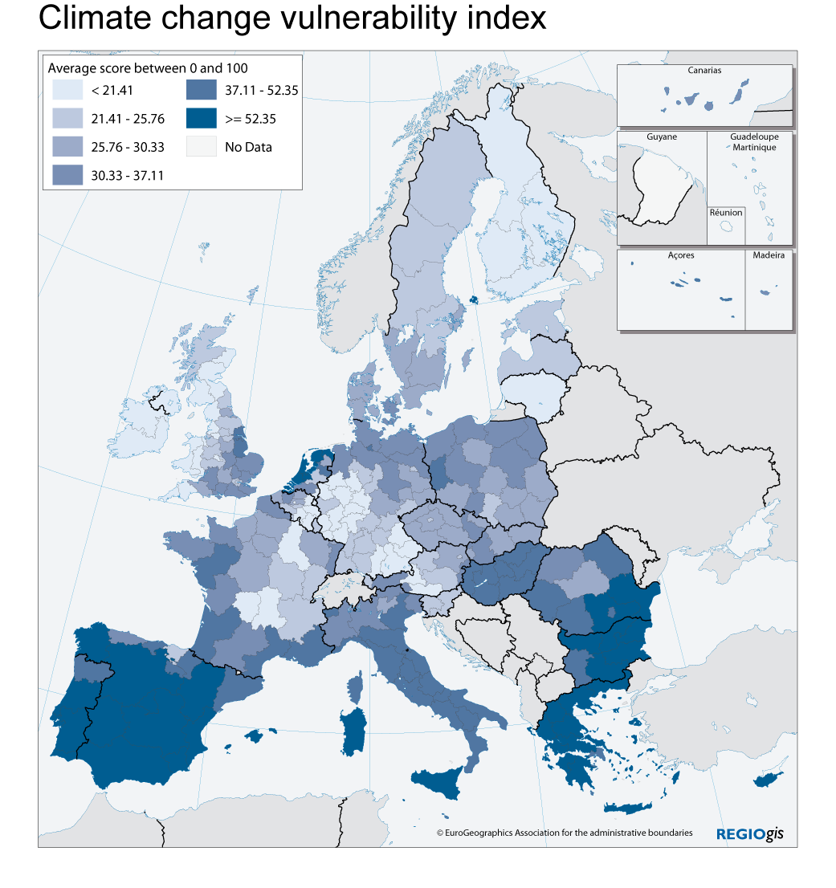Note: Index based on change in population affected by river floods, population in costal areas below 5m, potential drought hazard, vulnerability of agriculture, fisheries and tourism, taking into account temperature and precipitation changes.
Source: Eurostat, JRC, DG REGIO
Potential regional effects
Many European regions will be increasingly exposed to the asymmetric impact of climate change. This will pose serious challenges to agriculture, forestry, fisheries, large scale energy production and the tourism industry as well as health care in certain areas and will require significant investment to combat and prevent drought, fires, coastal erosion and flooding and peak temperatures.
Adaptation to climate change is of vital importance. The severity of the impacts will vary across European territories, depending on the physical vulnerability, the level of economic development, natural and human adaptive capacity, health services and disaster surveillance mechanisms.
In agriculture, changes in temperature and precipitation will lead to changing agricultural yields and production methods with distinct patterns throughout Europe. In fisheries, climate change will place an even greater strain on marine ecosystems subject to overfishing. In tourism, the number of Alpine areas with reliable snowfall will decrease and the industry will have to shift its focus to summer holidays, whereas Mediterranean regions might suffer from temperatures above the heat comfort zone and loss of biodiversity. In the energy sector, climate change will lead to changing patterns of energy demand and to greater fluctuations in energy production and demand, particularly in regions with a high share of renewable energy and varying availability of water for cooling of large-scale heating power plants. These effects will impact on regional growth potential in affected regions and create disparities with those regions that are less affected by climate change.
Changing weather conditions will have a negative impact on human health and well- being in several areas (the number of heat-related deaths may increase availability and quality of drinking water will decrease, etc). In this respect, the Mediterranean regions will suffer the most from worsening conditions, while Northern, Western and Eastern European regions will see a less serious deterioration or even a temporary improvement in conditions. This is likely to create social and environmental disparities between regions.
Similarly, the impact on access to environmental amenities and ecosystem resources will be asymmetric. In the competition for ecosystem services, rural and urban regions with a high risk of droughts will see more potential conflicts over the appropriate use of limited water resources, as well as potential damage to regional ecosystems that run short of water. In the large flood plains created to shield urban centres, the reverse may be true.

Energy challenge: A weak core-periphery pattern
Energy is essential for Europe to function. Energy prices appear to have become ever more volatile with extreme price peaks reached in recent months. All EU members are facing the challenges of climate change, increasing import dependence and higher energy prices. An Energy Policy for Europe is aimed at delivering sustainable, secure and competitive energy.
Europe is becoming increasingly dependent on imported fossil fuels. Under the "business as usual" scenario, the EU's energy import dependence will increase from 53% of total EU energy consumption in 2005 to 67% in 2030. Reliance on imports of gas is expected to increase from 58% to 84% by 2030, and on imports of oil from 82% to 95%. The EU is becoming increasingly exposed to the effects of price volatility and price rises on international energy markets, and the consequences of the gradual geopolitical concentration of fossil fuel reserves.
Rising and fluctuating energy prices, which are related to internal and external energy security, affect some European regions more than others. Currently, energy prices differ significantly across the EU, indicating the lack of a properly functioning EU market and potentially affecting the competitiveness of energy intensive sectors. The challenge for the EU will be how to achieve an Integrated Energy Market in order to share risks and pool advantages.
Another dimension of the energy challenge will be to move towards a low carbon economy by reducing greenhouse gas emissions through higher energy efficiency and a more pronounced role for renewable energies and the development of low-carbon technologies, such as carbon capture and storage (CCS). A number of sectors contribute to greenhouse gas emissions among them transport, energy, households, agriculture. High energy prices and growing carbon prices will affect regions in different ways depending on i) the structure of the regional economy and its energy efficiency, ii) the energy mix and low carbon potential (renewables, nuclear), iii) the prevailing transport modes and iv) the innovation potential. Energy accounts for 80% of all greenhouse gas emissions in the EU; it is at the root of climate change and of most air pollution.
The regional challenges of energy
The regional dimension of the energy challenge is strongly determined by national choices regarding energy mix as well as energy policy, and depends on three main structural factors: i) internal and external security of supply will determine how much regions are exposed to additional fluctuations of prices and supply; ii) energy use and efficiency determines consumption by households and industry and their vulnerability to high price levels and, finally, iii) carbon emissions are an indicator of sustainability. An energy vulnerability index (figure 4), which combines these three elements, seems to indicate that the core in Western and Northern Europe appears to be better prepared for the energy challenges of the coming years than the periphery.
- Peripheral regions located mainly in Eastern and Southern Member States appear particularly vulnerable, for reasons of internal and external security of supply, energy efficiency of the economy and environmental sustainability. About one third of the EU population live in such areas. There are some variations within this group. Polish regions have a lower security of supply risk, but the coal base leaves a negative ecological footprint. Irish regions combine a pattern of higher risks of security of supply with a low level of environmental sustainability and high household consumption.
- Centrally located regions in Belgium and Germany, for instance, are in the middle ground owing to high energy efficiency, but with high household consumption and relatively low environmental sustainability. A further one third of the EU population falls into this category.
- A third of the EU population lives in the least challenged regions. These are generally located in Northern and Western Europe and show a greater capacity to adapt, which is due either to higher own energy resources (United Kingdom, Netherlands) or to energy mixes allowing lower greenhouse gas emissions and lower dependency on fossil energy providers for electricity (Finland, France, Sweden).
- At sub-regional level, metropolitan areas with compact settlements generally seem less vulnerable to the energy challenge than remote areas, owing to the higher energy efficiency of the economy and lower household consumption.
Figure 4: Regional exposure to the energy challenge over the medium term
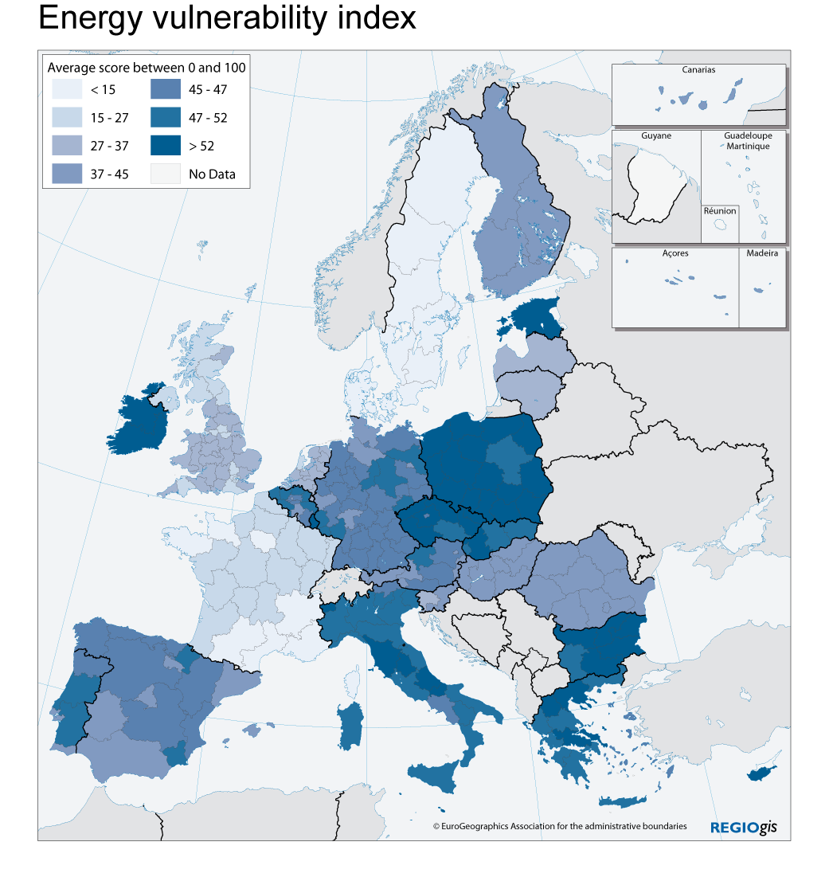Note: Index based on regional energy consumption by households (incl. private transport), estimated energy consumption by freight transport, industry, services and agriculture, national carbon intensity, national energy import dependency.
Source: DG TREN, DG REGIO.
Potential regional effects
Regions reliant on energy intensive sectors, such as transport, and heavy manufacturing and regions that depend on distant markets could be more exposed to changing energy conditions. On the other hand, energy efficient regions can benefit from the strong role which innovation, technology and ICT will play in the adaption and mitigation process. This can create "win-win" situations, both economically and environmentally, in energy efficient regions.
Some regions will potentially benefit from the production of renewable energies, including some rural and remote regions (e.g. geothermal, biomass) and coastal areas (e.g. offshore, wind, wave, tidal or solar energy). Substantial disparities among regions are also observed as regards modal splits in the transport sector, and energy intensity, where the highest figures are recorded in countries with low GDP per capita. High energy prices also have significant welfare effects, in particular for lower income households, for which energy related expenditure takes a comparatively high share of their income. High energy prices might therefore reduce the purchasing power of the poorest households and regions with a low average income.

Conclusions
Europe will face a number of key challenges in the years to come, including among others: adapting to globalisation, demographic change, climate change and the energy challenge. All European regions will be affected. However each of the challenges exhibits a distinct pattern. With the exception of energy, all challenges display strong sub-national variations:
- For globalisation, South and South Eastern regions appear to be highly vulnerable, but considerable variations can be observed in both Germany and the new Member States.
- For demographic change, there is significant variation across European regions, once again with slightly greater vulnerability in South and South Eastern regions. However, it should be stressed that there is a lag in the demographic transition of the new Member States and that the effects will be very similar in the next generation to those already seen in the old Member States.
- For climate change, there is a relatively strong core-periphery pattern, with Southern regions faring worse.
- The pattern for energy is largely country specific, with a weak core-periphery pattern at a European level.
Examining the combination of these challenges provides interesting results:
- As regards socio-economic challenges, some regions appear to be favourably placed to benefit from globalisation, but face the risk of demographic decline. These regions are located in Central France, Eastern Germany, parts of Sweden and Finland, as well as in some new Member States. A number of regions - mainly located in Southern Europe - appear to be vulnerable to both challenges. At sub-national level, metropolitan areas seem to be better equipped than remote rural areas to face both types of challenges. It is thus difficult to predict how these challenges will interact and what conclusions can be drawn in terms of future developments.
- Climate change and the energy challenge will affect all regions. Regions in the Mediterranean part of Europe seem to be more exposed to these challenges, whereas Northern and Western European regions appear to be less at risk. However, the impact depends on climate change scenarios which may vary considerably over time. Energy dependence clearly follows national patterns, without showing a clear East-West or North-South divide. Developments will depend on the European Union's capacity to develop, a common policy on energy ensuring the functioning of the internal market and security of energy supply.
The outermost regions will be in the front line for many of these challenges. Their experience will be important for their geographical surroundings and for the rest of the territory of the Union.
A synthetic index has been developed to further illustrate the geography of these multiple challenges. The index classifies in very broad terms how many challenges will affect each European region. It provides an overview of the top 50% of regions most affected by each individual challenge, indicating risk intensity.
Figure 5: Intensity of multiple risks for European Regions
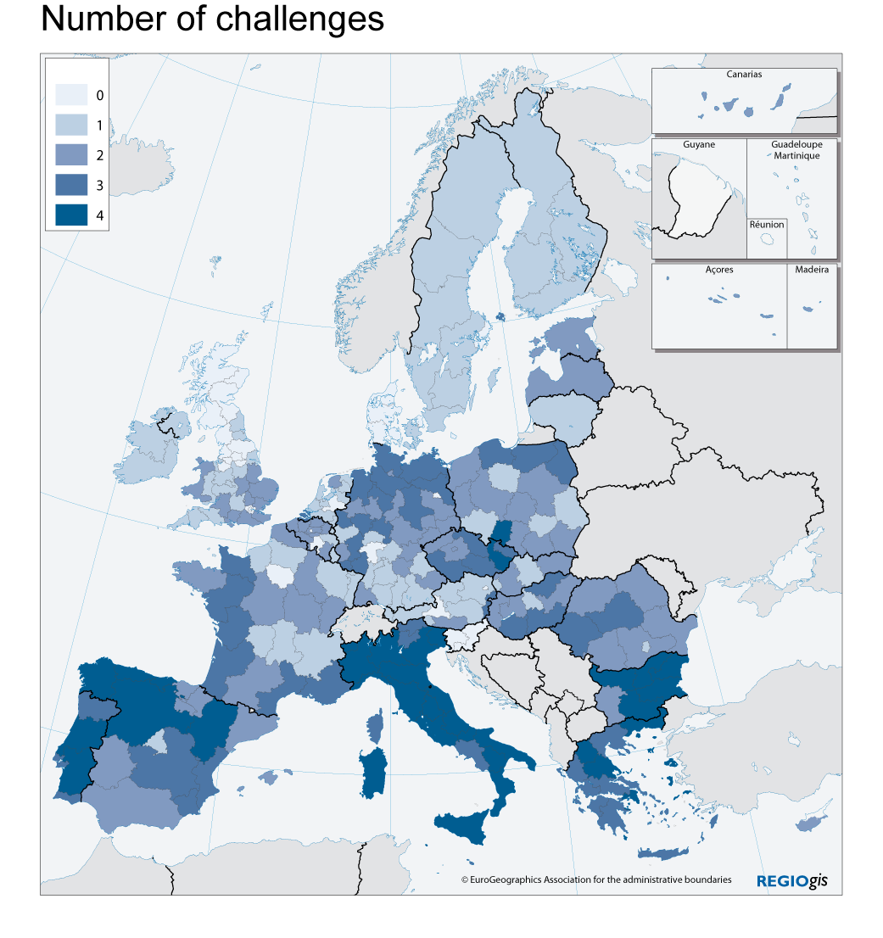
The map above summarises the geographical pattern of intensively challenged regions. Most regions expected to be intensively affected by three or more challenges at the same time are located in Southern Europe and on the coasts of Western and Central Europe. Regions with a lower number of simultaneous challenges are relatively close to the geographical core of the EU, but are also located in Southern Spain, the UK, Ireland, Denmark, Sweden, Finland and Lithuania.
Most of the impacts of the four challenges will be expressed in different ways according to the particular region and are likely to create regional disparities. Some of the challenges tend to be more closely interlinked than others. Globalisation, demographic change and aspects of energy and climate change have distinct impacts on the economy and regional growth potential, as well as on social polarisation. For example, overly volatile energy prices could adversely affect the competitiveness and regional growth potential of regions with inefficient energy use and high reliance on transport. As a consequence, households might be adversely affected by higher unemployment as well as by temporarily higher spending on energy. Growing social polarisation could be the result. Certain challenges, therefore, might reinforce each other. Other combinations of challenges might have a lower impact. Demographic change and globalisation may have a more limited impact on environmental sustainability than energy and climate change.
The interaction of various challenges is, thus, extremely complex. Moreover, as noted above, the projections made in the present document do not take into account a number of factors which may be decisive, such as the capacity of the regions, the Member States, and the European Union to respond, notably on the basis of further technological development. Through their cohesion programmes in 2007-2013 for example, some Member States and regions, in partnership with the Commission, endeavour to contribute towards tackling these challenges. The question how EU policies, including cohesion policy, can best contribute to addressing those challenges in the next decade and beyond, whilst fully taking solidarity and sustainability aspects into account, will be a key issue of the ongoing review of the EU budget.

Declaration No 3 attached to the Interinstitutional Agreement between the European Parliament, the Council and the Commission on budgetary discipline and sound financial management, OJ C 139, 14.6.2006, p. 15.
http://ec.europa.eu/budget/reform/library/issue_paper/consultation_paper_en.pdf, SEC(2007) 1188 final.
These four key challenges represent broad categories and are not exhaustive. Other challenges such as access to the information society and transport interconnectivity will also play an important role.
NUTS II in those Member States where these exist, national level for other Member States. Given the methodological limitations of the indicators used in the analysis, they should be considered as purely analytical, and not suitable for determining geographical eligibility.
In order to further deepen this analysis, the Commission intends to undertake a more wide-ranging study of the regional impact of the four challenges.
EU Declaration on Globalisation, European Council Presidency Conclusions, Brussels, 14 December 2007.
Metropolitan areas are defined as large agglomeration zones consisting of several urban centres or a very large city. In a number of Member States these are the capital region (e.g. Ile de France, Greater London, Madrid, Warsaw). In a number of other Member States these are more dispersed (e.g. Antwerp-Rotterdam, the Rhein-Main area, Munich).
There are however a number of rural and remote regions, which will fare well in response to globalisation. These regions are characterised by a high employment rate and an equally high educational attainment of the workforce.
The document draws from the 2004-based national and regional population projections produced by Eurostat, which were the latest available on a regional scale during its preparation. The 2008 national population projections differ considerably, in view of the application of a Convergence scenario (in contrast to the trend scenario applied for EUROPOP2004).
Communication from the Commission. Policy plan for legal migration SEC(2005)1680.
An Energy Policy for Europe, Communication, {SEC(2007) 12}.
The energy challenge is largely determined by national choices on the energy mix as well as national policies choices determining internal and external security of supply. These factors are strongly path dependent with a long term influence far beyond the time horizon of 2020. Distinct socio-economic factors determine thus regional disparities.
Communication COM (2008)642: the outermost regions, an asset for Europe

