EN
ANNEX
REGIONS 2020
An assessment of future challenges
for EU regions
1. Annex I: maps 3
1.1. GDP disparity map 4
1.2. Globalisation indicators: 5
Regional labour productivity in 2020 (EU-27=100) 5
Regional employment rate in 2020 (EU-27=100) 6
High educational level of the workforce in 2020 (EU-27=100) 7
Low educational level of the workforce in 2020 (EU-27=100) 8
1.3. Demography indicators: 9
Regional share of people aged 65 and above in 2020 (% of total population) 9
Population decline between 2004-2020 (annual average % change) 10
Regional share of working age population in 2020 (% of total population) 11
1.4. Climate change indicators: 12
Climate Zones 12
Change in regional population affected by river floods (% of total population), 2001-2100 13
Regional population in areas below 5m sea level (% of regional population), 2001 14
Potential regional drought hazard, 1958-2001 (average number of days with soil moisture deficit) 15
Regional share of agriculture and fisheries in GVA, 2005 16
Regional share of employment in hotels and Restaurants (% of total employment), 2005-2006 17
1.5. Energy challenge indicators: 18
Regional energy consumption of Households, 2006 estimates (including private transport) (toe per inhabitant) 18
Regional energy consumption of Industry, agriculture, services and freight Transport, 2006 estimates (toe per 1000 euro of GDP) 19
Energy import dependency (% of national gross inland consumption), 2006 20
Carbon content of gross inland energy consumption (CO2/TJ), 2006 21
2. Annex II: Impact matrices 22
3. Annex III: Methodological notes 25

Annex I: maps
Each index of the individual challenges indices is built on several indicators. The annex provides maps of each. Some of these indicators are relevant across challenges, i.e. they determine or attenuate regional exposure. However, each indicator is only counted once. High educational attainment, for example, is part of the globalisation index, but it is also an important characteristic to attenuate the impact of aging in demography. Carbon emissions are accounted for in the energy challenge, but are of course an important indicator of sustainability in climate change as well.

GDP disparity map
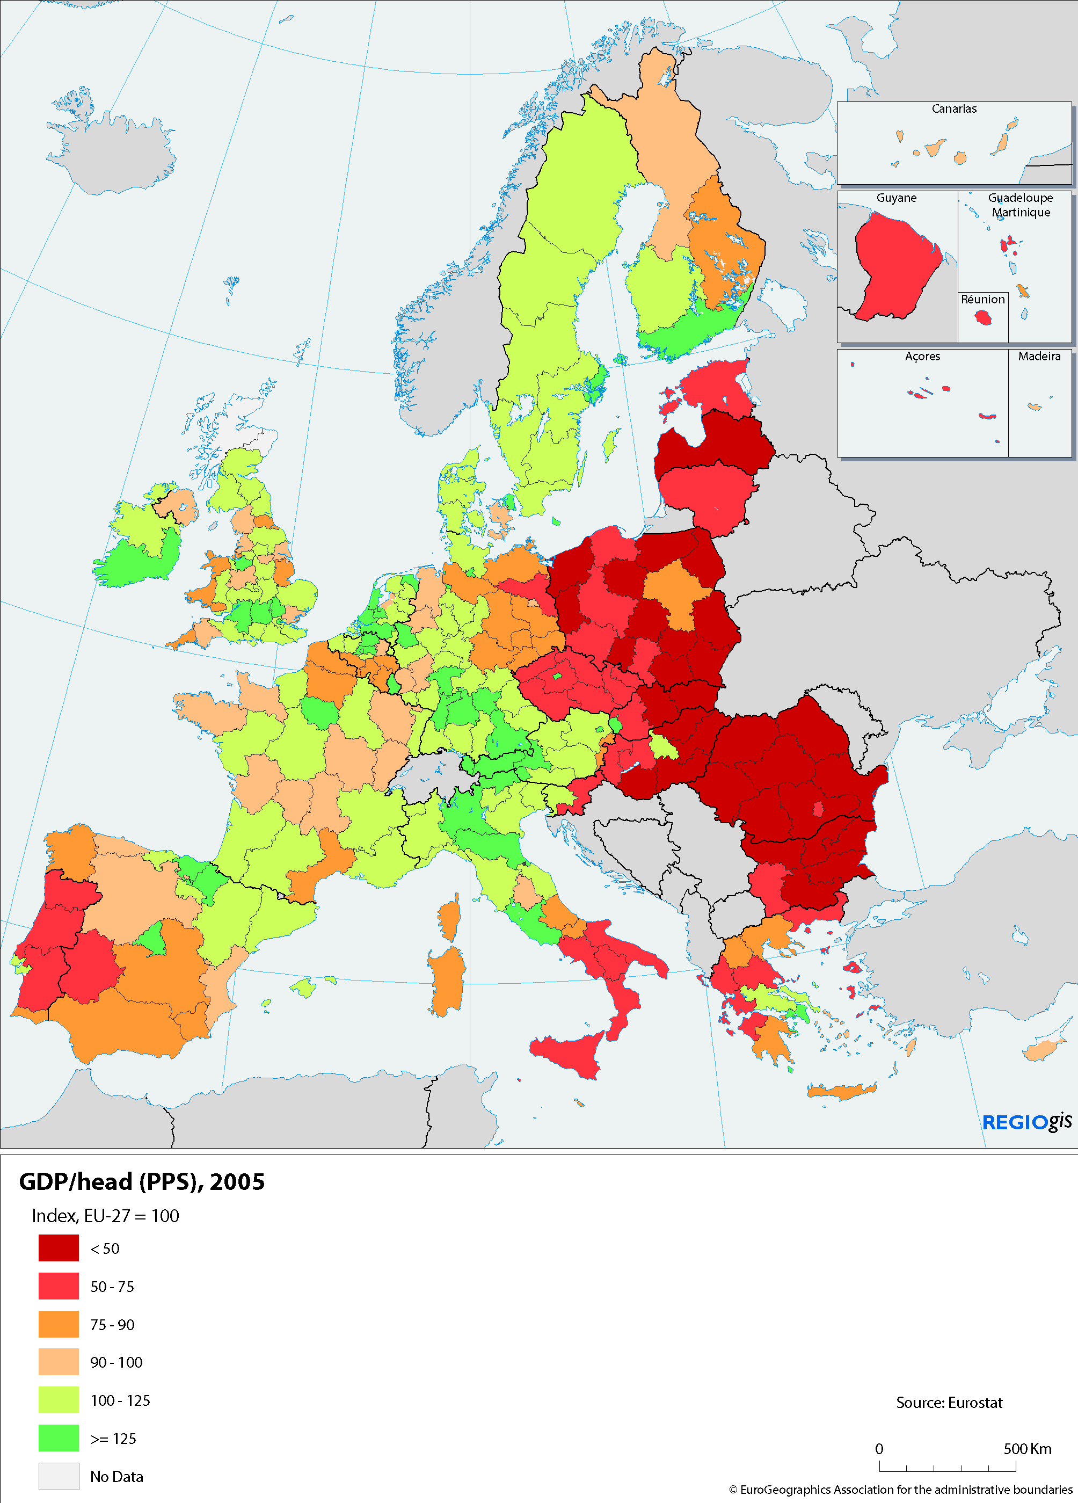

Globalisation indicators:
Regional labour productivity in 2020 (EU-27=100)
Regional employment rate in 2020 (EU-27=100)
High educational level of the workforce in 2020 (EU-27=100)
Low educational level of the workforce in 2020 (EU-27=100)

Demography indicators:
Regional share of people aged 65 and above in 2020 (% of total population)
Population decline between 2004-2020 (annual average % change)
Regional share of working age population in 2020 (% of total population)

Climate change indicators:
Climate Zones
Change in regional population affected by river floods
(% of total population), 2001-2100
Regional population in areas below 5m sea level
(% of regional population), 2001
Potential regional drought hazard, 1958-2001
(average number of days with soil moisture deficit)
Regional share of agriculture and fisheries in GVA, 2005
Regional share of employment in hotels and Restaurants
(% of total employment), 2005-2006

Energy challenge indicators:
Regional energy consumption of Households, 2006 estimates
(including private transport) (toe per inhabitant)
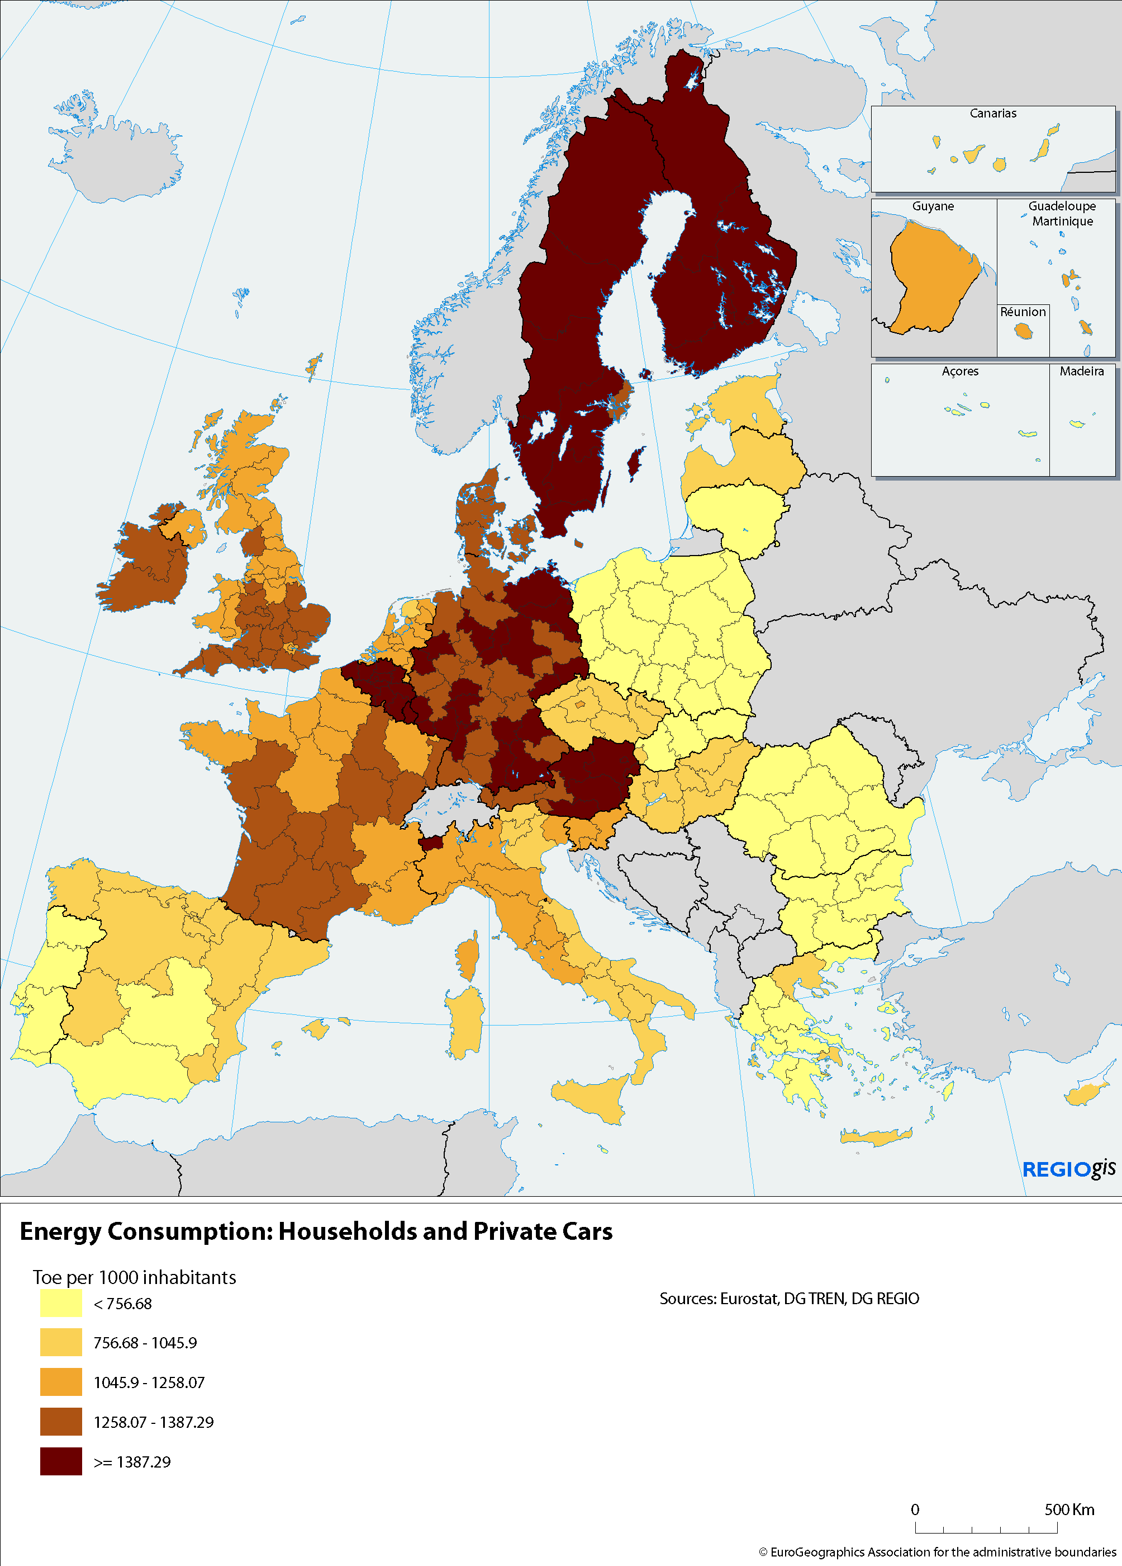
Regional energy consumption of
Industry, agriculture, services and freight Transport, 2006 estimates
(toe per 1000 euro of GDP)
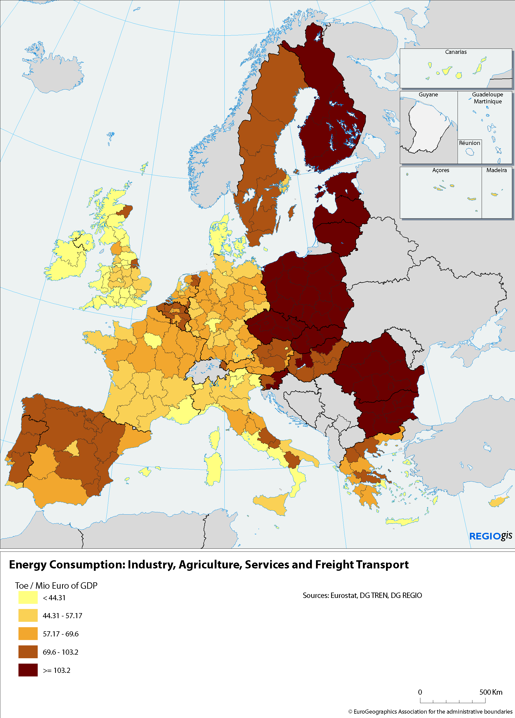
Energy import dependency (% of national gross inland consumption), 2006
Carbon content of gross inland energy consumption (CO2/TJ), 2006

Annex II: Impact matrices
The analysis of the impact of future challenges, i.e. globalisation, demographic change, climate change and energy, on regional disparities follows a logic which is laid down in the impact matrices. The variables for regional impact are: interregional disparities in growth potential, environmental sustainability and interregional social disparities. The logic is formulated in a qualitative way, but could equally - with the right methodological tools - be translated into a quantitative form, such as socioeconomic models and environmental assessment tools. The matrix also gives a qualitative assessment of the correlation for each variable selected, i.e. whether or not the variable is strongly linked to e.g. interregional disparities in growth potentials. The range is from "no clear link" to "+", and "++" as a strong impact. The signs do not show the direction of change, i.e. whether or not it is increasing, but merely the level of influence on the impacted regional variable.
Some of the impact variables overlap. High educational attainment of the workforce, for example, is just as important in terms of creating opportunities from the globalisation challenge as is minimizing the impacts of aging and a declining work force.

…and their  Impacts on  The drivers  of Challenges… |  | Interregional  Disparities in Growth Potentials | Environmental  Sustainability | Intraregional  Social disparities
Globalisation | Productivity | ++  Productivity of one of the key prerequisite to afford a high level competition in an open EU/World market | +  A fast growing economy may create phenomenon of agglomeration | No clear link
Globalisation | Education | ++  Education is key to growth potential | No clear link | ++  Education has a notable impact of social disparities
Globalisation | Employment | +  The link between employment and growth potentials may exist or not (e.g. there may be the case of a jobless growth) | No clear link | +  The link between employment and social disparities may exist or not (e.g. employment concentrated in few sectors may be irrelevant to social disparities).
Demographic change | Ageing | +  Population ageing may affect key drivers of regional growth such as productivity, investment and consumption.  Increasing age related infrastructural needs and access to them (health and long term care, housing…) constitute a challenge. | No clear link. | +  Poverty risks for persons aged 65 and above are high. Elderly people with low socio-economic status in deprived urban or peripheral rural areas are increasingly exposed at the risk of poverty and social exclusion.
Demographic change | Working-age population | ++  Shrinking labour force can constitute a drag on regional growth, dependent on the productivity of the labour force and participation rates. | No clear link | No clear link
Demographic change | Migration | +  Migrants' contribution to growth? – skills composition | No clear link | +  The impact will depend on the extent to which immigrants are integrated in the regional economy and society.
Demographic change | Rapidity of population decrease | ++  Very rapid population changes challenge existing infrastructure | +  Rapid population changes might challenge ecosystem | +  Poverty risk might increase for those remaining in areas of rapid decreases and for those not well integrated in areas with rapid increases
Climate Change | Vulnerable sectors (tourism, energy, agriculture and fisheries) | ++  Regions with a high concentration of sectors relying on natural resources and ecosystem services will be affected | ++  Regions with a high concentration of sectors relying on natural resources and ecosystem services will be affected | +  Regions with high dependency on vulnerable sectors have to face social costs of structural change or adaptation
Climate Change | Coastal erosion and flooding | + +  Affected areas might see assets and infrastructure destroyed | +++  Ecosystems are negatively affected | +  Population at risk of poverty face additional costs
Climate Change | Potential drought hazard | ++  Water dependent sectors will suffer | ++  Ecosystems are negatively affected | +  High water costs weigh more heavily on low income households
Energy challenge | Energy efficiency | ++  Vulnerability towards price shocks decreases with energy efficiency | ++  Growing efficiency reduces GHG emissions | +  Social costs of restructuring energy inefficient industries
Energy challenge | Energy consumption by households | No clear link | ++  GHG emissions correlated with levels of consumption | Households with higher levels of consumption and lower income more exposed to energy price changes
Energy challenge | Internal and external security of supply | ++  Vulnerability towards price shocks increases with  import dependency | No clear link | +  Low income households more vulnerable to energy price shocks
Energy challenge | Carbon intensity | ++  Competitiveness of carbon intensive regions with carbon pricing | +++  carbon intensive regions emit more GHG | +  Higher carbon prices might reduce purchasing power of low income households

Annex III: Methodological notes
The exercise represents a first attempt to analyse the pattern, characteristics, pressures and risks of challenges in their regional dimension, in order to identify potential regional disparities. The analysis identifies patterns and characteristics in an illustrative manner and ranks regions in terms of their exposure to the challenges across the EU. The scope of the analysis is limited by data availability and by methodological choices.
The projections of this analysis are not a forecast of what the situation will be, but of what it might be under a given set of assumptions. Of the many possible futures, the one which was judged the most plausible from a current point of view is selected.
The indices are based on different variables, which correspond to the key drivers of the challenges and reflect data availability. The variables seek to capture vulnerability according to exposure and adaptive capacity. Some indices are based on projected values (globalisation, demography, climate change); others use 2005 values for 2020 (energy). The latter is due to the structural or long-term nature of the driver concerned (for instance energy dependency). The indices summarise how regions score on the different variables (the values range from 0 to 100; the higher the value, the more the region is likely to be exposed to the given challenge).
The globalisation index is based on four variables, notably labour productivity in 2020, employment rate in 2020 and low and high educational attainment in 2020. Regional productivity and employment projections are based on DG ECFIN's long-term economic projections produced in 2005, the 2004-based Eurostat's regional population projection and on data regionalisation carried out in DG REGIO on the basis of regional trend projections using the current regional sectoral structure of GVA and employment and the changes over the past five to ten years at the national level. Educational level projections have been created using a cohort analysis of current regional education levels by five year age groups and changes over the past five years combined with Eurostat's regional population projections.
The demography index is based on three variables, notably the share of people aged 65 and above in 2020, population decline between 2005 and 2020 and the share of working-age population in 2020. All three indicators are derived from the 2004-based regional population projections produced by Eurostat. Regional data for France and the United Kingdom were calculated on the basis of data provided by national statistical institutes.
The climate change index is based on change in regional population affected by river floods between 2001 and 2100, regional population in areas below 5m in 2001, potential regional drought hazard (average number of days with soil moisture deficit based on the past 40 years), regional share of agriculture and fisheries in GVA in 2005, regional share of employment in hotels and restaurants (% of total employment) in 2005 taking into account the impact of climate change by climate zone.
The index draws from work from the IPCC, European Environmental Agency and the Joint Research Centre and includes long-term projections until 2100. However, these projections were used to describe the risks from the expected higher frequency of extreme weather events which will already start impacting on regional conditions in the short to medium run.
The energy index is based on four variables, notably regional energy consumption of households (including private transport) in 2004, regional energy consumption of industry, agriculture, services and freight transport in 2004, national energy import dependency in 2006, national carbon content of gross inland energy consumption in 2006. All four variables are based on current data. Since this index describes long-run behavioural conditions, which are strongly path dependent, (such as the energy mix of an economy and the consumption patterns and the development of energy efficiency) the index is unlikely to change dramatically between today and 2020.
The use of different data sources and projection methods, however, may create some consistency problems, despite efforts undertaken to minimize this effect. The analysis does not take into account dynamic aspects which occur, such as structural changes in regions which could substantially alter a region's position and risk status. Those dynamic changes are also the result of investments in the framework of Regional Policy. Therefore, the analysis does not prejudge the effects of Regional Policy in any way.
The prime data sources are Eurostat and the DG REGIO database. The decision to focus on NUTS 2 regions limits the analysis of certain geographical patterns of challenges, particularly in climate change, and also when focusing on social disparities. However, it is considered that it is the NUTS II level, where applicable, which represents an appropriate balance between detail and data availability.
Multiple Challenges
In order to illustrate the intensity of multiple challenges in more detail, a synthetic index has been developed. The index identifies how many challenges will affect each European region. It selects 50% of the regions most affected by each individual challenge. This step of the analysis gives some measure of the intensity of risk.
Each individual challenge index ranks regions according to their individual risk structure in relation to that challenge. This methodological choice means that the distributions of the indices remain relatively smooth and continuous, and thus sensitive to the selection of a cut-off point.
 | Region ranked among the "first 100" for…. | n° of  Regions | avg GDP  index (EU=100) | %pop  EU 27 | avg of the  4 index (1-100)
 | none of the 4 challenges | 28 | 131 | 11 | 21
 | 1 of the 4 challenges | 70 | 110 | 25 | 30
 | 2 of the 4 challenges | 78 | 89 | 29 | 41
 | 3 of the 4 challenges | 54 | 86 | 19 | 53
 | All 4 challenges | 37 | 84 | 16 | 66

