EN
COMMISSION OF THE EUROPEAN COMMUNITIES
Brussels, 13.11.2008
SEC(2008) 2869

COMMISSION STAFF WORKING DOCUMENT
accompanying the
GREEN PAPER
TOWARDS A SECURE, SUSTAINABLE AND COMPETITIVE EUROPEAN ENERGY NETWORK
OIL INFRASTRUCTURES
An assessment of the existing and planned oil infrastructures within and towards the EU
{COM(2008) 782 final}
COMMISSION STAFF WORKING DOCUMENT
OIL INFRASTRUCTURES
An assessment of the existing and planned oil infrastructures within and towards the EU
Introduction
In the next decades, due to the depletion of European indigenous resources, substantial quantities of crude oil will need to be imported into the EU through existing or new pipelines and/or via tankers. This situation raises concerns both in terms of security of supply and with regard to the environmental threat of tanker accidents in our seas.
The purpose of this document is to analyse the current and future possibilities for supplying oil to the European Union. This document provides an overview of the existing oil supply infrastructures towards and within the EU. An assessment of the feasibility of new pipelines in terms of their economic viability and their contribution to our objectives of security of supply and sustainable development is also provided.
The document is divided in the following five chapters:
- The present and future contribution of oil to the EU energy mix
- Internal oil market
- Supply infrastructures: ports, tankers, refineries and pipelines
- Chokepoints at world scale and in European waters (Baltic and Black seas)
- Conclusions
Crude oil pipelines are not included in the Guidelines for trans-European energy networks of 6 September 2006. The Commission's Legal Service has indicated however that no obstacles exist to the inclusion of oil infrastructures in the trans-European energy networks and the Council has previously indicated a willingness to consider Commission proposals in this respect.
In view of a revision of the Guidelines, a Green Paper on European energy networks will be adopted by the Commission in November 2008. The Green Paper assesses, inter alia, the need for including oil infrastructure, alongside gas and electricity networks, in the European Energy Networks.
1 The present and future contribution of oil to the EU energy mix
In 2006, oil and petroleum products covered 37% (673 million toe) of the EU27 primary energy demand of 1825 million toe (Mtoe). In the same year, our indigenous production of oil was 123 Mtoe, consequently 84% of our oil consumption was covered by imports.
The 2007 PRIMES Baseline Scenario, which takes into account policy initiatives implemented by the end of 2006 and assumes an oil price of 61$ per barrel in year 2005 $, indicates that by 2020 oil, with 702 Mtoe, will still represent more than 35% of our primary energy demand of 1968 Mtoe.
Therefore according to this scenario, in the next decade, oil will remain the main element of our energy mix, although its consumption in 2020 will exceed the current level only by approximately 5%. The Baseline Scenario also indicates that due to the progressive depletion of EU27 indigenous resources, only 53 Mtoe of oil will be produced in the EU in 2020. As a consequence, by that time, more than 90% of our oil consumption will be imported.
The PRIMES model has also been used to assess the impact of high oil prices (100 $ per barrel in year 2005 $) and new EU energy policy initiatives (beyond 2006) on our future energy requirements.
A scenario considering the effects of a high oil price (100 $ bbl (barrel)) compared to the baseline scenario has been produced. The impact of a high oil price in terms of oil demand and import is outlined in table 1. According to this high oil price scenario, a moderate decrease in oil demand (7.6%) in comparison with the baseline scenario could be expected by 2020. However, due to the progressive depletion of EU indigenous oil reserves, oil import requirements will increase in comparison to the 2005 level by more than 10%, to 651 Mtoe.
A further scenario "Energy Policy", which includes the impact of the new EU energy policy, has also been developed. The "Energy policy" scenario includes for example the objective by 2020 of:
- a 20% share of renewables in final energy demand including a sectoral objective of 10% of renewable energy in transport;
- a reduction in greenhouse gas emissions of 20% below the 1990 levels through energy policy measures;
EU27 Mtoe | 2005 | Baseline scenario, oil price 61$/bbl | Baseline scenario, oil price 100$/bbl | New Energy Policy scenario, oil price 61$/bbl | New Energy Policy scenario, oil price 100$/bbl
Primary Energy demand | 1811 | 1968 | 1903 | 1712 | 1672
Oil demand | 666 | 702 | 648 | 608 | 567
EU oil production | 133 | 53 | 53 | 53 | 52
EU net oil import | 590 | 707 | 651 | 610 | 569
Table 1 result of the PRIMES baseline and new energy policy scenario
- a 13% to 15% reduction in primary energy demand in 2020, compared to developments under a moderate oil price Baseline projection, which brings the EU a long way towards the 20% savings objective. The range provided for the reduction in the primary energy demand stems from the assumption regarding the oil price environment, with higher values corresponding to the "New Energy Policy" scenario with high oil prices.
In the Energy Policy Scenario, total primary energy demand will be reduced to 1672-1712 Mtoe by 2020, depending on the oil price. In particular, the demand for oil will be reduced to 567-608 Mtoe, which corresponds to a 9% to 15% decrease from the current level. However, due to the considerable reduction in EU indigenous oil production, more than 90% of our oil needs will still need to be imported.
Finally it should be remembered that modelling and scenario analysis involves many assumptions in terms of: oil and energy prices, inflation, GDP growth, population growth etc. and therefore cannot be taken as predictions. They can however help in assessing possible future developments of our energy needs and in deciding new policy initiatives.
Figure 1 indicates the main countries providing EU oil import in 2006. Since oil is a global commodity traded on international markets it will be extremely difficult to identify which will be the major source countries for European oil imports by 2020. However, it can be assumed that, considering the forecast increased contribution of OPEC to world oil consumption, a substantial amount of our additional requirements of oil would be met by increased supplies from OPEC countries.
Figure 1 EU 27 import of crude oil in 2006
All the EU countries with the exception of Denmark are net oil importers. The UK, which since the 1980s managed to cover its internal demand through its oil production in the North Sea, became in 2006 a net oil importer.
Some analysts suggest that new Member States, such as Romania, which holds the largest oil and gas reserves in Central Europe, have a considerable potential for additional oil production. However, in 2005, oil production in Romania was only 6 Mtoe with an internal consumption of more than 10 Mtoe. Therefore with its current oil production, Romania, which is also a mature oil region, is not in the position to alleviate EU oil import dependence.
The North Sea, which is by far the major oil producing region in the EU, is a mature oil and gas area in which production is declining. However, its field still hold a considerable amount of reserves and the North Sea production, including the EU and Norway, makes this region still the fourth in the world in terms of total oil and gas output (figure 2).
Notwithstanding the sovereignty of individual Member States over their hydrocarbon resources, the EU as a whole has an interest in continuation of hydrocarbon exploration and production in the North Sea and other EU producing areas, for security of supply reasons, creation of employment and promotion of EU service industry and technology.
The exploitation of indigenous oil resources in the EU is linked to technological progress and human resources expertise in Exploration and Production activities. The continuation of such technological progress and availability of human resources expertise in the EU would result in extending the lifetime of our oil fields through further increases in recovery rates from existing producing areas and discovery of new hydrocarbon reservoirs.
Figure 2 cumulative oil and gas production million barrels oil equivalent per day (Source BP Statistical Review 2007)
2 Internal oil market
The EU oil market has generally been considered as an open market where crude and refined products move smoothly and freely. Nevertheless, doubts have recently been raised as to whether legal, technical and logistic obstacles might prevent genuine free trade and circulation of crude and oil products.
For example one issue of particular concern is the limited connection between the pipeline networks of eastern and western Europe since the two systems are currently connected only through the Ingolstadt-Kralupy-Litinov pipeline (see chapter 3.2.2 on EU internal pipelines).
The Directorate General for Energy and Transport has launched a study "Survey of the competitive aspects of oil and oil product markets in the EU". The study is expected to be completed during 2009 and will provide an in depth analysis of various aspects of the internal market for oil and oil products in the EU.
The oil sector differs from other energy sectors in terms of storage, transmission and distribution since oil and its products can be transported and stored more easily and cheaply than gas and electricity.
In particular, transport and distribution of oil and refined products, both at a global scale and in the EU internal market, can be assured by many different competing infrastructures: pipelines, short-sea shipping, inland waterways, railways and road transportation.
Due to this multiple choice of transport options, in contrast to the electricity and gas markets, the oil sector has not been regulated by specific EU legislation on third party access (TPA) for transport and distribution. General EU competition rules apply however and have been used in a number of cases.
3 Supply infrastructures: ports, tankers, refineries and pipelines
3.1 Ports and tankers
Most of our imported oil, approximately 80%, is brought into the EU territory by tankers and only the remaining part arrives through two pipelines Druzhba and Norpipe (see chapter 3.3 on pipelines for details).
Most of the oil imported by tankers reaches the territory of the EU through a dozen major ports. Figure 3 indicates the major EU oil terminals, the quantity of oil imported is proportional to the size of the anchor.
The progressive depletion of EU indigenous oil reserves and the need for additional imports of oil, together with the predicted rise in international oil trade sea flows will generate an increasing density of maritime traffic in European waters in the years to come. This situation raises concerns with regard to environment, for example the increased pollutant emissions in our seas and ports and also the risk of tanker accidents.
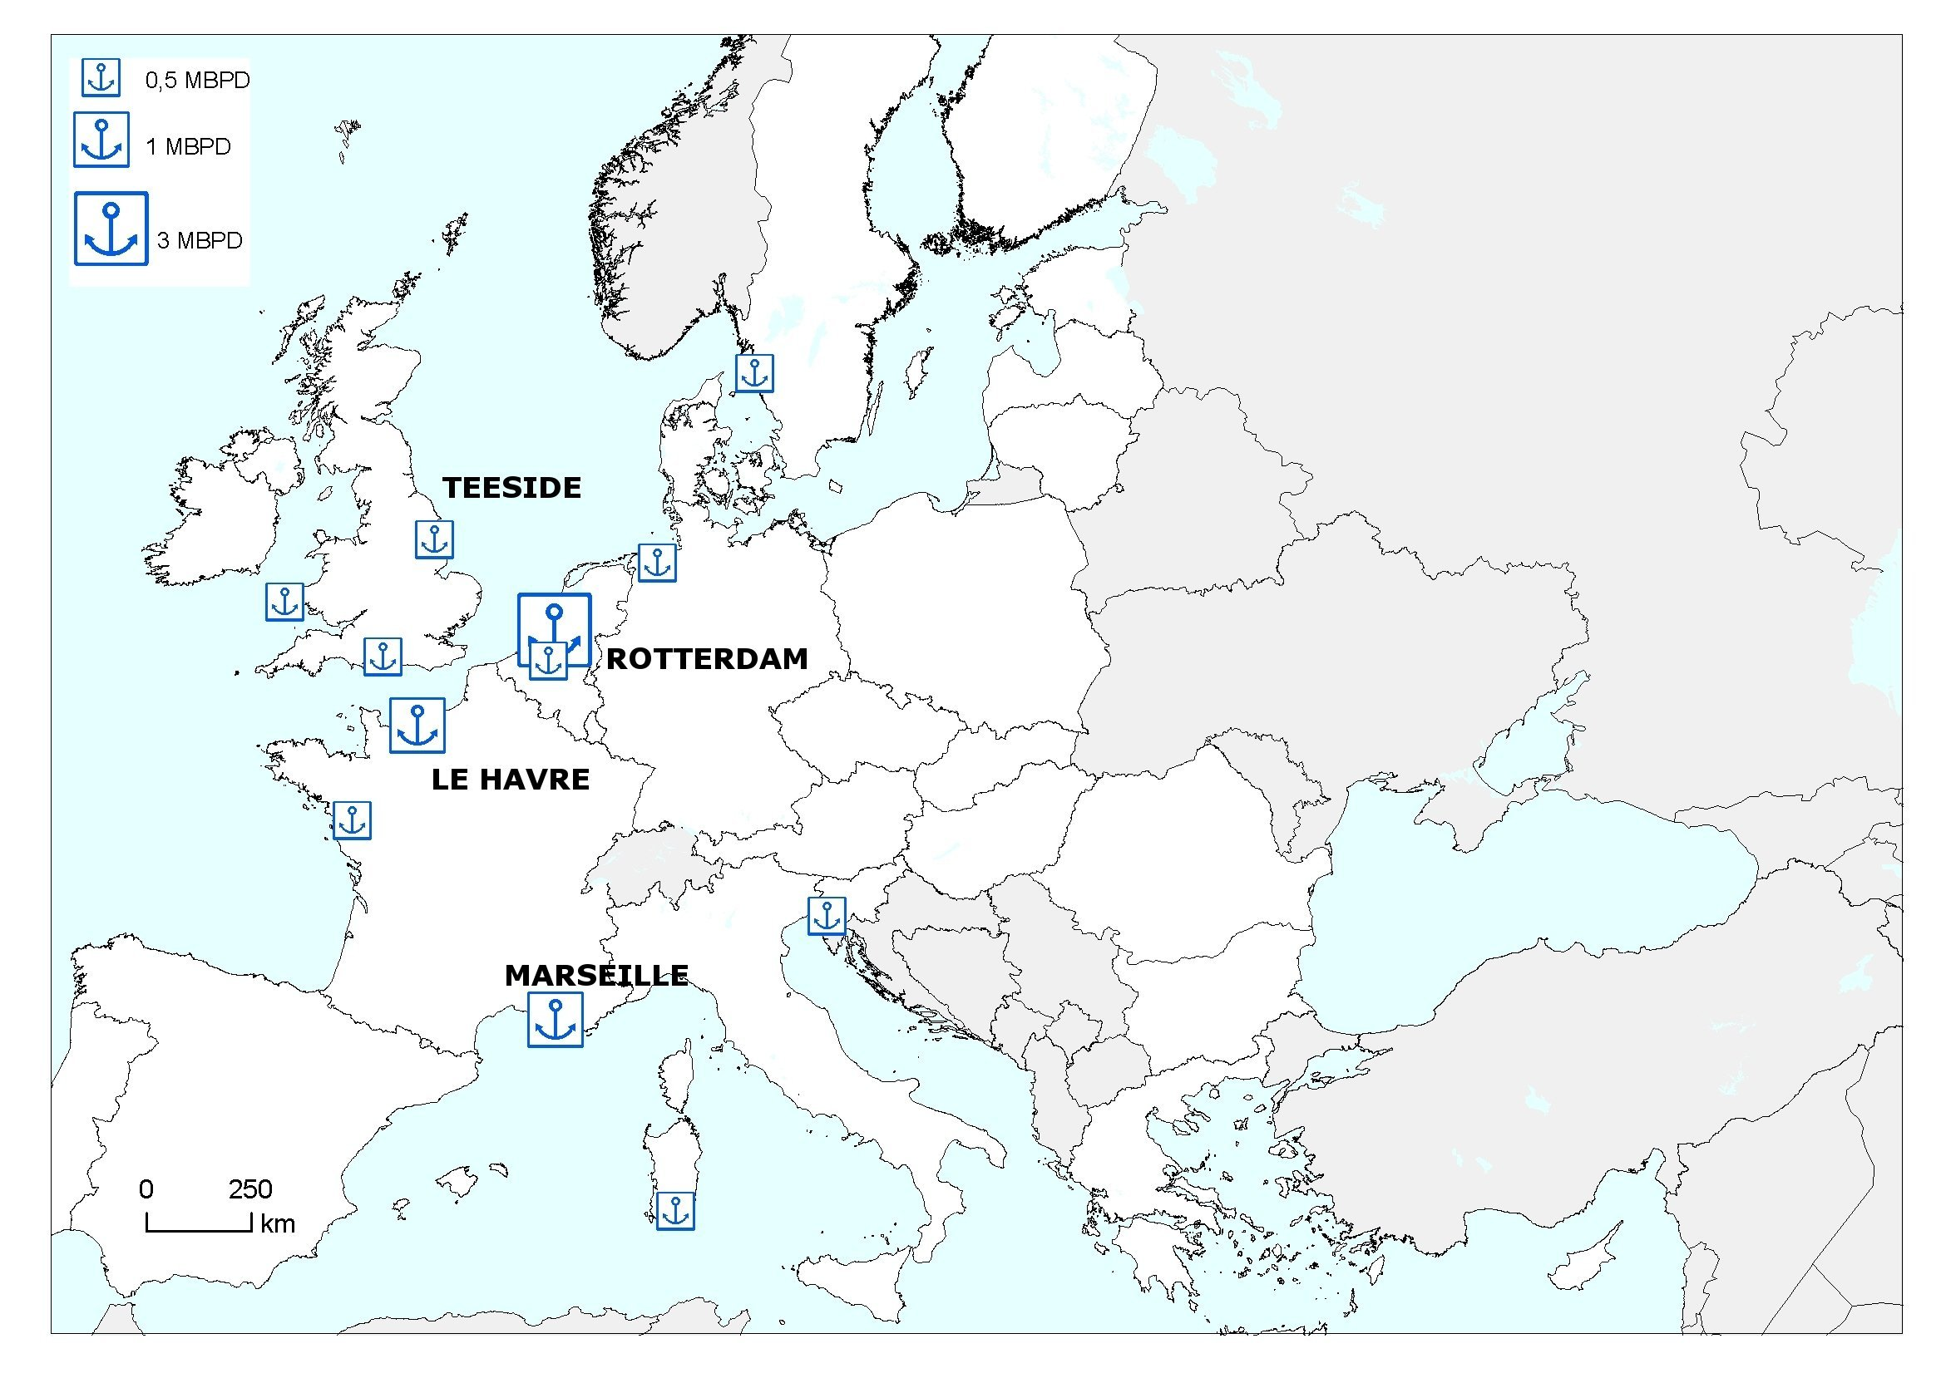
Figure 3 major ports and oil terminals in the EU
The Erika and Prestige accidents, and the environmental damage caused by the resulting oil spills highlighted the importance of the highest safety standards in maritime transport. The EU took robust action at European and international level through the accelerated phasing-out of single hull tankers, the detection and prosecution of polluters and the availability of pollution response means. The third maritime safety package currently under negotiation contains seven legislative proposals to further enhance quality shipping and combat sub-standard operators.
Beside tanker transport, new pipelines can provide alternative routes for imports of crude into the EU in the years to come. Chapter 3.3 provides an overview of existing and newly planned oil pipelines which are likely to influence oil supply to the EU in the years to come.
3.2 Refineries
Beside supply of crude oil from third countries, the EU also relies on international trade to balance its demand in refined products since its refining industry is characterised by overcapacity in production of gasoline and insufficient supply of diesel and other middle distillates. At the same time, in the US there is an oversupply of diesel and a shortage of gasoline. This situation makes both markets complementary and has generated a trade in refined products between the EU and the US. However, most of our diesel needs, not satisfied by the EU local production, are imported from the Russian Federation.
Since the 1980s and until recently, the refining industry at global scale has experienced a period of overcapacity and low profitability which has prevented investment in new plants. Therefore very limited new refinery capacity has been built in the US and the EU in the past twenty years.
However, in the past few years, a combination of demand growth and refinery capacity rationalisation has resulted in a tighter balance between refining capacity and demand for refined products. This tighter balance coupled with lack of investment in the past decades raised some concerns on future availability of refining capacity both in the EU and at global scale. This prompted the Commission to launch the "Study on oil refining and oil markets" which has analysed in detail the current situation and the likely development of the refining sector as well as its possible impact on oil prices.
The study was completed in November 2007 and its main outcomes were:
- until now the OECD countries accounted for most of the demand for refined products. The situation will change and in the future, developing countries will require massive amount of refined products. China for example is expected to increase its demand for oil products five fold by 2030;
- the structural deficit in diesel and excess production of gasoline in the EU will continue in the next years and will be exacerbated by the increased penetration of diesel vehicles. Industry will try to compensate with increase in international trade of refined products rather than with additional investments in new refining capacity. As a consequence, EU imports of diesel and other refined products from Russia and other areas are forecast to increase;
- in the next decades, in addition to increasing demand for refined products, important drivers of the refining sector would be: tighter fuels specification, new emissions trading schemes and taxation regimes for different products;
- Approximately 200 new refining projects have been announced globally which should lead to a capacity increase of 5 million barrels (Mbbl) per day by 2012. This amount will roughly satisfy additional demand by that time. However, by 2020 much more additional capacity is needed than is currently planned.
3.3 Pipelines
3.3.1 Existing pipelines from third countries
As indicated earlier, most of our imported oil, approximately 80%, is brought into the EU territory by tankers and only the remaining part arrives through two pipelines: Druzhba, which connects Russia to countries of Central & Eastern Europe, and Norpipe, an offshore trunk line linking Norwegian and British oil fields to the Teeside facilities in the UK.
Druzhba, the longest pipeline in the world (4000 km), was put in operation during the 1960s with the scope to supply oil to western regions of Former Soviet Union and countries of Central and Eastern Europe, members at that time of the Warsaw Pact.
The Druzhba pipeline (figure 4) begins in Tatarstan, southeastern Russia, where it collects oil from western Siberia, the Urals, and the Caspian Sea. It runs to Mozyr in Belarus, where it splits into a northern and a southern branch.
The northern branch crosses the remaining part of Belarus across Poland and Germany supplying the refineries of Płock, Schwedt and Leuna. In Schwedt the Druzhba pipeline is connected through the MVL pipeline to the German port of Rostock. In Poland the northern branch is connected by the Płock-Gdansk pipeline with the Polish oil terminal in Gdansk.
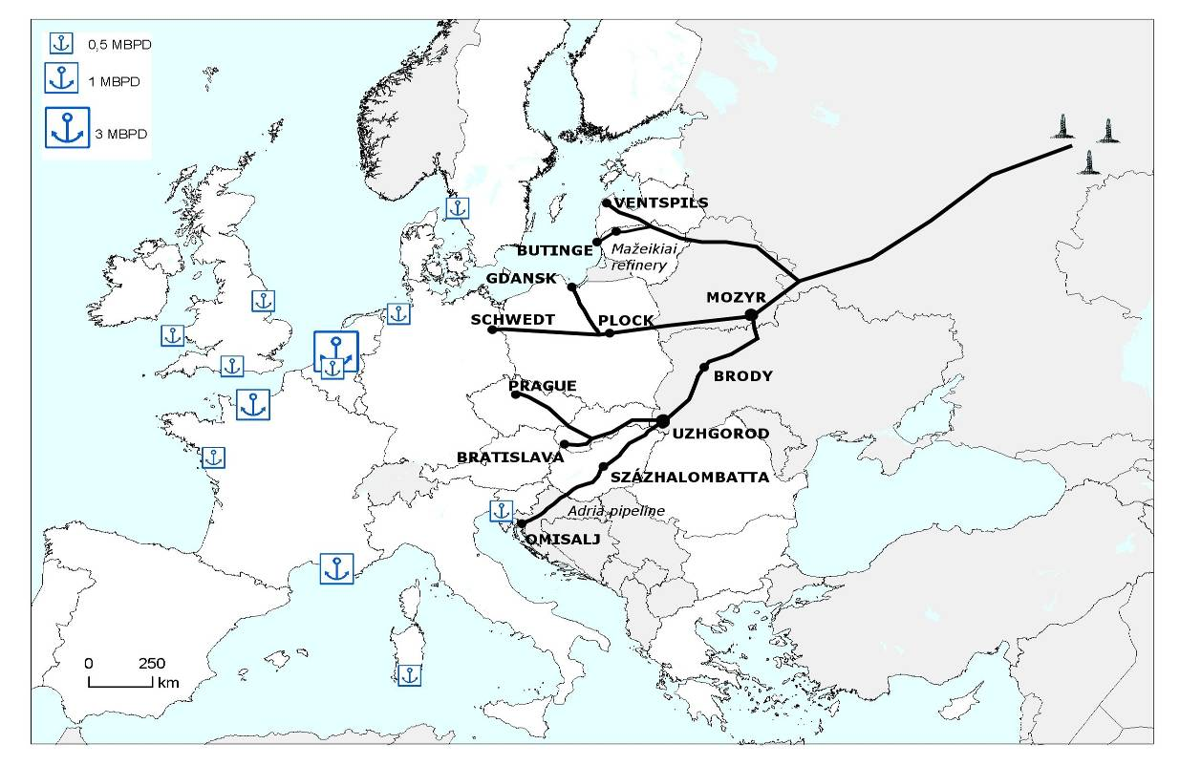
Figure 4 the Druzhba pipeline
The southern branch runs south through Ukraine, in Uzhgorod the pipeline splits into two lines one to Slovakia, Druzhba 1 and another to Százhalombatta in Hungary, Druzhba 2. Druzhba 2 is also connected through the Adria pipeline, from Százhalombatta in Hungary to the Adriatic port of Omisalj in Croatia.
In Brody, the Druzhba pipeline is also connected with the Odessa-Brody pipeline, (see later in the text) which is currently used to ship oil from the Druzhba pipeline to the port of Odessa in the Black Sea.
Within the territory of the Russian Federation, the main trunk of Druzhba has a spur line to the Mažeikiai refinery in Lithuania. From Mažeikiai, two additional branches connect with the oil terminals of Butinge in Lithuania and Ventspils in Latvia.
In 1997, with the objective of diversifying its export routes, Transneft started the construction of the Baltic Pipeline System (BPS), see figure 10. The BPS was completed in 2001 and in 2006 reached a capacity of 65 Mtons per year allowing Russia to divert oil, originally sent through the Druzhba and to the Mažeikiai refinery, to the Russian port of Primorsk.
The delivery of Russian crude to the Latvian port of Ventspils ceased in 2003. In 2006, noting some leaks on the Druzhba pipeline, Transneft stopped also the delivery of crude to the Lithuanian port of Butinge. Russia did not accept several offers to jointly evaluate the extent of the damage and to collaborate in the repairs. These decisions allowed Transneft to stop the delivery of oil to the Mažeikiai refinery and to the Baltic ports as well as to avoid the transit of part of its exports through the territory of Belarus and Ukraine. As a consequence, the full capacity of Druzhba of 100 Mtons per year is not utilized and the current flow is reduced to approximately 65-70 Mtons per year.
More recently, further to the January 2007 Russia-Belarus dispute on oil transit, the Russian Government approved in May 2007 the construction of the Baltic Pipeline System-2 (BPS-2) see figure 10. BPS-2 is a new pipeline with a transport capacity of 50-75 Mtons per year, to run from the Unecha junction of the Druzhba pipeline before the Russia-Belarus border to the Russian oil terminal of Ust-Luga (near Primorsk). The project also involves the enlargement of the Primorsk oil terminal to a capacity of 150 Mtons per year.
If implemented, the BPS-2 project will divert additional quantities of oil from Druzhba to Russian Baltic ports. This will lead to a big increase in tanker traffic in the environmentally sensitive Baltic area, which creates big concerns about the potential danger of accidents and oil spills (see also chapter 4 on chokepoints). In 2007, 171 Mtons of oil were transported through the Danish Straits, doubling the volume from 2000 (80 Mtons).
An additional concern is that if more oil is diverted from Druzhba to Primorsk, through BPS-2, a number of inland refineries, in Eastern Europe, currently fed through the Druzhba pipeline, will need to seek alternative and probably more expensive supply routes.
The 354 kilometres Norpipe oil pipeline starts in the Norwegian continental shelf, crosses British water and lands in Teeside in the UK (figure 5).
The 34 inch Norpipe oil pipeline carries oil from different Norwegian fields (Ekofisk, Eldfisk, Embla, Tor, Valhall, Hod, Ule Gyda and Tamber) as well as crude production from other offshore British fields.
The design capacity of the pipeline is 45 Mtons per year; however its flow rate is limited by the capacity of the receiving facilities in Teeside in the UK of 40 Mtons per year.
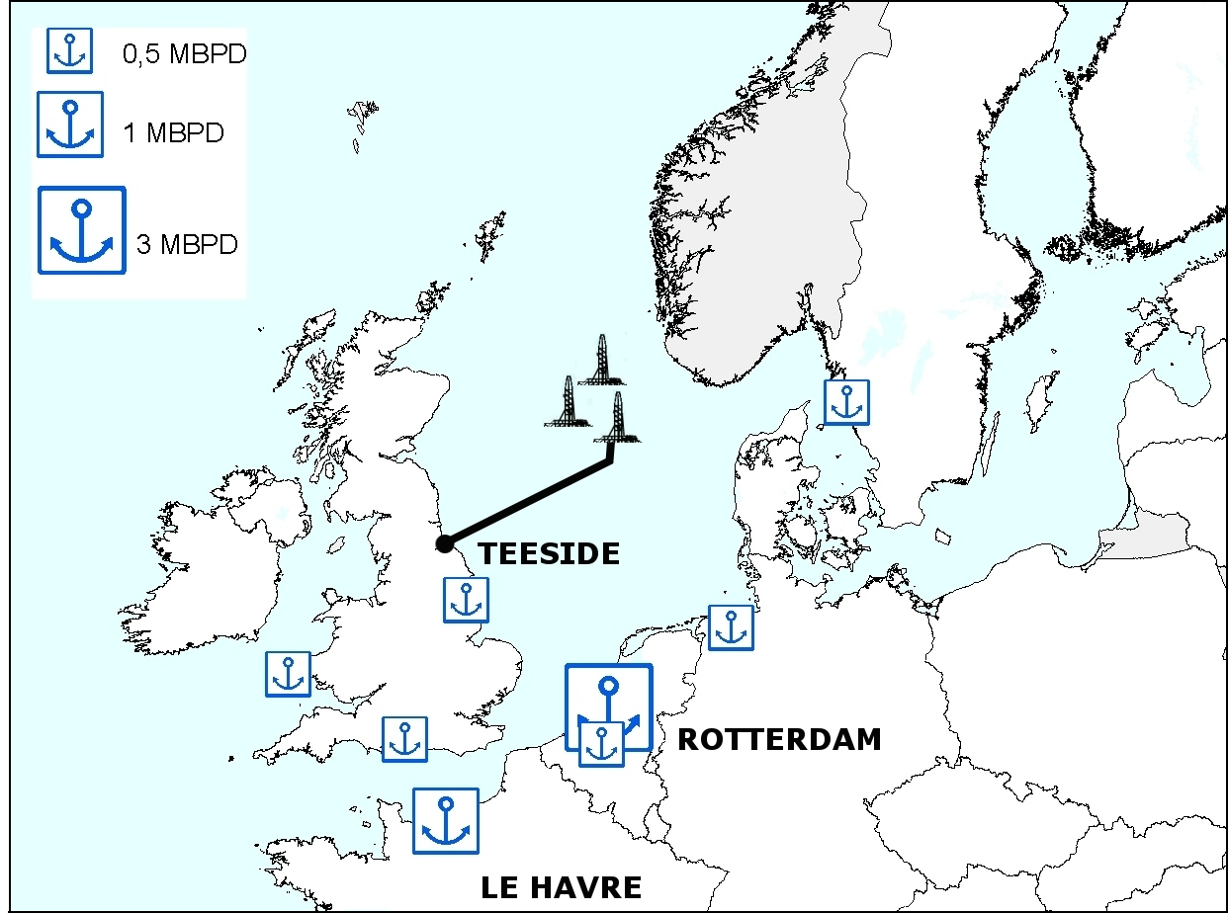
Figure 5 Norpipe Pipeline
3.3.2 Existing pipelines within the territory of the European Union
Beside pipelines which supply oil from third countries, the EU has a network which ensures transport and distribution of crude and oil products in its internal market.
Figure 6 is a map of the major pipelines in the central part of the territory of the EU. A full map is provided in annex 1. Owners of such pipelines are generally joint ventures of companies from the countries crossed by the infrastructure. For example, the Trans Alpine Pipeline (TAL), bringing oil from the Italian port of Trieste to Austria and Germany is owned by a consortium of companies from the three countries crossed by the pipelines.
Two other major internal oil pipelines are SPSE connecting the French port of Fos sur Mer to the French refinery of Feyzin and further up to the German refineries of Karlsruhe and Reichstett) and RAPL which connects Rotterdam, the biggest European oil terminal with Antwerpen and also to the German refinery of Wilhelmshaven.
Figure 6 Pipelines in territory of the EU and neighbouring countries
A major feature of EU internal pipeline networks is the limited connections between the western European pipeline network and the eastern infrastructures. This is a consequence of the fact that the eastern European pipeline network (an extension of the final part of the Druzhba pipeline) was conceived and built during the Cold War period and had, at that time, no pipeline link with the western network.
Currently the only pipeline connection between the eastern and the western EU oil networks is the Ingolstadt-Kralupy-Litinov (IKL) pipeline built in early 90s. An additional link between the eastern and the western part of the EU oil network, which has been discussed in the past few years, is the connection between the Bratislava and Schwechat near Vienna. This pipeline is only 60 kilometres long but faces major hurdles since it crosses environmentally sensitive areas and the Danube River.
An additional important feature of the internal EU oil network is that the western part is connected via pipeline to major European ports while most of the Central and Eastern Europe refineries are supplied through the Druzhba pipelines. If the Russian policy of redirecting its oil export from the Druzhba to Primorsk continues, Central European countries might face difficulties and increased costs for their supply of oil and oil products through alternative routes.
Another important network of pipelines is also managed by NATO which has operated its own pipeline systems since 1950. The NATO pipeline network comprises nine separate military storage, transport and distribution systems for oil products.
The biggest of the nine NATO systems is the Central Europe Pipeline System (CEPS) which manages 5.200 km of pipeline, 84 pump stations and 36 storage facilities with a capacity of 1.100.000 cubic meters of oil products.
3.3.3 New Pipelines and additional supply from the Caspian region
The Caspian region holds considerable amounts of oil reserves estimated to be in the same order of magnitude as the North Sea. Production from the Caspian countries will increase substantially in the next decades; Kazakhstan for example, plans to triple its oil production, from the current 75 Mtons per year, to 200 Mtons by 2030. This additional oil production will allow diversifying global and EU oil supply portfolio avoiding excessive dependence from a restricted number of suppliers.
However, due to the landlocked nature of the Caspian areas, its reserves are not easily accessible and transportation of crude to the international market will require construction of new oil pipeline(s) as the Turkish straits and the Baku-Tbilisi-Ceyhan (figure 7) will not be able to transit the future additional oil. If such pipelines are not built, Caspian oil producing countries will look for alternatives oil routes for example towards eastern markets. Swaps of Caspian oil are already taking place with Iran.
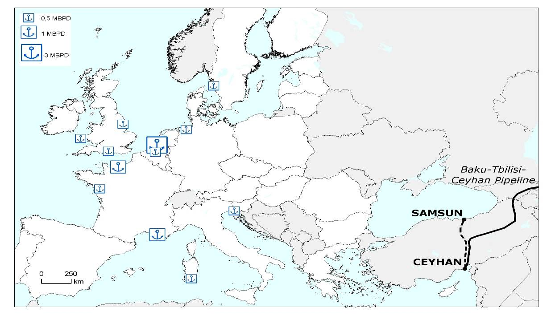
Figure 7 Samsun CeyhanPipeline
A number of pipeline projects have been proposed for bringing additional Caspian oil production to the international market: the Samsun-Ceyhan (figure 7), the Burgas-Alexandropoulos, the Burgas-Vlore, the Constanta-Trieste and the Odessa-Brody-Plock (figure 8).
Beside the advantage of bypassing the Turkish Straits, all these projects would permit a geographical diversification of routes as well as sources to the EU and to the international market. Of the following projects, the Constanta-Trieste (PEOP) and the Odessa-Brody-Plock pipelines offer the advantage of being directly connected to the EU’s internal oil network. 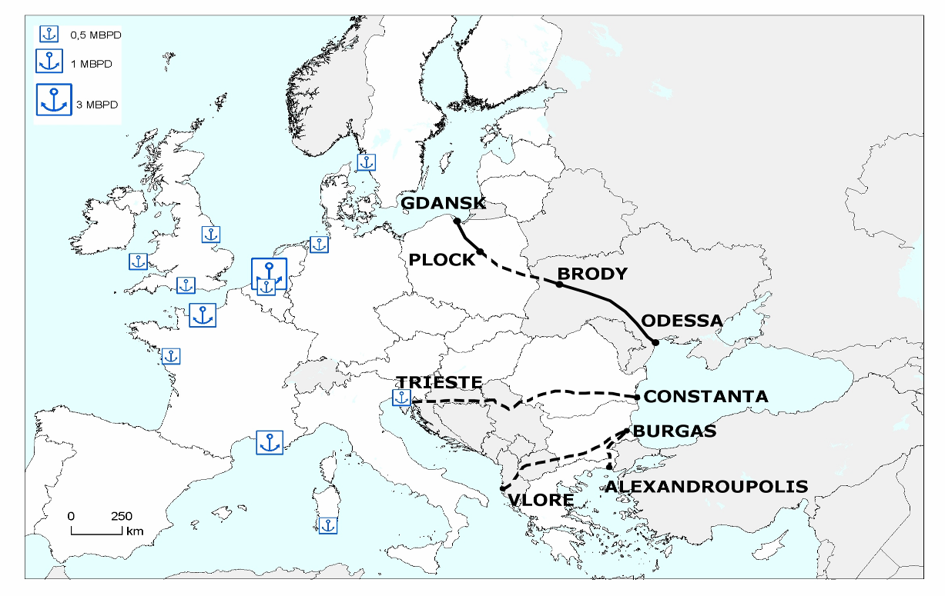
Figure 8 Planned pipelines
Samsun-Ceyhan: also known as Trans-Anatolian Pipeline (TAP), is a crude oil pipeline between Samsun in the Black Sea and the Mediterranean oil terminal of Ceyhan in Turkey (figure 7). In its final part, the pipeline will follow the existing Baku-Tbilisi-Ceyhan pipeline’s route.
The project was conceived in 2003, when Italy’s energy company Eni studied different oil export routes from the Caspian area. On 26 September 2005, Eni and Çalık Enerji signed a Memorandum of Understanding for the project. On June 2008 the promoters completed the Front End Engineering and Design (FEED) of the project.
The planned cost of the pipeline is $1.5 - 2 billion. The 555 km pipeline will be built by TAPCO, a company owned by Eni and Çalik. It will initially transport 50 Mtons of oil per year (1 Mbpd) with the possibility of expansion to 75 Mtons at a later stage.
The project includes a new terminal close to Samsun, a pipeline from Samsun to Ceyhan, and additional storage capacity in Ceyhan. When completed, the pipeline will give Turkey, and its Ceyhan terminal, a strategic role in the export of oil from the Caspian area to the international market.
Burgas-Alexandropoulis Pipeline (BAP): the project to build a 280 kilometre oil pipeline linking the Bulgarian Black Sea port of Burgas with Alexandroupolis on the Mediterranean coast of Greece was first considered in 1994. The project has been discussed for many years: on 12 April 2005, Russia, Greece, and Bulgaria signed a memorandum of understanding, on 15 March 2007 the agreement on the construction of the oil pipeline was signed and in December 2007, Russian President Putin and Greek premier Karamanlis signed the agreement to form a company for the development of the BAP pipeline.
The annual capacity should initially be some 35 Mtons and later should grow to 50 Mtons per year
The main advantages of BAP compared to other proposed projects in the area is that it is the shortest and cheapest route to bypass the Turkish Straits and its construction does not seem to raise major environmental concerns. Moreover with the recent increases in oil tanker fees and possible long waiting times in the Turkish Straits, the financial viability of this pipeline seems to be guaranteed. Like the Samsun-Ceyhan pipeline, it would be designed to serve the international market.
The ownership of the pipeline involves three Russian companies (Transneft, Rosneft and Gazprom Neft) which will together have a 51% stake in the project, with Bulgarian and Greek companies each holding 24.5% stakes. If the pipeline is completed, it will represent the first transport pipeline in the territory of the EU controlled by a Russian consortium.
Albania-Macedonia-Bulgaria pipeline (AMBO): this planned, 900 kilometres (35 Mtons per year) pipeline connects the Bulgarian Black Sea port of Burgas with the Albanian Adriatic port of Vlore, allowing exports of Russian and Caspian oil via the Adriatic Sea to the international market.
The AMBO pipeline would be longer and more expensive than BAP. Its promoters have however indicated that with a throughput tariff of $1.33 per barrel, it would be economically viable. Such a tariff is competitive with current tanker transport fees, particularly considering the risk of waiting time in the Turkish Straits. Unlikely the BAP, the consortium for the construction of AMBO is a US registered company owned by private investors.
An important advantage is that this pipeline will reduce tanker traffic and the possibility of related accidents, not only in the Turkish Straits but also in the Aegean Sea.
Constanta-Trieste (PEOP): the Constanta - Trieste oil pipeline also called Pan European Oil Pipeline (PEOP) would run from the Black Sea port of Constanta to the oil hub of Trieste in Italy, through Romania, Serbia, Croatia, Slovenia and Italy. On 3 April 2007, a ministerial declaration on next steps to build the pipeline was signed by Ministers of the concerned countries and Commissioner Piebalgs in Zagreb.
The capacity of the 1.400 km pipeline is expected to be approximately 60 Mtons per year (1.2 Mbbl per day). Besides creating an alternative route for exporting oil from the Caspian basin, a major advantage of this pipeline for EU security of supply is that, it will be connected at its end to the Trans Alpine Pipeline feeding oil to Italy, Austria, Germany and the Czech Republic.
A further advantage is that this pipeline could substantially reduce tanker traffic not only in the Turkish Straits and the Mediterranean but also in the environmentally sensitive Adriatic Sea.
While Serbia, Romania and Croatia strongly support the project, the position of Slovenia remains to be confirmed since part of the pipeline route would cross environmentally sensitive karst areas in this country. In addition, Slovenia has limited interest in additional oil supply/transit as the country has no refinery. An option to circumvent Slovenia (subsea) has been mentioned as more costly but feasible.
An Interstate Committee for PEOP, in which the Commission participates, has been created and meets regularly. On 22 April 2007 in Bucharest, the companies involved in the creation of a "Project Development Company" signed a shareholders' agreement.
Odessa-Brody-Plock: In 2001, Ukraine built the Odessa-Brody pipeline with the purpose of supplying oil from the Caspian region countries to the EU. However, so far, the pipeline has been used "in reverse mode" to transport Russian oil to the Black Sea port of Odessa. During 2007, approximately 9 Mtons of oil were transported from Brody to Odessa.
If reversed and extended from Brody to Plock (the main Polish refinery), this pipeline will enhance the EU’s energy security by facilitating Caspian oil supplies to the EU (particularly to Poland, the Baltic States, Slovakia and the Czech Republic) through Ukraine bypassing both the congested Turkish Straits and the Russian pipeline network. It would also further promote the integration of Ukraine into the EU’s internal energy market.
The EU support for the pipeline has included: a €2 million TACIS technical assistance project, including the completion of a Framework Business Plan for the extension of the Odessa-Brody pipeline to Plock in Poland. The Business Plan, which was presented on 12 January 2007, demonstrated a business case for the project.
On 10 October 2007 in Vilnius, Poland, Ukraine, Lithuania, Georgia and Azerbaijan signed an inter-governmental agreement to create a new joint venture "Sarmatia LTD" for the implementation of the pipeline extension. The Samartia joint venture launched a new feasibility study for the implementation of the Odessa-Brody-Plock-Gdansk pipeline.
A follow-up Energy Security Summit was held on 22-23 May 2008 in Kiev. The participants reiterated their political support for the practical implementation of the Odessa-Brody-Plock-Gdansk project by the signing of a Joint Statement. The need to modernise the under-utilised Ukrainian refinery system in order to be able to process the Caspian oil and make the Odessa-Brody-Plock-Gdansk project profitable was also discussed. Discussions will continue at the Summit planned at the end of 2008 in Azerbaijan.
One specific problem concerning transit of Caspian oil through the Odessa-Brody pipeline and then into the Druzhba pipeline to the EU is the need to avoid the mixing of different oil qualities as for example Caspian light oil and Russian export blend. In order to avoid such mixing, it is proposed to alternate the pumping of either type of oil. Discussions are ongoing with the Slovakian pipeline operator Transpetrol to perform pumping tests.
4 Chokepoints at world scale and in European waters (Baltic and Black seas)
Chokepoints are narrow channels used for transit of large volumes of international sea trade including oil. The concerns related to chokepoints can be different: geopolitical in the case of transit through potentially unstable areas, environmental and in particular in relation to damage from an accident, economic if transit through a chokepoint requires long waiting times, security in connection to possible terrorist attack etc...
Chokepoints (figure 9) therefore represent critical bottlenecks in the energy transport network since they transit high volumes of crude and products and the impact of interruptions of transit through them would affect severely the global oil market.
The Strait of Hormuz leading out of the Persian Gulf, the Strait of Malacca linking the Indian and the Pacific Oceans are the world’s most strategically important chokepoints. Other important passages are: Bab el-Mandab which connects the Arabian and the Red Sea, the Panama Canal connecting the Pacific and Atlantic Oceans, the Suez Canal and the Sumed Pipeline linking the Mediterranean with the Red Sea, the Baltic Sea and the Turkish Straits joining the Black Sea to the Mediterranean.
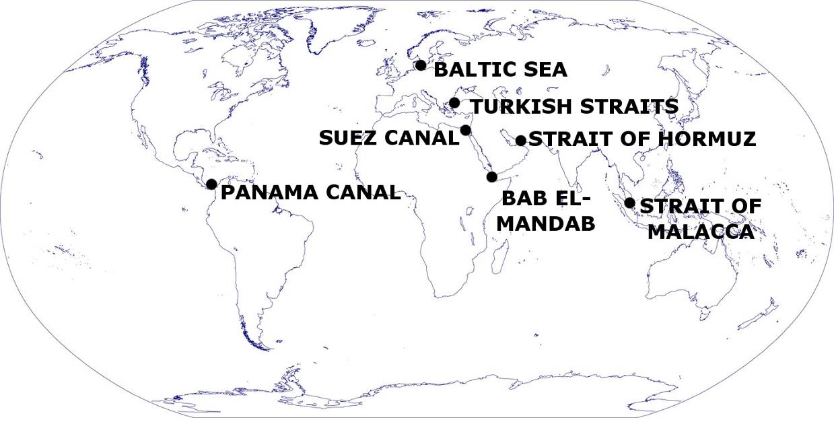
Figure 9 World chokepoints
In 2007, approximately half of the total world oil production of 86 Mbpd was moved by tankers on maritime routes. As the global oil market is dependent upon secure and reliable transport, the blockage of a chokepoint, even temporary, will result in supply disruptions with consequence including substantial increases in oil prices. A shipping accident through a chokepoint, besides the negative effect on oil supply and prices, can also have a disastrous environmental impact in case of oil spills or ship wrecks.
In conclusion, problems at chokepoints even in remote areas such as the Persian Gulf will have an impact on oil supply to the EU since oil is a commodity which is traded and exchanged on global market.
A description of the major chokepoints, on a global scale, is in annex 2. Two chokepoints located along the border of the EU, the Baltic Sea and the Turkish Straits, are described in the following chapters.
Baltic Sea
The Baltic Sea today is one of the busiest seas in the world, accounting for more than 15% of the world’s cargo transportation. Each month 3,500-5,000 ships cross the waters of the Baltic Sea. Approximately 17-25% of these ships are tankers transporting approximately 170 million tonnes of oil a year.
With the expansion of the transport capacity of the Baltic Pipeline System (BTS in figue 10) to 65 Mtons per year in 2006 and the planned construction of the Baltic Pipeline System 2 (BTS-2 in figure 10), tanker traffic in the environmentally sensitive Baltic area is going to increase substantially. It is expected that by building the Baltic Pipelines System 2, Russia will be able to increase its export capacity from the Primorsk and Ust-Luga oil terminals to approximately 150 Mtons per year.
Through the construction of the proposed Baltic Pipeline System 2, Russia will divert oil from the Druzhba pipeline to its Baltic ports. Doing that, Russia will have the opportunity to bypass a number of transit countries and to deliver oil cargo from its Baltic ports (Primorsk and Ust-Luga) not only to European clients but also to the wider international market.
All the Baltic littoral states, except Russia, have expressed on various occasions and in different fora their concerns about the Baltic Pipeline System 2 as an oil spill or a tanker accident in the area will have severe, some experts argue irrecoverable, environmental repercussions.
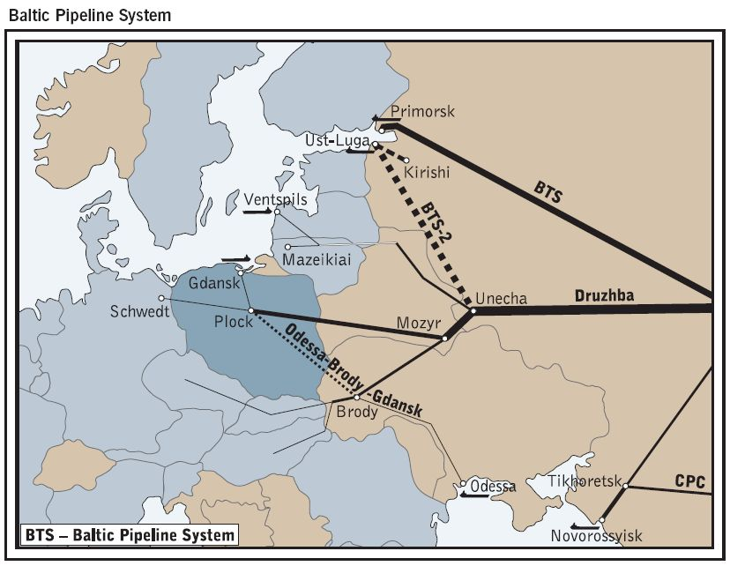e
Figure 10 Baltic Pipeline System (BTS) and proposed Baltic Pipeline System 2 (BTS-2)
Turkish Straits (Bosphorus and Dardanelles)
The Turkish Straits comprise the Bosphorus and Dardanelles and divide Asia from Europe. The Bosphorus connects the Black Sea with the Sea of Marmara, and the Dardanelles link the Sea of Marmara with the Aegean Sea.
Less than a kilometre wide at their narrowest point, the Turkish Straits are one of the world's most difficult waterways to navigate, due to their sinuous geography. With 50,000 vessels, including 5,500 oil tankers, passing through the straits annually, they are one of the world’s busiest and most dangerous chokepoints.
In 2006, oil shipments through the Turkish Straits were 2.4 Mbbl per day (120 Mtons per year). In 2007, some 1,200 tankers, totalling 135 m deadweight tons, of Panamax size and larger, along with a large number of smaller tankers, passed through the Turkish Straits. Unless alternative pipeline routes are built (see chapter 3.3), traffic through the Straits is expected to increase to an unsustainable level as Azerbaijan and Kazakhstan plan to increase substantially their crude production and exports in the future.
On different occasions, Turkey has raised concerns over the navigational safety and environmental threats to the Straits. Commercial shipping has the right of free passage through the Turkish Straits but Turkey claims the right to impose regulations for safety and environmental reasons.
5 Conclusions
The PRIMES Baseline scenario as well alternative energy policy scenarios which include the impact of high oil prices and the implementation of the new EU energy policy indicate that oil will still be the main element of our energy mix in 2020.
Moreover by 2020, due to the decline in North Sea oil production, approximately 90% of EU27 oil consumption will be imported from third countries. However, if planned energy and climate policies are successfully implemented (energy policy scenario), by 2020 oil imports in absolute quantity would be only slightly above levels of 2005. If oil prices were to return to 100 $ per barrel, in addition to assuming the implementation of the new Energy Policy, the net imports would be slightly lower than in 2005.
This note has analysed the existing and planned oil infrastructures within and towards the EU. Currently most oil arrives in the EU via ports and tankers. Due to the depletion of EU indigenous resources and the expected increase in international oil sea trade, increased tanker traffic is expected in European waters in the next decades. Such an increase raises concerns for the environment in relation to greenhouse gas emissions, air quality, oil spills and possible accidents; particularly in environmentally sensitive areas such as the Baltic and Black seas. Additional concerns exist about the risk of supply disruption should one of these transit routes be blocked.
Construction of new pipelines can provide environmentally viable alternatives to increased tanker transportation as well as a contribution to security of supply through new diversified routes. While the construction of new pipelines should be left to the private sector, consideration should be given as to whether complementary initiatives can help the development of such new infrastructures where they are of specific interest for the EU’s security of energy supplies.
A number of initiatives at different stage of advancement are listed hereafter:
- Assessment of the results of the study "Survey of the competitive aspects of oil and oil product markets in the EU" which are expected during 2009. The study will provide a thorough analysis of the functioning of the internal market for oil and oil products and should indicate whether new policy measures are required.
- While different pipeline options to bring oil to the EU have been individually assessed by promoters, an overall comparison of the pros and cons of different pipeline options is missing. A study to enable an independent comparison of the different options should be therefore considered, including the comparison with possible new ship routes and corresponding infrastructure. The study should pay attention not only to security of supply issues but also to all environmental threats for both – maritime and pipeline transport. Particular attention should be given to EU waters and particularly the Baltic, Black and Mediterranean seas. The study should make it possible to prioritise the projects, as it seems that at least some of them would compete for the same oil.
- To develop an oil dimension in the Energy Community. This proposal was on the agenda of Energy Community Ministerial Council in June 2008. This issue is highly relevant given that Contracting Parties of the Energy Community are supplied for most of their oil via the Adriatic Sea and the Danube River, supply routes which represent in some cases a high cost associated to an environmental risk. The Meeting Conclusions of the Energy Community Ministerial Council of 27 June 2008 included a specific point on the development of an oil dimension within the Community, including a request to the Secretariat to prepare a draft in view of a possible decision at the following Ministerial Council Meeting on December 2008.
- The possibility of inclusion of oil infrastructure in the Trans-European Energy network should be considered. Even if the limited budget provision available for trans-European Energy Network (TEN-E) projects is not likely to have a financial impact on the execution of new projects, the inclusion of strategic projects in the guidelines will encourage political support for such projects.
- The assessment of the effectiveness of environmental policy tools in taking into full account the impact of oil transport infrastructure on the environment, in relation to maritime transport (including ports and terminals) as well as the pipeline transport (including construction of new pipelines).
- The issue of oil transportation and supply should be kept under review in relevant Committees and bodies, as for example the Berlin Fossil Fuel Forum and the Oil Supply Group.
- Energy Dialogues with major oil suppliers (OPEC, Gulf Cooperation Council, Mediterranean countries, Norway, EU-Russia Energy Dialogue etc...) should pay attention to the issue of oil transportation and supply.
Annex 1
Annex 2
Chokepoints
Strait of Hormuz
The Strait of Hormuz (figure 11) is by far the world’s most important chokepoint with an oil flow of approximately 17 Mbbl per day (850 Mtons per year) in 2006. It connects the Persian Gulf with the Gulf of Oman and the Arabian Sea.
At its narrowest point the Strait is 34 kilometres wide, and consists of two 1.6 km wide channels for inbound and outbound tanker traffic.
The majority of oil exported from the Strait of Hormuz is shipped to Asia, the United States, and Western Europe. Most of the crude exported through the strait travels long distances by Very Large Crude Carriers (VLCC) which can carry over 200.000 tons of oil.
Closure of the Strait of Hormuz would require use of longer alternate routes with increased times and transportation costs. Alternate routes include the 1200 km long Petroline, also known as the East-West Pipeline, across Saudi Arabia which has a capacity to move 250 Mtons per year. Other alternate routes could include the deactivated 82 Mtons per year Iraqi Pipeline across Saudi Arabia (IPSA), and the 25 Mtons per year Tapline to Lebanon. Oil could also be pumped north from Iraq to the Ceyhan oil terminal in Turkey.
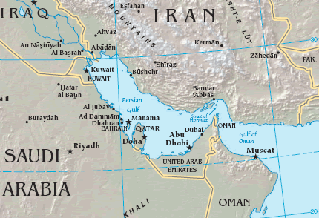
Figure 11 Strait of Hormuz
Strait of Malacca
The Strait of Malacca (figure 12), located between Indonesia, Malaysia, and Singapore, links the Indian Ocean to the South China Sea and Pacific Ocean. Malacca is the shortest sea route between Persian Gulf suppliers and the Asian consumers. It is the key chokepoint in Asia with an estimated flow of 750 Mtons during 2006.
At its narrowest point in the Phillips Channel of the Singapore Strait, Malacca is only 2.7 km wide creating a natural bottleneck, as well as potential for collisions, grounding, or oil spills.
Over 50,000 vessels transit the Strait of Malacca per year. If the Strait were blocked, transiting tankers would be required to reroute around the Indonesian archipelago through Lombok Strait, located between the islands of Bali and Lombok, or the Sunda Strait, located between Java and Sumatra. In 2007, Malaysian, Indonesian and Saudi companies signed a contract to build a $7 billion pipeline across the north of Malaysia and southern border of Thailand to reduce the tanker traffic through the Strait of Malacca. 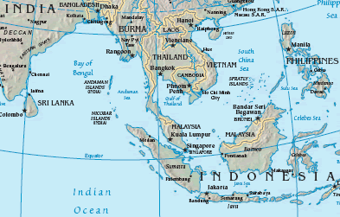
Figure 12 Strait of Malacca
Suez Canal
The Suez Canal (figure 13) is located in Egypt, and connects the Red Sea and Gulf of Suez with the Mediterranean Sea. Oil shipments from the Persian Gulf travel through the Canal primarily to European ports, but also to the United States. In 2006, an estimated 200 Mtons per year of oil flowed northbound through the Suez Canal to the Mediterranean, while 30 Mtons travelled southbound into the Red Sea.
Over 3,000 oil tankers pass through the Suez Canal annually, and represent around 25% of the Canal’s total revenues. With only 300 meters at its narrowest point, the Canal is unable to handle large tankers. The Suez Canal Authority has discussed widening and deepening the Canal to accommodate VLCCs and Ultra Large Crude Carriers (ULCC).
The 320 km long Sumed Pipeline, or Suez-Mediterranean Pipeline, also provides a route between the Red and Mediterranean Seas by crossing the northern region of Egypt from the Ain Sukhna to the Sidi Kerir Terminal. The pipeline provides an alternative to the Suez Canal, and can transport 155 Mtons of oil per year. In 2006, nearly all of Saudi Arabia’s northbound shipments (approximately 115 Mtons per year of crude) were transported through the Sumed pipeline. The pipeline is owned by Arab Petroleum Pipeline Co., a joint venture between EGPC, Saudi Aramco, Abu Dhabi’s ADNOC, and Kuwaiti companies.
Closure of the Suez Canal and the Sumed Pipeline would divert tankers around the Cape of Good Hope, adding 9600 kilometres to the transit route. 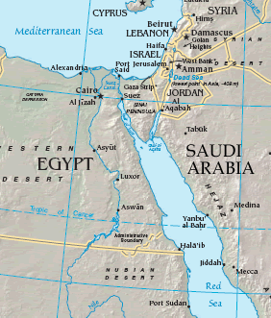
Figure 13 Suez Canal
Strait of Bab el-Mandab
The Strait of Bab el-Mandab (figure 14) is a chokepoint between the horn of Africa and the Middle East, and a strategic link between the Mediterranean Sea and Indian Ocean. It is located between Yemen, Djibouti, and Eritrea, and connects the Red Sea with the Gulf of Aden and the Arabian Sea.
Bab el-Mandab is 30 km wide at its narrowest point, making tanker traffic difficult and limited to two 3 km-wide channels for inbound and outbound shipments. Closure of the Strait could keep tankers from the Persian Gulf from reaching the Suez Canal or Sumed Pipeline, diverting them around the southern tip of Africa adding transit time and cost.
The Strait of Bab el-Mandab could be bypassed through the East-West oil pipeline, which crosses Saudi Arabia and has a capacity of 250 Mtons per year capacity. However, southbound oil traffic would still be blocked. Security remains a concern of foreign firms doing business in the region, after a French tanker was attacked off the coast of Yemen by terrorists in October 2002. 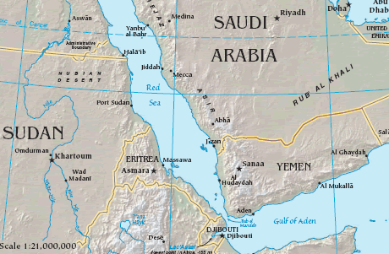
Figure 14 Bab el-Mandab
Panama Canal
The Panama Canal is an important route connecting the Pacific Ocean with the Caribbean Sea and Atlantic Ocean. According to the Panama Canal Authority, 25 Mtons per year of crude and petroleum products were transported through the canal in 2006. However, the relevance of the Panama Canal to the global oil trade has diminished, as many modern tankers are too large to travel through the canal. Some oil tankers, such as ultra-large crude carriers (ULCC), are nearly five times larger than the maximum capacity of the canal. The largest vessel that can transit the Panama Canal is known as a PANAMAX-size vessel (ships ranging from 50,000 – 80,000 dead weight tons.
The Canal is 80 km long and only 30 meters wide at its narrowest point. Around 14,000 vessels transit the Canal annually of which around half account for traffic to and from the United States. However, the Panama Canal is not a significant route for US petroleum imports.
In September of 2007, the Government of Panama began work on a $ 5 billion project to expand the Canal. The expansion will add a third lane of traffic that will handle wider loads and new locks that will be 50 meters wide (compared to the current 30 meters) as well as deeper and wider access canals that will allow for larger modern ships to pass. However, it is unlikely that oil flows would increase dramatically, as biggest oil tankers would still be unable to use the canal. On the other hand, the expansion would open the new possibility of using the canal to transport liquefied natural gas (LNG), as almost all existing LNG tankers are too large to use the canal as it now stands.
Closure of the Panama Canal would increase transit times and costs adding over 13.000 km of travel since vessels would have to reroute around the Straights of Magellan and Cape Horn.

Decision No 1364/2006/EC of the European Parliament end the Council of 6 September 2006 laying down guideline for trans-European energy networks and repealing Decision 96/391/EC and Decision 1229/2003/EC
Eurostat: "Energy – Yearly Statistics 2006
http://ec.europa.eu/dgs/energy_transport/figures/trends_2030_update_2007/index_en.htm
IEA World Energy Outlook 2007
EU energy and transport in figures Statistical Pocket Book 2007/2008
http://ec.europa.eu/transport/maritime/safety/2005_package_3_en.htm
In 2005, 28 Mton of diesel products were imported from Russia into the EU (source EUROPIA).
Purvin & Gertz Inc Study on Oil Refining and Oil Markets http://ec.europa.eu/dgs/energy_transport/security/studies/index_en.htm
The BPS-2 project has a construction cost estimated at $ 2-2.5 billion and there are indications that the cost of oil transportation through the new pipeline would be considerably higher than the cost through the existing Druzhba. However, recent declarations from the Russian Government indicated that Russia intends to proceed with the project.
In 2007 TAL transported approximately 34 Mtons of oil.
Deutsche Transalpine Oelleitung GmbH (DE), Transalpine Ölleitung Ges.m.b.H (AT) and Societá Italiana per l'Oleodotto Transalpino S.p.A (IT)
SPSE Société du Pipeline Sud-Européen http://www.spse.fr/en/accueil/index.html supplies the refineries and petrochemical plants from Fos to Karlsruhe through France, Switzerland and Germany. The current level of transport is 23 Mtons per year.
Rotterdam Antwerpen Pijpleiding http://www.rapl.nl/
Ingolstadt-Kralupy-Litinov has a length of 349 km (Vohburg and der Donau – Central Crude Oil Tank Farm in Nelahozeves) and a transport capacity of 10 Mtons of oil per year http://www.mero.cz/en/ikl_technicke_udaje.html)
Oil production will come primarily from Kazakhstan and Azerbaijan fields: Tengiz and Karachaganak in Kazakhstan and Azeri, Chirag and Guneshli in Azerbaijan. Substantial additional production is also expected from the Kazak Kashagan field currently being developed by a consortium of international oil companies.
The Turkish straits currently transit some 2.4 Mbbl of oil per day (120 Mtons per year).
The Baku-Tbilisi-Ceyhan pipeline is a crude oil pipeline which connects Baku, Tbilisi, to the Turkish port of Ceyhan. Oil is produced in the Azeri-Chirag-Guneshli oil field in the Caspian Sea. The pipeline is the only export line for Caspian oil which bypasses both the Russian network and the Bosphorus Straits.
The third country clause included in the third package on internal energy market adopted by the Commission on September 2007 covers only electricity and gas networks, oil pipelines are therefore excluded
Balkan & Black Sea Conference Bucharest April 2007
A PHARE study, limited to the Romanian part of the pipeline, was completed in 2005 indicated a construction cost of € 3Bn for a construction of a pipeline able to transport 90 Mtons per year.
see http://www.tnk-bp.com.ua/en/operations/projects/brodyodessa/
The Samartia LTD consortium includes companies from the 5 countries involved in the project.
The Ukrainian refineries have been designed and built to process Ural crude produced in Russia in order to refine Caspian light oil they will be need to be refurbished and modified.
Transpetrol is 49% owned by Yukos Finance BV
The Treaty establishing the Energy Community relates to electricity and gas. However, from the outset the Parties envisaged its extension at a later stage to "other energy products and carriers", including oil products and infrastructures. At its Article 100 (iii), the Treaty establishing the Energy Community, even foresees a simplified procedure allowing its Ministerial Council to decide by unanimity to extend it "to other energy products and carriers or to other essential network infrastructures". In particular, Croatia, Serbia, Slovenia, Italy and Romania signed in Zagreb on 3 April 2007 a "Ministerial declaration on the development of the hydrocarbons dimension of the Energy Community" in which they call for the establishment of an Oil Forum.
http://www.energy-community.org/portal/page/portal/ENC_HOME/INST_AND_MEETINGS/Ministerial_Council/2008/27_Jun
The inclusion of oil infrastructures in existing guidelines was considered but eventually dropped in 2003. To be noted also that in 2003, some of the countries crossed by planned pipelines as BAP, AMBO, PEOP and Odessa Brody Plock were not yet part of the EU.

