EN
COMMISSION OF THE EUROPEAN COMMUNITIES
Brussels, 19.12.2008
COM(2008) 891 final
2008/0265 (CNS)

Proposal for a
COUNCIL REGULATION (EC) No …/...
of […]
laying down a uniform format for visas (codified version)

(presented by the Commission)
2008/0265 (CNS)
Proposal for a
COUNCIL REGULATION (EC) No …/…
of […]
laying down a uniform format for visas
(Codified version)
EXPLANATORY MEMORANDUM
1. In the context of a people’s Europe, the Commission attaches great importance to simplifying and clarifying Community law so as to make it clearer and more accessible to the ordinary citizen, thus giving him new opportunities and the chance to make use of the specific rights it gives him.
This aim cannot be achieved so long as numerous provisions that have been amended several times, often quite substantially, remain scattered, so that they must be sought partly in the original instrument and partly in later amending ones. Considerable research work, comparing many different instruments, is thus needed to identify the current rules.
For this reason a codification of rules that have frequently been amended is also essential if Community law is to be clear and transparent.
2. On 1 April 1987 the Commission therefore decided to instruct its staff that all legislative acts should be codified after no more than ten amendments, stressing that this is a minimum requirement and that departments should endeavour to codify at even shorter intervals the texts for which they are responsible, to ensure that the Community rules are clear and readily understandable.
3. The Conclusions of the Presidency of the Edinburgh European Council (December 1992) confirmed this, stressing the importance of codification as it offers certainty as to the law applicable to a given matter at a given time.
Codification must be undertaken in full compliance with the normal Community legislative procedure.
Given that no changes of substance may be made to the instruments affected by codification, the European Parliament, the Council and the Commission have agreed, by an interinstitutional agreement dated 20 December 1994, that an accelerated procedure may be used for the fast-track adoption of codification instruments.
4. The purpose of this proposal is to undertake a codification of Council Regulation (EC) No 1683/95 of 29 May 1995 laying down a uniform format for visas. The new Regulation will supersede the various acts incorporated in it; this proposal fully preserves the content of the acts being codified and hence does no more than bringing them together with only such formal amendments as are required by the codification exercise itself.
5. The codification proposal was drawn up on the basis of a preliminary consolidation, in all official languages, of Regulation (EC) No 1683/95 and the instruments amending it, carried out by the Office for Official Publications of the European Communities, by means of a data-processing system. Where the Articles have been given new numbers, the correlation between the old and the new numbers is shown in a table contained in Annex III to the codified Regulation.
Proposal for a

ê 1683/95 (adapted)
(COD)
COUNCIL REGULATION (EC) No …/...
of […]
laying down a uniform format for visas (codified version)
THE COUNCIL OF THE EUROPEAN UNION,
Having regard to the Treaty establishing the European Community, and in particular Article Ö 62(2)(b)(iii) Õ thereof,
Having regard to the proposal from the Commission,
Having regard to the opinion of the European Parliament,
Whereas:

ê
(1) Council Regulation (EC) No 1683/95 of 29 May 1995 laying down a uniform format for visas has been substantially amended several times. In the interests of clarity and rationality the said Regulation should be codified.

ê 334/2002 Recital 4 and 1683/95 Recital 2
(2) The establishment of a uniform format for visas is an essential element in the harmonisation of visa policy. Article 14 of the Treaty stipulates that the internal market shall comprise an area without internal frontiers in which the free movement of persons is ensured in accordance with the provisions of the Treaty.

ê 1683/95 Recital 3
(3) It is essential that the uniform format for visas should contain all necessary information and meet very high technical standards, notably as regards safeguards against counterfeiting and falsification. It should also be suitable for use by all the Member States and bear universally recognisable security features which are clearly visible to the naked eye.

ê 334/2002 Recital 5
(4) In addition, it is necessary to provide for common standards relating to the implementation of the uniform format for visas, in particular common rules on the technical methods and standards to be used for filling in the form.

ê 334/2002 Recital 6 (adapted)
(5) Ö In that respect, Õ the integration of a photograph produced according to high security standards is a first step towards the use of elements establishing a more reliable link between the visa and the holder as an important contribution to ensuring that the uniform format for visas is protected even against fraudulent use. The specifications set out in ICAO (International Civil Aviation Organization) document 9303 on machine-readable visas should be taken into account.

ê 1683/95 Recital 4 (adapted)
(6) This Regulation only lays down such specifications as are not secret. Those specifications need to be supplemented by further specifications Ö for Õ which Ö it Õ should Ö be possible to decide that they Õ remain secret in order to prevent counterfeiting and falsification and which may not include personal data or references to such data. Powers to adopt further specifications should be conferred on the Commission.

ê
(7) The measures necessary for the implementation of this Regulation should be adopted in accordance with Council Decision 1999/468/EC of 28 June 1999 laying down the procedures for the exercise of implementing powers conferred on the Commission.

ê 1683/95 Recital 5
(8) To ensure that the information referred to is not made available to more persons than necessary, it is also essential that each Member State should designate not more than one body having responsibility for printing the uniform format for visas, with Member States remaining free to change the body, if need be. For security reasons, each Member State should communicate the name of the competent body to the Commission and the other Member States.

ê 1683/95 Recital 6 (adapted)
(9) To be effective, this Regulation should apply to all visas Ö as defined in this Regulation Õ. Member States should be free also to use the uniform visa format for visas for purposes other than those Ö defined in this Regulation Õ provided differences visible to the naked eye are incorporated to make confusion with the uniform visa impossible.

ê 1683/95 Recital 7
(10) With regard to the personal data to be entered on the uniform format for visas in accordance with Annex I hereto, compliance should be ensured with Member States' data-protection provisions as well as with the relevant Community legislation.

ê 334/2002 Recital 10
(11) The measures provided for in this Regulation should not affect the rules currently governing recognition of the validity of travel documents.

ê 856/2008 Recital 5
(12) As regards Iceland and Norway, this Regulation constitutes a development of provisions of the Schengen acquis within the meaning of the Agreement concluded by the Council of the European Union and the Republic of Iceland and the Kingdom of Norway concerning the latters' association with the implementation, application and development of the Schengen acquis which fall within the area referred to in Article 1, point B of Council Decision 1999/437/EC on certain arrangements for the application of that Agreement.

ê 856/2008 Recital 6
(13) As regards Switzerland, this Regulation constitutes a development of provisions of the Schengen acquis within the meaning of the Agreement signed between the European Union, the European Community and the Swiss Confederation concerning the association of the Swiss Confederation with the implementation, application and development of the Schengen acquis, which fall within the area referred to in Article 1, point A of Decision 1999/437/EC, read in conjunction with Article 4(1) of Council Decisions 2004/849/EC and 2004/860/EC.

ê 856/2008 Recital 7
(14) As regards Liechtenstein, this Regulation constitutes a development of provisions of the Schengen acquis within the meaning of the Protocol signed between the European Union, the European Community, the Swiss Confederation and the Principality of Liechtenstein on the accession of the Principality of Liechtenstein to the Agreement between the European Union, the European Community and the Swiss Confederation on the Swiss Confederation’s association with the implementation, application and development of the Schengen acquis, which fall within the area referred to in Article 1, point A of Decision 1999/437/EC, read in conjunction with Article 3 of Council Decision 2008/261/EC.

ê 856/2008 Recital 8
(15) In accordance with Article 1 of the Protocol on the position of the United Kingdom and Ireland annexed to the Treaty on European Union and to the Treaty establishing the European Community, the United Kingdom and Ireland are not participating in the adoption of this Regulation. As a result, and without prejudice to Article 4 of the said Protocol, the provisions of this Regulation do not apply to the United Kingdom and Ireland,

ê 1683/95
HAS ADOPTED THIS REGULATION:
Article 1
Visas issued by the Member States in conformity with Article 2 shall be produced in the form of a uniform format (sticker).
They shall conform to the specifications set out in Annex I.

ê 1683/95 Art. 5
Article 2
For the purposes of this Regulation, ‘visa’ shall mean an authorisation given by or a decision taken by a Member State which is required for entry into its territory with a view to:
(a) an intended stay in that Member State or in several Member States of no more than three months in all;
(b) transit through the territory or airport transit zone of that Member State or several Member States.

ê 334/2002 Art. 1 pt. 1
Article 3
1. Further technical specifications for the uniform format for visas relating to the following shall be established in accordance with the procedure referred to in Article 6(2):
(a) additional elements and security requirements including enhanced anti-forgery, counterfeiting and falsification standards;
(b) technical standards and methods to be used for the filling in of the uniform visa.
2. The colours of the visa sticker may be changed in accordance with the procedure referred to in Article 6(2).

ê 856/2008 Art. 1 pt. 1 (adapted)
3. In accordance with the procedure referred to in Article 6(2), it may be decided that the specifications referred to in paragraph 1 Ö of this Article Õ shall be secret and not be published. In that case they shall be made available only to the bodies designated by the Member States as responsible for the printing and to persons duly authorised by a Member State or the Commission.

ê 1683/95 Art. 3
Article 4
Each Member State shall designate one body having responsibility for printing visas. It shall communicate the name of that body to the Commission and to the other Member States. The same body may be designated by two or more Member States for that purpose. Each Member State shall be entitled to change its designated body. It shall inform the Commission and the other Member States accordingly.

ê 1683/95 Art. 4
Article 5
1. Without prejudice to the relevant more extensive provisions concerning data protection, an individual to whom a visa is issued shall have the right to verify the personal particulars entered on the visa and, where appropriate, to ask for any corrections or deletions to be made.
2. No information in machine-readable form shall be given on the uniform format for visas unless it also appears in the boxes described in points 6 to 12 of Annex I, or unless it is mentioned in the relevant travel document.

ê 334/2002 Art. 1 pt. 2
Article 6
1. The Commission shall be assisted by a committee.
2. Where reference is made to this paragraph, Articles 5 and 7 of Decision 1999/468/EC shall apply.
The period laid down in Article 5(6) of Decision 1999/468/EC shall be set at two months.

ê 1683/95
Article 7
Where Member States use the uniform visa format for purposes other than those covered by Article 2, appropriate measures must be taken to ensure that confusion with the visa referred to in Article 2 is not possible.

ê
Article 8
Regulation (EC) No 1683/95 is repealed.
References to the repealed Regulation shall be construed as references to this Regulation and shall be read in accordance with the correlation table in Annex III.

ê 1683/95 Art. 8 (adapted)
Article 9
This Regulation shall enter into force on Ö 1 May 2009 Õ.

ê 1683/95
This Regulation shall be binding in its entirety and directly applicable in all Member States in accordance with the Treaty establishing the European Community.
Done at Brussels, […]
For the Council
The President
[…]

ê 1683/95
ANNEX I

ê 856/2008 Art. 1 pt. 3
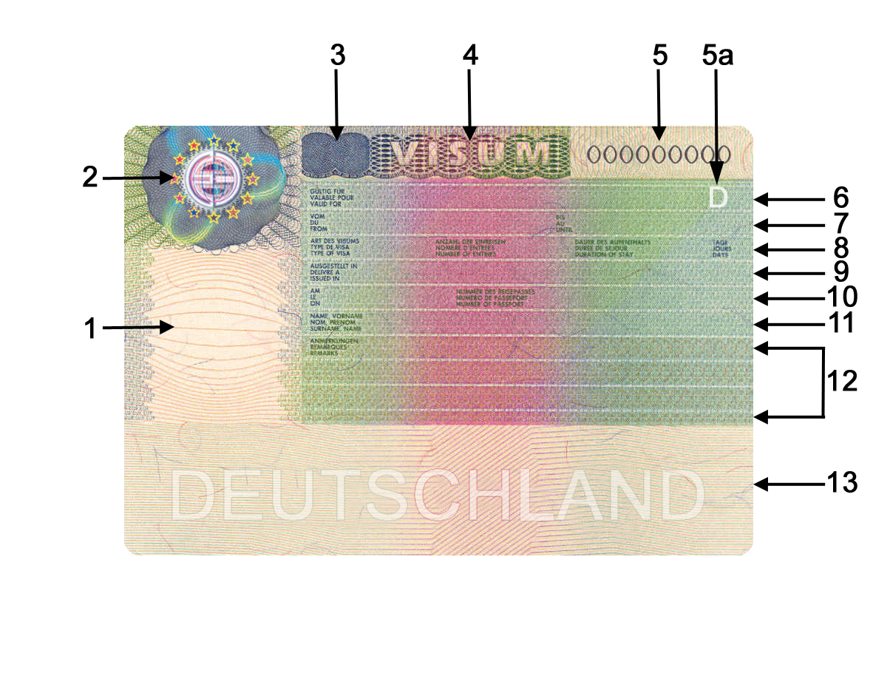
Security features
1. An integrated photograph produced to high security standards.
2. An optically variable mark (‘kinegram’ or equivalent) shall appear in this space. Depending on the angle of view, 12 stars, the letter ‘E’ and a globe become visible in various sizes and colours.
3. The logo consisting of a letter or letters indicating the issuing Member State (or ‘BNL’ in the case of the Benelux countries, namely Belgium, Luxembourg and the Netherlands) with a latent image effect shall appear in this space. This logo shall appear light when held flat and dark when turned by 90°. The following logos shall be used: A for Austria, BG for Bulgaria, BNL for Benelux, CY for Cyprus, CZE for the Czech Republic, D for Germany, DK for Denmark, E for Spain, EST for Estonia, F for France, FIN for Finland, GR for Greece, H for Hungary, I for Italy, IRL for Ireland, LT for Lithuania, LVA for Latvia, M for Malta, P for Portugal, PL for Poland, ROU for Romania, S for Sweden, SK for Slovakia, SVN for Slovenia, UK for the United Kingdom.
4. The word ‘visa’ in capital letters shall appear in the middle of this space in optically variable colouring. Depending on the angle of view, it shall appear green or red.
5. This box shall contain the 9-digit national number of the visa sticker, which shall be pre-printed. A special type shall be used.
5a. This box shall contain the three-letter country code as set out in ICAO Document 9303 on machine-readable travel documents, indicating the issuing Member State.
The “number of the visa sticker” is the three-letter country code as set out in box 5a and the national number as referred to in box 5.
Sections to be completed
6. This box shall begin with the words ‘valid for’. The issuing authority shall indicate the territory or territories for which the visa is valid.
7. This box shall begin with the word ‘from’ and the word ‘until’ shall appear further along the line. The issuing authority shall indicate here the period of validity of the visa.
8. This box shall begin with the words ‘type of visa’. The issuing authority shall indicate the category of visa in conformity with Articles 2 and 7 . Further along the line the words ‘number of entries’, ‘duration of stay’ (i.e. duration of applicants' intended stay) and again ‘days’ shall appear.
9. This box shall begin with the words ‘issued in’ and shall be used to indicate the place of issue.
10. This box shall begin with the word ‘on’ (after which the date of issue shall be filled in by the issuing authority) and further along the line the words ‘number of passport’ shall appear (after which the holder's passport number shall appear).
11. This box shall begin with the words ‘Surname, Name’.
12. This box shall begin with the word 'remarks'. It shall be used by the issuing authority to indicate any further information which is considered necessary, provided that it complies with Article 5 . The following two and a half lines shall be left empty for such remarks.
13. This box shall contain the relevant machine-readable information to facilitate external border controls. The machine-readable area shall contain a printed text in the background printing, indicating the Member State issuing the document. This text shall not affect the technical features of the machine-readable area or its ability to be read.
The paper shall have a natural colouring with red and blue markings.
The words designating the boxes shall appear in English and French. The issuing Member State may add a third official Community language. However, the word ‘visa’ in the top line may appear in any one official language of the Community.
_____________

é
ANNEX II
Repealed Regulation with list of its successive amendments
Council Regulation (EC) No 1683/95
(OJ L 164, 14.7.1995, p. 1)
 | Council Regulation (EC) No 334/2002  (OJ L 53, 23.2.2002, p. 7) |  | Articles 1 and 3 only
Point 18.B.1 of Annex II to the 2003 Act of Accession
(OJ L 236, 23.9.2003, p. 718)
 | Council Regulation (EC) No 1791/2006  (OJ L 363, 20.12.2006, p. 1) |  | Only as regards the reference to Regulation (EC) No 1683/95 in the eleventh indent of Article 1(1) and Annex, Part 11, point B.1
Council Regulation (EC) No 856/2008
(OJ L 235, 2.9.2008, p. 1)
_____________
ANNEX III

Correlation Table
Regulation (EC) No 1683/95 | This Regulation
Article 1, first sentence | Article 1, first paragraph
Article 1, second sentence | Article 1, second paragraph
Article 2 | Article 3
Article 3(2) | Article 4
Article 4 | Article 5
Article 5, introductory wording | Article 2, introductory wording
Article 5, first indent | Article 2(a)
Article 5, second indent | Article 2(b)
Article 6(1) and (2) | Article 6(1) and (2)
Article 6(3) | -
Article 7 | Article 7
- | Article 8
Article 8, first paragraph | Article 9
Article 8, second paragraph | -
Article 8, third paragraph | -
Annex | Annex I
- | Annex II
- | Annex III
_____________

COM(87) 868 PV.
See Annex 3 to Part A of the Conclusions.
Carried out pursuant to the Communication from the Commission to the European Parliament and the Council – Codification of the Acquis communautaire, COM(2001) 645 final.
See Annex II to this proposal.
OJ C […], […], p. […].
OJ L 164, 14.7.1995, p. 1.
See Annex II.
OJ L 184, 17.7.1999, p. 23.
OJ L 176, 10.7.1999, p. 36.
OJ L 176, 10.7.1999, p. 31.
OJ L 368, 15.12.2004, p. 26.
OJ L 370, 17.12.2004, p. 78.
OJ L 83, 26.3.2008, p. 3.
Exception for Germany: ICAO document 9303 on machine readable travel documents provides for Germany the country code “D”.

