South-East Finland-Russia ENPI CBC
 | Year | Unit | St. Petersburg | Leningrad region | South Karelia | Kymenlaakso |  | South-Savo
Population in the programme area |  |  | 4 594 000 | 1 650 000 | 135 604 | 185 196 |  | 160 507
1. Population statistics
Births: natural increase. decrease (-) |  | per 1000 people
 | 2001 |  | 7.2 | 7.3 | 9.2 | 9.3 | 8.8
 | 2002 |  | 8.1 | 7.8 | 8.6 | 8.8 | 8.4
 | 2003 |  | 8.8 | 8 | 8.4 | 8.8 | 8.4
 | 2004 |  | 8.9 | 8.3 | 8.5 | 9.4 | 8.3
 | 2005 |  | 8.6 | 7.8 | 9.0 | 9.0 | 8.1
Deaths: natural increase. decrease (-) |  | per 1000 people
 | 2001 |  | 16.2 | 20.1 | 11.0 | 11.6 | 11.6
 | 2002 |  | 16.6 | 20.6 | 10.5 | 12.1 | 11.7
 | 2003 |  | 17 | 21.1 | 11.7 | 11.4 | 11.9
 | 2004 |  | 16.2 | 20.3 | 11.5 | 11.1 | 11.9
 | 2005 |  | 16 | 20.3 | 11.3 | 11.4 | 12.0
Migration: increase. decrease (-). total |  | per 1000 people
 | 2001 |  | 2.3 | 7 | 0.5 | - 1.8 | - 4.9
 | 2002 |  | 1.7 | 7.9 | - 0.4 | 0.2 | - 4.0
 | 2003 |  | 1.1 | 8.4 | 0.5 | 0.2 | - 2.3
 | 2004 |  | 2.1 | 7.3 | - 0.7 | 1.0 | - 2.0
 | 2005 |  | 2.2 | 7 | 1.0 | 0.6 | - 1.4
2. Economic structure
Average GDP per capita |  | thousand €
 | 2001 |  | 1 721 |  | 26.2 | 28.0 | 19.1
 | 2002 |  | 2 311 | 1 791 | 25.9 | 27.2 | 20.2
 | 2003 |  | 2 762 | 2 371 | 27.1 | 27.0 | 20.7
 | 2004 |  | 3 308 | 3 097 | 26.9 | 28.8 | 21.9
(no information available) | 2005 |  | - | - | - | - | -
Average monthly income per capita |  | €
 | 2004/05 |  | 317.38 | 206.85 | 1540.00 | 1622.00 | 1388.00
Unemployment rate |  | %
 | 2001 |  | 0.9 | 1.5 | 16.3 | 14.8 | 16.3
 | 2002 |  | 0.9 | 1.6 | 15.7 | 14.2 | 15.6
 | 2003 |  | 0.8 | 1.1 | 15.2 | 13.7 | 14.9
 | 2004 |  | 0.8 | 1.2 | 15.1 | 13.7 | 15.2
 | 2005 |  | 0.8 | 1.1 | 14.2 | 13.0 | 13.9
Number of registered small- and middle-sized enterprises |  | thousands of units
 | 2001 |  | 124.7 | 9 347 | 5 870 | 7 770 | 7 690
 | 2002 |  | 136.8 | 11 484 | 5 845 | 7 860 | 7 645
 | 2003 |  | 203 | 12 189 | 5 860 | 7 900 | 7 670
 | 2004 |  | 246 | 12 494 | 5 880 | 7 950 | 7 760
 | 2005 |  | 160.9 | 11 740 | 5 940 | 8 130 | 7 790
3. Education and research
% of population with secondary or higher education |  | % of population
 | 2005 |  | 66.5 | 30.1 (2002) | 60.1 | 61.7 | 59.0
Number of educational and cultural institutions |  | pcs
Universities and institutions | 2005 |  | 111 | 5 + 30 SPB universities | 5 | 4 | 11
 |  | pcs
Number of research and development organizations | 2005 |  | 396 | 32 | 10 | 4 | 10

Diagram 1: Number of passengers passing through the border crossing points
(years 2000-2006)

Diagram 2: Volume of goods traffic passing through the border crossing points
(years 2000-2006)

Diagram 3: The growth dynamics of the Gross Regional Product (years 2000-2005)

Diagram 4: The structure of St. Petersburg's industry (year 2005)

Diagram 5: The structure of industry in the Leningrad Region (year 2005)

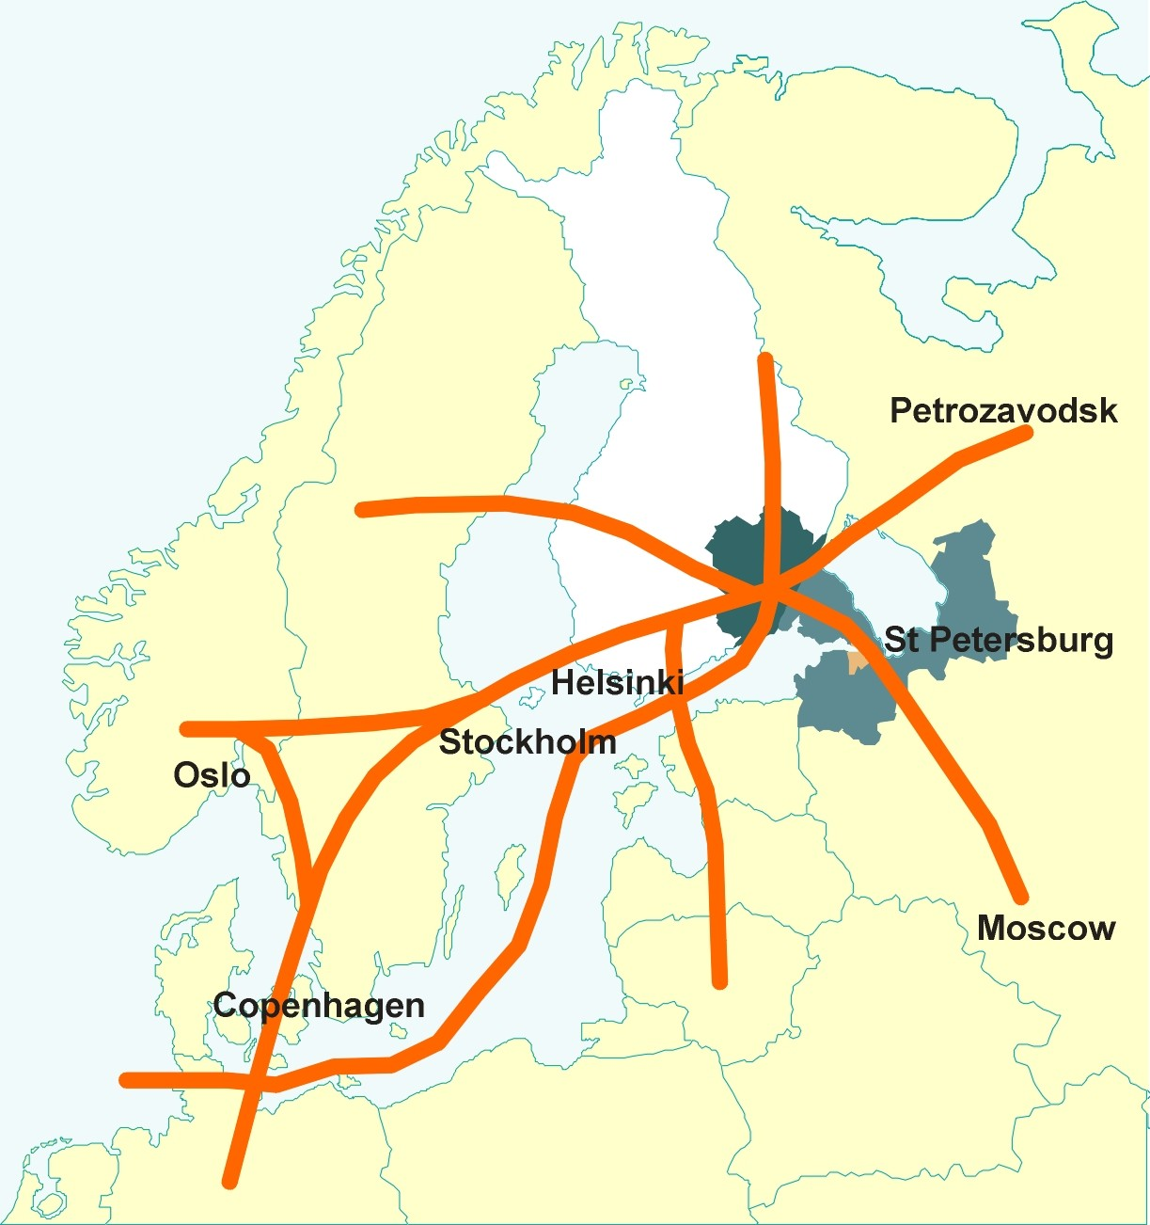

Map 1: Transportation network in the Programme area

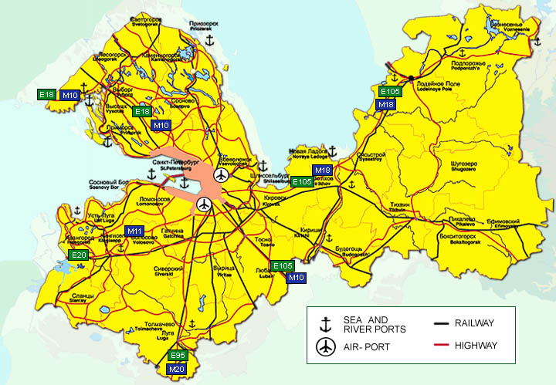

Map 2: Transportation in the St. Petersburg and Leningrad Regions

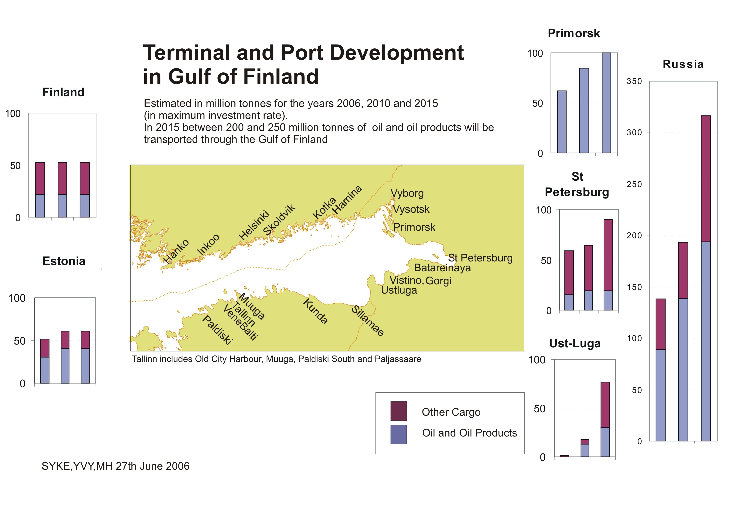

Map 3: Terminal and port development in the Gulf of Finland

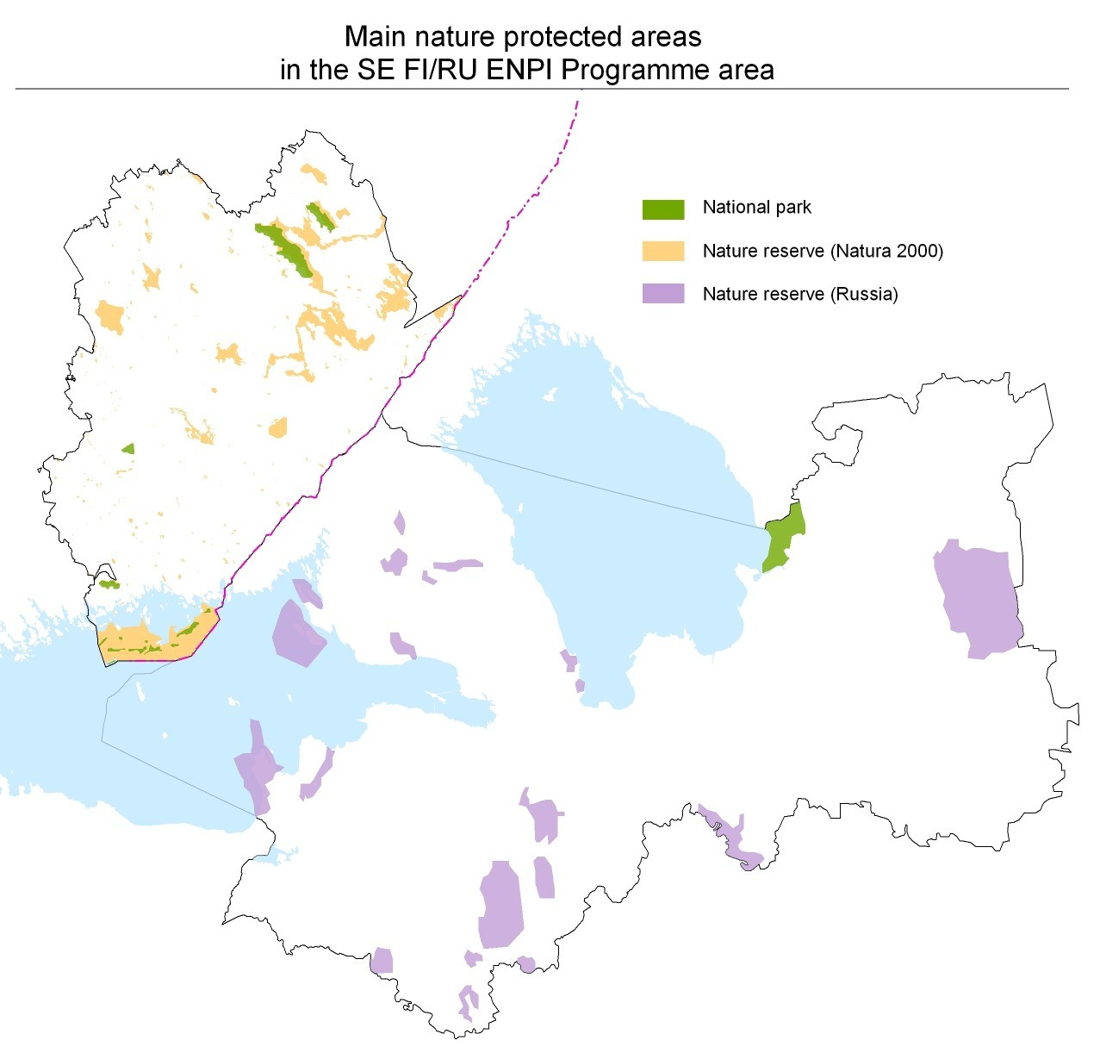

Map 4: The main nature conservation areas in the Programme area

