EN
COMMISSION OF THE EUROPEAN COMMUNITIES
Brussels, 20.1.2009
SEC(2009) 18
COMMISSION STAFF WORKING DOCUMENT
Accompanying document to the
REPORT FROM THE COMMISSION TO THE COUNCIL, THE EUROPEAN PARLIAMENT, THE EUROPEAN ECONOMIC AND SOCIAL COMMITTEE AND THE COMMITTEE OF THE REGIONS
ON THE IMPLEMENTATION OF THE TRANS-EUROPEAN TRANSPORT NETWORK GUIDELINES 2004 – 2005
Pursuant to Article 18 of Decision 1692/96/EC
{COM(2009) 5 final}
ANNEX
ANNEX 1: IMPLEMENTATION DETAILS

Introduction
Part 1 considers the main developments on the TEN-T modal networks as outlined in Annex I of the guidelines Decision i.e. road, rail, inland waterways, ports, airports and combined transport.
Part 2 looks in more detail at the horizontal issues of interoperability, research and development, and environmental protection.
In part 3 there is a general assessment of the development of the TEN-T during the period in question and a more detailed section on the TEN-T priority projects.
The part 4 on Community funding, provides an overview of the financing of TEN-T with particular reference to financial support from the EU during the reference period.

PART 1

Implementation in general
Total investment in the TEN-T network in the EU-27, which amounted to EUR 101.74 billion in the 2004 – 2005 period (EUR 50.4 billion in 2004 and 51.3 billion in 2005),has increased in comparison with the investment of 2002 -2003.
Table 1 shows the investments in TEN-T infrastructure in the years 2004 and 2005 per country and per mode of transport in millions of EUR and in % of the GDP per country.
Table 1: Investments in the 2004 and 2005 in the TEN-T in millions of EUR per country and per mode including the %of investments in GDP
 | Road | Railway | IWW | Airport | Port | TOTAL | GDP 2004/2005 | in % of GDP
Austria | 1281,81 | 2592,10 | 3,80 | 344,49 | 34,95 | 4257,15 | 481000,00 | 0,89%
Belgium | 112,57 | 1932,78 | 55,39 | 43,09 | 414,51 | 2558,34 | 586000,00 | 0,44%
Bulgaria | 139,98 | 85,50 | 0,64 | 41,68 | 3,42 | 271,22 | 41000,00 | 0,66%
Cyprus | 42,50 | 0,00 | 0,00 | 5,00 | 2,45 | 49,95 | 25000,00 | 0,20%
Czech Republic | 1455,00 | 388,00 | 0,00 | 0,00 | 5,10 | 1848,10 | 185000,00 | 1,00%
Denmark | 159,75 | 149,00 | 0,00 | 0,00 | 189,98 | 498,73 | 405000,00 | 0,12%
Estonia | 150,77 | 83,95 | 0,00 | 49,62 | 86,73 | 371,07 | 20000,00 | 1,86%
Finland | 270,00 | 583,94 | 0,00 | 0,00 | 334,15 | 1188,09 | 305000,00 | 0,39%
France | 5013,00 | 3269,00 | 172,78 | 61,71 | 585,94 | 9102,43 | 3369000,00 | 0,27%
Germany | 1568,87 | 6988,97 | 1594,08 | 4,98 | 309,49 | 10466,39 | 4463000,00 | 0,23%
Greece | 2396,25 | 795,61 | 0,00 | 93,76 | 0,00 | 3285,62 | 349000,00 | 0,94%
Hungary | 1307,50 | 520,06 | 0,00 | 0,00 | 0,00 | 1827,56 | 169000,00 | 1,08%
Ireland | 592,00 | 521,88 | 0,00 | 0,00 | 0,00 | 1113,88 | 309000,00 | 0,36%
Italy | 2876,53 | 13319,64 | 0,00 | 1324,00 | 371,50 | 17891,67 | 2806000,00 | 0,64%
Latvia | 173,35 | 113,52 | 0,00 | 0,60 | 39,40 | 326,87 | 24000,00 | 1,36%
Lithuania | 188,72 | 110,07 | 0,00 | 10,85 | 0,00 | 309,64 | 39000,00 | 0,79%
Luxemburg | 27,50 | 24,68 | 0,00 | 54,50 | 0,00 | 106,68 | 56000,00 | 0,19%
Malta | 7,89 | 0,00 | 0,00 | 1,00 | 16,81 | 25,70 | 8000,00 | 0,32%
Netherlands | 2042,32 | 3900,32 | 227,65 | 122,90 | 291,07 | 6584,26 | 991000,00 | 0,66%
Poland | 2032,55 | 218,68 | 0,00 | 136,83 | 0,00 | 2388,06 | 447000,00 | 0,53%
Portugal | 1548,20 | 633,80 | 0,00 | 286,51 | 96,83 | 2565,34 | 290000,00 | 0,88%
Romania | 252,15 | 101,34 | 19,70 | 3,12 | 14,32 | 390,63 | 140000,00 | 0,28%
Slovakia | 73,33 | 125,00 | 0,00 | 11,56 | 0,00 | 209,89 | 72000,00 | 0,29%
Slovenia | 604,67 | 75,89 | 0,00 | 0,42 | 5,92 | 686,90 | 53000,00 | 1,30%
Spain | 1829,99 | 6040,00 | 0,00 | 4381,38 | 1657,00 | 13908,37 | 1741000,00 | 0,80%
Sweden | 455,00 | 1610,00 | 0,00 | 121,00 | 150,84 | 2336,84 | 570000,00 | 0,41%
United Kingdom | 658,36 | 14402,60 | 0,00 | 2110,00 | 0,00 | 17170,96 | 3525000,00 | 0,49%
Croatia | 1481,00 | 39,37 | 0,38 | 12,32 | 21,36 | 1554,43 | 59000,00 | 2,63%
Turkey | 1828,38 | 1295,70 | 0,00 | 351,88 | 6,24 | 3482,20 | 533000,00 | 0,65%
Total EU-15 | 20832,15 | 56764,32 | 2053,70 | 8948,32 | 4436,26 | 93034,75 | 20246000,00 | 0,46%
Total EU-25 | 26868,43 | 58399,49 | 2053,70 | 9164,20 | 4592,67 | 101078,49 | 21288000,00 | 0,47%
Total EU-27 | 27260,56 | 58586,33 | 2074,04 | 9209,00 | 4610,41 | 101740,34 | 21469000,00 | 0,47%

Implementation by mode and sector
This section examines the main developments of the TEN-T modal networks (as outlined in Annex I of the guidelines Decision.)

TEN-T Road network
The total road network in the EU-27 comprised more than 4.8 million km of motorways, state roads, and provincial and local authority paved roads.
Road traffic in 2005 accounted for 1,800 billion tonne-km (44,8%) of intra-EU-27 freight traffic and for 5,250 billion passenger -km (83.5 % - 75.1% by passenger car and 8.4% by bus / coach) of intra-EU-27 passenger traffic.
- Development of the TEN-T road network in the EU-27
The total length of the current TEN-T roads, including ordinary roads yet to be upgraded, in EU27 in 2005 was approx. 98,500 km.
The total length of the current TEN-T roads composed of motorways and high-quality roads in EU27 in 2005 was approx. 70,200 km and is estimated to increase to 90,500 km in 2020.
In 2005 about 70% of the existing TEN-T road consists of motorways and high-quality roads. The remaining roads are still to be constructed or upgraded to the general target of the Guidelines. In 2005 about 28,300 km of the existing roads were still classified as ordinary roads.
In 2004 and 2005 approximately 1,700 km of motorways were newly constructed or adapted (upgraded from ordinary or high-quality road).Thus the quality development of the existing TEN-T road network continued. The growth of length of motorways between 1996 and 2020 is forecast to be almost 50% in the EU27. Further significant developments for the network are improvements in road conditions (capacity, additional lanes, electronic toll collection, emergency and incident management, traveller information service, etc.). However, these kinds of development do not increase the length of the TEN-T roads or change the category of the link type (motorway, high-quality road) of the section, but rather their quality.
Figure 1: Type of the TEN-T roads (in km) in EU27 in 2003, 2004 and 2005
Figure 1.1: Development of length of the TEN-T motorways (in km) in the EU-27 in 1996, 2005, 2013 and 2020.
- Investment in the TEN-T road network in the EU-27
Total investment in the TEN-T road network in the EU-27 amounted to EUR 12.71 billion in 2004 and EUR 14.55 billion in 2005 (a total of EUR 27.26 billion in the 2004 – 2005 period). In comparison with the investment in previous years the average annual roads investment increased in the 2004 – 2005 period.
Most of the expenditures are related to upgrading motorways and high-quality roads, constructing new 4-lane motorways, or upgrading ordinary roads or high-quality roads to 4-lane motorways. Other measures included the construction of new links, upgrading of intersections, expansion of 4-lane motorways to 6-lane motorways, electronic toll collection measures and emergency and incident management.
The countries with the highest notified expenditures in the period 2004 – 2005 were France (EUR 5.01 billion), Italy (EUR 2.88 billion), Greece (EUR 2.40 billion), The Netherlands (EUR 2.04 billion), Poland (EUR 2.03 billion), Spain (EUR 1.83 billion), Germany (EUR 1.57 billion), and Portugal (EUR 1.55 billion).
Figure 2: Investment in the TEN-T road network per country and mode for the first 14 countries having invested the most of the EU-27 in 2004 and 2005 in millions of EUR
Figure 3: Investment in the TEN-T road network per country and mode for remaining countries of the EU-27 in 2004 and 2005 in millions of EUR
Illustrative examples of the progress in the implementation of the TEN-T road network in the EU-27
The following examples illustrate the progress in the implementation of the TEN-T road network in the 2004-2005 period:
- In France, a motorway of 126 km Rouen-Arconnay was completed in 2005. Total cost of the project is about 800 million EUR.
- In France a motorway of 35 km, the "Millau by-pass" was completed in 2004 with a total cost of 311 million EUR.
- In Greece a new motorway Elefsina –Spata was completed in 2004. The motorway constitutes the ring road of Athens has a total length of 61km and a total cost of 1.25 billion EUR.
- In Greece, a new motorway section of the "Egnatia Road", Kozani- Klidi, was completed in 2004.It has a total length of 84 km and a total cost of almost 700million EUR.
- In Spain, most of the sections of the "Autorouta de la Plata", crossing the country from the north (Gijon) to the south (Seville)have been completed or are under construction. The new motorway will connect with the most important transport axis connecting Spain and Portugal.
- In Hungary a new 4-lane motorway Micolz-Emod was completed in 2004. It has a total length of 15 km and a total cost of almost150 million EUR.

TEN-T railway network
In 2005 railways accounted for 413 billion tonne-kilometres (10,3%) of intra-EU freight traffic; in the same year railways accounted for 374 billion person-km (6%) of intra-EU passenger traffic.
- Development of the TEN-T railway network in the EU-15
In 2005 the TEN-T railway had a total length (conventional and high-speed lines) of about 97,600 km. In accordance with decision 884/2004/EC the Member States have indicated that out of these existing railway lines about 14.000 km conventional lines are planned to be upgraded to high-speed lines. The development of completed high-speed lines, new and upgraded, progressed in 2004 – 2005, increasing the total length from 9,850 km in 1996 and 10,656 km in 2004 to 10,677 km in 2005.
Figure 4: Type of the TEN-T railways (high-speed lines and conventional lines in km) in EU27 in 2003, 2004 and 2005
The quality development of the TEN-T rail network continued slowly but should in the future profit from various upgrading measures. The total length of the high-speed lines, which was about 10,600 km in 2005
is expected to increase to almost 30,000km in 2020.
Figure 4.1: Development of length of the TEN-T railway-network (in km) in the EU-27 in 1996, 2005, 2013 and 2020.
- Investment in the TEN-T railways network in the EU-27
Total expenditures for the TEN-T railways in EU27 amounted to EUR 30.22 billion in 2004 and EUR 28.36 billion in 2005 (a total of EUR 58.58 billion in the period 2004 – 2005). In comparison, the expenditures made from 2002 to 2003 amounted to EUR 37.74 billion. The annual expenditures in railways thus increased significantly in the period 2004 – 2005.
The countries with the highest expenditures in the period 2004 – 2005 were United Kingdom (EUR 14.4 billion), Italy (EUR 13.32 billion), Germany (EUR 6.99 billion), Spain (EUR 6.04 billion), The Netherlands (EUR 3.90 billion), France (EUR 3.27 billion) and Austria (EUR 2.59 billion).
Figure 5: Investment in the TEN-T rail network per country and mode for the first 14 countries having invested the most of the EU-27 in 2004 and 2005 in millions of EUR
Figure 6: Investment in the TEN-T rail network per country and mode for remaining countries of the EU-27 in 2004 and 2005 in millions of EUR
Illustrative examples of the progress of the TEN-T railways network in the EU 27
- In Germany, the section Ludwigshafen-Saarbrücken has been upgraded to 160 km per hour (and in some sections to 200km/h). The project has been completed in 2004 with a total cost of 270 million EUR.
- In Germany the sections Berlin-Leipzig-Halle and Nürnberg- Münich on the PP1 have been upgraded to a max speed of 200km/h (and in some sections 300km/h ). Total cost of the projects was almost 1.5 billion EUR and 3.5 billion EUR respectively. The projects were almost completed by the end of 2005 and commissioning has taken place in the spring 2006.
-In Austria, works on the Linz main station have been completed in 2005, with a total cost of 125 million EUR.
- In Spain, the tunnel of Guadarrama on the HSL Madrid- Valladolid- North/North-West of Spain was completed in 2005. The tunnel consists of two tubes of 28.4 km each .It has a total cost of 1220 million EUR and was co-financed ( 85%) by the Cohesion Fund.
-In Spain, the 481 km long HSL Madrid- Barcelona-Lleida entered into operation in October 2004.It is part of the line Madrid-Barcelona- French border that will connect with the French TGV. The total cost of the Spanish part is 11.25 billion EUR and is co-financed by the Cohesion Fund and the TEN-T programme.
- In Romania the 92 km section Campina Bucharest on the PP22, was upgraded to max speed of 160 km/h. The project was completed in 2004.It is the first completed section on PP 22 in Romania.

TEN-T inland waterways network
- Developments in the TEN-T inland waterways network in the EU-27
Europe has around 29500 km navigable canals, rivers and lakes that are regularly used for transport.
The countries having inland waterways belonging to the TEN-T inland waterways in the EU27 are Austria, Belgium, Bulgaria, Czech Republic, Finland, France, Germany, Hungary, Italy, Lithuania, Luxembourg, the Netherlands Poland, Portugal, Romania and Slovakia.
Inland Waterways accounted for 138 tonnes –km (3,48% ) of intra-EU freight traffic in 2005
The total length of the TEN-T inland waterways in EU27 was 14,900 km in 2005, of which 9,935 km (67%) were classified as ECMT class V and higher. The main axes within the network are the Rhine and the Danube.
Figure 7: Development of type of TEN-T inland waterways (in km) in EU27 in 2003, 2004 and 2005
The total length of inland waterways at ECMT class V or higher increased only slightly between 1996 and 2005. But it is expected to increase to almost 11,500km by 2020 through major upgrading works.
Figure 7.1: Development of length of the TEN-T inland waterways network (in km) in the EU-27 in 1996, 2005, 2013 and 2020.
- Investment in the TEN-T inland waterways network in the EU-27
Total expenditures for the TEN-T inland waterways in EU27 amounted to EUR 1.03 billion in 2004 and EUR 1.03 billion in 2005 (a total of EUR 2.07 billion in the period 2004 – 2005).
The country with the highest expenditures in the period 2004 – 2005 was by far Germany (EUR 1.59 billion), followed by the Netherlands (EUR 0.23 billion) and France (EUR 0.17 billion ).
Most of the expenditures in the period 2004 – 2005 related to various upgrading measures, water regulation and improvement of locks.
Figure 8: Investment in the TEN-T inland waterway network in EU-27 per country in 2004 and 2005 in millions of EUR
Illustrative examples of the progress in the TEN-T inland waterways in EU- 27
- In the Netherlands, modernisation of the Maasroute (phase 1) was carried out. The project was undertaken between 1995 and 2005 and had a budget of EUR 71 million.
- In the Netherlands, the renovation of the North Sea locks was carried out between 2000 and 2005 and had a budget of EUR 229 million.
- In Romania, works for the band protection in the Danube delta, of a total budget of EUR 104 million started in 1996 and were completed in 2004.

TEN-T ports
- Development of the TEN-T ports in the EU-27
Decision No. 1346/2001/EC, amending the Guidelines adopted in 1996 as regards seaports, inland ports and intermodal terminals, as well as project No. 8 in Annex III, was adopted by the European Parliament and the Council on 22 May 2001. The Decision includes a more focused definition of ports and projects of common interest related to them.
The Decision states that interconnection points, including seaports, inland ports and intermodal terminals, are a pre-condition for the integration of the different transport modes in a multimodal network.
For the EU-27, the modal split of maritime transport was 38.1% (1,530 billion tonne-km) in intra-EU freight traffic in 2005.
Inland ports are part of the network, in particular as points of interconnection between the inland waterways referred to above and other modes of transport. The network includes inland ports open to commercial traffic, located on the network of inland waterways, interconnected with other trans-European transport routes as equipped with transhipment facilities for intermodal transport or with an annual freight traffic volume of at least 500,000 tons.
Seaports in the trans-European transport network are classified into categories A, B and C. These are defined on the basis of quantitative criteria (annual traffic volumes of freight or passengers) or their location on islands, or in peripheral or outermost regions. Only those ports in the highest category (category A) by volume of traffic are shown in the maps of the Decision.
The TEN-T ports comprise of 407 ports (seaports of category A and inland ports). Apart from seaports of category A, there are also13 ports of category B and 20 ports of category C.
The table below shows the numbers and types of TEN-T ports in EU27 as included in the project database. For a number of ports no information is available.
Country | Inland ports | Inland/Maritime port | Seaports (class A) | Total
Austria | 4 |  |  | 4
Belgium | 14 | 3 | 1 | 18
Bulgaria | 8 |  | 2 | 10
Cyprus |  |  | 2 | 2
Czech Republic | 11 |  |  | 11
Denmark |  |  | 14 | 14
Estonia |  |  | 5 | 5
Finland | 1 |  | 18 | 19
France | 10 | 4 | 22 | 36
Germany | 45 | 3 | 12 | 60
Greece |  |  | 17 | 17
Hungary | 7 |  |  | 7
Ireland |  |  | 6 | 6
Italy |  |  | 36 | 36
Latvia |  |  | 3 | 3
Lithuania |  |  | 1 | 1
Luxemburg | 1 |  |  | 1
Malta |  |  | 2 | 2
Netherlands | 9 | 7 | 2 | 18
Poland |  |  | 4 | 4
Portugal |  | 1 | 6 | 7
Romania | 8 | 5 |  | 13
Slovakia | 2 |  |  | 2
Slovenia |  |  | 1 | 1
Spain |  |  | 40 | 40
Sweden |  |  | 25 | 25
United Kingdom |  |  | 45 | 45
Total EU-27 | 120 | 23 | 264 | 407
Table 2: Numbers and types of TEN-T ports in EU27
Particular care has been taken to foster the improvement of connections with the TEN-T land networks, including logistic platforms associated with ports and the construction of new port infrastructures, thus advancing along the lines as defined in the guidelines.
Around 52% of the seaports, 86% of the maritime/inland ports and 63% of the inland ports notified to have intermodal transhipment facilities in 2005.
Around 50% of the seaports, 70% of the maritime/inland ports and 60% of the inland ports had a connection to the TEN-T railway network.
The situation is not expected to change significantly in the period to 2020. Ports intend to improve this situation between now and 2020; however, a long-term strategy concerning ports development was rarely available.
- Investments in TEN-T ports in the Member States
Total expenditures in TEN-T ports in the EU27 amounted to EUR 2.08 billion in 2004 and EUR 2.53 billion in 2005 (a total of EUR 4.61 billion in the period 2004 – 2005).
The countries with the highest expenditures in the period 2004 – 2005 were Spain (EUR 1.66 billion), France (EUR 0.59 billion), Belgium (EUR 0.41 billion), Italy (EUR 0.37billion), Finland (EUR 0.33 billion), Germany (EUR 0.31 billion), the Netherlands (0.29 billion), Denmark (EUR 0.19 billion) and Sweden (EUR 0.15 billion).
Figure 9: Investment in the TEN-T ports per country and mode for the first 14 countries having invested the most of the EU-27 in 2004 and 2005 in millions of EUR
Figure 10: Investment in the TEN-T ports per country and mode for remaining countries of the EU-27 in 2004 and 2005 in millions of EUR
Illustrative examples of the progress in the implementation of the TEN-T ports in the EU 27
- In Finland, a project of a total cost of EUR 145 million to upgrade the connections of the port in Vuosaari, near Helsinki have been completed in 2005.
- In Finland, works to upgrade the port of Kotka ( in the south of Finland, east of Helsinki ) have been implemented in the 2004-05 period. The total cost was EUR 65 million.
- In the Netherlands, in the port of Rotterdam, works to improve infrastructure and mobility have been completed in 2005. The total cost was EUR 470 million.
- In Belgium, works to upgrade infrastructure in the port of Antwerp of a total cost of EUR 280 million have been implemented in 2004-2005.

TEN-T airports
- Development of TEN-T airports in the EU-27
Intra-EU and domestic air transport in the EU27 accounted for 526 billion person-km in 2005. This is 8.1% of total intra-EU passenger transport and an increase of 57% since 1995. In comparison, overall passenger transport in the same period increased by 18%.
The TEN-T airports consist of airports of common interest that are situated within the territory of the Union and are open to commercial air traffic. Airports are classified differently according to the volume and type of traffic they handle and according to their function within the network. They should allow for the development of air links and the interconnection of air transport and other modes of transport.
The International Connecting Points and the Community Connecting Points constitute the core of the trans-European airport network. Links between the Community and the rest of the world mainly run via the international connecting points. The Community connecting points essentially provide links within the Community, while extra-Community services still account for a small proportion of their business. Regional connecting points and accessibility points facilitate access to the core of the network or help to open up peripheral and isolated regions.
Around 57% of the international system airports, 28% of the international airports and 15% of the Community and Community system airports had a connection to the TEN-T railway network in 2005. This is a slight increase compared to 1996. Only 3% of the national and regional airports had a connection to the TEN-T railways network.
The TEN-T airports comprise of 407 airports, including 71 international, 78 community and 258 regional airports in 2005.

Country | Community | International | Regional | Total
Austria | 1 | 1 | 4 | 6
Belgium | 1 | 1 | 2 | 4
Bulgaria |  | 1 | 4 | 5
Cyprus | 1 | 1 |  | 2
Czech Republic | 1 |  | 2 | 3
Denmark | 2 | 1 | 7 | 10
Estonia | 1 |  | 4 | 5
Finland | 1 | 1 | 21 | 23
France | 10 | 8 | 35 | 53
Germany | 8 | 9 | 9 | 26
Greece | 1 | 6 | 30 | 37
Hungary | 1 |  | 2 | 3
Ireland | 2 | 1 | 9 | 12
Italy | 14 | 5 | 18 | 37
Latvia | 1 |  | 3 | 4
Lithuania | 1 |  | 2 | 3
Luxemburg | 1 |  |  | 1
Malta | 1 |  |  | 1
Netherlands | 1 | 1 | 3 | 5
Poland | 3 | 1 | 4 | 8
Portugal | 1 | 8 | 7 | 16
Romania | 1 |  | 9 | 10
Slovakia | 1 |  | 2 | 3
Slovenia | 1 |  | 2 | 3
Spain | 7 | 14 | 23 | 44
Sweden | 5 | 1 | 37 | 43
United Kingdom | 10 | 11 | 19 | 40
Total EU-27 | 78 | 71 | 258 | 407
Table 3: Numbers and types of TEN-T airports in EU27
- Investments in TEN-T airports in the EU-27
The total reported expenditures in TEN-T airports in the EU27 amount to EUR 4.37 billion in 2004 and EUR 4.84 billion in 2005 (a total of EUR 9.21 billion in the period 2004 – 2005).
The countries with the highest reported expenditures in the period 2004 – 2005 are Spain (EUR 4.38 billion), United Kingdom (EUR 2.11 billion), Austria (EUR 0.34 billion), and Portugal (EUR 0.29 billion).
Figure 11: Investment in the TEN-T airports per country for the first 14 countries having invested the most of the EU-27 in 2004 and 2005 in millions of EUR
Figure 12: Investment in the TEN-T airports per country for remaining countries of the EU-27 in 2004 and 2005 in millions of EUR
Most of the total investment related to International Connecting airports. The largest part of the investments was funded by private sources, as most of the major airports are privately owned.
Illustrative examples of the progress in the implementation of the TEN-T airports in the EU-27
- In Spain, the new terminal of the Barajas airport in Madrid has been in operation since 5/02/2006. It is doubling the capacity of the airport to 70 million passengers / year. The new terminal is connected to Madrid and to the Spanish HSRail with a modern Metro line. Total cost of the project was EUR 6 billion.
- In Spain, important upgrading works and the new runway 7R have been implemented 1n 2003-2005. The total cost of the various projects was almost EUR 500 million.
- In the Netherlands, the extension of the "Terminal West" of the Schiphol airport, of a total cost of EUR 95 million, was completed in 2005.
- In Bulgaria, works in the new terminal of the Sofia airport were well advanced in 2005. The project was financed by the ISPA Fund. The terminal entered in operation in 2006.
Combined transport network
Progress reported in other modes of transport often includes extension or upgrading works contributing to the development of combined transport.
Illustrative example of developments of combined transport and terminals is the new combined transport terminal in Rostock of a total cost of EUR 33 million that received financial assistance from the TEN-T budget of EUR 2 million. The total capacity of the terminal will be 150000units/year. The 1st phase of the project including 2 rail lines is completed in 2005.

Motorways of the Sea
Four motorways of the sea corridors have been identified for support across the EU. On these corridors, projects will help to concentrate flows of freight on sea routes, with the aim of reducing road congestion and/or improving access to peripheral and island regions and Member States. The network will include facilities and infrastructure concerning at least two ports in two different Member States, primarily use for freight transport, although motorways of the sea should not exclude combined transport of persons and goods.
The projects may also include activities with wider benefits not linked to specific ports, such as ice breaking, dredging, information systems. However such projects have to demonstrate that they relate to the network and fulfil the general objectives of motorways of the sea: modal shift and/or cohesion..
Actually four corridors have been agreed, on which motorways of the sea projects will be implemented up to 2010:
Motorway of the Baltic Sea
Motorway of the sea of western Europe
Motorway of the sea of south-east Europe
Motorway of the sea of south-west Europe

Traffic management and navigation systems
- Intelligent Transport Systems (ITS) in the TEN-T
In 2001, the European Commission's Multi-Annual Indicative Programme (MIP) (Decision C(2001) 2654 final) was launched. The MIP grants Community financial aid to projects of common interest in the area of the TEN-T network for the 2001 – 2006 period. Six projects of common interest, each with separate works and studies actions, covering four principal technical domains: Road Monitoring Infrastructure, European Network of Traffic Centres, Traffic Management and Control, and Traveller Information Centres, were initiated in 2001. The individual projects have also worked together on issues of common interest, including Evaluation/Impact Assessment, Data exchange techniques, and have considered deployment in corridors as a multi-project task.
The MIP includes a total amount of EUR 2,781 million for the ITS programme. Of this, 47.07% is allocated to the priority projects, 19.78% to the trans-European satellite navigation system Galileo, and 6.9% (EUR 192 million) to the six ITS projects in the road sector: ARTS, CENTRICO, CORVETTE, SERTI, STREETWISE and VIKING.
In May 2004 a new Euro-regional project, CONNECT (Co-ordination and stimulation of innovative ITS activities in Central and Eastern European countries) has been started up. CONNECT is a co-operation between public authorities, road administrations and traffic information service providers from Austria, Czech Republic, Germany, Hungary, Italy, Poland, Slovakia and Slovenia.
A Directive(2004/52) on the interoperability of electronic fee collection has been adopted by the European Parliament and the Council.
European Rail Traffic Management System (ERTMS)
ERTMS is a project to implement a common European speed control and signalling system across key freight and high-speed corridors - and ultimately the wider rail network. ERTMS will replace often obsolete national system and it will allow for improved interoperability. It is one step in improving the competitiveness of the European railways. ERTMS is a tool to establish an integrated and intelligent railway transport system in Europe.
ERTMS is composed of two distinct features:
- GSM-R, based on GSM technology, but using radio frequencies specific to the railways, to exchange information (voice and data) between trackside and on-board and
- ETCS (European Train Control System), in which a train-based computer controls the speed of the train in relation to the operational characteristics of the track. Specifically, it manages the maximum allowed speed.
In 2004 the first high speed line operating with ERTMS (Roma-Napoli) was opened. In 2005 lines opened in also in Luxemburg, Spain and Italy.
On 17 March 2005 a "Memorandum of Understanding (MoU) establishing the basic principles for the definition of an EU deployment strategy for ERTMS" was signed between the Commission and the European railway associations (CER, EIM, UIC, UNIFE). The main objective of the MoU is to migrate a significant proportion of the trans-European network to ERTMS within a 10-12 year timeframe.
The Commission appointed on 20 July 2005 six European coordinators for specific priority projects in the trans-European transport network and entrusted Mr Karel Vinck with coordinating the ERTMS implementation.
- Air Traffic Management (ATM)
The TEN-T Guidelines in the area of ATM are designed to facilitate and accelerate implementing measures to increase the capacity and safety of the European ATM system and to ensure optimum use of available Air Traffic Control resources.
The current system is composed of different national systems. This causes delays, safety issues and higher operational costs. Community support has focused on two main streams of activities: upgrading the current system and facilitating the development of the future European system.
Improved air traffic and aircraft positioning and communication technologies offer opportunities for significant improvements in the efficiency and safety of air travel. It responds to the need to conceive developments in air traffic management as a building block for the Community transport policy, as also enshrined in the White Paper of 27 November 2001.
The Commission has developed a legislative package on the Single European Sky. The Single European Sky is an ambitious initiative to reform the architecture of European air traffic control to meet future capacity and safety needs.
The objectives of the legislation are to improve and reinforce safety, to restructure European airspace with air traffic flows in mind rather than national borders, to create additional capacity and to increase the overall efficiency of the air traffic management system (ATM).
This can be achieved by creating a more effective and integrated air traffic management architecture and by ensuring that this architecture is based on demand driven service provision.
The legislation will enhance cross-border co-ordination, remove administrative and organisational bottlenecks in the area of decision-making and enhance enforcement in ATM.
The legislative package was adopted in 2004 and comprises of four regulations covering the essential elements for a seamless European Air Traffic Management System.
The TEN-T programme provides an important financial instrument to support the achievement of Single European Sky objectives through the implementation of an efficient trans-European network, encompassing ATM national systems and in particular promoting interoperability, interconnection and technical advances.
- Global Navigation Satellite System (GNSS)
Recognising the strategic importance of satellite navigation and its potential applications, Europe has decided to develop its own GNSS capability in a two-step approach.
- GNSS-1: EGNOS
The European Geostationary Navigation Overlay Service (EGNOS) is the first step of Europe towards satellite navigation. It is being developed by ESA under a tripartite agreement between the Commission, Eurocontrol and European Space Agency (ESA). Several air traffic service providers are supporting the development programme with their own investments. The agreement was approved by the Council of the European Union on 18 June 1998.
EGNOS is one of the projects selected for the trans-European networks (TENs). It receives an amount of EUR 116.4 million (around 33% of the total cost) from European Community funding. In addition to financial contributions from the European Community and the ESA, public administrations and corporate members from the civil aviation sector have provided some EUR 100 million for the development of EGNOS.
- GNSS-2: Galileo
The second step is the Galileo programme and the actual launch of a new constellation of radio navigation satellites.
Galileo provides a highly accurate, guaranteed global positioning service under civilian control. While providing autonomous navigation and positioning services, Galileo will at the same time be interoperable with GPS and GLONASS, the two other global satellite navigation systems. By offering dual frequencies as standard, however, GALILEO will deliver real-time positioning accuracy down to the metre range, which is unprecedented for a publicly available system.
It will guarantee availability of the service under all but the most extreme circumstances and will inform users within seconds of a failure of any satellite. This will make it suitable for applications where safety is crucial, such as running trains, guiding cars and landing aircraft. The fully deployed Galileo system will consist of 30 satellites and the associated ground infrastructure.
The GALILEO programme comprises the phases definition of the system, development of the system and deployment and commercial operation.
To ensure a single management and financing structure for the development phase of the programme, the Commission has proposed to set up a Joint Undertaking, which should be composed of the European Commission and the European Space Agency.
On March 2002, the EU reached an agreement over the legal entity and the financing of the Galileo satellite.
The definition phase of EUR 80 million was funded from the Community budget. For an amount of EUR 1.5 billion the envelopment and validation phase (2001 – 2005) will be funded from public subsidies, 50% from the Community budget and 50% from the European Space Agency, plus an extra EUR 200 million from the private sector.
The overall cost of the Galileo deployment phase and Egnos exploitation phase over the period 2007-2013 is 3.4 billion euros. The European Commission will be responsible for the management of the programmes. Procurement tasks of the Galileo infrastructure will be delegated to the European Space Agency. The ownership of the systems will be with the European Community.
PART 2

Horizontal issues
- Interoperability
One of the main objectives of TEN-T is the interoperability of national networks.
Interoperability of the rail networks should integrate the national conventional and high-speed rail systems in order to make international services more competitive.
Greater interoperability, i.e. the capacity for trains to cross national frontiers without the need to stop or harmonise technical differences, significantly enhances transport performance and reduces operational costs.
In order to achieve these objectives, the Community has taken measures to ensure the interoperability of the networks, particularly in the field of technical standardisation.
An initial measure in the rail sector was taken by the Council on 23 July 1996 when it adopted Directive 96/48/EC on the interoperability of the trans-European high-speed rail system.
On the basis of the experience gained with in the field of the high speed railways system, the EU, on
19 March 2001, adopted Directive 2001/16/EC on the interoperability of the conventional rail system adopted like the one on the high-speed system, introduced Community procedures for the preparation and adoption of TSIs and common rules for assessing conformity to these specifications.
In order to achieve the objectives of these directives, technical specifications for interoperability (TSIs) were drawn up by the European Association for Railway Interoperability (AEIF) which acts as the joint representative body defined in the Directive, bringing together representatives of the infrastructure managers, railway companies and industry.
In parallel a programme to develop the corresponding European standards was launched in 1998 for high speed and in 2003 for conventional rail, which are regularly updated to reflect the work on TSIs.
In 2002 the Commission adopted a 1st series if TSIs for high speed railway system concerning infrastructure, rolling stock, energy, command and control and signalling, operation and maintenance, which allowed from 2002 onwards, to built new high-speed lines and upgraded lines according to the new interoperable standards.
Both the high-speed Directive and the conventional rail Directive have a three-level structure: the Directive itself identifies the essential requirements for interoperability which need to be met by the system, the Technical Specifications for Interoperability (TSI) and the European specifications, especially the European harmonised standards prepared by the European standardisation bodies CEN, Cenelec and ETSI which allows product to be put on the market.
In order to pursue the efforts to establish a common railway market and to improve the level of safety of the European railways, the EU adopted in 2004 the “Second Railway package” which consists of the following elements
Directive 2004/50/EC clarifies certain aspects in both interoperability directives, in particular with regard to the status of European specifications and harmonised standards, the homologation procedures and the programme for developing TSIs.
Directive 2004/49/EC on railway safety establishes a common regulatory framework for safety and asks each MS to establish a national safety authority to deal with safety rules and the supervision and the delivery of safety certificates to railway undertakings. It provides for the development of common safety indicators, targets and methods which are the basis for a common understanding of the European railway system. It also requires the establishment of an independent accident investigation body.
Regulation 881/2004 creates the European railway agency to prepare the technical specifications of interoperability and the common safety instruments. This agency will give opinions and recommendations to the Commission and the MS.
- Research and development
Research and development is one of the broad lines of measures covered by the TEN-T guidelines.
Under the Fifth Framework Programme (1998 – 2002) and Sixth Framework Programme (2002 – 2006) for research, technological development and demonstration, several key actions of individual, specific programmes, such as sustainable mobility and intermodality, land transport and marine technologies, efficient energy systems, and services for the citizen were initiated.
The theme Sustainable surface transport, which falls under priority Sustainable development, global change and ecosystems of the Sixth Framework Programme, aims at environmentally friendly and competitive transport systems and means of transport, new technologies and concepts for all surface transport modes (road, rail, waterborne), advanced design and production techniques, safer, more effective and competitive rail and maritime transport, rebalancing and integrating different transport modes, and increasing road, rail and waterborne safety and avoiding traffic congestion.
- Environmental protection
Sustainable environmental development and protection is an important cross-cutting issue, highly relevant for the development of the TEN-T but also for the different horizontal issues.
Transport accounts for 20% of the Union’s emissions of greenhouse gases and 29% of CO2 emissions. The White Paper pointed out that in the EU “some 7,500 km, i.e. 10% of the TEN-T road network, is affected daily by traffic jams”. The Paper also foresaw an annual growth rate in the EU of 1.8% for passenger transport and 2.8% for freight transport, leading to an overall increase of 24% in passenger transport and 38% in freight traffic between 1998 and 2010.
International commitments, standards and recommendations already exist for various environmental issues relating to transport.
The impact of transport infrastructure on the global and local environment and their related effects may seriously affect human health, climate change, biodiversity, limited natural resources, etc.
Sustainable environmental development and protection is an important cross-cutting issue, highly relevant for the development of the TEN-T but also for the different horizontal issues.
The environment and sustainable development should be integrated into transport policy, as outlined in the White Paper on Common Transport Policy (Com (2001) 370), the Sixth Environment Action Programme (COM (2001) 31), and the Sustainable Development Strategy (SDS), adopted by the European Council in Gothenburg in June 2001.
It is essential to accurately assess the environmental impacts of transport infrastructure activities already at the initial planning stage e.g. air quality, noise, greenhouse gas emissions, fragmentation of habitats, and loss of biodiversity and water resources. If identified early in the process, environmental control mechanisms can then be more easily developed relating to the construction and operation of the new transport infrastructure projects. In that context, promoting alternative modes of transport to road is also an important policy option to be considered. Since 1999 the standard application form for TEN-T projects has included a specific declaration by the authority responsible for monitoring Natura 2000 sites, within the Annex on conformity with environmental legislation. This facilitates internal procedures within Member States, thus ensuring the conformity of TEN-T projects with Natura 2000 and in particular with the site protection requirements of Article 6 of the Habitats Directive. The Annex on conformity with environmental legislation also covers environmental impact assessment (Directive 85/337/EEC as amended by Directive 97/11/EC).
Legal Provisions on strategic environmental assessment (SEA) requiring Member States to identify, describe and evaluate the environmental effect of certain plans and programmes on the environment, were adopted in the Community by the Directive 2001/42/EC. The Member States should have transposed this Directive into national law by July 2004.

PART 3

General assessment of TEN-T implementation in the 2004 – 2005 period

TEN-T Policy
With the establishment of the first guidelines, the Decision No. 1692/96/EC the Union has identified projects of common interest, and aimed at integrating national networks and different modes of transport. A further goal was to linking peripheral regions of the European Union to the centre, and improving safety and efficiency of the networks. The time horizon of these guidelines was 2010.
A further step was made in May 2001 when the European Parliament and the Council adopted Decision No. 1346/2001/EC, which amends the TEN-T guidelines as regards seaports, inland ports and intermodal terminals. It also specifies the criteria of projects of common interest in relation to these infrastructures. With this amendment, the multimodal dimension of the network is emphasised, as seaports and inland ports have become a full part of the network.
As a follow-up to the Gothenburg European Council of June 2001, which called for greater priority for rail, inland waterways, short-sea shipping, intermodal transport and the corresponding connections, the Commission proposed a revision of the guidelines for the trans-European network in October 2003, accompanied by an assessment of the impact of the measures proposed.
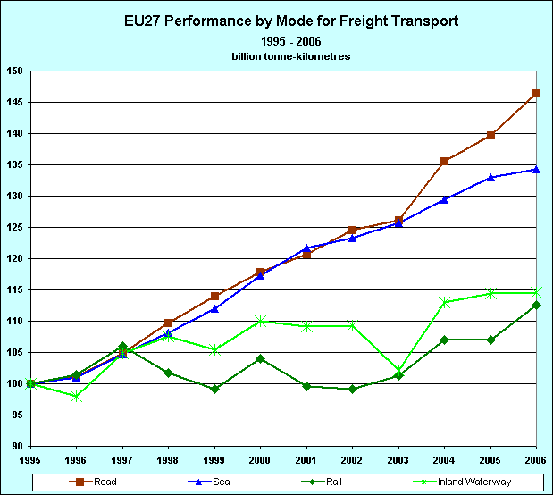
Freight railways traffic has continued to loose relevance within the modal split. It has being losing traffic in absolute terms since 2000; though the trend seems to be changing since 2003. Short Sea Shipping statistics show after some years of strong growth, two years of lower growth in 2001 and 2002, followed by a new increase of rate in 2003. In the inland navigation transport particular progress can be observed in container transport by inland navigation, where important growth rates over the past decade have at least been equivalent to those of road transport.
Figure 13: Freight transport growth by mode 1995-2006 (1995=100) in the EU 27
In April 2004, the European Parliament and the Council adopted Decision No. 884/2004/EC of the European Parliament and the Council, amending Decision No. 1692/96/EC on Community guidelines for the development of the trans-European transport network with a time horizon of 2020.
In Annex III to Decision No 1692/96/EC a list of priority projects is presented where future funding should be concentrated. For the identification of these projects a methodology was used which was based on criteria which include, in particular, their potential economic viability, the degree of commitment on the part of the Member States concerned to keeping to a timetable agreed in advance in the programming of projects, their impact on the mobility of goods and persons between Member States, and their impact on cohesion and sustainable development.
In order to facilitate the coordinated implementation of certain projects, in particular cross-border projects or sections of cross-border projects included among the projects declared to be of European interest, the Commission designated, in agreement with the Member States concerned, and after having consulted the European Parliament persons called "European Coordinator". The European Coordinator acts in the name of and on behalf of the Commission.
On 21 April 2004 Decision No 807/2004/EC was adopted by the European Parliament and the Council, amending Council Regulation (EC) No 2236/95 laying down general rules for the granting of Community financial aid in the field of trans-European networks. The Commissions’ proposed increase of the maximum rate of Community support, in exceptional cases, from 10% to 20 % was accepted.
An exception can be made for projects concerning satellite positioning and navigation systems and sections of the projects of European interest identified in Annex III to Decision No 1692/96/EC, provided that these projects are started before 2010, with the aim of eliminating bottlenecks and/or filling in missing sections, if such sections are cross border or cross natural barrier, and contribute to the integration of the internal market in an enlarged Community, promote safety, ensure the interoperability of the national networks and/or strongly contribute to the reduction of imbalances between modes of transport, in favour of the most environment-friendly modes.

General assessment of the EU-27
The total investment in the TEN-T network in the EU-27 amounted, as already mentioned in the main report, EUR 101.74 billion in the year 2004 and 2005. The countries with the highest investments in the 2004 – 2005 period are Italy (EUR 17.89 billion), UK (EUR 17.17 billion), Spain (EUR 13.91 billion), Germany (EUR 10.46 billion), France ( EUR 9.1 billion ) and the Netherlands (EUR 6.58 billion).
In terms of mode, the investment in the 2004 – 2005 period focused on railways (57%), followed by roads (27%), airports (9%), ports (5%) and inland waterways (2%). This distribution shows an increase in investment for rail and a relative decrease in investment for roads, compared to the 2002 – 2003 period.
Figure 14: Investment in the TEN-T network per country and mode for the first 14 countries having invested the most of the EU-27 in 2004 and 2005 in millions of EUR
Figure 15: Investment in the TEN-T network per country and mode for the remainder countries of the EU-27 in 2004 and 2005 in millions of EUR
On average the EU-27 countries devoted 0.47% of GDP on TEN-T infrastructure in the 2004 and 2005 period; in the 2002 and 2003 period it was an average of 0.43% of their GDP for the TEN-T network; the countries with the highest average were Estonia (1.86%), Latvia (1.36%) and Slovenia (1.30%) measured in GDP percentage followed by Hungary (1.08%). One can observe that the first countries are new Member States, where infrastructure development is an essential basis for the further economic development. At the other end of scale Denmark,Cyprus, Luxembourg, Germany, France,Romania and Slovakia have a much lower average compared with the average of the EU.
Figure 16: Investments in the TEN-T network by Member States in 2004 and 2005 in average /GDP in % for EU27.

Priority projects
The Community is making a special effort to support the projects of common interest ; this is necessary to ensure a coherent development of the network and to encourage investment on the main axes by national and regional authorities. These priority projects are selected according to a strict methodology that is included in the guidelines.
The 30 priority projects consist of 14 priority projects (the so-called Essen projects), identified under the 1996 guidelines, and 16 additional projects identified in the High Level Group exercise, chaired by Karel van Miert and adopted in 2004 by the guidelines. All these projects should be completed by 2020.
As the following detailed table shows the investments up to the end of 2004 in the priority projects amounted to EUR 108.1 billion, while the total investments in the priority projects, as reported by the Member States in 2008, for the whole 1996 – 2020 period are about EUR 397.2 billion. Thus the remaining investments in the 2006 – 2020 period amount to EUR 289.1 billion.
Out of 30 projects 18 railways projects are defined and demonstrate the clear mode preference of the EU transport policy.
Mode of transport | Rail | Road | Inland Waterway | Short Sea Shipping | Multimodal | Airport | Galileo
Number of projects | 18 | 3 | 2 | 1 | 4 | 1 | 1

No | Project | Mode | Total cost in bn € | Investment till end 2005 in bn € | Remaining investment in bn € | % of completion | TEN-T support till 31-12-2005 bn €
1 | Railway axis Berlin-Verona/Milan-Bologna-Naples-Messina-Palermo | Rail | 47,1 | 20,1 | 27,0 | 42,7% | 0,3736
2 | High-speed railway axis Paris-Brussels/Brussels-Cologne-Amsterdam-London | Rail | 18,8 | 15,8 | 3,0 | 84,0% | 0,7289
3 | High-speed railway axis of south-west Europe | Rail | 50,7 | 8,8 | 41,9 | 17,3% | 0,2547
4 | High-speed railway axis east | Rail | 5,3 | 2,6 | 2,7 | 49,0% | 0,2294
5 | Betuwe Line | Rail | 4,8 | 4,1 | 0,7 | 85,4% | 0,1350
6 | Railway axis Lyon-Trieste-Divaca/Koper/Divaca-Ljubljana-Budapest-Ukrainian border | Rail | 60,7 | 6,7 | 54,0 | 11,0% | 0,2846
7 | Motorway axis Igoumenitsa/Patra-Athina-Sofia-Budapest | Road | 14,9 | 7,8 | 7,1 | 52,3% | 0,1185
8 | Multimodal axis Portugal/Spain-rest of Europe | Multimodal | 15,3 | 7,1 | 8,2 | 46,4% | 0,0433
9 | Railway axis Cork-Dublin-Belfast-Stranraer | Rail | 0,4 | 0,4 | 0,0 | 100,0% | 0,0120
10 | Malpensa Airport (Milan) | Air | 1,3 | 1,3 | 0,0 | 100,0% | 0,0268
11 | Öresund fixed link: COMPLETED | Rail/road | 4,2 | 4,2 | 0,0 | 100,0% | 0,1927
12 | Nordic triangle railway-road axis | Rail/road | 11,7 | 3,8 | 7,9 | 32,5% | 0,1922
13 | UK-Ireland/Benelux road axis | Road | 7,5 | 2,4 | 5,1 | 32,0% | 0,0838
14 | West Coast Main Line | Rail | 12,6 | 10,1 | 2,5 | 80,2% | 0,0796
15
16 | Freight railway axis Sines-Madrid-Paris | Rail | 8,9 | 0,002 | 8,9 | 0,0% | 0,0000
17 | Railway axis Paris-Strasbourg-Stuttgart-Vienna-Bratislava | Rail | 13,6 | 3,0 | 10,6 | 22,1% | 0,1220
18 | Rhine/Meuse-Main-Danube inland waterway axis | IWW | 2,1 | 0,004 | 2,1 | 0,2% | 0,0021
19 | High-speed rail interoperability on the Iberian peninsula | Rail | 41,8 | 2,5 | 39,3 | 6,0% | 0,0620
20 | Fehmarn Belt railway axis | Rail/road | 7,9 | 0,1 | 7,8 | 0,1% | 0,0270
21
22 | Railway axis Athina-Sofia-Budapest-Vienna-Prague-Nürnberg/Dresden | Rail | 12,6 | 0,5 | 12,1 | 0,1% | 0,0070
23 | Railway axis Gdansk-Warsaw-Brno/Bratislava-Vienna | Rail | 6,2 | 0,9 | 5,3 | 15,0% | 0,0072
24 | Railway axis Lyon/Genoa-Basel-Duisburg-Rotterdam/Antwerp | Rail | 22,7 | 2,6 | 20,1 | 11,5% | 0,0450
25 | Motorway axis Gdansk-Brno/Bratislava-Vienna | Road | 6,8 | 1,0 | 5,8 | 15,0% | 0,0050
26 | Railway-road axis Ireland/United Kingdom/continental Europe | Rail/road | 6,2 | 2,2 | 4,0 | 35,5% | 0,0070
27 | Rail Baltica axis Warsaw-Kaunas-Riga-Tallinn-Helsinki | Rail | 3,2 | 0,03 | 3,2 | 0,1% | 0,0027
28 | Eurocaprail on the Brussels-Luxembourg-Strasbourg railway axis | Rail | 1,2 | 0,0 | 1,2 | 0,0% | 0,0035
29 | Railway axis if the Ionian/Adriatic intermodal corridor | Rail | 4,3 | 0,02 | 4,3 | 0,0% | 0,0000
30 | Inland waterway Seine-Scheldt | IWW | 4,4 | 0,1 | 4,3 | 2,2% | 0,0050
 | Grand total |  | 397.2 | 108,1 | 289,1 | 27,22% | 3,506
Table3: Investments on the 30Priority Projects
Figure 17: Modal segment of investments in priority projects in the EU-27
Three priority projects have already been completed:
Axis 9: Railway axis Cork-Dublin-Belfast-Stranraer (Ireland, UK) in 1989 – 2001.
Axis 10: Malpensa Airport (Milan, Italy) in 1995 – 2001.
Axis 11 Öresund fixed link (Denmark, Sweden) in 1992 – 2000.
PART 4
Sources of Funding
This chapter provides an overview of the financing of TEN-T, the EU financial support as well as EIB loans for the period 2004-2005.

TEN-T Budget
TEN-T funding is generally provided by way of grant or interest rebate (effectively the TENs budget line meets interest payments for a certain period, usually until the asset is ready for use). This funding is managed in accordance with Council Regulation no. 2236/95. The European Parliament and the European Council (on 21 April 2004) adopted an amendment of the regulation No 2236/95 establishing the new rules for “community financial aid” for the Trans-European-Networks (in force since 20 May 2004).
An important part of the TEN-T budget is assigned to TEN-T priority projects. Key restrictions include:
The total amount of financial support from the TENs budget line should not exceed 10% (in 2004 this percentage was increased to 20% for cross-border projects) of the total investment costs. Aid to feasibility studies is limited, generally to a maximum of 50% of the costs. The maximum duration of interest rate subsidy should generally not exceed 5 years. In addition, the EC financial support should not interfere in the existing competition.
In the years 2004 and 2005 the EU25 received about EUR 1.09 billion for investments on their TEN-T infrastructure. The additional investments in this period for Galileo was about EUR 0.24 billion.
Figure shows the distribution of funds per mode while Figure provides an overview of the funds per country and mode.
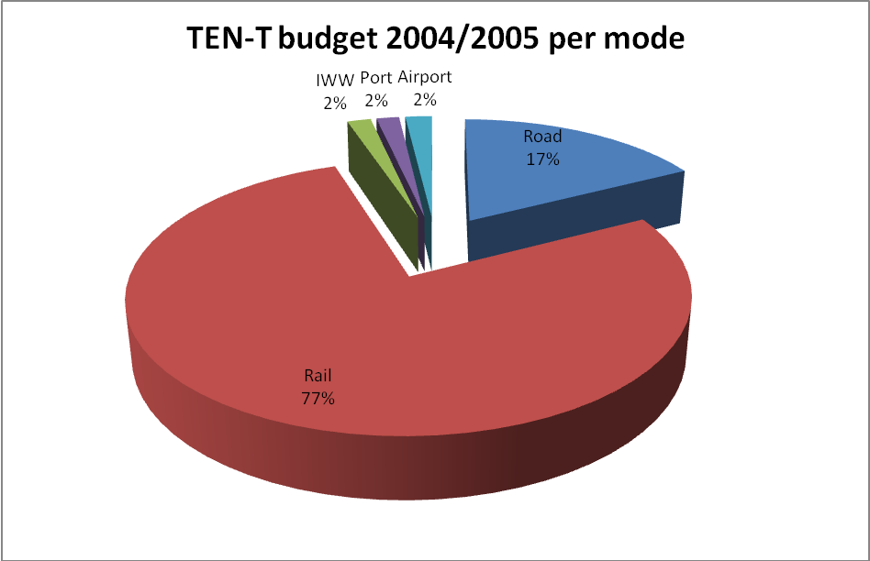
Figure18: Share of TEN-T budget 2004/2005 per mode
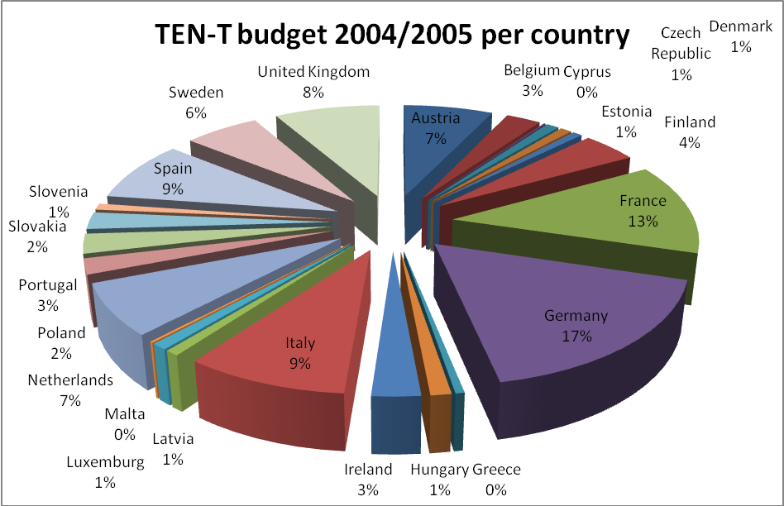
Figure19: Share of TEN-T budget 2004/2005 per country

Country | Total |  | Road |  | Rail |  | IWW |  | Port |  | Airport
Country | 2004 | 2005 | 2004 | 2005 | 2004 | 2005 | 2004 | 2005 | 2004 | 2005 | 2004 | 2005
Austria | 32.70 | 44.21 | 2.43 | 1.64 | 30.27 | 38.15 | 0.00 | 2.10
Belgium | 19.94 | 9.91 | 17.94 | 1.75 | 0.00 | 7.00 | 1.00 | 1.16 |  |  | 1.00
Bulgaria
Cyprus | 1.60 |  |  |  |  |  |  |  | 1.60
Czech Republic | 5.93 | 4.94 | 0.93 |  | 5.00 | 4.94
Denmark | 6.03 | 4.04 | 2.78 | 1.44 | 1.25 | 2.60 |  |  |  |  | 2.00
Estonia | 5.00 | 3.18 | 4.00 |  | 1.00 |  |  |  |  | 1.48 |  | 1.70
Finland | 20.68 | 26.74 | 5.68 | 3.74 | 15.00 | 19.80 |  |  |  | 3.20
France | 45.71 | 93.32 | 5.01 | 3.82 | 34.20 | 77.70 | 6.50
Germany | 113.72 | 73.55 | 10.70 | 5.35 | 100.07 | 62.30 |  | 5.90 | 1.95 |  | 1.00
Greece | 1.18 | 4.25 |  |  |  | 2.25 |  |  |  | 2.00 | 1.18
Hungary | 9.10 | 3.35 |  | 3.35 | 8.00 |  | 1.10
Ireland | 9.68 | 19.54 | 8.68 | 19.54 | 1.00
Italy | 48.96 | 49.05 | 3.79 | 2.55 | 43.00 | 46.50 |  |  |  |  | 2.18
Latvia | 4.50 | 3.95 | 2.85 | 3.95 |  |  |  |  | 1.65
Lithuania
Luxemburg | 4.54 | 5.25 | 2.04 | 1.75 | 2.50 | 3.50
Malta | 0.80 | 1.20 |  |  |  |  |  |  | 0.80 |  |  | 1.20
Netherlands | 46.44 | 31.20 | 8.54 | 1.75 | 37.60 | 29.45 | 0.30
Poland | 4.25 | 19.14 | 1.00 | 12.70 | 3.25 | 6.44
Portugal | 14.14 | 15.66 | 2.61 | 2.66 | 7.90 | 13.00 |  |  | 1.25 |  | 2.38
Romania
Slovakia | 4.90 | 21.01 | 3.80 | 7.19 |  | 13.82 |  |  |  |  | 1.10
Slovenia | 6.50 | 3.23 |  |  | 6.50 | 1.73 |  |  |  |  |  | 1.50
Spain | 37.84 | 55.53 | 5.07 | 2.67 | 31.60 | 52.86 |  |  |  |  | 1.18
Sweden | 24.28 | 39.90 | 6.78 | 4.54 | 16.00 | 33.50 |  |  | 1.50 | 1.86
United Kingdom | 58.12 | 32.20 | 6.62 | 6.20 | 51.50 | 22.00 |  |  |  |  |  | 4.00
TOTAL | 526.52 | 564.38 | 101.23 | 86.62 | 395.64 | 437.54 | 8.90 | 9.16 | 8.75 | 8.54 | 12.00 | 8.40
Table4: TEN-T budget 2004/2005 in million € per mode and country without investments for Galileo
 | 2004 | 2005 | 2004-05
Rail | 395,64 | 437,54 | 833,18
Road | 101,23 | 86,62 | 187,85
Galileo | 100 | 76 | 176
ITS | 70 | 68,27 | 138,27
Combined Transport | 15 | 20 | 35
Airport | 12 | 8,4 | 20,4
IWW | 8,9 | 9,16 | 18,06
Port | 8,75 | 8,54 | 17,29
Multimodal Transport | 11,6 | 0 | 11,6
Total | 711,52 | 714,53 | 1426,05

Table 5: TEN-T budget 2004/2005 in million €

The European Regional Development Fund
The EU budget for 2004 was the first with 25 Member States (EU25). The accession of ten new Member States (EU10) in May 2004 resulted in additional budget needs, which were covered by means of amending budgets (amended budget No 1/2004 provided EUR 3.812 million overall and EUR 1.702 million EUR for the Structural Funds in the EU10).
The year 2005 was dedicated to bringing the “programming period 2000 – 2006” to a successful end and to preparing the new “Cohesion Policy Programmes for 2007 – 2013”.
Based on the information provided by the Member States (in their expenditure claims), in 2005 the Objective 1 Programs on investments for basic infrastructure (40.1%) spent more than half of all investments for transport infrastructure (54.3%).
Within framework of ERDF more than EUR 8.8 billion were spent for major TEN-T projects in the period 2000 – 2006.

Cohesion Fund
The Cohesion Fund provides assistance for environmental and transport infrastructure (devoted especially to TEN-T projects) in Member States whose GDP is less than 90%of the average GDP in the EU.
On 1 May 2004, all 10 new Member States (those formerly benefiting from the ISPA programme plus Cyprus and Malta) met the criteria for Cohesion Fund eligibility. For structural assistance in the 10 new countries (for the years 2004 – 2006), an overall budget of EUR 24 billion was earmarked, out of which EUR 8.5 billion were designated to the Cohesion Fund.
Cohesion Fund resources available for commitment in 2004 were € 5.62 billion and in 2005 € 5.13 billion for the 13 beneficiary Member States. It should be noted that Ireland is no longer eligible for Cohesion Fund (since 1 January 2004).

 | 2004 |  | 2005 |  | 2004/2005
 | Commitments | Payments (Cohesion and former ISPA Fund) | Commitments | Payments (Cohesion and former ISPA Fund) | Commitments | Payments (Cohesion and former ISPA Fund)
Czech Republic | 144.82 | 49.36 | 130.83 | 36.41 | 275.64 | 85.77
Cyprus | 18.26 | 0.00 | 1.98 | 5.06 | 20.23 | 5.06
Estonia | 31.56 | 13.68 | 53.97 | 13.63 | 85.53 | 27.30
Greece | 239.01 | 265.54 | 321.69 | 157.31 | 560.70 | 422.85
Ireland |  | 0.02 |  | 4.39 |  | 4.41
Hungary | 188.22 | 10.12 | 153.05 | 117.70 | 341.27 | 127.82
Latvia | 102.88 | 13.49 | 76.22 | 45.39 | 179.10 | 58.88
Lithuania | 148.92 | 14.11 | 54.38 | 69.33 | 203.30 | 83.44
Malta |  |  | 5.35 |  | 5.35
Poland | 707.16 | 142.36 | 492.00 | 43.88 | 1199.16 | 186.24
Portugal | 217.96 | 193.35 | 199.77 | 150.78 | 417.73 | 344.13
Slovakia | 67.42 | 21.27 | 76.45 | 66.93 | 143.87 | 88.20
Slovenia | 45.61 | 1.61 | 4.69 | 16.68 | 50.30 | 18.29
Spain | 977.54 | 886.93 | 955.63 | 732.30 | 1933.18 | 1619.24
Total | 2889.34 | 1611.84 | 2526.01 | 1459.77 | 5415.35 | 3071.61
Table5: Transport infrastructure investment by country, funded by the Cohesion Funds in 2004 and 2005 (including former ISPA projects)
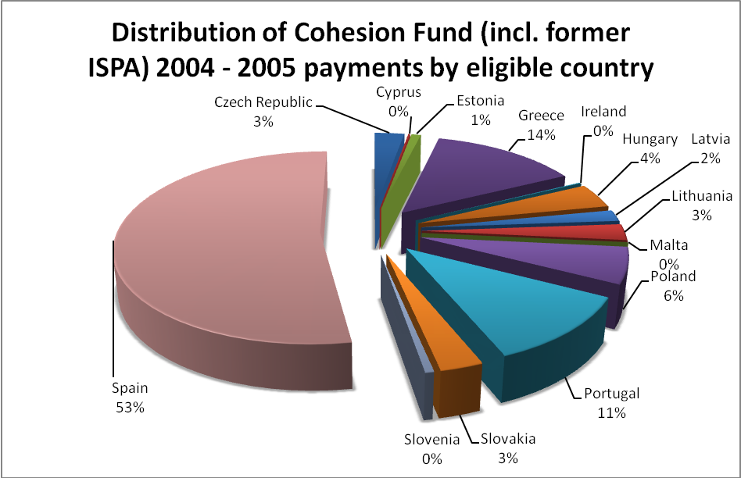
Figure20: Distribution of Cohesion Fund (incl. former ISPA) 2004 - 2005 payments by eligible country
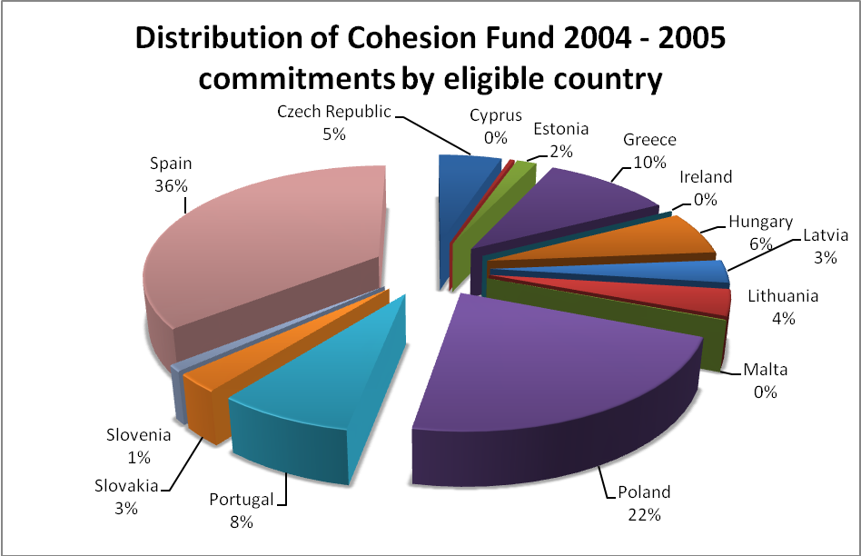
Figure21: Distribution of Cohesion Fund 2004 - 2005 commitments by eligible country

European Investment Bank (EIB)
The EIB finances a large number of TEN-T projects provided that they pass an evaluation of technical, financial and environmental matters and that the projects are consistent with EU objectives.
Key aspects of EIB loans are that they can cover up to 50% of the project costs: another advantage compared with the commercial banks is, that they have a longer term. Moreover, EIB loans are provided without the need for project specific premiums as the EIB requires that loans are backed by guarantee.
The EIB loans in 2004 and 2005 amounted to nearly 13.75 billion EUR, which represents about 14% of all TEN-T financing in this period. The EIB has about 75 billion EUR available to lend to TEN-T projects for
the 2004-2013 period.
More particularly, in the year 2004, EIB lent approx. EUR 6.3 billion (including EUR 0.7 billion for urban transport) for projects related to EU political objectives and EUR 7.4 billion (including EUR 0.3 billion for urban transport) in the year 2005. The amount for the EU27 totalled EUR 13.7 billion (including EUR 1 billion for urban transport) for 2004 and 2005, out of that, EUR 2.8 billion went to the new Member States.
EIB set up, in agreement with the EC and the EBRD, the new JASPERS instrument (Joint Assistance to Support Projects in European Regions), to help particularly the new Member States to prepare major infrastructure projects, needing finances form the Cohesion Fund, the Structural Fund and EIB.
 | Railways | Roads | IWW | Airports | Ports | Multimodal | Urban transport | Total
2004 | 2002 | 1508 | - | 1705 | 468 | - | 690 | 6374
2005 | 2806 | 2748 | - | 1015 | 461 | 41 | 300 | 7371
Total | 4808 | 4256 | - | 2720 | 929 | 41 | 990 | 13745
Table6: Distribution of EIB loans in million € for 2004 and 2005 per mode
The modal share of the lending was the following:
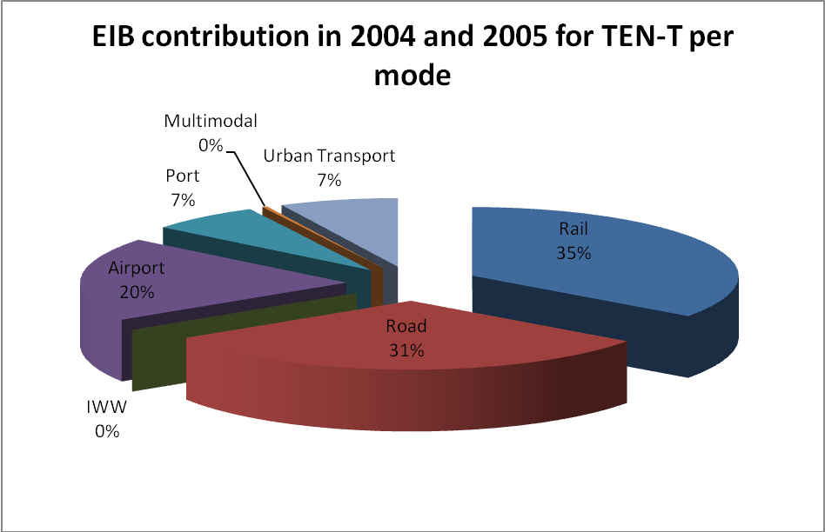
Figure22: EIB contribution in 2004 and 2005 for TEN-T projects per mode
Lending per country in 2004 and 2005:
 | 2004 | 2005 | Total
Austria | 48 | - | 48
Belgium | 212 | - | 212
Bulgaria | 20 | - | 20
Czech Republic | 200 | 275 | 475
Finland | - | 153 | 153
France | 640 | 390 | 1030
Germany | 260 | 185 | 445
Greece | 350 | 435 | 785
Hungary | - | 77 | 77
Ireland | 130 | - | 130
Italy | 1240 | 1423 | 2663
Netherlands | 200 | - | 200
Poland | 300 | 500 | 800
Portugal | 290 | - | 290
Romania | - | 550 | 550
Slovakia | 30 | - | 30
Slovenia | 110 | 250 | 360
Spain | 1971 | 2805 | 4776
Sweden | 158 | 328 | 486
United Kingdom | 215 | - | 215
Total | 6374 | 7371 | 13745
Table7: Distribution of EIB loans in million € for 2004 and 2005 by country
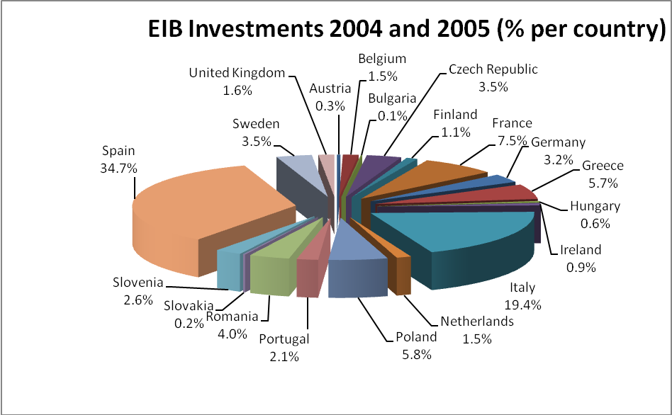
Figure23: Share of EIB financing in 2004 and 2005 for TEN-T projects per country

General assessment of funding sources
It can be concluded that investments in the TEN-T are funded by a variety of sources including national funds, various different European Community funding programs and loans. A general assessment of the sources of the TEN-T investments shows that national public funding contributed almost 78%, by far the largest share of the investments in the TEN-T in the 2004-2005 period. The second largest share, at approximately 13.5%, was loans from European Investment Bank. Together these sources contributed more than 90% of the investment on the TEN-T.
Although the exact amount of private funding is difficult to determine (due to the fact that for infrastructure in private hands like ports and airports it is difficult to obtain investment data), it is estimated that it represents a minor part. As a consequence, national public funding is still the main source of finance for TEN-T related projects.
Source of funding | 2004 | 2005 | 2004-05 | in %
TEN-T budget | 526,52 | 564,38 | 1090,9 | 1,1%
Cohesion Fund (incl. ISPA) | 1611,84 | 1459,77 | 3071,61 | 3,0%
EIB | 6374 | 7371 | 13745 | 13,5%
EBRD | 197,3 | 176,2 | 373,5 | 0,4%
ERDF (estimated) | 2045,9 | 1855,6 | 3901,5 | 3,8%
National budget & private sources | 39669,39 | 39889,34 | 79558,73 | 78,2%
Total | 50424,05 | 51316,29 | 101770,2 | 100,0%
Table8: Distribution of TEN-T funding sources in million € for EU 27
Figure24: Distribution of TEN-T funding sources

OP cit: 5
OP cit: 5
OP cit: 5
out of the 27 Member States 11 don’t have IWW and 9 MS didn’t report investments on IWW; thus only 7 MS reported investments on IWW
Note: In a majority of ports, the port services are provided by private operators. Therefore, information is rarely available centrally, and the information that is available is often incomplete or lacks homogeneity. Detailed information is only available in a limited number of cases.
OP cit: 5
Category A international seaports: ports with a total annual traffic volume of not less than 1.5 million tonnes of freight or 200,000 passengers which (unless impossible) are connected with the overland elements of the trans-European transport network and therefore play a major role in international maritime transport. Category B Community seaports: ports with a total annual traffic volume of not less than .0.5 million tonnes of freight or between 100,000 and 199,999 passengers, which are connected (unless impossible), with the overland elements of the trans-European transport network and are equipped with the necessary transhipment facilities for short-distance sea shipping. Category C regional ports: these ports do not meet the criteria of categories A and B but are situated in island, peripheral or outermost regions, interconnecting such regions by sea and/or connecting them with the central regions of the Community.
Due to liberalisation and privatisation, most major airports are in private hands and managed accordingly. Therefore, it was often difficult to obtain information, as data are rarely centralised by national authorities.
OP cit: 5
Due to the fact that many airports now have private managements, there are some uncertainties as to the investment figures, as investment data are rarely centralised by national authorities and are difficult to obtain from the individual airports. Long-term strategies as to the development of airports were rarely available, as well.
OP cit: 5
Regulation (EC) No 807/2004 of the European Parliament and of the Council of 21 April 2004 amending Council Regulation (EC) No 2236/95 laying down general rules for the granting of Community financial aid in the field of trans-European networks

