EN
COMMISSION OF THE EUROPEAN COMMUNITIES
Brussels, 28.1.2009
SEC(2009) 102

COMMISSION STAFF WORKING DOCUMENT
accompanying the
COMMUNICATION FROM THE COMMISSION
TO THE EUROPEAN PARLIAMENT, THE COUNCIL, THE EUROPEAN ECONOMIC AND SOCIAL COMMITTEE AND THE COMMITTEE OF THE REGIONS
Towards a comprehensive climate change agreement in Copenhagen
- Additional background information-
{COM(2009) 39 final}
{SEC(2009) 101}
Table of content
1. Low carbon development strategies 3
2. Technical provisions for monitoring, reporting and verification 5
3. Public funds and international carbon crediting mechanisms to support developing country mitigation 6
4. Compliance and enforcement 6
5. Funding early action through a Global Climate Financing Mechanism (GCFM) 7
6. Financing global research, technology development and demonstration 8

Low carbon development strategies
Low carbon development strategies need to include:
- a credible pathway to limit the country’s emissions through nationally appropriate mitigation actions
- an emissions inventory including key parameters (e.g. emission intensity) and a projection of business-as-usual emissions for key sectors;
- a portfolio of action to address emissions in key sectors following a two-track approach:
- autonomous action (mainly “win-win” and low-cost action), that are mainly to be financed and implemented by the country itself, and that could be supported by capacity building and targeted international loan schemes;
- supported action requiring assistance due to the incremental costs, in the form of financing, technology or capacity building for implementation;
- estimates of emission reduction targets from each category of action, in the short term (2020-2030) and with an identification of long-term (2050) targets;
- specific needs to support implementation.
The first set of strategies should cover a period of five years, but individual action and support could be updated more frequently.
Developing country strategies should identify the support required to enable the implementation of proposed action resulting in incremental costs that cannot be sustained by the country itself. This could include:
- Financial assistance, if possible performance-based, to implement policies and measures, e.g. action to reduce deforestation and other mitigation action;
- International crediting mechanisms, including no-lose sectoral crediting approaches as well as “classic” CDM for less advanced sectors;
- Technology cooperation, including joint technology development, cooperation on policies for technology deployment (including standards) and technology demonstration projects.
Key to the low carbon development strategy approach will be ensuring a sufficient level of ambition, which is linked to the ability to raise appropriate support for concrete proposals for action. Discussions on linking proposals for action to support should be facilitated by independent technical analysis of the proposed strategy and action, in particular:
- Methodology and assumptions to estimate business-as-usual emissions;
- Technology and policy assumptions underlying proposed action;
- Proposed support to implement the action, in particular an estimation of incremental costs;
Methodology and assumptions to estimate the mitigation impact of proposed action. Discussion of a country’s strategy in the Facilitative Mechanism for Mitigation Support should be based on the independent technical analysis.
.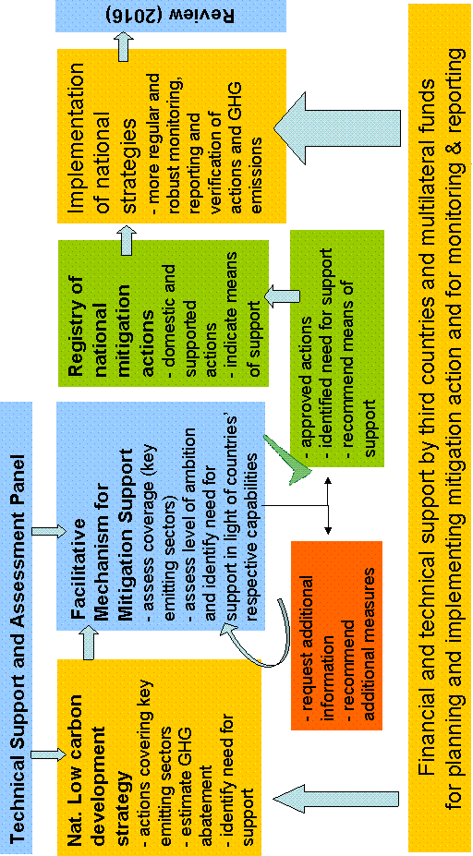

Technical provisions for monitoring, reporting and verification
Developed countries
Developed countries should improve the measurement, reporting and verification of their emissions. Future inventories should be prepared on the basis of the improved 2006 IPCC inventory guidelines. Sufficient resources should be made available to ensure a robust annual expert review of those inventories. Developed countries should furthermore provide every two years an update of their climate-related policies and emission projections, building on current EU practice. An in-depth review of these reports should include learning from good practice and early identification of problems in meeting emission targets on the basis of projections.
Developed countries should also significantly improve the measurement, reporting and verification of support provided to developing countries. Support for both mitigation and adaptation actions should be annually measured and reported in parallel with “traditional” Official Development Assistance (ODA). This should build on existing reporting practices, such as the OECD Development Assistance Committee (OECD DAC) database and should be complemented by new indicators on technology transfer.
Developing countries
Developing countries should regularly monitor and report action on mitigation and adaptation. This should form the basis for exchanging information, identifying and sharing good practice and regular peer reviews.
Following the assessment of a developing country’s low carbon development strategy in the Facilitative Mechanism for Mitigation Support, developing countries could enter mitigation action (both autonomous and supported action) in a registry for nationally appropriate developing country mitigation action. This registry, which should be operational as of 2012, will include a description of the action, quantified mitigation benefits and any other benefits. It will increase the visibility and recognition of action undertaken by developing countries.
Developing countries do not currently provide regular emission inventories, which makes it hard to identify opportunities for action and impossible to determine the effectiveness of their mitigation efforts. The Copenhagen agreement should ensure that all developing countries, except the Least Developed Countries, provide annual emission inventories, at least for the key emitting sectors of their economies, as of 2010 using the 2006 IPCC inventory guidelines. Comprehensive capacity building and technical and financial support must be provided to help them prepare these inventories.
In addition, a credible peer review process, building upon experience with the expert reviews under the UNFCCC, is needed to assess actual implementation of mitigation and adaptation policies and the quality of emission inventories. This should also include the support received for implementation. All action entered in the registry should be subject to this verification, even if they do not receive third country or international support.
Sectoral Approaches as a tool to engage the private sector
Several sectoral approaches have arisen as a promising tool to facilitate action on climate change:
- Industry led sectoral approaches have demonstrated that they are capable of building globally industry cooperation on climate change, leading to a better understanding of existing emissions and potential improvements as well as the sharing of best practice.
- Further opportunities exist in using sectoral approaches as an element in
- building low carbon development strategies,
- developing sector-specific technology development and demonstration as well as
- realising sectoral crediting mechanisms as part of a future global carbon market.
In conclusion, sectoral approaches, built on public private partnerships, can help mobilise action by business in both developed and developing countries and assist the transition towards a global low carbon economy.

Public funds and international carbon crediting mechanisms to support developing country mitigation
Support for the incremental costs of such investment should come from a range of sources. The UNFCCC estimated the annual additional investment and financial flows needed in developing countries at US $ 65 billion per year by 2030.
Public funds
These should leverage larger private finance flows and can be employed in a variety of instruments, including pure grants, interest reduction, publicly supported loan facilities and venture capital funds. Support for mitigation action should include:
- Capacity building. Public grants can focus on up-front capacity building and monitoring systems and be mobilised as of 2010. A significant amount will be required for mitigation and technology cooperation until 2015.
- Project-based programs such as the Global Energy Efficiency and Renewable Energy Fund (GEEREF), providing equity to the innovative private sector in developing countries.
- A Global Forest Carbon Mechanism that provides performance-based incentives to reduce deforestation emissions.
International carbon crediting mechanisms
Project-based offsetting in the Clean Development Mechanism (CDM) has demonstrated its limits both in scale and environmental integrity. New sector-wide mechanisms, including sectoral no-lose targets, should be developed to provide broad incentives and credit only action that that are additional and go beyond low cost options. The EU, as part of its 2020 unilateral 20% reduction target, has already committed to using up to 3 Gt CO₂ reductions through the CDM and Joint Implementation (JI) until 2020. In addition, a pilot phase should start in 2013 for reducing emissions of deforestation and forest degradation by establishing forest carbon credits that can be used exclusively for government compliance. Certain pre-conditions would need to be met before any inclusion of forests in carbon markets could be considered as a realistic option.

Compliance and enforcement
A robust compliance and enforcement system is key to ensure the implementation of a Copenhagen agreement. Such system will need to build upon the existing system under the Kyoto Protocol, which has already proven its effectiveness in the first non-compliance cases brought before its Compliance Committee. The experience with the application of the current system provides a solid basis to adjust the current system to the needs of a Copenhagen agreement. One particular aspect that should be explored in this context is how to deal with Parties that would not ratify the Copenhagen agreement which could potentially undermine the overall environmental effectiveness of a global accord.

Funding early action through a Global Climate Financing Mechanism (GCFM)
The Global Climate Financing Mechanism could be a short-term EU answer to the challenge that poor and most vulnerable developing countries are facing when tackling climate change. It aims to allow spending immediately on priority climate-related investments in those countries, contributing to rapidly reduce the current gap between the limited availability of funding and the need for climate-related priority investments (estimation of adaptation needs for developing countries by UNFCCC Secretariat amounts to € 23 to 54 billion per year in 2030). It will contribute to providing valuable returns on the ground in terms of development, in particular building climate resilience.
The GCFM has a temporary nature. It is conceived as a bridging facility to deliver substantial funding while a new architecture for climate financing is being built for the post-2012 period, paving the ground for its effective implementation in the longer term. Timing of the initiative is also important for the strong political signal it provides to the targeted countries during the negotiations. Being an EU initiative of significant size, this signal would be much stronger than smaller individual Member States initiatives.
The GCFM is not a new fund, but a fundraising mechanism which EU Member States would join on a voluntary basis. Funds raised would be used to complement existing instruments with their proper ways of delivery. Funds raised would be predominantly allocated to existing funding instruments depending on their comparative advantage. In this context, various criteria such as efficiency, effectiveness, coordination and coherence, support to approaches which integrate climate change into national planning processes and budget, the Paris Declaration principles, as well as absorption capacity, could be used.
The GCFM would raise funds on the capital market through the issuance of "climate" bonds. Repayment of the bonds over a long-term period (20 years) would be ensured by legally binding commitments from supporting EU Member States. They would agree on contributing to the overall level of funding according to relevant criteria, such as their GDP per capita and their level of GHG emissions.
The funds would be used with a priority for adaptation activities in poor developing countries most vulnerable to climate change (e.g. in agriculture, water, health, sustainable natural resources management). It is expected that adaptation costs will rise over time as climate impacts will worsen before effects of mitigation are felt and global temperature is stabilized. Even with reduced emissions from now on, the impact of past emissions would be felt for quite some time. Delaying interventions in adaptation actions risks putting in danger investments already done to reach development objectives. One clear example justifying early intervention in adaptation is disaster risk reduction. Studies reveal that for each dollar invested in disaster risk reduction, benefits between two and four dollars can be expected in terms of avoided or reduced social and economic impact of natural disasters.
Given the importance of early mitigation activities in some targeted developing countries, there is some flexibility to allocate a share of the funds raised to mitigation activities, still through the appropriate existing instruments.
As the poorest and most vulnerable developing countries would be targeted, many of which are facing problems of debt sustainability, grants should be the main financing modality. However, in order to increase the financial leverage, an additional option could be blending with loans from European development financial institutions having experience in this field (EIB, KFW, AfD, etc).

Financing global research, technology development and demonstration
Financing for global research, technology development and demonstration should include:
Capacity building
This would comprise support for identifying country-specific needs and existing capacity, support for expert training and best practice guidance, support for designing and implementing domestic policies, including data collection and the provision of technology information. It could be implemented by existing organisations.
Technology-oriented cooperation
For a number of specific key technologies, countries should agree to joint R&D and large-scale demonstration and deployment projects. RD&D projects should be taken forward in cooperation with developing countries to enhance ownership of new technologies, in particular intellectual property rights, and to accelerate the deployment and diffusion of advanced technologies, e.g. through technology roadmaps. The IEA has identified 17 key energy technologies on both the demand and supply side that could initially serve as a starting point for discussing such roadmaps, as well as those technologies identified under the EU’s Strategic Energy Technology (SET) Plan. It should also be considered how to strengthen existing international and regional technology initiatives, such as the Carbon Sequestration Leadership Forum, International Hydrogen Partnership.
Action should also be taken to strengthen innovation and diffusion systems in developing countries, to enable them to develop and adopt new technology suitable for their local circumstances and markets. This could be done through, for example, regional centres.
Reducing market barriers
Within the context of the WTO, tariffs and non-tariff barriers on clean environmental goods and services should be eliminated as early as possible in order to reduce the costs of advanced technologies and to spur their deployment. Using trade is an efficient and effective way to spread these goods and technologies internationally. Trade liberalisation in this area therefore would bring environmental, economic and commercial benefits for all sides.
Intellectual Property Rights (IPR)
Protecting IPRs is necessary to encourage research, technology development and demonstration, as well as large-scale deployment. Well established and enforced IPR rules also help technology transfer through increasing the willingness of enterprises to invest and license technology in emerging and developing countries. Countries should explore options to strengthen IPR frameworks to protect and share technology and further strengthening incentives for innovation.
Strengthening of knowledge
Advance understanding of the processes, evolution of climate change and its impacts to society, economy and ecosystems is required for the preparation of efficient and effective climate policies to adapt and mitigate. In particular, strengthening the research and observation on the economic and social dimensions of climate change mitigation and adaptation should be further enhanced.
Governance
The Copenhagen agreement will need to establish a consultative group that brings together government, private sector, civil society and other stakeholders’ expertise. This new body should provide strategic guidance for research and technology development and international cooperation drawing on technology needs identified in national low carbon development strategies. It could also provide advice on the course of action with respect to actual barriers to technology diffusion and social uptake of technological innovations.

UNFCCC secretariat. 2007. Investment and Financial Flows to Address Climate Change.
Equivalent to €45 billion for the period 2008-2020 at a price of 15 €/t CO₂.
Supply side: CCS fossil-fuel power generation, Nuclear power plants, Onshore and offshore wind, Biomass IGCC & co-combustion, Photovoltaic systems, Concentrating solar power, Coal: integrated-gasification combined cycle, Coal: ultra-supercritical, 2nd generation biofuels; Demand side: Energy efficiency in buildings and appliances, Heat pumps, Solar space and water heating, Energy efficiency in transport, Electric and plug-in vehicles, H2 fuel cell vehicles, CCS industry, H2 and fuel transformation Industrial motor systems.

