EN
COMMISSION OF THE EUROPEAN COMMUNITIES
Brussels, 17.3.2009
SEC(2009) 300

COMMISSION STAFF WORKING DOCUMENT
Impact Assessment concerning the Commission's proposal for a Council Regulation on the long-term management of the Northern hake stock
COM(2009)122 final
SEC(2009) 301
COMMUNICATION FROM THE COMMISSION
Impact Assessment concerning the Commission's proposal for a Council Regulation on the long-term management of the Northern hake stock
TABLE OF CONTENTS
1. Procedural issues and consultation of interested parties 4
1.1. Organisation and Timing 4
1.2. Consultation and expertise 4
1.3. Dissemination of scientific advice and the results of consultations with stakeholders 5
2. Problem Definition 5
2.1. Issue requiring action 6
2.2. Underlying driving forces 6
2.3. Effect on the sector 7
3. Objectives 10
4. Policy Options 11
4.1. Option 1 - no policy change 11
4.2. Option 2 - management plan 11
4.2.1. Option 2 implementation alternatives 12
4.3. Option 3 - decommissioning of fleet 12
5. Analysis of Impacts 13
5.1. Environmental impacts 13
5.2. Economic impacts 13
5.3. Social impacts 14
5.4. Impacts on international relations 14
5.5. Impact summary 15
6. 6. Comparing the Options 16
7. Monitoring and Evaluation 19
ANNEX 20
Glossary 25
EXECUTIVE SUMMARY
This Impact Assessment concerns a draft proposal for a Regulation that would replace the current recovery plan (EC Reg. No 811/2004) and set long-term management objectives and implementing methods concerning a fishery for the northern hake.
The likely environmental, social and economic impacts are limited as compared to the current Regulation because the changes foreseen are small, because it concerns a follow-up of the existing recovery plan. This is a proportionate impact assessment for which no formal inter-service steering group was set up.
The proposal is supported by DG MARE as an additional element in implementing sustainability in EU fisheries through maximum sustainable yield.
Scientific Committees and Stakeholders have been consulted. The Commission has sought the opinion of Member States and the Regional Advisory Councils (RACs) on the basis of a non-paper.
The operational elements are:
- A rule for setting the fishing opportunities each year in order to achieve sustainable long term exploitation of this resource.
- A rule for improving the exploitation pattern of the northern hake fishery in order to increase the benefits of the management plan in the long term and to reach the target fishing mortality sooner.
- A method for a reduction of overcapacity accompanying the options described above. The removal of excess fishing capacity would increase the economic benefit of each remaining vessel by increasing the available fishing opportunities per vessel and reducing costs.
The Impact Assessment considers three main options:
1) Option 1 – no policy change;
2) Option 2 - management plan;
3) Option 3 - decommissioning of fleet.
Details of the consultation processes, options and impacts are provided.

Procedural issues and consultation of interested parties

Organisation and Timing
This impact assessment concerns a proposal for a Council Regulation establishing a long-term plan for the stock of northern hake distributed mainly to the west and south of Ireland, in the western Channel and in the Bay of Biscay and the fisheries exploiting that stock. Its development is foreseen in Agenda Planning (FISH/2008/028) and in the 2008 Annual Management Plan of the Directorate-General of Maritime Affairs and Fisheries under the specific objective "Conservation and Management of Fish Resources" (to propose and negotiate measures, including multi-annual management plans, for the conservation and management of Community fish stocks, joint stocks and stocks partly occurring in international waters, with a view to ensuring the exploitation of fish stocks at maximum sustainable yield levels, taking into account broader environmental, economic and social concerns and making the best use of harvested fish resources, especially by avoiding wasteful discard practices).
The 2002 reform of the Common Fisheries Policy set the basis for management under long-term plans rather than by annual decision-making. In 2006 the Commission made a commitment to reach the objective of the declaration made at the World Summit on Sustainable Development in Johannesburg, with respect to restoring stocks to levels that can produce maximum sustainable yields (MSY) by 2015.
The Northern Hake recovery plan was adopted in 2004 (EC Reg. No 811/2004). The recovery plan is to be replaced by a management plan when, in two consecutive years, the target level for the stock has been reached. The International Council for the Exploration of the Sea (ICES), with the agreement of the Scientific Technical and Economic Committee for Fisheries (STECF), has evaluated and advised that the targets set in the recovery plan have been reached and therefore a management plan must be established to ensure the sustainable exploitation of this stock in the long-term.
The adoption of the proposal is foreseen in the fourth quarter of 2008.
The future management should be based on sound scientific advice. The Commission has asked STECF to provide scientific advice regarding several possible scenarios for the future management plan. The request covered both single-species management and multi-species management considerations, as well as socio-economic aspects.
This is a proportionate impact assessment and no inter-service steering group has been convened. The scope of the proposal is limited and the impact, in social, economic and environmental terms, is modest.

Consultation and expertise
External expertise has been sought from ICES concerning long-term management of fisheries resources of interest to the European Community since 2003. This organisation collates the expertise of fisheries scientists mostly working in the national fisheries laboratories of Member States and provides a systematic and standardised advice to the European Community and to Member States.
Advice on Northern Hake has been sought from relevant scientific organisations since 2001. The impact assessment is prepared by DG MARE on the basis of scientific advice concerning long-term management and is complemented with further economic analysis. Consultation with stakeholders has taken place with the relevant representative body.
Stakeholders were consulted by means of verbal and written presentations to the North Western Waters Regional Advisory Council (NWWRAC) and South Western Waters Regional Advisory Council (SWWRAC). These RACs ensure a fair representation of stakeholders as they have been established as the main bodies for consultations with parties having an interest in the Common Fisheries Policy in respect of fish stocks in the North and South Western Waters. The principal aim of the NWWRAC is to bring together stakeholders from across Europe, to advise the Commission on matters of fisheries management in respect of the waters covering ICES areas Vb (EC waters), VI, VII. The SWWRAC covers the Atlantic area going from the point of Brittany in its North to the Straits of Gibraltar in its South as well as the ultraperipheric regions of Madera, Azores and the Canarias Islands. The Advisory Committee on Fisheries and Aquaculture (ACFA) was not consulted as that body advises on cross-cutting issues whereas this plan concerns a specific regional issue.
The issue was first presented by the Commission services to the NWWRAC and SWWRAC beginning on 23rd February 2008. The RAC opinions indicated:
- general acceptance of the approach advised by STECF suggesting a reduction in fishing mortality (F);
- support for a reduction in F achieved through decommissioning of vessels within national schemes;
- disinclination to accept effort reduction through limitation of KW/days and its potential implications for TAC and quota allocations;
- possibility of harmonization of mesh sizes to 100mm for all the hake gillnet fishery, as opposed to increasing mesh size for the fishery;
- support to the French initiative to increase selectivity for Nephrops trawlers through the use of square mesh panels, as opposed to increasing the mesh size;
- disinclination to accept an increase in the mesh size of the demersal fishery to improve selectivity for hake;
- refusal to accept closing areas to fishing to protect juvenile hake.
The RAC representative from the environmental Non Governmental Organisation (NGO) generally supported the improvement of technical conservation measures (leaving the fishing industry members to determine the appropriate mesh sizes), and the closed areas proposal as suitable for conservation of the hake stocks.

Dissemination of scientific advice and the results of consultations with stakeholders
The scientific advice from ICES and from STECF and the advice from the RACs are available on the websites of the respective committees.

Problem Definition

Issue requiring action
In 2004, a recovery plan for the northern hake stock (EC Reg. No 811/2004) followed up a previous emergency plan (EC Reg. No 1162/2001, EC Reg. No 2602/2001 and EC Reg. No 494/2002). The recovery plan aimed at achieving a stock spawning biomass (SSB) of 140,000t (precautionary biomass level B_{pa}), by limiting the proportion of hake removed from the stock by fishing (fishing mortality) to 0.25, and with a maximum change in TAC between consecutive years of 15%. The objective of a recovery plan was to achieve an increase in the quantities of hake stock threatened with collapse to a minimum safe level according to the precautionary approach.
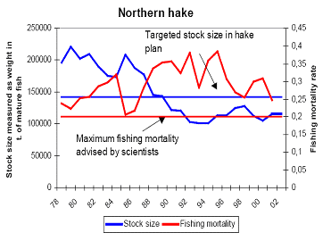
The recovery plan should be replaced by a management plan when, in two consecutive years, the target size level for the stock has been reached. ICES, with the agreement of STECF, should advise when the targets set in the recovery plan have been reached.
Recent scientific assessments by ICES and STECF indicate that the objective of the recovery plan has been achieved. The increase in spawning stock biomass (SSB) appears to be due to a combination of good recruitment and moderate fishing mortality. The recovery plan should now be replaced to ensure high yields and sustainable exploitation of this stock.

Underlying driving forces
The main long-term drivers of the fisheries system are the biological limitations on the productivity of the stock and the catching capacity of the fleet. Reducing the stock size to a low level will (while maintaining high catches for a short period) lower the productive potential of the stock. In contrast, in short-term perspectives it can often be economic and social pressures which predominate in the dynamics of the system and lead to decisions on fishing opportunities that become unsustainable.
Although the northern hake stock has recovered, it is still being fished at the rate which is too high for the stock (see Figure 1 in Annex). However a spawning stock biomass is above precautionary levels (SSB above B_{pa}), it is only slightly above this precautionary biomass limit, while the fleet fishing for this stock still has overcapacity and experiences high discarding rates, particularly of juvenile hake. STECF advises limiting the proportion of hake removed from the stock by fishing from current level of F=0.25 to F=0.17, to reduce the probability of SSB falling below the precautionary levels while maintaining yield.

Effect on the sector
2.3.1 Identification of the sectors affected
The sectors affected are fishing vessels from Spain, SW France, SW Ireland and SW UK, and associated on-shore processing industries. Spain accounts for the main part (59% in 2006) of landings. France was taking 26% of the total, UK 6%, with Ireland and Denmark taking each 3%.
Geographical distribution of Northern Hake
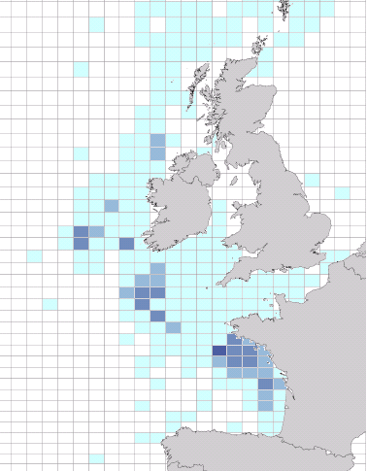
The main fisheries identified are:
- "Longliners" fishing in ICES Divisions VII, targeting hake (mainly Spain), with 22% of landings;
- "Gillnets" fishing in ICES Divisions VII and VIII, targeting mostly hake and sole (mainly France), with 21% of landings;
- "Demersal" trawlers fishing in ICES Divisions VII targeting anglerfish, hake, megrim (mainly France, Spain), with 33% of landings;
- "Nephrops" trawlers fishing in ICES Divisions VII; targeting Nephrops but taking by-catches of anglerfish, hake and megrim (mainly France).
Current size of the sectors and economic dependency on hake landings
As stated above, Spain and France are the key players in the Northern hake fishery being responsible for over 85% of landings. As such, those Member States have high dependency on hake landings and therefore will be subject to further detailed analysis.
Table A – overview of French and Spanish northern hake fleet (source STECF)
Type of vessel | FRANCE |  |  | SPAIN
Type of vessel | No. of vessels | Dependency on Hake | Percentage of overall landings | No. of vessels | Dependency on Hake | Percentage of overall landings
Longliners | 5 | 70% | 7% | 84 | 70% | 44%
Gillnets | 78 |  | 57%
Demersal | 160 | <6% | 15% | 113 | 20% | 56%
Nephrops trawlers | 204 | <4% | 10%
France had around 650 vessels engaged in fisheries for hake in 2006, while Spain had around 200 vessels in. Of the main fisheries identified in the previous section, the following have a high economic dependency on hake landings:
- "Longliners" depend strongly on hake landings (around 70%) although in France this fishery (only 5 vessels) catches low quantities of hake (7% of French landings). In Spain the fleet consists of 84 vessels catching 44% of the Spanish landings;
- "Gillnets" consist of 78 French vessels catching 57% of the total French landings;
- "Demersal" trawlers include 160 French vessels (corresponding to 15% of French landings) with low economic dependency (<6%) on hake. Spain has 113 vessels involved in this fishery (with 56% of Spanish landings), the majority of which have a higher dependency (20%) on hake landings.
- "Nephrops" trawlers include 204 French vessels (10% of French landings), the majority of which have very low economic dependency (<4%) on hake landings.
On board employment (full time equivalents) in the hake fishery in 2005 is estimated to be: 2438 people in France and 3077 people in Spain.
In 2008 a first-sale price value has been between €4.30-5.50.
Qualitatively, the impacts on the fleet would be magnified on-shore in the processing industry. However, given the low degree of processing taking place in the hake marketing chain, this knock-on effect is likely to be of a relatively minor importance.
2.3.2 Effect of the regulation
The proposed legal framework could include the following elements:
- Rules for setting TACs on the basis of scientific advice that will lead to exploiting the northern hake stock according to MSY within a medium (by 2016) to long-term (by 2021-2023) timeframe;
- Technical measures for special protection of hake juveniles and reducing discards;
- Sector voluntary decommissioning targets, a possibility available in the operational programmes of each Member State;
- Provisions for periodic review and adaptation of the plan.
Scientific evidence shows that maintaining present levels of fishing mortality will deliver less than the highest yield in the long term, and will incur unnecessary costs of fishing.
A legal framework is needed to bring a reduction in fishing mortality, which in turn would bring high economic benefits and more stability in TACs in the long-term. Reducing fishing mortality would increase yields and economic profitability of the industry, albeit with a small short term negative transitional impact. This increase in profitability is important because of the present high fuel costs and low profitability of some fleets.
2.3.3 Magnitude of the effect on the sectors
Up to 2003, landings of the northern hake have fluctuated around 40 000 t. In 2004 and 2005, an important increase in landings had been observed with 47 123 t and 46 300 t of Hake landed respectively. In 2006, the total landings decreased to 41,810 t. Recent landings from this stock have been around 50,000t according to scientific estimates, with an employment of some 6000 people.
The long-term plan may include the progressive adjustment of TACs that will allow the stock to be above B_{pa} at a low risk in the long term. This is achieved by an annual reduction in fishing mortality until reaching the long term fishing mortality target. This means reduced catches.
The economic analysis carried out by the STECF concludes that there will be a small impact in the short term on the fisheries subjected to a reduction of fishing mortality. Nevertheless, after a period of stability, catches will increase in the long term, and thus profitability of the sector will increase very substantially. If the exploitation pattern of the fisheries involved is improved the long term benefits are even higher (see section 6).
STECF also concluded that the impact on the onshore processing sector will be limited since most of the hake caught is sold chilled with very little processing.
Mixed fisheries considerations
Hake is caught in mixed fisheries with Nephrops, megrim and anglerfish.
A reduction in fishing mortality on hake will also reduce the fishing mortality on these species. However, the magnitude of the decrease on megrim and anglerfish will be lower than on hake. The yields of these species will increase in the long term, although only in one species to higher levels than at present. This fact may highlight the need for further reduction in the fishing mortalities of these stocks, to enable them to recover in the long term.
2.3.4 Legal basis for Community action
Article 37 of the Treaty establishing the European Community would serve as legal basis for the proposal. The proposal would fall under the exclusive competence of the Community and therefore the subsidiarity principle would not apply.
Council Regulation (EC) No 2371/2002 of 20 December 2002 on the Conservation and Sustainable Exploitation of Fisheries Resources under the Common Fisheries Policy provides for the establishment of recovery plans for stocks outside safe biological limits (Article 5) and for management plans for fisheries exploiting stocks within safe biological limits (Article 6). Moreover, the northern hake recovery plan (EC Reg. No 811/2004) states that the recovery plan is to be replaced by a management plan when, in two consecutive years, the target level for the stock has been reached, which has been the case.
2.3.5 Necessity and subsidiarity
The proposal would fall under the exclusive competence of the Community and therefore the subsidiarity principle would not apply;
This proposal concerns the annual setting of a TAC for a fish stock that is shared between several Member States: Spain, France, Ireland and the United Kingdom according to a fixed allocation. Management of the shared resource in those areas therefore must affect these Member States in exactly equal proportion. It is not possible for Member States to do this by independent or devolved action. Fisheries management is an exclusive Community responsibility and therefore, it is necessary that this management action be implemented in Community legislation.

Objectives
The general objective of the management plan is to ensure the exploitation of the stock consistently with high and sustainable yield.
Policy coherence concerning sustainability objectives should be maintained. The plan should conform to the objectives of the Common Fisheries Policy, as set out in Article 2 of Regulation (EC) No 2371/2002. In addition, such plans should contribute to the aims of the Implementation Plan agreed by the World Summit on Sustainable Development at Johannesburg in 2002, especially in respect of exploiting stocks compatibly with maximum sustainable yield (MSY). This political objective has been the subject of a separate Commission Communication (Implementing sustainability in EU fisheries through maximum sustainable yield (COM (2006) final) and accompanying working document (SEC(2006) 868).
Specific objectives
The MSY approach is based on a long-term strategy whereby catch rates are fixed, enabling fish stocks to reproduce so that exploitation can occur in sustainable economic, environmental and social conditions. In order to reach the foregoing objective, it is necessary to reduce fishing mortality.
A reduction of the proportion of hake removed from the stock by fishing (F) from the current precautionary level (Fpa) of 0.25 to the optimal fishing mortality set according to the maximum sustainable yield approach at 0.17 (Fmax) should be achieved. Fpa was set in the recovery plan to rebuild the hake stock to safe biomass levels. Fmax of 0.17 has been recommended by the scientists as a target level to ensure a sustainable yield for the stock (Annex Figure 1). By reducing F_{pa} to F_{max}:
- SSB would increase to 250 000t, a value well above B_{pa} (140 000t) and then stabilise at that value;
- yield would increase to the long-term equilibrium value (62 000t), which is above current yield (40 000t).
This would give the stock more stability, reducing the risk of getting back to an unsafe situation. Economic efficiency of the fishing industry would also improve.
Three measures that contribute to reducing fishing mortality are:
(1) establishing Harvest Control Rules (HCR)
As in the recovery plan, an annual Total Allowable Catch (TAC) would be set so as to implement an adjustment in fishing mortality towards the rate that will deliver the highest yields Decisions need to be made about the rate of adaptation, and the extent to which variations in TAC can be limited. This would maintain a healthy fishing industry and the Northern Hake stock.
(2) introducing technical measures to protect juvenile hake and reduce discards
An improvement in the exploitation pattern of the northern hake fishery would considerably add to the benefits of the management plan in the long term. Furthermore, the target fishing mortality might be reached sooner by improving the exploitation pattern. This would be achieved by improving selectivity through changes to mesh sizes and type of gear used.
(3) reducing overcapacity
In a situation of low economic profitability, with a reduction of fishing effort and increasing fuel costs, a possible economic solution might be a reduction of overcapacity accompanying the options described above. The removal of excess fishing capacity would increase the economic benefit of each remaining vessel by increasing the available fishing opportunities per vessel and would reduce costs.
Given the present problems of profitability in this fleet, options about the pace of decommissioning need to be considered, including the possibility of either a substantial one-off adjustment or a gradual reduction.
Attaining these measures should ensure that the principal objective is met. Furthermore, in order to improve the stability of the catches and markets, the TAC should be altered by no more than 15% from one year to the next.
All objectives and measures have been discussed with stakeholders in the NWWRAC and SWWRAC and are considered realistic.

Policy Options
The Impact Assessment has been considering 3 main scenario options. In parallel, an impact of changes in selectivity (i.e. improving protection of hake juvenile by using larger mesh sizes) on Option 1 and Option 2 has been examined. These impacts have been analysed as extra measures, outside of the scope of the presented options.

Option 1 - no policy change
This option is based on the current fishing mortality as set in the recovery plan. The option implies continuing to fish at the precautionary level of fishing mortality (Fpa) of 0.25.

Option 2 - management plan
This option is based on the approach based on maximum sustainable yield (MSY). It provides for gradual adjustments in fishing mortality to let the stock rebuild towards MSY levels. Reducing the current fishing mortality from Fsq=0.25 to Fmax=0.17 (MSY target level set by scientists) would lead to reduction in both fixed and variable costs for the fleet while allowing similar or better catches to be taken. A gradual reduction in total allowable catches (TAC) over 10-15 years, overall about 30% decrease in F, would be needed to achieve this improvement in economic efficiency.

Option 2 implementation alternatives
The baseline is the scenario for the precautionary fishing mortality rate (Fpa) i.e. fishing mortality rate fixed according to the precautionary principle. The value of Fpa is 0.25. This value is close to the status quo fishing mortality rate. The baseline has been compared to a number of scenarios, nine in total:
- In the first group, F has been reduced annually from Fsq down to Fmax by decresing TAC levels 5%, 10% and 15% respectively.
- In the second group the same system of gradual reduction in TACs has been used down to 80% of Fmax and 120% of Fmax respectively.
Details of analysed scenarios are presented in a table below.
Table B –Scenarios tested against the baseline scenario (Fsq=0.25)
Fmax (0.17) | 80 % of Fmax (0.136) | 120% of Fmax (0.204)
5% | 5% | 5%
10% | 10% | 10%
15% | 15% | 15%
According to a mandate to come up with a proposal to replace the recovery plan by a management plan (in accordance with Article 6 of Regulation (EC) No 2371/2002), given to the Commission by the Council (EC No 811/2004, Art 3), DG MARE does not consider other regulatory techniques than a regulation.

Option 3 - decommissioning of fleet
This option is also based on MSY approach but arriving at the Fmax would happen quicker. It would involve the capacity reduction of the same order as suggested reduction in fishing mortality - from 0.25 to 0.17. The option implies a short-term reduction of about 30% in northern hake fishing mortality to MSY levels by reducing overcapacity of fleet through decommissioning. Reducing the number of fishing vessels would reduce the proportion of hake removed from the stock by fishing but it would also increase the economic benefit for each remaining vessel by permitting higher catch per unit of effort and hence less running costs and higher value of landings.
Decommissioning of fleet would happen on a voluntary basis and Member States would decide the details and extend of the process. The Community would co-fund the initiative from the European Fisheries Fund (EFF).
An emergency package addressing the immediate situation of socio-economic hardship and contributing to tackling systemic overcapacity has been proposed by the EC. The package consists mainly of measures based on temporary derogations from rules under the EFF to support a faster adaptation of the EC fleet to the present situation and to provide temporary relief in order to cushion economic and social consequences in the transitional phase.

Analysis of Impacts

Environmental impacts
The environmental impact of fishing is related to the amount of fishing effort deployed. Two broad categories can be defined regarding direct and indirect impacts: on bycatch species and on fishing mortality, respectively.
In the demersal trawl fishery, bycatch species are mainly non-commercial fish species (e.g. boarfish, dragonets, etc.), but also harbour porpoises and dolphins caught in gill nets and a variety of benthic invertebrates caught in Nephrops trawls.
The estimated cetacean bycatch in the hake fishery is relatively high (i.e. studies have estimated that the annual bycatch of harbour porpoises in the Celtic Sea hake gillnet fishery is of the order of 2237 individuals). The Council Regulation (EC No 812/2004) is laying down measures concerning incidental catches of cetaceans in fisheries.
The mortality rate of commercial species can be unnecessarily high. For overfished stocks, by taking the highest catches, the stock sizes are brought down to the levels lower than necessary and to levels where their productivity is reduced. This has three indirect environmental consequences:
- species interactions change as prey availability to predator species in the ecosystem is reduced by removing biomass (landed fish), while to other species more food is available through discards;
- more fuel has to be burnt in order to maintain commercial catches;
- more small fish are discarded, because the abundance of larger fish is relatively low.
It is not normally possible to predict long-term trends in fisheries productivity. Changes in oceanic climate including global warming, and currently unexplained medium-term changes in recruitment can lead to significant trends in productivity. However, it is known that keeping fisheries impacts at levels no higher than those needed to take high yields improves the stability of the stock and improves the robustness of the fishery to adverse environmental effects. Implementing a plan which will lead to moderate fishing mortalities will therefore lead to improved stability in the industry.

Economic impacts
The cost of the investment of reducing fishing mortality to MSY is relatively low, between 1% and 5% of the GVA, depending on the fleet and reduction policy. The payback period is always between 10 and 15 years, i.e. relatively long. In addition, the small short term impact may be further reduced by voluntary decommission of vessels belonging to fleets with low profitability due to increasing fuel costs.
After a period of stability, catches will increase in the long term, and thus profitability of the sector will increase very substantially. The Commission believes that landings will increase around 48%, to 62 000 tonnes in the long term (source STECF). If the exploitation pattern of the fisheries involved is improved (i.e. bigger mesh size used to protect hake juvenile and reduce discards) the long term benefits are even higher, increasing up to 60%. A larger stock biomass will generate higher catch per unit of effort and hence less running costs and higher value of landings for the fleet.
Table C - Example of costs of reducing current fishing mortality (baseline scenario Fsq=0.25) to MSY (Fmax=0.17) for the aggregated fleet segments of Spain and France (source STECF)
TIME HORIZON: short and medium term (2008-2016). |  | Costs in absolute terms to move to Fmax from Fsq  (€ million GVA) |  |  | Costs in relative terms to move to Fmax from Fsq  (%)
 | POLICY OPTIONS | Fmax | 80% of Fmax | 120% of Fmax | Fmax | 80% of Fmax | 120% of Fmax
French fleet | 5% reduction | 24,0 | 28,8 | 9,8 | 2,2% | 2,6% | 0,9%
French fleet | 10% reduction | 23,8 | 46,6 | 6,6 | 2,2% | 4,3% | 0,6%
French fleet | 15% reduction | 20,8 | 46,6 | 4,0 | 1,9% | 4,3% | 0,4%
Spanish fleet | 5% reduction | 42,7 | 44,1 | 26,1 | 3,5% | 3,6% | 2,2%
Spanish fleet | 10% reduction | 56,8 | 86,6 | 26,4 | 4,7% | 7,2% | 2,2%
Spanish fleet | 15% reduction | 57,9 | 97,7 | 26,0 | 4,8% | 8,1% | 2,1%
The impact on the onshore processing sectors will be minor since most of the hake caught is sold chilled with very little processing.
A decrease in the short term of hake landings will not have a major impact on the market.
There will be no shortage of supply as a major share of the hake market is supplied by imports (frozen hake).

Social impacts
In the long term perspective, economic gains will likely benefit employment in fisheries dependent regions (see table 2 in Annex).
In order to offset the high fuel costs in overfished situations, employment at sea is often reduced to the lowest feasible crewing levels on each vessel.
Low net revenues can result in limited resources available for vessel maintenance and investment in safety. Also, the need to fish intensively in a situation of low net revenue means that working hours are extremely long and fatigue levels are often dangerous. There is also a pressure to continue working even in unsafe weather conditions. The combination of these factors results in very high accident rates: this is by far one of the most dangerous occupations.
After a transitional phase, the industry could move to a situation of higher revenues with more possibilities for investment in safer vessels, shorter working hours, better pay and a lesser need to work in poor weather conditions. However, an overall reduction in employment would be needed, which may impact disproportionately on immigrant seafarers.
Changing to larger mesh sizes and less intensive fishing will reduce the on-board workload due to the lower time spent discarding small fish and in handling and processing equivalent volumes of larger fish.
Since no new procedures would be introduced, no significant impact on administrative burden would take place.

Impacts on international relations
The stock is distributed entirely within EC waters and is not subject to unregulated exploitation by third-country vessels. The stock is not subject to any third-country agreements either. Catches and fish stock management will not be affected by such third-country activities.

Impact summary
Table D – Comparison of options against the baseline scenario (Fsq=0.25)
 | Option 1:  No change in policy | Option 2:  Management Plan | Option 3: Decommissioning
Positive impacts | No change, the current rules remain ineffective to achieve long-term stock sustainability but allow fishing at unchanged levels. | Stock long-term sustainability achieved as objective. | Reduced F leading to long-term stock stability and improved economic situation of fishing industry.
Negative impacts | Long-term sustainability not assured as an objective. | Short-term reduction in direct Northern Hake fishing. | Short-term reduction in employment.
Direct impacts | Management plan based on current F levels not efficient enough to achieve long-term stock sustainability. A risk of stock going back to an unsafe situation. | Likely to result in a sustainable and stable fishery in the long term. | Reduction in F and fishing overcapacity benefiting both the stock and the remaining fishing industry.
Indirect impacts | Negative economic, social and environmental impacts due to the possible stock reduction to unsafe levels and greatly reduced fishing opportunities in the long-term. | Positive economic, social and environmental impacts due to improved efficiency of management plan leading to long-term sustainability of the stock and improved fishing opportunities. | Positive economic, social and environmental impacts due to reduced fishing capacity leading to an increase in a stock biomass.
Economic impacts | Short-term: No change in catches and profits.  Long-term: Negative impacts due to the possible stock collapse resulting in loss of profitability of the fishing industry. | Short-term: Small decrease in catches – small reduction in sector's profitability.  Long-term: Positive impacts due to achieving long-term stock stability and improved profitability of the industry. | Short-term: Reduction in catches and higher profits for the remaining vessels.  Long-term: Increased economic benefit for the remaining vessels due to higher SSB generating higher catch per unit of effort and hence less running costs and higher value of landings for the industry.
Social  impacts | Short-term: No change.  Long-term: Possible stock collapse resulting in drastic decline of employment in the fishing sector. | Short-term: Small negative impact on employment.  Long-term: Substantial positive impact due to achieving a much higher stable stock and maintained employment in the sector. | Short-term: Reduced employment.  Long-term: Substantial positive impact due to achieving a much higher stable stock and maintained employment in the sector.
Environmental impacts | Short-term: Negative impact on the conservation of species due to fishing at unsafe levels.  Long-term: Decrease in stock biomass to unsafe levels, risk of the stock getting back to unsafe levels. | Short-term: Gradual positive impact on the stock biomass due to reduced fishing mortality.  Long-term: Improvement in the conservation of stocks resulting in a sustainable stock. | Short-term: Positive impact on the stock biomass due to reduced fishing overcapacity and fishing mortality.  Long-term: Improvement in the conservation of stocks resulting in a sustainable stock.

6. Comparing the Options
Comparison of options shows that the ranking of the selected scenarios in terms of the socio-economic benefit generated depends strongly on the length of the time period considered. The inclusion of selectivity improvements and discard estimates, analysed outside of the scope of options, also makes a difference to the end results.
Current (baseline) approach - Option 1
Comparing Option 1 with Option 2 and Option 3, as logically expected, in the short and medium term Option 1 yields higher economic results, although with the biological cost of putting the stock at a higher risk of returning to an unsafe situation.
In a sufficiently long time horizon of the management plan, i.e. around 2020, short-term economic losses due to the reduction in fishing mortality to be achieved under the remaining options, will be overcome by the long term gains obtained from the northern hake stock biomass exploited at maximum sustainable yield. A larger stock biomass will generate higher catch per unit of effort and hence less running costs and higher value of landings.
MSY approach - Option 2 and Option 3
In the long-term, from an economic point of view, Option 2 and, in particular, the scenario which considers a 15% yearly reduction from F_{sq} (0.25) to reach F_{max} (0.17), is the best policy option. The longer the time period, the larger the net gains provided by the Option 2 strategy.
Table 2 in the annex shows the potential net gains of the Option 2 objective compared to Option 1. Taking Spanish long-liners as an example, Option 2 would generate 8 million euros of extra rent compared with Option 1 in 2021, and 15 million euros of extra rent in 2029, (assuming a 15% yearly reduction pattern).
Irrespective of whether selectivity improvements and discards estimates are considered or not, it can be concluded that the cost of the investment of moving to MSY is relatively low, between 1% and 5% of the GVA, depending on the fleet and reduction policy. The payback period of Option 2 is 10 and 15 years, i.e. relatively long. The short-term losses of Option 3 could be mitigated with the Community financial assistance.
From the perspective of the society and from an economic viewpoint, it is useful to regard the option of moving to MSY (Option 2 and Option 3) as an investment choice, with an initial cost, a payback period (i.e. the period necessary to recover the initial cost) and a stream of benefits in the longer tem. The opportunity of such an investment has to be assessed in relation to these parameters. The initial 67-81 millions costs (loss of GVA) resulting from moving to MSY are not extremely high: in percentage they represent between 2% and 5% of the total Gross Value Added (GVA) generated per country for the analysed fleets over 9 years by the fishery, depending on the fleet and policy option. The payback period of implementing Option 2 under this scenario is 2021 for the Spanish fleets and 2023 for the French fleets, i.e. a relatively long period. As mentioned earlier, the longer term benefits from the investment (after the payback period) are estimated to produce e.g. for Spanish long-liners a total gain of 15 million euros in 2029 (i.e. 2% of the GVA generated over the same period) and 22 million euros in 2046.
If discard estimates are included in the analysis, benefits are greatly enhanced. Improving selectivity and hence reducing F on younger ages produces positive benefits on yield and SSB of similar magnitude to reductions in overall F. In the short and medium term (2008 to 2016), the difference between Net Present Values NPVs generated by Option 1 and Option 2 respectively is substantially reduced (around 50% lower compared with the “no changes in selectivity” scenario), and in the longer term the benefits of moving to MSY are greater.
Table E - Comparison of options for Spanish and French fleet in short and medium term (2008-2016). Net present value (NPV), million €. Baseline scenario Fsq=0.25 (source STECF)
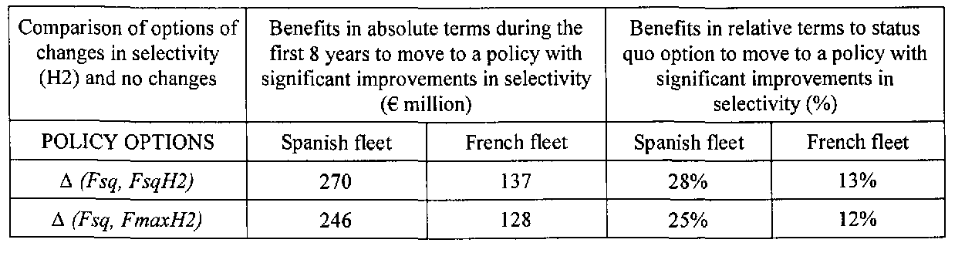
(*Exploitation pattern H2 assumes no catch at age 0 and 1, 10% at age 2, 50% at age 3 and 90% at age 4, compared to the current one).
The analyses in the report are based on preliminary and incomplete estimates of discard quantities. In spite of that, the report concludes that any long term management plan should consider that the more the exploitation pattern is improved, the greater the yield would be and the less the necessary reduction in overall effort.
Option 3 offers a possibility of achieving the same adaptation of F to MSY levels as Option 2 but over short-term period. Given the fact that over the past few years the economic situation of many fishing industries has deteriorated due to reduced fishing opportunities, such short-term solutions may be a better way to restore balance between a fishing capacity and available resources than a long-term plan.
Conclusions
The analysis has proven the benefits of an approach based on MSY represented by Option 2 and Option 3. Fishing at MSY levels would help reverse the trend of allowing aquatic stocks to run out. This approach would benefit the sea environment as a whole, since it would lead to an increase in available resources and renewed balance within ecosystems.
The approach represented by those two options would also bring economic benefits, since it would allow for a reduction in the cost of fishing activity. Exploitation of stocks would become less problematic once the availability of resources becomes more stable again.
Fishing within MSY limits would mean that the number of large-scale and high-value catches will increase while the proportion of discards would decrease.
In recent years, over 10 million tonnes of fish have been imported each year, which represents 60% of European fish consumption. An MSY approach to fisheries management would increase the European fisheries industry's competitive edge by ensuring stable and high-quality supply.
Option 2 offers a possibility of achieving the adaptation of fishing mortality to MSY levels over longer timeframe. Option 3 suggests the same adaptation to MSY but in a much shorter time.
In the past the Commission tended to centre on providing for gradual adjustments in fishing mortality through long-term management plans to avoid social disruptions. Given a current situation, where operational costs in the fishing industry have significantly increased leading to increased pressure to adopt the fleet capacity, the stakeholders themselves request more opportunities to allow for accelerated adaptations of the EU fleet.
Stakeholder consultation revealed that a short-term decommissioning of fleet would be a preferred option in the Northern hake fishery. Option 3 would bring the necessary short-time adjustment in F while allowing for a development of a smaller but more efficient and more profitable fishing sector.
Answering the demand expressed by stakeholders, DG MARE is therefore inclined to follow Option 3 and work on the basis of a short-term voluntary decommissioning of fleet, followed by fishing at a stable rate thereafter.

Monitoring and Evaluation
The indicators of successful operation of this plan are that:
- fishing mortality, as measured by ICES and STECF, should decrease and move towards the target values established in the plan;
- the size of the spawning stock should increase to 250 000t and then stabilise at that value;
- yield should increase to the long-term equilibrium value of 60 000t;
- TACs and quotas established according to the plan are respected and area-misreporting is eliminated.
It is necessary to keep under review (according to scientific advice) both the objectives and the efficiency of the plan. These are likely to need adaptation as ecosystems change and as changes to environment and climate affect fish populations.
Attainment of specific objective to reduce fishing mortality of Northern hake will be measured according to the annual evaluations of the state of the stock as assessed by ICES and STECF. Attainment of additional measures (2) and (3) will be monitored in the course of the evaluation of national inspection and control systems by the inspection team of DG MARE. Attainment of measure (1) will be proposed by the Commission for inclusion in annual regulations concerning the setting of fishing opportunities.
These indicators will be monitored annually in order to detect any deficiencies in the operation of the plan. At four-yearly intervals, a comprehensive review of the plan will be implemented.
The monitoring arrangements concerning the state of the stock are common to those for other stocks in the North-East Atlantic area. Collection of scientific data concerning landings and survey data from research vessels are co-funded by the European Community. Data are collected, analysed and evaluated by the ICES and formal advice is provided by STECF.
Should advice from STECF and ICES indicate that the plan is not reaching its objectives, a review process will be started by DG MARE.
Concerning control issues, cross-national coordination of inspection activities is to be established by the new CFC agency which is now being established. Additionally, the inspectors of DG MARE will follow-up and review the implementation of fisheries control measures by the relevant Member States.
ANNEX
Figure 1 –Fishing mortality target levels for northern hake
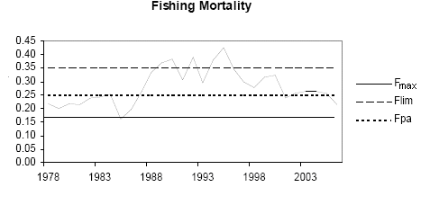Figure 2 - Summary plots for Northern Hake stock
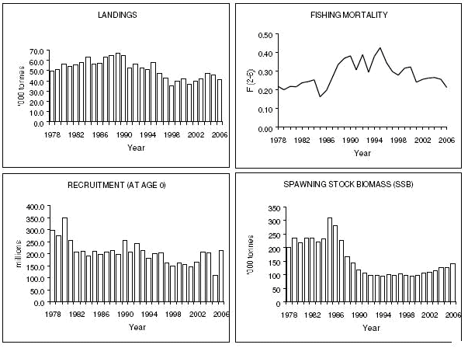
Graph 1: Projected yield (landing) for all options
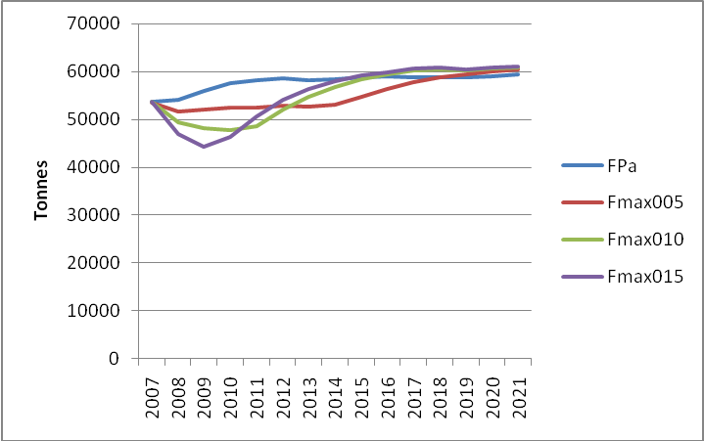
Graph 2: Projected stock biomass for all options
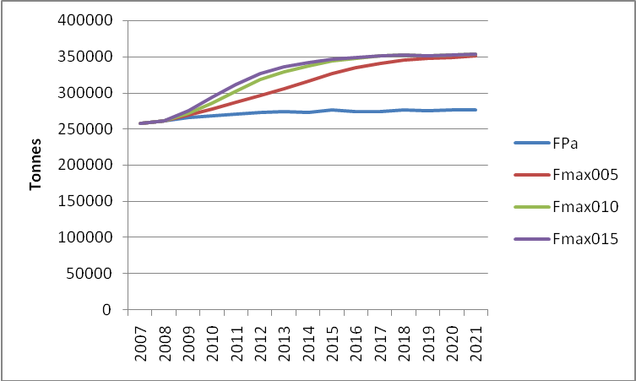
Graph 3: Comparison of different management scenarios per flee
FRANCE
NETTERS |  | DEMERSAL TRAWLERS
SPAIN
LONGLINERS | DEMERSAL TRAWLERS
Table1: Net present value at 5% and 10% discount rate for Spanish and French fleet segments. Million €
 |  | Spain |  |  | France
 |  | 5% |  | 10% | 5% |  | 10%
 |  | 2006-2014 |  | 2006-2014 | 2008-2016 |  | 2008-2016
Status quo
Value of landings |  | 1737 |  | 1404 | 2017 |  | 1628
Crew share |  | 792 |  | 640 | 676 |  | 546
Gross cash flow |  | 335 |  | 271 | 362 |  | 292
Net profit |  | 788 |  | 638 | 175 |  | 140
Gross value added |  | 971 |  | 785 | 1038 |  | 837
H2 at status quo
Value of landings | 1843 |  | 1473 |  |  | 2158 |  | 1730
Crew share | 850 |  | 679 |  |  | 732 |  | 587
Gross cash flow | 390 |  | 309 |  |  | 443 |  | 350
Net profit | 199 |  | 154 |  |  | 255 |  | 199
Gross value added | 1241 |  | 987 |  |  | 1175 |  | 937
H2 + 10% decrease in F to F_{max}
Value of landings | 1807 |  | 1444 |  |  | 2140 |  | 1714
Crew share | 833 |  | 665 |  |  | 727 |  | 582
Gross cash flow | 383 |  | 303 |  |  | 439 |  | 347
Net profit | 191 |  | 148 |  |  | 251 |  | 195
Gross value added | 1217 |  | 968 |  |  | 1166 |  | 929
Table 2. Net present value of GVA difference between 15% Fmax reduction and F status quo. Million €
France Netters 12-24m | TIME HORIZON
Time period - 2007 to | 2023 | 2031 | 2046
NPV difference between Fmax and Fsq | 3 | 6 | 9
NPV Fsq | 83.2 | 83.2 | 83.2
NPV Fmax 15% red. | 83.0 | 85.6 | 88.4
Spanish Longlines 24-40m
Time period - 2005 to | 2021 | 2029 | 2044
NPV difference between Fmax and Fsq | 8 | 15 | 22
NPV Fsq | 116.3 | 116.3 | 116.3
NPV Fmax 15% red. | 113.6 | 120.2 | 127.4
Table 3. Cost of initial investment in the "no change in selectivity" scenario
TIME HORIZON: short and medium term (2008-2016). |  | ∆ absolute (Fmax, Fsq): costs in absolute terms to move to Fmax from Fsq (€ million GVA) |  |  | ∆ relative (Fmax, Fsq): costs in relative terms to status quoto move to Fmax from Fsq (%)
 | POLICY OPTIONS | Fmax | 80% of Fmax | 120% of Fmax | Fmax | 80% of Fmax | 120% of Fmax
French fleet | 5% reduction | 24,0 | 28,8 | 9,8 | 2,2% | 2,6% | 0,9%
French fleet | 10% reduction | 23,8 | 46,6 | 6,6 | 2,2% | 4,3% | 0,6%
French fleet | 15% reduction | 20,8 | 46,6 | 4,0 | 1,9% | 4,3% | 0,4%
Spanish fleet | 5% reduction | 42,7 | 44,1 | 26,1 | 3,5% | 3,6% | 2,2%
Spanish fleet | 10% reduction | 56,8 | 86,6 | 26,4 | 4,7% | 7,2% | 2,2%
Spanish fleet | 15% reduction | 57,9 | 97,7 | 26,0 | 4,8% | 8,1% | 2,1%
Table 4. Cost of initial investment in the "changes in selectivity" scenario
Comparison of options of Fsq and Fmax under significant improvement in selectivity (H2) | Cost in absolute terms to move to FmaxH2 from FsqH2 (€ million) |  | Cost in relative terms to move to FmaxH2 from FsqH2 (%)
POLICY OPTIONS | Spanish fleet | French fleet | Spanish fleet | French fleet
∆ (FsqH2, FmaxH2) | 24 | 9 | 2% | 1%
Glossary
B
biomass– the total weight of living matter, either by species or all species combined. Also referred to as the standing stock.
Blim – see limit reference points.
Bmsy – the spawning stock biomass (SSB) necessary to support a fishery that would produce the maximum sustainable yield (MSY).
Bpa – see limit reference points.
by-catch – the catch of non-target species and undersized fish of the target species. By-catch of commercial species may be retained or discarded along with non-commercial by-catch.
C
catch (C) – the total quantity of fish that is retained by fishing gear and brought onto the deck or fishing station, ie landings plus discards.
CFP – the Common Fisheries Policy of the European Union (as revised in: Council Regulation 3760/92). It provides the framework for the management of the EU fishery sector, including all marine fisheries within 200 miles of member states’baselines.
collapsed stock – the decline in spawning stock biomass (SSB), through sustained fishing pressure or natural causes, to the point where it no longer generates sufficient recruits to support a fishery.
D
demersal – species of fish that live on, or in close proximity to, the seabed, eg flatfish, cod, haddock. The term also applies to fishing gear that is worked on the seabed.
depleted stock – the decline in spawning stock biomass (SSB) to a level that is approaching, or is below, the lowest historic record but has not necessarily reached the point of collapse. (See also limit reference points and safe biological limits.)
discards – any fish, or other living matter caught when fishing, that is not retained but returned to the sea – alive or dead.
effort (f) – the total quantity of fishing gear in use for a specific period of time (Ricker 1975). Effort can be expressed in a multitude of ways: days away from port, hours trawling, length of drift net, number of hooks used, and so on. At its most basic, it is the total number of boats engaged in a fishery and/or the number of days they were fishing.
environmentally sustainable fisheries – fisheries that safeguard the requirements of all animals and plants within an ecosystem or habitat and do not cause irreversible or other significant, long-term change to the environment or the communities of species that live within that environment.
exploitation pattern - the distribution of fishing mortality over the age composition of the fish population, determined by the type of fishing gear, area and seasonal distribution of fishing, and the growth and migration of the fish. The pattern can be changed by modifications to fishing gear, for example, increasing mesh or hook size, or by changing the ratio of harvest by gears exploiting the fish (e.g., gill net, trawl, hook and line, etc.).
F
F – formally, the instantaneous rate of fishing mortality (the natural logarithm of the change in abundance due to fishing per unit of time), but more simply, the proportion of the population killed each year by fishing.
Figure 8: A generalised yield-per-recruit (YPR) curve showing the point at which the fishing mortality rate (F) is equivalent to the maximum sustainable yield (Fmsy) and the point at which the slope of the curve is approximately 10% the slope of F=0, ie F 0.1.
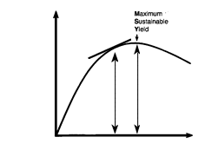
fish stock – scientifically, a population of a species of fish that is isolated from other stocks of the same species and does not interbreed with them and can, therefore, be managed independently of other stocks (cf gene pool). However, in EU legislation the term ‘stock’ is used to mean a species of fish living in a defined sea area, the two are not always synonymous (Holden 1994).
fishery conservation – the conservation and sustainable use of exploited fish stocks. It is the principal objective of UK and EU fisheries legislation; fishery management is the primary method through which the objective is pursued.
fishing effort – see effort.
fishing mortality rate – see F.
Flim – see limit reference points.
FMSY – the level of fishing mortality (F) that corresponds to the peak value on a dome-shaped yield-per-recruit curve and the value that will produce the maximum sustainable yield (MSY) from a fish stock (Fig. 8 & 10).
Fpa – see limit reference points.
I
ICES – the International Council for encourages research into commercial the Exploration of the Sea, an fish stocks, their biology and all factors independent scientific advisory body (natural and man made) that may founded in 1902. It is funded by 19 affect their abundance. It does not member states’ governments from undertake research in its own right but around the North Atlantic (including has a secretariat (in Copenhagen) to Canada and the USA) and Baltic Sea. It facilitate and co-ordinate collaboration, including fishery stockassessments, between member states. Work is carried out through numerous working groups convened under the remit of one or more standing committees:
Advisory Committee of Fisheries Management (ACFM), Advisory Committee for the Marine Environment (ACME), Baltic Committee, Fisheries Technology Committee, Living Resources Committee, Mariculture Committee, Marine Habitat Committee, Oceanography Committee, Resource Management Committee.
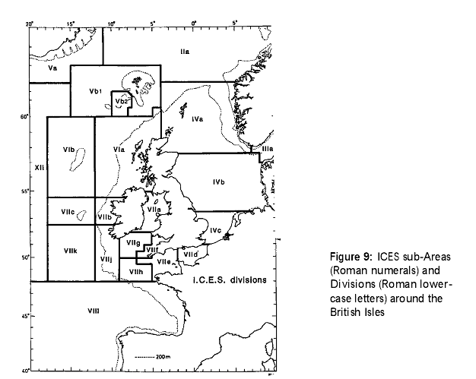
J
juvenile– an immature fish, ie one that has not reached sexual maturity (but could still be larger than the minimum landing size – MLS).
L
landings – that part of the catch which is put ashore. Frequently, landings provide the only record of total catch; ie the landings plus discards.
limit reference points – are biological or fishery management indicators that define the point at which precautionary action must be taken to safeguard a fish stock. In order for stocks and fisheries exploiting them to be within safe biological limits, there should be a high probability that: 1 – the spawning stock biomass (SSB = B) is above the threshold where recruitment is impaired; 2 - the fishing mortality (F) is below that which will drive the spawning stock to the biomass threshold, a condition that must be avoided. Thus: Blim = minimum acceptable biomass Flim = maximum acceptable fishing mortality (lim stands for ‘limit’).The certainty with which these points can be identified varies with the quality of assessment data available. Therefore, ICES has also identified precautionary reference points that identify higher biomass thresholds than Blim and lower fishing mortality thresholds than Flim:
Bpa = precautionary minimum biomass
Fpa = precautionary maximum fishing mortality (pa stands for precautionary approach).
In many instances, the value for Bpa will be the same as the value previously identified as the minimum biologically acceptable limit – MBAL (ICES 1998a and ICES Current). In circumstances where the relationship between the exploited stock and the spawning stock is not clear, as is the case with some of the deep-water species of fish, limit reference points may be expressed with respect to the ‘unexploited stock’:
M
MSY - Maximum Sustainable Yield: the largest average catch that can bet taken continuously from a stock under existing environmental conditions (Fig. 8). (For species with fluctuating recruitment, the maximum might be obtained by taking fewer fish in some years than in others). Also known as maximum equilibrium catch (Ricker 1975). (see also Figure 8).
misreporting – the inaccurate recording of catches in EU fishing log books or comparable reporting systems. Among the more common practices are under-reporting the quantity of fish caught or reporting the catch as being taken in a different area from the one in which it was actually made. The latter example is most widespread when the quota for a species in one ICES Division has been taken but quota is still available in an adjacent Division. (See also under-reporting and black-fish.)
mixed fishery – a fishery that takes multi-species catches. Pelagic fisheries tend to take relatively ‘clean’single species catches whereas multi-species catches are more frequent in demersal fisheries.
monitoring – the regular and systematic collection of environmental and biological data by agreed methods and to agreed standards. Monitoring provides information on current status, trends and compliance with respect to declared standards and objectives. (See also surveillance.)
mortality – the death of organisms through natural causes (M), eg predation, or fishing (F) etc. It is usually expressed as an instantaneous rate: the natural logarithm (with sign changed) of the ratio of number of animals surviving to the end of the year and the number at the start of the year (Ricker 1975).
O
over-fishing – any fishery where the total fishing effort is greater than is required to meet or match a specific management objective, eg maximum sustainable yield (MSY). (See also growth overfishing and recruitment overfishing.)
P
precautionary approach – a decision to take avoiding action based on the possibility of significant environmental damage, even before there is conclusive evidence that damage will occur (DOE 1992). This approach requires fishery managers to pay due regard to the uncertainties of stock assessment and management. They must implement the appropriate precautionary action if limit reference points are reached.
S
Spawning Stock Biomass – see SSB.
SSB– spawning stock biomass: the total weight of all sexually mature fish in a population or stock. It is the sexually mature part of an exploited population upon which the future survival of the stock, and its fishery, depends.
STECF – the Scientific, Technical and Economic Committee on Fisheries of the EC, DG Fisheries (Fig. 2). Unlike ICES working groups and ACFM (Fig. 3) which only consider stock assessments and management from a scientific perspective, the STEFC is expected to consider the socio- economic implications of modifying or varying scientific, including ICES’ advice.
stock biomass – the total weight of all fish of all ages in a given population or stock.
sustainability – meeting the needs of the present without compromising the ability of future generations to meet their own needs (WCED 1987 – the Brundtland Report).
sustainable fisheries – fisheries with an annual catch, including discards, that does not exceed the surplus production of the stock (ie annual growth plus recruitment less the annual natural mortality – M). Fisheries can be sustainable at levels of stock significantly below the stock that would support MSY or MEY but only if managers pay full regard to limit reference points. (See also environmentally sustainable fisheries .)
T
TAC – total allowable catch, the quantity of fish that can be taken from each stock each year. The figure is agreed by the Fisheries Council of Ministers each December for the following year. EU member states are allocated a fixed proportion of the TAC as their national quota. (See also relative stability and track record.)
target species – the primary species of fish that a fishing vessel aims to catch during a given fishing operation. In pelagic fisheries this can be a single species, eg herring or mackerel, but it is usually a group of species in demersal fisheries, eg cod and whiting or plaice and sole.
U
under-reporting – failure to meet the legal requirement under the CFP to report fully and accurately all the fish that have been caught and landed. (MLS). It is an offence for anyone to (See also misreporting) retain or offer for sale undersize fish.

http://eur-lex.europa.eu/LexUriServ
http://eur-lex.europa.eu/LexUriServ/LexUriServ.do?uri=COM:2003:0374:FIN:EN:PDF
http://fishnet.jrc.it/web/stecf
http://www.nwwrac.org/admin/publication
Term explained in glossary
Article 3 in EC Reg. No 811/2004
ICES areas in Figure 9 in Annex or http://www.ices.dk/aboutus/icesareas/ICES_areas_Arc9_Weuro_300.pdf
http://www.fao.org/fishery/species/2647
OJ L 358, 21.12.2002, pp.59-80
www.un.org/esa/sustdev/documents/WSSD_POI_DP
www.cc.cec/home/dgserv/sg/sgvista/i/sgv2/repo
report SGBRE-07-03, page 19-20, see footnote 3
Further explanation can be found in section 'E' of glossary
See STECF report, footnote 3
Note that Fsq equals Fpa=0.25
See footnote 3, Lisbon STECF report page 19
http://eur-lex.europa.eu/LexUriServ/LexUriServ.do?uri=OJ:L:2004:185:0001:0003:EN:PDF
http://eur-lex.europa.eu/LexUriServ/site/en/consleg/2004/R/02004R0812-20040701-en.pdf
https://stecf.jrc.ec.europa.eu/c/document_library/get_file?folderId=2495&name=DLFE-2701.pdf
The report also observes that economic gains from choosing an optimal policy would be magnified on shore due to the multiplier effect. This would benefit employment and economic activity in harbours and fishing communities.
See Table 3 in Annex
Pages 8 and 17 of the report “Northern Hake Long-Term Management Plan Impact Assessment (SGBRE-07-05)”.
Net Present Values (NPVs)
Page 80 of the report “Northern Hake Long-Term Management Plan Impact Assessment (SGBRE-07-05)”.
Refer to section 3.1
H2 implies a policy scenario that changes the selection pattern reducing fishing mortality in smaller sizes

