EN
COMMISSION OF THE EUROPEAN COMMUNITIES
Brussels, 24.3.2009
SEC(2009) 376
VOLUME 1 (Part1)
COMMISSION STAFF WORKING DOCUMENT
accompanying the
COMMUNICATION FROM THE COMMISSION TO THE COUNCIL, THE EUROPEAN PARLIAMENT, THE EUROPEAN ECONOMIC AND SOCIAL COMMITTEE AND THE COMMITTEE OF THE REGIONS
PROGRESS REPORT ON THE SINGLE EUROPEAN ELECTRONIC COMMUNICATIONS MARKET (14th REPORT)
{COM(2009) 140 final}
TABLE OF CONTENTS
MARKET AND ECONOMIC DEVELOPMENTS 4
Financial and Economic Sector Overview 4
The Mobile Market 9
Fixed Voice Sector 22
Broadband 33
Technology trends 44
REGULATORY DEVELOPMENTS 50
Institutional Framework 50
Implementation of Regulatory Measures 53
The Consumer Interest 61
Horizontal Regulation 70
SPECTRUM MANAGEMENT 76
MONITORING AND ENFORCEMENT 80
IMPLEMENTATION IN THE MEMBER STATES
BELGIUM 83
BULGARIA 92
CZECH REPUBLIC 102
DENMARK 114
GERMANY 124
ESTONIA 136
IRELAND 143
GREECE 154
SPAIN 164
FRANCE 174
ITALY 186
CYPRUS 198
LATVIA 208
LITHUANIA 219
LUXEMBOURG 224
HUNGARY 237
MALTA 249
NETHERLANDS 249
AUSTRIA 268
POLAND 278
PORTUGAL 289
ROMANIA 307
SLOVENIA 323
SLOVAKIA 323
FINLAND 333
SWEDEN 343
UNITED KINGDOM 353
MARKET AND ECONOMIC DEVELOPMENTS

Financial and Economic Sector Overview
This section provides an overview of the current economic and financial state of the electronic communications sector.
Notwithstanding the emergence of a difficult economic environment in the second half of 2008, the electronic communications sector is continuing to develop, bringing significant benefits to users and consumers. EU countries are world leaders in broadband take up, mobile Internet is growing rapidly, prices for most services are continuing to fall and consumers are increasingly availing themselves of bundled services.
In 2008, the sector grew at 1.3% in real terms which compares to 1% real increase in GDP for the economy overall. While the sector is not immune to the economic crisis, it is withstanding the current sharp deterioration in the economic climate relatively better than other sectors thanks to the stability of its cash flow (due to the essential nature of basic telecoms services, increasingly offered at flat rates), as well as to the relatively low debt levels. However, like the rest of the economy, the sector is now facing higher borrowing costs which will inevitably affect its capacity to invest. The prices of most standard communications services have continued to fall and have continued to have a dampening effect on inflation. The combination of increasing volumes and falling prices, suggests that the average European consumer of electronic communications services in 2008 was better off than in the year before. Sector revenues and investment grew in 2007 and were expected to do so again in 2008 for the sixth consecutive year, with revenues representing almost 3% of European GDP.
The financial performance of the telecoms sector on stock exchange markets is following a downward trend, but to a more limited extent than for other sectors, due to its strong cash-flows and the debt reduction carried out in recent years.

Consumer benefits: falling retail prices and increased number portability
Chart 1:
In the case of the mobile services, the OECD baskets measuring prices in mobile services for typical consumption patterns (see annex 2 of this report), show decreases of up to 4% between 2007 and 2008. In the fixed market for national calls, the decreases reach 11%.
In the broadband sector, monthly price reductions have been accompanied by increases in the average bandwidth quality, as well as overall connectivity.
The EU also contributed to these trends by intervening where competition was insufficient to deliver lower prices and better value to consumers. A good example is the EU Roaming Regulation which has led to a decrease in roaming prices of around 60% since the Commission announced its proposal. In 2009, the Roaming Regulation is expected to be extended to cover also excessive prices for SMS and data roaming services.
2008 saw an increase in both fixed and mobile number portability which is an important instrument to promote competition in the market. The average number of days for mobile portability in the EU remained stable at 8.5 between 2007 and 2008, while for fixed number portability this was reduced from 7.8 in 2007 to 7.5 in 2008.

Investments and Revenues
In 2008 revenues in the telecoms sector accounted for over 52 % of revenues of the whole ICT sector. The rate of increase in revenues is estimated by a number of analysts to have been 1.3% in 2008.Data for 2007 from NRAs shows that telecom sector revenues grew to €357 billion or 2.9 % of GDP. The fixed market accounted for 49% of the revenues whilst the mobile sector accounted for 51%.
Europe once again had the highest telecommunication services revenues in the world, surpassing North America and Asia-Pacific. Six of the top ten Telecom companies in the world are European.
New services such as mobile data services and broadband bundles are showing the strongest growth. Revenues from mobile Internet access in Europe (€4.4 billion) were higher than those in the US (€4.0 billion). 3 out of 4 European citizens are subscribers of the four main mobile groups and three of these groups are subsidiaries of fixed incumbents.
However, there is a slowdown in the growth rate of revenues since 2002 due to the broad adoption of electronic communication services such as mobile telephony.
Investment growth for 2007 was around one and a half per cent, thus marking the sixth consecutive year of growth. In 2008, aggregate investment in the electronic communications sector – measured in terms of capital expenditure – can be estimated at €53 billion. Consequently it will continue to grow in 2008 although with a flattening trend as a consequence of the financial crisis.
In 2007, aggregate investment in the telecoms accounted for €51.9 billion euros which represents around 0.4% of GDP (see chart 2).The fixed market accounted for 57% of the investment (56% in 2006), while the mobile sector accounted for 43% (the same figure as in 2006). Investment by fixed alternative operators represented 26% of the total investment in the EU (24% in 2006), while fixed incumbents accounted for 31% (32% in 2006).
European telecom operators invested 14.7% of their EU revenues in 2007 in the EU (12.8% in 2006). In the new Member States this figure (which is equivalent to the industry CAPEX over Sales), is higher.
Even aside from the effects of the recent economic difficulties, the investment growth rate had already begun to decline in 2006, primarily because of reduced investment in the mobile sector where 3G network deployment was almost complete. The increase in investment by the fixed sector does not compensate for this slowing growth rate in the mobile sector.
Because of more attractive potential growth rates, EU operators are continuing to invest in emerging markets such as India, South Africa or Latin America.
Chart 2
Data for investment in the Netherlands and UK are based on OECD estimates.

Financial performance and debt position of the telecom operators
The market capitalisation of the telecom sector has declined since the beginning of 2008 but less markedly than that of other sectors. Using the Dow Jones SXKP index, which captures the performance of the whole sector, the decline for 2008 was around 20 per cent, lower than that of the overall economy (25%). The Dow Jones SXKE index, which captures the performance of the main incumbents, has declined at a similar rate to that of the rest of the economy.
The reason for the better performance of the telecom sector can be found in the continued strong cash-flows from fixed and broadband activities coupled with the fact that many operators have reduced debt over recent years. In 2009 operators will have to refinance only 11% of their gross debt. The floating debt represents only around 25% of total sector debt.
- Short-term financing difficulties in 2008 suggest that the sector could face a higher cost of debt in 2009.
While borrowing costs together with incumbents' debt levels could have some repercussions for investment in fibre and spectrum, incumbents seem to have enough free cash flow to cope with near to mid-term funding requirements.
Chart 3:
The picture above is slightly more nuanced when assessed in a wider context, as shown in chart 2.
Chart 4:
It is too early to make assessments on the impact of the financial crisis for the sector. Nevertheless the growth path followed by the sector since the 2001-2002 downturn may come to a halt.
This would be the result of lower expenditure capacity by both businesses and households although the continuing reductions in prices for electronic communications services should soften this effect. Consumers may rationalize their consumption and adopt pricing plans that are better suited to their consumption patterns. The reluctance by the banks to finance investment also applies to telecoms. 2009 will show if the credit crunch has an effect on credit access for operators and whether consumption by subscribers of electronic communication services will slow down.
Whether or not these developments lead to a new wave of consolidation, will ultimately depend on the financial situation of each operator, on its level of liquidity and expected cash flow, and on the specific conditions of the country where its main operations take place. Mergers and acquisitions activity thus may grow in the sector in 2009-2010 compared to previous years.
Operators may reduce capital expenditure in 2009 to improve their operating cash flow, but those with a stronger financial position will continue to invest strategically and stimulate the migration to high-capacity broadband or Next Generation Access (NGA). Investment in fibre is expected to continue because of slower growth in both mobile revenues and broadband subscriptions, but may be redirected to cheaper VDSL solutions.
Examples of investment, or announced investment, in Next Generation Networks (NGN) can be found in Germany, the Netherlands; United Kingdom, France and Belgium.
In Germany, Deutsche Telekom has proposed approximately €3 billion investment to roll out very high-speed DSL. In the UK, BT has announced a GBP 1.5bn fibre plan to give 30% of homes access to fibre in the UK(15 July 2008).

The Mobile Market

The mobile sector
The mobile market remains, along with fixed broadband, the most dynamic of the electronic communications markets, due to increasing call volumes and the take-off of mobile broadband. This has led to continued operator growth over the past year despite a further decline in voice revenues due to price decreases in domestic markets.
Mobile broadband in many Member States is now a reality thanks to investment in high speed Internet access and flat-rate charging mechanisms. Revenues from mobile Internet are increasing and are higher than those of the US.
In general, prices for mobile services have fallen during the year. This mainly resulted from a decrease in prices for mobile voice services and domestic SMS. This led to lower revenues for operators although, as predicted, volumes have increased to compensate partially for the price decreases.
The average price per minute for mobile voice communications (including roaming) in the EU in 2007 was 0.14 €. Prices in almost all countries were between 0.10 € and 0.30 € (see chart 5). The cheapest prices were found in Bulgaria, Cyprus, Lithuania, Austria, Romania and Poland whilst the highest prices could be found in Malta.
Chart 5:
There is evidence that wholesale tariffs in the mobile market have a positive correlation with retail prices applied to consumers. Reducing the wholesale termination rates should therefore benefit consumers by leading to reduced retail prices (as seen in chart 6). The similar patterns of reductions for mobile retail and wholesale prices provide evidence of this relationship.
Chart 6:
Since 2004, mobile telephony prices, as measured by the OECD baskets methodology, have decreased for all consumer patterns. While prices in the low usage basket have fallen by around 36.3%, prices for mobile services in the medium usage basket have fallen by around 34.5% and those in the high usage basket have decreased by nearly 36.1% since 2004 (as seen in chart 7).
Chart 7:
For the purposes of the above graphs, baskets using 2002 OECD methodology have been used.
Despite still offering a limited share of the total revenue for mobile operators, mobile Internet services now account for around 3% of industry turnover, and are continuing to show strong signs of growth. The growing demand for mobile broadband services demonstrates the need for a more coordinated approach to management of spectrum resources at Community level which is a key aim of the Commission's review proposals.
The average revenue per user (ARPU) in the mobile communications market in Europe was 282.49 € per year in 2007. The highest per year revenues are found in France (426.71 €) and Ireland (415.53 €). The lowest ARPUs are found in Bulgaria (110 €) and Lithuania (110.5 €).
ARPU are declining all over the world (8% less in 2007), especially in emerging markets.
Chart 8:

Mobile Penetration
The average EU penetration rate continued to grow and has now reached 119%. There are now only 4 Member States that have not exceeded 100% penetration. While this could be seen as a sign of a maturing market, notable increases are still taking place in Member States with high penetration in previous years such as Italy with 152% and Lithuania with 149%.
Chart 9:
Chart 10:
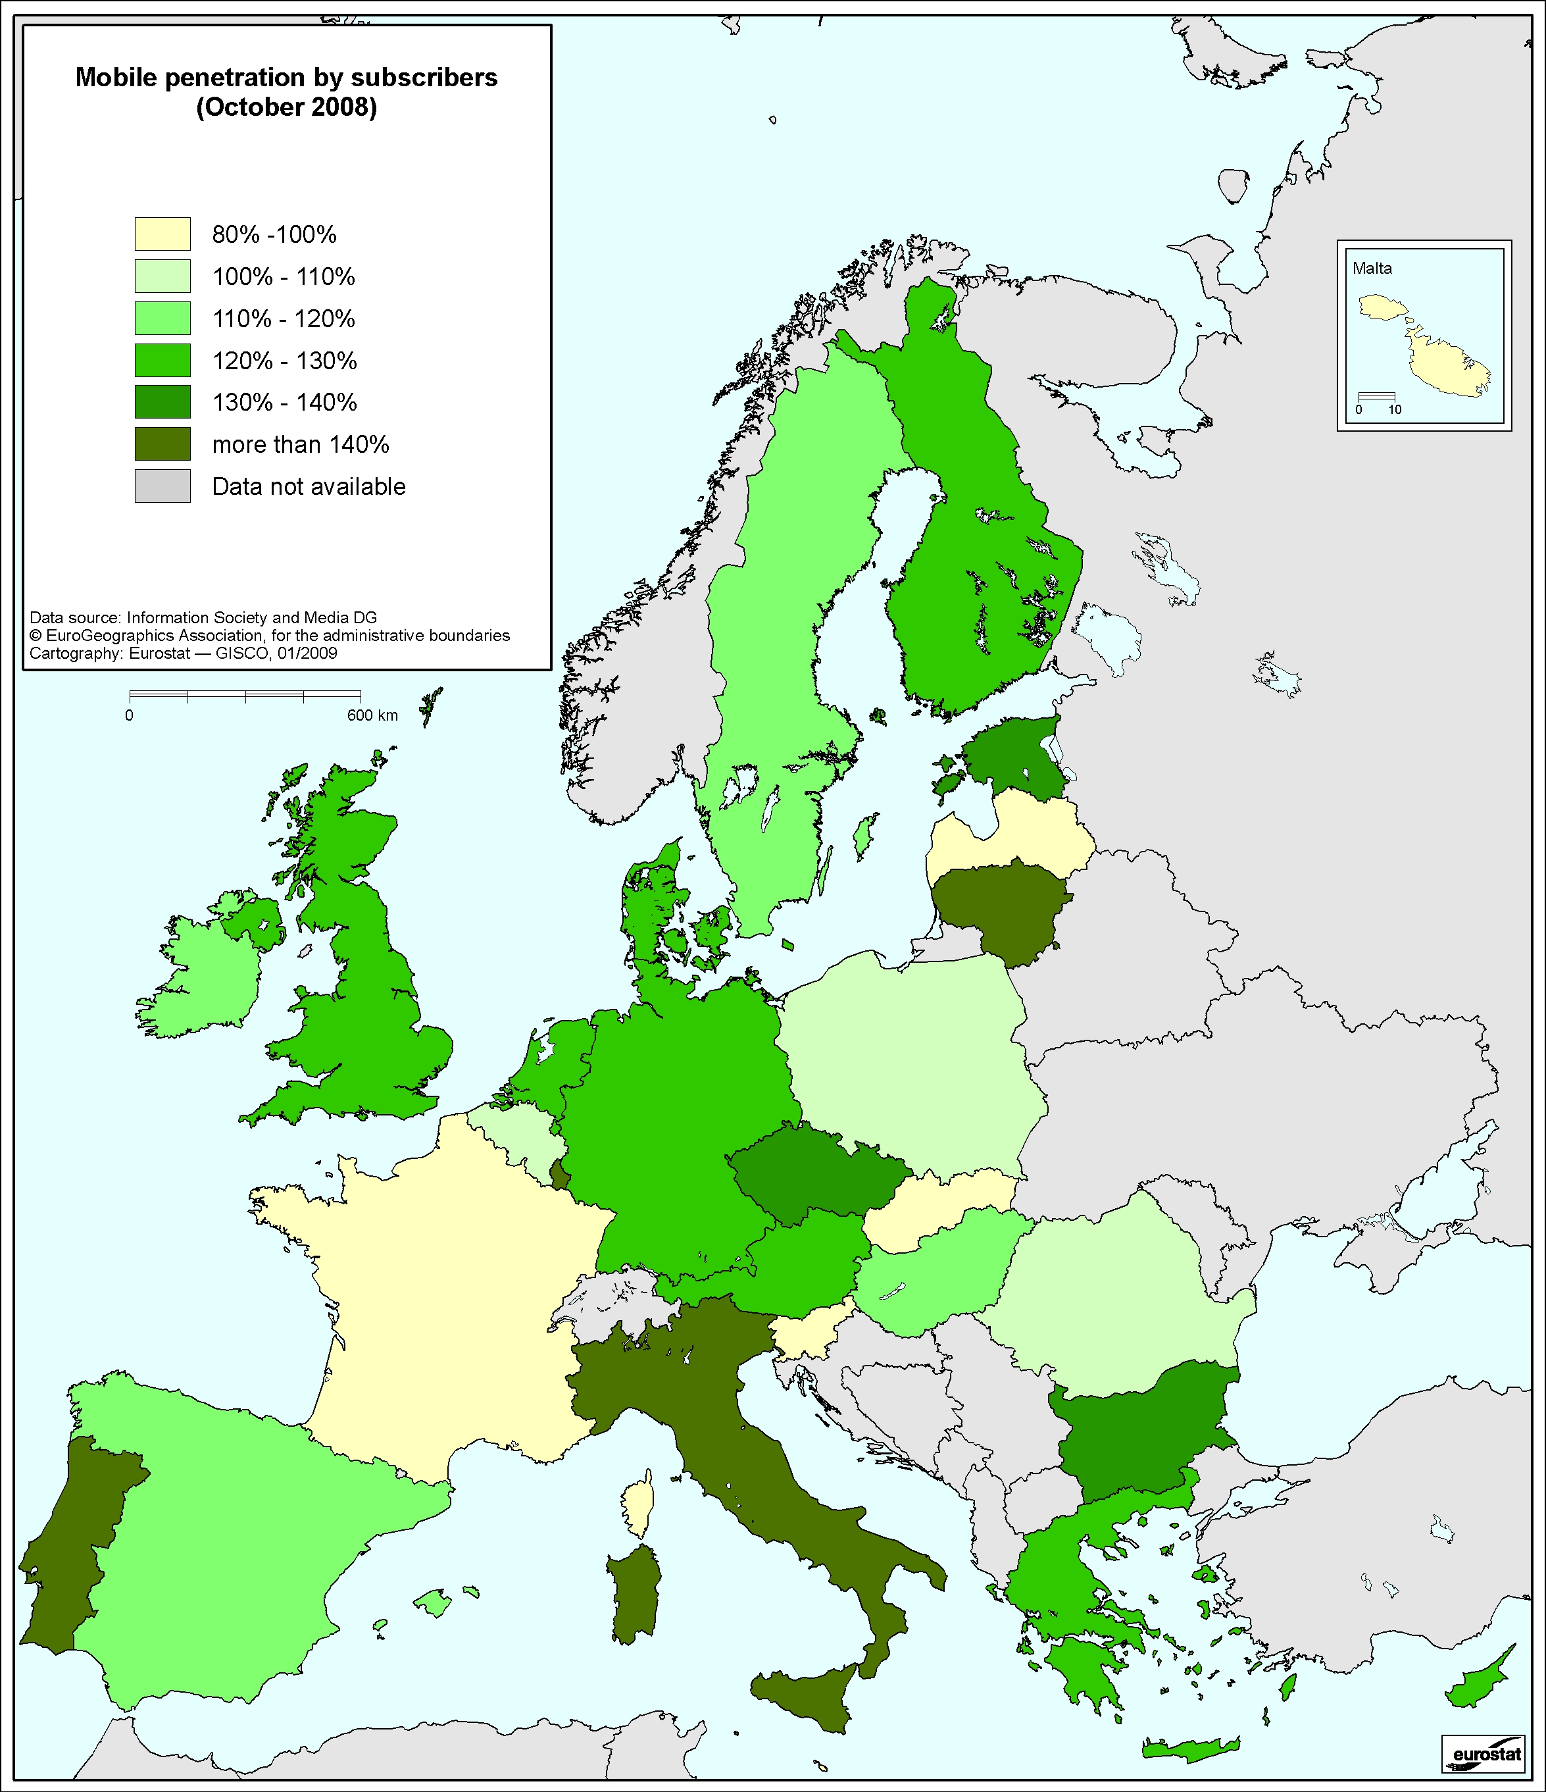
Penetration rates increased by more than 10% compared to the previous year in a number of Member States: Bulgaria, Czech Republic, Denmark, Greece, Hungary, Poland, Portugal, Romania and Finland. On the other hand, some Member States have continued to show only slight growth, which to a certain extent indicates market maturity, with France being the only Member State below 90% penetration, at 83%.
The number of prepaid customers is gradually decreasing, from 61% in 2007 to 58.2% in 2008. Malta and Italy still have the highest amount of prepaid customers at 88% and 87% respectively. However, prepaid customers also exceed 70% of the customer base in Ireland and Portugal. While decreasing everywhere else, the proportion of prepaid customers has increased in Greece, Latvia and the Netherlands. Countries with a higher proportion of prepaid users appear to have higher overall penetration rates.
Chart 11:

Market players
The number of mobile network operators has remained about the same. As was the case last year, there are more 3G networks offering commercial services than 2G networks, thereby completing the transition to the newer technology. 93 operators are now offering 3G on a commercial basis, which is an increase from 86 operators last year.
Chart 12:
Consumers are witnessing lower prices as a result of effective regulation and increasing competition. The EU average market shares of the leading operators have reduced (3%) after being relatively stable for the previous two years (as seen in chart 13). Equally, the difference between the main competitor and alternative competitors has further reduced (from 3.4 to 0.3 percentage points) in the last year, indicating that competing operators are finding ways to dent the market position of the leading operators.
Chart 13:
Market share of the leading operator in the mobile market, October 2008
In general, the leading operators in most Member States have between 30% and 40% share of subscribers although in the United Kingdom the market share is 25%. Although the EU average is declining, the leading operators in Cyprus and Slovenia continue to have very high market shares, nearly 85.2% and 60.35% respectively.
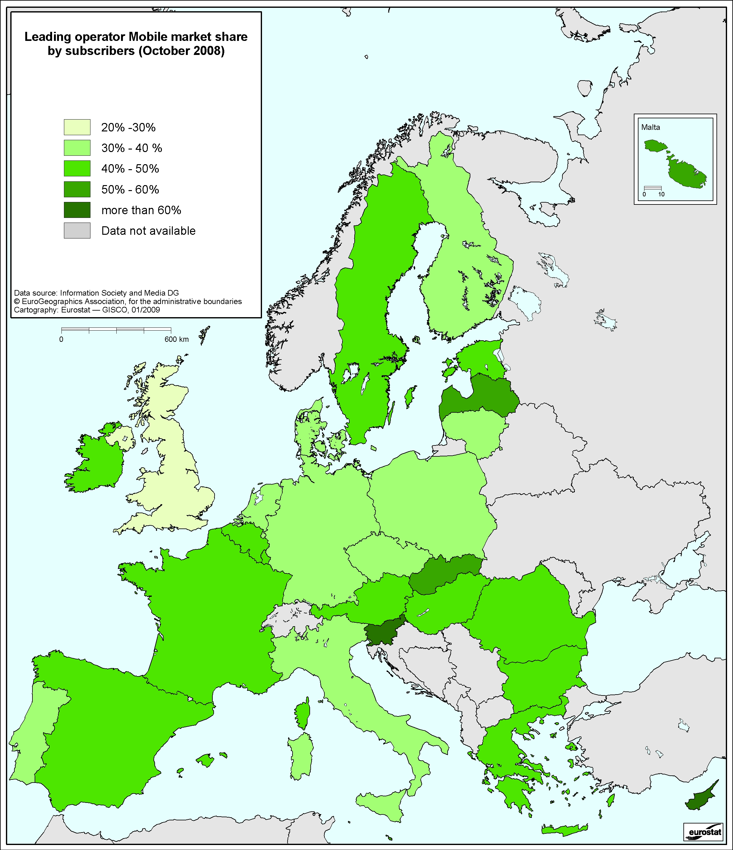

3G and data services
According to data from NRAs, it is estimated that there are around 91.3 million 3G mobile users in the EU (15.5% of the total mobile operator's subscribers). The penetration rates are highest in Italy, Austria, Sweden and the United Kingdom where they exceed 20% of the total subscribers.
SMS is still a very important source of revenue for mobile operators. In fact, most markets continue to register growth in SMS volumes which is compensating for the slight decrease in domestic prices. SMS accounts for an estimated 11% of the total mobile operators' revenues. Whilst prices per SMS have remained stable, operators are offering ‘buckets’ of SMS which can be very cheap on a per SMS basis and which can generate considerable volumes.
Chart 14:
Mobile networks are gradually catching up with fixed-line providers on price and speeds for broadband. In some cases, prices are even lower than for fixed broadband which might encourage fixed to mobile broadband substitution and mobile-only households. This trend is also expected to put pressure of fixed broadband prices. Multimedia Mobile Messages (MMS) revenues are estimated to be 0.28% of the total of mobile operators' revenues. Finally, as noted above, revenues from mobile Internet access were €4.426 billion in 2007 (not including Italy), which represents more than 3% of the total mobile operators' revenues.
The trend noted last year whereby some operators had changed their strategy by offering data services through flat-rate data tariffs has accelerated in 2008. This strategy appears to have improved transparency for customers thereby encouraging greater usage.

Interconnection and access
Mobile termination rates (MTRs) have continued to fall as can be seen in the table below. The average value of these rates was 8.55 euro cents, a reduction of 11.6% compared to the 9.67 cents of October 2007 (as seen in chart 15).
Chart 15:
However there remain major discrepancies, explained in large part by different methodologies, between the MTRs in different Member States. MTRs vary from the lowest in Cyprus at 2.10 cents, to the highest in Bulgaria at 15.92 cents. The Commission has commented again in several notifications on the need to bring termination rates down by shortening glide paths and ending asymmetric treatment (i.e. favourable treatment for specific operators). Regulatory pressure in some Member States has led to MTR rates dropping below the EU average of 8.55cents. While this trend is expected to continue in light of glide paths set by NRAs a better reflection of the costs actually incurred in the wholesale termination service is needed. This is why the Commission Services are working on a Recommendation on the regulatory treatment of both fixed and mobile termination rates which is aimed at ensuring effective and consistent regulation.
Chart 16:
High wholesale termination tariffs appear to have a very negative effect on the volumes of mobile communications, as seen in the chart 17 below, which depicts the relationship between mobile termination rates and the Average Minutes per User in the EU Member States.
It appears therefore that high termination rates lead to higher retail prices and lower volumes of communications.
Chart 17:

International roaming
The Roaming Regulation, which entered into force in June 2007, ensured that consumers continued to benefit from significant cost savings when making or receiving calls while in another Member State. The Roaming Regulation introduced maximum ceilings (Eurotariff) on retail prices for making and receiving calls in the EU as well as improving transparency for consumers by ensuring that operators send pricing information to their customers when they cross a border.
It is estimated that over 400 million EU citizens could benefit from the ‘Eurotariff’ which makes it the standard default tariff in Europe. While per minute retail roaming prices in the quarter prior to the entry into force of the regulation were €0.77 for outgoing voice calls and €0.42, for incoming voice calls prices have now fallen to no more than €0.46 per minute for making calls and no more than €0.22 per minute for receiving calls (excluding VAT). Under the Roaming Regulation, these tariff ceilings were introduced on 30 August.
Chart 18:
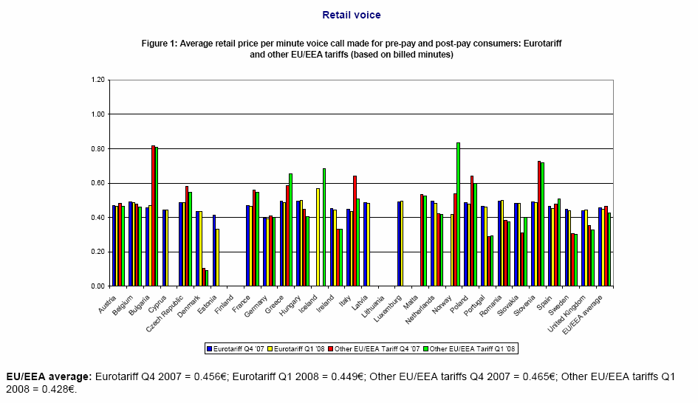
During the year, the Commission carried out an extensive of the functioning of the Roaming Regulation review including a public consultation. The Commission made a proposal to the European Parliament and Council to extend the regulation by a further three years up to June 2013 and to include SMS and data roaming services in addition to voice. National level trends in prices for data and SMS are not reflected in prices for SMS roaming and to some extent prices for data roaming services, which remain unjustifiably high across the EU.
The proposed Regulation is now being discussed by the European Parliament and Council and should be adopted in time for the changes to be effective as of 2009.

Mobile number portability
The number of mobile ported numbers increased over the past year (14.1 million more in 2008 compared to 7.1 million in 2007). As of October 2008, 60.2 million subscribers have ported their number.
The percentage of ported numbers in the EU since the introduction of mobile number portability was 10.3% in October 2008 (from 8.3% in October 2007).
Spain, with 4,173,159 ported numbers and Italy with 4,044,000 ported numbers, continue to lead in terms of the number of subscribers that have ported their numbers. Finland has the highest percentage of ported numbers (68.7%) followed by Denmark (43.9%) and then Spain (35.4%).
In Spain, Estonia, Latvia, Poland and Lithuania there is no charge at inter-operator level for the porting of numbers.
In October 2008, the average European time needed in number of days for mobile number portability is 8.5 days (as seen in chart 19). The longest duration at wholesale level for porting a mobile is in Poland which at 38 days far exceeds other countries.
Chart 19:
Chart 20:

EITO November 2008.
Data for this section is based on information provided by NRAs unless otherwise indicated.
http://ec.europa.eu/information_society/activities/roaming/regulation/index_en.htm
EITO Special Report – The Financial Crisis and ICT Markets in Europe new market forecast 2008-2009
According to Nielsen "Critical mass: the worldwide state of the Internet web".
Data from national regulatory authorities
Constituents of the Dow Jones SXKP Telecoms Index (as of 22 Aug 2008): Vodafone 27%, Telefonica 21%, France Telecom 11%, Deutsche Telekom 10%, BT 5%, KPN 6%, Telecom Italia 3% and Other (Belgacom, Cable & Wireless, Elisa, OTE, ISat, Mobistar, PT, Scom, Tele2, TKA, TNOR, TLSN) 17%.
Dow Jones Euro Stoxx 50
Constituents of the Dow Jones SXKE Telecoms Index (as of 22 Aug 2008): Telefonica 36%, France Telecom 19%, Deutsche Telekom 17%, KPN 11%, Telecom Italia 6% and Other (Belgacom, Elisa, OTE, ISat, Mobistar, PT, TKA) 12%.
According to JP Morgan: European Corporate Research October 2008
This is an indicator that does not give an actual price but the average price level for a minute of communication.
Further details on the composition of these baskets can be found in the Annexes.
According to IDATE: Mobile
Figures from UK not available.

