EN
COMMISSION OF THE EUROPEAN COMMUNITIES
Brussels, 21.4.2009
SEC(2009) 450

ANNEX TO THE
COMMISSION STAFF WORKING DOCUMENT
accompanying the
COMMUNICATION FROM THE COMMISSION TO THE EUROPEAN PARLIAMENT, THE COUNCIL, THE EUROPEAN ECONOMIC AND SOCIAL COMMITTEE AND THE COMMITTEE OF THE REGIONS
Towards a better targeting of the aid to farmers in areas with natural handicaps
Impact Assessment
ANNEX 1 (part 1)
{COM(2009) 161 final}
{SEC(2009) 449}
{SEC(2009) 451}
ANNEX
Annex 1 (part 1) Facts and figures: main features of agriculture in non-mountain LFAs 3

Annex 1 (part 1) Facts and figures: main features of agriculture in non-mountain LFAs

Map 1 below shows the three categories of LFAs delimited in the EU 27.Under the legislation currently in force, each LFA category characterises a specific cluster of handicaps, common to certain areas of agricultural land across Europe, and which threaten the continuation of agricultural land use:
- Mountain Areas (Article 18 of Regulation (EEC) No 1257/1999) are characterised as those areas handicapped by a short growing season because of a high altitude, or by steep slopes at a lower altitude, or by a combination of the two. Areas north of the 62nd parallel are also delimited as mountains.
- Other Less Favoured Areas (so-called 'intermediate LFAs', Article 19 of Regulation (EEC) No 1257/1999) are those areas in danger of abandonment of agricultural land-use and where the conservation of the countryside is necessary. They exhibit all of the following handicaps: land of poor productivity; production which results from low productivity of the natural environment; and a low or dwindling population predominantly dependent on agricultural activity.
- Areas Affected by Specific Handicaps (Article 20 of Regulation (EEC) No 1257/1999) are areas where farming should be continued in order to conserve or improve the environment, maintain the countryside, preserve the tourist potential of the areas; protect the coastline.
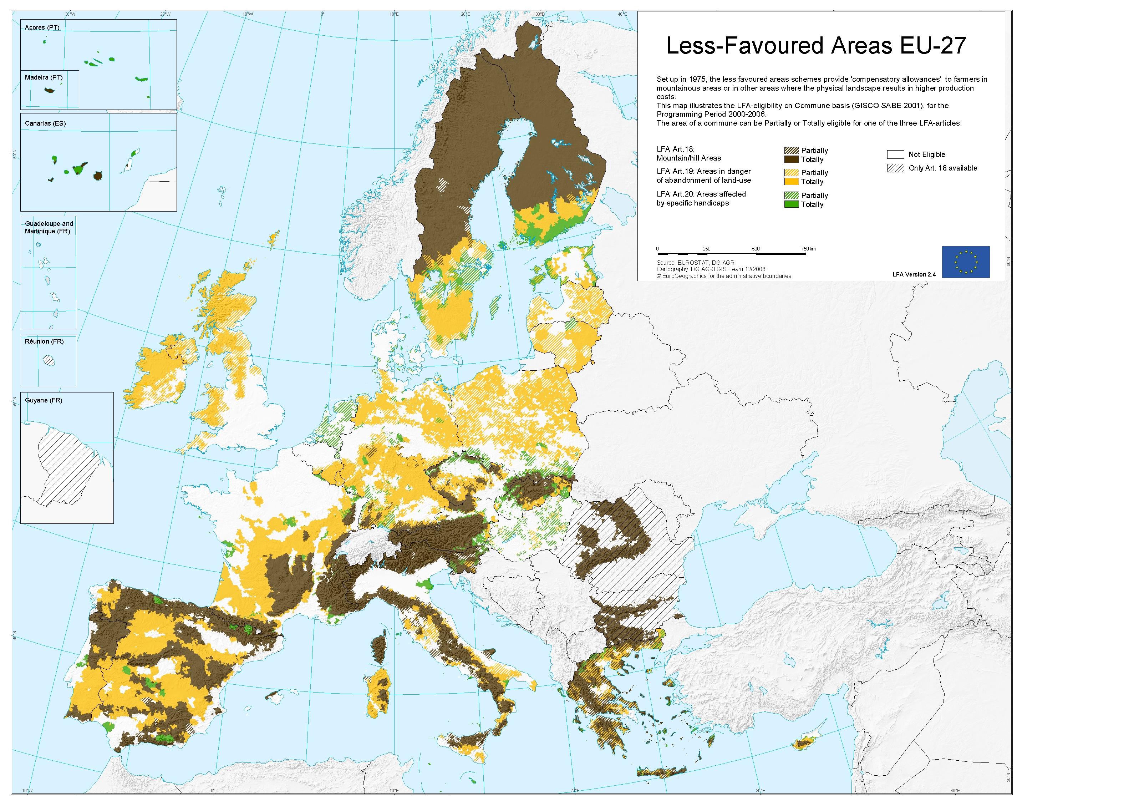

According to the most recent data provided by the Member States following the LFA expert meeting of 14 November 2007, approximately 57% of the overall Utilized Agricultural Area (UAA) in the EU27 is classified as LFA. Table 1 shows the relative importance of the three types of less favoured areas as part of the total Utilized Agricultural Area in the Member States.
N.B.: 2007 data for Bulgaria and Romania -Source: Member States Communications following LFA expert meeting of 14.11.2007 - For Member States who did not report any data directly, CAP-IDIM data were used.

The following sections summarize the main features of agriculture in non-mountain LFAs, intended as the areas classified as intermediate LFAs as well as areas with specific handicaps.

Importance of non-mountain LFAs

According to the Farm Structure Survey (FSS) of Eurostat, in 2005 non mountainous LFAs accounted for 30% of the agricultural holdings, 39% of the utilised agricultural area, 31% of the agricultural labour force and 26% of the agricultural economic potential expressed in terms of economic size (graph 1).
Graph 1: Importance of non-mountain LFAs in the EU 25 – 2005
Source: Eurostat, Farm Structure Survey 2005.

The structural adjustment of agriculture in non-mountain LFAs between 1995 and 2005 does not differ systematically from non LFAs. Similarly to other areas, non-mountain LFAs recorded a decrease in the number of agricultural holdings. However, in comparison to non disadvantaged areas, the decrease of farms in non-mountain LFAs was higher in some Member States (BE, ES, IT) and lower in others (IE, FR, AT, PT, SE). Overall for the EU, when comparing with non handicapped areas, the decrease of the number of holdings in non mountainous LFA is higher but there is no decrease of utilised agricultural area. However, Europe-wide data mask some more significant trends at a micro-scale (see box on page 13).

The analysis includes also areas with specific handicaps, since FSS distinguishes LFA data according to two categories only: mountain LFA and LFA other than mountain, where the latest category includes intermediate LFAs and areas with specific handicaps. However, given the limited size of areas with specific handicaps, the picture of the main features of agriculture in non mountain LFAs resulting from FSS statistics is considered relevant for intermediate LFAs.
In the Farm structure Survey of Eurostat, the UAA is the area covered by arable crops, permanent pastures, permanent crops and kitchen gardens. It also covers area maintained in good agricultural and environmental conditions. The Total area of the holdings covers UAA and area not used for agricultural production such as former UAA, wooded land, ponds, and artificial area.
Labour force is expressed in Annual Work Units (AWU). An AWU is equivalent of the full-time employment. 1 AWU corresponds to the work performed by a person undertaking fulltime agricultural work on the holding over a 12 month period. It corresponds to 1800 hours (225 working days of 8 hours per day), unless national provisions governing contracts of employment are specified.
The economic size reflects the potential gross value added of the farms. It is evaluated using the Standard Gross Margins. The total Standard Gross Margin of the farms, measured in €, is expressed in terms of European Size Units (ESU). The value of one ESU is defined as a fixed number of EUR of. Since 2002, 1ESU=1200€.
The analysis of the time development when considering the LFA character is limited to EU-14 (EU-15 without Germany), due to the lack of data for Germany in 1995 farm structure survey of Eurostat.
Only in Italy, a significantly higher decrease of utilised agricultural area in non mountainous LFA is observed but it is more probably an artefact produced by changes in the methodology of the survey in this country.

