EN
COMMISSION OF THE EUROPEAN COMMUNITIES
Brussels, 21.4.2009
SEC(2009) 450

ANNEX TO THE
COMMISSION STAFF WORKING DOCUMENT
accompanying the
COMMUNICATION FROM THE COMMISSION TO THE EUROPEAN PARLIAMENT, THE COUNCIL, THE EUROPEAN ECONOMIC AND SOCIAL COMMITTEE AND THE COMMITTEE OF THE REGIONS
Towards a better targeting of the aid to farmers in areas with natural handicaps
Impact Assessment
ANNEX 1 (part 2)
{COM(2009) 161 final}
{SEC(2009) 449}
{SEC(2009) 451}
ANNEX

Annex 1 (part 2) Facts and figures: main features of agriculture in non-mountain LFAs 3

Annex 1 (part 2) Facts and figures: main features of agriculture in non-mountain LFAs

Structure and economic situation of LFA farms
Graph 2: Characteristics of average farm in LFA (EU25 -2005- all farms=100%)
Source: Eurostat, Farm Structure Survey 2005.

As regards the characteristics of the farms (graph 2), FSS data show that:
- Despite a larger average physical size in non mountainous LFA, necessary to compensate an average lower productivity, the average economic size of the farms, reflecting their potential gross value added, is lower in non mountainous LFA than in non LFAs.
- As the average labour force per farm does not vary significantly according to the type of areas (on average 1 labour force unit per holding), the average potential gross value added per labour force unit appears lower in non mountainous LFA than in non LFAs.

Between 1995 and 2005, it seems that the economic situation of the holdings evolved globally better in non mountainous LFA than in non disadvantaged areas: the average physical size has increased by 21% (against 13%) and the area productivity has increased by 37% (against 23%) (graph 3). Despite this evolution, which is partial since it concerns only 11 Member States, farms in these areas are still lagging behind the areas without handicaps, as shown in graph 2.
Graph 3: Development of the characteristics of average farm in "EU-11" (EU-15 without DE, IT, FI and UK) – 2005 – 1995 = 100
Source: Eurostat, Farm Structure Survey.

Farmland use and production patterns in LFAs
As regards the main uses of agricultural land, arable land represents only 54% of the UAA in non-mountain LFAs, against 74% in non-disadvantaged areas, since when natural conditions become more difficult, arable crops are in general replaced by permanent grassland and meadows. An increasing share of the total area of farms is dedicated to non agricultural production (forestry, natural areas, unused, etc) when the less favoured character increases: 17% in non mountainous LFA and up 44% in mountainous LFA.

Graph 4: Type of farmland use in EU-25 – 2005
Source: Eurostat, Farm Structure Survey 2005.

Between 1995 and 2005, in non mountainous and mountainous LFA, the share of permanent pastures increased and the share of arable crops decreased while an opposite change occurred in non disadvantaged areas. However, this global picture hides different developments in land use in some Member States: the share of permanent pastures decreased in LFAs in Ireland, France, Luxemburg and Austria and increased in not LFA in Spain, Italy and Portugal.
Finally, as regards the intensity of farming, several indicators reveal that the intensity of farming is lower in LFA:
- Livestock stocking densities are lower, at least in EU-15 whereas in EU-10 the density is equally low among all types of areas (graph 5),
- Between 1995 and 2005 for EU-14, the livestock stocking density for all animal production remained stable in all types of area whereas the stocking density of grazing livestock decreased significantly in "not LFA" and in non mountainous LFA (graph 5);
- Concerning crops production, many (NUTS-2) regions where non mountainous LFA are important are characterised by low-input farm types (map 2).

Graph 5: 1995-2005 development of livestock stocking density according to LFAsin "EU-14" (EU-15 without Germany).
Source: Eurostat, Farm Structure Survey 2005.

Map 2: Importance of low-input farming in EU-25 – 2005 and change 1995-2005
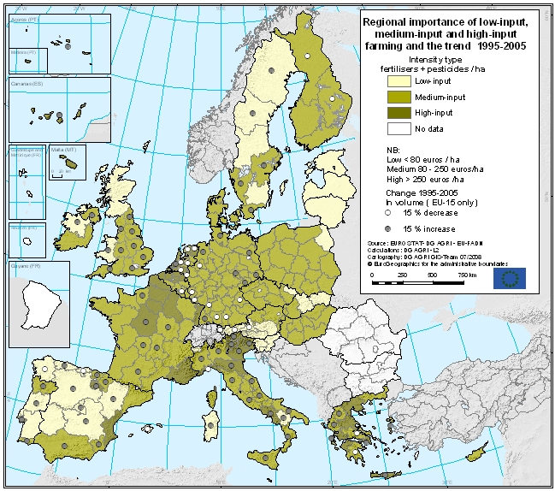

The information provided in Map 2 is based on the methodology used for indicator 15 of IRENA operation. It is limited to inputs for crops production and the change has been evaluated in "volume", eliminating the effects of the inflation and of price development of inputs. It should be taken with caution since the trends are considered for NUTS-2 regions, a territorial level that is too large to detect actual trends specific to less favoured areas. However, it is interesting to note that in several regions with large parts of non-mountain LFAs like Eastern Germany, Ireland, Spain, South-West France, Southern Italy an increase of the use of inputs has been observed between 1995 and 2005. Conversely, a decrease is observed in West and South Germany, Belgium and the Netherlands.

As in the rest of the EU territory, agriculture in non-mountain LFAs is facing a rapidly changing environment. The portrait drawn above should not be considered as a stabilised situation. The abandonment of previously extensively grazed land in the most marginal areas, the intensification and specialisation trends in response to market demands and the pressure to non agricultural land uses are, according to the evaluation, the expertise gathered and the stakeholders indications, the main threats to the nature value of these areas. Further liberalization of agricultural markets could in particular put pressure on the less productive livestock systems and reinforce these trends in the areas characterized by permanent pastures (currently covering 41% of UAA in non-mountain LFAs in the EU25).

Due to methodological changes in the Farm Structure Survey in IT, FI and UK between 1995 and 2005 and the absence of information for DE in 1995, the comparison has been made without these 4 Member States.
The analysis of the time development when considering the LFA character is limited to EU-14 (EU-15 without Germany), due to the lack of data for Germany in 1995 farm structure survey of Eurostat.
Grazing livestock covers cattle, sheep and goats. Forage area corresponds to permanent grassland (pastures and meadows) and forage crops area (temporary grass, grass & maize silage, etc).
European Environmental Agency Report n°6/2005.
It should be considered that a decrease in volume does not take into account possible increase in the input concentration.

