EN
SANCO/4560/2009 (POOL/D1/2009/4560/4560IA-EN.doc)
COMMISSION OF THE EUROPEAN COMMUNITIES
Brussels, 16.6.2009
SEC(2009) 776 final
COMMISSION STAFF WORKING DOCUMENT
Accompanying document to the
Proposal for a
REGULATION OF THE EUROPEAN PARLIAMENT AND OF THE COUNCIL
amending Regulation (EC) No 998/2003 laying down the animal health requirements applicable to the non-commercial movement of pet animals
IMPACT ASSESSMENT
{COM(2009) 268 final}
{SEC(2009) 777}
Lead DG: DG SANCO
Other involved services: AGRI, ENTR, SG, TAXUD, TRADE
Agenda planning: 2008/SANCO/010
The report commits only the Commission’s services involved in its preparation and the text is prepared as a basis for comment and does not prejudge the final form of any decision to be taken by the Commission.
TABLE OF CONTENTS
1. Executive summary 7
2. Procedural issues and consultation of interested parties 10
2.1. Procedural issues 10
2.2. Consultation of interested parties 10
2.2.1. Public consultation 10
2.2.2. Consultation of competent authorities 11
2.2.3. Consultation of the European Food Safety Authority (EFSA) 12
2.2.4. Consultation of EU-approved serology laboratories 12
2.2.5. Consultation of the Union of European Veterinary Practitioners (UEVP) 12
2.2.6. Inter-Service Steering Group (ISSG) 13
2.2.7. Impact Assessment Board (IAB) 13
3. Problem identification 14
3.1. Legal background 14
3.1.1. Legal obligation to review the Regulation 14
3.1.2. General regime 15
3.1.2.1. Movements within the EU 15
3.1.2.2. Entry into the EU 15
3.1.3. Transitional regime 16
3.1.3.1. Rabies 16
3.1.3.2. Echinococcus/ticks 17
3.1.3.3. Bilateral regime between Sweden and Denmark 17
3.1.4. Free movement regime between the UK and Ireland 17
3.2. Issues to tackle 20
3.2.1. The current national rules are complex and place a considerable burden on pet owners 20
3.2.2. Equivalence of health status for rabies, Echinococcosis (E. multilocularis) and ticks in the Member States 22
3.2.2.1. Rabies 22
3.2.2.2. Echinococcosis (Echinococcus multilocularis) 25
3.2.2.3. Ticks 25
3.3. The principle of subsidiarity 25
4. Objectives 26
5. Key policy options 26
6. Impact analysis 27
6.1. Preliminary remarks 27
6.1.1. Costs incurred by owners to prepare a pet 28
6.1.2. Administrative costs 31
6.2. Analysis of impacts of option 1: No action 31
6.2.1. Economic impacts 32
6.2.1.1. Pet owners 32
6.2.1.2. Authorised veterinarians 33
6.2.1.3. EU-approved rabies serology laboratories 33
6.2.1.4. Suppliers of anti-parasite treatments 34
6.2.1.5. Transport companies ('carriers') 34
6.2.1.6. Quarantine facilities 34
6.2.1.7. Competent authorities 35
6.2.1.8. Third countries 35
6.2.1.9. Others 35
6.2.2. Social impacts 35
6.2.2.1. Employment 35
6.2.2.2. Welfare of citizens 36
6.2.2.3. Public health 36
6.2.3. Environmental impacts 38
6.3. Analysis of impacts of option 2: Extension of the transitional regime 38
6.3.1. Economic impacts 39
6.3.2. Social impacts 39
6.3.3. Environmental impacts 39
6.4. Analysis of impacts of option 3: Adjustment of the current rules applicable to all Member States 39
6.4.1. Economic impacts 40
6.4.1.1. Pet owners 40
6.4.1.2. Authorised veterinarians 40
6.4.1.3. EU-approved rabies serology laboratories 40
6.4.1.4. Anti-parasite treatment suppliers 40
6.4.1.5. Transport companies ('carriers') 41
6.4.1.6. Quarantine facilities 41
6.4.1.7. Competent authorities 41
6.4.1.8. Third countries 41
6.4.2. Social impacts 41
6.4.2.1. Employment 41
6.4.2.2. Welfare of citizens 41
6.4.2.3. Public health 42
6.4.3. Environmental impacts 42
6.5. Analysis of impacts of option 4: Continuation of the transitional regime on a permanent basis 42
6.5.1. Economic impacts 42
6.5.1.1. Pet owners 42
6.5.1.2. Authorised veterinarians 43
6.5.1.3. EU-approved rabies serology laboratories 43
6.5.1.4. Anti-parasite treatment suppliers 44
6.5.1.5. Transport companies ('carriers') 44
6.5.1.6. Quarantine facilities 44
6.5.1.7. Competent authorities 45
6.5.1.8. Impact on third countries 45
6.5.2. Social impacts 45
6.5.2.1. Employment 45
6.5.2.2. Welfare of citizens 46
6.5.2.3. Public health 46
6.5.3. Environmental impacts 46
7. Comparison of the different options 46
7.1. Comparison of impacts 46
7.2. Discussing the options 51
8. Monitoring and evaluation 54
9. Conclusion 55
ANNEX 1 57
ANNEX 2 60
ANNEX 3 61
ANNEX 4 64
ANNEX 5 66
ANNEX 6 67
ANNEX 7 69
ANNEX 8 70
ANNEX 9 74
ANNEX 10 76
ANNEX 11 78
ANNEX 12 79
ANNEX 13 83
ANNEX 14 84
ANNEX 15 85
ANNEX 16 86
ANNEX 17 87
ANNEX 18 91
ANNEX 19 92
ANNEX 20 95
ANNEX 21 97
ANNEX 22 101
ANNEX 23 105
ANNEX 24 106

Executive summary
The item is part of the Commission agenda planning /work programme under the reference 2008/SANCO/010.
Regulation (EC) No 998/2003 of the European Parliament and of the Council ('the Regulation') lays down harmonised animal health requirements applicable to non-commercial movements of pet animals within and into the Community ("general regime").
The rules established by the Regulation are the outcome of a controversial discussion, in particular on rabies, which resulted in a delicate compromise granting certain special conditions to five Member States for a transitional period of time.
Indeed, the Regulation grants a period of five years starting from the date of its entry into force, i.e. until 3 July 2008 (extended to 30 June 2010), to Finland, Ireland, Malta, Sweden and the United Kingdom to make the entry of pet animals into their territory subject to compliance with certain additional requirements to prevent the risk of introducing rabies, echinococcus and ticks ("transitional regime").
The Regulation lays down a legal obligation to review the rules by the end of the transitional period and requests the Commission to submit to the European Parliament and to the Council a report based on experience gained and on a risk evaluation together with appropriate proposals for determining the regime to be applied at the end of the transitional period. The Commission adopted its report on 8 October 2007 together with a proposal to the Council and the European Parliament to briefly extend the transitional measures until September 2009 (further deferred to 30 June 2010²) to allow sufficient time to consider all aspects and consult all interested parties on the options.
In the light of its report, the outcome of various recent consultations conducted and the available updated information on the diseases concerned - rabies, Echinococcosis and/or tick-borne diseases - in the whole EU, the Commission should now assess the long-term options and in particular the case for extending the general regime to the Member States currently operating under the transitional regime.
When evaluating the available options for determining the regime to be applied after the end of the transitional period, the Commission's primary objective is to ensure a sufficiently high, risk–adequate and proportionate level of protection of animal and public health. The operational objective is to determine the regime that will supplant the transitional regime as of 1 July 2010. These are the purposes of the current impact assessment.
The Commission has accordingly identified four policy options and impacts of an economic, social and environmental nature were considered for each of them:
Option 1: No action - this option means that after 30 June 2010, Finland, Ireland, Malta, Sweden and the UK will no longer make the entry of pet animals into their territory subject to additional requirements regarding rabies, echinococcus and ticks.
Option 2: Extension of the transitional regime – this option means a further temporary extension of the transitional period until the end of 2011, which is when the Commission expects to end EU support to national programmes to eradicate sylvatic rabies in the Baltic States. A substantially improved rabies situation in those Member States would fully address the risks identified by EFSA and render its recommendations for mitigating measures obsolete. This option would require a Commission proposal to the European Parliament and the Council extending the transitional period for the five Member States that currently apply special rules and clarifying the regime that would apply as from 1 January 2012.
Option 3: Adjustment of the current rules applicable to all Member States – this option means ending the specific conditions applied by the five Member States and implementing a harmonised regime by means of a technically reviewed Regulation based on a Commission proposal taking into account the EFSA opinions.
Option 4: Continuation of the transitional regime on a permanent basis – this option means an indefinite extension of the transitional regime and therefore enables the Member States claiming free status, including Finland, Ireland, Malta, Sweden and the UK, to systematically request additional guarantees. This option would require a Commission proposal to the European Parliament and the Council to ensure equal treatment of all Member States.
A Commission proposal to the European Parliament and the Council, as per options 2, 3 and 4, should in any case enhance legal clarity by addressing some unclear provisions of the current Regulation, in particular concerning the regime that would apply in all Member States at the end of the transitional period. However, any such proposal might lead, at Council and European Parliament level, to reopening of the debate on some fundamental aspects of the Regulation not covered by the present impact assessment and for which a delicate compromise was achieved in 2003.
Following on from the impact assessment, preference has been given to options 1 and 2, which are similar in principle. Either would entail removing, sooner or later, the unjustified disparities, discrimination and burden felt by citizens including citizens from the five Member States who are affected by additional requirements when returning from abroad. At the same time, both options would maintain a high level of safety for pet movements within and into the EU, by applying the general regime, which has proved to be effective in preventing human and pet animal cases of rabies caused by lawful movement of pets between and into Member States.
Both options also take into account most of the EFSA recommendations, in particular those related to echinococcus and ticks. As regards rabies, EU-supported national eradication programmes in Member States with sylvatic rabies have recently led to a quasi-equivalent situation in all Member States which is comparable to the situation in those EU-15 Member States where rabies in wildlife was still a significant problem when Regulation (EC) No 998/2003 was adopted. The current situation does not justify the implementation of differentiated and discriminatory rules according to the country of origin. Beefing up the risk assessment with elements other than those used by EFSA has proved to be effective in preventing the introduction of rabies through pet movements from listed third countries such as the USA and the Russian Federation with a significantly higher prevalence of rabies in wildlife than Member States with remaining sylvatic rabies.
Both options would ensure that there is sufficient time for the competent authorities of Finland, Ireland, Malta, Sweden and the UK to provide the public with clear and easily accessible information concerning the new rules.
There is a slight advantage in selecting option 2 over option 1. In terms of lowering the public health risk, a reasonable extension of the transitional measures would defer the application of the general regime throughout the EU to a point in time when EU-supported measures to eradicate remaining pockets of sylvatic rabies in the EU will render the EFSA recommendations on risk mitigation redundant. Moreover, in accordance with the Regulation, by 2011 electronic identification will be the only means of identifying an animal. This should ensure additional safety and security of the movement of pet animals since the new system in place would avoid falsifications and make the identification information easier to read. Option 2 would also clarify the regime that would apply at the end of the transitional period in all Member States.
Given the enlargement of the Schengen area and the consequent disappearance of control points, such a delay could be sufficient to dispel remaining concerns and prejudices about the perceived risks related to pet movements and thus facilitate acceptance of the general regime in all Member States.
In contrast, options 3 and 4 do not appear to contribute meaningfully to solving the most acute problems voiced by administrations and citizens affected by a complicated, burdensome and inconsistent system of excessive and unjustified animal health requirements regarding the diseases concerned.
Option 3 would take full account of the EFSA opinion on rabies, which recommends additional risk-mitigating measures for certain categories of pet animals coming from Baltic States. It would, however, not only increase confusion amongst travellers dealing with new regimes according to the country of origin, but also completely disregard other risk-relevant aspects considered in listing third countries. It would give those Member States an unjustifiable bad reputation and discriminate against them in favour of certain listed third countries. This is contrary to the fundamental principles of the EU Treaty. It would also disregard Member States' requests for simplification based on field evidence.
Moreover, when redesigning the rules for movement of pets on technical grounds (option 3), the most likely scenario would be that those Member States that currently benefit from the transitional regime would have no reason to depart from their traditionally very restrictive policy, other equally rabies-free Member States might well perceive the general regime as excessive, and the Baltic States, given their improved situation, might see it as discriminatory. The result would be a compromise that further diversifies the movement conditions and dismantles an efficient and well-tried regime without improving the overall level of protection within the EU.
Option 4 would assign to the five Member States, and possibly to other free Member States in the future, a particular status with regard to the diseases concerned which is not supported by the relevant scientific EFSA opinions. It is a far cry from the desire of most Member States to achieve harmonisation and simplify pet movements within and into the EU, considering the similarity of the animal health situation in the EU. It would continue to prove onerous for citizens including those re-entering the five Member States and possibly other free Member States. This option is likely to be opposed by most of the Member States as it will appear to be granting scientifically unjustified privileges.

Procedural issues and consultation of interested parties

Procedural issues
The item is part of the Commission agenda planning /work programme (reference 2008/SANCO/010).
This Impact Assessment ('the IA') follows the structure given in the Commission’s IA guidelines SEC (2005)791 of 15 June 2005.

Consultation of interested parties
In accordance with Article 23 of Regulation (EC) No 998/2003 of the European Parliament and of the Council laying down the animal health requirements applicable to the non-commercial movement of pet animals ('the Regulation'), the Commission was required to submit, before 1 February 2007, a report together with appropriate proposals for a revised regime, based on a risk evaluation and on experience gained by the Member States.
To this end, the Commission has officially consulted the European Food Safety Authority (EFSA) and the competent authorities of Member States. The Commission Report to the European Parliament and the Council was adopted on 8 October 2007.
Moreover, in order to collect data for producing its impact assessment, the Commission has also consulted other interested parties.

Public consultation
The above-mentioned Commission report has been placed on the DG SANCO website and interested parties have had the opportunity to send their comments on it, including the last section of the report, which lists preliminary options to adapt the regime. No reaction from the public has been recorded so far.
The Commission has also registered an increase of Parliamentary questions in relation to the Regulation and mainly concerning complaints from British, Irish and Swedish citizens on the difficulties encountered in moving pets to those Member States under the transitional regime.

Consultation of competent authorities
With a view to producing its report, the Commission officially requested the 27 Member States' competent authorities in October 2006 to provide information on experience gained so far with the implementation of Articles 6, 8 and 16 of the Regulation (Annex 1). This drew a significant response from 20 Member States ranging from a detailed report based on external surveys to a short statement.
In order to help EFSA with its opinions on echinococcosis and ticks, the Commission officially requested in December 2005 that the five Member States which have been allowed to retain their national rules according to Article 16 of the Regulation provide a report on the situation with regard to those diseases, setting out grounds for the need for additional guarantees to prevent the risk of introduction of those diseases (Annex 2). Except Malta, four Member States did provide a report.
With a view to producing this impact assessment, on 27 September 2007 the Commission officially requested the five Member States that have been allowed to retain their national rules to provide all the information they consider relevant and useful for drawing up the impact assessment, in particular the impact on approved transport companies ('carriers') and quarantine facilities if national rules were to be withdrawn and the outcome of any stakeholder consultation (Annex 3). The five Member States did provide a detailed answer.
In addition, on 23 November 2007 the Commission officially requested the 27 Member States to provide information on the average costs of preparation of a pet animal incurred by pet owners before movement (Annex 4). This information serves as a basis for any calculation of economic impacts of each option identified. 19 Member States did provide a detailed answer.
In the same context, on 20 December 2007 the Commission also officially requested Malta, Ireland, Sweden and the United Kingdom ('the UK') to provide information on any arrangements regarding rabies which may exist between them in accordance with the provisions of the last paragraph of Article 6 of the Regulation (Annex 5). The four Member States provided a detailed answer.
Following the initial consultations, more detailed information was sought from the competent authorities of some Member States (e.g. Sweden in the framework of the bilateral agreement existing between Sweden and Denmark established by Commission Decision 2004/557/EC).

Consultation of the European Food Safety Authority (EFSA)
The European Food Safety Authority (EFSA) was requested to issue a scientific opinion to assist the Commission in its science-based review of the Regulation.
• The Commission asked EFSA on 11 January 2006 to issue a scientific opinion on an assessment of the risk of rabies introduction into the UK, Ireland, Sweden and Malta, as a consequence of abandoning serological tests measuring protective antibodies to rabies. The scientific opinion and its related press release were published on 28 February 2007.
• The Commission also asked EFSA on 17 July 2006 to issue a scientific opinion on an assessment of the risk of echinococcosis/ticks introduction into the UK, Ireland, Sweden, Malta and Finland as a consequence of abandoning the national rules. The scientific opinions on "echinococcosis" and "ticks" were respectively published on 26 January 2007 and 19 March 2007.
Following its initial opinion on echinococcosis risk and in response to a special request from Sweden, EFSA was asked by the Commission on 30 October 2008 to provide scientific advice on whether recent additional information provided by Sweden would change its previous scientific opinion on the subject (Annex 6). In response, EFSA confirmed that the information provided did not add significant new elements and therefore would not change conclusions and recommendations made in the opinion (Annex 7).

Consultation of EU-approved serology laboratories
With a view to producing this impact assessment, on 27 September 2007 the Commission officially requested 36 laboratories that are approved to perform serological tests, situated in the EU and Switzerland (out of the 54 worldwide laboratories), to monitor the effectiveness of rabies vaccines, to fill in a questionnaire aiming at evaluating the potential impact on their activities of a regime which may restrict the implementation of a test (Annex 8).

Consultation of the Union of European Veterinary Practitioners (UEVP)
The UEVP is an organisation of 27 national organisations for veterinary practitioners. UEVP is affiliated to the Federation of Veterinarians of Europe (FVE) and the largest of FVE's sections.
UEVP took the initiative to call the Commission's attention on several occasions in 2006 and 2007 to various issues regarding the review of the Regulation. In response to the publication of the Commission's report on its website, UEVP expressed its opinion on the review of the regime provided for in Article 23 of the Regulation (Annex 9).

Inter-Service Steering Group (ISSG)
Given the cross-cutting nature of the issues concerned, the Commission set up an ISSG to collect specialised inputs and bring a wider perspective to the process (Annex 10).
DGs AGRI, ENTR, SG, TAXUD and TRADE were invited to attend meetings and to express comments of which account was taken as far as possible. However, it should be noted that the interest of the DGs was limited.

Impact Assessment Board (IAB)
A draft impact assessment was submitted to the IAB on 20 February 2008 and discussed at the Board's meeting of 17 March 2008. The opinion of the IAB published on 19 March 2008 included a number of recommendations for improving the impact assessment report. The key amendments made to the impact assessment following the issuing of the Board's initial opinion are as follows:
• Refining the comparison of options by defining a clear baseline (option 4) for comparing options. In addition, remarks on possible differentiation per group of countries (Member States currently under the transitional regime; Member States applying the general regime; the UK/Ireland; listed third countries; non-listed third countries) have been added in the "analysis of impacts" section as much as possible.
• Clarifying in the "problem definition" section the special regime applying to pet animals moved between the UK and Ireland.
• Providing additional data on the rabies situation in EU-15 Member States at the time when the Regulation was adopted as well as additional data from EU-27 Member States still affected by epidemics of wildlife rabies.
• Shortening the text to approximately 30 pages excluding annexes, executive summary and tables.
The draft impact assessment report was re-submitted to the IAB. The IAB's final opinion published on 20 January 2009 requested the following amendments:
• Refining the overview table comparing the various options for action (section 7) to adequately address the recommendations of the previous IAB opinion.
• Clarifying and analysing the implications of the various options as regards continuation of the free movement regime practised between Ireland and the UK.
The revision of the impact assessment in line with the recommendations of the IAB led to a change in the preferred option.

Problem identification

Legal background

Legal obligation to review the Regulation
With a view to completion of the internal market associated with the abolition of veterinary checks at the Community's internal frontiers, harmonised animal health requirements were adopted by Council Directive 92/65/EEC as regards intra-Community trade in and imports from third countries of all animals and animal products, including dogs, cats and ferrets. However, as the non-commercial movement of pet animals was a very sensitive issue, in particular in relation to rabies, rules for such movements were only adopted in 2003.
Regulation (EC) No 998/2003 of the European Parliament and of the Council ('the Regulation') lays down harmonised animal health requirements applicable to the non-commercial movement of pet animals within and into the Community ("general regime"), with certain derogations being granted for a transitional period of time to five Member States ("transitional regime").
Indeed, although measures adopted at Community level were deemed necessary in this field, complete harmonisation was not achieved with the Regulation. In the course of the negotiations, it appeared necessary for Finland, Ireland, Malta, Sweden and the UK to make the entry of pet animals into their territory subject to compliance with certain additional requirements to prevent the risk of introducing certain diseases.
Thus the Regulation allowed those five Member States to maintain their national rules - additional pre-entry measures such as blood testing and/or anti-parasite treatment requirements - provided that this was for a transitional period to be reviewed on scientific grounds five years on from the date of entry into force of the Regulation.
Article 23 of the Regulation provides for a legal obligation to review the Regulation at the end of the transitional period and requires the Commission to submit to the European Parliament and to the Council, before 1 February 2007, a report based on experience gained and on a risk evaluation together with appropriate proposals for determining the regime to be applied for Articles 6, 8 and 16 of the Regulation at the end of the transitional period.
On 8 October 2007 the Commission adopted such a report together with a proposal for a Regulation of the European Parliament and of the Council to defer the ending of the transitional period to 31 August 2009. The purpose of this short extension was to allow enough time for collecting data, consulting all interested parties and reviewing the impacts of the different options. In order to take account of amendments requested by the European Parliament in connection with its forthcoming elections in 2009, the Council and Parliament eventually agreed to extend the transitional period to 30 June 2010 by adopting Regulation (EC) No 454/2008 of 21 May 2008.
Based on this report, the outcomes of the various recent consultations conducted and available updated information on the situation with regard to the diseases concerned - rabies, Echinococcosis and/or tick-borne diseases - in the whole EU, the Commission should now evaluate to what extent it is scientifically justified for the five Member States to retain their national rules. It should also assess whether an alternative less restrictive system could be envisaged, provided that it can offer an equivalent level of safety commensurate with the risk posed by pet animal movements.

General regime

Movements within the EU
The Regulation stipulates that pet animals travelling with their owner from one Member State to another must be identified and accompanied by an EU passport (Annex 11).
The passport laid down in Commission Decision 2003/803/EC contains certain obligatory information about the pet, such as its identification number and the proof of a valid anti-rabies vaccination certified by a veterinarian authorised for the purpose by the competent authority. The passport is valid throughout the life of the pet. The veterinarian can only issue a passport if he has verified beforehand that the animal is properly identified, either with a micro-chip or until 3 July 2011 a tattoo (Article 4 of the Regulation).

Entry into the EU
The regime applicable to pets entering the EU from third countries depends on the quality of guarantees provided by the third country of origin regarding rabies. The Regulation established three categories of third countries:
(1) The first category - section 2 of part B of Annex II to the Regulation - concerns third countries, for example Liechtenstein, Norway, San Marino and Switzerland, which belong from the animal health standpoint to the same geographical region as the Community. The general regime applicable to movements within the EU applies to pet animals coming from those third countries.
(2) The second category - part C of Annex II to the Regulation - concerns third countries conditionally named "listed third countries" which are either countries free of rabies or countries in respect of which the risk of rabies entering the Community as a result of movements of pets from their territories has been found to be no higher than the risk associated with such movements between Member States. The general regime applicable to movements within the EU applies to pet animals coming from those third countries. Third countries listed under this part are for example Australia, Belarus, Canada, Malaysia, Mexico, Russia and the United States of America.
(3) The third category concerns third countries not listed in part C of Annex II to the Regulation, designated as "non-listed third countries", for example Brazil, India, Morocco, Republic of Korea, Serbia and South Africa. Pet animals coming from those third countries must undergo rabies antibody titration with favourable results, carried out by an EU-approved laboratory on a blood sample taken at least 30 days after vaccination and three months prior to movement.
Moreover, under the general regime, paragraph 3(b) of Article 8 of the Regulation provides that the movement of pet animals (dogs, cats and ferrets) between, respectively, San Marino, the Vatican and Italy, Monaco and France, Andorra and France or Spain, and Norway and Sweden may continue under the conditions laid down by national rules in force on 3 July 2004. According to the Swedish Board of Agriculture website, there are no requirements for moving dogs and cats directly from Norway into Sweden, and vice versa.

Transitional regime
The transitional regime, which has been granted to Finland, Ireland, Malta, Sweden and the UK, is summarised in Table 1 and consists of a combination of EU and national rules. This regime provides both for additional entry requirements, which vary according to the Member State of destination and the disease, and for exemptions between the Member States under the transitional regime.

Rabies
Article 6(1) of the Regulation provides for the transitional application of mandatory additional rabies-risk mitigating measures in relation to pet animals of the species listed in part A of Annex I (dogs and cats) entering Ireland, Malta, Sweden and the UK from other Member States and possible exceptions to them. Thus, the last paragraph of Article 6(1) allows those four Member States to exempt pet dogs and cats moving between them from the vaccination and antibody titration requirements in accordance with national rules in force on 3 July 2004.
Article 8(1) of the Regulation provides for the transitional application of mandatory additional rabies-risk mitigating measures in relation to pet animals of the species listed in parts A and B of Annex I (dogs, cats and ferrets) entering Ireland, Malta, Sweden and the UK from third countries.
Annexes 12 and 13 provide detailed information respectively on the various national protocols in force in the Member States concerned and on the various arrangements existing between those Member States.

Echinococcus/ticks
Article 16 of the Regulation authorises Member States that had such requirements on the date on which the Regulation came into force to require pre-entry anti-parasitic treatment (Echinoccoccus and ticks). Various national rules are in force in Finland, Ireland, Malta, Sweden and the UK, including exceptions (Annex 12).

Bilateral regime between Sweden and Denmark
Commission Decision 2004/557/EC provides that, by derogation from Article 6 of the Regulation and until the end of the transitional period, transit of dogs and cats between the Island of Bornholm and other parts of the territory of Denmark through Sweden is permitted according to the conditions agreed between the two Member States (Annex 14).

Free movement regime between the UK and Ireland
In line with the transitional regime for dogs and cats, the UK and Ireland mutually derogate from the anti-rabies vaccination requirements. As a perceived consequence of this derogation, the UK and Ireland also apply a mutual free movement regime for dogs and cats without the need for pet identification (marking) or passports.
Unlike the case highlighted in section 3.1.2.2, this free movement regime is not part of either the general or the transitional regime since the Regulation does not provide for any derogation in regard to the identification rules for movements within Member States.
This historically established system that is based on the anti-rabies vaccination waiver remained in place despite the entry into force of the Regulation, adopted by the Council and European Parliament.
During the consultations, the competent authorities of the UK and Ireland considered that a significant number of people would be affected by discontinuing the free movement regime between those countries. Some 4-5 million people travel between the two countries each year, many of whom are accompanied by their pets. According to the UK and Ireland, removing this free movement regime would place new regulatory and cost burdens on pet owners whereas the Regulation is directly applicable in Member States.
Ireland maintains that as in the case of a non-vaccination policy the identification/passport requirements serve no animal/public health purpose, and implementing such requirements, with the consequent significant cost and inconvenience to Ireland-UK commuters would risk bringing EU law into disrepute and undermine EU standards with regard to unnecessary regulation. It concludes that such requirements could well be deemed an unjustified obstacle to movement.
The free movement regime mutually applied by the UK and Ireland for dogs and cats is not in line with the Regulation. However, it must be acknowledged that the Council and European Parliament have in the past accepted that a free movement scheme applies on a permanent basis for movements of all pet species between, for example, Norway and Sweden (as explained in section 3.1.2.2).
A complete analysis of this issue falls outside the scope of this impact assessment.
Table 1:Overview of the rules currently applied by Member States under the transitional regime
Legal Nature |  |  | Measures | IE | MT | SE | UK | FI
General Regime |  |  | Identification by passport and microchip  or tattoo until 2011 (Article 4) | x | x | x | x | x
 |  |  | Valid anti-rabies vaccination (Article 5) | x | x | x | x | x
 |  |  | Simplified import regime for pet animals (Article 8(3)(b)) |  |  | Norway
Transitional regime | Community provisions | Article 6(1) | Microchip compulsory | x | x |  | x | n/a
Transitional regime | Community provisions | Article 6(1) | Mandatory antibody titration before entry into their territory to confirm a protective level of anti-rabies antibodies | x | x | x | x | n/a
Transitional regime | Community provisions | Article 6(1) | Exemptions from the anti-rabies vaccination and antibody titration requirements for pet dogs and cats moving between these Member States | x | x | x | x | n/a
Transitional regime | Community provisions | Article 8(1) | Pet animals entering from listed third countries must comply with same rules as pets from other EU Member States | x | x | x | x | n/a
Transitional regime | Community provisions | Article 8(1) | Pet animals entering from non-listed third countries are to be put in quarantine | x | x | x | x | n/a
Transitional regime | Community provisions | Article  16 | Mandatory anti-parasite treatment against Echinococcus/ticks | x | x | x | x | x
Transitional regime | Community provisions | Article  21 | Exemptions from the passport, anti-rabies vaccination and antibody titration requirements for Danish dogs and cats transiting through Sweden |  |  | Denmark
Transitional regime | National Rules | Article  16 | Exemptions from anti-parasite treatment against Echinococcus/ticks | x | x | x | x | x
Transitional regime | National Rules | No legal basis in Regulation | Approved transport companies | x | x |  | x
Free movement regime | National Rules | No legal basis  in Regulation | Exemptions from the identification and passport requirements for pet dogs and cats moving between Ireland and the UK | x |  |  | x

Issues to tackle

The current national rules are complex and place a considerable burden on pet owners
Preliminary remarks on pet movements
It is very difficult – or even impossible - to have reliable figures on the number of pet animals in the EU as well as the number of pet animals which move throughout and into Europe, and are consequently affected by any rules on movements. However, there are indications that pet movements are generally on the rise (in parallel with an increase in movements of people).
As regards the number of pets overall in the EU, according to EFSA, the number of dogs and cats may be estimated from human population by using a formula published by Jones et al. 2002, i.e. 1.0 dog and 1.1 cats per 10 people.
As regards pet movements, the number of pet passports issued does not provide an accurate estimation of movements as passports are issued for the whole life of a pet animal, allowing multiple movements. According to the Member States' consultation, no statistics on pet movements are available with the exception of the UK, Ireland and Malta, as those countries are islands accessible through a limited number of guarded ports of entry at which information on movements is partly recorded by the customs services. Movements may concern animals moving within and into the EU but also pets re-entering a Member State after a trip abroad. For example, the UK competent authorities have reported that 60% of the animals entering the UK are UK animals returning from visits abroad. In addition, in the case of the UK, the figures on pet movements are certainly underestimated since the competent authorities acknowledge that figures which relate to animals entering the UK do not include animals coming from Ireland as this information is not collected.
Despite these limitations, current available figures from these Member States, including very recent ones (Annex 15), show that Ireland, Malta and the UK have registered an impressive increase of movements since the entry conditions into those Member States were adjusted by the Regulation.
Extra burden and practical difficulties encountered by pet owners
The fact that the existing national rules differ considerably between the five Member States makes it difficult for travellers to understand the applicable conditions and hampers long journeys that pass through these Member States: a dog fulfilling the requirements for travelling from Portugal to Ireland does not automatically fulfil the requirements for travelling to Sweden. Overall, the system seems discriminatory, unnecessarily complex and burdensome for pet owners.
The following elements in relation to additional animal health requirements or obligations on transport/routes represent a burden and difficulties for pet owners:
(1) Additional animal health requirements
• Blood testing and tapeworm treatment protocols are not identical in the five Member States entitled to apply their national rules.
• Blood testing and tapeworm treatments create burdens since time is needed to accomplish all the requested procedures and therefore last-minute trips are impossible.
• Anti-parasite treatments have strict deadline constraints and cause extra problems for pet owners. High veterinary fees related to anti-parasite treatment could be incurred if the service together with the certification is provided during the weekend or on a bank holiday or if, when making long-distance trips, owners have to visit another veterinarian en route to the final destination to meet the deadline constraints of the anti-parasite treatment protocols. In addition, it is evident that a market-dominating position in key exit ports can increase prices for simple and routine application of medication to exorbitant levels, leading to consumer complaints.
• Certain obligations for pets in transit appear to be inconsistent. For example, anti-parasite treatment is required in the case of transit from Denmark via Sweden to Bornholm (Denmark) although the animal stays in the transit country for a very short time, legally limited to four hours, and is not allowed to leave the vehicle. Because this may become a serious animal welfare issue and in order to alleviate the burden on commuters travelling between Sweden and Denmark, a specific four-week certificate has been introduced by Sweden.
(2) Transport and routes requirements
Apart from the national animal health requirements, national rules imposed by the UK, Ireland and Malta have established a particular checking system which obliges pet owners to use only certain transport companies ('carriers') and routes to bring in dogs, cats and ferrets, thus ensuring in practice a 100% rate of checks at frontiers.
This obligation entailing systematic checks on pet animals by the Member State of destination is against the principles of Council Directive 90/425/EEC of 26 June 1990, which specifically abolished checks at frontiers.
Because this Directive categorically does not apply to veterinary checks carried out on the movements between Member States of pets accompanied by and under the responsibility of a natural person, where such movements are not the subject of a commercial transaction, the provisions of Article 1 of Council Directive 92/65/EEC of 13 July 1992 assume particular importance by stating that "this Directive shall not affect the national rules applicable to pet animals, although their retention may not jeopardize the abolition of veterinary checks at the frontiers between Member States".
These requirements have led to the following practical difficulties:
• There may be a limit to the total number of animals that a company will permit to travel on each boat or aircraft. It is for the pet owner to check with the company before booking tickets that they are prepared to carry pets.
• Transport companies may have their own additional conditions of travel. These conditions may include a health declaration for the pet. Pets going to the UK and Ireland by air must travel as cargo, unless they are registered assistance dogs entering with an approved airline, on a route that permits them to travel in the cabin. In addition, as regards trains, travelling with Eurostar (between Belgium/France and the UK) is only accessible to registered assistance dogs while the non-registered ones have access only to Eurotunnel Shuttle Service.
• The costs imposed on pet owners may be very high. To give a concrete example, bringing a pet into Ireland from continental Europe by plane as cargo costs €910 (including 'carriers' and airline costs) compared to €70 for a pet entering Belgium from any EU Member State via a Belgian airlines company when the pet weighs more than 6 kg. When pets weigh 6 kg or less including dog bag, they are allowed to travel in the cabin and the cost is €30.
• Approved routes may change and new ones may be added. Others may operate irregularly or seasonally.
• Pets entering those countries by means of an unapproved transport company or route may be quarantined until they can be shown to comply with all the necessary rules.
• Some companies may not wish to carry ferrets.
• It is not possible to bring a pet into the UK from a private boat or plane.
Overall, as a result of these complex systems and measures, pet owners may have to use the services of pet relocation companies arranging the full door-to-door transportation of their pets, at additional cost to them.
Although not illegal, this situation has given rise to complaints from individuals and Member States' authorities as summarised in Annex 16.

Equivalence of health status for rabies, Echinococcosis (E. multilocularis) and ticks in the Member States

Rabies
Epidemiology and disease control measures
Detailed information, including EU contribution to the rabies monitoring and eradication programmes in Member States and neighbouring countries, is summarised in Annex 17.
Countries with a higher rate of reported rabies cases in wildlife (e.g. Baltic States) have made extensive efforts and have continued to monitor the situation. As a result, the situation can now be considered as roughly equivalent in all Member States of the EU-27, comparable to the situation in those EU-15 Member States where rabies in wildlife had still been a significant problem when Regulation (EC) No 998/2003 was adopted. Indeed, at that time, sylvatic rabies still occurred in some remaining pockets in Germany (see Annexes 18-19).
Illegal movements of animals
In addition to the reduction of rabies in wildlife, successful control of rabies in domestic animals in the EU depends on the efficiency of the control measures aiming at preventing and detecting illegal movement of non-eligible domestic animals. Indeed, recent "imported" rabies cases in certain Member States were associated with the illegal introduction of pets, mainly non-vaccinated puppies or pets not vaccinated according to the rules.
The risk of introducing rabies into the EU is high in places with a serious urban rabies problem among stray dogs, such as Morocco or India. Therefore, this residual risk should be controlled by information campaigns for the public (e.g. by means of posters) enlightening them about the risks associated with contact with pet animals of unknown health status and appropriate penalty systems discouraging adoption of pets overseas, unless they can be introduced in accordance with the law.
Conversely, it should be emphasised that no rabies cases caused by legal cross-border pet movements within the EU have been recorded for many years and particularly since the Regulation entered into force.
Recent data on rabies in the EU and in neighbouring countries (from various sources)
(1) EFSA
For its opinion referred to above, EFSA used information reported by 40 European countries' competent authorities and available in the Rabies Information System of the WHO Collaboration Centre for Rabies Surveillance and Research (commonly known as Rabies Bulletin Europe).
The most recent data used by EFSA in its assessment are from the year 2005.
EFSA concluded that the rabies situation in the 25 Member States varies greatly. Some countries are considered free from rabies, while in others it is still prevalent at a lower or higher level. Based on estimates of pet population as a fraction of human population as described in section 3.2.1 (there may be some doubts as to whether this model can be easily adapted to countries in transition), EFSA has estimated the prevalence of pet rabies in Europe in 2005, with the highest prevalence being found in the Baltic States. Overall, the prevalence of pet rabies in the three Baltic States was about 15 per million in 2005 (or 1.5*10⁻⁵). In Poland, Hungary and Slovakia the prevalence in 2005 was around 10⁻⁷ (two orders of magnitude lower than in the Baltic States) while in the remaining Member States the prevalence was nil.
(2) WHO 'Rabies Bulletin Europe'
More recent figures extracted from this Bulletin show that the total number of rabies cases in pet animals in the EU recorded in 2007 (27 Member States) is 217 as compared with 389 in 2005 (25 Member States + Bulgaria and Romania). The highest figures recorded for pet animals in EU-27 in 2007 are found in Lithuania (77), Romania (64) and Latvia (53). Estonia did not record any while Bulgaria (13) and Poland (8) recorded very few. In Europe, Ukraine (1164), the Russian Federation (1056) and Belarus (140) account for the highest prevalence. Croatia (27) records the highest number of cases in the Western Balkan countries.
Data show a remarkable decline of rabies cases in domestic and wild animals in the Baltic States, in particular in Lithuania, mostly due to effects of oral rabies vaccination of wildlife, the implementation of compulsory vaccination of dogs and cats combined with control of the population of stray and feral dogs and cats inducing a sufficient level of vaccination coverage and reducing the occurrence of the disease in these species.
The latest 2008 figures newly communicated by Member States to Rabies Bulletin Europe confirm this encouraging trend in the Baltic States.
Bulgaria also maintains a very low rate both in pet animals and wildlife.
Although Romania still registers a high number of cases in wildlife, the situation seems to be stable in pet animals. Although the Community has approved the rabies eradication programme for Romania and allocated the necessary resources, the implementation of this programme is still hampered by technical difficulties.
In Europe, the situation in Ukraine, the Russian Federation and Belarus is unchanged.
The situation in Croatia is comparable to the one in Romania.
Comparative data for those countries from the years 2003 to 2008 compiled by Rabies Bulletin Europe have been summarised in Annex 19.
(3) FVO missions to evaluate rabies eradication programmes
Two missions of the Food and Veterinary Office (FVO) took place respectively in May and June 2007 to evaluate the progress of rabies eradication in Lithuania and Latvia in the framework of Council Decision 90/424/EEC (co-financing by the Community budget).
Both Member States border areas that are still infected with rabies and do not carry out any systematic vaccination. The current eradication strategy based on oral immunisation of wildlife twice a year has been applied nationwide since the spring campaign of 2006 and is complemented by manual distribution close to or into urban settlements starting from spring 2007. The decrease in cases is significant.
Latvia and Lithuania have adopted national legislation imposing compulsory vaccination of all dogs and cats. The last indigenous human cases were notified in 2003 and 2000 respectively.
The peak number of rabies outbreaks was reached in Latvia in 2003 and has since then steadily decreased with a 50% drop in cases from 2006 to 2007.
The rabies situation in Lithuania was deteriorating markedly until May 2006 in the country as a whole, and, in particular, in the wildlife population. Since the start of oral vaccination in March/April 2006, the incidence of outbreaks of rabies has decreased considerably, above expectations in wild animals. Equally, since October 2006 the outbreaks in domestic animals have started to decrease.

Echinococcosis (Echinococcus multilocularis)
EFSA provided information on the disease situation, which has been summarised in Annex 20.

Ticks
EFSA has provided information, in particular on the ticks' geographical distribution (Annex 20).

The principle of subsidiarity
The problem is clearly of a trans-national nature which cannot be satisfactorily regulated by Member States acting on their own, as it means increasing public health and animal health risks as well as risking the introduction of disguised barriers to movements. Restrictions on free circulation of pet animals must be justified in a proportional manner, based on solid reasons (e.g. public health) justifying the need for additional measures creating barriers to free circulation between countries.

Objectives
The overall objectives are to be seen in the light of the free circulation of people (EC Treaty) and of the new Animal Health Strategy.
The specific objectives are:
• To harmonise requirements so as to remove disproportionate obstacles to the movement of pets for non-commercial purposes across the EU or entering the EU from third countries while properly protecting public and animal health, in particular with regard to rabies.
• To provide EU rules that are proportionate, avoid causing difficulties and give clear benefits in terms of clarity and simplification for travelling pet owners.
The operational objective of the review is to determine the regime to be applied with effect from 1 July 2010 for Articles 6, 8 and 16 of the Regulation, which include transitional measures.

Key policy options
Accordingly, the Commission has identified four policy options entailing legal and administrative intervention, all related to Articles 6, 8 and 16 of the Regulation:
Option 1: No action
This would mean that after 30 June 2010, Finland, Ireland, Malta, Sweden and the UK will no longer make entry into their territory subject to the requirements provided for in Article 6(1) for dogs and cats and in Article 16 for dogs, cats and ferrets.
Option 2: Extension of the transitional regime
This would mean a further temporary extension of the transitional period until the end of 2011, which is when the Commission expects to end EU support to national programmes to eradicate sylvatic rabies in the Baltic States. A substantially improved rabies situation in those Member States would fully address the risks identified by EFSA and render its recommendations for mitigating measures obsolete.
This option would require a Commission proposal to the European Parliament and the Council extending the transitional period and clarifying the regime to be applied with effect from 1 January 2012 for Articles 6, 8 and 16.
Option 3: Adjustment of the current rules applicable to all Member States
This would mean ending the specific conditions applied by the five Member States and proposing a technically reviewed regime in line with EFSA recommendations. This option would require a Commission proposal to the European Parliament and the Council composed of the following elements:
(1) Application of the general regime in the EU;
(2) Withdrawal of any national measures;
(3) Additional safeguard measures for certain categories of animals coming from Member States and third countries with a less favourable rabies situation.
Option 4: Continuation of the transitional regime on a permanent basis
This would mean an indefinite extension of the transitional regime and therefore enable the five Member States to systematically request additional guarantees. It is not impossible that other Member States complying with OIE criteria for a rabies-free country or claiming a special health status with regard to tick-borne diseases and Echinococcosis would equally request additional conditions. This option would require a Commission proposal to the European Parliament and the Council to ensure equal treatment of all Member States. This option does not assume continuation of the free movement regime between the UK and Ireland.
NB: A Commission proposal as foreseen in options 2, 3 and 4 would, in any case, enhance legal clarity. However, such a proposal might lead, at Council and European Parliament level, to reopening of the debate on aspects of the Regulation not covered by the present impact assessment.

Impact analysis

Preliminary remarks
This impact assessment combines quantitative and qualitative approaches to ensure that adequate consideration is given to a broad range of economic, social and environmental impacts.
Each option is analysed and evaluated with all elements available and where possible in a monetised form.
This impact assessment is based on the evidence obtained through the various consultations, including data supplied by Member States' competent authorities, EFSA and other stakeholders likely to be affected as well as available updated information on the situation with regard to rabies, Echinococcus and/or ticks in the EU territory.
The quantification of impacts needs preliminary knowledge of some core elements and data, in particular detailed costs incurred by pet owners to prepare a pet under the general and transitional regimes.
The Commission collected information on those costs through the various consultations launched at the end of 2007.
As already explained in section 3.1.4, an impact analysis on the free movement regime between the UK and Ireland and its future should not be carried out within the context of this impact assessment report. However, to better understand the implications of this issue, it will be further developed in section 7 ("comparison of the different options").
Data limitations: it should be noted that although the various consultations did provide extensive data, any calculation of global costs needs to be based on a precise knowledge of the number of pet movements within and into the EU. Unfortunately, as mentioned in section 3.2.1, this information is not available in most of the Member States.
The evaluation of likely impacts of an economic, social and environmental nature must be directed towards the different actors concerned: pet owners, authorised veterinarians issuing passports (certification), carrying out sampling and delivering anti-parasite treatment, suppliers of anti-rabies vaccine and anti-parasite medicinal products, EU-approved laboratories performing the serological tests to monitor the effectiveness of rabies vaccines, approved transport companies, approved quarantine facilities and competent authorities.
As regards suppliers of anti-rabies vaccine, there is no need to develop any further calculation of impacts of whatever nature, because EFSA recommends unambiguously that the anti-rabies vaccination should remain the minimum requirement before moving a pet animal within and into the EU.

Costs incurred by owners to prepare a pet
Under the Regulation, the total cost of preparing a pet animal for travel varies according to the country of origin and the Member State of destination. The average costs for a dog of average size travelling within the EU or re-entering the EU after a trip abroad are detailed in Annex 21 and summarised in Table 2.
Those costs do not take into account the particular arrangements existing between the Member States (as explained in section 3.1.3 - transitional regime), which may lead to a significant reduction of preparation costs. Obligations in the form of electronic identification and/or vaccination under national law are also to be considered when comparing the costs.
Moreover, since only Member States could be asked to provide the different costs linked to the preparation of a pet before movement and no figures from third countries are available, only costs for re-entering the EU from listed or non-listed third countries can be estimated.
In addition, the costs presented in Table 2 relate to preparing a pet animal to travel for the first time, meaning that identification (marking + passport), vaccination and where necessary titration must be carried out before movement.
The costs presented in Table 2 show that it is more expensive for an EU citizen to travel with a pet to Member States under the transitional regime, except Finland, than to return from a non-listed third country under the general regime.
Table 2: COMPARATIVE COSTS for a dog of average size
 | Identification (microchip + passport) | Vaccination documented in the passport | Sampling + certification | test | Anti-tick treatment | Anti-echinococcus treatment | 'Carriers' | Quarantine | Total
General regime
Pet travelling within EU | €42.93  (€15 to 95.5) | €22.5 ³⁵  (€2 to 63) | - | - | - | - | - | - | €65.43
Pet re-entering EU from listed third countries | €42.93³⁵  (€15 to 95.5) | €22.5³⁵  (€2 to 63) | - | - | - | - | - | - | €65.43
Pet re-entering EU from non-listed third countries | €42.93³⁵  (€15 to 95.5) | €22.5³⁵  (€2 to 63) | €29.2³⁵  (€5 to 53) | €50  (€30 to 88) | - | - | - | - | €144.63
Transitional regime
Pet entering/re-entering UK, IE, MT from the rest of EU | €50.5  (€15 to 107) | €26.7  (€2 to 63) | €34  (€5 to 69) | €50  (€30 to 88) | €18.8  (€5 to 56) | €16.8  (€1 to 39.3) | UK: N/A  IE: ferry=€20,  plane=€910,  MT: €72 | - | €196.8 (+'carriers' costs)
Pet entering/re-entering SE from the rest of EU | €50.5  (€15 to 107) | €26.7  (€2 to 63) | €34  (€5 to 69) | €50  (€30 to 88) | - | €16.8  (€1 to 39.3) | - | - | €178
Pet entering/re-entering FI from the rest of EU | €50.5  (€15 to 107) | €26.7  (€2 to 63) | - | - | - | €16.8  (€1 to 39.3) | - | - | €94
Pet entering UK, IE, MT, SE from non-listed third countries | - | - | - | - | - | - | - | UK: €3480  IE: €2500  MT: €1000  SE: 3€350 | €3480  €2500  €1000  €3350

Administrative costs
Because administrative costs and compliance costs are closely interlinked, we have not in many cases drawn up a distinction between compliance and administrative costs for the different private parties concerned. In any case, administrative costs are very marginal for operators and embedded in compliance costs.
For example, when veterinarians give pets an anti-rabies vaccination for travelling reasons (compliance costs) they have to certify it on the passport (administrative costs). In such cases, administrative costs represent a very short amount of their time (1-2 minutes) as part of a consultation and can therefore be considered as insignificant.
As regards administrative costs for Member States' competent authorities, these are mainly incurred by two types of obligations: (1) controls at borders that are performed either by competent authorities themselves or by approved 'carriers' acting on behalf of the competent authorities and (2) information obligations vis-à-vis the public on the regime and the different treatments that they should administer to their pets when travelling within the EU.
As regards control costs, these are likely to remain more or less the same in the different options – the controls will stay in place whatever regime may apply to the five Member States currently under the transitional regime.
As regards information costs, in the current context, additional information needs to be provided because of the complexity of the rules applicable in each country. On the other hand, if the regime is simplified, it would be necessary at the beginning to inform pet owners adequately and therefore information costs may rise. But these costs will in the medium term be reduced as the rules will be simpler and therefore necessitate less specific information on the regime. Overall, these information costs may slightly change over time but not to a substantial extent and the variation in this type of costs is expected to be minimal.
Therefore, a detailed and quantified analysis of administrative costs using the Standard Cost Model was not carried out as it was considered disproportionate.

Analysis of impacts of option 1: No action
This would mean that after 30 June 2010, Finland, Ireland, Malta, Sweden and the UK will no longer make entry into their territory subject to the requirements laid down in Article 6(1) for dogs and cats and in Article 16 for dogs, cats and ferrets.

Economic impacts

Pet owners
Pet owners from the Member States other than those currently under the transitional regime:
As described in section 6.1.1, the additional requirements requested by the five Member States currently under the transitional regime result in additional costs for citizens. This option would certainly benefit travellers by removing those costs.
Table 2 shows the comparative costs.
Only identification and a valid anti-rabies vaccination would remain as obligatory measures to be fulfilled and, for a pet properly vaccinated according to the specifications of the vaccine, a last-minute departure will always be possible.
As already mentioned in section 6.1.1, in some Member States anti-rabies vaccination for travelling may not incur additional costs since it is already an obligation under national law. Combined with the mandatory identification of dogs currently applicable in most of the Member States, the preparation of a pet animal will no longer represent a cost obstacle for travellers throughout the EU.
Pet owners from the five Member States currently under the transitional regime:
Bilateral arrangements are part of the transitional regime. Therefore if the latter ceases, those arrangements described in Annexes 12, 13 and 14 will cease with the following consequences:
• Travellers from Ireland, Malta, Sweden and the UK would be affected by the ending of totally liberated movement between some of these Member States. They will have to comply with the vaccination requirements and connected costs.
• Travellers from Sweden and Denmark would be affected by the ending of the derogation provided for in Commission Decision 2004/557/EC. They will have to comply with the vaccination and passport requirements and connected costs.
• Specific arrangements between the five Member States regarding anti E. multilocularis treatment would not be affected as far as the general regime does not include such a requirement.
NB: Specific arrangements existing between Sweden and Norway under Article 8(3)(b) of the Regulation would not be affected as they are part of the general regime, as explained in section 3.1.2.2.
Pet owners originating in or returning from non-listed third countries and entering the four Member States applying the quarantine placement
This option would certainly benefit pet owners that are currently not inclined to travel because of the quarantine measures and linked costs.

Authorised veterinarians
Overall, since the limited constraints related to anti-rabies vaccination and identification requirements may encourage pet owners to bring their pets with them when travelling, veterinarians would certainly benefit from this option.
The following elements should also be taken into account:
• The ending of bilateral arrangements (e.g. Ireland, Malta, the UK, Sweden and Denmark) may increase veterinarians' incomes related to anti-rabies vaccination in formerly non-vaccinating Member States since veterinarians will have to deal with a new population of unvaccinated pets.
• As animal sampling would disappear with the general regime within the EU, veterinarians may initially face a minor decrease in their activities. This would apply to veterinarians both in Member States currently under the transitional regime and in the others. However, the impact on authorised veterinarians should not be considered negative in so far as they will continue to sample animals departing for non-listed third countries which have to meet the requirements for returning to the EU.
• Delivery of anti-parasite treatment should not seriously decrease, as such preventive systematic deworming of carnivores is recommended to be applied at least twice a year for wider public health reasons than travelling reasons (Source UEVP recommendations).

EU-approved rabies serology laboratories
The impact of this option on serology laboratories should be very minimal.
Indeed, laboratory incomes generated by the entry of pet animals into the EU from non-listed third countries or the return of EU pet animals after a trip to non-listed third countries will not be affected.
Serology regarding pet movements accounts for between 5% and 95% of the work of the rabies laboratories consulted. Economic impacts will therefore depend on the type of laboratory concerned. The impact would be greater for those laboratories whose activities are geared exclusively to responding to those obligations. This would concern only five laboratories out of the 25 that replied to the consultation, with staff numbers ranging from 3 to 13.
In addition, from the consultation, it appears that pet serology activities may have produced specific income which provides infrastructure, equipment and technical staff to further develop laboratory activities and not necessarily the serology part. However, in the event of a significant decrease in serology activities, most of the laboratories envisage shifting to other activities such as rabies research including lyssaviruses in bats or oral vaccination programmes in wildlife.
Nevertheless, it should be noted that if this option is selected, the quarantine placement which applies to pets entering Ireland, Malta, Sweden or the UK from non-listed third countries will be replaced by pre-testing requirements applicable under the general regime. A transfer of laboratory incomes to that category of pets is therefore to be expected. It may be high since it would concern expatriate citizens willing to come back home with their newly adopted pet animal after a professional stay abroad or citizens who may wish to travel to countries that have until now been inaccessible because of the quarantine measures.

Suppliers of anti-parasite treatments
There should be no or only marginal impact on suppliers of medicines for treating ticks or Echinococcus. Indeed, it is clear that activities of suppliers will not stop since anti-parasite treatments are not only recommended for travelling purposes but also for general animal and public health reasons as explained in section 6.2.1.2.

Transport companies ('carriers')
It can be assumed that with this option, new business opportunities will open up for 'carriers' to offer their services to travellers with pets.
The UK considers that this option is unlikely to have a negative impact on 'carriers' as the rules, including the checking system, would be simplified. This is also likely to create greater market opportunities for pet owners and 'carriers' as the costs for owners will be reduced. This would also lead to an increase in the number of pets travelling to the UK due to the substantially reduced cost of preparing pets.
Ireland considers that the checking process would be simplified. However, the number of pets entering the country would probably increase.
Malta envisages a reduction of the overall costs.

Quarantine facilities
From the consultation, it appears that this option may have a significant impact on the business of quarantine facilities in Ireland, Malta, Sweden and the UK. It is envisaged that a number of these facilities may cease operations due to the likely fall in the number of animals being licensed into long-term quarantine.
However, quarantine facilities will still be used for short-term stays for reasons other than an anti-tick/echinococcus treatment not properly administered, such as microchip failure/loss.

Competent authorities
The UK reported a significant impact in the short term due to the need to publicise, explain and put in place new import rules and arrangements. In the longer term, certain obligations and administrative tasks will still have to be fulfilled in terms of ensuring that legislative requirements are met and enforced. But these are evaluated as not significant.
Malta reported that the work involved is minor and already part of their normal duties.
Ireland reported that this option would simplify the prior approval process, thus reducing the workload of headquarters staff on individual files. However, the subsequent increase in numbers of pets entering the country may mean that the overall workload would not diminish – it is not possible to measure this aspect at this stage. This option would not affect the spot-checking regime involving staff at ferry ports/airports, as the increasing number of pet imports would be likely to increase the workload.
Sweden reported that direct costs will be less due to fewer administrative tasks for administrative staff, clinical practitioners and customs authorities.
As regards Finland, this option would not have any marked influence on the administrative tasks and costs.

Third countries
This option would ease travelling with pet animals especially for those originating in non-listed third countries because they would fall under the general regime.

Others
Through the consultation, Finland and Sweden raised the need to maintain the transitional regime as regards E. multilocularis and the potential associated consequences if that regime is discontinued. The image of Sweden and Finland as nature tourism countries would be seriously harmed and the fruit and berry industry would suffer with regard to the production of Nordic specialities in Sweden and the related export incomes in Finland.

Social impacts

Employment
Activities of EU-approved serology laboratories may suffer if this option is selected. However, the impact would be very limited. Some laboratories envisage redundancies due to a decrease in activities. One private UK laboratory (90% activity dedicated to serology regarding pet movements) does not rule out closure of the laboratory with 13 full-time employees and potential difficulties of reorganisation.
However, most of the laboratories intend to redeploy staff to other laboratory activities.
The likely fall in the number of animals being licensed into quarantine may induce a negative impact on the business of quarantine facilities. According to Ireland, Malta and the UK, respectively two, nine and four to five employees per facility would be affected.
On the other hand, this option may have a positive effect on tourism and consequently on employment in so far as travellers will no longer be concerned about the additional logistic and financial requirements.

Welfare of citizens
If this option is selected, the quarantine placement which applies to pet animals coming from non-listed third countries or to those not in compliance with the national rules will be lifted.
In so far as the general regime will be applicable to pets coming from non-listed third countries, social (and/or welfare) impacts should be considered positive since pets will no longer be separated from their owners.
Indeed, experience has shown that most of the applications submitted by the competent authorities of newly listed third countries are supported by British expatriates, the quarantine measure being a serious obstacle to their return. Impacts of this option on British expatriates should therefore be positive.
Those considerations cannot determine the level of harmonising movements of pet animals within the EU, as these practical difficulties are faced by almost all Member States.

Public health
Selecting this option would mean the ending of rabies antibody titration requirements and pre-treatment requirements in regard to E. multilocularis and ticks.
The assessment of the risk of those diseases of zoonotic potential being introduced into the five Member States concerned if national rules were abandoned has been carried out by EFSA.
Rabies
Based on figures for the year 2005, EFSA recommends the introduction of additional measures for certain categories of pets coming from Baltic States. Poland, Hungary and Slovakia were singled out by EFSA as not representing a particular risk. However, according to the figures given in Annex 19 and commented on in section 3.2.2.1, and in the light of additional elements, this recommendation should be graded as follows:
1. The improvement of the rabies situation in the Baltic States is remarkable:
• The total number of rabies cases recorded by Estonia has decreased from 266 in 2005 to 3 in 2008.
• Latvia has also recorded a significant decrease, with the number of rabies cases in total/pets falling from 421/49 in 2005 to 110/18 in 2008.
• Lithuania has also recorded a remarkable decrease, with the number of rabies cases in total/pets falling from 1652/181 in 2005 to 69/11 in 2008.
Some of these figures are comparable to those recorded in 2005 by Poland (138/12), which had the highest number of cases in the EU, and to those recorded by the remaining affected Member States when the Regulation was adopted (Annex 18). In view of these results, the long-term strategy for eradication of rabies applied by the Baltic States can be considered successful and encouraging for the future.
2. Since the entry into force of the Regulation, no rabies cases imported from the Baltic States have been reported in the Member States applying provisions of the general regime. The potential risk posed by the Baltic States is therefore reduced by the high level of vaccination coverage of wildlife and domestic animals.
3. It should be noted that the Regulation provides for criteria for the listing of a third country and these criteria, which are not the ones used by the EFSA to evaluate the risk posed by the Baltic States, should also be taken into account for this impact assessment.
The Community criteria so far applicable are not built on the prevalence of rabies in pets but on the implementation of regulatory measures to prevent and control rabies, how the competent authorities guarantee the validity of the certification and the quality of the monitoring system and vaccines.
This approach applied since the entry into force of the Regulation could be considered a success since no imported cases have been registered in the EU for pets originating in listed countries. Thus, third countries such as the United States of America and the Russian Federation, where the vast majority of rabies cases occur in wild animals like raccoons, skunks, bats, wolves, badgers and foxes, which were able to demonstrate their capacity to control the disease, have been accepted by the EU under the general regime despite having a higher incidence of rabies in wildlife than the Baltic States.
Therefore, the risk of introducing rabies as a result of lawful movements of pets from the Baltic States under the general regime can be estimated with a high degree of certainty to be no higher than the risk associated with movements between the other Member States and from listed third countries.
E. multilocularis
EFSA reported that the risk of introducing E. multilocularis from endemic areas into countries where the intermediate host is present, but which are considered free from the disease on the basis of national surveys, is greater than negligible.
However, estimation of the risk is impaired by a lack of reliable data. In addition, it is impossible to quantify the risk incurred by humans in so far as certain countries are more exposed to the risk of introduction of E. multilocularis through trans-boundary wildlife movements than through movements of potentially infected pet animals.
Although EFSA acknowledges the zoonotic potential of the parasite, it considers that not only pets are responsible for human infection cases.
There is a risk of humans contracting the disease in endemic areas via accidental ingestion of tapeworm eggs through contact with infected pets or with wild or cultivated fruits and vegetables contaminated by foxes. Therefore, if alveolar echinoccocosis is considered a significant public health problem, it is then unjustified to concentrate the risk-mitigating measures exclusively on pet animals travelling with their owners. No negative impacts on public health and in particular on the introduction of E. multilocularis will necessarily be recorded.
Ticks
EFSA's opinion does not correlate the well-known extension of the geographical distribution of many tick species to the increased mobility of dogs and cats but rather to the potential impacts of climatic changes. Therefore any measures recommended for the control of ticks only on pets may have a limited effect on preventing further introduction and expansion of tick species.
No causative impacts on public health and in particular on the extension of the geographical distribution of tick species will necessarily be recorded.

Environmental impacts
If this option is selected, there is likely to be an increase in the number of pet movements in the future as a result of fewer constraints on pet owners.
However, environmental impacts of more pets (and pet owners) travelling are impossible to assess outside the context of mobility in general.

Analysis of impacts of option 2: Extension of the transitional regime
This would mean a further temporary extension of the transitional period until the end of 2011, which is when the Commission expects to end EU support to national programmes to eradicate sylvatic rabies in the Baltic States. A substantially improved rabies situation in those Member States would fully address the risks identified by EFSA and render its recommendations for mitigating measures obsolete.
This option would require a Commission proposal to the European Parliament and the Council extending the transitional period and clarifying the regime to be applied with effect from 1 January 2012 for Articles 6, 8 and 16 of the Regulation.

Economic impacts
Impacts on pet owners, authorised veterinarians, EU-approved rabies serology laboratories, suppliers of anti-parasite treatments, 'carriers', quarantine facilities and third countries are of the same nature as those described in section 6.5.1, but on a shorter timescale.

Social impacts
In the shorter term, social impacts are of the same nature as those described in section 6.5.2.
Nevertheless, as regards the public health impacts, by the time this extended period comes to an end, rabies eradication is likely to be achieved in the Baltic States, taking into account the recent figures published in Rabies Bulletin Europe. This option would help upgrade the level of safety of pet movements in the EU and decrease the potential public health risk accordingly; however, as there has been no human case of rabies attributable to movements of pets, the difference is expected to be very minimal.

Environmental impacts
On a shorter timescale, environmental impacts are of the same nature as those described in section 6.5.3.

Analysis of impacts of option 3: Adjustment of the current rules applicable to all Member States
This option would mean ending the specific conditions applied by the five Member States of destination and implementing a harmonised regime based on a technically reviewed Regulation in line with the EFSA opinions and including differentiated rules according to the Member State of origin:
• EFSA recommends applying a regime where the anti-rabies vaccination is supplemented by certain risk-mitigating measures targeted on primo-vaccinated pet animals coming from Baltic States: a serological test to confirm the level of antibodies against rabies or a second injection of vaccine carried out 4 to 6 weeks after the first injection is recommended.
• EFSA does not demonstrate a particular status of the five Member States currently under the transitional regime with regard to echinococcosis and tick-borne diseases since no harmonised programmes are in place to allow a possible comparison of status. The regime would therefore not include measures against those diseases.
Main elements of the EFSA conclusions are summarised in Annex 22.

Economic impacts

Pet owners
There is a need to distinguish between two categories of pet owners:
• Owners of primo- or multiple-vaccinated pets: they will fall under the general regime.
• Owners of primo-vaccinated pets originating in the Baltic States: they would be obliged to subject their pets to a serological test or a second injection of vaccine 4 to 6 weeks after the first vaccination.
The economic impacts on the first category are already described in section 6.1.1.
The economic impacts on the second category depend on the option chosen: serological test or second injection of vaccine. From a financial point of view, the preferred option should be the second injection of vaccine, which is cheaper than the test as described in Table 2 that must in case of insufficient immunity anyway be supplemented by a subsequent booster immunisation. However, according to the legislation, an anti-rabies vaccination is valid, and as such suitable for travelling, 21 days from the date of completion of the vaccination protocol for the primary vaccination (including two injections of vaccine). By contrast, a test can be carried out within hours or a few days allowing the pet animal to be moved immediately upon certification of the test result.

Authorised veterinarians
Veterinarians' incomes should not increase substantially since the population of the pet animals concerned (primo-vaccinated pets originating in the Baltic States) is quite small.

EU-approved rabies serology laboratories
If the adjustments concerning the blood testing requirement were adopted, the activities of EU-approved laboratories would decrease despite the implementation of tests on primo-vaccinated animals from the Baltic States. This should not represent more than 10% of the current volume of activities.
Therefore, the impact would be very close to that described in section 6.2.1.3, the loss for laboratories being compensated by the application of the general regime to pets entering the EU from non-listed countries that will no longer be subject to quarantine measures but to testing measures whatever the destination in the EU.

Anti-parasite treatment suppliers
Since this option does not entail any specific requirement with regard to anti-parasite treatment, impacts would be the same as those described in section 6.2.1.4.

Transport companies ('carriers')
Since this option would mean termination of the specific conditions applied by the five Member States, including specific checking systems in place, impacts on 'carriers' would be the same as those described in section 6.2.1.5.

Quarantine facilities
Since this option would mean termination of the specific conditions applied by the five Member States, including quarantine measures, impacts on quarantine facilities would be the same as those described in section 6.2.1.6.

Competent authorities
Since this option would mean termination of the specific conditions applied by the five Member States, impacts on administrative tasks and costs for the competent authority would be the same as those described in section 6.2.1.7.
In addition, if this option is chosen, impacts reported by the UK concerning the need to publicise, explain and put in place new rules and arrangements and ensure that legislative requirements are met and enforced should also concern all the Member States.

Third countries
Impacts of this option are of the same nature as those described in section 6.2.1.8 since the risk-mitigating measures recommended by EFSA are based on the country of origin and only apply to pet animals originating in the Baltic States. Rules for importing a pet animal will fall under the general regime whatever the destination in the EU.

Social impacts

Employment
Since this option would mean termination of the specific conditions applied by the five Member States, impacts on employment would be the same as those described in section 6.2.2.1. Since the population of pets affected by specific additional measures is quite small, pet owners should not be greatly inconvenienced and the impact on tourism should accordingly be limited.

Welfare of citizens
Since this option would mean termination of the specific conditions applied by the five Member States, impacts on welfare of citizens are the same as those described in section 6.2.2.2.

Public health
Despite the fact that EFSA considers that the rabies risk posed by the Baltic States is not negligible and that risk-mitigating measures should therefore apply to pets originating in those Member States, the impact of such measures on public health would be marginal. Indeed the pet population that would be concerned is very small and the effect of those additional measures could be questioned in light of practical findings as mentioned in section 6.2.2.3.
As regards E. multilocularis and tick risks, the impacts would be the same as those described in section 6.2.2.3 since EFSA opinions have highlighted the lack of sufficient data justifying additional guarantees.

Environmental impacts
Environmental impacts stemming from a likely increase in the number of pet movements due to termination of the specific conditions applied by the five Member States are difficult to quantify.

Analysis of impacts of option 4: Continuation of the transitional regime on a permanent basis
This would mean an indefinite extension of the transitional regime and therefore enable the five Member States to systematically request additional guarantees. It is not impossible that other Member States complying with OIE criteria for a rabies-free country or claiming a special health status with regard to tick-borne diseases and Echinococcosis would equally request additional conditions. This option would require a Commission proposal to the European Parliament and the Council to ensure equal treatment of all Member States.

Economic impacts

Pet owners
The additional requirements requested by the five Member States currently under the transitional regime result in continuing additional costs for travellers with pets.
Indeed, in addition to identification and vaccination costs of the general regime, pet owners are obliged to conduct a series of tests and /or treatments with different protocols, depending on the Member State of destination. Table 2 allows a comparative cost evaluation.
Except for Finland, the costs incurred by pet owners entering the UK, Ireland, Malta and Sweden are at least doubled or can be multiplied up to 10 times where carriers' costs are taken into account. For example, according to the data mentioned in sections 3.2.1 and 6.1.3, the cost for a pet of less than 6kg to enter Ireland by air from Portugal would be €1 100 while the cost for the same pet to enter Belgium by air from Portugal would be €108.5.
This example applies to pet owners coming from Member States other than those currently under the transitional regime and from listed third countries or those returning to one of the four Member States.
Nevertheless, it should be noted that no further blood tests are required following a satisfactory result as long as the animal is revaccinated against rabies on time. This element must be taken into account when comparing the costs.
Moreover, although pets' eligibility is, for the most part, established before travel, there may be cases where ticks/echinococcus treatment has not been properly administered, resulting in pet animals being temporarily quarantined although they come from EU Member States, and causing unexpected expense likely to compromise travel plans.
Another possible scenario is that, owing to a lack of boxes at the quarantine stations, pet owners ready to enter or re-enter one of the four Member States from non-listed countries may have to wait before travelling, with economic consequences.

Authorised veterinarians
Impact on authorised veterinarians may be considered positive in so far as they will continue to sample animals and deliver an anti-parasite treatment for pets entering the five Member States. In a way, these additional requirements may contribute to sustainable vets' incomes, although there is no way of quantifying them.
In addition, when these services are requested at the weekend, due to protocol constraints, fees are higher.

EU-approved rabies serology laboratories
Measures constituting a precondition for entry such as blood testing requested by those Member States currently under the transitional regime involve 54 EU-approved laboratories throughout the world that are authorised to carry out serological tests to monitor the effectiveness of rabies vaccines. These laboratories are situated mainly in Europe but also in 14 third countries. To be recognised and maintained as approved, laboratories must participate in annual proficiency tests organised by the Community reference laboratory for rabies serology located in Nancy (AFSSA-France). This proficiency testing scheme generates costs for the participating laboratories because of the service offered by AFSSA.
Maintaining the pre-testing requirements would generate sustainable incomes for laboratories. From the consultation responses, it appears that about 145 000 analyses are performed annually by the 23 laboratories that responded (about a third are performed by the UK's laboratories), with an average rate of €50 per test. The global annual income rises to about €7 250 000. It should be noted that the above-mentioned analyses may concern pet animals of EU or third country origin.
It could be assumed that, considering the current trend towards an increase of pet movements within or into the EU, this global income could only increase.

Anti-parasite treatment suppliers
As in the case of authorised veterinarians, impacts on suppliers of anti-tick or anti-Echinococcus treatment may be considered positive since they will have to further respond to the demand. However, as mentioned in section 6.2.1.2, activities of suppliers are not exclusively linked to pet travel but rather to general animal and public health aspects.

Transport companies ('carriers')
Carriers (ferry, rail and airline companies) are part of the national checking system installed by the UK, Ireland and Malta to monitor and control the eligibility of movements of pet animals into their territory.
If the transitional regime is definitively maintained, transport and checking activities of those companies officially approved by the competent authorities of the three Member States will be maintained. From the consultation, it appears that the UK has approved 114 foreign and national companies, Ireland 9 and Malta 7.
Competent authorities from the UK, Ireland and Malta also provided information on the number of pets entering their country per year and subject to national rules (including pets returning from abroad), the number of applications handled per year by carriers and the cost of an operation. Limited figures are summarised in Annex 23.
Member States were also asked to provide the cost of an operation for carriers, but were unable to do so because this is considered as commercial information. Therefore, a global estimation of incomes for those carriers is impossible.
A global calculation of the costs incurred by pet owners is theoretically possible, except for the UK, which did not provide figures, but this will not produce any valuable information on the real incomes for carriers.
Maintaining the national rules will anyway contribute to sustainable incomes due to the monopoly situation generated by the national system in place.

Quarantine facilities
Approved quarantine facilities are used to accommodate for a six-month period pet animals entering the UK, Ireland, Malta and Sweden when coming from non-listed third countries.
If the transitional regime is definitively maintained, activities of quarantine facilities will be kept going. From the consultation, it appears that the UK has approved 31 quarantine facilities, Ireland 1, Malta 1 and Sweden 2, with respectively 2 134, 71, 206 and 34 applications relating to dogs, cats and ferrets handled in 2006. The number of applications may be less than the number of animals entering quarantine as a licence can cover more than one animal.
Member States were asked to provide the cost of a quarantine stay for a quarantine facility, but either failed to do so because it was considered as commercial information or provided information that was incomplete or not monetised.
Therefore, a global estimation of incomes for those quarantine facilities is impossible. Only the costs incurred by owners have been provided by Member States and figures which range from €1 000 to €3 480 are presented in Annex 24.
Maintaining national rules will anyway contribute to sustainable incomes due to the monopoly situation generated by the national system in place.

Competent authorities
From the Member State consultation, it appears that the various additional guarantees cause extra work because it is not easy to find out what are the exact rules in each country.
For those Member States which have installed checks at the border either via "carriers", customs or veterinary authorities, in contradiction with Community law (see point 3.2.1), maintaining the national rules will mean no let-up in the work, on a full or part-time basis, of these categories of operators.

Impact on third countries
Under this option, the more restrictive conditions for entering the five countries will remain and still apply to pets coming from third countries listed or not listed. The costs and burden on third countries' pet owners as well as on citizens from the five Member States returning home after a trip abroad are explained in section 6.1.2.

Social impacts

Employment
If national rules are maintained, activities of EU-approved serology laboratories, 'carriers', quarantine facilities, authorised veterinarians and anti-parasite treatment suppliers will be kept going and there should consequently be no particular unemployment.

Welfare of citizens
If national rules are maintained, the quarantine placement which applies to pet animals coming from non-listed third countries or not in compliance with the national rules (short-term quarantine stays) will continue.
In such cases, social (and/or welfare) impacts should be considered where pet owners are more often separated from their pet for a six-month period.
As already mentioned in section 6.5.1.1, a lack of boxes at the quarantine stations could lead to travel delays for pet owners which may cost them money and cause them inconvenience.
In extreme cases a decision may be taken to resort to euthanasia or re-export, with all the associated effects.

Public health
If national rules are maintained, it can be reasonably assumed that there will be no significant clear benefits in terms of public health. As explained in section 6.2.2.3, no human case of rabies within the EU due to lawful movements of pets has been reported in recent years (including from Baltic States or listed third countries such as the Russian Federation or the USA).

Environmental impacts
This option means no major change as regards the situation today. Although pet travel is on the increase and may have implications for the environment, it is difficult to establish a correlation between the current restrictive regimes and the number of pets (and pet owners) travelling.

Comparison of the different options

Comparison of impacts
To better compare the four options and clarify the magnitude of impacts according to the different groups of countries, distinction is made in the following tables between those groups: Member States currently under the transitional regime (Finland, Ireland, Malta, Sweden and the UK), Member States applying the general regime (EU-22 or EU-19 + 3 Baltic States), listed third countries and non-listed third countries.
For options 1, 2 and 3, separate tables visualise the impacts on the costs incurred by travelling pet owners according to the origin and destination of the movement. The symbols 0 (neutral), + (positive impact) and – (negative impact) value the impact in the following order: marking, passport, anti-rabies vaccination, titration, anti-echinococcus and anti-tick treatment.
No table has been prepared for option 4, which reflects the current situation (baseline - all 0).
NB: Although the free movement regime practised between Ireland and the UK is not in line with the Regulation, the impact assessment would be incomplete without evaluating the consequences particularly for this aspect, when comparing the options, and in particular in the above-mentioned separate tables.
Option 1
 |  |  |  | Going to |  |  | EU 22 |  |  | FI |  | IE |  | MT |  |  |  | SE |  | UK |  |  | Listed TC | Non-listed TC
 |  |  |  |  |  |  | EU 19 | Baltic States
Economic impacts
Impacts on costs for travelling pet owners | Coming from | EU 22 |  |  | EU 19 |  | 0 | 0 |  | 0000+0 |  | 000+++ |  | 000+++ |  |  |  | 000++0 |  | 000+++
Impacts on costs for travelling pet owners | Coming from |  |  |  | Baltic States |  | 0 | 0 |  | 0000+0 |  | 000+++ |  | 000+++ |  |  |  | 000++0 |  | 000+++
Impacts on costs for travelling pet owners | Coming from | FI |  |  |  |  | 0 | 0 |  |  |  | 000+++ |  | 000+++ |  |  |  | 000++0 |  | 000+++
Impacts on costs for travelling pet owners | Coming from | IE |  |  |  |  | 0 | 0 |  | 0 |  |  |  | 0 |  |  |  | 00-000 |  | ---000
Impacts on costs for travelling pet owners | Coming from | MT |  |  |  |  | 0 | 0 |  | 0000+0 |  | 0 |  |  |  |  |  | 0 |  | 0
Impacts on costs for travelling pet owners | Coming from | SE |  |  |  |  | 0 | 0 |  | 0 |  | 0 |  | 0 |  |  |  |  |  | 0
Impacts on costs for travelling pet owners | Coming from | UK |  |  |  |  | 0 | 0 |  | 0 |  | ---000 |  | 0 |  |  |  | 00-000
Impacts on costs for travelling pet owners | Coming from | Listed TC |  |  |  |  | 0 | 0 |  | 0000+0 |  | 000+++ |  | 000+++ |  |  |  | 000++0 |  | 000+++
Impacts on costs for travelling pet owners | Coming from | Non listed TC |  |  |  |  | 0 | 0 |  | 0000+0 |  | + |  | +² |  |  |  | +² |  | +²
Impacts on authorised veterinarians |  |  |  |  |  | 0/- |  |  | 0/- |  |  |  | + |  | 0/- |  | 0/- |  | + |  |  | 0/- |  |  | +
Impacts on EU-approved rabies serology laboratories |  |  |  |  |  | -/-- |  |  | -/-- |  |  |  | -/-- |  | -/-- |  | -/-- |  | -/-- |  |  | -/-- |  |  | -/--
Impacts on suppliers of anti-parasite treatments |  |  |  |  |  | 0 |  |  | 0 |  |  |  | 0 |  | 0 |  | 0 |  | 0 |  |  | 0 |  |  | 0
Impacts on transport companies |  |  |  |  |  | N/A |  |  | N/A |  |  |  | 0 |  | 0 |  | N/A |  | 0 |  |  | N/A |  |  | N/A
Impacts on quarantine facilities |  |  |  |  |  | N/A |  |  | N/A |  |  |  | --- |  | --- |  | --- |  | --- |  |  | N/A |  |  | N/A
Impacts on third countries (pet owners) |  |  |  |  |  | +++ |  |  | +++ |  |  |  | +++ |  | +++ |  | +++ |  | +++
Impacts on MS competent authorities |  |  | Enforcement costs |  |  | - |  |  | -- |  |  |  | -- |  | -- |  | -- |  | --
 |  |  | Administrative costs |  |  | + |  |  | + |  |  |  | + |  | + |  | + |  | +
Social impacts
Employment impacts |  |  |  |  |  | 0 |  |  | 0 |  | 0 |  |  |  | 0 | 0 |  |  |  |  | 0 | 0 |  |  | 0
Impacts on welfare of citizens |  |  |  |  |  | ++ |  |  | ++ |  | ++ |  |  |  | ++ | ++ |  |  |  |  | ++ | ++ |  |  | +++
Public health impacts |  |  | rabies |  |  | 0 |  |  | 0 |  | 0 |  |  |  | 0 | 0 |  |  |  |  | 0 | 0 |  |  | 0
 |  |  | E.multilocularis |  |  | 0 |  |  | 0 |  | 0 |  |  |  | 0 | 0 |  |  |  |  | 0 | 0 |  |  | 0
 |  |  | ticks |  |  | 0 |  |  | 0 |  | 0 |  |  |  | 0 | 0 |  |  |  |  | 0 | 0 |  |  | 0
Environmental impacts
 |  |  |  |  |  | 0 |  |  | 0 |  | 0 |  |  |  | 0 | 0 |  |  |  |  | 0 | 0 |  |  | 0

Option 2
 |  | Going to |  | EU 22 |  | FI | IE | MT | SE | UK | Listed TC | Non-listed TC
 |  |  |  | EU 19 | Baltic States
Economic impacts
Impacts on costs for travelling pet owners | Coming from | EU 22 | EU19 | 0 | 0 | 0→0000+0 | 0→000+++ | 0→000+++ | 0→000++0 | 0→000+++
Impacts on costs for travelling pet owners | Coming from | EU 22 | Baltic States | 0 | 0 | 0→0000+0 | 0→000+++ | 0→000+++ | 0→000++0 | 0→000+++
Impacts on costs for travelling pet owners | Coming from | FI |  | 0 | 0 |  | 0→000+++ | 0→000+++ | 0→000++0 | 0→000+++
Impacts on costs for travelling pet owners | Coming from | IE |  | 0 | 0 | 0 |  | 0 | 0→00-000 | 0→---000
Impacts on costs for travelling pet owners | Coming from | MT |  | 0 | 0 | 0→0000+0 | 0 |  | 0 | 0
Impacts on costs for travelling pet owners | Coming from | SE |  | 0 | 0 | 0 | 0 | 0 |  | 0
Impacts on costs for travelling pet owners | Coming from | UK |  | 0 | 0 | 0 | 0→---000 | 0 | 0→00-000
Impacts on costs for travelling pet owners | Coming from | Listed TC |  | 0 | 0 | 0→0000+0 | 0→000+++ | 0→000+++ | 0→000++0 | 0→000+++
Impacts on costs for travelling pet owners | Coming from | Non listed TC |  | 0 | 0 | 0→0000+0 | 0→+ | 0→+¹ | 0→+¹ | 0→+¹
Impacts on authorised veterinarians |  |  |  | 0/- |  | 0/- | + | 0/- | 0/- | + | 0/- | +
Impacts on EU-approved rabies serology laboratories |  |  |  | -/-- |  | -/-- | -/-- | -/-- | -/-- | -/-- | -/-- | -/--
Impacts on suppliers of anti-parasite treatments |  |  |  | 0 |  | 0 | 0 | 0 | 0 | 0 | 0 | 0
Impacts on transport companies |  |  |  | N/A |  | N/A | 0 | 0 | N/A | 0 | N/A | N/A
Impacts on quarantine facilities |  |  |  | N/A |  | N/A | --- | --- | --- | --- | N/A | N/A
Impacts on third countries (pet owners) |  |  |  | +++ |  | +++ | +++ | +++ | +++ | +++
Impacts on MS competent authorities |  | Enforcement costs |  | - |  | -- | -- | -- | -- | --
 |  | Administrative costs |  | + |  | + | + | + | + | +
Social impacts
Employment impacts |  |  |  | 0 |  | 0 | 0 | 0 | 0 | 0 | 0 | 0
Impacts on welfare of citizens |  |  |  | ++ |  | ++ | ++ | ++ | ++ | ++ | ++ | +++
Public health impacts |  | rabies |  | 0 |  | 0 | 0/+ | 0/+ | 0/+ | 0/+ | 0 | 0
 |  | E.multilocularis |  | 0 |  | 0 | 0 | 0 | 0 | 0 | 0 | 0
 |  | ticks |  | 0 |  | 0 | 0 | 0 | 0 | 0 | 0 | 0
Environmental impacts
 |  |  |  | 0 |  | 0 | 0 | 0 | 0 | 0 | 0 | 0

Option 3
 |  |  | Going to |  |  |  | EU 22 |  | FI |  |  | IE | MT |  |  |  | SE |  | UK |  | Listed TC | Non-listed TC
 |  |  |  |  |  |  | EU 19 | Baltic States
Economic impacts
Impacts on costs for travelling pet owners | Coming from | EU 22 |  |  | EU 19 |  | 0 | 0 | 0000+0 |  |  | 000+++ |  |  | 000+++ | 000++0 |  | 000+++
Impacts on costs for travelling pet owners | Coming from |  |  |  | Baltic States |  | 00--00 | 00--00 | 00--+0 |  |  | 00--++ |  |  | 00--++ | 00--+0 |  | 00--++
Impacts on costs for travelling pet owners | Coming from | FI |  |  |  |  | 0 | 0 |  |  |  | 000+++ |  |  | 000+++ | 000++0 |  | 000+++
Impacts on costs for travelling pet owners | Coming from | IE |  |  |  |  | 0 | 0 | 0 |  |  |  |  |  | 0 | 00-000 |  | ---000
Impacts on costs for travelling pet owners | Coming from | MT |  |  |  |  | 0 | 0 | 0000+0 |  |  | 0 |  |  |  | 0 |  | 0
Impacts on costs for travelling pet owners | Coming from | SE |  |  |  |  | 0 | 0 | 0 |  |  | 0 |  |  | 0 |  |  | 0
Impacts on costs for travelling pet owners | Coming from | UK |  |  |  |  | 0 | 0 | 0 |  |  | ---000 |  |  | 0 | 00-000
Impacts on costs for travelling pet owners | Coming from | Listed TC |  |  |  |  | 0 | 0 | 0000+0 |  |  | 000+++ |  |  | 000+++ | 000++0 |  | 000+++
Impacts on costs for travelling pet owners | Coming from | Non listed TC |  |  |  |  | 0 | 0 | 0000+0 |  |  | + |  |  | +¹ | +¹ |  | +¹
Impacts on authorised veterinarians |  |  |  |  |  |  | 0/- |  | 0/- |  |  | + |  |  | 0/- | 0/- |  | + |  |  | 0/- | +
Impacts on EU-approved rabies serology laboratories |  |  |  |  |  |  | -/-- |  | -/-- |  |  | -/-- |  |  | -/-- | -/-- |  | -/-- |  |  | -/-- | -/--
Impacts on suppliers of anti-parasite treatments |  |  |  |  |  |  | 0 |  | 0 |  |  | 0 |  |  | 0 | 0 |  | 0 |  |  | 0 | 0
Impacts on transport companies |  |  |  |  |  |  | N/A |  | N/A |  |  | 0 |  |  | 0 | N/A |  | 0 |  |  | N/A | N/A
Impacts on quarantine facilities |  |  |  |  |  |  | N/A |  | N/A |  |  | --- |  |  | --- | --- |  | --- |  |  | N/A | N/A
Impacts on third countries (pet owners) |  |  |  |  |  |  | +++ |  | +++ |  |  | +++ |  |  | +++ | +++ |  | +++
Impacts on MS competent authorities |  |  | Enforcement costs |  |  |  | - |  | -- |  |  | -- |  |  | -- | -- |  | --
 |  |  | Administrative costs |  |  |  | + |  | + |  |  | + |  |  | + | + |  | +
Social impacts
Employment impacts |  |  |  |  |  |  | 0 |  | 0 |  | 0 |  |  | 0 |  | 0 |  | 0 |  | 0 |  | 0
Impacts on welfare of citizens |  |  |  |  |  |  | ++ |  | ++ |  | ++ |  |  | ++ |  | ++ |  | ++ |  | ++ |  | +++
Public health impacts |  |  |  | rabies |  |  | 0 |  | 0 |  | 0 |  |  | 0 |  | 0 |  | 0 |  | 0 |  | 0
 |  |  |  | E.multilocularis |  |  | 0 |  | 0 |  | 0 |  |  | 0 |  | 0 |  | 0 |  | 0 |  | 0
 |  |  |  | ticks |  |  | 0 |  | 0 |  | 0 |  |  | 0 |  | 0 |  | 0 |  | 0 |  | 0
Environmental impacts
 |  |  |  |  |  | 0 |  |  |  | 0 | 0 |  |  | 0 |  | 0 |  | 0 |  | 0 |  | 0

Discussing the options
Building on the analysis of section 6, below is a summary of the advantages and disadvantages of the four options.
Option 1
No action
Disadvantages
• It would not take into account the EFSA approach to the definition of countries at risk with regard to rabies based only on the prevalence in pet animals.
• It would be likely to lead to a decrease in laboratory incomes with associated effects on staff, although activities in relation to non-listed third countries ought to compensate for those losses.
Advantages
• It will lead to perfect harmonisation and simplification of the legislation governing non-commercial movement of pet animals. It will respect the single market principles.
• It would lead to proportionate measures that
✓ are the most advantageous to citizens who travel with their pet animals in terms of ease and cost-risk/benefit ratio, including citizens from the five Member States - predominantly Ireland and the UK - who are affected when returning home.
✓ at the same time, preserve and help ensure a high level of safety of pet movements throughout EU territory and abroad.
• The current provisions of the general regime regarding non-listed third countries guarantee a sufficient level of safety which would allow the lifting of quarantine measures likely to boost tourism.
• It would acknowledge the huge efforts made by the Baltic States with the support of the Community to combat rabies in their territories and would avoid giving them an unjustifiable bad reputation and treating them less favourably than certain listed third countries.
• It would take into account most of the recommendations of the EFSA opinions, in particular those which recognise that
✓ any measures aimed only at pets for the control of ticks may have a limited effect on preventing further introduction and expansion of tick species,
✓ the risk of introduction of E. multilocularis through trans-boundary wildlife movements is higher than through movements of infected pet animals.
• It would not allow at Council and European Parliament level the reopening of the debate on aspects of the Regulation not covered by the present impact assessment.
Option 2
Extension of the transitional regime until 2011
Disadvantages
• They are of the same nature as those highlighted in option 4 but on a shorter timescale.
• It would allow at Council and European Parliament level the reopening of the debate on aspects of the Regulation not covered by the present impact assessment.
Advantages
• It would pave the way for harmonising the rules at a sufficiently high level of protection under the currently established, tried and proven system at the earliest possible point of time when further reduced or even eradicated sylvatic rabies in the EU makes the risk-mitigating measures recommended by EFSA redundant.
• 2011 also corresponds to the end of the eight-year transitional period, not under review in accordance with Article 23 of the Regulation, after which only electronic identification will be accepted as the means of identifying an animal under the Regulation. Thus, this option would contribute to clarity of Community legislation, because changes to two aspects of rules on pet movements would coincide.
• It would give the competent authorities of the Member States under the transitional regime more time to provide the public with clear and easily accessible information on the new rules.
• It would enhance clarity by determining the regime to be applied for Articles 6, 8 and 16 as of 1 January 2012 and allow technical adaptations to be made.
Option 3
Adjustment of the current rules applicable to all Member States based on a technically reviewed Regulation
Disadvantages
• It would lead to the creation of two groups of countries with differentiated rules according to the country of origin
✓ while singling out the Baltic States despite huge efforts and positive developments over several years.
✓ while causing extra confusion and inconvenience amongst travellers with new rules in place.
• It would conflict with the current EU approach to the definition of safe countries with regard to rabies that has proved successful since the entry into force of the Regulation for third countries willing to be recognised as safe.
• When redesigning the rules for the movement of pets on technical grounds, the most likely scenario would be that those Member States that currently benefit from national rules would have no reason to depart from their privileged zero-risk policy, other equally rabies-free Member States might well perceive the general regime as excessive, and the Baltic States, given their improved situation, might see it as discriminatory. The result would be a compromise liable to further diversify the movement conditions and to significantly reduce the overall level of protection within the EU.
• It would be likely to lead to a drop in laboratory incomes with associated effects on staff, although activities in relation to non-listed third countries and to young animals from Baltic States could compensate for those losses.
Advantages
• It would take account of the EFSA opinion on rabies which, based on 2005 data, singles out the Baltic States as countries with a residual rabies risk due to overly high prevalence in pet animals which requires the implementation of additional risk-mitigating measures to enhance the level of safety.
• EFSA regime shifts the burden of risk mitigation to the Member State of origin of the risk and thus sets incentives for improvement.
Option 4
Continuation of the transitional regime on a permanent basis
Disadvantages
• It will not take account of the scientific opinions provided by EFSA, according to which the five Member States have no particular status with regard to the diseases concerned, and would appear disproportionate in the light of our current knowledge of the risk posed in particular by ticks and echinococcus.
• It would not remove the confusion and disruption experienced by some travellers and would continue to be costly for pet owners (cost multiplied by 2 to 10) including citizens from the five Member States – predominantly Ireland and the UK - who are affected when returning home.
• It is far removed from the desire of most Member States to achieve harmonisation and simplification, considering the similar animal health situation in Europe with regard to the diseases concerned. Keeping different sanitary requirements in place in the EU is not supported by the evidence and experience gained so far.
Advantages
• Apart from the financial aspect, the availability of a quarantine regime may be beneficial for those that need to depart without delay due to professional or personal reasons.
• In a quarantine regime, checks are performed post-arrival on the travelling pet by the competent authorities of the Member State of destination.

Monitoring and evaluation
To ensure that the new regime achieves the objectives set in section 4, the Commission will regularly monitor several indicators to assess its performance.
Data on indicators will be collected through different existing sources of information as summarised in the table on page 52. Additional data may be generated, especially by means of surveys and/or interviews, to measure the level of satisfaction among the population/pet owners. Data from Member States' authorities (on pet movements and on public health) will be collected regularly at EU level as part of reinforced cooperation processes with Member States by the Standing Committee on the Food Chain and Animal Health (SCoFCAH).
The Commission will closely monitor the situation, especially as regards animal and public health. After consulting our internal evaluation office and assessing DG SANCO's multi-annual evaluation programme, it was decided not to plan external evaluations at this stage as it was deemed disproportionate. In our view, the monitoring mechanisms will provide sufficient information to assess the case for revising the Regulation at a later stage (in 5-10 years). However, if the situation changes and animal and public health risks increase, we will consider conducting an external evaluation on animal and public health issues, which would cover this Regulation.
Issues to be monitored | Indicators | Source | Frequency of data collection
Animal and public health situation (equivalent in all MS) | Incidence/prevalence of rabies cases in pets per Member State | WHO Rabies Bulletin Europe  FVO inspections | Quarterly data available (distinction per country and per type of domestic animal)  periodically
Animal and public health situation (equivalent in all MS) | Incidence/prevalence of ticks in pet population | Existing WHO monitoring | periodically
Animal and public health situation (equivalent in all MS) | Incidence/Prevalence of E. multilocularis in pet population | EFSA Annual report on zoonoses (based on Member States' data) | yearly
Difficulties, complexity and burden for pet owners | Change in perception of the complexity amongst pet owners / level of satisfaction of pet owners | Number of consumer complaints (via letters)  Number of European Parliament questions  Survey amongst pet owners | n/a  n/a  3-5 years after entry into force of new regime in all MS
Implementation of the regime | Level of implementation | Information via the SCoFCAH (questionnaires to Member States)  Number of consumer complaints (via letters) | 1-2 years after the ending of the transitional period – and after that periodically

Conclusion
Following the analysis of the available options it appears that options 3 and 4 do not contribute meaningfully to solving the most acute problems voiced by administrations and citizens affected by a complicated, burdensome and inconsistent system of excessive and unjustified animal health requirements, in particular regarding rabies.
Moreover, when redesigning the rules for the movement of pets on technical grounds (option 3), the most likely scenario would be that those Member States that currently benefit from national rules would have no reason to depart from their privileged zero-risk policy, while other equally rabies-free Member States might well perceive the general regime as excessive, and the Baltic States, given their improved situation, might see it as discriminatory especially in comparison with certain listed third countries. The result would be a compromise liable to further diversify the movement conditions and to dismantle an efficient and well-tried regime and thus significantly reduce the overall level of protection within the EU.
Options 1 and 2 are similar in principle and either would entail removing sooner or later the unjustified disparities and discriminations by implementing throughout the EU the harmonised rules of the general regime, whose high level of protection has proven to be effective in preventing human and pet animal cases of rabies caused by lawful movement of pets between and into Member States.
Both options would ensure that there is sufficient time for the competent authorities of Finland, Ireland, Malta, Sweden and the UK to provide the public with clear and easily accessible information concerning the new rules.
Option 2 has a slight advantage over option 1. In terms of lowering the public health risk, a reasonable extension of the transitional measures would defer the application of the general regime throughout the EU to a point in time when EU-supported measures to eradicate remaining pockets of sylvatic rabies in the EU have rendered EFSA recommendations on risk mitigation obsolete.
Moreover, in accordance with the Regulation, in 2011 electronic identification will be the only means of identifying an animal. This would ensure additional safety and security of the movement of pet animals since the new system in place would avoid falsifications and enhance legibility of the identification information.
Option 2 would also clarify the regime that would apply at the end of the transitional period in all Member States.
Given the enlargement of the Schengen area and the likely disappearance of control points, such a delay could be sufficient to dispel remaining concerns and prejudices about the perceived risks related to pet movements and thus facilitate acceptance of the general regime in all Member States.
ANNEX 1
Member State consultation on experience gained with the implementation of Article 6, 8 and 16 of the Regulation
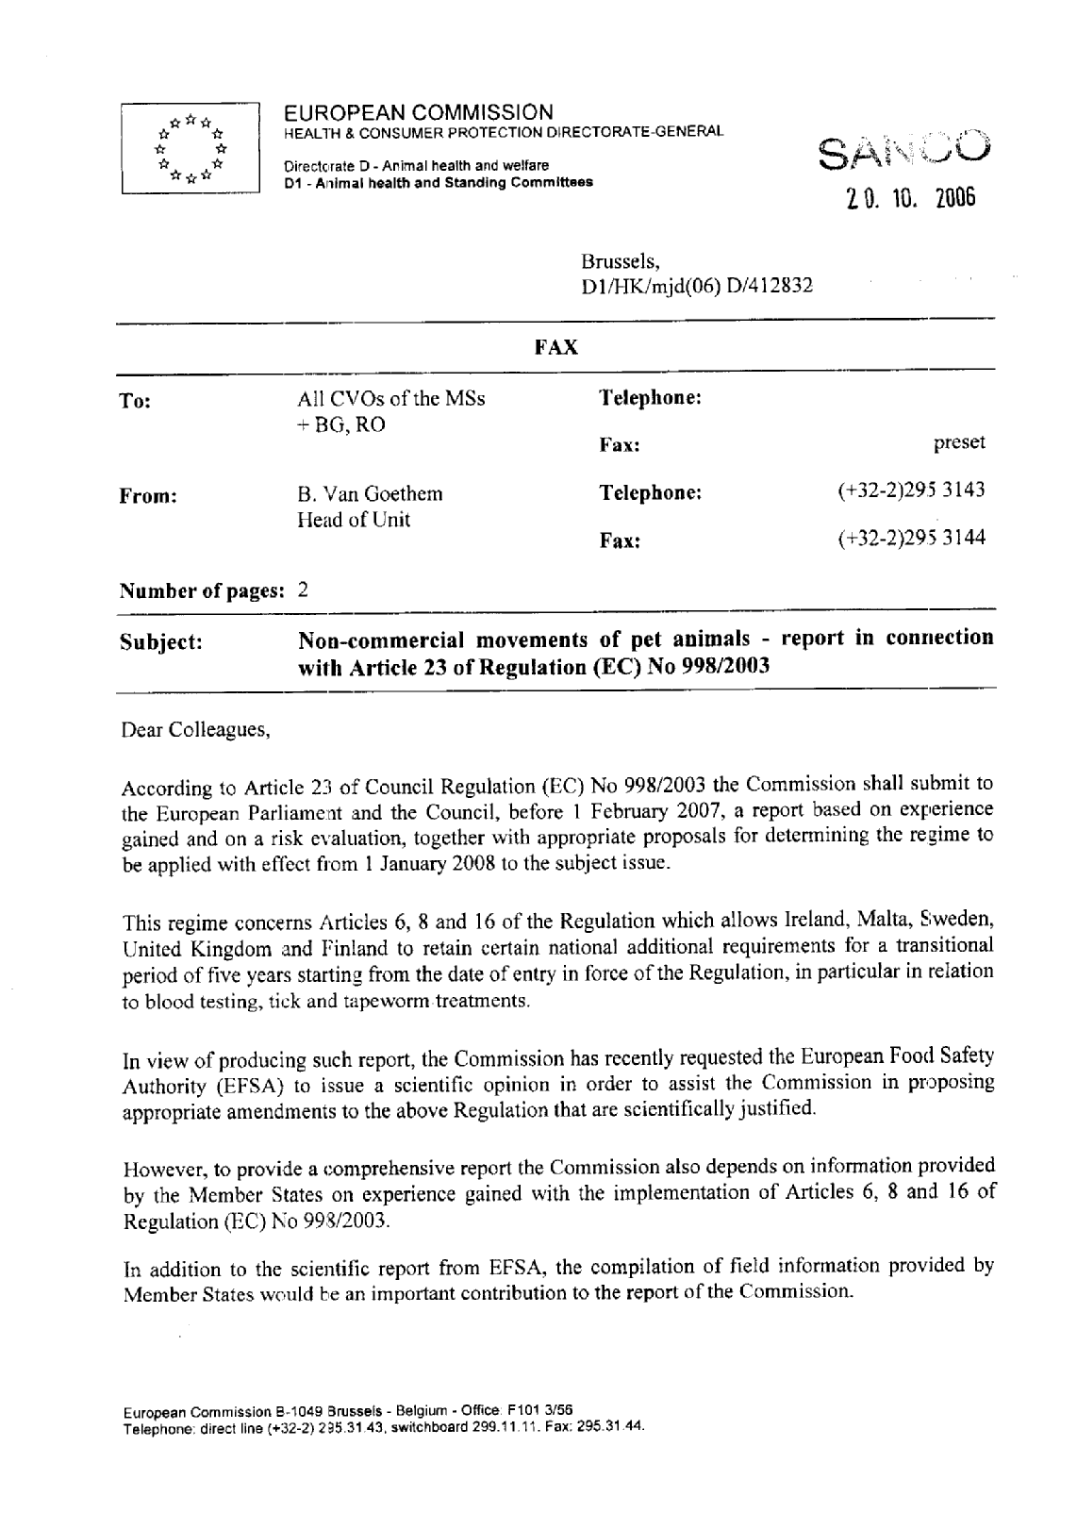
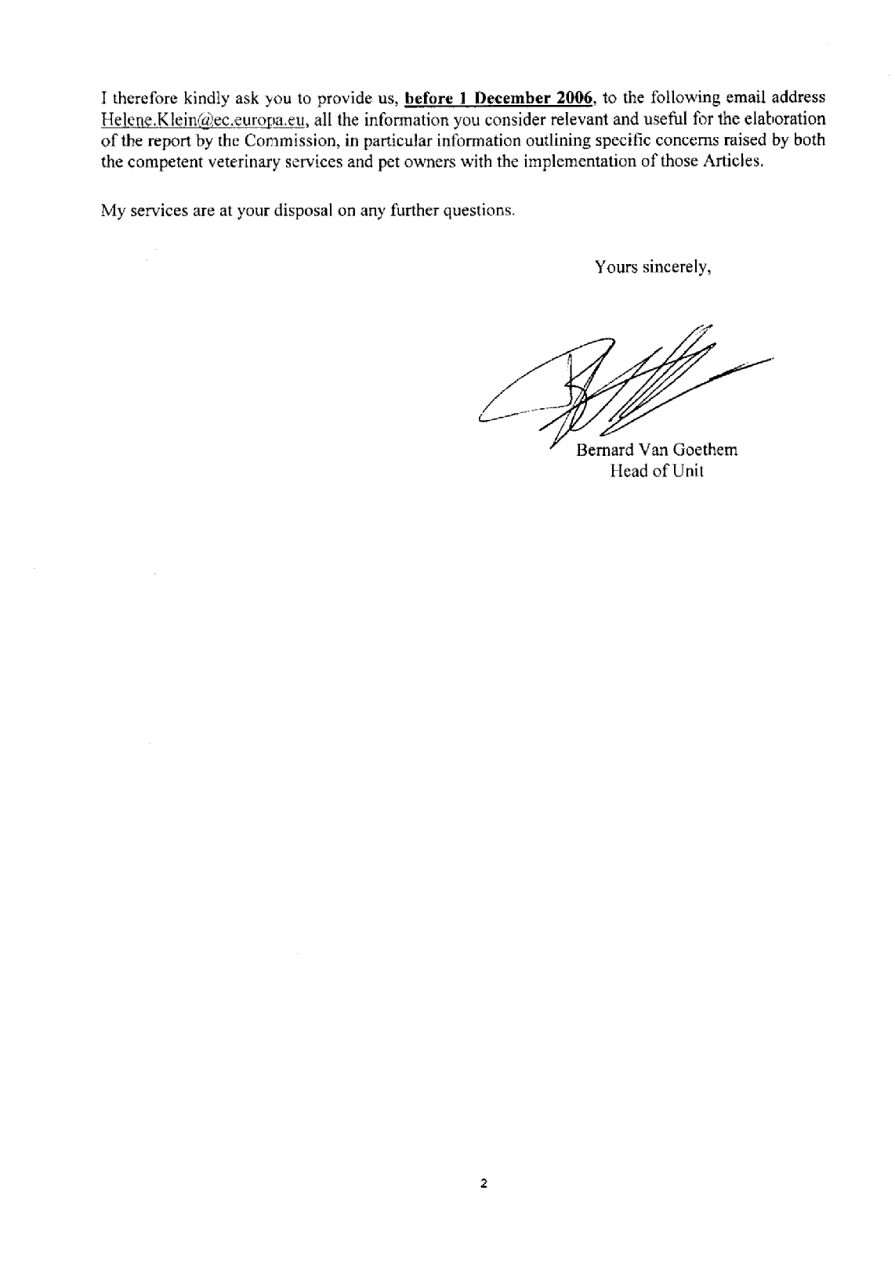
ANNEX 2
Commission request to Ireland, Malta, Sweden and the UK to provide a report according to Article 16 of the Regulation
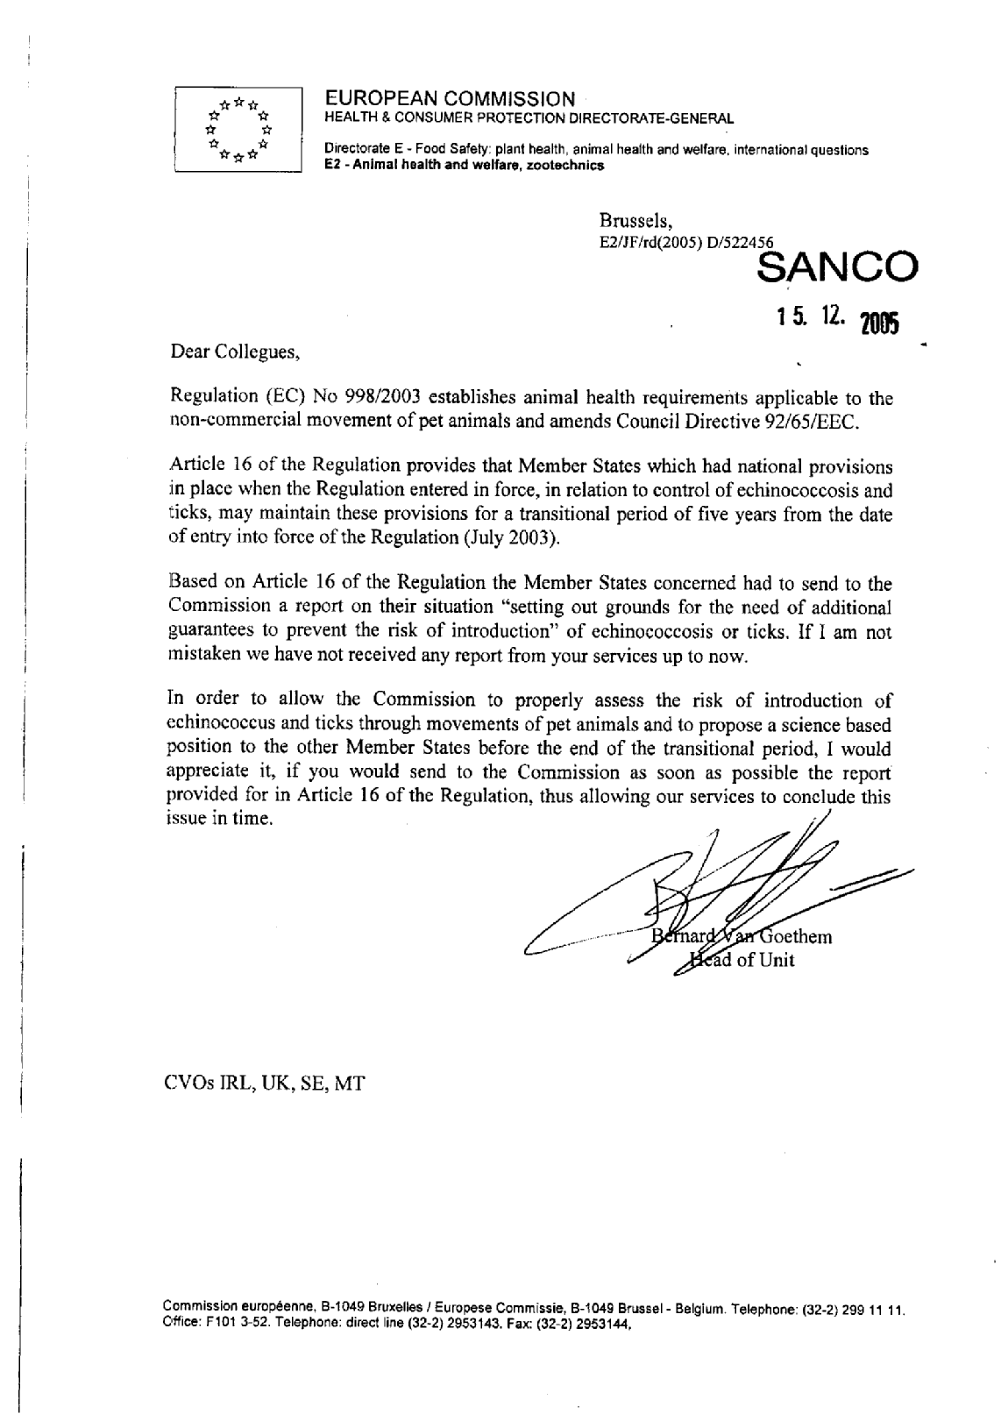
ANNEX 3
Five Member States consultation on the impacts on approved transport companies and quarantine facilities if national rules were to be withdrawn
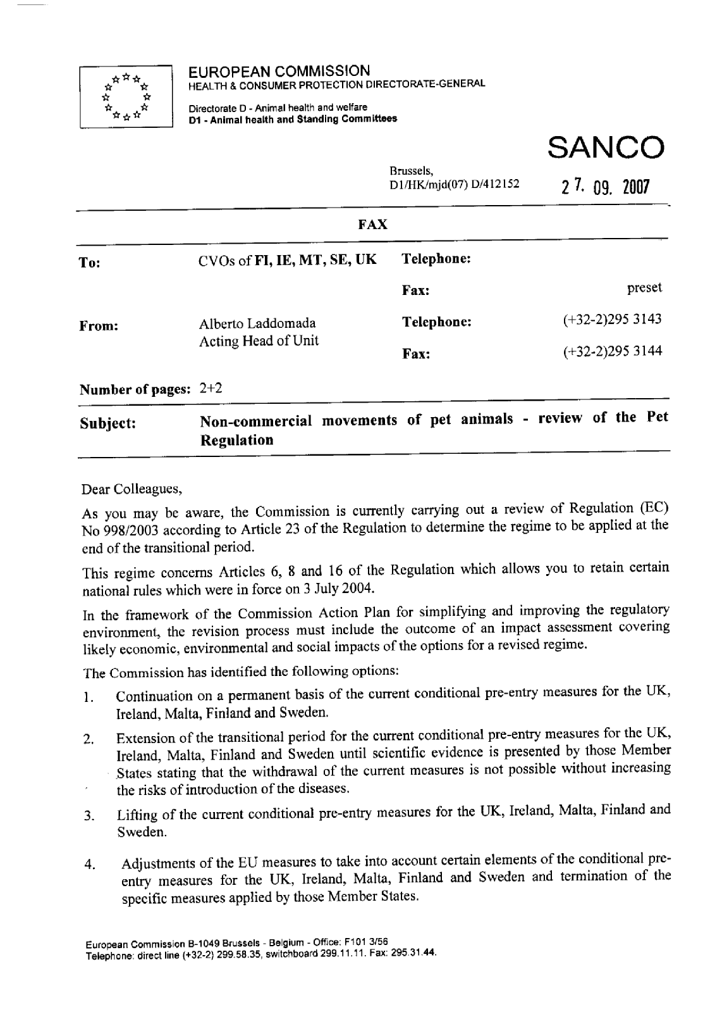
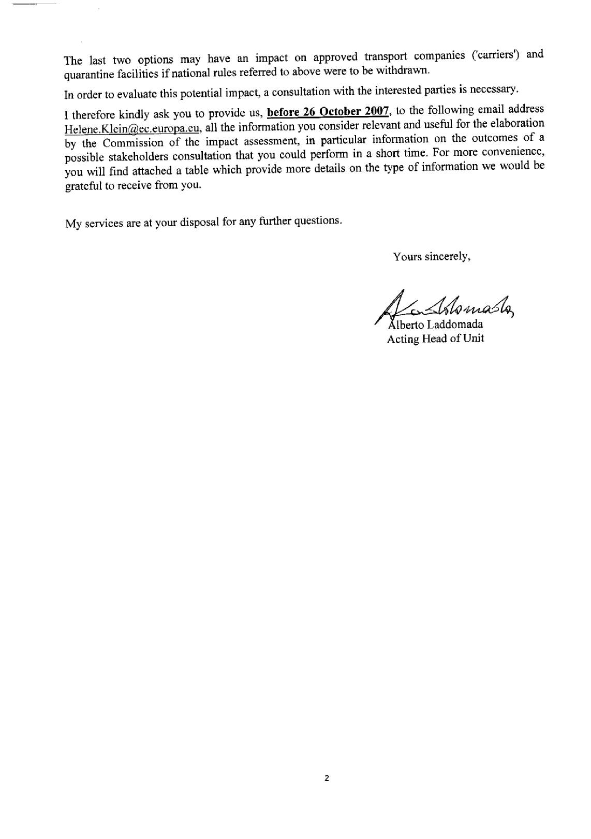
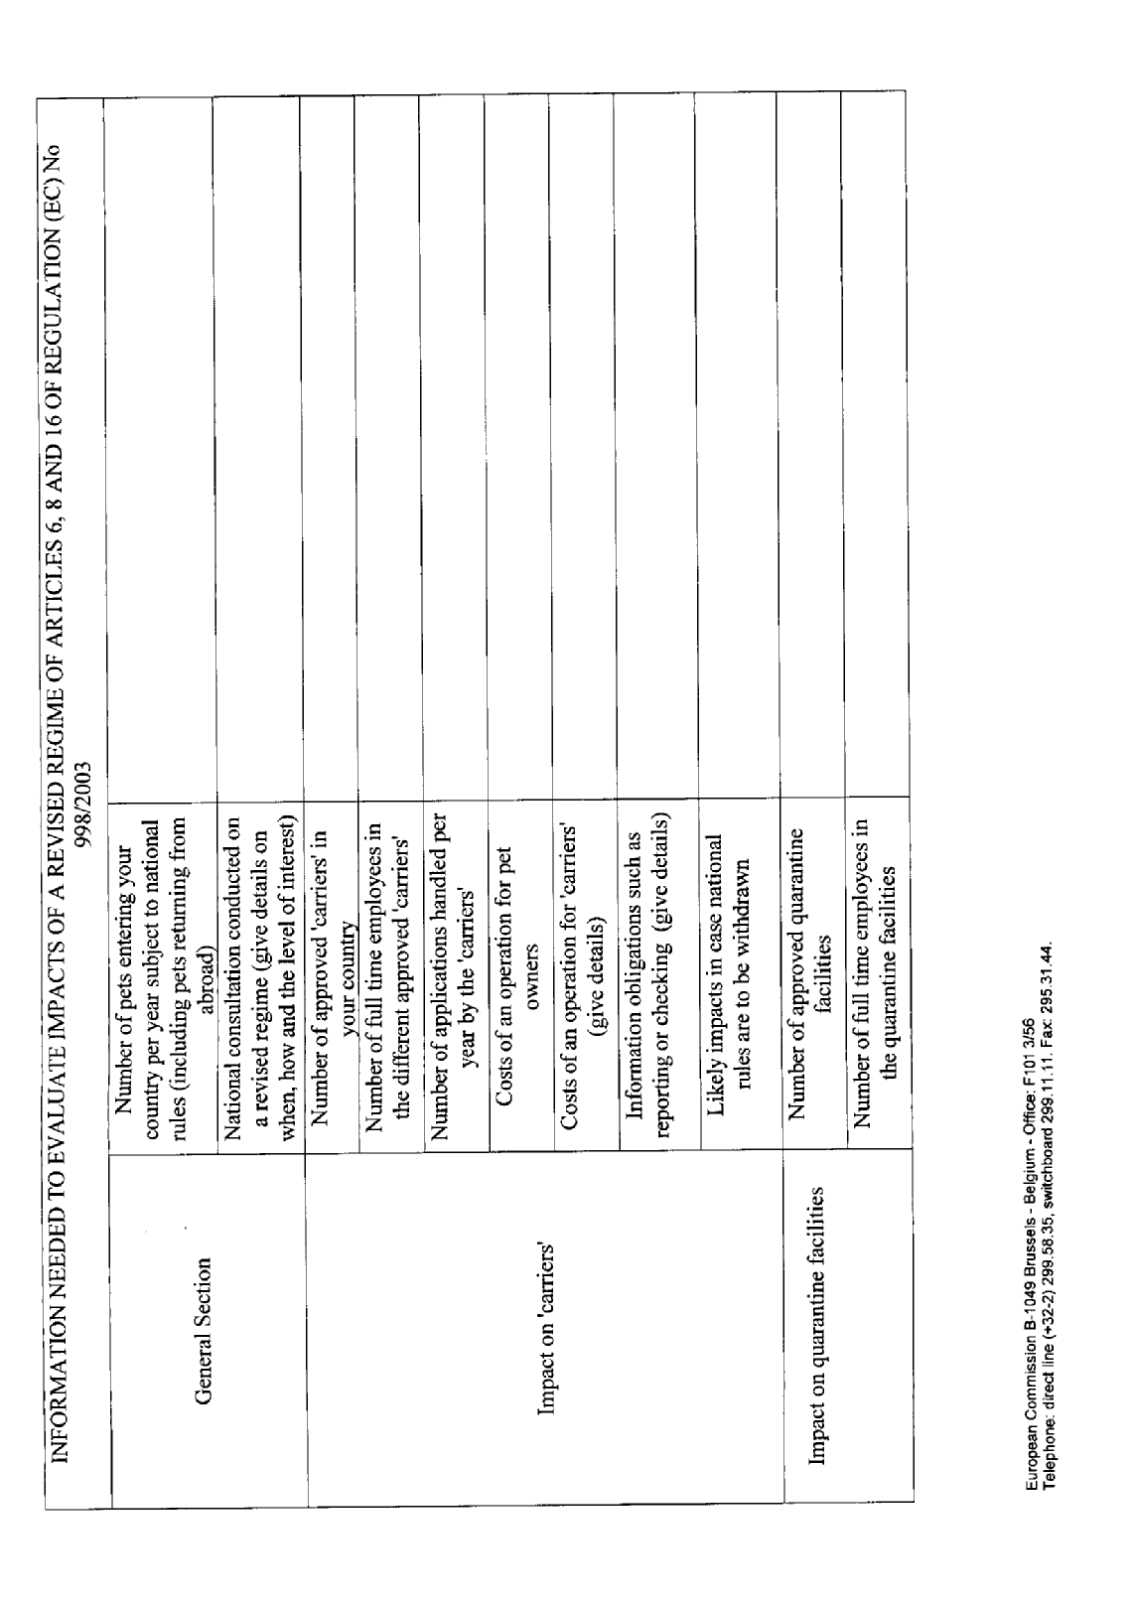
ANNEX 4
Member State consultation on the preparation costs incurred by pet owners
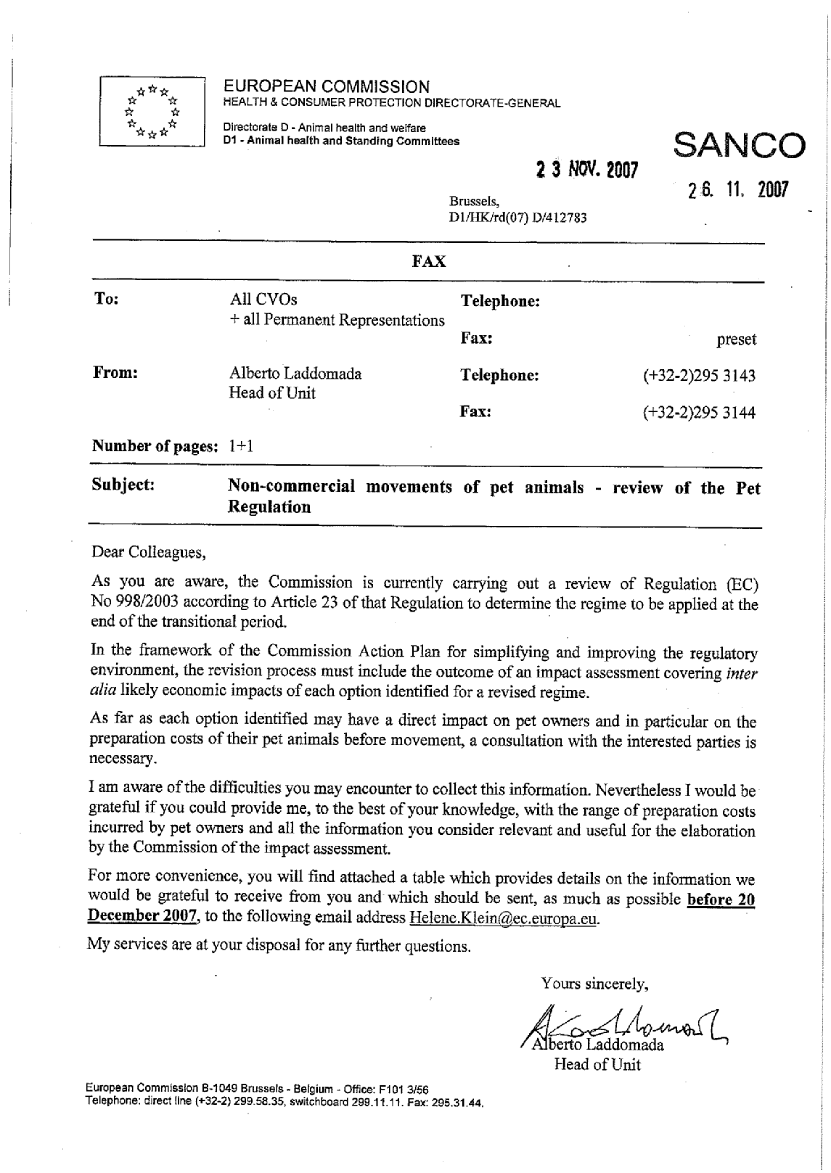
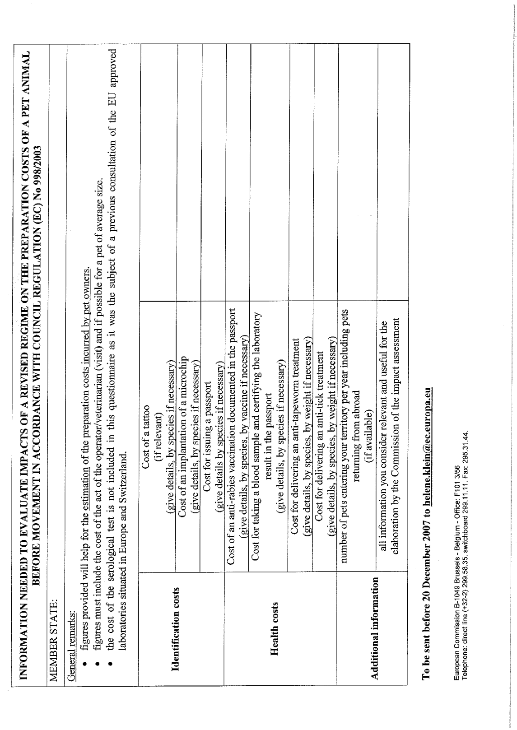
ANNEX 5
Member States consultation on bilateral arrangements between Ireland, Malta, Sweden and the UK
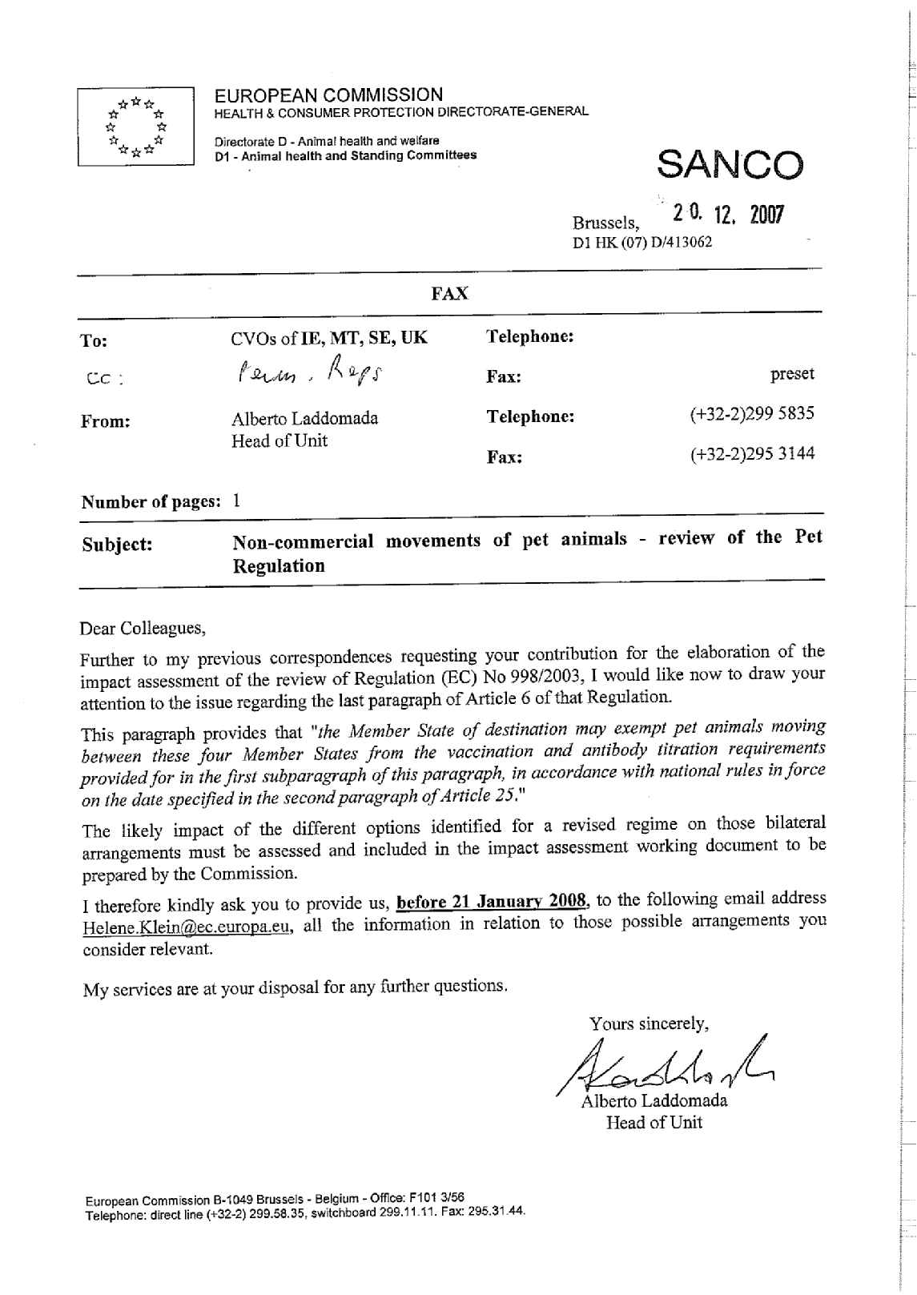
ANNEX 6
Commission's request to EFSA for a scientific advice on the fox tapeworm
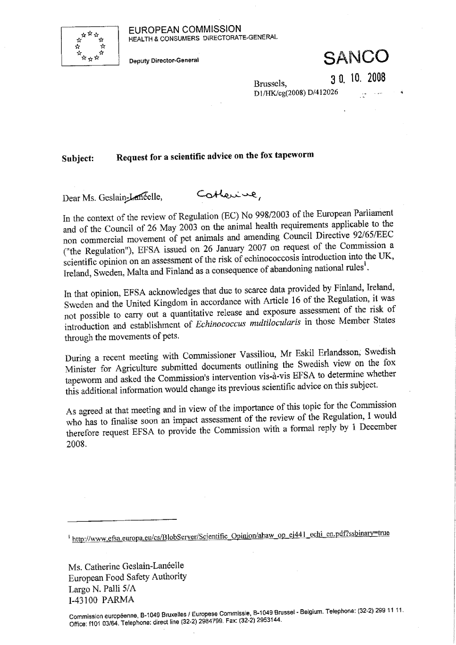
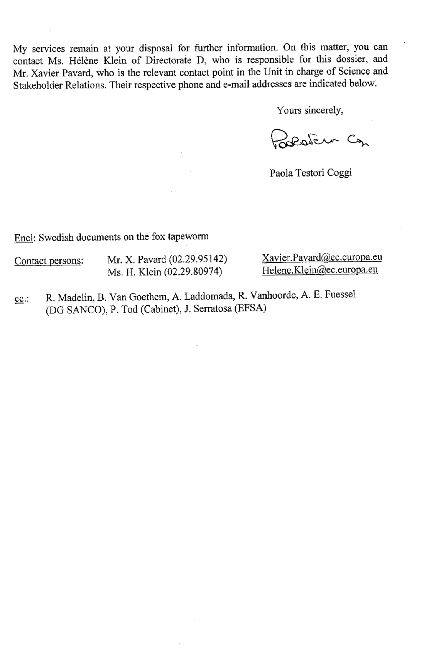
ANNEX 7
Scientific advice from EFSA on the fox tapeworm
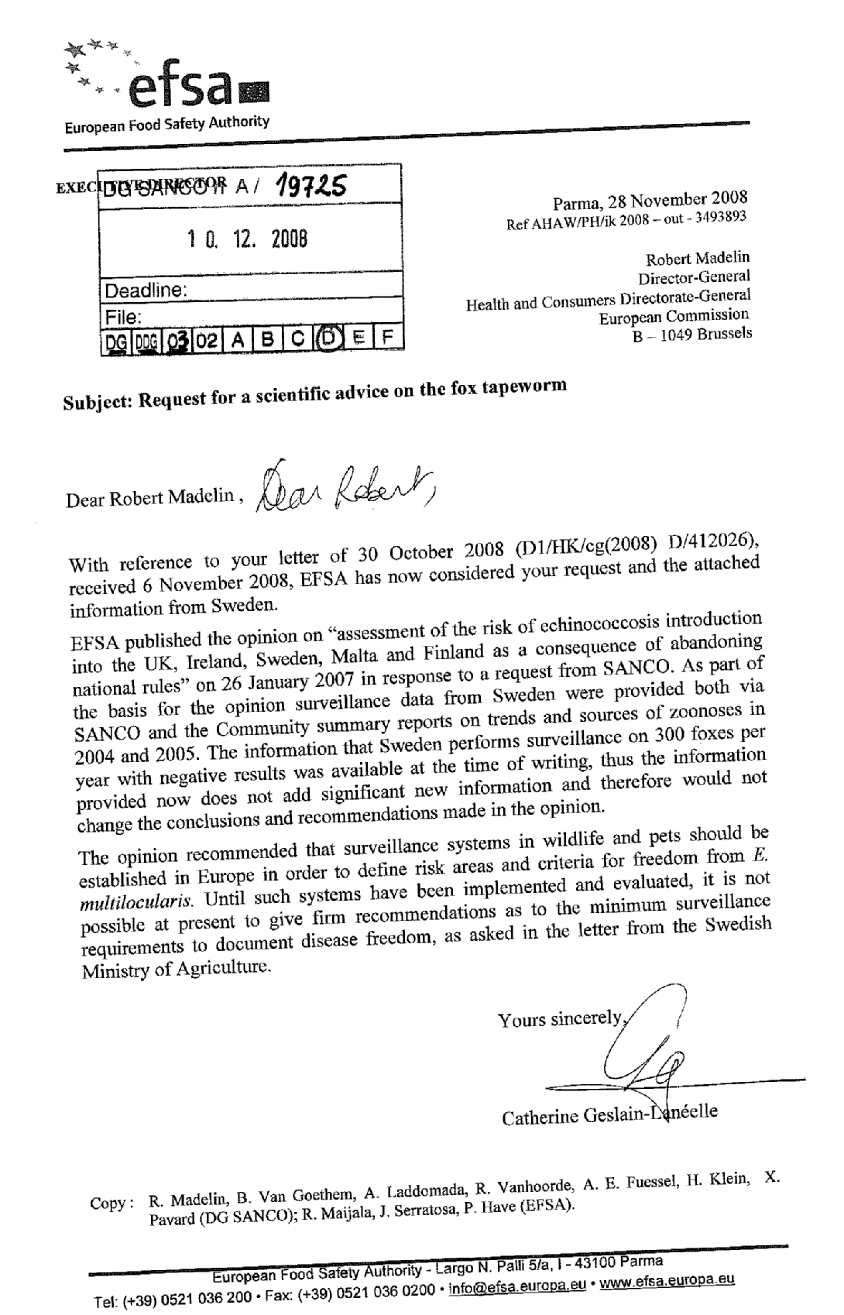
ANNEX 8
Consultation of EU-approved serology laboratories on potential impacts of a regime which may restrict the implementation of a test
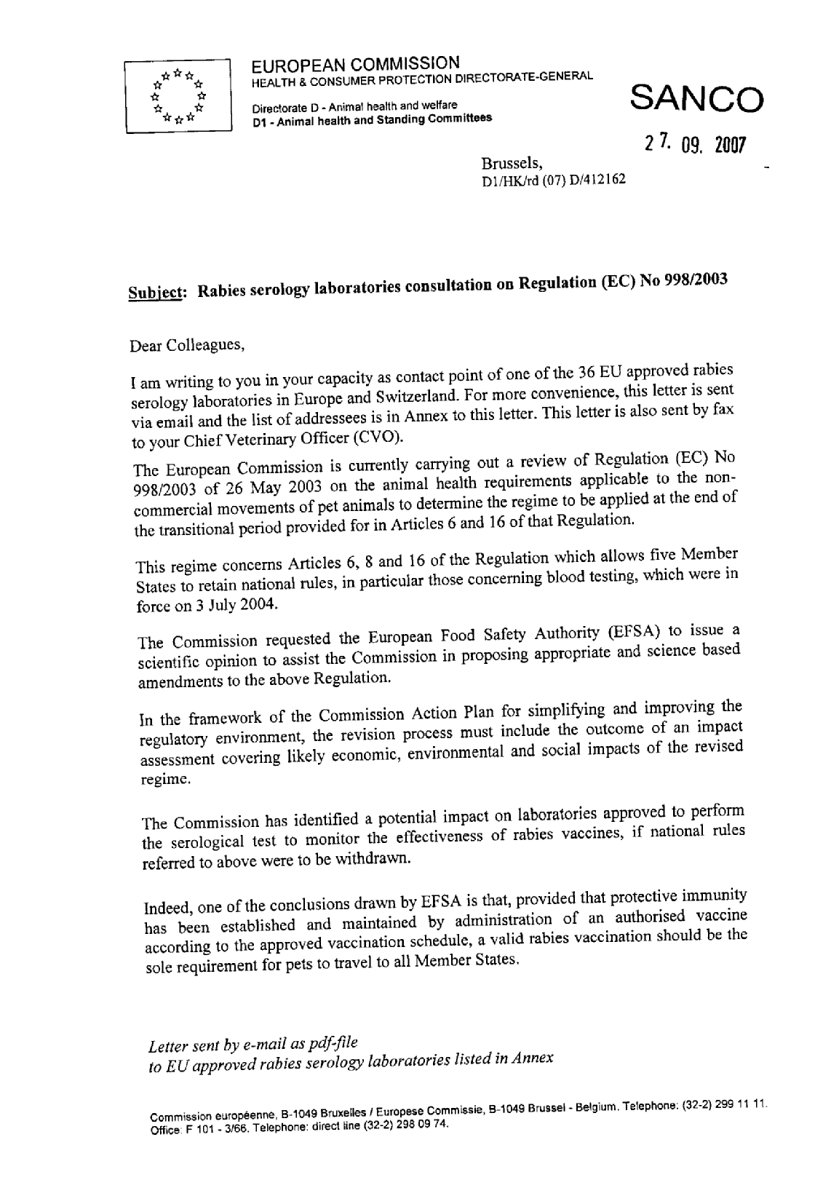
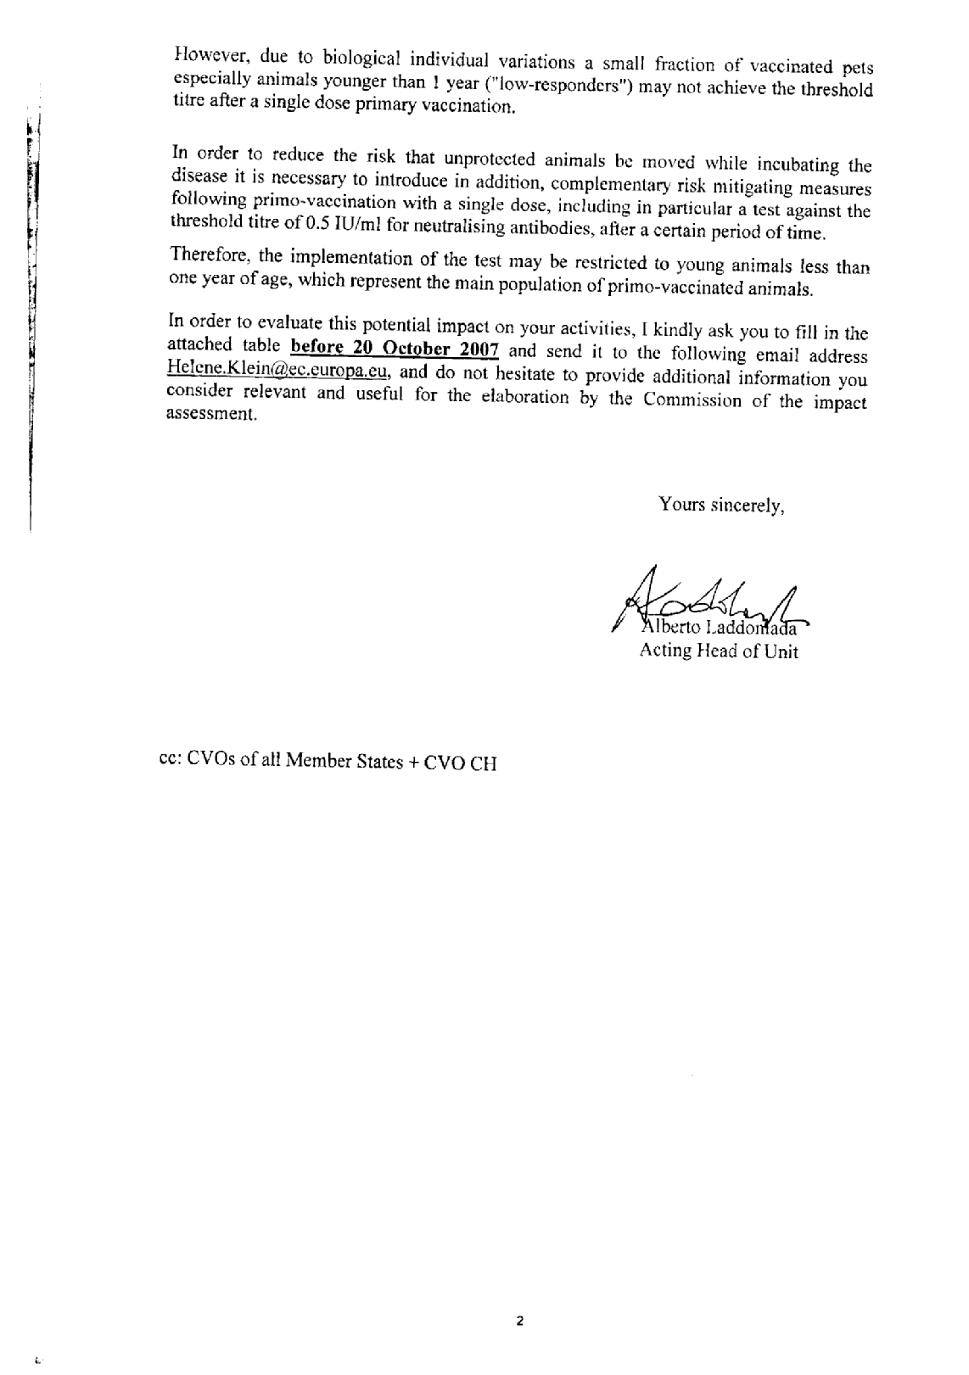
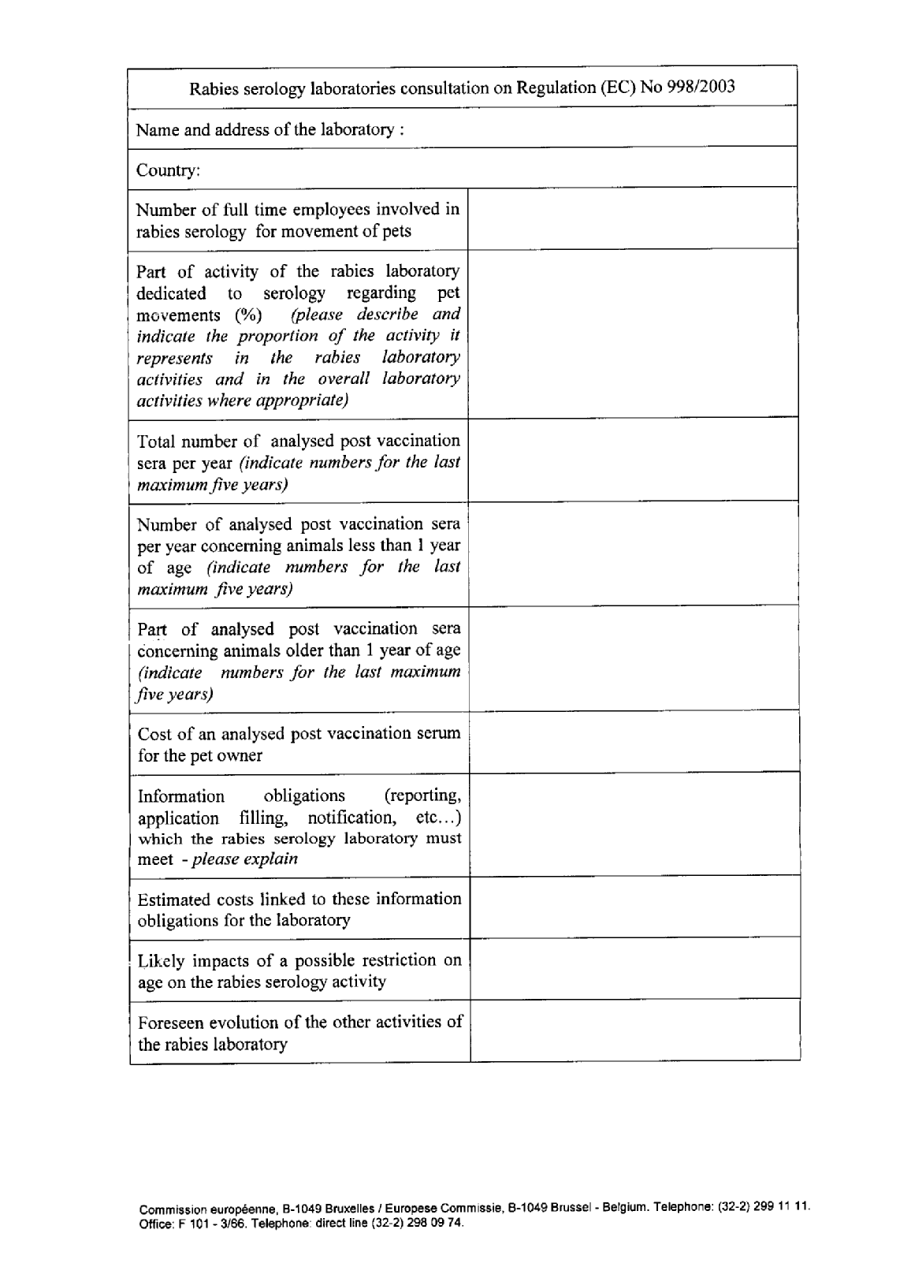
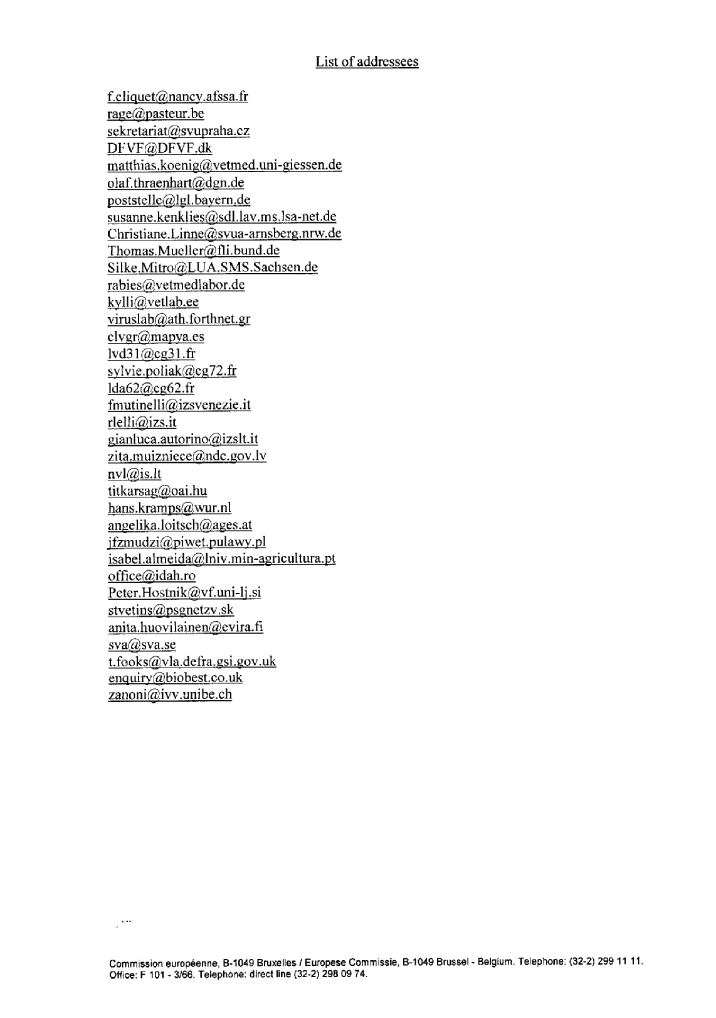
ANNEX 9
UEVP's opinion on the review of the Regulation
ANNEX 10
Setting up of an Inter Service Steering Group
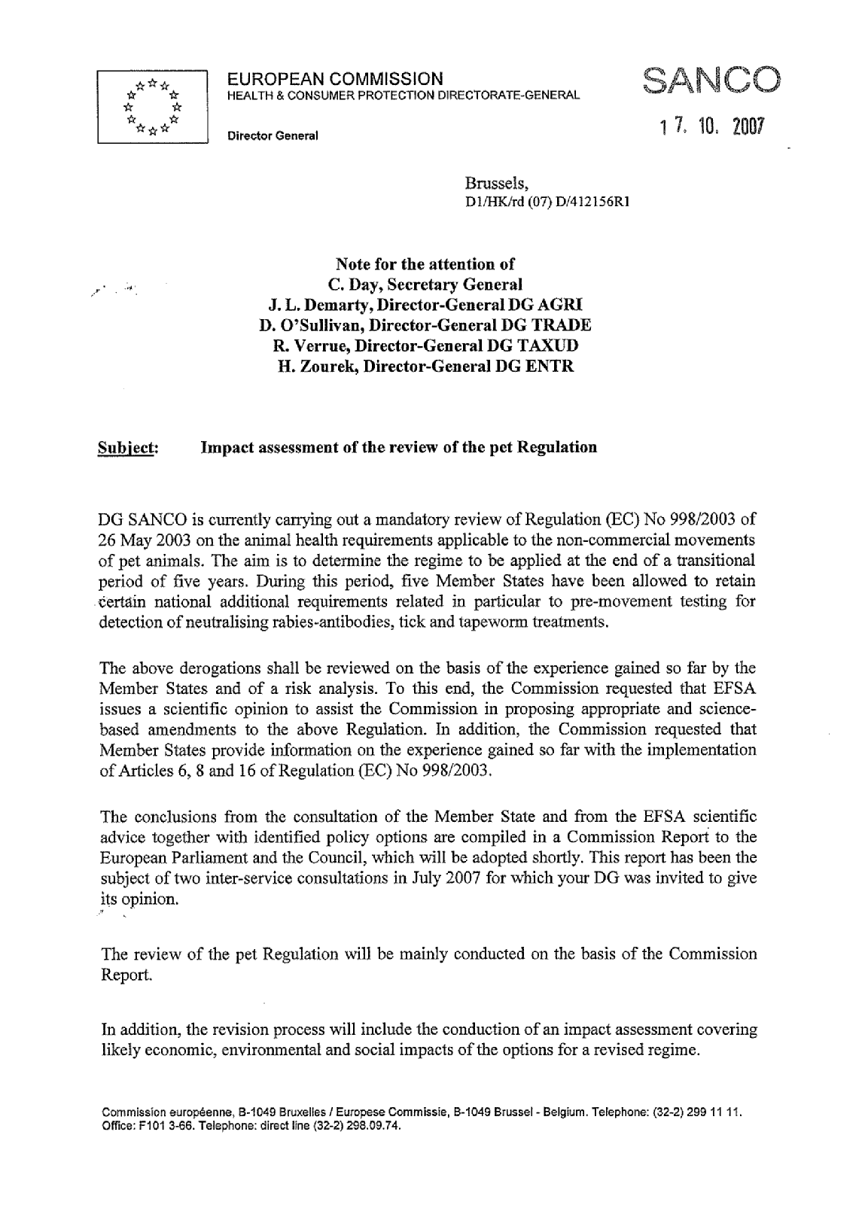
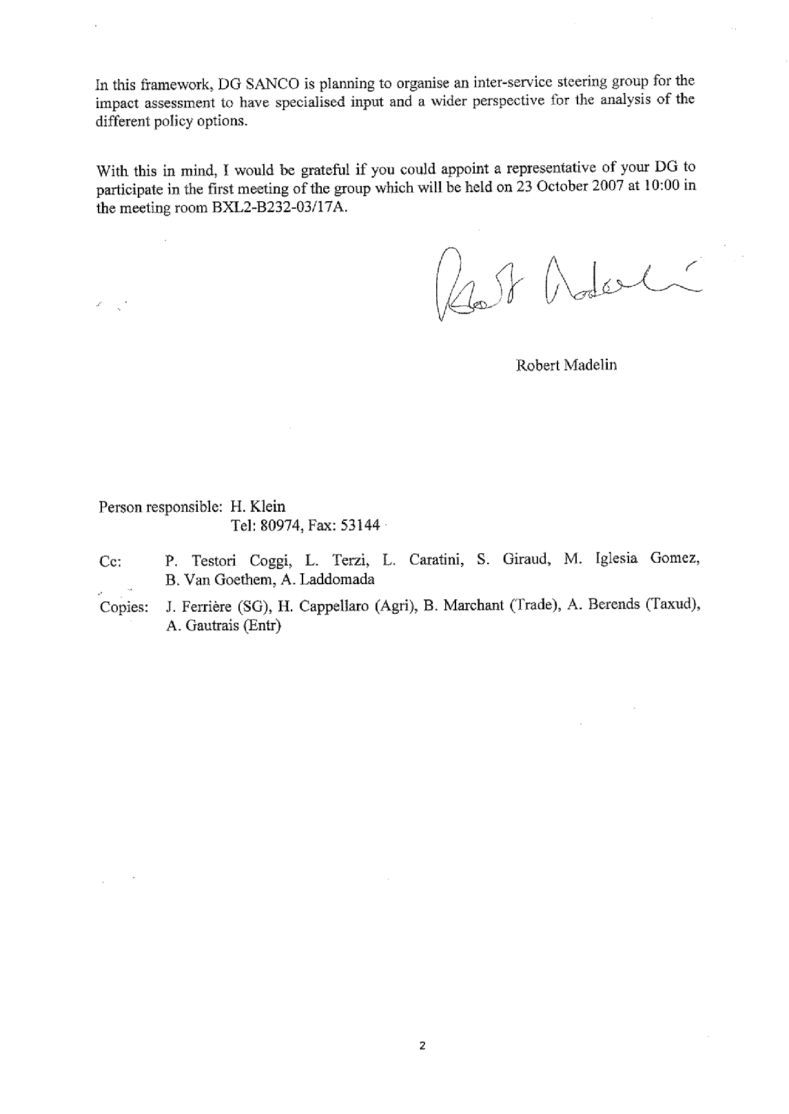
ANNEX 11
Pet passport
(Commission Decision 2003/803/EC)
ANNEX 12
Transitional regime
Summary of the different national animal health requirements in force in Finland, Ireland, Malta, Sweden and the UK
(Source: Websites' competent authorities)
FI
Information extracted from
http://www.evira.fi/portal/en/animals_and_health/import_and_export/dogs__cats_and_ferrets_and_import_of_canine_semen/
Mandatory anti-parasite treatment against echinococcus |  | Dogs and cats must be given not more than 30 days before it arrives to Finland an appropriate dosage of medicine containing praziquantel or epsiprantel against tapeworm causing echinococcosis approved for the species concerned. The medication against echinococcosis is entered to the pet passport by veterinarian.  Medication against echinococcosis is not required if the animal is imported directly from Sweden, Norway (other parts than Spitsbergen), the United Kingdom or Ireland, or if the animal is brought back to Finland within 24 hours from leaving the country. Medication against echinococcosis is also not required for animals which are less than three months old.
IE
Information extracted from
http://www.agriculture.gov.ie/index.jsp?file=pets/travel.xml
Mandatory blood testing before entry into their territory to confirm a protective level of anti-rabies antibodies | Subsequent to the first rabies vaccination (usually about a month later but your veterinarian will advise) your pet must be blood tested to confirm a neutralising antibody titration at least equal to 0.5 IU/ml. The test must be carried out in a laboratory approved for this purpose. If you keep your rabies vaccinations up to date you will only have to do this blood-test once. However if there is any break in vaccination the test must be repeated. Blood sampling must have been carried out in an eligible country. Your pet may enter Ireland only when at least six months has expired since a successful blood-test. This provision is to ensure that your pet is not incubating rabies.  If your pet has had a break in its vaccinations and has had to repeat the blood-test, six months must pass from the date of the most recent test before your pet can enter Ireland.
Mandatory anti-parasite treatment against echinococcus | Between 24 and 48 hours before you check-in for travel you must bring your pet to a registered veterinarian to be treated against tapeworm. This is to prevent a risk of potentially serious disease entering Ireland. The tapeworm (echinococcus multilocularis) treatment must contain praziquantal as an active ingredient.
Mandatory anti-parasite treatment against ticks | Between 24 and 48 hours before you check-in for travel you must bring your pet to a registered veterinarian to be treated against tick. This is to prevent a risk of potentially serious disease entering Ireland. The tick treatment must be other than by a collar impregnated with acaricide.
MT
Information extracted from
http://www.veterinary.gov.mt/page.asp?p=6107&l=1
Mandatory blood testing before entry into their territory to confirm a protective level of anti-rabies antibodies | The pet owner must refer to his/her Veterinarian in order to have a blood sample taken at least 30 days after the rabies vaccination, and then sent to an authorised laboratory where a seroneutralization titre test is carried out in order to determine the antibody titre. Pet animals cannot enter Malta until at least six calendar months after the date that the Veterinarian took a blood sample that give a successful seroneutralization titre test result.
Mandatory anti-parasite treatment against echinococcus | 24-48 hours prior before starting the journey for Malta, it must be treated with praziquantel for tapeworm. The treatment must be carried out by a Veterinarian, who will then issue a certificate indicating the products used as well as the date and the time (in 24-hour system) when the treatment was carried out.
Mandatory anti-parasite treatment against ticks | 24-48 hours prior before starting the journey for Malta, it must be treated with fiprinol for ticks. The treatment must be carried out by a Veterinarian, who will then issue a certificate indicating the products used as well as the date and the time (in 24-hour system) when the treatment was carried out.
SE
Information extracted from
http://www2.sjv.se/webdav/files/SJV/trycksaker/Pdf_ovrigt/ovr76gb.pdf
Mandatory blood testing before entry into their territory to confirm a protective level of anti-rabies antibodies |  | No sooner than 120 days and no more than 365 days after the basic vaccination against rabies, a veterinarian shall take a blood sample of the animal in order to verify the level of rabies antibodies.
Mandatory anti-parasite treatment against echinococcus |  | A veterinarian shall deworm your animal against tapeworm (Echinococcus) 1-10 days before you bring it to Sweden.  There is no requirement for deworming a cat or a dog that are to be imported into Sweden and that have only stayed in Finland and Norway at least one year prior to import.  Four-week certificate for commuting between Sweden and Denmark: by derogation, animals that live in Sweden or Denmark and that accompany commuters between these two countries, are allowed to be dewormed every 28 days by a veterinarian
UK
Information extracted from
http://www.defra.gov.uk/animalh/quarantine/pets/procedures/vets_proc.htm
Mandatory blood testing before entry into their territory to confirm a protective level of anti-rabies antibodies | To be carried out after vaccination against rabies by an approved laboratory six months prior to travel
Mandatory anti-parasite treatment against echinococcus | The treatment must be carried out not less than 24 hours and not more than 48 hours before the pet is checked-in with the approved transport company to travel on the return journey to the UK. The treatment must be given every time a pet enters the UK.  The tapeworm treatment must contain praziquantel and be administered in accordance with the manufacturer’s instructions.
Mandatory anti-parasite treatment against ticks | The treatment must be carried out not less than 24 hours and not more than 48 hours before the pet is checked-in with the approved transport company to travel on the return journey to the UK. The treatment must be given every time a pet enters the UK.  The tick treatment must be a veterinary product which has marketing authorisation in the country of use and is licensed for use against ticks. A tick collar is not acceptable.

ANNEX 13
Transitional regime
Exemptions existing between Ireland, Malta, Sweden and the UK, as regard anti-rabies vaccination and antibody titration requirements
in the context of Article 6(1) of the Regulation
(Source: Member States' competent authorities' consultation)
IE | • Ireland currently exempts pets entering from the UK from vaccination and antibody titration requirements.
MT | • Malta exempts UK, IE and SE from the antibody titration but not from vaccination.
SE | • Pets coming directly from the UK and Ireland: no rabies vaccination and no antibody titration  • Pets coming directly from Malta: Rabies vaccination + antibody titration at 120 days post vaccination, at the earliest (Sweden is currently performing a review of the national regulation complementing Regulation 998/2003, and is considering abolishing the vaccination and titration requirement for pets from Malta.)
UK | • The UK currently exempts pets entering from Ireland from vaccination and antibody titration requirements.  • No exemption from vaccination and antibody titration requirements for pets entering the UK from Sweden and Malta

ANNEX 14
Transitional regime
Exemptions existing between Sweden and Denmark
in the context of Article 21 of the Regulation
(Source: Commission Decision 2004/557/EC and MS consultation)
SE/DK | By way of derogation of Article 6 of the Regulation, Sweden exempts the Danish dogs and cats travelling to the Danish island of Bornholm via Sweden from the passport, rabies vaccination or antibody titration requirements, as long as the animals  • are marked either by tattoo or transponder,  • travel directly along one of two given routes from Sealand through Sweden to Bornholm either way (maximum of 4 hours drive) and,  • have a ticket for the ferry trip,  • do not leave the car/truck/bus/train when in Sweden,  • are not in contact with any other animals,  • are de-wormed according to Swedish rules. De-worming has to take place either within 10 days before entry or continuously every 28 days according to the four-week certificate.

ANNEX 15
Figures on pet movements
(Source: Member States' competent authorities' consultation)
 |  | IE | MT | UK
Number of pets entering the country per year (including pets returning from abroad) | 2002 |  |  | 41137
 | 2003 |  |  | 55516
 | 2004 |  | 289 | 65656
 | 2005 | 955 | 330 | 79923
 | 2006 | 1295 | N/A | 84767
 | 2007 | 1278 | 528 | 99307
 | 2008 |  |  | 104031

ANNEX 16
Complaints
Complaints from individuals
Since the entry into force of the Regulation, the Commission has registered many complaints from British, Irish and Swedish citizens submitted either directly or through their Member of the European Parliament. It is certainly the case that national rules affect primarily citizens from those five Member States upon their return from a trip abroad. Complaints are mainly about:
(1) exorbitant cargo rates charged by international air carriers to transport pets due to the monopoly situation as a result of the obligation to transport pets as "cargo",
(2) limited number and inequitable geographical distribution of entry points where necessary checks are performed,
(3) different protocols in place in these Member States leading to unfortunate misunderstandings,
(4) high fees requested by veterinarians situated in the proximity of exit ports to the UK, in particular the area of Calais, for the certification and treatment required for pets accompanying UK citizens regularly holidaying outside the UK (stays of more than 48 hours and during bank holidays/weekends may lead to additional costs in relation to the pre-entry anti-parasite treatment).
Complaints from competent authorities of Member States
Although the Member States consider the general regime under the Regulation to be an improvement overall compared to the previous situation in which the individual Member States applied their own import rules, the following shortcomings of the current transitional regime have been singled out:
- the reinforced protection measures between rabies-free Member States (most of the western parts of the EU according to OIE) and those with a long history of rabies freedom (UK or Ireland) are considered outdated and discriminatory. OIE does not justify such differences as there are two ways of achieving rabies freedom;
- the transitional regime is unfair in comparison with the general regime that has proved to be efficient, as no rabies cases have been reported in Member States other than the UK, Ireland, Malta and Sweden although they allow entry of pets coming from non-rabies-free Member States without prior testing for antibodies;
- differences in sanitary requirements, including amongst the five Member States concerned, lead to a lengthening of the time required before pets are authorised to travel and hamper subsequent journeys through those five Member States,
- Denmark raised the specific issue of the Swedish national transit requirements, which cause serious inconvenience to pet owners travelling frequently.

ANNEX 17
Rabies epidemiology and control measures in the EU
Rabies is one of the first diseases to be identified as a zoonosis. It causes encephalomyelitis and can affect all mammals including humans. Virus transmission occurs when there is contact with infectious saliva, i.e. bites, scratches, broken skin. In the absence of timely and appropriate treatment the disease is always fatal.
Although rabies is a vaccine-preventable, compulsorily notifiable disease, it is still widespread throughout the world, responsible for about 55 000 human deaths every year (99% occur in Asia and Africa), most often following an infection transmitted by a rabid dog (urban rabies). Each year, around 10 million people receive treatment after exposure to animals in which rabies is suspected. The World Heath Organisation (WHO) has developed strategies to promote wider access to appropriate post-exposure treatment to prevent human rabies cases and to support dog rabies control by mass vaccination campaigns and dog population management.
I. Rabies eradication strategy in the EU
With wildlife species accounting for approximately 80% of all rabies cases in Europe, rabies is predominately of a sylvatic nature. More than 80% of wildlife cases are recorded in red foxes (Vulpes vulpes). Rabies transmission within animal populations is largely density dependent. In the past, conventional methods of fox rabies control such as intensive culling or trapping have generally failed to reduce and maintain the fox population below a certain level to extinguish rabies, not least because such measures also affect the social structure and behavioural patterns of the fox population.
The oral vaccination of foxes against rabies via aerial bait distribution, which was introduced some 25 years ago, opened up a new avenue of rabies control in wildlife. Since then this method has proved to be the only effective way to eliminate rabies in foxes and other terrestrial reservoir species, such as raccoon dogs. Great progress has been made in the eradication of rabies in the EU with the optimisation of vaccination strategies: aerial bait distribution schemes using GPS (Global Positioning System) technology, size of vaccination areas, timing and duration of vaccination campaigns, surveillance and monitoring (follow-up of bait uptake and immunity of foxes).
Field evidence has demonstrated that with the elimination of sylvatic rabies in the EU, occurrence of the disease is diminishing in domestic animals.
II. Community contribution to the rabies monitoring and eradication programmes
The results obtained with EU-wide oral vaccination of foxes, financed by the Community in the framework of rabies eradication and monitoring programmes, are outstanding. Over a ten-year period more than €80 000 000 has gone towards eradicating rabies with a view to protecting the health of humans and facilitating movements of susceptible species within the EU.
Therefore, in most parts of Western and Central Europe, rabies has been successfully controlled and eradicated. So far between 1991 and 2008, as a result of effective oral vaccination programmes, nine Member States (Finland, the Netherlands, Italy, France, Luxembourg, Belgium, Czech Republic, Austria and Germany) have declared compliance with the criteria to be considered free of rabies in accordance with the relevant Chapter of the Terrestrial Animal Health Code of the World Organisation for Animal Health (OIE).
Experience has shown that rabies eradication is successful when eradication programmes are properly defined, resourced and implemented. Member States with positive findings in their wild carnivore population have eradication programmes in progress or planned. In order to eradicate rabies throughout the EU, and to avoid reintroduction of rabies from neighbouring countries east of the EU, continuous vaccination programmes are important in high-risk areas.
Council Decision 90/424/EEC of 26 June 1990 on expenditure in the veterinary field provides for the possibility of a financial contribution by the Community in the rabies eradication and monitoring programmes.
The Commission has intensified exchanges of views between Member States involved in co-financed eradication programmes by creating a task force dedicated to rabies and aiming at improving the effectiveness of its eradication. The rabies subgroup, which meets regularly, provides technical expertise and advice for the Member States and the Commission.
Concerned by the residual risks arising from potentially infected wildlife in Eastern Europe and from the presence of rabies in neighbouring countries, the Commission also increased its financial contributions to cross-border programmes for the oral vaccination of wildlife along the Community's external borders. The appropriate financial contributions were committed for the 2007 rabies eradication programme to be implemented by Lithuania, including vaccination along the border with the Kaliningrad Region of the Russian Federation.
Legal constraints hampered the implementation of that programme, for which a solution was found by adopting Council Decision 2006/965/EC providing a legal basis for direct Community support of disease control measures outside the EU.
Subsequently the Russian Federation submitted a multi-annual rabies eradication plan in the Kaliningrad Region for the period from 1 January 2009 to 31 December 2011, providing for anti-rabies vaccination of wildlife in the entire region. A draft Commission Decision necessary to provide the required Community funding is currently under consideration.
A programme on the territory of the Russian Federation at the border with Finland has been in place since 2000. Similarly, discussions are under way with Ukraine and are at a less advanced stage with Belarus about joint efforts to tackle this disease within their territories.
In 2007 the Commission initiated discussions with the Western Balkan countries (that have candidate or potential candidate status) aiming at supporting their efforts to combat animal diseases including rabies in order to limit the risk to animal and human health, not only in the countries themselves but also in regard to the Member States. The Commission's intention is to give financial aid to those countries via IPA funds (the instrument for pre-accession assistance), through the buying of vaccines and the possibility to drop bait from airplanes. All Western Balkan countries have submitted their national disease eradication programmes for financing under the IPA 2008 budget.
III. The role of the Community Reference Laboratory for rabies
In mid 2007, the Commission decided to launch a procedure for designation of a Community Reference Laboratory (CRL) for rabies. The existing CRL for rabies serology only conducts serological tests to monitor the effectiveness of vaccinations against rabies for movements of pets and has very limited competence as regards the main tasks related to rabies control and eradication. There is indeed a need to have an EU laboratory with special expertise on analysis relevant to the detection of rabies which could provide advice on:
(1) the latest methods for combating rabies via the use of vaccines which are based on the results of epidemiological investigations;
(2) harmonising and coordinating the use of methods to monitor vaccination efficacy;
(3) making it easier to obtain comparable data collected in countries with eradication programmes;
(4) analysing the data collected and sharing experience.
This reference laboratory should also offer training and advice on rabies eradication. These tasks could be dealt with in close cooperation with the European Food Safety Authority (EFSA) or other relevant bodies.
By Commission Regulation (EC) No 737/2008, the Laboratoire d'études sur la rage et la pathologie des animaux sauvages of the Agence Française de Sécurité Sanitaire des Aliments (AFSSA), Nancy, France, was designated as CRL for rabies from 1 July 2008 until 30 June 2013. AFSSA-Nancy is also the existing CRL for rabies serology, operative since 2000.
IV. Community financial contribution to rabies eradication programmes since 1995
ANNEX 18
Rabies data in EU-15 when the Regulation was adopted
(Source 'Rabies Bulletin Europe'- years 2002/2003)
2002
 | total number | wildlife | domestic animals
 | total number | wildlife | dogs | cats | others
AT | 24 | 22 | 1 | 1 | 0
BE | 0 | 0 | 0 | 0 | 0
DK | 3 | 0 | 0 | 0 | 1
FI | 0 | 0 | 0 | 0 | 0
FR | 3 | 0 | 1 | 0 | 0
DE | 43 | 33 | 1 | 1 | 0
GR | 0 | 0 | 0 | 0 | 0
IE | 0 | 0 | 0 | 0 | 0
IT | 0 | 0 | 0 | 0 | 0
LU | 0 | 0 | 0 | 0 | 0
NL | 3 | 0 | 0 | 0 | 0
PT | 0 | 0 | 0 | 0 | 0
ES | 8 | 0 | 4 | 0 | 3
SE | 0 | 0 | 0 | 0 | 0
UK | 2 | 0 | 0 | 0 | 0
2003
 | total number | wildlife | domestic animals
 | total number | wildlife | dogs | cats | others
AT | 1 | 0 | 0 | 0 | 1
BE | 0 | 0 | 0 | 0 | 0
DK | 3 | 0 | 0 | 0 | 0
FI | 1 | 0 | 0 | 0 | 1
FR | 2 | 0 | 0 | 0 | 0
DE | 37 | 24 | 0 | 0 | 0
GR | 0 | 0 | 0 | 0 | 0
IE | 0 | 0 | 0 | 0 | 0
IT | 0 | 0 | 0 | 0 | 0
LU | 0 | 0 | 0 | 0 | 0
NL | 7 | 0 | 0 | 0 | 0
PT | 0 | 0 | 0 | 0 | 0
ES | 1 | 0 | 1 | 0 | 0
SE | 0 | 0 | 0 | 0 | 0
UK | 1 | 0 | 0 | 0 | 0

ANNEX 19
Comparative rabies data from 2003 to 2008 in Bulgaria, Belarus, Estonia, Croatia, Lithuania, Latvia, Poland, Romania, the Russian Federation and Ukraine
(Source 'Rabies Bulletin Europe')
BULGARIA
 | total number | wildlife | domestic animals
 | total number | wildlife | dogs | cats | others
2003 | 19 | 15 | 2 | 0 | 2
2004 | 11 | 4 | 0 | 2 | 5
2005 | 8 | 4 | 1 | 0 | 3
2006 | 10 | 4 | 1 | 4 | 1
2007 | 40 | 27 | 7 | 6 | 0
2008 | 51 | 41 | 5 | 4 | 1
BELARUS
 | total number | wildlife | domestic animals
 | total number | wildlife | dogs | cats | others
2003 | 1077 | 761 | 133 | 119 | 64
2004 | 211 | 135 | 27 | 28 | 21
2005 | 591 | 442 | 63 | 41 | 45
2006 | 1499 | 1136 | 136 | 129 | 98
2007 | 823 | 603 | 61 | 79 | 80
2008 | 964 | 735 | 79 | 75 | 75
ESTONIA
 | total number | wildlife | domestic animals
 | total number | wildlife | dogs | cats | others
2003 | 814 | 697 | 34 | 28 | 55
2004 | 314 | 254 | 24 | 20 | 16
2005 | 266 | 229 | 6 | 8 | 23
2006 | 114 | 101 | 5 | 4 | 4
2007 | 4 | 2 | 0 | 0 | 2
2008 | 3 | 1 | 1 | 0 | 1

CROATIA
 | total number | wildlife | domestic animals
 | total number | wildlife | dogs | cats | others
2003 | 633 | 590 | 21 | 14 | 8
2004 | 504 | 471 | 13 | 15 | 5
2005 | 557 | 525 | 11 | 14 | 7
2006 | 565 | 516 | 24 | 12 | 13
2007 | 635 | 596 | 15 | 12 | 12
2008 | 1061 | 982 | 29 | 30 | 20
LITHUANIA
 | total number | wildlife | domestic animals
 | total number | wildlife | dogs | cats | others
2003 | 1108 | 796 | 56 | 81 | 175
2004 | 553 | 408 | 39 | 34 | 72
2005 | 1652 | 1312 | 89 | 92 | 159
2006 | 2232 | 1883 | 111 | 88 | 150
2007 | 432 | 313 | 34 | 43 | 42
2008 | 69 | 47 | 5 | 6 | 11
LATVIA
 | total number | wildlife | domestic animals
 | total number | wildlife | dogs | cats | others
2003 | 964 | 282 | 62 | 52 | 21
2004 | 443 | 350 | 33 | 35 | 25
2005 | 421 | 353 | 20 | 29 | 19
2006 | 472 | 384 | 31 | 44 | 13
2007 | 203 | 145 | 26 | 27 | 5
2008 | 110 | 90 | 8 | 10 | 2
POLAND
 | total number | wildlife | domestic animals
 | total number | wildlife | dogs | cats | others
2003 | 388 | 310 | 19 | 27 | 26
2004 | 136 | 103 | 4 | 10 | 9
2005 | 138 | 98 | 5 | 7 | 24
2006 | 82 | 59 | 4 | 6 | 9
2007 | 70 | 52 | 2 | 6 | 7
2008 | 29 | 21 | 1 | 1 | 3

ROMANIA
 | total number | wildlife | domestic animals
 | total number | wildlife | dogs | cats | others
2003 | 95 | 67 | 8 | 5 | 15
2004 | 187 | 119 | 28 | 18 | 22
2005 | 530 | 354 | 64 | 61 | 51
2006 | 293 | 219 | 34 | 17 | 23
2007 | 378 | 269 | 40 | 24 | 44
2008 | 1089 | 906 | 79 | 47 | 57
RUSSIA
 | total number | wildlife | domestic animals
 | total number | wildlife | dogs | cats | others
2003 | 2866 | 1360 | 624 | 347 | 531
2004 | 1549 | 563 | 361 | 282 | 330
2005 | 3087 | 1306 | 647 | 493 | 633
2006 | 1349 | 579 | 261 | 227 | 280
2007 | 3471 | 1610 | 539 | 517 | 798
2008 | 3353 | 1628 | 758 | 501 | 454
UKRAINE
 | total number | wildlife | domestic animals
 | total number | wildlife | dogs | cats | others
2003 | 2031 | 924 | 369 | 442 | 293
2004 | 907 | 425 | 132 | 221 | 128
2005 | 2113 | 959 | 358 | 470 | 324
2006 | 2020 | 982 | 376 | 400 | 262
2007 | 2932 | 1348 | 495 | 669 | 417
2008 | 2164 | 822 | 545 | 628 | 106

ANNEX 20
Information on alveolar echinococcosis and tick borne diseases
(Source EFSA opinion)
Alveolar echinococcosis
Alveolar echinococcosis, caused by the tapeworm E. multilocularis, is a rare zoonotic chronic cancer-like disease with a fatality rate of up to 100% in untreated patients. It is considered one of the most severe human parasitoses in non tropical regions and has received considerable attention in recent years particularly in Europe, Japan and most recently China.
E. multilocularis occurs throughout the northern hemisphere although its scale of distribution and frequency is not completely known. The tapeworm can be found in foxes in central Europe, to the north of Denmark, the Netherlands and Belgium, in the east to the Baltic States and Slovakia, in the south to north eastern Italy and Hungary and in the west to central France. Although the parasite has an extensive geographic distribution in most of Europe, it has never been recorded in the British Isles, Fennoscandia, and the Iberian Peninsula.
A number of isolated surveys in wildlife show great variations from one country to another and even between regions in the same country. Therefore it is extremely difficult to compare epidemiological situations and any evaluation of the epidemiology can only be an approximation.
Risk factors are still incompletely known.
The typical transmission cycle in Europe is wildlife-based, involving red foxes as final hosts and rodents as intermediate hosts. Domestic dogs and cats can be infested but they appear to be of secondary importance for the lifecycles' persistence. As potential definitive hosts they may, however, play a role in transmission to humans.
There is evidence that prevalence rates in foxes have risen in many agriculturally dominated landscapes of France, the Netherlands, Germany, Austria, Slovakia and Poland, but the life cycle is now also established in many urban areas, where red foxes occur with high population densities. According to EFSA and more recent data collected by the Member States, with the increasing population of foxes in the Community and the migration of those animals into urban areas, there may be an increased risk of humans becoming infected through accidental ingestion of fox faeces contaminating fruits and vegetables. Trans-boundary wildlife movements can also constitute an important route for the introduction of the disease in certain countries.
Very few data on the infection rates of pets (dogs and cats) are available, and existing data are difficult to interpret due to a lack of information on the sampling strategies. Surveys conducted in Finland to detect E. multilocularis in dogs have so far yielded negative results. Ireland, Malta, Sweden and the UK have not provided any information on surveillance in domestic dogs. From the limited number of published surveys on infection in pets in Europe, it seems that tapeworm infection rates in domestic carnivores are low, most likely due to low exposure to the intermediate stages of the parasite and to routine deworming.
In humans, data from the year 2005 point to an apparent increase of cases. However, as it typically takes an infected person 10 to 15 years to develop the disease, it is difficult to determine the origin of the infection which is often not reported by Member States. Imported cases have been reported in non-endemic areas. This shows that the risk of people travelling to endemic areas (whether or not from non endemic areas) and contracting the disease by accidentally ingesting tapeworm eggs through contact with infected pets or contaminated wild or cultivated fruits and vegetables cannot be excluded.
The risk for humans in non endemic areas cannot therefore be limited to hazards from infected pets introduced from endemic areas.
Tick borne diseases
Ticks as hematophagous parasites are known to transmit serious zoonotic diseases. They are also considered a major burden in livestock production due to their ability to transmit several diseases as well as causing significant irritation to animals that can influence their productivity.
Out of the 866 tick species identified, approximately 54 affect pets. Pets can suffer from tick-borne diseases but can also be a vehicle to transmit ticks to humans and to new environments and countries.
Ticks together with fleas, are the most widespread ectoparasites affecting pets. They are indiscriminate feeders as they parasitize a large range of small mammals, companion and economic animals and humans.
Tick species harboured by pets are widespread in Europe, including in the UK, Ireland and probably Malta. Surveillance systems for tick species and tick-transmitted diseases are limited and incomplete. The current available data indicate a lack of systematic specimen collection, epidemiological background and effective control measures. Some of the available information is either anecdotal or outdated.
ANNEX 21
Costs incurred by pet owners to prepare a pet under the different regimes
(Source: Member State consultation)

Costs incurred by pet owners to prepare a pet under the general regime

Movement within, and entry from listed third countries into, the EU
Preparation costs include those incurred for identification and vaccination of the pet animal.
(1) Identification costs
According to the Regulation, a pet animal (cat, dog or ferret) is regarded as identified when it bears either a clearly readable tattoo or a microchip (transponder) and when it is accompanied by a passport. After 3 July 2011, tattooing will no longer be accepted.
As part of the consultation, Member States were asked to provide the cost of both a tattoo and implantation of a microchip and the cost of issuing a passport, including service fees. With a view to comparing costs between Member States, the information was requested for a pet of average size and if necessary with distinction of the species.
From the consultation, it appears that the cost of a tattoo is no longer relevant since most Member States have already banned it. Where tattooing is still authorised, the cost provided by 8 out of 18 Member States ranges from €1.95 (Czech Republic) to €72 (Denmark), with an average cost of €25.5, including where necessary the sedation of the animal.
The cost of a microchip, which may include the vet's charge to the owner to cover issuing of a passport, ranges from €5 (Romania) to €64 (Finland), with an average cost of €34.3. A microchip is usually more expensive than a tattoo. In the same Member State it may be 12 times more expensive. In two Member States, however, it is cheaper.
The veterinary charge to the owner to cover issuing of a passport, when not included in the cost of the microchip, ranges from 0 (Ireland) to €45 (Sweden), with an average cost of €16.2.
It should be noted that since identification of dogs is obligatory under national law in most Member States, a tattoo or microchip may not necessarily constitute an additional travel-related cost.
(2) Health costs²⁵
Health costs consist of the cost of an anti-rabies vaccination.
According to the Regulation, a vaccination against rabies is valid 21 days from completion of the vaccination protocol for the primary vaccination and from the date of revaccination where the vaccine is administered within the period of validity of a previous vaccination. It should be noted that where anti-rabies vaccination of domestic carnivores is obligatory under national law (in the framework of rabies eradication programmes), there are no additional travel-related costs.
Several vaccines against rabies are marketed and a vaccine produced by one company may have a distinct period of validity according to the marketing authorisation granted by the competent authority in the country of origin of the vaccinated pet. These differences in vaccination validity, which affect travellers through different frequencies of revaccination, do not exist for vaccines for which the manufacturer holds a marketing authorisation granted by means of a centralised procedure according to Directive 2001/82/EEC of 6 November 2001 of the European Parliament and of the Council on the Community code relating to veterinary medicinal products.
The vaccination must be carried out by an authorised veterinarian who must endorse the passport or issue a certificate to that effect.
As part of the consultation, Member States were therefore asked to provide the average cost of an injection of anti-rabies vaccination including vaccine, visit/act fees and passport documentation.
From the consultation, it appears that the cost of the anti-rabies vaccination ranges from €2 (Romania) to €65 (Denmark), with an average cost of €26.7.

Entry from non-listed third countries into the EU
Preparation costs include, in addition to the identification and anti-rabies vaccination costs, the cost of sampling with certification of the laboratory result in the passport and laboratory analysis, since that category of pets must be subjected to blood testing to confirm the protective level of anti-rabies antibodies.
As part of the consultation, Member States were therefore asked to provide the average cost²⁵ of sampling with certification of the laboratory result in the passport and EU-approved laboratories were asked to provide the cost of an analysed post-vaccination serum.
From the Member State consultation, it appears that the average cost of sampling with certification of the laboratory result in the passport ranges from €5 (Lithuania) to €65 (the UK), with an average cost of €34.
25 out of the 36 EU-approved laboratories officially consulted by the Commission on 27 September 2007 sent the standardised questionnaire back.
From the replies, although some laboratories did not provide a response concerning the cost, it appears that the average cost of titration of a post-vaccination serum is €50, with a range of between €23 (the UK) and €88 (France).
It should be noted that since a veterinarian is allowed to order an analysis at any of the 53 EU-approved laboratories in the world, knowledge of the average cost of titration is of value.

Costs incurred by pet owners to prepare a pet under the transitional regime, i.e. for movement to a Member State applying national rules

Movement within, and entry from listed third countries into, that Member State
Under existing national rules, preparation costs include where appropriate, in addition to the identification and anti-rabies vaccination costs, the costs of sampling with result certification and laboratory analysis, anti-parasite treatments and 'carriers'.
1. Anti-parasite treatment costs²⁵
Anti-parasite treatments must be carried out by an authorised veterinarian who must endorse the passport or issue a certificate to that effect.
As part of the consultation, Member States were therefore asked to provide the cost of an anti-parasite treatment including drug and visit/act fees and where necessary a distinction by species and weight. It should be noted that veterinary fees provided by Member States are those usually requested during weekdays. Indeed, fees may be higher where the service is provided during a weekend or on bank holidays due to protocol time constraints (treatment 24 to 48 hours before check-in for travel) or where, when making long-distance trips, owners have to visit another vet en route to the final destination to comply with the deadline constraints of the anti-parasite treatment protocols. Although the amount of this extra cost may be sizeable, Member States were not asked to provide it since it is considered to be too uncertain and probably variable.
From the consultation, it appears that some Member States provided unique average data while others made a distinction by species and/or by weight or a range of costs. Calculation of an average cost for that treatment is therefore difficult.
€16.8 could be considered the average cost of anti-echinococcus treatment for a dog of 10 kg but with a great variation from €1 (Romania) to €39 (Finland).
€18.8 could be considered the average cost of anti-tick treatment for a dog of 10 kg but with a great variation from €5 (Romania) to €56 (Denmark).
2. Carriers' costs
From the consultation it appears that Sweden does not hire the services of these 'carriers'. Finland has only one company specialising in pet transport but did not provide the requested figures. As regards the UK, Ireland and Malta, 'carriers' act as transport providers and checking companies which could charge their services separately.
Finland | 1 transport company
Ireland | Ferry: €20 to €25 (car travel only)  Air travel: around €700 as airline cost from continental Europe + €210 as 'carrier's' cost
Malta | Pets less than 5kg: €46. Additional €5.3 for every kg above 5kg
Sweden | No carriers
United Kingdom | Not provided: carriage charges are variable

Entry from non-listed third countries into that Member State
According to the Regulation, pets coming from non-listed third countries must fulfil a quarantine period when entering the UK, Ireland, Malta and Sweden. For the same category of third countries, the other Member States request blood testing to confirm the level of rabies antibodies.
The following figures about quarantine facilities emerge from the consultation:
Malta | €3.5 per small dog/cat per day (+18%VAT) (i.e. around €740 VAT incl. for a 6-month quarantine)  €4.7 per dog> 5kg weight per day (+18%VAT) (i.e. around €1000 VAT incl. for a 6-month quarantine)
Ireland | Between €2000 and €3000 approximately depending on species and size for a 6-month quarantine
Finland | No approved quarantine facilities for dogs, cats and ferrets (application of home quarantine isolation)
Sweden | €3300 – €3400 per dog and €2050 - €2200 per cat for quarantine of at least 120 days
United Kingdom | £2500 for dogs and £1800 for cats (i.e. around €3480 and €2500) for a 6-month quarantine

ANNEX 22
Main elements of EFSA’s conclusions/recommendations
Rabies risk assessment
A rabies vaccination using an authorised vaccine administered according to the approved vaccination schedule is considered to be the key requirement for pet movement between and into Member States, provided that protective immunity has been established and is maintained.
A serological titre of 0.5 IU/ml of neutralising antibodies measured in a sample taken after the prescribed period following primo-vaccination with a single dose is considered to be indicative of a high probability of protection and is used as the threshold titre.
Because this assumption is not related to the efficacy of any vaccine but to the definition of a certain level of risk, the following issues must be specifically addressed:
- as a function of time, vaccinating an already rabies-incubating animal may have limited or no effect on subsequent development of the disease;
- no discriminatory methods are available to detect infection in a live vaccinated animal;
- due to individual biological variations, a small fraction of vaccinated pets, especially animals younger than 1 year ("low responders"), may not achieve the threshold titre after a single dose of primary vaccination.
From the above it is possible to identify two risk scenarios which require additional mitigating measures to prevent spread of the disease:
- the animal was vaccinated while incubating the disease (type A risk), and
- a low responder becomes infected and incubates the disease despite a positive vaccination record (type B risk).
A protocol including the following risk-mitigating measures would be the best way to deal with the risk of rabies introduction:
- a waiting time (time spent between vaccination and movement) following primo-vaccination with a single dose would allow clinical disease to develop if the animal was infected before primo-vaccination. EFSA’s risk assessment has modelled the effect of the waiting time on the probability of developing clinical signs before the end of the waiting time, for the two risk scenarios. As an example, an animal has a 95.2% probability of developing clinical signs before the end of a waiting period of 60 days.
- serological testing or administration of a second injection of vaccine 4 to 6 weeks after the first vaccination, to overcome the problem of low responders, provided that approved vaccination schedules are amended to include such an option in the marketing authorisation.
There is no rationale for including a waiting time beyond the point where protective immunity has been reached for animals coming from countries with a negligible incidence of rabies in pets (lower than one case per million pets per year). According to EFSA's opinion, the highest rabies prevalence in pets in 2005 within the EU was to be found in Baltic States.
Very little published data are available to support the positive impact of a second injection and the assumption is mainly based on expert advice from laboratories authorised to do serological tests. Consequently the number of true non-responders after two injections is considered negligible.
Echinococcosis risk assessment
The opinion addresses the risk of introduction of Echinococcus multilocularis into free Member States, through pet movements, if the pre-movement treatment is abandoned. There are very few data on the prevalence or incidence of infections with E. multilocularis in pets, in particular in pets to be moved into an area considered free of this parasite. Therefore EFSA could not carry out a quantitative release and exposure assessment of the risk of introduction and establishment of E. multilocularis in the five Member States.
Risk factors are still not fully known. The typical transmission cycle in Europe is indirect and wildlife-based: eggs shed in the faeces of infected definitive hosts, mainly the Red Fox (Vulpes vulpes) and to a lesser extent domestic dogs and cats, are ingested by and develop to the metacestode stage in arvicolid rodents, which are the prey of carnivores and serve as intermediate hosts.
In accidental cases, humans may also become an intermediate host and acquire the infection by egg ingestion through manipulation of definitive hosts, ingestion of row fruits, plants or garden vegetables, ingestion of contaminated water or picking-up of wood. Only preventive hygiene measures can minimise the risk of infection, the complete eradication of the parasite being utopian.
There is evidence that prevalence rates in foxes have risen in many agriculturally dominated landscapes of France, the Netherlands, Germany, Austria, Slovakia and Poland, but the life cycle is now also established in many urban areas, where red foxes occur with high population densities due to abundant availability of anthropogenic food. Infection rates can be high but tend to be lower than in surrounding rural areas, probably because of the limited presence of habitats suitable for voles (intermediate hosts) in urban areas. However, due to the high density of fox populations in urban areas, the absolute number of infected foxes may still be higher than in rural areas and the close proximity between foxes and humans is a cause for concern.
There are no records of E. multilocularis from the Iberian Peninsula, Fennoscandia (in Norway the parasite was introduced only into the arctic islands of Svalbard through grain deliveries inhabited by voles) and the British Isles. The reasons for unequal prevalence are not yet clear, but appear to be linked to agricultural land use and landscape patterns. The presence of permanent grassland favours populations of the parasite's most important intermediate hosts and is likely to be of primary importance for transmission.
Infection of domestic carnivores appears to be a rare event that is difficult to detect as large numbers of samples per geographical unit must be analysed to obtain an accurate estimate of the prevalence of the infection. While domestic dogs and cats are sporadically naturally infected, they appear of secondary importance for the life cycle, which is typically wildlife-based. The low infestation rates in domestic dogs in Europe are most likely due to low exposure to the invasive stage of the parasite and to routine deworming of domestic pets. The suitability of cats as final hosts is less clear.
In humans, data from the year 2005 point to an apparent increase of cases. EFSA recognises that the situation is not elucidated: is it the result of an expansion of E. multilocularis in wild hosts and an increased host population in Europe or of intensified investigations combined with improvements in diagnosis.
The risk of introducing E. multilocularis from endemic areas into a country where the intermediate hosts (rodents) are present but is considered free from the disease on the basis of national surveys is greater than negligible and could be reduced if pets are treated before movements. However, the estimation of the risk is impaired by a lack of reliable data in particular on the frequency of pet movements, their infestation rate, the quality of hygiene measures taken by owners to remove droppings, the likelihood of contact between intermediate hosts and contaminated faeces, and the tenacity of the invasive form of the parasite in decomposed rodents, in so far as rodents die soon after infestation.
With the overall expansion of the endemic area, it is most likely that the parasite will be introduced through wild carnivores or infested rodents.
The opinion recommended that surveillance systems for wildlife and pets should be established in Europe in order to define risk areas and criteria for freedom from E. Multilocularis. Until such systems have been implemented and evaluated, it is not possible to give firm recommendations as to the minimum surveillance requirements to document disease freedom.
Ticks risk assessment
EFSA clearly indicated a lack of sufficient evidence as regards the epidemiological situation in the UK, Ireland and Malta to refute or accept the justification for the additional measures currently applied by these countries.
ANNEX 23
Outcomes of the Member State consultation on approved 'carriers'
 | IRELAND  (year 2007 to date) | MALTA  (year 2007 to date) | UK  (2006)
Number of approved 'carriers' | 9 | 7 | 114
Number of pets entering the country | 1278 | 528 | 84767
Number of applications per year | 1278 (774 using ferries, 504 using airlines) | 60 | 84767
Cost of an operation for pet owners | Ferry: €20 to 25 (car travel only)  Air travel (as cargo only): around €700 as airline cost from continental Europe + €210 as 'carriers" cost | Under 5 kg: €45  Above 5 kg: €5.3 per additional kg | Carriage charges are variable
Cost of an operation for carriers | Commercial information | Not available | Not provided
Global cost for pet owners | Ferry: €15 480 to 19 350  Air travel: €458 640 | Calculation impossible due to lack of detailed information

ANNEX 24
Outcomes of the Member State consultation on quarantine facilities
Year 2006 | IRELAND | MALTA | SWEDEN | UK
Number of approved quarantine facilities | 1 | 1 | 2 | 31
Number of pets quarantined per year | - | 206 | 34 | 3281
Number of applications per year | 71 | 206 | 34 | 2134
Cost of a quarantine stay for pet owners (6 months quarantine) | Between €2000 and 3000 approximately depending on species and size | € 3.5 per small dog/cat per day (+18%VAT) (i.e. around €740 VAT incl.)  €4.7 per dog> 5kg weight per day (+18%VAT) (i.e. around €1000 VAT incl.) | 33000-34000 SEK (~ €3300-3400) per dog and 20500-22000 SEK (~ €2050-2200) per cat. | £ 2500 for dogs and £ 1800 for cats (i.e. ~ €3480 and 2500€)
Cost of a quarantine stay for a quarantine facility | Not mentioned | The costs of 9 full time workers | Border inspection 2046 SEK, veterinary inspections during stay 5600 SEK, feed 1500 SEK, toys/bedding/treats etc 1200 SEK, full time employee (based on full time with 30 pets a year) 12000 SEK, plus other costs | Not available as these facilities operate as independent commercial businesses

http://eur-lex.europa.eu/LexUriServ/site/en/consleg/2003/R/02003R0998-20081122-en.pdf.
In order to take account of amendments requested by the European Parliament in relation to the forthcoming elections for the European Parliament in 2009, The Council and European Parliament eventually agreed to defer the date proposed by the Commission to 30 June 2010 by adopting Regulation (EC) No 454/2008 of 21 May 2008 of the European Parliament and of the Council.
http://ec.europa.eu/food/animal/liveanimals/pets/petreport_en.htm
COM(2007) 578 final.
Except RO and BG who were not yet part of the EU; EE, GR, HU and MT did not respond to the consultation.
AT, BG, DE, FR, GR, PL, SI and SK did not respond to the consultation.
OJ L 249, 23.7.2004, p. 18.
http://www.efsa.europa.eu/EFSA/efsa_locale-1178620753812_1178620772660.htm
http://www.efsa.europa.eu/EFSA/efsa_locale-1178620753812_1178620772901.htm
http://www.efsa.europa.eu/EFSA/efsa_locale-1178620753812_1178620771045.htm
OJ L 268, 14.9.1992, p. 52.
Article 6 lays down rabies testing requirements applicable to the entry of dogs and cats into Ireland, Malta, Sweden and the UK.
Article 8 lays down the animal health requirements applicable to the entry of dogs, cats and ferrets originating from third countries, listed or not listed in part C of Annex II to the Regulation. Distinct conditions regarding rabies testing for pets entering Ireland, Malta, Sweden and the UK and for pets entering the rest of the Member States are described.
Article 16 lays down anti-parasite pre-entry treatment requirements applicable to the entry of pet animals into Finland, Ireland, Malta, Sweden and the UK.
COM (2007) 572 final.
OJ L 145, 4.6.2008, p. 238.
OJ L 312, 27.11.2003, p. 1.
To be listed, the competent authority of the third country concerned must submit an application containing detailed information demonstrating its status with regard to rabies and compliance with certain conditions relating to notification, monitoring, veterinary services, prevention and control of rabies and regulation of vaccines. Where the application is eligible, the Commission adopts a Decision under the Comitology procedure to include the new third country in part C of Annex II to the Regulation.
When a third country is not listed in part C of Annex II to the Regulation, this could mean that • it does not fulfil the conditions to be listed, • an application is under consideration, • no application has been submitted for lack of needs. Indeed, an application is usually submitted by the competent authorities when needs arise from expatriated EU citizens returning home after a professional stay abroad.
http://www2.sjv.se/webdav/files/SJV/trycksaker/Pdf_ovrigt/ovr76gb.pdf
OJ L 249, 23.7.2004, p. 19.
Those figures are estimates provided by the UK and are not included in the figures in Annex 15.
EEA-agreement.
See details in Annex 11.
See details in Annex 12.
See details in Annex 10.
OJ L 224, 18.8.1990, p. 29.
OJ L 268, 14.9.1992, p. 52.
http://www.who-rabies-bulletin.org/Queries/Distribution.aspx This is the main institution officially monitoring the rabies situation in wildlife, domestic animals and humans in the EU and in bordering countries. It publishes on a quarterly basis the information provided by the competent authorities. The database contains factual rabies cases with no information on the origin of each case reported. That information (indigenous or imported cases) is available in the yearly "EFSA Community Summary Report on Zoonoses, Zoonotic Agents, Antimicrobial resistance and Food Borne Outbreaks in the European Union".
http://ec.europa.eu/food/fvo/act_getPDF.cfm?PDF_ID=6491
http://ec.europa.eu/food/fvo/act_getPDF.cfm?PDF_ID=6403
Based on mandatory reports sent by Finland, Ireland, the UK and Sweden and the EFSA's Community Summary Report on Zoonoses, Zoonotic Agents, Antimicrobial resistance and Food Borne Outbreaks in the European Union in 2005 which are based on the annual Member States' reports
Based on reports sent by Ireland and on the review produced by DEFRA (the UK).
EFSA highlighted a possible residual risk of importing rabies with primo-vaccinated pet animals coming from areas where the incidence of rabies in pets is more than one case per million pets per year. It recommends that for pets coming from those areas, risk mitigating measures such as waiting time following primo-vaccination and serological testing or a second injection of vaccine should be introduced to take account of low responders to the classic scheme of vaccination and of the case of an animal vaccinated while incubating the disease or being exposed to the virus while building up post-vaccination immunity.
Figures excluding those provided by the UK, IE, MT, SE and FI.
Article 10 of the Regulation.
marking-passport-anti-rabies vaccination-titration-anti-echinococcus treatment-anti-tick treatment.
Skip the costs of quarantine stay which depends on the Member State.
Skip the costs of quarantine stay which depends on the Member State.
Skip the costs of quarantine stay which depends on the Member State.
Last update 1/11/2007.
Figures extracted from http://www.defra.gov.uk/animalh/quarantine/pets/procedures/stats.htm (Figures exclude animals entering quarantine and do not include animals entering UK from the Republic of Ireland as this information is not collected.).
http://www.oie.int/eng/normes/mcode/en_chapitre_2.2.5.htm
http://eur-lex.europa.eu/LexUriServ/site/en/consleg/1990/D/01990D0424-20070101-en.pdf
http://ec.europa.eu/food/animal/diseases/eradication/taskforce_en.htm
Commission Decisions 2006/687/EC and 2006/875/EC.
OJ L 397, 30.12.2006, p. 22.
Median value not indicated when not significantly different from average.
Including night watchmen, the pet food which is consumed, water/ electricity and maintenance of the premises.
Rent, maintenance, telephone, fax, transport vehicle and gasoline, security alarm system, waste disposal, electricity, etc. (costs for rent, maintenance and electricity are quite large but have not been specified in detail).

