EN
COMMISSION OF THE EUROPEAN COMMUNITIES
Brussels, 14.7.2009
COM(2009) 348 final/2
2008/0221 (COD)
CORRIGENDUM
Annule et remplace le document COM(2009)348 final du 30.6.2009
Concerne toutes les versions linguistiques
Amended pProposal for a
DIRECTIVE REGULATION OF THE EUROPEAN PARLIAMENT AND OF THE COUNCIL
on labelling of tyres with respect to fuel efficiency and other essential parameters
{SEC(2008) 2860}
{SEC(2008) 2861}
EXPLANATORY MEMORANDUM
The Commission presents an amended proposal for a Regulation of the European Parliament and of the Council on labelling of tyres with respect to fuel efficiency and other essential parameters. Incorporated within the amended proposal are amendments proposed by the European Parliament at its first reading which are acceptable to the Commission, along with technical improvements that are necessary for changing the format from a Directive into a Regulation.

1. Background
On 13 November 2008, the Commission adopted a proposal for a Directive of the European Parliament and of the Council on labelling of tyres with respect to fuel efficiency and other essential parameters. This proposal was forwarded to the European Parliament and the Council on 13 November 2008.
The European Economic and Social Committee gave its opinion on 12 March 2009 and proposed amendments to the Commission proposal.
The European Parliament adopted a legislative resolution at its first reading on 22 April 2009.

2. Objective of the Commission's proposal
With as much as 23% of total CO₂ emissions coming from road transport, reducing vehicles’ energy intensity and emissions is a major challenge for the EU.
The labelling proposal follows an integrated approach on tyres which will ensure that standardised information is supplied not only on fuel efficiency but also on wet grip and external rolling noise, so that end-users can make an informed choice. The aim is to promote, through the operation of market forces, dynamic improvement of all parameters beyond the minimum requirements set for type approval (the procedure which grants access to the EU market) and by so doing improve energy efficiency of road transport.

3. Commission's opinion on the amendments adopted by the European Parliament
On 22 April 2009, the European Parliament adopted 42 amendments on the proposal. The Commission considers that a majority of the European Parliament's amendments are acceptable as they maintain the aims and political viability of the proposal and in many cases enhance the original drafting. The Commission therefore accepts in full, in part or with redrafting, the following amendments of the European Parliament.

3.1. Format of the proposal
A main feature of the European Parliament's amendments is to change the format of the proposal from a Directive into a Regulation (Amendment 1). Taking into account that a Regulation will reduce transposal costs and ensure that the application date of the labelling scheme applies to all stakeholders at the same time, the Commission acknowledges this change.

3.2. Scope of application and other general provisions (Articles 1-3)
Aim and subject matter: Amendment 11 clarifies that the aim of the proposal is to promote wet grip and external rolling noise in addition to fuel efficiency which is in line with the approach of the entire labelling scheme. The Commission therefore accepts this amendment in full, together with Amendment 30 which follows the same logic. The wording of Recital 20 proposed in Amendment 7 is also modified for consistency.
Amendment 13 removes tyre stored from the definition of 'point of sale'. It is acceptable to clarify the wording to indicate that those stocks, where tyres are not offered for sale to end-users (such as storage places of suppliers) are not included in the definition of point of sale. The Commission however deems that it is crucial that those tyres stored at the point of sale to end-users (i.e. tyres stored by the distributors) bear a label. This will ensure maximum visibility of the labelling scheme and avoid situations where only the best tyres are displayed with a label in the show room (if there is one). The latter situation would undermine the whole effectiveness of the scheme which is based on the obligation for suppliers to display the classes of all tyres including those poorly rated. Thus, the Commission accepts this amendment in part and with redrafting in order keep tyre stored into the definition of point of sale but clarify that tyre stored by suppliers are not included.
Amendment 14 reduces the scope of the definition of technical promotional literature (the list of examples of 'technical promotional literature' becomes a closed list) and excludes 'media advertising' from such definition. The Commission believes that such exclusion of 'media advertising' should be removed for clarity sake since no definition of 'media advertising' is provided and leaflets and suppliers' website can be considered as 'media advertising'. In addition, the initial wording of the proposal already makes it clear that only the marketing tools describing the specific parameters of a tyre are considered to be technical promotional literature. It is therefore the content of information displayed by the marketing tool and not the tool itself that is relevant to determine what is considered as technical promotional literature.

3.3. Responsibilities of suppliers and distributors (Articles 4 to 6)
Explanation of the label to end-users: Amendment 6 requires the provision of supplementary standardised information to end-users explaining the components of the label. The Commission agrees with the principle. As laid down in point 3 (i) of Annex III, suppliers are requested to provide an explanation of the pictograms printed on the label. Additional information requirements such as a fuel savings calculator and EU website appear however disproportionate. An EU wide website and fuel savings calculator would be extremely costly to monitor and burdensome for a limited effectiveness. It would also raise issues about updating and liability of data provided. Consumer information should be better addressed at national level. Thus, the amendment is accepted in part and with redrafting of new recital 18.
Responsibilities of tyre suppliers: Amendment 19 requires that suppliers also provide the measured rolling resistance coefficient on technical promotional literature for C2 and C3 tyres. Since it will not imply extra burden or costs for the industry, the Commission can accept this amendment in full. Amendment 20 requires suppliers to declare in a publicly available database the rolling resistance coefficient, wet grip index and external rolling noise emissions of the tyres as measured at type approval. The measured values declared on the label will not necessarily be the same as the type approved values. In addition, the Commission does not support the setting of a publicly available database (see comments to Amendment 6 above). The Commission therefore accepts that the declared rolling resistance coefficient, wet grip index and external rolling noise emissions are made public on the supplier's website but without specifications whether these values are from the type approval procedure or not.
Responsibilities of tyre distributors: Amendment 24 requires distributors to give 'an explanatory version of the label' to end-users 'on or with' the bill in addition to the information required by the current Article 5 (3). The Commission considers that this 'explanatory information on the label' (i.e. information given after the purchasing decision of the end-user) would be of limited use and should not be required in view to reduce to a minimum the burden on distributors. The Commission however accepts the proposed wording 'on or with' the bill which gives more flexibility to distributors on the way they will comply with Article 5 (3).
Responsibilities of vehicle suppliers and distributors: Amendments 25 and 44 improve the initial wording. The Commission accepts them in full.

3.4. Compliance with information requirements (Articles 7, 8 and 12)
Testing methods: Amendment 26 stresses that the testing methods shall provide end-users with reliable and reproducible information. While the Commission fully shares this view, the wording needs redrafting to be in line with existing labelling initiatives. An amendment is introduced for that purpose in Recital 19.
Market surveillance and penalties: Amendments 8, 27, 28, 29 and 33 aim at reinforcing the provisions on market surveillance and penalties which the Commission in principle fully supports. The Commission takes note that this is a major concern of the stakeholders. The Commission however cannot accept the wording which makes a distinction between sanctions and penalties. The term 'penalty' in EU law already includes administrative and criminal penalties. Furthermore, Regulation (EC) No 765/2008 of the European Parliament and of the Council of 9 July 2008 setting out the requirements for accreditation and market surveillance relating to the marketing of products and repealing Regulation (EEC) No 339/93 already sets the rules applicable for market surveillance as from 1 January 2010. Since Regulation (EC) No 765/2008 sets very precise rules on market surveillance and penalties which would address the intention of the amendments referred above, it is suggested to introduce a reference to this Regulation in Recital 21 and in a new Article 12 on enforcement. The current Article 12 on penalties is deleted as it becomes redundant with Article 41 of that Regulation.

3.5. Comitology and Review (Articles 11 and 14)
Snow and Nordic winter tyres tyres: Amendments 4, 12 and 31 introduce the possibility in comitology to adapt the labelling scheme to the technical specificities of snow and Nordic winter tyres. While the Commission supports these amendments in principle, a problem arises as to the lack of a precise definition of snow tyres (which is under progress at UNECE level) and the absence of definition of Nordic winter tyres. Taking these uncertainties into account, it is suggested to refer to "tyres primarily designed to achieve in ice conditions, in snow conditions, or both, a performance better than that of a normal tyre with regard to its ability to initiate or maintain vehicle motion" instead of snow tyres or Nordic winter tyres, which will leave the regulatory committee the necessary room to adapt the label adequately once the definitions will be well known. In addition, the wording of Amendment 31 is modified in order to clarify the mandate of the European Commission within the comitology procedure. The proposed new wording for Article 11 indicates that the grip grading of those tyres may be adapted to their technical specificities in comitology. This means in practice that, until an implementing measure is introduced for that purpose, these tyres are included in the scope of the labelling scheme and have to display information on fuel efficiency, wet grip and external rolling noise like all other tyres. A revised wording is also introduced in Recitals 10 and 24 to reflect this intention.
Introduction of new parameters on the label: The deletion of Article 11 (2) by Amendment 32 removes the possibility to add new parameters on the label through the comitology procedure which the Commission accepts. Recital 24 is modified accordingly.
Timing and scope of the review: Amendments 10 and 34 lists some of the elements to be considered in the review of the proposal and requires that this review takes place after three years of the proposal's entry into force instead of the five years initially proposed. The list is acceptable in principle for the Commission but 'three years' is too early for a review. A labelling scheme takes in average eight years to fully impact market transformation; in three years, not all end-users will have changed their tyres even once. In addition, the comitology procedure in Article 11 already gives the room for adaptation of the labelling scheme to technological changes if necessary.

3.6. Date of application (Article 17)
Early implementation: Amendment 5 specifies that stakeholders should be encouraged to label tyres before the mandatory application date of the proposal. Nothing in the current text forbids placing tyres on the market with the label before its date of application. The Commission therefore accepts this amendment
Exemption of tyres produced before 1 July 2012 from the labelling requirements: Amendment 45 excludes all tyres produced before 1 July 2012 from the requirement to be labelled from 1 November 2012. The Commission does not see the need for exempting tyres produced before 1 July 2012. The industry will have had between 2 and 3 years to prepare for the labelling scheme, which should be sufficient. In addition, this amendment appears disproportionate compared to the related costs and complexity of market surveillance for Member States.

4. Conclusion
Having regard to article 250(2) of the EC treaty, the Commission modifies its proposal as follows:
2008/0221 (COD)
Amended pProposal for a
REGULATION DIRECTIVE OF THE EUROPEAN PARLIAMENT AND OF THE COUNCIL
on labelling of tyres with respect to fuel efficiency and other essential parameters
Text with EEA-relevance
THE EUROPEAN PARLIAMENT AND THE COUNCIL OF THE EUROPEAN UNION,
Having regard to the Treaty establishing the European Community, and in particular Article 95 thereof,
Having regard to the proposal from the Commission,
Having regard to the opinion of the European Economic and Social Committee,
Having regard to the opinion of the Committee of the Regions,
Acting in accordance with the procedure laid down in Article 251 of the Treaty,
Whereas:
(1) Sustainable mobility is a major challenge facing the Community in the light of climate change and the need to support European competitiveness as stressed in the Commission Communication on Greening Transport.
(2) The Communication of the Commission "Action Plan on Energy Efficiency- Realising the potential" highlighted the potential to reduce total energy consumption by 20% by 2020 by means of a list of targeted actions including labelling of tyres.
(3) Tyres, mainly because of their rolling resistance, account for 20% to 30% of the fuel consumption of vehicles. A reduction of the rolling resistance of tyres may therefore contribute significantly to the energy efficiency of road transport and thus to the reduction of emissions.
(4) Tyres are characterised by a number of parameters which are interrelated. Improving one parameter such as rolling resistance may have an adverse impact on other parameters such as wet grip, while improving wet grip may have an adverse impact on external rolling noise. Tyre manufacturers should be encouraged to optimise all parameters.
(5) Fuel-efficient tyres are cost-effective as fuel savings over-compensate more than compensate for the increased purchasing price of tyres stemming from higher production costs.
(6) [Regulation (EC) No …/… concerning type-approval requirements for the general safety of motor vehicles] sets out minimum requirements on rolling resistance of tyres. Technological developments make it possible to significantly decrease energy losses due to tyre rolling resistance beyond those minimum requirements. To reduce the environmental impact of road transport, it is therefore appropriate to lay down provisions to encourage end-users to purchase more fuel efficient tyres by providing them harmonised information about this parameter.
(7) Traffic noise is a significant nuisance and has a harmful effect on health. [Regulation (EC) No …/… concerning type-approval requirements for the general safety of motor vehicles] sets out minimum requirements on external rolling noise of tyres. Technological developments make it possible to significantly reduce external rolling noise beyond those minimum requirements. To reduce traffic noise, it is therefore appropriate to lay down provisions to encourage end-users to purchase tyres with low external rolling noise by providing them harmonised information about this parameter.
(8) The provision of harmonised information on tyre external rolling noise would also facilitate the implementation of measures against traffic noise and contribute to increased awareness of the effect of tyres on traffic noise within the framework of Directive 2002/49/EC of the European Parliament and of the Council of 25 June 2002 relating to the assessment and management of environmental noise.
(9) [Regulation (EC) No …/… concerning type-approval requirements for the general safety of motor vehicles] sets out minimum requirements on wet grip performance of tyres. Technological development make it possible to significantly improve wet grip beyond those minimum requirements, and thus to reduce wet breaking distances. To improve road safety it is therefore appropriate to lay down provisions to encourage end-users to purchase tyres with high wet grip performance by providing them harmonised information about this parameter.
(10) Other tyre parameters, such as aquaplaning or handling in curves, also affect road safety. However, at this stage, harmonised testing methods are not yet available in respect of such parameters. Therefore, it is appropriate to provide for the possibility, at a later stage and if necessary, of laying down provisions on harmonised information to end-users about such tyre parameters.
(10) The provision of information on wet grip may not reflect the primary performance of tyres specifically designed for snow and ice conditions. Taking into account the fact that harmonised testing methods are not yet available in respect of such tyres, it is appropriate to provide for the possibility of adapting their grip grading in comitology at a later stage if necessary.
(11) The provision of information on tyre parameters in the form of a standard label is likely to influence purchasing decisions by end-users in favour of safer, quieter and more fuel efficient tyres. This in turn is likely to encourage tyre manufacturers to optimise those tyre parameters, which would pave the way for more sustainable consumption and production.
(12) Multiplicity of rules concerning labelling of tyres across Member States would create barriers to intra-Community trade and increase the administrative burden and testing costs for tyre manufacturers.
(13) Replacement tyres account for 78% of the tyre market. It is therefore justified to inform the end-user about the parameters of replacement tyres as well as tyres fitted on new vehicles.
(14) The need for greater information on tyre fuel efficiency and other parameters is relevant for consumers, including fleet managers and transport companies, who cannot easily compare the parameters of different tyre brands in the absence of a labelling and harmonised testing regime. It is therefore appropriate to include C1, C2 and C3 tyres in the scope of the Regulation directive.
(15) The energy label which ranks products on a scale from “A to G”, as applied to household appliances pursuant to Directive 1992/75/EC on the indication by labelling and standard product information of the consumption of energy and other resources by household appliances, is well known by consumers and has proven to be successful in promoting more efficient appliances. The same design should be used for the labelling of tyre fuel efficiency.
(16) The display of a label on tyres at the point of sale, as well as in technical promotional literature, should ensure that distributors as well as potential end-users receive harmonised information on tyre fuel efficiency, wet grip performance and external rolling noise.
(17) Some end-users choose tyres before arriving at the point of sale or purchase tyres by mail order. To ensure that those end-users can also make an informed choice on the basis of harmonised information on tyre fuel efficiency, wet grip performance and external rolling noise, labels should be displayed in all technical promotional literature, including where such literature is made available on the Internet.
(18) Potential end-users should be provided with information explaining each component of the label and its relevance. This information should be provided in technical promotional literature such as suppliers' websites.
(198) Information should be provided in accordance with the harmonised testing methods that should be reliable, accurate and reproducible, in order to laid down in [Regulation (EC) No …/… concerning type-approval requirements for the general safety of motor vehicles] to enable end-users to compare different tyres and to limit testing costs for manufacturers.
(2019) In order to reduce greenhouse gases emissions and increase the safety of road transport, some Where Member States may put in place incentives in favour of fuel-efficient and safer tyres. I, it is appropriate that minimum fuel efficiency and wet grip classes be determined below which such incentives may not be granted in order to avoid fragmentation of the internal market. Such incentives might constitute State aid. This Regulation Directive is without prejudice to the outcome of any future State aid procedure that may be undertaken in accordance with Articles 87 and 88 of the Treaty in their respect.
(2120) Compliance with provisions on labelling by manufacturers, suppliers and distributors is essential to achieve the aims of those provisions and to ensure a level playing field within the Community. Member States should therefore monitor such compliance through market surveillance and regular ex-post controls in accordance with Regulation (EC) No 765/2008 of the European Parliament and of the Council of 9 July 2008 setting out the requirements for accreditation and market surveillance relating to the marketing of products and repealing Regulation (EEC) No 339/93.
(2221) Tyre suppliers and distributors should be encouraged to comply with the provisions of this Regulation before 2012 to speed up the recognition of the label and realisation of its benefits.
(2321) The measures necessary to implement this Directive Regulation should be adopted in accordance with Council Decision 1999/468/EC of 28 June 1999 laying down the procedures for the exercise of implementing powers conferred on the Commission.
(2422) In particular, power should be conferred on the Commission to introduce requirements with respect to wet grip grading of C2 and C3 tyres classes, to introduce essential tyre parameters other than fuel efficiency, wet grip and external rolling noise adapt the grip grading of tyres specifically designed for snow and ice conditions and to adapt the Annexes to technical progress. Since those measures are of general scope and are designed to amend non-essential elements of this Regulation Directive by supplementing it, they must be adopted in accordance with the regulatory procedure with scrutiny provided for in Article 5a of Decision 1999/468/EC.
(25) A review of this Regulation should be undertaken to determine end-users' understanding of the label and its ability to achieve market transformation.
HAVE ADOPTED THIS REGULATION DIRECTIVE:
Article 1
Aim and subject matter
The aim of this Regulation Directive is to increase the safety, economic and environmental fuel-efficiency of road transport by promoting fuel-efficient, safe and low-noise tyres.
This Regulation Directive establishes a framework for the provision of harmonised information on tyre parameters through labelling, allowing consumers to make an informed choice when purchasing tyres.
Article 2
Scope
1. This Regulation Directive shall apply to C1, C2 and C3 tyres.
2. By derogation from paragraph 1, this Regulation Directive shall not apply to:
(a) re-treaded tyres;
(b) off-road professional tyres;
(c) tyres designed to be fitted only to vehicles registered for the first time before 1. October 1990;
(d) T-type temporary-use spare tyres;
(e) tyres whose speed rating is less than 80 km/h;
(f) tyres whose nominal rim diameter does not exceed 254 mm or is 635 mm or more;
(g) tyres fitted with additional devices to improve traction properties, such as studded tyres.
Article 3
Definitions
For the purpose of this Regulation Directive :
(1) ‘C1, C2 and C3 tyres’ means the tyre classes defined in Article 8 of [Regulation (EC) No …/… concerning type-approval requirements for the general safety of motor vehicles];
(2) ‘T-type temporary-use spare tyre’ means a temporary-use spare tyre designed for use at inflation pressures higher than those established for standard and reinforced tyres;
(3) ‘point of sale’ means a location where tyres are displayed, or stored or and offered for sale to end-users, including car show rooms as regards displayed tyres offered for sale to end-users which are not fitted on the vehicles;
(4) ‘technical promotional literature’ means technical manuals, brochures, leaflets and catalogues either all printed or in and electronic form as well as internet marketing, material used in the promotion marketing of tyres or vehicles and aimed at end-users or distributors which describes the specific parameters of a tyre, including technical manuals, brochures, Internet marketing, leaflets and catalogues;
(5) ‘technical documentation’ means information relating to tyres, including the manufacturer and brand of the tyre; description of the tyre type or the grouping of tyres determined for the declaration of the fuel efficiency class, wet grip class and external rolling noise measured value; test reports and testing accuracy.
(6) ‘manufacturer’ means any natural or legal person who manufactures a product, or has a product designed or manufactured and markets that product under his name or trademark;
(7) ‘importer’ means any natural or legal person established within the Community who places a product from a third country on the Community market;
(8) ‘supplier’ means the manufacturer or its authorised representative in the Community or the importer;
(9) ‘distributor’ means any natural or legal person in the supply chain, other than the supplier or the importer, who makes a tyre available on the market;
(10) ‘making available on the market’ means any supply of a product for distribution or use on the Community market in the course of a commercial activity, whether in return for payment or free of charge;
(11) ‘end-user’ means a consumer, including a fleet manager or road transport company that is buying or expected to buy a tyre;
(12) ‘essential parameter’ means a tyre parameter such as rolling resistance, wet grip or external rolling noise that has a notable impact on the environment, road safety or health during use.
Article 4
Responsibilities of tyre suppliers
Member States shall ensure that tyre suppliers comply with the following provisions:
1.(1) Ssuppliers shall ensure that C1 and C2 tyres, which are delivered to distributors or end-users, are equipped with a sticker on the tyre tread displaying a label indicating the fuel efficiency class as set out in Annex I, Part A and the external rolling noise measured value as set out in Annex I, Part C.
C1 tyre labels shall also indicate the wet grip class as set out in Annex I, Part B.
2.(2) Tthe format of the sticker referred to in paragraph 1 shall be as prescribed in Annex II.
3.(3) Ssuppliers shall state the fuel efficiency class, wet grip class and the external rolling noise measured value and where applicable, the wet grip class, of C1, C2 and C3 tyres on technical promotional literature as set out in Annex I in the order specified in Annex III; for C2 and C3 tyres the measured rolling resistance coefficient shall also be stated.
4. Suppliers shall make the rolling resistance coefficient, the external rolling noise measured value and where applicable, the wet grip index, of C1, C2 and C3 tyres publicly available on their websites.
5.(4) Ssuppliers shall make technical documentation available to the authorities of Member States on request, for a period ending five years after the last tyre of a given tyre type has been made available on the market; the technical documentation shall be sufficiently detailed as to allow the authorities to verify the accuracy of information provided on the label on fuel efficiency, wet grip and external rolling noise.
Article 5
Responsibilities of tyre distributors
Member States shall ensure that tyre distributors comply with the following provisions:
1.(1) Ddistributors shall ensure that tyres, at the point of sale, bear the sticker provided by suppliers in accordance with Article 4(1) in a clearly visible position.
2.(2) Wwhere tyres offered for sale are not visible to the end-user, distributors shall provide end-user with information on the fuel efficiency class, wet grip class and external rolling noise measured value of those tyres.
3.(3) Ffor C1, and C2 and C3 tyres, distributors shall provide state, the fuel efficiency class and, the external rolling noise measured value and where applicable, the wet grip class, as set out in Annex I on or with the bills delivered to end-users when they purchase tyres. For C1 tyres, the wet grip class shall also be provided.
Article 6
Responsibilities of vehicle car suppliers and vehicle car distributors
Member States shall ensure that car suppliers and car distributors comply with the following provisions:
1.(1) car Vehicle suppliers and car vehicle distributors shall ensure that technical promotional literature provides information on tyres which are fitted on new vehicles; that information shall include the fuel efficiency class as set out in Annex I, Part A, the external rolling noise measured value as set out in Annex I, Part C and, for C1 tyres the wet grip class as set out in Annex I, Part B, in the order specified in Annex III. That information shall be included in at least the technical promotional literature in electronic form and shall be provided to end-users before the sale of the vehicle.
2.(2) Wwhere different tyre types may be fitted on a new vehicle, without end-users being offered a choice between them and end-users are not offered a choice between them, the information referred to in paragraph 1 shall state the lowest fuel efficiency class, wet grip class and the highest external rolling noise measured value of these tyre types shall be mentioned in the technical promotional literature in the order specified in Annex III.
3.(3) Wwhere end-users are offered a choice between different tyre types to be fitted on a new vehicle, car suppliers shall state the fuel efficiency class, wet grip class and external rolling noise measured value of these tyre types in the technical promotional literature in the order specified in Annex III the following shall apply:
(a) where end-users are offered a choice between different tyre rim sizes but not between other parameters of the tyre type, the information referred to in paragraph 1 shall mention for each tyre rim size, the lowest fuel efficiency class, wet grip class and the highest external rolling noise measured value;
(b) except in cases covered in point (a) of this paragraph the information referred to in paragraph 1 shall state the fuel efficiency class, wet grip class and external rolling noise measured value of all tyre types which may be chosen by the end-user.
(4) where end-users are offered a choice between different tyre types to be fitted on a new vehicle, car distributors shall provide information on the fuel efficiency class, wet grip class and external rolling noise measured value of these tyre types before sale.
Article 7
Harmonised testing methods
The information to be provided under Articles 4, 5 and 6 on the fuel efficiency class, the external rolling noise measured value, and the wet grip class of tyres shall be obtained by applying the harmonised testing methods referred to in Annex I.
Article 8
Verification procedure
Member States shall assess the conformity of the declared fuel efficiency and wet grip classes, within the meaning of Annex I, Parts A and B, and the declared external rolling noise measured value within the meaning of Annex I, Part C, in accordance with the procedure laid down in Annex IV.
For the conformity assessment, Member States may make use of the tyre type approval documentation provided in accordance with the Regulation (EC) No …/… [concerning type-approval requirements for the general safety of motor vehicles] in addition to technical documentation provided in accordance with Article 4 (5).
Article 9
Internal market
1. Where the provisions of this Regulation Directive are satisfied, Member States shall neither prohibit nor restrict the making available of tyres on the market on grounds of product information covered by this Regulation Directive.
2. Unless they have evidence to the contrary, Member States shall consider that labels and product information comply with the provisions of this Regulation Directive. They may require suppliers to provide technical documentation, in accordance with Article 4 (5), in order to assess the accuracy of the declared values.
Article 10
Incentives
Member States shall not provide incentives with regard to tyres below class C with respect to either fuel efficiency level or wet grip class C within the meaning of Annex I Parts A and B respectively.
Article 11
Amendments and adaptations to technical progress
The following measures designed to amend non-essential elements of this Regulation Directive by, inter alia, supplementing it shall be adopted in accordance with the regulatory procedure with scrutiny referred to in Article 13 (2):
(1) introduction of requirements with respect to wet grip grading of C2 and C3 tyres, provided that suitable harmonised testing methods are available;
(2) introduction of requirements with respect to other essential parameters insofar as those parameters affect the environment, health or safety, provided that suitable harmonised testing methods are available and provided that such requirements are cost-effective adaptation, where relevant, of the grip grading to the technical specificities of tyres primarily designed to achieve in ice conditions, in snow conditions, or both, a better performance than that of a normal tyre with regard to its ability to initiate or maintain vehicle motion;
(3) adaptation of Annexes I to IV to technical progress.
Article 12
Enforcement
Member States shall ensure that the authorities responsible for market surveillance verify compliance with the requirements of this Regulation in accordance with Regulation (EC) No 765/2008 of the European Parliament and of the Council, in particular in accordance with Article 41 of that Regulation laying down penalties.
Article 12
Penalties
- Member States shall lay down the rules on penalties applicable to infringements of the national provisions adopted pursuant to this Directive and shall take the measures necessary to ensure that they are implemented.
- The penalties provided for must be effective, proportionate and dissuasive. The Member States shall notify those provisions to the Commission no later than eighteen months after the entry into force of this Directive and shall notify it without delay of any subsequent amendment affecting those provisions.
Article 13
Committee
1. The Commission shall be assisted by a committee.
2. Where reference is made to this paragraph, Articles 5a(1) to (4) and Article 7 of Decision 1999/468/EC shall apply, having regard to the provisions of Article 8 thereof.
Article 14
Review
- Not later than 5 years after the date of application of this Regulation Directive, tThe Commission shall assess the need to review this Regulation, considering inter alia: the energy efficiency and wet grip classes as laid down in Annex I.
(a) the effectiveness of the label in terms of end-user awareness;
(b) whether the labelling scheme should be extended to include retreaded tyres;
(c) whether new tyre parameters should be introduced;
(d) the information on tyre parameters provided by vehicle suppliers and distributors to end-users.
- The Commission shall present the result of this assessment to the European Parliament and the Council no later than 5 years after the date of application of this Regulation.
Article 15
Transposition
1. Member States shall adopt and publish by 1 November 2011 at the latest, the laws, regulations and administrative provisions necessary to comply with this Directive. They shall forthwith communicate to the Commission the text of those provisions and a correlation table between those provisions and this Directive.
They shall apply those provisions from 1 November 2012.
When Member States adopt those provisions, they shall contain a reference to this Directive or be accompanied by such a reference on the occasion of their official publication. Member States shall determine how such reference is to be made.
2. Member States shall communicate to the Commission the text of the main provisions of national law which they adopt in the field covered by this Directive.
Article 16 15
Entry into force
- This Regulation Directive shall enter into force on the twentieth day following that of its publication in the Official Journal of the European Union.
- This Regulation shall apply from 1 November 2012.
This Regulation shall be binding in its entirety and directly applicable in all Member States.
Article 17
This Directive is addressed to the Member States.
Done at Brussels,
For the European Parliament For the Council
The President The President
Annex I
Grading of tyre parameters
Part A: Fuel efficiency classes
The fuel efficiency class must be determined on the basis of the rolling resistance coefficient (RRC) according to the "A to G" scale specified below and measured in accordance with UNECE Regulation No 117 and its subsequent amendments.
If a tyre type is approved for more than one tyre class (e.g. C1 and C2), the grading scale used to determine the fuel efficiency class of this tyre type should be that which is applicable to the highest tyre class (e.g. C2, not C1).
C1 tyres |  | C2 tyres |  | C3 tyres
RRC in kg/t | Energy efficiency class | RRC in kg/t | Energy efficiency class | RRC in kg/t | Energy efficiency class
RRC≤6.5 | A | RRC≤5.5 | A | RRC≤4.0 | A
6.6≤RRC≤7.7 | B | 5.6≤RRC≤6.7 | B | 4.1≤RRC≤5.0 | B
7.8≤RRC≤9.0 | C | 6.8≤RRC≤8.0 | C | 5.1≤RRC≤6.0 | C
Empty | D | Empty | D | 6.1≤RRC≤7.0 | D
9.1≤RRC≤10.5 | E | 8.1≤RRC≤9.2 | E | 7.1≤RRC≤8.0 | E
10.6≤RRC≤12.0 | F | 9.3≤RRC≤10.5 | F | RRC≥8.1 | F
RRC≥12.1 | G | RRC≥10.6 | G | Empty | G

Part B: Wet Grip Classes
The wet grip classes of C1 tyres must be determined on the basis of the wet grip index (G) according to the "A to G" scale specified below and measured in accordance with UNECE Regulation 117 and its subsequent amendments on uniform provisions concerning the approval of tyres with regard to rolling sound emissions and to adhesion on wet surfaces.
G | Wet grip classes
155≤G | A
140≤G≤154 | B
125≤G≤139 | C
Empty | D
110≤G≤124 | E
G≤109 | F
Empty | G
Part C: External Rolling noise
The external rolling noise measured value shall be declared in decibels and measured in accordance with UNECE Regulation 117 and its subsequent amendments on uniform provisions concerning the approval of tyres with regard to rolling sound emissions and to adhesion on wet surfaces.
Annex II: Format of the label
The sticker referred to in Articles 4(1) and 5(1) consists of two parts: (1) a label printed in the format described below and (2) a space where the name of the supplier and the tyre line, tyre dimension, load index, speed rating and other technical specification are displayed (hereinafter “brand space”).
1. Label design
1.1 The label printed on the sticker, referred to in Articles 4(1) and 5(1), must be in accordance with the illustration below:
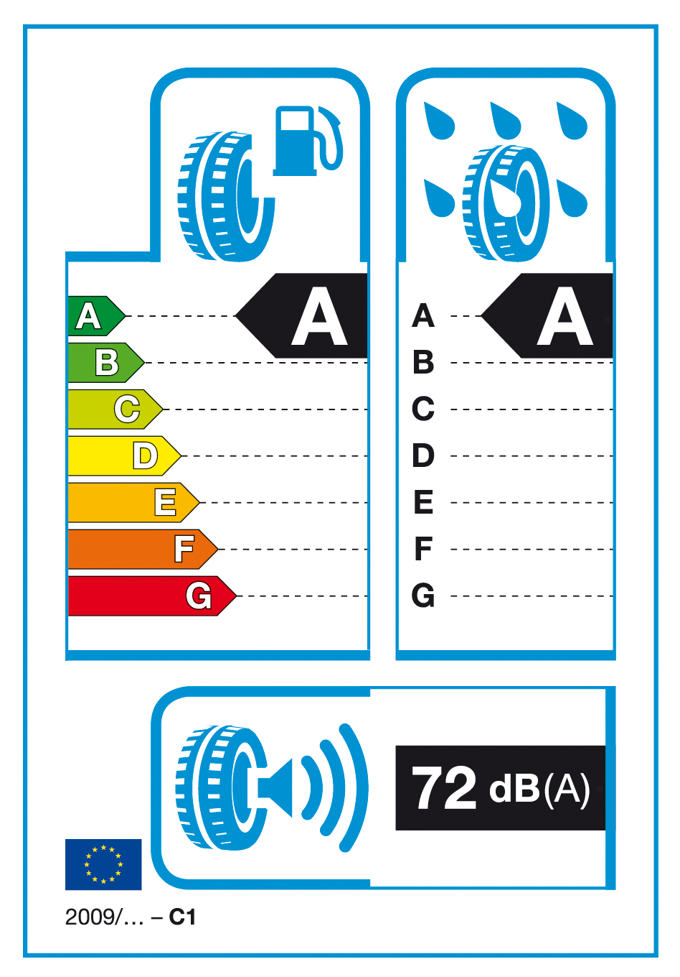
1.2 The following provides specifications for the label:
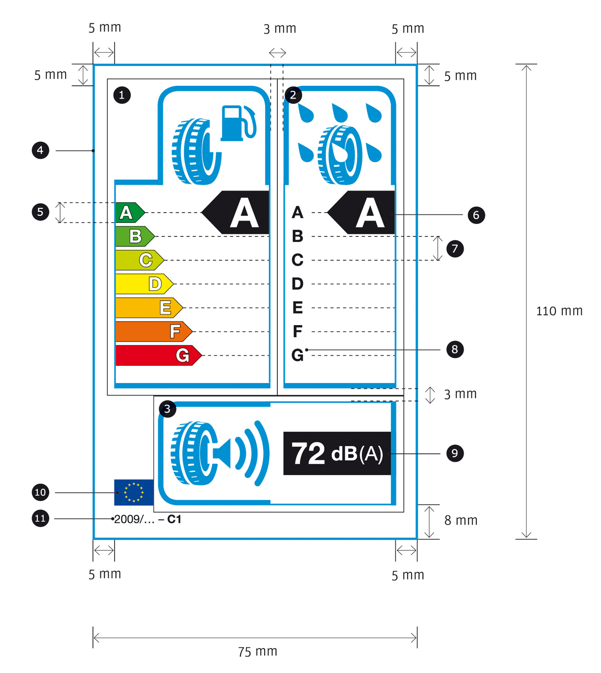
1.3 The label must be at least 75 mm wide and 110 mm high. Where the label is printed in a larger format, its content must nevertheless remain proportionate to the specifications above.
1.4 The label must conform to the following requirements:
(a) Colours are CMYK – cyan, magenta, yellow and black – and are given following this example: 00-70-X-00: 0 % cyan, 70 % magenta, 100 % yellow, 0 % black;
(b) The numbers listed below refer to the legends indicated in section 1.2;
 Fuel efficiency
Pictogram as supplied: width: 19.5 mm, height: 18.5 mm – Frame for pictogram stroke: 3.5 pt, width: 26 mm, height: 23 mm – Frame for grading: stroke: 1 pt – Frame end: stroke: 3.5 pt, width: 36 mm – Colour: X-10-00-05;
 Wet grip
Pictogram as supplied: width: 19 mm, height: 19 mm – Frame for pictogram: stroke: 3.5 pt, width: 26 mm, height: 23 mm – Frame for grading: stroke: 1 pt – Frame end: stroke: 3.5 pt, width: 26 mm – Colour: X-10-00-05;
 External rolling noise
Pictogram as supplied: width: 23 mm, height: 15 mm – Frame for pictogram: stroke: 3.5 pt, width: 26 mm, height: 24 mm – Frame for value: stroke: 1 pt – Frame end: stroke: 3.5 pt, height: 24 mm – Colour: X-10-00-05;
 Label border: stroke: 1.5 pt – Colour: X-10-00-05;
 A-G scale
- Arrows: height: 4.75 mm, gap: 0.75 mm, black stroke: 0.5 pt – colours:
• A: X-00-X-00;
• B: 70-00-X-00;
• C: 30-00-X-00;
• D: 00-00-X-00;
• E: 00-30-X-00;
• F: 00-70-X-00;
• G: 00-X-X-00.
- Text: Helvetica Bold 12 pt, 100% white, black outline: 0.5 pt;
 Grading
- Arrow: width: 16 mm, height: 10 mm, 100% black;
- Text: Helvetica Bold 27 pt, 100% white;
 Lines in scale: stroke: 0.5 pt, dashed line interval: 5.5 mm, 100% black;
 Scale text: Helvetica Bold 11 pt, 100% black;
 Value of noise
- Box: width: 25 mm, height: 10 mm, 100% black;
- Text: Helvetica Bold 20 pt, 100% white;
- Unit text: Helvetica Bold Regular for ‘(A)’ 13 pt, 100% white;
 EU logo: width: 9 mm, height: 6 mm;
 Regulation Directive reference: Helvetica Regular 7.5 pt, 100% black;
Tyre class reference: Helvetica Bold 7.5 pt, 100% black;
(c) The background must be white.
1.5 The tyre class (C1, C2 or C3) must be indicated on the label in the format prescribed in the illustration in section 1.2.
2. Brand space
2.1 Suppliers must add their name, the tyre line, tyre dimension, load index, speed rating and other technical specifications on the sticker along with the label in any colour, format and design, provided that the proportional size of brand space does not exceed a 4:5 ratio against the size of the label and the message published along with the label does not disrupt the message of the label.
Annex III
Information provided in technical promotional literature
1. Information on tyres shall be provided in the order specified as follows:
(i) the fuel efficiency class (letter A to G); for C2 and C3 tyres, the rolling resistance coefficient is also stated;
(ii) the wet grip class (letter A to G)
(iii) the external rolling noise measured value (dB).
2. Theis information provided in point 1 must meet the following requirements:
(i) be easy to read;
(ii) be easy to understand;
(iii) if different grading is available for a given tyre type depending on dimension or other parameters, the range between the least and best performing tyre is stated.
3. Suppliers must also make available on their website:
(i) an explanation of the pictograms printed on the label;
(ii) a statement highlighting the fact that actual fuel savings and road safety heavily depend on the drivers' behaviour, in particular the following:
- eco-driving can significantly reduce fuel consumption;
- tyre pressure should be regularly checked for higher wet grip and fuel efficiency performance characteristics;
- stopping distances should always be strictly respected.
Annex IV: Verification procedure
The conformity of the declared fuel efficiency and wet grip classes as well as the declared external rolling noise measured value shall be assessed for each tyre type or each grouping of tyres as determined by the supplier; according to the following procedure:
(1) a single tyre shall be tested first. If the measured value meets the declared class or external rolling noise measured value, the test is passed;
(2) if the measured value does not meet the declared class or external rolling noise measured value, three more tyres shall be tested. The average measurement value stemming from the four tyres tested shall be used to assess accordance with the declared information.

European Environment Agency, Annual European Community Greenhouse Gas Inventory 1990-2005 and Inventory Report 2007, p. 88.
OJ C , , p. .
OJ C , , p. .
OJ C , , p. .
OJ C , , p. .
COM(2008) 433
(COM(2006)545).
[Proposal COM(2008) 316 under adoption,] OJ C , , p. .
OJ L 189, 18.7.2002, p. 12.
OJ L 297, 13.10.1992, p. 16.
OJ L 218, 13.8.2008, p. 30
OJ L 184, 17.7.1999, p. 23.
[NB: The current tyre classification of the proposal for a Regulation (COM(2008)316) has omitted light duty vehicles (N1). There is an agreement at Council level to revise the definition proposed in Article 8 of COM(2008) 316 to include N1 tyres, the agreement will be reached in October at the latest before the adoption of this proposal for a Directive on tyre labelling- this is for information during the legislative procedure and must be deleted at the time of adoption].
OJ …, …2009, p.
OJ L 231, 29.08.2008, p. 19.

