EN
COMMISSION OF THE EUROPEAN COMMUNITIES
Brussels, 4.9.2009
COM(2009) 451 final

REPORT FROM THE COMMISSION TO THE COUNCIL AND THE EUROPEAN PARLIAMENT
on the use of the provisions on mutual assistance for the recovery of claims relating to certain levies, duties, taxes and other measures in 2005-2008

REPORT FROM THE COMMISSION TO THE COUNCIL AND THE EUROPEAN PARLIAMENT
on the use of the provisions on mutual assistance for the recovery of claims relating to certain levies, duties, taxes and other measures in 2005-2008

1. Introduction
EC Member States provide mutual assistance to each other for the recovery of claims relating to certain levies, duties, taxes and other measures. The legislation concerned was originally laid down in Council Directive 76/308/EEC of 15 March 1976. This Directive has been replaced by Directive 2008/55/EC of 26 May 2008. Under this legislation the Commission is required to produce a regular report on the use of the mutual assistance arrangements. The first report (document COM(2006)43) was published on 8 February 2006. It provided an overview of the mutual recovery assistance provided in 2003 and 2004. The present report relates to recovery assistance granted in 2005-2008. It also deals with the current Commission initiatives in this field.

2. Analysis of the use of mutual assistance measures in 2005-2007

2.1. Introductory remark
In its previous report the Commission indicated that the statistics of various Member States contained certain inconsistencies. The statistics relating to the numbers of requests made in the period 2005-2007 in general show an important decrease in these inconsistencies, even though the number of requests has increased enormously.
This demonstrates that Member States have paid more attention to establishing correct statistics. The adoption of precise instructions concerning the statistical reporting obligations on 5 December 2005 will undoubtedly have contributed to the improved accuracy of the statistics. Moreover, Member States' questions on this issue were carefully examined in the Recovery Committee, which enabled the national authorities to reduce possible divergent views that may lead to inconsistencies in the statistics reported.

2.2. Increasing use of EC mutual assistance requests
Statistics provided by Member States show an increasing number of requests for assistance on the basis of the EC Directive (first column in the graphics below).
It also appears that the EC legislative framework is much more widely used between EC Member States than any other mutual recovery assistance agreement or arrangement. The use of other mutual assistance arrangements between the Member States (second column in the graphics below) has diminished in the period 2005-2008. (Data on the use of other mutual assistance arrangements are only available for the period from 2005 to 2008).

2.2.1. Evolution of the requests for information
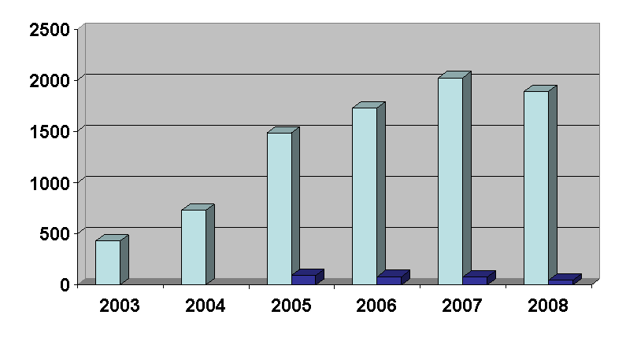
2.2.2. Evolution of the requests for notification
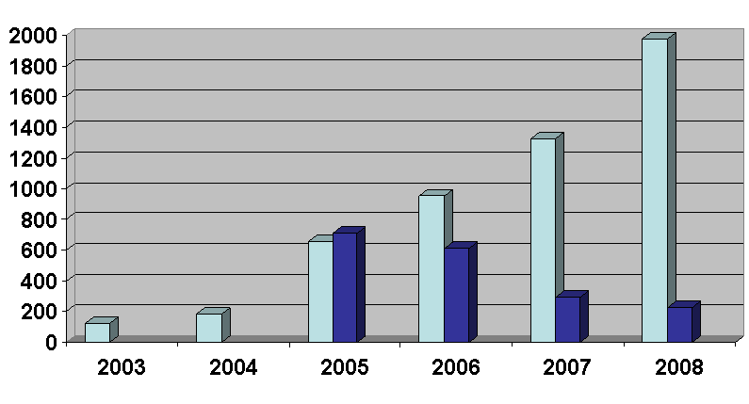

2.2.3. Evolution of the requests for recovery
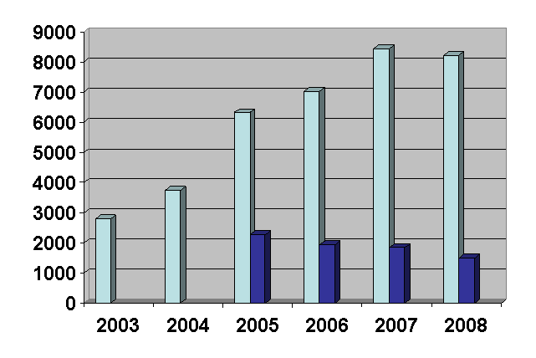
2.2.4. Nature of the claims for which recovery assistance was requested
The nature of the claims, in percentage of the total amounts of all claims, is illustrated by the following graphics:
- requests concerning VAT claims (referred to in Art. 2(e) of Directive 2008/55/EC) represent a major part of the requests for recovery measures: their part has raised from 43 % in 2005 to 57 % in 2007; in 2008 it diminished to 34 %.
- requests relating to taxes on income and capital (referred to in Art. 2(g) of the Directive) represent the other major part of the requests. This part diminished from 37 % of all requests in 2005 to 26 % of all requests in 2007; in 2008, 50 % of all requests related to claims of this category.
- requests relating to refunds, interventions ad other measures forming part of the system of financing of the European Agricultural Guarantee Fund and the European Agricultural Fund for Rural Development, levies and other duties provided for under the common organisation of the market for the sugar sector, import and export duties (referred to in Art. 2(a)-(d) of the Directive) represent approximately 10 % of all requests;
- requests relating to excise duties (referred to in Art. 2(f) of the Directive) also represent about 10 % of all requests (except in 2007, where this part diminished to 4 %);
- requests relating to taxes on insurance premiums (referred to in Art. 2(h) of the Directive) only represent a very small part of all requests. In 2008, there were even no requests relating to such taxes.
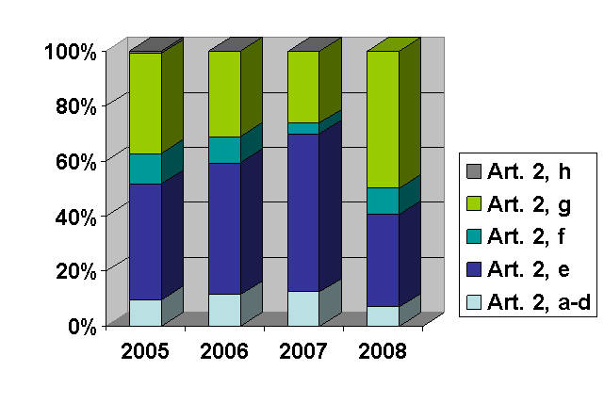
2.3. Increasing amounts recovered

2.3.1. Global evolution of the amounts recovered
The evolution of the amounts that are effectively recovered also shows an increasing tendency. Compared to the amounts recovered in 2003 (100 %), the recovered amounts have risen to over 600 % in 2006 and 2008.
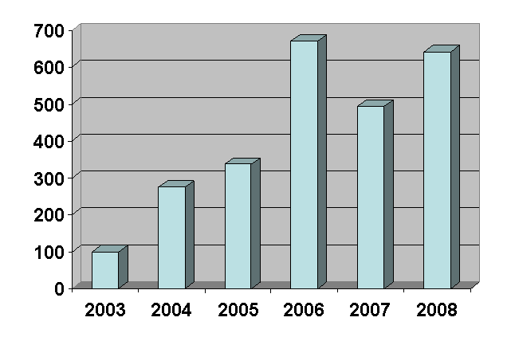
2.3.2. Distribution of the amounts recovered for other Member States, according to the years to which the requests concerned relate
It takes some time before recovery measures are taken and before they produce their effect. For instance, amounts recovered by a requested Member State in 2008 will only partially relate to requests received in 2008; these amounts will also relate to requests received in previous years. The following graphics show, with regard to the amounts effectively recovered in the years 2005-2008, to which year the requests concerned relate. It appears from these statistics that (more than) 80 % of the amounts recovered in these years relates to requests made in the same year (indicated by "=" in the graphics below) or in the two previous calendar years (indicated as "-1" and "-2" in the graphics below).
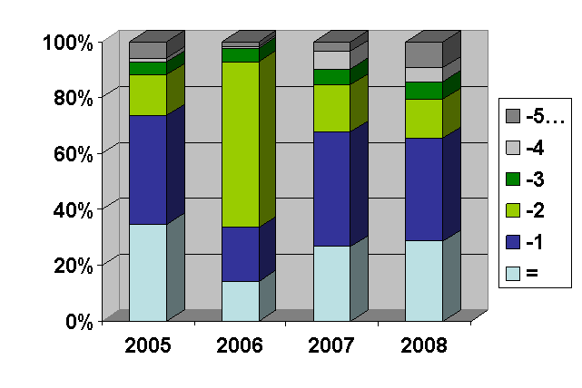

2.4. Lack of efficiency
Statistics on mutual assistance for recovery relating to 2005 - 2008 show that the recovered amounts have increased considerably. However, the number of requests and the amounts for which recovery assistance is requested, are also growing. Consequently, there remains a large gap between the amounts for which assistance is requested and amounts actually recovered through mutual assistance.
As already indicated under point 2.3.2., recovery measures taken in the execution of a request received in a certain year do not lead to an immediate recovery within that same year. Statistics about this postponed effect of the recovery measures were not available for the years preceding 2005. Therefore, it is not possible now to have a precise idea of the percentage of the amounts that are effectively recovered, compared to the amounts for which recovery assistance was requested in a given year. However, the partial information now available makes it clear that the global recovery ratio for the recovery requests between EC Member States can be expected to be now around 5 %.
Faced with the increase in requests and the increase of the amounts for which recovery assistance is requested, special efforts are needed to improve the efficiency of this assistance. These efforts have to be made on national level and on Community level:
- the individual Member States have to strengthen the recovery instruments available in their domestic legislation; and
- the European Community has to reinforce and facilitate the mutual recovery assistance between the Member States.

3. New Community initiatives to strengthen the mutual recovery assistance

3.1. New Council Directive
The original Directive on mutual assistance for the recovery of claims relating to certain levies, duties, taxes and other measures – Directive 76/308/EEC – has been amended several times. In the interests of clarity and rationality the said Directive has been codified. The new Council Directive 2008/55/EC was adopted on 26 May 2008 and entered into force on 30 June 2008.

3.2. New Commission Regulation facilitating the exchange of assistance requests
On 28 November 2008, the Commission adopted Regulation (EC) No 1179/2008, which replaced Commission Directive 2002/94/EC as of 1 January 2009. This new legislation, which lays down detailed rules to implement the Council Directive, facilitates mutual assistance in practice, in particular communication between the competent authorities of different Member States. This is indeed indispensable, given the continuous increase of requests.
According to the new rules the electronic communication of requests and replies is in principle applied to all types of mutual assistance requests. New standard request forms also contribute to a faster communication between the applicant and the requested authority.
An electronic version of these new request forms, allowing an automatic translation, is now being developed. A test phase for the use of these electronic request forms started on 1 June 2008. It involves authorities from 6 Member States. It is expected that all Member States will be able to use the new electronic forms in the course of 2010.

3.3. Proposal for new Council legislation
On 2 February 2009, the Commission presented a proposal COM(2009)28 to replace Council Directive 2008/55/EC by new provisions, to reinforce the recovery assistance.
The main objectives and elements of this proposal relate to:
- an extension of the scope to levies that are not yet covered by the present EC legislation, since the competitiveness and the fiscal neutrality of the internal market is not only affected by the non-payment of the taxes now falling within the scope of Directive 2008/55/EC. Distorsions of the internal market conditions, as well as the threat to financial interests of the Community and the Member States may also result from fraud concerning other taxes;
- the preferential use of EC legislation for all mutual recovery assistance requests between EC Member States. This should enable officials concerned to avoid the difficulties that result from the application of several agreements and arrangements, each with different possibilities, conditions, modalities and communication methods;
- the reinforcement of possibilities to request mutual assistance and to speed up the treatment of mutual assistance requests. This appears essential, as the chances to recover claims are clearly related to the age of the claim. In order to improve the recovery chances, the Commission proposes measures such as:
- the possibility to request recovery measures, even when not all appropriate recovery actions have been taken in the applicant Member State;
- the spontaneous exchange of certain categories of information;
- the possibility for recovery officials to be present in administrative offices and to participate in administrative enquiries in another Member State;
- the simplification of the procedures to notify documents by the introduction of a uniform notification method, using a standard form;
- the development of uniform Community instruments permitting enforcement or precautionary measures, allowing to avoid problems of translation and recognition of foreign instruments.

4. Conclusions and recommandations

4.1. Conclusions
The increase in the number of assistance requests demonstrates that Member States feel the need to work closely together in the fight against tax fraud.
Although the recovered amounts have increased over the period 2005-2008, a further reinforcement of the existing legislation in this field is needed, in order to cope with the increasing number of requests for assistance and to improve the efficiency of the recovery assistance.

4.2. Recommendations
The Member States are urged to strengthen the recovery instruments available in their domestic legislation.
The Council and the Parliament are invited to adopt quickly the proposal that the Commission has presented on 2 February 2009 to reinforce mutual recovery assistance.

OJ L 73, 19.3.1976, p. 18.
OJ L 150, 10.6.2008, p. 28.
Information according to the statistics communicated by requested Member States.
Statistics based on the average of requests received and sent. For 2005, these statistics are based on data reported by 17 Member States; for 2006 on data reported by 20 Member States; for 2007 on data reported by 24 Member States; and for 2008 on data reported by 25 Member States.
Statistics reported by the requested Member States as recovered at the request of other Member States.
It should however be kept in mind that the total sum of the amounts mentioned in the recovery requests does not necessarily correspond to the amounts really due; e.g. the same claim may be the subject of several requests to different Member States; or requests may be withdrawn at a later stage, because the claims are paid voluntarily or contested successfully. At present, the statistics available do not allow to take account of all these situations.

