EN
COMMISSION OF THE EUROPEAN COMMUNITIES
Brussels, 25.9.2009
COM(2009) 494 final

REPORT FROM THE COMMISSION TO THE EUROPEAN PARLIAMENT AND THE COUNCIL
Annual report to the Council and the European Parliament on the activities of the EURODAC Central Unit in 2008
REPORT FROM THE COMMISSION TO THE EUROPEAN PARLIAMENT AND THE COUNCIL
Annual report to the Council and the European Parliament on the activities of the EURODAC Central Unit in 2008

1. Introduction

1.1. Scope
Council Regulation EC/2725/2000 of 11 December 2000, concerning the establishment of ‘EURODAC’ for the comparison of fingerprints for the effective application of the Dublin Convention (hereinafter referred to as “EURODAC Regulation”), stipulates that the Commission shall submit to the European Parliament and the Council an annual report on the activities of the Central Unit. The present sixth annual report includes information on the management and the performance of the system in 2008. It assesses the output and the cost-effectiveness of EURODAC, as well as the quality of its Central Unit’s service.

1.2. Legal and policy developments
In order to address the issues (related to the efficiency of the EURODAC Regulation and the improvement of the system's support to facilitate the application of the Dublin Regulation) flagged in its report on the evaluation of the Dublin system published in June 2007 (the Evaluation Report), the Commission put forward a proposal for amending the EURODAC Regulation on 3 December 2008.
In 2008, the geographical scope of the EURODAC Regulation was expanded to cover Switzerland, which (after notifying the Commission of their readiness to participate in the system in accordance with Article 27(2)a of the EURODAC Regulation) connected to EURODAC on 12 December 2008.

2. The EURODAC Central Unit

2.1. Management of the system
Given the increasing amount of data to manage (some categories of transactions have to be stored for 10 years), the natural obsolescence of the technical platform (delivered in 2001) and the unpredictable trends of the EURODAC transaction volume due to the accession of new Member States, an upgrading of the EURODAC system is being carried out and is planned to be finalised in the first quarter of 2010. The Commission signed the "secure-Trans European Services for Telematics between Administrations (s-TESTA) network" contract in 2006. During 2007, the migration of Member States from the previously used TESTA II network to S-TESTA started with 18 Member States migrating to this new system providing a higher level of security and reliability, and during 2008 the remainder of Member States were migrated.

2.2. Quality of service and cost-effectiveness
The Commission has taken the utmost care to deliver a high quality service to the Member States, who are the final end-users of the EURODAC Central Unit. During 2008 the EURODAC Central Unit was available 99.84% of the time.
Two "false hits", i.e. wrong identification performed by the AFIS, were reported to the Commission in 2008, following the one notified in 2007. Although Member States are required to verify all hits immediately, as described in Article 4(6) of the EURODAC Regulation, they are currently not obliged to notify the Commission of false hits. However, with a total of three false hits reported out of more than 1.5 million searches and more than 300.000 hits the system can still be considered extremely accurate.
The expenditure for maintaining and operating the Central Unit in 2008 was 605.720,67 euros. This expenditure decreased compared to the previous year since the figure for 2007 included costs of an essential upgrade of the capacity of the Business Continuity System. However, the costs for 2008 still represent an increase compared to the years before (2004-2005-2006) due to increased system maintenance costs.
Savings for the EURODAC expenditure were made possible by the efficient use of existing resources and infrastructures managed by the Commission, such as the use of the S-TESTA network.
The Commission also provided (via the IDABC Programme) the communication and security services for exchange of data between the Central and National Units. These costs, initially intended to be borne by each Member State in accordance with Article 21 (2) and (3) of the Regulation, were finally covered by the Commission making use of common available infrastructures, thereby generating savings for national budgets.

2.3. Data protection and data security
Article 18 paragraph 2 of the EURODAC Regulation establishes a category of transactions which provides for the possibility to conduct so called "special searches" on the request of the person whose data are stored in the central database in order to safeguard his/her rights as the data subject to access his/her own data.
In 2008, a steep decrease of such "special searches" took place: 56 such searches were conducted in 2008, compared to 195 in 2007, constituting a drop of 71, 3%.
As a welcome development, the number of Member States using special searches almost halved (8, compared to 15 of the previous year).
However, as discussed in previous annual reports as well as in the Evaluation Report, the Commission is still concerned about the use of such searches and considers its number still too high. To better monitor this phenomenon, the Commission has included in its proposal for amendment of the EURODAC Regulation a requirement for Member States to send a copy of the data subject's request for access to the competent national supervisory authority.
In consultation with the European Data Protection Supervisor (EDPS), the Commission is committed to taking steps against Member States which persist in misusing this important data-protection related provision.

3. Figures and Findings
The annex attached to the present annual report contains tables with factual data produced by the Central Unit for the period 01.01.2008 – 31.12.2008. The EURODAC statistics are based on records of fingerprints from all individuals aged 14 years or over who have made applications for asylum in the Member States, who were apprehended when crossing a Member State's external border irregularly, or who were found illegally present on the territory of a Member State (in case the competent authorities consider it necessary to check a potential prior asylum application).
It should be noted that EURODAC data on asylum applications are not comparable with those produced by Eurostat, which are based on monthly statistical data provided by the Ministries of Justice and of the Interior. There are a number of methodological reasons for the differences. First, the Eurostat data include all asylum applicants, ie. of whatever age. Second, their data is collected with a distinction between persons applying for asylum during the reference month (which may also include repeated applications) and persons applying for asylum for the first time.

3.1. Successful transactions
A “successful transaction” is a transaction which has been correctly processed by the Central Unit, without rejection due to a data validation issue, fingerprint errors or insufficient quality.
In 2008, the Central Unit received a total of 357.421 successful transactions, which is an overall increase of 19,1% compared to 2007 (300.018). Regarding the number of transactions of data of asylum seekers ("category 1"), the increasing trend of 2007 continued in 2008: the EURODAC statistics reveal a 11,3% rise (to 219.557) compared to 2007 (197.284). Such an increase reflects the general rise in the number of asylum applications in the EU in 2008.
The trend regarding the number of persons who were apprehended in connection with an irregular crossing of an external border ("category 2") also changed in 2008. After a drop of 8% between 2006 and 2007 (to 38.173), the number of transactions rose by 62,3% in 2008 (to 61.945). Italy (32.052 compared to 15.053 in 2007), Greece (20.012 compared to 11.376 in 2007) and Spain (7.068, compared to 9.044 in 2007) introduce the vast majority of the category 2 fingerprints, followed by Hungary (1.220), the United Kingdom (344) and Bulgaria (307). In 2008, 7 Member States (the Czech Republic, Estonia, Ireland, Iceland, Luxemburg, Norway and Portugal) did not send any "category 2” transactions. The issue of divergence between the number of category 2 data sent to EURODAC and other sources of statistics on the volume of irregular border crossings in the Member States, highlighted by the EURODAC statistics, is most likely due to the vague definition in Article 8(1) of the EURODAC Regulation. This issue will be clarified in the framework of the on-going revision of the EURODAC Regulation.
The option of sending “category 3” transactions (data of persons apprehended when illegally residing on the territory of a Member State) experienced a significant rise in 2008. After the slight increase between 2006 and 2007 (to 64.561) the number of transactions rose to 75.919 in 2008, meaning an increase of 17,6%. Ireland and Malta remain those Member States which did not send any "category 3" transactions.

3.2. “Hits”

3.2.1. “Category 1 against category 1” hits
Table 3 of the Annex shows for each Member State the number of asylum applications which corresponded to asylum applications previously registered in another ("foreign hits") or in the same Member State ("local hits"). It also gives an indication of the secondary movements of asylum seekers in the EU. Apart from the 'logical' routes between neighbouring Member States, one can note that a high number (1.739) of asylum applicants in France and in Belgium (625) previously lodged their application in Poland, or that the highest amount of foreign hits in Greece (316) and in Italy (680) were found against data of asylum applicants previously recorded in the United Kingdom. In the latter case, the flows are symmetric and most of the hits on "category 1" transactions introduced by the United Kingdom occur on data submitted by Italy (768). It is striking that 42,2% of the overall subsequent applications were lodged in the same Member State as the previous one. In Belgium, Cyprus, Czech Republic, Poland and United Kingdom well over half of the subsequent applications were lodged in the same Member State.

3.2.2. Multiple asylum applications
From a total of 219.557 asylum applications recorded in EURODAC in 2008, 38.445 applications were 'multiple asylum applications', which means that in 38.445 cases, the fingerprints of the same person had already been recorded as a "category 1" transaction (in the same or in another Member State). The first reading of the statistics of the system would therefore suggest that 17,5% of the asylum applications in 2008 were subsequent (i.e. second or more) asylum applications, representing a rise of 1,5% compared to the previous year. The transmission of a "category 1" transaction does not however mean in each and every case that the person in question made a new asylum application. In fact, the practice of some Member States to fingerprint upon take back under the Dublin Regulation results in a distortion of the statistics on multiple applications: taking and transmitting again the fingerprints of the applicant upon arrival after a transfer under the Dublin Regulation falsely indicates that the applicant applied again for asylum. The Commission intends to solve this problem and, in its proposal for the amendment of the EURODAC Regulation, has introduced the requirement that transfers should not be registered as new asylum applications.

3.2.3. “Category 1 against category 2” hits
These hits give an indication of routes taken by persons who irregularly entered the territory of the European Union, before applying for asylum. As in the previous year, most hits occur against data sent by Greece and Italy and to a much lesser extent, Spain and Hungary. Most of these hits are 'local' (which means that persons irregularly entering their territory subsequently apply for asylum in the same country). Taking all Member States into consideration, more than half (64,4%) of the persons apprehended in connection with an irregular border-crossing and who decide to lodge an asylum claim, do so in the same Member State they entered irregularly.
The majority of those who entered the EU illegally via Greece and then travel further, head mainly to United Kingdom, Norway, Italy and the Netherlands. Those entering via Italy proceed mainly to the United Kingdom Norway, Switzerland and Sweden. Those who entered via Spain most often leave for France and Italy, while those who entered via Hungary travel on mainly to Austria.

3.2.4. “Category 3 against category 1” hits
These hits give indications as to where illegal migrants first applied for asylum before travelling to another Member State. It has to be borne in mind, however, that submitting category 3 transactions is not mandatory and that not all Member States use the possibility for this check systematically.
The data available suggest that, as during the previous year, persons apprehended when illegally residing in Germany often had previously claimed asylum in Sweden or in Austria, and that those apprehended when illegally residing in France often had previously claimed asylum in the United Kingdom or in Italy. As a recent development, asylum seekers who first applied in Italy are found staying illegally in larger numbers in Norway. It is worth noting that on average around 19.6% of the persons found illegally on the territory had previously applied for asylum in a Member State.

3.3. Transaction delay
The EURODAC Regulation currently only provides a very vague deadline for the transmission of fingerprints, which can cause significant delays in practice. This is a crucial issue since a delay in transmission may lead to results contrary to the responsibility principles laid down in the Dublin Regulation. The issue of exaggerated delays between taking fingerprints and sending them to the EURODAC Central Unit was pointed out in the previous annual reports and highlighted as a problem of implementation in the Evaluation Report.
After a better performance of the previous year, 2008 saw an overall increase in the delay of transmission, with the worst record being 22,09 days. The Commission must reiterate that a delayed transmission can result in the incorrect designation of a Member State by way of two different scenarios outlined in the previous annual report 2006: "wrong hits" and "missed hits".
The deterioration of the performance in the transmission of fingerprints clearly shows its results in the amount of missed and wrong hits.
In 2008, the Central Unit detected 450 "missed hits", which is a 7,5 multiplication of the figure of 2007 (60). 324 hits were "wrong hits" (233 in 2007). On the basis of the above results, the Commission again urges the Member States to make all necessary efforts to send their data in accordance with Articles 4 and 8 of the EURODAC Regulation.
In its proposal for the amendment of the EURODAC Regulation, the Commission has proposed a deadline of 48 hours for transmitting data to the EURODAC Central Unit.

3.4. Quality of transactions
The average rate in 2008 of rejected transactions for all Member States is 6,4%, which is almost the same as in the previous years (2006: 6,03%, 2007: 6,13%). 6 Member States have rejection rate over 10%: Estonia (26, 67%), Malta, Finland, Luxembourg, Netherlands, United Kingdom. 13 Member States have a rejection rate above the average. It has to be highlighted that the rejection rate does not depend on technology or system weaknesses. The causes of this rejection rate are mainly the low quality of the fingerprints images submitted by Member States, human error or the wrong configuration of the sending Member State’s equipment. On the other hand, it has to be noted that in some cases these figures include several attempts to send the same fingerprints after they were rejected by the system for quality reasons. While acknowledging that some delay can be caused by the temporary impossibility of taking fingerprints (damaged fingertips or other health conditions hindering the prompt taking of fingerprints), the Commission reiterates the problem of generally high rejection rates already underlined by previous annual reports urging those Member States to provide specific training of national EURODAC operators, as well as to correctly configure their equipment in order to reduce this rejection rate.

4. Conclusions
In 2008, the EURODAC Central Unit continued to provide very satisfactory results in terms of speed, output, security and cost-effectiveness.
As a logical consequence of the overall increase in asylum applications in the EU in 2008, the amount of 'category 1 transactions' introduced in EURODAC has also increased. The number of 'category 2 transactions' rose by 62,3%, while the number of 'category 3 transactions' increased by 17,6%.
Concerns remain about the recently risen excessive delay in the transmission of data to the EURODAC Central Unit.
Table 1: EURODAC Central Unit, Database content status on 31/12/2008
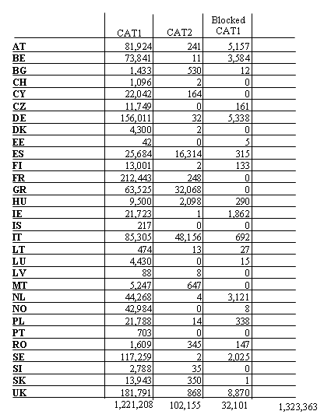
Table 2: Successful transactions to the EURODAC Central Unit, in 2008
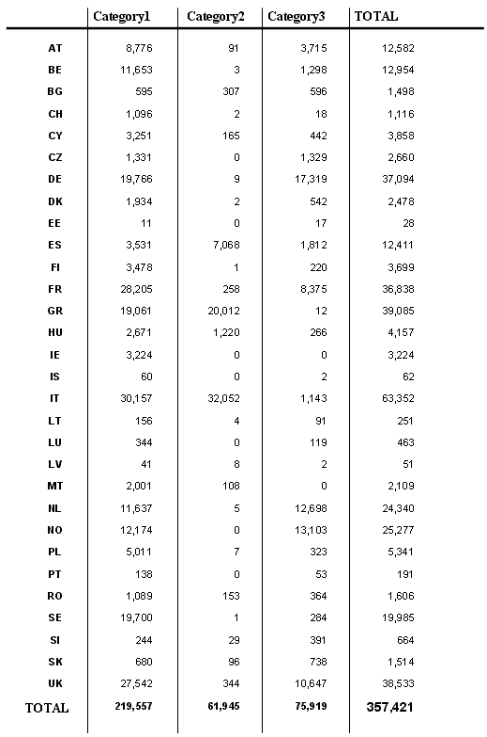
Table 3: Hit repartition – Category 1 against Category 1, in 2008
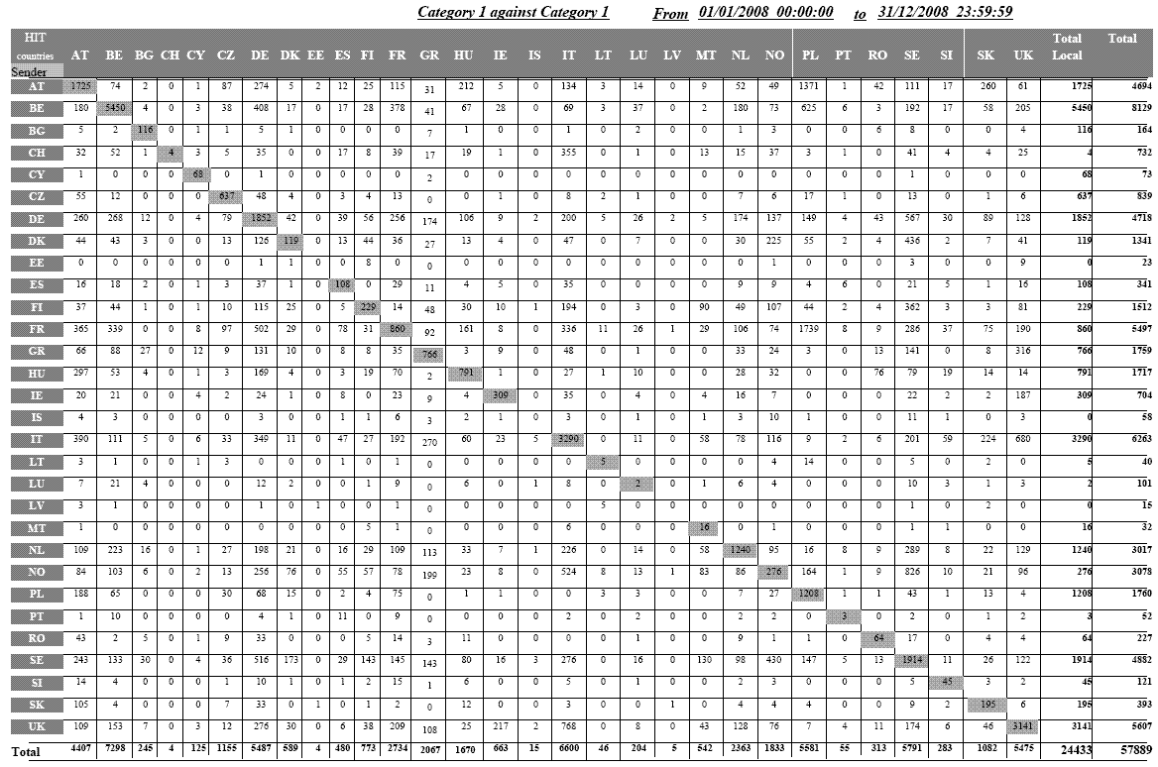
Table 4: Hit repartition – Category 1 against Category 2, in 2008
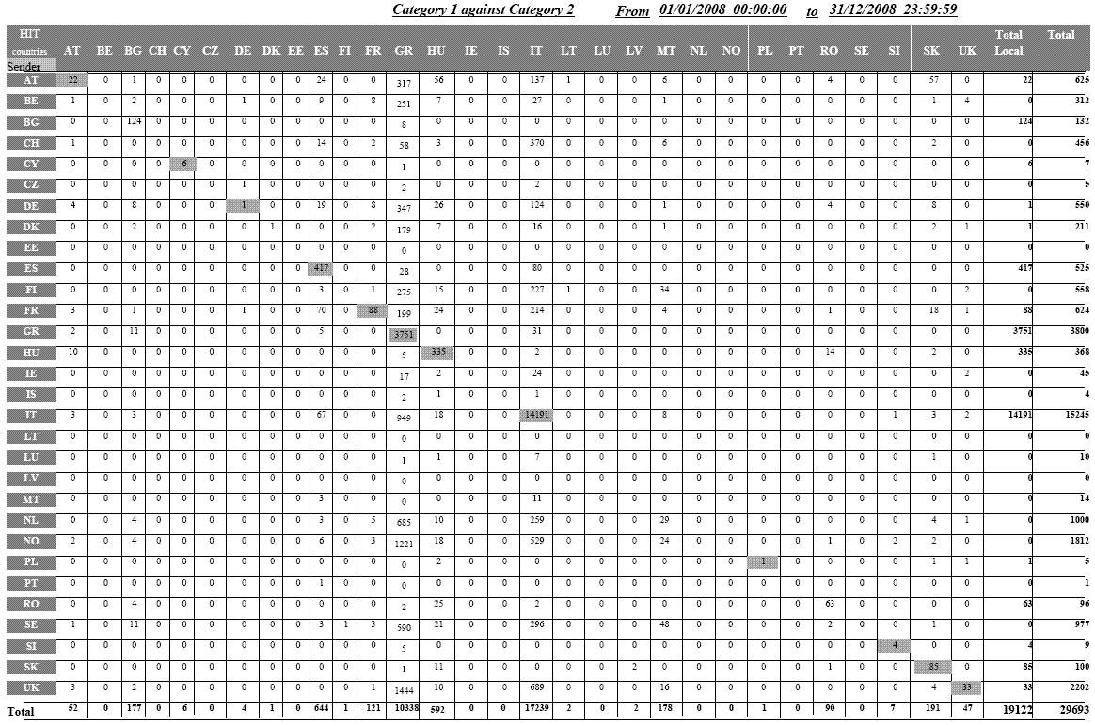

Table 5: Hit repartition – Category 3 against Category 1, in 2008
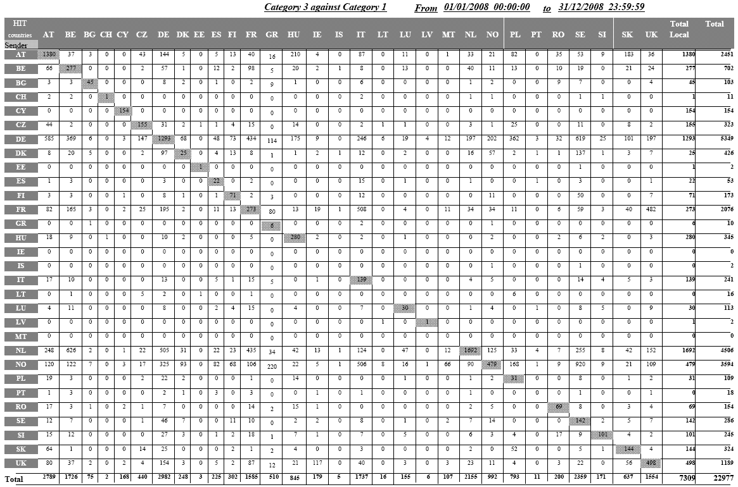
Table 6: Rejected transactions, percentage in 2008
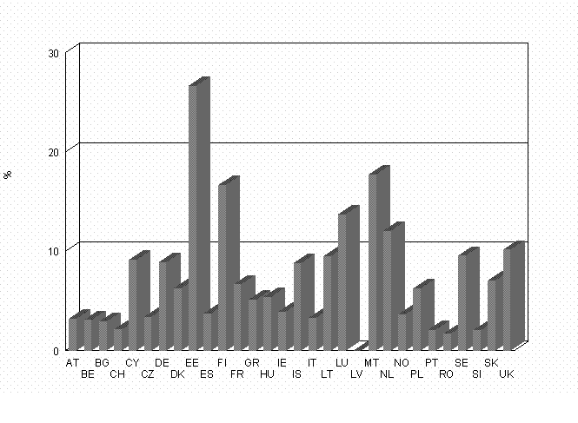
Table 7: Average time between the date of taking the fingerprints and their sending to the EURODAC Central Unit, in 2008
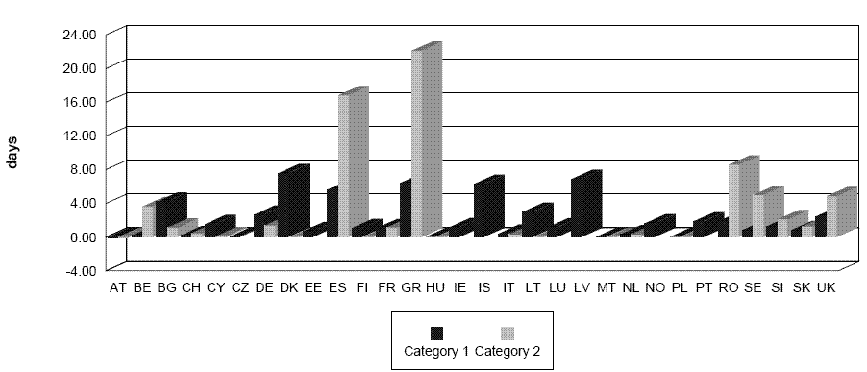
Table 8: Category 1 against Category 1 hit in wrong sense, in 2008
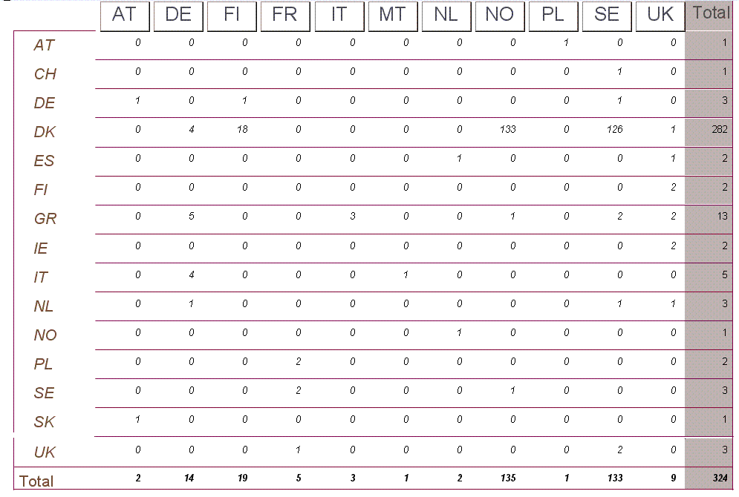
Table 9: Distribution of CAT1/CAT2 hits missed because a delay when sending the CAT2, in 2008
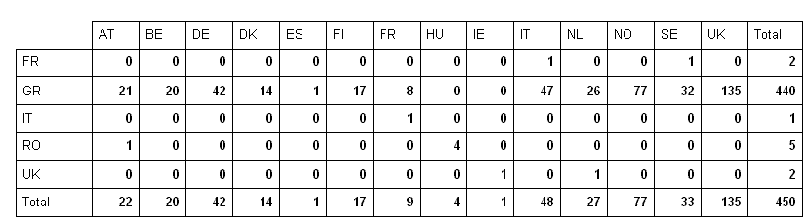
Table 10: Distribution of hits against blocked cases (art. 12 of the EC Regulation 2725/2000), in 2008
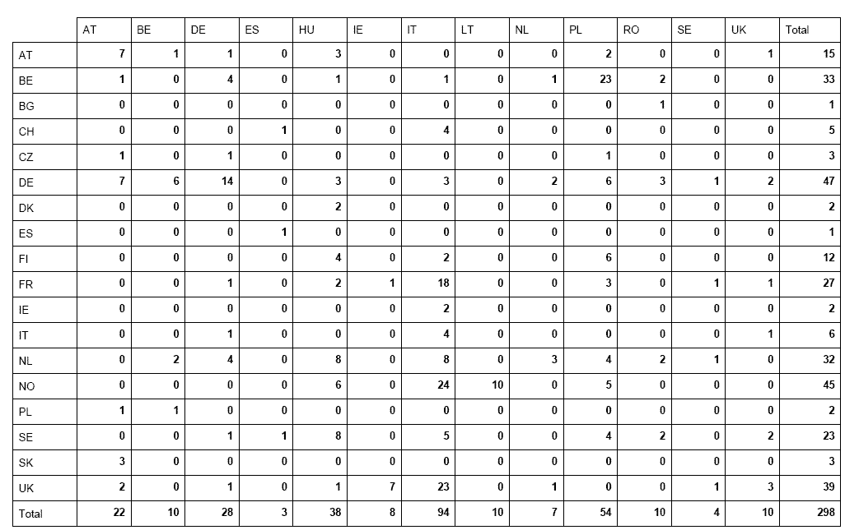
Table 11: Count of category 9 per Member State, in 2008
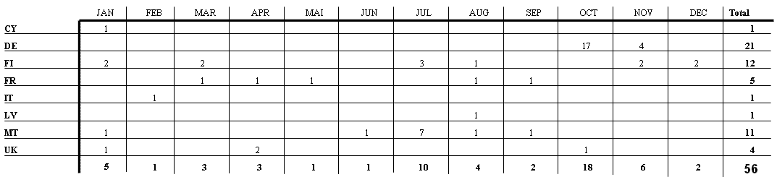

OJ L 316, 15.12.2000, p.1.
Article 24(1) EURODAC Regulation.
Report from the Commission to the European Parliament and the Council on the evaluation of the Dublin system, COM (2007) 299 final {SEC(2007) 742}.
Proposal for a Regulation of the European Parliament and of the Council establishing 'EURODAC' for the comparison of fingerprints for the effective application of the Dublin Regulation, COM(2008) 825.
The Commission provided assistance to Switzerland to link up with the EURODAC system, including prior operational testing.
A general description of the EURODAC Central Unit, as well as the definitions of the different types of transactions processed by the Central Unit and of the hits they can create, can be found in the first annual report on the activities of the EURODAC Central Unit. See Commission Staff Working Paper - First annual report to the council and the European Parliament on the activities of the EURODAC Central Unit, SEC (2004)557, p.6.
All EU Member States, as well as Norway and Iceland, apply the Dublin and EURODAC Regulations, therefore the notion "Member States" is used in this Report to cover the 29 States using the EURODAC database.
These services not only include those provided directly by the Central Unit (e.g. matching capacity, storage of data, etc), but cover also communication and security services for the transmission of data between the Central Unit and the National Access Points.
The Commission has proposed to add the obligation for Member States to inform about any false hit in the revision of the EURODAC Regulation.
The Business Continuity System is used in case of unavailability of the Central Unit, and it also has testing capabilities to allow Member States or acceding countries to test new solutions.
Table 2 of the Annex details the successful transactions per Member State, with a breakdown by category, between 1 January 2008 and 31 December 2008.
Data of asylum applications. Fingerprints (full 10 print images) of asylum applicants sent for comparison against fingerprints of other asylum applicants who have previously lodged their application in another Member State. The same data will also be compared against the “category 2” data (see below). These data will be kept for 10 years with the exception of some specific cases foreseen in the Regulation (for instance an individual who obtains the nationality of one of the Member States) in which cases the data of the person concerned will be erased.
Data of aliens apprehended in connection with the irregular crossing of an external border and who were not turned back. These data (full 10 print images) are sent for storage only, in order to be compared against data of asylum applicants submitted subsequently to the Central Unit. These data will be kept for two years with the exception that cases are deleted promptly when the individual receives a residence permit, leaves the territory of the Member State or obtains the nationality of one of them.
"Each Member State shall, in accordance with the safeguards laid down in the European Convention on Human Rights and in the United Nations Convention on the Rights of the Child, promptly take the fingerprints of all fingers of every alien of at least 14 years of age who is apprehended by the competent control authorities in connection with the irregular crossing by land, sea or air of the border of that Member State having come from a third country and who is not turned back."
And thereby compare the data of third country nationals apprehended when illegally staying on the territory with the previously recorded fingerprints of asylum seekers.
Data relating to aliens found illegally present in a Member State. These data, which are not stored, are searched against the data of asylum applicants stored in the central database. The transmission of this category of data is optional for the Member States.
The statistics concerning local hits shown in the tables may not necessarily correspond to the hit replies transmitted by the Central Unit and recorded by the Member States. The reason for this is that Member States do not always use the option, provided by Art. 4(4), which requests the Central Unit to search against their own data already stored in the Central database. However, even when Member States do not make use of this option, the Central Unit must, for technical reasons, always perform a comparison against all data (national and foreign) stored in the Central Unit. In these concrete cases, even if there is a match against national data, the Central Unit will simply reply “no hit” because the Member State did not ask for the comparison of the data submitted against its own data.
An asylum application overrules an irregular entry, therefore, it is not necessary to send a 'category 2 transaction' in cases where a person apprehended at the border at the same time also applies for asylum.
Statistics concerning Switzerland have to be balanced against the fact that this country only connected to EURODAC on 12 December 2008, therefore their statistics represent less than 3 weeks of activity in the system.
Yearly average of transmission delay of one category of data of the Member State with the worst record.
In the scenario of the so-called "wrong hit", a third-country national lodges an asylum application in a Member State (A), whose authorities take his/her fingerprints. While those fingerprints are still waiting to be transmitted to the Central Unit (category 1 transaction), the same person could already present him/herself in another Member State (B) and ask again for asylum. If this Member State B sends the fingerprints first, the fingerprints sent by the Member State A would be registered in the Central database later then the fingerprints sent by Member State B and would thus result in a hit from the data sent by Member State B against the data sent by the Member State A. Member State B would thus be determined as being responsible instead of the Member State A where an asylum application had been lodged first.
In the scenario of the so-called "missed hit", a third-country national is apprehended in connection with an irregular border crossing and his/her fingerprints are taken by the authorities of the Member State (A) he/she entered. While those fingerprints are still waiting to be transmitted to the Central Unit (category 2 transaction), the same person could already present him/herself in another Member State (B) and lodge an asylum application. At that occasion, his/her fingerprints are taken by the authorities of Member State (B). If this Member State (B) sends the fingerprints (category 1 transaction) first, the Central Unit would register a category 1 transaction first, and Member State (B) would handle the application instead of Member State A. Indeed, when a category 2 transaction arrives later on, a hit will be missed because category 2 data are not searchable.

