EN
COMMISSION OF THE EUROPEAN COMMUNITIES
Brussels, 9.9.2009
SEC(2009) 1197 final/2

CORRIGENDUM: Concerne la note en bas
no 26 et la page 58.
COMMISSION STAFF WORKING DOCUMENT
Making public support for innovation in the EU more effective:
Lessons learned from a public consultation for action at Community level
TABLE OF CONTENTS
Executive Summary 2

Introduction 2

1. The policy framework for innovation support 2
1.1. What is innovation support? 2
1.2. The concept of market and systemic failures 2
1.3. The concept of subsidiarity 2

2. The main results from the public consultation on the effectiveness of innovation support in Europe 2
2.1. Methodology and profile of respondents 2
2.2. Stakeholders’ views on the needs for more effective innovation support 2
2.3. Stakeholders’ views on the role of the Community in support of innovation 2
2.4. Stakeholders’ views on the impact of the economic crisis on innovation support 2

3. Main challenges to improve the effectiveness of innovation support at European level 2
3.1. Better demonstrating European added value 2
3.2. Better promoting synergies between national and European actions 2
3.3. Better leveraging the results of EU pilot actions 2
3.4. Better streamlining of EU instruments supporting eco-innovation 2
3.5. Better aligning EU support of research for the benefit of SMEs. 2
3.6. Better valorising Enterprise Europe Network partners for innovation support 2
3.7. Better implementing Community rules to provide innovation support more effectively 2

References 2

Annexes: Results of the public consultation on the effectiveness of innovation support in Europe 2
Annex 1: Views from companies (sample size: 792) 2
Annex 2. Views from the institutional stakeholders (sample size: 428) 2
Annex 3: Views from Finnish companies (sample size: 201) 2

Executive Summary
This Staff Working Document aims to support an open and informed discussion on how to best improve the effectiveness of public innovation support mechanisms in the EU. In order to promote innovation in the EU as effectively as possible, innovation support needs to be based on a clear policy rationale and respond to the needs of innovative enterprises. In this respect, the public consultation on the effectiveness of innovation support in Europe revealed a high degree of dissatisfaction with existing innovation support measures.
The public consultation on the effectiveness of innovation support in Europe was conducted in order to get more in-depth insights on how to best improve the effectiveness of public innovation support mechanisms in the EU, against the background of changing innovation patterns in enterprises. Overall, more than 1.000 companies and 430 innovation intermediaries responded to the questionnaires through different channels Although the results cannot be considered as representative, they nevertheless allow to draw some important conclusions on the needs of enterprises for better innovation support and the perception of current measures at national and EU level.
With regard to the main factors hampering innovation activities, the most pertinent barriers identified by enterprises are lack of access to finance, too high costs of innovation and lack of incentives facilitating cooperation between actors. To a lesser extent innovation efforts of enterprises are considered to be hampered by difficulties in finding partners for innovation and lack of knowledge about support instruments. Other barriers were considered to be of low relevance.
As far as direct innovation support is concerned, the vast majority of enterprises and innovation professionals believe that it could help to overcome barriers to innovation. According to the results, the four most frequently provided forms of innovation support to enterprises over the last three years were financing for innovation projects, support to networking and cooperation , awareness raising and technology transfer; less than a third of the enterprises surveyed reported not to have received any kind of support. However, the received public funds did not represent a significant share of enterprises' overall expenditures on innovation over the last three years. Although the majority of enterprises surveyed indicated to have received public support, for most of them it accounted for less than 10% of their overall spending on innovation.
As regards the level of satisfaction of the beneficiaries of public innovation support, the overall perception is not very positive. When asked to evaluate the extent to which received public support met their expectations many more respondents stated that the support did not meet their expectations at all than respondents saying that it perfectly met their expectations. Less than a third rated the received support for financing, awareness raising, networking and technology transfer as satisfying. Support for financing still received the highest appreciation, whereas support for innovation management, including IPR, was ranked lowest.
These results from the open consultation suggest that there is a gap between what enterprises would expect to receive as innovation support and what they actually get. As far as more effective ways of public innovation support provision are concerned, there is practically no area that is considered to offer “best practice”. This should lead to some more caution in using this term in relation with innovation support. What seems to be at stake is the search for “better practice” rather than being complacent with the dissemination and further implementation of “best practice”, which is unlikely to exist from an enterprise point of view. Nearly 80% of the innovation support providers would admit that there is a need to improve existing support mechanisms.
The large majority of enterprises believe that introducing fast-track procedures for administration and evaluation of projects is necessary. This opinion is also shared by innovation intermediaries. Furthermore, enterprises wish that private organisations and innovation experts would be more directly involved in the service provision and that more integrated innovation support services would be offered. This corresponds with the views of the intermediaries, who agree with the need of offering more integrated innovation support services and involving private organisations and innovation experts more directly in the service provision. This calls for new forms of innovation support, such as voucher schemes, as well as for a better integration of different public services into single entry points. Finally, a large share of enterprises believes that innovation support for services needs to be improved. Surprisingly, this opinion is not only supported by most service companies but also by manufacturing companies, which is a clear indication that services innovation matters across sectoral boundaries.
Whereas measures in support of transnational cooperation within Europe already have some tradition, support to international innovation activities outside Europe is still in its infancy. Regarding measures supporting innovation activities outside Europe, the top priorities according to enterprises are improving networking with companies and research institutes and improving access to knowledge on international market conditions. Fewer enterprises consider measures in support of mobility of human resources and IP protection abroad as matters of high priority. The innovation intermediaries seem to be prepared to follow these priorities, as indicated by their replies.
With regard to innovation management, enterprises would expect to receive better public support primarily for innovation strategy and organisational innovation, including the use of IT and e-business. Fewer companies prioritised IP management and design management. Concerning IP protection, most enterprises would expect public support for patents. Regarding other forms of protection the need for public support is significantly lower. However, in this respect some differences between manufacturing and service firms can be observed.
What kinds of innovation support do enterprises expect to be offered at EU level? The results of the consultation clearly indicate that the vast majority of stakeholders is in favour of EU involvement in innovation support. Both enterprises and innovation intermediaries agree that the EU has an active role to play in this regard. Concerning the specific fields in which the EU should provide innovation support, enterprises view support for financing innovation projects together with support for networking and cooperation between actors as the main areas, where European instruments should be made available. Fewer enterprises call for EU instruments to support identifying their innovation potential, support for internationalisation of innovative SMEs and support for technology transfer. As concerns other forms of innovation support, such as support to innovation management, IP and design as well as support for the creation of specific skills, only few enterprises expect the EU to be active in these fields. Regarding the institutional stakeholders, the top three priorities at EU level are facilitating cooperation, exchange of information, good practice and policy learning together with the facilitation of technology transfer and access to finance, including leveraging/co-funding of seed and venture capital funds.
When asked about the added value of current EU support initiatives that support cooperation between innovation actors most enterprises admitted that they were not aware of them. This is particularly obvious for the IPR Helpdesk and Europe INNOVA – a large majority of respondents said they did not know these initiatives. Slightly more than half of the enterprises consulted indicated to be at least familiar with the Enterprise Europe Network. However, only about half of those assessed the added value of the Network as very good. Unsurprisingly, the level of knowledge about EU initiatives is much higher among institutional players. However, also among the innovation professionals the share of those who are not aware of major EU actions is still relatively high.
Twice as many institutional actors as enterprises rated the added value of the Enterprise Europe Network as high, which represents the highest appreciation of EU initiatives. Overall, Europe INNOVA and PRO INNO Europe® also receive reasonably high scores among those who know about them. Within PRO INNO Europe®, the INNO-Policy TrendChart is not only largely unknown but also not highly appreciated by those who are familiar with it. This may suggest that the information published there, may not meet the expectations of this specific target group. This raises the question of whether to continue with this instrument. A majority of institutional players who are aware of the European Innovation Scoreboard evaluate it as having a high added value. However, the Scoreboard does not provide information at sectoral and regional levels and this may explain why a significant number of respondents considered it to have low added value. Whereas enterprises seem less convinced of the IPR Helpdesk, a larger proportion of intermediaries are rather satisfied with this service.
Concerning the expectations on how to further improve the effectiveness of EU support measures, three quarters of the enterprises surveyed would expect a simplification of the participation rules in EU projects. Furthermore, more than half ask for more direct support for SMEs through EU support mechanisms and for better information about EU initiatives. The expectations of the intermediaries are the same as regards the simplification of administrative procedures. The vast majority is of the opinion that introducing fast-track procedures for administration and evaluation of projects could help improve the effectiveness of measures. Three quarters think that offering more integrated innovation support services (e.g. one-stop-shop approach) and involving private organisations and innovation experts more directly in the service provision would help achieve this goal.
When exploring how to make EU innovation support more effective, different options exist. As far as the CIP-EIP programme is concerned, a general choice exists between direct measures in support of innovative companies such as through the financial instruments and the financing of demonstration projects, indirect support provided through services of the Enterprise Europe Network, support for best practice exchange and policy learning and pilot actions aiming at fostering better innovation support at regional and national level. Whereas the potential impact of financial support to enterprises can be directly measured, it is much more difficult to assess the European added value created by the provision of European wide services and, in particular, by the development and further dissemination of better innovation support fostered by policy learning and pilot actions at European level.
In response to the main lessons learned from the public consultation it is clear that the subsidiarity principle will have to be strictly respected, and that actions need to be concentrated on those areas where a truly European added value may be expected.

Introduction
This Staff Working Document aims to support an open and informed discussion on how to best improve the effectiveness of public innovation support mechanisms in the EU. ”Innovation support to businesses” can be distinguished from “support for innovation” in general in the sense that it is supporting the growth and competiveness of individual companies through a range of specific measures such as business incubation, growth financing, technology transfer between companies and others. Unlike support to research and development such forms of direct innovation support do not focus per-se on increased technical performance or at solving problems through advancement of technologies. This Staff Working Document only addresses the question of the effectiveness of direct innovation support to SMEs, as supported at European level notably by the Entrepreneurship and Innovation Programme (EIP) of the Competitiveness and Innovation Framework Programme (CIP).
Innovation is considered as the key to fight the current economic downturn by helping businesses to grow and create jobs to counterbalance layoffs elsewhere. In order to promote innovation in the EU as effectively as possible, innovation support needs to be based on a clear policy rationale and to demonstrate the capability to make a real difference. This document is not about whether innovation support efforts in the EU are too big or too small, but about whether they are effective and how their effectiveness could be further improved.
As part of the Lisbon Strategy for Growth and Jobs, most Member States have undertaken great efforts in recent years to further improve their innovation support mechanisms, by investing in research and implementing new or better instruments in support of innovative SMEs. The INNO-Policy TrendChart currently identifies more than 1000 horizontal and specific innovation support measures across Europe, supporting technology transfer, incubation, access to finance, etc. Further major improvements are expected in the coming years, including through increased focus of the Cohesion Policy Funds on innovation. However, there are first signs that, notably due to the economic crisis, the commitment to further support innovation may become weaker in some Member States. This entails the risk that the catching-up process in innovation performance, which could be observed in recent years, may come to a halt.
The current global economic crisis puts increased pressure on public budgets. According to the 2009 Innobarometer on “Strategic trends in innovation”, the impact of the crisis on innovation expenditures seems greatest in medium-low tech manufacturing sectors and in countries classified as "catching up" by the 2008 European Innovation Scoreboard. As a direct impact of the economic crisis, the innovation gap in the EU risks to be widened again. This is an additional reason why governments need to verify which innovation support policies work best and could be made more effective to avoid falling behind in global competition. However, due to future budgetary restrictions policy priorities may be shifted away from activities like innovation support, that are likely to create impact in the long term, towards activities that mainly aim at addressing urgent short-term challenges.
Innovation support must demonstrate its economic impact in order to justify further funding. This Staff Working Document sheds some more light on the kind of innovation support stakeholders expect and what could be the role of the Commission in supporting Member States’ efforts in this respect in the most effective manner. The document provides further arguments for a better understanding of the optimal "division of labour" between the EU and the national or regional levels when it comes to innovation support. Since innovation support is typically provided at different levels, there is without doubt a risk of overlap between the support mechanisms provided at regional, national and EU level. However, potential synergy effects may also exist that need to be fully exploited.
This document builds on the results from the public consultation on the effectiveness of innovation support in Europe that was conducted between March and May 2009, which add to the ongoing and planned evaluations of Community programmes and initiatives in support of innovation. These results are complemented by feedback from other sources, such as the 2009 Innobarometer, the INNO-Learning Platform activities and discussions with stakeholders on how to better streamline and exploit synergies between EU instruments supporting innovation. Based on this, the main challenges for better innovation support to be provided in the future at Community level will be further elaborated in this document.
Following the shift of innovation support to businesses from the Framework Programme on Research and Development (FP) to the Competitiveness and Innovation Framework Programme (CIP) more emphasis is now placed on helping innovative SMEs, by complementing and further improving regional and national measures. However, in this respect there is still scope for further improvements, taking into account the policy objectives of the Small Business Act. The new Community innovation support measures funded under the CIP are intended to be more result-oriented and focused on SME needs.
Part 1 of this document provides a definition and typology of innovation support measures and discusses how the concept of market and systemic failures can be applied to innovation support. Furthermore, the implications of the subsidiarity principle are analysed.
Part 2 presents the main findings of the public consultation on the needs for better innovation support in Europe, reflecting the views of more than 1.000 enterprises and 430 innovation intermediaries. The results confirm that there is wide scope for improvements in support for innovation and a need to better prioritise actions towards the real needs of innovative SMEs.
Part 3 identifies a number of challenges to be addressed at Community level to further improve the effectiveness of innovation support in the EU. These challenges range from seeking better complementarities between regional, national and Community support actions to a more effective use of Community instruments in support of innovation.

The policy framework for innovation support
The concept of innovation support is not clearly defined, and the evolution towards a broader, more comprehensive view of innovation policy clearly expands the boundaries of the policy instruments that may be applied to support innovation. In a broad sense, an innovation support measure can be defined as a policy instrument designed at regional, national or EU level to support innovation in businesses. This section discusses the concept of innovation support and the rationale for public intervention at Member State and European level, with a view to providing a better understanding of the needs and scope for more effective innovation support at EU level. This includes a thorough understanding of the subsidiarity principle and how to apply it to innovation support.

What is innovation support?
Innovation support to businesses is a broad concept, comprising many different aspects that are often difficult to distinguish from the concept of innovation policy and support to later stages of research and development activities. In recent years, a quite substantial shift in the way innovation policy is viewed has taken place. The Competitiveness Council, in its conclusions of December 2006, considered that "innovation policy should be best understood as a set of instruments. These aim at improving access to financing in support of innovation, at creating an innovation friendly regulatory environment and demand for innovation as well as at reinforcing the activities of institutions relevant for innovation, including the links between research institutions and industry". It also acknowledged that "innovation policy typically addresses horizontal issues, consisting of various public policies, thus requiring effective governance". It is this mix of specific support actions and horizontal measures both aiming at supporting innovation that makes it difficult to define innovation support in a strict and straightforward manner.
During the last decade, there has been a move towards the integration of various related policy areas such as R&D and industrial policy to build a more coherent innovation policy perspective. The evolution of a broader, more comprehensive view of innovation policy, as outlined in the "broad-based innovation strategy for Europe" in particular, clearly expands the boundaries of the policy instruments that may be applied to support innovation. Innovation takes different forms and happens at different levels, namely at activity, firm, sector or market level. Policy actions may aim at supporting innovation in general, irrespective of the sector or type of firm in which it occurs. In this case, the objective is to promote innovation as an activity, e.g. product and/or service innovation, process innovation, organisational innovation or marketing innovation. Another objective would be to support innovative firms, as they are seen as drivers for competitiveness and growth. Still other objectives aim to foster the innovativeness of entire sectors or to create new market opportunities for innovative services through better regulation or liberalisation of services markets or through concerted action, such as activities linked to the Lead Market Initiative. These different dimensions of innovation may either be supported by specific measures or by horizontal policies, together forming what may be called a “broad-based innovation strategy”.

Figure 1: A mapping of policy actions in support of innovation
 | Activity level | Firm level | Sector level | Market level
Specific support policies | - statistical and stakeholder-based analysis on innovation performance  - Support to public RTD  - Facilitation of knowledge transfer  - Promotion of ICT use (e-business)  - Market replication projects, such as on eco-innovation | - Innovation bench- marking & techno- logy foresight  - Business incubation  - Innovation management training & support for protection of intellectual property (IP)  - Access to finance  - interactions with other firms or research bodies / universities | - Sectoral industry policy initiatives in specific sectors, including innovation  - Specific cluster policies and/or initiatives in specific sectors | - Standardisation & certification  - Legal & regulatory framework for innovative activities  - Better regulation/ liberalisation of specific markets  - Lead market initiatives on new markets
Horizontal  support policies | - Tax incentives  - State aids  - Public procurement  - Education & training | - Entrepreneurship policies for start up’s  - Mobility programmes  - Public procurement | - IPR policy  - Sector-specific standardisation, such as in ICT | - Internal Market  - Trade & competition policy, including merger controls
Source: Adapted from Hertog, P. den, Rubalcaba, L. and Segers, J. (2008) and Cruysen, A. van and Hollanders, H. (2008).
Figure 1 summarises the possible policy actions in support of innovation. Specific innovation support policies address, in particular, factors hampering innovation activities at activity and firm level. They represent the bulk of what may be considered as the core of public innovation support actions. Typically, such innovation support measures are implemented either through framework programmes or specific actions with a certain budget and for a defined duration. In many Member States, specific innovation agencies are charged with the task of implementing such measures. Hereby, the borderlines between public support for research and innovation are often fuzzy and may differ from country to country. The beneficiaries of such innovation support actions vary, depending on whether innovation is supported as an activity in general or whether the innovation capacity of firms is targeted. Innovation support for firms may either be part of entrepreneurship policies or provided through innovation support actions that address the specific needs of innovative firms or of firms becoming more innovative. Taking into account this fuzziness it does not come as a surprise that no reliable information is currently available on the public budgets made available in the EU in support of innovation.
This situation is further complicated by the fact that many other policies are needed and practically used to support innovation in its different forms, including for example fiscal incentives, public procurement and IPR policies. These horizontal policies are instrumental to create a favourable environment for innovation at activity and firm level and, in particular, important at sectoral and market level. If not supported or complemented by horizontal support policies, it is unlikely that specific innovation support measures will unfold their full potential. However, it has to be clearly understood that such horizontal policies have their own legitimacy following their own objectives and time horizons. They may not be classified as innovation support in the strict sense but if properly defined and implemented, they are relevant and supportive for innovation.

The concept of market and systemic failures
Most forms of innovation are market-driven, with enterprises and users as their main drivers. Innovation happens where new ideas meet entrepreneurial spirit and users willing to pay for them. Specific public measures in support of innovation should be the exception, not the rule, and they require a strong policy rationale. From a theoretical point of view, public intervention to support business innovation processes may only be justified if the existing activities and interactions in the private sector do not result in optimal outcomes from a societal point of view. Typically, there is a case for public support if private activities and interactions lead to too low investments in innovation. This refers to the concept of market and systemic failures, which defines the conditions under which public intervention may be justified in order to improve the efficiency of markets and to overcome practical barriers for innovation.
Within the framework of State aid, the services of the European Commission developed a broad understanding of the market failure concept whereas different concepts and definitions exist. The market failure concept focuses on resource allocation to knowledge production and other innovative activities and is associated with risk and uncertainties, whereas the systemic failure approach focuses on the efficiency of the innovation system as a whole. It recognises that actors have different motivations when engaged in knowledge creation and diffusion. This approach is broader in nature. The relationships between the two concepts are not always clear and certainly not mutually exclusive as they overlap in some ways. The main goal behind both concepts is to identify potential barriers to innovation that constrain actors in one way or another. In terms of intervention, the market failure concept usually leads to specific actions aiming at compensating the negative impact of the identified barriers, while actions considering systemic failures tackle specific weaknesses of the innovation system as a whole.
Market and systemic failures may take different forms. The concept of market failures starts from the assumption that in well functioning markets the price mechanism ensures optimum results. Innovative firms are active in many markets, such as for products and services, knowledge and technologies, high skills and human resources, or finance. Most often, these markets function far from perfectly. As a result, firms may under invest in innovation activities, as they are not able to find the right knowledge or skilled people or cannot appropriate the full benefits of these investments. Figure 2 summarises possible reasons for market failures, as identified in the literature, and describes possible actions addressing them.
Figure 2: Main characteristics of market failures
Market failures | Main characteristics | Policy actions areas | Correction measures
Market power | Lack of adequate competition in markets | Specific support policies  - Support to start-ups  - Access to finance | - Supporting the formation and start-ups of new innovative SMEs  - Access to seed-capital funds for SMEs  - Lead market initiatives
Market power | Lack of adequate competition in markets | Horizontal support policies  - Market integration and better regulation  - Public procurement | - Removing market barriers  - Control mergers regulations and competitive tendering  - Pro Competition measures
Externalities | Enterprises are involved in transactions where they cannot achieve the expected profits | Specific support policies  - R&D and Innovation programmes  - Support to start-ups  - Access to finance | - Measures which favour KIBS innovation performance and dissemination (services specific)  - Lead market initiatives  - Innovation management training & specific IP support
Externalities |  | Horizontal support policies  - Support the use of IPR  - Public procurement | - Facilitating resources allocation of knowledge production and diffusion  - Public procurement of innovative goods and services  - Industrial property pre-diagnosis  - Ensuring the respect of quality standards and certification
Information asymmetry | Economic agents interacting within a particular market are not well informed, or information is not equally distributed among participants | Specific support policies  - Support to start-ups  - Access to finance | - Promoting financing facilities by means of soft credits, grants, etc.  - Diffusion of innovation metrics
Information asymmetry |  | Horizontal support policies  - Market integration and deregulation  - Support the use of IPR | - Seeking for transparency in markets  - Promoting reputation and brand recognition  - Public investment to reduce uncertainty problems (particularly important in the case of SMEs)

It has to be acknowledged that there is not yet a common understanding of market failures with respect to support for innovation. There are many different approaches to further define this concept, and the policy rationale behind the different innovation support measures is not always obvious. Traditionally, market failures are analysed in the context of national markets. Taking into account global markets, the argumentation generally remains valid but becomes more complex, to the extent that it can be argued that global markets are imperfect by default. For example, who could claim having perfect oversight over technological trends and market regulations worldwide? This raises the question which market failures are indeed practically relevant for innovative firms and which only exist theoretically. Without further empirical evidence on the existence of market failures and a demonstration of their practical impact on innovation activities, the concept of market failures is rather vague and not sufficient to provide a strong policy rationale for specific innovation support measures.
Overall, the market failure approach focuses on resource allocation to knowledge production and other innovative activities. Failure is associated with risk and uncertainties. In order to decrease the risk of government failure, interventions in the market have to be limited to the absolutely necessary and focused on projects that promise the highest social returns, and they shall provide market actors with incentives to correct market failures by themselves.
Not only can markets fail to deliver optimal results but so can the lack of a favourable business environment for innovation, which is referred to as “systemic failures”. Beyond simply addressing market failures that lead to underinvestment in R&D and innovation, this concept aims at ensuring that the innovation system works effectively as a whole, by removing blockages that hinder the effective networking of its components. According to leading experts in this field, innovation activities are often organised by cooperating enterprises or through informal, cooperative and open networks. Such processes link enterprises to each other, to knowledge providers, such as universities and research institutes, as well as to public authorities and agencies. Together, these linkages build a system of innovation making it easier for firms to innovate. This is supported by evidence from the European Innovation Scoreboard that shows that the best performing countries usually do better in all relevant areas such as knowledge creation, skills, entrepreneurship and intellectual property (IP).
The system failure concept focuses on processes in knowledge exploration and exploitation. It recognises that different functions and roles are engaged in knowledge creation and diffusion with different motivations. Thus, this concept is broader in nature. This raises the question whether existing innovation systems are well adapted to the specific needs of innovative enterprises. Systemic failures refer to structural, institutional and regulatory deficiencies, which lead to sub-optimal investment in knowledge creation and other innovative activity. Actors not only perform at individual levels, but they interact and exchange knowledge. Consequently, firms establish links with other firms, universities, and government. If these interactions are poor, they will have a negative impact on the pace of innovation activity. Innovation processes and networks function on the basis of trust and reciprocity and may fail for various systemic reasons. The most pertinent types of systemic failures and possible measures to correct them are summarised in figure 3.
Figure 3: Main characteristics of systemic failures
Systemic failures | Main characteristics | Policy action areas | Correction measures
Capability | Inability of firms to adapt freely to structural changes, new technologies or new organisational concepts | Specific support policies  - R&D and innovation programmes  - Supply of qualified personnel | - Measures launched to fulfil specific requirements for innovation;  - Promotion of ICT use  - Business incubation  - Diffusion of innovation metrics
Capability |  | Horizontal support policies  - Market integration and better regulation  - Public procurement  - Education & training. | - SME-oriented policies  - Skill awareness programmes
Network | The flow of information and cooperation between different actors in the innovation system is sub-optimal | Specific support policies  - R&D and innovation programmes  - Access to finance  - Support to start-ups  - Access and use of public science | - Specific clusters policies  - Facilitation of knowledge transfer  - Schemes aiming at adapting the public-science outcomes to services commercial needs
Network |  | Horizontal support policies  - Market integration and better regulation  - Public procurement.
Institutional | Effective innovation depends also on favourable regulatory frameworks, health and safety rules, as well as on sophisticated consumer demand | Specific support policies  - R&D and innovation programmes  - Access to finance  - Supply of qualified personnel  - Legal & regulatory framework for innovative activity | - Institutional set-up of an innovation system more adapted to service sector (services specific)  - Ensuring an efficient and transparent financial market  - Technology venture capital programmes  - Fiscal incentives for innovation activities  - Business incubation
Institutional |  | Horizontal support policies  - Market integration and better regulation  - Support for the use of IPR  - Public procurement  - Legal & regulatory framework, incl. broader policies having an impact on innovative activities | - Measures supporting training and expertise for public procurers
Infrastructural | Difficulty to provide innovative firms with the necessary human resources and knowledge base | Specific support policies  - Access to finance  - Access and use of public science | - Innovation management training & IP support  - Science and technology parks  - Establishment of university and research institute positions and laboratories in emerging technological fields  - Facilitation of knowledge transfer;  - Academic schemes more services related (services specific)
Infrastructural |  | Horizontal support policies  - Public procurement | - Investment in transport and communication facilities (incl. broadband, transnational networks)  - Mobility programmes
Like the concept of market failures, the concept of systemic failures is not always defined in a clear and unambiguous manner. In particular, the idea of “institutional failures” allows for different interpretations. Under this label, a number of potential barriers for innovation can be summarised, including the lack of fiscal incentives that would encourage entrepreneurship, environmental regulation, market regulation, etc. However, there may be different opinions on the appropriateness of such incentives. As far as “capability failures” are concerned, it has to be acknowledged that the risk aversion of firms differ between the European Union and the United States. This may hint at “systemic failures” but could also be explained by different social preferences, which may be politically accepted or not.
Overall, there is a strong rationale for public innovation support. Market failure is a legitimate cause for government intervention if it is supported by empirical evidence showing that it hampers innovation. Systemic failures may justify government intervention in order to pragmatically address weaknesses of the innovation system. In this respect, innovation support has often to be considered as a second best solution to limit the negative impact of imperfections of markets and innovation systems. A broader and more sustainable impact may be expected by horizontal support measures directly tackling the source of the problem rather than the symptoms. This has to be kept in mind when assessing the effectiveness of innovation support measures.
The economic crisis reinforces the phenomenon of market and systemic failures and thus creates new conditions, at least during a transitional period, where public action in support of innovation would be even further justified. Strategies to combat the recession are being defined by governments. They may include specific actions in support of innovation as it is considered an important ingredient for a recipe to get out of the crisis. In this sense, innovation is supported as a goal in itself and not only to correct specific market and systemic failures. Innovation is supposed to drive competitiveness and productivity. Correspondingly, support to innovation is a key element of the Lisbon strategy aiming at competitiveness and job creation.
Another emerging rationale for supporting innovation is in terms of addressing major societal challenges. It is increasingly recognised that policy objectives such as better public services (e.g. in health, education, local) and policy goals such as the reduction of CO2 emissions can only be achieved through innovation. In such cases, public interventions to support innovation can be justified in terms of the rationales for the particular policy (e.g. in health, environment, energy) in addition to the analysis of market and systemic failures.
Moreover, policy interventions for societal challenge-oriented innovation, including competitiveness and job creation goals, are not limited to State aid or financial support, but can make use of demand-side instruments such as public procurement, legislation and standard setting. Such instruments do not fall into the same category of innovation support measures as they aim at transforming the market conditions rather than subsidising certain projects or activities. As such, the analysis of market and systemic failures is less relevant, and the rationales are more linked to the benefits of better policy making and policy coordination, which are also beneficial for a wider impact of specific innovation support measures.

The concept of subsidiarity
Innovation support is provided at different levels (regional, national, and European) and by different actors in Europe. This may result in duplication of efforts and/or creation of gaps in support provision. In order to improve the effectiveness and impact of innovation support in Europe, it is therefore important to raise ex-ante the question what is the appropriate level for designing, coordinating, funding, implementing, supporting, and evaluating public intervention in support of innovation.
Under the principle of subsidiarity, which applies to areas of shared competences, the Union shall act only if the objectives of the proposed action cannot be sufficiently achieved by the Member States themselves, either at central, regional or local level, but can be better achieved at Union level due to reasons of scale or effects of the proposed action.
The question is how to determine what should best be done at the EU level in terms of innovation support. One of the main reasons for support actions at EU level are economies of scale and policy externalities. Policy externalities arise when a national policy of a Member State has unintended consequences for another Member State, for instance when knowledge is diffused across borders and foreign actors benefit from domestic R&D. Without European coordination, Member States would probably ignore the positive effects on foreign actors when determining the scope of their policy. In addition, access to networks is also of the utmost importance for EU support. Speeding up innovation processes and providing access to knowledge networks is decisive for entrepreneurial success. The potential benefits for individual actors grow with the size of a network. Given the scope of EU-wide networks, EU involvement seems to be appropriate. These are just two examples where the provision of innovation support could add European value, thus justifying actions at EU level.
Most European innovation support measures under the Competitiveness and Innovation Framework Programme (CIP) – with the exception of the financial instruments and the business support services provided by the Enterprise Europe Network – are more of an indirect nature, not providing direct support or assistance to enterprises. Furthermore, it has to be acknowledged that approximately €86 billion – representing 25% of the total Cohesion Policy Funds – have been allocated in the current programming period (2007-2013) to support research and innovation in the Member States. These funds are implemented at national and regional level. On this basis, cooperation between regional actors and the European level should be reinforced to promote better practices in the regions to maximise the impact of innovation support in Europe.
Following the typology presented in figure 1, a first category of Community instruments in support of innovation includes the collection and assessment of information on national and regional innovation support measures and the identification and sharing of good practice cases on what works best. This is further completed by the facilitation of transnational cooperation between actors (networking) to facilitate exchanges of information between Member States and regions. The European added value of such actions consists in providing EU policy makers with neutral information on policy trends, and utilising cross-country comparative analysis, which help to better understand needs for further action and scope for improvement. These EU initiatives are of a clearly complementary nature and therefore fully line with the subsidiarity principle.
A second category of current EU innovation support refers to piloting new forms of better innovation support. This includes the joint development and testing of new tools and instruments in support of innovative enterprises. Interested Member States and regions can then adapt and implement the same scheme at national and/or regional level according to their respective rules and specificities. Again, these measures are to be seen as complementary to regional and national efforts in support of innovation. They help reduce the costs of developing new or better tools and instruments in support at EU level, and support Member States in their efforts to further improve their innovation systems.
One of the objectives of the public consultation on the effectiveness of innovation support in Europe was to identify the need and scope for further development of European innovation support mechanisms. The subsidiarity principle should not be interpreted in a static manner but rather makes it necessary to regularly review existing Community instruments with respect to their rationale, as it is also necessary and legitimate to reflect about new paths to be followed. The results of the public consultation are presented in the next chapter.

The main results from the public consultation on the effectiveness of innovation support in Europe
The public consultation on the effectiveness of innovation support in Europe was conducted in order to get more in-depth insights on how to best improve the effectiveness of public innovation support mechanisms in the EU, against the background of changing innovation patterns in enterprises. The consultation focused on direct innovation support measures. It identified emerging needs of enterprises for innovation support and asked for the main priorities to be followed in this respect. Innovation intermediaries were consulted on similar questions.
More than 1.000 companies and 430 innovation intermediaries responded to the questionnaires. Although the results cannot be considered as representative, they nevertheless allow to draw some important conclusions on the needs of enterprises for better innovation support and on the perception of current measures at national and EU level. Current innovation support in the EU is not considered as sufficiently good by a majority of respondents. This calls for a serious discussion.

Methodology and profile of respondents
The consultation was conducted between 6 March and 31 May 2009. The initial duration was envisaged for two months but later extended with the view to increase the number of responses. The consultation was aimed at enterprises and institutional stakeholders from the 27 EU Member States as well as from countries eligible for the CIP programme. The full statistical results of the consultation are summarised in the annex.
The consultation was carried out through two web-based anonymous questionnaires: the first asked the main target group of innovation support measures, namely enterprises, to provide their views on the direction of future innovation support policies and instruments in the EU. The second invited institutional stakeholders active in the design, funding, implementation, and evaluation of innovation support measures at regional, national and European level to give their opinion on the key issues for better innovation support in Europe. Both questionnaires were available in English, French, German, Italian, Polish and Spanish.
Overall, more than 1.000 enterprises and 430 innovation intermediaries responded to the consultation. Whereas 792 enterprises and 428 innovation intermediaries completed the online questionnaires, responses from 201 Finnish enterprises, 89 enterprises from other countries and 9 institutional stakeholders were collected and transmitted to the Commission services in the form of a summary report. The statistical results presented in this chapter only refer to the directly registered responses, while the additional responses are referred to separately. The largest share of responding enterprises came, apart from Finland, from Spain, Poland, Germany, Italy, the United Kingdom and the Netherlands. In the category of innovation intermediaries, most responses were registered from Germany, France and Italy. The overall participation rate from the new Member States was particularly low.
The large majority of enterprises surveyed were innovative micro and small companies operating for more than five years and basing most of their innovations on research. As far as the sectoral breakdown is concerned more enterprises represented manufacturing than services. However, three out of five of the highest represented sectors were services, in particular consultancy services and engineering companies. The vast majority of responding institutional actors is involved in providing support for networking and cooperation between innovation actors, technology and knowledge transfer and raising awareness of innovation support possibilities. Furthermore, 40 ministries responded to the survey.

2.2. Stakeholders’ views on the needs for more effective innovation support
A first objective of the consultation was to gather feedback on the existing public innovation support in Europe. To this end, the respondents were asked about the factors hampering innovation and the kinds of support they received over the last three years and its relevance for their overall innovation efforts. The consultation also explored to what extent the support received met the expectations of the beneficiaries and asked about their general level of satisfaction. In this respect, important gaps between expectations and actual support could be observed.
With regard to main factors hampering innovation activities, the most pertinent barriers identified by enterprises are lack of access to finance, too high costs of innovation and lack of incentives facilitating cooperation between actors. To a lesser extent, innovation efforts of enterprises are considered to be hampered by difficulties in finding partners for innovation and lack of knowledge about support instruments. Other barriers were considered to be of low relevance.
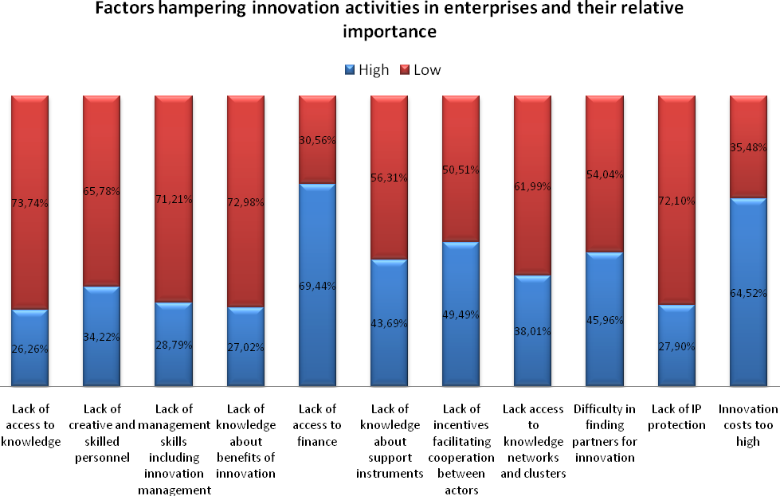
Views of the Enterprises

In line with enterprises, innovation intermediaries consider lack of access to finance as the most pertinent factor hampering companies from bringing innovation to the market. They also frequently pointed to the lack of access to international markets, lack of market information and lack of information on available innovation support measures as other relevant factors. The latter was also recognised by many enterprises as a hampering factor.
Although the views from both stakeholder groups are rather consistent there are, nevertheless, some differences between the perceptions of enterprises and innovation intermediaries. For example, when asked about barriers hampering companies for organising innovation processes more effectively, institutional players indicated lack of innovation management skills and lack of access to qualified and creative skills as the most pertinent ones. This contrasts with the perceptions of enterprises that do not consider these factors as playing an important role. These differences in opinion may either suggest that innovation management of enterprises is better than perceived by innovation intermediaries or that enterprises wrongly believe that they are good enough in this field. Further evidence from the IMP³ROVE database supports the first rather than the second view. Consequently, this question may have to be investigated in more depth before engaging further into this specific type of innovation support.

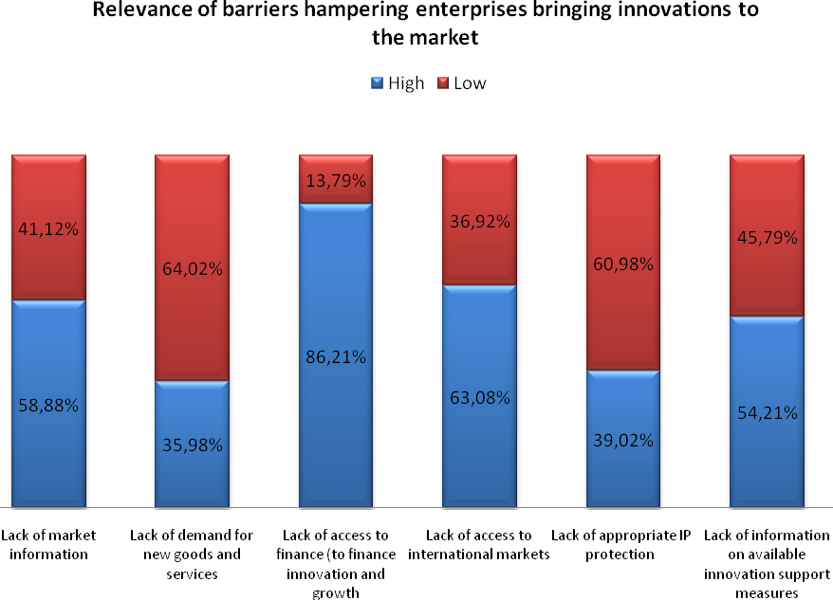
Views of institutional stakeholders

As far as direct innovation support is concerned, the vast majority of enterprises and innovation professionals believe that such measures could help overcome barriers to innovation. However, as argued by the Association of German Chambers of Industry and Commerce (DIHK), innovation support should be target-group oriented, non-bureaucratic and based on a sound market failure analysis. According to the results, the four most frequently provided forms of innovation support to enterprises over the last three years were financing for innovation projects, support for networking and cooperation, awareness raising, and technology transfer; less than a third of the enterprises surveyed reported not to have received any kind of support. No major differences were observed between the kind of direct support most frequently provided to enterprises from the manufacturing sector and to enterprises from the service sector.
With the exception of financing support, this largely confirms the results of the Innobarometer 2007, which indicated that the most widespread forms of public assistance to enterprises were support for participation in trade fairs, information provision and networking with companies.

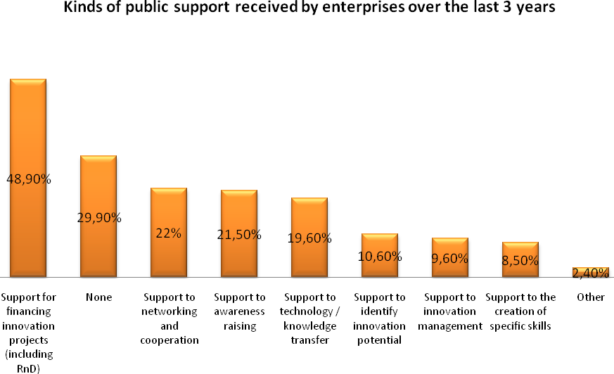
Views of Enterprises

Altogether, public funds did not represent a significant share of enterprises' overall expenditure on innovation over the last three years. Although the majority of enterprises surveyed indicated to have received public support, for the biggest share it accounted for less than 10% of their overall spending on innovation. Only for 12% of the enterprises, did the public funds received represent between 10% and 25% of their total expenditure. Consequently, more than half of the enterprises surveyed stated that public innovation support was not instrumental for their innovation projects. Overall, these results correspond with findings from the Innobarometer 2007 where publicly funded support schemes were considered as crucial for the innovation activities of only 24% of EU innovating firms.
With respect to the impact of public innovation support, some differences can be observed between enterprises from the manufacturing sector and enterprises from the service sector. Concerning the service sector, fewer companies than from the manufacturing sector have received public support. For most service companies, this support was not instrumental, whereas more than half of the enterprises from the manufacturing sector reported that such public support was fundamental for their innovation projects. This may suggest that innovation support is better geared towards the needs of manufacturing companies.

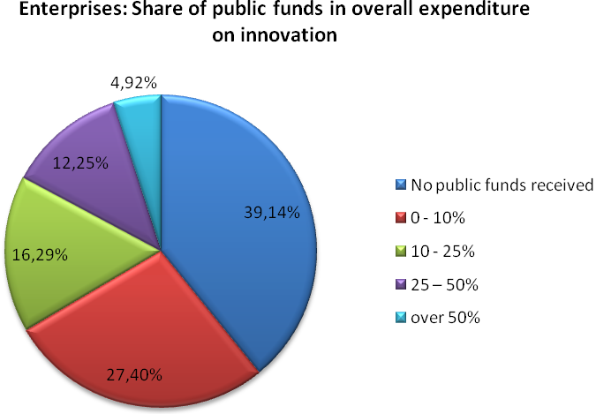
Views of Enterprises

As regards the level of satisfaction of the beneficiaries of public innovation support, the overall perception is not very positive. When asked to evaluate the extent to which the received public support met their expectations many more respondents stated that the support did not meet their expectations at all than respondents that it perfectly met their expectations. As for all other forms of innovation support, the majority of enterprises were not satisfied with the volume or quality of the most frequently provided forms of innovation support. Less than 1/3 rated the received support for financing, awareness raising, networking and technology transfer as satisfying. Support for financing still received the highest support, whereas support for innovation management, including IPR, was ranked lowest.

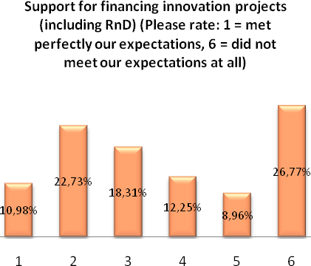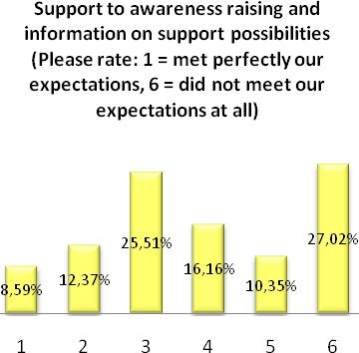
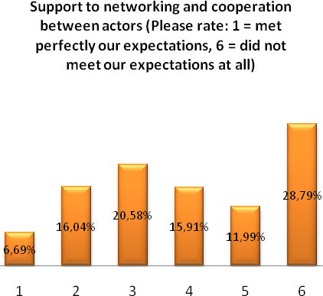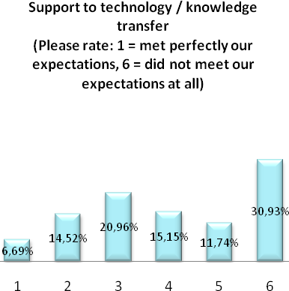
The Finnish sample of enterprises confirms this perception with even lower levels of satisfaction for all forms of support, except for financing innovation projects which 42% of enterprises considered satisfactory. The lowest satisfaction was expressed for support for technology transfer and support for innovation management, including IPR, with comparatively significantly lower scores. As innovation support in Finland is often described as a “good practise” example, these results confirm the overall scepticism that exists towards innovation support in Europe. It seems that this is a widespread feeling, which can be found in most Member States, regardless of whether they are leading in innovation performance or lagging behind.
These results from the open consultation suggest that there is a gap between what enterprises would expect to receive as innovation support and what they actually get. As far as more effective ways of public innovation support provision are concerned, all proposed areas for improved service provision are considered to be highly relevant. There is practically no area that is considered to offer “best practice”. This should lead to some more caution in using this term in relation to innovation support. What seems to be at stake is the search for “better practice” rather than being complacent with the dissemination and further implementation of “best practice”, which is unlikely to exist from an enterprise point of view. Nearly 80% of the innovation support providers would admit that there is a need for improving existing support mechanisms.
The large majority of enterprises believe that introducing fast-track (i.e. simpler and faster) procedures for administration and evaluation of projects would be necessary. This is confirmed by a business panel organised by the Consortium for the Trade Promotion of Catalonia that described processes for receiving public aids as too bureaucratic, slow and inefficient. This opinion is shared by many innovation intermediaries, for example by the Association of German Chambers of Industry and Commerce (DIHK) that stated that administrative processes are too complicated, time consuming and bureaucratic. Furthermore, enterprises wish that private organisations and innovation experts would be more directly involved in the service provision and that more integrated innovation support services would be offered. This corresponds with the views of the intermediaries who agree with the need to offer more integrated innovation support services and to involve private organisations and innovation experts more directly in the service provision. This calls for new forms of innovation support, such as voucher schemes, as well as for a better integration of different public services into single entry points. Finally, a large share of enterprises believes that innovation support for services needs to be improved. Surprisingly, this opinion is not only supported by most service companies but also by manufacturing companies. This is a clear indication that services innovation matters across sectoral boundaries.
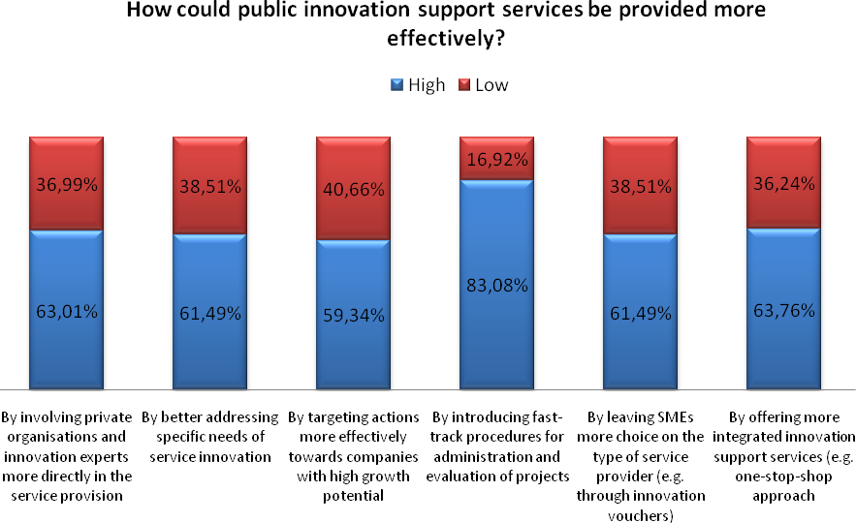
Views of Enterprises

As far as the providers of innovation support are concerned, most enterprises would expect better innovation support from innovation and development agencies as well as from universities and research centres. More than half of the enterprises would also expect support from Chambers of Commerce and business associations. But also cluster organisations and private consultants are considered as important channels for providing innovation support. This clearly suggests that effective innovation support depends on a large number of different service providers, each addressing specific issues and requiring specific expertise.
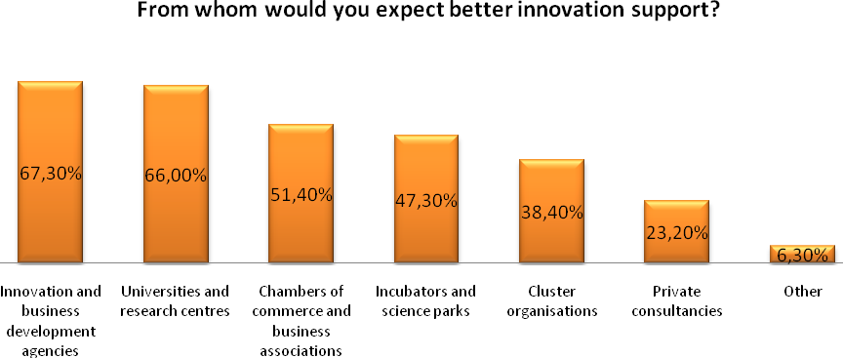
Views of enterprises

Most innovation intermediaries are well aware of the need to better customise their services, taking into account new needs and higher expectations of enterprises. In this respect, the most frequently mentioned new challenges include better support for the internationalisation of innovative SMEs within Europe, for new forms of innovation (such as user-driven innovation) and for the specific needs of enterprises with high growth potential (gazelles).
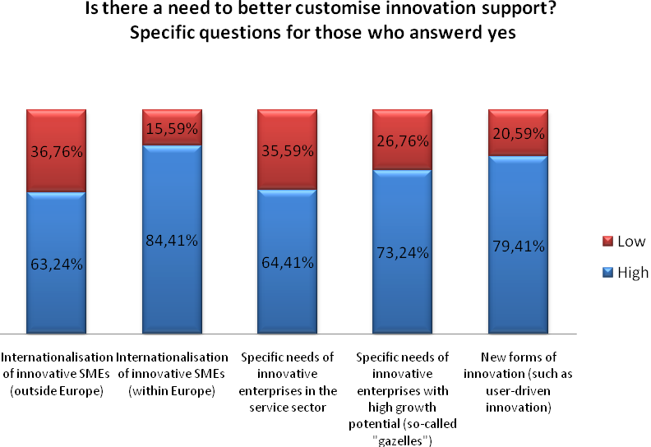
Views of Institutional stakeholders

Whereas measures in support of transnational cooperation within Europe already have some tradition, support to international innovation activities outside Europe is still in its infancy. Regarding measures supporting innovation activities outside Europe, the top priorities according to enterprises are improving networking with companies and research institutes and improving access to knowledge on international market conditions. Fewer enterprises consider measures in support of mobility of human resources and IP protection abroad and as a matter of high priority. The innovation intermediaries seem to agree with these priorities.
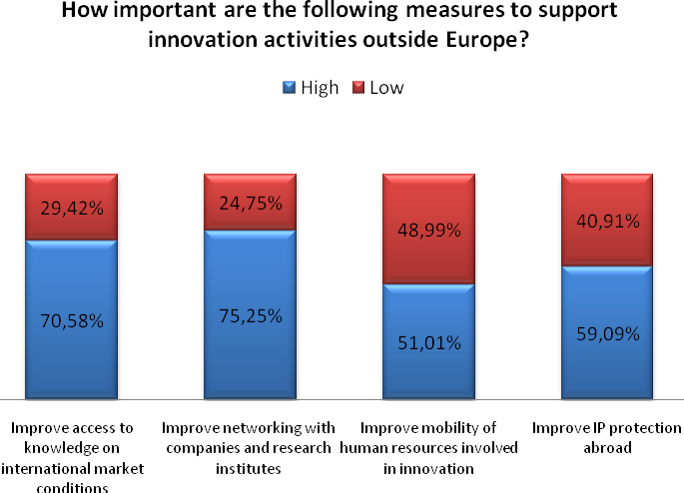
Views of Enterprises
.

With regard to innovation management, enterprises would expect to receive better public support primarily for designing their innovation strategy and improving organisational innovation, including the use of IT and e-business. Fewer companies prioritised IP management and design management. However, for the companies from the manufacturing sector public support for IP management is considered to be as important as support for the use of IT and e-business, whereas service companies seem to be more in line with the general trend. Concerning IP protection, most enterprises would expect public support for patents. Regarding other forms of protection the need for public support is significantly lower. This is valid for both enterprises from the service sector and enterprises from the manufacturing sector. However, most enterprises from the service sector would also expect better public support for copyrights, which is not of similar relevance to enterprises from the manufacturing sector.

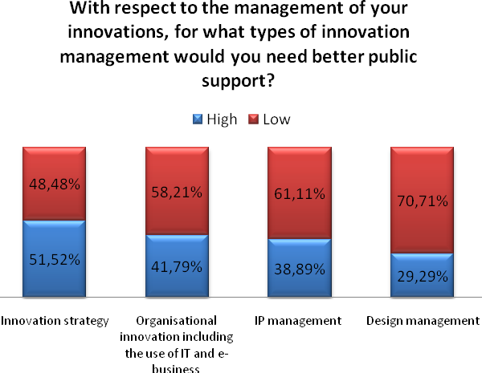
Views of Enterprises

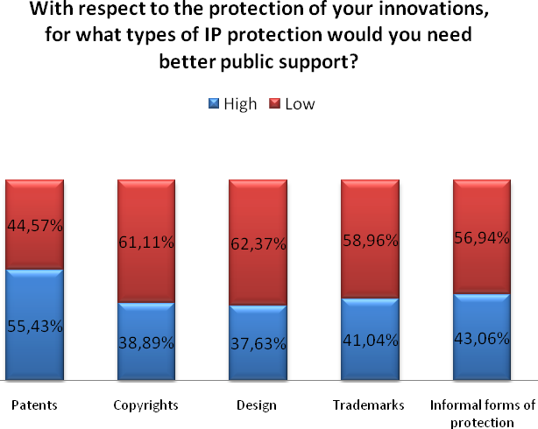
Views of Enterprises

Furthermore, some differences are visible between innovation leaders and countries lagging behind in innovation, such as the new Member States. More companies from the new Member States than from countries leading in innovation would expect better support for organisational innovation, including the use of IT and e-business.

The Finnish sample of enterprises confirms the need to primarily receive better public support for innovation strategy. Furthermore, more enterprises prioritised design management over IP management. As regards IP protection, Finnish enterprises seem to have a higher level of expectations for better public support, in particular for design and, to a lesser extent, for copyright protection. This suggests different expectations exist, depending on the level of innovation performance. What may be acceptable quality levels of services for enterprises that are less innovative, may not respond to the needs of the top innovation performers. With respect to IP protection, different expectations exist between manufacturing and service firms. While manufacturing firms are more interested in better support for patenting, service firms prioritise copyrights much higher.

2.3. Stakeholders’ views on the role of the Community in support of innovation
A further objective of the public consultation was to get better insights and perceptions regarding the role of the EU actions in support of innovation. In this respect, the consultation examined stakeholders' awareness of major EU innovation support actions and asked them to evaluate their added value. The focus was on the expectations of various types of actors regarding the kinds of support that should preferably be provided at EU level. In addition, the willingness of innovation intermediaries and funding agencies to collaborate with other partners in the field of innovation was surveyed.
The results of the consultation clearly indicate that a vast majority of stakeholders is in favour of EU involvement in innovation support. Both enterprises and innovation intermediaries agree that the EU has an active role to play in this regard. Due to the complex nature of innovation, support as expected at all levels, as expressed in the summary report reflecting the views from enterprises from North Rhine-Westphalia in Germany.
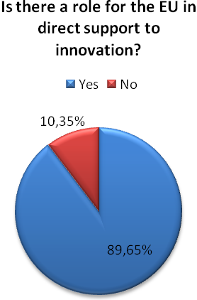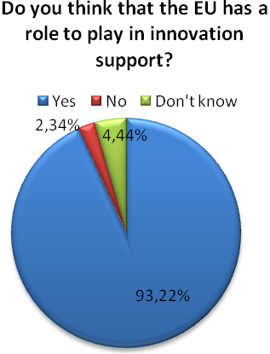
Views of Enterprises Views of Institutional Stakeholders

The small fraction of enterprises that are of the opinion that the EU should not play a role in innovation support are primarily micro and small companies characterised by low growth in terms of staff employed and turnover.
As regards the specific fields in which the EU should provide innovation support, enterprises view support for financing innovation projects together with support for networking and cooperation between actors as the main areas where European instruments should provide support. To a lesser degree, EU instruments are proposed to focus on support for the identification of innovation potential, support for internationalisation of innovative SMEs and support for technology transfer. As concerns other forms of innovation support, such as support for innovation management, IP and design as well as support for the creation of specific skills, many fewer enterprises expect these to be provided at EU level.
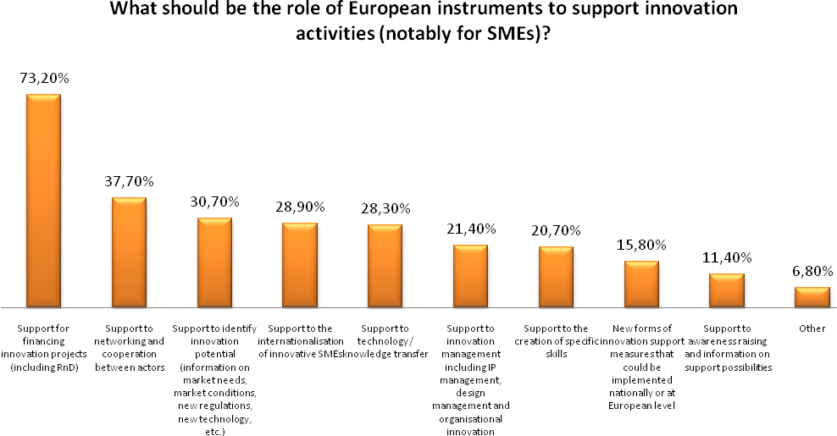
Views of enterprises

As far as these priorities are concerned, no significant differences were observed between enterprises involved in services and enterprises involved in manufacturing, or between countries. The different support levels do not necessarily indicate a ranking of the importance of the different support mechanisms but rather reflect that enterprises have different needs and expectations. However, the general pattern is that enterprises are mostly interested in receiving financial support, professional expertise and support for finding innovation partners, whereas less high expectations seem to exist with respect to general information and awareness raising.
Regarding the institutional stakeholders, the top three priorities at EU level are facilitating cooperation, exchange of information, good practice and policy learning together with facilitation of technology transfer and access to finance, including leveraging/co-funding of seed and venture capital funds. Other high priorities include providing EU-wide services to enterprises, facilitating the development of new tools and instruments in support of innovation, helping the internationalisation of enterprises and, to a lesser degree, fostering the emergence of lead markets with high economic and societal value in the EU. This may suggest that intermediaries rather see a role to be played at national or regional level with regard to fostering the emergence of lead markets. Generally, innovation intermediaries show even stronger support for most categories of innovation support than do enterprises, which may reflect their better knowledge about current EU support mechanisms. It may well be that existing EU support mechanisms are not always recognised by enterprises as such, as many EU-wide services and support measures are offered or implemented by regional and national partners.

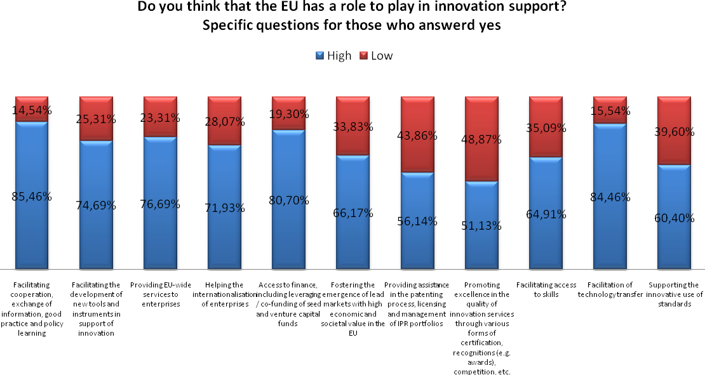
Views of institutional stakeholders

As concerns innovation policy learning, a large majority of respondents expressed their willingness to cooperate with other European partners on the development and improvement of tools and instruments in support of innovation. Member States lagging behind in innovation signalled as strong support as did innovation leading countries. This confirms that the scope for international cooperation is huge. Schemes for exchange of experiences and good practice, cluster development and technology platforms, innovation schemes for SMEs, Europe INNOVA and PRO INNO Europe® platforms were most frequently mentioned in this regard.

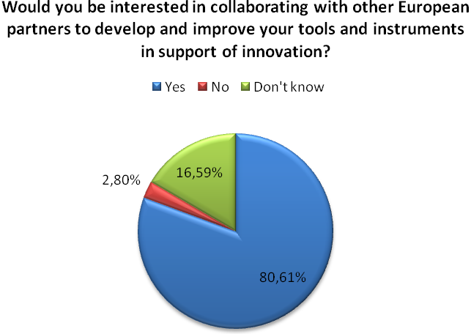
Views of institutional stakeholders

When asked about the added value of current EU support initiatives that support cooperation between innovation actors most enterprises admitted that they were not aware of them. This is particularly obvious for the IPR Helpdesk and Europe INNOVA – a large majority of respondents said they did not know these initiatives. As regards Europe INNOVA this results is not surprising as it does not deal with enterprises directly but predominantly with innovation intermediaries. However, the new generation of Europe INNOVA actions launched in 2009 will more directly involve SMEs in testing new tools and instruments in support of innovation. From those familiar with Europe INNOVA, more than half expressed their satisfaction with this initiative, whereas the satisfaction with the IPR helpdesk seems less strong. This corresponds with the overall scepticism expressed by enterprises about the added value of measures in support of innovation management in general, whether provided at European or national level.
Slightly more than half of the enterprises consulted indicated being familiar with the Enterprise Europe Network. In this respect, it has to be taken into account that the Network was particularly active in promoting this survey. About a third of the enterprises assess the added value of the Network as very good. User satisfaction was highest in micro- and small companies characterised by low growth in terms of staff employed and turnover. The vast majority of them have introduced an innovation over the last 3 years which, in nearly 2/3 of the cases, was based on research. This corresponds largely with the traditional clientele of the former Innovation Relay Centres, valuing particularly technology-oriented services, such as technology transfer. Also, most enterprises claiming that the added value of the Network is poor were highly innovative, which may suggest that for a large group of companies the services offered by the Enterprise Europe Network are either not relevant (for example for service companies) or relevant support services are of differing quality (high or low).

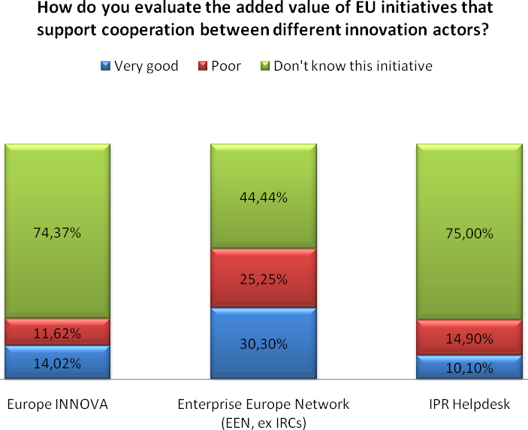
Views of enterprises

Unsurprisingly, the level of knowledge of EU initiatives is much higher among institutional players than enterprises. However, also among the innovation professionals the share of those who are not aware of major EU actions is relatively high. This may call for specific awareness raising actions in order to better inform them about major EU schemes. However, the data may also suggest that EU initiatives are not offering enough interesting results to be of sufficient interest for regional and national innovation intermediaries in their daily work.
Twice as many institutional actors as enterprises rated the added value of Enterprise Europe Network as high, which represents the highest appreciation of EU initiatives. Overall, Europe INNOVA and PRO INNO Europe® also get reasonably high scores. Within PRO INNO Europe®, the INNO-Policy TrendChart is not only largely unknown but also not highly appreciated by those who are familiar with it. This may suggest that the information published there, may not meet the expectations of the specific target group. This raises the question of how to better capture the needs for an innovation policy intelligence tool such as TrendChart. A majority of institutional players who are aware of the European Innovation Scoreboard evaluate it as having a high added value. However, the Scoreboard does not provide information at sectoral and regional levels which may explain why a significant number of respondents considered that it to have low added value. Whereas enterprises seem less convinced of the IPR Helpdesk, a larger proportion of intermediaries are rather satisfied with this service. It may well be that these services are of higher value for intermediaries than directly for enterprises. This may need to be further explored to better tailor them according to user requirements.

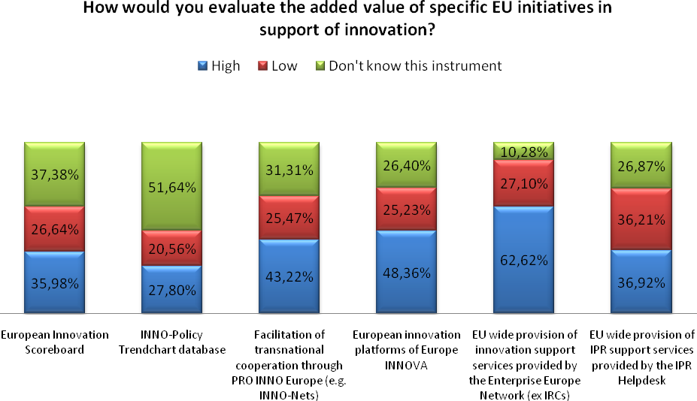
Views of institutional stakeholders

Concerning the expectations on how to further improve the effectiveness of EU support measures, three quarters of the enterprises surveyed would expect a simplification of the participation rules in EU projects. Furthermore, more than half ask for more direct support for SMEs through EU support mechanisms and for better information about EU initiatives. The expectations of the intermediaries are the same as concerns the simplification of administrative procedures. The vast majority is of the opinion that introducing fast-track procedures for the administration and evaluation of projects could help improve the effectiveness of measures. Three quarters think that offering more integrated innovation support services (e.g. one-stop-shop approach) and involving private organisations and innovation experts more directly in the service provision would help achieve this goal.

2.4. Stakeholders’ views on the impact of the economic crisis on innovation support
The enterprises and innovation intermediaries were also asked about the implications of the current economic downturn on their innovation activities. Respondents were expected to indicate to which extent the current crisis has an impact on their innovation activities. The majority of enterprises and innovation intermediaries confirmed that the downturn has a medium to strong impact on innovation as well as on innovation support, whereas only few denied such impact.
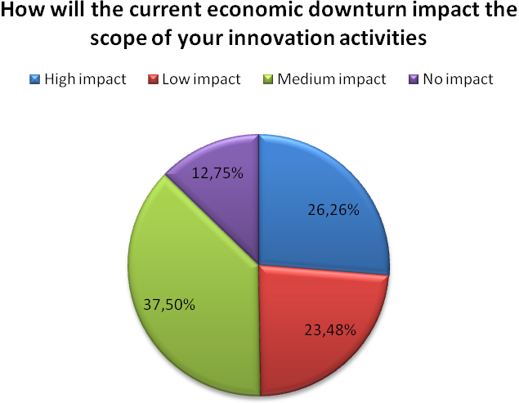
Views of Enterprises

The sectors which seem to be least affected by the downturn include consultancy services and ICT. Overall, approximately 40% of the enterprises that considered themselves to be unaffected by the downturn came from the service sector and 60% from manufacturing. A big share of them were innovative high growth enterprises (37% reported turnover growth of more than 20% and 22% reported staff growth of more than 20%) established before 2004. Most of them employ staff especially for innovation management, including IP management and design. More than a third did not receive any kind of public funds as support for innovation, and for two thirds of those who did it was not fundamental for their innovation activities.
As far as the specific impact of the downturn is concerned, the largest proportion of enterprises affected expressed the view that financing for innovation activities is less accessible due to the crisis. Many enterprises expect a reduction of budgets for R&D projects and a shift of the company's priorities away from innovation. Overall, companies are less concerned about the reduction of budgets for non-R&D projects, which suggests that short-term considerations may become more important than long-term innovation strategies. Financial constraints were also the principal concern of the institutional stakeholders: a majority feels that pressure on budgets has been increased. As a result, it is believed that priorities may shift towards more short term objectives, such as support for innovation financing.
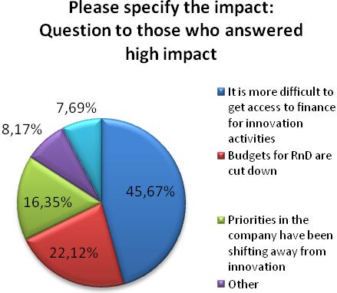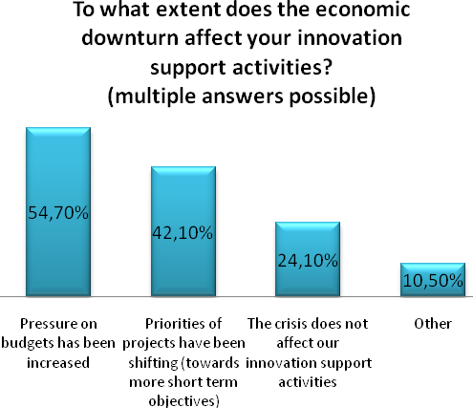
Views of enterprises Views of Institutional stakeholders

In Finland, companies seem to feel less affected by the economic downturn. Nearly half of the consulted companies (45%) express the view that it will have a low or no impact on their innovation activities. Fewer companies are concerned about access to finance, but more expect to be affected by a reduction of budgets for R&D. In particular, three times more companies seem concerned by the reduction for non R&D based projects. This is further stressed by the additional comments of the companies, expressing a lack of public financing for projects with insufficient ‘technological value’, whereas more support would be needed for rather short-term innovation activities (mainly non R&D based) to generate cash-flows in this period of crisis. These results suggest that the economic crisis may not undermine the overall commitment to innovation in high performing countries, but will lead to a more short-term orientation of enterprises.
According to the Innobarometer 2009, when asked about the direct effects of the current economic downturn, most enterprises did not report any change in innovation expenditure during the past six months (59%). However, of those who did change, roughly twice as many enterprises indicated that they have cut back on innovation-related spending (22%) compared to 9% that have increased their innovation budget. This marks a rapid deterioration compared to the period 2006-08, where 35% of companies said they had increased innovation related expenditure while only 9% reported a decrease.
In this context, the Annual Report 2008-09 of the INNO-Learning Platform stresses that investments in R&D and innovation are vital to ensure that companies can weather the crisis and are prepared to (re)gain market share and keep conquering markets with consumer responsive products and services. Since not all companies prepare well for the subsequent better days and are not all equally willing to make the same investments, it is important that additional (public) injections of resources into R&D and innovation are selectively targeted at those companies that have the vision, commitment and capabilities to continuously serve customers with market responsive products.

Main challenges to improve the effectiveness of innovation support at European level
Not all EU initiatives in support of innovation are well known by enterprises, and where known are they not considered of high value by all. Thus, there is not much room for self-complacency. Regional and national innovation support providers are of the opinion that the current economic crisis will put additional pressure on them to focus on real needs of enterprises and to re-prioritise support actions towards higher added value. This must also be accepted as a challenge for EU innovation support.
The terms “effectiveness” and “efficiency” are often used interchangeably as synonyms. However, there are clear differences between the two concepts and the relationship between them in terms of strategic planning is worth clarifying, notably in the context of policy-making at European level. In general, the terms efficiency and effectiveness are used to describe the relationships between inputs, outputs and outcomes. Following the White Paper on “Reforming the Commission”, the concept of “efficiency" aims at ensuring maximum results with limited resources. This concept was further defined in a Commission Staff Working Document on measuring the efficiency of public spending on R&D, which clarified that "the efficiency concept refers to the concept of production possibility frontier, which indicates the quantity of output which can be efficiently produced for a given input level.” In other words, the greater the output for a given input or the lower the input for a given output, the more efficient is the activity. Efficiency levels are influenced by framework conditions that may stimulate or hamper the performance of a policy measure.

Figure 4: Conceptual framework of efficiency and effectiveness
Source: DG ECFIN, European Commission, 2008
Input
Output
Outcome
Efficiency
Effectiveness
Framework conditions & governance

While the concept of “efficiency” allows a rather straightforward interpretation, the concept of “effectiveness” is more difficult to grasp as it also depends on political objectives and priorities. In the White Paper on European Governance, the Commission refers to the concept of "European governance" that is defined by the rules, processes and behaviour affecting the way in which decisions are taken and implemented at European level. Taking these into account, "effectiveness" can be understood as one of the “five principles of good governance", together with openness, participation, accountability, and coherence. In this sense, the term "effectiveness" means that "policies must be effective and timely, delivering what is needed on the basis of clear objectives, an evaluation of future impact and, where available, of past experience”. In terms of decision-making at EU level, it is also stressed that effectiveness “depends on implementing EU policies in a proportionate manner and on taking decisions at the most appropriate level".
Following this approach, “effectiveness” describes the extent to which objectives are achieved as well as the relationship between the objectives set and the actual impact of an activity. Whereas "efficiency" is measured by the relationship between the output (in terms of goods, services and other results), and the resources used to produce them, “effectiveness” means "doing the right things right". An efficient activity maximises output for a given input or minimises input for a given output, which can be interpreted as "doing things well". In terms of effectiveness, the focus is more on the impact than on the output of the activity.
In this respect, a recent ex post evaluation of Directorate General Enterprise and Industry’s innovation activities that were funded through FP6 highlighted the need for better assessing the impact of the actions rather than mainly describing their output. In particular, it stressed the need to have "a clear statement in respect of the intervention logic underpinning the Commission’s programme of innovation activities in order to improve overall coherence and clarify the roles of individual activities". Consequently, “there should be a more systematic use of metrics in order to ascertain the impacts of the innovation activities". However, in order to implement these recommendations it would be necessary to identify ex-ante and in much more detail the problem to be addressed, against which the impact of the action has to be measured later on.
As far as the CIP-EIP programme is concerned, a general choice exists between direct measures in support of innovative companies such as through the financial instruments and the financing of demonstration projects, indirect support provided through the Enterprise Europe Network, support for best practice exchange and policy learning and pilot actions aiming at fostering better innovation support at regional and national level. Whereas the potential impact of financial support to enterprises can be directly measured, it is much more difficult to assess the European added value created by the provision of European-wide services and, in particular, by the development and further dissemination of better innovation support fostered by policy learning and pilot actions at European level.
The effectiveness of Community innovation support has not only to be measured in terms of its impact. What is equally important is to raise the question of its legitimacy in terms of good “European governance” in support of innovation. The main objective of current “indirect” European innovation support actions can be seen as complementing regional and national efforts, by facilitating mutual policy learning, piloting new forms of better innovation support and providing incentives for their wider take-up. In a nutshell, European actions need to be designed in a way that they address well-identified market failures (and do not compete with existing market solutions), and fully respect the subsidiarity principle (not duplicating regional or national support measures). At the same time, they should provide a measurable European added value (and not only announce solutions), which calls for performance indicators measuring the impact rather than the output.
To make this happen and taking into account the main findings of the public consultation, the following challenges can be identified to raise the level of effectiveness of innovation support to enterprises at Community level:

Better demonstrating European added value
When asked about the added value of EU innovation support actions, on average less than half of the respondents to the open consultation expressed their satisfaction. This may indicate a communication problem, but the widely observed lack of interest in such initiatives may also indicate that their added value is not always evident.
Actions in support of innovation may take different forms and be implemented at different levels, depending on their objectives and target audiences. Innovation support may aim at promoting innovation in general or at providing specific support to innovative firms; it may aim at fostering the innovativeness of specific sectors or creating new market opportunities for innovative companies. Thus, innovation can be supported at different levels, and for each level a broad range of innovation support instruments is available. At best, these different instruments in support of innovation may mutually reinforce each other, but in the worst case this may also result in duplication of efforts and inefficiencies that may be referred to as “policy failures”.
Generally, most public innovation support actions seem to have only little impact on the capability of companies to innovate, as suggested by the results of the public consultation. For most firms that have received some form of publicly funded innovation support, this support was apparently not instrumental for their innovation activities and did not fully meet their expectations. Public innovation support is perceived by many companies as a "vitamin pill or placebo" rather than a tailored remedy to improve their innovative activity. This highlights the need to shape innovation support instruments in line with the expectations of stakeholders to ensure maximum impact for enterprises, in particular in view of helping them to better cope with the current global economic crisis.
At Community level, direct innovation support is mainly provided by measures under the Entrepreneurship and Innovation Programme (EIP) of the Competitiveness and Innovation Framework Programme (CIP). Taking into account the subsidiarity principle, such Community actions must demonstrate their added value at European level. Following an evidence-based approach, this would require a clear, prior demonstration of market and systemic failures to be tackled best at European level, thus fully respecting the subsidiarity principle. Furthermore, to be effective such measures must be proportionate to the size and scope of the problem so as to respond optimally to its nature and gravity.
Innovation support at Community level: Less than 5 % of the 15 leading innovation agencies
The EU budget dedicated on an annual basis to the specific Entrepreneurship and Innovation Programme of the CIP corresponds to less than 9%, and only 3% without the financial instruments and the business support services provided by the Enterprise Europe Network of the budget allocated to innovation support schemes by the 15 leading national innovation agencies in terms of funding. The annual budget of the 15 leading innovation funding agencies in Europe allocated to innovation support schemes is estimated at €3.641 billion whereas the EIP's annual budget is about €0.309 billion. The budget made available for financial instruments is €161 mio, and the business support services via the Enterprises Europe Network: account for €59 mio. In addition, eco-innovation activities are supported by €61 mio.

Whereas a better application of the subsidiarity principle would contribute to determine what shall best be done at EU level, a clearer focus on key priorities would ensure better value for money and thus maximise the potential impact of Community actions. This is the approach that has been followed, for example, by the last call for proposals on the renewal of the Europe INNOVA initiative, where most actions aim at supporting the Action Plans of the European Lead Market Initiative. Similarly, the PRO INNO Europe® initiative focuses on policy areas covered by the “broad-based innovation strategy”, as described in the Communication of 2006.
Within the scope of the current CIP-EIP innovation support activities, a more strategic and targeted approach in support of innovation could be further pursued by more systematically following an “evidence-based approach”. Better knowledge of existing market and systemic failures would be needed to define the policy challenges to be addressed at EU level and to set clear benchmarks for actions. Whereas good knowledge exists about innovation performance and policy trends in general, the challenge of systematically identifying specific barriers for innovation is not yet sufficiently addressed.
Systematically applying an ex-ante analysis of expected effects to new innovation support actions to be funded under CIP-EIP would contribute to a better evaluation culture in the field of innovation, not only at Community level but also in general, thus ensuring better value for money. However, the most important impact of such ex-ante analysis would be that, in many cases, the level of aspiration would have to be raised. For example, whenever systemic failures are said to be addressed it would be necessary to demonstrate that the proposed action would indeed help to remedy the problem effectively. This would require a measurable and sustainable effect of the proposed action which, until now, has not systematically been built into most Community actions in support of innovation. Most performance indicators used by Community pilot actions are rather arbitrarily chosen ad-hoc and do not necessarily reflect the nature and size of the problem to be addressed.

Better promoting synergies between national and European actions
In the public consultation, a clear majority of innovation intermediaries indicated interest in transnational cooperation and participation in European initiatives aiming at policy learning and exchange of “good practice”. However, in reality only very few regional and national innovation agencies are actively involved in this process of mutual learning and transnational cooperation at European level. In particular, there seems to be very little interest from the new Member States to actively engage into this process, which is a matter of great concern, taking into account the need to strengthen regional and national innovation systems in these countries in order to further continue with the catching-up process.
Public innovation support is a shared responsibility between regions, Member States and the European Union. In comparison with the innovation support provided at regional and national level, Community support is rather small. The annual budgets of a large number of innovation agencies in Europe exceed by far the available funding at Community level, as illustrated by figure 5. This calls for seeking and exploiting synergies between the different levels of intervention. Each level has its own legitimacy but, so far, no sufficiently strong coordination mechanisms exist that would ensure an effective application of the subsidiarity principle. Achieving better synergies between EU, national and regional initiatives is therefore a challenge that needs to be addressed as a matter of high priority in order to ensure better effectiveness and cost efficiency of innovation support in the EU.
The main objective of current “indirect” Community innovation support measures is to complement regional and national efforts, by facilitating mutual policy learning, piloting new forms of better innovation support and providing incentives for their wider take-up. Furthermore, the Enterprise Europe Network aims at ensuring a European wide provision of “baseline services” in support of SMEs, and financial support for innovative SMEs is provided through the financial instruments funded under CIP-EIP. However, as regards innovation pilot actions in particular, no strong coordination mechanisms exist yet that would ensure a streamlining between regional, national and European initiatives in support of innovation.
As part of the Lisbon Strategy for Growth and Jobs, most Member States have undertaken great efforts in recent years to further improve their innovation support mechanisms by investing in research infrastructure and implementing new or better instruments in support of innovative SMEs. Within this Lisbon process, Member States are invited to present their innovation support policies as part of the National Reform Programmes and to report annually on their achievements. On this basis, the Commission formulates country specific recommendations addressed to the Member States, which set out priority areas for reform. Overall, this process has significantly improved the exchanges of information and experiences between Member States and with the Commission on broad policy areas serving the goals of growth and jobs. As regards innovation support however, the Integrated Guideline 8 of the Lisbon Strategy covers a rather broad range of policy fields, which makes it difficult to identify, on the basis of the information available, possible policy gaps that would have to be addressed at Community level. Therefore, the feedback collected from the Lisbon process needs to be further completed by other policy exchanges to better identify how to best complement Member State actions at EU level.
Figure 5: Top 15 innovation agencies in Europe (in terms of funding dedicated to innovation support)
Innovation Agency | Country | Annual budget ( € Million)
CDTI | Spain | 1234 (2009)*
OSEO | France | 500 (2009)
PARP | Poland | 449 (2009)
VDI Technologiezentrum GmbH | Germany | 220 (2009)
ZAB - Brandenburg | Germany | 212 (2007)
SenterNovem | Netherlands | 141 (2009)
SIEA | Slovakia | 139 (2009)
Enterprise Ireland | Ireland | 120 (2008)
SPRI (Basque agency ) | Spain | 120 (2008)
Projektträger Jülich | Germany | 107 (2007)
Tekes | Finland | 90 (2008)
Scottish Enterprise | United Kingdom | 84 (2009)
TSB | UK | 80 (2009)
FFG | Austria | 75 (2008)
NKTH | Hungary | 70 (2008)
*Total annual budget managed by CDTI in national and international programmes.
Source: European Commission, DG Enterprise and Industry

To this end, a number of initiatives have been set up at Community level in the framework of the Open Method of Coordination, to help Member States and regions learning from each other, sharing experience and building partnerships in support of innovation. Under the CIP-EIP, the Europe INNOVA and PRO INNO Europe® initiatives aim at facilitating the cooperation of innovation practitioners and innovation policy-makers across borders. The concept of the INNO-Nets has been particularly successful in facilitating partnerships and in demonstrating the scope for complementarities between EU and national actions. The INNO-Learning Platform has helped in exploring and testing the added value of targeted transnational cooperation between Member States and regions and in launching a more regular dialogue between national and regional publicly funded innovation agencies. Furthermore, the new “European Territorial Cooperation” objective of Cohesion Policy focus on innovation, has clusters and SMEs as one of its important priorities. The “Regions for Economic Change” initiative, built through INTERREG IVC and URBACT, is a proactive instrument to help regions implement the renewed Lisbon and Gothenburg agenda. It draws on the experience and good practice examples of high performance regions, with the view to disseminate these practices faster throughout Europe. The novelty of this initiative is that the participating regions develop action plans, which are to be implemented by the Managing Authorities of the Structural Funds thus creating a solid bridge between networks and Operational Programmes.
All these initiatives contribute to mutual policy learning and transnational cooperation in support of innovation. However, there is still much room for improvement within the existing policy instruments. First of all, not all Member States and regions are actively participating in this process. Some Member States and regions are more interested in transnational cooperation and mutual policy learning than others, as reflected in the differences in participation in the Community pilot actions. Secondly, the current initiatives mainly support networking activities rather than the preparation of strategic policy agendas to be implemented at different levels. The level of ambition of the pilot actions is not always high enough to make a real contribution towards achieving better synergies between the different policy instruments and levels in support of innovation. Thirdly, the practical problems to fostering transnational cooperation in this field are particularly great, taking into account the variety of policy instruments and the differences in strategic interests of Member States and regions.
The current policy framework for innovation support in Europe would have to be substantially improved in order to ensure better complementarities between the different levels. There is an urgent need for better coordination and cooperation, taking into account that approximately €86 billion, representing 25% of the total Cohesion Policy Funds, has been allocated to research and innovation in the current programming period (2007-2013). Under the Community Strategic Guidelines on Cohesion 2007-2013 adopted by the Council and EP , the Member States and regions have been invited to make the best use of Cohesion Policy Funds to strengthen their regional innovation systems and to improve their innovation performance. The challenge is how to make best use of these funds, which requires inter alia more effective forms of policy learning in Europe.
To promote better synergies between regional, national and European mechanisms in support of innovation, mutual policy learning in support of innovation needs to be reinforced. There should be a strong interest in learning from each other and sharing experience, in particular in new fields that require new policy responses. The new generation of INNO-Nets starting in 2009 will again focus on clusters, as well as on services innovation and eco-innovation. However, a more open and integrative approach needs to be followed to interest and include more Member States and regions in this kind of mutual policy learning. In this respect, the participation from the new Member States in these learning platforms is still particularly unsatisfactory, so specific efforts to better include them are required.
More effective mutual learning at policy level needs to be complemented by closer cooperation and contacts between regional and national innovation agencies from different Member States. The challenge is to create a “win-win” situation for those who are willing to coach others and those interested in learning from others. This requires a broad range of activities which offers something of interest for everybody. Starting in 2009, the new INNO-Partnering Forum will provide an open platform where different innovation support providers from across Europe can meet and engage into a mutual learning process, with a view to improving their effectiveness in providing innovation support services to innovative SMEs. This initiative shall act as a catalyst for the modernisation of innovation support mechanisms in Europe. To broaden its impact, a reflection group representing public authorities and innovation agencies across Europe shall explore the possibilities for making better use of complementarities between the different levels of innovation support in Europe. It will, in particular, formulate recommendations on possible new ways of cooperating between national and European levels.
The forthcoming INNO-Partnering Forum can only be a first step in this direction. Still more needs to be done in order to involve more innovation agencies in a mutual learning and partnering process at EU level. As a further measure to accelerate the implementation of Cohesion Policy support for innovation, policy learning at regional level is intended to be enhanced by a “Regional Innovation Monitor” under the CIP-EIP, which will be launched in 2009. The Monitor will provide a continuous analysis and evaluation of regional innovation support policies and strategies. It will also provide facts and data about the use of Structural Funds in support of innovation by regions. In addition, the Monitor will contribute to a more effective use of Cohesion Policy support for innovation, by analysing the scope for complementarities between the Structural Funds and other EU funding instruments for innovation, in particular CIP-EIP and FP7, and with national and regional funding.
The potential impact of such effective policy learning at European level can be showcased by the recent example of the EU Baltic Sea Region Strategy. The BSR-INNO-Net on clusters, which was one of four cluster projects funded under the first generation of the PRO INNO Europe® initiative (2007-2009), has become the backbone of the forthcoming Baltic Sea Region Strategy for innovation and cluster development in this region. The objective of this EU-BSR Strategy is to improve cooperation among the involved countries to better address a number of economic, social and environmental issues in order to make the region an even more prosperous and attractive place for investment and living. This particular case shows how an EU-funded project, which involves strong key partners from the Member States, can be the driver of a common innovation and cluster framework for a number of countries, thus demonstrating how complementarities between different policy levels can be achieved. Whereas the conceptual work was funded by the Community action, the further implementation will fall under the responsibility of the regional and national authorities.
European innovation support actions may expect the highest impact if they lead to such “leverage effects”. Taking into account the moderate funds available for innovation support at Community level, a strong impact can only be achieved if, through them, additional funding is mobilised at regional and/or national level. This would normally be the most promising way to reach the target audience of innovative SMEs.

Better leveraging the results of EU pilot actions
In the public consultation, nearly 2/3 of the respondents considered the facilitation of the development of new tools and instruments in support of innovation to be very relevant, even more so than directly providing EU-wide services or offering venture capital to enterprises (both 55%). This seems to be a clear indication of how most regional or national actors interpret the subsidiarity principle.
Pilot actions launched at Community level support innovation policy learning. They allow testing of new support instruments and contribute to the development of “better practice” in support of innovation. However, to have a real impact the results need to be taken up as widely as possible, by regional and national support programmes. Although some progress has been made in this respect, the complementarities between regional, national and European support actions are still not effective enough to ensure this. As a result, the impact of Community pilot actions in support of innovation cannot be considered optimal.
In principle, all deliverables of the pilot actions are made publicly available. But despite the fact that the web portals of the two main initiatives, Europe INNOVA and PRO INNO Europe®, reach a wide community and are further supported by a pro-active communication strategy, there is little evidence that regional and national innovation support agencies and ministries take much inspiration from this offer. This may have different reasons:
Figure 6: Examples of new innovation support tools developed by European pilot projects
Europe INNOVA Online tools | Europe INNOVA non-line tools
Innovation Management Self Assessment Tool (IMP³rove) | Construction Sector: BuildNova Good Practice Handbook
Achieve ICT Sector Self Assessment Tool | Construction Sector BuildNova Finance Guide
INVESaT Space Applications Wikipedia Tool l | eHealth Sector: BioHealth Good Practice Handbook
Space downstream Guide 2 "Finance Space" | Shipbuilding: EUROMIND Good Practice in e-Business Standards Handbook
eHealth Sector: BioHealth tool for the Screening and Selection of Security and Identity Management Standards | Energy: Service Manual
ENFFI Food & Drink Sector Financing Toolbox | Achieve ICT Sector How-to-guide
INJECTION Medical Devices Sector Financing Toolbox | Achieve and Achieve More toolkits for Incubators
Financing One Stop Shop for Textile and Clothing Enterpreneurs | Achieve ICT Sector: Guide to Incubation Excellence
Energy: EIFN Budget Tool and Network | The Design of Environmentally-friendly Products: Using Information Standards handbook
Energy: EIFN Real Options Valuation Spreadsheet | Standards in European Public Procurement Handbook
Construction Sector: BuildNova Innovation Funding Map | Applying open standards to INNOVAte FUrNiture business process: INNOVAFUN Handbook
Construction Sector: BuildNova 'How to write a business plan' Tool | Automotive sector: Guidelines on Methodology of Visiting Schemes and Matchmaking Events
Achieve More Entrepreneurship and Innovation Exchange Platform for Incubators | Textile Sector: NetFinTex report on ‘Opportunities and Challenges for Financing Innovation in the European Textile and Clothing Industry’
 | Biotechnology Sector: report on ‘Do’s and don’ts for biotech cluster development: the results of NetBioCluE’
PRO INNO Europe® online tools | PRO INNO Europe® non-line tools
Search tool on leading science and technology parks/high tech sectors worldwide (EOS) | The use of data and analysis as a tool for cluster policy
Design management DME self assessment tool (ADMIRE) | Business Angels Cross Border Deals Structuring Tool and BA SAT for cross-border investment readiness (EASY)
Train-the-trainer modules on IP management (IP4INNO)
Business Angels: EASY BA Platform
Source: European Commission, DG Enterprise and Industry
Firstly, the dissemination of good or better practice through databases and other electronic means does not seem to be the most effective communication channel for this purpose. Policy learning depends on direct contacts and inter-active communication. The “window of opportunity” for implementing better practice developed at Community level is relatively small. Regional and national support programmes follow their own objectives, timetables and implementation modes. Community actions are most often not aligned with these constraints, thus offering ideas for “better practice” not necessarily at the time when this is most needed. This calls for flexible mechanisms that can be used when there is demand for new or better practices in support of innovation.
Secondly, regional and national innovation agencies would only be motivated to follow discussions at European level closely and to engage into transnational cooperation, if this supports their own agenda. This is not always ensured as there are no effective structures in place to involve regional and national innovation agencies more actively in the priority setting and further implementation of EU pilot initiatives. Their lack of direct involvement might prevent them from assuming full ownership of actions launched at Community level which, in turn, hinders a later, large-scale take-up of the results.
The wide absence of ‘ownership’ by Member States of the pilot actions during the whole project cycle from definition to roll-out of results, hampers the mobilisation of resources for the establishment of new or renewed innovation support services based on the results of these pilot actions. This may call for stronger incentives to take up the results of European pilot actions. Such additional incentives could be justified by positive or negative externalities in case a European approach is followed. Positive externalities would exist, for example, if the common use of an instrument would allow for reducing the costs of implementation or offer additional features, such as for benchmarking purposes. Negative externalities could arise if, due to the lack of modern innovation support in some Member States, the general innovation performance in the EU would be affected.
Thirdly, the further take-up of the results of Community actions may be hampered by their lack of transferability. Well-defined and standardised support services and tools can more easily be integrated into an existing framework of service provision. In most cases, this requires additional efforts to codify such services and to make them more generally available as exemplified in cases such as the innovation management project IMP³rove and the ‘train the trainers’ scheme for intellectual property management ip4inno, that show the potential but also the difficulties of this approach. To launch further standardisation and certification activities requires ownership of the intellectual property by an entity that is willing to share it with peers later on. This is not always ensured. Furthermore, such additional work is costly and needs strong drivers, which may require further public funding beyond the pilot phase.
More flexible support mechanisms are needed to facilitate the further dissemination of better practice in support of innovation in the EU. In 2009, a new “promotion pillar” will be established under the Europe INNOVA initiative that aims to assist operating projects in designing, standardising, certifying and communicating the results for a wide and easy take-up. A specific liaison group will be created to actively involve networks providing innovation support services at European level, like the Enterprise Europe Network, EBN, PROTON Europe, EOS or ENoLL. This will complement the new instruments currently tested in the framework of the INNO-Learning Platform, such as peer-reviews of innovation support services and twinning arrangements between innovation agencies to facilitate the transfer of good practices. These instruments will be further developed by the future INNO-Partnering Forum, which will act as a catalyst for the modernisation of innovation support mechanisms in Europe.
The main impact resulting from these initiatives would be to establish different relationships between the Commission and innovation agencies at regional and national level. It seems that, in particular, regions are more courageous in testing new approaches in support of innovation that promise to have a real impact, even though these may often be more risky. Examples include support schemes for “growth champions”, internationalisation of innovative SMEs and better IP management, which introduce new service components and delivery mechanisms such as voucher schemes. Already, the current EU pilot actions could be used to develop and test radically new innovation support mechanisms that would ultimately be implemented at regional and national level once their potential and impact have been proven. In other words, whereas the development risks are shared at EU level, it would be the main responsibility of regional and/or national innovation agencies and other intermediaries to fully implement such new mechanisms.
Only leveraging the most successful pilot projects funded by CIP-EIP and other Community instruments would result in better value for money. Member States and regions would benefit immediately from the initial investment through saved costs for the development of own tools. Enhanced ownership and better involvement of Member States and regions throughout the full project cycle would allow for better design and packaging of tools according to practical needs. This would also result in a better use of the Cohesion Policy Funds in the field of innovation, thus contributing to higher innovation performance in the EU. In this respect, those Member States and regions that are still lagging behind in terms of innovation performance would benefit most from such a combined approach. The quality of innovation support services in all regions would be improved, which would reduce the innovation gap between European regions. In the medium to long term this should be reflected in a faster catch-up of innovation performance in those regions actively using the new instruments.

Better streamlining of EU instruments supporting eco-innovation
In the public consultation, about a third of all enterprises are of the opinion that a better coordination between the different EU instruments (Research Framework Programme, Cohesion Policy Funds, Competitiveness and Innovation Framework Programme) would improve the effectiveness of EU innovation support measures. Several initiatives and policy documents at EU level have recently stressed the need to optimise synergies between Community programmes and called for stronger bridges between different instruments in order to strengthen the impact of the projects funded under the different programmes. Eco-innovation is at the crossroads between many different EU initiatives and therefore the first candidate to which this challenge could be applied.
Eco-innovation is recognised as a crucial opportunity to tackle and overcome the environmental challenges of the next decades in a cost-efficient way that ensures the competitiveness of the European economy and creates new and better jobs. Still, too few solutions find their way to commercial exploitation. Eco-innovation has a cross-cutting nature, covering different dimensions of sustainable development. As a result, eco-innovation is supported by different EU initiatives and programmes, thus raising the challenge of better streamlining them.
First steps in this direction are being undertaken within the CIP-EIP: the EU Environmental Technology Action Plan (ETAP), which aims to stimulate the development and take-up of eco-innovative solutions, is among others implemented through pilot and market replication projects (so-called "Eco-innovation projects") and the provision of financial instruments for SMEs specifically in support of eco-innovation. In addition, the last calls for proposals on the further development of the Europe INNOVA and PRO INNO Europe® initiatives were implemented in close cooperation between Directorate General Enterprise and Industry and Directorate General Environment. Within the European Eco-innovation Platform (Eco-IP) of Europe INNOVA, the public-private partnerships managed by Directorate General Enterprise and Industry will be supported by the Eco-innovation Observatory and will also benefit from the new INNO-Net on eco-innovation (also called ‘championing eco-innovation’), which are both managed by Directorate General Environment through the CIP-EIP Eco-innovation initiative. Further possibilities for cooperation exist in the field of clusters, where the Eco-innovation Observatory and the Cluster Observatory are expected to work closely together to better define and agree on better statistical measurement of environmental clusters and analysis of their relevance for eco-innovation.
Further scope for better cooperation between different Community actions in support of eco-innovation exists with respect to the FP research and demonstration projects. One of the main recommendations of the sixth ETAP forum on eco-innovation was to reinforce the links between research and the following phases of the innovation chain for commercial exploitation of eco-innovative solutions. CIP encourages the support of the take-up of innovative technologies and concepts as well as their innovative application. It also foresees that funding the transfer of research results to commercialisation is a task to be carried out in close coordination with FP7 and other relevant research programmes. Such coordination between the CIP and the FP could thereby be reinforced.
Cohesion Policy Funds also play a crucial role for the implementation of ETAP. Innovation, including eco-innovation, is among the main themes of cohesion policy: for the current 2007-2013 cycle some Member States have launched operational programmes on eco-innovation, notably on renewables and energy efficiency. The Cohesion Policy Fund investments in eco-innovation are expected to amount to some €49 billion between 2007 and 2013, including direct investment for SMEs for eco-innovation (some €3 billion) and indirect investments (€ 46 billion) of which € 22 billion is for water management and €6 billion for waste management. Some €9 billion of the Cohesion Policy funding are planned for investments in energy efficiency and renewables. Synergies between regional, national and European initiatives – aiming at better exchange of good practice and facilitating networking among policy makers – should be reinforced notably with policy makers and Managing Authorities in Member States for the Cohesion Policy playing a primary role. The open platforms offered by the INNO-Net on eco-innovation could be instrumental in this respect. Moreover, the Regions for Economic Change initiative of the Cohesion Policy is an opportunity for further reinforcement of the links with the CIP actions.
Finally, the need for better streamlining of EU instruments supporting eco-innovation seems particularly relevant for eco-innovation that is not energy-related. Energy-related issues are supposed to be coordinated under the SET plan. While there is room for improvement in the field of eco-innovation, the IEE under CIP seems already very well structured in terms of connections with both SMEs and intermediaries. The following set of actions is therefore focused on non-energy-related eco-innovation: some elements may, in any case, be extended to the IEE projects as well, notably the connections with the FP applied research projects.
A better co-ordination of Community actions in support of eco-innovation would raise the probability that environmental technologies are introduced more rapidly in the market. This may create an even stronger momentum for the take-up of eco-innovation as the larger investment feeds faster growth and earlier returns on the investment so that the innovative business reaches the growth stage earlier. Improving the flow of information on eco-innovations to the Managing Authorities of the Structural Funds and public procurers could induce a rise in public demand for the new products and services faster than would otherwise occur. A better prospect for early customers constitutes an important advantage for new business activities in terms of both access to finance and growth.

Better aligning EU support of research for the benefit of SMEs.
In the public consultation on the effectiveness of innovation support more than 70% of the enterprises indicated that their priority for support at EU-level is direct funding of innovation projects, including research and development. In addition, more than 50% asked for more information about EU initiatives. The Seventh Framework Programme for Research, Technological Development and Demonstration (FP7) with an overall budget of € 54 billion for the period 2007-2013 is committed to meeting the needs of industry. SME participation is strongly encouraged: The themes of the Cooperation Programme include a budgetary target of 15 % participation of research-performing SMEs which equals some € 5 billion. SMEs and SME associations in need of outsourcing research to research providers are supported through the programme "Research for the Benefit of SMEs" with an overall budget of € 1.3 billion. In this respect, facilitating better access for SMEs to research capacities can be considered as an important element of indirect public innovation support.

FP7, and notably its SME oriented actions, has the objective of raising businesses' competitiveness through better access to new and external knowledge, thus helping them to expand their activities into new products, services and markets, and to create new jobs.

Strengthening knowledge exchange and transfer between research and SMEs and internationalising their knowledge network offers SMEs new opportunities to innovate. Even though there are clearly defined incentives in this respect, SME participation in FP7 shows a mixed picture. On the one hand, their overall share in retained proposals is around 12% in terms of requested EC contribution. SME involvement in the large-scale, often long-term science and technology projects is still below expectations. On the other hand, the SME specific schemes to outsource research ("Research for the benefit of SMEs") receive strong interest, but the budget allows financing of only 12-14% of the project proposals.

The high interest in the SME specific measures shows a large, unmet demand for transnational SME research projects. The challenge remains to enhance SME access to European research and knowledge in a cost-efficient manner for them, while responding better to their expectations – not only by reinforcing their involvement in FP7 but also in other Community instruments as well as in national and regional activities to facilitate SME access to transnational research.

European support mechanisms for SME participation in transnational R&D projects have to offer the highest possible European added value. In this respect, the great efforts undertaken in Member States to facilitate SME access to international knowledge in an unbureaucratic manner have to be taken into account. Attracting SMEs to European research requires simple and flexible support programmes that are adapted to the needs of SMEs with a rather medium-to-short-term perspective. Specific calls on topics that are suited for SMEs, dedicated support networks, information and awareness raising are measures that have already contributed to involving more SMEs in European research projects, and these merit to be further developed. Enterprises and intermediaries ask for reduced administrative burden, simplified procedures, shorter project cycles and a reduced "time to contract" for publicly funded projects to enhance their relevance for innovation and business development. While progress has been made in FP7, there is scope to further simplify and accelerate selection and administrative procedures and to consider alternative approaches (e.g. two-step evaluations, open calls with several cut-off dates per year, fast-track procedures, smaller grants).

Evidently, SMEs do not form a homogeneous target group and their engagement in R&D and technological innovation varies considerably depending on their capacities and their innovation strategies. "Radical" small innovators, for example, need more flexible support allowing them to quickly capture the full value of their innovation while technology users and service providers will be more interested in knowledge transfer from research and demonstration activities. Tailoring support schemes to the different categories of SMEs promises to better meet their needs. At the same time a common framework is necessary to ensure complementarity and coherence between the instruments as well as a comprehensive policy approach to help SMEs develop from knowledge users to knowledge producers. Simplifying, streamlining and bundling the SME measures dispersed over the various programmes of FP7 could render EU research funding for SMEs more visible, more targeted and, consequently, more accessible.

Improving the coordination of different Community activities in support of research and innovation, including FP7, the Competitiveness and Innovation Programme (CIP) and the Structural Funds, has the potential to build a pipeline of innovation support from proof-of-concept to wide-scale market introduction for the most promising SMEs. As a first step, a Practical Guide was conceived in order to help potential beneficiaries of the programmes identify the most appropriate funding scheme for them. It provides a description of the three funding sources and explains how they can be combined in practice. Intermediaries that support potential applicants need to develop a comprehensive view of the programmes, including those from Member States and regions, based on the practical guide to better support their clients. This Practical Guide was considered of great value by a large majority of the respondents to the public consultation,, but still more needs to be done to raise awareness about it.

In the existing, complex environment SMEs not only need better information on available funding possibilities but also coaching and mentoring to identify the most suitable support scheme at the most appropriate level and help to overcome initial administrative hurdles. A good starting point would be closer cooperation between the FP7 SME National Contact Points and the Enterprise Europe Network.

Developing and strengthening the coordination of support schemes at regional, national and European level should avoid overlaps, duplication and fragmentation of research efforts, ensuring better use of scarce resources, achieving critical mass and opening new opportunities to enable transnational R&D activities. In addition to direct subventions, FP7 supports the coordination of national and regional SME programmes by means of ERANETs such as CORNET and EraSME and through Joint Programmes set up by Member States (Article 169) such as Eurostars. Via joint calls, they offer additional opportunities to SMEs and SME associations to participate in transnational research. The mid-term assessment of CORNET and EraSME, which receive €4 mio of administrative support from FP7, will provide information on their viability and development potential. The high interest generated by Eurostars, an initiative between EUREKA and the EC for R&D performing SMEs willing to undertake close-to-market research, encourages exploring the further use of this kind of approach.

When it comes to transforming research results into innovative products, processes and services, enterprises in Europe are lagging behind. Maximising the economic impact and more effective exploitation of European research therefore remains a major challenge and not only with regard to SMEs. Two impact assessments on SME participation under the previous Framework Programmes for Research and Development have been commissioned analysing the roles of SMEs in transnational research projects as well as the tangible and intangible impact on the participating SMEs (the results of these assessments shall be available in early 2010). If SMEs are to benefit from improved access to knowledge, they will have to better value and protect their intellectual assets. European R&D funding instruments should therefore seize the opportunity of funded projects to professionalise IP management in the participating SMEs.

Knowledge and technology transfer is mostly addressed from the perspective of the generators of knowledge in the research community. It is, however, equally pertinent to develop methods based on a "market-pull" approach particularly taking into account the needs of innovative SMEs. SMEs often have problems and lack resources to establish contacts with nearby universities and research centres. Developing and improving support actions like the industry-academia partnerships and pathways under FP7 or brokerage events would help to overcome these difficulties. The publication of "technology requests" in the Enterprise Europe Network technology transfer services is open to all potential technology providers, but it is not linked to any financial support. Synergies with the research outsourcing programme "Research for the benefit of SMEs" need to be further explored. SMEs involvement in the large scale, often long term science and technology projects should be enhanced to fully realise the impact of the 'innovative communities' that build around the projects. Moreover cluster initiatives are an effective tool to trigger knowledge-based environments whose potential for disseminating research results has not been fully exploited yet.

Better valorising Enterprise Europe Network partners for innovation support
Despite its recent creation, the Enterprise Europe Network is becoming a well-known EU initiative in support of business and innovation among enterprises, but a number of them still doubt its added value. Taking into account the funding put into this initiative, further efforts are recommended to increase the recognition of this EU-wide service by European enterprises.
The Enterprise Europe Network is the largest business and innovation support network for SMEs established by the European Commission. It was set up in 2008 by merging the Innovation Relay Centre Network (1995-2008) and the Euro Info Centres (1987-2007). Since 2008 the services provided by the Network have been accessible in all regions of the EU, EEA countries and an increasing number of countries that either chose to participate in the Competitiveness and Innovation Framework Programme (CIP) or collaborate only with the Enterprise Europe Network. With 567 participating organisations, the Enterprise Europe Network is an important channel of communication with SMEs and also of providing specific support services to them. Among these organisations, around one-third are primarily specialised in the provision of innovation services to their SME customers.
The services offered by the Network are based on those of earlier networks, but they are continuously improved to better satisfy SME needs. In the past, access to technology and lack of communication platforms were important barriers for SMEs to innovate. This has partly changed with the vast amount of information available through the internet and intermediaries, and the possibility to publish and interact on open platforms, even if the benefits of such approaches for SMEs are not fully disclosed. New commercial service providers have entered the scene providing similar services to those of the Network whereas, at the same time, the needs of the customers are becoming more and more specialised and sophisticated. In addition, the innovation support services offered by the Network are, in several geographic areas, more geared towards the needs of manufacturing companies than those of service companies.
With the increasing importance of the service sector in the global economy, the Network’s support services should better reflect this, notably by developing specific and customised services that cater for the needs of knowledge-based companies, in particular companies with a high growth potential, such as facilitating access to finance, and to advanced services for IPR and innovation management. Thus, the ever-faster changing economic environment requires constant review and renewal of the Network’s services, taking into account the subsidiarity principle. As there is a clear need to strengthen services aimed at raising the innovation capacity of SMEs and at better addressing the specific needs of service companies, the Enterprise Europe Network partners will be encouraged to move towards upgrading their innovation support services.
A restricted call for proposals addressed to Network partners to organise “SME Innovation Information Days” will be launched in mid-2009 inviting a number of regions to present the innovation support services available in their region to SMEs, during 2009 and 2010. This initiative will not only help to better promote the services offered by the Enterprise Europe Network, but also to receive useful feedback on the actual needs of SMEs which, in turn, will inform the design and content of future services thus enhancing their effectiveness.
The Enterprise Europe Network is an international reference point for technology transfer services which, in particular, support innovative manufacturing firms. By increasing its capacity to provide new, high-quality innovation support services the Network would become more attractive to new groups of clients, particularly to service companies that represent a very high proportion of innovative SMEs. By upgrading the role of the Enterprise Europe Network as an ‘international information and partnership broker’ the Network would contribute to opening up access to specialist expertise across borders which would enhance the effectiveness of innovation support. However, in order to avoid a negative impact on commercial innovation support services, the subsidiarity principle needs to be strictly applied. Innovation support services provided directly by specialised partners in the Enterprise Europe Network will have to focus on those services that require a European-wide network. This would ensure a basic availability of innovation support services in all European regions, guarantee the quality of proven services and stimulate the further development of innovation support services in regions.

Better implementing Community rules to provide innovation support more effectively
Following the public consultation, it has become evident that simplification of the participation rules in programmes of Member States and also of the Union, ranks highest on the “wish list” of companies. In so far as the Union is concerned, this preference has several aspects, including administrative requirements for applicants and the duration of evaluation cycles as well as the heterogeneity of rules across different programmes managed by the Commission. Another aspect is that young companies with international ambitions often fail to pass the selection criteria regarding the financial capacity, or are subject to onerous financial guarantee conditions. Such companies are thus prevented from accessing the innovation support programmes or participating in appropriate procurement contracts. The importance of new companies for structural adaptation of industrial sectors is acknowledged by the Union. The obstacles related to the financial capacity of young companies often place unnecessary burdens on fast-growing companies and thus prevent them from exploiting their potential to grow as well as to benefit from innovation support services. To address this problem, the selection criteria within open calls would have to be defined and applied in a way that would not de facto exclude the participation of young innovative companies.
The co-ordination of support policies and programmes in Member States and their regions is notably supported by the policy learning activities funded under the PRO INNO Europe® initiative. Likewise, the exploration of new innovation support policy instruments is supported specifically by the Europe INNOVA initiative. Furthermore, the Enterprise Europe Network provides a set of proven support services to SMEs Europe-wide. Most of the CIP-EIP actions are implemented by grants from the Community budget to add a European value-added to innovation support measures in Member States. These grants are mostly awarded by way of open, competitive call for proposals. Most of the actions funded under CIP-EIP are executed by consortia that consist of intermediaries offering test beds for new innovation support services.

Figure 7: Breakdown of beneficiaries of Community innovation support measures under PRO INNO Europe® and Europe INNOVA initiatives (2005-09)
Source: European Commission, DG Enterprise and Industry

The consortia characteristically take some form of public-private partnerships. The public component in such partnerships is national or regional organisations that either own innovation support programmes, i.e. are ministries or agencies, or are mandated by the owners to act as innovation agencies. Altogether, these actors already represent more than 60% of the funded partners (see figure 8). In the future, this share will further increase, taking into account that priority will be given to public-private partnerships. The pool of potential applicants to call for proposals for such policy-oriented initiatives is limited and widely known in advance. Therefore, new approaches and/or a more flexible use of existing instruments are needed to actively involve partners from as many Member States and eligible countries as possible in these actions.
Concerns about the need to introduce fast-track or simpler administrative procedures to provide public innovation support services more effectively are well reflected in the public consultation results. In some respect, these concerns have already been addressed in various Community programmes. For example, in the CIP-EIP significant efforts were undertaken regarding the Enterprise Europe Network to ease the administrative burden for members of the Network: Partnerships are established for seven years with work programmes that can be adapted to changing needs after three years. Quantitative performance indicators to a large extent replace long, written reports. Payment modalities were established to reduce the effort necessary for reimbursement claims. The mid-term review in 2010 will show how these intentions are translated into practice.
Additional efforts need to be undertaken in order to better involve ministries and agencies in policy learning initiatives funded under CIP-EIP. In this respect, the options offered by the current Financial Regulation would need to be better exploited and implemented in a more harmonised way across different EU programmes. Given that CIP has the potential to offer further innovation support to successful research and demonstration projects of the research FP, options could be examined on how to bring the CIP procedures closer to those companies are familiar with from the research FP.
It is not necessarily high administrative costs that limit the effectiveness of Community initiatives in support of innovation but rather a mechanic application of common rules and procedures to situations they were not been defined for, that prevents the Commission from effectively supporting Member States in their own efforts. As a result, fewer public authorities in Member States and regions than expected seem willing to engage in the process of innovation policy learning, as they find the costs in terms of administrative effort of co-operation at European level too high. Implementing measures in ways that are better suited to the specific core target group of innovation support providers would render the entire process of defining innovation support activities leaner. It would also make it possible to design policy support that responds better to the specificities of the market or systemic failures requiring the policy intervention, and the process would be more satisfactory for potential actors without comprising the quality of the actions. Such a more goal-oriented approach would rather lower the barriers for new actors to come forward. As a result, public-private partnerships at EU level would become more attractive and inclusive so that a higher leverage of public funding by private investment could be expected.
Further efforts to improve the efficiency of contract management under CIP-EIP will be explored in the future, with the view to reducing the administrative burden on the various stakeholders and to accelerate the procedures by detecting and getting rid of redundancies and by improving instructions and guidance to stakeholders as well as to EU officials. To this end, two elements are essential: to simplify and modernise the existing Financial Regulation and to make better use of IT tools. In this respect, the current efforts to streamline procedures and to reduce administrative costs cannot be considered sufficient.
* * *
From the consultation it can be concluded that a large number of the potential beneficiaries of public innovation support is not fully satisfied with the support services and programmes offered. Also many support providers see the need to develop new or better forms of innovation support, although the priorities are not always the same as articulated by enterprises.
The current Community approaches to support enterprises in their efforts to innovate still offer scope for improvement. To get more out of the existing Community actions in support of innovation, it would be in particular necessary to concentrate on areas where a clear European added value can be demonstrated. Thus, the subsidiarity principle will have to be strictly respected and the availability of suitable instruments will need to be demonstrated much better. To be effective, EU innovation support must be complementary to regional and national efforts to strengthen innovation, concentrating on those areas where the highest European added value may be expected.

References
Aghion, P; N. Bloom, R. Blundell, R. Griffith and P. Howitt (2002) Competition and innovation: An Inverted U Relationship”, The Institute for Fiscal Studies, Working Paper, 02/04.
Block, T. (2002) Financial systems, innovation and economic performance, MERIT Research Memorandum 2002-011.
Council of the European Union (2008) Conclusions of Competitiveness Council of 29 and 30 May 2008, 10174/08, see at: http://register.consilium.europa.eu/pdf/en/08/st 10/st10174.en0 8.pdf
Council of the European Union (2006) Council conclusions on A broad-based innovation strategy: strategic priorities for innovation action at the EU level, Competitiveness Council (2769th Council meeting) of 4 December 2006, Brussels
Cunningham, P (2007) Innovation in Services, INNO Policy Trendchart Thematic Report, 2007, available at http://www.proinnoeurope.eu/admin/uploaded_documents/Thematic_Report _Innovation_ Services_Nov_2007.pdf
European Cluster Alliance (2009) The use of data and analysis as a tool for cluster policy – An overview of international good practice and perspectives prepared for the European Commission, available at http://www.proinno-europe.eu/admin/uploaded_documents /GreenpaperECA_web.pdf
European Commission (2009a) An EU strategy to support innovation in services, Commission Staff Working Document, SEC (2009) 1195
European Commission, DG Enterprise and Industry (2009b) Innobarometer 2009 on Strategic trends in innovation 2006-2008, available at: http://www.proinnoeurope.eu/index.cfm? fuseaction=page. display&topicID=250& parentID=51
European Commission, DG Enterprise and Industry (2009c) Annual Report 2008-09 of the INNO-Learning Platform available at http://www.proinno-europe.eu/index.cfm?fuseaction=page. display&topicID=57&parentID=57
European Commission, DG Enterprise and Industry (2008a) European Innovation Scoreboard 2008 is available at http://www.proinno-europe.eu/index.cfm?fuseaction=page.display &topicID=437&parentID=51
European Commission (2008b) DG ECFIN Measuring the efficiency of public spending on R&D, Note for the working Group in the Quality of Public Finances
European Commission (2007) The economic analysis of state aid: Some open question, DG for Economic and Financial Affairs, Economic Papers Number 286, Brussels
European Commission, DG Enterprise and Industry (2007b) Innobarometer 2007, available at http://www.proinno-europe.eu/admin/uploaded_documents/Fl215_Analytical_Report _2007.pdf
European Commission (2006) Putting knowledge into practice: A broad-based innovation strategy for the EU, COM (2006) 502 final of 13.9.2006
European Commission (2005a) Innovation market failures and state aid: developing criteria, Report prepared for DG Enterprise and Industry, by Oxera, Brussels, November 2005
European Commission (2005b) State aid action plan, less and better targeted state aid: a road map for state aid reform 2005-2009, COM (2005) 107 final, {SEC (2005) 795} Brussels
European Commission (2005c) DG Enterprise and Industry, Innovation market failures and state aid: developing criteria, Report prepared by Oxera, November 2005.
European Commission (2001) White Paper on European Governance, COM (2001) 428 final of 25.7.2001
European Commission (2000) White Paper Reforming the Commission, COM (2000) 200 final/2 of 05.04.2000
European Parliament and Council of the EU (2006) Decision No 1639/2006/EC of 24 October 2006 establishing the CIP Framework Programme (2007 to 2013), see http://ec.europa. ,eu/cip/ciplegalbase_en.htm
European Parliament and Council of the EU (2004) Directive 2004/18/EC and explanatory note, available at http://ec.europa.eu/internal_market/publicprocurement/docs/explan-notes/classic-dir-dialogue_en.pdf
Gustafsson, R. and E. Autio (2006) Grounding for Innovation Policy: The Market, System and Social Cognitive Failure Rationales, Innovation Pressure – Rethinking Competitiveness, Policy and the Society in a Globalised Economy , International ProACT conference, Tampere, Finland, March 15-17, 2006
Hollanders, H (2008) Policy rational for Innovation support, INNO Learning Platform, PRO INNO Europe, Mini study, June.
Hollanders, H. and Van Cruysen, A. (2008) Are specific policies needed to stimulate innovation in services? PRO INNO Europe, INNO METRICS, workshop of DG Enterprise and Industry, 4 February 2008.
Jacobs, B. and J.J.M. Theeuwes (eds.) (2004): Innovatie in Nederland: De markt draalt en de overheid faalt, Koninklijke Vereniging voor de Staathuishoudkunde, Preadviezen 2004.
OCDE (2009) OCDE Work on Innovation- A stocktaking of existing work, Stii Working paper 2009/2 Science and Technology policy, by Sarah Box.
Rubalcaba, L. (2008) Towards a European Strategy in Support of Innovation in Services, Europe INNOVA, Sectoral innovation Watch, 24 November 2008.
Technopolis (2008) Ex post evaluation of the activities carried out by DG Enterprise and Industry under FP6, GHK, September 2008
Treaty establishing the European Community (consolidated text), Official Journal C115, 9.5.2008, see at: http://eur-lex.europa.eu/JOHtml.do?uri=OJ:C:2008:115:SOM:EN:HTML
Treaty of Lisbon amending the Treaty on European Union and the Treaty establishing the European Community, signed at Lisbon, 13 December 2003, Official Journal 2007/C 306/01, see at: http://eur-lex.europa.eu/JOHtml.do?uri=OJ:C:2007:306:SOM:EN:HTML

Annexes: Results of the public consultation on the effectiveness of innovation support in Europe

Annex 1: Views from companies (sample size: 792)
1. How did you first hear about the public consultation?
Source | Total
From the Enterprise Europe Network (EEN) | 42,80%
From a business association | 21,46%
Other | 18,31%
From EU information sources (e.g. EU web portal) | 15,03%
From the press | 2,40%
Grand Total | 100,00%
2. In which country is your company located?
Location | Total
Spain | 13,64%
Poland | 11,87%
Germany | 11,49%
Italy | 10,23%
United Kingdom | 9,34%
Netherlands | 9,22%
France | 8,21%
Iceland | 3,79%
Belgium | 3,54%
Luxembourg | 2,53%
Serbia | 2,02%
Lithuania | 1,89%
Turkey | 1,39%
Denmark | 1,39%
Ireland | 1,14%
Hungary | 1,01%
Estonia | 0,88%
Romania | 0,88%
Austria | 0,76%
Slovenia | 0,76%
Greece | 0,63%
Latvia | 0,51%
Israel | 0,51%
Bulgaria | 0,38%
Finland | 0,38%
Sweden | 0,38%
Other | 0,25%
Portugal | 0,25%
China | 0,13%
Malta | 0,13%
Czech Republic | 0,13%
Slovakia | 0,13%
USA | 0,13%
Canada | 0,13%
Grand Total | 100,00%

3. In which sector can your activities be found? Please specify (if more than one category applies, choose the most characteristic one):
Sector | Total
Consultancy services | 12,88%
Other | 11,62%
ICT and communication equipment | 11,36%
Biotechnologies (health, industrial, agricultural) | 8,59%
Engineering | 7,20%
Software | 6,82%
Construction | 5,56%
Energy | 4,92%
Food/Drink | 4,17%
Chemicals | 3,91%
Automotive | 3,79%
Machine building | 3,66%
Environmental services | 3,66%
Medical devices and medical instruments | 3,54%
Textile | 1,64%
Pharmaceuticals | 1,52%
Transport services | 1,52%
Aeronautics and Space | 1,39%
Entertainment (film, radio, TV, video games, etc.) | 1,01%
Financial services | 1,01%
Insurance | 0,13%
Real estate | 0,13%
Grand Total | 100,00%
4. Was your company established after January 1st 2004?
Answer | Total
Yes | 34,34%
No | 65,66%
Grand Total | 100,00%

5. Please indicate the turnover of your company in 2008.
Turnover | Total
0-2 mio € | 61,99%
2-10 mio € | 17,05%
10-50 mio € | 9,97%
over 50 mio € | 10,98%
Grand Total | 100,00%
6. Please indicate the annual growth rate of your turnover during the last 3 years.
Turnover growth | Total
0-10% | 49,75%
10-20% | 20,20%
over 20% | 19,82%
below 0% | 10,23%
Grand Total | 100,00%
7. Please indicate the number of staff employed.
Staff number | Total
0-9 | 44,70%
10-49 | 30,68%
50-249 | 12,50%
250 or more | 12,12%
Grand Total | 100,00%
8. Please indicate the annual growth rate of staff employed during the last 3 years.
Staff growth | Total
0-10% | 55,68%
below 0% | 17,42%
over 20% | 14,27%
10-20% | 12,63%
Grand Total | 100,00%

9. Do you have staff especially assigned to innovation management, including IP management and design?
Special staff | Total
Yes | 56,06%
No | 41,54%
Don't know | 2,40%
Grand Total | 100,00%
10. Over the last 3 years, has your company introduced any of the following forms of innovation? (multiple answers possible)
Innovative activities | Total
New or significantly improved goods | 51,50%
New or significantly improved services | 48,20%
New or significantly improved processes for manufacturing goods or producing services | 31,10%
New or significantly improved organisational methods (such as change in management structure, work organisation or new methods of interacting with other companies) | 30,70%
A new business model or a new way of marketing your product/service | 28,50%
New or significantly improved logistics, delivery or distribution processes | 11,60%
None | 5,90%
Other | 2,30%
11. If your company has introduced any form of innovation over the last 3 years as mentioned in question 10, was this form of innovation based on research?
Research based | Total
Yes | 66,79%
No | 33,21%
Grand Total | 100,00%

12. Approximately how much did your company spend in 2008 on all of your innovation activities?
Spending on innovation | Total
below 100 000 € | 55,93%
100 000-500 000 € | 26,26%
1 mio-5 mio € | 6,57%
over 5 mio € | 6,31%
500 000-1 mio € | 4,92%
Grand Total | 100,00%
13. In your opinion, how will the current economic downturn impact the scope of your innovation activities?
Crisis impact | Total
High impact | 26,26%
Low impact | 23,48%
Medium impact | 37,50%
No impact | 12,75%
Grand Total | 100,00%

Question to those who answered Low impact | Total
It is more difficult to get access to finance for innovation activities | 44,09%
Budgets for R&D are reduced | 12,90%
Budgets for non-R&D based innovation projects are reduced | 11,83%
Other | 17,20%
Priorities in the company have been shifting away from innovation | 13,98%
Grand Total | 100,00%

Question to those who answered medium impact | Total
It is more difficult to get access to finance for innovation activities | 35,69%
Budgets for R&D are reduced | 28,62%
Priorities in the company have been shifting away from innovation | 16,16%
Other | 11,11%
Budgets for non-R&D based innovation projects are reduced | 8,42%
Grand Total | 100,00%

Question to those who answered high impact | Total
It is more difficult to get access to finance for innovation activities | 45,67%
Budgets for R&D are cut down | 22,12%
Priorities in the company have been shifting away from innovation | 16,35%
Other | 8,17%
Budgets for non-R&D based innovation projects are cut down | 7,69%
Grand Total | 100,00%
14. Over the last 3 years, what kind of public innovation support has your company received? (multiple answers possible)
Kind of support received | Total
Support for financing innovation projects (including R&D) | 48,90%
None | 29,90%
Support to networking and cooperation | 22%
Support to awareness raising | 21,50%
Support to technology / knowledge transfer | 19,60%
Support to identify innovation potential | 10,60%
Support to innovation management | 9,60%
Support to the creation of specific skills | 8,50%
Other | 2,40%

Support to innovation management (please specify) | Total
Organisational management | 59,20%
IP management | 36,80%
Design management | 17,10%
Other | 7,90%

15. Over the last 3 years, what was the share of public funds received as support for innovation in your overall expenditure on innovation?
Public funds share | Total
No public funds received | 39,14%
0 - 10% | 27,40%
10 - 25% | 16,29%
25 – 50% | 12,25%
over 50% | 4,92%
Grand Total | 100,00%
16. Was the support from publicly funded schemes instrumental to any of your company’s innovation projects, in such a way that the innovation would not have been developed or introduced without this support?
Public funds relevance | Total
Yes | 47,47%
No | 52,53%
Grand Total | 100,00%
17. To what extent did the support you received in different forms meet your expectations? (Please rate: 1 = met perfectly our expectations, 6 = did not meet our expectations at all)
Support to awareness raising and information on support possibilities | Total
1 | 8,59%
2 | 12,37%
3 | 25,51%
4 | 16,16%
5 | 10,35%
6 | 27,02%
Grand Total | 100,00%

Support to networking and cooperation between actors | Total
1 | 6,69%
2 | 16,04%
3 | 20,58%
4 | 15,91%
5 | 11,99%
6 | 28,79%
Grand Total | 100,00%

Support for financing innovation projects (including R&D) | Total
1 | 10,98%
2 | 22,73%
3 | 18,31%
4 | 12,25%
5 | 8,96%
6 | 26,77%
Grand Total | 100,00%

Support to innovation management including IP management, design management and organisational innovation | Total
1 | 6,31%
2 | 11,49%
3 | 21,21%
4 | 17,30%
5 | 11,62%
6 | 32,07%
Grand Total | 100,00%

Support to the creation of specific skills | Total
1 | 5,43%
2 | 9,22%
3 | 22,47%
4 | 18,81%
5 | 12,88%
6 | 31,19%
Grand Total | 100,00%

Support to identify innovation potential (information on market needs, market conditions, new regulations, new technology, etc.) | Total
1 | 5,68%
2 | 10,23%
3 | 22,35%
4 | 15,40%
5 | 13,76%
6 | 32,58%
Grand Total | 100,00%

Support to technology / knowledge transfer | Total
1 | 6,69%
2 | 14,52%
3 | 20,96%
4 | 15,15%
5 | 11,74%
6 | 30,93%
Grand Total | 100,00%

Other | Total
1 | 8,46%
2 | 6,44%
3 | 22,73%
4 | 14,90%
5 | 6,57%
6 | 40,91%
Grand Total | 100,00%

18. What are the factors hampering innovation activities in your company and what is their relative importance?
 | High | Low
Lack of access to knowledge | 26,26% | 73,74%
Lack of creative and skilled personnel | 34,22% | 65,78%
Lack of management skills including innovation management | 28,79% | 71,21%
Lack of knowledge about benefits of innovation | 27,02% | 72,98%
Lack of access to finance | 69,44% | 30,56%
Lack of knowledge about support instruments | 43,69% | 56,31%
Lack of incentives facilitating cooperation between actors | 49,49% | 50,51%
Lack access to knowledge networks and clusters | 38,01% | 61,99%
Difficulty in finding partners for innovation | 45,96% | 54,04%
Lack of IP protection | 27,90% | 72,10%
Innovation costs too high | 64,52% | 35,48%
19. If you are aware of other factors hampering innovation activities in your company than those mentioned in question 18, please specify them and rate their relevance (high, low)
An open question

20. Do you expect public authorities to provide direct innovation support?
Public | Total
Yes | 78,28%
No | 21,72%
Grand Total | 100,00%
21. What is the relative importance of the following different forms of direct innovation support for your company?
 | High | Low
Support to networking and cooperation between actors | 58,84% | 41,16%
Support for financing innovation projects (including R&D) | 86,99% | 13,01%
Support to innovation management including IP management, design management and organisational innovation | 43,81% | 56,19%
Support to the creation of specific skills | 44,07% | 55,93%
Support to identifying innovation potential (information on market needs, market conditions, new regulations, new technology, etc.) | 58,21% | 41,79%
Support to technology / knowledge transfer | 57,32% | 42,68%
Support to the internationalisation of innovative SMEs | 59,97% | 40,03%
Support to awareness raising and information on support possibilities | 55,93% | 44,07%
22. If you are aware of other forms of direct innovation support than those mentioned in question 21, please specify them and rate their relevance (high, low).
An open question
23. With respect to the management of your innovations, for what types of innovation management would you need better public support?
 | High | Low
Innovation strategy | 51,52% | 48,48%
Organisational innovation including the use of IT and e-business | 41,79% | 58,21%
IP management | 38,89% | 61,11%
Design management | 29,29% | 70,71%

24. With respect to the protection of your innovations, for what types of IP protection would you need better public support?
 | High | Low
Patents | 55,43% | 44,57%
Copyrights | 38,89% | 61,11%
Design | 37,63% | 62,37%
Trademarks | 41,04% | 58,96%
Informal forms of protection | 43,06% | 56,94%
25. In your opinion, how important are the following measures to support innovation activities outside Europe?
 | High | Low
Improve access to knowledge on international market conditions | 70,58% | 29,42%
Improve networking with companies and research institutes | 75,25% | 24,75%
Improve mobility of human resources involved in innovation | 51,01% | 48,99%
Improve IP protection abroad | 59,09% | 40,91%
26. If you are aware of other measures to support innovation activities outside Europe than those mentioned in question 25, please specify them and rate their relevance (high, low).
An open question
27. From whom would you expect better innovation support? (Please choose 3 options)
From whom | Total
Innovation and business development agencies | 67,30%
Universities and research centres | 66,00%
Chambers of commerce and business associations | 51,40%
Incubators and science parks | 47,30%
Cluster organisations | 38,40%
Private consultancies | 23,20%
Other | 6,30%

28. In your opinion, how could public innovation support services be provided more effectively?
 | High | Low
By involving private organisations and innovation experts more directly in the service provision | 63,01% | 36,99%
By better addressing specific needs of service innovation | 61,49% | 38,51%
By targeting actions more effectively towards companies with high growth potential | 59,34% | 40,66%
By introducing fast-track procedures for administration and evaluation of projects | 83,08% | 16,92%
By leaving SMEs more choice on the type of service provider (e.g. through innovation vouchers) | 61,49% | 38,51%
By offering more integrated innovation support services (e.g. one-stop-shop approach | 63,76% | 36,24%
29. If you are aware of other means to provide public innovation support services more effectively than those mentioned in question 28, please specify them and rate their relevance (high, low).
An open question
30. In your opinion, is there a role for the EU in direct support to innovation?
EU role | Total
Yes | 89,65%
No | 10,35%
Grand Total | 100,00%

EU role specification | Total
Support for financing innovation projects (including R&D) | 73,20%
Support to networking and cooperation between actors | 37,70%
Support to identify innovation potential (information on market needs, market conditions, new regulations, new technology, etc.) | 30,70%
Support to the internationalisation of innovative SMEs | 28,90%
Support to technology / knowledge transfer | 28,30%
Support to innovation management including IP management, design management and organisational innovation | 21,40%
Support to the creation of specific skills | 20,70%
New forms of innovation support measures that could be implemented nationally or at European level | 15,80%
Support to awareness raising and information on support possibilities | 11,40%
Other | 6,80%
31. How do you evaluate the added value of EU initiatives that support cooperation between different innovation actors?
 | Very good | Poor | Don't know this initiative
Europe INNOVA | 14,02% | 11,62% | 74,37%
Enterprise Europe Network (EEN, ex IRCs) | 30,30% | 25,25% | 44,44%
IPR Helpdesk | 10,10% | 14,90% | 75,00%
32. In your opinion, how could the effectiveness of the EU support measures best be improved? (Please choose 3 options)
How to improve | Total
Simplification of the participation rules in EU projects | 75,50%
More direct support for SMEs through EU support mechanisms | 57,60%
Better information about the EU initiatives in support of innovation | 54,20%
Better coordination between the different EU initiatives and national/regional support measures | 32,20%
Better coordination between the different EU instruments (Research Framework Programme, Structural Funds, Competitiveness and Innovation Framework Programme) | 28,90%
New forms of innovation support for SMEs such as support for innovation management and internationalisation | 26,40%
Better dissemination of the results of EU projects to SMEs | 20,80%
Other | 4,40%

Annex 2. Views from the institutional stakeholders (sample size: 428)
1. How did you first hear about the public consultation?
Info source | Total
From the Enterprise Europe Network (EEN) | 45,09%
From EU information sources (e.g. EU web portals) | 22,66%
Other | 15,65%
From a business association | 14,49%
From the press | 2,10%
Grand Total | 100,00%
2. In which country is the institution / organisation you represent located?
Location | Total
Germany | 16,59%
France | 12,62%
Italy | 11,45%
Spain | 7,94%
United Kingdom | 7,71%
Belgium | 7,48%
Poland | 3,97%
Iceland | 3,04%
Finland | 2,34%
Netherlands | 2,34%
Romania | 2,34%
Austria | 2,34%
Serbia | 1,87%
Denmark | 1,87%
Czech Republic | 1,87%
Other | 1,64%
Slovakia | 1,40%
Portugal | 1,40%
Lithuania | 1,40%
Slovenia | 1,17%
Greece | 1,17%
Estonia | 0,93%
Hungary | 0,93%
Israel | 0,93%
Latvia | 0,70%
Sweden | 0,70%
Turkey | 0,47%
Croatia | 0,47%
Luxembourg | 0,47%
Ireland | 0,23%
Bulgaria | 0,23%
Grand Total | 100,00%
3. What kind of institution / organisation do you represent?
Kind | Total
Not-for-profit organisation / foundation | 16,59%
Regional public agency | 14,02%
Business organisation | 12,38%
Chamber of commerce | 10,51%
Other | 8,41%
Higher education institution | 7,94%
National public agency | 7,01%
Cluster organisation | 6,31%
Regional government / Ministry / Department | 5,61%
National government / Ministry / Department | 3,74%
Public research institute | 3,74%
Private research institute | 2,34%
International organisation | 1,40%
Grand Total | 100,00%

4. What kinds of activities fall under your institution’s / organisation’s responsibility? (multiple answers possible)
Activities | Total
Provision of services to enterprises based on own budget | 61,4%
Implementation / management of funded innovation programmes | 61%
Involvement in innovation policy formulation | 49,1%
Conducting policy analysis and evaluation | 34,1%
Supervision of funded innovation programmes | 32,5%
Other | 15,9%
5. What type of innovation support is your institution / organisation involved in? (multiple answers possible)
Type | Total
Support to networking and cooperation between actors | 78,70%
Support to awareness raising and information on support possibilities | 72,70%
Support to technology / knowledge transfer | 72,20%
Support to identify innovation potential (information on market needs, market conditions, new regulations, new technology, etc.) | 66,40%
Support to innovation management, including IP management, design management and organisational innovation | 53,50%
Support to innovative start-ups (incubation, access to finance) | 53,50%
Support to financing innovation projects (including R&D) | 49,80%
Support to cluster development | 49,80%
Support to the creation of specific skills | 40%
Other | 4,40%
None | 1,20%

6. What is the annual budget of the innovation support schemes provided by your institution / organisation?
Budget | Total
<1 mio € | 61,45%
1-5 mio € | 21,26%
>5 mio € | 17,29%
Grand Total | 100,00%
7. Please specify the source of the budget of the innovation support schemes provided by your institution / organisation
Origin | Total
Own resources plus external funds | 44,16%
Mainly external funds | 34,35%
Own resources | 17,06%
Other sources | 4,44%
Grand Total | 100,00%
8. Over the last year, how many companies have benefited from innovation support provided by your institution / organisation?
An open question
New | Total
Yes | 41,59%
No, existing measures work quite well | 19,86%
No, but to optimise the impact of the support measures, they need to be coordinated better with those of other innovation support actors | 16,12%
Not relevant | 10,75%
No, but we feel the need for it | 6,78%
No, but we modified existing measures | 4,91%
Grand Total | 100,00%
9. Has your institution / organisation recently introduced or is it about to introduce new innovation support measures?
Please specify what you expect from these new measures primarily? (multiple answers possible)
Expectations | Total
To address new needs of innovative SMEs | 70,20%
To better promote innovation in general | 69,10%
To support specifically enterprises with high-growth potential | 52,80%
To increase the gross added value (GVA) in a region | 35,40%
To support non-innovative companies (e.g. in low tech sector) | 30,30%
To support specifically enterprises in the service sector | 23,60%
To reduce administrative burdens | 14,60%
Other | 11,20%
10. In your opinion, to what extent does the economic downturn affect your innovation support activities?
Downturn | Total
Pressure on budgets has been increased | 54,70%
Priorities of projects have been shifting (towards more short term objectives) | 42,10%
The crisis does not affect our innovation support activities | 24,10%
Other | 10,50%
11. Please rate the relevance of the following barriers hampering companies bringing innovations to the market.
 | High | Low
Lack of market information | 58,88% | 41,12%
Lack of demand for new goods and services | 35,98% | 64,02%
Lack of access to finance (to finance innovation and growth | 86,21% | 13,79%
Lack of access to international markets | 63,08% | 36,92%
Lack of appropriate IP protection | 39,02% | 60,98%
Lack of information on available innovation support measures | 54,21% | 45,79%
12. If you are aware of other barriers than those mentioned in question 11 please specify them and rate their relevance (high, low)
This is an open question
13. Please rate the relevance of the following barriers hampering companies to organise innovation processes more effectively.
 | High | Low
Lack of cutting-edge knowledge on new technologies and / or business models | 62,38% | 37,62%
Lack of access to knowledge (such as research, patents, standards, etc.) | 59,58% | 40,42%
Lack of access to networks (cluster initiatives, business networks | 46,73% | 53,27%
Lack of access to qualified and creative skills / staff | 69,39% | 30,61%
Lack of incentives for cooperation between actors | 59,11% | 40,89%
Lack of innovation management skills | 82,71% | 17,29%
14. If you are aware of other barriers than those mentioned in question 13 please specify them and rate their relevance (high, low)
An open question
15. In your opinion, can direct innovation support help to overcome these barriers?
Overcome | Total
Yes | 90,89%
No | 9,11%
Grand Total | 100,00%
16. Which direct innovation support measures have the biggest potential to remove existing barriers to innovation (i.e. address the most relevant barriers in an effective manner)? (Please, select the 3 most important ones)
Potential | Total
Support to financing innovation projects (including R&D) | 56,30%
Support to networking and cooperation between actors | 40,90%
Support to technology / knowledge transfer | 38,80%
Support to identify innovation potential (information on market needs, market conditions, new regulations, new technology, etc.) | 32,40%
Support to innovation management, including IP management, design management and organisational innovation | 31,40%
Support to innovative start-ups (incubation, access to finance) | 27,20%
Support to awareness raising and information on support possibilities | 21,90%
Support to the creation of specific skills | 18,50%
Support to cluster development | 11,80%
Other | 4,60%
17. Is there a need to better customise innovation support?
Customise | Total
Yes | 79,44%
Don't know | 15,42%
No | 5,14%
Grand Total | 100,00%

Please rate the following challenges to better support innovation in SMEs | High | Low
Internationalisation of innovative SMEs (outside Europe) | 63,24% | 36,76%
Internationalisation of innovative SMEs (within Europe) | 84,41% | 15,59%
Specific needs of innovative enterprises in the service sector | 64,41% | 35,59%
Specific needs of innovative enterprises with high growth potential (so-called "gazelles") | 73,24% | 26,76%
New forms of innovation (such as user-driven innovation) | 79,41% | 20,59%
18. In your opinion, how important are the following measures to support innovation activities outside Europe?
 | High | Low
Improve access to knowledge on international market conditions | 74,30% | 25,70%
Improve networking with companies and research institutes | 87,62% | 12,38%
Improve mobility of human resources involved in innovation | 67,76% | 32,24%
Improve IP protection | 56,07% | 43,93%
19. If you are aware of other measures than those mentioned in question 17, please specify them and rate their relevance (high, low).
An open question
20. In your opinion, how could public innovation support services be provided more effectively?
 | High | Low
By involving private organisations and innovation experts more directly in the service provision | 67,29% | 32,71%
By introducing fast-track procedures for administration and evaluation of projects | 81,54% | 18,46%
By leaving SMEs more choice on the service provider (e.g. through innovation vouchers | 62,15% | 37,85%
By offering more integrated innovation support services (e.g. one-stop-shop approach | 75,93% | 24,07%
21. If you are aware of other measures than those mentioned in question 19, please specify them and rate their relevance (high, low)
An open question
22. To what extent are you familiar with EU measures in support of innovation?
Familiar | Total
Familiar with the principal support schemes | 57,94%
Very familiar | 21,96%
Knowledge of support measures is still low | 17,99%
Don't know | 2,10%
Grand Total | 100,00%
23. In your opinion, are EU support measures easily understandable by the stakeholders?
Understandable | Total
No | 71,03%
Yes | 19,39%
Don't know | 9,58%
Grand Total | 100,00%
24. Do you think that the EU has a role to play in innovation support?
EU role | Total
Yes | 93,22%
Don't know | 4,44%
No | 2,34%
Grand Total | 100,00%

25. Please rate the relevance of the following roles the EU is expected to play in the field of innovation support:
 | High | Low
Facilitating cooperation, exchange of information, good practice and policy learning | 85,46% | 14,54%
Facilitating the development of new tools and instruments in support of innovation | 74,69% | 25,31%
Providing EU-wide services to enterprises | 76,69% | 23,31%
Helping the internationalisation of enterprises | 71,93% | 28,07%
Access to finance, including leveraging / co-funding of seed and venture capital funds | 80,70% | 19,30%
Fostering the emergence of lead markets with high economic and societal value in the EU | 66,17% | 33,83%
Providing assistance in the patenting process, licensing and management of IPR portfolios | 56,14% | 43,86%
Promoting excellence in the quality of innovation services through various forms of certification, recognitions (e.g. awards), competition, etc. | 51,13% | 48,87%
Facilitating access to skills | 64,91% | 35,09%
Facilitation of technology transfer | 84,46% | 15,54%
Supporting the innovative use of standards | 60,40% | 39,60%
26. Please rate the relevance of current EU innovation support schemes in the following fields:
 | High | Low
Facilitating cooperation, exchange of information, good practice and policy learning | 75,93% | 24,07%
Facilitating the development of new tools and instruments in support of innovation | 63,32% | 36,68%
Providing EU-wide services to enterprises | 56,54% | 43,46%
Helping the internationalisation of enterprises | 53,04% | 46,96%
Access to finance, including leveraging/co-funding of seed and venture capital funds | 56,78% | 43,22%
Facilitate networking and cooperation among actors | 73,83% | 26,17%
Fostering the emergence of lead markets with high economic and societal value in the EU | 47,90% | 52,10%
Providing assistance in the patenting process, licensing and management of IPR portfolios | 44,86% | 55,14%
Promoting excellence in the quality of innovation services through various forms of certification, recognitions (e.g. awards), competition, etc. | 44,86% | 55,14%
Facilitating access to skills | 51,40% | 48,60%
Facilitation of technology transfer | 67,99% | 32,01%
Supporting the innovative use of standards | 44,63% | 55,37%
27. How would you evaluate the added value of specific EU initiatives in support of innovation?
 | High | Low | Don't know this instrument
European Innovation Scoreboard | 35,98% | 26,64% | 37,38%
INNO-Policy Trendchart database | 27,80% | 20,56% | 51,64%
Facilitation of transnational cooperation through PRO INNO Europe (e.g. INNO-Nets) | 43,22% | 25,47% | 31,31%
European innovation platforms of Europe INNOVA | 48,36% | 25,23% | 26,40%
EU wide provision of innovation support services provided by the Enterprise Europe Network (ex IRCs) | 62,62% | 27,10% | 10,28%
EU wide provision of IPR support services provided by the IPR Helpdesk | 36,92% | 36,21% | 26,87%
28. If you are aware of other EU initiatives in support of innovation, please specify them and evaluate their added value (high, low)
An open question
29. Would you be interested in collaborating with other European partners to develop and improve your tools and instruments in support of innovation?
Interest in  collaboration | Total
Yes | 80,61%
Don't know | 16,59%
No | 2,80%
Grand Total | 100,00%
30. Under which tool or instrument would you be interested in collaborating with others at EU level? Please specify:
An open question
31. Are you aware of the Community Framework for State Aid for research, development and innovation?
State Aid | Total
Yes | 60,75%
No | 39,25%
Grand Total | 100,00%
32. In your opinion, would you need further guidance on how to use the Community Framework for State Aid for research and development and innovation to take maximum advantage of it?
Would you need further guidance? | Total
Yes | 46,26%
No | 53,74%
Grand Total | 100,00%
33. Are you familiar with the Practical guide to EU funding for research and innovation?
Familiar with the guide? | Total
Yes | 47,20%
No | 52,80%
Grand Total | 100,00%
34. Please rate the usefulness of this guide
Usefulness | Total
High | 76,73%
Low | 23,27%
Grand Total | 100,00%
35. Would you have any further comments on the issues raised in this consultation?
An open question

Annex 3: Views from Finnish companies (sample size: 201)
Responses collected by the Helsinki Region Chamber of Commerce.
Part I: Existing innovation support
1. In your opinion, how will the current economic downturn impact the scope of your innovation activities? (197 persons answered)
- Low impact 26.9% of answers (53 answers)
- Medium impact 33% of answers (65 answers)
- High impact 22.3% of answers (44 answers)
- No impact 17.8% of answers (35 answers)
If yes, please specify the impact (138 persons answered):
- It is more difficult to get access to finance for innovation activities 37% of answers (51)
- Budgets for R&D are reduced 35.5% of answers (49)
- Budgets for non-R&D based innovation projects are reduced 15.9% of answers (22)
- Priorities in the company have been shifting away from innovation 23.2% of answers (32)
- Other 17.4% of answers (24)
3. Over the last 3 years, what kind of public innovation support has your company received? (196 persons answered)
- Support to awareness raising and information on support possibilities 5.1% of answers (10)
- Support to networking and cooperation between actors 10.7% of answers (21)
- Support for financing innovation projects (including R&D) 24.5% of answers (48)
- Support to innovation management 1% of answers (2)
If yes please specify (17 persons answered):
- IP management 20% of answers (3)
- design management 26.7% of answers (4)
- organisational innovation 0% (0)
- Other 66.7% (10)
- Support to the creation of specific skills 2.6% of answers (5)
- Support to identify innovation potential (information on market needs, market conditions, new regulations, new technology, etc.) 3.6% of answers (7)
- Support to technology / knowledge transfer 2% of answers (4)
- Other 5.1% of answers (10)
- None 63.3% of answers (124)
Other: Creative branches support about 1000€, although our total investment was over 60 000€, of which launching and moves to new premises over 34 000€.
4. Over the last 3 years, what was the share of public funds received as support for innovation in your overall expenditure on innovation? (181 persons answered)
- No public funds received 69.1% (125)
- 10 - 25% 17.7% (32)
- 25 – 50% 10.5% (19)
- >50% 2.8% (5)
5. Was the support from publicly funded schemes instrumental to any of your company’s innovation projects, in such a way that the innovation would not have been developed or introduced without this support? (124 persons answered)
- Yes 44.4% (55)
- No 55.6% (69)
6. To what extent did the support you received in different forms meet your expectations? (Please rate: 1 = met perfectly our expectations, 6 = did not meet our expectations at all) (83 persons answered)
- Support to awareness raising and information on support possibilities
1 | 2 | 3 | 4 | 5 | 6
4.1% | 18.4% | 24.5% | 14.3% | 10.2% | 26.5%
2 | 9 | 12 | 7 | 5 | 14
- Support to networking and cooperation between actors
1 | 2 | 3 | 4 | 5 | 6
3.8% | 21.2% | 23.1% | 9.6% | 11.5% | 30.8%
2 | 11 | 12 | 5 | 6 | 16
- Support for financing innovation projects (including R&D)
1 | 2 | 3 | 4 | 5 | 6
13.5% | 28.4% | 12.2% | 9.5% | 17.6% | 18.9%
10 | 21 | 9 | 7 | 13 | 14
- Support to innovation management including IP management, design management and organisational innovation
1 | 2 | 3 | 4 | 5 | 6
2.3% | 7% | 13.3% | 16.3% | 14% | 37.2%
1 | 3 | 10 | 7 | 6 | 16
- Support to the creation of specific skills
1 | 2 | 3 | 4 | 5 | 6
4.4% | 11.1% | 22.2% | 17.7% | 11.1% | 33.3%
2 | 5 | 10 | 8 | 5 | 15
- Support to identify innovation potential (information on market needs, market conditions, new regulations, new technology, etc.)
1 | 2 | 3 | 4 | 5 | 6
4.4% | 8.7% | 37% | 8.7% | 10.9% | 30.4%
2 | 4 | 17 | 4 | 5 | 14
- Support to technology / knowledge transfer
1 | 2 | 3 | 4 | 5 | 6
4.7% | 9.3% | 28% | 16.3% | 9.3% | 30.2%
2 | 4 | 12 | 7 | 5 | 13
- Other
1 | 2 | 3 | 4 | 5 | 6
4.3% | 4.3% | 26.1% | 17.4% | 8.7% | 39.1%
1 | 1 | 6 | 4 | 2 | 9
Part II: Needs of Companies for more Effective Forms of Innovation Support and the Role of EU Instruments in Support of Innovation
1. What are the factors hampering innovation activities in your company and what is their relative importance? (175 persons answered )
Lack of access to knowledge
High 37.6% | Low 62.4%
50 | 83
Lack of creative and skilled personnel
High 53.5% | Low 46.5%
76 | 66
Lack of management skills including innovation management
High 33.1% | Low 66.9%
43 | 87
Lack of knowledge about benefits of innovation
High 35.8% | Low 64.2%
48 | 86
Lack of access to finance
High 76.7% | Low 23.3%
115 | 83
Lack of knowledge about support instruments
High 65.2% | Low 34.8%
92 | 49
Lack of incentives facilitating cooperation between actors
High 58.4% | Low 41.6%
80 | 57
Lack of access to knowledge networks and clusters
High 48.5% | Low 51.5%
65 | 69
Difficulty in finding partners for innovation
High 55.3% | Low 44.7%
78 | 63
Lack of IP protection
High 36.6% | Low 63.4%
48 | 83
Innovation costs too high
High 67.8% | Low 32.2%
97 | 46
Other:
High 24.4% | Low 75.6%
10 | 31
2. Do you expect public authorities to provide direct innovation support? (183 persons answered)
- Yes 67.8% (124)
- No 32.2% (59)
3. What is the relative importance of the following different forms of direct innovation support for your company? (171 persons answered)
Support to networking and cooperation between actors
High 55.9% | Low 44.1%
85 | 67

Support for financing innovation projects (including R&D)
High 88.3% | Low 11.7%
144 | 19
Support to innovation management, including IP management, design management and organisational innovation
High 42.6% | Low 5734%
63 | 85
Support to the creation of specific skills
High 48.6% | Low 51.4%
71 | 75
Support to identify innovation potential (information on market needs, market conditions, new regulations, new technology, etc.)
High 56.6% | Low 43.4
82 | 63
Support to technology / knowledge transfer
High 42.7% | Low 57.3%
61 | 82
Support to the internationalisation of innovative SMEs
High 64.2% | Low 35.8%
95 | 53
Support to awareness raising and information on support possibilities
High 70.1% | Low 29.2%
103 | 44

4. With respect to the management of your innovations, for what types of innovation management would you need better public support? (164 persons answered)
- Innovation strategy
High 51.4% | Low 48.6%
76 | 72
- Organisational innovation, including he use of IT and e-business
High 47.2% | Low 52.38
68 | 76
- IP management
High 33.3% | Low 66.7%
49 | 98
- Design management
High 42.8% | Low 57.2%
59 | 79
5. With respect to the protection of your innovations, for what types of IP protection would you need better public support? (164 persons answered)
- Patents
High 47.9% | Low 52.1%
68 | 74
- Copyrights
High 53.5% | Low 46.5%
76 | 66
- Design
High 61.3% | Low 38.7%
84 | 53

- Trademarks
High 44.7% | Low 55.3%
63 | 78
- Informal forms of protection
High 56.8% | Low 43.2%
84 | 64
6. In your opinion, how important are the following measures to support innovation activities outside Europe? (169 persons answered)
- Improve access to knowledge on int. market conditions
High 53.7% | Low 46.3%
79 | 68
- Improve networking with companies and research institutes
High 67.1% | Low 32.9%
104 | 51
- Improve mobility of human resources involved in innovation
High 52.3% | Low 47.7%
79 | 72
- Improve IP protection abroad
High 65.6% | Low 34.4%
105 | 55
- Others (please specify):
High 10.9% | Low 89.1%
5 | 41
- On the whole, lack of information on this kind of support.
- Particularly understanding legislation and other directions is problematic, in my opinion.
- Making the IP rights of an added value creating subcontractor better in relation to the customer. A few big companies « steal » the added value (IP right) created by the subcontractor, overtake/ignore the subcontractor and demand the subcontractor's IP right straight from the producer.
- Difficult to say without more experience/opinions.
- Public financing could relate more flexibly to projects where a company is transferring a part of its business abroad. A typical example is according to the Israel model where the mother company is transferred to the USA, leaving, however, all research and development to Finland. The overall effect of this phenomenon is clearly positive for the Finnish national economy.
7. From whom would you expect innovation support? (Please choose 3 options) (176 persons answered)
- Universities and research centres | 43.8% (77)
- Incubators and science parks | 48.3% (85)
- Innovation and business development agencies | 61.4% (108)
- Chambers of commerce and business associations | 40.3% (71)
- Cluster organisations | 26.7% (47)
- Private consultancies | 16.5% (29)
- Other | 9.7% (17)
8 In your opinion, how could public innovation support services be provided more effectively? (178 persons answered)
By involving private organisations and innovation experts more directly in the service provision | High 82.1 %  133 | Low 17.9%  29
By better addressing specific needs of service innovation | High 67.5%  104 | Low 32.5%  50
By targeting actions more effectively towards companies with high growth potential | High 57%  85 | Low 43%  64
By introducing fast-track procedures for administration and evaluation of projects | High 65.1%  97 | Low 34.9%  52
By leaving SMEs more choice on the type of service provider (e.g. through innovation vouchers) | High 69%  107 | Low 31%  31
By offering more integrated innovation support services (e.g. one-stop-shop approach) | High 79.9%  127 | Low 20.1%  32
Other (please, specify): | High 22.2%  8 | Low 77.8%  28
9. In your opinion, is there a role for the EU in direct support to innovation? (180 persons answered)
- Yes 66.6% (120)
- No 33.4% (60)
10. If yes, what should be the role of European instruments to support innovation activities (notably for SMEs)? (Please choose 3 options) (128 persons answered)
- Support to networking and cooperation between actors | 43.8% (56)
- Support for financing innovation projects (including R&D) | 84.4% (108)
- Support to innovation management including IP management, design management and organisational innovation | 25.8% (33)
- Support to the creation of specific skills | 23.4% (30)
- Support to identify innovation potential (information on market needs, market conditions, new regulations, new technology, etc.) | 32.8% (42)
- Support to technology / knowledge transfer | 14.8% (19)
- Support to the internationalisation of innovative SMEs | 53.1% (68)
- Develop new forms of innovation support measures that could be implemented nationally or at European level | 34.4% (44)
- Support to awareness raising and information on support possibilities | 25% (32)
- Other | 2.3% (3)
11. How do you evaluate the added-value of the main EU initiatives that support cooperation between different innovation actors? (166 persons answered)
- Europe INNOVA
Very good 6.6% | Poor 6.6% | Don’t know this initiative 86.7%
11 | 11 | 144
- Enterprise Europe Network (EEN, ex IRCs)
Very good 10.8% | Poor 4.8% | Don’t know this initiative 84.3%
18 | 8 | 140
- IPR Helpdesk
Very good 6% | Poor 3.6% | Don’t know this initiative 90.3%
10 | 6 | 150
12. In your opinion, how could the effectiveness of the EU support measures best be improved? (Please choose 3 options) (173 persons answered)
- Better information about the EU initiatives in support of innovation 55.5% (96)
- Simplification of the participation rules in EU projects 61.3% (106)
- Better dissemination of the results of EU projects to SMEs 38.7% (67)
- More direct support for SMEs through EU support mechanisms 63.6% (110)
- Better coordination between the different EU instruments (Research Framework Programme, Structural Funds, Competitiveness and Innovation Framework Programme) 19.7% (34)
- New forms of innovation support for SMEs such as support for innovation management and internationalisation 41% (71)
- Better coordination between the different EU initiatives and national/regional support measures 23.1% (40)
- Other 2.9% (5)

Details of the participation: 792 enterprises and 428 institutional stakeholders completed the online questionnaires. Responses from 201 Finnish enterprises, 89 enterprises from various other countries and 9 institutional stakeholders were transmitted to the Commission services in the form of summary reports. All the results and contributions received can be consulted at: http://www.proinno-europe.eu/index.cfm?fuseaction=page.display&topicID=522&parentID=55#
See: http://ec.europa.eu/growthandjobs/index_en.htm
See: http://www.proinno-europe.eu/index.cfm?fuseaction=page.display&topicID=52&parentID=52
The 2009 Innobarometer on Strategic trends in innovation 2006-2008 is available at: http://www.proinno-europe.eu/index.cfm?fuseaction=page.display&topicID=250&parentID=51
Public consultation open from 06.03.09 to 31.05.09 at: http://ec.europa.eu/enterprise/newsroom/cf/itemlongdetail.cfm?item_id=2490&lang=en
2009 Innobarometer, see: http://www.proinno-europe.eu/index.cfm?fuseaction=page.display&topicID=250&parentID=51
See: http://www.proinno-europe.eu/index.cfm?fuseaction=page.display&topicID=57&parentID=57
Expert workshop held in Glasgow on 3-4 March 2009, see: http://www.proinno-europe.eu/index.cfm?fuseaction=nwev.NewsReader&news=2435&lang=EN&ParentID=57&topicID=119
COM(2008) 394 final of 30.06.08
Council conclusions on “A broad-based innovation strategy: strategic priorities for innovation action at the EU level”, Competitiveness Council (2769th Council meeting), Brussels, 4th December 2006
"Putting knowledge into practice: A broad-based innovation strategy for the EU" COM(2006) 502 final of 13.9.2006
More information on the Lead Market Initiative is available at http://ec.europa.eu/enterprise/leadmarket/leadmarket.htm
See European Commission (2005): Innovation market failures and state aid: developing criteria, Report prepared DG Enterprise and Industry, by Oxera, Brussels, November 2005. European Commission (2007) The economic analysis of state aid: Some open questions, European Commission, DG for Economic and Financial Affairs, Economic Papers Number 286, Brussels European Commission (2005) State aid action plan, Less and better targeted state aid: a road map for state aid reform 2005-2009, Com (2005) 107 final, {SEC (2005) 795} Brussels.
See Hollanders, H (2008), Cruysen, A. van and H. Hollanders (2008), Jacobs and Theeuwes (2004), See Aghion et al (2002) for the failures in the product market; see Block (2002) for failures in the financial market; see Gustafsson and Autio (2006) for systemic failures.
See Hollanders, H (2008), Cruysen, A. van and H. Hollanders (2008), Rubalcaba, L (2008), OCDE (2009), European Commission (2005), Oxera (2006).
See Hollanders, H (2008), Cruysen, A. van and H. Hollanders (2008), Rubalcaba, L (2008)
See: http://www.proinno-europe.eu/index.cfm?fuseaction=page.display&topicID=5&parentID=51
See: http://ec.europa.eu/enterprise/policies/innovation/support/eu-support-for-innovation/index_en.htm
For non-EU countries formally participating in the CIP see at: http://ec.europa.eu/enterprise/policies/international/competitiveness-innovation/participation/index_en.htm
All results and responses received can be consulted at: http://www.proinno-europe.eu/index.cfm?fuseaction=page.display&topicID=522&parentID=55#
Profile of enterprises participating in the consultation: 66% established after 2004; 50% declared annual growth turnover-rate during last 3 years between 0-10% and 56% the annual growth-rate of staff employed between 0-10%; 67% based new forms of innovation introduced during last 3 years on research; 61% received public funds for innovation over the last 3 years which, for 52%, was not instrumental for their innovation projects. 13% represented consultancy services sector, 11% ICT and communication equipment, 9% biotechnologies and 7% engineering. For complete results see Annex 1.
Most represented types of respondents: 17% not-for-profit organisation/foundation, 14% regional public agency, 12% business organisation, 11% chamber of commerce; 79% is involved in support for networking and cooperation between actors, 73% in awareness raising and information on support possibilities 72% in support for technology transfer; 61% declared budget less than €1 million. For complete results see Annex 2.
See: www.improve-innovation.eu
See: http://www.proinno-europe.eu/admin/uploaded_documents/Fl215_Analytical_Report_2007.pdf
The respondents were expected to rate their satisfaction with the support received on a scale from 1 to 6, with 1 representing the highest satisfaction level and 6 the lowest. Ratings 1-2 were considered as "satisfied", 3-4 as "average" and 5-6 as "satisfied"
For further details, see the Commission Staff Working Document "Challenges for EU support to innovation in services – Fostering new markets and jobs through innovation", SEC(2009) 1195
http://www.proinno-europe.eu/admin/uploaded_documents/Innobarometer_2009.pdf
http://www.proinno-europe.eu/index.cfm?fuseaction=page.display&topicID=541&parentID=57
Efficiency: All European Institutions are faced with the challenge of ensuring maximum results with limited resources. To achieve this, it is essential to improve procedures, both internal ones and those related to the way the Commission works with other Institutions, Member States and citizens. Simplification has an important role to play since simpler procedures are easier to understand and so are more likely to be effective. Also decentralisation can increase efficiency and, linked to a clear allocation of responsibility, will empower officials to exercise their own initiative. White Paper: Reforming the Commission, COM(2000) 200 final/2 of 05.04.2000
"Measuring the efficiency of public spending on R&D", Note for the Working Group on the Quality of Public Finances, DG ECFIN, European Commission, 2008.
White Paper on European Governance, COM(2001) 428 final of 25.7.2001.Effectiveness: Policies must be effective and timely, delivering what is needed on the basis of clear objectives, an evaluation of future impact and, where available, of past experience. White Paper on European Governance, COM (2001) 428 final of 25.7.2001.
These five "principles of good governance" are deemed to reinforce those of subsidiarity and proportionality.
"Ex-post evaluation of the activities carried out by DG Enterprise and Industry under FP6", GHK, Technopolis, September 2008
See figure 5 on the annual budget dedicated to innovation support by the 15 leading innovation agencies in Europe (in terms of funding).
A Lead Market initiative for Europe, see: http://ec.europa.eu/enterprise/policies/innovation/policy/lead-market-initiative/index_en.htm
COM(2006) 502 final
See: http://ec.europa.eu/growthandjobs/pdf/european-dimension-200712-annual-progress-report/200712-annual-report-integrated-guidelines_en.pdf
The European Territorial Co-operation objective strengthens cross-border co-operation through joint local and regional initiatives, transnational co-operation aiming at integrated territorial development, and interregional co-operation and exchange of experience. The population living in cross-border areas amounts to 181.7 million, whereas all EU regions and citizens are covered by one of the existing 13 transnational co-operation areas. The €8.7 billion (2.5% of the total) available for this objective is split as follows: €6.44 billion for cross-border, €1.83 billion for transnational and €445 million for inter-regional co-operation. In 2007-2013, 27% of the European territorial cooperation objective or nearly €2 billion is planned be dedicated to innovation.
See: http://ec.europa.eu/regional_policy/sources/docoffic/2007/osc/index_en.htm
See: http://ec.europa.eu/regional_policy/cooperation/baltic/index_en.htm
See: http://www.europe-innova.org/index.jsp?type=page&lg=en&&from=child&classificationId=8536 &classificationName=Europe%20INNOVA%20online%20tools%20@:@%20multimedia%20presentations&cid=8513&parentClassificationId=8532&parentClassificationName=Publications&parentContentId
See:http://www.europe-innova.org/index.jsp?type=page&lg=en&&from=child&classificationId=9768 &classificationName=Europe%20INNOVA%20nonline%20instruments&cid=9766&parentClassificationId=8532&parentClassificationName=Publications&parentContentId=
BeLCAR Deliverables with restricted access.
The report is available at http://www.europe-innova.org/servlet/Doc?cid=8406&lg=EN
The report is available at http://www.europe-innova.org/servlet/Doc?cid=10303&lg=EN
www.euroffice-services.eu
The report on ‘The use of data and analysis as a tool for cluster policy – An overview of international good practice and perspectives prepared for the European Commission’ by the European Cluster Alliance is available at http://www.proinno-europe.eu/admin/uploaded_documents/GreenpaperECA_web.pdf
www.designmanagementeurope.com
www.ip4inno.eu
The European Business & Innovation Centre Network, see: www.ebn.be
The European Knowledge Transfer Association, see: www.protoneurope.org
The EurOffice Services initiative, See: www.euroffice-services.eu
European Network of LivingLabs, see http://www.openlivinglabs.eu/
See: http://www.proinno-europe.eu/index.cfm?fuseaction=page.display&topicID=57&parentID=57
To quote some examples: the Community Strategic Guidelines for 2007-2013; the European Council of March 2007; the Competitiveness Council of June 2007. In response, the Commission adopted the Communication "Competitive European regions through research and innovation - A contribution to more growth and more and better jobs" COM(2007) 474 final. The Commission Communication on clusters "Towards world-class clusters in the European Union: implementing the broad-based innovation strategy” COM(2008) 652 also highlights the importance of increasing the synergies between all relevant Community instruments and programmes in support of clusters. The rationale for synergies is more than ever reinforced with the recent financial crisis in terms of effective management of European funds to boost innovation for economic recovery. Action for better synergy is under way (e.g. studies from the European Parliament and the Commission "Practical guide to EU funding opportunities for research, development and innovation" of 2008), but far from being finalised.
Eco-innovation has, for the programming period 2007-2013, an earmarked budget of €195 mio for pilot and market replication projects managed by the Executive Agency for Competitiveness and Innovation (EACI) under the responsibility of Directorate General Environment and of €225 mio for financial instruments for SMEs (GIF- High growth and innovative SME facility) managed by the European Investment Fund under the responsibility of Directorate General Economic and Financial Affairs. Another €5 mio is for the Eco-innovation Observatory and the INNO-Net on eco-innovation.
Environmental clusters are not only environmental industrial districts but also industrial districts producing something else which may turn out to "produce" eco-innovation, in order to overcome the stringent environmental and social legal requirements. It could be worthwhile to look into these sectors and identify the cases and potentialities for eco-innovative solutions, starting from those sectors with economic and industrial relevance in Europe and with particular pressure on the environment. Examples are tannery, ceramic, food. The use and reinforcement of the European Cluster Observatory and the forthcoming Eco-innovation Observatory, both funded under Europe INNOVA, seem very appropriate in this context.
Berlin, 2-3 April 2009
Art. 13, c) of the CIP and Article 14 a) thereof for eco-innovation.
Introduction (9) of the CIP.
The Regions for Economic Change initiative was introduced with the 2007-2013 programming cycle of the Cohesion Policy. It is a proactive instrument to help Member States implement the renewed Lisbon and Gothenburg agenda through actions aimed at economic modernisation. It aims to draw on the experience and best practice of high performance regions in order both to transfer this to regions wishing to improve and to more solidly link this exchange of best practice to the implementation of the Convergence and Competitiveness Programmes. "Regions for Economic Change" works through the mechanisms of Interregional Cooperation (INTERREG) and Urban Development under the Territorial Cooperation Objective.
For non-EU countries formally participating in the CIP see: http://ec.europa.eu/enterprise/policies/international/competitiveness-innovation/participation/index_en.htm. National consortia involved in the Network but from other countries not participating formally in the CIP include Russia, Serbia, Bosnia-Herzegovina, Armenia, the USA, China, Chile, Egypt, Syria.
These specialised services include, inter alia, innovation strategy consulting, review of skills needs and culture susceptibility for faster innovation, investor readiness consulting for start-ups or consultancy on organisational innovation and design.
See section 3 (results for questionnaire addressed to companies) - 76% of surveyed companies have identified the need to simplify the participation rules in EU projects as a top priority to improve the effectiveness of EU innovation support measures.
See annex (results for question 19 of questionnaire addressed to institutional stakeholders).

