EN
COMMISSION OF THE EUROPEAN COMMUNITIES
Brussels, 7.10.2009
SEC(2009) 1295

COMMISSION STAFF WORKING DOCUMENT
Accompanying document to the
COMMUNICATION FROM THE COMMISSION TO THE EUROPEAN PARLIAMENT, THE COUNCIL, THE EUROPEAN ECONOMIC AND SOCIAL COMMITTEE AND THE COMMITTEE OF THE REGIONS
on Investing in the Development of Low Carbon Technologies
(SET-Plan)
A TECHNOLOGY ROADMAP
{COM(2009) 519 final}
{SEC(2009) 1296}
{SEC(2009) 1297}
{SEC(2009) 1298}
COMMISSION STAFF WORKING DOCUMENT
A TECHNOLOGY ROADMAP
for the Communication on Investing in the Development of Low Carbon Technologies (SET-Plan)
TABLE OF CONTENTS
1. Introduction 4
2. Technology Roadmaps 4
2.1. Concept and methodology 4
2.2. Limitations 5
3. The SET-Plan Roadmap on Low Carbon Energy Technologies 6
4. Summary of Roadmaps 8
4.1. Wind energy 8
4.2. Solar energy 9
4.3. Electricity grid 10
4.4. Bioenergy 10
4.5. Carbon capture and storage 11
4.6. Nuclear fission 11
4.7. Energy efficiency – Smart Cities Initiative 12
4.8. Key milestones of the roadmaps 12
4.9. European Energy Research Alliance (EERA) 14
5. Synergies and Specific Issues 14
6. Cross-Cutting Activities 14
7. Next Steps 15
Technology Roadmaps 16
European Industrial Initiative on Wind Energy 16
European Industrial Initiative On Solar Energy 21
European Industrial Initiative on Solar Energy - Photovoltaic Energy 21
European Industrial Initiative on Solar Energy – Concentrating Solar Power 25
European Industrial Initiative on Bioenergy 30
European Industrial Initiative on Carbon Capture and Storage 35
European Industrial Initiative on the Electricity Grid 39
European Industrial Initiative on Sustainable Nuclear Energy 43
European Initiative on Smart Cities 48
European Energy Research Alliance (EERA) 53

Introduction
The achievement of the goals of the European energy and climate change policy necessitates the development and deployment of a diverse portfolio of low carbon energy technologies. This is a key conclusion from the Commission Communication An Energy Policy for Europe. However, according to the 2nd Strategic European Energy Review the EU will continue to rely on conventional energy technologies unless there is a radical change in our attitude and investment priorities for the energy system. In response, the EU has endorsed the European Strategic Energy Technology Plan (SET-Plan) as a vehicle to accelerate the development and large scale deployment of low carbon technologies that draws upon the current R&D activities and achievements in Europe. It proposes a new innovation model based on a collective approach to research, development and demonstration planning and implementation with a focus on large scale programmes. The pertinence of this approach has already been recognised by the international community.
The implementation of the SET-Plan has started and is currently working towards the establishment of large scale programmes such as the European Industrial Initiatives (EIIs) that bring together industry, the research community, the Member States and the Commission in risk-sharing, public-private partnerships aiming at the rapid development of key energy technologies at the European level. Six priority technologies have already been identified as the focal points of the first EIIs: wind, solar, electricity grids, bioenergy, carbon capture and storage and sustainable nuclear fission. A further initiative on energy efficiency in cities is currently being proposed, with the aim of stimulating the take-up of low carbon technologies developed in the other EIIs or by other programmes. Other Initiatives may be proposed in the future. In parallel, the European Energy Research Alliance (EERA), which brings together key European research organisations, has been working since 2008 to align their individual R&D activities to the needs of the SET-Plan priorities and to establish a joint programming framework at the EU level.
The purpose of this document is to present the costed technology roadmaps for the implementation of the six first European Industrial Initiatives, the Initiative on Smart Cities and the EERA during the next 10 years.

Technology Roadmaps

Concept and methodology
The technology roadmaps serve as a basis for strategic planning and decision making. They have been drawn up by the Commission services from the ongoing work to define the proposed European Industrial Initiatives. This has been a collective endeavour that started in 2008 based on industry proposals, and has advanced through continuous discussions, workshops, multilateral meetings and expert consultations between the Commission services and the European energy technology platforms, the relevant sector associations, the research community, Member States and other stakeholders. In this framework, the information system of the SET-Plan (SETIS) has provided valuable data and analysis on the current state of the art of the individual technologies and their anticipated technological development and market potential through its Technology Map; and on the ongoing private and public R&D investments in these technologies through its Capacities Map. Significant steps have been taken to define measurable and suitably ambitious technological objectives and of the required research, development and demonstration activities for each EII. Consultations with the European Community Steering Group on strategic energy technologies have also been initiated via dedicated workshops to agree on the scope and content of each EII and the appropriate implementation methods.

Limitations
Although the EII roadmaps provide a master plan of the efforts needed over the next 10 years in the EU based on the best available information, they do not constitute detailed implementation plans. The detailed planning will have to be jointly elaborated and agreed by the Member States, industry and the Commission, ahead of the launch of each EII. Further prioritisation of the actions proposed will be necessary in function of the available resources and the logic of intervention at different levels.
In particular, the technology penetration targets communicated as the non-binding goals of the European Initiatives are proposed by the industry sectors, illustrating the level of their ambition and vision. Hence, these should be distinguished from the already adopted EC targets. They have not been thoroughly analysed by the Commission Services and therefore their degree of feasibility and the likeliness of reaching the indicated maximum penetration levels cannot be corroborated. The SET-Plan information system (SETIS) will review these targets as we progress towards the implementation of these Initiatives, and estimate their limits based on a robust scientific methodology and accounting for the SET-Plan objective of enabling an accelerated technological development.
Similarly, the cost estimates of the Initiatives have been derived from consultation with the industry sectors and are based on best available data. The estimates include EU, national public funds and private investment. They will be consolidated during the definition of the concrete implementation plans for each Initiative.
Finally, although the presentation of the roadmaps has been harmonized as far as possible, in reality, each low carbon technology faces its own challenges, market dynamics, maturity and deployment horizon. Hence, in each case, the activities are tailored to the specific innovation needs, reflecting also non-technological barriers. Similarly, the anticipated impact of the Initiatives varies both in volume, intensity and timing. It is recommended to keep the technology specificities of the roadmaps when furthering their implementation as a European Industrial Initiative.
The SET-Plan information system (SETIS) will provide a technology-neutral performance management framework to meaningfully monitor progress towards the objectives of the Initiatives and the SET-Plan as a whole, ensuring the cost-effectiveness of the allocation of public funding.

The SET-Plan Roadmap on Low Carbon Energy Technologies
Seven roadmaps are proposed, built around a vision for the European energy system that by 2020 will have already embarked on a transition to a low carbon economy. These roadmaps put forward concrete action plans aimed at raising the maturity of the technologies to a level that will enable them to achieve large market shares during the period up to 2050. The main sectoral targets are:
- Up to 20% of the EU electricity will be produced by wind energy technologies by 2020.
- Up to 15% of the EU electricity will be generated by solar energy in 2020. However if the DESERTEC vision is achieved, the contribution of solar energy will be higher, especially in the longer term.
- The electricity grid in Europe will be able to integrate up to 35% renewable electricity in a seamless way and operate along the "smart" principle, effectively matching supply and demand by 2020.
- At least 14% of the EU energy mix will be from cost-competitive, sustainable bio-energy by 2020.
- Carbon capture and storage technologies will become cost-competitive within a carbon-pricing environment by 2020-2025.
- While existing nuclear technologies will continue to provide around 30% of EU electricity in the next decades, the first Generation-IV nuclear reactor prototypes will be in operation by 2020, allowing commercial deployment by 2040.
- 25 to 30 European cities will be at the forefront of the transition to a low carbon economy by 2020.
It is noted that there is no directly quantifiable link between research expenditures and the value of the results obtained from research. However, as a pre-requisite for any cost-competitive deployment of technologies, each roadmap presents the technology objectives that are critical for making each low carbon technology fully cost-competitive, more efficient and proven at the right scale for market roll-out. For these technology areas, concrete research, development, demonstration and market replication activities, for which working together can make a difference in terms of maximizing the industrial and societal returns, have been identified. These activities, to be implemented in the next 10 years, have been classified into three main categories:
- R&D programmes that include:
- Basic and Applied research - This refers to both conceptual and more applied research carried out within research centres, universities, and (to a lesser degree) private sector institutions.
- Pilot projects - This consists mainly of initial small scale trials of new technologies and developments straight out of the research laboratory. The results of this type of effort are proof of technological feasibility and assessment of subsystem and component operability.
- Test facilities for materials, components, etc.
- Demonstration programmes - This constitutes the actual trial and large scale demonstration of technologies, and is particularly relevant to prove the full-scale viability of the technology. This includes measures for coordination, knowledge and information exchange, etc.
- Market Replication measures - This represents the successful transfer of products from the demonstration stage into first markets, addressing the 'valley of death' phenomenon.
In essence, the roadmaps call for an unprecedented European research, development and demonstration programme that comprises:
- vigorous R&D programmes on materials; component design, development and testing in pilot plants; energy resource mapping; and development of planning, optimization and energy management tools, to remove the bottlenecks to competitiveness and to facilitate the development for new generations of energy technologies
- support research infrastructures, that include testing facilities for technology components, manufacturing of nuclear fuels, etc.
- comprehensive demonstration programmes that include demonstrators for all technologies, to bridge the gap and accelerate the transfer of technologies from research to market deployment
- market replication measures to demonstrate the feasibility and gain experience on key concepts that will become the backbone of the future energy system, such as virtual power plants to accommodate variable power, large scale photovoltaic systems in cities, and other energy efficiency measures.
This European research, development and demonstration programme on low carbon energy technologies has been estimated by the Commission together with the industry to cost between 58.5 to 71.5 billion euros over the next 10 years, divided between the EIIs and the Smart Cities Initiative as shown in Table 1. This should be shared between industry, the Member States and the European Commission. The partition of the cost for each EII may vary as well as for the activities within each EII. Typically, R&D programmes should have a prominent public and EU investment component, the demonstration programmes should have a strong industrial drive, accompanied by public support, both EU and national; and the market replication measures should have a large participation from industry.

Table 1: Cost estimates of the proposed SET-Plan EIIs and the Smart Cities Initiative
European Industrial Initiatives | Total (b€)
Wind Energy | 6
Solar Energy (PV & CSP) | 16
Bioenergy | 9
Carbon Capture and Storage (CCS) | 10.5 - 16.5
Electricity grid | 2
Sustainable Nuclear Energy | 5 – 10
Smart Cities | 10 – 12
Total | 58.5 – 71.5
It is noted that although the cost of the electricity grid EII is significantly lower than that of other EIIs, the issue of integrating distributed energy sources in the transmission and the distribution power grid is addressed in the Wind and Solar EIIs, where activities with their own budget have been planned.
In 2007, the total R&D public and corporate investments for wind, solar (PV and CSP), carbon capture and storage, biofuels, smart grids and nuclear fission amounted to €2.23 billion in the EU. €1.77 billion were devoted to non-nuclear technologies and €0.46 billion to nuclear fission.

Summary of Roadmaps

Wind energy
This European Industrial Initiative aims to improve the competitiveness of wind energy technologies, to enable the exploitation of the offshore resources and deep waters potential, and to facilitate grid integration of the wind power, to enable wind energy to take a 20% share of the final EU electricity consumption by 2020.
Achieving these objectives, especially moving to deep offshore locations, presents a whole new range of challenges. More detailed resource mapping and spatial planning tools will have to be developed. A new generation of large scale, more efficient and more reliable wind turbines will have to be demonstrated under real operating conditions for both offshore and onshore applications. Dedicated maritime technologies, e.g. structures, need to be rolled out to allow for exploitation of offshore potential in deep waters. Manufacturing processes have to be further automated and optimised relying notably on industrial cooperation with other sectors; and the whole logistics cycle from component manufacture, transport and erection to wind farm operation and maintenance has to be worked out and refined. In addition, an overhaul of the electricity networks will have to be planned using new techniques and concepts to enable them to fully operate under high shares of variable power supply.
To this end, the EII proposes to develop a more accurate mapping of wind resources and capacity potentials in Europe including hostile and complex environments, through coordinated measurement campaigns and the development of spatial planning tools; to build 5-10 new testing facilities for new turbine systems; up to 10 demonstration projects of next generation turbines including a 10-20 MW prototype; at least 4 prototypes of new offshore structures tested in different environments; demonstration of new manufacturing processes; and testing the viability of new logistics strategies and erection techniques in remote and often hostile weather environments; and to demonstrate at an industrial scale, grid integration techniques to manage wind farms as “virtual power plants”. All of this will be underpinned by a comprehensive research programme to constantly improve the technical and economic performance of wind turbines. The cost of such a European programme is estimated at €6 billion over the next ten years.

Solar energy
The European Industrial Initiative on solar energy focuses on photovoltaics (PV) and concentrating solar power (CSP) technologies. The objective of the PV component of the Initiative is to improve the competitiveness of the technology and to facilitate its large scale penetration in urban areas and green field locations, as well as its integration into the electricity grid. These measures should establish PV as a competitive and sustainable energy technology contributing up to 12% of European electricity demand by 2020. For the CSP component, the objective is to demonstrate the competitiveness and readiness for mass deployment of advanced CSP plants, through scaling-up of the most promising technologies to pre-commercial or commercial level in order to contribute to around 3% of European electricity supply by 2020 with a potential of at least 10% by 2030 if the DESERTEC vision is achieved.
Achieving this objective for photovoltaic energy requires a substantial reduction of costs, the improvement of device efficiencies, and at the same time, the demonstration of innovative technological solutions for large scale deployment of PV and the integration of large scale PV generated electricity into the European grid. The EII proposes an R&D programme focused on increasing performance and extending the life time of PV systems and components, and on key technologies for the interface with the power grid, such as inverter and storage devices; up to 5 pilot plants of advanced automated high throughput manufacturing processes for mass production; and a portfolio of demonstration projects of PV power production in decentralized applications and in urban communities, e.g. as building integrated concepts and as centralised power plants of 50-100 MW. This will be underpinned by a long term R&D programme on advanced PV concepts and systems.
Achieving large-scale, sustainable deployment of advanced CSP plants with better technical and environmental performance and lower costs requires addressing the system efficiency, together with increasing power availability through better storage systems and hybridisation and reducing water consumption by developing new thermal cycles and dry cooling systems. The EII proposes an R&D and demonstration programme focused on the development of innovative components and cycles in all the areas mentioned above and their demonstration at an industrial scale through the construction of at least 10 first-of-a-kind power plants. The cost of the solar EII programme is estimated at 16 B€ over the next ten years, of which €9 billion are for the PV and €7 billion for the CSP.

Electricity grid
The objective of the European Industrial Initiative on electricity grid is to enable the transmission and distribution of up to 35% of electricity from dispersed and concentrated renewable sources by 2020 and a completely decarbonised electricity production by 2050; to integrate further national networks into a market-based truly pan-European network, to guarantee a high quality of electricity supply to all customers and to engage them as active participants in energy efficiency; and to anticipate new developments such as the electrification of transport.
As a response, the EII proposes a strongly integrated R&D and demonstration programme to identify and implement the most suitable grid architectures. The research part concentrates on the development of new technologies to improve flexibility and security of the network and to mitigate future capital and operational expenditure, but also on developing the necessary modeling and planning tools for designing and testing innovative pan-European grid architectures. In parallel, up to 20 large-scale demonstration projects covering diversified geographical, social and climate conditions are proposed to validate solutions before their market roll-out, in all sectors from home energy efficiency through smart meters to the system integration of variable energy sources to the automation and control of whole networks. Cross-cutting activities are also included to propose innovative market designs in keeping with the evolving European electricity system. The cost of the Electricity Grids EII is estimated at €2 billion over the next ten years excluding the costs of the generic assets used in the demonstration, estimated in several billions euros, paid directly by the balance sheet of the network operators and of other participants.

Bioenergy
The European Industrial Initiative on Bioenergy addresses the technical and economic barriers to the further development and accelerated commercial deployment of bioenergy technologies for widespread sustainable exploitation of biomass resources, aiming to ensure at least 14% bioenergy in the EU energy mix by 2020, and at the same time to guarantee greenhouse gas (GHG) emission savings of 60% for bio-fuels and bio-liquids under the sustainability criteria of the new RES Directive.
Bioenergy encompasses a chain of technologies from the production of biomass in a sustainable manner, meaning cultivation, harvesting, transportation, storage and eventually pre-treatment before use in a conversion process to produce the final energy, biofuel or chemical feedstock. While many technologies in use are quite mature, there is still considerable work to ensure that a minimum sustainability threshold is exceeded. Combined production of heat and electricity (CHP) is moving to wide commercial exploitation in co-firing systems with fossil fuels, particularly coal, while efficiency and scale of operation in purely biomass fired systems still needs some development before optimum efficiencies may be achieved. Production of biofuels from ligno-cellulosic biomass is only at the pilot scale, although demonstration projects will be on line by 2010. Biorefineries are some way behind ligno-cellulosic biofuel production and are unlikely to be fully demonstrated by 2015. Cost of investment is steadily being reduced for all bioenergy systems. Only approximate figures for ligno-cellulosic biofuel production can be given in the absence of large-scale demonstration performance data. With the exception of biomass co-firing in fossil power plants and biogas production from agricultural residues, all other technologies still require considerable research and development.
The EII proposes to carry out an ambitious demonstration programme of different bio-energy pathways at a scale appropriate to the level of their maturity – pilot plants, pre-commercial demonstration or full industrial scale. Up to about 30 such plants will be built and operated across Europe to take full account of differing geographical and climate conditions and logistical constraints. A longer term research programme will support the bio-energy industry development beyond 2020. The cost of such a European programme is estimated at €9 billion over the next ten years.

Carbon capture and storage
The objective of the European Industrial Initiative on Carbon Capture and Storage (CCS) is to demonstrate the commercial viability of CCS technologies in an economic environment driven by the emissions trading scheme, and in particular, to enable their cost competitive deployment in coal-fired power plants by 2020 or soon after; and to further develop them to allow for their subsequent wide-spread use in all carbon intensive industrial sectors.
Today, most elements of the CCS chain of technologies (comprising CO₂ capture, transport and underground storage) are used commercially, albeit at a scale much smaller than that required for power generation or by other carbon intensive industries. Furthermore, the technology is expensive, its utilization reduces significantly the overall efficiency of the power plant or the industrial process to which it is applied, and there are concerns over the long term safety of underground CO₂ storage. A prerequisite for the large scale deployment of CCS is the demonstration of the technical and economic feasibility of existing technologies. At the same time, a comprehensive research programme is needed to reduce costs, increase efficiencies across the whole CCS technology chain, particularly in the capture process, and optimize the technology for use in all carbon intensive industrial sectors.
In response to these challenges, a portfolio of different demonstration projects needs to be constructed within the next five years, to test existing CCS technologies and their integration and demonstrate their long term operational availability and reliability. The demonstration projects shall be networked at EU level to increase the level of knowledge sharing and promote common activities. The research programme shall deliver more efficient and cost competitive CCS technologies based on improved components, integrated systems and processes to make CCS commercially feasible by 2020. Preparations for the roll-out phase of CCS, including CO₂ transport and storage infrastructure will be started in parallel. The cost of the CCS Initiative will be of the order of €10.5 to €16.5 billion over the next 10 years, depending on the actual number of demonstration plants built.

Nuclear fission
The long-term sustainability of nuclear energy is the main driver of the European Industrial Initiative on nuclear fission. In particular, the EII is focused on a new generation of reactor – the so-called Generation-IV nuclear reactor. Such reactors will operate in new ways that have the capability of exploiting the full energetic potential of uranium, thus greatly extending resource availability by factors of up to 100 over current technologies. They will maximise inherent safety and produce less radioactive waste. Some types – the high-temperature reactors – will also have the ability to co-generate electricity and process heat for industrial purposes (oil, chemical and metal industry needs of process heat, synfuels and hydrogen production, seawater desalination, etc).
Two reactor concepts are included in the EII: a prototype sodium cooled fast reactor coupled to the electricity grid and a demonstrator reactor of an alternative fast neutron design, either lead or gas cooled, not coupled to the grid. The decision on whether to favour the lead or gas cooled reactor as the alternative technology will be taken around 2012 on the basis of the conclusions of research programmes currently on-going. In addition, the initiative will design and construct pilot fuel fabrication workshops to produce the fuel for both demonstration plants by the start of their operation in 2020, as well as all the necessary supporting research infrastructures for such a programme of advanced reactor design and construction. Operation of the prototype and demonstrator reactors from 2020 will allow a return of experience that, coupled with further R&D, will enable commercial deployment starting from 2040. At the same time, a coordinated programme of cross-cutting research will be conducted in all aspects of nuclear reactor safety, performance, lifetime management, waste handling and radiation protection to serve both the development of future Generation IV reactors but also the continued safe and competitive operation of current nuclear plants that are providing 30% of EU electricity. The cost of the Initiative is estimated at €5-€10 billion over the next ten years.

Energy efficiency – Smart Cities Initiative
The Smart Cities Initiative aims to improve the energy efficiency and to deploy renewable energy in large cities beyond the levels envisaged for the EU energy and climate change policy. This Initiative will support cities and regions to take ambitious and pioneering measures to progress by 2020 towards a 40% reduction of greenhouse gas emissions through sustainable use and production of energy. This will require systemic approaches and organisational innovation, encompassing energy efficiency, low carbon technologies and the smart management of supply and demand. In particular, measures on buildings, local energy networks and transport would be the main components of the Initiative. It builds on existing EU and national policies and measures and it draws upon the other SET-Plan Industrial Initiatives in particular the solar and electricity grid. It also relies on the European Economic Plan for Recovery, and public-private partnerships on Buildings and Green Cars.
In order to achieve the above measures, the Smart Cities Initiative proposes ambitious development, deployment and testing programmes for building, energy networks (heating and cooling, electricity) and transport applications to test and validate advanced energy efficient and low carbon technologies and programme strategies under real-life conditions. This includes the testing and assessment in the next 10 years of up to 200 zero-energy buildings in different climatic zones, of different strategies for the refurbishment of existing buildings; the establishment of up to 10 development and deployment programmes for smart grids in cities, the set up of development and testing programmes for the large deployment of low carbon transport systems and alternative fuel vehicles. In parallel, demonstration programmes will focus on the large scale deployment of RES heating and cooling in cities and their integration in energy efficient buildings. The cost of such a European programme is estimated at €10-€12 billion over the next ten years.

Key milestones of the roadmaps
The global roadmap that appears below shows the key milestones of each EII, assuming that all activities start in 2010. More details are given in the individual roadmaps.
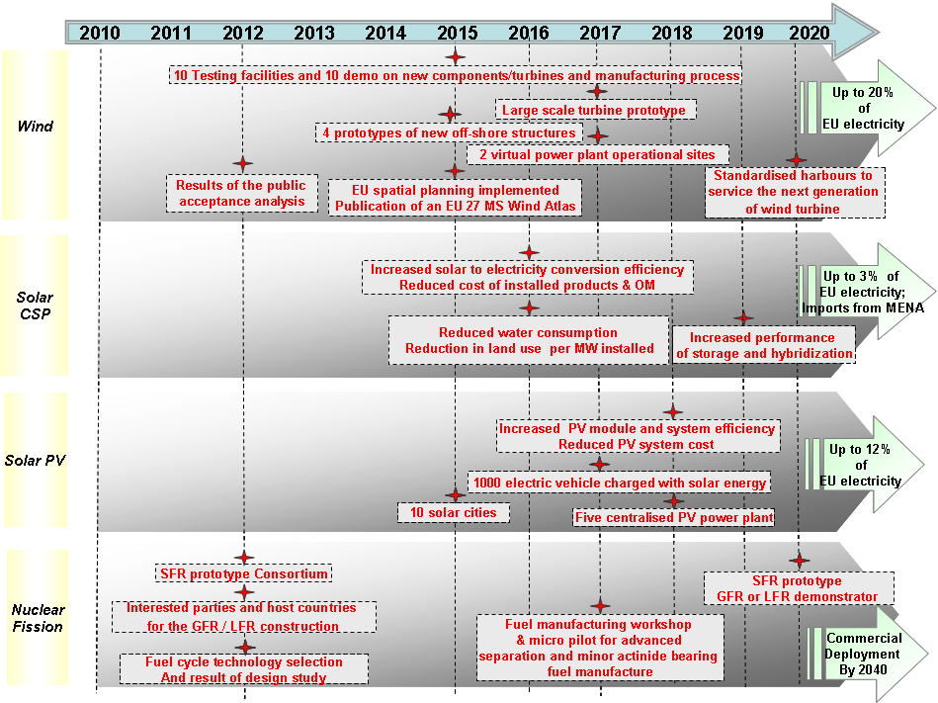
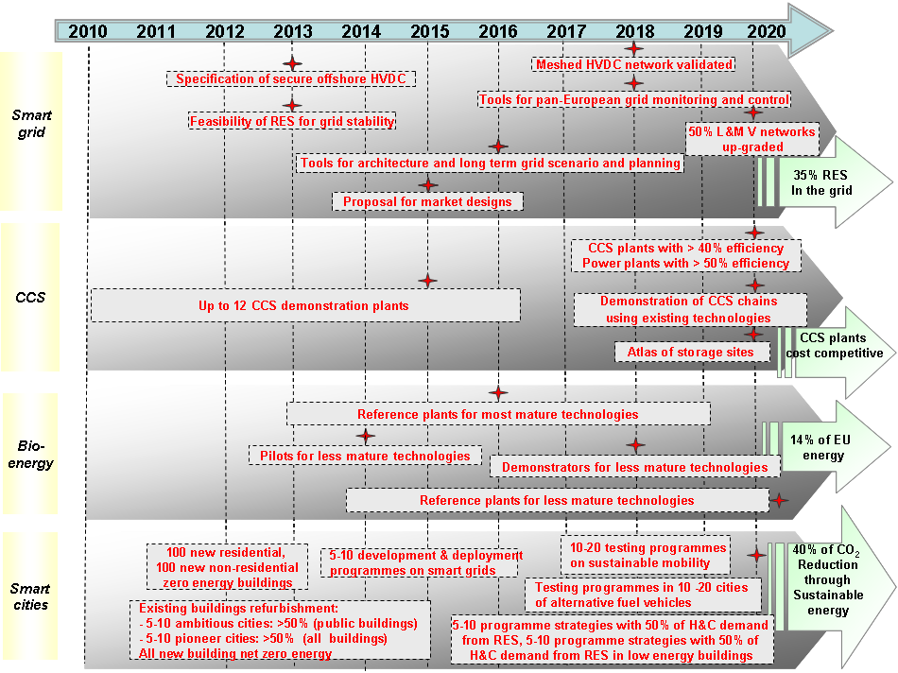

European Energy Research Alliance (EERA)
Achieving Europe's 2020 and 2050 targets on greenhouse gas emissions, renewable energy and energy efficiency will require the deployment of more efficient and advanced technologies. Research and development are essential to develop such new generations of energy technologies, to lower their costs and accelerate the time for market take-up. EERA is the EU response to a better organised and more efficient research based on European excellence. The objectives of the EERA are therefore to accelerate the development of new energy technologies in support of the SET-Plan by strengthening, expanding and optimising EU energy research capabilities through the sharing of world-class national facilities in Europe and the joint realisation of pan-European R&D programmes. In particular a number of joint programming activities are proposed in the areas of wind, solar, CCS, biofuels, geothermal, materials for nuclear energy, etc. These activities will be complemented with key partnerships with industry though the EIIs, universities and non-EU leading research institutes. The cost of the proposed activities is estimated to be 500 million euro per year.

Synergies and Specific Issues
Due to the necessary combination of a range of energy technologies into the future energy mix, several technology roadmaps have prioritised integrating activities. An obvious case is the supply of inherently variable energy sources such as solar and wind into the electricity network, which is addressed in the EII on electricity grid as well as in the relevant technology-specific EIIs. Although currently these activities have been formulated independently, discussions have started between the respective sectors to enhance their coordination, which may take the form of common actions.
It is also noted that, most of the Initiatives focus on delivering cost effective technologies to contribute to the achievement of the 2020 policy goals. However, it is apparent that the scope of their programme extends to 2050 as illustrated by the consideration of long term research activities. In particular, the EII on nuclear fission focuses on the development of a new generation of reactors for the post-2020 horizon. Due consideration of these long-term specific issues needs to be made when progressing towards the implementation of the EIIs.

Cross-Cutting Activities
All Initiatives have addressed a number of common cross-cutting issues that are essential for the successful development of technologies. These issues include public acceptance, human resources and international cooperation.
The transition to a low carbon economy will require the large scale deployment of new types of technology in the EU, which may not be fully known and understood by the public or are associated with controversial issues such as the location of energy generation facilities in general, the utilization of biomass resources, the safety of carbon storage underground, or the safe disposal of nuclear waste. To this end, dedicated activities on public acceptance are envisaged to address the concerns of the public with respect to the roll-out of specific low carbon technologies.
The high penetration of low carbon technologies in the coming years requires a large pool of skilled personnel to secure the foreseen industrial growth. In response to this challenge, a large scale pan-European activity is being planned to create the necessary training schemes, filling the needs of the future technology sectors.
Low carbon technologies have been recognised as a key element for fighting climate change at the global level, hence the coordination of international research and development is crucial. In this context, international cooperation is a key priority of the SET-Plan, which has been transposed into the roadmaps. In particular, several EIIs envisage capacity building and joint research activities in developing economies, such as for building large scale CCS demonstration plants. Knowledge exchange on technology developments, technology transfer or sharing of costly equipment, with developed or emerging economies, either bilaterally or through global institutions may also play a prominent role in many EIIs.

Next Steps
As already stressed in section 2.2, these roadmaps constitute the master-plan for the implementation of the SET-Plan in the next 10 years. The next step is to produce a detailed implementation plan for each EII, prior to their launch. In particular, activities need to be further defined and prioritized according to their level of implementation; the timing of commitment of resources needs to be aligned to priorities and availability of funds; key performance indicators need to be further elaborated and agreed; and concrete projects have to be identified for rapid implementation.
Technology Roadmaps

European Industrial Initiative on Wind Energy

Strategic objective
To improve the competitiveness of wind energy technologies, to enable the exploitation of the offshore resources and deep waters potential, and to facilitate grid integration of wind power.

Industrial sector objective
To enable a 20% share of wind energy in the final EU electricity consumption by 2020.

Technology objectives
1. New turbines and components to lower investment, operation and maintenance costs:
- To develop large scale turbines in the range of 10 - 20 MW especially for offshore applications.
- To improve the reliability of the wind turbine components through the use of new materials, advanced rotor designs, control and monitoring systems.
- To further automate and optimise manufacturing processes such as blade manufacturing through cross industrial cooperation with automotive, maritime and civil aerospace.
- To develop innovative logistics including transport and erection techniques, in particular in remote, weather hostile sites.
2. Offshore technology with a focus on structures for large-scale turbines and deep waters (> 30 m).
- To develop new stackable, replicable and standardised substructures for large-scale offshore turbines such as: tripods, quadropods, jackets and gravity-based structures.
- To develop floating structures with platforms, floating tripods, or single anchored turbine.
- To develop manufacturing processes and procedures for mass-production of substructures.
3. Grid integration techniques for large-scale penetration of variable electricity supply.
- To demonstrate the feasibility of balancing power systems with high share of wind power using large-scale storage systems and High Voltage Alternative Current (HVAC) or High Voltage Direct Current (HVDC) interconnections.
- To investigate wind farms management as “virtual power plants".
4. Resource assessment and spatial planning to support wind energy deployment.
- To assess and map wind resources across Europe and to reduce forecasting uncertainties of wind energy production.
- To develop spatial planning methodologies and tools taking into account environmental and social aspects.
- To address and analyse social acceptance of wind energy projects including promotion of best practices.

Actions
1. New turbines and components to lower investment, operation and maintenance costs:
- A R&D programme focused on new turbine designs, materials and components addressing on- and offshore applications coupled with a demonstration programme dedicated to the development and testing of a large scale turbine prototype (10-20MW).
- A network of 5-10 European testing facilities to test and assess efficiency and reliability of wind turbine systems.
- An EU cross-industrial cooperation and demonstration programme drawing upon the know-how from other industrial sectors (e.g. offshore exploration) for mass production of wind systems focused on increased component and system reliability, advanced manufacturing techniques, and offshore turbines. A set of 5 – 10 demonstration projects testing the production of the next generation of turbines and components will be carried out.
2. Offshore technology with a focus on structures for large-scale turbines and deep waters (> 30 m).
- A development and demonstration programme for new structures distant from shore aiming at lower visual impact and at different water depths (>30m). At least 4 structure concepts should be developed and tested under different conditions.
- A demonstration programme on advanced mass-manufacturing processes of offshore structures.
3. Grid integration techniques for large-scale penetration of variable electricity supply. A programme focused on wind farms management as “virtual power plants” to demonstrate at the industrial-scale:
- Offshore wind farms interconnected to at least two countries and combined with the use of different grid interconnection techniques.
- Long distance High Voltage Direct Current.
- Controllable multi-terminal offshore solutions with multiple converters and cable suppliers.
4. Resource assessment and spatial planning to support wind energy deployment. A R&D programme for forecasting distribution of wind speeds and energy production that includes:
- Wind measurement campaigns.
- Database on wind data, environmental and other constrains.
- Spatial planning tools and methodologies for improved designs and production.

Indicative costs (2010-2020)
Technology objectives | Costs (M€)
1. New turbines and components | 2 500
2. Offshore structure-related technologies | 1 200
3. Grid integration | 2 100
4. Resource assessment and spatial planning | 200
Total | 6 000
This reflects the total sum of the required public and private investments.

Indicative Key Performance Indicators (KPIs)
- Strategic Key Performance Indicator: average wind energy electricity production cost reduced by 20% by 2020
Activities | Key Performance Indicators
1. New turbines and components | - Manufacturing costs of wind turbines and their components reduced by 20% by 2020  - Transport and erection costs of on- and offshore wind turbines reduced by 20% by 2020
2. Offshore structure-related technologies | - Installation costs of offshore wind turbines reduced by 20% by 2020  - Maintenance costs of offshore wind turbines reduced by 20% by 2020
3. Grid integration | - Virtual capacity factor of wind farms reaching 80%
4. Resource assessment and spatial planning | - Wind resources and conditions predicted with an uncertainty of less than 3%

Indicative Roadmap
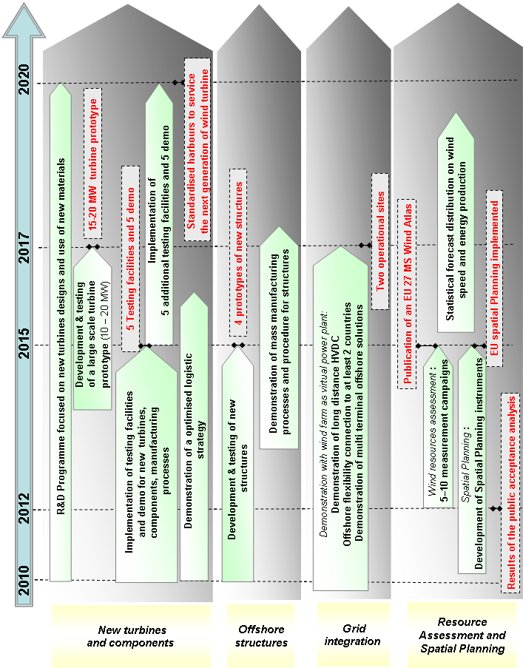

European Industrial Initiative On Solar Energy

European Industrial Initiative on Solar Energy - Photovoltaic Energy

Strategic objective
To improve the competitiveness and ensure the sustainability of the technology and to facilitate its large-scale penetration in urban areas and as free-field production units, as well as its integration into the electricity grid.

Industrial sector objective
Establish photovoltaics (PV) as a clean, competitive and sustainable energy technology providing up to 12% of European electricity demand by 2020.

Technology objectives
1. PV Systems to enhance the energy yield and reduce costs
- To increase conversion efficiency, stability and lifetime.
- To further develop and demonstrate advanced, high-yield, high-throughput manufacturing processes, including in-line monitoring and control
- To develop advanced concepts and new generation of PV systems
2. Integration of PV-generated electricity
- To develop and validate innovative, economic and sustainable PV applications
- To develop grid interfaces and storage technologies capable of optimising the PV contribution to the EU electrical energy supply from installations urban and in green field environments

Actions
To meet these challenges the Initiative proposes the following actions:
1. PV Systems to enhance the energy yield and reduce cost.
- A collaborative technological development programme focused on enhancing the performance and lifetime of PV systems impacts directly on the cost of the electricity generated. Advances in this area need to be driven by better understanding of material behaviour and the realisation of engineered devices with specific characteristics, which have also potential to be reproduced in efficient fabrication processes. Improved system architecture, balance of system components and operational control are needed to complement increases in cell efficiency and ensure higher overall energy output. The scalability of the results will be demonstrated on pilot production environments.
- A collaborative technological development programme on manufacturing process development to address the twin challenges of PV device innovation and scalability to mass production. Advanced high-yield manufacturing processes for substrates, cells and modules, transparent conductive oxides, packaging and encapsulation have to be brought to commercial maturity. Advanced application technologies for active layers, roll-to-roll manufacturing on flexible substrates, high-temperature substrates for ultra-thin polycrystalline silicon cells or high-throughput deposition for other thin-film material systems have to be developed and demonstrated in pilot production lines. Such trials should include a complete range of features so as to facilitate subsequent transfer to production.
- A longer-term research programme aimed at supporting the development of the PV industry beyond 2020. Advanced concepts which need to be investigated and checked for feasibility include up/down converters, quantum and plasmonic effects to boost efficiency, device concepts for organic/ inorganic hybrids and multi-junction materials, and bulk-type intermediate band materials.
2. Integration of PV-generated electricity
- A technology development and demonstration programme for Building-Integrated PV (BIPV). Aesthetics and suitability are the challenges that relate to both the appearance and functionality of the module and its support structure. Advanced BIPV modules need to be developed which are multifunctional, self-cleaning and serve as construction elements. To support the large-scale deployment in typical urban environments and small decentralised communities demonstration projects ("Solar Cities") will be promoted.
- A technology development and demonstration programme on stand-alone and large ground-based PV systems, such as simplified module mounting structures, combined inverter and tracker electronics, combined maximum power point and smart tracking control, low cost support structures, cabling and electrical connections need to be accelerated. A portfolio of demonstration projects for ground-based PV power plants on the scale of 50-100 MW each would deliver proof of concept in terms of feasibility, costs and benefits.
- A technology development and demonstration programme on connection to electricity networks and advanced power storage devices. It is very important to develop system components, including highly efficient inverters with new semiconductor materials (SiC, GaN), controllers and dedicated energy management tools (models, software and hardware). Introduction of new storage technologies in pilot units for large-scale field trials and assessment of their lifetime and cost will promote the deployment of such systems and improve the dispatchability to the grid of the electricity generated. . The same applies for the development of active distribution systems, with improved functionality regarding voltage regulation, power management and use of distributed energy storage.

Indicative costs (2010-2020)
Technology objectives | Costs (M€)
1. PV systems | 5 500
2. Integration of PV-generated electricity | 3 500
Total | 9 000
This reflects the total sum of the required public and private investments.

Indicative Key Performance Indicators (KPIs)
Actions | Key Performance Indicators (KPI)
1. PV system | - Reduced conventional turnkey PV system cost to <1.5€/Wp by 2020  - Reduced concentrated PV system cost to <2€/Wp by 2020  - Increased PV (module) conversion efficiency to > 23 % by 2020  - Increased conversion efficiency of concentrated PV to > 35% by 2020  - Increased crystalline silicon and thin film modules lifetime to 40 years
2. Integration of PV-electricity generation | - Increased inverter lifetime to >25 years by 2020  - Battery storage cost < 0.06 €/kWh and life > 25 years

Indicative Roadmap
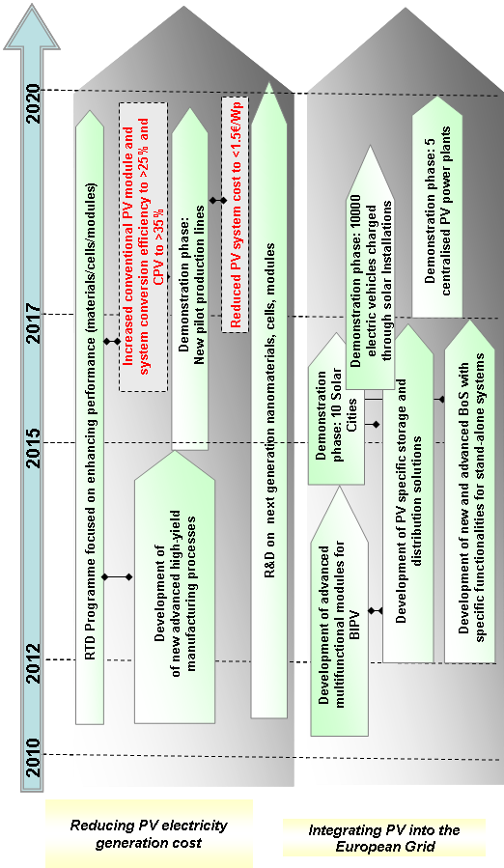

European Industrial Initiative on Solar Energy – Concentrating Solar Power

Strategic objective
To demonstrate the competitiveness and readiness for mass deployment of advanced concentrating solar power (CSP) plants, through scaling-up of the most promising technologies to pre-commercial or commercial level.

Industrial sector objective
To contribute around 3% of European electricity supply by 2020 with a potential of at least 10% by 2030 if the DESERTEC vision is achieved.

Technology objectives
Achieving large-scale, sustainable deployment of advanced CSP plants with better performance and lower costs requires addressing a series of technical issues, as well as carrying out a parallel series R&D and demonstration activities designed to better exploit the inherent strengths of CSP technology.
1. Reduction of generation, operation and maintenance costs
- To improve the conversion efficiency at system level as well as the reliability and efficiency of individual components.
- To develop advanced plant monitoring and control technologies.
2. Improvement of operational flexibility and energy dispatchability
- To develop and improve thermal energy storage, as well as hybridisation of the power plant with natural gas and potentially with bio-mass renewable energy.
3. Improvement in the environmental and water-use footprint
- To reduce the cooling water consumption through innovative cycles, by developing dry cooling systems and optimising land use through new and innovative designs.
- To demonstrate CSP-specific sustainable water desalination processes.
4. Advanced concepts & designs
- To address advanced components, concepts and systems.

Actions
1. Reduction of generation, operation and maintenance costs
- A R&D & demonstration programme to address individual components as well as the overall conversion efficiency and to reduce the investment cost of the installations, as well as the operation and maintenance costs. Some of the specific aspects may need to be addressed on a small-to-medium scale before moving to demonstration in full-scale power plants.
1.1 Development and test of new components with increased efficiency and reliability (high temperature joints, new collector designs, improved absorber tubes, new reflector solutions, improve pumps and valves, improved the power block and instrumentation);
1.2 Decrease the heat losses in the receiver;
1.3 Reduction of optical losses by increased mirror reflectivity and receiver absorption;
1.4 More efficient cycles and receivers:
- high efficiency air receivers
- high pressure, high efficiency steam receivers
1.5 Operation with heat transfer fluids at higher temperatures.
1.6 Development and testing of new, more economic components i.e. high temperature joints, absorber tubes, new reflector solutions and collector design, pumps and power blocks, as well as heat transfer fluids;
1.7 Identification, development and assessment of alternative heat transfer fluids with lower costs, low environmental impact and a wide operation range;
1.8 Optimise and improve the monitoring and communication technologies for the control, operation and maintenance of CSP power plants, as well as developing operation strategies and prediction tools to better facilitate grid integration.
2. Improvement of operational flexibility and energy dispatchability
- A R&D and demonstration programme addressing thermal energy storage and CSP plant hybridization with other energy sources in order to increase the ability to deliver electricity at any given time. Some of the aspects may need to be addressed on a small-to-medium scale before moving to full-scale demonstration on plants.
2.1 New and improved concepts and materials for heat energy storage and heat transfer systems will be developed and tested (transfer fluids, filler materials, change of phase systems, molten salts, ultra capacitors etc.) and implemented in large-scale demonstration plants;
2.2 New process design and operating modes;
2.3 Hybridisation of solar energy with other renewable energy sources (mostly biomass);
2.4 Development of control systems for monitoring the consumption curves.
3. Improve the environmental footprint
- A R&D and demonstration programme addressing water cooling needs, dry cooling, water desalination and purification as well as the efficient and innovative use of land.
3.1 New approaches to reduce water consumption, e.g. through innovative use of an organic Rankine cycle (ORC) coupled with conventional steam cycle;
3.2 Develop and demonstrate dry cooling systems;
3.3 Develop and demonstrate CSP-specific sustainable water desalination and purification processes;
3.4 Integration of low-polluting materials;
3.5 Better utilisation of available land through new design strategies;
4. Advanced concepts & designs
- A longer-term R&D programme aimed at supporting the longer-term CSP industry development (beyond 2020) will focus on advanced concepts and systems, as well as innovative approaches to the critical major components.

Indicative costs (2010-2020)
Technology Objectives | Costs (M€)
1. Increase efficiency & Reduce generation costs | 4 400
2. Increase dispatchability | 1 700
3. Improve the environmental footprint | 800
4. Longer term R&D | 100
Total | 7 000
This reflects the total sum of the required public and private investments.

Indicative Key Performance Indicators (KPIs)
Activity | Key Performance Indicators
1. Increase efficiency & Reduce cost | - Increased solar to electricity conversion efficiency by at least 20% (relative)  - Reduce cost of installed products and O&M by at least 20% compared with state of the art in commercial plants in 2009
2. Increase dispatchability | - Increased performance of storage and hybridisation by at least 20%
3. Improve the environmental profile | - Substantial reduction of water consumption with only minor loss of performance  - Substantial reduction in land use per MW installed

Indicative Roadmap
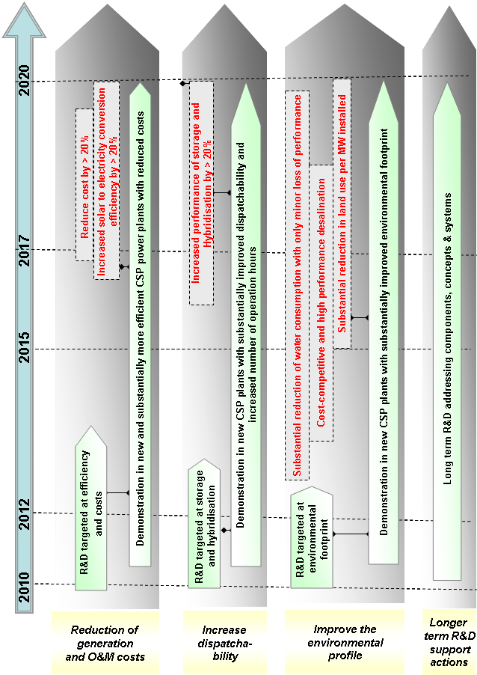

European Industrial Initiative on Bioenergy

Strategic objective
To address the technical-economic barriers to the further development and accelerated commercial deployment of bioenergy conversion technologies for widespread sustainable exploitation of biomass resources.

Industrial sector objective
To ensure at least 14% bioenergy in the EU energy mix by 2020, and at the same time to guarantee GHG emission savings of 60% for bio-fuels and bio-liquids under the sustainability criteria of the new RES directive.

Technology objectives
1. Bring to commercial maturity the currently most promising technologies and value-chains through the development and optimisation of feedstock-flexible thermochemical pathways and biochemical pathways, in order to promote large-scale, sustainable production of advanced biofuels and highly efficient heat & power from biomass. This will require scaling up and optimization of process integration, with focus on the improvement of feedstock flexibility, energy and carbon efficiency, capex efficiency, reliability and maintenance of plants.
2. Contribute to a set of activities in the field of biomass feedstock availability assessment, production, management and harvesting in support of the up-scaling of promising technologies. Biomass availability, production and harvesting are not specific to the bioenergy use of biomass and are to be addressed in a coherent effort shared with relevant stakeholders and initiatives.
3. Develop a longer term R&D programme to support the Bioenergy industry development beyond 2020.

Actions
1. Optimisation of the most promising value chains within thermo-chemical (characterised by the use of high temperature transformations) and biochemical (characterised by the use of biological and chemical processes) pathways. As within the current R&D efforts in Europe, several technology options have shown promising performances at pilot scale, this calls for a collaborative programme of demonstration and first-of-this-kind industrial-size plants depending on the level of maturity of each specific value chain, supported by targeted RTD actions. If pilot plants aim at establishing technical performance, demonstration plants (D) are the last non-economic step to demonstrate the performance and reliability of all critical steps in a value chain. First-of-this-kind industrial-size plants (F) are then the first commercial unit operating at an economically viable scale.
Within the thermo-chemical pathways, the five generic value chains listed below will be optimised for the production of gas, liquids, heat and power from a large variety of lignocellulosic material. Activities will include the optimised use of advanced catalysts and the improvement of gas cleaning technologies and quality/stability of bioliquids.
A: Production of synthesis gas (syngas) as an intermediary to create liquid fuels (e.g. gasoline, naphtha, kerosene or diesel fuel) and chemicals (1-2D and 2-3 F plants)
B: Production of bio-methane and other bio-synthetics gaseous fuels through gasification (1-2D and 2-3 F plants)
C: Optimisation of syngas combustion to produce heat and electrical power (2-3 F plants).
D: Optimisation of the production of bioenergy carriers such as bio-oil and solid intemediates (2-3 F plants).
E: Co-processing of biomass and bio-energy carriers with petroleum oil (2-3 F plants).
Within the biochemical pathways, the following three value chains will be optimised for the production of gas and liquids from biomass, including the optimisation of feedstock pre-treatment and downstream processing and the optimised use of advanced enzymes, ensuring the optimum production of valuable co-products where possible:
A: Production of ethanol and higher alcohols from ligno-cellulosic feedstock (agricultural and forest biomass – either residues or dedicated crops- and urban municipal solid waste) with simultaneous production of valuable co-products (1-2D and 2-3F plants working with different types of biomass).
B: Synthesis of hydrocarbons (e.g. diesel and jet fuel) through biological and/or chemical process from biomass containing carbohydrates. (2-3D and 1-2F plants preceded by some RTD activities and pilots)
C: The micro-organism (algae, bacteria)-based production of bioenergy carriers (e.g. bio-oils) from CO₂ and sunlight, and further upgrading into transportation fuels (e.g. biodiesel and aviation fuels) and valuable by-products (2-3D and 1-2 F).
2. The pre-requisite for the implementation of the above mentioned programme of demonstration and first-of-this-kind industrial-size plants will be an assessment of the biomass availability, and the development/optimisation of technologies and logistics for sustainable feedstock production, management and harvesting. A set of activities will therefore be implemented together with concerned stakeholders to assess sustainable biomass availability in Europe, to develop improved crops (including aquatic crops) suitable for the production of biofuels or chemicals, to develop better harvesting technologies, to improve forest management techniques or the fuel extraction from waste.
3. A longer-term R&D programme to support the bioenergy industry development beyond 2020. This involves the construction of a couple of pilot plants followed by a couple of demonstration plants, possibly around 2018. This action will focus on the identification and development of new value chains able to further improve the performance of the concerned processes and/or to permit the exploitation of new raw materials under sustainable conditions.
All the actions and relative indicative costs are summarised in the tables that follow.

Summary of actions
Technology pathways /  Generic value-chains and support activities | Maturity in Europe | Estimated N° of plants | Potential specific value-chains
1. Optimisation of the most promising value chains
Thermochemical pathways |  | 2-4D, 10-15F
A: Liquid fuels (e.g. gasoline, naphtha, kerosene or diesel fuel) and chemicals through gasification. | Pilot & demo | 1-2D, 2-3F | Example of potential specific value chains for the thermochemical pathways are:  - Bio-dimethyether (DME) and methanol from black liquor  - Fisher-Tropsch diesel and naphtha from waste wood, forest residues, short rotation crops, straw forest residues, stumps, bark  - Bio-methane from dry lignocellulosic biomass  - Bio-oil for light/heavy oil applications from forest residue
B: Bio-methane and other bio-synthesitic gaseous fuels through gasification. | Pilot | 1-2D, 2-3 F
C: Heat and electrical power through gasification. | Demo | 2-3 F
D: Intermediate bioenergy carriers through techniques such as pyrolysis and torrefaction. | Pilot & demo | 2-3 F
E: Co-processing biomass and/or bio-energy carriers with petroleum oil. | Demo | 2-3 F
Biochemical pathways |  | 5-8D, 4-7 F
A: Ethanol, higher alcohols and valuable co-products from ligno-cellulosic feedstock through chemical and biological processes. | Pilot & demo | 1-2D, 2-3 F | Example of potential specific value chain for the biochemical pathways are:  - Ethanol from dedicated feedstocks, agricultural bio-products, wood wastes  - Ethanol, animal feed and fertiliser from food industry waste and side streams  - Ethanol, C5 molasses, lignin pellets from wheat straw  - Biodiesel from algae
B: Hydrocarbons (e.g. diesel and jet fuel) through biological and/or chemical Synthesis from biomass containing carbohydrates. | Lab | 2-3D, 1-2 F
C: Transportation fuels (e.g. biodiesel and aviation fuels) and valuable by-products from bioenergy carriers produced by micro-organisms (algae, bacteria). | Pilot | 2-3D, 1-2 F
2-3.Supporting and complementary activities |  |  | Types of activities
2: Contribution to activities on biomass feedstock assessment, production, management and harvesting for energy purposes |  | 2-3 P, 1D | Studies on biomass availability assessment, R&D on improved and new crops (including aquatic crops) and pilots/demonstration on optimised technologies and logistics for sustainable feedstock production, management and harvesting.
3: Identification of new value chains via longer term RTD programmes |  | 1-2P, 1-2 D | Various R&D, pilot and demonstration activities

Indicative costs (2010-2020)
Technology Objectives | Costs (M€)
1. Optimisation of the most promising value chains via:
a. Thermochemical pathways from lingo-cellulosic feedstock | 4 500
b. Biochemical pathways | 3 400
2. Support activities on biomass feedstock assessment, production, management and harvesting for energy purposes | 600
3. Identification of new value chains via longer term RTD programmes | 400
Total | 9 000
This reflects the total sum of the required public and private investments.

Indicative Key Performance Indicators (KPIs)
For electricity generation
- Investment cost < 1500 €/kWe by 2015-2020
- Electricity production cost < 0.05 €/kWh by 2015-2020
For Biofuels production
- Biofuel production cost < 0.6 € /litre gasoline equivalent (2008 equivalent)
- Capital investment and operation costs in line with fossil industry refinery costs

Indicative Roadmap
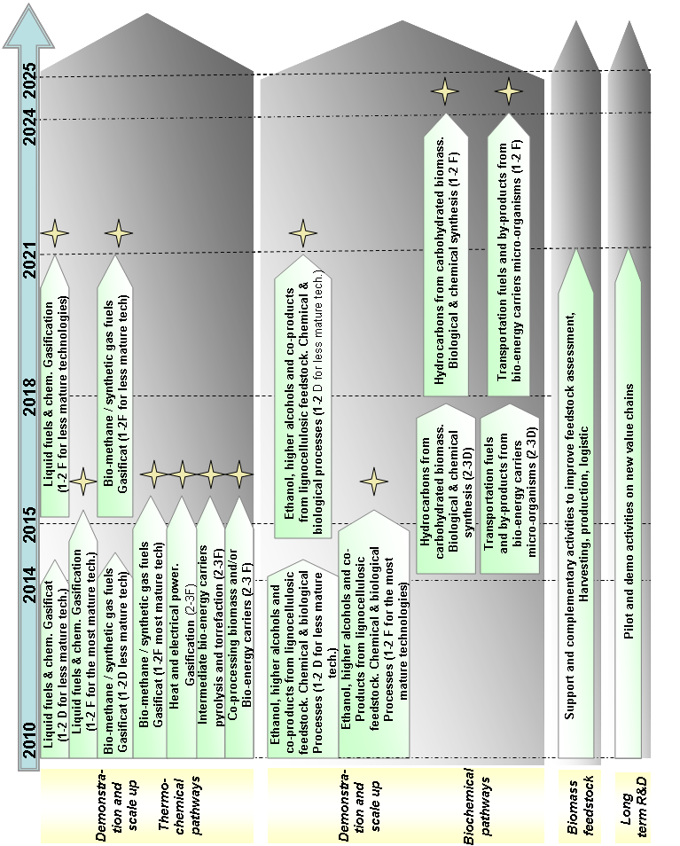

European Industrial Initiative on Carbon Capture and Storage

Strategic objective
To demonstrate the commercial viability of carbon capture and storage (CCS) technologies in an economic environment driven by the emissions trading scheme. In particular, to enable the cost competitive deployment of CCS technologies in coal-fired power plants by 2020-2025 and to further develop the technologies to allow for their subsequent wide-spread use in all carbon intensive industrial sectors.

Industrial sector objective
To enable European fossil fuel power plants to have near to zero CO₂ emissions by 2020.

Technology objectives
1. Proving the technical and economic feasibility of CCS using existing technology
- To test the most promising CO₂ capture, transport and storage technologies at large scale in a fully integrated chain (called CCS chain hereafter) and optimise their operational performance, for demonstrating the technical feasibility and safety of the CCS concept.
- To reduce the costs of CO₂ capture (currently estimated to be around 60-90 € per tonne of CO₂ abated) and therefore to lower the cost of electricity produced by CCS-equipped power plants through learning effects, thus making CCS technology cost competitive in the European power generation system.
2. Developing more efficient and cost competitive CCS technologies
- To further improve the efficiency of conventional (non-CCS) power plants that will enable the utilisation of CO₂ capture technologies at a minimum overall efficiency penalty.
- To develop new capture concepts that will pave the way for next generations of CO₂ capture technologies, marked by improved performance (i.e. lower efficiency penalty and cost of capture), which will result in further reductions of electricity costs to levels comparable to or lower than those associated with other future low-carbon technologies.
- To further optimise capture technologies for expanding their use to other carbon-intensive sectors such as the cement, refineries and the iron and steel industries.
- To develop alternative technologies for CO₂ transport and storage that will enable the geographically broader deployment of CCS technologies.

Actions
1. Proving the technical and economic feasibility of CCS using existing technology
- Realisation of a large scale demonstration programme for the construction and operation of a fleet of up to 12 large-scale first-of-a-kind power plants that capture, transport and store the majority of the CO₂ generated during their operation. The aim of the demonstration programme will be to test CCS technologies and their integration on a large scale and demonstrate their long term operational availability and reliability. The operation of the plants will commence by 2015 in the power sector to allow a sufficient track record by 2020 and provide the necessary learning for the next generation of CCS plants to come on stream in power generation and industrial sectors soon after 2020. The early demonstration programme will ensure that the first CCS projects will not focus only on the simplest technological solutions but collectively develop a coherent portfolio that will demonstrate CCS chains comprising different capture (post-combustion, pre-combustion, oxyfuel) and storage (on- and offshore saline aquifers and hydrocarbon fields) options using different fossil fuel types.
- Establishment of a network of CCS projects representing the portfolio of demonstration plants, aiming at a structured and coordinated knowledge sharing and the development of joint activities concerning public acceptance, international cooperation, identification of future R&D priorities, etc. The network will facilitate the identification of best practises through information sharing; achieve cost savings for projects by undertaking joint activities in areas where synergies can be best developed and exploited, and leverage the projects for increasing public acceptance of CCS by using them as evidence of the safety of geological storage of CO₂.
2. Developing more efficient and cost competitive CCS technologies
- Establishment of an R&D programme that will address:
- Fossil fuel conversion technologies aimed at improving power plant efficiency in all main fossil fuel power generation routes to better compensate for the efficiency penalty imposed by CO₂ capture.
- Capture technologies aimed at improved efficiency and cost-effectiveness and their better integration in power generation. This includes research on new components and technologies, such as solvents and membranes. New technology options, whenever mature, will be first tested through pilot plants. Such testing will ultimately contribute to the optimisation of processes in large plants.
- Transport and storage concepts aimed at identifying and quantifying storage capacities in Europe; as well as injection and monitoring technologies to track CO₂ in underground reservoirs and to detect leaks. Research in CO₂ transport includes improved materials for pipelines and terminal storage installations as well as development and testing of ship transport concepts.
- Use of CCS technologies in other industrial sectors focusing on the research for the application of capture technologies to carbon-intensive industrial sectors such as cement, steel, refineries, etc.

Indicative costs (2010-2020)
Technology Objectives | Costs (M€)
1. Proving existing technology (additional costs for CCS only) | 8 500 - 13 000
2. Developing more efficient and cost competitive CCS technologies | 2 000 - 3 500
Total | 10 500 - 16 500
This reflects the total sum of the required public and private investments.

Indicative Key Performance Indicators (KPIs)
- Strategic Key Performance Indicator: Cost of CCS technology (including capture, transport and storage) in power plants reduced by 30-40% by 2020
Specific KPIs
- Average annual load factor of at least 80% in CCS power plants by 2020
- Average annual CO₂ capture rate of at least 90% in CCS power plants by 2020
- Net efficiency of coal fired power plants equipped with CCS (pulverised coal with post-combustion capture, IGCC with pre-combustion capture, or oxyfuel) higher than 40% by 2020.
- Net efficiency of conventional coal fired power plants higher than 50% by 2020.
- Publication of an accurate atlas of CO₂ storage sites in Europe and an outline of the European transport infrastructure by 2020
- First commercial deployment of CCS technologies to energy intensive industrial applications by 2025.

Indicative Roadmap
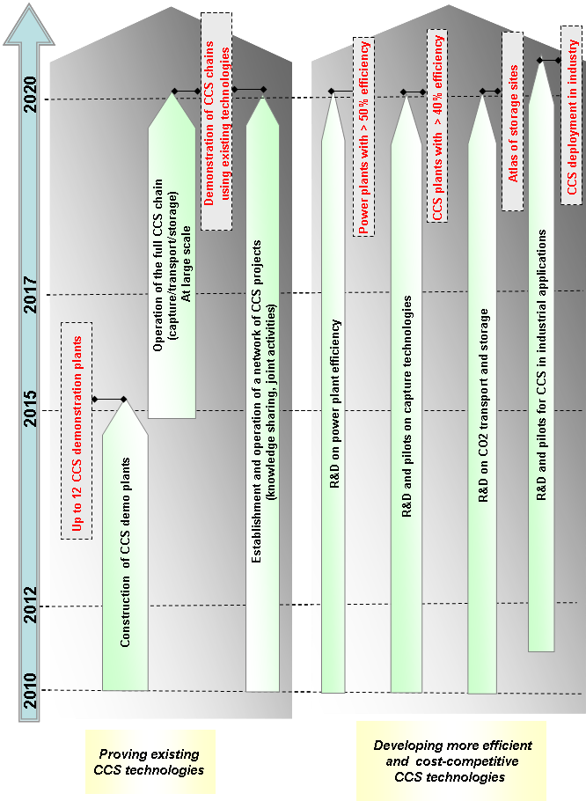

European Industrial Initiative on the Electricity Grid

Strategic objective
To transmit and distribute up to 35% of electricity from dispersed and concentrated renewable sources by 2020 and a completely decarbonised electricity production by 2050; to integrate national networks into a market-based truly pan-European network, to guarantee a high quality of electricity supply to all customers and to engage them as active participants in energy efficiency; and to anticipate new developments such as the electrification of transport.

Industrial sector objective
To substantially reduce capital and operational expenditure for the operation of the networks while fulfilling the objectives of a high-quality, low-carbon, pan-European, market based electricity system.

Technology objectives
1. Developing and validating advanced network technologies to improve flexibility and security of the network, and to mitigate future capital and operational expenditure. These include new high-power equipment, integration of electricity storage and monitoring and control systems.
2. Preparing the long-term evolution of electricity grids to ensure the proper investments are made in the coming years to address the requirements of the future portfolio of electricity generation and consumption.
3. Engaging the active participation of customers in energy markets and energy efficiency through better information about their consumption, incentives such as dynamic pricing mechanisms and appropriate ICT tools.
4. Elaborating and testing innovative market designs to ensure a proper functioning of the internal market for electricity both at European and local scale.
Structured interactions will be setup with the other industrial initiatives, particularly on wind and solar energy and with the public-private partnerships on green cars and on efficient buildings, to ensure a coordinated development of the appropriate technologies, and where appropriate, to organise joint demonstration activities.

Actions
A balanced research and demonstration programme led by Transmission and Distribution System Operators (TSO's and DSO's) is required that includes in the demonstration part of the programme a set of 20 large scale projects, covering diversified geographical, social and climate conditions, involving a total of at least 1.5 million customers. All the actions will be fully in line with the 3rd Internal Energy Market package.
1. Network technologies
- R&D & demonstration activities to validate state-of-the-art power technologies for transmitting and controlling the flow of large amounts of power over long distances and from offshore sources and to develop new monitoring and control systems to ensure the integration of large numbers of variable renewable energy sources while providing the expected power quality and voltage, and to operate pan-European networks in normal and critical conditions. These solutions will also consider the integration of electricity storage and facilitate the introduction of large numbers of electric vehicles.
- Demonstration activities on solutions for automating distribution network control and operation, including self-healing capabilities. These will increase power quality and reduce operational expenditure
2. Long-term evolution of electricity networks
- R&D activities to develop modelling and planning tools for the long-term evolution of the grid, and validating innovative pan-European grid architectures, needed to increase the capacity to transport large quantities of renewable energy from all sources and to develop methods and tools for asset management, for preventive maintenance and for optimising the assets' life cycle.
3. Active customers
- Demonstration activities on different solutions to activate demand response for energy saving, for the reduction of peak consumption and for balancing variable renewable electricity generation using visualisation of consumption for consumers, dynamic time of use tariffs and home automation technologies (up to 500000 customer points) and on solutions for smart metering infrastructure to unlock the potential of smart meters as the key to provide detailed information to customers, and to provide benefits to retailers and network operators, identifying regulatory, technical and economic opportunities.
4. Innovative market designs
- R&D activities on cross-cutting issues to proposing market designs that provide incentives for all actors to contribute to the overall efficiency, cost-effectiveness and carbon footprint of the electricity supply system to provide inputs to updates of regulatory frameworks to ensure their following the policy and technology developments.

Indicative costs (2010-2020)
Technology Objectives | Total (M€)
1. Network technologies | 1 200
2. Long-term evolution | 100
3. Active customers | 600
4. Innovative market designs | 100
Total | 2 000
This reflects the total sum of the required public and private investments.

Indicative Key Performance Indicators (KPIs)
- Number of customers involved (at least 1.5 million).
- Greatly increased capacity to host RES electricity from central and distributed sources, (to at least 35% of electricity consumption) including readiness for massive off-shore wind integration.
- Increased overall quality of electricity supply (by a 2-10% reduction of energy not supplied).
- Reduced peak to average load ratio (by 5-10%) and thus reduced need for investments.
- Full integration of customers in market mechanisms promoting energy efficiency and active demand practices.

Indicative Roadmap
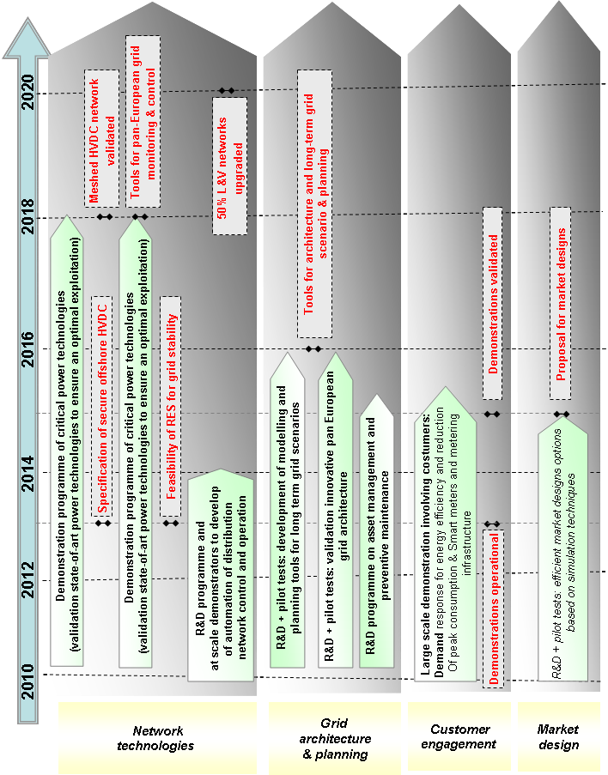

European Industrial Initiative on Sustainable Nuclear Energy

Strategic objective
A vast increase in the sustainability of nuclear energy through demonstrating the technical, industrial and economic viability of Generation-IV fast neutron reactors (FNRs), thereby ensuring that nuclear energy can remain a long-term contributor to the low carbon economy and building on the safety, reliability and competitiveness of current reactors.

Industrial sector objective
To enable the commercial deployment of Generation-IV FNRs from 2040, while in the meantime maintaining at least a 30% share of EU electricity from currently available reactors with an expansion towards the cogeneration of process heat for industrial applications when such markets develop.

Technology objectives
1. Through the design, construction and operation of a prototype sodium fast reactor (SFR), considered as the reference FNR technology, and a demonstrator reactor of alternative technology (either gas or lead cooled fast reactor – GFR or LFR), demonstrate that FNRs:
- are able to exploit the full energy potential of uranium by extracting up to 100 times more energy than current technology from the same quantity of uranium;
- have the ability to "burn" (i.e. eradicate though nuclear transmutation in the reactor) the "minor actinides" produced in the fuel during reactor operation by recycling these minor actinides in fresh fuel, and in so doing significantly reduce quantities, heat production and (by factors of up to 1000) hazardous lifetime of the ultimate waste for disposal;
- attain safety levels at least equivalent to the highest levels attainable with Generation II and III reactors;
- eliminate proliferation risks by avoiding separation of weapon's grade fissile material at any point during the fuel cycle;
- can attain levelised electricity and heat production costs on a par with other low carbon energy systems.
2. The refurbishment and/or design, construction and operation of infrastructures needed to support the design and/or operation of prototype and demonstrator FNRs, in particular
- fuel fabrication facilities to develop and manufacture driver fuel and minor actinide bearing fuels for the prototype and demonstrator;
- facilities for the development of materials and components, code validation and qualification, and design and validation of safety systems.
3. A comprehensive programme of R&D supporting all aspects of the design, construction and operation of the prototype, demonstrator and support infrastructure. Cross-cutting R&D will also benefit current reactors in terms of maintaining safety and radiation protection, increasing performance and competitiveness, ensuring lifetime management, and implementing solutions for waste management.

Actions
Thanks to past and current R&D efforts in Europe, considerable experience in the various technology options has already been acquired, and international cooperation in basic R&D is on-going as part of the Generation-IV International Forum (GIF). From this solid basis collaborative programmes of demonstration plants (prototypes and demonstrators) will emerge, supported by dedicated R&D programmes and infrastructures. Owing to the length of time before commercial deployment, the EII on sustainable nuclear energy is possible only with significant public funding. International cooperation for building prototypes and demonstrators might provide a wider financing base in some cases. In the following actions, pilot plants aim at establishing technical performance, demonstrators are the last pre-commercial step to demonstrate the performance and reliability of all key aspects of the technology, and prototype reactors, the most advanced stage prior to commercial deployment, are the first to be coupled to the electricity grid in order to demonstrate economic viability.
1. Design, construction and operation of a prototype sodium fast reactor (SFR) coupled to the grid
- Finalise the design and obtain a license for the construction of the SFR prototype in the range 250-600 MW_{e}, with start of operation by 2020;
- Demonstrate the safety of SFR technologies by analysis and experiment, in particular by prevention and mitigation of severe accidents, including those linked to sodium;
- Demonstrate the economic competitiveness and identify key areas for further cost reduction of SFR technologies (improvements in operability through monitoring, inspection and fuel handling, design options, material selection, increase of fuel burn-up) by return of experience from operation between 2020 and 2030;
- Demonstrate, by return of experience, significantly reduced long-term burden of ultimate radioactive waste for final geological disposal through recycling and nuclear transformation in the reactor of all actinides (including minor) extracted from spent nuclear fuel.
2. Design, construction and operation of a demonstrator (not coupled to the grid) of alternative technology, either gas or lead cooled fast reactor (GFR or LFR)
- Perform comparative assessment of GFR and LFR technologies by 2012 and selection of reactor system for the demonstrator;
- Finalise the design and obtain a license for the construction of the demonstrator in the range 50-100 MWth, with start of operation by 2020;
- Demonstrate the technical performance and reliability of the alternative technology and identification of design modifications for overall performance improvement;
- Demonstrate safety and waste minimisation performance by return of experience 2020-30 and identify further improvements in safety design and fuel cycle;
- Based on the return of experience 2020-30, prepare the design for a prototype;
- In the case of GFR, extend the range of applications of nuclear energy beyond the production of electricity through developing high temperature heat supply capabilities.
3. Supporting infrastructures for prototype and demonstrator
- Design the necessary fuel fabrication workshops for the SFR prototype and alternative demonstrator reactor, dedicated to uranium-plutonium driver and minor actinide bearing fuels;
- Obtain licenses for construction of the fuel fabrication workshops and start the operation by 2017 in order to produce fuel for the prototype and demonstrator reactors at the time of their start-up in 2020;
- Design, construct or upgrade a consistent suite of experimental facilities for component design, system development and code qualification and validation that are essential in order to perform design and safety analyses in support of the prototype and demonstrator reactors (hot cells, gas loops, liquid metal loops, irradiation facilities, …)
4. Cross-cutting R&D programme
- Basic and applied research to support the activities foreseen in the actions above. In particular, the development of simulation and testing tools and associated methodologies to support the design and operational assessment of the reactors and support facilities. This will draw heavily on current R&D programmes, but efforts in all domains need to be intensified and focused on the EII objectives. Much of this research will be linked to nearer term R&D activities of relevance for current nuclear technology, e.g. design and operational safety and radiation protection, waste management, component ageing and lifetime management, materials science and multiscale modelling of material behaviour (structural materials, fuels, cladding), code development and qualification, severe accident management, etc.

Indicative costs (2010-2020)
Activities | Costs
Prototype sodium fast reactor | €2-4 billion, depending on the electrical power (250-600 MW_{e}) and technical options
Demonstrator alternative fast reactor | €600-800 million¹⁹ (50-100 MWth)
Supporting infrastructures | Fuel fabrication workshops: €600 million (U-Pu fuel) + €250-450 million (prototype fuel)  Experimental facilities: €600-1600 million depending on the need for a specific fast neutron irradiation facility
Cross-cutting R&D programme | €1-2 billion
Total | € 5-10 billion
This reflects the total sum of the required public and private investments.

Indicative Key Performance Indicators (KPIs)
1. Demonstration of the safety and security credentials of the fast neutron reactors by obtaining a license to enable operation of the prototype and demonstrator reactors to start in 2020.
2. By 2020, through the operation of the fuel fabrication workshops:
- production of up to several tonnes of driver fuel per year;
- development of high performance minor actinide bearing fuel with a production of up to tens of kilograms per year.
3. Demonstration, through the operation of the prototype and demonstrator reactors starting in 2020, of the long-term sustainability of nuclear energy by exploiting at least 50% of the energy content of uranium and significantly reducing the thermal load and lifetime (by up to a factor of 1000) of ultimate high-level nuclear waste for final disposal.
4. Demonstration by 2025 that the levelised cost for the electricity generation using future nuclear reactors is comparable with costs of other sources of low carbon electricity (e.g. Generation-III levelised cost of electricity generation).

Indicative Roadmap
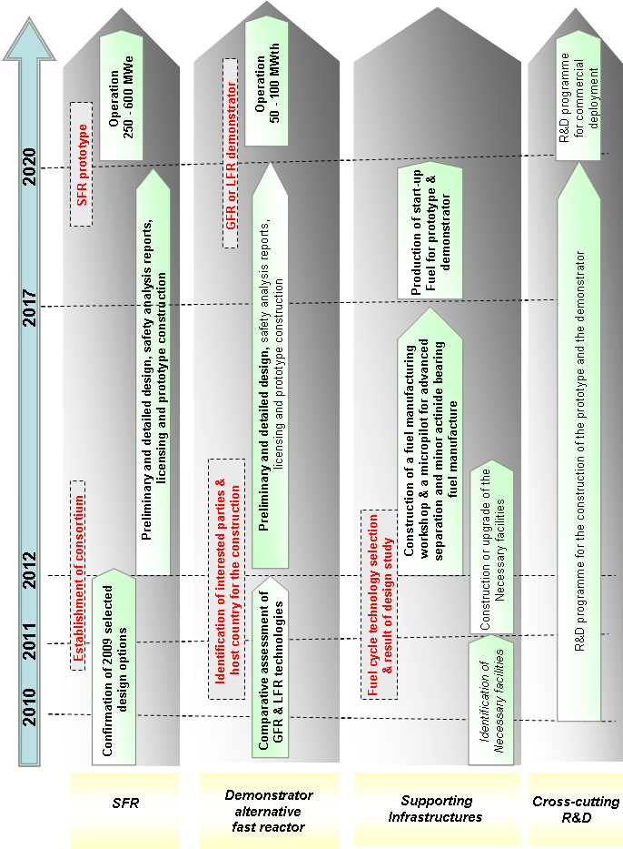

European Initiative on Smart Cities

Strategic objective
To demonstrate the feasibility of rapidly progressing towards our energy and climate objectives at a local level while proving to citizens that their quality of life and local economies can be improved through investments in energy efficiency and reduction of carbon emissions. This Initiative will foster the dissemination throughout Europe of the most efficient models and strategies to progress towards a low carbon future.
This Initiative will support cities and regions in taking ambitious and pioneering measures to progress by 2020 towards a 40% reduction of greenhouse gas emissions through sustainable use and production of energy. This will require systemic approaches and organisational innovation, encompassing energy efficiency, low carbon technologies and the smart management of supply and demand. In particular, measures on buildings, local energy networks and transport would be the main components of the Initiative.
The Initiative builds on existing EU and national policies and programmes, such as CIVITAS, CONCERTO and Intelligent Energy Europe. It will draw upon the other SET-Plan Industrial Initiatives, in particular the Solar and Electricity Grid, as well as on the EU public-private partnership for Buildings and Green Cars established under the European Economic Plan for Recovery. The local authorities involved in the Covenant of Mayors (more than 500 cities) will be mobilised around this initiative to multiply its Impact.

Specific objectives
- To trigger a sufficient take-up (reaching 5% of the EU population) of energy efficient and low carbon technologies to unlock the market.
- To reduce by 40% the greenhouse gas emissions by 2020, that will demonstrate not only environmental and energy security benefits but also to provide socio-economic advantages in terms of quality of life, local employment and businesses, and citizen empowerment.
- To effectively spread across Europe best practices of sustainable energy concepts at local level, for instance through the Covenant of Majors.
In moving towards these objectives, local authorities will propose and implement holistic problem-solving approaches, integrating the most appropriate technologies and policy measures. This would involve ambitious and pioneer measures in buildings, energy networks and transport.
1. Buildings:
- New buildings with net zero energy requirements or net zero carbon emissions when averaged over the year by 2015, thus anticipating the requirements of the recast Directive on the energy performance of buildings (EPBD). This requirement could be anticipated (e.g. 2012) for all new buildings of the local public authority (city).
- Refurbish of the existing buildings to bring them to the lowest possible energy consumption levels (e.g. passive house standard or level of efficiency that is justified by age, technology, architectural constrains) maintaining or increase performances and comfort. This would include innovative insulation material (solid insulation, vacuum insulation, vacuum windows, cool roofs, etc.)
2. Energy networks
Heating and Cooling
- Innovative and cost effective biomass, solar thermal and geothermal applications
- Innovative hybrid heating and cooling systems from biomass, solar thermal, ambient thermal and geothermal with advanced distributed heat storage technologies.
- Highly efficient co- or tri-generation and district heating and cooling systems.
Electricity
- Smart grids, allowing renewable generation, electric vehicles charging, storage, demand response and grid balancing.
- Smart metering and energy management systems.
- Smart appliances (ICT, domestic appliances), lighting (in particular solid state lighting for street and indoor), equipment (e.g. motor systems, water systems)
- To foster local RES electricity production (especially PV and wind applications).
3. Transport
- 10 – 20 testing and deployment programmes for low carbon public transport and individual transport systems, including smart applications for ticketing, intelligent traffic management and congestion avoidance, demand management, travel information and communication, freight distribution, walking and cycling.
- Sustainable mobility: advanced smart public transport, intelligent traffic management and congestion avoidance, demand management, information and communication, freight distribution, walking and cycling.

Actions
The Initiative will be modulated according to the cities' ambition and risk involved. Ambitious cities could receive funding for technical assistance to facilitate access to loans and risk sharing loans. Pioneer cities, taking much greater risks through radical technology and organisational transformations, could in addition receive funding in the form of grants to support the implementation of the proposed package of technologies and measures.
The Smart Cities initiative will result on the following actions, spread across Europe but closely interlinked through the Covenant of Majors.
1. Buildings:
- Test 100 new residential and 100 new non-residential buildings for different design options for zero energy buildings in different climatic zones. In particular the focus should be on the design integration of the different technologies to prove cost-effective solution (no more than 5% of traditional construction costs), and on monitoring of the performance under real use (the monitoring being part of the R&D)
- Test and assess through 5-10 programmes, strategies for the refurbishment of at least 50% of existing public buildings (including social housing, non-residential buildings, etc.). Besides technologies, innovative financing schemes, and refurbishment techniques will be developed and tested.
- Test and assess through 5-10 programmes, strategies for the complete refurbishment of 50% of all existing buildings (e.g. residential buildings, public buildings, non-residential buildings, etc.). Besides technologies, innovative financing schemes, and refurbishment techniques have to be developed and tested. It is foreseen that these programmes will be allocated A much higher amount of funds will be allocated to this action.
2. Energy Networks
Heating and Cooling
- 5-10 demonstration programmes for large deployment of RES heating and cooling in cities supplying 50 % of the heat and cooling demand from RES
- 5-10 demonstration programmes for large scale RES heating and cooling integration in energy efficient buildings in pioneer cities supplying about 50% of the heat and cooling demand from RES
Electricity
- development and deployment programme focused on high efficient appliances lighting and smart metering
- 5-10 development and deployment programmes for smart grids in cities, in cooperation all relevant SET-Plan Initiatives, including priority access for local generation and renewable electricity, smart metering, storage, and demand response. European cities piloting the smart grid concept in collaboration with local distribution companies will be given priority.
3. Transport:
- 10-20 testing programmes for the large deployment of alternative fuel vehicles, from road public transport and municipal fleets to private passenger vehicles (electric vehicles, hydrogen and fuel cells, low consumption vehicles, natural gas vehicles, biofuels, etc) including the fuel/energy supply infrastructure (e.g..
- Development and testing programmes focused on sustainable mobility including advanced smart public transport, intelligent traffic management and congestion avoidance, demand management, information and communication, freight distribution, walking and cycling.

Indicative costs (2010-2020)
Actions | Total (M€)
1. New Buildings & Refurbishment of existing buildings (for 20 millions citizen) | 10 000 - 12 000
2. Energy networks (Heating and Cooling and Electricity) | 10 000 - 12 000
3. Transport | 10 000 - 12 000
This reflects the total sum of the required public and private investments.

Indicative Key Performance Indicators (KPIs)
- Overall Key Performance Indicator: participation of 25 large cities (>500 000 inhabitants) and 5 very large cities (>1 000 000 inhabitants) committing to implement the proposed demonstration, testing and deployment programmes in the 3 sectors – buildings, energy networks and transport and to go beyond the 2020 EU climate and energy targets.
Activities | Key Performance Indicators
2. Energy Networks | - Average RES heating cost at 15€/GJ by 2020  - 50% of the heat and cooling demand from RES for 10-20 programmes
2. Energy Networks | - Establishment of smart grids coupled with smart building and equipment, RES electricity and smart meters. At least 20 pilot schemes by 2015
3. Transport | - In participating pioneer cities (20 cities) 100% for the municipal fleet running on alternative/clean fuels  - In participating pioneer cities (20 cities), low carbon transport projects implemented by 2015

Indicative roadmap
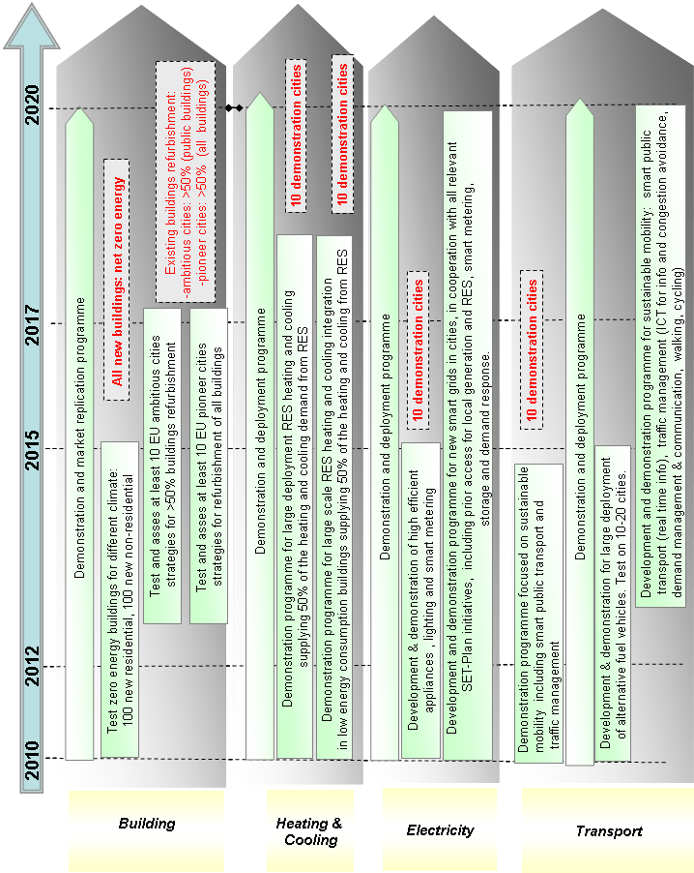

European Energy Research Alliance (EERA)

Overall objective
To accelerate the development of new energy technologies in support of the SET-Plan by strengthening, expanding and optimising EU energy research capabilities through the joint realisation of pan-European programmes and the sharing of world-class national facilities in Europe, drawing upon results from fundamental research in order to mature technologies to the point where it can be embedded in industry-driven research.

Technology innovation objectives
Achieving Europe's 2020 targets on greenhouse gas emissions, renewable energy and energy efficiency will require the deployment of more efficient and less costly technologies, available today at large but unattractive to the market. If the 2050 vision for complete decarbonisation in the EU is to be seized, actions to develop new energy technologies, through major breakthroughs and to advance these through the innovation chain to the market must be better organised, reinforced and carried out more efficiently. The objectives of the EERA are to:
1. Increase energy efficiency and emission reduction potential – by focussing on medium to long term research questions, enabling the required system change and avoiding technological lock through incremental innovation.
2. Decrease costs and time to market– by aligning national and European R&D programmes resulting in an increase in the efficiency of the research programmes by decreasing fragmentation and redundancy as well as sharing of world-class research facilities through the joint realisation of pan-European research programmes.

Actions
The actions of the EERA comprise two levels: (1) Joint Programming and (2) linking the EERA programmes to other existing and emerging initiatives.
1. Joint programming – Joint Programmes will be launched for several areas such as wind, PV, CSP, CCS, materials for nuclear energy, geothermal, smart grids, marine energy, biofuels etc. These areas are in line with the selected SET-Plan technologies and comprise the majority of the Alliance's current activities portfolio. As such, these have been identified as the most potent for joint programming. Initially, the activities of EERA will be based on the alignment of its own resources to meet a critical mass for a substantial programme undertaking. Over time, alignment with EU programmes can be achieved and the Joint Programmes expanded with additional sources, including from Community programmes. It is expected that the first Joint Programmes will be launched by the end of 2009. Ongoing deliberations by the Alliance members and in consultation with the relevant experts in the broader research community have preliminarily concluded on the following programmes:
- Wind Energy: The Joint Programme for Wind Energy will be divided into four main areas: aerodynamics, wind conditions, offshore wind farms and electrical integration. The programme will focus on optimising and up-scaling large offshore turbines, where incremental scaling up of current concepts and technology leaps will lead to more cost efficient wind turbines.
- PV: Six priority themes have been identified as a starting point for a Joint Programme: silicon materials, organic PV, module technology, transparent conductive oxides (TCO), large area deposition and interfaces and education and training. Other topics will be added once the programme is advanced such as novel absorber materials for thin films, reliability of components (i.e. ageing models), BIPV and thin film optics.
- CCS: Within the CCS Joint Programme, a distinction is made between CO₂ capture (oxy-combustion, pre-combustion, post-combustion) and storage. Within separation techniques for pre-combustion and oxyfuel, activities will initially focus on oxygen transport, sorbents (including high temperature sulphur removal), hydrogen separation membranes and sorption-enhanced reforming. The activities for oxy-combustion technologies will at first instance focus on oxyfuel boilers, CO₂ processing for specific oxy-fuel, material selection for oxy-fuel, gas turbine development and separation technologies, where process simulation and emissions from a capture unit will be handled as cross cutting issues. Research activities focussing on storage as well as pre-combustion are yet to be identified.
- Biofuels: Within the field of bio energy, a large number of actors are involved at different parts of various value chains, stressing the need for coordination of (pre-competitive) research. First research topics yet to be detailed, relate with biomass resources, combining thermochemical and biochemical conversion pathways.
- CSP: Whilst yet large demonstrations of CSP plants are foreseen, the main challenge for research lies in the development of the second generation technologies. Pre-selected topics include (high temperature) thermochemistry (CO₂ splitting), power generation and desalination, thermal storage, accelerated ageing and engines (e.g. dish Stirling technology).
- Geothermal energy: Main areas that will serve as starting point for the joint activities are reservoir exploitation, reservoir accessing and engineering, thermal water looping and efficiency of the geothermal power, heat and/or chill.
- Materials for nuclear energy: The activities will focus on structural materials for Generation IV reactors. High-chromium-steels, refractory alloys and ceramics/composites were identified as priority areas to undertake joint activities in the field of material development and screening, characterisation, fabrication, pre-normative research and modelling, simulation and experimental validation.
- Other areas; For smart grids, fuel cells and marine energy, preparatory steps to develop a Joint Programme have been undertaken. Tentatively, the programme for smart grids will be centred on transmission, distribution and horizontal issues.
2. Develop links and sustained partnerships with existing and emerging initiatives
The EERA aims to accelerate the development of new energy technologies by building upon the results of fundamental research and maturing technology development to a stage where it can be embedded in industry driven research. Therefore, close links with both industry driven research as well as fundamental research are key elements in the success of the EERA.
2.1 Link to industry and industry driven research. Both on the level of Joint Programmes (e.g. Wind, PV, CSP etc.) as well as on the level of sub-programmes (i.e. aerodynamics within the Wind Joint Programme), the EERA aims to contribute to and complement the emerging EIIs as it may be necessary and mutually reinforcing the SET-Plan drive. In addition, the EERA will consider and build upon the Strategic Research Agendas (SRA) as developed in various Technology Platforms.
2.2 Link to universities and fundamental research. Both at national and EU-level, the EERA aims to connect with fundamental research as well as educational aspects. The European University Association (EUA), currently associated with the Alliance, has already created a platform to enable participation of universities in the EERA activities. In addition, EERA intends to develop a close link to the emerging European Institute of Technology (EIT) and their Knowledge and Innovation Communities (KICs).
2.3 Cooperation with non-EU leading research institutes. Key technologies that are needed to meet the challenges with respect to climate change and security of supply have a global scale for deployment. In the pre-commercial phase where the EERA is focussing on, cooperation with leading research institutes from e.g. the USA and Japan, can further accelerate the required technology development. EERA has already started building up relationships with some national laboratories in the USA and aims to further expand and strengthen this relationship both with research institutes from the USA as well as Japan.
2.4 Collaboration with the SET-Plan Information System (SETIS). In setting the right research priorities and monitoring the development of progress (efficiency, costs) cooperation with SETIS is crucial. Discussions to streamline the cooperation are developing positively.

Indicative Costs (2010 – 2020)
Preliminary estimates by the Alliance to undertake and sustain the necessary joint programmes addressing the technologies of today, to better these for market take-up and innovate for the technologies of tomorrow show that an additional investment of about 500 million euros per year is required to complement the activities based on Member State funding.

Indicative Key Performance Indicators (KPI)
There envisaged two set KPIs, to address the progress and success of joint programming for energy technology innovation, the effectiveness of the EERA links with industrial driven research, i.e. alignment with these of the Industrial Initiatives as well as fundamental research and with international RTD efforts. The identification of and formulation of the various KPIs will be addressed soon with the assistance of the SET-Plan Information System (SETIS). An example of the foreseen KPIs for Joint Programming is given below.
Activity | Key performance indicators
Joint programming | - No. of joint programmes  - No.of scientists involved  - No.of research institutes involved  - total budget of the programme by funding category  - No.of patents  - No.of cooperative schemes with EIT/KIC  - No.programmes/activities with US, Japan etc.

COM(2007)1
COM(2008)0781
O. Edenhofer and N. Stern: Towards a global green recovery, Recommendations for immediate G20 Action, G20 London Summit, 2009
http://setis.ec.europa.eu (to be released in October 2009)
The concept of DESERTEC initiative is a massive deployment of solar technology, mainly CSP, in MENA countries and the export of electricity to Europe. (MENA = Middle East and North Africa)
SEC(2009)1296
The idea of DESERTEC is a massive deployment of solar technology, mainly CSP, in MENA countries and export of electricity to Europe. (MENA = Middle East and North Africa)
A virtual power plant is a cluster of distributed generation installations which are collectively run by a central control entity in order to increase the system flexibility (including with the support of existing storage systems) and to make the best of available potential (spatial smoothing)
Under the same assumptions as presented by Wind Energy –The Facts www.wind-energy-the-facts.org
See footnote 8
The concept of DESERTEC is a massive deployment of solar technology, mainly CSP, in MENA countries and the export of electricity to Europe. (MENA = Middle East, and North Africa)
Large single production units or large number of smaller units
Local and national authorities, farming associations, European Technology Platforms such as Plants for the Future and Forestry
P= Pilot, D= Demo, F=First-of-this-kind industrial-size plant
IEA, 2008, from 1st to 2nd generation Biofuel technologies, assuming 1€ = 1USD
Commercial plant possible – D: demo; F: First of this kind industrial size plant
These costs exclude the costs of the generic assets used in the demonstration, estimated in several billions euros, paid directly by the balance sheet of the network operators and of other participants.
Costs currently under detailed analysis
Includes basic detailed design, licensing, testing and qualification of components, construction, and start-up operations
The cost of the research programmes performed in the experimental facilities is included in the cross-cutting R&D action
Equivalent to €100-200 / year over 10 years
Reference year 1990

