EN
COMMISSION OF THE EUROPEAN COMMUNITIES
Brussels, 19.10.2009
COM(2009)546 final
2009/0154 (COD)

Proposal for a
DIRECTIVE OF THE EUROPEAN PARLIAMENT AND OF THE COUNCIL
relating to the radio interference (electromagnetic compatibility) of vehicles
(Codified version)

EXPLANATORY MEMORANDUM
1. In the context of a people’s Europe, the Commission attaches great importance to simplifying and clarifying Community law so as to make it clearer and more accessible to the ordinary citizen, thus giving him new opportunities and the chance to make use of the specific rights it gives him.
This aim cannot be achieved so long as numerous provisions that have been amended several times, often quite substantially, remain scattered, so that they must be sought partly in the original instrument and partly in later amending ones. Considerable research work, comparing many different instruments, is thus needed to identify the current rules.
For this reason a codification of rules that have frequently been amended is also essential if Community law is to be clear and transparent.
2. On 1 April 1987 the Commission therefore decided to instruct its staff that all legislative acts should be codified after no more than ten amendments, stressing that this is a minimum requirement and that departments should endeavour to codify at even shorter intervals the texts for which they are responsible, to ensure that the Community rules are clear and readily understandable.
3. The Conclusions of the Presidency of the Edinburgh European Council (December 1992) confirmed this, stressing the importance of codification as it offers certainty as to the law applicable to a given matter at a given time.
Codification must be undertaken in full compliance with the normal Community legislative procedure.
Given that no changes of substance may be made to the instruments affected by codification, the European Parliament, the Council and the Commission have agreed, by an interinstitutional agreement dated 20 December 1994, that an accelerated procedure may be used for the fast-track adoption of codification instruments.
4. The purpose of this proposal is to undertake a codification of Council Directive 72/245/EEC of 20 June 1972 relating to the radio interference (electromagnetic compatibility) of vehicles. The new Directive will supersede the various acts incorporated in it; this proposal fully preserves the content of the acts being codified and hence does no more than bring them together with only such formal amendments as are required by the codification exercise itself.
5. The codification proposal was drawn up on the basis of a preliminary consolidation, in all official languages, of Directive 72/245/EEC and the instruments amending it, carried out by the Office for Official Publications of the European Communities, by means of a data-processing system. Where the Articles have been given new numbers, the correlation between the old and the new numbers is shown in a table contained in Annex XII to the codified Directive.

ê 95/54/EC Art. 1, pt. 1
2009/0154 (COD)

Proposal for a
DIRECTIVE OF THE EUROPEAN PARLIAMENT AND OF THE COUNCIL
relating to the radio interference (electromagnetic compatibility) of vehicles (codified version)
(Text with EEA relevance)

ê 72/245/EEC (adapted)

THE EUROPEAN PARLIAMENT AND THE COUNCIL OF THE EUROPEAN UNION,
Having regard to the Treaty establishing the European Community, and in particular Article Ö 95 Õ thereof,
Having regard to the proposal from the Commission,
Having regard to the opinion of the European Economic and Social Committee,
Acting in accordance with the procedure laid down in Article 251 of the Treaty,
Whereas:

ê
- Council Directive 72/245/EEC of 20 June 1972 relating to the radio interference (electromagnetic compatibility) of vehicles has been substantially amended several times. In the interests of clarity and rationality the said Directive should be codified.

ê 2005/49/EC recital 1 (adapted)
- Directive 72/245/EEC is one of the separate directives Ö of Õ the Ö EC Õ type-approval Ö system Õ Ö provided for in Õ Directive Ö 2007/46/EC of the European Parliament and of the Council of 5 September 2007 establishing a framework for the approval of motor vehicles and their trailers, and of systems, components and separate technical units intended for such vehicles (Framework Directive) and lays down technical prescriptions concerning the radio interference (electromagnetic compatibility) of vehicles. Those technical prescriptions concern the approximation of the laws of the Member States to enable the EC type-approval procedure provided for in Directive 2007/46/EC to be applied in respect of each type of vehicle. Consequently, the provisions laid down in Directive 2007/46/EC relating to vehicle systems, components and separate technical units apply to this Directive Õ.

ê 72/245/EEC recital 3 (adapted)
- Ö It is desirable to take into account the technical requirements adopted by the UN Economic Commission for Europe (UN/ECE) in its corresponding regulations annexed to the Agreement of the United Nations Economic Commission for Europe concerning the adoption of uniform technical prescriptions for wheeled vehicles, equipment and parts which can be fitted and/or be used on wheeled vehicles and the conditions for reciprocal recognition of approvals granted on the basis of these prescriptions (Revised 1958 Agreement). Õ

ê
- This Directive should be without prejudice to the obligations of the Member States relating to the time-limits for transposition into national law and application of the Directives set out in Annex XI, Part B,

ê 72/245/EEC

HAVE ADOPTED THIS DIRECTIVE:

ê 95/54/EC Art. 1 pt. 2

Article 1
For the purposes of this Directive, ‘vehicle’ means any vehicle as defined in Directive 2007/46/EC.

ê 95/54/EC Art. 1 pt. 3 (adapted)

Article 2

ê 2004/104/EC Art. 2 (adapted)
1. For vehicles, components or separate technical units which comply with the Ö requirements Õ laid down in Annexes I to X , no Member State may, on grounds relating to electromagnetic compatibility:
(a) refuse to grant EC type-approval, or national type-approval; or
(b) prohibit registration, sale or entry into service.
2. For a type of vehicle, component or separate technical unit where the requirements laid down in Annexes I to X , are not fulfilled, Member States, on grounds related to electromagnetic compatibility:
(a) shall no longer grant EC type-approval; and
(b) may refuse to grant national type-approval.

ê 2005/49/EC Art. 3 (adapted)
3. If the Ö requirements Õ laid down in this Directive are not fulfilled, Member States, on grounds related to electromagnetic compatibility:
(a) shall consider certificates of conformity which accompany new vehicles in accordance with Directive 2007/46/EC to be no longer valid for the purposes of Article 26(1) of that Directive;
(b) may refuse the registration, sale or entry into service of new vehicles.
Approvals for vehicles not fitted with 24 GHz or 79 GHz short-range radar equipment Ö granted before 1 July 2006 Õ remain unchanged.

ê 2004/104/EC Art. 2 (adapted)
4. The Ö requirements Õ laid down in Annexes I to X relating to electromagnetic compatibility shall apply to components or separate technical units for the purposes of Article 28 of Directive 2007/46/EC.

ê 95/54/EC Art. 2
5. Notwithstanding paragraphs 2 and 4, for the purposes of replacement parts, Member States shall continue to grant EC type approval and to permit the sale and entry into service of components or separate technical units intended for use on vehicle types which have been approved before 1 January 1996 pursuant to either Directive 72/245/EEC or Directive 72/306/EEC and, where applicable, subsequent extensions to those approvals.

ê 2005/49/EC Art. 3
6. With effect from 1 July 2013, Member States shall prohibit the registration, sale or entry into service of vehicles equipped with 24 GHz short-range radar equipment.
7. In case the reference date in Article 2(5) of Commission Decision 2005/50/EC is modified in accordance with Article 5 of that Decision, Member States shall prohibit the registration, sale or entry into service of vehicles equipped with 24 GHz short-range radar equipment after the modified reference date.

ê 95/54/EC Art. 1 pt. 4 (adapted)

Article 3
1. This Directive shall constitute a ‘specific directive’ for the purposes of Article 1(4) of Directive 2004/108/EC of the European Parliament and of the Council .
2. Vehicles, components or separate technical units approved pursuant to this Directive shall be considered to fulfil the provisions of other directives, cited in Annex IV to Council Directive 92/53/EEC, which refer to electromagnetic compatibility.

ê 72/245/EEC (adapted)

Article 4
Ö The amendments necessary to adapt the requirements of Annexes I to X to take account of technical progress shall be adopted in accordance with the procedure referred to in Article 40(2) of Directive 2007/46/EC. Õ

Article 5
Ö Member States shall communicate to the Commission the texts of the main provisions of national law which they adopt in the field covered by this Directive. Õ

ê

Article 6
Directive 72/245/EEC, as amended by the acts listed in Annex XI, Part A, is repealed without prejudice to the obligations of the Member States relating to the time-limits for transposition into national law and application of the Directives set out in Annex XI, Part B.
References to the repealed Directive shall be construed as references to this Directive and shall be read in accordance with the correlation table set out in Annex XII.

Article 7
This Directive shall enter into force on the twentieth day following that of its publication in the Official Journal of the European Union.
It shall apply from [...].

ê 72/245/EEC

Article 8
This Directive is addressed to the Member States.
Done at Brussels,
For the European Parliament For the Council
The President The President

ê 2004/104/EC Art. 1 and Annex (adapted)

LIST OF ANNEXES
Annex I: | Requirements to be met by vehicles and electrical/electronic subassemblies fitted to a vehicle
Annex I: | Appendix 1: | List of standards referred to in this Directive
Annex I: | Appendix 2: | Vehicle broadband reference limits  Antenna-vehicle separation: 10 m
Annex I: | Appendix 3: | Vehicle broadband reference limits  Antenna-vehicle separation: 3 m
Annex I: | Appendix 4: | Vehicle narrowband reference limits  Antenna-vehicle separation: 10 m
Annex I: | Appendix 5: | Vehicle narrowband reference limits  Antenna-vehicle separation: 3 m
Annex I: | Appendix 6: | Electrical/electronic subassembly  Broadband reference limits
Annex I: | Appendix 7: | Electrical/electronic subassembly  Narrowband reference limits
Annex I: | Appendix 8: | Model for the EC type-approval mark
Annex IIA: | Information document relating to EC type-approval of a vehicle
Annex IIB: | Information document relating to EC type-approval of an electric/electronic subassembly
Annex IIIA: | Model of EC type-approval certificate
Annex IIIB: | Model of EC type-approval certificate
Annex IV: | Method of measurement of radiated broadband electromagnetic emissions from vehicles
Annex V: | Method of measurement of radiated narrowband electromagnetic emissions from vehicles
Annex VI: | Method of testing for immunity of vehicles to electromagnetic radiation
Annex VII: | Method of measurement of radiated broadband electromagnetic emissions from electrical/electronic subassemblies
Annex VII: | Appendix 1 — Figure 1: |  | Open-area test site: electrical/electronic subassembly test area boundary  Level clear area free from electromagnetic reflecting surfaces
Annex VIII: | Method of measurement of radiated narrowband electromagnetic emissions from electrical/electronic subassemblies
Annex IX: | Method(s) of testing for immunity of electrical/electronic subassemblies to electromagnetic radiation
Annex IX: | Appendix 1 — Figure 1: |  | 800 mm stripline testing
Annex IX: | Appendix 1 — Figure 2: |  | 800 mm stripline dimensions
Annex IX: | Appendix 2: |  | Typical TEM cell dimensions
Annex X: | Method(s) of testing for immunity to and emission of transients of electrical/electronic subassemblies
Ö Annex XI: Õ | Ö Part A: Repealed Directive with list of its successive amendments Õ
Ö Annex XI: Õ | Ö Part B: List of time-limits for transposition into national law and application Õ
Ö Annex XII: Õ | Ö Correlation table Õ

ê 2004/104/EC Art. 1 and Annex

ANNEX I

REQUIREMENTS TO BE MET BY VEHICLES AND ELECTRICAL/ELECTRONIC SUBASSEMBLIES FITTED TO A VEHICLE

1. SCOPE
This Directive applies to the electromagnetic compatibility of vehicles covered in Article 1, being vehicles or trailers (hereinafter referred to as vehicles) as supplied by the vehicle manufacturer and to components or separate technical units intended to be fitted in vehicles.
It covers:
- requirements regarding the immunity to radiated and conducted disturbances for functions related to direct control of the vehicle, related to driver, passenger and other road users' protection and related to disturbances, which would cause confusion to the driver or other road users,
- requirements regarding the control of unwanted radiated and conducted emissions to protect the intended use of electrical or electronic equipment at own or adjacent vehicles or nearby, and the control of disturbances from accessories that may be retrofitted to the vehicle.

2. DEFINITIONS
2.1. For the purposes of this Directive:
2.1.1. ‘Electromagnetic compatibility’ means the ability of a vehicle or component(s) or separate technical unit(s) to function satisfactorily in its electromagnetic environment without introducing intolerable electromagnetic disturbances to anything in that environment.
2.1.2. ‘Electromagnetic disturbance’ means any electromagnetic phenomenon which may degrade the performance of a vehicle or component(s) or separate technical unit(s), or of any other device, unit of equipment or system operated in vicinity of a vehicle. An electromagnetic disturbance may be electromagnetic noise, an unwanted signal or a change in the propagation medium itself.
2.1.3. ‘Electromagnetic immunity’ means the ability of a vehicle or component(s) or separate technical unit(s) to operate without degradation of performance in the presence of (specified) electromagnetic disturbances which includes wanted radio frequency signals from radio transmitters or radiated in-band emissions of industrial-scientific-medical (ISM) apparatus, internal or external to the vehicle.
2.1.4. ‘Electromagnetic environment’ means the totality of electromagnetic phenomena existing at a given location.
2.1.5. ‘Broadband emission’ means an emission, which has a bandwidth greater than that of a particular measuring apparatus or receiver (International Special Committee on Radio Interference (CISPR) 25, 2nd edition).
2.1.6. ‘Narrowband emission’ means an emission which has a bandwidth less than that of a particular measuring apparatus or receiver (CISPR 25, 2nd edition).
2.1.7. ‘Electrical/electronic system’ means (an) electrical and/or electronic device(s) or set(s) of devices together with any associated electrical connections which form part of a vehicle but which are not intended to be type-approved separately from the vehicle.
2.1.8. ‘Electrical/electronic subassembly’ (ESA) means an electrical and/or electronic device or set(s) of devices intended to be part of a vehicle, together with any associated electrical connections and wiring, which performs one or more specialised functions. An ESA may be approved at the request of a manufacturer or his authorised representative as either a ‘component’ or a ‘separate technical unit (STU)’ (see Article 3(24) and (25) of Directive 2007/46/EC).
2.1.9. ‘Vehicle type’ in relation to electromagnetic compatibility means vehicles which do not differ essentially in such respects as:
2.1.9.1. the overall size and shape of the engine compartment;
2.1.9.2. the general arrangement of the electrical and/or electronic components and the general wiring arrangement;
2.1.9.3. the primary material of which the body or shell (if applicable) of the vehicle is constructed (for example, a steel, aluminium or fibreglass body shell). The presence of panels of different material does not change the vehicle type provided the primary material of the body is unchanged. However, such variations must be notified.
2.1.10. An ‘ESA type’ in relation to electromagnetic compatibility means ESAs which do not differ in such essential respects as:
2.1.10.1. the function performed by the ESA;
2.1.10.2. the general arrangement of the electrical and/or electronic components, if applicable.
2.1.11. ‘Vehicle wiring harness’ means supply voltage, bus system (e.g. CAN), signal or active antenna cables, which are installed by the vehicle manufacturer.
2.1.12. Immunity-related functions are:

(a) functions related to the direct control of the vehicle:

ê 2005/83/EC Art. 1 and Annex pt. 1(a)
- by degradation or change in: e.g. engine, gear, brake, suspension, active steering, speed limitation devices,

ê 2004/104/EC Art. 1 and Annex
- by affecting driver’s position, e.g. seat or steering wheel positioning,
- by affecting driver’s visibility: e.g. dipped beam, windscreen wiper;

(b) functions related to driver, passenger and other road-user protection:
- e.g. airbag and safety restraint systems;

(c) functions which, when disturbed, cause confusion to the driver or other road users:
- optical disturbances: incorrect operation of e.g. direction indicators, stop lamps, end outline marker lamps, rear position lamp, light bars for emergency system, wrong information from warning indicators, lamps or displays related to functions in points (a) or (b) which might be observed in the direct view of the driver,
- acoustical disturbances: incorrect operation of anti-theft alarm, horn, for example;

(d) functions related to vehicle data bus functionality:
- by blocking data transmission on vehicle data bus-systems, which are used to transmit data, required to ensure the correct functioning of other immunity-related functions;

(e) functions which, when disturbed, affect vehicle statutory data: e.g. tachograph, odometer.

ê 2005/49/EC Art. 1, pt. 1
2.1.13. ‘24 GHz short-range radar equipment’ means a radar as defined in Article 2(2) of Decision 2005/50/EC, and satisfying the performance requirements of Article 4 of that Decision.

ê 2004/104/EC Art. 1 and Annex (adapted)
è1 2005/83/EC Art. 1 and Annex pt. 1(b)
è2 2005/83/EC Art. 1 and Annex pt. 1(c)
è3 2006/96/EC Annex, pt. A.8

3. APPLICATION FOR EC TYPE-APPROVAL
3.1. Approval of a vehicle type
3.1.1. The application for approval of a vehicle type, with regard to its electromagnetic compatibility pursuant to Article 7(1) and (2) of Directive 2007/46/EC shall be submitted by the vehicle manufacturer.
3.1.2. A model for the information document is given in Annex IIA.
3.1.3. The vehicle manufacturer shall draw up a schedule describing all relevant vehicle electrical/electronic systems or ESAs, body styles, variations in body material, general wiring arrangements, engine variations, left-hand/right-hand drive versions and wheelbase versions. Relevant vehicle electrical/electronic systems or ESAs are those which may emit significant broadband or narrowband radiation and/or those which are involved in immunity-related functions (see point 2.1.12 ) of the vehicle.
3.1.4. A representative vehicle shall be selected from this schedule for the purpose of being tested, in mutual agreement between the manufacturer and the competent authority. This vehicle shall represent the vehicle type (see Appendix 1 to Annex IIA). The choice of vehicle shall be based on the electrical/electronic systems offered by the manufacturer. One or more vehicles may be selected from this schedule for the purpose of being tested if it is considered by mutual agreement between the manufacturer and the competent authority that different electrical/electronic systems are included which are likely to have a significant effect on the vehicle's electromagnetic compatibility compared with the first representative vehicle.
3.1.5. The choice of the vehicle(s) in conformity with point 3.1.4 is limited to vehicle/electrical/electronic system combinations intended for actual production.
3.1.6. The manufacturer may supplement the application with a report from tests, which have been carried out. Any such data provided may be used by the Approval Authority for the purpose of drawing up the EC type-approval certificate.
3.1.7. If the technical service responsible for the EC type-approval test carries out the test itself, then a vehicle representative of the type to be approved, according to point 3.1.4 shall be provided.
3.1.8. The vehicle manufacturer must provide a statement of frequency bands, power levels, antenna positions and installation provisions for the installation of RF-transmitters, even if the vehicle is not equipped with an RF-transmitter at the time of EC type-approval. This should cover all mobile radio services normally used in vehicles. This information must be made publicly available following the EC type-approval.
Vehicle manufacturers must provide evidence that vehicle performance is not adversely affected by such transmitter installations.
3.2. Approval of a type of electrical/electronic subassembly (ESA)
3.2.1. Applicability of this Directive to ESA:
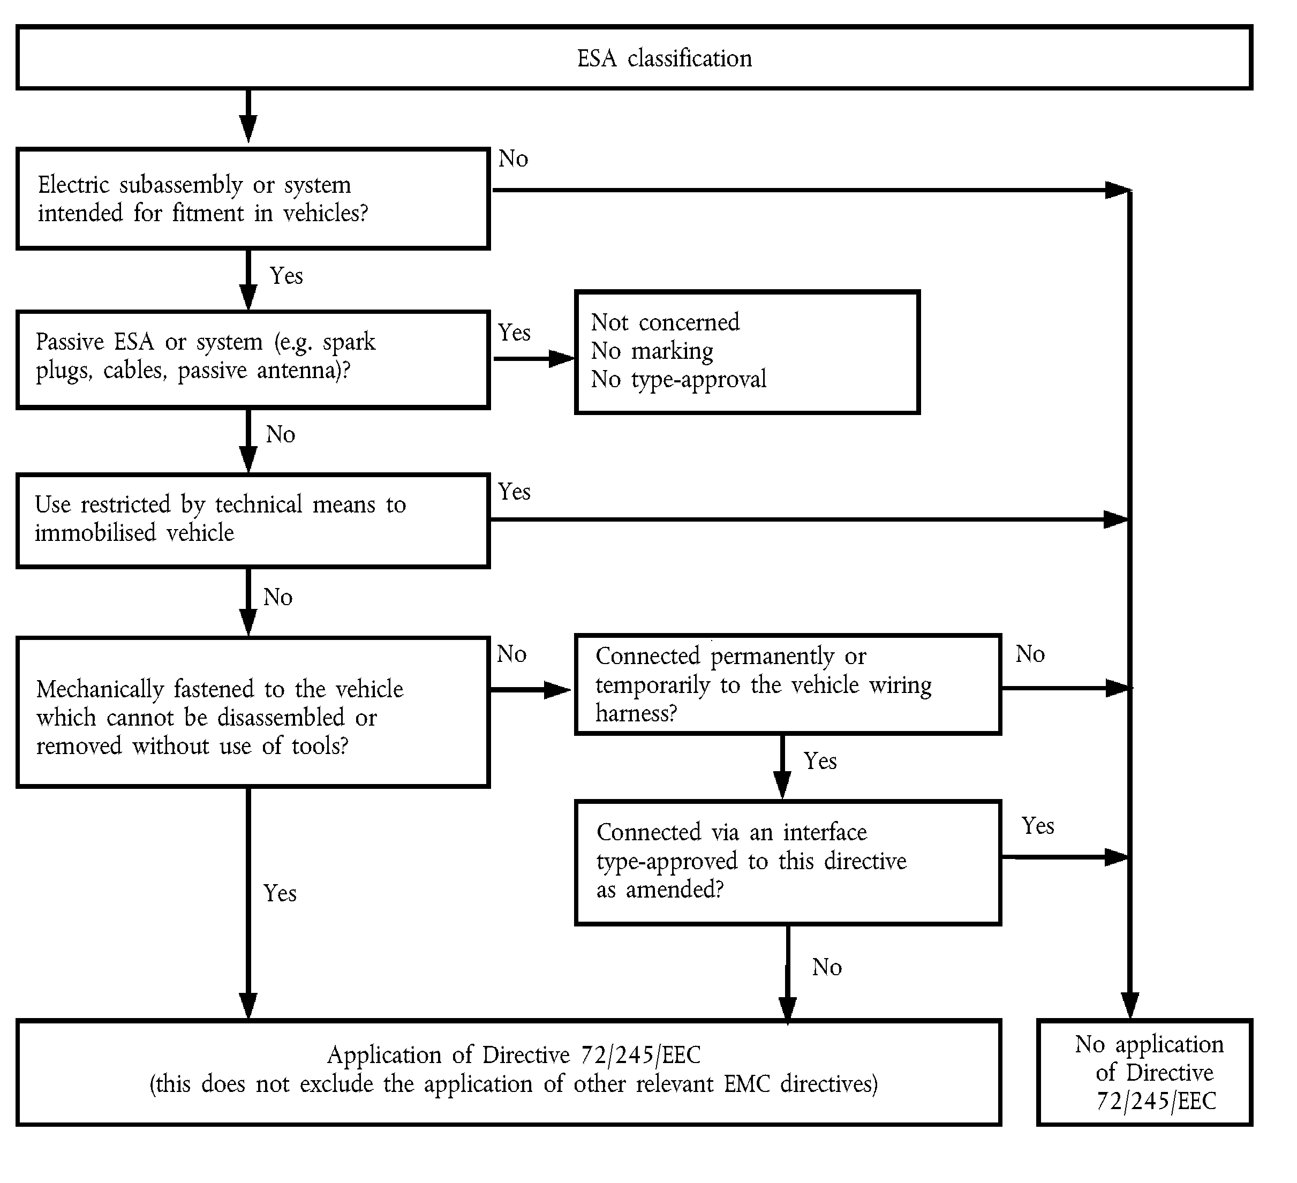
Application of Directive ../…/EC
(this does not exclude the application of other relevant EMC directives)
No application of Directive ../…/EC
3.2.2. The application for approval of a type of ESA with regard to its electromagnetic compatibility pursuant to Article 7(1) and (2) of Directive 2007/46/EC shall be submitted by the vehicle manufacturer or by the manufacturer of the ESA or his/her authorised representative.
3.2.3. A model for the information document is given in Annex IIB.
3.2.4. The manufacturer may supplement the application with a report from tests which have been carried out. Any such data provided may be used by the Approval Authority for the purpose of drawing up the EC type-approval certificate. For equipment intended for installation in a vehicle, the manufacturer may supplement the application with the manufacturer’s Declaration of Conformity in line with the provisions of Directive 1999/5/EC of the European Parliament and of the Council or Directive 2004/108/EC, the EMC test report and the instruction for the user giving guidance for installation of such equipment in vehicles.
3.2.5. If the technical service responsible for the EC type-approval test carries out the test itself, then a sample of the ESA system representative of the type to be approved shall be provided, if necessary, after discussion with the manufacturer on, for example, possible variations in the layout, number of components, number of sensors. If the technical service deems it necessary, it may select a further sample.
3.2.6. The sample(s) must be clearly and indelibly marked with the manufacturer’s trade name or mark and the type designation.
3.2.7. Where applicable, any restrictions on use should be identified. Any such restrictions must be included in Annexes IIB and/or IIIB.
3.2.8. ESAs which are brought to the market as spare parts need no EC type-approval if they are obviously marked as a spare part by an identification number and if they are identical and from the same manufacturer as the corresponding original equipment manufacturer (OEM) part for an already type-approved vehicle.
3.2.9. Components sold as aftermarket equipment and intended for the installation in motor vehicles need no EC type-approval if they are not related to immunity-related functions (point 2.1.12). In this case a Declaration of Conformity according to the procedures of Directive 1999/5/EC or 2004/108/EC must be issued. Part of this declaration must be that the ESA fulfils the limits defined in points 6.5, 6.6, 6.8 and 6.9 of Annex I to this Directive.

4. EC TYPE-APPROVAL
4.1. Routes to EC type-approval
4.1.1. EC type-approval of a vehicle
The following alternative routes to EC type-approval of a vehicle may be used at the discretion of the vehicle manufacturer.
4.1.1.1. Approval of a vehicle installation
A vehicle installation may achieve EC type-approval directly by following the provisions laid down in the relevant parts of point 6 . If this route is chosen by a vehicle manufacturer, no separate testing of electrical/electronic systems or ESAs is required.
4.1.1.2. Approval of vehicle type by testing of individual ESAs
A vehicle manufacturer may obtain approval for the vehicle by demonstrating to the Approval Authority that all the relevant (see point 3.1.3 ) electrical/electronic systems or ESAs have individually been approved in accordance with this Directive and have been installed in accordance with any conditions attached thereto.
4.1.1.3. A manufacturer, if he/she wishes, may obtain approval according to this Directive if the vehicle has no equipment of the type which is subject to immunity or emission tests. Such approvals do not require testing.
4.1.2. EC type-approval of an ESA
EC type-approval may be granted to an ESA to be fitted either to any vehicle type (component approval) or to a specific vehicle type or types requested by the ESA manufacturer (separate technical unit approval).
4.1.3. ESAs, which are intentional RF transmitters, which have not received EC type-approval in conjunction with a vehicle manufacturer, must be supplied with suitable installation guidelines.
4.2. Granting of EC type-approval
4.2.1. Vehicle
4.2.1.1. If the representative vehicle fulfils the requirements of this Directive, EC type-approval pursuant to Article 9(3), and if applicable, Article 10(4) of Directive 2007/46/EC shall be granted.
4.2.1.2. A model for the EC type-approval certificate is given in Annex IIIA.
4.2.2. ESA
4.2.2.1. If the representative ESA system(s) fulfil(s) the requirements of this Directive, EC type-approval pursuant to Article 9(3), and if applicable, Article 10(4) of Directive 2007/46/EC shall be granted.
4.2.2.2. A model for the EC type-approval certificates is given in Annex IIIB.
4.2.3. In order to draw up the certificates referred to in point 4.2.1.2 or 4.2.2.2, the competent authority of the Member State granting the approval may use a report prepared by a test laboratory accredited to ISO 17025 and recognised by the Approval Authority.
4.3. Amendments to approvals
4.3.1. In the case of amendments to approvals granted pursuant to this Directive, the provisions of Articles 13 to 16 of Directive 2007/46/EC] shall apply.
4.3.2. Amendment of a vehicle type-approval by ESA addition or substitution
4.3.2.1. Where a vehicle manufacturer has obtained approval for a vehicle installation and wishes to fit an additional or substitutional electrical/electronic system or ESA which has already received approval pursuant to this Directive, and which will be installed in accordance with any conditions attached thereto, the vehicle approval may be amended without further testing. The additional or substitutional electrical/electronic system or ESA shall be considered as part of the vehicle for conformity of production purposes.
4.3.2.2. Where the additional or substitutional part(s) has (have) not received approval pursuant to this Directive, and if testing is considered necessary, the whole vehicle shall be deemed to comply if the new or revised part(s) can be shown to comply with the relevant requirements of point 6 or if, in a comparative test, the new part can be shown not to be likely to adversely affect compliance of the vehicle type.
4.3.3. The addition of used ESAs, which are not type-approved according to this Directive because at their first time of installation no type-approval was required, shall not invalidate the type-approval if the installation of such used ESAs is done according to the recommendations of the ESA and vehicle manufacturer.

5. MARKING
5.1. Every ESA conforming to a type approved under this Directive shall bear an EC type-approval mark.
5.2. The EC type-approval mark shall consist of a rectangle surrounding the lower case letter ‘e’ followed by the distinguishing number of the Member State which has granted the EC component type-approval:
1 | for Germany
2 | for France
3 | for Italy
4 | for the Netherlands
5 | for Sweden
6 | for Belgium
7 | for Hungary
8 | for the Czech Republic
9 | for Spain
11 | for the United Kingdom
12 | for Austria
13 | for Luxembourg
17 | for Finland
18  è3 19 ç | for Denmark  è3 for Romania ç
20 | for Poland
21 | for Portugal
23 | for Greece
24 | for Ireland
26 | for Slovenia
27 | for Slovakia
29 | for Estonia
32 | for Latvia
è3 34 ç | è3 for Bulgaria ç
36 | for Lithuania
49 | for Cyprus
50 | for Malta
In the vicinity of the rectangle the ‘base approval number’ contained in section 4 of the EC type-approval number referred to in Annex VII of Directive 2007/46/EC preceded by the two figures indicating the sequence number assigned to the latest major technical amendment to this Directive. The amendment sequence number and the EC component type-approval number shown on the certificate shall be separated by a single space.
5.3. The EC type-approval mark must be affixed to the main part of the ESA (e.g. the electronic control unit) in such a way as to be clearly legible and indelible.
5.4. An example of the EC type-approval mark is shown in Appendix 8.
5.5. No marking is required for electrical/electronic systems included in vehicle types approved by this Directive, and for spare parts as defined in point 3.2.8.
5.6. Markings on ESAs in compliance with point 5.3 need not be visible when the ESA is installed in a vehicle.

6. SPECIFICATIONS

6.1. General specification
6.1.1. A vehicle and its electrical/electronic system(s) or ESA(s) shall be so designed, constructed and fitted as to enable the vehicle, in normal conditions of use, to comply with the requirements of this Directive.
6.1.1.1. A vehicle shall be tested for radiated emissions and for immunity to radiated disturbances. No tests for conducted emissions or immunity to conducted disturbances are required for vehicle EC type-approval.
6.1.1.2. ESA(s) shall be tested for radiated and conducted emissions, for immunity to radiated and conducted disturbances.
6.1.2. Before testing, the technical service has to prepare a test plan in conjunction with the manufacturer, which contains at least mode of operation, stimulated function(s), monitored function(s), pass/fail criteria(s) and intended emissions.

6.2. Specifications concerning broadband electromagnetic radiation from vehicles
6.2.1. Method of measurement
The electromagnetic radiation generated by the vehicle representative of its type shall be measured using the method described in Annex IV. The method of measurement shall be defined by the vehicle manufacturer in accordance with the technical service.
6.2.2. Vehicle broadband type-approval limits
6.2.2.1. If measurements are made using the method described in Annex IV using a vehicle-to-antenna spacing of 10,0 ± 0,2 m, the limits shall be 32 dB microvolts/m in the 30 to 75 MHz frequency band and 32 to 43 dB microvolts/m in the 75 to 400 MHz frequency band, this limit increasing logarithmically with frequencies above 75 MHz as shown in Appendix 2 to this Annex. In the 400 to 1 000 MHz frequency band the limit remains constant at 43 dB microvolts/m.
6.2.2.2. If measurements are made using the method described in Annex IV using a vehicle-to-antenna spacing of 3,0 ± 0,05 m, the limits shall be 42 dB microvolts/m in the 30 to 75 MHz frequency band and 42 to 53 dB microvolts/m in the 75 to 400 MHz frequency band, this limit increasing logarithmically with frequencies above 75 MHz as shown in Appendix 3 to this Annex. In the 400 to 1 000 MHz frequency band the limit remains constant at 53 dB microvolts/m.
6.2.2.3. On the vehicle representative of its type, the measured values, expressed in dB microvolts/m shall be below the type-approval limits.

6.3. Specifications concerning narrowband electromagnetic radiation from vehicles.
6.3.1. Method of measurement
The electromagnetic radiation generated by the vehicle representative of its type shall be measured using the method described in Annex V. These shall be defined by the vehicle manufacturer in accordance with the technical service.
6.3.2. Vehicle narrowband type-approval limits
6.3.2.1. If measurements are made using the method described in Annex V using a vehicle-to-antenna spacing of 10,0 ± 0,2 m, the limits shall be 22 dB microvolts/m in the 30 to 75 MHz frequency band and 22 to 33 dB microvolts/m in the 75 to 400 MHz frequency band, this limit increasing logarithmically with frequencies above 75 MHz as shown in Appendix 4 of this Annex. In the 400 to 1 000 MHz frequency band the limit remains constant at 33 dB microvolts/m.
6.3.2.2. If measurements are made using the method described in Annex V using a vehicle-to-antenna spacing of 3,0 ± 0,05 m, the limit shall be 32 dB microvolts/m in the 30 to 75 MHz frequency band and 32 to 43 dB microvolts/m in the 75 to 400 MHz frequency band, this limit increasing logarithmically with frequencies above 75 MHz as shown in Appendix 5 to this Annex. In the 400 to 1 000 MHz frequency band the limit remains constant at 43 dB microvolts/m.
6.3.2.3. On the vehicle representative of its type, the measured values, expressed in dB microvolts/m, shall be below the type-approval limit.
6.3.2.4. Notwithstanding the limits defined in points 6.3.2.1, 6.3.2.2 and 6.3.2.3 of this Annex, if, during the initial step described in Annex V, point 1.3, the signal strength measured at the vehicle broadcast radio antenna is less than 20 dB microvolts over the frequency range 76 to 108 MHz measured with an average detector, then the vehicle shall be deemed to comply with the limits for narrowband emissions and no further testing will be required.

6.4. Specifications concerning immunity of vehicles to electromagnetic radiation.
6.4.1. Method of testing
The immunity to electromagnetic radiation of the vehicle representative of its type shall be tested by the method described in Annex VI.
6.4.2. Vehicle immunity type-approval limits.
6.4.2.1. If tests are made using the method described in Annex VI, the field strength shall be 30 volts/m rms in over 90 % of the 20 to 2 000 MHz frequency band and a minimum of 25 volts/m rms over the whole 20 to 2 000 MHz frequency band.
6.4.2.2. The vehicle representative of its type shall be considered as complying with immunity requirements if, during the tests performed in accordance with Annex VI, there shall be no degradation of performance of ‘immunity-related functions’.

6.5. Specification concerning broadband electromagnetic interference generated by ESAs
6.5.1. Method of measurement
The electromagnetic radiation generated by the ESA representative of its type shall be measured by the method described in Annex VII.
6.5.2. ESA broadband type-approval limits
6.5.2.1. If measurements are made using the method described in Annex VII, the limits shall be 62 to 52 dB microvolts/m in the 30 to 75 MHz frequency band, this limit decreasing logarithmically with frequencies above 30 MHz, and 52 to 63 dB microvolts/m in the 75 to 400 MHz band, this limit increasing logarithmically with frequencies above 75 MHz as shown in Appendix 6 to this Annex. In the 400 to 1 000 MHz frequency band the limit remains constant at 63 dB microvolts/m.
6.5.2.2. On the ESA representative of its type, the measured values, expressed in dB microvolts/m, shall be below the type-approval limits.

6.6. Specifications concerning narrowband electromagnetic interference generated by ESAs.
6.6.1. Method of measurement
The electromagnetic radiation generated by the ESA representative of its type shall be measured by the method described in Annex VIII.
6.6.2. ESA narrowband type-approval limits
6.6.2.1. If measurements are made using the method described in Annex VIII, the limits shall be 52 to 42 dB microvolts/m in the 30 to 75 MHz frequency band, this limit decreasing logarithmically with frequencies above 30 MHz, and 42 to 53 dB microvolts/m in the 75 to 400 MHz band, this limit increasing logarithmically with frequencies above 75 MHz as shown in Appendix 7 to this Annex. In the 400 to 1 000 MHz frequency band the limit remains constant at 53 dB microvolts/m.
6.6.2.2. On the ESA representative of its type, the measured value, expressed in dB microvolts/m shall be below the type-approval limits.

6.7. Specifications concerning immunity of ESAs to electromagnetic radiation.
6.7.1. Method(s) of testing
The immunity to electromagnetic radiation of the ESA representative of its type shall be tested by the method(s) chosen from those described in Annex IX.
6.7.2. ESA immunity type-approval limits
6.7.2.1. If tests are made using the methods described in Annex IX, the immunity test levels shall be 60 volts/m for the 150 mm stripline testing method, 15 volts/m for the 800 mm stripline testing method, 75 volts/m for the TEM cell testing method, 60 mA for the bulk current injection (BCI) testing method and 30 volts/m for the free field testing method in over 90 % of the 20 to 2 000 MHz frequency band, and to a minimum of 50 volts/m for the 150 mm stripline testing method, 12,5 volts/m for the 800 mm stripline testing method, 62,5 volts/m, for the TEM cell testing method, 50 mA for the bulk current injection (BCI) testing method and 25 volts/m for the free field testing method over the whole 20 to 2 000 MHz frequency band.
6.7.2.2. The ESA representative of its type shall be considered as complying with immunity requirements if, during the tests performed in accordance with Annex IX, there shall be no degradation of performance of ‘immunity-related functions’.

6.8. Specifications concerning the immunity to transient disturbances conducted along supply lines
6.8.1. Method of testing
The immunity of ESA representative of its type shall be tested by the method(s) according to è1 ISO 7637-2: 2nd edition, 2004 ç as described in Annex X with the test levels given in Table 1.
Table 1: Immunity of ESA
Test pulse number | Immunity test level | Functional status for systems
Test pulse number | Immunity test level | Related to immunity-related functions | Not related to immunity-related functions
1 | III | C | D
2a | III | B | D
2b | III | C | D
3a/3b | III | A | D
4 | III | B  (for ESA which must be operational during engine start phases)  C  (for other ESAs) | D
6.9. Specifications concerning the emission of conducted disturbances
6.9.1. Method of testing
The emission of ESA representative of its type shall be tested by the method(s) according to è2 ISO 7637-2: 2nd edition, 2004 ç as described in Annex X for the levels given in Table 2.
Table 2: Maximum allowed pulse amplitude
Polarity of pulse amplitude | Maximum allowed pulse amplitude for
Polarity of pulse amplitude | vehicles with 12 V systems | vehicles with 24 V systems
Positive | + 75 | + 150
Negative | – 100 | – 450

7. CONFORMITY OF PRODUCTION
7.1. Measures to ensure the conformity of production shall be taken in accordance with the provisions laid down in Article 12 of Directive 2007/46/EC.
7.2. Conformity of production with regard to the electromagnetic compatibility of the vehicle or component of separate technical unit shall be checked on the basis of the data contained in the EC type-approval certificate(s) set out in Annex IIIA and/or IIIB of this Directive as appropriate.
7.3. If the authority is not satisfied with the auditing procedure of the manufacturer, then points 2.4.2 and 2.4.3 of Annex X to Directive 2007/46/EC and points 7.3.1 and 7.3.2 of this Annex shall apply.
7.3.1. If the conformity of a vehicle, component or STU taken from the series is being verified, production shall be deemed to conform to the requirements of this Directive in relation to broadband radiated emissions and narrowband radiated emissions if the levels measured do not exceed by more than 4 dB (60 %) the type-approval limits prescribed in points 6.2.2.1, 6.2.2.2, 6.3.2.1, 6.3.2.2, 6.3.2.4, 6.5.2.1 and 6.6.2.1 (as appropriate).
7.3.2. If the conformity of a vehicle, component or STU taken from the series is being verified, production shall be deemed to conform to the requirements of this Directive in relation to immunity to electromagnetic radiation if the vehicle, component or STU shows no degradation of performance of ‘immunity-related functions’ when the vehicle, component or STU is in the state defined in point 2 of Annex VI, and subjected to a field strength or current, expressed in volts/m or mA, up to 80 % of the type-approval limits prescribed in points 6.4.2.1 and 6.7.2.1 of this Annex as appropriate.
7.3.3. If the conformity of a component or STU taken from the series is being verified, production shall be deemed to conform to the requirements of this Directive in relation to immunity to conducted disturbances and emission if the component or STU shows no degradation of performance of ‘immunity-related functions’ up to levels given in point 6.8.1 and does not exceed the levels given in point 6.9.1.

8. EXCEPTIONS
8.1. Where a vehicle or electrical/electronic system or ESA does not include an electronic oscillator with an operating frequency greater than 9 kHz, it shall be deemed to comply with point 6.3.2 or 6.6.2 of this Annex and with Annexes V and VIII.
8.2. Vehicles which do not have electrical/electronic systems with ‘immunity-related functions’ need not be tested for immunity to radiated disturbances and shall be deemed to comply with point 6.4 of this Annex and with Annex VI .
8.3. ESAs with no immunity-related functions need not be tested for immunity to radiated disturbances and shall be deemed to comply with point 6.7 of this Annex and with Annex IX .
8.4. Electrostatic discharge
For vehicles fitted with tyres, the vehicle body/chassis can be considered to be an electrically isolated structure. Significant electrostatic forces in relation to the vehicle's external environment only occur at the moment of occupant entry into or exit from the vehicle. As the vehicle is stationary at these moments, no type-approval test for electrostatic discharge is deemed necessary.
8.5. Conducted emission
ESAs that are not switched, contain no switches or do not include inductive loads need not be tested for conducted emission and shall be deemed to comply with point 6.9 of this Annex.
8.6. The loss of function of receivers during the immunity test, when the test signal is within the receiver bandwidth (RF exclusion band) as specified for the specific radio service/product in the harmonised EMC standard and whose reference is published in the Official Journal of the European Union, does not necessarily lead to a fail criteria.
8.7. RF transmitters shall be tested in the transmit mode. Wanted emissions (e.g. from RF transmitting systems) within the necessary bandwidth and out of band emissions are disregarded for the purpose of this Directive. Spurious emissions are subject to this Directive but need not be tested if the transmitter has a Declaration of Conformity according to Directive 1999/5/EC using a harmonised standard.
8.7.1. ‘Necessary bandwidth’: for a given class of emission, the width of the frequency band which is just sufficient to ensure the transmission of information at the rate and with the quality required under specified conditions (Article 1, No 1152 of the radio regulations).
8.7.2. ‘Out-of-band emissions’: emission on a frequency or frequencies immediately outside the necessary bandwidth which results from the modulation process, but excluding spurious emissions (Article 1, No 1144 of the radio regulations).
8.7.3. ‘Spurious emission’: in every modulation process additional undesired signals exist. They are summarised under the expression ‘spurious emissions’. Spurious emissions are emissions on a frequency or frequencies which are outside the necessary bandwidth and the level of which may be reduced without affecting the corresponding transmission of information. Spurious emissions include harmonic emissions, parasitic emissions, intermodulation products and frequency conversion products, but exclude out-of-band emissions (Article 1 No 1145 of the radio regulations).

Appendix 1

List of standards referred to in this Directive
1. CISPR 12 ‘Vehicles, motorboats and spark-ignited engine-driven devices — radio disturbance characteristics — Limits and methods of measurement’, 5th edition, 2001
2. CISPR 16-1 ‘Specifications for radio disturbance and immunity measuring apparatus and methods — Part 1: Radio disturbance and immunity measuring apparatus’, 2nd edition, 2002
3. CISPR 25 ‘Limits and methods of measurement of radio disturbance characteristics for the protection of receivers used on board vehicles’, 2nd edition, 2002
4. ISO 7637-1 ‘Road vehicles — Electrical disturbance from conduction and coupling — Part 1: Definitions and general considerations’, 2nd edition, 2002
5. ISO 7637-2 ‘Road vehicles — Electrical disturbance from conduction and coupling — Part 2: Electrical transient conduction along supply lines only on vehicles with nominal 12 V or 24 V supply voltage’, 2nd edition, 2004
6. ISO-EN 17025 ‘General requirements for the competence of testing and calibration laboratories’, 1st edition, 1999

ê 2005/83/EC Art. 1 and Annex pt. 1(d)
7. ISO 11451 ‘Road vehicles — Electrical disturbances by narrowband radiated electromagnetic energy — Vehicle test methods’
Part 1: | General and definitions | (ISO 11451-1: 3rd edition, 2005)
Part 2: | Off-vehicle radiation source | (ISO 11451-2: 3rd edition, 2005)
Part 4: | Bulk current injection (BCI) | (ISO 11451-4: 1st edition, 1995)

ê 2005/83/EC Art. 1 and Annex pt. 1(e)
8. ISO 11452 ‘Road vehicles — Electrical disturbances by narrowband radiated electromagnetic energy — Component test methods’
Part 1: | General and definitions | (ISO 11452-1: 3rd edition, 2005)
Part 2: | Absorber-lined chamber | (ISO 11452-2: 2nd edition, 2004)
Part 3: | Transverse electromagnetic mode (TEM) cell | (ISO 11452-3: 2nd edition, 2001)
Part 4: | Bulk current injection (BCI) | (ISO 11452-4: 3rd edition, 2005)
Part 5: | Strip line | (ISO 11452-5: 2nd edition, 2002)

ê 2004/104/EC Art. 1 and Annex
9. ITU Radio Regulations, Edition, 2001

Appendix 2

Vehicle broadband reference limits
Antenna-vehicle separation: 10 m
Limit E (dBμV/m) at frequency F (MHz)
30-75 MHz | 75-400 MHz | 400-1 000 MHz
E = 32 | E = 32 + 15,13 log (F/75) | E = 43
Vehicle-radiated emission limit
Broadband type-approval limit – 10 m
Quasi-peak detector – 120 kHz bandwidth
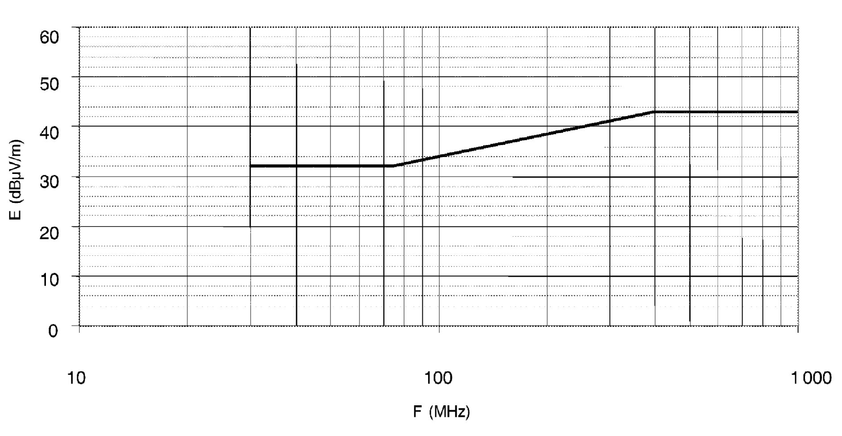

Frequency — megahertz — logarithmic
See point 6.2.2.1 of Annex I .

Appendix 3

Vehicle broadband reference limits
Antenna-vehicle separation: 3 m
Limit E (dBμV/m) at frequency F (MHz)
30-75 MHz | 75-400 MHz | 400-1 000 MHz
E = 42 | E = 42 + 15,13 log (F/75) | E = 53
Vehicle-radiated emission limit
Broadband type-approval limit – 3 m
Quasi-peak detector – 120 kHz bandwidth
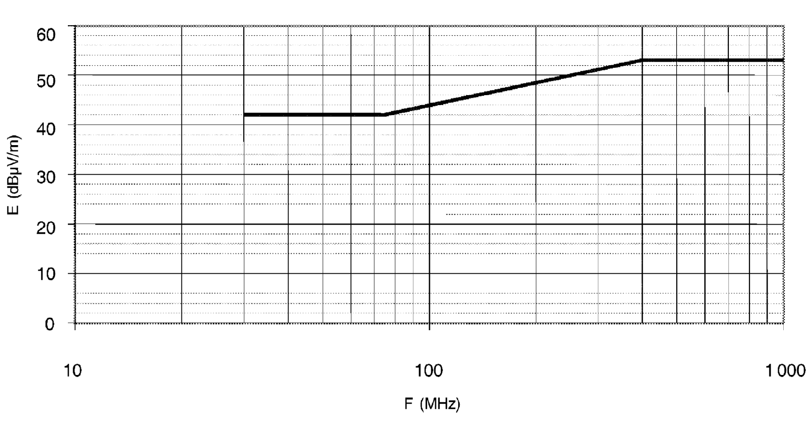

Frequency — megahertz — logarithmic
See point 6.2.2.2 of Annex I

Appendix 4

Vehicle narrowband reference limits
Antenna-vehicle separation: 10 m
Limit E (dBμV/m) at frequency F (MHz)
30-75 MHz | 75-400 MHz | 400-1 000 MHz
E = 22 | E = 22 + 15,13 log (F/75) | E = 33
Vehicle-radiated emission limit
Narrowband type-approval limit – 10 m
Average detector – 120 kHz bandwidth
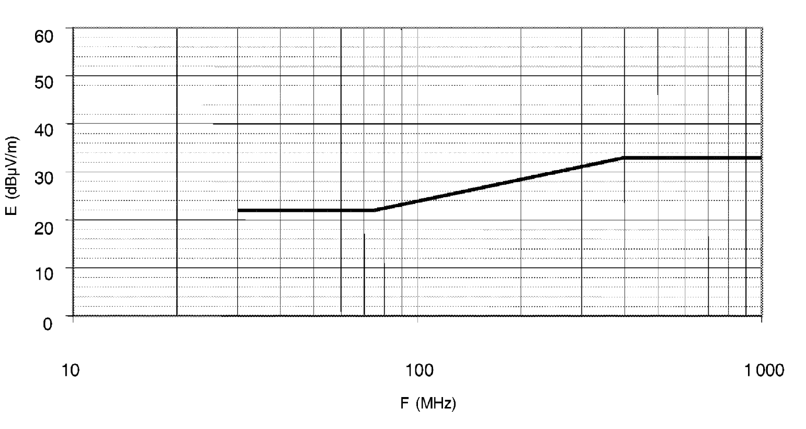

Frequency — megahertz — logarithmic
See point 6.3.2.1 of Annex I

Appendix 5

Vehicle narrowband reference limits
Antenna-vehicle separation: 3 m
Limit E (dBμV/m) at frequency F (MHz)
30-75 MHz | 75-400 MHz | 400-1 000 MHz
E = 32 | E = 32 + 15,13 log (F/75) | E = 43
Vehicle-radiated emission limit
Narrowband type-approval limit – 3 m
Average detector – 120 kHz bandwidth
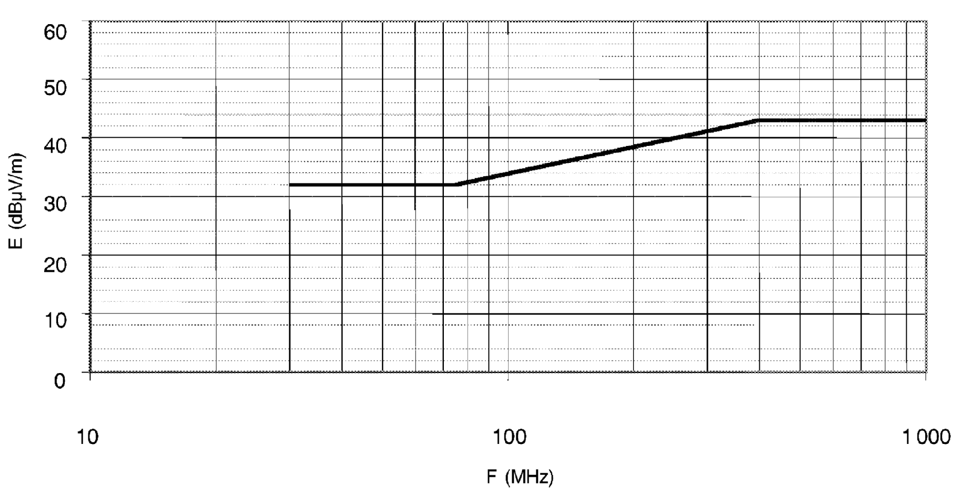

Frequency — megahertz — logarithmic
See point 6.3.2.2 of Annex I

Appendix 6

Electrical/electronic subassembly
Broadband reference limits
Limit E (dBμV/m) at frequency F (MHz)
30-75 MHz | 75-400 MHz | 400-1 000 MHz
E = 62 – 25,13 log (F/30) | E = 52 + 15,13 log (F/75) | E = 63
ESA-radiated emission limit
Broadband type-approval limit – 1 m
Quasi-peak detector – 120 kHz bandwidth
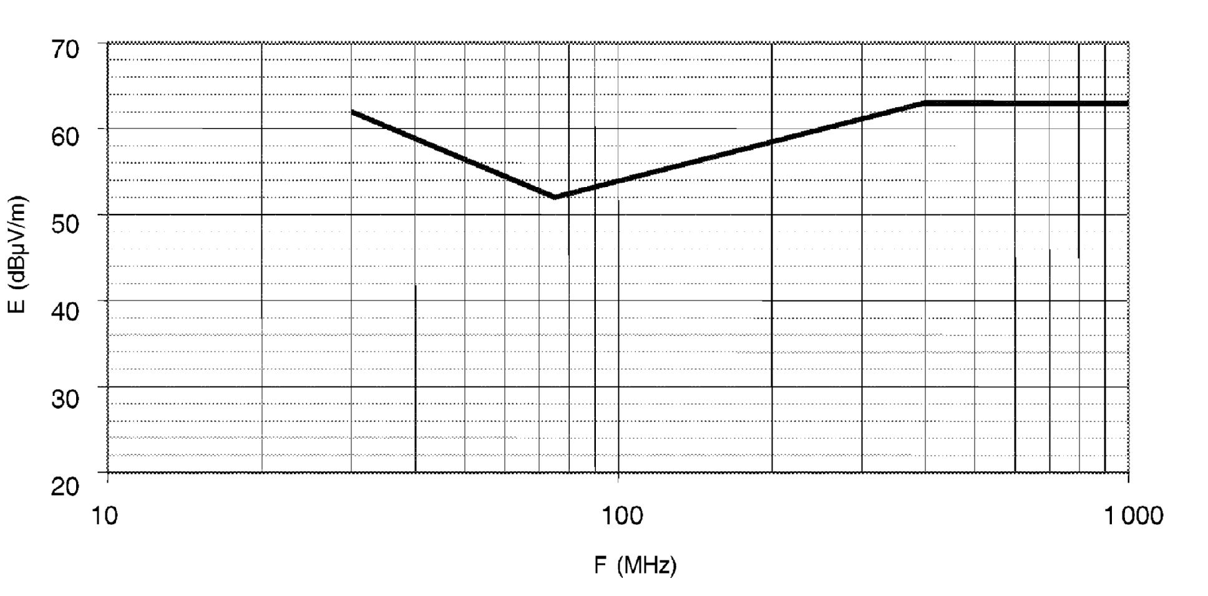

Frequency — megahertz — logarithmic
See point 6.5.2.1 of Annex I

Appendix 7

Electrical/electronic subassembly
Narrowband reference limits
Limit E (dBμV/m) at frequency F (MHz)
30-75 MHz | 75-400 MHz | 400-1 000 MHz
E = 52 – 25,13 log (F/30) | E = 42 + 15,13 log (F/75) | E = 53
ESA-radiated emission limit
Narrowband type-approval limit – 1 m
Average detector – 120 kHz bandwidth
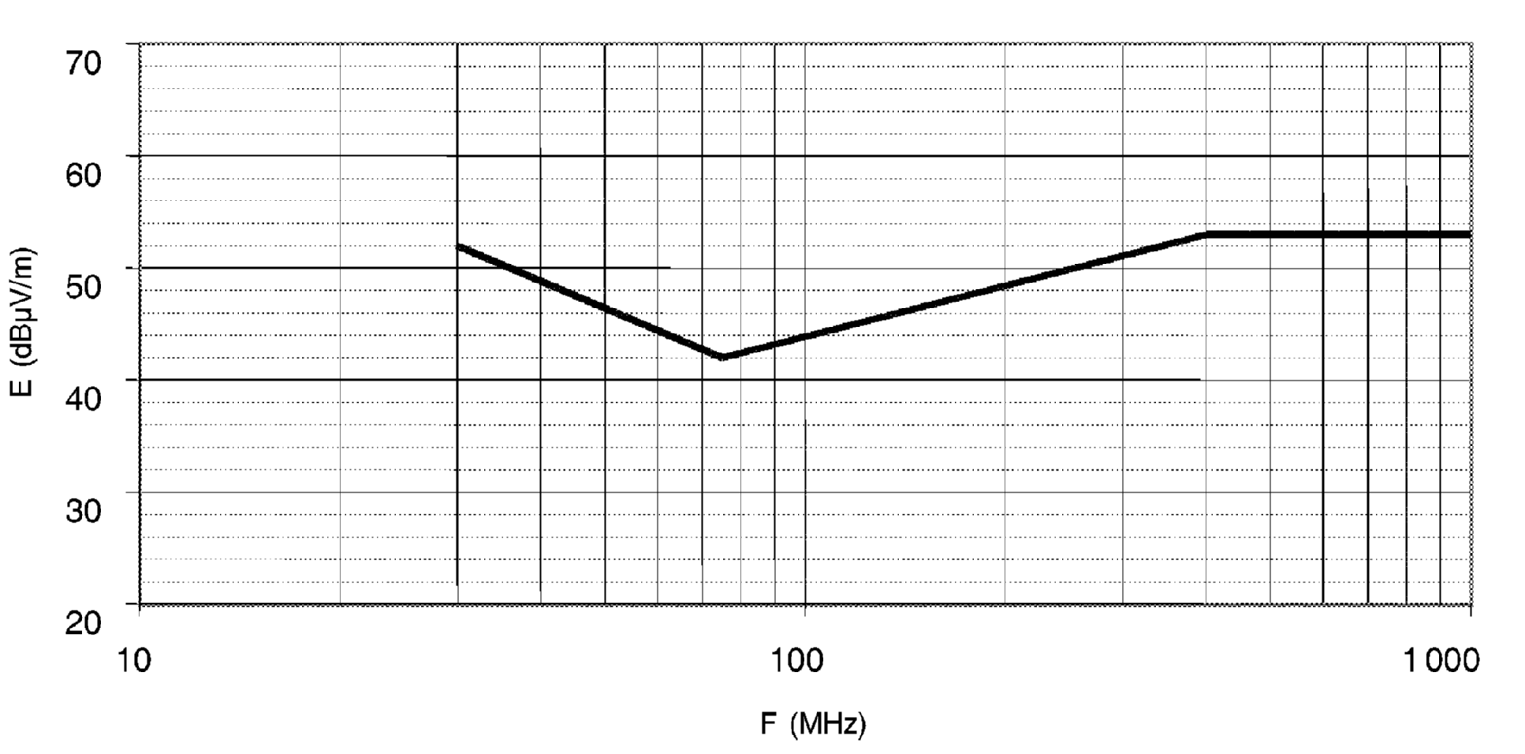

Frequency — megahertz — logarithmic
See point 6.6.2.1 of Annex I

Appendix 8

Model for the EC type-approval mark
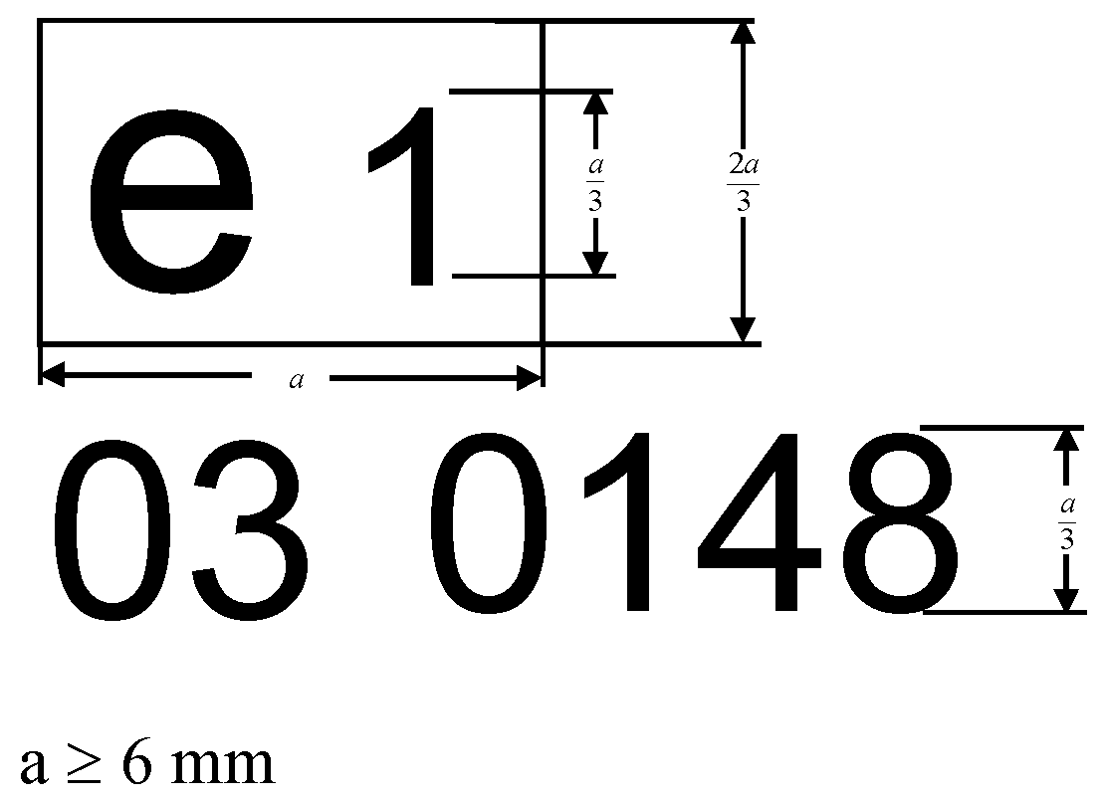

ê 2004/104/EC Art. 1 and Annex (adapted)
The ESA bearing the above EC type-approval mark is a device which has been approved in Germany (e1) under the base approval number 0148. The first two digits (03) indicate that the device conforms to the requirements of Directive 72/245/EEC, as amended by Directive Ö 2004/104/EC Õ.

ê 2004/104/EC Art. 1 and Annex
è1 Corrigendum, 2004/104/EC (OJ L 56, 2.3.2005, p. 35)
The figures used are only indicative.
_____________

ANNEX IIA
Information document No ... pursuant to Annex I to Directive 2007/46/EC relating to EC type-approval of a vehicle with respect to electromagnetic compatibility (Directive [72/245/EEC])è1 ç
The following information, if applicable, must be supplied in triplicate and must include a list of contents. Any drawings must be supplied in appropriate scale and in sufficient detail on size A4 or on a folder of A4 format. Photographs, if any, must show sufficient detail.
If the systems, component or separate technical units have electronic controls, information concerning their performance must be supplied.

0. GENERAL
0.1. Make (trade name of manufacturer):
0.2. Type:
0.4. Category of vehicle (^{c}):
0.5. Name and address of manufacturer:
Name and address of authorised representative, if any:
0.8. Address(es) of assembly plant(s):

1. GENERAL CONSTRUCTION CHARACTERISTICS OF THE VEHICLE
1.1. Photograph(s) and/or drawing(s) of a representative vehicle:
1.6. Position and arrangement of the engine:

3. POWER PLANT (^{q})
3.1. Manufacturer:
3.1.1. Manufacturer's engine code as marked on the engine:
3.2. Internal combustion engine
3.2.1.1. Working principle: positive ignition/compression ignition, four-stroke/two stroke
3.2.1.2. Number and arrangement of cylinders:
3.2.4. Fuel feed
3.2.4.2. By fuel injection (compression ignition only): yes/no
3.2.4.2.9. Electronic control unit
3.2.4.2.9.1. Make(s):
3.2.4.2.9.2. Description of the system:
3.2.4.3. By fuel injection (positive ignition only): yes/no
3.2.5. Electrical system
3.2.5.1. Rated voltage: … V, positive/negative ground
3.2.5.2. Generator
3.2.5.2.1. Type:
3.2.6. Ignition
3.2.6.1. Make(s):
3.2.6.2. Type(s):
3.2.6.3. Working principle:

3.2.15. LPG fuelling system: yes/no
3.2.15.2. Electronic engine management control unit for LPG fuelling
3.2.15.2.1. Make(s):
3.2.15.2.2. Type(s):

3.2.16. NG fuelling system: yes/no
3.2.16.2. Electronic engine management control unit for NG fuelling
3.2.16.2.1. Make(s):
3.2.16.2.2. Type(s):
3.3. Electric motor
3.3.1. Type (winding, excitation):
3.3.1.2. Operating voltage:
3.9. GAS FUELLED ENGINES (in the case of systems laid-out in a different manner, supply equivalent information)
3.9.7. Electronic control unit (ECU)
3.9.7.1. Make(s):
3.9.7.2. Type(s):

4. TRANSMISSION (^{v})
4.2. Type (mechanical, hydraulic, electric, etc.):
4.2.1. A brief description of the electrical/electronic components (if any):

6. SUSPENSION
6.2.2. A brief description of the electrical/electronic components (if any):

7. STEERING

7.2.2.1. A brief description of the electrical/electronic components (if any):

8. BRAKES
8.5. Anti-lock braking system: yes/no/optional
8.5.1. For vehicles with anti-lock systems, description of system operation (including any electronic parts), electric block diagram, hydraulic or pneumatic circuit plan:

9. BODYWORK
9.1. Type of bodywork:
9.2. Materials used and methods of construction:
9.5. Windscreen and other windows

9.5.2.3. A brief description of the electrical/electronic components (if any) of the window-lifting mechanism:
9.9. Rear-view mirrors (state for each mirror)
9.9.7. A brief description of the electronic components (if any) of the adjustment system:
9.12. Safety belts and/or other restraint systems:
9.12.4. A brief description of the electrical/electronic components (if any):
9.18. Suppression of radio interference
9.18.1. Description and drawings/photographs of the shapes and constituent materials of the part of the body forming the engine compartment and the part of the passenger compartment nearest to it:
9.18.2. Drawings or photographs of the position of the metal components housed in the engine compartment (e.g. heating appliances, spare wheel, air filter, steering mechanism, etc.):
9.18.3. Table and drawing of radio interference control equipment:
9.18.4. Particulars of the nominal value of the direct current resistance and, in the case of resistive ignition cables, of their nominal resistance per metre:

10. LIGHTING AND LIGHT-SIGNALLING DEVICES
10.5. A brief description of electrical/electronic components other than lamps (if any):

12. MISCELLANEOUS
12.2. Devices to prevent unauthorised use of the vehicle
12.2.3. A brief description of the electrical/electronic components (if any):
12.7. Table of installation and use of RF transmitters in the vehicle(s), if applicable (see point 3.1.8 of Annex I):
frequency bands (Hz) | max. output power (W) | antenna position at vehicle,  specific conditions for installation and/or use
The applicant for EC type-approval must also supply, where appropriate:
Appendix 1
A list (with make(s) and type(s) of all electrical and/or electronic components concerned by this Directive (see points 2.1.9. and 2.1.10. of Annex I) and not previously listed.
Appendix 2
Schematics or drawing of the general arrangement of electrical and/or electronic components (concerned by this Directive) and the general wiring harness arrangement.
Appendix 3
Description of vehicle chosen to represent the type
Body style:
Left or right-hand drive:
Wheelbase:
Appendix 4
Relevant test report(s) supplied by the manufacturer from a test laboratory accredited to ISO 17025 and recognised by the Approval Authority for the purpose of drawing up the EC type-approval certificate.

ê 2006/28/EC Art. 1, pt. 2(a)
12.7.1. Vehicle equipped with 24 GHz short-range radar equipment: Yes/No/Optional (strike out which is not applicable).
_____________

ê 2004/104/EC Art. 1 and Annex
è1 Corrigendum, 2004/104/EC (OJ L 56, 2.3.2005, p. 35)

ANNEX IIB
Information document No … relating to EC type-approval of an electric/electronic subassembly with respect to electromagnetic compatibility (Directive [72/245/EEC])è1 ç
The following information, if applicable, must be supplied in triplicate and must include a list of contents. Any drawings must be supplied in appropriate scale and in sufficient detail on size A4 or on a folder of A4 format. Photographs, if any, must show sufficient detail.
If the systems, component or separate technical units have electronic controls, information concerning their performance must be supplied.

0. GENERAL
0.1. Make (trade name of manufacturer):
0.2. Type:
0.3. Means of identification of type, if marked on the component/separate technical unit:
0.3.1. Location of that marking:
0.5. Name and address of manufacturer:
Name and address of authorised representative, if any:
0.7. In the case of components and separate technical units, location and method of affixing of the EC type-approval mark:
0.8. Address(es) of assembly plant(s):
1. This ESA shall be approved as a component/STU
2. Any restrictions of use and conditions for fitting:
3. Electrical system rated voltage: … V, positive/negative ground
Appendix 1
Description of the ESA chosen to represent the type (electronic block diagram and list of main components constituting the ESA (e.g. make and type of microprocessor, crystal, etc.)).
Appendix 2
Relevant test report(s) supplied by the manufacturer from a test laboratory accredited to ISO 17025 and recognised by the Approval Authority for the purpose of drawing up the EC type-approval certificate.
_____________

ANNEX IIIA

MODEL
(maximum format: A4 (210 × 297 mm))
EC TYPE-APPROVAL CERTIFICATE
Stamp of administration
Communication concerning the:
- EC type-approval
- extension of EC type-approval
- refusal of EC type-approval
- withdrawal of EC type-approval
of a type of vehicle with regard to Directive …/…/EC, as last amended by Directive …/…/EC.
EC type-approval number:
Reason for extension:

SECTION I
0.1. Make (trade name of manufacturer):
0.2. Type:
0.4. Category of vehicle (^{c}):
0.5. Name and address of manufacturer:
Name and address of authorised representative, if any:
0.8. Address(es) of assembly plant(s):

SECTION II
1. Additional information (where applicable): see Appendix
2. Technical service responsible for carrying out the tests:
3. Date of test report:
4. Number of test report:
5. Remarks (if any): see Appendix
6. Place:
7. Date:
8. Signature:
9. The EC type-approval file deposited at the Administrative Service having delivered the EC type-approval may be obtained on request.
Appendix to EC type-approval of a vehicle with regard to Directive [72/245/EEC]è1 ç
1. Additional information
1.1. Electrical system rated voltage: … V. positive/negative ground
1.2. Type of bodywork:
1.3. List of all electronic functions (concerned by that Directive) installed in the vehicle(s)

ê 2006/28/EC Art. 1, pt. 3(a)
1.3.1. Vehicle equipped with 24 GHz short-range radar equipment: Yes/No/Optional (strike out which is not applicable)

ê 2004/104/EC Art. 1 and Annex
è1 Corrigendum, 2004/104/EC (OJ L 56, 2.3.2005, p. 35)
1.4. Laboratory accredited to ISO 17025 and recognised by the Approval Authority (for the purpose of this Directive) responsible for carrying out the tests:
5. Remarks:
(e.g. valid for both left-hand drive and right-hand drive vehicles)
_____________

ANNEX IIIB

MODEL
(maximum format: A4 (210 × 297 mm))
EC TYPE-APPROVAL CERTIFICATE
Stamp of administration
Communication concerning the:
- EC type-approval
- extension of EC type-approval
- refusal of EC type-approval
- withdrawal of EC type-approval
of a type of component/separate technical unit with regard to Directive …/…/EC, as last amended by Directive …/…/EC.
EC type-approval number:
Reason for extension:
EC type-approval mark to be affixed on ESA:

SECTION I
0.1. Make (trade name of manufacturer):
0.2. Type:
0.3. Means of identification of type, if marked on the component/separate technical unit :
0.3.1. Location of that marking:
0.5. Name and address of manufacturer:
Name and address of authorised representative, if any:
0.7. In the case of components and separate technical units, location and method of affixing of the EC approval-mark:
0.8. Address(es) of assembly plant(s):

SECTION II
1. Additional information (where applicable): see Appendix
2. Technical service responsible for carrying out the tests:
3. Date of test report:
4. Number of test report:
5. Remarks (if any): see Appendix
6. Place:
7. Date:
8. Signature:
9. The EC type-approval file deposited at the Administrative Service having delivered the EC type-approval, may be obtained on request.
Appendix to EC type-approval certificate No … concerning the EC type-approval of an electric/electronic subassembly with regard to Directive [72/245/EEC]è1 ç
1. Additional information:
1.1. Electrical system rated voltage:
1.2. This ESA can be used on any vehicle type with the following restrictions:
1.2.1. Installation conditions, if any:
1.3. This ESA can only be used on the following vehicle types:
1.3.1. Installation conditions, if any:
1.4. The specific test method(s) used and the frequency ranges covered to determine immunity were (please specify precise method used from Annex IX):
1.5. Laboratory accredited to ISO 17025 and recognised by the Approval Authority (for the purpose of this Directive) responsible for carrying out the test
5. Remarks:
_____________

ANNEX IV
METHOD OF MEASUREMENT OF RADIATED BROADBAND ELECTROMAGNETIC EMISSIONS FROM VEHICLES

1. General
1.1. The test method described in this Annex shall only be applied to vehicles.
1.2. Test method
This test is intended to measure the broadband emissions generated by electrical or electronic systems fitted to the vehicle (e.g. ignition system or electric motors).
If not otherwise stated in this Annex the test shall be performed according to CISPR 12 (5th edition, 2001).

2. Vehicle state during tests
2.1. Engine
The engine shall be in operation according to CISPR 12 (5th edition, 2001) clause 5.3.2.
2.2. Other vehicle systems
All equipment capable of generating broadband emissions which can be switched on permanently by the driver or passenger should be in operation in maximum load, e.g. wiper motors or fans. The horn and electric window motors, etc., are excluded because they are not used continuously.

3. Test requirements
3.1. The limits apply throughout the frequency range 30 to 1 000 MHz for measurements performed in a semi anechoic chamber or an outdoor test site.
3.2. Measurements can be performed with either quasi-peak or peak detectors. The limits given in points 6.2 and 6.5 of Annex I are for quasi-peak detectors. If peak detectors are used a correction factor of 20 dB as defined in CISPR 12 (5th edition, 2001) shall be applied.
3.3. Measurements
The technical service shall perform the test at the intervals specified in the CISPR 12 (5th edition, 2001) standard throughout the frequency range 30 to 1 000 MHz.
Alternatively, if the manufacturer provides measurement data for the whole frequency band from a test laboratory accredited to the applicable parts of ISO 17025 (1st edition, 1999) and recognised by the Approval Authority, the technical service may divide the frequency range in 14 frequency bands 30-34, 34-45, 45-60, 60-80, 80-100, 100-130, 130-170, 170-225, 225-300, 300-400, 400-525, 525-700, 700-850, 850-1 000 MHz and perform tests at the 14 frequencies giving the highest emission levels within each band to confirm that the vehicle meets the requirements of this Annex.
In the event that the limit is exceeded during the test, investigations shall be made to ensure that this is due to the vehicle and not to background radiation.
3.4. Readings
The maximum of the readings relative to the limit (horizontal and vertical polarisation and antenna location on the left and right-hand sides of the vehicle) in each of the 14 frequency bands shall be taken as the characteristic reading at the frequency at which the measurements were made.
_____________

ANNEX V
METHOD OF MEASUREMENT OF RADIATED NARROWBAND ELECTROMAGNETIC EMISSIONS FROM VEHICLES

1. General
1.1. The test method described in this Annex shall only be applied to vehicles.
1.2. Test method
This test is intended to measure the narrowband electromagnetic emissions such as might emanate from microprocessor-based systems or other narrowband source.
If not otherwise stated in this Annex the test shall be performed according to CISPR 12 (5th edition, 2001) or to CISPR 25 (2nd edition, 2002).

ê Corrigendum, 2004/104/EC (OJ L 56, 2.3.2005, p. 35)
1.3 As an initial step the levels of emissions in the FM frequency band (76 to 108 MHz) shall be measured at the vehicle broadcast radio antenna with an average detector. If the level specified in point 6.3.2.4 of Annex I is not exceeded, then the vehicle shall be deemed to comply with the requirements of this Annex in respect of that frequency band and the full test shall not be carried out.

ê 2004/104/EC Art. 1 and Annex
è1 2005/83/EC Art. 1 and Annex pt. 2(a)
è2 2005/83/EC Art. 1 and Annex pt. 2(b)

2. Vehicle state during tests
2.1. The ignition switch shall be switched on. The engine shall not be operating.
2.2. The vehicle's electronic systems shall all be in normal operating mode with the vehicle stationary.
2.3. All equipment which can be switched on permanently by the driver or passenger with internal oscillators > 9 kHz or repetitive signals should be in normal operation.

3. Test requirements
3.1. The limits apply throughout the frequency range 30 to 1 000 MHz for measurements performed in a semi anechoic chamber or an outdoor test site.
3.2. Measurements shall be performed with an average detector.
3.3. Measurements
The technical service shall perform the test at the intervals specified in the CISPR 12 (5th edition, 2001) standard throughout the frequency range 30 to 1 000 MHz.
Alternatively, if the manufacturer provides measurement data for the whole frequency band from a test laboratory accredited to the applicable parts of ISO 17025 (1st edition, 1999) and recognised by the Approval Authority, the technical service may divide the frequency range in 14 frequency bands 30-34, 34-45, 45-60, 60-80, 80-100, 100-130, 130-170, 170-225, 225-300, 300-400, 400-525, 525-700, 700-850, 850-1 000 MHz and perform tests at the 14 frequencies giving the highest emission levels within each band to confirm that the vehicle meets the requirements of this Annex.
In the event that the limit is exceeded during the test, investigations shall be made to ensure that this is due to the vehicle and not to background radiation including broadband radiation from any ESA.
3.4. Readings
The maximum of the readings relative to the limit (horizontal and vertical polarisation and antenna location on the left and right-hand sides of the vehicle) in each of the 14 frequency bands shall be taken as the characteristic reading at the frequency at which the measurements were made.
_____________

ANNEX VI
METHOD OF TESTING FOR IMMUNITY OF VEHICLES TO ELECTROMAGNETIC RADIATION

1. General
1.1. The test method described in this Annex shall only be applied to vehicles.
1.2. Test method
This test is intended to demonstrate the immunity of the vehicle electronic systems. The vehicle shall be subject to electromagnetic fields as described in this Annex. The vehicle shall be monitored during the tests.
If not otherwise stated in this Annex, the test shall be performed according to è1 ISO 11451-2: 3rd edition, 2005 ç .
1.3. Alternative test methods
The test may be alternatively performed in an outdoor test site for all vehicles. The test facility shall comply with (national) legal requirements regarding the emission of electromagnetic fields.
If a vehicle is longer than 12 m and/or wider than 2,60 m and/or higher than 4,00 m, the BCI method according to ISO 11451-4 (1st edition, 1995) can be used in the frequency range 20-2 000 MHz with levels defined in point 6.7.2.1 of Annex I.

2. Vehicle state during tests
2.1. The vehicle shall be in an unladen condition except for necessary test equipment.
2.1.1. The engine shall normally turn the driving wheels at a steady speed of 50 km/h if there is no technical reason due to the vehicle to define a different condition. The vehicle shall be on an appropriately loaded dynamometer or alternatively supported on insulated axle stands with minimum ground clearance if no dynamometer is available. Where appropriate, transmission shafts may be disconnected (e.g. trucks).
2.1.2. Basic vehicle conditions
This point defines minimum test conditions and failures criteria for vehicle immunity tests. Other vehicle systems, which can affect immunity-related functions must be tested in a way to be agreed between manufacturer and technical service.
‘50 km/h cycle’ vehicle test conditions | Failure criteria
Vehicle speed 50 km/h ± 20 % (vehicle driving the rollers). If the vehicle is equipped with a cruise control system, it shall be operational | Speed variation greater than ± 10 % of the nominal speed  In case of automatic gearbox: change-of-gear ratio inducing a speed variation greater than ± 10 % of the nominal speed
Dipped beams ON (manual mode) | Lighting OFF
Front wiper ON (manual mode) maximum speed | Complete stop of front wiper
Direction indicator on driver’s side ON | Frequency change (lower than 0,75 Hz or greater than 2,25 Hz)  Duty cycle change (lower than 25 % or greater than 75 %)
Adjustable suspension in normal position | Unexpected significant variation
Driver’s seat and steering wheel in medium position | Unexpected variation greater than 10 % of total range
Alarm unset | Unexpected activation of alarm
Horn OFF | Unexpected activation of horn
Airbag and safety restraint systems operational with inhibited passenger airbag if this function exists | Unexpected activation
Automatic doors closed | Unexpected opening
Adjustable endurance brake lever in normal position | Unexpected activation

‘Brake cycle’ vehicle test conditions | Failure criteria
To be defined in brake cycle test plan. This must include operation of the brake pedal (unless there are technical reasons not to do so) but not necessarily an anti-lock brake system action. | Stop lights inactivated during cycle  Brake warning light ON with loss of function  Unexpected activation
2.1.3. All equipment which can be switched on permanently by the driver or passenger should be in normal operation.
2.1.4. All other systems which affect the driver’s control of the vehicle shall be (on) as in normal operation of the vehicle.
2.2. If there are vehicle electrical/electronic systems which form an integral part of the direct control of the vehicle, which will not operate under the conditions described in point 4.1, it will be permissible for the manufacturer to provide a report or additional evidence to the testing authority that the vehicle electrical/electronic system meets the requirements of this Directive. Such evidence shall be retained in the EC type-approval documentation.
2.3. Only non-perturbing equipment shall be used while monitoring the vehicle. The vehicle exterior and the passenger compartment shall be monitored to determine whether the requirements of this Annex are met (e.g. by using (a) video camera(s), a microphone, etc.).

3. Test requirements
3.1. Frequency range, dwell times, polarisation
The vehicle shall be exposed to electromagnetic radiation in the 20 to 2 000 MHz frequency ranges in vertical polarisation.
The test signal modulation shall be:
- AM, with 1 kHz modulation and 80 % modulation depth in the 20-800 MHz frequency range, and
- PM, t on 577 μs, period 4 600 μs in the 800-2 000 MHz frequency range,
if not otherwise agreed between technical service and vehicle manufacturer.
Frequency step size and dwell time shall be chosen according to è2 ISO 11451-1: 3rd edition, 2005 ç .
3.1.1. The technical service shall perform the test at the intervals specified in è2 ISO 11451-1: 3rd edition, 2005 ç throughout the frequency range 20 to 2 000 MHz.
Alternatively, if the manufacturer provides measurement to data for the whole frequency band from a test laboratory accredited to the applicable parts of ISO 17025 (1st edition, 1999) and recognised by the Approval Authority, the technical service may choose a reduced number of spot frequencies in the range, e.g. 27, 45, 65, 90, 120, 150, 190, 230, 280, 380, 450, 600, 750, 900, 1 300, and 1 800 MHz to confirm that the vehicle meets the requirements of this Annex.
If a vehicle fails the test defined in this Annex, it must be verified as having failed under the relevant test conditions and not as a result of the generation of uncontrolled fields.

4. Generation of required field strength
4.1. Test methodology
4.1.1. The substitution method according to è2 ISO 11451-1: 3rd edition, 2005 ç shall be used to establish the test field conditions.
4.1.2. Calibration
For transmission-line-systems (TLS) one field probe at the facility reference point shall be used.
For antennae, four field probes at the facility reference line shall be used.
4.1.3. Test phase
The vehicle shall be positioned with the centre line of the vehicle on the facility reference point or line. The vehicle shall normally face a fixed antenna. However, where the electronic control units and the associated wiring harness are predominantly in the rear of the vehicle, the test should normally be carried out with the vehicle facing away from the antenna. In the case of long vehicles (i.e. excluding cars and light vans), which have electronic control units and associated wiring harness predominantly towards the middle of the vehicle, a reference point may be established based on either the right-side surface or the left-side surface of the vehicle. This reference point shall be at the midpoint of the vehicle’s length or at one point along the side of the vehicle chosen by the manufacturer in conjunction with the competent authority after considering the distribution of electronic systems and the layout of any wiring harness.
Such testing may only take place if the physical construction of the chamber permits. The antenna location must be noted in the test report.
_____________

ANNEX VII
METHOD OF MEASUREMENT OF RADIATED BROADBAND ELECTROMAGNETIC EMISSIONS FROM ELECTRICAL/ELECTRONIC SUBASSEMBLIES

1. General
1.1. The test method described in this Annex may be applied to ESAs, which may be subsequently fitted to vehicles, which comply with Annex IV.
1.2. Test method
This test is intended to measure broadband electromagnetic emissions from ESAs (e.g. ignition systems, electric motor, etc.).
If not otherwise stated in this Annex the test shall be performed according to CISPR 25 (2nd edition, 2002).

2. ESA state during tests
2.1. The ESA under test shall be in normal operation mode, preferably in maximum load.

3. Test arrangements

ê 2005/83/EC Art. 1 and Annex pt. 3
3.1. The test shall be performed according to CISPR 25 (2nd edition, 2002) clause 6.4 — ALSE method.

ê 2004/104/EC Art. 1 and Annex
3.2. Alternative measuring location
As an alternative to an absorber-lined shielded enclosure (ALSE) an open-area test site (OATS), which complies with the requirements of CISPR 16-1 (2nd edition, 2002) may be used (see Appendix 1 to this Annex).
3.3. Ambient
To ensure that there is no extraneous noise or signal of a magnitude sufficient to affect materially the measurement, measurements shall be taken before or after the main test. In this measurement, the extraneous noise or signal shall be at least 6 dB below the limits of interference given in point 6.5.2.1 of Annex I, except for intentional narrowband ambient transmissions.

4. Test requirements
4.1. The limits apply throughout the frequency range 30 to 1 000 MHz for measurements performed in a semi anechoic chamber or an outdoor test site.
4.2. Measurements can be performed with either quasi-peak or peak detectors. The limits given in points 6.2 and 6.5 of Annex I are for quasi-peak detectors. If peak detectors are used a correction factor of 20 dB as defined in CISPR 12 (5th edition, 2001) shall be applied.
4.3. Measurements
The technical service shall perform the test at the intervals specified in the CISPR 25 (2nd edition, 2002) standard throughout the frequency range 30 to 1 000 MHz.
Alternatively, if the manufacturer provides measurement to data for the whole frequency band from a test laboratory accredited to the applicable parts of ISO 17025 (1st edition, 1999) and recognised by the Approval Authority, the technical service may divide the frequency range in 13 frequency bands 30–50, 50-75, 75-100, 100-130, 130-165, 165-200, 200-250, 250-320, 320-400, 400-520, 520-660, 660-820, 820-1 000 MHz and perform tests at the 13 frequencies giving the highest emission levels within each band to confirm that the ESA meets the requirements of this Annex.
In the event that the limit is exceeded during the test, investigations shall be made to ensure that this is due to the ESA and not to background radiation.
4.4. Readings
The maximum of the readings relative to the limit (horizontal/vertical polarisation) in each of the 13 frequency bands shall be taken as the characteristic reading at the frequency at which the measurements were made.

Appendix 1

Figure 1
Open-area test site: Electrical/electronic subassembly test area boundary
Level, clear area free from electromagnetic reflecting surfaces
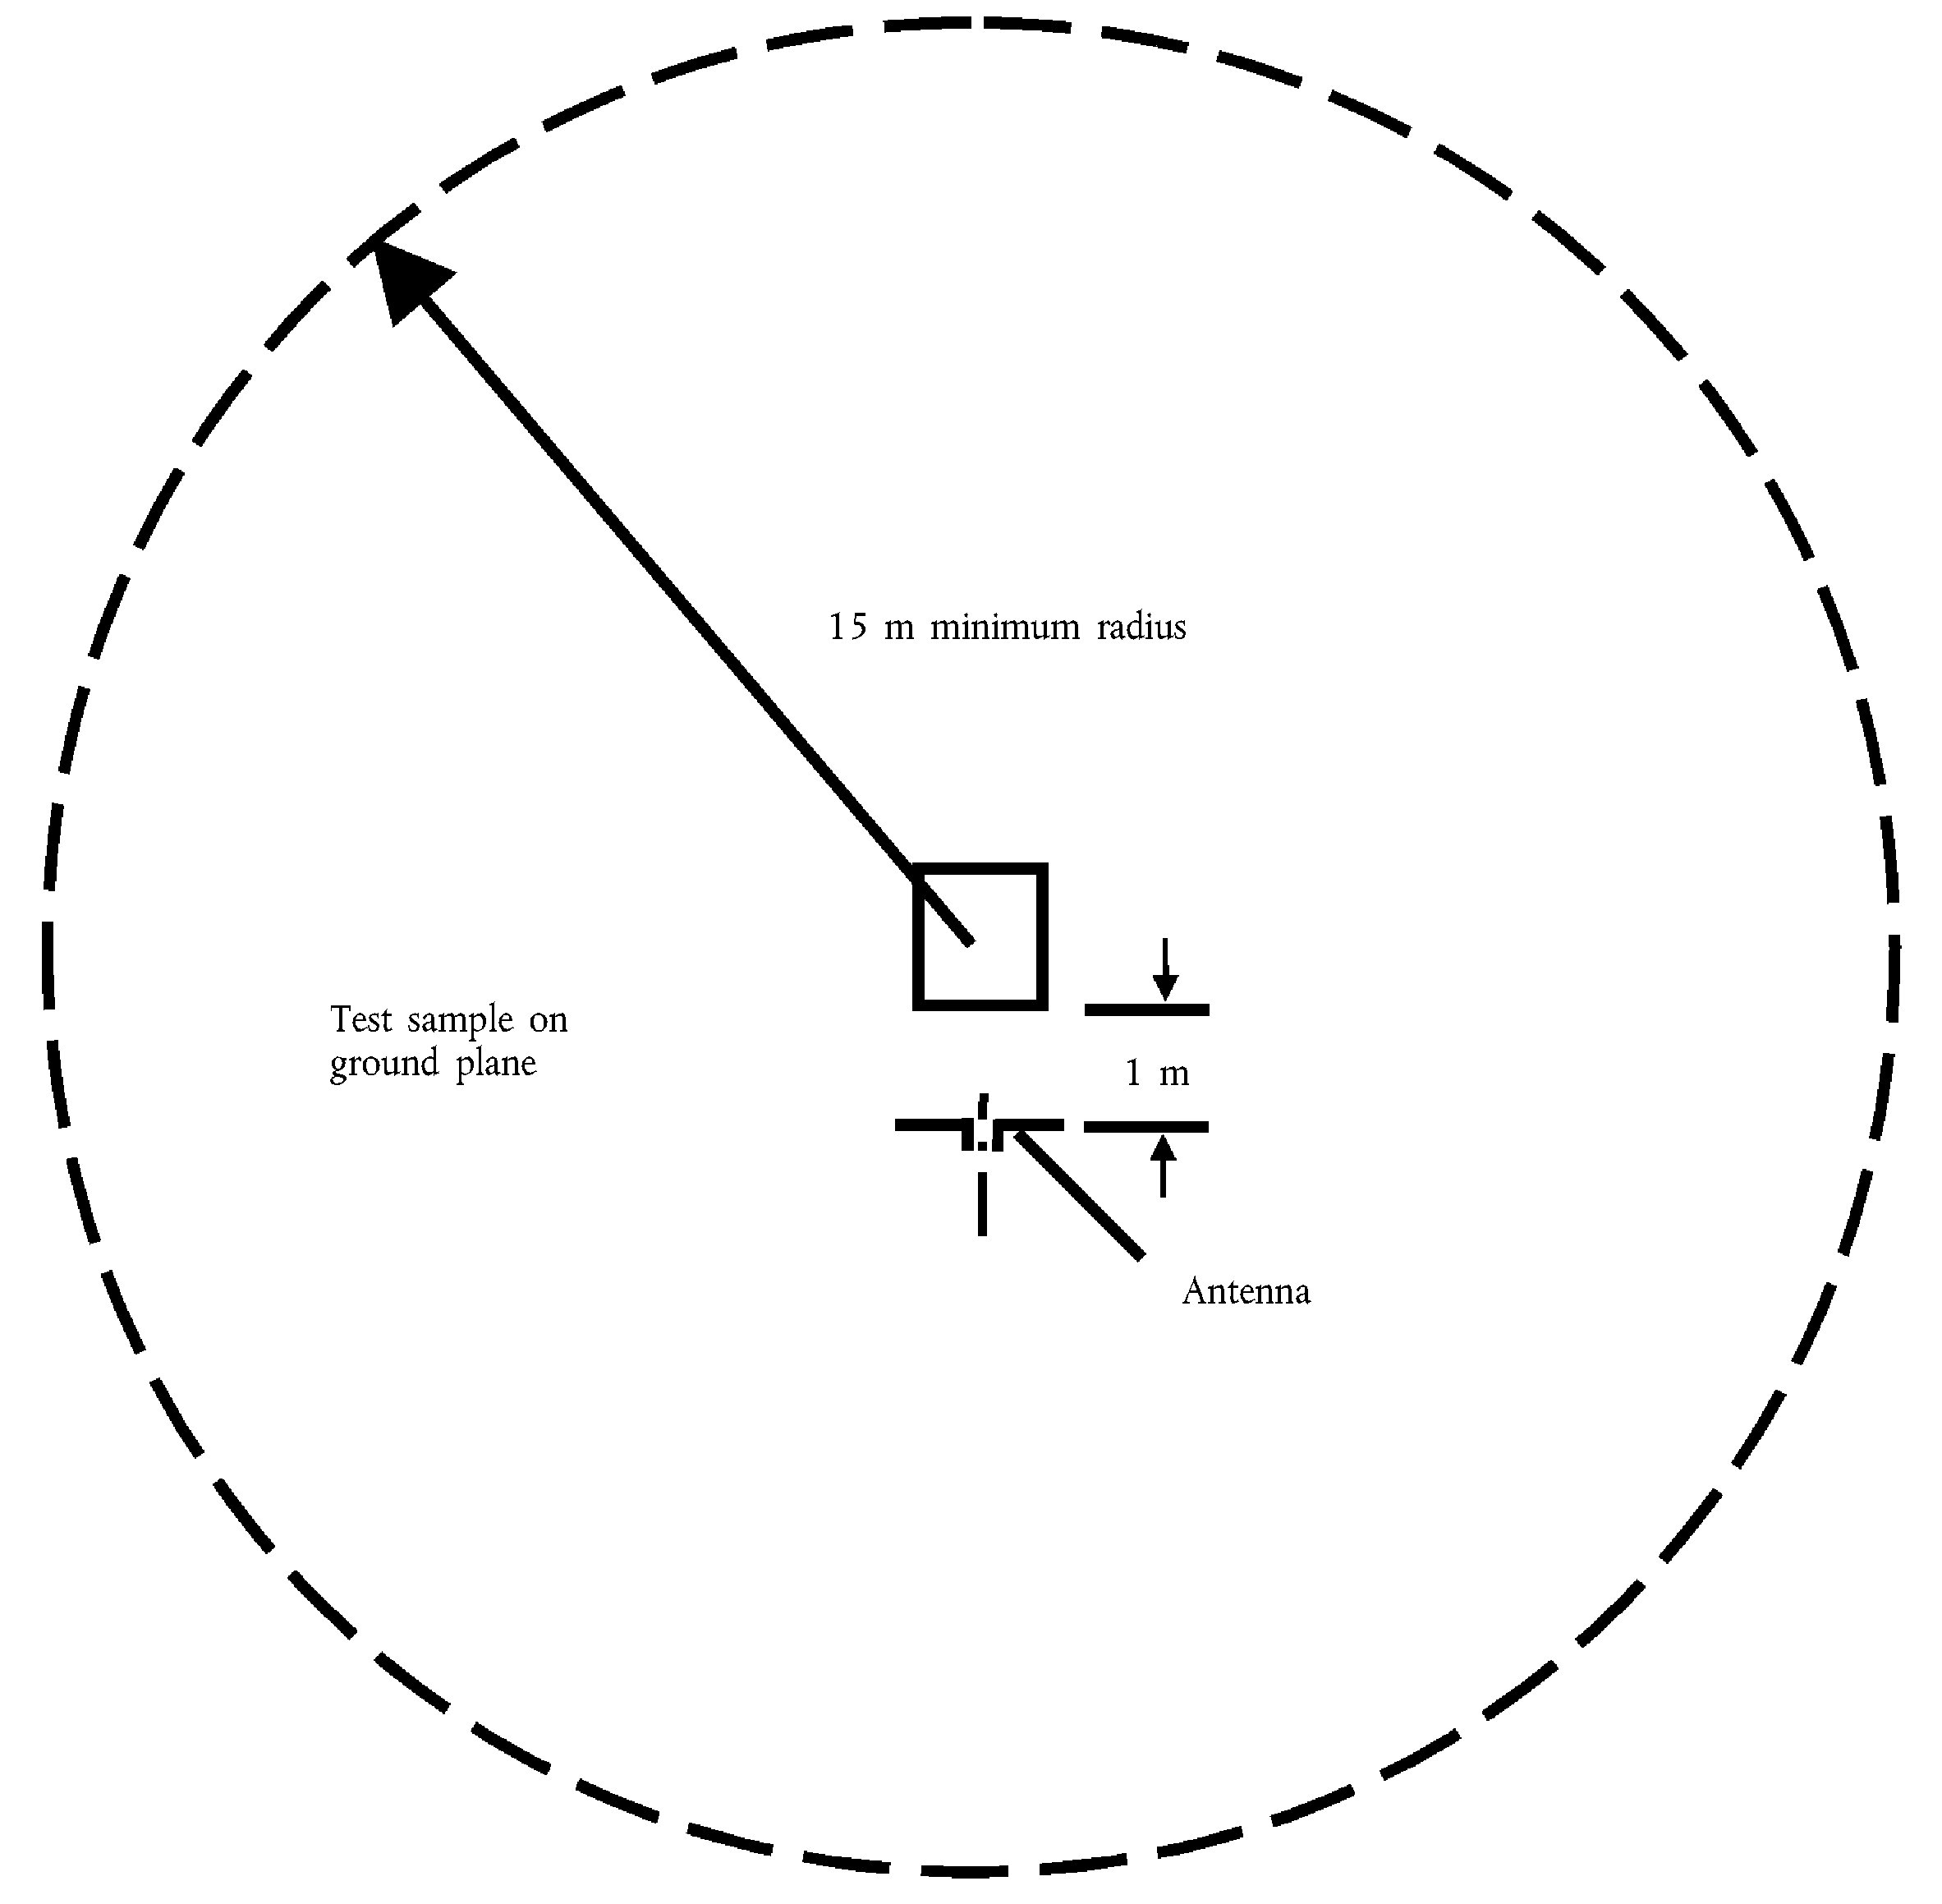
_____________

ANNEX VIII
METHOD OF MEASUREMENT OF RADIATED NARROWBAND ELECTROMAGNETIC EMISSIONS FROM ELECTRICAL/ELECTRONIC SUBASSEMBLIES

1. General
1.1. The test method described in this Annex may be applied to ESAs, which may be subsequently fitted to vehicles, which comply with Annex IV.
1.2. Test method
This test is intended to measure the narrowband electromagnetic emissions such as emanate from a microprocessor-base system.
If not otherwise stated in this Annex the test shall be performed according to CISPR 25 (2nd edition, 2002).

2. ESA state during tests
The ESA under test shall be in normal operation mode.

3. Test arrangements

ê 2005/83/EC Art. 1 and Annex pt. 4
3.1. The test shall be performed according to CISPR 25 (2nd edition, 2002) clause 6.4 — ALSE method.

ê 2004/104/EC Art. 1 and Annex
3.2. Alternative measuring location
As an alternative to an absorber-lined shielded enclosure (ALSE) an open-area test site (OATS) which complies with the requirements of CISPR 16-1 (2nd edition, 2002) may be used (see Appendix 1 to Annex VII).
3.3. Ambient
To ensure that there is no extraneous noise or signal of a magnitude sufficient to affect materially the measurement, measurements shall be taken before or after the main test. In this measurement, the extraneous noise or signal shall be at least 6 dB below the limits of interference given in point 6.5.2.1 of Annex I, except for intentional narrowband ambient transmissions.

4. Test requirements
4.1. The limits apply throughout the frequency range 30 to 1 000 MHz for measurements performed in semi-anechoic chambers or outdoor test sites.
4.2. Measurements shall be performed with an average detector.
4.3. Measurements
The technical service shall perform the test at the intervals specified in the CISPR 12 (5th edition, 2001) standard throughout the frequency range 30 to 1 000 MHz.
Alternatively, if the manufacturer provides measurement to data for the whole frequency band from a test laboratory accredited to the applicable parts of ISO 17025 (1st edition, 1999) and recognised by the Approval Authority, the technical service may divide the frequency range in 13 frequency bands 30-50, 50-75, 75-100, 100-130, 130-165, 165-200, 200-250, 250-320, 320-400, 400-520, 520-660, 660-820, 820-1 000 MHz and perform tests at the 13 frequencies giving the highest emission levels within each band to confirm that the ESA meets the requirements of this Annex. In the event that the limit is exceeded during the test, investigations shall be made to ensure that this is due to the ESA and not to background radiation including broadband radiation from the ESA.
4.4. Readings
The maximum of the readings relative to the limit (horizontal/vertical polarisation) in each of the 13 frequency bands shall be taken as the characteristic reading at the frequency at which the measurements were made.
_____________

ANNEX IX
METHOD(S) OF TESTING FOR IMMUNITY OF ELECTRICAL/ELECTRONIC SUBASSEMBLIES TO ELECTROMAGNETIC RADIATION

1. General
1.1. The test method(s) described in this Annex may be applied to ESAs.
1.2. Test methods

ê 2005/83/EC Art. 1 and Annex pt. 5(a)
1.2.1. ESAs may comply with the requirements of any combination of the following test methods at the manufacturer's discretion provided that this results in the full frequency range specified in point 3.1 being covered.
- Absorber Chamber test: according to ISO 11452-2: 2nd edition, 2004
- TEM cell testing: according to ISO 11452-3: 2nd edition, 2001
- Bulk current injection testing: according to ISO 11452-4: 3rd edition, 2005
- Stripline testing: according to ISO 11452-5: 2nd edition, 2002
- 800 mm Stripline: according to point 4.5 .
Frequency range and general test conditions shall be based on ISO 11452-1: 3rd edition, 2005.

ê 2004/104/EC Art. 1 and Annex

2. State of ESA during tests

ê 2005/83/EC Art. 1 and Annex pt. 5(b)
2.1. The test conditions shall be according to ISO 11452-1: 3rd edition, 2005.

ê 2004/104/EC Art. 1 and Annex
2.2. The ESA under test shall be switched on and must be stimulated to be in normal operation condition. It shall be arranged as defined in this Annex unless individual test methods dictate otherwise.
2.3. Any extraneous equipment required to operate the ESA under test shall not be in place during the calibration phase. No extraneous equipment shall be closer than 1 m from the reference point during calibration.
2.4. To ensure reproducible measurement results are obtained when tests and measurements are repeated, the test signal generating equipment and its layout shall be to the same specification as that used during each appropriate calibration phase.
2.5. If the ESA under test consists of more than one unit, the interconnecting cables should ideally be the wiring harnesses as intended for use in the vehicle. If these are not available, the length between the electronic control unit and the AN shall be as defined in the standard. All cables in the wiring harness should be terminated as realistically as possible and preferably with real loads and actuators.

3. General test requirements

ê 2005/83/EC Art. 1 and Annex pt. 5(c)
3.1. Frequency range, dwell times
Measurements shall be made in the 20 to 2 000 MHz frequency range with frequency steps according to ISO 11452-1: 3rd edition, 2005.
The test signal modulation shall be:
- AM, with 1 kHz modulation and 80 % modulation depth in the 20-800 MHz frequency range,
- PM, t on 577 μs, period 4 600 μs in the 800-2 000 MHz frequency range,
if not otherwise agreed between technical service and ESA manufacturer.
Frequency step size and dwell time shall be chosen according to ISO 11452-1: 3rd edition, 2005.

ê 2005/83/EC Art. 1 and Annex pt. 5(d)
3.2. The technical service shall perform the test at the intervals specified in ISO 11452-1: 3rd edition, 2005 throughout the frequency range 20 to 2 000 MHz.
Alternatively, if the manufacturer provides measurement to data for the whole frequency band from a test laboratory accredited to the applicable parts of ISO 17025: 1st edition, 1999 and recognised by the Approval Authority, the Technical Service may choose a reduced number of spot frequencies in the range, e.g. 27, 45, 65, 90, 120, 150, 190, 230, 280, 380, 450, 600, 750, 900, 1 300, and 1 800 MHz to confirm that the ESA meets the requirements of this Annex.

ê 2004/104/EC Art. 1 and Annex
3.3. If an ESA fails the tests defined in this Annex, it must be verified as having failed under the relevant test conditions and not as a result of the generation of uncontrolled fields.

4. Specific test requirements
4.1. Absorber chamber test
4.1.1. Test method
This test method allows the testing of vehicle electrical/electronic systems by exposing an ESA to electromagnetic radiation generated by an antenna.

ê 2005/83/EC Art. 1 and Annex pt. 5(e)
4.1.2. Test methodology
The ‘substitution method’ shall be used to establish the test field conditions according to ISO 11452-2: 2nd edition, 2004.
The test shall be performed with vertical polarisation.

ê 2004/104/EC Art. 1 and Annex
4.2. TEM cell testing
4.2.1. Test method
The TEM (transverse electromagnetic mode) cell generates homogeneous fields between the internal conductor (septum) and housing (ground plane).

ê 2005/83/EC Art. 1 and Annex pt. 5(f)
4.2.2. Test methodology
The test shall be performed according to ISO 11452-3: 2nd edition, 2001.
Depending on the ESA to be tested the technical service shall choose the method of maximum field coupling to the ESA or to the wiring harness inside the TEM-cell.

ê 2004/104/EC Art. 1 and Annex
4.3. Bulk current injection testing
4.3.1. Test method
This is a method of carrying out immunity tests by inducing currents directly into a wiring harness using a current injection probe.

ê 2005/83/EC Art. 1 and Annex pt. 5(g)
4.3.2. Test methodology
The test shall be performed according to ISO 11452-4: 3rd edition, 2005 on a test bench.
As an alternative the ESA may be tested while installed in the vehicle according to ISO 11451-4: 1st edition, 1995.
- The injection probe shall be positioned at a distance of 150 mm from the ESA to be tested.
- The reference method shall be used to calculate injected currents from forward power.
- The frequency range of the method is limited by the injection probe specification.

ê 2004/104/EC Art. 1 and Annex
è1 2005/83/EC Art. 1 and Annex pt. 6
4.4. Stripline testing
4.4.1. Test method
This test method consists of subjecting the wiring harness connecting the components in an ESA to specified field strengths.
4.4.2. Test methodology
The test shall be performed according to ISO 11452-5 (2nd edition, 2002).
4.5. 800 mm stripline testing
4.5.1. Test method
The stripline consists of two parallel metallic plates separated by 800 mm. Equipment under test is positioned centrally between the plates and subjected to an electromagnetic field (see Appendix 1 to this Annex).
This method can test complete electronic systems including sensors and actuators as well as the controller and wiring loom. It is suitable for apparatus whose largest dimension is less than one third of the plate separation.
4.5.2. Test methodology
4.5.2.1. Positioning of stripline
The stripline shall be housed in a screened room (to prevent external emissions) and positioned 2 m away from walls and any metallic enclosure to prevent electromagnetic reflections. RF absorber material may be used to damp these reflections. The stripline shall be placed on non-conducting supports at least 0,4 m above the floor.
4.5.2.2. Calibration of the stripline
A field-measuring probe shall be positioned within the central one third of the longitudinal, vertical and transverse dimensions of the space between the parallel plates with the system under test absent.
The associated measuring equipment shall be sited outside the screen room. At each desired test frequency, a level of power shall be fed into the stripline to produce the required field strength at the antenna. This level of forward power, or another parameter directly related to the forward power required to define the field, shall be used for EC type-approval tests unless changes occur in the facilities or equipment, which necessitate this procedure being repeated.
4.5.2.3. Installation of the ESA under test
The main control unit shall be positioned within the central one third of the longitudinal, vertical and transverse dimensions of the space between the parallel plates. It shall be supported on a stand made from non-conducting material.
4.5.2.4. Main wiring loom and sensor/actuator cables
The main wiring loom and any sensor/actuator cables shall rise vertically from the control unit to the top ground plate (this helps to maximise coupling with the electromagnetic field). Then they shall follow the underside of the plate to one of its free edges where they shall loop over and follow the top of the ground plate as far as the connections to the stripline feed. The cables shall then be routed to the associated equipment, which shall be sited in an area outside the influence of the electromagnetic field, e.g. on the floor of the screened room 1 m longitudinally away from the stripline.

Appendix 1

Figure 1
800 mm stripline testing
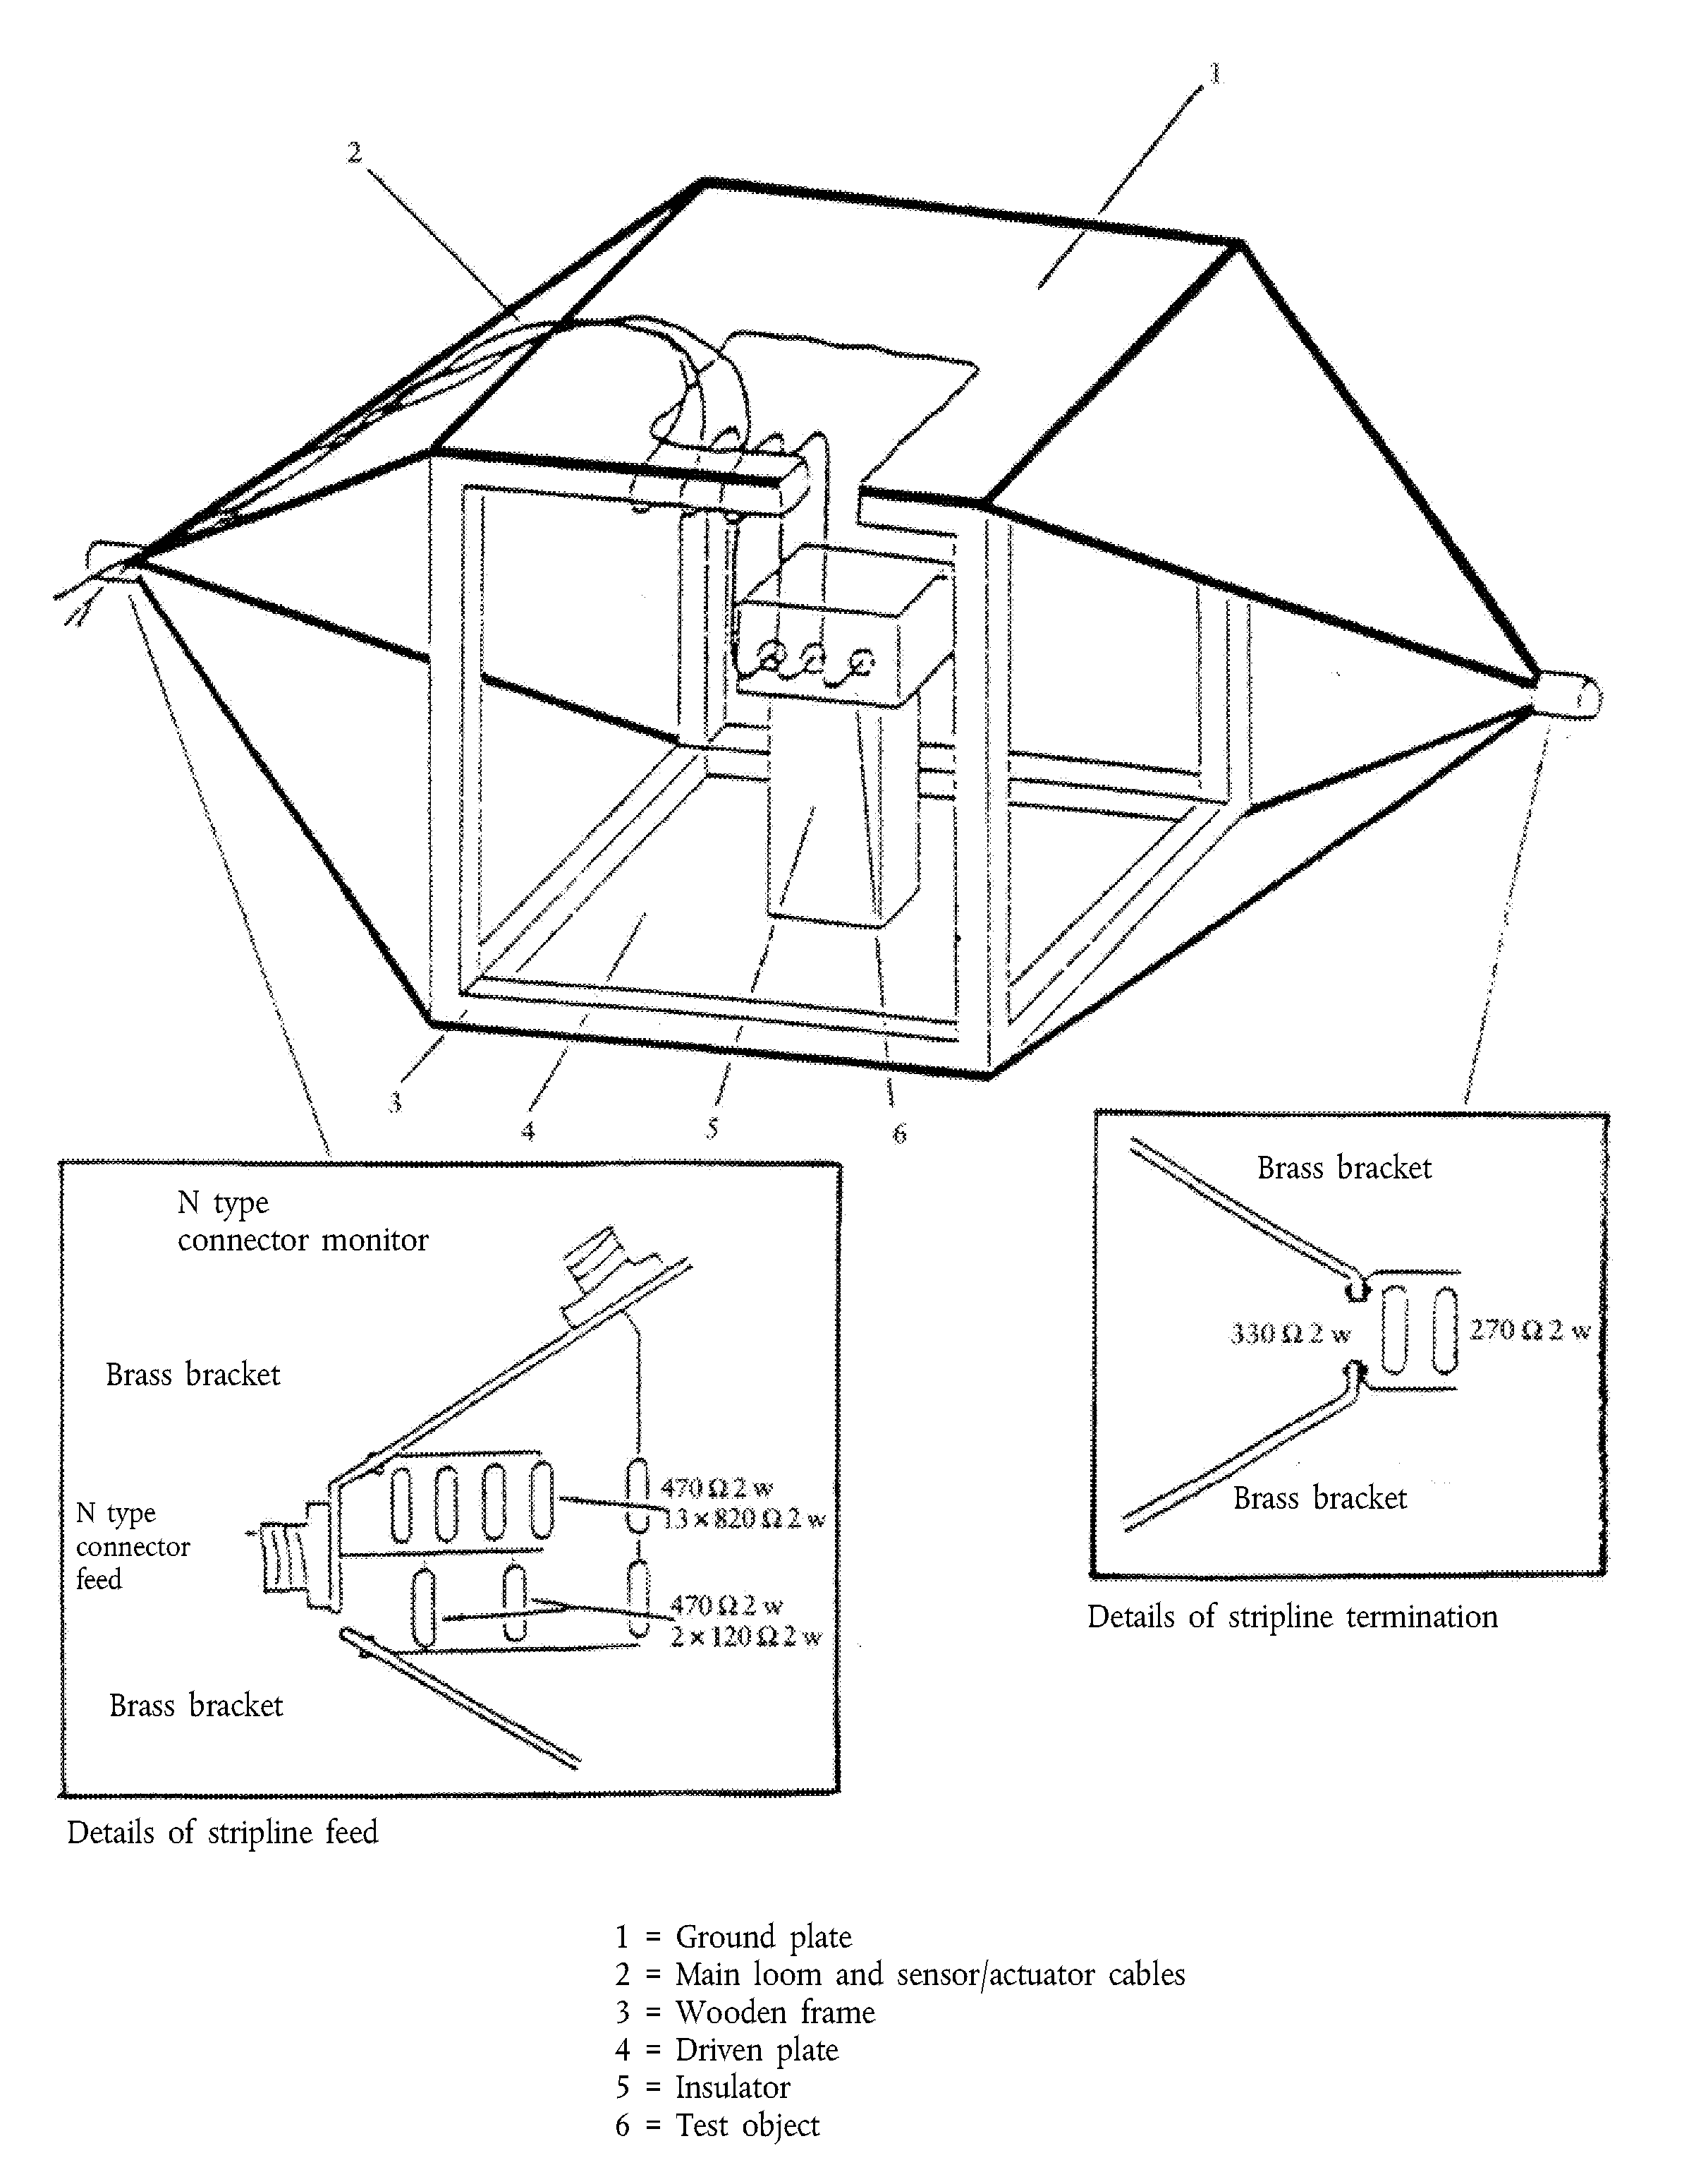

Figure 2
800 mm stripline dimensions
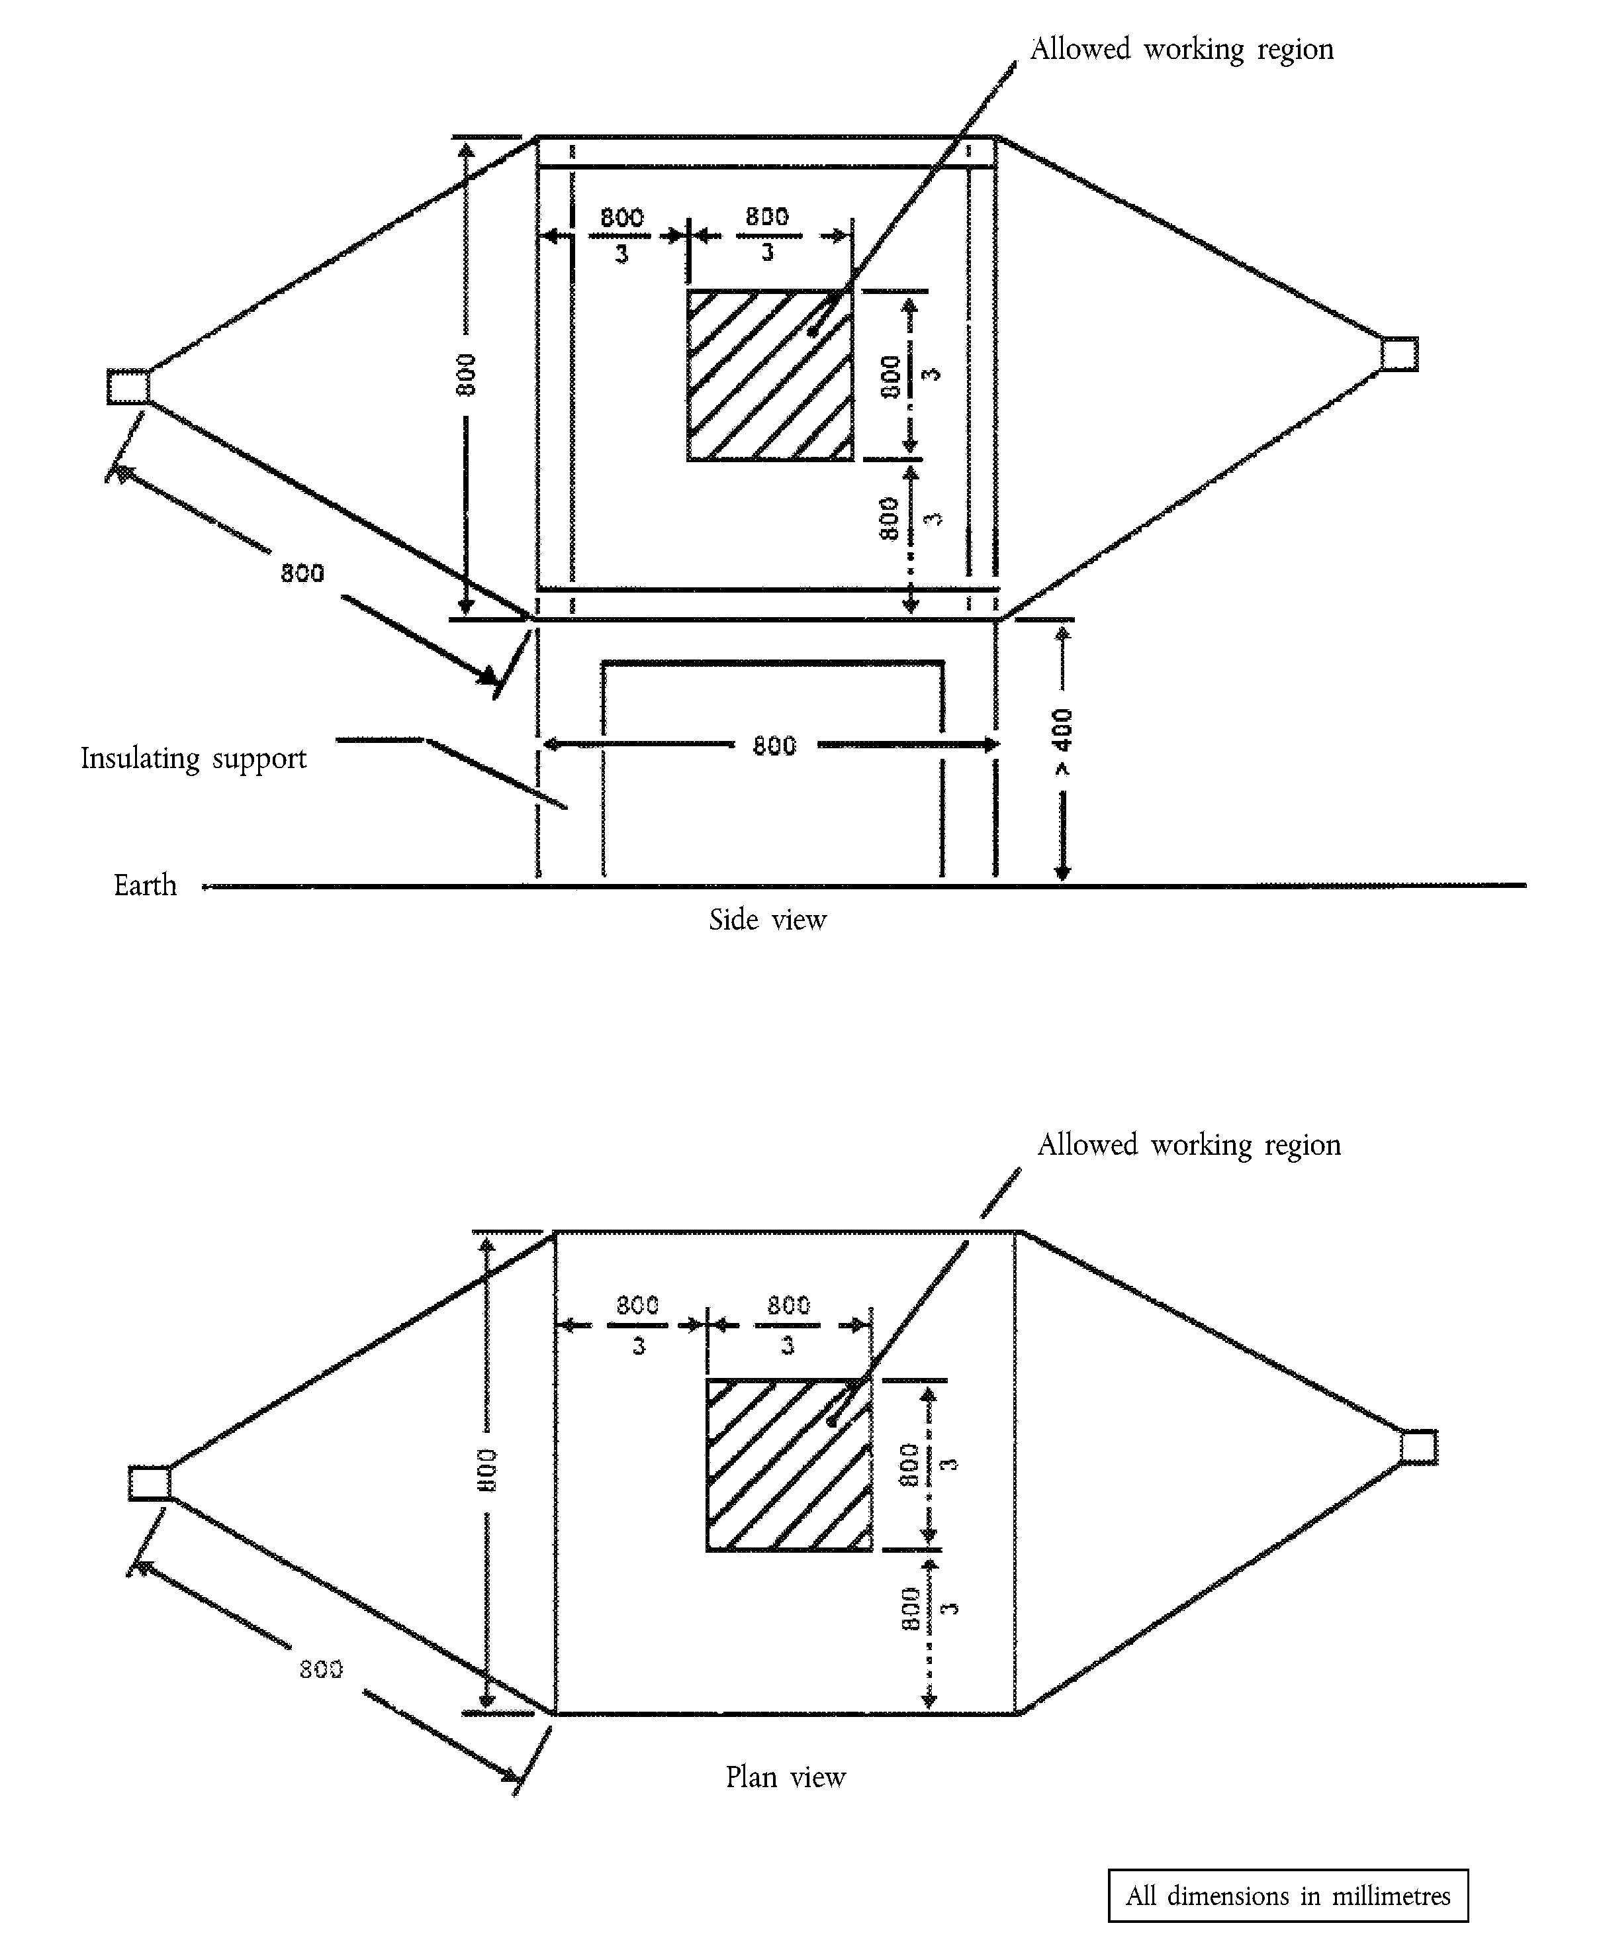

Appendix 2

Typical TEM cell dimensions
The following table shows the dimensions for constructing a cell with specified upper frequency limits:
Upper frequency  (MHz) | Cell form factor  W:b | Cell form factor  L/W | Plate separation  b (cm) | Septum  S (cm)
200 | 1,69 | 0,66 | 56 | 70
200 | 1,00 | 1 | 60 | 50
_____________

ANNEX X
METHOD(S) OF TESTING FOR IMMUNITY TO AND EMISSION OF TRANSIENTS OF ELECTRICAL/ELECTRONIC SUBASSEMBLIES

1. General
This test method shall ensure the immunity of ESAs to conducted transients on the vehicle power supply and limit conducted transients from ESAs to the vehicle power supply.

2. Immunity against disturbances conducted along supply lines
Apply the test pulses 1, 2a, 2b, 3a, 3b and 4 according to the International Standard è1 ISO 7637-2: 2004 ç to the supply lines as well as to other connections of ESAs which may be operationally connected to supply lines.

3. Emission of conducted disturbances along supply lines
Measurement according to the International Standard è1 ISO 7637-2: 2004 ç on supply lines as well as to other connections of ESAs which may be operationally connected to supply lines.
_____________

é

ANNEX XI
Part A
Repealed Directive with list of its successive amendments
(referred to in Article 6)
Council Directive 72/245/EEC
(OJ L 152, 6.7.1972, p. 15)
 | Commission Directive 89/491/EEC  (OJ L 238, 15.8.1989, p. 43) | Third indent of Article 1 and Annex III only
 | Commission Directive 95/54/EC  (OJ L 266, 8.11.1995, p. 1) | except Article 3
Point 1.A.8 of Annex II to the 2003 Act of Accession
(OJ L 236, 23.9.2003, p. 56
 | Commission Directive 2004/104/EC  (OJ L 337, 13.11.2004, p. 13) | except Article 3
 | Commission Directive 2005/49/EC  (OJ L 194, 26.7.2005, p. 12) | except Article 2
Commission Directive 2005/83/EC
(OJ L 305, 24.11.2005, p. 32)
Commission Directive 2006/28/EC
(OJ L 65, 7.3.2006, p. 27)
 | Council Directive 2006/96/EC  (OJ L 363, 20.12.2006, p. 81) | Annex, point A.8 only
Commission Directive 2009/19/EC
(OJ L 70, 14.3.2009, p. 17)
Part B
List of time-limits for transposition into national law and application
(referred to in Article 6)
Directive | Time-limit for transposition | Date of application
72/245/EEC | 22 December 1973 | -
89/491/EEC | 1 January 1990 | -
95/54/EC | 30 November 1995^{(*)} | -
2004/104/EC | 31 December 2005 | 1 January 2006^{(**)}
2005/49/EC | 30 June 2006 | 1 July 2006^{(***)}
2005/83/EC | 30 September 2006 | 1 October 2006
2006/28/EC | 30 June 2006 | 1 July 2006
2006/96/EC | 1 January 2007 | -
2009/19/EC | 1 October 2009 | 2 October 2009
____________________
^{(*)} In conformity with Article 2 of Directive 95/54/EC:
‘1. With effect from 1 December 1995, Member States may not, on grounds relating to electromagnetic compatibility:
- refuse, in respect of any given type of vehicle, to grant EEC type-approval or national type-approval,
- refuse, in respect of any given type of component or separate technical unit, to grant EEC component or technical unit type-approval, or
- prohibit the registration, sale or entry into service of vehicles,
- prohibit the sale or use of components or separate technical units,
if the vehicles, components or separate technical units comply with the requirements of Directive 72/245/EEC as amended by this Directive.
2. With effect from 1 January 1996, Member States:
- shall no longer grant EEC vehicle type-approval, EEC component type-approval or EEC separate technical unit type-approval, and
- may refuse to grant national type-approval,
for any type of vehicle, component or separate technical unit on grounds relating to electromagnetic compatibility, if the requirements of Directive 72/245/EEC, as amended by this Directive, are not fulfilled.
3. Paragraph 2 shall not apply to vehicle types approved before 1 January 1996 pursuant to Directive 72/306/EEC nor to any subsequent extensions to these approvals.
4. With effect from 1 October 2002, Member States:
- shall consider certificates of conformity which accompany new vehicles in accordance with the provisions of Directive 70/156/EEC to be no longer valid for the purposes of Article 7 (1) of that Directive,
- may refuse the registration, sale or entry into service of new vehicles which are not accompanied by a certificate of conformity in accordance with Directive 70/156/EEC, and
- may refuse the sale and entry into service of new electrical/electronic sub-assemblies as components or separate technical unit,
if the requirements of this Directive are not fulfilled.
5. With effect from 1 October 2002 the requirements of Directive 72/245/EEC, relating to electrical/electronic sub-assemblies as components or separate technical units, as amended by this Directive, are applicable for the purposes of Article 7 (2) of Directive 70/156/EEC.
6. Notwithstanding paragraphs 2 and 5, for the purposes of replacement parts, Member States shall continue to grant EEC type approval and to permit the sale and entry into service of components or separate technical units intended for use on vehicle types which have been approved before 1 January 1996 pursuant to either Directive 72/245/EEC or Directive 72/306/EEC and, where applicable, subsequent extensions to these approvals.’
^{(**)} In conformity with Article 2 of Directive 2004/104/EC:
‘1. With effect from 1 January 2006, for vehicles, components or separate technical units which comply with the provisions laid down in Annexes I to X to Directive 72/245/EEC as amended by this Directive, no Member State may, on grounds relating to electromagnetic compatibility:
(a) refuse to grant EC type-approval, or national type-approval or
(b) prohibit registration, sale or entry into service.
2. With effect from 1 July 2006, for a type of vehicle, component or separate technical unit where the requirements laid down in Annexes I to X to Directive 72/245/EEC, as amended by this Directive, are not fulfilled, Member States, on grounds related to electromagnetic compatibility:
(a) shall no longer grant EC type-approval, and
(b) may refuse to grant national type-approval.
3. With effect from 1 January 2009, if the provisions laid down in Annexes I to X to Directive 72/245/EEC, as amended by this Directive, are not fulfilled, Member States, on grounds related to electromagnetic compatibility:
(a) shall consider certificates of conformity which accompany new vehicles in accordance with the provisions of Directive 70/156/EEC to be no longer valid for the purposes of Article 7(1) of that Directive;
(b) may refuse the registration, sale or entry into service of new vehicles.
4. As from 1 January 2009, the provisions laid down in Annexes I to X to Directive 72/245/EEC, as amended by this Directive, relating to electromagnetic compatibility, shall apply to components or separate technical units for the purposes of Article 7(2) of Directive 70/156/EEC.’
^{(***)} In conformity with Article 3 of Directive 2005/49/EC:

‘Transitional provisions
1. With effect from 1 July 2006, if the provisions laid down in Directive 72/245/EEC, as amended by this Directive, are not fulfilled, Member States, on grounds related to electromagnetic compatibility:
(a) shall consider certificates of conformity which accompany new vehicles in accordance with the provisions of Directive 70/156/EEC to be no longer valid for the purposes of Article 7(1) of that Directive;
(b) may refuse the registration, sale or entry into service of new vehicles.
Existing approvals for vehicles not fitted with 24 GHz or 79 GHz short-range radar equipment remain unchanged.
2. With effect from 1 July 2013, Member States shall prohibit the registration, sale or entry into service of vehicles equipped with 24 GHz short-range radar equipment.
3. In case the reference date in Article 2(5) of Decision 2005/50/EC is modified in accordance with Article 5 of that Decision, Member States shall prohibit the registration, sale or entry into service of vehicles equipped with 24 GHz short-range radar equipment after the modified reference date.’
_____________

ANNEX XII

Correlation Table
 | Directive 72/245/EEC | This Directive
 | Article 1 | Article 1
 | Article 2 | -
Directive 95/54/EC
Article 2(6) |  | Article 2(5)
Directive 2004/104/EC
Article 2(1) |  | Article 2(1)
Article 2(2) |  | Article 2(2)
Article 2(4) |  | Article 2(4)
Directive 2005/49/EC
Article 3(1) |  | Article 2(3)
Article 3(2) |  | Article 2(6)
Article 3(3) |  | Article 2(7)
 | Articles 3 and 4 | Articles 3 and 4
 | Article 5(1) | -
 | Article 5(2) | Article 5
 | - | Articles 6 and 7
 | Article 6 | Article 8
 | Annexes I to X | Annexes I to X
 | - | Annex XI
 | - | Annex XII
________

COM(87) 868 PV.
See Annex 3 to Part A of the Conclusions.
Carried out pursuant to the Communication from the Commission to the European Parliament and the Council – Codification of the Acquis communautaire, COM(2001) 645 final.
See Annex XI, Part A of this proposal.
OJ C […], […], p. […].
OJ C […], […], p. […].
OJ L 152, 6.7.1972, p. 15.
See Annex XI, Part A.
OJ L 263, 9.10.2007, p. 1.
Published as Annex I to Council Decision 97/836/EC (OJ L 346, 17.12.1997, p. 78).
OJ L 21, 25.1.2005, p. 15.
OJ L 390, 31.12.2004, p. 24.
OJ L 225, 10.8.1992, p. 1.
If applicable.
If applicable.
OJ L 91, 7.4.1999, p. 10.
The item numbers and footnotes used in this information document correspond to those set out in Annex I to Directive 2007/46/EC. Items not relevant for the purpose of this Directive are omitted.
Delete where not applicable.
Delete where not applicable.
Delete where not applicable.
Delete where not applicable.
Delete where not applicable.
Delete where not applicable.
Delete where not applicable.
If the means of identification of type contains characters not relevant to describe the component or separate technical unit types covered by this information document, such characters shall be represented in the documentation by the symbol ‘?’ (e.g. ABC??123??).
Delete where not applicable.
Delete where not applicable.
Delete where not applicable.
Delete where not applicable.
Delete where not applicable.
Delete where not applicable.
Delete where not applicable.
Delete where not applicable.
Delete where not applicable.
Delete where not applicable.
Delete where not applicable.
Delete where not applicable.
If the means of identification of type contains characters not relevant to describe the component or separate technical unit types covered by this type-approval certificate such characters could be represented in the documentation by the symbol: ‘?’ (e.g. ABC??123??).

