EN
COMMISSION OF THE EUROPEAN COMMUNITIES
Brussels, 3.12.2009
SEC(2009) 1652 final
Partie 2b
COMMISSION STAFF WORKING DOCUMENT
Accompanying the
COMMUNICATION FROM THE COMMISSION
FIFTH NATIONAL COMMUNICATION FROM THE EUROPEAN COMMUNITY UNDER THE UN FRAMEWORK CONVENTION ON CLIMATE CHANGE (UNFCCC)
(required under Article 12 of the United Nations Framework Convention on Climate Change)
Part 2b
[COM(2009) 667 final]

A 11 EU-15, 2000
Summary 1.A Summary report for National Greenhouse Gas Inventories (IPCC Table 7A)
(Sheet 1 of 3)
EU-15, 2000 Summary 1.A Summary report for National Greenhouse Gas Inventories (IPCC Table 7A)
(Sheet 2 of 3)
EU-15, 2000 Summary 1.A Summary report for National Greenhouse Gas Inventories (IPCC Table 7A)
(Sheet 3 of 3)
A 12 EU-15, 2001
Summary 1.A Summary report for National Greenhouse Gas Inventories (IPCC Table 7A)
(Sheet 1 of 3)
EU-15, 2001 Summary 1.A Summary report for National Greenhouse Gas Inventories (IPCC Table 7A)
(Sheet 2 of 3)
EU-15, 2001 Summary 1.A Summary report for National Greenhouse Gas Inventories (IPCC Table 7A)
(Sheet 3 of 3)
A 13 EU-15, 2002
Summary 1.A Summary report for National Greenhouse Gas Inventories (IPCC Table 7A)
(Sheet 1 of 3)
EU-15, 2002 Summary 1.A Summary report for National Greenhouse Gas Inventories (IPCC Table 7A)
(Sheet 2 of 3)
EU-15, 2002 Summary 1.A Summary report for National Greenhouse Gas Inventories (IPCC Table 7A)
(Sheet 3 of 3)
A 14 EU-15, 2003
Summary 1.A Summary report for National Greenhouse Gas Inventories (IPCC Table 7A)
(Sheet 1 of 3)
EU-15, 2003 Summary 1.A Summary report for National Greenhouse Gas Inventories (IPCC Table 7A)
(Sheet 2 of 3)
EU-15, 2003 Summary 1.A Summary report for National Greenhouse Gas Inventories (IPCC Table 7A)
(Sheet 3 of 3)
A 15 EU-15, 2004
Summary 1.A Summary report for National Greenhouse Gas Inventories (IPCC Table 7A)
(Sheet 1 of 3)
EU-15, 2004 Summary 1.A Summary report for National Greenhouse Gas Inventories (IPCC Table 7A)
(Sheet 2 of 3)
EU-15, 2004 Summary 1.A Summary report for National Greenhouse Gas Inventories (IPCC Table 7A)
(Sheet 3 of 3)
A 16 EU-15, 2005
Summary 1.A Summary report for National Greenhouse Gas Inventories (IPCC Table 7A)
(Sheet 1 of 3)
EU-15, 2005 Summary 1.A Summary report for National Greenhouse Gas Inventories (IPCC Table 7A)
(Sheet 2 of 3)
EU-15, 2005 Summary 1.A Summary report for National Greenhouse Gas Inventories (IPCC Table 7A)
(Sheet 3 of 3)
A 17 EU-15, 2006
Summary 1.A Summary report for National Greenhouse Gas Inventories (IPCC Table 7A)
(Sheet 1 of 3)
EU-15, 2006 Summary 1.A Summary report for National Greenhouse Gas Inventories (IPCC Table 7A)
(Sheet 2 of 3)
EU-15, 2006 Summary 1.A Summary report for National Greenhouse Gas Inventories (IPCC Table 7A)
(Sheet 3 of 3)
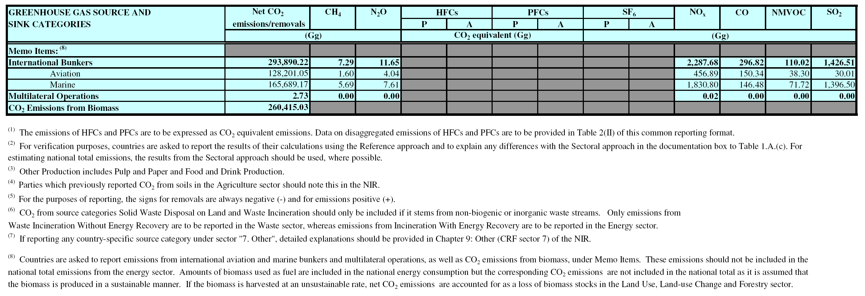
A 18 EU-15, 2007
Summary 1.A Summary report for National Greenhouse Gas Inventories (IPCC Table 7A)
(Sheet 1 of 3)
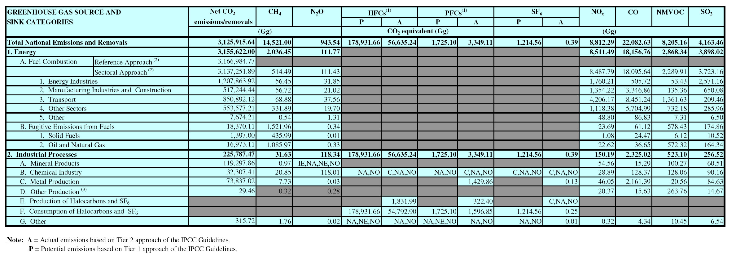
EU-15, 2007 Summary 1.A Summary report for National Greenhouse Gas Inventories (IPCC Table 7A)
(Sheet 2 of 3)
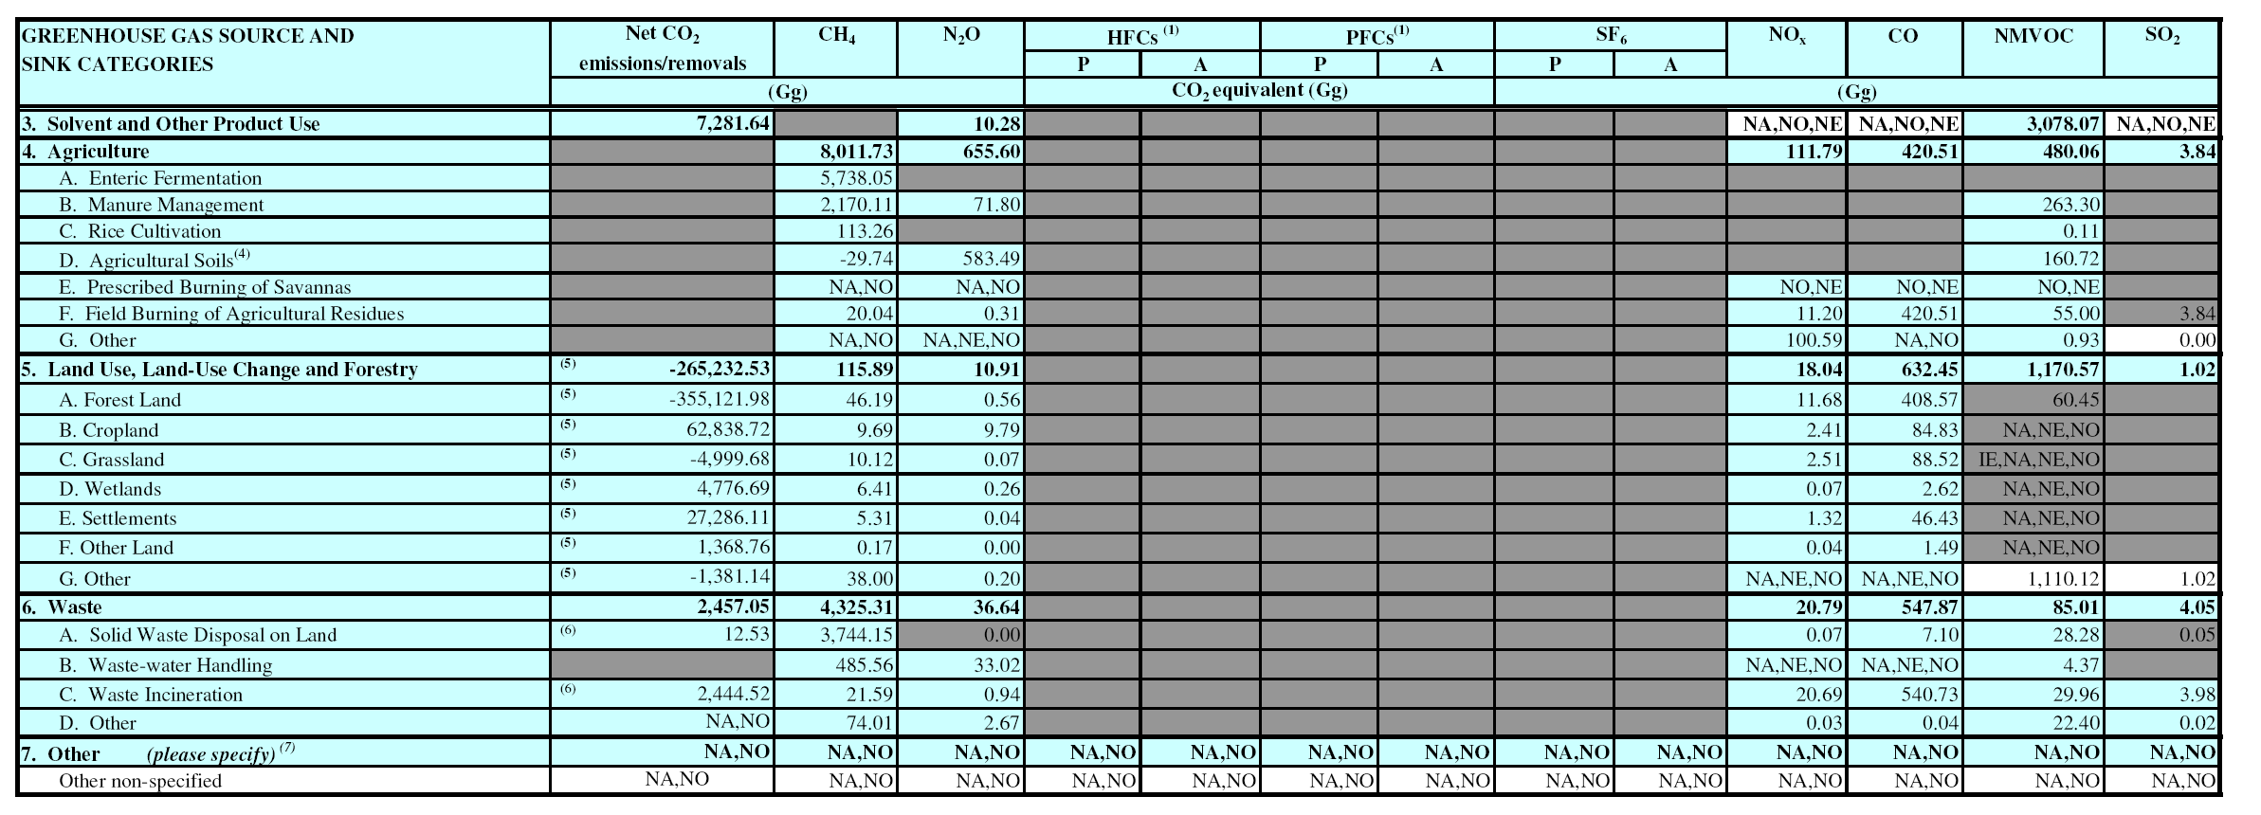
EU-15, 2007 Summary 1.A Summary report for National Greenhouse Gas Inventories (IPCC Table 7A)
(Sheet 3 of 3)
