EN
EUROPEAN COMMISSION
Brussels, 9.2.2010
SEC(2010) 118 final

COMMISSION STAFF WORKING DOCUMENT
On implementation of Council Directive 91/676/EEC concerning the protection of waters against pollution caused by nitrates from agricultural sources based on Member State reports for the period 2004-2007
Accompanying document to the
Report from the Commission to the Council and the European Parliament
{COM(2010) 47}

COMMISSION STAFF WORKING DOCUMENT
On implementation of Council Directive 91/676/EEC concerning the protection of waters against pollution caused by nitrates from agricultural sources based on Member State reports for the period 2004-2007
Accompanying document to the
Report from the Commission to the Council and the European Parliament
{COM(2010) 47}
Chapter I
Figure 1A: Fertilizer consumption in the EU 27 (Source EFMA, 2009).
Figure 1B: Fertilizer consumption in the EU 15 (Source EFMA, 2009).
Figure 2. Frequency diagram of groundwater classes. Digital data provided by Member States. The figure shows for each MS the percentage of sampling points per water quality class: (i) nitrate values measured below 25 mg/l;(ii) between 25 and 40 mg/l; (iii) between 40 and 50 mg/l; (iv) above 50 mg/l.
Figure 3. Frequency diagram of trends in groundwater classes. Digital data provided by Member States. The figure shows for each MS the percentage of sampling points per water quality trend class as compared with the previous reporting period: (i) nitrate values decreased with more than 5 mg/l;(ii) nitrate values decreased with values between 1 and 5 mg/l; (iii) nitrate values varied between -1 and +1 mg/l ; (iv)nitrate values increased with values between 1 and 5 mg/l; (v) nitrate values increased with more than 5 mg/.l
EU-15 + 4* = EU 15 minus Sweden and Greece, plus Bulgaria, Cyprus, Estonia and Hungary
EU-15** = EU-15 minus Sweden and Greece
Figure 4. Frequency diagram of groundwater classes at different depths. Digital data provided by Member States. The figure shows -the percentage of sampling points per water quality class and depth: (i) nitrate values measured below 25 mg/l;(ii) between 25 and 40 mg/l; (iii) between 40 and 50 mg/l; (iv) above 50 mg/l.
Figure 5. Frequency diagram of surface water classes. Digital data provided by Member States. The figure shows for each MS the percentage of sampling points per water quality class: (i) nitrate values measured below 2 mg/l;(ii) between 2 and 10 mg/l; (iii) between 10 and 25; (iv) between 25 and 40 mg/l; (v) between 40 and 50 mg/l; (vi) above 50 mg/l.
Figure 6. Frequency diagram of trends in fresh surface water classes. Digital data provided by Member States. The figure shows for each MS the percentage of sampling points per water quality trend class as compared with the previous reporting period: (i) nitrate values decreased with more than 5 mg/l;(ii) nitrate values decreased with values between 1 and 5 mg/l; (iii) nitrate values varied between -1 and +1 mg/l ; (iv)nitrate values increased with values between 1 and 5 mg/l; (v) nitrate values increased with more than 5 mg/l.
EU-15 + 4* = EU 15 minus Sweden, plus Bulgaria, Cyprus, Estonia and Hungary
EU-15** = EU-15 minus Sweden
Greece is revising data on surface water trends
Figure 7. Frequency diagram of fresh surface water trophic classes. All fresh waters except for Austria, Germany, Spain, Portugal Romania and Slovenia (lakes only) and for Czech Republic and Slovakia (rivers only). Digital data provided by Member States. The figure shows for each MS the percentage of sampling points per water quality class: (i) ultra-oligotrophic; (ii) oligotrophic; (iii) mesotrophic; (iv) eutrophic; (v) hypertrophic.
EU* = EU-27 minus Cyprus, Denmark, Estonia, Greece, France, Italy, Luxembourg, the Netherlands, Poland and the United Kingdom (for Greece and Italy the data were not covering all the required information to be included in the figure, for Italy some data are presented in map 15)
Table 1. Average groundwater: percentage of points per water quality class for all stations for EU 15 Member States for the period 2000-20003 and 2004-2007. Reduced comparability of data between the 2 reporting periods due to possible changes in monitoring networks.
mg/l | < 25 | 25-40 | 40-50 | ≥ 50 | reporting period | number of stations
Austria | 89.3% | 6.9% | 1.3% | 2.6% | 2000-2003 | 392
Austria | 91.3% | 5.7% | 1.4% | 1.6% | 2004-2007 | 368
Belgium | 56.8% | 22.1% | 7.6% | 13.5% | 2000-2003 | 944
Belgium | 60.0% | 14.7% | 6.9% | 18.4% | 2004-2007 | 3020
Germany* | 9.3% | 16.7% | 20.7% | 53.0% | 2000-2003 | 150
Germany* | 11.8% | 20.0% | 18.2% | 50.0% | 2004-2007 | 170
Denmark | 85.5% | 7.2% | 1.4% | 5.8% | 2000-2003 | 69
Denmark | 70.4% | 7.7% | 4.9% | 17.0% | 2004-2007 | 1479
Greece | 91.0% | 4.8% | 1.2% | 3.0% | 2000-2003 | 433
Greece | 58.1% | 14.5% | 6.3% | 21.2% | 2004-2007 | 415
Spain | 55.6% | 12.7% | 6.7% | 24.9% | 2000-2003 | 6706
Spain | 54.0% | 13.5% | 6.1% | 26.5% | 2004-2007 | 4078
Finland | 73.7% | 10.5% |  | 15.8% | 2000-2003 | 19
Finland | 96.3% | 1.9% |  | 1.9% | 2004-2007 | 54
France | 51.0% | 24.9% | 10.7% | 13.4% | 2000-2003 | 3174
France | 50.3% | 25.8% | 10.3% | 13.6% | 2004-2007 | 2666
Ireland | 79.0% | 13.7% | 5.9% | 1.4% | 2000-2003 | 219
Ireland | 73.3% | 19.5% | 4.8% | 2.4% | 2004-2007 | 210
Italy | 68.1% | 15.9% | 5.0% | 11.0% | 2000-2003 | 3041
Italy | 65.9% | 15.5% | 6.2% | 12.5% | 2004-2007 | 5782
Luxembourg | 42.1% | 31.6% | 5.3% | 21.1% | 2000-2003 | 19
Luxembourg | 40.0% | 35.0% | 10.0% | 15.0% | 2004-2007 | 20
Netherlands | 90.1% | 2.0% | 1.3% | 6.5% | 2000-2003 | 902
Netherlands | 70.9% | 5.1% | 3.1% | 20.9% | 2004-2007 | 1244
Portugal | 41.3% | 14.1% | 6.5% | 38.1% | 2000-2003 | 341
Portugal | 65.1% | 11.6% | 3.5% | 19.8% | 2004-2007 | 630
Sweden | 98.6% | 0.7% | 0.7% |  | 2000-2003 | 147
Sweden | 98.8% | 1.2% |  |  | 2004-2007 | 163
United Kingdom  ** | 60.0% | 23.5% | 6.6% | 10.0% | 2000-2003 | 904
United Kingdom  ** | 61.4% | 17.0% | 6.6% | 15.0% | 2004-2007 | 3061
* for Germany only agriculture monitoring network
** for the reporting period 2000-2003 United Kingdom reported only stations within England.

Table 2. surface water: percentage of points per water quality class for all stations for EU 15 Member States for the period 2000-20003 and 2004-2007. Reduced comparability of data between the 2 reporting periods due to possible changes in monitoring networks.
mg/l | 0 - 2 | 2-10 | 10-25 | 25 - 40 | 40 - 50 | ≥ 50 | reporting period | number of stations
Austria | 16.1% | 68.2% | 15.7% |  |  |  | 2000-2003 | 242
 | 22.9% | 61.6% | 14.1% | 1.3% |  |  | 2004-2007 | 297
Belgium | 22.6% | 51.8% | 22.4% | 3.0% | 0.1% | 0.1% | 2000-2003 | 953
Belgium | 3.0% | 24.8% | 41.6% | 15.8% | 5.6% | 9.3% | 2004-2007 | 1179
Germany | 0.7% | 19.7% | 68.4% | 11.2% |  |  | 2000-2003 | 152
Germany | 12.3% | 22.2% | 61.4% | 4.1% |  |  | 2004-2007 | 171
Denmark | 52.6% | 10.3% | 20.5% | 13.9% | 2.3% | 0.3% | 2000-2003 | 302
Denmark | 60.1% | 12.1% | 15.7% | 9.6% | 2.0% | 0.6% | 2004-2007 | 356
Greece | 26.5% | 62.7% | 8.8% | 2.0% |  |  | 2000-2003 | 102
Greece | 33.1% | 58.5% | 7.6% |  | 0.8% |  | 2004-2007 | 118
Spain | 47.0% | 37.5% | 13.1% | 1.4% | 0.4% | 0.6% | 2000-2003 | 2505
Spain | 45.9% | 36.7% | 13.2% | 2.6% | 0.6% | 1.0% | 2004-2007 | 3083
Finland | 61.0% | 33.9% | 5.1% |  |  |  | 2000-2003 | 59
Finland | 65.3% | 33.7% | 1.0% |  |  |  | 2004-2007 | 193
France | 4.2% | 29.7% | 40.9% | 18.4% | 4.9% | 1.9% | 2000-2003 | 1720
France | 3.4% | 31.0% | 46.8% | 15.1% | 2.3% | 1.4% | 2004-2007 | 1769
Ireland | 40.6% | 33.3% | 23.2% | 2.9% |  |  | 2000-2003 | 69
Ireland | 47.8% | 32.1% | 18.4% | 1.7% |  |  | 2004-2007 | 343
Italy | 26.4% | 48.9% | 21.0% | 2.9% | 0.6% | 0.3% | 2000-2003 | 1543
Italy | 36.5% | 45.3% | 16.2% | 1.8% | 0.1% | 0.1% | 2004-2007 | 2572
Luxembourg |  |  | 100.0% |  |  |  | 2000-2003 | 10
Luxembourg |  | 6.3% | 62.5% | 31.3% |  |  | 2004-2007 | 16
Netherlands | 8.6% | 47.4% | 34.2% | 7.3% | 1.2% | 1.2% | 2000-2003 | 914
Netherlands | 13.6% | 48.6% | 30.4% | 4.8% | 0.7% | 1.8% | 2004-2007 | 543
Portugal | 21.3% | 70.5% | 8.2% |  |  |  | 2000-2003 | 61
Portugal | 58.0% | 37.3% | 4.1% | 0.6% |  |  | 2004-2007 | 169
Sweden | 86.7% | 11.9% | 1.2% | 0.2% |  |  | 2000-2003 | 579
Sweden | 97.0% | 2.7% | 0.4% |  |  |  | 2004-2007 | 2414
United Kingdom | 7.2% | 28.5% | 29.3% | 23.8% | 6.7% | 4.5% | 2000-2003 | 8007
United Kingdom | 11.7% | 25.4% | 29.1% | 20.9% | 6.6% | 6.3% | 2004-2007 | 8831

Table 3. Change of animal numbers between the 2003 and 2007; year 2003=100, blank –no information (data source Eurostat, data set accessed 17th November 2009).
 | all cattle | dairy cows | goats | sheep | pigs | broilers | laying hens | other poultry
Belgium | 95.9 | 91.6 |  |  | 97.4 | 110.8 | 91.7 | 77.9
Austria | 97.5 | 94.0 | 110.8 | 107.9 | 101.0 | 122.4 | 110.7 | 101.5
Bulgaria | 83.0 | 92.8 | 68.3 | 95.5 | 86.1 | 79.3 | 76.9 | 91.2
Cyprus | 95.4 | 89.1 | 90.2 | 110.4 | 95.7 | 85.6 | 71.1 | 91.3
Czech Republic | 95.8 | 90.7 | 127.7 | 158.3 | 80.4 | 103.8 | 84.4 | 108.4
Denmark | 91.9 | 93.5 |  | 93.3 | 101.5 | 96.3 | 84.9 | 111.6
Estonia | 93.5 | 88.2 | 114.3 | 239.9 | 108.7 | 83.5 | 69.1 | 50.0
Finland | 92.3 | 90.3 | 112.5 | 134.0 | 102.3 | 83.8 | 99.1 | 70.3
France | 99.8 | 93.4 | 101.2 | 92.6 | 98.1 | 90.9 | 99.8 | 92.1
Germany | 94.9 | 94.2 | 112.5 | 90.6 | 102.3 | 108.7 | 92.4 | 101.3
Greece | 104.8 | 100.7 | 96.4 | 96.3 | 104.5 | 95.4 | 73.8 | 42.3
Hungary | 95.4 | 85.8 | 81.7 | 95.1 | 78.8 | 73.8 | 91.2 | 104.9
Ireland | 94.8 | 95.8 | 81.1 | 72.8 | 91.0 | 85.9 | 116.1 | 92.9
Italy | 97.8 | 96.1 | 95.7 | 103.6 | 101.3 | 86.7 | 104.6 | 89.5
Latvia | 105.3 | 96.8 | 86.7 | 137.5 | 93.2 | 183.9 | 111.8 | 77.8
Lithuania | 97.0 | 90.3 | 72.4 | 256.2 | 87.3 | 154.0 | 115.7 | 43.6
Luxembourg | 104.5 | 97.6 | 137.5 | 110.8 | 113.8 | 200.0 | 100.0
Malta | 108.4 | 98.7 | 114.8 | 82.6 | 105.2 | 77.6 | 109.8 | 0.0
Netherlands | 102.3 | 96.0 | 122.4 | 116.2 | 108.8 | 102.5 | 133.7 | 147.5
Poland | 102.4 | 95.1 |  | 95.3 | 95.6 | 69.7 | 99.6 | 88.1
Portugal | 103.9 | 93.1 | 101.4 | 100.0 | 105.5 | 80.9 | 79.3 | 61.5
Romania | 97.3 |  | 127.6 | 113.7 | 127.6 | 186.6 | 96.4 | 29.5
Slovakia | 84.6 | 84.0 | 96.7 | 106.7 | 66.0 | 93.5 | 97.4 | 103.1
Slovenia | 106.6 | 89.7 | 121.0 | 124.1 | 87.4 | 131.9 | 91.4 | 57.9
Spain | 100.6 | 80.8 | 91.4 | 94.5 | 108.1 | 85.8 | 100.7 | 95.2
Sweden | 97.6 | 90.6 | 0.0 | 115.5 | 86.2 | 112.5 | 117.8 | 34.5
United Kingdom | 95.8 | 89.6 |  | 97.0 | 96.5 | 95.9 | 100.8 | 76.3
European Union (15 countries)* | 97.6 | 93.0 | 96.8 | 95.5 | 102.5 | 93.4 | 101.4 | 84.2
European Union (27 countries)* | 97.7 | 99.4 | 97.4 | 97.1 | 100.7 | 92.4 | 100.5 | 90.6

* statistic for either EU-15 or EU-27 unless there is no data for a specific country in the table, then the statistic covers EU-15 or EU-27 minus that country
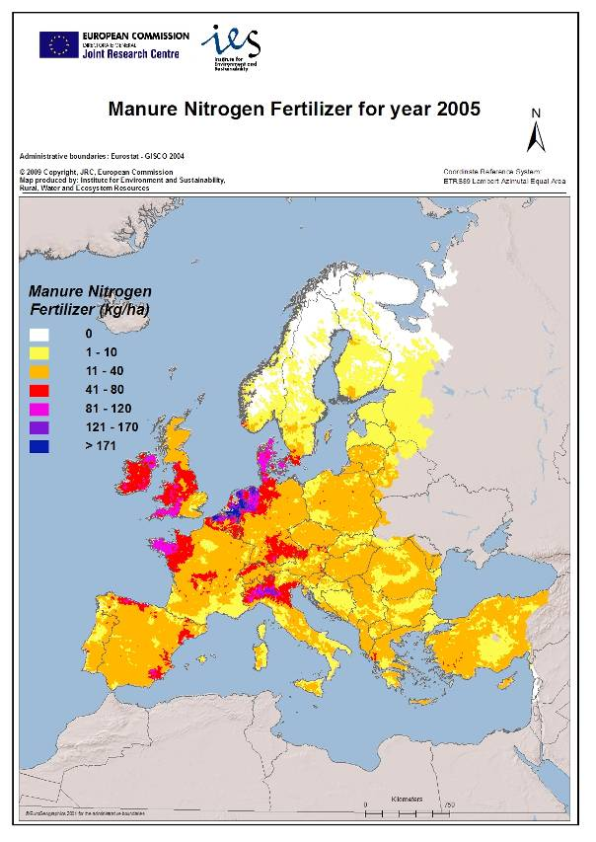Map 1. Manure nitrogen fertilizer application for year 2005 (Bouraoui F., Grizzetti B. Aloe A., 2009. Nutrient discharge from rivers to seas. JRC EUR 24002 EN, 72pp.).
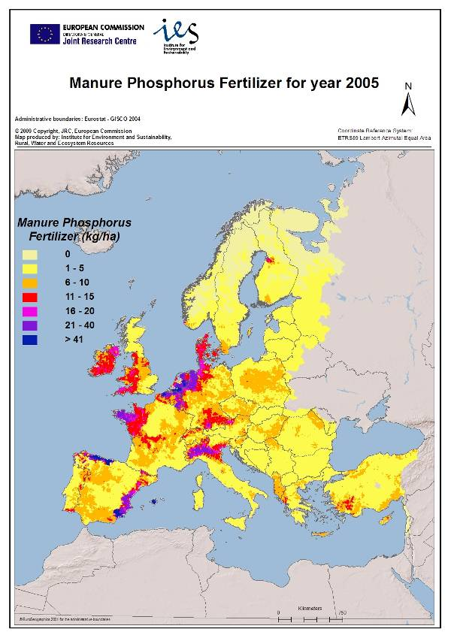
Map 2. Manure phosphorus fertilizer application for year 2005 (Bouraoui F., Grizzetti B. Aloe A., 2009. Nutrient discharge from rivers to seas. JRC EUR 24002 EN, 72pp.).
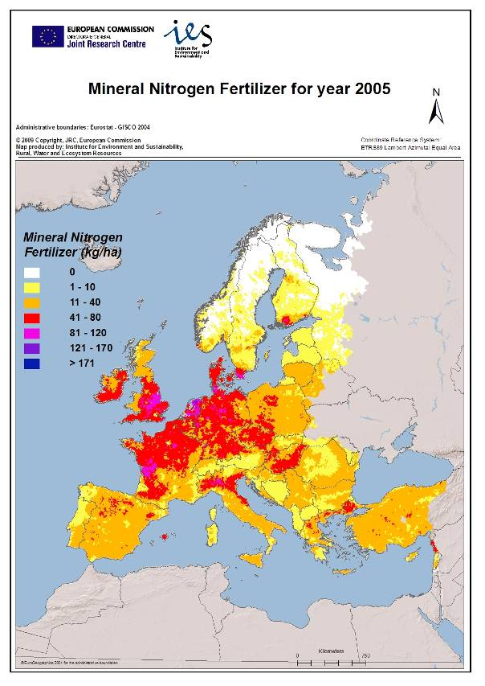
Map 3. Mineral nitrogen fertilizer application for year 2005 (Bouraoui F., Grizzetti B. Aloe A., 2009. Nutrient discharge from rivers to seas. JRC EUR 24002 EN, 72pp.).
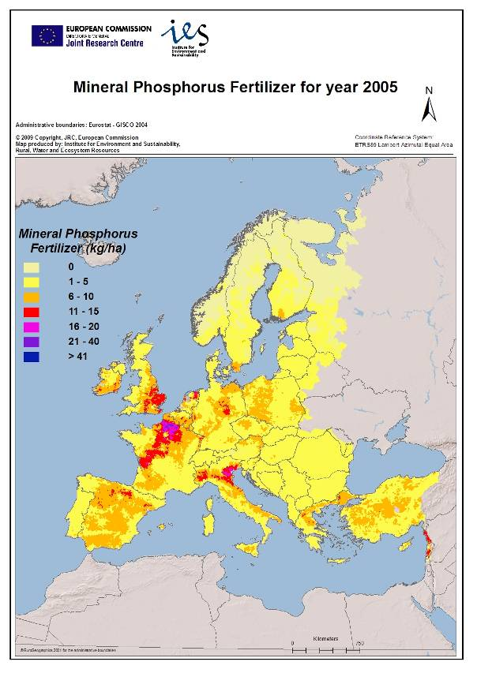
Map 4. Mineral phosphorus fertilizer application for year 2005 (Bouraoui F., Grizzetti B. Aloe A., 2009. Nutrient discharge from rivers to seas. JRC EUR 24002 EN, 72pp.).
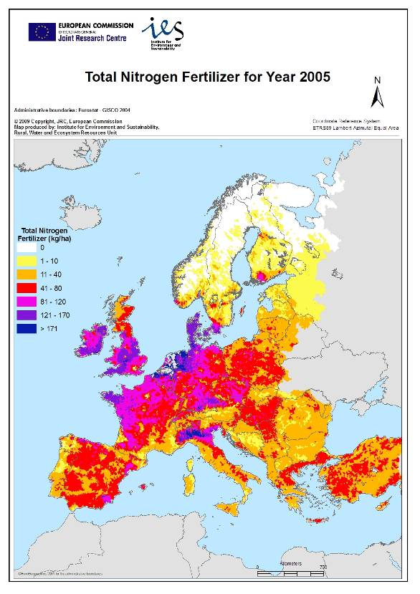
Map 5. Total nitrogen application, manure and chemical fertilizer for year 2005 (Bouraoui F., Grizzetti B. Aloe A., 2009. Nutrient discharge from rivers to seas. JRC EUR 24002 EN, 72pp.).
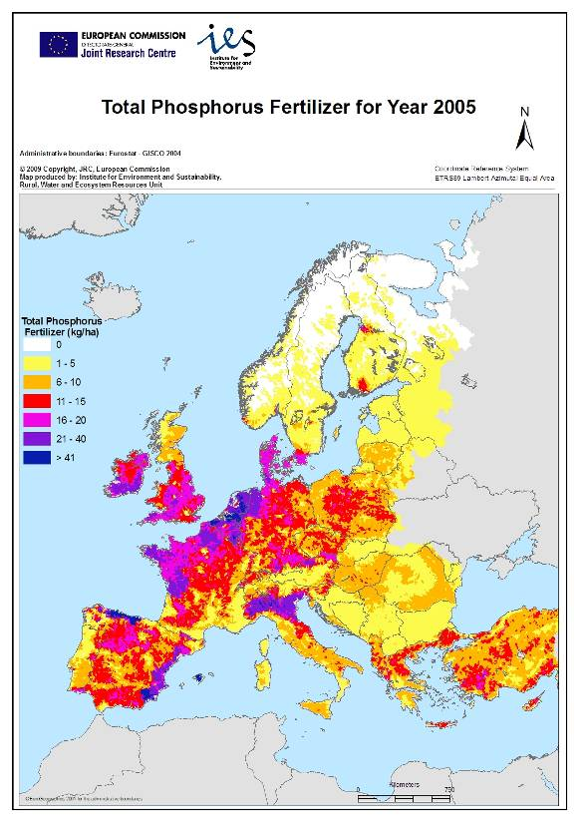
Map 6. Total phosphorus application, manure and chemical fertilizer for year 2005 (Bouraoui F., Grizzetti B. Aloe A., 2009. Nutrient discharge from rivers to seas. JRC EUR 24002 EN, 72pp.).
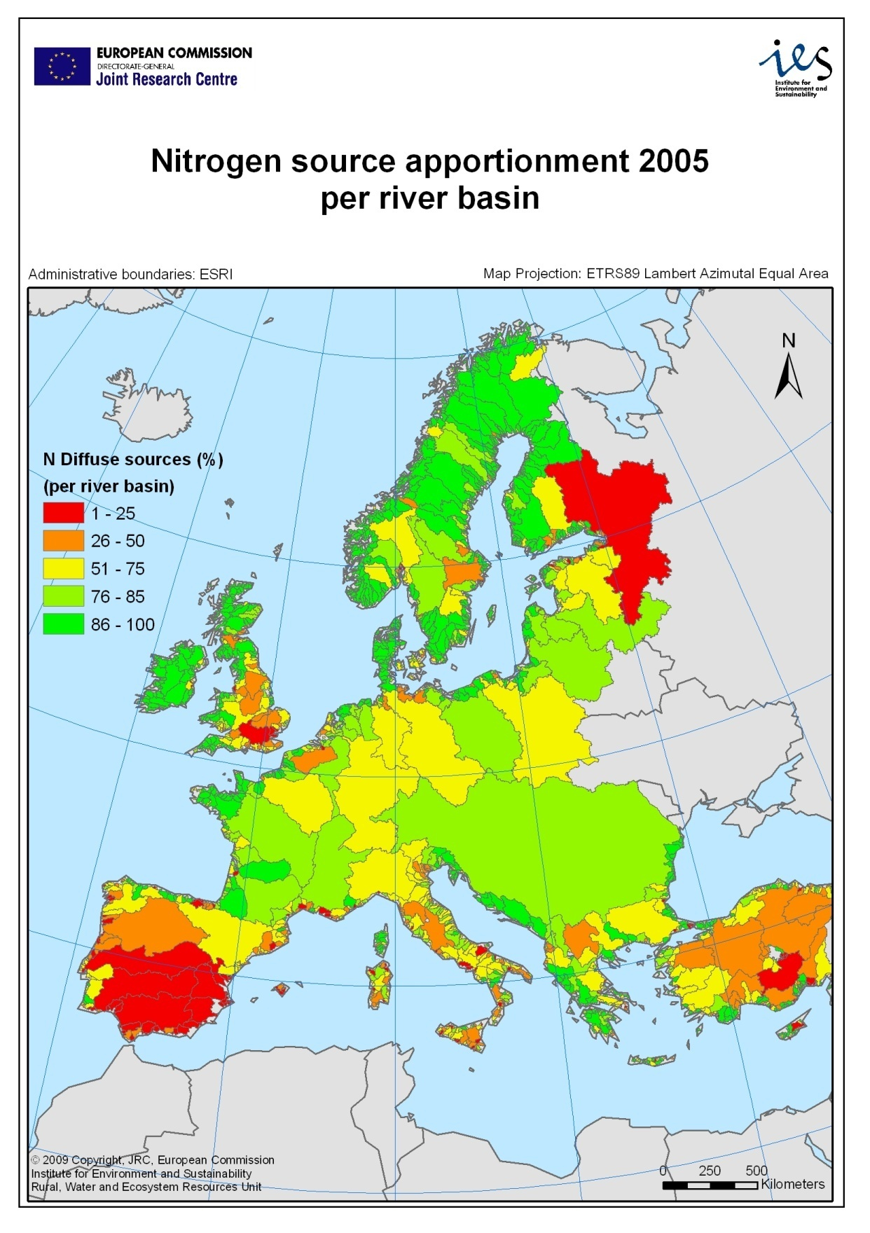
Map 7. Estimation of nitrogen source apportionment for Europe (Bouraoui F., Grizzetti B. Aloe A., 2009. Nutrient discharge from rivers to seas. JRC EUR 24002 EN, 72pp.).
Map 8.Groundwater average nitrate concentrations for reporting period 4 (2004-2007).
Map 9. Groundwater maximum nitrate concentrations, reporting period 4 (2004-2007).
Map 10. Trends in ground water nitrates concentrations between reporting period 3 (2000-2003) and 4 (2004-2007).
Map 11. Average surface water nitrate concentrations for reporting period 4 (2004-2007).
Map 12. Maximum surface water nitrate concentrations for reporting period 4 (2004-2007).
Map 13. Trends of nitrate concentrations in surface water between reporting period 3 (2000-2003) and 4 (2004-2007). (Greece is revising data on surface water trends).
Map14. Winter averages of nitrate concentration in surface water for reporting period 4 (2004-2007).
Map 15. Trophic status of surface water for reporting period 4 (2004-2007), (Greece submitted data however they were not covering required information to be included in the map).
Map 16. Designation of vulnerable zones in EU-27 including designation of whole territory of some Member States (Implementation of an Action Programme on the whole territory according to article 3 (5) of the Nitrates Directive; this does not necessarily mean that the whole territory is nitrate vulnerable according to article 3 (2) of the Nitrates Directive).
Table 4. Nitrate vulnerable zones in EU Member States 1999-2008 (# Values as provided by Eurostat in July 2009).
Member State | Total Area# | Area NVZ 1999 (EU 15) |  | Area NVZ 2003 (EU15) |  | Area NVZ 2006 for EU15, For EU10+2 as from 2007** |  | Area NVZ 2008 **
 | (km2)*1000 | (km2)*1000 | % | (km2)*1000 | % | (km2)*1000 | % | (km2)*1000 | %
Austria* | 83.9 | 83.9 | 100.0 | 83.9 | 100.0 | 83.9 | 100.0 | 83.9 | 100.0
Belgium | 30.5 | 1.8 | 5.9 | 7.2 | 23.6 | 7.20 | 23.6 | 20.7 | 67.8
Bulgaria | 111.0 |  |  |  |  | 58.96 | 53.1 | 59.0 | 53.1
Cyprus*** | 9.3 |  |  |  |  | 0.46 | 5.0 | 0.6 | 6.8
Czech Republic | 78.9 |  |  |  |  | 28.86 | 36.6 | 31.4 | 39.8
Denmark* | 43.1 | 43.1 | 100.0 | 43.1 | 100.0 | 43.1 | 100.0 | 43.1 | 100.0
Estonia | 45.2 |  |  |  |  | 3.0 | 6.7 | 3.4 | 7.5
Finland* | 338.4 | 338.4 | 100.0 | 338.4 | 100.0 | 338.4 | 100.0 | 338.4 | 100.0
France | 549.1 | 197.9 | 36.0 | 239.7 | 43.7 | 239.7 | 43.7 | 250.1 | 45.6
Germany* | 357.1 | 357.1 | 100.0 | 357.1 | 100.0 | 357.1 | 100.0 | 357.1 | 100.0
Greece | 132.0 | - |  | 14.0 | 10.6 | 14.0 | 10.6 | 32.0 | 24.2
Hungary | 93.0 |  |  |  |  | 43.3 | 46.5 | 42.6 | 45.8
Ireland* | 70.3 | - |  | 70.3 | 100.0 | 70.3 | 100.0 | 70.3 | 100.0
Italy | 301.3 | 5.7 | 1.9 | 18.4 | 6.1 | 24.9 | 8.3 | 38.1 | 12.6
Lithuania* | 65.3 |  |  |  |  | 65.3 | 100.0 | 65.3 | 100.0
Luxembourg* | 2.6 | 2.6 | 100.0 | 2.6 | 100.0 | 2.6 | 100.0 | 2.6 | 100.0
Latvia | 64.6 |  |  |  |  | 8.1 | 12.5 | 8.2 | 12.7
Malta* | 0.3 |  |  |  |  | 0.3 | 100.0 | 0.3 | 100.0
Netherlands* | 37.4 | 37.4 | 100.0 | 37.4 | 100.0 | 37.4 | 100.0 | 37.4 | 100.0
Poland | 312.7 |  |  |  |  | 5.5 | 1.7 | 4.6 | 1.5
Portugal | 91.9 | 0.2 | 0.2 | 0.3 | 0.3 | 1.1 | 1.2 | 3.4 | 3.7
Romania | 238.4 |  |  |  |  | 16.0 | 6.7 | 16.0 | 6.7
Slovakia | 49.0 |  |  |  |  | 16.5 | 33.6 | 16.4 | 33.5
Slovenia* | 20.3 |  |  |  |  | 20.3 | 100.0 | 20.3 | 100.0
Spain | 505.4 | 26.0 | 5.1 | 55.4 | 11.0 | 63.9 | 12.6 | 63.7 | 12.6
Sweden | 450.3 | 41.6 | 9.2 | 67.1 | 14.9 | 67.2 | 14.9 | 67.5 | 15.0
United Kingdom | 244.1 | 5.8 | 2.4 | 79.9 | 32.7 | 93.7 | 38.4 | 94.4 | 38.7
TOTAL EU15/EU27 | 4,325.1 | 119.2 | 3.7 | 1,414.7 | 43.7 | 1,711.0 | 39.6 | 1,770.6 | 40.9
*Implementation of an Action Programme on the whole territory in accordance with art 3 (5) of the Nitrates Directive; this does not necessarily mean that the whole territory is nitrate vulnerable according to Article 3 (2) of the Nitrates Directive; **based on information made available to the Commission in digital form. The estimate of designated area does not include some designations communicated in paper form only; *** According to Protocol 10 of Accession the application of the aquis communutaire is suspended in the areas of the Republic of Cyprus not under the effective control of the Government of the Republic
Figure 8. Percentage of territory of Member states designated as NVZ. (Member States that apply the whole territory approach are not included in the figure: Austria, Denmark, Finland, Germany, Ireland, Lithuania, Luxembourg, Malta, Netherlands and Slovenia).
Table 5. Density of groundwater (GW) and freshwater stations (SW) measured for the whole land surface (yellow: MS that apply the whole territory approach).
MS | Total land surface km2* | GW stations | density of GW stations  (points / 1000 km²) | SW stations | density SW stations  (points / 1000 km²)
AT-Austria | 83870 | 368 | 4.4 | 297 | 3.5
BE-Belgium | 30528 | 3020 | 98.9 | 1154 | 37.8
BG-Bulgaria | 110910 | 128 | 1.2 | 109 | 1.0
CY-Cyprus | 9250 | 222 | 24.0 | 10 | 1.1
CZ-Czech Republic | 78866 | 408 | 5.2 | 949 | 12.0
DE-Germany | 357110 | 893 | 2.5 | 171 | 0.5
DK-Denmark | 43090 | 1479 | 34.3 | 220 | 5.1
EE-Estonia | 45222 | 621 | 13.7 | 70 | 1.5
EL-Greece | 131940 | 418 | 3.2 | 107 | 0.8
ES-Spain | 504782 | 4078 | 8.1 | 2544 | 5.0
FI-Finland | 338420 | 54 | 0.2 | 147 | 0.4
FR-France | 547030 | 2664 | 4.9 | 1746 | 3.2
HU-Hungary | 93030 | 1868 | 20.1 | 535 | 5.8
IE-Ireland | 70280 | 210 | 3.0 | 217 | 3.1
IT-Italy | 301230 | 5479 | 18.2 | 2111 | 7.0
LT-Lithuania | 65200 | 53 | 0.8 | 108 | 1.7
LU-Luxembourg | 2580 | 20 | 7.8 | 16 | 6.2
LV-Latvia | 63589 | 176 | 2.8 | 325 | 5.1
MT-Malta | 316 | 14 | 44.3 | 7 | 22.2
NL-Netherlands | 37350 | 1244 | 33.3 | 502 | 13.4
PL-Poland | 312685 | 1266 | 4.0 | 3397 | 10.9
PT-Portugal | 92391 | 630 | 6.8 | 127 | 1.4
RO-Romania | 237500 | 1371 | 5.8 | 1240 | 5.2
SE-Sweden | 449964 | 163 | 0.4 | 2185 | 4.9
SI-Slovenia | 20270 | 112 | 5.5 | 117 | 5.8
SK-Slovakia | 49035 | 1767 | 36.0 | 224 | 4.6
United Kingdom | 244820 | 3061 | 12.5 | 7988 | 32.6
* Data from Eurostat - July 2009
Table 6. Density of groundwater (GW) and freshwater stations (SW) within the NVZ areas.
 |  | NVZ surface | GW stations within NVZ | density GW stations within NVZ  (points/1000  km²) | SW fresh water stations within NVZ | density SW fresh stations within NVZ  (points / 1000 km²)
BE-Belgium | BE | 20700 | 2527 | 122.1 | 1141 | 55.1
BG-Bulgaria | BG | 58960 | 110 | 1.9 | 67 | 1.1
CY-Cyprus | CY | 630 | 74 | 117.5 | 4 | 6.3
CZ-Czech Rep | CZ | 31370 | 211 | 6.7 | 552 | 17.6
EE-Estonia | EE | 3390 | 570 | 168.1 | 10 | 2.9
EL-Greece | EL | 31960 | 114 | 3.6 | 41 | 1.3
ES-Spain | ES | 63690 | 1512 | 23.7 | 378 | 5.9
FR-France | FR | 250130 | 2260 | 9.0 | 1209 | 4.8
HU-Hungary | HU | 52240 | 1627 | 31.1 | 369 | 7.1
IT-Italy | IT | 38090 | 2549 | 66.9 | 707 | 18.6
LV-Latvia | LV | 8170 | 62 | 7.6 | 53 | 6.5
PL-Poland | PL | 4608 | 168 | 36.5 | 135 | 29.3
PT-Portugal | PT | 3370 | 208 | 61.7 | 8 | 2.4
RO-Romania | RO | 16040 | 298 | 18.6 | 145 | 9.0
SE-Sweden | SE | 67520 | 35 | 0.5 | 442 | 6.5
SK-Slovakia | SK | 16410 | 1275 | 77.7 | 120 | 7.3
UK-United Kingdom | UK | 94410 | 1818 | 19.3 | 4203 | 44.5

Chapter II
Commission Decisions on derogation requests submitted by Member States
- Austria: Up to 230 kg N/ha from livestock manure on cattle farms on which the crop rotation includes more than 70% of particularly nitrogen consuming crops like grass, grass catch crops or beets and other crops being undersown by grass with low nitrate leaching potential
(Decision 2006/189/EC; expired on 31 December 2007)
- Belgium
- Flanders: Up to 250 kg N/ha from grazing livestock manure and treated manure on parcels from any type of farms cultivated with grassland and maize undersown with grassland; Up to 200 kg N/ha from grazing livestock manure and treated manure on parcels from any type of farm cultivated with winter wheat followed by a catch crop and with beets.
(Commission Decision 2008/64/EC)
- Wallonia: Up to 230 kg N/ha from livestock manure on cattle farms for grassland and not more than 115 kg N/ha on other farmland on cattle farms.
(Commission Decision 2008/96/EC)
- Ireland: Up to 250 kg N/ha from grazing livestock manure on grassland farms where 80% or more of the agricultural land is grassland.(Commission Decision 2007/697/EC)
- Germany: Up to 230 kg N/ha from livestock manure on cattle farms and only on fields intensive grassland fields with at least four cuts per year or three cuts plus pasture.
(Commission Decision 2006/1013/EC as extended by Commission Decision 2009/753/EC)
- Denmark: Up to 230 kg N/ha from livestock manure on cattle farms on which the crop rotation includes more than 70% of particularly nitrogen consuming crops like grass, grass catch crops or beets and other crops being undersown by grass with low nitrate leaching potential.
(Decision 2002/915/EC as replaced by Commission Decision 2005/294/EC as extended by commission Decision 2008/664/EC)
- Netherlands: Up to 250 kg N/ha from manure from grazing livestock on grassland farms with at least 70% or more of the agricultural land is grassland
(Commission Decision 2005/880/EC; a draft proposal for extension of the decision received a positive opinion in the nitrates Directive, but not yet approved by the College; situation January 2010)
- United Kingdom:
- England, Scotland and Wales: Up to 250 kg N/ha from grazing livestock manure on grassland farms where 80% or more of the agricultural land is grassland.
(Commission Decision 2009/431/EC
- Northern Ireland: Up to 250 kg N/ha from grazing livestock manure on grassland farms where 80% or more of the agricultural land is grassland.
(Commission Decision 2007/863/EC)
Chapter III
Examples of progress made in action programmes
Italy revised its national framework decree on action programmes in 2006, after which the regions updated the specific regional action programmes in 2007-2008. The ministerial decree contains specific provisions on how to implement the measures of annex II and III of the directive, including the limit of 170 kg N/ha, criteria for the limitation of fertiliser application based on a balance system, the periods during which fertilisation should be banned (closed periods), norms on slurry storage differentiated by geographic areas, provisions on storage of solid manure, tables for design of storage constructions, manure nitrogen excretion figures for the evaluation of compliance with the limit of 170 kg N/ha per year from livestock manure. The decree obliges as well notification to the authorities of all livestock farms above a certain size, including the obligation of preparing detailed fertilisation plans. In addition, the decree sets out a series of obligations that also apply to farms outside designated nitrate vulnerable zones.
Based on the ministerial decree, the regions amended their action programmes or established new action programmes further specifying some provisions like the start of closed periods depending on the geographic area, detailed instructions on fertilisation plans and total N limit.
Spain carried out a revision of its action programmes with all regions with designated vulnerable zones having amended their action programmes in the period 2008-2009. All the regions have now established the standard of 170 kg N/ha from livestock manure and a federal decree established manure nitrogen excretion for the evaluation of compliance with this standard which are based on a detailed scientific study. The specific measures related to annex II and III of the directive were revised for all action programmes with particular attention to limitation of fertilisation (application standards in function of crop rotation, fertiliser plans, etc), storage capacity and specific technical requirements for construction, reinforcement of closed periods in function of local climatic conditions and practices and specific provisions for fertilisation through irrigation systems.
Portugal intends to integrate the different action programmes that currently apply in the different designated vulnerable zones into one action programme that would apply in all designated zones, including the new designated area in 2005, 2006 and 2007. The action programme would cover in detail the measures as outlined in annex II and III of the directive. End 2009, a draft text was available aiming to be approved early 2010.
Ireland established an action programme applicable on its whole territory in 2006. The programme covers all measures referred to in the annex of the directive and set detailed rules for farmyard management, storage requirements, closed periods for fertilisation, distance rules towards waters for fertilisation, procedures for land application to minimise pollution risks and provisions for nutrient management aiming balanced fertilisation for both nitrogen as phosphorus through a system of detailed application standards in function of the nitrogen an phosphorus content of soil and the crop nutrient needs.
United Kingdom for Northern Ireland established an action programme applicable on the whole region in 2006. For the regions England, Scotland and Wales a new action programme was established in 2008 referring to specific designated vulnerable zones. Both programmes covers all the measures referred to in the directive, including detailed rules on closed periods, land application procedures including application techniques, storage requirements, limitation of fertilisation through means of a calculated balance system in combination with maximum application standards for grassland (Northern Ireland) and application standards based on crop type and soil conditions and land cover and specific provisions for application near waters and on slopes. England, Scotland and Wales introduced the obligation to draft a parcel risk map taking account of field slope, vicinity of waters, soil and crop type, etc. Northern Ireland established as well a specific regulation on phosphorus management regulating balanced phosphorus application in function of soil phosphorus status, crop phosphorus needs and phosphorus availability in (organic) fertilisers.
Belgium established in 2007 a new action programme for the regions Flanders and Wallonia. The Flemish action programme refers to the whole territory and includes reinforced action regarding closed periods, nitrogen application standards, storage capacity, livestock excretion values for nitrogen and phosphorus, and a reinforced system of phosphorus limitation in function of crop type and soil phosphorus saturation grade. The action programme introduces as well GPS recording of manure transports like it was already the case in the Netherlands. The Walloon region introduced measures that apply on the whole territory referring to minimum storage capacity, closed periods, procedures for land application, including closed periods and maximum application standards. The action programme includes in addition reinforced measures that apply only to the designated vulnerable zones like the application standard of 170 kg N/ha from livestock manure, land management procedures, particularly for grassland, land application on slopes and winter cover crop so land.
The Netherlands approved a new fourth action programme for the period 2010-2013 that builds further on the former third action programme with reinforced measures, particularly for the sandy areas, that refer to application standards, closed periods, storage capacity requirements and the stimulation of research to and use of innovative techniques for land application and management.
Denmark started in 2009 the integration of its action programme into the new green growth strategy policy aiming to ensure that a high level of environmental, nature and climate protection goes hand in hand with modern and competitive agriculture and food industries. The strategy sets specific reduction targets for nitrogen and phosphorus loads towards the aquatic environment.
All New Member States had established action programmes at the date of accession and most of the New Member States started in the period 2006-2009 a thorough revision process of their action programmes in close cooperation the Commission. Detailed discussions, including field visits carried out by Commission staff, were held in Czech Republic, Slovakia, Hungary, Latvia, Lithuania, Slovenia and Poland.
Poland, Czech Republic, Slovakia and Hungary established new action programmes in 2008. The polish implementation exists of a national ministerial framework order and 21 regional action programmes detailing the specific measures referred to in the annexes of the directive. The other countries have established one action programme that applies to the designated zone or zones in the state.
Lithuania has established a new action programme in 2009 while for Slovenia, and Estonia the revision process was still ongoing in 2009. Latvia on the other hand established one regulation implementing the action programme that has been amended several times during the period 2004-2009.
The new programmes substantially improve the first action programmes, however further technical analysis and discussions are required in order to ensure full compliance with the directive.
For Bulgaria and Romania, that joined the EU in 2007, the Commission has started first discussions on the quality of the action programmes. Bulgaria established one action programme that applies to all designated vulnerable zones while Romania established a federal framework decree and specific action programmes on commune level, resulting in over than four hundred action programmes country wide. However, the Romanian authorities work on simplification of NVZ designation and integration of action programmes.
Furthermore, it should be noted that for the action programmes of Hungary, Spain and Cyprus particular attention is paid to irrigation systems requiring farmers to take into account both the amount of water and the level of fertilizer application, in order to minimize its risks of losses. In Hungary farmers who want to use irrigation are required to have an irrigation soil conservation plan and a water law permit issued on the basis of this plan. In Cyprus, about 85-90% of farmers apply advanced irrigation techniques regulating water supply in function of actual crop water needs and for this reducing leaching risks.
Chapter IV
Links with other EU policies
Water Quality
The Water Framework Directive, which entered into force in 2000, aims to reach a good status of European water bodies by 2015 by establishing an integrated approach to the protection of waters. The Nitrates Directive forms integral part of the Water Framework Directive and is one of the key instruments in the protection of waters against agricultural pressures. Besides nitrogen, phosphorus is a key nutrient in fertilisation practices and both elements play an important role in triggering eutrophication processes. The application needs to be controlled in order to attain good ecological status of waters. Several Member States, including Ireland, United Kingdom for Northern Ireland, the Netherlands and Belgium, have recognised this and included specific phosphorus controlling measures within their legislation. Several other Member States, particularly those having areas characterised by intensive livestock farming, will need to include phosphorus controlling measures within their legislation in order to meet the water quality goals stated in the Water Framework Directive. Member States will also need to integrate nitrate action programmes into River Basin Management Plans and Programmes of Measures containing the required actions in order to reach good ecological status of waters. Member States are working on integration of established monitoring networks under the Nitrates Directive into the networks established under the Water Framework Directive.
The Groundwater Directive, which entered into force in January 2007, aims to prevent and control groundwater pollution. The transposition of this directive was due by January 2009. The Directive requires Member States to establish threshold values for pollutants and indicators of pollutants causing a risk that the conditions for good chemical status of groundwater bodies are not being met. For nitrates, it confirms as quality standard the trigger quality value of 50 mg nitrate introduced by the Nitrates Directive. By this, it complements the Nitrates Directive by giving a clear time line for attaining the threshold of 50 mg/l in groundwater bodies. Furthermore, Member States are required to identify any significant and sustained upward trends of pollutants, including nitrates, and to reverse these trends on the basis of the programme of measures defined under the Water Framework Directive. Consequently, the requirements of the Nitrates Directive concerning trend and action programmes will have to be closely operated with the implementation of the Groundwater and Water Framework Directives.
It should be noted that if the nitrate quality standard of 50 mg per litre is not adequate for achieving the environmental objectives, more stringent values have to be established by Member States and several Member States have already indicated to set a more stringent threshold value for nitrates than the 50 mg nitrates per litre.
Air quality and climate change
All activities related to livestock management, including housing, chemical and organic fertiliser management, manure storage and fertilizers application have an impact on the environment. Besides losses of nitrates (NO₃⁻) to waters, the emissions of the greenhouse gasses nitrous-oxide (N₂O) and methane (CH₄) cause impacts. Those gases are characterised by a global warming potential of 310 (for N₂O) and 21 (for CH₄) times higher than CO_{2.} The emissions of ammonia (NH₃) are responsible for impacts on human health, eutrophication of waters and acidification of soils. The field of application of the Nitrates Directive overlaps with EU policies related to the limitation of pollutants responsible for acidification, eutrophication and ground-level ozone pollution (sulphur dioxide, nitrogen oxides, volatile organic compounds and ammonia), the control of industrial emissions, including from intensive livestock units, and climate change strategies.
Scientific analysis has shown that measures to be established in action programmes taken under the scope of the Nitrates Directive - therefore aiming at the emission reduction of nitrates to waters – represent "win win" solutions, as they also decrease atmospheric emissions of nitrogen compounds. In particular, the analysis showed that a "Nitrate Directive fully implemented" scenario would result in additional emission reductions of 14% and 6% respectively for ammonia and nitrous oxide in 2020 compared to 2000. The Commission will continue to study these synergistic effects in order to assess this impact in detail, particularly effects related to derogations allowing farmers to apply higher amounts of manure on land.
Agricultural policies
The implementation of the Nitrates Directive has strong links with the common agricultural policy (CAP), related both to direct support and rural development.
Direct payments to farmers as well as certain rural development payments are subject to cross compliance. This means that, in order to avoid any possible reduction in the total level of support received under these aid schemes, farmers must comply with 18 statutory management requirements, including the Nitrates Directive, and a number of requirements for ensuring the 'good agricultural and environmental condition' of agricultural land.
The main instrument under rural development for environmental protection is the agri-environmental measure, which is the only measure Member States are required to include in their rural development programmes reflecting its importance for environmental integration. Agri-environment commitments must go beyond baseline standards, including cross compliance standards as well as minimum requirements for fertiliser and plant protection product use established by national legislation. In relation to the Nitrates Directive, this means that farmers must go beyond the obligations specified in the nitrate action programmes for nitrate vulnerable zones and beyond provisions in the codes of good agricultural practices outside vulnerable zones. For the period 2007-2013, Several Member States have included in their rural development programmes agri-environmental measures that relate to nutrient management such as the establishment of wider buffer strips near water courses or reduced fertilisation application levels. The support for investments (e.g. for manure storage) is another important rural development measure contributing to the implementation of the Nitrates Directive.
Research policies
Actions undertaken under the 6th and 7th Framework Programme contributed on the better understanding of nitrate pollution pathways. It is particularly referred to the Euroharp (FP6) and Genesis (FP7) projects. The Euroharp project assessed different methodologies for quantifying diffuse losses of nutrients aiming to provide policy makers information on their ability to estimate diffuse nutrient losses to surface fresh water systems and coastal systems and by this facilitating implementation of the Water Framework Directive. The Genesis project expects to provide tools to assess land use and climate impacts on ground water and related ecosystems which will set the basis for future and better groundwater management.

Chapter V
References
- European Fertilizer Manufacturers Association (EFMA)
- Eurostat statistics: http://epp.eurostat.ec.europa.eu
- OECD statistics: http://stats.oecd.org
- Draft Guidelines for the monitoring required under the Nitrates Directive, European Commission, 2004
- Commission report 'Integrated measures in agriculture to reduce ammonia emissions', Alterra 2007; http://ec.europa.eu/environment/archives/air/cafe/activities/ammonia_en.htm
- Climate Change 1995, the Science of Climate Change: Summary for Policymakers and Technical summary of the Working Group I Report, page 22; http://unfccc.int/ghg_data/items/3825.php
- Member State reports on implementation of the Nitrates directive for the period 2004-2007
- Bouraoui F., Grizzetti B. Aloe A., 2009. Nutrient discharge from rivers to seas. JRC EUR 24002 EN, 72pp.

Germany: Agricultural monitoring network only
Germany: See foot note 1
OJ L 66/44, 8.3.2006
OJ L16/28, 19.1.2008
OJ L 32/21, 6.2.2008
OJ L 284/27, 30.10.2007
OJ L 382/1, 28.12.2006
OJ L 268/35, 13.10.2009
OJ L 319/24, 23.11.2002
OJ L 94/34, 13.4.2005
OJ L 217/16, 13.8.2008
OJ L 324/89, 10.12.2005
OJ L 141/48, 29.5.2009
OJ L 337/122, 21.12.2007
Directive 2000/60/EC
See also point 4, monitoring networks
Directive 2006/118/EC
Austria (45 mg/l); Ireland (37.5 mg/l); United Kingdom (between range 18-42 mg/l); Hungary (range between (25-50 mg/l); Latvia (48.7 mg/l)
Climate Change 1995, The Science of Climate Change: Summary for Policymakers and Technical Summary of the Working Group I Report.
Directive 2001/81/EC on National Emission Ceilings for certain pollutants (NEC Directive).
Directive 2008/1/EC concerning integrated pollution and control (IPPC directive, codified version).
Commission report 'Integrated measures in agriculture to reduce ammonia emissions', Alterra, 2007

