EUROPEAN COMMISSION
Brussels, 12.7.2010
SEC(2010)840

COMMISSION STAFF WORKING DOCUMENT
IMPACT ASSESSMENT
PART IV
Accompanying document to the
WHITE PAPER
on Insurance Guarantee Schemes
{COM(2010) 370}
{SEC(2010) 841}

A6 Comparison of different policy options by country
A6.1 Austria 2
A6.2 Belgium 3
A6.3 Bulgaria 4
A6.4 Cyprus 5
A6.5 Czech Republic 6
A6.6 Germany 7
A6.7 Denmark 8
A6.8 Estonia 9
A6.9 Spain 10
A6.10 Finland 11
A6.11 France 12
A6.12 United Kingdom 13
A6.13 Greece 14
A6.14 Hungary 15
A6.15 Ireland 16
A6.16 Iceland 17
A6.17 Italy 18
A6.18 Lithuania 19
A6.19 Luxembourg 20
A6.20 Latvia 21
A6.21 Malta 22
A6.22 The Netherlands 23
A6.23 Norway 24
A6.24 Poland 25
A6.25 Portugal 26
A6.26 Romania 27
A6.27 Sweden 28
A6.28 Slovenia 29
A6.29 Slovakia 30
1
A6.1 Austria

Austria - Total Insurance

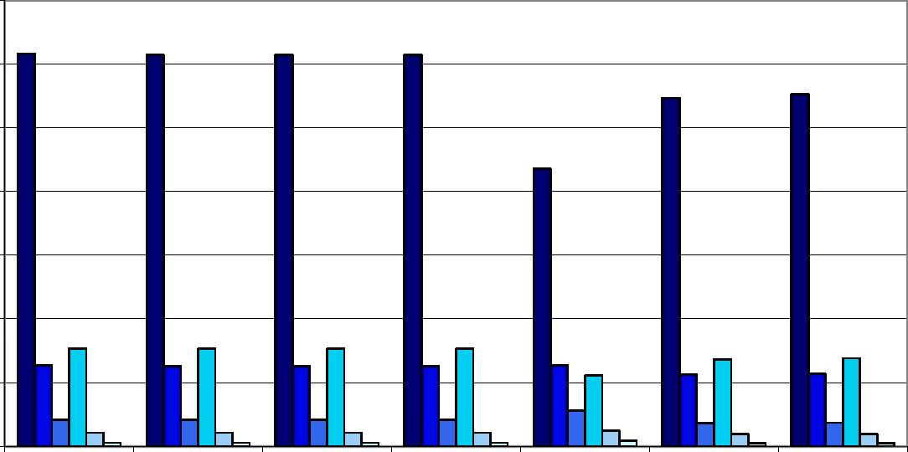

7C0

dCO

4C0
3C0
: ι
■ 'i

Home
Host Domestic, Domestic, Country contribution Home - Home -
w/o Cross Border w/o Cross Border to 1 EU IGS claims compensation claims and
(FPS + branches) (branches only) only premiums
compensation
PD=0.5%,α=99% PD=0.5%,α=90% PD=0.5%,α=75% PD=0.1%,α=99% PD=0.1%,α=90% PD=0.1%,α=75%
Austria - Life Insurance

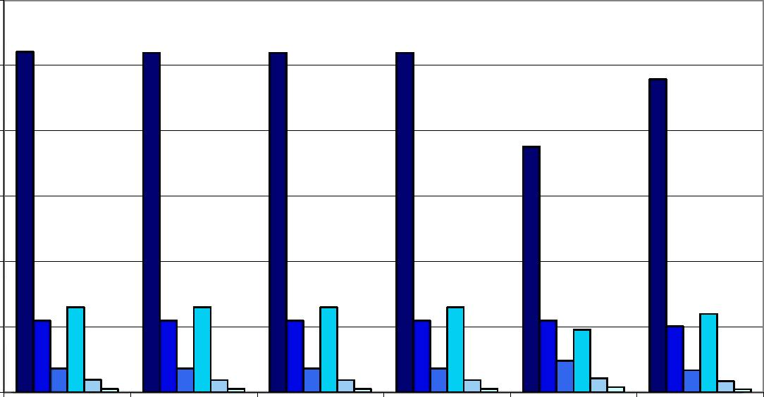

dCO

4CÜ

3C0
. 'i
■ 'i

Home

Host
Domestic, w/o Cross Border (FPS + branches)
Domestic, w/o Cross Border (branches only)
Country contribution to 1 EU IGS
Home -
claims compensation
only

■ ■ODDO

Austria - Non-Life Insurance

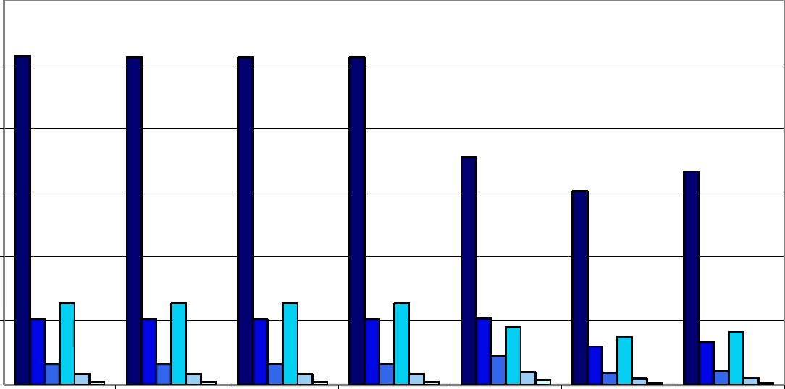

1A]
■ ί
w

W

Æ

Home
Host Domestic, Domestic, Country contribution Home - Home -
w/o Cross Border w/o Cross Border to 1 EU IGS claims compensation claims and
(FPS + branches) (branches only) only premiums
compensation
PD=0.5%,α=99% PD=0.5%,α=90% PD=0.5%,α=75% PD=0.1%,α=99% PD=0.1%,α=90% PD=0.1%,α=75%

2

A6.2 Belgium

Belgium - Total Insurance

0-
e Host Domestic, Domestic, Country contribution Home - Home -
w/o Cross Border w/o Cross Border to 1 EU IGS claims claims and
(FPS + branches) (branches only) compensation only premiums
compensation
PD=0.5%,α=99% PD=0.5%,α=90% PD=0.5%,α=75% PD=0.1%,α=99% PD=0.1%,α=90% PD=0.1%,α=75%

Belgium - Life Insurance

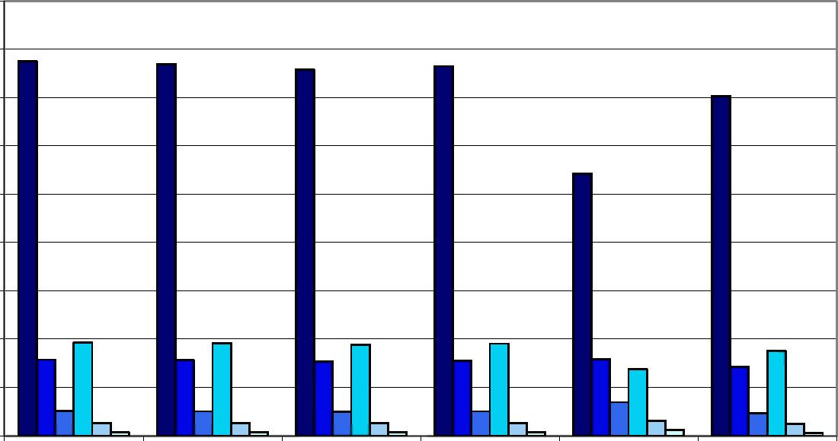

1Щ)
1,200
1,000
400
¿00

Home

Host
Domestic, Domestic, Country contribution Home -
w/o Cross Border w/o Cross Border to 1 EU IGS claims compensation
(FPS + branches) (branches only) only

DPD=0.5%,α=99% DPD=0.5%,α=90% DPD=0.5%,α=75% DPD=0.1%,α=99% ŪPD=0.1%,α=90% DPD=0.1%,α=75%

Belgium - Non-Life Insurance

0

Home
Host Domestic, Domestic, Country contribution Home - Home -
w/o Cross Border w/o Cross Border to 1 EU IGS claims compensation claims and
(FPS + branches) (branches only) only premiums
compensation
PD=0.5%,α=99% PD=0.5%,α=90% PD=0.5%,α=75% PD=0.1%,α=99% PD=0.1%,α=90% PD=0.1%,α=75%

3

A6.3 Bulgaria

Bulgaria - Total Insurance

Home
Host Domestic, Domestic, Country contribution Home - Home -
w/o Cross Border w/o Cross Border to 1 EU IGS claims compensation claims and premiums
(FPS + branches) (branches only) only compensation
PD=0.5%,α=99% PD=0.5%,α=90% PD=0.5%,α=75% PD=0.1%,α=99% PD=0.1%,α=90% PD=0.1%,α=75%

Bulgaria - Life Insurance

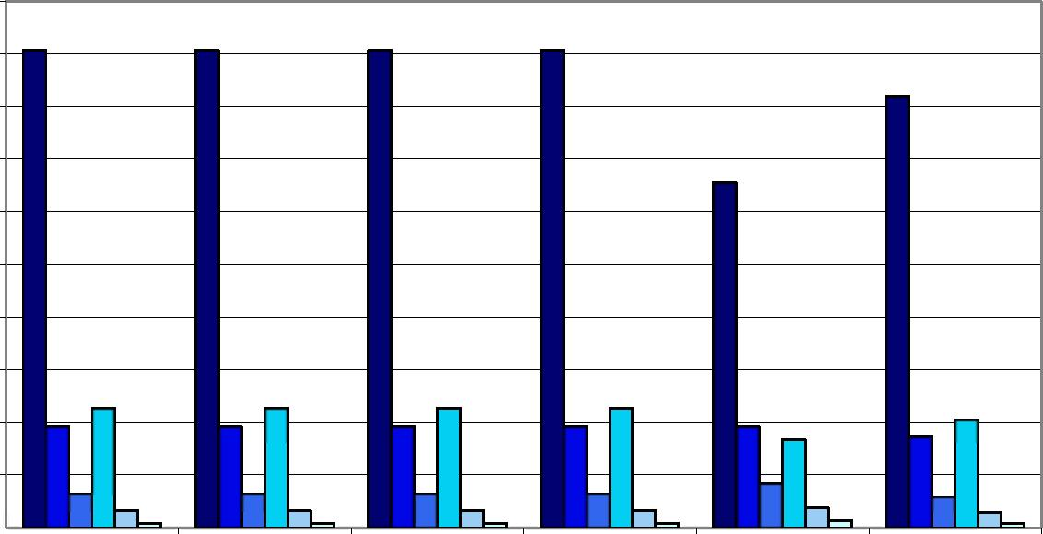

1

Home

Host

Domestic, | Domestic, | Country contribution | Home -
w/o Cross Border | w/o Cross Border | to 1 EU IGS | claims compensation
(FPS + branches) | (branches only) |  | only

DPD=0.5%,α=99% DPD=0.5%,α=90% DPD=0.5%,α=75% DPD=0.1%,α=99% ŪPD=0.1%,α=90% DPD=0.1%,α=75%

Bulgaria - Non-Life Insurance

Home

Host
Domestic, Domestic,
w/o Cross Border w/o Cross Border (FPS + branches) (branches only)
Country contribution Home - Home -
to 1 EU IGS claims compensation claims and premiums
only compensation

■ ■ D O D D
4

A6.4 Cyprus

Cyprus - Total Insurance

35
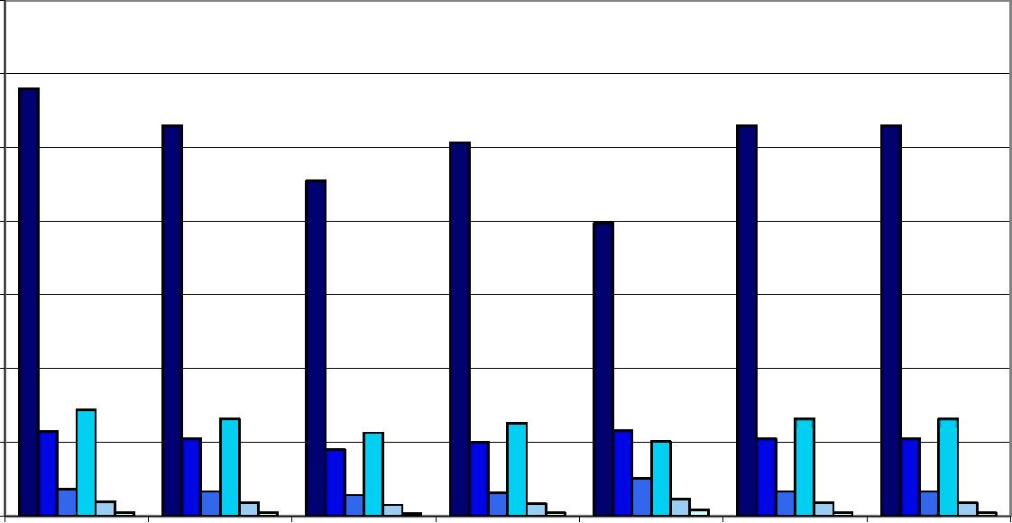
30
25

¿0

Home
Host Domestic, Domestic, Country contribution Home - Home -
w/o Cross Border w/o Cross Border to 1 EU IGS claims compensation claims and premiums
(FPS + branches) (branches only) only compensation
PD=0.5%,α=99% PD=0.5%,α=90% PD=0.5%,α=75% PD=0.1%,α=99% PD=0.1%,α=90% PD=0.1%,α=75%

Cyprus - Life Insurance
30

20
15

Home

Host
Domestic, Domestic,
w/o Cross Border w/o Cross Border
(FPS + branches) (branches only)
Country contribution Home -
to 1 EU IGS claims compensation
only

DPD=0.5%,α=99% DPD=0.5%,α=90% DPD=0.5%,α=75% DPD=0.1%,α=99% ŪPD=0.1%,α=90% DPD=0.1%,α=75%

Cyprus - Non-Life Insurance

Home
Host Domestic, Domestic, Country contribution Home - Home -
w/o Cross Border w/o Cross Border to 1 EU IGS claims compensation claims and premiums
(FPS + branches) (branches only) only compensation
PD=0.5%,α=99% PD=0.5%,α=90% PD=0.5%,α=75% PD=0.1%,α=99% PD=0.1%,α=90% PD=0.1%,α=75%

5

A6.5 Czech Republic

Czech Republic - Total Insurance

0

Home
Host Domestic, Domestic, Country contribution Home - Home -
w/o Cross Border w/o Cross Border to 1 EU IGS claims compensation claims and premiums
(FPS + branches) (branches only) only compensation
PD=0.5%,α=99% PD=0.5%,α=90% PD=0.5%,α=75% PD=0.1%,α=99% PD=0.1%,α=90% PD=0.1%,α=75%

Czech Republic - Life Insurance
tìO

IO
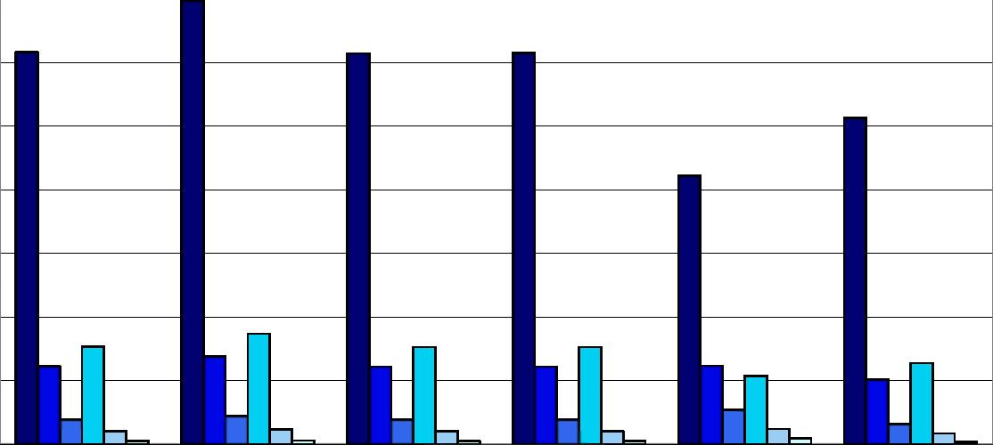
60 -

30
20 -

10
50
40

Home

Host
Domestic, Domestic,
w/o Cross Border w/o Cross Border
(FPS + branches) (branches only)
Country contribution to 1 EU IGS
Home -
claims compensation
only

DPD=0.5%,α=99% DPD=0.5%,α=90% DPD=0.5%,α=75% DPD=0.1%,α=99% ŪPD=0.1%,α=90% DPD=0.1%,α=75%

Czech Republic - Non-Life Insurance

14
12
10

Home
Host Domestic, Domestic, Country contribution Home - Home -
w/o Cross Border w/o Cross Border to 1 EU IGS claims compensation claims and premiums
(FPS + branches) (branches only) only compensation
PD=0.5%,α=99% PD=0.5%,α=90% PD=0.5%,α=75% PD=0.1%,α=99% PD=0.1%,α=90% PD=0.1%,α=75%

6

A6.6 Germany

Germany - Total Insurance

θ ,000
7,000
6,000
5,000 4,000
3,000
2,000 -
1,000

e Host Domestic, Domestic, Country contribution Home - Home -
w/o Cross Border w/o Cross Border to 1 EU IGS claims claims and
(FPS + branches) (branches only) compensation only premiums
compensation
PD=0.5%,α=99% PD=0.5%,α=90% PD=0.5%,α=75% PD=0.1%,α=99% PD=0.1%,α=90% PD=0.1%,α=75%

Germany- Life Insurance

лооо
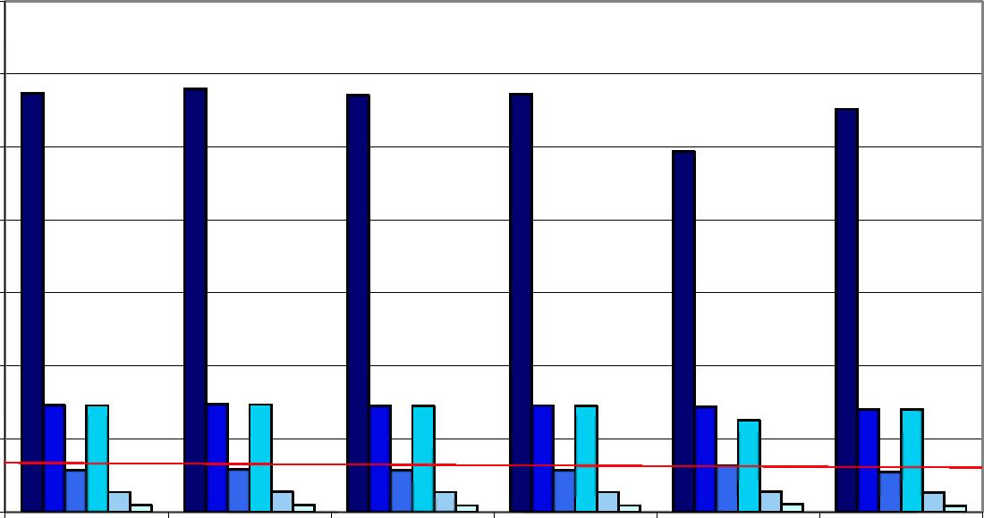
4,000 3,000
2,000
1,000

Home

Host
Domestic, Domestic, Country contribution Home -
w/o Cross Border w/o Cross Border to 1 EU IGS claims compensation
(FPS + branches) (branches only) only

DPD=0.5%,α=99% DPD=0.5%,α=90% DPD=0.5%,α=75% DPD=0.1%,α=99% ŪPD=0.1%,α=90% DPD=0.1%,α=75%

Germany - Non-Life Insurance

2,000
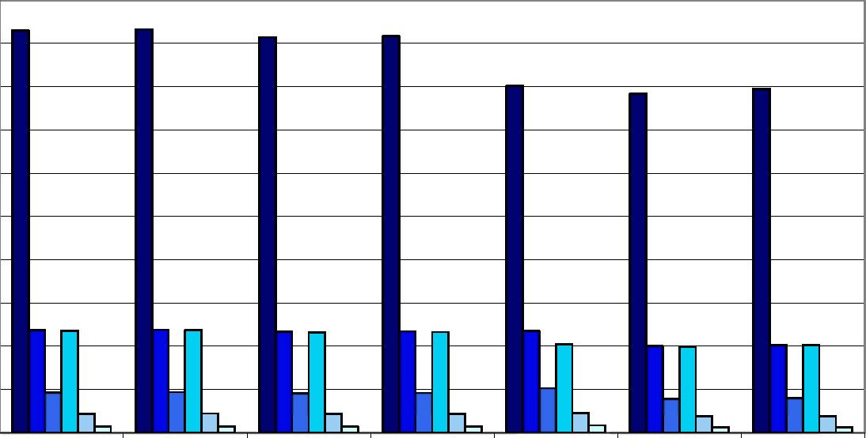
1,000 1,600
1,400 1,200
1,000 Θ00 -600
400
200

e Host Domestic, Domestic, Country contribution Home - Home -
w/o Cross Border w/o Cross Border to 1 EU IGS claims claims and
(FPS + branches) (branches only) compensation only premiums
compensation
PD=0.5%,α=99% PD=0.5%,α=90% PD=0.5%,α=75% PD=0.1%,α=99% PD=0.1%,α=90% PD=0.1%,α=75%
7

A6.7 Denmark

Denmark - Total Insurance

1,200
300
600
200

Home

Host
Domestic, Domestic, Country contribution Home -
w/o Cross Border w/o Cross Border to 1 EU IGS claims
(FPS + branches) (branches only) compensation only
Home -
claims and
premiums
compensation

HPD=0.5%,α=99% DPD=0.5%,α=90% DPD=0.5%,α=75% OPD=0.1%,α=99% ūPD=0.1%,α=90% ūPD=0.1%,α=75%

Denmark - Life Insurance

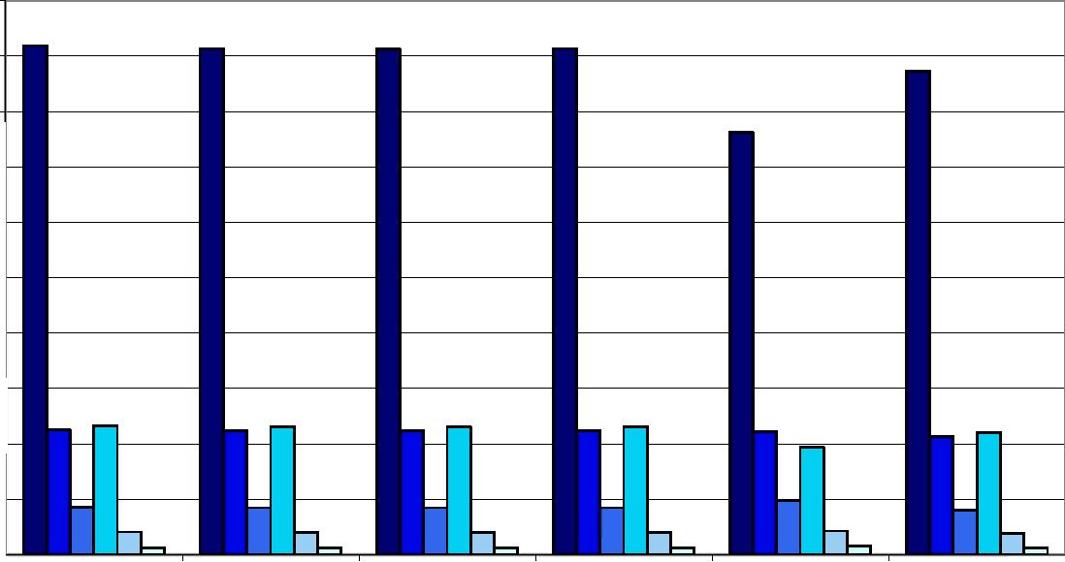
1,000 900 Θ00 700 - 600 500 400 300 200 -100

Home

Host
Domestic, w/o Cross Border (FPS + branches)
Domestic, w/o Cross Border (branches only)
Country contribution to 1 EU IGS
Home -
claims compensation
only

lPD=0.5%,α=99% DPD=0.5%,α=90% DPD=0.5%,α=75% ūPD=0.1%,α=99% ūPD=0.1%,α=90% ūPD=0.1%,α=75%

Denmark - Non-Life Insurance

30
ίΰ
50 40 30

Home
Host Domestic, Domestic, Country contribution Home - Home -
w/o Cross Border w/o Cross Border to 1 EU IGS claims compensation claims and premiums
(FPS + branches) (branches only) only compensation
PD=0.5%,α=99% PD=0.5%,α=90% PD=0.5%,α=75% PD=0.1%,α=99% PD=0.1%,α=90% PD=0.1%,α=75%

Note: red line refers to the target fund size
8

A6.8 Estonia

Estonia - Total Insurance

Θ.0
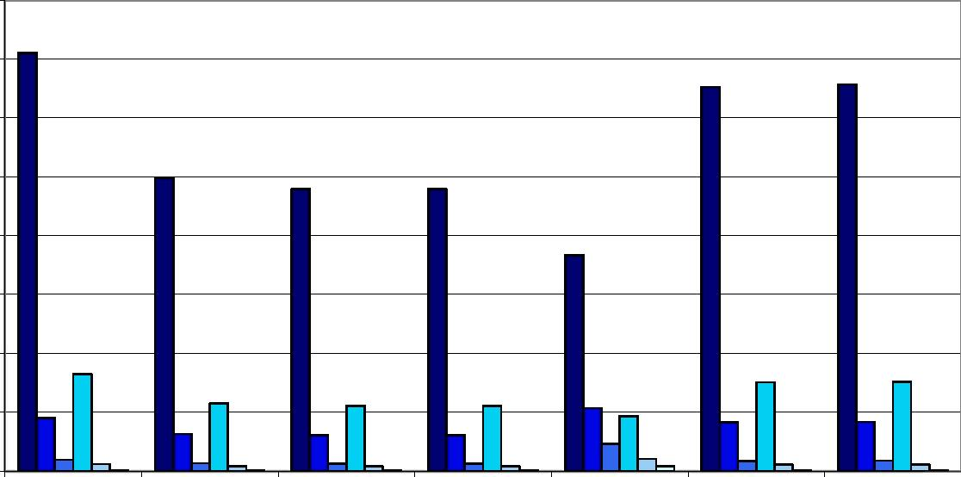

b.O
b.O

4.0

3.0
0.0

Home
Host Domestic, Domestic, Country contribution Home - Home -
w/o Cross Border w/o Cross Border to 1 EU IGS claims compensation claims and
(FPS + branches) (branches only) only premiums
compensation
PD=0.5%,α=99% PD=0.5%,α=90% PD=0.5%,α=75% PD=0.1%,α=99% PD=0.1%,α=90% PD=0.1%,α=75%

Estonia - Life Insurance

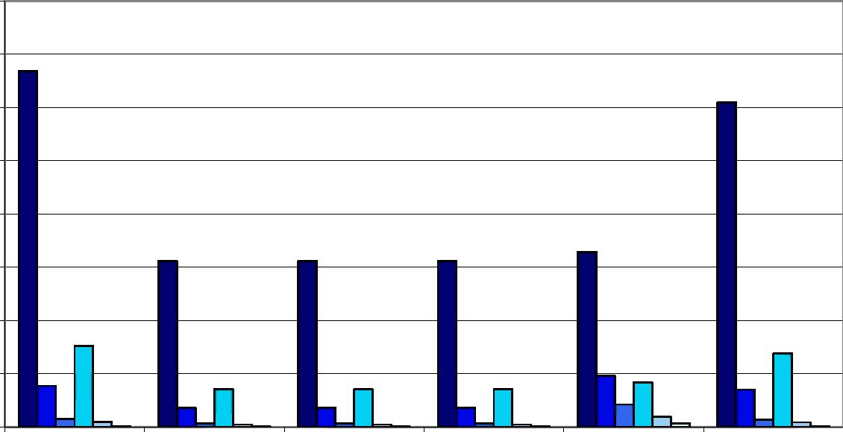

Home

Host
Domestic, w/o Cross Border (FPS + branches)
Domestic, w/o Cross Border (branches only)
Country contribution to 1 EU IGS
Home -
claims compensation
only

DPD=0.5%,α=99% DPD=0.5%,α=90% DPD=0.5%,α=75% DPD=0.1%,α=99% ŪPD=0.1%,α=90% DPD=0.1%,α=75%

Estonia - Non-Life Insurance

1.4
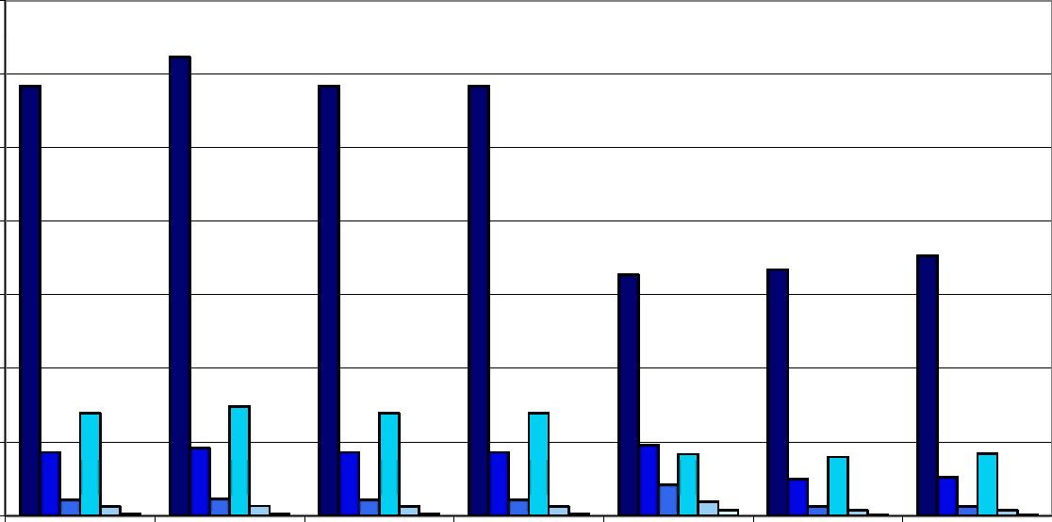
1.2
1.0

Ой

Oź
0.0

Ob

Home
Host Domestic, Domestic, Country contribution Home - Home -
w/o Cross Border w/o Cross Border to 1 EU IGS claims compensation claims and
(FPS + branches) (branches only) only premiums
compensation
PD=0.5%,α=99% PD=0.5%,α=90% PD=0.5%,α=75% PD=0.1%,α=99% PD=0.1%,α=90% PD=0.1%,α=75%

9

A6.9 Spain

Spain - Total Insurance

Ι,ΘΟΟ
1,600 1,400 1,200 1,000 800 600 400
200

Home

Host
Domestic, Domestic, Country contribution Home -
w/o Cross Border w/o Cross Border to 1 EU IGS claims
(FPS + branches) (branches only) compensation only
Home -
claims and
premiums
compensation

■ ■ D O D D

Note: red line refers to the 2008 fund size

Spain - Life Insurance

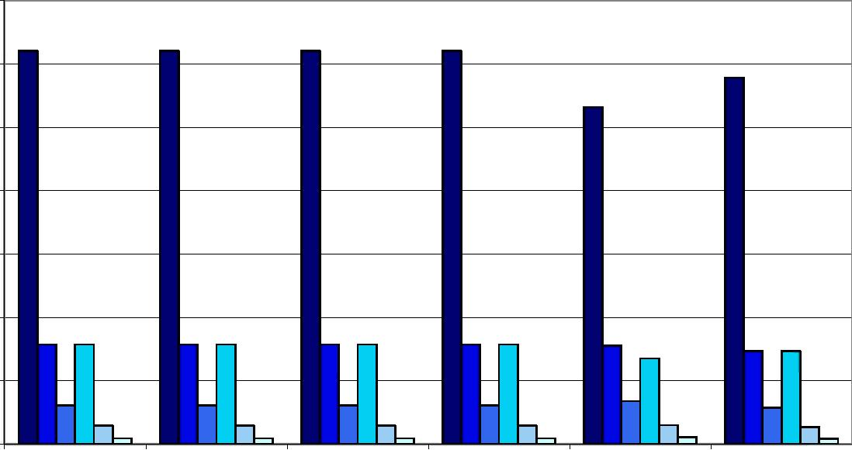

1,400

Θ00
600
400

Home

Host
Domestic, w/o Cross Border (FPS + branches)
Domestic, w/o Cross Border (branches only)
Country contribution to 1 EU IGS
Home -
claims compensation
only

lPD=0.5%,α=99% DPD=0.5%,α=90% DPD=0.5%,α=75% ūPD=0.1%,α=99% ūPD=0.1%,α=90% ūPD=0.1%,α=75%

Spain - Non-Life Insurance

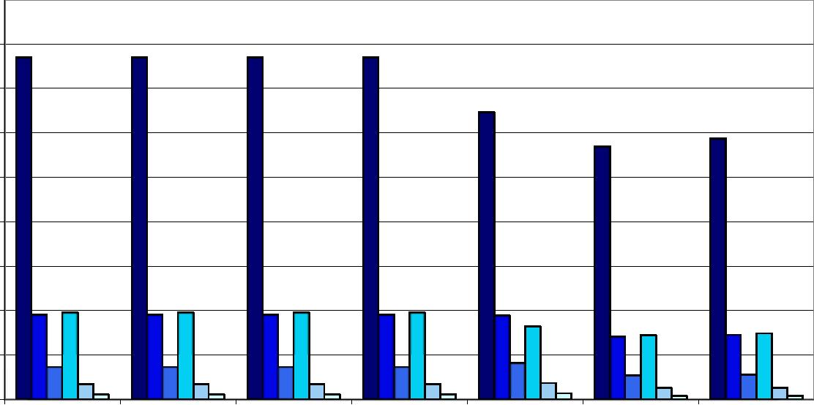

4bO
300
200
tO

Home
Host Domestic, Domestic, Country contribution Home - Home -
w/o Cross Border w/o Cross Border to 1 EU IGS claims compensation claims and
(FPS + branches) (branches only) only premiums
compensation
PD=0.5%,α=99% PD=0.5%,α=90% PD=0.5%,α=75% PD=0.1%,α=99% PD=0.1%,α=90% PD=0.1%,α=75%

10

A6.10 Finland

Finland - Total Insurance

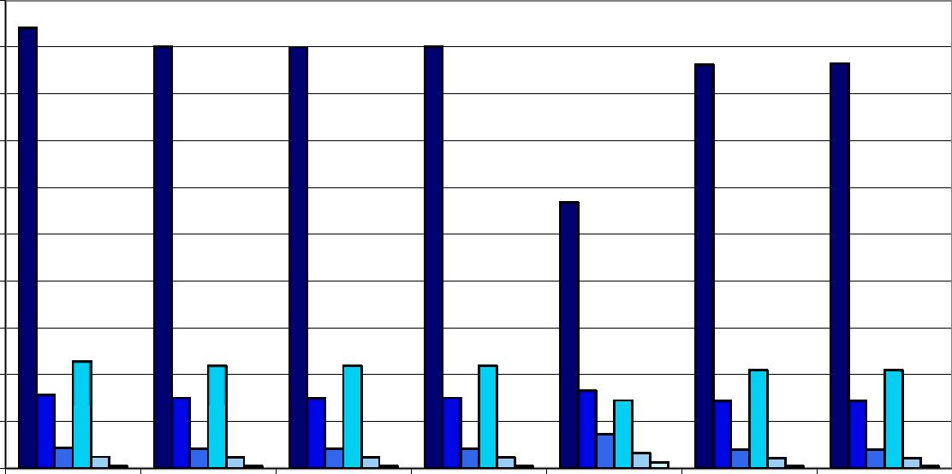
500
400
300

IbO
100

Home
Host Domestic, Domestic, Country contribution Home - Home -
w/o Cross Border w/o Cross Border to 1 EU IGS claims compensation claims and
(FPS + branches) (branches only) only premiums
compensation
PD=0.5%,α=99% PD=0.5%,α=90% PD=0.5%,α=75% PD=0.1%,α=99% PD=0.1%,α=90% PD=0.1%,α=75%

Finland - Life Insurance

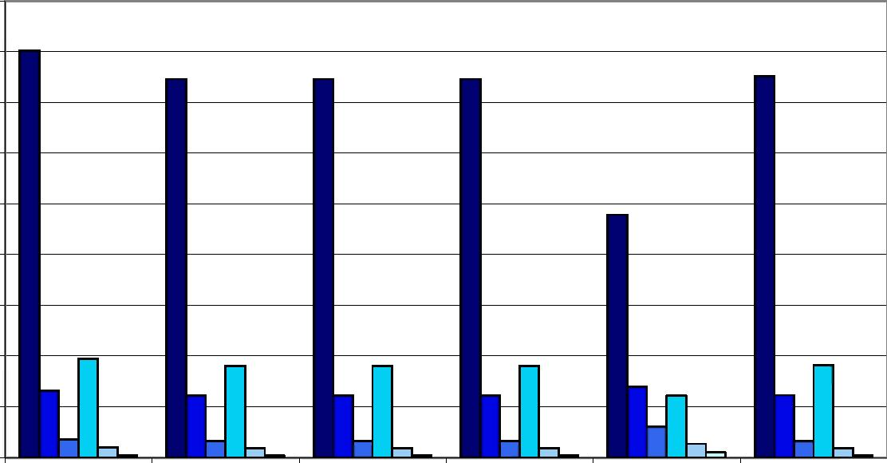

4bO
300
Æ0

Home

Host
Domestic, Domestic,
w/o Cross Border w/o Cross Border
(FPS + branches) (branches only)
Country contribution Home -
to 1 EU IGS claims compensation
only

DPD=0.5%,α=99% DPD=0.5%,α=90% DPD=0.5%,α=75% DPD=0.1%,α=99% ŪPD=0.1%,α=90% DPD=0.1%,α=75%

Finland - Non-Life Insurance
90

30
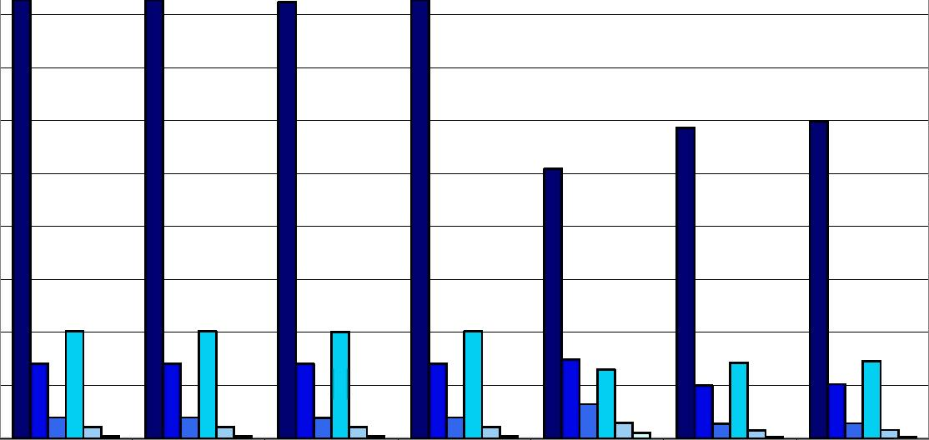

/0
bO

30
¿0
10
50
40

Home
Host Domestic, Domestic, Country contribution Home - Home -
w/o Cross Border w/o Cross Border to 1 EU IGS claims compensation claims and premiums
(FPS + branches) (branches only) only compensation
PD=0.5%,α=99% PD=0.5%,α=90% PD=0.5%,α=75% PD=0.1%,α=99% PD=0.1%,α=90% PD=0.1%,α=75%

11

A6.11 France

France - Total Insurance

12,000
10,000
Θ,ΟΟΟ -
b ,000
4,000
2,000

e Host Domestic, Domestic, Country contribution Home - Home -
w/o Cross Border w/o Cross Border to 1 EU IGS claims claims and
(FPS + branches) (branches only) compensation only premiums
compensation
PD=0.5%,α=99% PD=0.5%,α=90% PD=0.5%,α=75% PD=0.1%,α=99% PD=0.1%,α=90% PD=0.1%,α=75%

France - Life Insurance

10,000 Θ,ΟΟΟ 6,000 4,000 2,000
0

Home

Host
Domestic, Domestic, Country contribution Home -
w/o Cross Border w/o Cross Border to 1 EU IGS claims compensation
(FPS + branches) (branches only) only

DPD=0.5%,α=99% DPD=0.5%,α=90% DPD=0.5%,α=75% DPD=0.1%,α=99% DPD=0.1%,α=90% DPD=0.1%,α=75%

Note: red line refers to the 2007 fund size

France - Non-Life Insurance

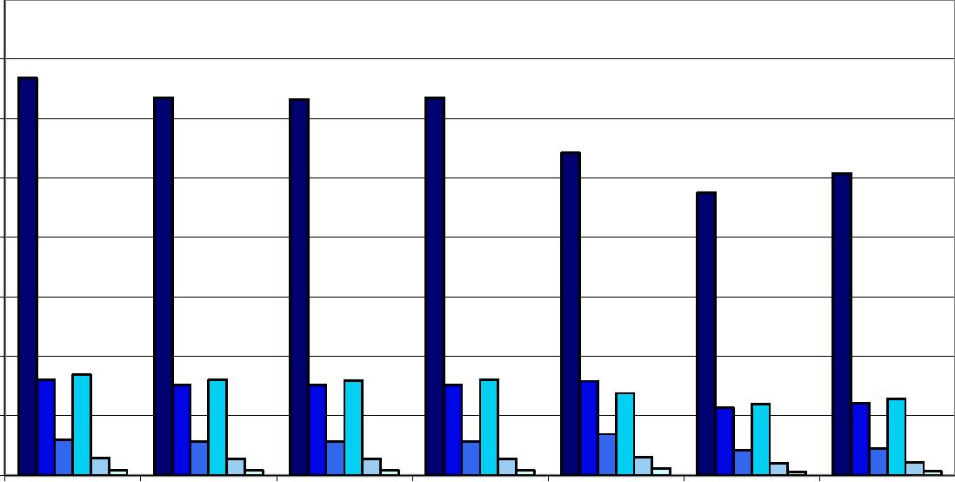

IMI)
1,400
bOO
400
200

e Host Domestic, Domestic, Country contribution Home - Home -
w/o Cross Border w/o Cross Border to 1 EU IGS claims claims and
(FPS + branches) (branches only) compensation only premiums
compensation
PD=0.5%,α=99% PD=0.5%,α=90% PD=0.5%,α=75% PD=0.1%,α=99% PD=0.1%,α=90% PD=0.1%,α=75%
12

A6.12 United Kingdom

United Kingdom - Total Insurance

0-
e Host Domestic, Domestic, Country contribution Home - Home -
w/o Cross Border w/o Cross Border to 1 EU IGS claims claims and
(FPS + branches) (branches only) compensation only premiums
compensation
PD=0.5%,α=99% PD=0.5%,α=90% PD=0.5%,α=75% PD=0.1%,α=99% PD=0.1%,α=90% PD=0.1%,α=75%

United Kingdom - Life Insurance

16,000 14,000 -12,000 10,000 -Θ,ΟΟΟ
4,000 2,000 0 -

Home

Host
Domestic, w/o Cross Border (FPS + branches)
Domestic, w/o Cross Border (branches only)
Country contribution to 1 EU IGS
Home -
claims compensation
only

DPD=0.5%,α=99% DPD=0.5%,α=90% DPD=0.5%,α=75% DPD=0.1%,α=99% DPD=0.1%,α=90% ŪPD=0.1%,α=75%

United Kingdom - Non-Life Insurance

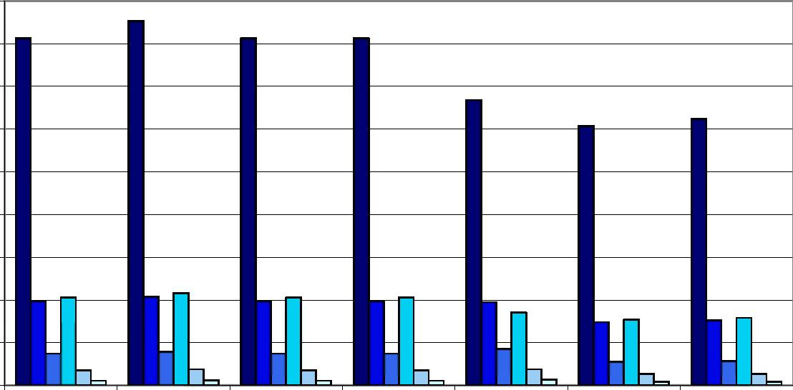

900
ÜOO
100

e Host Domestic, Domestic, Country contribution Home - Home -
w/o Cross Border w/o Cross Border to 1 EU IGS claims claims and
(FPS + branches) (branches only) compensation only premiums
compensation
PD=0.5%,α=99% PD=0.5%,α=90% PD=0.5%,α=75% PD=0.1%,α=99% PD=0.1%,α=90% PD=0.1%,α=75%
13

A6.13 Greece

Greece - Total Insurance

90
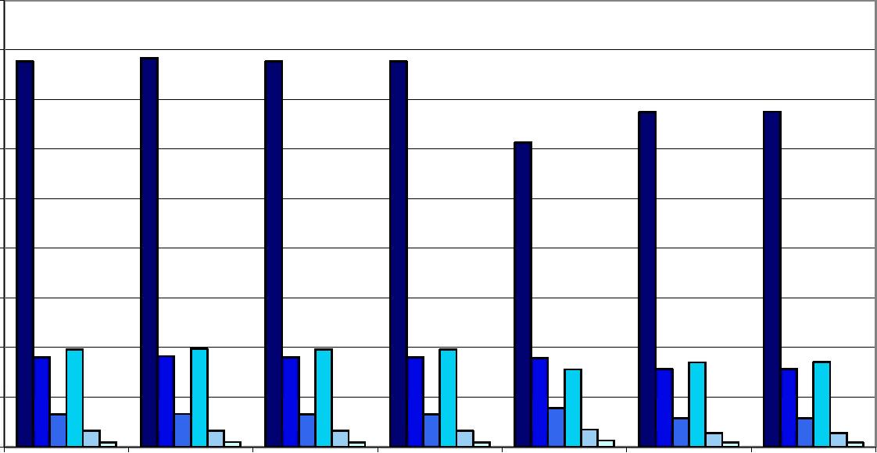

Θ0
/Ό

JO
40

Home

Host
Domestic, Domestic,
w/o Cross Border w/o Cross Border (FPS + branches) (branches only)
Country contribution Home - Home -
to 1 EU IGS claims compensation claims and premiums
only compensation

■ ■DŪDO

Greece - Life Insurance

60 50 40 -30 20 10 -n -

Home

Host

Domestic, | Domestic, | Country contribution | Home -
w/o Cross Border | w/o Cross Border | to 1 EU IGS | claims compensation
(FPS + branches) | (branches only) |  | only

DPD=0.5%,α=99% DPD=0.5%,α=90% DPD=0.5%,α=75% DPD=0.1%,α=99% ŪPD=0.1%,α=90% DPD=0.1%,α=75%

Greece - Non-Life Insurance

14
12
10

Home

Host
Domestic, Domestic,
w/o Cross Border w/o Cross Border (FPS + branches) (branches only)
Country contribution Home - Home -
to 1 EU IGS claims compensation claims and premiums
only compensation

■ ■DŪDO
14

A6.14 Hungary

Hungary - Total Insurance

45
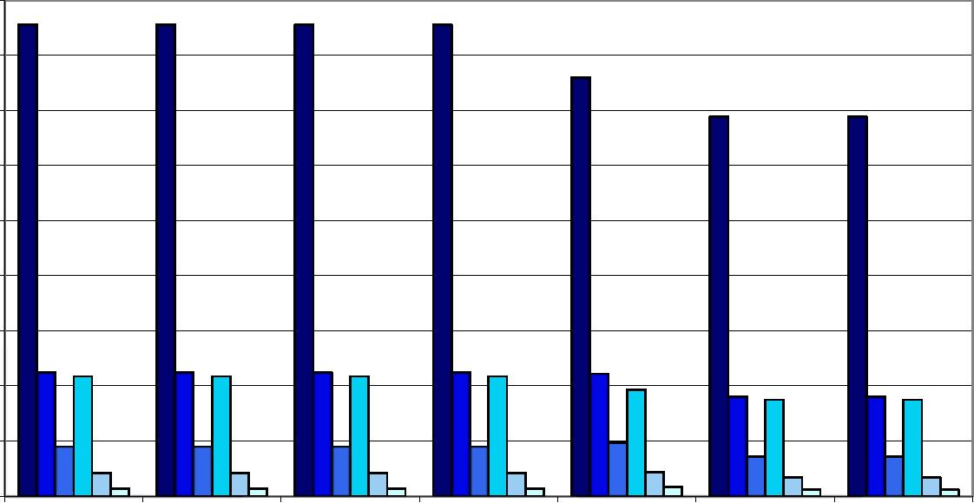
40
db

1b
20

Home
Host Domestic, Domestic, Country contribution Home - Home -
w/o Cross Border w/o Cross Border to 1 EU IGS claims compensation claims and premiums
(FPS + branches) (branches only) only compensation
PD=0.5%,α=99% PD=0.5%,α=90% PD=0.5%,α=75% PD=0.1%,α=99% PD=0.1%,α=90% PD=0.1%,α=75%

Hungary - Life Insurance

0

Home

Host
Domestic, Domestic, Country contribution Home -
w/o Cross Border w/o Cross Border to 1 EU IGS claims compensation
(FPS + branches) (branches only) only

DPD=0.5%,α=99% DPD=0.5%,α=90% DPD=0.5%,α=75% DPD=0.1%,α=99% ŪPD=0.1%,α=90% DPD=0.1%,α=75%

Hungary - Non-Life Insurance

Home
Host Domestic, Domestic, Country contribution Home - Home -
w/o Cross Border w/o Cross Border to 1 EU IGS claims compensation claims and premiums
(FPS + branches) (branches only) only compensation
PD=0.5%,α=99% PD=0.5%,α=90% PD=0.5%,α=75% PD=0.1%,α=99% PD=0.1%,α=90% PD=0.1%,α=75%

15

A6.15 Ireland

Ireland - Total Insurance

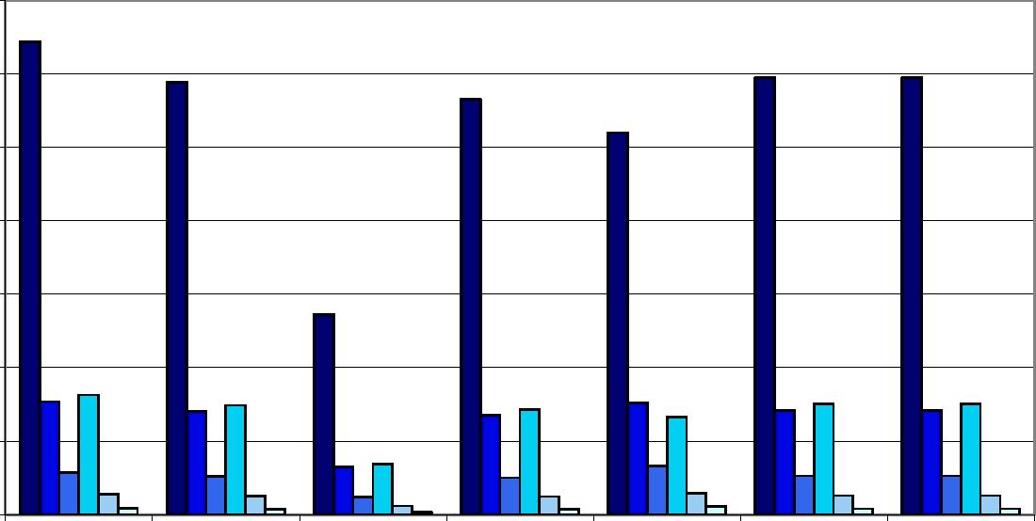

1,400
¿00

e Host Domestic, Domestic, Country contribution Home - Home -
w/o Cross Border w/o Cross Border to 1 EU IGS claims claims and
(FPS + branches) (branches only) compensation only premiums
compensation
PD=0.5%,α=99% PD=0.5%,α=90% PD=0.5%,α=75% PD=0.1%,α=99% PD=0.1%,α=90% PD=0.1%,α=75%

Ireland - Life Insurance

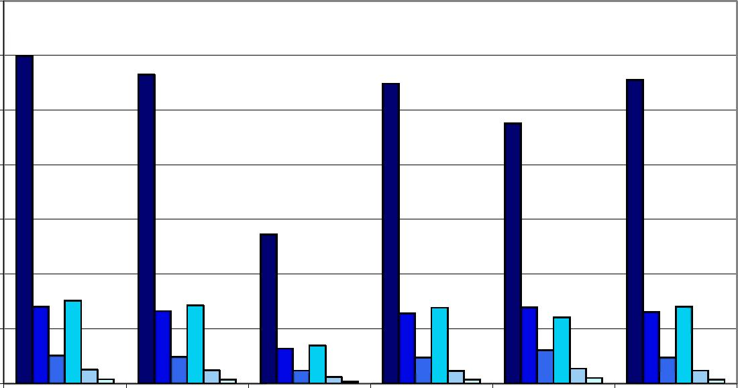

1,400
600
400
¿00

Home

Host
Domestic, Domestic, Country contribution Home -
w/o Cross Border w/o Cross Border to 1 EU IGS claims compensation
(FPS + branches) (branches only) only

DPD=0.5%,α=99% DPD=0.5%,α=90% DPD=0.5%,α=75% DPD=0.1%,α=99% ŪPD=0.1%,α=90% DPD=0.1%,α=75%

Ireland - Non-Life Insurance

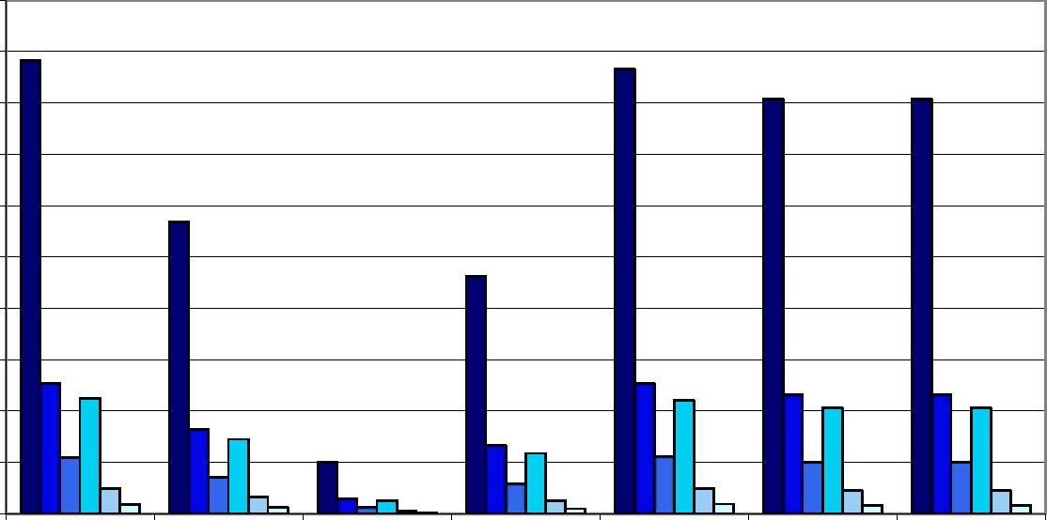
100

30
60 50
30
20
0

Home
Host Domestic, Domestic, Country contribution Home - Home -
w/o Cross Border w/o Cross Border to 1 EU IGS claims compensation claims and
(FPS + branches) (branches only) only premiums
compensation
PD=0.5%,α=99% PD=0.5%,α=90% PD=0.5%,α=75% PD=0.1%,α=99% PD=0.1%,α=90% PD=0.1%,α=75%

16

A6.16 Iceland

Iceland - Total Insurance

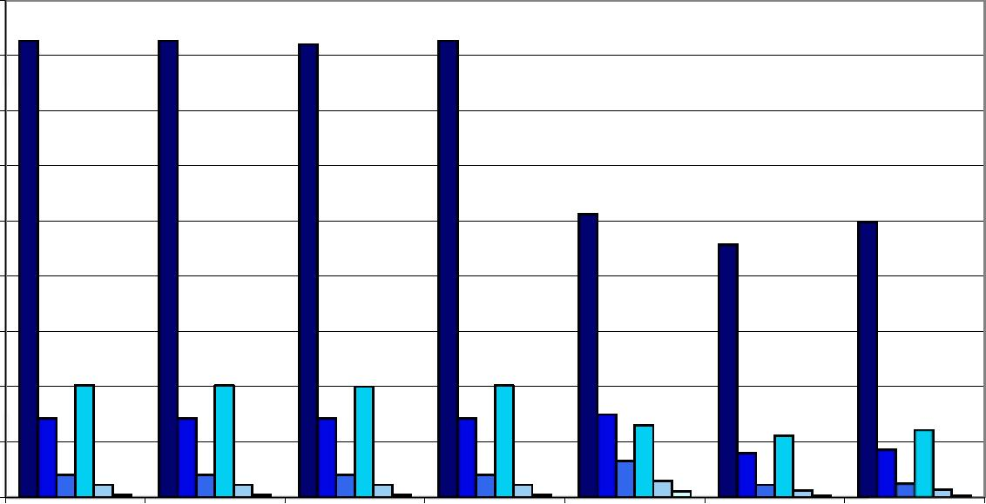

Home
Host Domestic, Domestic, Country contribution Home - Home -
w/o Cross Border w/o Cross Border to 1 EU IGS claims compensation claims and premiums
(FPS + branches) (branches only) only compensation
PD=0.5%,α=99% PD=0.5%,α=90% PD=0.5%,α=75% PD=0.1%,α=99% PD=0.1%,α=90% PD=0.1%,α=75%

Iceland - Life Insurance

2

Home

Host
Domestic, Domestic,
w/o Cross Border w/o Cross Border
(FPS + branches) (branches only)
Country contribution Home -
to 1 EU IGS claims compensation
only

DPD=0.5%,α=99% DPD=0.5%,α=90% DPD=0.5%,α=75% DPD=0.1%,α=99% ŪPD=0.1%,α=90% DPD=0.1%,α=75%

Iceland - Non-Life Insurance

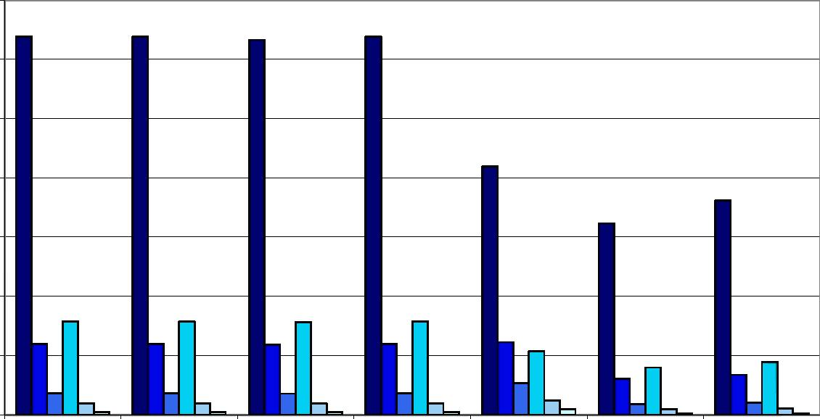

Home
Host Domestic, Domestic, Country contribution Home - Home -
w/o Cross Border w/o Cross Border to 1 EU IGS claims compensation claims and premiums
(FPS + branches) (branches only) only compensation
PD=0.5%,α=99% PD=0.5%,α=90% PD=0.5%,α=75% PD=0.1%,α=99% PD=0.1%,α=90% PD=0.1%,α=75%

17

A6.17 Italy

Italy - Total Insurance

4,500
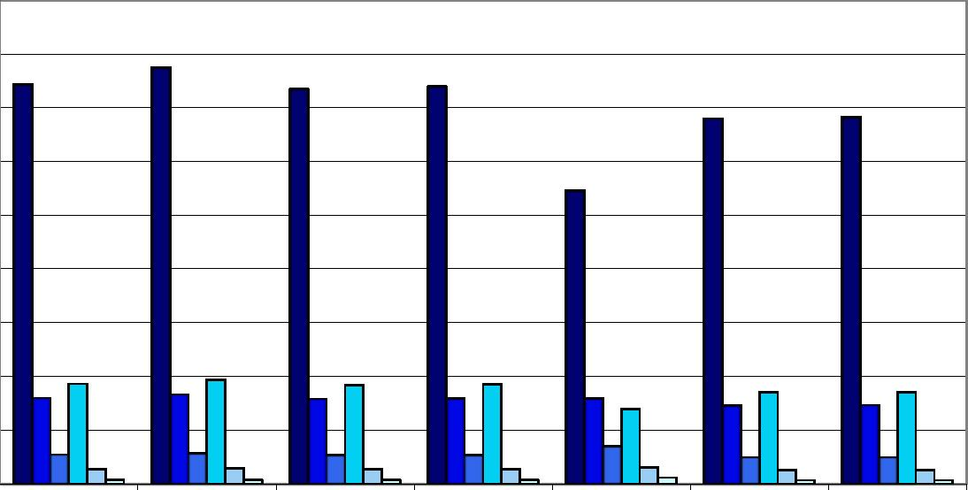
4,000 3,500 3,000 2,500 2,000 1,500 1,000 500

e Host Domestic, Domestic, Country contribution Home - Home -
w/o Cross Border w/o Cross Border to 1 EU IGS claims claims and
(FPS + branches) (branches only) compensation only premiums
compensation
PD=0.5%,α=99% PD=0.5%,α=90% PD=0.5%,α=75% PD=0.1%,α=99% PD=0.1%,α=90% PD=0.1%,α=75%

Italy - Life Insurance

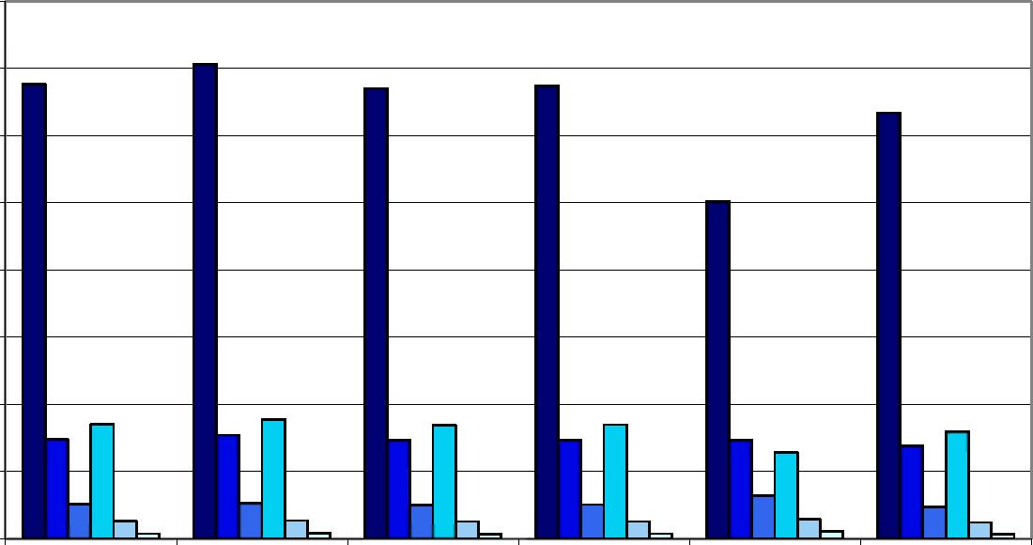
4,000
2,500 2,000
500

Home

Host
Domestic, Domestic, Country contribution Home -
w/o Cross Border w/o Cross Border to 1 EU IGS claims compensation
(FPS + branches) (branches only) only

DPD=0.5%,α=99% DPD=0.5%,α=90% DPD=0.5%,α=75% DPD=0.1%,α=99% ŪPD=0.1%,α=90% DPD=0.1%,α=75%

Italy - Non-Life Insurance

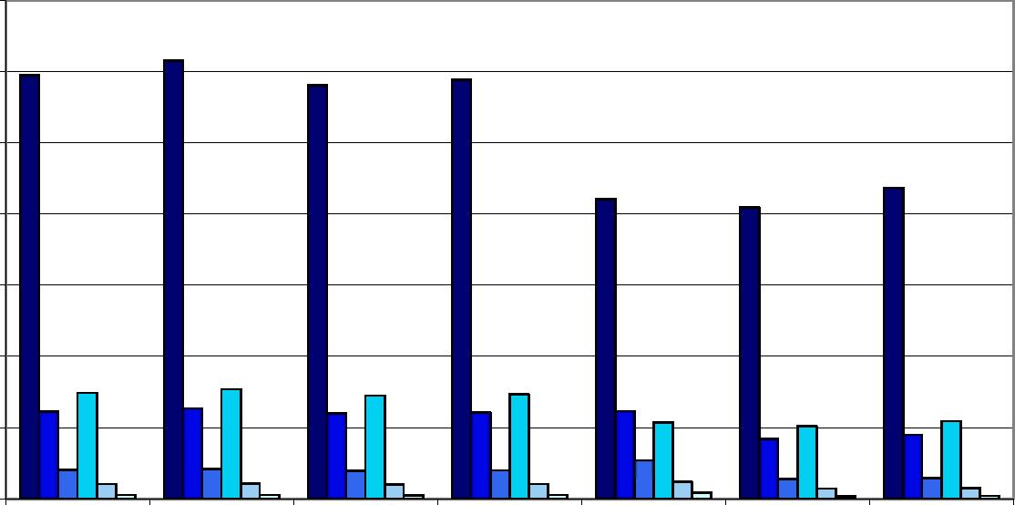

350

dO

Home
Host Domestic, Domestic, Country contribution Home - Home -
w/o Cross Border w/o Cross Border to 1 EU IGS claims compensation claims and
(FPS + branches) (branches only) only premiums
compensation
PD=0.5%,α=99% PD=0.5%,α=90% PD=0.5%,α=75% PD=0.1%,α=99% PD=0.1%,α=90% PD=0.1%,α=75%

18

A6.18 Lithuania

Lithuania - Total Insurance

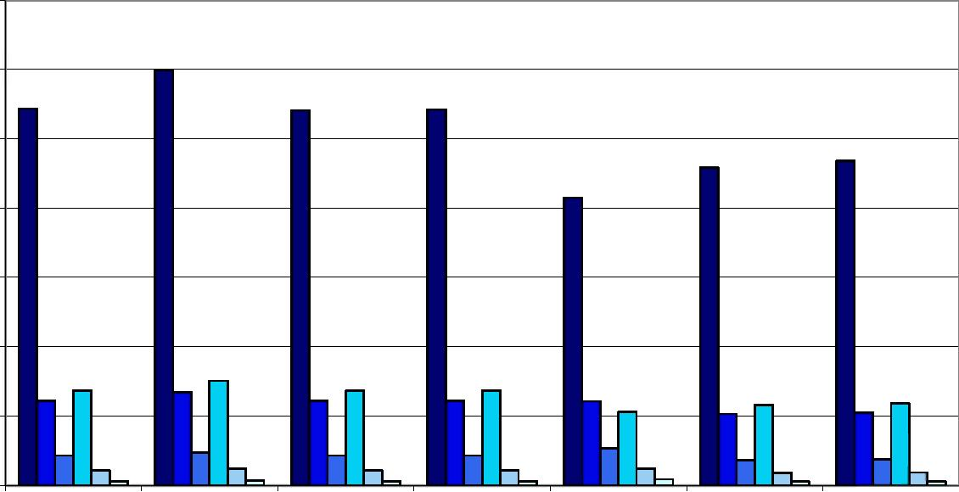

Home
Host Domestic, Domestic, Country contribution Home - Home -
w/o Cross Border w/o Cross Border to 1 EU IGS claims compensation claims and premiums
(FPS + branches) (branches only) only compensation
PD=0.5%,α=99% PD=0.5%,α=90% PD=0.5%,α=75% PD=0.1%,α=99% PD=0.1%,α=90% PD=0.1%,α=75%

Lithuania - Life Insurance

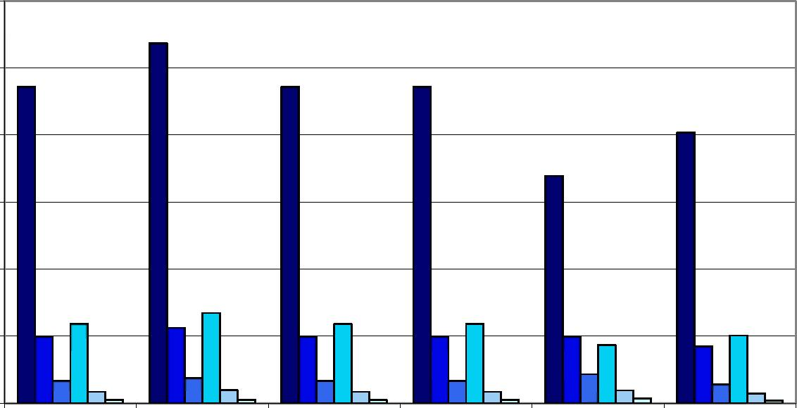

Home

Host
Domestic, Domestic, Country contribution Home -
w/o Cross Border w/o Cross Border to 1 EU IGS claims compensation
(FPS + branches) (branches only) only

DPD=0.5%,α=99% DPD=0.5%,α=90% DPD=0.5%,α=75% DPD=0.1%,α=99% ŪPD=0.1%,α=90% DPD=0.1%,α=75%

Lithuania - Non-Life Insurance

Home
Host Domestic, Domestic, Country contribution Home - Home -
w/o Cross Border w/o Cross Border to 1 EU IGS claims compensation claims and premiums
(FPS + branches) (branches only) only compensation
PD=0.5%,α=99% PD=0.5%,α=90% PD=0.5%,α=75% PD=0.1%,α=99% PD=0.1%,α=90% PD=0.1%,α=75%

19

A6.19 Luxembourg

Luxembourg - Total Insurance

600
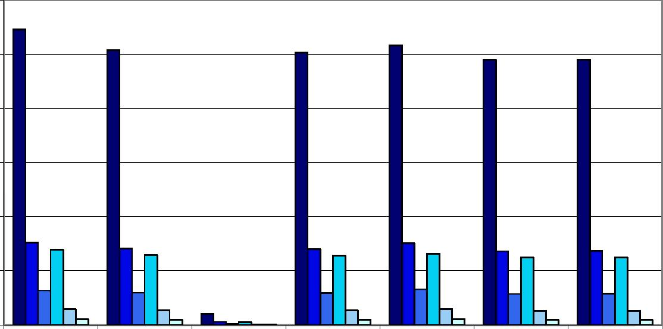
b 00

100

Home
Host Domestic, Domestic, Country contribution Home - Home -
w/o Cross Border w/o Cross Border to 1 EU IGS claims compensation claims and
(FPS + branches) (branches only) only premiums
compensation
PD=0.5%,α=99% PD=0.5%,α=90% PD=0.5%,α=75% PD=0.1%,α=99% PD=0.1%,α=90% PD=0.1%,α=75%

Luxembourg - Life Insurance

b 00
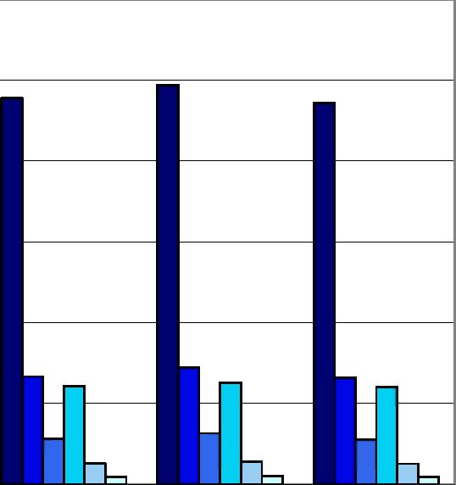
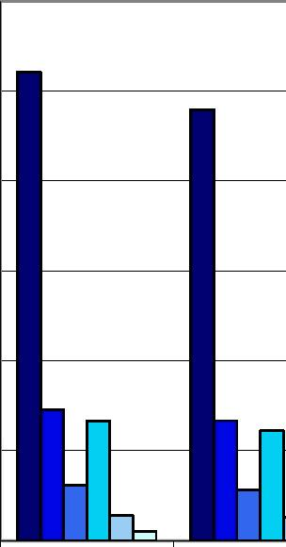
400

100

Home

Host
Domestic, Domestic, Country contribution Home -
w/o Cross Border w/o Cross Border to 1 EU IGS claims compensation
(FPS + branches) (branches only) only

DPD=0.5%,α=99% DPD=0.5%,α=90% DPD=0.5%,α=75% DPD=0.1%,α=99% ŪPD=0.1%,α=90% DPD=0.1%,α=75%

Luxembourg - Non-Life Insurance

30
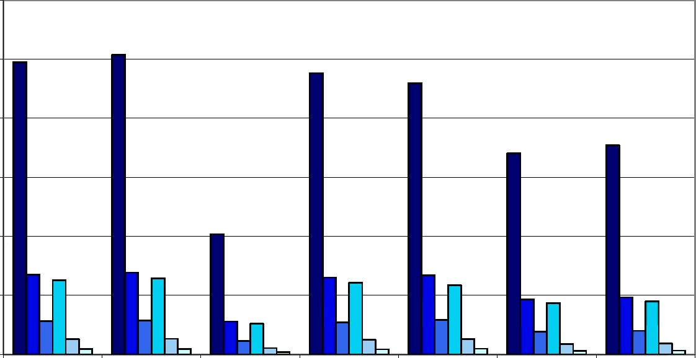
¿b

10

Home
Host Domestic, Domestic, Country contribution Home - Home -
w/o Cross Border w/o Cross Border to 1 EU IGS claims compensation claims and premiums
(FPS + branches) (branches only) only compensation
PD=0.5%,α=99% PD=0.5%,α=90% PD=0.5%,α=75% PD=0.1%,α=99% PD=0.1%,α=90% PD=0.1%,α=75%

20

A6.20 Latvia

Latvia - Total Insurance

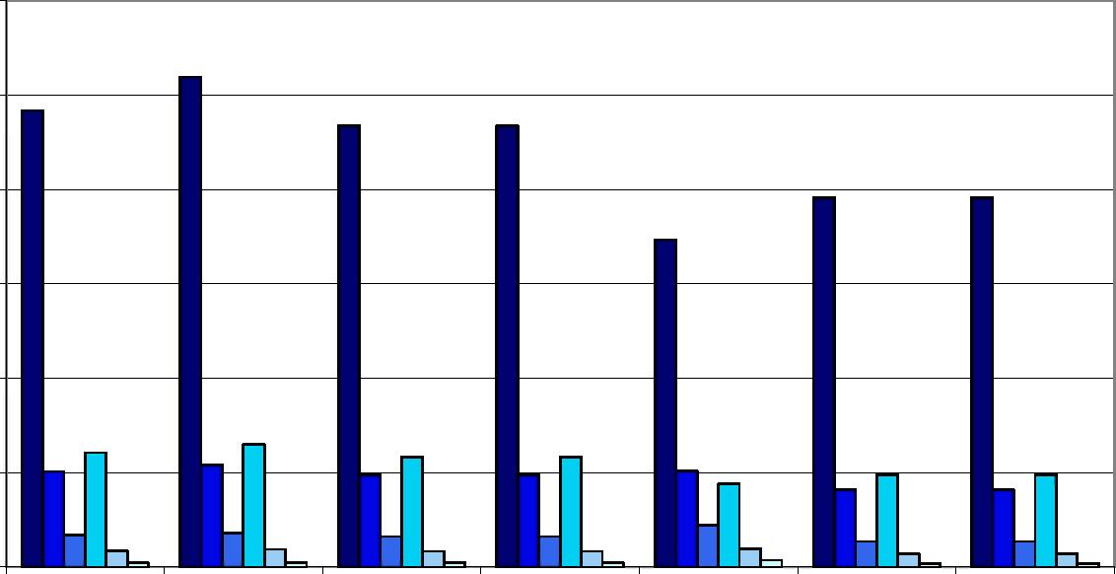

Home

Host Domestic, Domestic, Country contribution Home - Home -
w/o Cross Border w/o Cross Border to 1 EU IGS claims compensation claims and premiums
(FPS + branches) (branches only) only compensation
PD=0.5%,α=99% PD=0.5%,α=90% PD=0.5%,α=75% PD=0.1%,α=99% PD=0.1%,α=90% PD=0.1%,α=75%

Latvia - Life Insurance

1.6
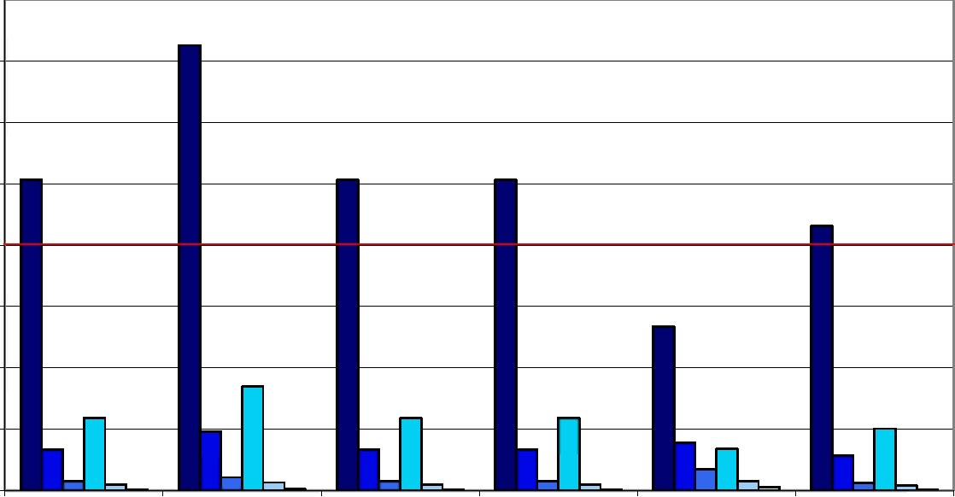
1.4
12

ϋ.ϋ

0.2
0.0
1.0

Home

Host
Domestic, Domestic, Country contribution Home -
w/o Cross Border w/o Cross Border to 1 EU IGS claims compensation
(FPS + branches) (branches only) only

■ PD=0.5%,α=99% DPD=0.5%,α=90% DPD=0.5%,α=75% ūPD^.I^o.α^G^o ūPD=0.1%,α=90% ΠΡΟ=0.1%,α=75%

Note: red line refers to the 2006 fund size

Latvia - Non-Life Insurance

3.0
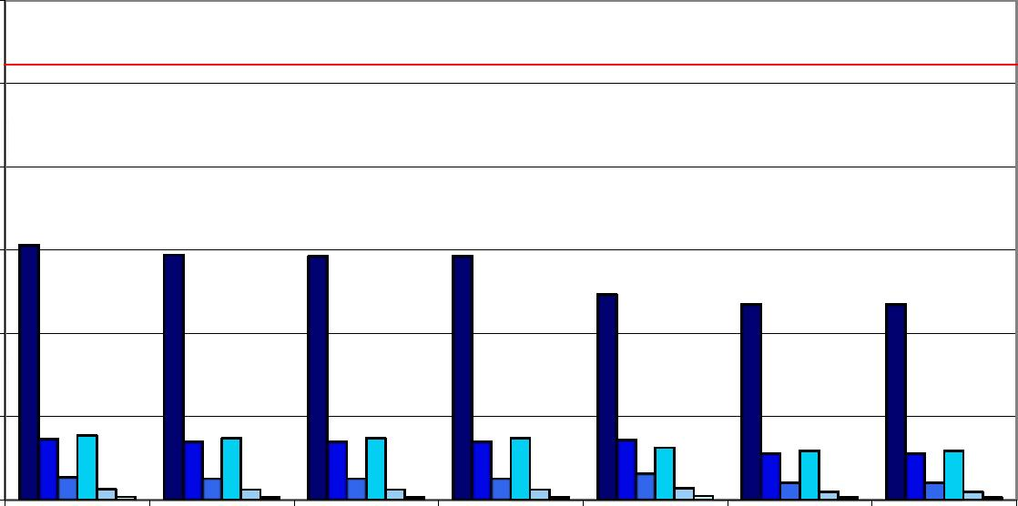
2.5
2.0

1.b

1.0
0.5
0.0

Home
Host Domestic, Domestic, Country contribution Home - Home -
w/o Cross Border w/o Cross Border to 1 EU IGS claims compensation claims and
(FPS + branches) (branches only) only premiums
compensation
PD=0.5%,α=99% PD=0.5%,α=90% PD=0.5%,α=75% PD=0.1%,α=99% PD=0.1%,α=90% PD=0.1%,α=75%

Note: red line refers to the 2006 fund size
21

A6.21 Malta

Malta - Total Insurance
¿b

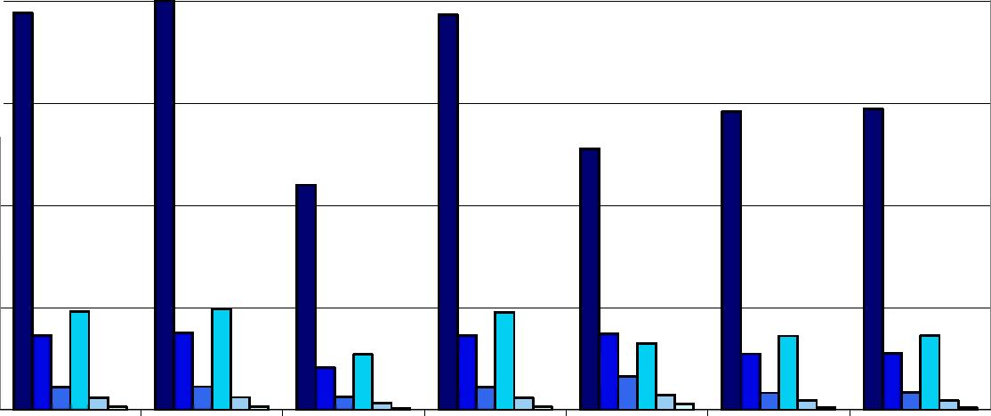
¿u
15

10

Home
Host Domestic, Domestic, Country contribution Home - Home -
w/o Cross Border w/o Cross Border to 1 EU IGS claims compensation claims and premiums
(FPS + branches) (branches only) only compensation
PD=0.5%,α=99% PD=0.5%,α=90% PD=0.5%,α=75% PD=0.1%,α=99% PD=0.1%,α=90% PD=0.1%,α=75%

Malta - Life Insurance

16
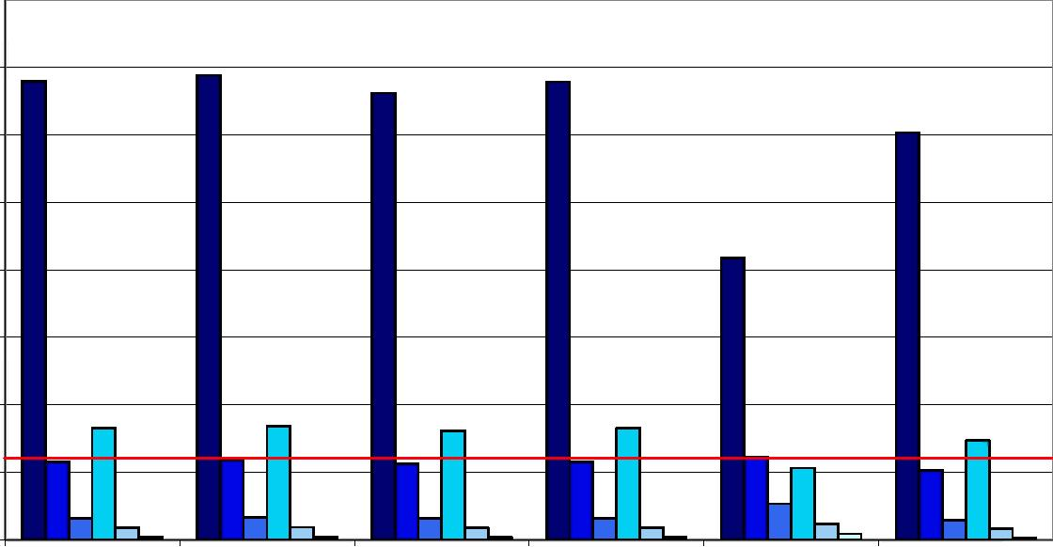
14
12

10

Home

Host
Domestic, Domestic, Country contribution Home -
w/o Cross Border w/o Cross Border to 1 EU IGS claims compensation
(FPS + branches) (branches only) only

lPD=0.5%,α=99% GPD=0.5%,α=90% DPD=0.5%,α=75% DPD=0.1%,α=99% ūPD=0.1%,α=90% OPD=0.1%,α=75%

Note: red line refers to the target fund size

Malta - Non-Life Insurance

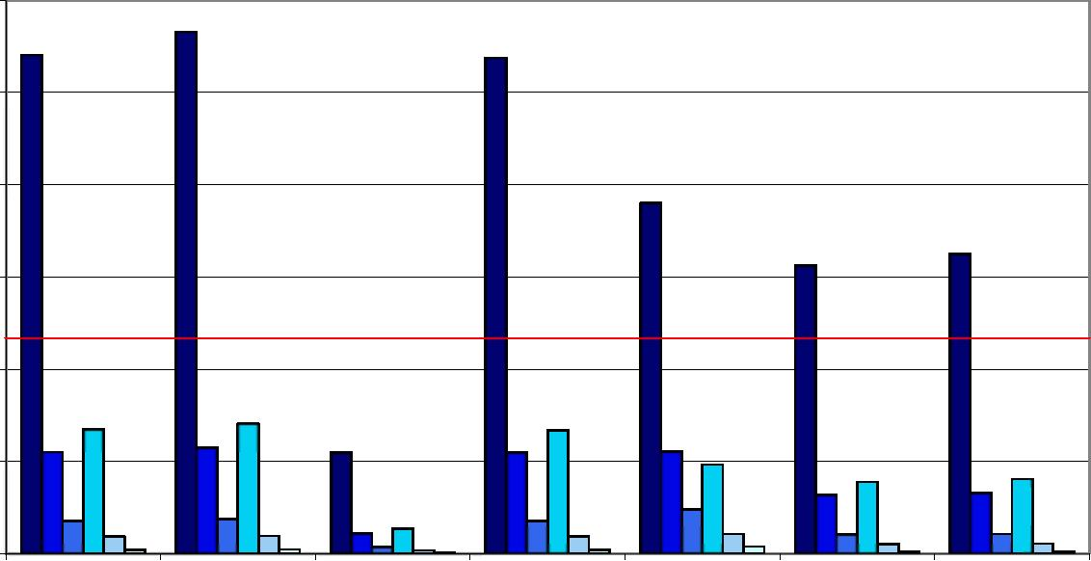

Home
Host Domestic, Domestic, Country contribution Home - Home -
w/o Cross Border w/o Cross Border to 1 EU IGS claims compensation claims and premiums
(FPS + branches) (branches only) only compensation
PD=0.5%,α=99% PD=0.5%,α=90% PD=0.5%,α=75% PD=0.1%,α=99% PD=0.1%,α=90% PD=0.1%,α=75%

Note: red line refers to the target fund size
22

A6.22 The Netherlands

The Netherlands - Total Insurance

3,000

ZbOO
¿poo -
1,500
1,000
500

e Host Domestic, Domestic, Country contribution Home - Home -
w/o Cross Border w/o Cross Border to 1 EU IGS claims claims and
(FPS + branches) (branches only) compensation only premiums
compensation
PD=0.5%,α=99% PD=0.5%,α=90% PD=0.5%,α=75% PD=0.1%,α=99% PD=0.1%,α=90% PD=0.1%,α=75%

The Netherlands - Life Insurance

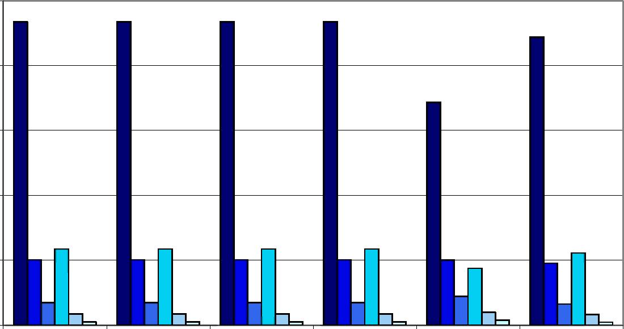

¿,500
¿,000
1,500

Home

Host
Domestic, Domestic, Country contribution Home -
w/o Cross Border w/o Cross Border to 1 EU IGS claims compensation
(FPS + branches) (branches only) only

DPD=0.5%,α=99% DPD=0.5%,α=90% DPD=0.5%,α=75% DPD=0.1%,α=99% ŪPD=0.1%,α=90% DPD=0.1%,α=75%

The Netherlands - Non-Life Insurance

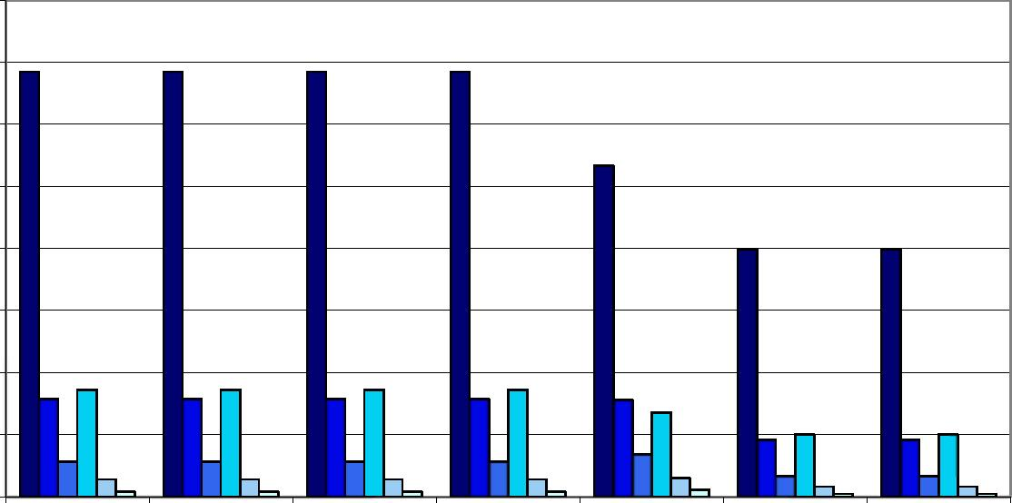

Θ00
500
400
300

Home
Host Domestic, Domestic, Country contribution Home - Home -
w/o Cross Border w/o Cross Border to 1 EU IGS claims compensation claims and
(FPS + branches) (branches only) only premiums
compensation
PD=0.5%,α=99% PD=0.5%,α=90% PD=0.5%,α=75% PD=0.1%,α=99% PD=0.1%,α=90% PD=0.1%,α=75%

23

A6.23 Norway

Norway - Total Insurance

1,200
1,000
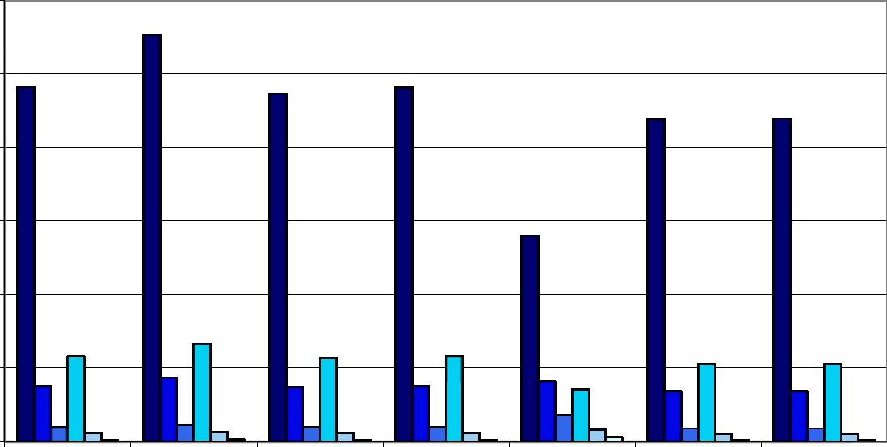

200

e Host Domestic, Domestic, Country contribution Home - Home -
w/o Cross Border w/o Cross Border to 1 EU IGS claims claims and
(FPS + branches) (branches only) compensation only premiums
compensation
PD=0.5%,α=99% PD=0.5%,α=90% PD=0.5%,α=75% PD=0.1%,α=99% PD=0.1%,α=90% PD=0.1%,α=75%

Norway - Life Insurance

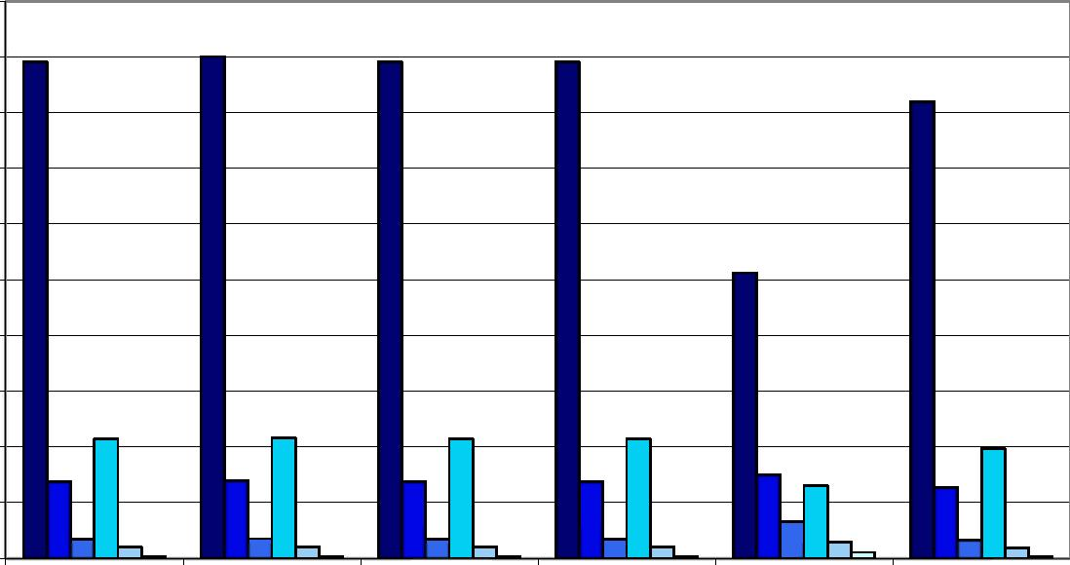
1,000

ÜOO
600 500

JOO

Home

Host
Domestic, Domestic,
w/o Cross Border w/o Cross Border
(FPS + branches) (branches only)
Country contribution Home -
to 1 EU IGS claims compensation
only

DPD=0.5%,α=99% DPD=0.5%,α=90% DPD=0.5%,α=75% DPD=0.1%,α=99% ŪPD=0.1%,α=90% DPD=0.1%,α=75%

Norway - Non-Life Insurance

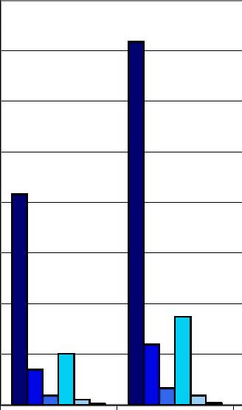

160
100 BO
60
40

Home
Host Domestic, Domestic, Country contribution Home - Home -
w/o Cross Border w/o Cross Border to 1 EU IGS claims compensation claims and
(FPS + branches) (branches only) only premiums
compensation
PD=0.5%,α=99% PD=0.5%,α=90% PD=0.5%,α=75% PD=0.1%,α=99% PD=0.1%,α=90% PD=0.1%,α=75%

24

A6.24 Poland

Poland - Total Insurance

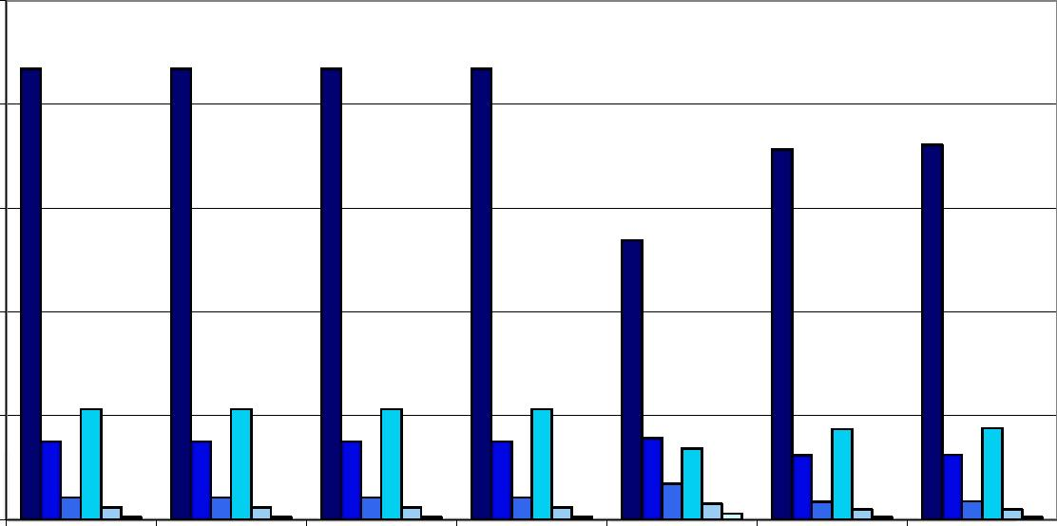

250
¿00

IbO
53

Home
Host Domestic, Domestic, Country contribution Home - Home -
w/o Cross Border w/o Cross Border to 1 EU IGS claims compensation claims and
(FPS + branches) (branches only) only premiums
compensation
PD=0.5%,α=99% PD=0.5%,α=90% PD=0.5%,α=75% PD=0.1%,α=99% PD=0.1%,α=90% PD=0.1%,α=75%

Poland - Life Insurance

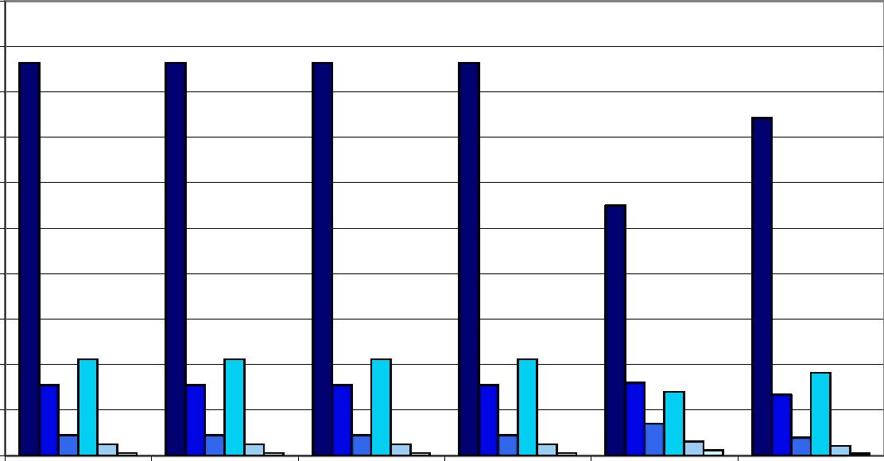

¿00

'¡¿O
100

ÖJ
40
20

Home

Host
Domestic, Domestic, Country contribution Home -
w/o Cross Border w/o Cross Border to 1 EU IGS claims compensation
(FPS + branches) (branches only) only

DPD=0.5%,α=99% DPD=0.5%,α=90% DPD=0.5%,α=75% DPD=0.1%,α=99% ŪPD=0.1%,α=90% DPD=0.1%,α=75%

Poland - Non-Life Insurance

db
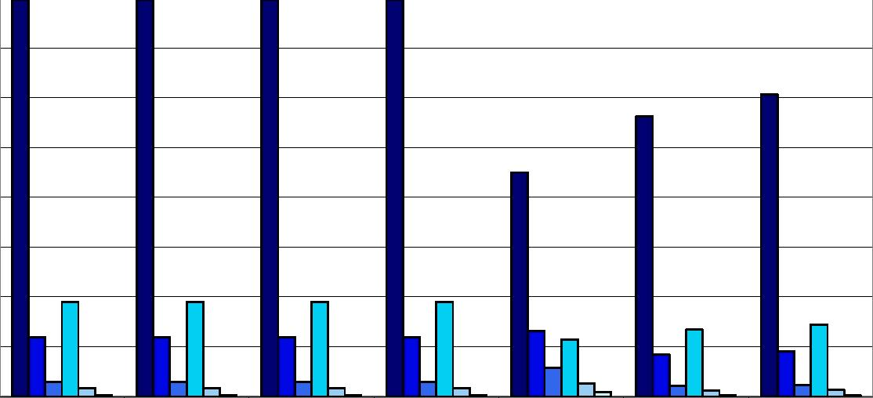
30

25

20
1b
10

Home
Host Domestic, Domestic, Country contribution Home - Home -
w/o Cross Border w/o Cross Border to 1 EU IGS claims compensation claims and premiums
(FPS + branches) (branches only) only compensation
PD=0.5%,α=99% PD=0.5%,α=90% PD=0.5%,α=75% PD=0.1%,α=99% PD=0.1%,α=90% PD=0.1%,α=75%

25

A6.25 Portugal

Portugal - Total Insurance

450
400
350

ZbO
200
100

Home
Host Domestic, Domestic, Country contribution Home - Home -
w/o Cross Border w/o Cross Border to 1 EU IGS claims compensation claims and
(FPS + branches) (branches only) only premiums
compensation
PD=0.5%,α=99% PD=0.5%,α=90% PD=0.5%,α=75% PD=0.1%,α=99% PD=0.1%,α=90% PD=0.1%,α=75%

Portugal - Life Insurance

400
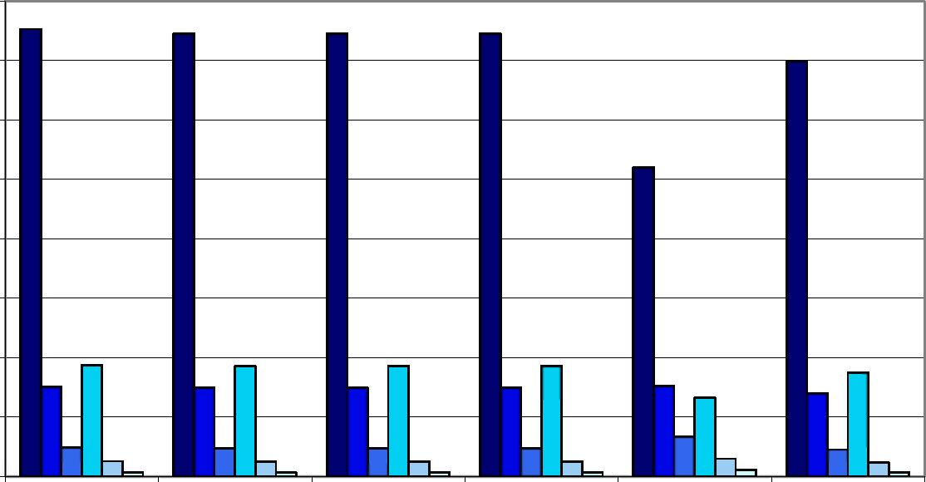
250 150
50

Home

Host
Domestic, Domestic, Country contribution Home -
w/o Cross Border w/o Cross Border to 1 EU IGS claims compensation
(FPS + branches) (branches only) only

DPD=0.5%,α=99% DPD=0.5%,α=90% DPD=0.5%,α=75% DPD=0.1%,α=99% ŪPD=0.1%,α=90% DPD=0.1%,α=75%

Portugal - Non-Life Insurance

50
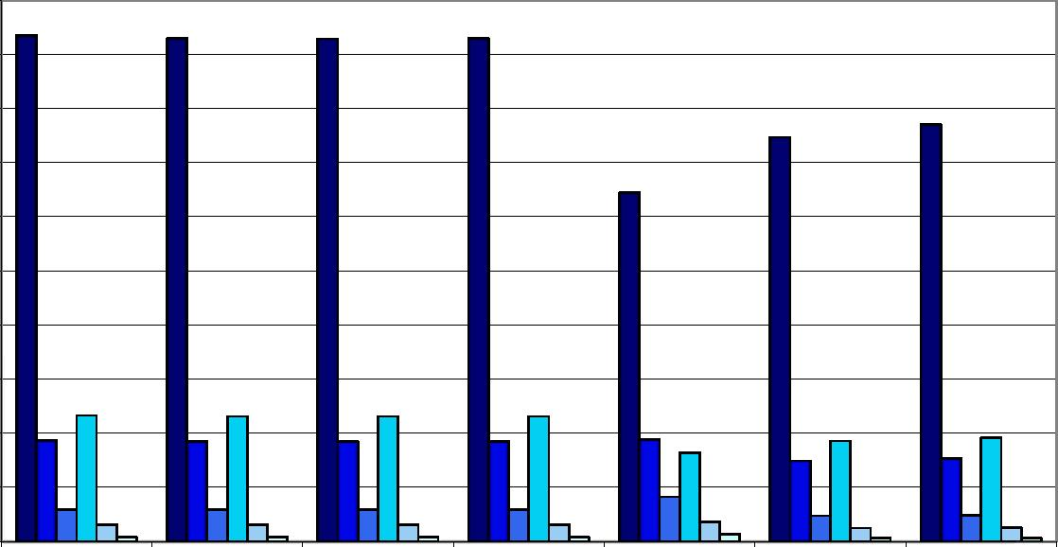

45 40
35

20
10

Home
Host Domestic, Domestic, Country contribution Home - Home -
w/o Cross Border w/o Cross Border to 1 EU IGS claims compensation claims and premiums
(FPS + branches) (branches only) only compensation
PD=0.5%,α=99% PD=0.5%,α=90% PD=0.5%,α=75% PD=0.1%,α=99% PD=0.1%,α=90% PD=0.1%,α=75%

26

A6.26 Romania

Romania - Total Insurance

12
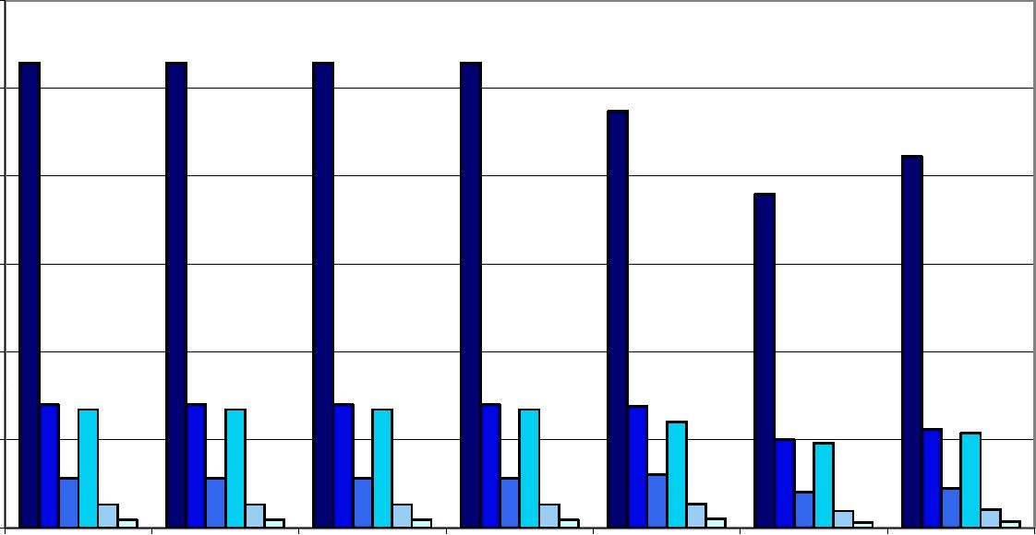
10

Home
Host Domestic, Domestic, Country contribution Home - Home -
w/o Cross Border w/o Cross Border to 1 EU IGS claims compensation claims and premiums
(FPS + branches) (branches only) only compensation
PD=0.5%,α=99% PD=0.5%,α=90% PD=0.5%,α=75% PD=0.1%,α=99% PD=0.1%,α=90% PD=0.1%,α=75%

Romania - Life Insurance

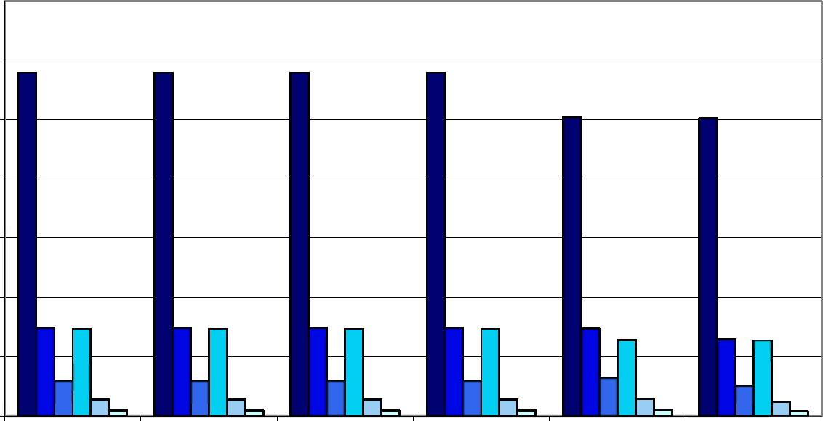

Home

Host
Domestic, w/o Cross Border (FPS + branches)
Domestic, w/o Cross Border (branches only)
Country contribution to 1 EU IGS
Home -
claims compensation
only

 |  |  |  |  | ■ ΡΜ5%,α=99% DPD=0 5%,α=90% DPD=0 5%,α=75% DPD^D 1%,α^9% ŪPD^D 1%,α=90% DPD=0 1%,α=75%
 |  |  |  |  | Romania - Non-Life Insurance
Home |  |  |  |  | Host Domestic, Domestic, Country contribution Home - Hom w/o Cross Border w/o Cross Border to 1 EU IGS claims compensation claims and (FPS + branches) (branches only) only compe |  |  |  |  |  |  |  |  |  |  |  |  |  |  |  |  |  |  |  |  | e -  premiums nsation
 |  |  |  |  | ■ PD=0.5%,α=99% DPD=0.5%,α=90% DPD=0.5%,α=75% DPD=0.1%,α=99% ŪPD=0.1%,α=90% DPD=0.1%,α=75%

27

A6.27 Sweden

Sweden - Total Insurance

2,500
2,000
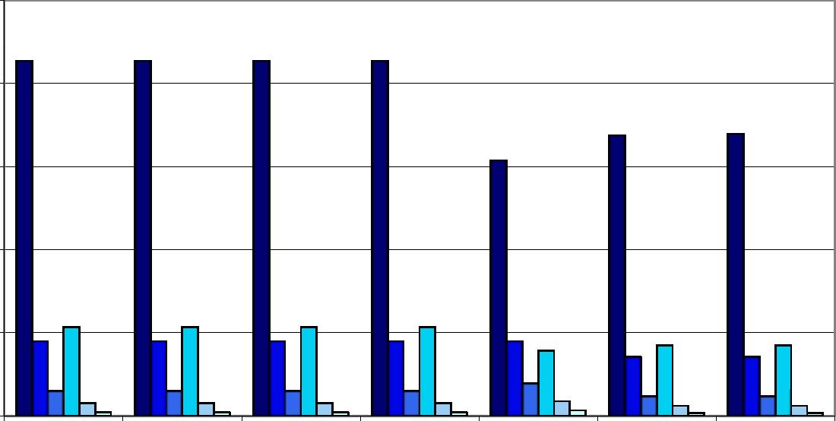
1,500 1,000
500

e Host Domestic, Domestic, Country contribution Home - Home -
w/o Cross Border w/o Cross Border to 1 EU IGS claims claims and
(FPS + branches) (branches only) compensation only premiums
compensation
PD=0.5%,α=99% PD=0.5%,α=90% PD=0.5%,α=75% PD=0.1%,α=99% PD=0.1%,α=90% PD=0.1%,α=75%

Sweden - Life Insurance

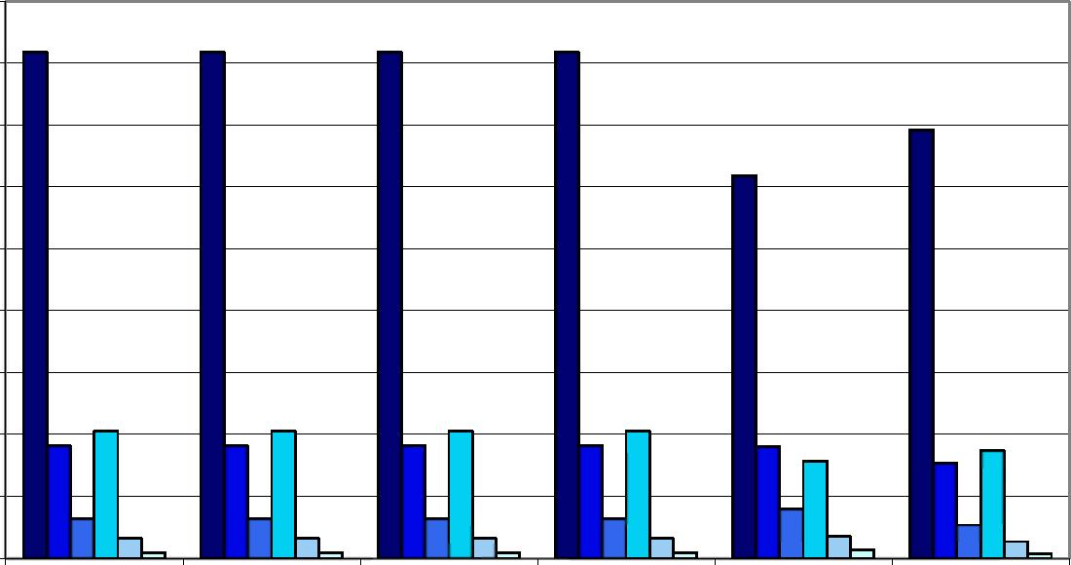

1Ш0
1,200
400

Home

Host
Domestic, Domestic, Country contribution Home -
w/o Cross Border w/o Cross Border to 1 EU IGS claims compensation
(FPS + branches) (branches only) only

DPD=0.5%,α=99% DPD=0.5%,α=90% DPD=0.5%,α=75% DPD=0.1%,α=99% ŪPD=0.1%,α=90% DPD=0.1%,α=75%

Sweden - Non-Life Insurance

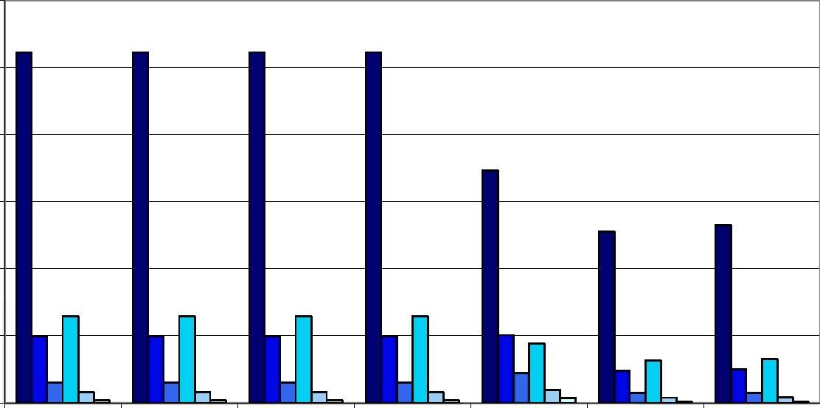
600
500
300
100

Home
Host Domestic, Domestic, Country contribution Home - Home -
w/o Cross Border w/o Cross Border to 1 EU IGS claims compensation claims and
(FPS + branches) (branches only) only premiums
compensation
PD=0.5%,α=99% PD=0.5%,α=90% PD=0.5%,α=75% PD=0.1%,α=99% PD=0.1%,α=90% PD=0.1%,α=75%

28

A6.28 Slovenia

Slovenia - Total Insurance
50
4b

40
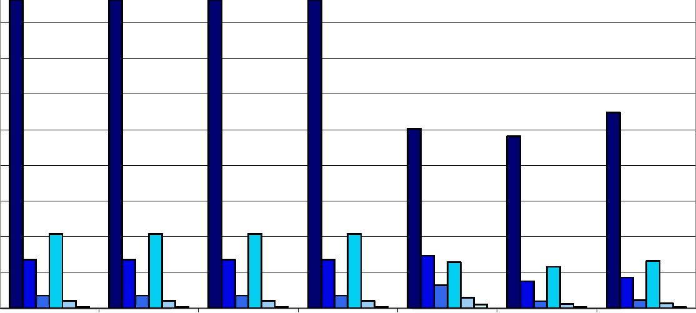
35
25 -

15
10
30
¿0

Home
Host Domestic, Domestic, Country contribution Home - Home -
w/o Cross Border w/o Cross Border to 1 EU IGS claims compensation claims and premiums
(FPS + branches) (branches only) only compensation
PD=0.5%,α=99% PD=0.5%,α=90% PD=0.5%,α=75% PD=0.1%,α=99% PD=0.1%,α=90% PD=0.1%,α=75%

Slovenia - Life Insurance
25

20
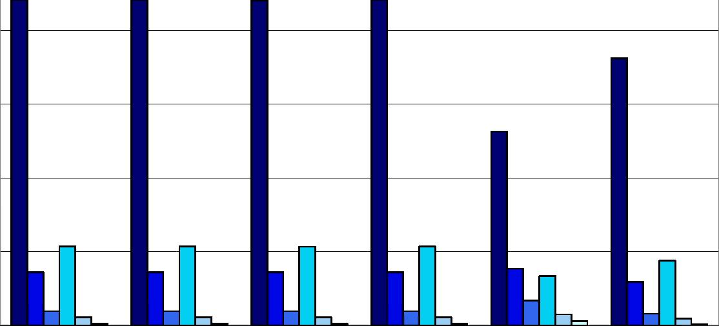
10

Home

Host
Domestic, Domestic, Country contribution Home -
w/o Cross Border w/o Cross Border to 1 EU IGS claims compensation
(FPS + branches) (branches only) only

DPD=0.5%,α=99% DPD=0.5%,α=90% DPD=0.5%,α=75% DPD=0.1%,α=99% ŪPD=0.1%,α=90% DPD=0.1%,α=75%

Slovenia - Non-Life Insurance

14
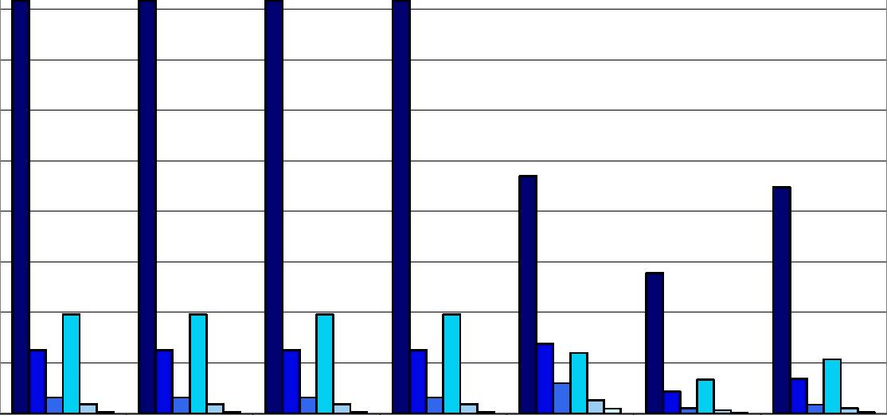
12

10

Home
Host Domestic, Domestic, Country contribution Home - Home -
w/o Cross Border w/o Cross Border to 1 EU IGS claims compensation claims and premiums
(FPS + branches) (branches only) only compensation
PD=0.5%,α=99% PD=0.5%,α=90% PD=0.5%,α=75% PD=0.1%,α=99% PD=0.1%,α=90% PD=0.1%,α=75%

29

A6.29 Slovakia

Slovakia - Total Insurance

30
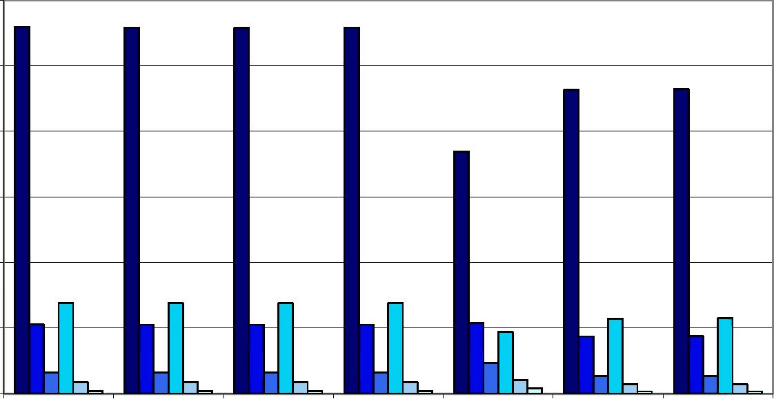
25

10

Home

Host
Domestic, Domestic,
w/o Cross Border w/o Cross Border (FPS + branches) (branches only)
Country contribution Home - Home -
to 1 EU IGS claims compensation claims and premiums
only compensation

■ ■DŪDO

Slovakia - Life Insurance

0

Home

Host
Domestic, w/o Cross Border (FPS + branches)
Domestic, w/o Cross Border (branches only)
Country contribution to 1 EU IGS
Home -
claims compensation
only

DPD=0.5%,α=99% DPD=0.5%,α=90% DPD=0.5%,α=75% DPD=0.1%,α=99% ŪPD=0.1%,α=90% DPD=0.1%,α=75%

Slovakia - Non-Life Insurance

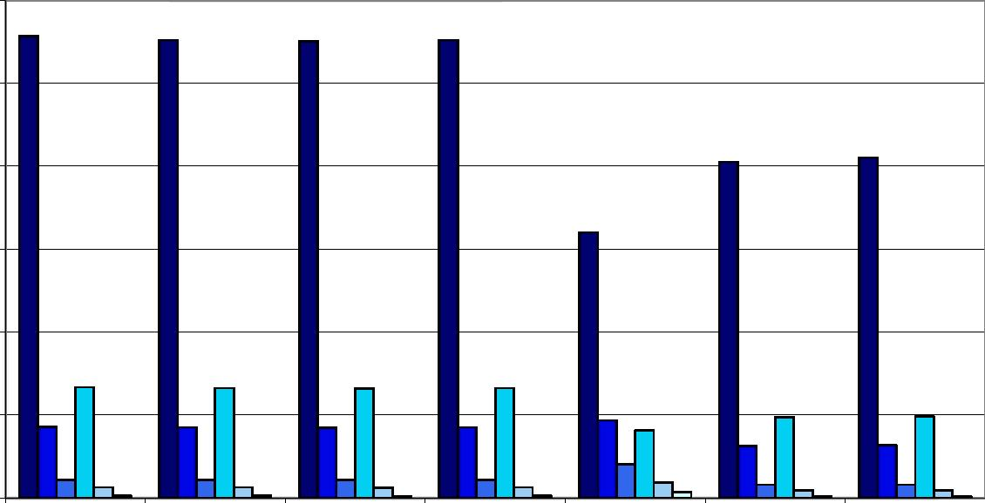

Home

Host
Domestic, Domestic,
w/o Cross Border w/o Cross Border (FPS + branches) (branches only)
Country contribution Home - Home -
to 1 EU IGS claims compensation claims and premiums
only compensation

■ ■ D O D D
30

