EN
EUROPEAN COMMISSION
Brussels, 23.9.2010
COM(2010) 496 final
REPORT FROM THE COMMISSION TO THE EUROPEAN PARLIAMENT AND THE COUNCIL
Report on the advisability and feasibility of presenting a legislative proposal enabling EFSA to receive fees
REPORT FROM THE COMMISSION TO THE COUNCIL AND THE EUROPEAN PARLIAMENT
Report on the advisability and feasibility of presenting a legislative proposal enabling EFSA to receive fees
According to Article 45 of Regulation (EC) N° 178/2002, the Commission shall, after consulting the European Food Safety Authority (EFSA), the Member States and the interested parties publish a report stating its position on the advisability and feasibility of presenting a proposal establishing fees for EFSA three years after its creation.
The Commission considered it necessary to base the report on a longer period of EFSA's existence, in particular because EFSA was still in its development phase as a new EU agency. This allowed the Commission to take into account the Authority's experience in managing its workload, particularly in the light of new challenges over recent years (increasing workload, evolving number of applications in various sectors such as health claims, feed additives, flavourings, and the difficulties in assessing poor quality dossiers).
The processing of applications has significantly increased in EFSA’s overall workload since the end of 2006.The share of budget required for handling applications in 2010 represents 31% of EFSA's budget, compared to 20% in 2007. These new challenges should be taken into account when envisaging the establishment of fees for EFSA. They provide useful information that needs to be considered in light of the comments gathered from stakeholders, Member States and EFSA in 2007.
The consultation paper issued by the Commission's services identified the tasks rendered by EFSA for which fees could be made payable (i.e. scientific assessment of authorisation dossiers). It also challenged stakeholders on the advantages and disadvantages of charging fees for EFSA and on the identification of those liable to pay fees (all applicants – for generic as well as individual authorisations- or only authorisation holders - ie. those applicants who have a specific economic interest from an individual authorisation).
The vast majority of the comments received highlighted the complexity of a fee-system in the food safety sector and the need to further analyse the legal, economic and political implications of the establishment of fees for EFSA.
The objective of the report is to examine the feasibility and advisability of a fee-based system. It is based on the experience gained by EFSA with application dossiers since its creation and takes into account the views expressed by Member States, stakeholders and EFSA.

Analysis of the contributions from member states, stakeholders, and efsa
As required by Article 45 of Regulation (EC) N° 178/2002, the Commission consulted Member States, EFSA and stakeholders on the advisability and feasibility of establishing fees for EFSA.
In 2007, the Commission launched a web consultation and organised meetings with Member States in the Standing Committee on the Food Chain and Animal Health and with stakeholders in the Advisory Group on the Food Chain, and Animal and Plant Health.
A detailed summary of all the written comments received in 2007 is available on the Commission's website at http://ec.europa.eu/food/consultations/sum_cons_efsa_fees_en.pdf
In May and June 2010, the Commission consulted Member States and stakeholders on the Commission's draft report. The minutes of these meetings are available on the internet.
The analysis of the contributions shows that while the majority of Member States are not, in principle, against a fee-system, they point out its complexity in the food sector given that most authorisations delivered in the food sector are generic and benefit the whole sector.
Industry (both producers and users) is generally opposed to a fee-based system because of the predominance of a generic authorisation system in the food and feed sectors. However, most contributions from users of substances/products conclude that if fees were to be established, they should only be envisaged when the applicant (authorisation holder) benefits from a legal protection (period of exclusivity). Moreover, they should be linked to a better service to applicants and to a reduction in delays in the treatment of applications.
Farmers are also opposed, as well as some retailers and representatives of small and medium-size enterprises. Consumer organisations are opposed to a fee-system, mainly because they have concerns about EFSA's independence and stress that the financing of EFSA is a public responsibility.

Advisability of establishing a fee-system

Comments from Member States, stakeholders and EFSA

Member States
The majority of the Member States are not, in principle, against a fee-system to remunerate a service to applicants, and most of them consider that it is an element of good governance. Some identified the key arguments in favour of fees:
- Better security of adequate funding;
- A more professional service;
- Enhancement of cooperation and synergy between EFSA and the national agencies;
- Reduction in delays for dealing with authorisation procedures;
- Harmonisation of various agency procedures at European level.
However, Member States recognise the complexity of establishing a fee-system in the specific case of EFSA. They have therefore identified conditions and specific cases where the principle of fees could apply (see section 2 on feasibility).

Stakeholders
Most representatives of the actors of the food chain expressed reservations regarding the advisability of establishing fees:
- Concerns about EFSA's independence
This argument was raised by almost all organisations (consumer organisations, retailers, farmers and the industry). They pointed out that establishing a fee-system for EFSA would create confusion in the public perception of EFSA's independence – even if guarantees exist to ensure it in an effective manner. They considered that this is a challenging issue as, in an EU centralised authorisation system, it is paramount that EFSA's scientific opinions are fully trusted.
- The financing of EFSA is a public responsibility
Representatives of the industry stressed that it is not the private sector's role to compensate for the lack of public funding of an Authority that has been established to protect public health. Fees should not be established when the current public funding is supposed to be sufficient to cover the increase in EFSA's tasks. Consumer organisations also considered that the financing of EFSA is a public responsibility.
- Need to be compatible with the better regulation approach
Representatives of the industry (including SMEs) indicated that the addition of a further financial burden would be contrary to the Lisbon agenda, in particular because the cost of compliance with food law is already high. In addition, operators would find it more difficult to accede to the markets if fees were established. In their view, additional costs could disrupt the cost/benefit ratio, discourage operators from submitting authorisation files, and distort competition since operators in third countries would not be paying a fee. It would also be detrimental to innovation.
They also stressed that the impact on EFSA's workload of some Regulations requiring a pre-market approval in the food area (e.g. on claims and fortified food) should have been assessed before being adopted.

EFSA
While not expressing a position in favour of or against the establishment of fees, EFSA's Management Board stressed that it is the decision-making bodies (Commission, European Parliament and Council) which ultimately construct the financial system allowing EFSA to function. The source of the funding may not be an issue provided that a certain number of conditions, particularly in relation to the independence and accountability of EFSA are covered by the legislators.

Commission's analysis
- Concerns about EFSA' independence
The Commission has always set excellence, independence and transparency as essential requirements of EFSA's Scientific Committee and Panels' work. As required by Article 37 of Regulation (EC) N° 178/2002, EFSA's independence is ensured by a series of mechanisms. Its Scientific Committee and Panels are composed of independent experts who are required to complete declarations of independence and interests, which are made public.
The Commission considers that the establishment of fees would not diminish the independence of EFSA. Neither would it affect the perception of independence, even if specific attention should be given to how fees may be perceived in sensitive areas such as genetically modified (GM) organisms and GM feed and food. As effective and transparent mechanisms are in place, a fee-system can be established without compromising the Authority's independence. This is the case for other European/national agencies that have a cost-recovery system for the assessment of applications/authorisation dossiers (e.g. the European Medicines Agency (EMA), the European Chemicals Agency (ECHA). Experience shows that they do not undermine the perception of the agencies’ independence.
- The financing of EFSA is a public responsibility
Most of EFSA's tasks are of general interest and financed by the public budget (69% of EFSA's budget is used for such tasks). According to the current operating principles, only EFSA's tasks related to the assessment of authorisation dossiers could be subject to fees because in this case public money might partly be used to serve private interests and the services rendered appear as being supplied separately to clearly differentiated users.
It is useful to mention that the distinction between general and private interest is not always straight-forward. For example, the clarification of specific scientific issues raised by an individual application (e.g. antibiotic resistance marker genes) led to additional EFSA scientific opinions which were of general interest.
Suitable mechanisms should be put in place to prevent distortions of priority and to ensure appropriate balance between the interests of a more efficient service for fee paying services and other work of general-interest objectives.
.
- Need to be compatible with the better regulation approach
The Commission is committed to the better regulation approach, which implies, in particular, performing impact assessments on new policy initiatives. This implies that fees would not be established without a meaningful cost/benefit ratio. To meet this objective, a global analysis will be carried out in order to assess the impact that a fee-system would have on EFSA's functioning and its independent public health mission, as well as its impact on competitiveness and SMEs.

Feasibility of establishing a fee-system

Main difficulties identified by Member States and stakeholders on the establishment of a fee-system
The analysis of the contributions shows that the vast majority of the Member States and stakeholders consider that a system for the collection of fees would be complex and difficult to institute. Interestingly, there is a common line amongst those whose opinions diverge on the advisability of establishing fees for the assessment of authorisation dossiers by EFSA (see section 1.1).
Their main concerns are the following:
- Generic authorisations and difficulties in identifying beneficiaries
One of the principal arguments is based on the fundamentals of EU food legislation, i.e. that the legal framework imposing authorisation procedures for certain foods or substances used in the food chain is mainly aimed at giving general approvals for the benefit of all operators. It contains little protection of proprietary data and seldom offers exclusivity to the applicant.
For these reasons, some stakeholders and Member States stressed that it is not possible to compare food or substance authorisations to medical products. The medical product legislation indeed offers pay-back for investments to the applicants by protecting clinical pharmaceutical data and granting exclusivity.
The predominant system of generic authorisations in the food area makes it complex to identify beneficiaries, and therefore the potential fee-payer. Most stakeholders and some Member States made it clear that if fees were to be established, it would be unfair to make the applicant pay a fee for a generic authorisation since the whole sector benefits from the authorisation. However, in the case of individual authorisations where an authorisation holder benefits from some specific protection (e.g. GMOs, Plant Protection Products etc), the payment of fees by the applicant is seen as more justified.
Some Member States expressed a different view and suggested that a general, simple fee system could be put in place: all applicants for authorisation dossiers would pay a fee, but this fee should be modest.
- EFSA's budget instability and the potential inefficiency of a fee-system
The introduction of fees may not always guarantee a stable annual EFSA budget as the number of dossiers for assessment may vary unpredictably from year to year. In addition, a fee system may provide grounds for reducing public funding, even though such contributions are necessary for stable and efficient management of all EFSA's activities of general interest. Fees could lead to a decrease in EFSA's budget.
If a system were to be put in place, it could generate a disproportionate amount of administrative burden and all the benefit could go to "self-financing the system and no more".

Commission's analysis
- Generic authorisations
The Commission shares the view that the predominance of a generic authorisation system in the food and feed sectors makes it difficult to identify beneficiaries, and therefore the potential fee-payers. In this respect, the EU food legislation is different from the legislative framework setting up EMA and ECHA, which provide for specific benefits to individual applicants.
Under the medicinal products legislation, Article 14 (11) states: "Without prejudice to the law on the protection of industrial and commercial property, medicinal products for human use which have been authorised in accordance with the provisions of this Regulation shall benefit from an eight-year period of data protection and a ten-year period of marketing protection…."
The chemicals legislation (REACH) provides for a registration system that also includes an authorisation system. Only the manufacturers/importers who have registered specific chemical substances may manufacture or import them. A transition system based on pre-registration is established to phase in substances and allow importers/manufacturers who currently manufacture/import these substances to continue to do so. The payment of a fee to ECHA is one of the conditions of registration.
Contrary to EMA and ECHA, EFSA has to process applications under approximately 15 different pieces of vertical legislation requiring scientific assessment and re-assessment through mechanisms of "applications" that have not been designed to integrate the requirements of a cost-recovery system (i.e. applicants paying for services of private interest). It is therefore not always straightforward to associate an application with one unique "owner" of the request who can enjoy proprietary rights or an exclusive use of the approved substance for a certain period.
For these reasons, the Commission considers that it is not possible to apply reasoning by analogy with EMA and ECHA cost-recovery systems when discussing the establishment of fees in the food and feed area. In the case of EFSA, a sector-by-sector approach would be more rational as only some sectorial legislation provides for individual authorisations granting some specific rights. The legal procedures provide for an authorisation holder in the case of genetically modified food and feed, GMOs, pesticides, some smoke flavourings, some categories of feed additives, some categories of nutritional and health claims and, potentially some novel food, even if in some sectors (for example smoke flavourings) there is both an authorisation holder and a positive list.
In cases where the authorisation is not generic but granted to specific authorisation holders, specific economic advantages derive from the authorisation system. Therefore, as public money is partly being used for private interests, a legislative system for charging fees should be explored in more detail.
- EFSA's budget instability and the potential inefficiency of a fee-system
Since the Union subsidy for EFSA’s budget has a balancing effect, the risk of budget instability is limited. In particular, a number of fixed costs should be able to be guaranteed by public funding in order to stabilise EFSA's budget. In addition, the establishment of fees can only be based on the stable workload, as is the case, for example, for ECHA under the REACH Regulation. This difficult issue needs to be further explored in order to identify the sectors where a predictable workload is foreseen.
The Commission agrees that the introduction of any fee system comes at a cost. However, experience shows that these costs did not change the final cost benefit/ratio for the establishment of fees in EMA, REACH and Joint Research Centre.

EFSA’s EXPERIENCE IN MANAGING APPLICATIONS

Part of the applications in EFSA’s overall workload
A certain number of new elements have to be taken into account since EFSA's creation when envisaging the establishment of a cost-recovery system. EFSA has become a mature Authority that has recently entered a phase of stabilisation, both in terms of staff and budget. In parallel, EFSA has been faced with an increasing number of applications in various sectors, as shown in graph 1 below.
Graph 1 – Estimated Number of Applications 2007-2013 (source: EFSA)
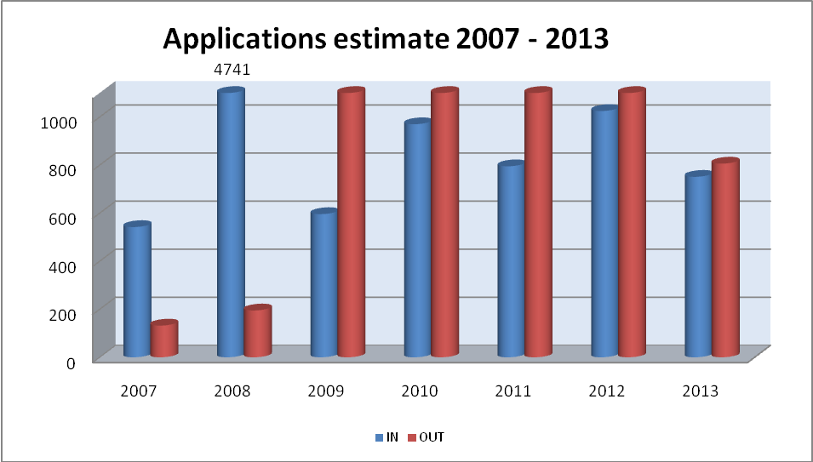
Graph 2 below shows that since 2003, the number of applications has significantly increased, especially in 2009 and 2010.
Graph 2- Scientific output evolution (source: EFSA)
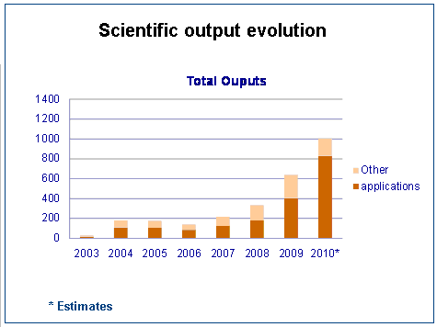
It should be noted that the estimates provided by EFSA include generic as well as individual applications. They also comprise the reviews EFSA had to carry out over the last few years (on nationally authorised substances/claims or on "old authorisations"), which form an important part of the increased workload (e.g. health claims, "old" pesticides, flavourings, “old” additives).
These preliminary data lead to the following observations that would need to be further analysed:
- The “peaks” of applications received in a certain number of areas destabilise EFSA’s workload. Experience shows that they require significant human and financial resources, and that EFSA has to reorganise its work in order to manage these peaks.
- Applications are an important part of EFSA’s current workload, as reflected in the two graphs above. It would be necessary to distinguish between the number of applications for authorisation of new substances/products/claims from the number of applications originating from reviews in order to identify the yearly income that a fee-system could generate. An initial, rough estimate that would need to be further refined, shows that the number of applications that would be predictable/foreseeable for new products/substances/claims would amount to around 210 applications per year.
EFSA can undertake three types of "reviews" which have different objectives, as follows:
  - Mandatory renewal of an authorisation after 10 years, required by sectorial legislation (pesticides, GMOs and feed additives) (similar to renewals under the medicinal products legislation). This type of review brings direct profits to individual natural or legal persons (i.e. firms applying for the renewal of the authorisation).
  - Some "old" substances have to be reviewed by EFSA in the light of new information and the Commission sends a mandate to EFSA to undertake this review. These reviews are not based on legal provisions and concern generic substances. Contrary to category (1) above, this is a task of general interest. In addition, it might be difficult to predict the workload involved with this type of review as it is not legally required.
  - Assessment of substances (or claims) already on national market(s) in order to be authorised at EU level (submitted by the Member States). The reviews belonging to this category will come to an end or will have started by the time a fee system could be established in 2012/13. It must also be taken into account that recent experience has demonstrated that in some cases EFSA received "empty dossiers" that resulted in a waste of resources in terms of time and money. Fees would be an incentive for applicants to submit better quality dossiers. At the same time, it would help EFSA to optimise the resources it allocates to assessing dossiers.

Estimates of costs of applications
One of the arguments put forward by some stakeholders was that a decision on the establishment of fees should be based on their potential level. Evaluating the cost of applications by sector is a complex and difficult task, as the types of applications (and therefore the resources needed to assess them) differ according to +/- 15 different pieces of vertical legislation required for an EFSA scientific assessment.
EFSA has provided estimates of the costs related to the applications processed. Table 1 below shows that the percentage of EFSA's budget required for processing the applications has increased in the last three years.
Table 1 – Percentage of EFSA's budget allocated to the processing of applications (source: EFSA)
 | 2007 | 2008 | 2009 | 2010
% of EFSA's budget required for processing of applications | 20% | 29% | 31% | 31%
Number of applications processed (number and evolution on previous year) | 132 | 195  (+48%) | 1258  (+545%) | 2209  (+76%)
Number of applications received (number and evolution on previous year) | 542 | 4741  (+774%) | 596  (-87%) | 970  (+63%)
Table 1 above demonstrates that there is little correlation between the number of applications and the resources allocated to their processing, as EFSA's budget is subject to constraints specific to public spending patterns. In order to respond to this problem, EFSA has had to prioritize, to limit the service to applicants and to spread the workload over rather long periods of time.
Graph 3 below shows the amount of EFSA’s budget devoted to applications and projections over the period 2007-2013.
Graph 3: Estimated cost of applications 2007-2013 (source: EFSA)
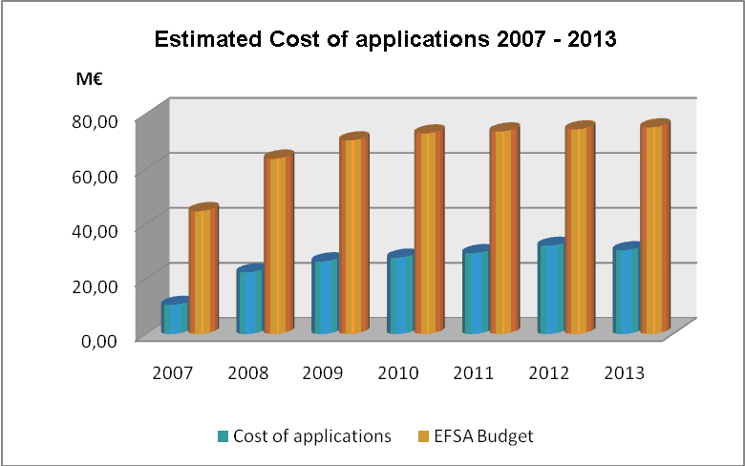
Preliminary estimates provided by EFSA show that the costs per application vary considerably according to the different sectors: € 23,000 for a health claim, € 29,000 for a food contact material, € 68,000 for a novel food application, € 337,000 for a GMO application, between € 43,000 and € 91,000 for feed additives, € 66,000 for a food additive, € 34 000 for a food flavouring, € 58 000 for a smoke flavouring, € 32 000 for a food enzyme, € 88,000 for nutrient sources (food supplements, food for particular nutritional uses, fortified food), between € 4,900 (MRLs) and € 375,000 (active substances) for pesticides and € 131,000 for an infant formulae application.
The cost allocated to dossiers is influenced by their complexity and the number of dossiers involved.
These preliminary estimates include operational and administrative costs (staff costs, operational support, development of guidance documents, infrastructure costs, overheads), and also a percentage of supplementary services that would be developed for the applicants.
They give a general overview of the repartition of the costs according to the various sectors, but need to be further analysed and completed. In particular, there is a need to break down, by sector, all the activities required to assess the applications, identify the time required for each activity, and to quantify the costs according to the labour costs. It will also be important to identify how costs that are linked to general services, such as the development of guidance documents, should be attributed or shared.
The Commission considers that, besides a further analysis of the costs of application per sector, the following elements should be taken into account:
- The cost of the application should not be the level of fees itself. The latter should be based on the cost of the service rendered and take into account other elements such as an average cost, the eventual differences of complexity of the different applications (extension of authorisation, renewal etc), the possibility of joint dossiers and the possibility of reduced fees for SMEs.
- The level of the fees should take into account not only the cost of the work currently carried out by EFSA, but also the cost of the additional services that would be delivered. For example, the Authority would be able to introduce service standards, which would ensure that the Authority commits itself to the respect of precise standards, intermediate deadlines and tangible indicators.

Options stemming from the stakeholder consultation
Most of the comments provided by Member States and stakeholders (see section 1 above) acknowledged that, in principle, fees are a useful tool for good governance. They stressed, in particular, that a fee-system can contribute to ensuring that the spending of public money is focussed on financing activities of public interest while promoting a more professional service to applicants (section 1.1.1 on advisability). Their main concerns relate to the feasibility of the establishment of a fee system in the food sector, given that the legal framework imposing authorisation procedures for certain foods or substances used in the food chain is mainly aimed at giving general approvals for the benefit of all operators (section 1.2.1 on feasibility).
Four options emerge from these contributions:
- Flat-rate fee for all applicants for authorisation;
- Graduated fees for all applicants for authorisation;
- Graduated fees for applicants who are authorisation holders;
- Maintain the existing system without fees.
Under options (1), (2), and (3), the issues related to the reviews as mentioned under 2.1 will also be examined.
This is not an exhaustive list of possible options, but those that resulted from the stakeholder consultation. They are a good basis for further work, but are not exclusive of other alternatives.
The Commission's analysis on feasibility (see 1.2.2) concludes that a number of issues need to be further examined. In addition, a decision on the establishment and level of fees needs to be taken in the light of the costs of the services that could be subject to fees and the current estimation of these costs has to be further refined (see 2.2).
The following elements will also have to be taken into account:
- In the plant protection products sector, EU legislation provides for the possibility of national fees. Additional fees could largely duplicate national fees since a part of these national fees may already contribute to the financing of the Member States' participation in the EFSA peer review.
- It is important to maintain the capacity of SMEs to accede to the market. Therefore specific conditions for SMEs will have to be examined.
- The establishment of fees for ESFA should not become an incentive to give rights of exclusivity to the applicants, considering that one of the aims of generic authorisations is to ensure that substances that are not really innovative can be put on the market at the best price by any producer.

General conclusion
In view of the all the issues outlined in this report, in particular the complexity of establishing a fee-system in the area of EU food legislation, the Commission considers that more reflection is needed on the range of options to be considered and that it is not possible to draw any definitive conclusions at this stage. This will be done in the course of an impact assessment. Without pre-empting the outcome of such an assessment, the option of graduated fees for applicants who are authorisation holders (option 3) should in any cases be given further consideration. In this context, the issue of enhanced services for applicants will also have to be explored.
The introduction of fees for EFSA could, in particular, be considered in the following sectors where the authorisation in all cases, or in some specific cases, is issued to a specific holder and is not generic:
- authorisation of genetically modified organisms (cultivation);
- authorisation of genetically modified food and feed;
- authorisation of feed additives issued to a specific holder;
- authorisation of claims issued to a specific holder;
- authorisation of novel foods issued to a specific holder;
- positive listing of active substances eligible for authorisation as plant protection products;
- authorisation of smoke flavourings.
In order to develop the optimum approach, the Commission intends to launch an impact assessment which will take into account the results of the Member States', stakeholders' and EFSA's comments and the observations and remarks highlighted in this report. The assessment will also look at other EU policy areas as well as practices of other EU regulatory agencies.
Each potential candidate sector will have to be assessed in detail in order to identify the economic and budgetary impact of the various scenarios of fees on enterprises (including SMEs). This will allow an identification of the distributional impact of the different types of fees on the different sectors, the amount of fees that could be set up, the conditions to determine affordable fees for SMEs and their impact on innovation.
It is also essential to assess the impact that a fee-system would have on EFSA's overall functioning and efficiency, in particular: the various options for providing a more professional service to applicants, the impact on the sharing of work with national agencies/bodies, the balance between the interests of a more efficient service and the preservation of general interest objectives, the perception of EFSA's independence, and the impact on the overall sustainability of EFSA's functioning.
The Commission requests the Parliament and the Council to take a position on this report and the conclusions made by the Commission.

Stakeholders were consulted in the Advisory Group on the Food Chain, and Animal and Plant Health, see http://ec.europa.eu/food/committees/advisory/index_en.htm
Member States were consulted on 27 June 2007 in the ScoFCAH, see http://ec.europa.eu/food/committees/regulatory/scfcah/general_food/sum_25062007_en.pdf
The consultation paper is available at http://ec.europa.eu/food/consultations/fees_efsa_en.pdf
See footnote 2 above
See footnote 1 above
http://ec.europa.eu/food/committees/advisory/summary_20052010_efsa_en.pdf http://ec.europa.eu/food/committees/regulatory/scfcah/toxic/index_en.htm
Regulation (EC) N° 1107/2009 of the European Parliament and the Council of 21 October 2009 concerning the placing of plant protection products on the market. In the pesticides sector, the authorisation procedure is partly decentralised.
The tasks performed by EFSA are essentially as follows: scientific opinions issued for the Commission, Member States and the European Parliament; technical and scientific assistance to the Commission; collection and analysis of data on the safety of the food chain; identification of emerging risks; scientific support to the Commission in cases of emergency/crisis; communication to the public on risks.
Commission Regulation (EC) N° 297/95 of 10 February 1995 on fees payable to the European Agency for the Evaluation of Medicinal Products.
Commission Regulation (EC) N° 340/2008 of 16 April 2008 on the fees and charges payable to the European Chemicals Agency pursuant to Regulation (EC) N° 1907/2006 of the European Parliament and of the Council on the Registration, Evaluation, Authorisation and Restriction of Chemicals (REACH).
Regulation (EC) N° 726/2004 of the European Parliament and of the Council of 31 March 2004 laying down procedures for the authorisation and supervision of medicinal products for human and veterinary uses and establishing a European Medicines Agency.
Regulation (EC) N° 1907/2006 of the European Parliament and of the Council of 18 December 2006 concerning the Registration, Evaluation, Authorisation and Restriction of Chemicals (REACH), establishing a European Chemicals Agency.
Proposal for a Regulation of the European Parliament and the Council on novel foods COM (2007) 872 final, which proposes applicant specific authorisations for five years linked to approved data protection. See also footnote 19.
Estimates are the following: Food additives: 20; Feed additives: 34; GMOs: 15; Food contact materials: 30; Food flavourings: 25, Food enzymes: 20; Smoke flavourings: 3; Novel foods: 10; Food supplements: 3; Health claims: 50 minimum.
Estimates.
In the case of flat rate fees, all applicants pay the same fee. One of the sub-option could be to consider the payment of administrative fees (only covering administrative costs) for all applications
In the case of graduated fees, the level of fees will differ according to the type of product/substance and the corresponding sectorial authorisation procedure. The fee could therefore be a flat rate that will differ according to the sector concerned or it could be an hourly fee. .
See foot note 17
According to Articles 7 and 12 of the Commission proposal on novel food (COM (2007) 872), in cases where the novel food would be included in the Community positive list on the basis of newly scientific evidence and /or proprietary data, the novel food may not be used for the benefit of another application during a period of five years from the date of the inclusion of the novel food in the Community list without the agreement of the applicant (which name and address appear on the list).
For plastic recycling processes, an authorisation holder is foreseen.

