EN
EUROPEAN COMMISSION
Brussels, 23.9.2010
COM(2010) 502 final

REPORT FROM THE COMMISSION TO THE EUROPEAN PARLIAMENT AND THE COUNCIL
3rd FINANCIAL REPORT FROM THE COMMISSION
TO THE EUROPEAN PARLIAMENT AND THE COUNCIL
on the EUROPEAN AGRICULTURAL GUARANTEE FUND
2009 FINANCIAL YEAR
SEC(2010) 1098
TABLE OF CONTENTS
1. BUDGET PROCEDURE 4
1.1. Preliminary Draft Budget 2009 4
1.2. Draft Budget 2009 4
1.3. Amending Letter for 2009 4
1.4. Adoption of the 2009 budget 4
1.5. Amending Budget No 8/2009 4
1.6. Amending Budget No 10/2009 4
1.7. Revenue assigned to EAGF 5
1.8. Temporary restructuring amounts in the sugar sector 5
1.9. Part of the EAGF budget in total EU budget 6
2. CASH POSITION AND MANAGEMENT OF APPROPRIATIONS 7
2.1. Management of appropriations 7
2.1.1. Appropriations available for the 2009 financial year: 7
2.1.2. Execution of appropriations available for the 2009 financial year: 8
2.1.3. Budget execution - Expenditure under direct management made by the Commission 8
2.1.4. Monthly payments to Member States 9
2.1.4.1. Monthly payments on the provision for expenditure 9
2.1.4.2. Decisions on monthly payments for 2009 9
3. THE IMPLEMENTATION OF THE 2009 EAGF BUDGET 9
3.1. Introduction 9
4. COMMENTS ON THE IMPLEMENTATION OF THE AGRICULTURAL BUDGET 10
4.1. Chapter 05 02: Interventions in agricultural markets 10
4.1.1. Introduction 10
4.1.2. Cereals 10
4.1.3. Food programmes 10
4.1.4. Fruit and vegetables 10
4.1.5. Products of the wine-growing sector 11
4.1.6. Milk and milk products 11
4.2. Chapter 05 03: Direct Aids 11
4.3. Chapter 05 07: Audit of agricultural expenditure 11
4.3.1. Article 05 07 01: Control of agricultural expenditure 11
5. IMPLEMENTATION OF ASSIGNED REVENUE 11
5.1. Revenue assigned to EAGF 11
5.2. Assigned revenue concerning temporary restructuring amounts in the sugar sector 12
5.3. Sugar Restructuring Fund 12
6. BREAKDOWN BY TYPE OF EXPENDITURE 12

Annex 1 Budgetary procedure for 2009 EAGF commitment Appropriations
Annex 2 Part of the EAGF budget in the EU budget 2003 to 2009
Annex 3 Analysis of EAGF budgetary execution – 2009 Financial year
Annex 4-I Analysis of EAGF Budgetary execution – 2009 Financial year. assigned revenue. C4
Annex 4-II Analysis of EAGF Budgetary execution – 2009 Financial year. assigned revenue. C5
Annex 5 EAGF Budgetary execution by article and by Member State – 2009 Financial year
Annex 6 Evolution of the breakdown of EAGF expenditure 2004 to 2009 Financial years

Note: A detailed Commission Working Document accompanies this report. The full text of this Working Document (in English) and the annexed tables (in English) will be also available on DG Agriculture’s Europa website (http://ec.europa.eu/agriculture/fin/finrep_en.htm).

BUDGET PROCEDURE

Preliminary Draft Budget 2009
The 2009 Preliminary Draft Budget (PDB) was adopted by the Commission and proposed to the Budgetary Authority on 6 May 2008. The commitment appropriations proposed for the European Agricultural Guarantee Fund (EAGF) under heading 2 of the Financial Framework 2007-2013 totalled
EUR 42 860.3 million.

Draft Budget 2009
The Council adopted the 2009 Draft Budget in July 2008. The appropriations of EAGF were reduced by EUR 380.0 million as compared to the PDB to
EUR 42 480.3 million.

Amending Letter for 2009
In October 2008 the Commission adopted Amending Letter No 2 to the 2009 PDB, setting commitment appropriation requirements for EAGF at EUR 41 579.89 million which was lower by EUR 1 280.4 million compared to the Preliminary Draft Budget.

Adoption of the 2009 budget
The European Parliament adopted the 2009 budget in its plenary session of December 2008.
The voted EAGF commitment appropriations amounted to EUR 41 131.4 million in total, ie: they were lower by EUR 448.5 million compared to the Amending Letter. Within this total, commitment appropriations amounting to EUR 3 409.6 million were foreseen for market measures under chapter 05 02 while EUR 37 779.0 million were foreseen for direct aids under chapter 05 03. Furthermore, the 2009 budget foresaw commitment appropriations of EUR 320.7 million for policy area 17-veterinary and phyto-sanitary measures and EUR 29.5 million for policy area 11-fisheries.
For details, please see annex 1.

Amending Budget No 8/2009
In June 2009, the Commission proposed and the Budgetary Authority adopted Amending Budget No 8/2009, of the 2009 budget’s commitment appropriations, which increased the amount available for EAGF by EUR 49.3 million destined for the animal eradication programmes, and specifically for the eradication of the bluetongue disease, in Policy area 17-veterinary and phyto-sanitary measures.

Amending Budget No 10/2009
In November 2009, the Commission proposed and the Budgetary Authority adopted Amending Budget No 10/2009 whereby EAGF’s commitment appropriations were reduced by EUR 135.0 million in order to contribute to the financing of the European Economic Recovery Package (EERP) and TRDI's payment appropriations were reduced by EUR 111.2 million (NB: TRDI is financed under the ex-European Agricultural Guidance and Guarantee Fund-Guarantee Section).

Revenue assigned to EAGF
In accordance with Article 34 of the CAP Financing Regulation (EC) No 1290/2005, the receipts originating from financial corrections under conformity clearance decisions, from irregularities and from the milk levy are designated as revenue assigned to the financing of EAGF expenditure. This assigned revenue can be used, partly or wholly, to cover the financing of EAGF expenditure if the budget appropriations granted by the Budgetary Authority are not sufficient to finance the expenditure incurred by the Member States. In the case where all or part of this revenue is not used, then, it will be automatically carried over into the following budget year in order to finance budgetary needs of that year.
At the time of establishment of the 2009 budget, an estimate of the revenue was made both for the amount expected to be collected in the course of the 2009 budget year as well as of the amount which was expected to be carried over from the budget year 2008 into 2009. This estimate was taken into consideration when the Budgetary Authority adopted the 2009 budget. Specifically:
- Revenue from the conformity clearance corrections and from irregularities was estimated at EUR 600.0 million and EUR 105.0 million correspondingly while the receipts from the milk levy were estimated at EUR 337.0 million. Thus, the total amount of assigned revenue expected to be collected in the course of the 2009 budget year was estimated at EUR 1 042.0 million.
- The amount of assigned revenue expected to be carried over from the budget year 2008 into 2009 was estimated at EUR 1 334.0 million.
The total amount of EUR 2 376.0 million was taken into consideration as the Commission reduced the appropriations requested for the operational funds for producer organisations in the fruit and vegetables sector by EUR 515.0 million and for the single payment scheme by EUR 1 861.0 million. After taking account of these amounts, the Budgetary Authority eventually granted appropriations amounting to EUR 260.0 million and EUR 27 239.0 million correspondingly for these schemes.
For details, please see annexes 4.I and 4.II.

Temporary restructuring amounts in the sugar sector
The temporary restructuring amounts in the sugar sector, as set out in article 11 of Council Regulation (EC) No 320/2006, are treated as assigned revenue intended to finance the sugar restructuring aid and other aids foreseen in the Sugar Restructuring Fund. For each marketing year, starting with 2006/07 up to 2008/09, these amounts relate to the sugar, inulin syrup and isoglucose quantitative quotas held by operators in each Member State and they are to be paid by the Member States into the Fund in two instalments, the deadlines of which are 31 March and 30 November respectively for each year.
At the time of establishment of the 2009 budget, the estimate of this revenue expected to be transferred to the EU budget within the year amounted to EUR 1 742.0 million. At the same time, an amount of EUR 2 006.0 million was expected to be carried over from the budget year 2008 into 2009.
For details, please see annexes 4.I and 4.II.

Part of the EAGF budget in total EU budget
The final EAGF budget's (commitment appropriations) part of the total EU budget for the period 2003–2009 appears in annex 2.

CASH POSITION AND MANAGEMENT OF APPROPRIATIONS

Management of appropriations

2.1.1. Appropriations available for the 2009 financial year:
In EUR
Expenditure section of budget (1) | Commitment appropriations | Payment appropriations | Revenue section of budget (AR) (3) | Forecasts
1. Initial appropriations for EAGF | 41 131 356 325 | 41 265 823 325 | 1. Conformity clearance | 600 000 000
2. Amending budgets (2) | -85 660 000 | -246 200 000 | 2. Irregularities | 105 000 000
3. Final appropriations for EAGF of which: | 41 045 696 325 | 41 021 423 325 | 3. Super levy from milk producers | 337 000 000
3a. Appropriations for shared management (excluding TRDI (4) EU 10) | 40 589 704 325 | 40 589 704 325 | 4. Temporary restructuring amounts for sugar sector (5) | 1 742 000 000
3b. Appropriations for expenditure under direct management (6) | 455 992 000 | 360 919 000 | Total forecast of AR | 2 784 000 000
3c. Appropriations for TRDI EU 10 (7) | 0 | 70 800 000
(1) Appropriations entered in the 2009 budget taking into account the assigned revenue to be collected in 2009 and the carry over from 2008 to 2009 in accordance with Article 10 of the Council Regulation (EC) No 1605/2002.
(2) For commitment appropriations, Amending Budgets No 8 and No 10/2009 foresee a reduction of EUR 135.0 million for the EERP (point 1.6) and an increase for Policy area 17-Veterinary and phyto-sanitary measures expenditure (Directorate–General Health and Consumers), of EUR 49.3 million (point 1.5).
For payment appropriations, the Amending Budget No 10/2009 foresees a reduction of EUR 135 million for the EERP (point 1.6) and of EUR 111.2 million for the TRDI-ex-European Agricultural Guidance and Guarantee Fund-Guarantee Section (ex-EAGGF).
(3) AR: Assigned revenue to be collected. There are no amounts of revenue entered on the revenue line (p.m.), but the forecast amount is indicated in the budget comments.
(4) TRDI: Transitional Rural Development Instrument for EU 10.
(5) This revenue is used to provide appropriations for the payment of Sugar Restructuring Fund support.
(6) 80% of commitment appropriations concern Policy area 17-Veterinary and phyto-sanitary measures expenditure (Directorate-General Health and Consumers). The rest concern equally Policy area 05- Agriculture and Rural Development (Directorate-General Agriculture and Rural Development) and Policy area 11-Fisheries (Directorate-General Maritime Affairs and Fisheries). Payments for Directorate-General Maritime Affairs and Fisheries include EUR 1.8 million which was transferred from other items of Policy area 11-Fisheries.
(7) At the end of the year, the original payment appropriations of EUR 182 million were decreased to
EUR 70.8 million following the Amending Budget No 10/2009.

2.1.2. Execution of appropriations available for the 2009 financial year:
In EUR
 | Execution of commitment appropriations | Execution of payment appropriations
Shared management (excluding TRDI EU 10) (1): | 46 024 783 279.92 | 46 024 783 279.92
Expenditure under direct management | 444 795 087.91 | 270 611 015.99
TRDI EU 10 | 0.00 | 67 170 526.24
Total (including Sugar Restructuring Fund)(2)  Sugar Restructuring Fund  Total (excluding Sugar Restructuring Fund) | 46 469 578 367.83  3 017 689 890.69  43 451 888 477.14 | 46 362 564 822.15  3 017 689 890.69  43 344 874 931.46
(1) Committed amounts. Commitments and payments less assigned revenue received: EUR 43 197 343 784.95.
(2) By adding an amount of EUR 2 165 546.21 (concerning the execution of assigned revenue for direct expenditure not taken into account) the execution amounts to EUR 46 471 743 914.04 in commitment appropriations (EAGF + Sugar restructuring Fund). The net amount after subtraction of the Sugar restructuring Fund is EUR 43 454 054 023.35.
For the financial year 2009, the actual amount of commitment appropriations used amounted to EUR 46 469 578 368 while that for payment appropriations amounted to EUR 46 362 564 822.

2.1.3. Budget execution - Expenditure under direct management made by the Commission
In EUR
Expenditure under direct management | Commitment appropriations | Decommitments | Payment appropriations | Carry over to 2010 (1)
Appropriations | 455 992 000.00 | - | 360 919 000.00 | -
Execution | 444 795 087.91 | - | 270.611.015.99 | 31.370.402.92
Appropriations cancelled | 11 196 912.09 | - | 90 307 984.01 | -
(1) Carry over to 2010 only for non-differentiated appropriations
Commitment appropriations of EUR 456 million were foreseen for expenditure under direct management in the 2009 budget. An amount of EUR 444.8 million was committed in 2009. The balance of these appropriations, EUR 11.2 million, was cancelled.
80% of commitment appropriations concern Policy area 17-Veterinary and phyto-sanitary measures expenditure. The rest concern equally Policy area 05-Agriculture and Rural Development and Policy area 11-Fisheries.

2.1.4. Monthly payments to Member States

2.1.4.1. Monthly payments on the provision for expenditure
Council Regulation (EC) No 1290/2005 of 21 June 2005 on the financing of the Common Agricultural Policy states in Article 15 that "monthly payments shall be made by the Commission … for expenditure effected by Member States' accredited paying agencies during the reference month". Monthly payments shall be made to each Member State at the latest on the third working day of the second month following that in which the expenditure is effected.
The monthly payments are a reimbursement of net expenditure (after deduction of revenue) which has been already carried out and are made available on the basis of the monthly declarations forwarded by the Member States. The monthly booking of expenditure and revenue is subject to checks and corrections on the basis of the detailed declaration. Moreover, these payments will become final after the verification during the following exercises in the light of the clearance of accounts decisions.
Payments made by the Member States from 16.10.2008 to 15.10.2009 are covered by the system for monthly payments. For the remaining payments, the Commission carries out direct payments for a limited number of measures.
For exercise 2009, the total net amount of monthly payments effected was EUR 43 197 343 784.95.

2.1.4.2. Decisions on monthly payments for 2009
For the financial year 2009, the Commission adopted twelve decisions on monthly payments. Furthermore, an additional monthly payment, adjusting those already granted for the total expenditure chargeable to the year, was decided in December 2009.

THE IMPLEMENTATION OF THE 2009 EAGF BUDGET

Introduction
The 2009 agricultural year was marked by a remarkable fall in agricultural output prices, both in the EU and in world markets, particularly in the dairy sector. The difficult situation in agricultural markets was further accentuated by the world-wide financial crisis and by the overall negative economic outlook. These developments affected both the level of EAGF expenditure and the utilisation of available credit appropriations in certain areas of the budget.
The implementation of the budget amounted to EUR 43 454.1 million. This expenditure was funded by the budget's initial appropriations, by using the entire amount of assigned revenue, of EUR 1 474.1 million, carried over from 2008 and a part of the assigned revenue collected in 2009 amounting to EUR 944.5 million out of a total EUR 1 086.0 million. Within Policy area 05-Agriculture and Rural Development, the expenditure for market measures amounted to EUR 3 987 million and for direct aids to EUR 39 113.9 million, both sectors exceeding the budget’s voted appropriations. This apparent over-implementation was partly covered by transfers of appropriations from other items of the budget and partly by the revenue which was assigned to the EAGF budget.
Furthermore, the aforementioned total implementation amount includes expenditure for fisheries market measures (Policy area 11) of EUR 29.4 million as well as those corresponding to veterinary expenditure (Policy area 17) of EUR 364.3 million. (NB: For details please see annex 3). Annex 5 presents a breakdown of EAGF expenditure by article and by Member State.

COMMENTS ON THE IMPLEMENTATION OF THE AGRICULTURAL BUDGET
A brief commentary on the implementation of the agricultural budget's appropriations is presented hereafter based on details appearing in annex 3.

Chapter 05 02: Interventions in agricultural markets

Introduction
Total payments for this area of the budget amounted to EUR 3 987.0 million and they were funded by the budget’s voted appropriations amounting to EUR 3 287.7 million and by assigned revenue amounting to EUR 702.0 million.

Cereals
The sector's over-implementation was primarily due to the fact that intervention stocks increased from around 0.047 million tonnes at the start of the year to around 1.56 million tonnes by the end of the year.

Food programmes
With regard to the distribution of agricultural products to deprived persons, the observed under-implementation was due to the administrative difficulties encountered by certain Member States which prevented them from making all the market purchases for the various products foreseen in the 2009 distribution plan. It should also be noted that the budgeted amount increased to EUR 500 million in 2009.

Fruit and vegetables
The sector's apparent over-implementation was due to the technical effect of funding part of the expenditure by assigned revenue, amounting to EUR 413.4 million, for operational funds for producer organisations and by the increased payments incurred by Member States for aid to producer groups for preliminary recognition.

Products of the wine-growing sector
The primary measures funded in this sector are the national support programmes and the grubbing up scheme. With regard to the national support programmes, Member States incurred a satisfactory implementation of these programmes in view of the fact that this was the first year of their application. With regard to the grubbing up scheme, applications for aid were much higher resulting in higher expenditure by the Member States concerned compared to the appropriations retained in the budget.

Milk and milk products
In order to counter the difficult market situation in the dairy sector, the Commission reintroduced export refunds in January 2009. Furthermore, significant quantities of skimmed milk powder and butter were bought into public storage for which the buying-in period was extended beyond the normal time limit of 31 August. The 2009 budget having been established in September 2008 did not foresee appropriations for these operations with the result that the expenditure incurred in this sector exceeded the corresponding budget appropriations.

Chapter 05 03: Direct Aids
The voted appropriations for this chapter of the budget amounted to EUR 37 779.0 million while payments amounted to approximately EUR 39 113.9 million. This apparent over-implementation was, primarily, attributable to the single payment scheme (payment appropriations had been reduced to take account of assigned revenue) and it was covered partly by budget transfers from other items of the budget and partly by the revenue which was assigned to this scheme in the 2009 budget.

Chapter 05 07: Audit of agricultural expenditure

Article 05 07 01: Control of agricultural expenditure
This article mainly includes the amounts credited to the EAGF budget through the corrections from accounting clearance of accounts and from the non-respect of deadlines for payments to beneficiaries. The total amount of these corrections amounted to - EUR 115.1 million. The budget appropriations adopted by the Budgetary Authority amounted to - EUR 490.0 million for these corrections. The Commission closed this account by transferring appropriations amounting to EUR 375.1 million from the assigned revenue collected in the course of the 2009 EAGF budget year.

IMPLEMENTATION OF ASSIGNED REVENUE

Revenue assigned to EAGF
The assigned revenue actually carried over from 2008 into 2009, amounted to EUR 1 474.1 million and has been entirely used for financing expenditure of the 2009 budget year in accordance with article 10 of the Financial Regulation. This amount covered expenditure of EUR 343.8 million for the operational funds for producer organisations and of EUR 1 130.4 million for the single payment scheme.
The assigned revenue collected in 2009 amounted to EUR 1 086.0 million. A part of this assigned revenue amounting to EUR 944.7 million was used in order to cover expenditure incurred within the year and the balance amounting to EUR 141.5 million was automatically carried over into the 2010 budget in order to fund budgetary needs of that year.
For details please see annexes 4.I and 4.II.

Assigned revenue concerning temporary restructuring amounts in the sugar sector
The total amount of assigned revenue transferred by Member States in 2009 amounted to EUR 1 742.0 million. In addition, the assigned revenue carried over from 2008 into 2009 amounted to EUR 2 044.6 million. Therefore, the total amount of assigned revenue available to the EU budget in 2009 in the form of temporary restructuring amounts came to EUR 3 786.0 million. At this point in time, after the aid payments made to the beneficiaries of the sugar restructuring fund, the temporary restructuring amounts present a balance of EUR 768.3 million which will be carried forward into 2010.
For details please see point 5.3 and annexes 4.I and 4.II.

Sugar Restructuring Fund
In the course of the 2009 budget year, Member States made total payments for aids to the restructured sugar industry, for diversification aids as well as for aids to sugar refining which amounted to approximately EUR 3 017.7 million. These aids were paid from the aforementioned revenue originating from the temporary restructuring amounts in the sugar sector.
For details please see annexes 4.I and 4.II.

BREAKDOWN BY TYPE OF EXPENDITURE
The total EAGF expenditure amounts to EUR 43 454.1 million (excluding the Sugar Restructuring Fund). Hereafter, this expenditure is presented broken down into the most significant categories along with the percentage that these represent in the total EAGF expenditure for 2009:
Storage
Expenditure for storage amounted to EUR 173.4 million, i.e: 0.04 % of the total. The main products involved were products of the cereals, wine, and milk and pig meat sectors.
Export refunds
Spending on export refunds amounted to EUR 649.5 million, i.e: 1.50 % of the total.
Other market measures
Other market measures expenditure amounted to EUR 3 085.6 million, i.e.: 7.10 % of the year's total. This category covers expenditure mainly relating to the cereals, fruit and vegetables, wine, milk and milk products, beef and veal, pig meat markets as well as the food programmes. It also includes part of the corrections arising from the audit of agricultural expenditure.
Direct aids
Expenditure for direct aids amounted to EUR 39 113.9 million, i.e.: 90.01 % of the total.
Direct expenditure
This expenditure amounting to EUR 447 million, i.e.: 1.03% was made directly by the Commission and it mostly covered the expenditure relating to veterinary measures as well as to farm accounting and agricultural surveys.
Rural development
No appropriations were foreseen in the 2009 budget for the Guarantee Section of the ex-EAGGF. At the same time, Member States declared recoveries of previously paid amounts of -EUR 13.3 million.
The evolution of this breakdown by type of expenditure for the period 2004-2009 is presented in annex 6.
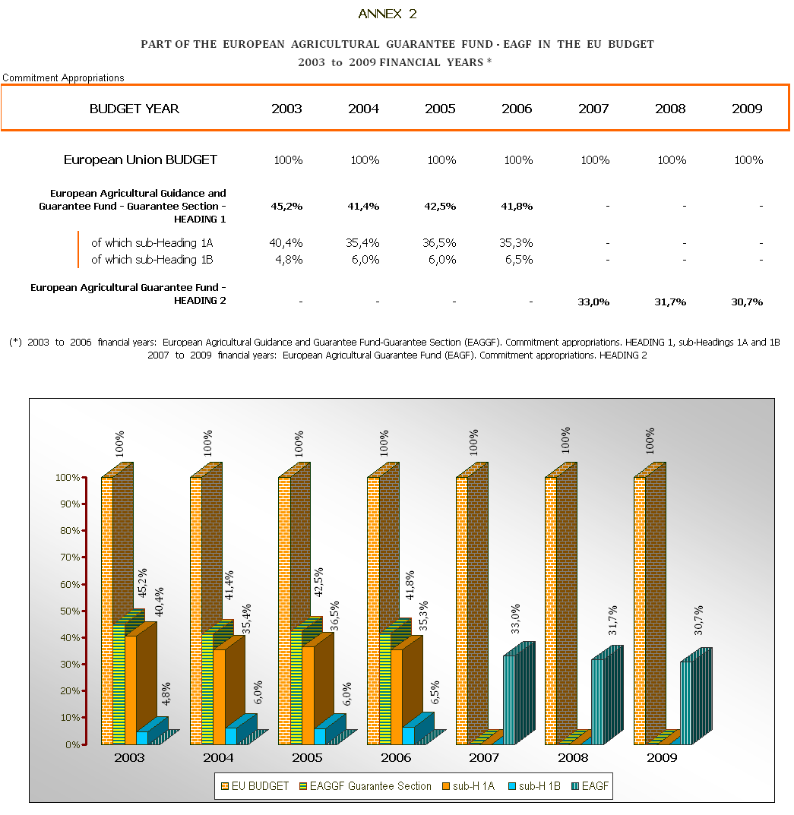
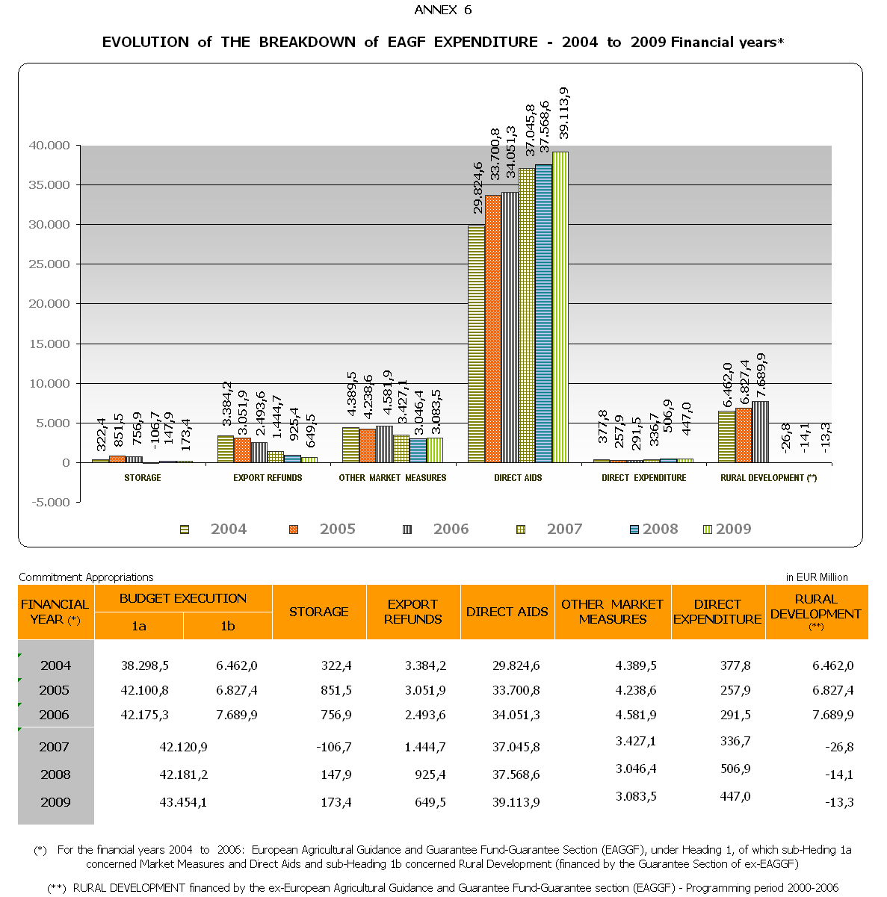

This procedure is presented in annex 1.
TRDI: Transitional Rural Development Instrument for EU 10
These amounts are not entered in the revenue lines of the budget (article 670 for the revenue assigned to the EAGF) but they are mentioned in the budgetary comments for this article.
These amounts are not entered in the revenue lines of the budget (article 680 for the temporary restructuring amounts for the sugar sector) but they are mentioned in the budgetary comments for this article.
p.m.: "pour mémoire".
OJ L 209 of 11.8.2005, p. 1.
These monthly declarations of expenditure are transmitted by the Member States by the declaration of the 10th of the month N+1.
The detailed declarations are transmitted monthly by the Member States (by table 104) on the 20th of the month N+1.
Rural development financed by the ex-European Agricultural Guidance and Guarantee Fund-Guarantee Section (EAGGF)–Programming period 2000-2006.

