EN
EUROPEAN COMMISSION
Brussels, 8.10.2010
SEC(2010) 1163 final
Vol.1
COMMISSION STAFF WORKING DOCUMENT
CONSOLIDATED PROFILE
Accompanying document to the
REPORT FROM THE COMMISSION TO THE COUNCIL AND THE EUROPEAN PARLIAMENT
THE 2010 ASSESSMENT OF IMPLEMENTING THE EU BIODIVERSITY ACTION PLAN
COM(2010) 548
SEC(2010) 1164
SEC(2010) 1165

TABLE OF CONTENTS
INTRODUCTION 3
POLICY AREA 1: Biodiversity in the EU 4
Objective 1. To safeguard the EU's most important habitats and species. 4
Objective 2: To conserve and restore biodiversity and ecosystem services in the wider EU countryside. 27
Objective 3. To conserve and restore biodiversity and ecosystem services in the wider EU marine environment. 51
Objective 4. To reinforce compatibility of regional and territorial development with biodiversity in the EU 70
Objective 5. To substantially reduce the impact on EU biodiversity of invasive alien species and alien genotypes. 79
POLICY AREA 2: The EU and global biodiversity 87
Objective 6. To substantially strengthen effectiveness of international governance for biodiversity and ecosystem services. 87
Objective 7. To substantially strengthen support for biodiversity and ecosystem services in EU external assistance. 91
Objective 8. To substantially reduce the impact of international trade on global biodiversity and ecosystem services. 99
POLICY AREA 3: Biodiversity and climate change 109
Objective 9. To support biodiversity adaptation to climate change. 109
POLICY AREA 4: The knowledge base 115
Objective 10. To substantially strengthen the knowledge base for conservation and sustainable use of biodiversity, in the EU and globally. 115
B. THE FOUR KEY SUPPORTING MEASURES 123
Supporting Measure 1. Ensuring adequate financing 123
Supporting Measure 2. Strengthening EU decision–making for biodiversity 134
Supporting Measure 3. Building partnerships 138
Supporting Measure 4. Building public education, awareness and participation 142
C. MONITORING, EVALUATION AND REVIEW 145
INTRODUCTION
This consolidated profile presents a comparative factual assessment of progress at both Community and Member States levels in the implementation of the EC Biodiversity Action Plan. It is intended to complement the information given in the Communication, providing a more detailed analysis, and presenting key comparative data underpinning the assessment.
It is based on information collected for the country profiles as well as the Community level assessment and is organised according to the four main policy areas, ten objectives and four supporting measures set out in the Biodiversity Action Plan.
Contextual information, drawn from the 2006 and 2008 Biodiversity Communications, is presented at the outset for each objective and supporting measure. This is then followed by a progress assessment. As far as possible, the assessment of progress by Member States has been made at the level of individual actions.
More detailed information for the targets and actions can be found in the country profiles as well as in the table summarising progress at Community level.
The emphasis has been on using official sources of information. In addition to the responses to a questionnaire sent to Member States the Commission has availed of different databases and information systems, such as the Natura 2000 database and assessments of Community funded programmes (e.g. LIFE, Rural and Regional Development programmes).
Information compiled within the framework of the European Environment Agency EU 2010 Biodiversity Baseline and the 2010 update of the Streamlining of European Biodiversity Indicators (SEBI 2010) set has also been used where this is directly linked to individual targets of the Biodiversity Action Plan. However, there is a separate report providing more details for the updated indicators under the SEBI 2010 project.
It should be noted that some data, including those relating to allocations of funds to nature and biodiversity under different Community programmes are preliminary and will require further evaluation.
POLICY AREA 1: Biodiversity in the EU

Objective 1. To safeguard the EU's most important habitats and species.

Headline Target: Biodiversity loss of most important habitats and species halted by 2010, [these habitats and species showing substantial recovery by 2013]

A. Context
Action to safeguard the EU’s most important habitats and species is critical to halting biodiversity loss as well as to fostering its recovery. The basis for EU action in this regard is mainly provided by the Birds and the Habitats Directives (the ‘nature directives’). Special attention needs to be afforded to the creation and protection of Natura 2000, a network of sites of highest nature value. The network is almost completed on land and extended to the marine environment. Focus shifts towards the effectively management of Natura 2000 sites. There is also a need to strengthen coherence, connectivity and resilience of the network, including through support to national, regional and local protected areas. The use of species action plans for the recovery of the EU’s most threatened species needs to be extended. Discussions are ongoing to set comparable measures for habitats and species in those EU outermost regions not covered by the nature directives.

B. Progress assessment
Target 1.1 Natura 2000 network established, safeguarded, designated and under effective conservation management by 2010, 2012 in marine
[A1.1.1 Accelerate efforts to finalise the Natura 2000 network including: complete terrestrial network of Special Protection Areas (SPA [by 2006, 2008 for marine]; adopt lists of Sites of Community Importance (SCI) [by 2006, 2008 for marine]; designate Special Areas of Conservation (SAC) and establish management priorities and necessary conservation measures for SACs [by 2010, 2012 for marine]; establish similar management and conservation measures for SPAs [by 2010, 2012 for marine].
Terrestrial Natura 2000 sites
At the core of EU biodiversity policy are the Birds and Habitats Directives, which provide the legal basis for the Natura 2000 network of protected areas. The terrestrial Natura 2000 network now comprises about 26,000 sites, covering nearly 18% of the total area of the European Union (see obj. 1 figure 1 and obj. 1 figure 2). The NATURA barometer is updated twice yearly by the European Topic Centre for Biodiversity of the European Environment Agency, providing summary statistics for Natura 2000 sites for each Member State based on officially supplied data.
Obj. 1 Figure 1: Cumulative surface area of sites proposed for the Habitats Directive over time (source: European Topic Centre for Biodiversity).
Obj. 1 figure 2: Cumulative surface area of sites (designated under the Birds Directive over time (source: European Topic Centre for Biodiversity).
Since the 2008 mid-term assessment of implementation of the EU Biodiversity Action Plan (BAP), as part of the completion exercise of the Natura 2000 network, additional areas have been designated bringing the terrestrial area covering 716,992 km² under and 574,819 km² under the Birds Directive. Progress has been made in a number of countries. For example, Poland, Lithuania and Spain have significantly increased the number of both Special Protection Areas (SPAs) and Sites of Community Importance (SCIs) within their respective countries. Poland’s SPA list is now considered largely complete.
By July 2009, 21 of the EU-27 Member States were considered to have reached a sufficient representation of site coverage for more than 80 % of the terrestrial species and habitats of Community interest under the Habitats Directive within their territory. The new Member States are generally doing well (see obj. 1 figure 14).
Obj. 1 figure 14: Level of sufficiency of representation of different habitat types and species in Member States' proposed site networks under the Habitats Directive (European Topic Centre for Biodiversity, 2009).
As of June 2010, thirteen Member States had designated more that 13%of their terrestrial territory as SCIs: Slovenia (31.4%), Bulgaria (29.6%), Spain (24.5%), Portugal (17.4%), Estonia (16.7%), Greece (16.3%), Luxembourg (15.4%), Hungary (15%), Italy (14.3%), Lithuania (13.9%), Sweden (13.7%), Malta (13.3%) and Romania (13.2%) (obj. 1 figure 3).
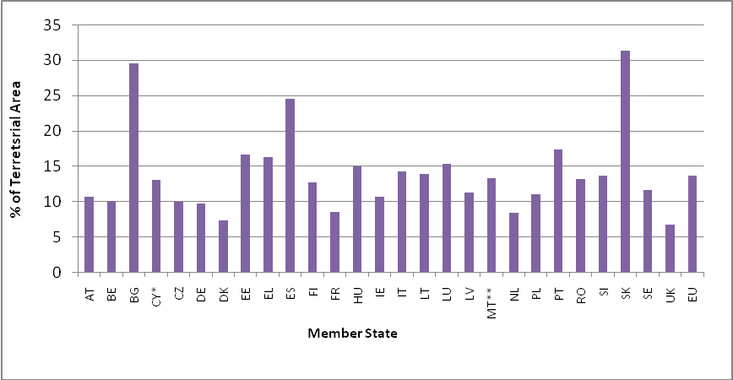
Obj. 1 figure 3: Percentage of SCIs terrestrial area under the Habitats Directive compared to Member State terrestrial area (* the area and % of territory corresponds to the area of Cyprus where the Community acquis applies at present, according to protocol 10 of the Accession Treaty of Cyprus; ** several marine sites, but no information on marine areas provided in the database) (source: Natura 2000 barometer, number 28, June 2010).
As of June 2010, fourteen Member States had designated more than 11% of their terrestrial territory as SPAs: Cyprus (25.9%), Slovakia (25.1%), Slovenia (23%), Bulgaria (20.4%), Greece (20.9%), Spain (20.6%), Poland (15.6%), Hungary (14.5%), Italy (13.6%), Estonia (13.5%), the Netherlands (12.6%), Czech Republic (12.3%), Germany (12.2%), and Austria (11.8%) (obj. 1 figure 4).
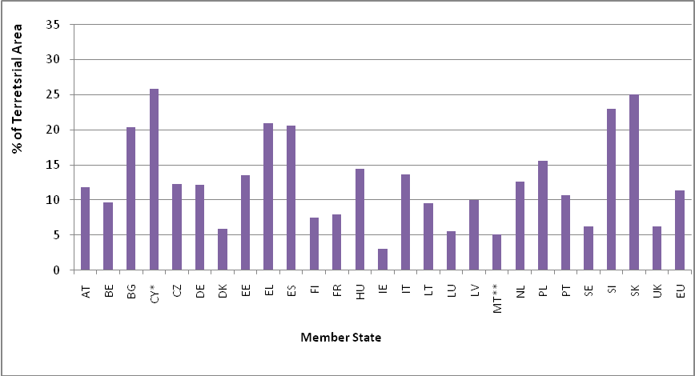
Obj. 1 figure 4: Percentage of SPAs terrestrial area under the Birds Directive compared to Member State terrestrial area (* the area and % of territory corresponds to the area of Cyprus where the Community acquis applies at present, according to protocol 10 of the Accession Treaty of Cyprus; ** several marine sites, but no information on marine areas provided in the database; no surface area provided in the Romanian database) (source: Natura 2000 barometer, number 28, June 2010).
There has also been an increase in the total number and area of Natura 2000 sites since June 2008. By June 2010, there were 22,529 Sites of Community Importance (SCIs) under the Habitats Directive covering 719,015 km². This represents an increase by 917 sites from 21,612 Sites of Community Importance and Special Areas of Conservation (SACs) and an increase of 63,047 km² in area covered by these sites from 655,968 km² in June 2008. See obj. 1 figure 5 and obj. 1 figure 6 for a breakdown according to Member States.
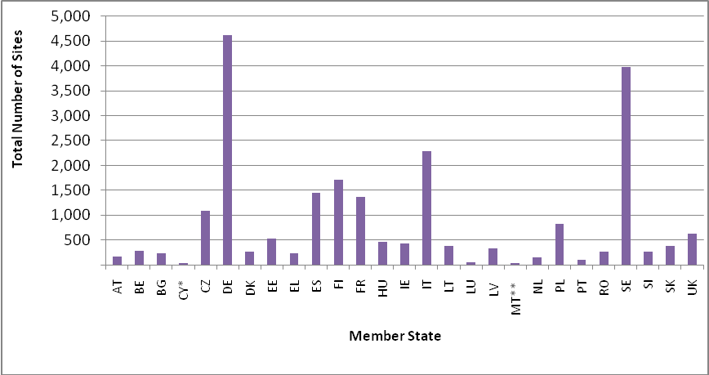
Obj. 1 figure 5: Number of SCIs under the Habitats Directive per Member State (* the area and % of territory corresponds to the area of Cyprus where the Community acquis applies at present, according to protocol 10 of the Accession Treaty of Cyprus; ** several marine sites, but no information on marine areas provided in the database) (source: Natura 2000 barometer, number 28, June 2010).
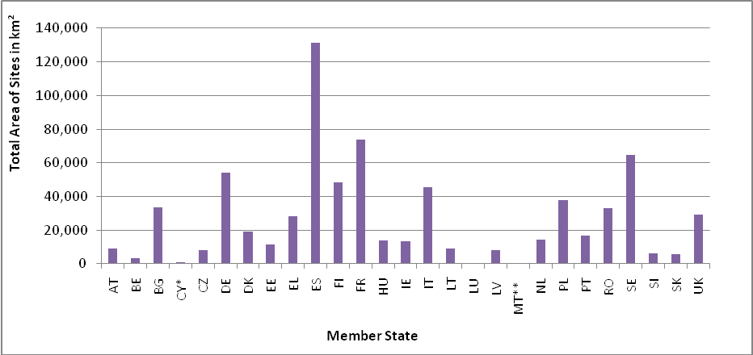
Obj. 1 figure 6: Total Area of SCIs under the Habitats Directive per Member (* the area and % of territory corresponds to the area of Cyprus where the Community acquis applies at present, according to protocol 10 of the Accession Treaty of Cyprus; ** several marine sites, but no information on marine areas provided in the database) (source: Natura 2000 barometer, number 28, June 2010).
By June 2010, there were 5,315 Special Protection Areas (SPAs) under the Birds Directive covering 593,486 km², representing an increase by 311 sites from 5004 SPAs and an increase of 75,590 km² in an area covered by SPAs from 517,896 km² in June 2008 (see obj. 1 figure 7 and obj. 1 figure 8).
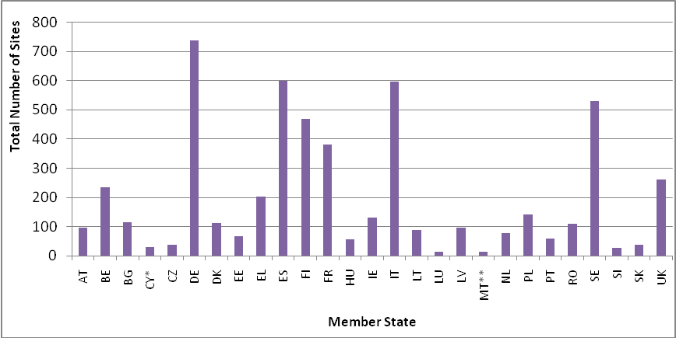
Obj. 1 figure 7: Number of SPAs under the Birds Directive per Member State (* the area and % of territory corresponds to the area of Cyprus where the Community acquis applies at present, according to protocol 10 of the Accession Treaty of Cyprus; ** several marine sites, but no information on marine areas provided in the database; no surface area provided in the Romanian database) (source: Natura 2000 barometer, number 28, June 2010)
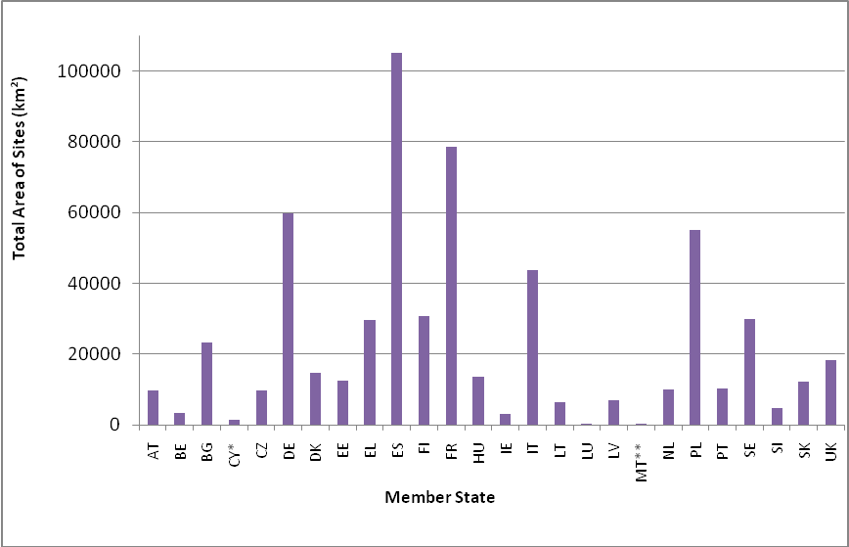
Obj. 1 figure 8: Total area of SPAs under the Birds Directive per Member State (* the area and % of territory corresponds to the area of Cyprus where the Community acquis applies at present, according to protocol 10 of the Accession Treaty of Cyprus; ** several marine sites, but no information on marine areas provided in the database; no surface area provided in the Romanian database) (source: Natura 2000 barometer, number 28, June 2010).
EC nature legislation does not apply the Overseas Countries and Territories (OCTs). Outermost Regions (ORs) on their side, face different situations: the Macaronesian region is making progress in the actual establishment of the Natura 2000 network whereas French overseas departments are not covered by this legislation. Considering that OCTs and ORs host some of the richest biodiversity hot-spots on the planet, the EC is engaged with concerned Member States to develop a voluntary scheme to promote the conservation and sustainable use of biodiversity and ecosystem services in European Overseas inspired by the experience of Natura 2000.
With regard to evaluating the completeness of national SPA networks, there is no biogeographical screening process, but the Commission makes use of different scientific references, including national inventories, where they exist, and the Important Bird Areas (IBAs) publications of BirdLife International.
Marine Natura 2000 sites
The situation regarding the marine establishment of Natura 2000 is less advanced than for terrestrial areas, which was addressed in the 2008 BAP mid-term assessment. This is especially the case for the offshore marine environment. An increased focus was given to complete the Natura 2000 Network for the marine environment. Dedicated marine biogeographical seminars were held for the Atlantic marine region and the Baltic Sea. Further marine seminars were organised in 2010 for the Black Sea and the Mediterranean and the Macaronesian Atlantic marine regions. However, progress is slow and only a few MS (e.g. NL, DK) proposed additional offshore sites in 2009. Two meetings of marine expert group were held to assess state of play with marine Natura 2000 designations and to specify the assessment process and the implementation of fisheries measures.
With these progresses, the EU has a network of marine Natura 2000 sites throughout the Member States covering a total of 167,560.60km², and designation is still in process (obj. 1 figure 9 to 13). As a result, the total marine area included in the Natura 2000 Network for each of these countries (DK, FR, NL) has more than doubled. In France the increase in marine area is over fourfold and the UK has considerably increased the marine area of their SPAs, which has tripled in size. The Natura 2000 Network for the Baltic Sea region has more than doubled. With regard to evaluating the completeness of national SPA networks, there is no biogeographical screening process, but the Commission makes use of different scientific references, including national inventories, where they exist, and the Important Bird Areas (IBAs) publications of BirdLife International.
With close cooperation of the Commission services, a set of guidelines were produced on how Member States can adapt fisheries measures within marine Natura 2000 sites that fall under the CFP to avoid fisheries’ negative impacts on these protected species and habitats. Four coastal Member States have made requests to the Commission to adapt fisheries measures within marine Natura 2000 sites that fall within Union waters: Spain, Ireland, UK and the Netherlands. The Commission is responding to Member States requests regarding fisheries management measures for Natura 2000 sites on individual basis.
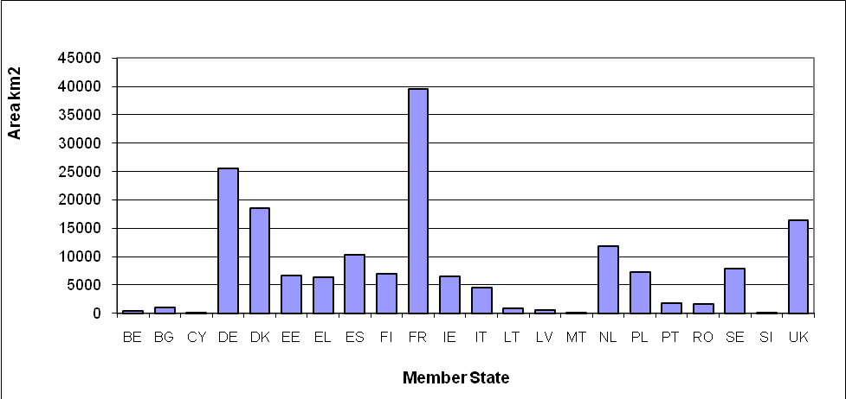
Obj. 1 figure 9: Contribution of coastal Member States to the Marine Natura 2000 network (area). Austria, the Czech Republic, Hungary, Luxembourg and Slovakia do not have a coastline and have not been included in this analysis (source: DG Environment).
By June 2010, there were 1,412 marine Sites of Community Importance (SCIs) under the Habitats Directive covering 132,923 km² as compared to 1,391 sites in December 2009 covering 131,459 km². See obj. 1 figure 10 and obj. 1 figure 11 for a breakdown according to Member States.
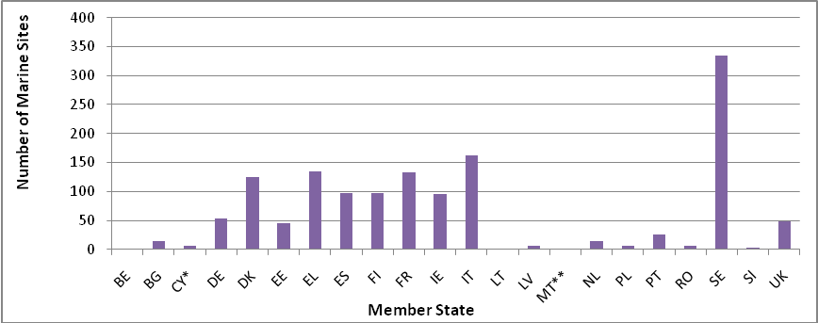
Obj. 1 figure 10: Number of Marine SCIs under the Habitats Directive per Member State (* the area and % of territory corresponds to the area of Cyprus where the Community acquis applies at present, according to protocol 10 of the Accession Treaty of Cyprus; ** several marine sites, but no information on marine areas provided in the database) (source: Natura 2000 barometer, number 28, June 2010).
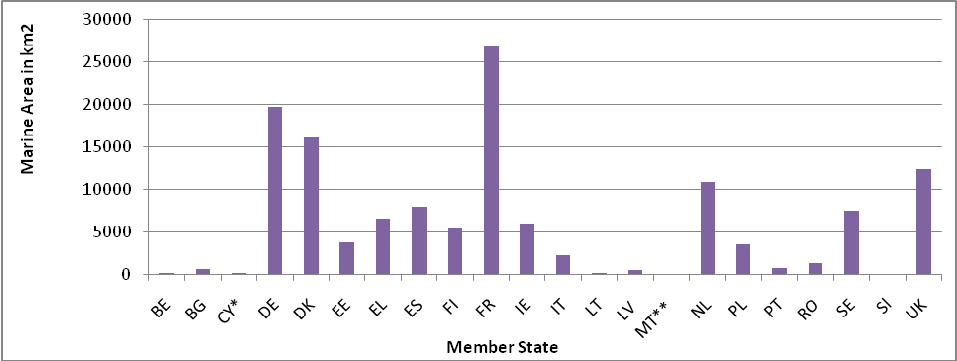
Obj. 1 figure 11: Marine area of SCIs under the Habitats Directive per Member State (* the area and % of territory corresponds to the area of Cyprus where the Community acquis applies at present, according to protocol 10 of the Accession Treaty of Cyprus; ** several marine sites, but no information on marine areas provided in the database) (source: Natura 2000 barometer, number 28, June 2010).
By June 2010, there were 700 marine Special Protection Areas (SPAs) under the Birds Directive covering 102,663 km² as compared to 619 sites in December 2009 covering 97,507 km². See obj. 1 figure 12 and obj. 1 figure 13 for a breakdown according to Member States.
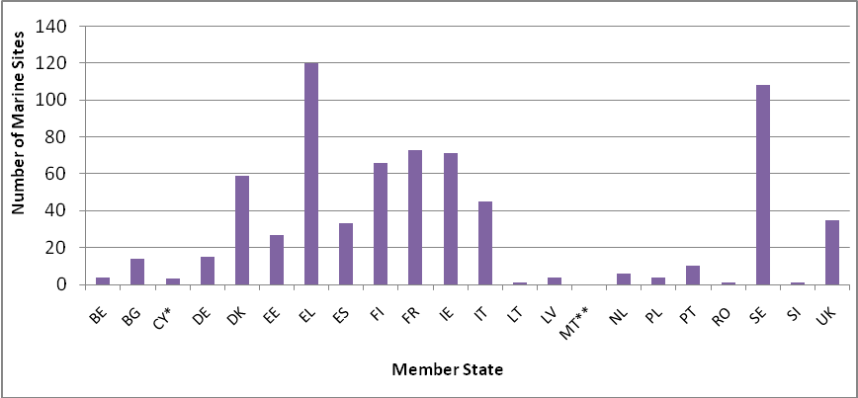
Obj. 1 figure 12: Number of marine SPAs under the Birds Directive per Member State (* the area and % of territory corresponds to the area of Cyprus where the Community acquis applies at present, according to protocol 10 of the Accession Treaty of Cyprus; ** several marine sites, but no information on marine areas provided in the database; no surface area provided in the Romanian database) (source: Natura 2000 barometer, number 28, June 2010).
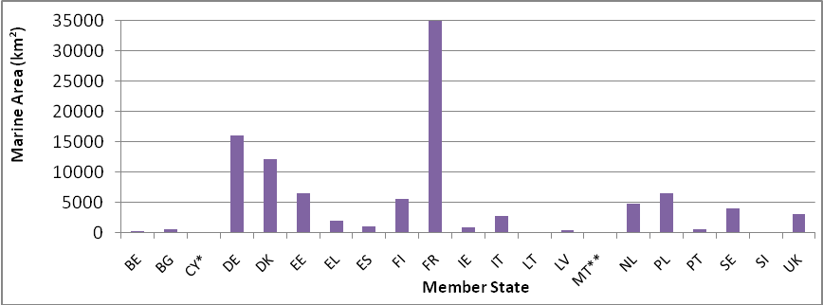
Obj. 1 figure 13: Marine area of SPAs under the Habitats Directive per Member State (* the area and % of territory corresponds to the area of Cyprus where the Community acquis applies at present, according to protocol 10 of the Accession Treaty of Cyprus; ** several marine sites, but no information on marine areas provided in the database; no surface area provided in the Romanian database) (source: Natura 2000 barometer, number 28, June 2010).
Management and protection of Natura 2000 sites
[A1.1.1 Accelerate efforts to finalise the Natura 2000 network including: complete terrestrial network of Special Protection Areas (SPA [by 2006, 2008 for marine]; adopt lists of Sites of Community Importance (SCI) [by 2006, 2008 for marine]; designate Special Areas of Conservation (SAC) and establish management priorities and necessary conservation measures for SACs [by 2010, 2012 for marine]; establish similar management and conservation measures for SPAs [by 2010, 2012 for marine]
As the selection, proposal and designation of Natura 2000 sites is now at an advanced stage attention needs to increasingly focus on the protection and management of the network. A New expert group on Natura 2000 management was set up and held its first meeting on 25 November 2009. This group is inter alia working on the process of SAC designation, the establishment of conservation objectives & management instruments.
Although not explicitly mentioned as an obligation under the Habitats Directive management plans are recognised by most Member States as a valuable tool to assist with the positive management of Natura 2000 sites. Five Member States have more than 50% of Natura 2000 sites with a management plan completed (obj. 1 figure 15). These include Sweden (95%); UK (83%); Cyprus (69.4%), France (52%) and Portugal (51%). Five Member States have more than 50% of Natura 2000 sites with a management plan in preparation: Denmark (100%); Czech Republic (99.63%); Belgium (84.5%), Romania (80%) and Ireland (58%). Nine Member States indicated that they have more than 50% of Natura 2000 sites with no management plan completed or in preparation.
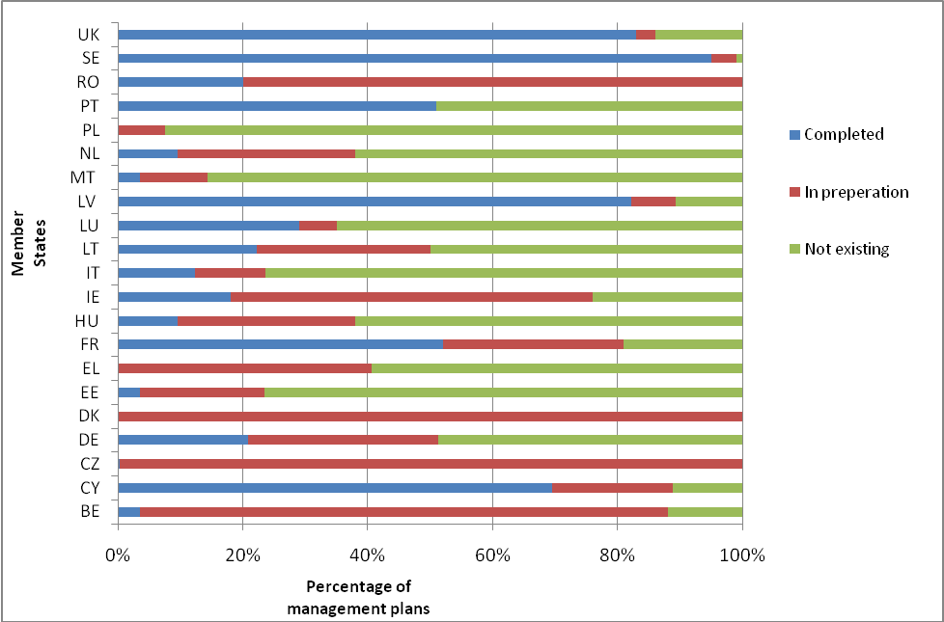
Obj. 1 figure 15: Percentage of management plans completed/in preparation/not existing per Member State (Austria, Bulgaria, Spain, Finland, Slovenia and Slovakia have not provided data) (source: Country Profiles).
In order to assist the protection and positive management of Natura 2000 sites and in recognition of potential conflicts with certain socio-economic sectors the Commission is developing guidance documents for Natura 2000 in estuaries and coastal zones, for non-energy extractive industries and for wind energy and nature conservation, that are to be published in the course of 2010.
[A1.1.3 Number of complaints/infringements (legal cases) related to Article 6 of the Habitats Directive Transpose fully [by 2006] Articles 6(2), 6(3) and 6(4) of the Habitats Directive into national legislation and planning policies and ensure subsequent timely implementation; where appropriate (i.e. where development proposals cannot avoid damage to Natura 2000 sites, but proceed for reasons of overriding public interest) ensure special effort for adequate design and implementation of compensatory measures [2006 onwards]]
The figures presented in obj. 1 figure 16 relate to cases of infringements or complaints related to Article 6 of the Habitats Directive, which deals with management of Natura 2000 sites, open on 15 December 2009 only. The majority of Member States had open cases of infringements or complaints on Article 6 (management) of the Habitats Directive in mid December 2009, reflecting on the many cases of challenges to an effective conservation of Natura 2000 sites.
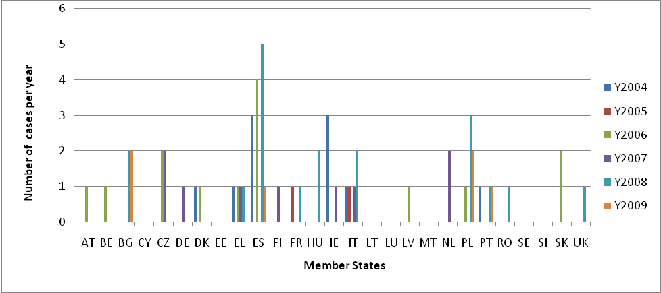
Obj. 1 figure 16: Number of infringements or complaints related to Article 6 of the Habitats Directive open on 15 December 2009, the year indicating the issue date. (Source: DG Environment).
LIFE Financing for Natura 2000
[A1.1.2 Ensure adequate financing provided to Natura 2000 implementation from EU sources (notably Rural Development funds, Cohesion and Structural Funds, Pre-Accession Instrument, Life-III, Life+) and MS sources, accessible to those who manage Natura 2000 sites, with focus on optimising long-term conservation benefits as well as priority awareness raising and networking initiatives [2006 onwards]].
This section, together with other financing instruments for nature and biodiversity, is discussed in Supporting Measure 1 on financing (see section B1.1.1).
Target 1.2 Sufficiency, coherence, connectivity and resilience of the protected areas network in the EU substantially enhanced by 2010 [and further enhanced by 2013]
[A1.2.3 ACTION: Assess [by 2008] and substantially strengthen [by 2010] coherence, connectivity and resilience of the protected areas network (Natura 2000 and non-Natura protected areas) by applying, as appropriate, tools which may include flyways, buffer zones, corridors and stepping stones (including as appropriate to neighbouring and other third countries), as well as actions in support of biodiversity in the wider environment (see also actions under objectives 2, 3 and 9)]
Natura 2000 sites do not exist in isolation from the surrounding landscape. Corridors and connectivity, as recognised under Article 10 of the Habitats Directive are important especially in the light of the pressures that will be associated with climate change. First guidelines on how to manage landscape features of major importance for wild flora and fauna have been prepared with a view to identifying ways of supporting the ecological coherence of the Natura network. A workshop was held in 2009 to further discussing on the ‘green infrastructure’ concept, a network taking Natura 2000 sites as its core element, which will not only contribute to the connectivity of Natura 2000 sites but through its multifunctional feature will provide benefits for various aims.
In regards to whether or not Member States have tools in place to support ecological connectivity, sixteen Member States indicated that they have tools in place to support ecological connectivity (obj. 1 figure 17). Six Member States indicated that they do not have tools in place to support ecological connectivity, while five Member States did not provide information on this.
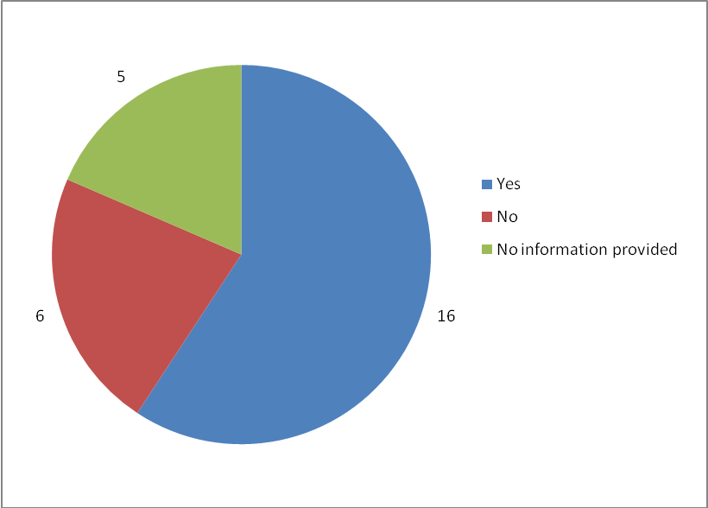
Obj. 1 figure 17: Number of MS that have or have no tools in place to support ecological connectivity (source: Country Profiles).
Target 1.3 Good conservation status of species achieved (Article 17 of Habitats Directive, Red Data Book, Atlases, Common bird monitoring, ex-situ conservation)
Conservation status assessment and red data lists
Monitoring of conservation status is an obligation arising from Article 11 of the Habitats Directive for all habitats (as listed in Annex I) and species (as listed in Annex II, IV and V) of Community interest. Data need to be collected both in and outside the Natura 2000 network to achieve a full appreciation of conservation status. The main results of this monitoring have to be reported to the Commission every six years according to Article 17 of the directive.
The first major 'health check' of the conservation status of species and habitats of Community interest under Article 17 of the Habitats Directive covered the years 2001-2006. On the basis of national reports received in 2007/early 2008 the Commission, with support of the European Topic Centre on Biological Diversity of the European Environment Agency completed an EU level assessment, for which a composite report and a technical report with the national assessments are available.
Across the EU (25 Member States, excluding Bulgaria and Romania who before accession were not included in the reporting under Article 17 of the Habitats Directive), the greatest percentage of habitats determined to be in a favourable condition are rocky habitats, followed by sclerophyllous scrub and forest habitats (obj. 1 figure 18). The condition of 55% of rocky habitats is favourable. The condition of 20% of the sclerophyllous scrub habitats was reported to have a favourable status, the same applied to 20% of forest habitats. The condition of 10% of coastal habitats is in a favourable status. The condition of 15% of health and scrub habitats and 15% of freshwater habitats is reported to have a favourable status. Dunes, grasslands, and bogs, mires and fens have the lowest percentage of habitats determined to be in a favourable condition: 2% of dunes, 5% of grasslands and 5% of bogs, mires and fens.
The greatest percentage of habitats determined to be in an unfavourable-bad condition are bogs, mires and fens; grasslands; and dunes. 50% of grassland habitats, 50% of dunes and 55% of bogs, mires and fens have an unfavourable-bad status. 35 % each of coastal habitats, forests, and heath and scrub habitats have an unfavourable-bad status.
The habitats with the largest percentage determined to be in an unfavourable-inadequate condition are dunes, sclerophyllous, bogs, mires and fens, coastal, freshwater, and heath and scrub habitats. The condition of 40% of dunes and 30% of coastal, freshwater, and bogs, mires and fens habitats were reported to have an unfavourable-inadequate status. The condition of 30% of sclerophyllous scrub habitats was reported to have unfavourable-inadequate status. 20% of rocky habitats were reported to have an unfavourable-inadequate status. The largest percentage of habitats reported as unknown refers to 40% of sclerophyllous scrub habitats.
At EU level (obj. 1 figure 18), 15% of all habitats were reported to have a favourable status and 62% to have an unfavourable status. The conservation status of more than 10% of all habitats was reported as of unknown condition and approximately 2% were not assessed. There is no habitat type with any specific habitats in an unfavourable-bad condition.
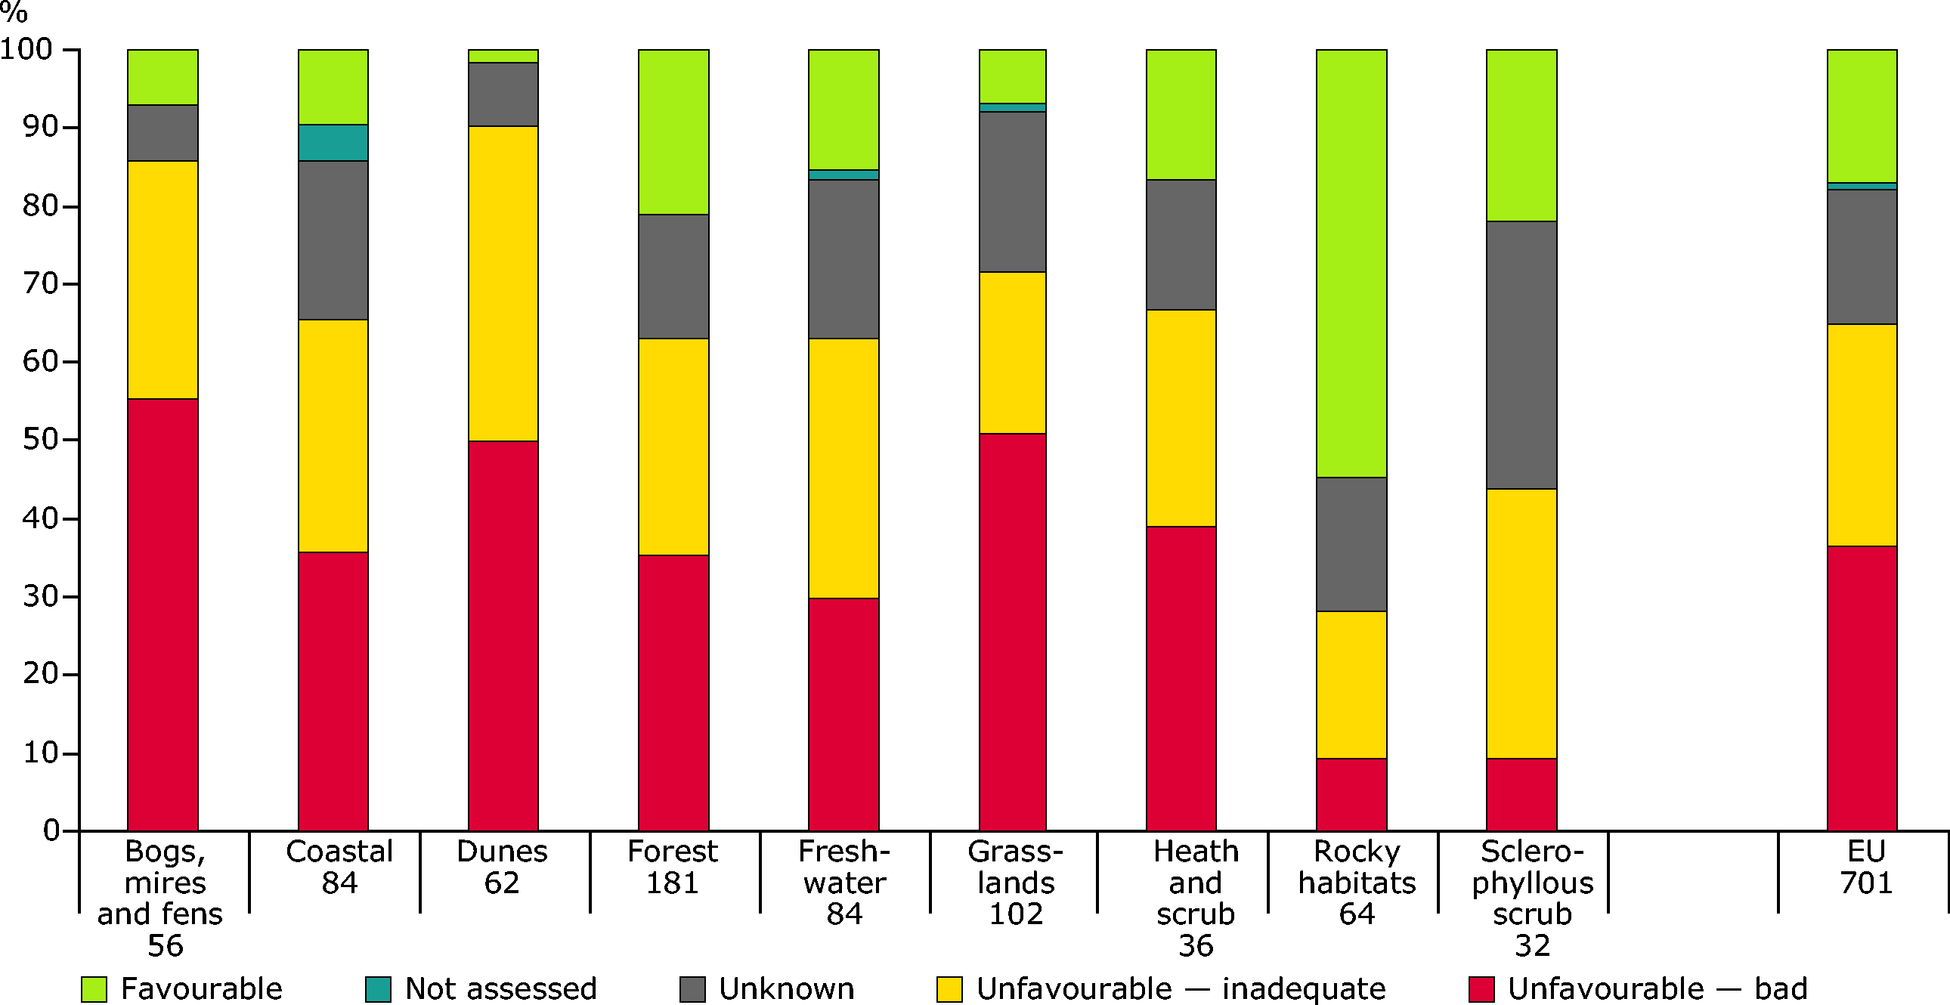
Obj. 1 figure 18: Conservation status by main type of habitats (source: European Environmental Agency, 2009 - Data provided by 25 EU Member States (EU-27 except Bulgaria and Romania that will be included in the next reporting phase in 2013) through their reports under Article 17 of the Habitats Directive, 2008).
A look at the status of habitats in the biogeographical regions reveals that, in the Alpine biogeographical region (obj. 1 figure 19), 30% of habitats are in favourable and unfavourable-inadequate conservation status, each. About 25% are in an unfavourable-bad status and the condition of 15% was reported as unknown. In the Atlantic biogeographical region, more than 55% of habitats are in an unfavourable-bad and about 20% in an unfavourable-inadequate status. The condition of 25% of habitats was reported as unknown.
In the Boreal biogeographical region, about 15% of habitats are in favourable conservation status, but 40% are in unfavourable-inadequate and unfavourable-bad conservation status, each. The condition of 5% of the habitats was reported as unknown.
In the Continental biogeographical region, about 20% of habitats are in favourable conservation status, but 40% are in unfavourable-bad conservation status. 35% of the habitats were determined to be in an unfavourable-inadequate condition. The condition of 5% of the habitats in this biogeographical region was reported as unknown
In the Mediterranean biogeographical region about 20% of habitats are in favourable conservation status and unfavourable-inadequate status, each. However, about 15% of habitats in this bioregion in an unfavourable-bad conservation status and 32% were reported as unknown. About 3% habitats were not assessed.
In the Pannonian biogeographical region, more than 55% of habitats are in unfavourable-bad conservation status. About 15% are in unfavourable-inadequate status. The condition of approximately 25% of the habitats was reported as unknown.
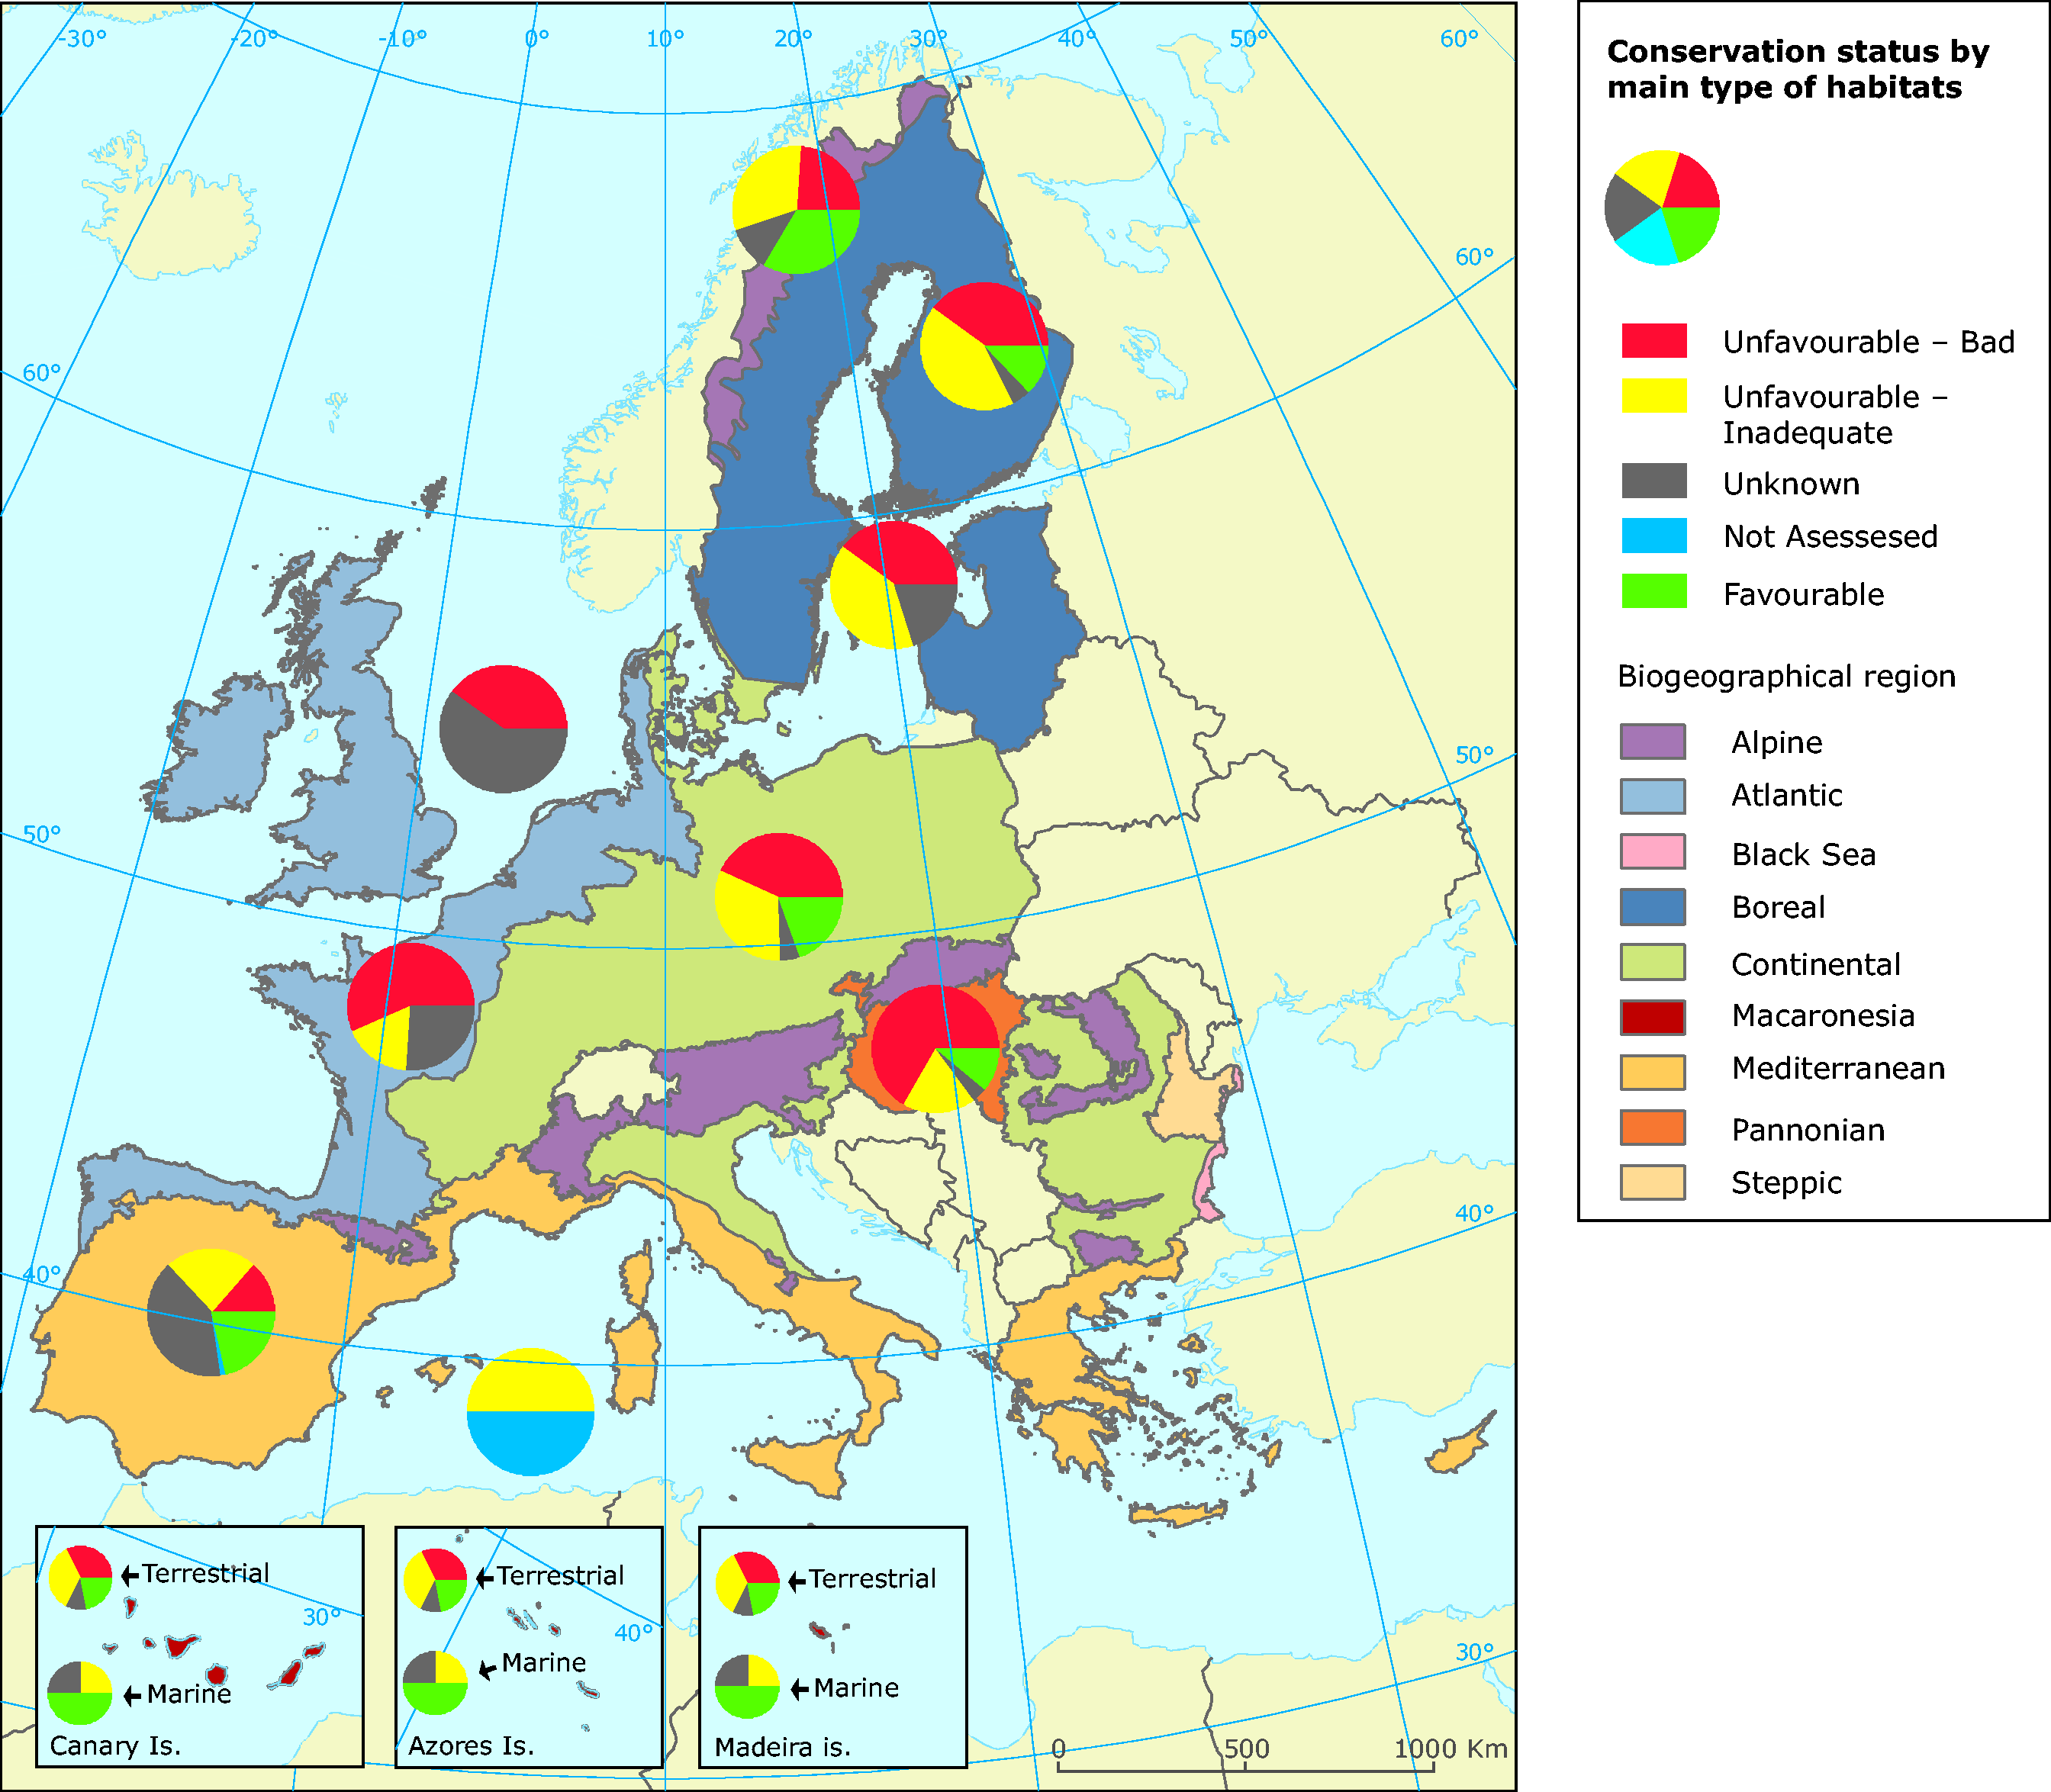
Obj. 1 figure 19: Habitats of European interest — conservation status by biogeographical region (Bulgaria and Romania will be included in the next reporting phase in 2013) through their reports under Article 17 of the Habitats Directive) (source: European Environmental Agency, 2009 - DG Environment and ETC/BD, based on data provided by 25 EU Member States).
The Article 17 reports on the status of species reveal that the species groups with the largest percentage determined to be in a favourable condition are vascular plants, followed by non-vascular plants, molluscs, fish and reptiles (obj. 1 figure 20). The condition of 25% of vascular plants and more than 15% of non-vascular plants has been reported to be favourable. 15% of molluscs have a favourable status. In addition, about 15% of fish, amphibians, reptiles and mammals each have a favourable status.
The species groups with the largest percentage determined to be in an unfavourable–inadequate condition are amphibians, vascular plants and fish. 45% of amphibians have an unfavourable-inadequate status. The condition of 35% of vascular plants and 30% of fish is reported to be unfavourable-inadequate.
The species groups with the largest percentage determined to be in an unfavourable-bad condition are molluscs, arthropods and fish. 40% of molluscs and about 30% of arthropods have been reported to have an unfavourable-bad status. More than 25% of fish have an unfavourable-bad status.
The species groups with the largest percentage reported as unknown are “other species”, mammals and reptiles. The conservation status of about 80% of “other species” and 45% of reptiles and mammals, respectively, is unknown. The condition of 25% of non-vascular plants was also reported as unknown.
At EU level, only about 15% of all species were reported to have a favourable status, with 52% having an unfavourable status. Approximately 29% of species have an unknown status and 4% of all species at EU level were not assessed.
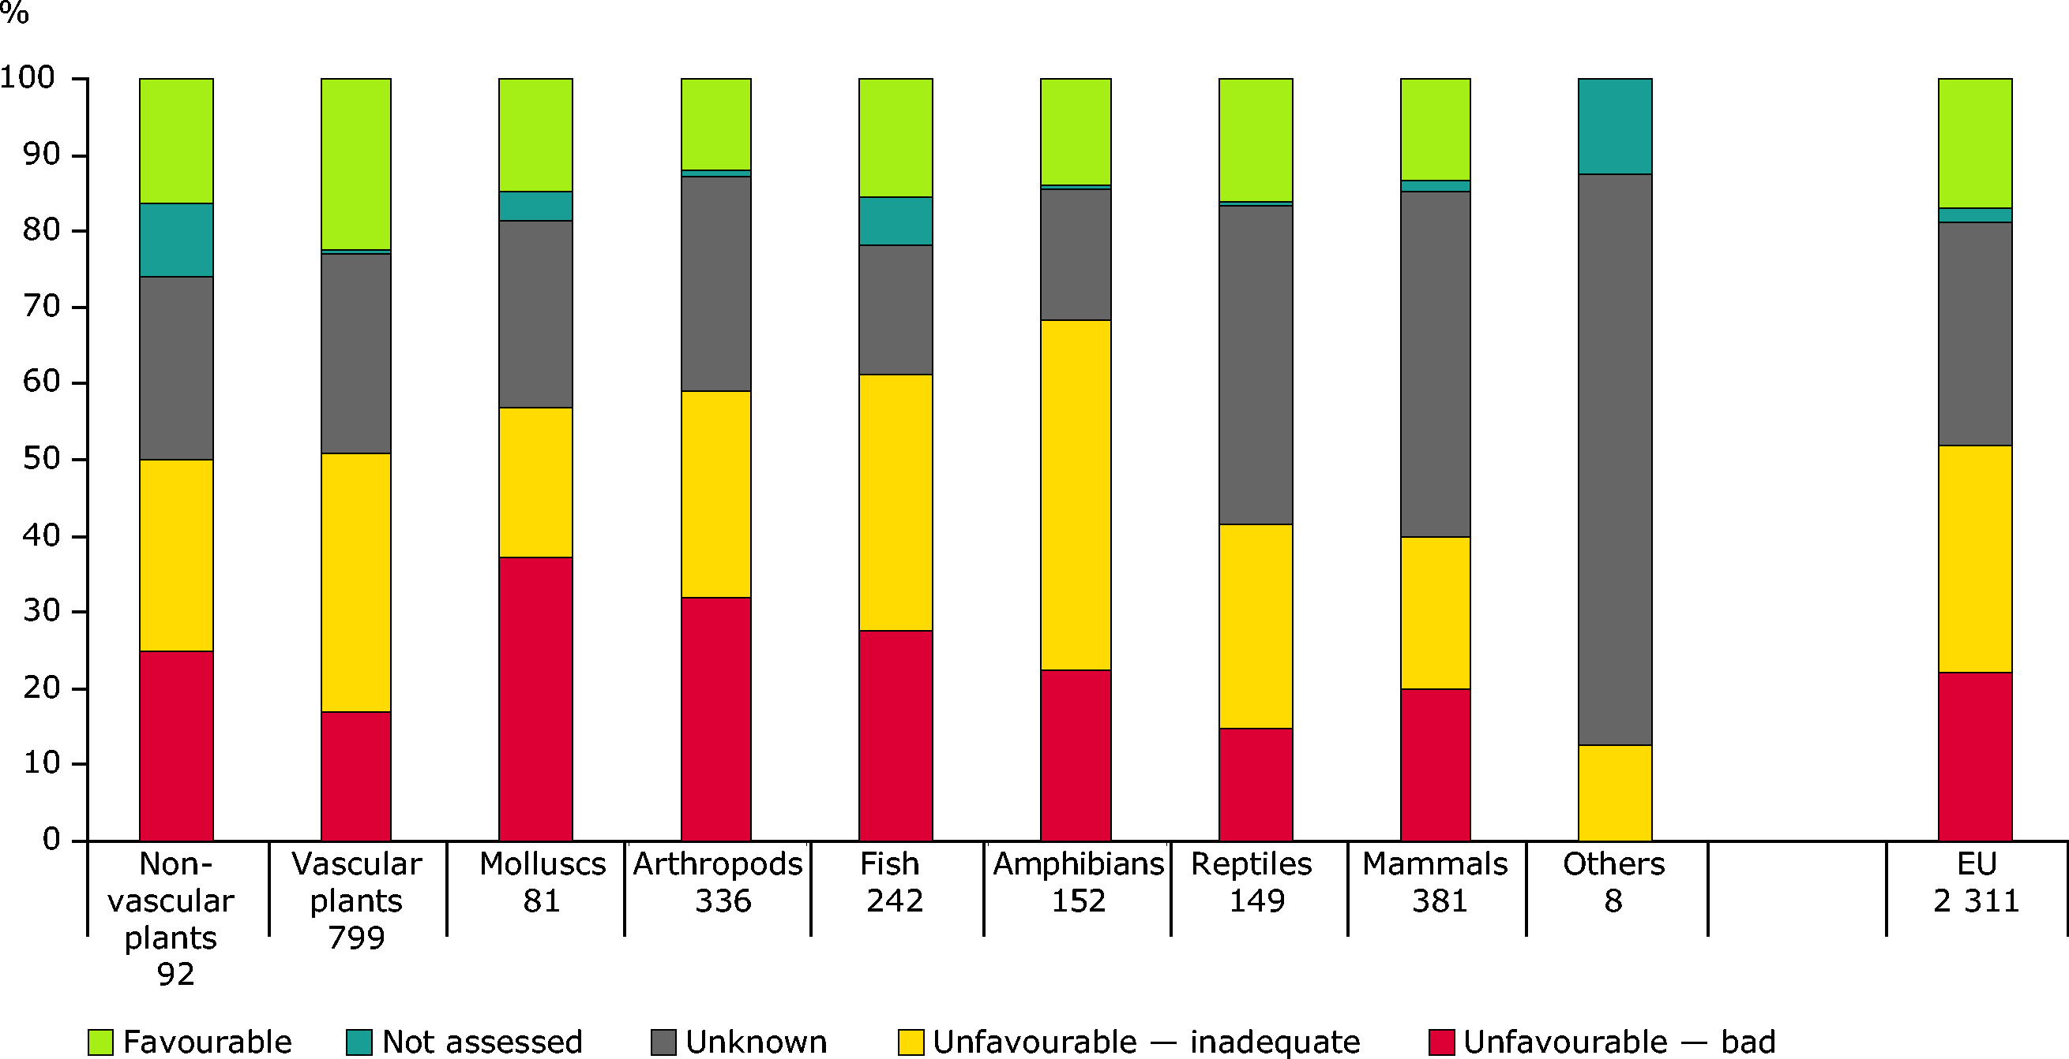
Obj. 1 figure 20: Conservation status of species protected by the Habitats Directive by taxonomic group. (Source: European Environmental Agency, 2009).
Looking at the biogeographical regions (obj. 1 figure 21), unfavourable status is most frequently reported for the species in the Marine Baltic region and the Continental region (100 and 70%, respectively). The variation amongst species groups is limited, but amphibians appear to be most threatened, with nearly 70% having an unfavourable conservation status.
In the Alpine biogeographical region, 20% of species are in favourable, unfavourable-inadequate and unfavourable-bad conservation status, each. The condition of about 16% of species was reported as unknown and 4% were not assessed.
In the Atlantic biogeographical region, the condition of about 8% of species was reported to be in a favourable condition. 35% of species are in unfavourable-inadequate condition. An additional 35% were reported as unknown. 20% of species were reported to be in an unfavourable-inadequate conservation status. The condition of 2% of species was not assessed.
In the Boreal biogeographical region, about 28% of species are in favourable, unfavourable-inadequate and unfavourable-bad conservation status, each. The condition of 14% of species was not reported and 2% of the species were not assessed.
In the Continental biogeographical region, 35% of species are in an unfavourable-inadequate and unfavourable-bad conservation status, each. About 14% of the species are in a favourable conservation status and a further 14% were not reported. 2% of the species were not assessed.
In the Mediterranean biogeographical region, 15% of species are in favourable conservation status and unfavourable-bad status, each. 20% of species in this bioregion in an unfavourable-inadequate conservation status and the condition of 50% of species were reported as unknown.
In the Pannonian biogeographical region, 20% of species are in favourable conservation status. 45% of species are in unfavourable-inadequate status. The condition of 15% of species is reported to be unfavourable-bad and 20% of the species was reported as unknown
There are still significant gaps in knowledge, resulting in unknown assessments. This reflects a lack of knowledge for many species, for example in the structure and function of their required habitats. This is especially the case for marine species. Trend information was not supplied for most assessments, so it is not possible to determine if their status is getting better or worse. For many species, recovery to a favourable conservation status is expected to take considerable time.
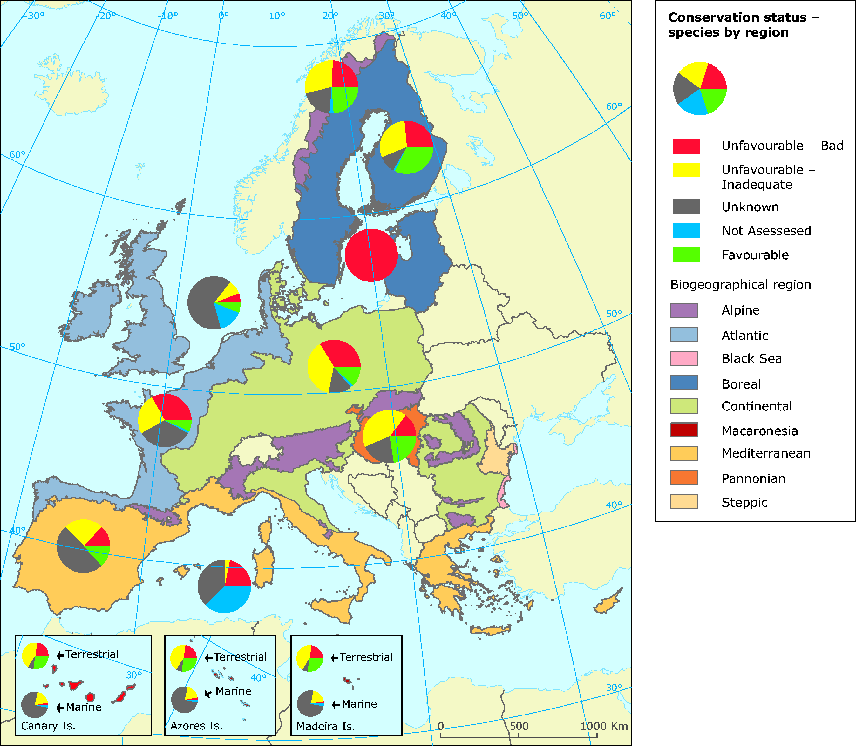
Obj. 1 figure 21: Species of European interest — conservation status by biogeographical region (Bulgaria and Romania will be included in the next reporting phase in 2013) through their reports under Article 17 of the Habitats Directive) (source: European Environmental Agency, 2009 - DG Environment and ETC/BD, based on data provided by 25 EU Member States.
The conservation status of birds is measured here (obj. 1 figure 22) at the global level, for each Member State, using the global Red List of threatened species from IUCN, with data provided by BirdLife International. Compared with other regions of the world, Europe has a low number of globally threatened bird species. It is therefore not surprising that least concern status is most frequently reported for all bird species across all Member States. The conservation status of species reported as of “least concern” at global level ranges from 91.4% for 97.8% for all Member States. The conservation status of bird species reported as globally near-threatened range from 1.4% to 5% Member States. The conservation status of bird species reported as red-listed at a global level ranges from 0% to 4.2% for all Member States.
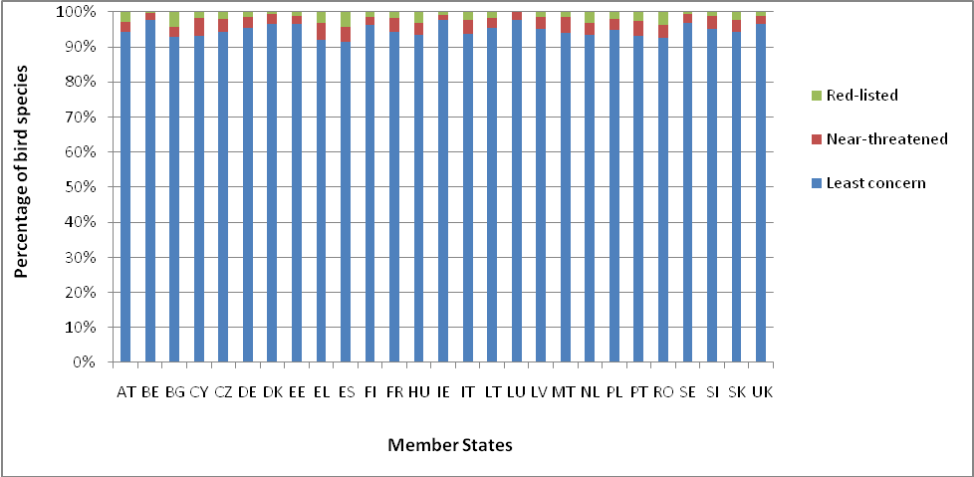
Obj. 1 figure 22: Global conservation status of birds per Member State as percentage of threat categories for regularly occurring species, as of 2009 (source: BirdLife International).
While not encouraging these preliminary results, based on assessment for the period up to 2006, are not surprising. The decline and destruction of species and habitats, which has been ongoing for many decades, cannot be reverted within a few years. A range of animal species, once at the brink of extinction like for example the Otter Lutra lutra, the Beaver Castor fiber or the European bison Bison bonasus are doing very well again and have – due to their protection and active conservation measures – increasing populations. For others, the decline has been stopped, implementation of management/restoration measures are about to start and will hopefully show first signs of recovery in the next assessment of 2013/2015.
Following up the Article 17 conservation status assessment exercise, the Commission has started a new initiative in streamlining reporting under the Birds and the Habitats Directive. The Expert Group on reporting established aims to initiate a similar status and trends assessment for bird species as well as improving the dataflow on Natura 2000, which might already be in place for the next (2007-2012) reporting exercise.
[A1.3.1 Existence of Red Data lists Implement [2006 onwards], at EC or MS level as appropriate existing species action or management plans for species under threat and review and update as necessary; elaborate [2006 onwards] and implement [2007 onwards] additional species action or management plans for a wider range of species under threat - including birds, mammals, reptiles, amphibians, freshwater fish, invertebrates and plants; ensure monitoring of implementation and effectiveness of plans]
Red data lists are being prepared and updated at EU and Member State levels. A European red data list for amphibians and reptiles, and for dragonflies, butterflies & saproxylic beetles were published since 2008.
In regards to national red lists for species, the information from Member States shows that encouragingly more than 20 EU countries have red data lists for birds, mammals, amphibians and reptiles, fish and plants (obj. 1 figure 23). These include 24 countries with red data lists for plants, 22 countries with red data lists for birds, 22 countries with red data lists for mammals, 21 countries with red data lists for amphibians and reptiles and 21 countries with red data lists for fish. 19 EU countries have red data lists for invertebrates. In all cases, some member states did not provide information on whether or not they have red data lists for the group of species mentioned in obj. 1 figure 23.
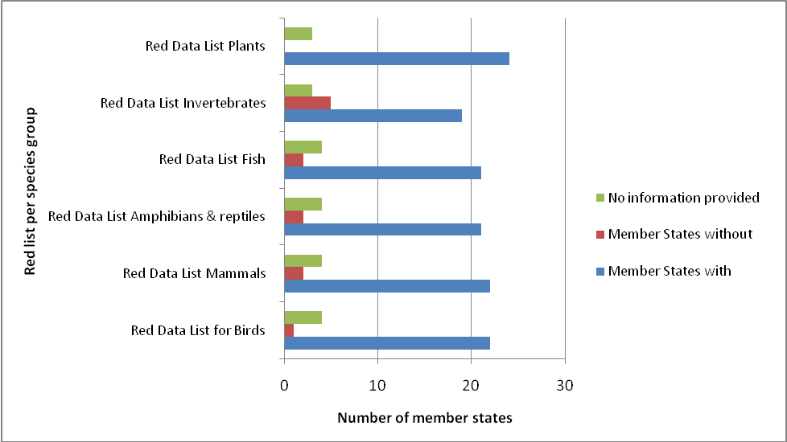
Obj. 1 figure 23: Number of EU Member States with Red Data Lists. (Source: Country Profiles).
Conservation action for species
[A1.3.1 Implement [2006 onwards], at EC or MS level as appropriate existing species action or management plans for species under threat and review and update as necessary; elaborate [2006 onwards] and implement [2007 onwards] additional species action or management plans for a wider range of species under threat - including birds, mammals, reptiles, amphibians, freshwater fish, invertebrates and plants; ensure monitoring of implementation and effectiveness of plans]
Species action plans continue to be developed as a practical tool to help target conservation action, as evidence by the success of earlier plans for 47 threatened bird species. Work is still ongoing to update existing plans (Acrocephalus paludicola, Marmaronetta anguistirostris, Aquila adalberti) and on the preparation of new bird action plans (Coracias garullus, Chersophilus duponti, Neophron percnopterus). An EU guideline for management plans for large carnivores promoting best practice has been prepared.
According to the information available, more than 10 Member States have species actions plans for birds, mammals, amphibians and reptiles, fish, invertebrates and plants completed (obj. 1 figure 24). The number of Member States with completed species action plans includes 16 with action plans for birds; 19 with action plans for mammals; 13 with action plans for amphibians and reptiles; 10 with action plans for fish; 12 with action plans for invertebrates and another 12 with action plans for plants. 11 and 10 Member States indicated that they do not have species actions plans for birds and fish in preparation, respectively.
In addition, more than 10 Members States indicated that they have actions plans in preparation for birds, mammals, invertebrates and plants. The number of Member States with species action plans in preparation includes 11 with action plans in preparation for birds; 14 with action plans in preparation for mammals; 11 with action plans in preparation for invertebrates and another 11 with action plans in preparation for plants.
Overall, these figures suggest an improvement over the data reported in the 2008 assessment, when 14 Member States reported that they do not have any species action plans.
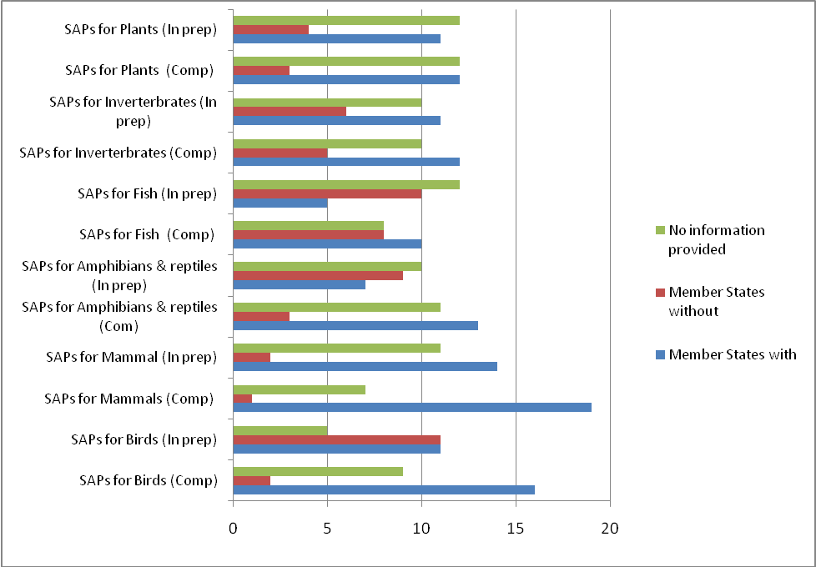
Obj. 1 figure 24: Number of Member States with species action plans (SAPs) per species group completed and in preparation (source: Country Profiles).
Furthermore, according to the information from Member States, 26 Member States have a common bird monitoring scheme or more than one such scheme but only 20 of them contribute data to the Pan-European Common Bird Monitoring Scheme. Only one Member State, Malta, indicated not to have a common bird monitoring scheme. In addition, 19 member states indicated that they have developed indicators derived from common bird monitoring schemes, 6 indicated that they do not while 2 countries did not provide information on this. For example, in Germany data from common bird monitoring are used to report the national state indicator ‘Sustainability Indicator for Species Diversity’ (SISD). The SISD is part of the German Biodiversity Strategy and of the National Sustainability Strategy. Italy has a common farmland bird index, mainly developed from the common bird monitoring scheme Monitoraggio ITaliano Ornitologico (MITO).
Butterfly monitoring schemes have been implemented for many years in 15 European countries (including some non-EU countries, see obj. 1 figure 25 for details). The results show a steady decline (obj. 1 figure 25). Grassland butterflies are declining severely; their populations have declined by almost 70%, indicating a dramatic loss of grassland biodiversity.
Obj. 1 figure 25: Grassland butterfly population index (1990 – 100) (source: De Vlinderstichting/ Butterfly Conservation Europe/ Statistics Netherlands, 2010 and SEBI factsheet: Headline indicator: Trends in abundance and distribution of selected species. 2010)
Target 1.4 All above targets applied for Acceding Countries from date of accession
Since the accession of Bulgaria and Romania on 1 January 2007, assessments of their progress are being incorporated into overall evaluations for Member States.

Objective 2: To conserve and restore biodiversity and ecosystem services in the wider EU countryside.

Headline target: In wider countryside (terrestrial, freshwater, brackish water outside Natura 2000 network), biodiversity loss halted by 2010 and showing substantial recovery by 2013

A. Context
Agriculture, in managing a large part of the EU territory, has a major influence on genes, species and habitats. However, in recent decades, intensification and specialisation, and at the same time marginalisation and under-utilisation of land have resulted in significant biodiversity loss. The Common Agricultural Policy (CAP), together with broader developmental dynamics of the agricultural sector, was one of the drivers for these processes, but has since 1992 been adapted to better integrate biodiversity needs. The new Rural Development Regulation provides inter alia for enhanced support for Natura 2000, maintains agri-environment measures and payments for areas with handicaps and provides for a set of measures in support of sustainable forest management. Increasing use of agri-environmental measures, organic farming and the support of Less Favoured Areas (LFA) and other pro-biodiversity instruments (e.g. cross-compliance, the decoupling of single farm payments and modulation) have favoured farmland biodiversity. In the 2008 "Health Check" of the CAP, the Good Agricultural and Environmental Conditions (GAEC) of cross-compliance were amended partly in favour of biodiversity. In addition, it provided for the transfer of resources from Pillar 1 to Pillar 2 on new challenges, including biodiversity.
Key actions of the Objective include optimising the use of available measures under the reformed CAP, notably to prevent intensification or abandonment of High Nature Value farmland, woodland and forest and supporting their restoration; implementing the Forest Action Plan including measures to prevent and combat forest fires; advancing implementation of key environmental framework directives and thematic strategies which reduce pressures on biodiversity, notably by improving the quality of freshwater and of soils, and by reducing diffuse pollutant pressures (e.g. airborne acidifying and eutrophicating substances, nitrates from farm sources, pesticides).

B. Progress assessment
Agricultural & Rural development policy, FOREST POLICY
Headline target: In wider countryside (terrestrial, freshwater, brackish water outside Natura 2000 network), biodiversity loss halted by 2010 and showing substantial recovery by 2013.
Indicators reflecting state of biodiversity in the wider countryside
One of the best indicators of the impacts of agricultural practices on farmland biodiversity are population's trends in common farmland birds. These trends are reflected in the Common Farmland Bird Indicator, which provides an index of population change in relation to 1990 levels (see Figure 1). This indicator clearly shows a decline in common farmland bird populations, from 1990 to 2007, of approximately 20-25%. It is also important to remember that these trends relate to common farmland birds and that the trends in rarer and otherwise threatened farmland species are also of great concern. There is now also growing concern over populations of forest birds in Europe. The common forest bird indicator data shown in Figure 1 suggest that there has also been a clear and significant decline in populations of about 20-25% since 1990 even if some forest bird populations have now stabilized after decline (Green Paper on Forest Protection (COM(2010)66).
Trends in the common bird indicators for the European Union, base = 1990
(numbers in brackets show the number of species in each indicator)
Source: Eurostat, 2010 (env_bio2) - EBCC/RSPB/BirdLife/Statistics Netherlands.
High Nature Value farmland provide habitat for a wide range of species. They are however under threat from intensification and land abandonment. Promoting conservation and sustainable farming practices in these areas is crucial for biodiversity. Area of High Nature Value (HNV) farmland is one of 35 environmental indicators for agriculture developed by EEA under the steering of the Commission. In this regard, a map of High Nature Value farmland has been updated by the European Environment Agency and the Joint Research Centre. In parallel, the Commission has contracted a study on an HNV indicator for rural development evaluation as well as a report providing guidance to the Member States on the application of the HNV impact indicator. These are used as biodiversity-related indicators in the context of the Common Monitoring and Evaluation Framework (CMEF) for rural development. This will ascertain the extent to which measures under the rural development policy are delivering biodiversity benefits.
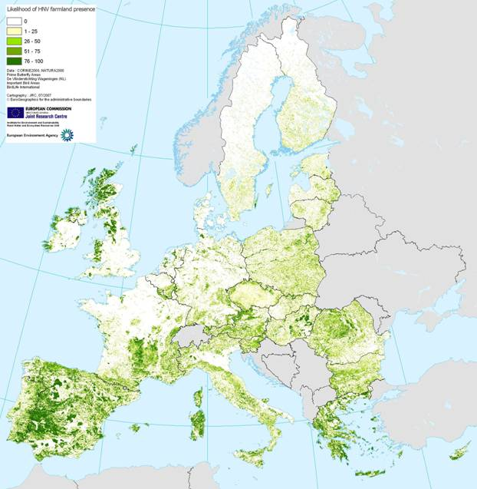
Obj 2 Figure 2: High nature value farmland areas
Target A2.1 Member States have optimised use of opportunities under agricultural, rural development and forest policy to benefit biodiversity 2007-2013
Rural Development Programmes – Planned expenditures
Rural Development Programmes (RDPs) funded under Pillar 2 of the CAP by the European Agricultural Fund for Rural Development (EAFRD) provide the principal means of supporting biodiversity protection, management and restoration measures in agricultural and forest habitats. The RDPs give Member States opportunities to support measures that aim to conserve biodiversity: under Axis 1, measures on training, information and advisory services; under Axis 2, land management and non-productive investment measures and under Axis 3, measures for the conservation and upgrading of natural heritage, which can support the drawing-up of management plans for Natura 2000 sites (depending on implementation by the Member State). The most important measures for biodiversity are primarily the ones available under Axis 2 of the EAFRD (in particular Natura 2000 payments, Agri-environment payments and Forest-environment payments), which amount to 44% (approximately EUR 42.7 billion) of total EAFRD for 2007-2013.
Therefore the proportion of Pillar 2 spending that is allocated to Axis 2 measures provides a broad indication of the degree to which Members States are using EAFRD funds to support the environment, including biodiversity. Table 1 summarises EAFRD expenditure in all approved RDPs and indicates that the budgetary emphasis placed on environmental measures varies considerably, with Slovenia, Ireland, Austria, the UK, Finland and Sweden giving a particularly high priority to Axis 2 measures. Furthermore, there does not seem to be any clear relationship between the allocation of spending on Axis 2 measures and the proportion of each Member State that is Natura 2000 designated or considered to be High Nature Value (HNV) farmland. In particular Romania, Bulgaria, Hungary and Poland have large areas of semi-natural farmland and forest habitat but less than 35% of their RDP budget allocated to Axis 2 measures. In some of these countries, such as Romania and Bulgaria, this may reflect the greater priority given to addressing socio-economic needs, although such a conclusion is bound up with considerations of the cost of delivery of biodiversity benefits (e.g. costs are likely to be higher in the EU-15 than amongst the new Member States).
Obj 2 Table 1: Planned allocation, as of January 2010, of EAFRD resources in Member States, for the period [2007-2013]
Of these four measures, agri-environment payments, account for the majority of EAFRD expenditure, with approximately 23% of RDP expenditure (roughly EUR 22.2 billion of the EAFRD across all Member States). But there is considerable variation in the proportion spent amongst the Members States. Sweden allocates the greatest proportion of RDP expenditure to this measure (48.4%), with Austria, Belgium, Denmark, Finland, Ireland and the UK each allocating in excess of 30% of expenditure. At the other extreme, 8 Member States allocate less than 20% of their RDP budgets to the agri-environment measure, including Member States with large areas of Natura 2000 and other areas of High Nature Value farmland, such as Bulgaria, Portugal, Greece, Spain and Romania.
Budget allocations for the other three Axis 2 measures that may provide substantial biodiversity benefits are small in all Member States and absent in many. In particular, allocations for dedicated Natura 2000 measures (agriculture and forest) are very low, 0.62% of total EAFRD expenditure, approximately EUR 590 million. These measures were included in the Rural Development Regulation in order to support conservation management on Natura sites and the implementation of the Water Framework Directive (WFD). In total, the measure for Natura 2000 payments for agricultural land will be used in 14 Member States, with an allocated EAFRD expenditure of EUR 488 million. Slovenia and Ireland are the only countries that allocate a substantial proportion of their budget to such Natura measures. Ten Member States are expected to use Natura 2000 payments for forests with an EAFRD allocation of approximately EUR 102 million. The most public money allocated to this measure is in Estonia, which planned to spend EUR 25 million of EAFRD resources, about 3.48% of its RDP budget.
The reason for the low allocations for dedicated Natura measures is probably because many countries have established systems for managing Natura 2000 sites that are already supported by established agri-environment schemes (e.g. UK). Another important reason is the fact that in many Member States uptake of Natura measures is constrained by a lack of management plans for Natura 2000 sites. However, some of the Member States concerned are taking up the opportunity of supporting the drawing up of site management plans under Axis 3 measures (i.e. "conservation and upgrading of the rural heritage").
Rural Development Programmes – Actual expenditures
Information on each Member State’s actual expenditure on Natura 2000 (including forests), agri-environment and forest environment payments is provided in Table 2. This also indicates low levels of Natura 2000 and forest environment expenditure but substantial agri-environment expenditure levels.
Obj 2Table 2: Actual cumulative EAFRD payments (million EUR) in Member States for the period 2007 to 2008 and as percentage of EAFRD payments to total 2007-2013 commitments
Increased modulation rates
As a result of the CAP Health Check in 2008 levels of compulsory modulation (i.e. the transfer of CAP funds from Pillar 1 direct payments and market measures to Pillar 2 measures) have risen for all Member States with different set-off date for new Member States. The final agreement allows for a doubling in the rate of modulation to 10% by 2013 for all farms receiving more than EUR 5,000 per annum in direct payments, with a higher rate of 14% for those farms receiving over EUR 300,000, with the additional funds requiring national co-financing at 25% (and 10% in convergence areas). This has released additional funds for Pillar 2 measures across much of Europe, although not the UK or Portugal. Member States are allowed to use the new modulated funds to address the new challenges of: biodiversity, climate change, renewable energies, water management support for the dairy industry. Following the revision of RDPs since the 2008 Health Check, 31% of the additional modulation has been allocated to biodiversity by Member States, largely via additional funding allocations to agri-environment measures.
However, national data on the allocation of the additional financing made available to Member States for their Rural Development Programmes as a result of the 2008 CAP Health Check and the European Economic Recovery Package (EERP) indicates that there are significant differences between Member States in their use of the funds for biodiversity purposes (Table 3). Biodiversity is the main focus (over 30%) of the additional funding in Member States such as Slovakia, Spain, France, the UK, Cyprus and Ireland. In contrast, biodiversity has not been prioritised by the majority of new Member States, with eight of the twelve not using the additional funds to target biodiversity at all.

Obj 2 Table 3: The amount and percentage of funds generated by additional rates of modulation arising from the CAP Health Check that have been allocated to biodiversity.
Note: Figures above present the overall distribution of the funds as a result of the Health Check of the Common Agriculture Policy - CAP (including voluntary modulation and the additional funds for Germany and Sweden) and the European Economic Recovery Plan (EERP) taken together. Numbers have been rounded to the first figure after the decimal by official sources.
Source: European Commission.
http://europa.eu/rapid/pressReleasesAction.do?reference=IP/10/102&format=HTML&aged=0&language=EN&guiLanguage=en

Less favoured areas
In addition to the measures described above, the less favoured area (LFA) measure may provide some biodiversity benefits where it supports traditional low intensity farming systems that maintain certain semi-natural habitats and other high nature value farmland.

Non productive investments measures for agriculture and forestry areas
Two other measures under Axis 2 may also provide important biodiversity benefits: the non-productive investment measures for agriculture and for forests. These measures are sometimes used to provide one-off capital grants, e.g. for habitat restoration works.
Agricultural cross-compliance
Beneficiaries of CAP payments must comply with a range of requirements and standards, or risk reductions in or cancellations of their payment. There are two sets of requirements that must be complied with under cross-compliance. Firstly, the ‘Statutory Management Requirements’ (SMR), which are derived from 18 items of EU legislation in the areas of the environment, public health, plant health and animal health and welfare, including requirements related to the Birds and Habitats Directives. Secondly, the standards that set the framework for Good Agricultural and Environmental Condition (GAEC). This framework directs Member States to introduce standards to address soil erosion, soil structure, soil organic matter and the minimum maintenance of habitats.
The SMR and GAEC standards provide broad baseline coverage, mandatory for all farmers receiving direct payments and most of the area-related rural development payments.
In the “Health Check” of the CAP, adopted in 2008, the GAEC were amended. The standard on the retention of landscape features was specified to give more precise examples of features important for biodiversity. A new optional GAEC standard was introduced to favour the establishment and/or retention of habitats. In addition, the new compulsory standard on the establishment of buffer strips along watercourses could also provide benefits for biodiversity depending on the management applied on these areas. A new, optional GAEC standard specifically targeted at biodiversity protection was also introduced: establishment and/or retention of habitats. The aim of these new and revised standards is to compensate in part for abolishing set-aside.
The GAEC standards on maintenance of minimum livestock rates and appropriate management regimes and on protection of permanent pasture are important to maintain the ecological value of grasslands. The standard on retention of landscape features, such as hedgerows, ponds and trees, can provide important habitat components (e.g. breeding sites) and help to maintain ecological connectivity. Other GAEC standards include ones like measures to avoid cultivation close to watercourses (e.g. Austria and the UK), avoid cultivation, fertiliser and pesticide applications close to hedgerows (e.g. the UK), maintain crop diversity and provide for a minimum environmental surface (e.g. France), retain buffer strips along water bodies (Finland) and retain stone walls on terraced slopes (Malta).
Table 4 below indicates that most Member States have set standards for the four GAEC measures of primary importance to biodiversity, although these vary considerably amongst countries according to local conditions. However six countries, namely the Czech Republic, Denmark, Italy, Latvia, Netherlands and Sweden, have not implemented GAEC standards relating to the establishment and/or retention of habitats. Other GAEC standards relating to biodiversity often refer to soils and measures to avoid cultivation close to watercourses.
Obj 2 Table 4: Summary of Member States' progress with implementation of GAEC standards
Common monitoring and evaluation framework]
Under Council Regulation (EC) No 1698/2005 Member States are obliged to establish a Common Monitoring and Evaluation Framework to assess the impacts of their RDPs. This should include the establishment of monitoring systems for various mandatory baseline and impact indicators, which, in case of biodiversity, relate to farmland bird populations, the area of HNV farming and forestry, and forest tree species composition, as well as additional programme-specific indicators. Table 5 summaries the progress made by Member States in establishing monitoring systems for these mandatory biodiversity related indicators. This clearly indicates that more progress needs to be made in terms of developing and implementing the biodiversity components of the monitoring framework. Although most countries have farmland bird monitoring systems in place or are developing them, few have established monitoring systems for HNV farmland and forestry and forest tree species composition. In December 2008, the Commission finalised a guidance document on the application of HNV indicators in the context of the evaluation of Rural Development Programmes. The aim of the document is to set out a best practice approach to applying the indicator.
Obj 2 Table 5: Summary of Member States' progress with establishing RDP monitoring systems for mandatory biodiversity related indicators according to the Common Monitoring and Evaluation Framework
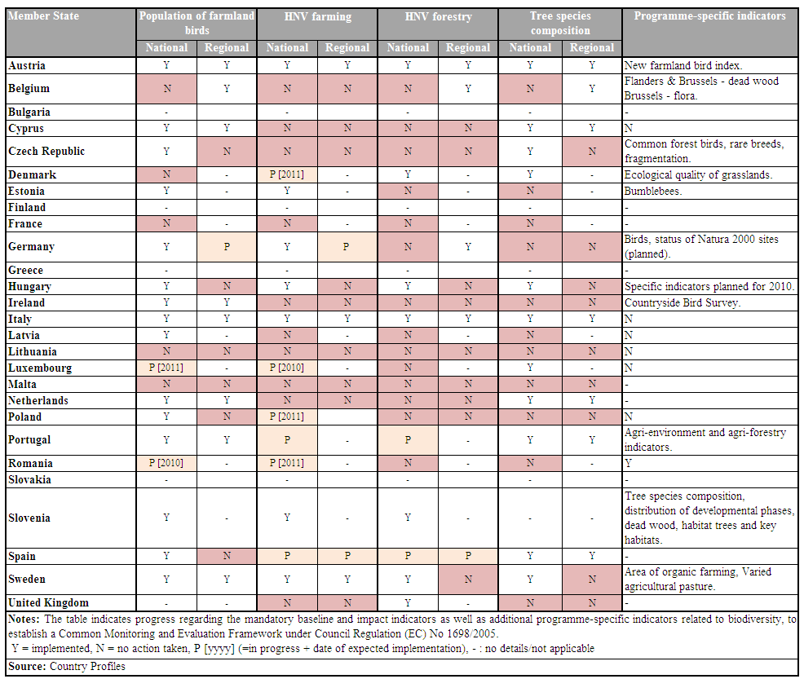
Agricultural genetic diversity
Rural Development Article 39 (1)-(4) of Regulation (EC) No 1698/2005, and Article 27 of Regulation (EC) No 1974/2006 offer the possibility to promote agri-environment measures which may support the rearing of "farm animals of local breeds indigenous to the area and in danger of being lost to farming", and the preservation of "plant genetic resources naturally adapted to the local and regional conditions and under threat of genetic erosion". Article 39(5) of Regulation 1698/2005, and Article 28 of Regulation 1974/2006 may also support the conservation of genetic resources in operations not covered by the above-mentioned measures supporting the preservation of endangered animal and plant genetic resources.
In 2008, EUR 15.7 million out of EAFRD funding spent on agri-environment were used for the preservation of local and endangered animal and plant genetic resources, and EUR 10 million for the conservation of genetic resources in agriculture.
In addition, the Community programme on the conservation, characterisation, collection and utilisation of genetic resources in agriculture, which has been established by Regulation (EC) No 870/2004, promotes genetic diversity in agriculture. The Community Programme has given rise to 17 actions, involving 179 partners located in 25 Member States and 12 non EU countries, and a total EU co-funding of EUR 8.9 million. 59% of the actions concern plant, 12% tree and 29% animal species. The actions started in 2007 and have a maximum duration of 4 years.
The recently adopted Commission Directives on the acceptance and marketing of landraces and varieties which are naturally adapted to the local and regional conditions and threatened by genetic erosion covering seed of agricultural plant species, vegetables, vegetable propagating and planting material other than seeds and fodder plant seed mixtures might contribute to the conservation and use of local varieties and thus to climate adaptation.
EU zoo technical legislation is being adapted with view to protect animal genetic resources are going on.
The need to conserve genetic diversity as well as species and habitats is now widely recognised, both in terms of its importance for wild nature and its socio-economic importance with respect to cultivated crops, domesticated livestock and commercial forestry. Table 6 therefore provides a summary of each Member States’ progress with respect to the development of national strategies and/or action plans that aim to address the conservation of genetic resources. This clearly indicates that much more needs to be done in terms of the development and implementation of conservation strategies and actions for genetic diversity. Indeed, 15 Member States have either indicated that they have not completed a national strategy or action plan for genetic diversity or have not indicated if they had.
The Member States’ responses did indicate that many are taking practical measures to conserve genetic diversity in situ, such as through RDP schemes that support the conservation of traditional breeds of livestock or varieties of fruit etc. However, the supplied data were not sufficiently representative to enable an informative and reliable comparative assessment.
Ob 2 Table 6: The development of national strategies and/or action plans that address the conservation of genetic resources in the EU27
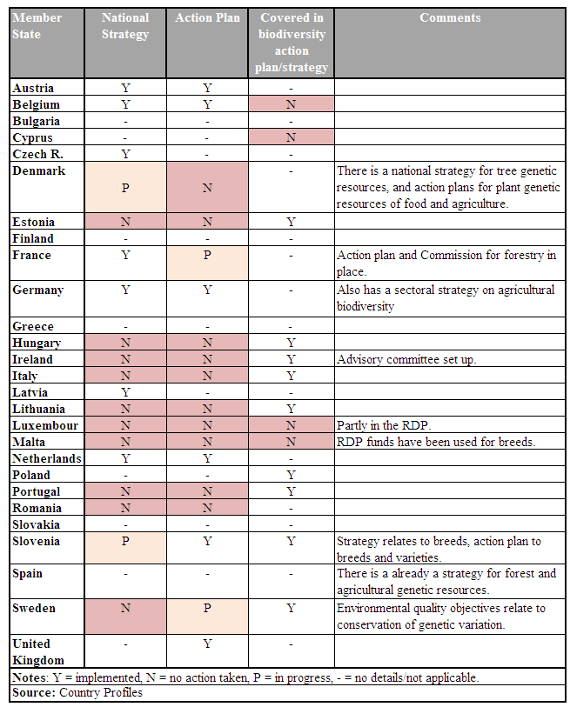
Afforestation / deforestation policies and biodiversity
Fifteen Member States out of the 22 that responded to the questionnaires indicated that they have national or sub-national strategies regulating afforestation and 12 have strategies relating to deforestation plans. Most countries indicated that afforestation activities were regulated in some way, usually involving a requirement for some form of authorisation after completion of a Strategic Environmental Assessment (SEA) and Environmental Impact Assessment (EIA). Fifteen Member States indicated that EIAs are required for afforestation (6 indicated that they are not) and 16 indicated that they are required for deforestation (3 indicated that they are not). Out of those, 9 have set limits in hectares for the application of EIA for afforestation and 10 for deforestation operations. SEA, however, is less often used to regulate forestry activities as only 12 indicated that it is required for afforestation or deforestation (whilst 8 and 6 indicated that it is not required for afforestation or deforestation respectively). Thus although it may appear that forestry activities could be better regulated in some Member States, especially at large strategic scales, it is difficult to draw clear conclusions as the degree to which afforestation and deforestation possess a significant biodiversity threat in each Member State will be context specific. It should be stressed that in the case of support for afforestation in the framework of rural development policy, any first afforestation should be adapted to local conditions and compatible with the environment (not causing environmental damages) and enhance biodiversity. In case of afforestation to be done in NATURA 2000 sites it has to be implemented in accordance with management objectives of such sites.
Environment policy
Target 2.2 Risks to soil biodiversity in the EU substantially reduced by 2013
Soil protection and biodiversity
The response received from Member States relating to soil biodiversity clearly indicates that, despite its importance (e.g. in relation to general ecosystem health, erosion prevention, and agricultural production and water quality) and risks posed to soil biodiversity (see 2008 BAP mid-term assessment, soil biodiversity monitoring is in its infancy in most Member States. Only eight Member States indicated that they have national soil biodiversity monitoring programmes and only six of these assess soil fauna / microbiological conditions. Furthermore, only eight indicated that they have undertaken studies to identify suitable soil biodiversity indicators.
Obj 2 Table 7: Summary of Member States' progress with establishing monitoring programmes for soil
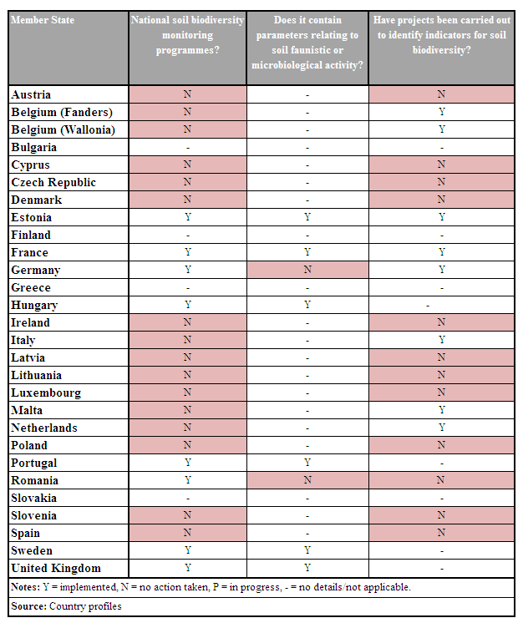
Target 2.3 Substantial progress made towards 'good ecological status' of freshwaters by 2010 and further substantial progress made by 2013
Ecological status of freshwaters
The principal measures for improving aquatic environment is the Water Framework Directive (WFD), which aims to establish a framework to protect inland surface waters, transitional waters, coastal waters and groundwater in order to prevent the deterioration of aquatic ecosystems and protect and enhance the status of aquatic ecosystems. The legal obligation is to prepare River Basin Management Plans and programme of environmental measures for each river basin district by 22 December 2009 and to put in place measures to achieve the ‘good status’, including ‘good ecological status’ of all freshwaters as a rule by December 2015.The adoption of river basin management plans is still in progress in some Member States. Between December 2009 and March 2010, adoption and submission of the River Basin Management Plans by Member States to the Commission was required. The Commission is in the process of carrying out the full assessment of the Plans. These should aim at complying with the obligation to achieve good ecological status of waters by 2015.
Under the 'Common Implementation Strategy for the Water Framework Directive' a new work programme has been adopted for 2010-2012 for the implementation of the Water Framework Directive.
Figure 3 below indicates that some significant improvements in freshwater quality have been achieved in European rivers and lakes in recent decades, before the development of the WFD. Nitrates and especially phosphates (which are mainly derived from agriculture and domestic sewage) are key nutrients that lead to the eutrophication of freshwaters and potentially serious disruption of aquatic ecosystems. However, the nitrate concentrations have declined by about 10% in rivers since 1992 and by 15% in lakes (although concentrations are much lower in lakes). This is largely due to declines in nitrogen pollution from agricultural activities, in part in response to the EU Nitrates Directive. These improvements have not however been mirrored in groundwater, where nitrates tend to be retained and therefore accumulated.
Similarly, phosphorous concentrations have declined considerably, as a result of legislation requiring improvements in waste water treatment, such as the Urban Waste Water Treatment Directive. Consequently, levels of phosphorous concentration in rivers have almost halved since 1992. But levels in lakes have remained almost constant, largely because phosphorous remains bound to sediments and therefore is retained within lake ecosystems unless proactive actions are taken to remove it. Further measures are also necessary to reduce phosphate inputs from agriculture as they remain high in many areas, e.g. as a result of nutrient-rich or silty runoff from farmland. However, recent data are not currently available and therefore trends after 2006 are unknown.
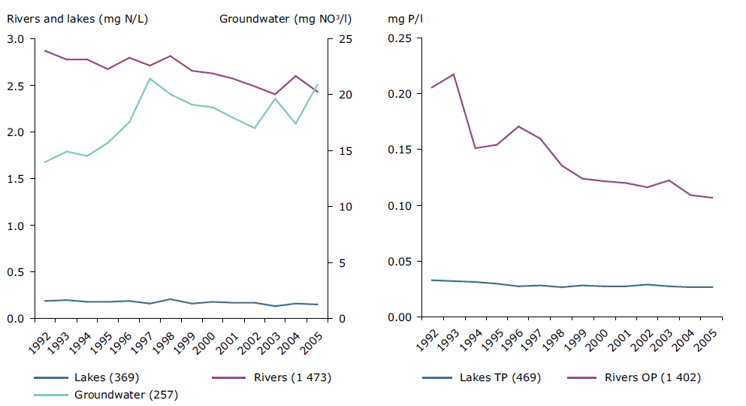
Obj 2 Figure 3: Concentrations of nitrate (left) and phosphorous (right, OP (orthophosphate) or TP (total phosphorous)) in European freshwater bodies in the period 1992-2005
Note: These graphs do not include data from all European countries, data from most southern European countries are missing. Country coverage (the number of stations included per country is given in parenthesis):
Nitrate in groundwater: Austria (14), Belgium (25), Bulgaria (63), Denmark (3), Estonia (5), Finland (38), Germany (9), Great Britain (29), Hungary (18), Ireland (3), Latvia (2), Liechtenstein (1), Lithuania (7), Netherlands (9), Norway (1), Poland (3), Portugal (3), Slovenia (5), Slovakia (10), Spain (1), Sweden (3).
Nitrate in rivers (countries with an asterisk reported total oxidised nitrogen): Austria (145), Belgium (23), Bulgaria (82), Czech Republic (70), Denmark* (39), Estonia (53), Finland* (131), France (287), Germany (125), Great Britain* (139), Hungary (98), Lithuania (64), Luxembourg (3), Latvia (47), Netherlands* (9), Norway (10), Poland (104), Slovenia (24), Slovakia (52), Sweden* (113).
Nitrate in lakes (countries with an asterisk reported total oxidised nitrogen): Estonia (5), Finland (21), Germany (6), Great Britain (21), Hungary (16), Lithuania (8), Latvia (8), Netherlands* (7) Norway (92), Slovenia (4), Sweden* (181).
Orthophosphate in rivers: Austria (134), Belgium (26), Bulgaria (64), Czech Republic (65), Denmark (40), Estonia (53), Finland (116), France (241), Germany (133), Great Britain (69), Hungary (98), Latvia (47), Lithuania (64), Norway (10), Poland (100), Slovenia (23), Slovakia (6), Sweden (113).
Total phosphorus in lakes: Austria (5), Denmark (23), Estonia (5), Finland (207), Germany (7), Great Britain (18),
Hungary (10), Ireland (7), Latvia (8), Lithuania (7), Netherlands (7), Sweden (165).
Source: EEA http://www.eea.europa.eu/highlights/publications/progress-towards-the-european-2010-biodiversity-target/
Biological assessment methods
Although the monitoring of pollutants such as nitrates and phosphates is essential and provides an indicator of key pressures on aquatic ecosystems, biological indicators provide a more integrated and meaningful assessment of the status of an ecosystem. Work is therefore being carried out to develop biological indictors and assessment methods for water bodies in accordance with the needs of the WFD. As Table 8 shows, some progress is being made on this, but much more needs to be done.
Obj 2 Table 8: Overview of development of biological assessment methods in the Member States for all water categories
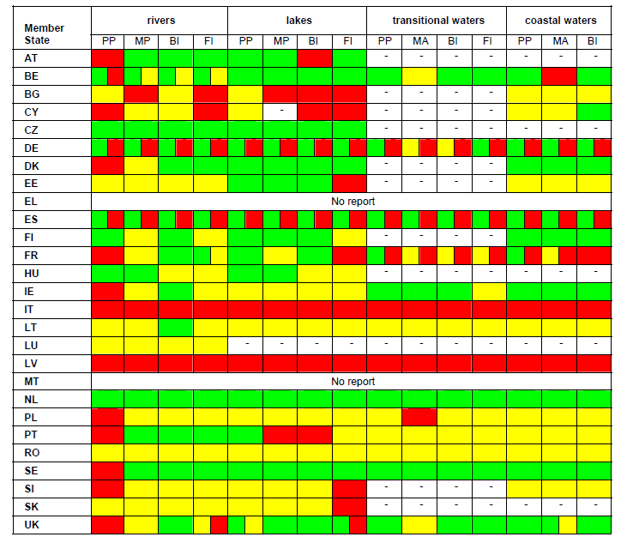
Note: PP = phytoplankton, MP = macrophytes and phytobenthos, BI = benthic invertebrates, FI = fish fauna, MA = macro-algae and angiosperms. Green: Method available. Yellow: Method under development or information incomplete. Red: Method not developed or no information available. Green/Yellow: Differences in river basin district: methods partially available, partially under development or incomplete Yellow/Red: Differences in river basin district: methods partially under development, partially not developed or no information. Green/Red: Differences in river basin district: development of methods shows complete range from developed to undeveloped
Source: 2nd report from the Commission to the European Parliament and the Council in accordance with article 18.3 of the Water Framework Directive 2000/60/EC on programmes for monitoring of water status (April 2009)
http://ec.europa.eu/environment/water/water-framework/implrep2007/pdf/sec_2009_415_en.pdf
Target 2.4 Principal pollutant pressures on terrestrial and freshwater biodiversity substantially reduced by 2010, and again by 2013
The proposed Directive on industrial emissions that recasts seven existing Directives (IPPC Directive, the Large Combustion Plants Directive, the Waste Incineration Directive, the Solvents Emissions Directive and 3 Directives on Titanium Dioxide) related to industrial emissions into a single clear and coherent legislative instrument is to be adopted end 2010.
The IPPC Directive (2008/1/EC) requires installations falling under its scope to operate in accordance with permits including emission limit values based on the best available techniques (BAT), designed to prevent and, where that is not practicable, generally to reduce emissions and the impact to the environment as a whole. The prevention or reduction of emissions to air, water and soil should therefore be dealt with in the environmental permits issued in accordance with the IPPC Directive.
EPER is the European Pollutant Emission Register, the first European-wide register of industrial emissions into air and water. According to the EPER Decision, Member States have to produce a triennial report, which covers the emissions of 50 pollutants to be included if the threshold values indicated in Annex A1 of the EPER Decision are exceeded. From 2007, reporting is made according to Regulation 2006/166/EC concerning the establishment of a European Pollutant Release and Transfer Registers that replaces EPER.
The Commission adopted under the 'Common Implementation Strategy for the Water Framework Directive' a new work programme for 2010-2012 for the implementation of the Water Framework Directive (2000/60/EC). The recently adopted Environmental Quality Standards Directive has to be seen in the context of the Water Framework Directive. It establishes environmental quality standards for 41 dangerous chemical substances (including 33 priority substances and 8 other pollutants) that pose a particular risk (hazard and exposure) to animal and plant life in the aquatic environment and to human health. REACH (Registration, Evaluation, Authorisation and Restriction of Chemical substances) (EC 1907/2006) entered into force on 1 June 2007. The Regulation will result in assessing risks to human health and the environment of ca. 30 000 chemical substances being currently used in the EU. The Framework Directive on the Sustainable Use of Pesticides entered into force on 25th November 2009 to reduce the risks to human health and the environment from the use of pesticides. The new Directive is accompanied by a Regulation on the placing of plant protection products on the market, revising existing legislation regarding the placing of plant protection products on the market and by two additional pieces of legislation: the Regulation concerning the statistics on pesticides and the revision of the Machinery Directive.
Acidification, eutrophication and ground-level ozone exposure are the most significant threats to biodiversity in Europe resulting from air pollution. The National Emission Ceilings Directive (NECD) was therefore established to reduce emissions of the four pollutants responsible for these threats, namely sulphur oxides (SO_{x}), nitrogen oxides (NO_{x}), ammonia (NH₃) and non-methane volatile organic compounds (NMVOC). The NECD sets ceilings for each Member State for emissions within their boundaries of each of these pollutants, which must be complied with by 2010. Although, the Directive allows Member States to decide how to comply, they are obliged to provide annual reports with emissions inventories and projections to 2010, and to draw up programmes for the progressive reduction of their emissions to meet the 2010 ceilings.
The latest emission data and projections from Member States are summarised in Table x and show that some Member States have already succeeded in reducing or keeping their emissions below their agreed ceilings. Emission projections for 2010 are based on the “with measures” scenario which takes into account all currently implemented and adopted policies and measures. It is expected that the majority of Member States will further reduce their emissions of all four pollutants and are expected to comply with their 2010 SO_{x}, NH₃ and NMVOC emission ceilings. This especially refers to the EU-12 Member States, although some of them expect increases in their emissions due to future economic development.
However, many Member States are unlikely to comply with their NO_{x} ceilings. Moreover, studies of critical loads of NO_{x} and SO_{x} in relation to modelled emission and deposition projections suggest that significant areas are at risk of eutrophication (Table 9). In particular, it is clear that even if NECD ceilings are met, significant areas will be at risk from eutrophication. In fact, large areas will remain at risk even by 2020 in some Member States, even if all currently feasible reductions are achieved. Similarly, although the NECD ceilings are mostly being met for SO_{x} the modelling suggests that significant areas will be at risk of acidification in some Member States. However, the area at risk is much lower than that at risk of eutrophication and the impacts of implementing all feasible measures would be much more effective, reducing areas at risk in most countries to no more than a few percent.
Obj 2 Table 9: Comparison of Member States’ emission ceilings with Member States’ current emissions and ‘with measures’ projections by 2010
Obj 2 Table 10: Percentage of natural ecosystem area at risk of eutrophication (left) and of acidification (right) in each EU Member State in 2000 and for two emission scenarios: current legislation (CLE) in 2010 and 2020, maximum feasible reductions (MFR) in 2020
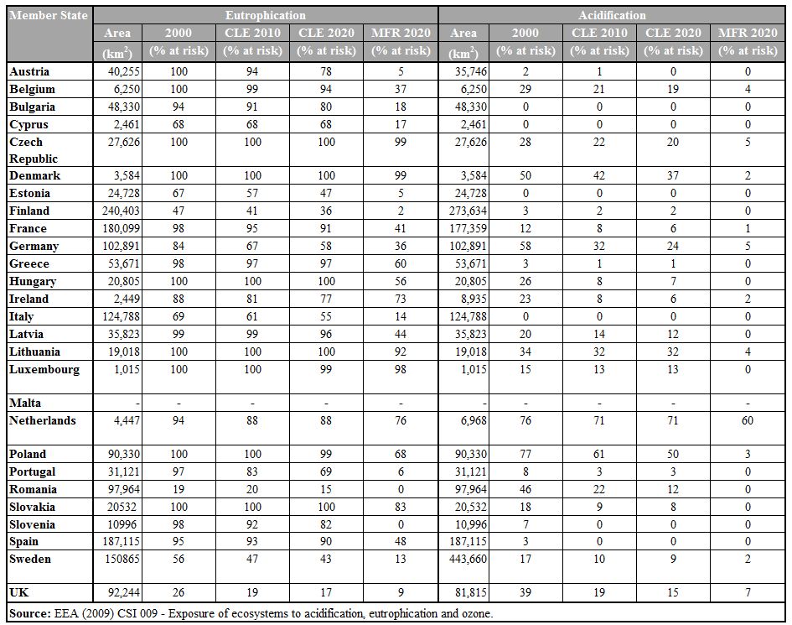
Obj 2 Figure 4: N-balance per ha of agricultural land
Source: OECD, 2008
A nutrient balance describes the difference between all nutrient inputs and outputs on agricultural land. A positive balance or surplus reflects inputs that are, in excess of crop and forage needs, and can result in the loss of nutrients to water bodies, decreasing their quality and promoting eutrophication. Surplus nitrogen can also be lost to air as ammonia and greenhouse gases.
All European countries exhibit a nitrogen surplus, though overall agricultural nitrogen surpluses declined (Figure 13), potentially reducing the environmental pressures on soil, water and air. The adoption of nutrient management plans and environmental farm plans has had a key role in this reduction. It is, however, important not only to consider rates of surplus decline, but the absolute value too.
Target 2.5 Flood risk management plans in place and designed in such a way as to prevent and minimise biodiversity loss and optimised biodiversity
Flood Risk Directive as basic legal measure has been adopted in 2007. The first milestone will be the preliminary flood risk assessment (for 2011), to be followed by the preparation of flood hazard maps and flood risk maps (for 2013). The implementation of the Directive is supported by an expert working group established and information exchange on different topics in relation to implementation of this Directive is going on with thematic workshops organised.
Flood risk management plans are to be developed by 2015 for each river basin also in line with the implementation of Water Framework Directive. Certain aspects of flood risk management are also foreseen to be considered in the first river basin management plans.

Objective 3. To conserve and restore biodiversity and ecosystem services in the wider EU marine environment.

Headline target: In wider marine environment (outside Natura 2000 network), biodiversity loss halted by 2010 and showing substantial recovery by 2013

A. Context
EU fisheries and aquaculture have had damaging impacts both on commercially harvested fish stocks, and on non–target species and habitats. While recent years have seen progress in integrating biodiversity into fisheries policy, it is too soon to judge effectiveness and 88% of Community stocks are still being fished beyond Maximum Sustainable Yield. However, the reformed Common Fisheries Policy (CFP), when fully implemented, will reduce fishing pressure, improve the status of harvested stocks and better protect non-target species and habitats. The adoption of the Marine Strategy Framework Directive (2008/56/EC) and different regulations, strategies on water pollutants has strengthened the conservation of marine environment.

B. Progress assessment
Headline target: In wider marine environment (outside Natura 2000 network), biodiversity loss halted by 2010 and showing substantial recovery by 2013
A multispecies fishery can be assumed to be unsustainable if the mean Trophic Level of the species it exploits keeps declining. The decline in Mean Trophic Index (MTI) is happening at different rates in different seas and four European seas have shown no overall changes in their MTI since 1950. A more thorough analysis of the individual fisheries is required to assess causes of declines and specific effects on the wider marine ecosystems.
Most preferred fish catches consist of large, high value predatory fish, such as tuna, cod, sea bass and swordfish. The intensification of fishing has led to the decline of the stocks of these large fish, which are high up in the food chain. As predators are removed, the relative number of small fish and invertebrates lower in the food chain tends to increase and the mean trophic level (i.e. the mean position of the catch in the food chain) of fisheries landings goes down. The mean trophic level of a species is a calculated value, which reflects the species abundance balance across a trophic range from large long-living and slow-growing predators to fast-growing microscopic primary producers. It is therefore a reflection of the biodiversity status of the system. It is derived by assigning a numerical trophic level to selected taxa, established by size, diet or nitrogen isotope levels.
Thus, the MTI describes a major aspect of the complex interactions between fisheries and marine ecosystems and communicates a measure of species replacement induced by fisheries. What is most important in the MTI is the trend, rather than the specific value.
In the majority of European seas, the Marine Trophic Index (MTI) has been declining since the mid-1950s, which means that populations of predatory fishes decline to the benefit of smaller fish and invertebrates.
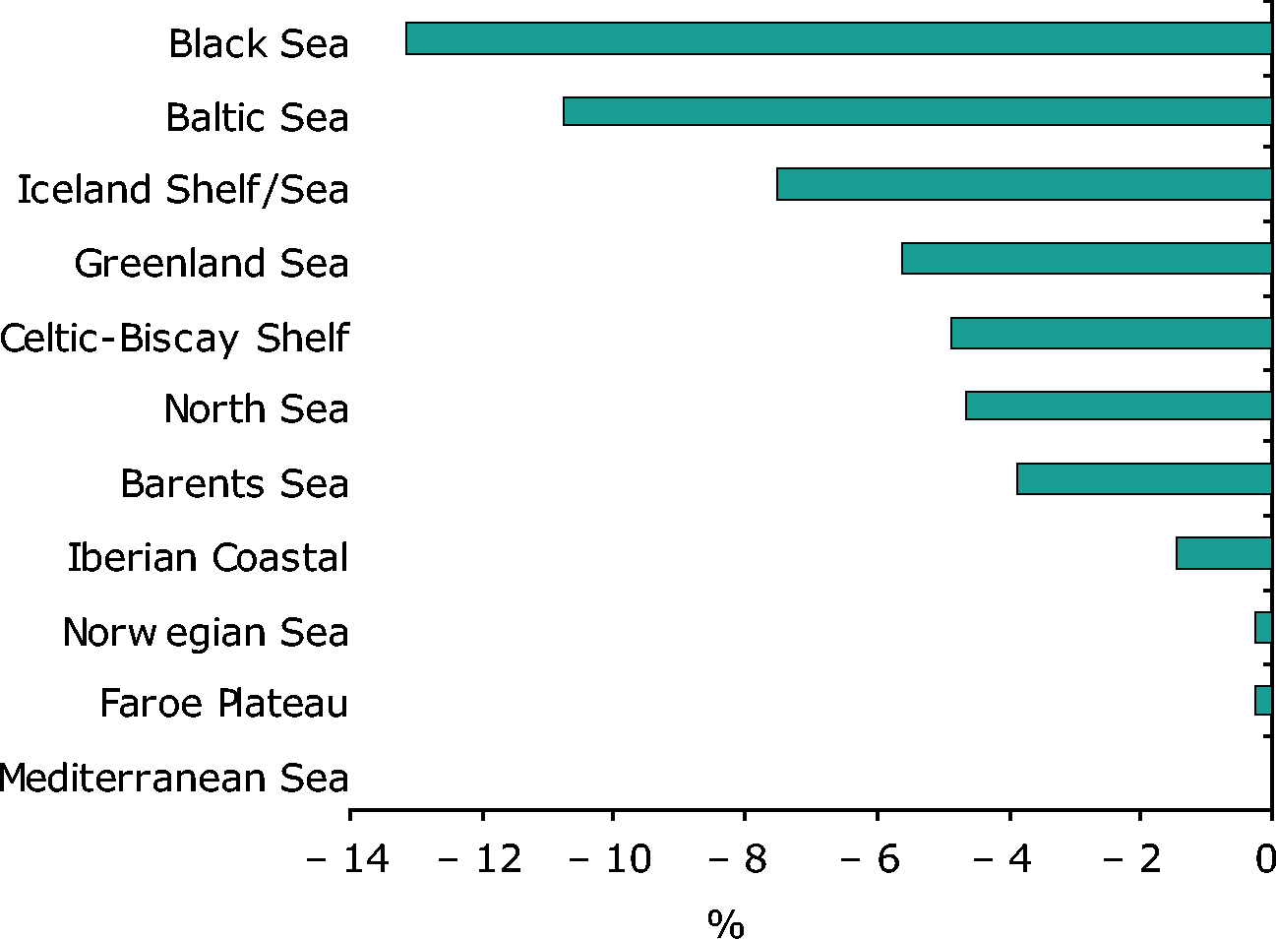
Obj3 Figure 1: Percentage change in Marine Trophic Index 1950-2004. Data source: Marine Trophic Index for EEZs and LMEs, Sea Around Us Project. Reproduced from SEBI012-Marine trophic index of European Seas (May 2010)
Some improvements of this indicator (calculating an MTI using commercial landings and existing lists of trophic level of adult fish by species) as well as supplementary indicators have been suggested.
Pursuant to the Marine Strategy Framework Directive (Art. 8) the EU requires that by mid-2012 the Member States should make an integrated 'initial assessment' of the environmental situation of their marine waters. However it is noted that MTI has been presented by marine basin rather than Member State since a number of States border each sea/basin, and the fish within the basin are not confined to national boundaries.
Target 3.1 Substantial progress achieved by 2010 towards 'good ecological status' of the marine environment
Habitat Conservation status
Target 3.1 of the Biodiversity Action Plan requires progress in ‘good ecological status’ of the marine environment. Assessments are undertaken in accordance with Article 17 of the Habitats Directive under which a range of marine and coastal species (Annex II) and habitat types (Annex I) are protected, some of which require further protection under Natura 2000.
Information provided by Member States during the Article 17 reporting period 2001-2006 has been aggregated to show habitat and species status by biogeographic region, since the habitats and species contained within are not confined by political boundaries.
Marine Habitats
Of the four European marine biogeographic regions, the Marine Atlantic biogeographic region has the smallest proportion of habitats with a ‘Favourable’ status (6%). It also has one of the largest proportions of ‘Unknown’ habitat statuses (41%). In contrast, the Marine Baltic has one of the highest proportions of habitats with a ‘Favourable’ status (35%) and the smallest proportion of ‘Unknown’ habitats (13%). The conservation status of the Marine Mediterranean biogeographic region falls between the Atlantic and Baltic, with 15% of its habitats assessed as ‘Favourable’ and 32% of its habitats assessed as ‘Unknown’. Interestingly, all three of these marine biogeographic regions have a similar proportion of ‘Unfavourable’ habitats (when Unfavourable-Inadequate and Unfavourable-Bad are combined: Marine Atlantic, 52%; Marine Baltic, 52%; and, Marine Mediterranean 53%). Of the six habitats in the Marine Macaronesian/Atlantic region, half had a ‘Favourable’ status and half had an ‘Unknown’ status.
Obj3 Figure 2: Proportions of marine habitat conservation status by marine biogeographic region 2000-2006 (Numbers in parentheses refer to the number of marine habitats asssessed in each biogeographic region). Source: EIONET habitats report
Member States with the highest proportions of ‘Favourable’ marine habitats in each of the marine biogeographic regions include:
- Marine Atlantic: Belgium (1 of 1);
- Marine Baltic: Estonia (3 of 3), Lithuania (1 of 1), Latvia (2 of 2) and Poland (2 of 3);
- Marine Mediterranean: UK (1 of 2); and
- Marine Macaronesian/Atlantic: Portugal (3 of 4).
Member States with the highest proportions of ‘Unfavourable’ marine habitats (when Unfavourable-Inadequate and Unfavourable-Bad are combined) in each of the marine biogeographic regions include:
- Marine Atlantic: Denmark (3 of 3), France (4 of 4), Ireland (3 of 4), Netherlands (2 of 2) and Sweden (3 of 3);
- Marine Baltic: Denmark (4 of 5), Finland (3 of 3) and Sweden (3 of 3);
- Marine Mediterranean: France (5 of 5), Greece (4 of 5); and
- Marine Macaronesian/Atlantic: none.
In the Marine Atlantic, both Portugal and Spain have listed all of their marine habitats as ‘Unknown’. The UK (3) and Germany (2) also have habitats with ‘Unknown’ status. In the Marine Mediterranean, all of Spain’s five habitats assessed and four of five of Malta’s habitats have an ‘Unknown’ status. Both of Spain’s two Marine Macaronesian/Atlantic habitats are also ‘Unknown’.
Coastal Habitats
There are fewer coastal habitats than marine habitats assessed under Article 17 that have an ‘Unknown’ status. Overall, the ‘Boreal’ biogeographic region has the highest proportion of ‘Favourable’ habitats (50%) and the lowest proportion of ‘Unfavourable’ habitats (50%) (when Unfavourable-Inadequate and Unfavourable-Bad are combined). The Mediterranean biogeographic region had the lowest proportion of ‘Favourable’ habitats (15%) and the highest proportion of ‘Unknown’ habitats (25%). The Atlantic, Continental, Macaronesian and Mediterranean biogeographic regions all had similar proportions of ‘Unfavourable’ habitats with 61%, 63%, 64% and 58% respectively.
Obj 3 Figure 3: Proportions of coastal habitat conservation status by biogeographic region 2000-2006 (Numbers in parentheses refer to the number of coastal habitats assessed in each biogeographic region). Source: EIONET habitats report.
Member States with the highest proportions of ‘Favourable’ coastal habitats in each of the biogeographic regions include:
- Atlantic: France (8 of 12) and Germany (6 of 10);
- Boreal: Estonia (9 of 10) and Lithuania (2 of 2);
- Continental: Slovenia (6 of 9);
- Mediterranean: UK (1 of 1); and
- Macaronesian: Portugal (2 of 7).
Member States with the highest proportions of ‘Unfavourable’ (when Unfavourable-Inadequate and Unfavourable-Bad are combined) coastal habitats in each of the biogeographic regions include:
- Atlantic: Ireland (11 of 11), Netherlands (5 of 5), Portugal (7 of 8), UK (11 of 11);
- Boreal: Finland (7 of 10), Sweden (9 of 13);
- Continental: France (2 of 2), Germany (8 of 9), Poland (7 of 7) and Sweden (8 of 10);
- Macaronesian: Spain (3 of 4); and
- Mediterranean: France (10 of 10), Greece, (8 of 10), Malta (6 of 7) and Portugal (10 of 13).
Spain had the highest proportion of ‘Unknown’ coastal habitats, with 13 of 13 in the Mediterranean biogeographic region; 9 of 9 in the Atlantic biogeographic region and 1 of 4 in the Macaronesian biogeographic region.
Marine species
There is a very high proportion of marine species with an ‘Unknown’ or ‘Not reported’ status in three of the four marine biogeographic regions. Species with an ‘Unknown’ or ‘Not reported’ status comprise 71% of the species assessed in the Marine Atlantic, 75% in the Marine Mediterranean and 74% in the Marine Macaronesian/Atlantic. The Marine Baltic has the smallest proportion of ‘Unknown’ species with just 5%. The marine biogeographic region with the highest proportion of marine species with a ‘Favourable’ status is the Marine Atlantic, but this is just 13%. The Marine Atlantic biogeographic region also has the lowest proportion of species with ‘Unfavourable’ status (when Unfavourable-Inadequate and Unfavourable-Bad are combined) at 17%.
The Marine Baltic is the region with the highest number of ‘Unfavourable’ species at 86%.
Obj3 Figure 4: Proportions of marine species conservation status by marine biogeographic region 2000-2006 (Numbers in parentheses refer to the number of coastal habitats assessed in each biogeographic region). Source: EIONET species report.
The proportions of ‘Favourable’ species are quite low in each biogeographic region. Even for those Member States with the highest proportions of ‘Favourable’ marine species, of the total species assessed, only 50% or less have a ‘Favourable’ status. In each marine biogeographic region, this includes:
- Marine Atlantic: UK (6 of 13),
- Marine Baltic: Finland (1 of 2),
- Marine Mediterranean: Slovenia (2 of 4), and
- Marine Macaronesian/Atlantic: Spain (2 of 30).
Member States with the highest proportions of ‘Unfavourable’ (when Unfavourable-Inadequate and Unfavourable-Bad are combined) marine species in each of the marine biogeographic regions include:
- Marine Atlantic: Belgium (6 of 6), Denmark (2 of 3), Germany (2 of 3);
- Marine Baltic: Estonia (2 of 2), Germany (3 of 3), Poland (4 of 4), Sweden (4 of 4);
- Marine Mediterranean: Cyprus (3 of 4), UK (3 of 3); and
- Marine Macaronesian/Atlantic: Spain (7 of 30), Portugal (7 of 36).
The highest proportions of ‘Unknown’ and ‘Not Reported’ species in the marine biogeographic regions were: France (23/25 in Marine Atlantic), Italy (29 of 33 in Marine Mediterranean), Malta (22 of 22 in Marine Mediterranean), Netherlands (26 of 32 in Marine Atlantic), Portugal (31 of 24 in Marine Atlantic and 28 of 36 in Marine Macaronesian/Atlantic), Spain (25 of 25 in Marine Mediterranean and 21 of 30 in Marine Macaronesian/Atlantic).
Marine strategy directive
The Marine Strategy Framework Directive establishes European Marine Regions on the basis of geographical and environmental criteria and has expanded the scope of water protection to all marine areas, with the objective of good environmental status for all marine waters and improved conservation status for the EU's marine biodiversity by 2020, and an obligation for Member States to cooperate and coordinate action in shared marine regions or sub-regions, across administrative and political boundaries. A Common Implementation Strategy has been adopted, entailing the set in motion of a Strategy Coordination Working Group as well as working groups to further develop the 'good environmental status' concept and data handling and monitoring activities.
Each Member State, in close cooperation with the relevant other Member States and third countries within a Marine Region, will be required to develop Marine Strategies for its marine waters. The Marine Strategies will contain a detailed assessment of the state of the environment, a definition of 'good environmental status' at regional level and the establishment of clear environmental targets and monitoring programmes.
The recently adopted Commission progress report on the Integrated Maritime Policy consolidates the Marine Strategy Framework Directive as the environmental pillar. Moreover, the definition of the boundaries of sustainability of human activities that have an impact on the marine environment, in line with the Directive is considered one of the six strategic directions to deliver the IMP objectives.
National plans for marine environment under the Water Framework Directive (WFD)
Only 5 out of the 27 Member States are non-coastal (Austria, Czech Republic, Hungary, Luxemburg and Slovakia). Many coastal Member States have a dedicated national plan or strategy specific to the marine environment or incorporate marine environmental measures into other relevant documents. Additionally, many Member States include measures to prevent and reduce negative impacts on the marine environment caused by fishing activities through their European Fisheries Fund (EFF) Operational Programmes for the period 2007–2013 (see Target A3.4).
All of the coastal Member States are contracting parties to various regional and/or international conventions that contain further obligations aiming to protect the coastal and/or marine environment, such as the Mediterranean Action Plan (MAP, 1975), the first-ever Regional Seas Programme under UNEP's umbrella; the Action Plan for the Protection of the Marine Environment and the Sustainable Development of the Coastal Areas of the Mediterranean (MAP Phase II, 1995) that replaced MAP; the Barcelona Convention on the protection of biological diversity; the Strategic Action Plan for Protection of Biological Diversity in the Mediterranean Region (SAP BIO) adopted by UNEP-MAP in 2003; the Helsinki Convention (1992) under which the Baltic Sea Action Plan was adopted in 2007; the OSPAR Convention (1992) on the protection of the marine environment of the North-East Atlantic; the Bucharest Convention (1992) on the Protection of the Black Sea Against Pollution which adopted the Black Sea Biodiversity and Landscape Conservation Protocol (BSBLCP) in 2002, including the main objective “to halt losses of currently known threatened species and destruction of their habitats by 2010 arising from human activities in the BSBLCP area and to prevent appearance of new threatened species by human activities”.
Action A3.1.4 of the Biodiversity Action Plan requires there to be timely implementation of the Water Framework Directive (WFD) as it applies to coastal areas; and for Member States to develop, adopt and implement monitoring programmes and Programmes of Measures for coastal areas. The Water Framework Directive (2000/60/EC) includes provisions for the improvement and protection of water status including coastal waters. Member States have been required to establish surveillance and operational monitoring programmes by 2006 (Article 8) in their coastal waters including developing methods for monitoring phytoplankton, benthic invertebrates and macroalgae. An evaluation was published by the European Commission in 2009 on the monitoring programmes for coastal areas under the WFD. The majority (18 Member States) of those affected have monitoring programmes in place for coastal waters. One Member State (Lithuania) does not have a monitoring programme and two Member States are currently developing monitoring programmes (Ireland and Malta). No information was available for Greece.
Under the Water Framework Directive, Programmes of Measures are also required to be established for each River Basin District by 2009 (Article 11) and to be operational by 2012. Five out of the twenty-two coastal Member States (Belgium, France, Latvia, Sweden and the UK) have started to implement Programmes of Measures for coastal waters. One Member State (Italy) does not have a Programme of Measures. Ten Member States (Cyprus, Denmark, Estonia, Spain, Ireland, Malta, Poland, Portugal, Romania, Solvenia) are in the process of developing Programmes of Measures for coastal waters. No information was available for five Member States (Bulgaria, Greece, Finland, Lithuania, Netherlands).
Coastal zone policy
Action A3.1.5 of the Biodiversity Action Plan requires implementation and review of the EU Integrated coastal zone management (ICZM) Recommendation. The European Commission launched a contract in 2008 to support the exchange of experiences and best practices in coastal management.
In 2010, three (Sweden, Slovenia and Lithuania) out of the twenty-two coastal Member States did not have a plan or strategy. This shows an improvement since 2006 (reported in the 2008 BAP assessment) when eight countries were reported to have no strategy for ICZM (including Bulgaria, Denmark, Estonia, Ireland, Italy, Lithuania, Latvia and Sweden).
The most recent data shows that five Member States had adopted an ICZM plan (Germany, Denmark, Malta, Portugal, United Kingdom). Three Member States (Lithuania, Sweden and Slovenia) stated that no IZCM plan or strategy had been adopted. Many Member States were still in the process of developing an ICZM plan (Belgium, Cyprus, Estonia, Spain, France, Ireland, Italy, Latvia, Poland). No information was available for the five remaining Member States.
Obj3 Figure 7 Number of MS that have developed, adopted and implemented a national ICZM plan or strategy.
Target 3.2 Principal pollutant pressures on marine biodiversity substantially reduced by 2010
Marine Pollution
The Marine Strategy Framework Directive includes pollutants, eutrophication and acidifying pollution and toxic chemicals.
The original EU Bathing Water Directive (76/160/EEC) was adopted in 1976. In 2006 a new Bathing Water Directive (2006/7/EC) was adopted and will repeal the earlier Directive by 2014 at the latest. Both Directives are currently in application. Bathing waters covered by the Directive are either coastal or inland waters that are traditionally utilised by a large number of people and must be explicitly authorised (or not prohibited) from use. Swimming pools and waters for therapeutic purposes are not covered. To ensure good bathing water quality, the EU has set limits for microbiological parameters. Member State authorities must test the bathing waters which are then classified into categories.
According to the EEA report ‘Quality of Bathing Water: 2008 Bathing Season’, 97.4% of EU coastal bathing waters met the minimum mandatory compliance standards. This compares to 91% in 2007 and 96.6% in 2008; and represents an overall significant improvement over the past decade. The report also indicated that 76.4% of bathing waters reached the stricter guideline standards in 2008 with 16 countries above the EU average and only Germany, UK, Poland, Estonia, Belgium and Romania falling below average.
Obj3 Figure 8: Coastal Bathing Water Quality: EU Average 2006–2008.
Winter oxidised nitrogen and orthophosphates have been monitored within coastal and open seas throughout Europe as another indicator of marine pollution. In general nitrogen concentrations have remained the same over the monitoring period (1995–2005) with some small changes mainly in the Baltic and North Sea. Orthophosphate concentrations have also remained stable in most areas, but have shown some increases again mainly in the North Sea and Baltic Sea. However there have also been areas in all regions where concentrations have decreased. There has been no update of data since 2005 so it is not possible to draw conclusions on trends after the given period.
Obj3 Figure 9: Changes in winter orthophosphate concentrations in coastal and open waters per Regional Sea, 1995–2005.
Other directives and EU strategies on different sources of pollutants include measures taken to promote the protection of coastal and marine environment together with regulations on terrestrial areas (see Objective 2 Target A2, in particular targets to reduce principle pollutant pressures on terrestrial and freshwater environments by strengthening action on Integrated Pollution Prevention and Control; and reducing airborne eutrophication and acidification through emission ceilings).
The European Union established the European Maritime Safety Agency (EMSA) (1406/2002/EC) to strengthen its role in the field of maritime safety and pollution by ships. This Agency provides technical and scientific assistance to the Commission and Member States on related matters and fulfils tasks on responses to oil pollution.
Target 3.3 Ecosystem approach to the protection of the seas in place and implying fisheries management measures no later than 2016
Ecosystem approach within Operational Programmes
The Commission's Communication of April 2008 to the Council and the European Parliament emphasised the need to integrate the ecosystem approach into the Common Fisheries Policy.
National Fisheries Operational Programmes do not explicitly state if they apply the ecosystem based approach, but in 2010, protection of aquatic fauna and flora is included within funding of Axis 3 in 17 out of 26 Member States (see Target 3.4). Related measures include the protection or restoration of spawning grounds, improved fishing gear selectivity, the creation of artificial reefs or the reduction of invasive species. 17 out of the 22 coastal Member States also include measures to reduce the impact or improve selectivity of fishing gear within Axis 1 of their Operational Programmes (see Target A3.4).
Target 3.4 Substantially enhanced funding provided to environmentally-friendly fisheries management from 2007 onwards
European Fisheries Fund
The European Fisheries Fund (EFF, 2007–2013) is designed to secure a sustainable European fishing and aquaculture industry. Assistance under the EFF shall aim to: support the Common Fisheries Policy (CFP) so as to ensure exploitation of living aquatic resources and support aquaculture in order to provide sustainability in economic, environmental and social terms; promote a sustainable balance between resources and the fishing capacity of the Community fishing fleet; promote a sustainable development of inland fishing; and foster the protection and enhancement of the environment and natural resources where related to the fisheries sector.
Under the EFF, each Member State was required to adopt a national strategic plan and submit it with the Operational Programme document. The Operational Programme (OP) is the single document drawn up by the Member State and approved by the Commission containing a set of ‘Priority Axes’ to be achieved with the aid of the EFF. Axis 1 is for measures for the adaptation of the Community fishing fleet to ensure it is in balance with available resources; Axis 2 is for measures relating to aquaculture, inland fishing, processing and marketing of fishery and aquaculture products and requires the inclusion of aqua-environmental measures; Axis 3 is for measures of common interest (e.g. collective actions, protection and development of aquatic fauna and flora; fishing ports; development of new markets etc.); and Axis 4 is for actions that support the sustainable development of fisheries areas.
Within these Axes are objectives and measures, some of which promote environmentally-friendly fisheries. For example, under Axis 1 some countries have included objectives for improvement of selectivity, reducing the impact of fishing on non-commercial species, reducing the overall fishing capacity, and reducing the impact of fishing on ecosystems and the sea bottom. 18 out of the 22 coastal Member States have measures to reduce the impact or improve selectivity of fishing gear, including: Belgium, Bulgaria, Cyprus, Denmark, Germany, Estonia, Greece, Finland, Spain, France, Italy, Lithuania, Malta, Poland, Portugal, Romania, Sweden the UK. Within Axis 2, 21 out of 25 Member States have included measures to promote environmentally-friendly methods of aquaculture (see Target 3.5). Within Axis 3, 17 out of 26 Member States have actions to protect aquatic flora and fauna (Belgium, Bulgaria, Cyprus, Czech Republic, Germany, Estonia, Spain, France, Hungary, Italy, Latvia, Lithuania, Malta, Portugal, Romania, Sweden and the UK). About half of the coastal Member States (Cyprus, Estonia, Finland, France, Italy, Lithuania, Latvia, Poland, Portugal, Sweden, Slovenia and the UK) have also included diversification of activities within Axis 4 to support reduction in fishing capacity.
Due to the structure of data collection on funding under EFF, it is not possible to give exact figures on EFF funds allocated to biodiversity and Natura 2000 purposes. The only available information concerns the total allocation of the EFF plus the national public contribution for each Priority Axis, and the total annual commitment of the EFF in the operational programme. Obj3 Figure 9 provides details on funding for Axes 1–4.
Obj3 Figure 10: European Fisheries Total Funding Axis 1 – 4: Member State and EU contributions
Target 3.5 Stock levels maintained or restored to levels that can produce maximum sustainable yield, where possible no later than 2015
Stock levels in relation to safe biological limits
The Green Paper on the CFP reform recognised the failures of implementation that led to the state where 88% of Community stocks are being fished beyond Maximum Sustainable Yield and 46% outside safe biological limits, which means the stocks may not recover. Many of these commercial fish stocks in European waters are still outside safe biological limits.
Restoration programmes for diadromous species
Diadromous fishes are species that use both marine and freshwater habitats during their life cycle. These include certain species of salmon, trout, sturgeon, and eels. Because of their vast migration distances, conservation measures of these species need to cover both targeted fishing for the species and river management issues like dam construction and fish passes.
Currently, it is known that 14 out of 27 Member States have a management plan for at least one diadromous species. This is an improvement from 12 Member States in 2008. In some countries there might not be any natural habitats for diadromous species.
Obj3 Figure 12: Number of Member States with restoration plans for diadromous species
A total of nine Member States had management plans for salmon in 2010, the same as in 2008 (Czech Republic, Denmark, Germany, Estonia, France, Ireland, Lithuania, Sweden and the UK). This includes national obligations under regional management plans. The Baltic Sea Regional Advisory Council (BSRAC) recently published recommendations for a renewal of the Salmon Action Plan started by the IBSFC in 1997. However, not all stocks are managed through regional cooperation. In Ireland, salmon are managed under advice from a National Salmon Commission and a detailed system for the management of stocks is administered through the Wild Salmon and Sea Trout tagging scheme. In the case of some of the Member States it is unclear whether they have a management plan for salmon (Bulgaria, Greece, Finland, Netherlands, Romania and Slovakia).
In 2010, six Member States had management plans for diadromous species of trout (Austria, Czech Republic, Germany, Denmark, France and Lithuania). A total of 12 Member States did not have management plans for trout and for 12 Member States the situation is unclear. Trout populations are not recorded in Cyprus or Malta.
Germany and the Czech Republic have management plans for sturgeon, and there is one in development for France. A further 14 Member States do not have any management plans for sturgeon and for 7 the situation is unclear. Romania, for example, banned sturgeon fishing for ten years starting from April 2006 and has forbidden trading of wild sturgeon caught in Romania. However, there is no information on whether they have a management plan for restoring sturgeon populations. Sturgeon is not recorded in Cyprus, Malta and Sweden.
According to the EU regulation on eel protection Member States are obliged to identify and define individual river basins (including maritime waters) within their national territory that constitute natural habitats for the European eel (Anguilla anguilla), prepare Eel Management Plans for each eel river basin to reduce anthropogenic mortalities, with a view to bringing the eel population up to at least 40% of the size that is estimated to have been had there been no human influence. The Plan must also include an intended time scale to achieve this. Member States are exempt from preparing such a plan if they do not have any natural habitats for European eel. A total of 12 Member States have prepared Eel Management Plans and submitted them for approval to the European Commission (Belgium, Czech Republic, Germany, Denmark, Estonia, France, Lithuania, Luxembourg, Poland, Portugal, Sweden and the UK). Italy has a plan in development. Five Member States have not developed a plan and it is unclear for seven Member States whether they have one in place. Such plans are not relevant for Cyprus and Malta where Eel populations have not been recorded.
Other species of diadromous fish for which management plans exist include houting (Coregonus oxyrhynchus) in Denmark; Alosa sp in Germany; and Alosa alosa, Alosa fala, Lampestra fluviatis and Petromyzon marinus in France.
In addition a number of Member States have undertaken actions that support diadromous species for example: the restoration of rivers; removal of migratory barriers and stocking of rivers. 17 Member States have undertaken at least one of these activities including Austria, Belgium, Czech Republic, Denmark, Germany, Estonia, Spain, France, Ireland, Lithuania, Luxembourg, Latvia, Portugal, Poland, Romania, Sweden and the UK.
Obj 3 Figure 13: Number of Member States undertaking actions to promote diadromous species

Common Fisheries Policy in the Maritime Policy
The Common Fisheries Policy (CFP) is designed to improve the balance between fishing capacity and available resources. The aim of the CFP is to secure the future of the EU fisheries sector by ensuring sustainable fisheries. Member States have agreed a series of multi-annual guidance programmes (MAGP), aimed at reducing the EU fishing fleet’s capacity to levels more in line with the opportunities to catch fish. These programmes operate by setting targets for each Member State for their individual fishing fleets. The exact measures set out in the programmes for reductions in fleet capacity have become more and more complex with each programme and include targets related to total tonnage and engine power and for the reduction of fishing effort for individual specific fisheries as well. Quotas are set yearly for each fleet, on the species and sea region they are allowed to fish.
In 2004, when data were first available for all 27 Member States (excluding those without a coastline), total EU fishing capacity was 91,332 vessels, falling by 5.4% to 86,413 in 2008, and in terms of tonnage, 2,106,001 tonnes in 2004 falling by 11% to 1,869,822 tonnes in 2008. The country with the greatest fishing capacity is Spain with 458,520 tonnes in 2008, and Slovenia has the least (983 tonnes in 2008). 18 out of the 22 coastal Member States include measures within their fisheries Operational Programmes to reduce fishing capacity. For example 14 coastal countries have had either had a decommissioning scheme between 2004 and 2010 or have a scheme ongoing (Cyprus, Denmark, Estonia, Greece, Spain, France, Ireland, Italy, Lithuania, Latvia, Netherlands, Sweden, UK and Romania).
Fishing capacity measured in terms of the tonnage has fallen in all countries between 2004 and 2008 apart from Bulgaria and Germany.
Obj3 Figure 14: Percentage change in fishing capacity by Member State, 1999–2008 and 2004–2008
Technical workshops on Marine Protected Areas’ appropriateness as a management tool for the management of fisheries activities were carried out by the Commission and supported by EU experts. Measures are being introduced to protect sensitive habitats (e.g. deep sea coral reefs) and may result in no-take areas. A Council Regulation concerning management measures for the sustainable exploitation of fisheries in the Mediterranean has been adopted, chapter III of which includes fishing in protected areas.
The revised Control Regulation establishing an EU control system for ensuring compliance with the rules of the Common Fisheries Policy has set up the Community Fisheries Control Agency (CFCA) to harmonise control measures including sanctions across Member States. The regulation is designed to strengthen the current regulatory framework in order to ensure a level playing field and to develop a culture of compliance within the fisheries sector across the European Union.
The number of infringements of the CFP illustrates the degree to which the EU is achieving its plans to achieve sustainable fisheries management. In 2006 there was an average of 11% serious infringements of the CFP as a proportion of number of vessels, with nine Member States falling above this average (Ireland, Netherlands, Slovenia, Cyprus, Spain, Poland, Portugal, France and Belgium).
Obj3 Figure 15: Number of serious infringements of the CFP as a percentage of number of vessels by Member State
A specific illegal, unreported and unregulated (IUU) regulation (1005/2008) was brought into force this year (January 2010) which specifically targets the first action in the IUU strategy (preventing imports of illegal fish into the EU). It requires a new system of catch certification for consignments imported into the EC that are validated by the flag state. This validates that catches have been made in accordance with applicable laws and international conservation and management measures.
Target 3.6 Impact of fisheries on non-target species and habitats progressively and substantially reduced from 2006 onwards
Action plans and conservation status for marine species and habitats
The Community Action Plan for Sharks was adopted in February 2009. The Council welcomed the Action Plan and supported an approach to implement elements of the Plan. The Commission is working on the amendment of the finning Regulation and proposed to the Council the Total Allowable Catch (TAC) and quotas Regulation for 2010, which was adopted with a zero TAC for porbeagle and limited by-catch for spurdog.
The Commission supported the listing of several shark species in the annexes of the Convention on the Conservation of Migratory Species of Wild Animals (CMS) and Specially Protected Areas and Biological Diversity in the Mediterranean (SPA/BD) Protocol of the Barcelona Convention. Proposals are being prepared to list two shark species in Appendix II of CITES (Convention on International Trade in Endangered Species of Wild Fauna and Flora).
In 2010, 14 coastal Member States had specific monitoring programmes for seabirds (Belgium, Cyprus, Denmark, Germany, Estonia, Spain, France, Ireland, Italy, Latvia, Malta, Portugal, Sweden and the UK), two Member States did not have a monitoring programme (Poland and Slovenia) and it was not possible to determine for six Member States as no information was provided (Bulgaria, Greece, Finland, Lithuania, Netherlands and Romania). Far fewer coastal Member States have specific monitoring programmes for sharks (six in total including Germany, Ireland, Italy, Malta, Portugal and the UK). Half of the 22 coastal Member States did not have a shark monitoring programme and it was not possible to tell for the remaining Member States as no information was provided (Bulgaria, Greece, Finland, Netherlands and Romania).
Marine Natura 2000 sites
The EU has a network of marine Natura 2000 sites throughout the Member States covering a total of 167,560.60 km² (see detailed breakdown in Objective 1, A1.1), however, designation is still in process. With close cooperation of the Commission services, a set of guidelines were produced on how Member States can adapt fisheries measures within marine Natura 2000 sites that fall under the CFP to avoid fisheries’ negative impacts on these protected species and habitats. Four coastal Member States have made requests to the Commission to adapt fisheries measures within marine Natura 2000 sites that fall within EU waters: Spain, Ireland, UK and the Netherlands. The Commission is responding to these Member States’ requests regarding fisheries management measures for Natura 2000 sites on an individual basis.
Nine out of the 22 coastal Member States have made independent adaptations to fisheries measures within Marine Natura 2000 sites that fall within their own territorial waters (Belgium, Germany, Estonia, Spain, Lithuania, the Netherlands, Portugal, Sweden and the UK).
Protection of non-target species and by-catch
Type D infringements of the Common Fisheries Policy concern the use or presence of prohibited fishing gear or methods that have significant impacts on by-catch affecting the conservation status of marine species and habitats. In 2006 there was an EU average of 4% Type D infringements (as a percentage of total vessels). Member States that fell above this average were: the Netherlands, Spain, Cyprus, Poland, France, Belgium, Portugal and Italy. Unfortunately, more recent data were not available to assess whether there has been any improvement.
Obj3 Figure 16: Member State Type D infringements as a % of total vessels (2006)
Aquaculture planning and biodiversity
Priority Axis 2 of the European Fisheries Fund (EFF) relates to promoting environmentally-friendly aquaculture. The Operational Programmes of 21 out of 25 Member States describe plans for aquaculture that promote environmentally-friendly measures (Austria, Belgium, Cyprus, Denmark, Germany, Greece, Spain, Finland, France, Hungary, Italy, Lithuania, Latvia, Malta, Netherlands, Poland, Portugal, Romania, Sweden, Slovenia and the UK). Some of these specifically mention biodiversity. For example Romania takes into consideration Natura 2000 sites when developing aquaculture sites and some countries (e.g. Denmark and Germany) are supporting a move towards organic aquaculture. This is an improvement from 2008 where only 15 of the available draft Operational Programmes included promotion of environmentally-friendly aquaculture.
Target 3.7: Substantially improved information and reporting on environmental integration of the Common Fisheries Policy from 2008 onwards
Reporting of environmental integration
In 2008, the Commission established rules on the collection and management, in the framework of multi-annual programmes, of biological, technical, environmental and socio-economic data concerning the fisheries sector. Article 12 of this Regulation indicates that Member States shall carry out research surveys at sea to, amongst other things, assess the impact of fishing activity on the environment.
Pursuant to this, the Commission defined the environmental indicators for the multiannual Community programme to measure the effects of fisheries on the marine ecosystem. These indicators are: 1) Conservation status of fish species; 2) Proportion of large fish; 3) Mean maximum length of fishes; 4) Size at maturation of exploited fish species; 5) Distribution of fishing activities; 6) Aggregation of fishing activities; 7) Areas not impacted by mobile bottom gears; 8) Discarding rates of commercially exploited species; and 9) Fuel efficiency of fish capture.
Of the 22 coastal Member States, 21 have established a national programme for the collection of fisheries data for 2009–2010 that includes a module of evaluation of the effects of the fishing sector on the marine ecosystem, incorporating data collection for the environmental indicators listed above. Only Bulgaria has not established such a programme for 2009–2010, but they indicated that they would like to develop such a module for the next multi-annual programme.
There are opportunities to improve reporting of specific funding within fisheries Operational Programmes that is directed to specific environmentally-friendly measures (see Target 3.4).

Objective 4. To reinforce compatibility of regional and territorial development with biodiversity in the EU

Headline target: Regional and territorial development benefiting biodiversity, and negative impacts on biodiversity prevented and minimised or, where unavoidable, adequately compensated for

A. Context
Member States have the opportunity to support nature conservation and biodiversity through programmes integrated into their development strategies and co-financed from the Structural Funds (the European Regional Development Fund and European Social Fund), the Cohesion Fund, the European Agricultural Fund for Rural Development (EAFRD), LIFE+, and the 7th Framework Research Programme. Nevertheless, estimates of EU actual spending on biodiversity are not widely available and the best estimates on expenditure are those of the LIFE programme, which amounts to less than 0.1 % of the EU budget in any year. The nature directives and the Environmental Impact Assessment (EIA) Directive require the consideration of potential impacts of certain regional and territorial developments. This includes consideration of alternatives and the design of measures to prevent and reduce negative impacts. Careful assessments carried out early in the decision-making process have proven helpful. However, the planning and quality of those assessments need to be further improved. The recent introduction of strategic environmental assessments (SEA), which apply to certain plans and programmes, should help better reconcile conservation and development needs by ensuring consideration of impacts much earlier in the planning process. Further benefits could also be reaped from better coordination and integrated spatial planning, in accordance with the subsidiarity principle, with the development of and investment in ‘green infrastructure’.

B. Progress assessment
REGIONAL POLICY, SPATIAL PLANNING
Target 4.1 Cohesion and structural funds contributing to sustainable development and making (directly or indirectly) a positive contribution to biodiversity, and negative impacts on biodiversity prevented or minimised or, where unavoidable, adequately compensated for
Cohesion and structural funds contributing to nature conservation and biodiversity
In relation to EU Cohesion policy the Community Strategic Guidelines and the relevant fund regulations include clear references to the importance of nature protection in developing infrastructure and in relation to economic diversification. Moreover, the 2007-2013 programming period of the Cohesion Policy addresses directly the preservation of biodiversity. Under the European Regional Development Fund (ERDF), European Social Fund (ESF) and Cohesion Fund (CF), each Member State is required to adopt a national development plan and submit it with the Operational Programmes referring to sectoral (horizontal) and regional programmes. The Operational Programme (OP) is the single document drawn up by the Member State and approved by European Commission. Based on the selection criteria developed for each measure it is the Member States' responsibility to award projects except for Major Projects that have to be approved by the European Commission.
An assessment of the Cohesion and Structural Funds Operational Programmes for 2007-2013 reveals that Member States have made allocations to several categories of spending related to the protection of biodiversity and management of natural resources. Member States have allocated a total of about € 2.7 billion to the “Promotion of biodiversity and nature protection (including Natura 2000)”. In the framework of tourism a further € 1.1 billion has been allocated to the "protection of natural assets" and €1.4 billion for the "protection and development of natural heritage", both including projects potentially contribute to nature and biodiversity. Finally, other categories not assessed under the BAP study have the potential to provide indirect benefits to nature and biodiversity (Cat No. 45, 47, 53 or 54). For instance € 13.9 billion of the 2007-2013 Cohesion Policy funding will be invested into waste water treatment which will contribute to preserve biodiversity in rivers and seas while € 5.7 billion will go to natural risk prevention, also protecting biodiversity through projects such as restoration of natural floodplains. However, actual impact of investments remains to be difficult to assess due to the lack of common indicator(s) on biodiversity.
All but two Member States have allocated some funding for nature and biodiversity protection, although as a proportion of the overall allocations this varies considerably between countries. As it is shown in Objective 4 Table 1, and in line with the 2008 BAP Assessment, seven Member States intend to use more than 2% of their allocated funds for biodiversity related categories. Among the best performers, Lithuania and Malta are planning to allocate respectively 2.8% and 3% of their Cohesion Policy funds to nature protection (for further information see Supporting Measure 1, A B.1.1.1 and B.1.1.2).
Objective 4 Table 1: Cohesion and Structural expenditure promoting nature conservation and biodiversity (cat. No. 51, 55 and 56);
Source: DG Regio
Country | Biodiversity Protection in Cohesion and Structural Policy (million EUR, 2007-2013)  on category 51+55+56 | Biodiversity Protection in Cohesion and Structural Funds (% of Cohesion Policy, 2007-2013)  category 51+55+56 | Total CSF amount (million EUR, 2007-2013) | Actual allocation to selected operations  (% of progress 2007- sept 2009 for categories 51+55+56)
Austria | 2.18 | 0.2% | 1,204.48 | 52.5%
Belgium | 25.20 | 1.2% | 2,063.50 | 27.4%
Bulgaria | 159.11 | 2.4% | 6,673.63 | 43.1%
Czech Republic | 737.89 | 2.8% | 26,302.60 | 4.1%
Cyprus | 0.00 |  | 612.43 | 0.0%
Denmark | 12.25 | 2.4% | 509.58 | 1.4%
Estonia | 46.16 | 1.4% | 3,403.46 | 0.0%
Finland | 16.91 | 1.1% | 1,595.97 | 9.6%
France | 327.51 | 2.4% | 13,449.22 | 18.1%
Germany | 193.23 | 0.8% | 25,488.62 | 20.0%
Greece | 233.26 | 1.2% | 20,210.26 | 2.8%
Hungary | 402.86 | 1.6% | 24,921.15 | 17.6%
Ireland | 3.50 | 0.5% | 736.52 | 26.9%
Italy | 392.84 | 1.4% | 27,965.32 | 22.9%
Latvia | 26.00 | 0.6% | 4,530.45 | 0.0%
Lithuania | 188.32 | 2.8% | 6,775.49 | 10.6%
Luxembourg | 0 | 0 | 50.49 | 0.0%
Malta | 25.08 | 3.0% | 840.12 | 33.5%
Netherlands | 22.94 | 1.4% | 1,660.00 | 45.6%
Poland | 306.42 | 0.5% | 65,221.85 | 5.5%
Portugal | 214.85 | 1.0% | 21,411.56 | 68.3%
Romania | 351.40 | 1.8% | 19,213.04 | 1.3%
Slovakjia | 76.76 | 0.7% | 11,360.62 | 10.3%
Slovenia | 97.25 | 2.4% | 4,101.05 | 58.1%
Spain | 813.36 | 2.3% | 34,657.73 | 20.4%
Sweden | 15.87 | 1.0% | 1,626.09 | 7.7%
United Kingdom | 89.01 | 0.9% | 9,890.94 | 32.7%
EU cross-border cooperation | 453.36 | 5.8% | 7,815.22 | 20.1%
EU27 + cross-border | 5,233.51 | 1.5% | 344,291.40 | 20.0%
There are Member States, like Belgium and Malta primarily promoting the active, direct protection of natural assets through activities like habitat reconstruction, reduction of adverse impacts of infrastructural elements (increase habitats connectivity, reduce migration barriers) etc. Others, like Czech Republic and Latvia give more emphasise on the implementation of Natura 2000 network, or on the strengthening of knowledge-base and promoting the access to information on protected species just like Spain or Greece. Some Member States like Ireland, Austria, Finland or the United Kingdom promote nature conservation through tourism development and sustainable development of recreational activities. Those activities are mainly carried out under the ‘Regional Competitiveness and Employment’ objective of the Cohesion Policy, with Operational Programs (OPs) covering the following areas: environment, energy, tourism, transport or risk prevention. However, biodiversity benefits can also be expected from OPs contributing toward the achievement of the ‘European Territorial Cooperation’ (ETC) objective (formerly INTERREG) that supports transnational cooperation and a wide variety of cross-border actions at pan-European level. It appears to have higher allocations for specific action in favour of biodiversity, representing on average 5.8% of the ETC 2007-2013 programmes budget. With approximately EUR 450 million allocated for categories 51, 55 and 56, these measures are covering a great variety of environment related activities occurring in biodiversity rich region like Central Europe or Mediterranean region. This cross border cooperation usually seeks to develop joint strategies for protecting and managing biodiversity, natural resources and the landscape of the transnational areas such as between France and Italy (Alps-ALCOTRA program) or Poland and Slovakia.
Several OPs contributing towards the achievement of the Regional Competitiveness and Employment objective also allow the use of the Technical Assistance (TA) to support measures that indirectly promote biodiversity activities. This technical assistance allow funding activities in relation to the implementation of environmental measures like environmental monitoring, development of GIS, evaluation activities, reinforcement of capacity building and assistance to prepare Natura 2000 management plans. In order to get an accurate picture of how Cohesion and Structural Funds integrate biodiversity issues, it is worth mentioning that the total spending under the three biodiversity categories abovementioned for the EU 27, including the cross-border cooperation, is representing 1.5% of the total Cohesion and Structural Funds amount for 2007-2013.
Nonetheless other categories under the Cohesion and Structural Funds can have indirect benefits on biodiversity such as Management and distribution of water (No. 45), Water treatment (No. 46), Air quality (No. 47), Integrated prevention and pollution control (No. 48), Rehabilitation of industrial sites and contaminated land (No. 50) or Promotion of clean urban transport (No. 52). Those categories often contribute to preserve biodiversity when it comes to get to cleaner rivers and water bodies, urban rehabilitation, re-establishment of green areas, transport development and landscape conservation measures where they accompany major infrastructure projects to compensate for biodiversity losses. The same is also valid for the use of the ESF funds to promote employment and better prepare workforce and companies to face new challenges such as biodiversity protection. It is difficult to track accurately spending for nature protection under the ESF, however impacts can be positive just like in Spain where spending has been made to improve and adapt labour force and companies to new environmental challenges and to promote nature conservation into the private sector management.
Though there has been no agreement at Union level on specific biodiversity indicators as part of the core Structural Funds indicators adopted for the programming period 2007-2013, some Member States set adequate indicators in each of their OPs and this experience should be extended to other countries. This way information on changes in nature and biodiversity and effectiveness of the activities carried out will be provided by Member States financing such projects. There are cases of best practice projects that promote biodiversity protection in territorial planning but there are no systematic overviews available of such actions yet. There is a need to build on the existing good practice cases demonstrating beneficial impacts for biodiversity from the Cohesion Policy.
Finally the “Cohesion policy: Strategic report 2010 on the implementation of the programmes 2007-2013”, adopted on 31 March 2010 by the European Commission underlines interesting trends regarding current implementation of OPs by Members States. Thus, it reveals that the overall level of investments under the ‘environment’ component is underperforming at this stage. The volume of selected projects in the Community Strategic Guideline theme reaches 21% of the decided amounts in the OPs. This overall average hides nevertheless the very diverse situations at national and sector level. On one hand some Member States (Czech Republic, Greece and Denmark) face major delays to implement projects. On the other hand some other Member States (Belgium, Ireland, and Estonia) show a good level of progress demonstrating the feasibility of selecting and implementing projects in the environmental area. At sector level, investments in biodiversity categories are performing relatively well with 22.0% of the funds allocated under category 55 “Promotion of natural assets”, 18.1% for those in category 51 “Promotion of biodiversity and nature protection (including Natura 2000)” and at 17.3% for category 56 “Protection and development of natural heritage”. However there are differences between Member States in the way they allocate funds under these categories, with delivery that seems to accelerate in some countries (Portugal, Slovenia, Austria) whereas slower implementation is experienced in others (Denmark, Czech Republic or Romania). At a time when regions need to adapt to climate change, i.e. cope with increased risk of natural disasters (flooding, forest fires, storms) the uptake of investments in “risk prevention” (only 12.2% at EU level) is especially weak in some Member States (Spain, Greece, Hungary, Poland or Romania). A positive development is the higher absorption of environmental projects under the European Territorial Cooperation (ETC) programmes (31.3% for ‘environment’ theme and 20% for categories 51, 55 and 56) underlining the added-value of cross-border cooperation in this area.
Strategic Environmental Assessment (SEA) and Environmental Impact Assessment (EIA) of programmes and project that might have an impact on nature, biodiversity
Biodiversity considerations are also integrated into the regional development investments. Programmes and plans operated under the Cohesion policy have to undergo a mandatory Strategic Environmental Assessment (SEA) which is essential in helping avoid negative impacts on environment and biodiversity. Experience with application of SEA to Structural Funds for 2007-2013 is progressing as reflected in the 2008 BAP Mid Term Assessment. Findings suggest that specific guidance explaining how to effectively apply these directives needs to be provided. The preparation of guidance document will be submitted to the EIA – SEA Experts group for further consideration and follow-up action. According to the initial timetable, a guidance document may be available in 2011. On the basis of two studies on the application of the EIA and SEA Directives (launched in 2008 and finalized in 2009), including examination of the relationship between these directives and the EU Biodiversity Action Plan and the Habitats Directive, the Commission has issued implementation reports for both Directives COM(2009)378 for the EIA Directive and COM(2009)469 for the SEA Directive.
In addition, the working groups set-up under the ENEA (European network of environmental authorities dealing with structural funds programmes) such as the one on "Biodiversity", "Structural Funds and SEA" and on "climate change" consider the biodiversity dimension in their forthcoming new work-programmes.
Additionally, the Commission is considering options to review the EIA Directive in order to improve the process of project development and promote sustainable development through the assessment of projects possibly having an impact on the environment, including nature and biodiversity. An open public Internet consultation was open from 28 June to 24 September 2010.
Target 4.3 Ecological coherence and functioning strengthened through spatial planning
European ecosystems are literally cut to pieces by the expansion of artificial surfaces, in particular urban sprawl and the rapidly expanding transport network. The increase of mixed natural landscape patterns due to the spread of artificial and agricultural areas into what used to be core natural and semi-natural landscapes is more significant in south-western Europe. Habitat fragmentation is particularly due to increasing urbanisation and the multiplication of grey infrastructures that have major impacts on landscapes, turning large continuous unbroken patches of wild or biodiversity-friendly managed habitats into numerous small patches, isolated from each other among a matrix of inhospitable land-uses. The EEA estimates that nearly 30% of EU-27 land is highly fragmented due to urban sprawl and infrastructure development.
Fragmentation is also in many places caused by forest harvesting and has a dynamic and cyclic nature but in south-western Europe, losses towards agricultural and artificial surfaces are more frequent. In the period 1990 - 2000 the connectivity for forest species was stable in approximately half of Europe's territory and increasing or decreasing slightly for another 40%. The decrease was significant in about 5% of provinces spread in Denmark, France, the Iberian Peninsula, Ireland and Lithuania (for more information see SEBI13 - Fragmentation of natural and semi-natural areas - Assessment published May 2010).
Ecological coherence is a crucial concept to help strengthening our ecosystems and developing an integrated land management to adapt to climate change. The EU is addressing this issue of ecological connectivity and biodiversity integration into spatial planning within the concept of “green infrastructure”. This concept is actively promoted by the European Commission based on Article 10 of the Habitats Directives on ecological coherence of Natura 2000 notably and in the White paper on adaptation to climate change adopted in 2009, which emphasises the importance of maintaining and restoring ecosystem integrity and the development of a "green infrastructure". Green infrastructure should serve the following purposes:
(a) Combating biodiversity loss by increasing spatial and functional connectivity between existing natural areas and improving landscape permeability (elements such as hedgerows, wildlife strips in fields, small watercourses, ‘eco-ducts’, green urban areas and habitat patches could help in this respect);
(b) Strengthening the functionality of ecosystems for delivering goods and services, as well as mitigating and adapting to climate change effects. This includes increasing the resilience and restoration of ecosystems;
(c) Promoting integrated spatial planning by identifying multi-functional zones or by incorporating habitat restoration measures and other connectivity elements into various land-use plans and policies, such as linking peri-urban and urban areas or in marine spatial planning policy;
(d) Contributing to developing a greener and sustainable economy by investing in ecosystem services instead of purely technical solutions, and mitigating adverse effects of transport and energy infrastructure.
An emphasis on green infrastructure often ensures efficient and sustainable use of land by integrating interacting functions or activities occurring on the same area. Developing green infrastructures requires an integrated approach to combat biodiversity loss, re-connecting habitats which had been separated by intensive land use, transport routes and urban sprawl, together with supporting a range of vital ecosystem functions. Therefore the EU is promoting and supporting exchanges of best practice and is developing an EU strategy on "green infrastructure", which is foreseen to be adopted in 2011 (for further information see Objective 1 A.1.2.3).The majority of Members States are considering ecological networks, a core element of Green Infrastructure, as very important for biodiversity conservation in particular with regards to climate change adaptation strategies (reflected under “biocorridor”, “greenbelt” or “green network”). Indeed, 16 of them (Objective 4 Table 2) included ecological networks into their national legislations (usually under a Spatial Planning Law and associated regional and local planning), among which 9 passed a law before 2006 and 6 after this date. Encouraging progress can be seen since many of the Members States have taken a more holistic approach to deal with ecological connectivity, pursuing to balance competing sectoral requirements. Besides, the policy processes concerned are usually being considered at various decision making levels and frequently embrace cross-sectional issues. For instance Estonia is integrating ecological coherence into other sectoral legislation such as forestry to encourage narrow clear-cut areas, strip along streams and waterbodies, and maintain key habitats and retention trees in commercial forests to strengthen coherence and connectivity. A number of Members States (Hungary, Slovenia, Netherlands, Luxemburg, United Kingdom) have carefully designed their national ecological strategies using their Natura 2000 sites, thus integrating different protection zones at the planning level (core areas, ecological corridors, buffer zones). Finally, concerning the global assessment of ecological coherence within their territory, 10 Members States have established mechanisms to monitor the effectiveness of ecological networks implementation.
Objective 4 Table 2: Ecological network status in Member States with regards to national legislation
Source: Country Profiles.
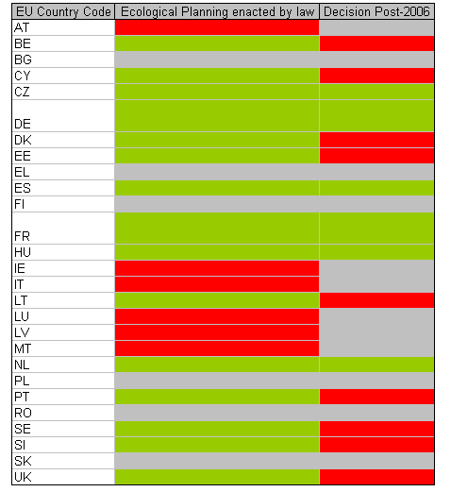
Target 4.4 Significant increases in proportion of tourism which is ecologically sustainable
The European Commission, recognising the important role of tourism in the European economy and the significant contribution of tourism to meeting the key challenges facing Europe in the XXI century, has been increasingly keen on promoting sustainable tourism since the early 1990s. Across Europe, vital reserves of biodiversity are looked after in protected areas that provide protection to natural habitats, species but also very often enjoyment and recreational activities bringing together people and nature. The European Commission itself has no ready initiative or guidance document on ecologically sustainable tourism, but in 2006 it launched a program EDEN "European Destinations of Excellence" aiming at promoting sustainable tourism development models across the European Union, with annual award of the EDEN price along a specific destination topic.
All Member States and candidate countries can take part in the initiative which annually selects winning destinations that best reflect the chosen theme of the year in line with sustainable tourism. Objective 4 Table 3 shows an overview of Members States involved in this project and the number of awarded projects since 2006.
Objective 4 Table 3: Member States taking part in the EDEN initiative with number of projects awarded since 2006
Source: EDEN website, accessed May 2010.
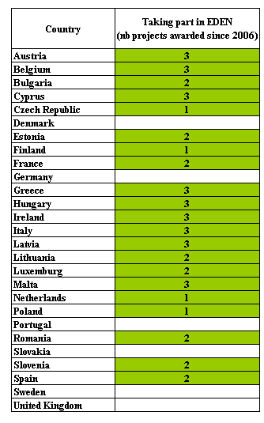
Additionally, the European Commission has recently launched the European Business and Biodiversity (B@B) Platform that includes the tourism among its key sectoral areas. It aims at integrating biodiversity concerns into tourism sector by engaging businesses and stakeholders to understand what their link with ecosystem services is and to better assess the risks related to the loss of biodiversity. Activities proposed through the B@B Platform will provide tools and methodologies to companies to promote value creation and mitigate risk thanks to biodiversity conservation programs through sharing of best practices or the development of guidance documents.
Sustainable tourism is also a highly important component of the Convention on Biological Diversity (CBD) to achieve biodiversity conservation. Indeed, the Convention recognize that travellers, tourism operators, investors and professionals all have an inherent interest in the conservation and sustainable use of biodiversity resources; it is, after all, one of the industry’s main assets. In that respect the Conference of the Parties adopted the CBD Guidelines for Biodiversity and Tourism Development (Decision VII/14) which implementation at national level was assessed with the BAP process. Disparities can be observed among Member States with 9 of them who implemented the guidelines against 16 who did not. When considering legal provisions to support those guidelines, only 3 Members States (Denmark, Spain, Lithuania) have reported to consider sustainable tourism within their national legislation. None of the 27 Members States is producing any report on the usage of the Guidelines. Generally, the majority of Members States are taking into account sustainability criteria and biodiversity within their tourism sector, but not all of them are relying on the entire CBD guidelines, but rather on national strategies that include them at various degree.
Target 4.5 All above outcomes achieved also in Outermost Regions
Allocations of EU Regional Funds under Objective 4 include expenditure for Outermost Regions as well. The 3 Members States concerned by Outermost Regions, namely France, Spain and Portugal all include biodiversity concerns into Regional and territorial development activities and programmes for their overseas territories. As often part of their National Biodiversity Strategy, Outermost Regions sometimes benefit from specific legislations and policies that support biodiversity integration into other activities, projects and programs of regional development (such as biodiversity compensation when negative effects are unavoidable in Portugal and Spain).
For more information on the progress please see also Objective 1, Target A1.5.

Objective 5. To substantially reduce the impact on EU biodiversity of invasive alien species and alien genotypes.

Headline target: Negative impacts on EU biodiversity of IAS and alien genotypes prevented or minimised from 2010 onwards

A. Context
Invasive alien species were identified in the 6th EAP as a priority for action. While support has been given to some localised eradication programmes via LIFE funding, the Union has still to develop a comprehensive strategy to address this issue. Work on this is currently ongoing, but there are still significant policy and legal gaps at national and EU level to tackle this rapidly evolving threat to biodiversity in Europe. At present overall efficiency of EU responses to deal with IAS is low and biodiversity-rich areas (e.g. EU overseas entities) do not receive appropriate attention. The multitude of existing EU legislation partially covering different aspects of IAS makes co-ordinated implementation difficult. Policy consistency between most Member States is low or non-existent. Scientific scenarios illustrate a dramatic increase in biological invasions.

B. Progress assessment (Synthesis of EU-level actions)
Target 5.1 Impact of IAS on biodiversity in the EU and alien genotypes prevented or minimised from 2010 onwards
Strategies to reduce impacts from invasive alien species
Invasive alien species (IAS) are non-native species that are deliberately or unintentionally introduced by human action outside their natural habitats where they then establish, proliferate and spread in ways that cause damage to biological diversity, economy and human health. Overall IAS are currently considered to be the second most important threat to biodiversity at a global level. The main pathways for IAS introduction are associated directly or indirectly with trade. Rapid growth in trading and transport activities expand the opportunities for IAS introduction and environmental pressures such as rising CO₂ concentrations, warmer temperatures, greater nitrogen deposition, altered disturbances regimes and increased habitat fragmentation may facilitate further invasions.
Work is ongoing to develop an EU Framework on Invasive Alien Species (IAS) in 2 steps. The first step was the Communication "Towards an EU Strategy on Invasive Species" adopted in December 2008. The Communication identifies policy options to tackle IAS. An ongoing study for the Commission assessing environmental, economic, and social impacts of IAS assists with development of this policy. The next step will be the development of an EU Strategy on IAS in line with the Council conclusions from June 2009, which give the Commission a mandate to do so. The EESC and Committee of the Regions stated that legislation will be needed. The strategy is currently being prepared, to be presented by the end of 2010.
The EU Biodiversity Action Plan includes a specific objective and several actions for IAS and alien species. Importantly, it encourages Member States to develop national strategies on invasive alien species (by 2007) and to fully implement them by 2010. Table 1 sets out a summary of each Member States’ progress with this action as of 2010.
Obj 5 Table 1: Summary of Member States' responses on progress with preparation of national strategies and plans to reduce impacts from Invasive Alien Species (IAS)
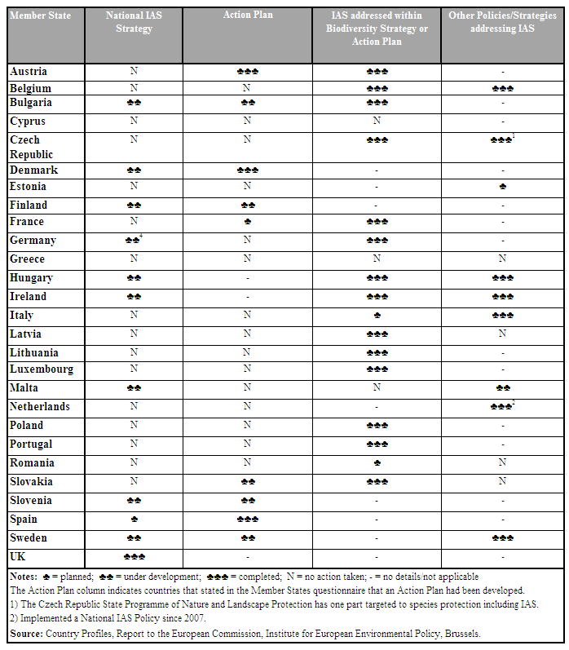
According to the information received from each Member State, only the United Kingdom has completed an IAS strategy at a national level, although nine are currently developing such strategies. Furthermore, only three countries (Austria, Denmark and Spain) definitely have IAS Action Plans and only five more are developing them. However, at least 14 states are addressing IAS issues as part of their biodiversity action planning process and seven have other policies and measures that are contributing to tackling IAS issues.
Existing EU legislation and policy already provides part of the solution to the problems concerning invasive species. However, at present there are no mechanisms to support harmonisation or consistency of approaches between neighbouring countries or countries in the same sub-region. There are no formal requirements for risk analysis for intentional introduction of non-native species that may affect biodiversity and accidental and negligent introductions remain largely unregulated both at Member State and Union levels. No unified system exists to monitor and control IAS and their effects on European biodiversity. This means that actions undertaken by one Member States may be negated by the non-action of the neighbouring countries.
Number of worst invasive alien species
Figure 1 shows the occurrence of IAS that are considered to pose the most serious threats to biodiversity. This clearly shows that large numbers of these highly threatening IAS occur in most European countries and that there is no clear geographical pattern in the magnitude of the threat. Isolation may provide some protection as some island nations such as Iceland and Ireland appear to have low numbers of the worst IAS, but this affect is obviously weak as the United Kingdom has amongst the highest number of worst IAS present. However, caution needs to be taken in the interpretation of these IAS data as they may be affected by a lack of information on the occurrence of IAS in some countries.
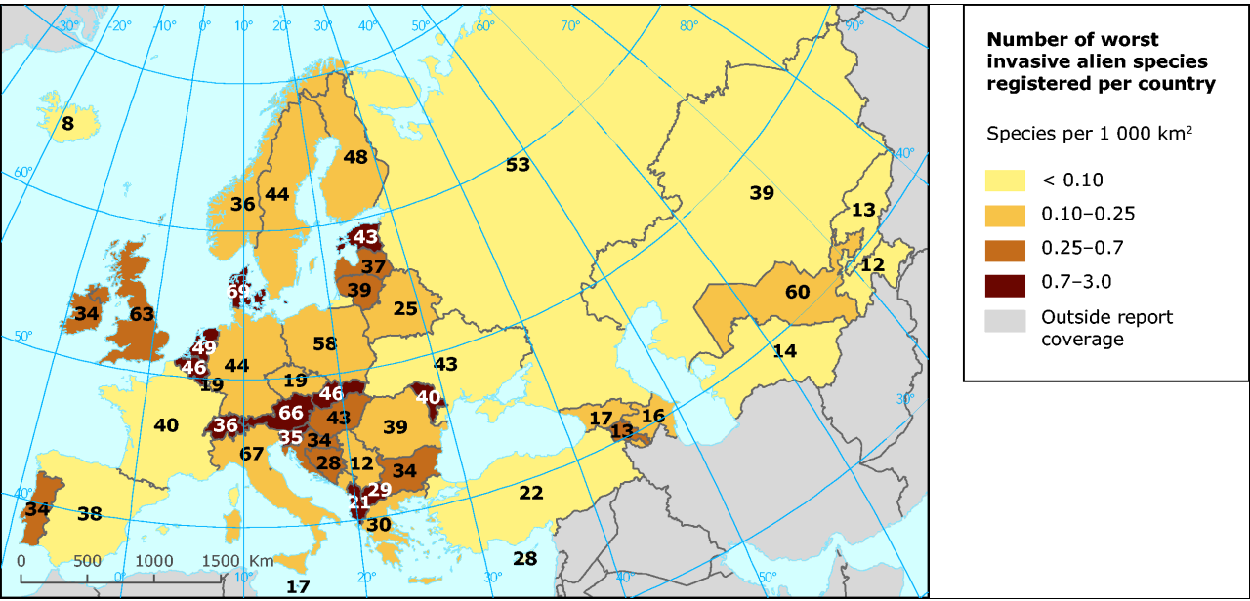
Obj 5 Figure 1: Number of the listed 'worst' terrestrial and freshwater invasive alien species threatening biodiversity in Europe (Temporal coverage 2006)
Source: EEA http://www.eea.europa.eu/data-and-maps/figures/number-of-the-listed-worst-terrestrial-and-freshwater-invasive-alien-species-threatening-biodiversity-in-europe
Early warning system
The European Union is committed under the Biodiversity Action Plan to establish an early warning system for the prompt exchange of information between neighbouring countries on the emergence of IAS and cooperation on control measures across national boundaries, taking into account biogeographical regions. An effective early warning and information system (EWIS) is an integral part of the policy options suggested in 2008 Commission Communication on IAS and the EEA has commissioned a feasibility study on it. Such a system would be based on existing activities including the Alien Species Inventory for Europe delivered by DAISIE, NOBANIS (North European and Baltic Network on IAS), and scientific online journals including "Aquatic Invasions" and "Biorisk".
Table 2 below provides a summary of the progress that Member States have made with establishing IAS databases and early warning systems as of 2010. This shows that good progress has been made by some states with the development of inventories and database. Nine (Austria, Belgium, Denmark, Ireland, Italy, Luxembourg, The Netherlands, Portugal, Sweden have developed such inventories and most other states are developing them. However, 10 indicated that they are not currently developing IAS databases and inventories or provided no response. But of greatest concern is the apparent lack of progress with the development of IAS early warning systems. Only the Netherlands has such a system in place and only six other states (Austria, Belgium, France, Germany, Ireland, Spain) appear to be developing them.
Obj 5 Table 2: Summary of Member States' progress with establishing databases and early warning system for Invasive Alien Species (IAS)
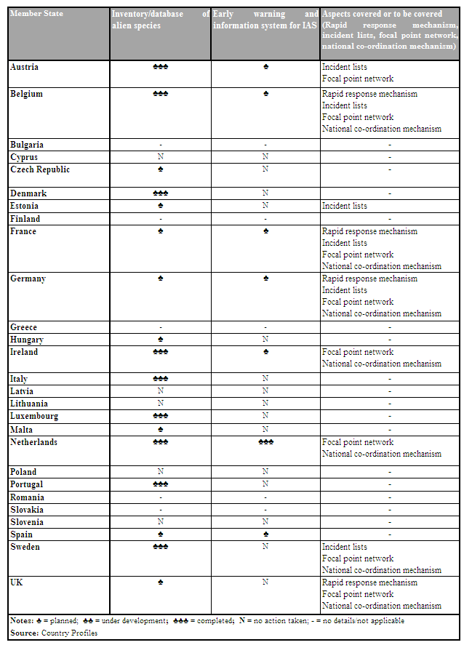
Target 5.2 Impact of alien genotypes on biodiversity in the EU significantly reduced by 2010 [and again by 2013]
Biosafety measures to prevent the impact from GMOs on biodiversity
The European Food Safety Authority is working on a revision of the guidelines on environmental risk assessment, which is designed amongst others, to prevent risk to biodiversity from GMOs. The revised guidelines are expected to be available by November 2010 and be followed by discussions with MS.

Directive 79/409/EC, OJ L 103, 25.4.1979, p.1.
Directive 92/43/EEC, OJ L 206, 22.7.1992, p.7.
I.e. measures taken voluntarily and at national initiative for French Guiana, Reunion, Guadeloupe, Martinique.
The figure is based on spatial data and is subject to change over time.
COM(2006) 216 final
The average terrestrial territory designated as SCIs across the EU is 13.6%.
European Commission. 2010. Natura 2000. Stepping up action for biodiversity. European Commission Nature and Biodiversity Newsletter. Number 28. June 2010. Available: http://ec.europa.eu/environment/nature/info/pubs/docs/nat2000newsl/nat28_en.pdf
The average terrestrial territory designated as SPAs across the EU is 11%.
http://ec.europa.eu/environment/nature/natura2000/marine/docs/fish_measures.pdf
Article 6(1) of the Habitats Directive requires Member States to establish the necessary conservation measures for special areas of conservation involving, if need be, appropriate management plans specifically designed for the sites or integrated into other development plans.
Note that these figures change often so a snapshot of one particular date is provided here.
http://ec.europa.eu/environment/nature/ecosystems/index_en.htm
Spain, France, Ireland, Latvia, Poland and Slovenia
Austria, Bulgaria, Cyprus, Greece and Slovakia
http://eur-lex.europa.eu/LexUriServ/LexUriServ.do?uri=CELEX:52009DC0358:EN:NOT
http://biodiversity.eionet.europa.eu/article17
http://www.eea.europa.eu/data-and-maps/figures/conservation-status-by-main-type-of-habitats
http://www.eea.europa.eu/data-and-maps/figures/habitats-of-european-interest-2014-conservation-status-by-biogeographical-region
http://themes.eea.europa.eu/IMS/ISpecs/ISpecification20070226095607/IAssessment1252589201170/view_content
http://www.eea.europa.eu/data-and-maps/figures/species-of-european-interest-2014-conservation-status-by-biogeographical-region
Note that this information cannot be compared with the information for other taxa reported below: The methodology for the other taxa is based on the conservation status report (Habitats Directive Article 17).
http://www.birdlife.org/datazone/species/index.html
http://ec.europa.eu/environment/nature/conservation/wildbirds/action_plans/docs/ action_plans_review.pdf
http://ec.europa.eu/environment/nature/conservation/species/carnivores/index_en.htm
For this graph, the data used for grassland butterfly species were from Butterfly Monitoring Schemes in fifteen countries: Belgium – Flanders (since 1991), Estonia (since 2004), Finland (since 1999); France (since 2005), France – Doubs region (2001–2004), Germany (since 2005), Germany – Nordrhein Westfalen (since 2001), Germany – Pfalz region (Phengaris nausithous only, since 1989), Ireland (since 2007), Jersey (since 2004), Lithuania (since 2009), Portugal (1998-2006), Slovenia (since 2007), Spain – Catalunya (since 1994), Switzerland – Aargau (since 1998), the Netherlands (since 1990), Ukraine – Transcarpathia (since 1990) and the United Kingdom (since 1976).
Council Regulation (EC) No 1698/2005, OJ L 277, 21.10.2005, p.1.
http://www.birdlife.org/action/science/species/birds_in_europe/birds_in%20_the_eu.pdf
Publication in September 2006 of a Communication on agri-environment indicators (COM(2006(508)) based on IRENA work.
For more details, see http://reports.eea.europa.eu/state_of_environment_report_2007_1/en/chapter4.pdf
For more details, see http://ec.europa.eu/agriculture/analysis/external/evaluation/index_en.htm
Council Regulation 1698/2005 of 20 September 2005 on support for rural development by the European Agricultural Fund for Rural Development, OJ L 277, 21.10.200.
Directive 2000/60/EC of the European Parliament and of the Council of 23 October 2000 establishing a framework for Union's action in the field of water policy.
In the absence of implementing rules for WFD payments under article 38 of Reg. 1698/2005, Member States can only use this measure for Natura 2000 support. Therefore, these resources should only be dedicated to Natura 2000 sites.
see Article 10 of R 73/2009
The UK and Portugal are the only two Member States which were allowed to continue operating voluntary modulation alongside compulsory modulation from 2007. As part of this agreement, they are required to reduce these rates proportionally to the increases in compulsory modulation, leaving them with no increase in their Pillar 2 budgets as a result.
As set out by Council Regulation 73/2009 of 19 January 2009 establishing common rules for direct support schemes for farmers under the common agricultural policy and establishing certain support schemes for farmers, amending Regulations (EC) No 1290/2005, (EC) No 247/2006, (EC) No 378/2007 and repealing Regulation (EC) No 1782/2003, OJ L 30, 31.1.2009 and by Council Regulation (EC) No 1698/2005 of 20 September 2005 on support for rural development by the European Agricultural Fund for Rural Development (EAFRD), OJ L 277, 21.10.2005.
listed in Annex III of Regulation 73/2009.
For more details, see http://ec.europa.eu/agriculture/genetic-resources/index_en.htm
Directive 2008/62/EC
Directive 2009/145/EC
COM(2008)864 final
Directive 2008/105/EC
Directive 91/414/EEC
Directive 2001/81/EC of the European Parliament and of the Council of 23 October 2001 on national emission ceilings for certain atmospheric pollutants.
OECD (2008), Environmental Performance of Agriculture in OECD countries since 1990, Paris, France, www.oecd.org/tad/env/indicators.
Directive 2007/60/EC of the European Parliament and of the Council of 23.10.2007 on the assessment and management of flood risks.
COM(2001) 135.
www.seaaroundus.org
http://themes.eea.europa.eu/IMS/ISpecs/ISpecification20070226095838/IAssessment1253173286214/view_content
http://circa.europa.eu/Public/irc/env/monnat/library?l=/habitats_reporting/reporting_2001-2007&vm=detailed&sb=Title
http://biodiversity.eionet.europa.eu/article17/index_html/habitatsreport
http://biodiversity.eionet.europa.eu/article17/index_html/habitatsreport
http://biodiversity.eionet.europa.eu/article17/index_html/speciesreport
http://eur-lex.europa.eu/LexUriServ/LexUriServ.do?uri=OJ:L:2008:164:0019:0040:EN:PDF
For more information on EU marine policy see http://ec.europa.eu/environment/water/marine/index_en.htm.
COM/2009/0540 final
http://ec.europa.eu/environment/water/water-framework/implrep2007/pdf/sec_2009_415_en.pdf
Integrated Coastal Zone Management: A Strategy for Europe (COM (200) 547).
COM(2008)864 final
However, it should be noted that some discrepancies can be observed between the data. Information reported in 2008 was based on an independent evaluation of ICZM in Europe published in 2006 which interpreted existing MS policies whereas the 2010 data was based on responses received directly from Member States using a questionnaire.
In 2010, Denmark reported that it has a planning policy for the coastal area which it considers address the principles of ICZM. The municipal plans are binding and set the framework for sectoral activities and revised every four years. However this is not called a national ICZM Strategy as such.
http://ec.europa.eu/environment/water/water-bathing/report2009/report.pdf
COM(2008)0187 on the role of the CFP in implementing an ecosystem approach to marine management.
Luxembourg does not have a Fisheries Operational Programme
Council Regulation (EC) No 1198/2006
Luxembourg does not have a Fisheries Operational Programme and Ireland has no funding under Axis 2
Council Regulation (EC) No 1100/2007 on establishing measures for the recovery of the stock of European eel.
Council Regulation (EC) No. 1224/2009 of 20 November 2009
http://eur-lex.europa.eu/LexUriServ/LexUriServ.do?uri=OJ:L:2008:286:0001:0032:EN:PDF
COM(2009)4 final
http://ec.europa.eu/environment/nature/natura2000/marine/docs/fish_measures.pdf
Council Regulation (EC) No 199/2008 of 25 February 2008 concerning the establishment of a Community framework for the collection, management and use of data in the fisheries sector and support for scientific advice regarding the Common Fisheries Policy
Commission Decision of 6 November 2008 adopting a multiannual Community programme pursuant to Council Regulation (EC) No 199/2008 establishing a Community framework for the collection, management and use of data in the fisheries sector and support for scientific advice regarding the common fisheries policy (2008/949/EC)
Directive 79/409/EC, OJ L 103, 25.4.1979, p.1 and Directive 92/43/EEC, OJ L 206, 22.7.1992, p.7.
Directive 85/337/EEC as amended by Directive 97/11/EC, OJ L 073, 14.3.1997, p.5.
Directive 2001/42/EC, OJ L 197, 21.7.2001, p.30.
COM(2008)864 final
SEC(2010)360 Cohesion policy: Strategic report 2010 on the implementation of the programmes 2007-2013; http://ec.europa.eu/regional_policy/policy/reporting/cs_reports_en.htm
COM (2009) 0147 final
COM(2008)789 final
http://www.europe-aliens.org/index.jsp

