EN
EUROPEAN COMMISSION
Brussels, 8.10.2010
SEC(2010) 1165 final

COMMISSION STAFF WORKING DOCUMENT
UPDATE OF SEBI 2010 BIODIVERSITY INDICATORS
Accompanying document to the
REPORT FROM THE COMMISSION TO THE COUNCIL AND THE EUROPEAN PARLIAMENT
THE 2010 ASSESSMENT OF IMPLEMENTING THE EU BIODIVERSITY ACTION PLAN
COM(2010) 548
SEC(2010) 1163
SEC(2010) 1164
TABLE OF CONTENTS
1. Streamlining European 2010 Biodiversity Indicators (SEBI 2010) fact sheets 3
2. Headline indicator: trends in abundance and distribution of selected species 4
3. Headline indicator: trends in extent of selected biomes, ecosystems and habitats 7
4. Headline indicator: Coverage of protected areas 11
5. Headline indicator: water quality in aquatic ecosystems 13
6. Headline indicator: Ecological Footprint and biocapacity of European countries 17
7. Headline indicator: public awareness and participation 20

Streamlining European 2010 Biodiversity Indicators (SEBI 2010) fact sheets
This accompanying document contains the 2010 update of six fact sheets” of the SEBI 2010 biodiversity indicators.
The SEBI 2010 process was initiated in 2005 to provide a streamlined set of biodiversity indicators for Europe, ensuring consistency between national and international biodiversity indicators sets and help achieve progress towards the European target to halt biodiversity loss by 2010. SEBI 2010 institutional partners are the European Environment Agency (and its European Topic Centre on Biological Diversity), ECNC (European Centre for Nature Conservation), UNEP-WCMC (World Conservation Monitoring Centre), DG Environment of the European Commission, the PEBLDS Joint Secretariat, and the Czech Republic (as lead country for the Kiev Resolution action plan on biodiversity indicators).
The SEBI 2010 process has to a large extent been made possible by the contributions of more than 120 experts from across the pan-European region and from international NGOs and IGOs.
A history of the SEBI 2010 process as well as technical specifications of the indicators can be found in EEA Technical report 11/2007 “Halting the loss of biodiversity by 2010: proposal for a first set of indicators to monitor progress in Europe” (http://reports.eea.europa.eu/technical_report_2007_11/en). Readers are encouraged to consult this publication if they need detailed information on the methodology for each indicator.
The SEBI assessment report 2009 concluded that the 2010 target to halt biodiversity loss in Europe would not be met (EEA Report/n°4/2009).
Based on the best available sources of information, including the set of SEBI 2010 indicators, the European Environment Agency (EEA) has published the EU 2010 biodiversity baseline in June 2010 to support post-2010 policy development. The EU 2010 biodiversity baseline provides the latest information on the state of biodiversity and ecosystem services within the EU. It is available from the Biodiversity Information System for Europe (BISE), the single entry point for data and information on biodiversity and ecosystems in the EU, also launched in June 2010.

Headline indicator: trends in abundance and distribution of selected species

01 Abundance and distribution of selected species
Key policy question: Have declines in common species in Europe been halted?
Key message:
Overall, populations of common birds in the European Union countries reduced by around 10 % since 1990. Common farmland and forest birds declined by some 20-25 %. Falls have levelled off since the late 1990s. Europe’s grassland butterflies have declined dramatically (almost 70 %) since 1990 and this reduction shows no sign yet of levelling off.
Trends in the common bird indicators for the European Union, base = 1990
(numbers in brackets show the number of species in each indicator)
Note: How to read the graph: since 1990 the number of common farmland and forest birds have declined by around 20 %.
Source: Eurostat, 2010 (env_bio2) - EBCC/RSPB/BirdLife/Statistics Netherlands.
Geographical coverage: Belgium, Bulgaria Finland, Netherlands, Portugal, Republic of Ireland, Sweden, Switzerland, Czech Republic, Italy, Latvia, Spain, Norway, United Kingdom, France, Denmark, Poland, Germany, Estonia, Hungary.
For common farmland bird species, n=36; for common forest bird species, n=29; for all common bird species (this line includes the farmland and forest birds as well as other common species that are not primarily associated with either of these habitats), n=136.
Grassland butterflies, population index (1990 = 100)
Source: De Vlinderstichting/Butterfly Conservation Europe/ Statistics Netherlands, 2010.
Note: How to read the graph: since 1990, grassland butterflies have declined by almost 70 %. For this graph, the data used for grassland butterfly species were from Butterfly Monitoring Schemes in fifteen countries: Belgium – Flanders (since 1991); Estonia (since 2004); Finland (since 1999); France (since 2005); France – Doubs region (2001–2004); Germany (since 2005); Germany – Nordrhein Westfalen (since 2001); Germany – Pfalz region (Phengaris nausithous only, since 1989); Ireland (since 2007); Jersey (since 2004); Lithuania (since 2009); Portugal (1998-2006); Slovenia (since 2007); Spain – Catalunya (since 1994); Switzerland – Aargau (since 1998); the Netherlands (since 1990);Ukraine – Transcarpathia (since 1990) and the United Kingdom (since 1976).
Assessment: For some populations of European common birds, downward trends appear to have slowly levelled off but it needs to be borne in mind that significant losses had already happened by 1990.
Of the more common bird species, farmland birds have declined. The initial steep decline of farmland birds was associated with increasing agricultural specialisation and intensity in some areas, and large-scale marginalisation and land abandonment in others. The falling trend has levelled off since the late 1990s, partly because of stabilising inputs of nutrients and pesticides and the introduction of set-aside in the EU-15, and partly because of drastically lower nutrient inputs in the EU-10 as a result of political reforms and the resulting economic crisis in the agricultural sector. An increase in agricultural production in eastern Europe, if linked to higher inputs of nutrients and pesticides, combined with further land abandonment in some parts of Europe and the abolition of set-aside, may lead to a new decline.
Conservation measures adopted under the EU Birds Directive have proven effective in the recovery of threatened bird populations (Donald et al., 2007) but not in the case of more widespread birds species, where different recovery mechanisms are now required. Well-designed agri-environment measures have been shown to reverse bird declines at local levels. The recent loss of set-aside areas under agricultural policy may result in greater pressures on many farmland bird species.
The challenge now is to deploy the Birds Directive conservation measures or others widely enough to help populations recover at national and European scales. Trends in species in Europe are also driven by pressures outside Europe, e.g. for migratory bird species, and a comprehensive response would need to be effective beyond European territory.
Grassland butterflies are declining severely; their populations have declined by almost 70%, indicating a dramatic loss of grassland biodiversity.
The main driver behind the decline of grassland butterflies is the change in rural land use: agricultural intensification where the land is relatively flat and easy to cultivate, abandonment in mountains and wet areas, mainly in Eastern and Southern Europe. Agricultural intensification leads to uniform, almost sterile grasslands, where the management is so intensive that grassland butterflies can only survive in traditional farmed low input systems (High Nature Value Farmland) as well as nature reserves, and marginal land such as road verges and amenity areas.
Notes: An increase in the population index means that there are more species with populations increased than species with populations decreased: it does not necessarily mean that the population of all species has increased. It can be due to expansion of some species (typically, generalists) at the expense of other species (typically, specialists). It must also be noted that populations fluctuate on a yearly basis.
In the absence of the information on abundance, information on the distribution of species can help assess species status. However, at a European level, this type of information is still weak for other groups of species.
Geographical coverage
Birds
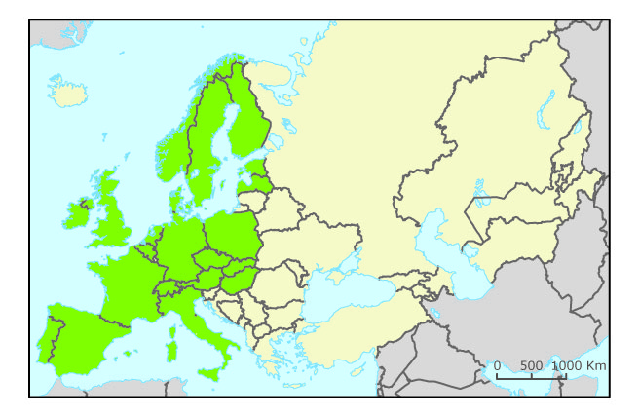
Butterflies
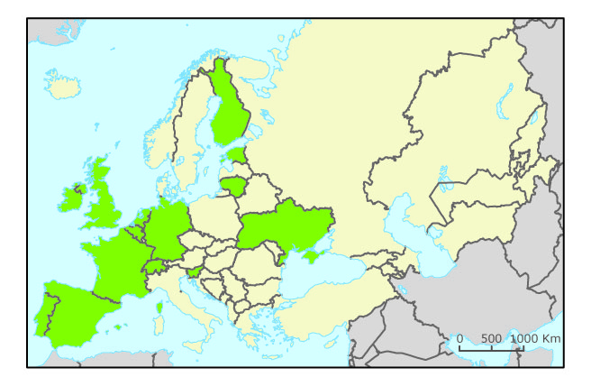
Web links:
- European Bird Census Council (EBCC): www.ebcc.info/
- Butterfly Conservation Europe: www.bc-europe.org/
Sources and references: Donald, P. F.; Sanderson, F. J.; Burfield, I. J.; Bierman, S. M.; Gregory, R. D.; and Waliczky, Z., 2007. 'International Conservation Policy Delivers Benefits for Birds in Europe'. Science 317: 810.

Headline indicator: trends in extent of selected biomes, ecosystems and habitats

04. Ecosystem coverage
Key policy question: Which changes are occurring in the distribution of Europe's ecosystems and habitats?
Key message:
Artificial surfaces (housing and industrial areas and infrastructure) as well as woodland are increasing whilst agricultural land, semi-natural and natural habitats decrease. The overall statistics hide more detailed transition patterns. Urban sprawl, for example, accelerates, mainly at the expense of agricultural land. Wetlands are mainly changing into forest; other (semi-)natural areas primarily give way to agriculture.
Land cover change between 1990 and 2006: area change for major habitat classes
Note: How to read the graph: from 1990 to 2006, artificial areas (housing and industrial areas and infrastructure) increased by nearly 8 %, whereas wetlands decreased by nearly 3 %.
Source: EEA, 2010 – EU27 except Greece, Finland, United Kingdom and Sweden
Assessment: The latest Corine Land Cover (CLC) inventory (2006) indicates in the period 1990-2006 a continued expansion of artificial surfaces (e.g. urban sprawl, infrastructures) and abandoned land at the expense of agricultural land, grasslands and wetlands across Europe. In the years 2000-2006 annual land uptake by urban areas doubled compared to previous period (1990-2000) and, as in the previous period, was mainly at the expense of agriculture (76%).
Changes in land cover between 1990 and 2000 and 2000 and 2006: previous status of newly urban areas
Note: Based on Corine Land Cover data.
Sources: EEA 2010, LEAC (Land and Ecosystems Accounts)
How to read the graph: between 2000 and 2006, 47 % of new urban lands were formerly arable land and permanent crops.
The annual increase in forest area in EU was around 0.5% between 1990 and 2000 and around 0.1% between 2000 and 2006. However, this increase is not uniformly distributed. In addition, the spatial forest pattern is changing locally due to different dynamics such as loss of forest areas, fragmentation of forest cover and therefore loss of connectivity.
Heaths and scrubs area increased because transitional woodland included in this category increased by 12%. During the same period, heaths and scrub sensu stricto decreased by 3%, which is associated with biodiversity decline.
Conversion of wetlands into other classes, in the periods 1990–2000 and 2000-2006
Note: Based on Corine Land Cover data.
Sources: EEA 2010, LEAC (Land and Ecosystems Accounts)
How to read the graph: of wetland area converted to other land uses between 2000 and 2006, 39 % became agricultural.
Natural grasslands are still being turned into arable land and built up areas. The loss of wetlands has slowed down (nearly 3% lost in the last 16 years) but Europe had already lost more than half of its wetlands before 1990. Increase of water bodies is mainly due to creation of dams.
Agricultural areas are decreasing mainly due to urban sprawl, driven mainly by the sprawl of industrial and commercial sites, transport networks and infrastructures. In many places, agriculture has been marginalised as an economic activity, often with resulting land abandonment. Extensive agricultural land is being converted predominantly into forest and other forms of more intensive agriculture.
Geographical coverage
Corine Land Cover v.2000
Corine Land Cover v.2006
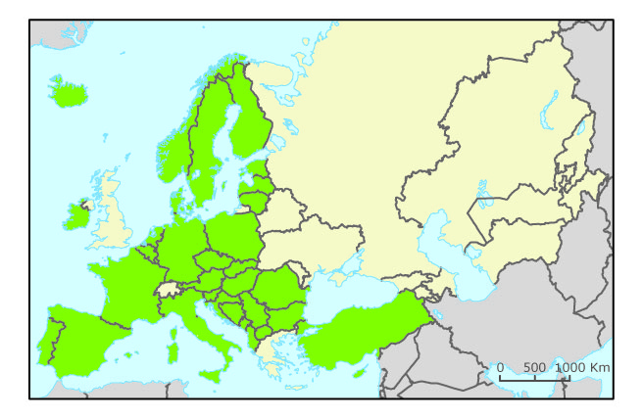
Web links:
Corine Land Cover http://reports.eea.europa.eu/COR0-landcover/en
Sources and references: EEA 2010, Corine Land Cover

Headline indicator: Coverage of protected areas

07. Nationally designated protected areas
Key Policy Question: What is the progress with the national designation of protected areas as a tool for biodiversity conservation?
Key message: The total area of nationally-designated protected areas in Europe has increased over time. The total area of nationally designated sites in 39 European countries was more than 1 million square kilometres in 2009. In EECCA countries, the area of nationally designated sites is at least 1.5 million square kilometres. 1.2 million square kilometres can be added to this area, the information about the year of the designation is missing, however, .
This quantitative information needs to be complemented by a qualitative assessment of the efficiency and the representativeness of the network of designated areas including good management practices.
Growth of the nationally designated protected areas and site number in 39 EEA countries
Note: Overlap may exist due to multiple designations for a same site. The average of overlap is around 14 % at European level At country level the average varies from 46 % of overlap for Germany, 34 % for Estonia and less that in 5 % in Turkey.
Source: CDDA (Common Database on Designated Areas) v8, 2009.
How to read: the graph: In 1995 there was more than 40 000 of nationally designated sites within the 39 countries. More than 600 000 km2 were under national designations.
Assessment: In 39 countries, on average 16 % of the terrestrial area has been designated as a national protected area.
The growth in nationally designated areas in 39 EEA countries has been exponential, and it has been levelling off in recent years. A precise assessment of trends over time is much more difficult to make for EECCA countries because of gaps in the data. These countries contain around 18000 sites covering in total 2.6 million square kilometres. However, for more than 2 thirds of the sites no designation date is known, and one fourth of the sites no size information is known.
Countries have national legislation that enables them to establish various types of protected areas.
For nationally-designated protected areas, the total area protected in Europe continues to increase.
On the one hand it is difficult to know exactly how far these areas contribute to halt the loss of biodiversity without any specific information on site management and quality. On the other hand, other indicators can show how much pressure on biodiversity outside those areas increases through growing urbanisation and transport infrastructures for instance.
Therefore, the expansion of protected areas and their role in protecting biodiversity have to be considered and assessed within the wider environment and with the climate change perspective.
Geographical coverage
Web links:
About Nationally designated areas:
- European dataset: http://www.eea.europa.eu/data-and-maps/data/nationally-designated-areas-national-cdda-4
- Global dataset: http://www.wdpa.org/

Headline indicator: water quality in aquatic ecosystems

16. Freshwater quality
Key Policy Question: What is the status of freshwater quality in Europe?
Key message: Pollution of rivers with organic matter and ammonium is decreasing as are the levels of other anthropogenic nutrients in freshwater generally (rivers, lakes and groundwater). This reduces stress on freshwater biodiversity and improves ecological status.
Biochemical Oxygen Demand (BOD5) and total ammonium concentrations in rivers between 1992 and 2007
Source: Waterbase Version 9
How to read the graph: Between 1992 and 2007, BOD5 decreased from 4 to 2 mg O²/l and Ammonium from 700 to 300 µg N/l
Note: Criterion for selection series: consistent time series (1992-2007) after interpolation of one or two year missing concentrations and extrapolation of one year missing concentrations in the beginning or the end of series on station level.
Number of river monitoring stations included in analysis noted in brackets. BOD5 data from Austria, Belgium, Bulgaria, Czech Republic, Denmark, France, Hungary, Ireland, Luxembourg, the Former Yugoslav Republic of Macedonia, Slovakia, Slovenia, Spain and United Kingdom. BOD7 data from Finland, Estonia, Latvia (1996-2001) and Lithuania (1996-2007). BOD7 data were recalculated into BOD5 data. Total ammonium data from Albania, Austria, Belgium, Bulgaria, Denmark, Estonia, Finland, France, Germany, Hungary, Ireland, Latvia, Lithuania, Luxembourg, the Former Yugoslav Republic of Macedonia, Norway, Poland, Slovenia, Spain, Sweden and United Kingdom.
Concentrations of nitrate and orthophosphate in rivers and total phosphorus in lakes in the period 1992-2007
Note: Total number of stations in parenthesis. Concentrations are expressed as weighted means of annual mean concentrations for rivers and lakes. Only stations with time series consisting of a minimum of seven years are included.
Nitrate in rivers (* = total oxidized nitrogen): Austria (144), Belgium (10), Bulgaria (80) Czech Republic (69), Denmark* (39), Estonia (51), Finland* (52), France (177), Germany (123), Hungary* (87), Lithuania (26), Luxembourg (3), Norway (10), Poland (101), Slovakia (48), Slovenia (14), Spain (128), Sweden* (113), Switzerland (6).
Orthophosphate in rivers: Austria (115), Belgium (8), Bulgaria (59), Denmark (41), Estonia (51), Finland (46), France (156), Germany (109), Lithuania (26), Luxembourg (1), Norway (10), Slovakia (6), Slovenia (14), Spain (69), Sweden (113), Switzerland (6).
Total phosphorus in lakes: Austria (5), Denmark (20), Estonia (2), Finland (130), Hungary (9), Ireland (8), Lithuania (3), Latvia (3), Slovenia (2), Sweden (140), Switzerland (10).
Source: Waterbase (version 9).
Assessment: Biochemical Oxygen Demand (BOD) and total ammonium concentration have decreased in European rivers over the period 1992-2007, corresponding to the general improvement in wastewater treatment. BOD and ammonium concentrations are generally highest in eastern, southern and south-eastern European rivers. The largest declines in BOD are evident in the rivers of Western Europe, while the biggest drops of ammonium are apparent in eastern European countries.
Concentrations of BOD and ammonium are key indicators of the organic matter and oxygen content of water bodies. They normally increase as a result of organic pollution due to discharges from waste water treatment plants, industrial effluent and agricultural run-off. Severe organic pollution may lead to rapid de-oxygenation of river water along with increased ammonium levels and the consequent disappearance of fish and aquatic invertebrates.
The most important sources of organic waste load are household waste water, discharges from industries such as paper production or food processing and occasional silage or slurry effluents from agriculture. Increased industrial and agricultural production, coupled with a greater percentage of the population being connected to sewerage systems, initially resulted in increased discharge of organic waste into surface water across most European countries after the 1940s. Over the past 15 to 30 years, however, the biological treatment of waste water has increased and organic discharges have consequently decreased throughout Europe.
Nutrient levels in freshwaters are decreasing. The average nitrate concentration in European rivers has decreased since 1992, from 2.5 to 2.1 mg N/l, reflecting the effect of measures to reduce agricultural inputs of nitrate. Nitrate levels in lakes are in general much lower than in rivers but there has also been a 15 % reduction of the average concentration in lakes.
Agriculture is the largest contributor of nitrogen pollution. Due to the EU Nitrate Directive and national measures the nitrogen pollution from agriculture has, however, been reduced in some regions during the last 10-15 years. European air emissions of nitrogen oxides have gone down by one third over the last 15 years and the deposition of nitrogen on inland surface waters has also declined.
Phosphorus concentrations in European rivers and lakes generally decreased during the last 15 years, reflecting the general improvement in wastewater treatment and reduced phosphate content of detergents over this period. In many rivers the reduction started in the 1980s. During the past few decades there has also been a gradual fall in phosphorus concentrations in many European lakes. The decrease is due to nutrient removal measures introduced by national and European legislation particularly the Urban Waste Water Treatment Directive. As treatment of urban wastewater has improved and many waste water outlets have been diverted away from lakes, point source pollution is gradually becoming less important. Agricultural inputs of phosphorus are still significant and need increased attention to achieve a good status in lakes and rivers. However, it should be noted that the consumption of phosphorus in agriculture has been steadily decreasing since the late 1980s.
Geographical coverage
Total ammonium concentrations
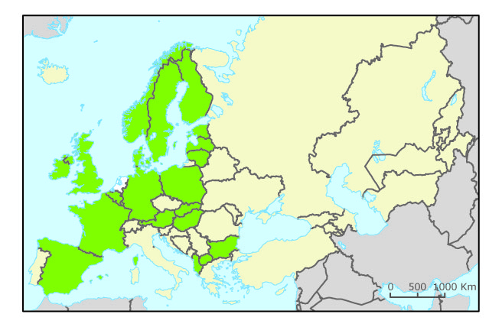
Biochemical Oxygen Demand (BOD5)
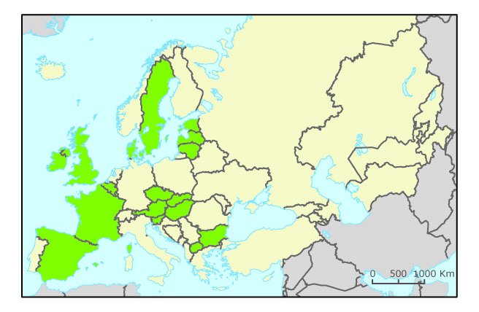
Concentrations of nitrate
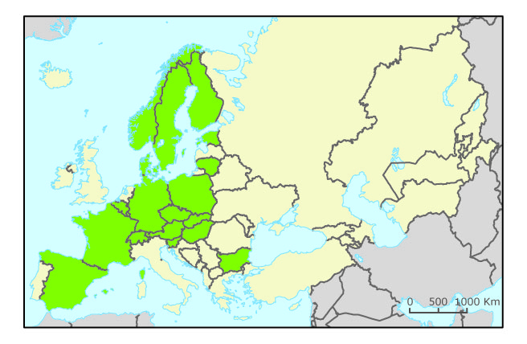
Concentrations of phosphorus
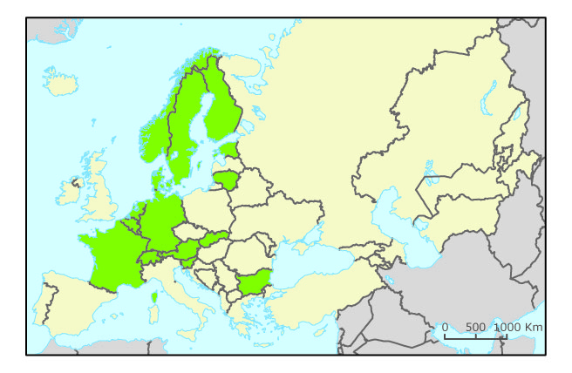
Web links:
EEA Core Set indicators:
http://themes.eea.europa.eu/IMS/ISpecs/ISpecification20041007131940/IAssessment1116505271445/view_content and
http://themes.eea.europa.eu/IMS/ISpecs/ISpecification20041007131957/IAssessment1116497150363/view_content

Headline indicator: Ecological Footprint and biocapacity of European countries

23. Ecological Footprint of European countries
Key policy question: Are Europeans using more than their share of the world’s resources?
Key message: The Ecological Footprint for pan-Europe has been increasing almost constantly since 1961, while Europe’s biocapacity has decreased. This results in an ever larger deficit, with negative consequences for the environment within and outside Europe.
Ecological Footprint, biocapacity and reserve or deficit (2006)
How to read the graph: from 1961 to 2006, Europe’s Ecological Footprint increased from 3 to 4 ha/person.
Assessment: Europe’s ecological deficit is considerable. Overall biological resource use and waste emission is more than twice the biological capacity available within Europe, showing that the continent cannot sustainably meet its consumption demands from within its own borders. The average per capita Ecological Footprint in the European Union has increased more than 50 percent since 1961, while per capita biocapacity has decreased by 13 percent, thus increasing the ecological deficit. Pan-European nations, as a whole, have seen a fluctuating per capita Ecological Footprint, though in 2006 the Footprint was more than a quarter larger than in 1961. A clear trend can be seen in Pan-European biocapacity, however, with a steady per capita decline as populations increase and resources are stretched among more consumers.
A regional or national ecological deficit means that the region is either importing biocapacity through trade or liquidating regional ecological assets. Evidently, a global ecological deficit cannot be compensated through trade and therefore corresponds to liquidation of natural capital.
In a world that is already in ecological overshoot, Europe’s ecological deficit contributes to the diminishing amount of renewable natural resources available in the future, adds to overall waste accumulation and puts regional and global ecosystems at greater risk of degradation. Further work should examine in more detail the linkages between the Ecological Footprint and biodiversity.
The figure below shows that Europe is not the only region where the Ecological Footprint (shown as per person Footprint times population size) exceeds the biocapacity (per person biocapacity shown as green dotted line). Europe beyond the EU actually has a biocapacity that is slightly larger than its Footprint. North America, the EU-25 and the remaining European nations have a per person Footprint that is significantly larger than that in any other continent.
Ecological Footprint variation per region (2006)
Source: Global Footprint Network, National Footprint Accounts 2009
How to read the graph: the EU has 487 million citizens, and a biocapacity of two global hectares per person. The Ecological Footprint however, is 4.5 hectares per EU citizen. The Footprint is the area used to support a defined population's consumption including the area needed to produce the materials consumed and to absorb the waste. The deficit is the difference between the biocapacity and Ecological Footprint of a region or country. The 2009 National Footprint Accounts contain a number of revisions from the 2008 edition. The methodological changes reflect new source data from the United Nations, new source data organization, and improved calculations in grazing land, forest land, and fishing grounds Footprint and biocapacity data.
Geographical coverage
Web links: Global Footprint Network: http://www.footprintnetwork.org/
Sources and references: Global Footprint Network., 2009. National Footprint Accounts, 2009 Edition. Available at:
http://www.footprintnetwork.org/en/index.php/GFN/page/ecological_footprint_atlas_2009/
[Accessed 25 May 2010]

Headline indicator: public awareness and participation

26. Public awareness
Key Policy Question: What is the level of public awareness about biodiversity in Europe? Are people willing to take action?
Key message: Two-thirds of EU citizens do not know the meaning of the word ‘biodiversity’, let alone understand what the threats and challenges to its conservation are. Most EU citizens have never heard of the Natura 2000 network (78 %). However, over two-thirds of EU citizens report personally making efforts to help preserve nature.
Assessment: Recent surveys showed that only about one-third of EU citizens were familiar with the term ‘biodiversity’: more precisely, 38 % of interviewees said they knew the meaning of the term (a three percentage point increase compared to 2007) and that few feel well informed about biodiversity loss.
Source: Gallup Organization, Flash Eurobarometer Series No. 290, 2010.
How to read the graph: 34 % of EU citizens have never heard of biodiversity (2010).
Two-thirds of EU citizens do not know the meaning of the word ‘biodiversity’, let alone understand the threats and challenges to its conservation. That does not mean, however, they are unaware of environmental matters. When the issue is explained to them, over two-thirds consider the loss of biodiversity a serious problem, although more so at the global rather than the local level. The main threats to biodiversity identified by Europeans both in 2007 and 2010 surveys – pollution and man-made disasters – indicate that the level of understanding of the problem is still inadequate.
Figure: Awareness of the Natura 2000 Network, share of respondents
Source: Gallup Organization, Flash Eurobarometer Series No. 290, 2010.
How to read the graph: 78 % of EU citizens have never heard of Natura 2000 (2010)
The survey also reveals that Europeans are unaware of what the EU is doing to save biodiversity: Only one in five has ever heard of Natura 2000, the EU’s main programme for biodiversity conservation, and only 8 % of respondents indicated they really knew what Natura 2000 meant (slight increase compared to the year 2007). Most EU citizens have never heard of the Natura 2000 network (78 %). The Natura 2000 programme needs urgent attention as far as communication to the public is concerned.
If the survey is repeated at regular intervals, it will be possible to identify trends and assess the effectiveness of existing and future policies aimed at raising public awareness and participation with regards to biodiversity.
Geographical coverage
Web links:
About Eurobarometer: http://ec.europa.eu/public_opinion/archives/flash_arch_en.htm
Sources and references:
Gallup Organization, 2007. Flash Eurobarometer Series No. 219. Attitudes of Europeans towards the issue of biodiversity. Survey conducted by Gallup Organization at the request of the Directorate-General for Environment. Coordinated by Directorate-General Communication. Available at: http://ec.europa.eu/public_opinion/flash/fl_219_en.pdf [Accessed 14 July 2010].
Gallup Organization, 2010. Flash Eurobarometer Series No. 290. Attitudes of Europeans towards the issue of biodiversity. Survey conducted by Gallup Organization at the request of the Directorate-General for Environment. Coordinated by Directorate-General Communication. Available at: http://ec.europa.eu/public_opinion/flash/fl_290_en.pdf [Accessed 14 July 2010].

http://www.biodiversity.europa.eu/
A “Nationally designated area” is an area designated by a national designation instrument based on national legislation. If a country has included in its legislation the sites designated under the EU Birds and Habitats directive, the Natura 2000 sites of this country are included in the figure.
For 39 countries, there is 37 000 sqm2 of additional designated areas but without any information of designation year. For the EECCA countries, for 25 % of sites included in the database, no size information is available.
Concentrations are expressed as the station weighted mean of the annual mean concentrations by countries. Stations with time series consisting of minimum seven years are included. The number of available mean concentrations/stations per year is different, except for Luxembourg and Norway with constant number.
For this analysis, data from all European countries were used, except for nations that were excluded because of insufficient population (Cyprus, Iceland, Liechtenstein, Luxembourg and Malta) and nations for which data are lacking (Andorra, Monaco, San Marino).
The capacity of ecosystems to produce useful biological materials and to absorb waste materials generated by humans, using current management schemes and extraction technologies.
Gallup Organization, 2007. Flash Eurobarometer Series No. 219, Gallup Organization, 2010. Flash Eurobarometer Series No. 290.

