EN
EUROPEAN COMMISSION
Brussels, 6.10.2010
COM(2010) 553 final
COMMUNICATION FROM THE COMMISSION TO THE EUROPEAN PARLIAMENT, THE COUNCIL, THE EUROPEAN ECONOMIC AND SOCIAL COMMITTEE AND THE COMMITTEE OF THE REGIONS
Regional Policy contributing to smart growth in Europe 2020
SEC(2010) 1183
COMMUNICATION FROM THE COMMISSION TO THE EUROPEAN PARLIAMENT, THE COUNCIL, THE EUROPEAN ECONOMIC AND SOCIAL COMMITTEE AND THE COMMITTEE OF THE REGIONS
Regional Policy contributing to smart growth in Europe 2020

Introduction
This Communication sets out the role of Regional Policy in implementing the Europe 2020 strategy, in the area of smart growth and in particular the flagship initiative, "Innovation Union". As highlighted by the European Council, Regional Policy can unlock the growth potential of the EU by promoting innovation in all regions, while ensuring complementarity between EU, national and regional support for innovation, R&D, entrepreneurship and ICT. Indeed, Regional Policy is a key means of turning the priorities of the Innovation Union into practical action on the ground.
It does so by creating favourable conditions for innovation, education and research so encouraging R&D and knowledge-intensive investment and moves towards higher value added activities. It can so help meet the major challenge for Member States and regions of increasing innovation capacity and R&D in businesses and strengthening their links with universities and research centres.
Regions have a central role as they are the primary institutional partner for universities, other research and education institutes and SMEs, which are key to the process of innovation, making them an indispensable part of the Europe 2020 strategy.
This Communication complements the one on the Innovation Union by calling on policy-makers in Member States at all levels to act without delay to invest more of the resources still available from the European Regional Development Fund (ERDF) in the present programming period on smart growth. The document first looks at what is the situation in regions with respect to R&D and innovation and at the resources regions have planned to invest in these areas. It then describes the main elements of a strengthened effort in support of R&D and innovation under EU Regional Policy. It concludes by putting forward concrete ideas for implementing such efforts.

Regional Innovation Potential and Challenges
The Innovation Union is based on a broad concept of innovation encompassing not only new or improved products and processes, but also services, new marketing, branding and design methods and new forms of business organisation and collaborative arrangements. Innovation is increasingly understood as an open system where different actors collaborate and interact.
Accordingly, public support for innovation needs to adapt to this change, complementing efforts to support research and technology with promoting open collaboration between all stakeholders.
Such support is justified since market forces cannot always ensure adequate long-term funding for investment due to differences between social and private returns, uncertain outcomes, asymmetry of information and system failure (e.g. inefficient regulation). Public intervention is equally important to facilitate change. The geography of innovation is however very diverse with certain regions competing worldwide on the technological frontier, and other struggling to move closer to that frontier by adopting and adapting innovative solutions to their specific situation ("innovation divide"). Public support needs to tailor strategy and interventions to reflect this diversity.

Regional diversity at the service of a common goal: smart growth
To reach the Europe 2020 objective of smart growth, the full innovation potential of EU regions needs to be mobilised. Innovation is important for all regions; for advanced ones to remain ahead and lagging ones to catch up.
Map 1: Regional Innovation Performance Index
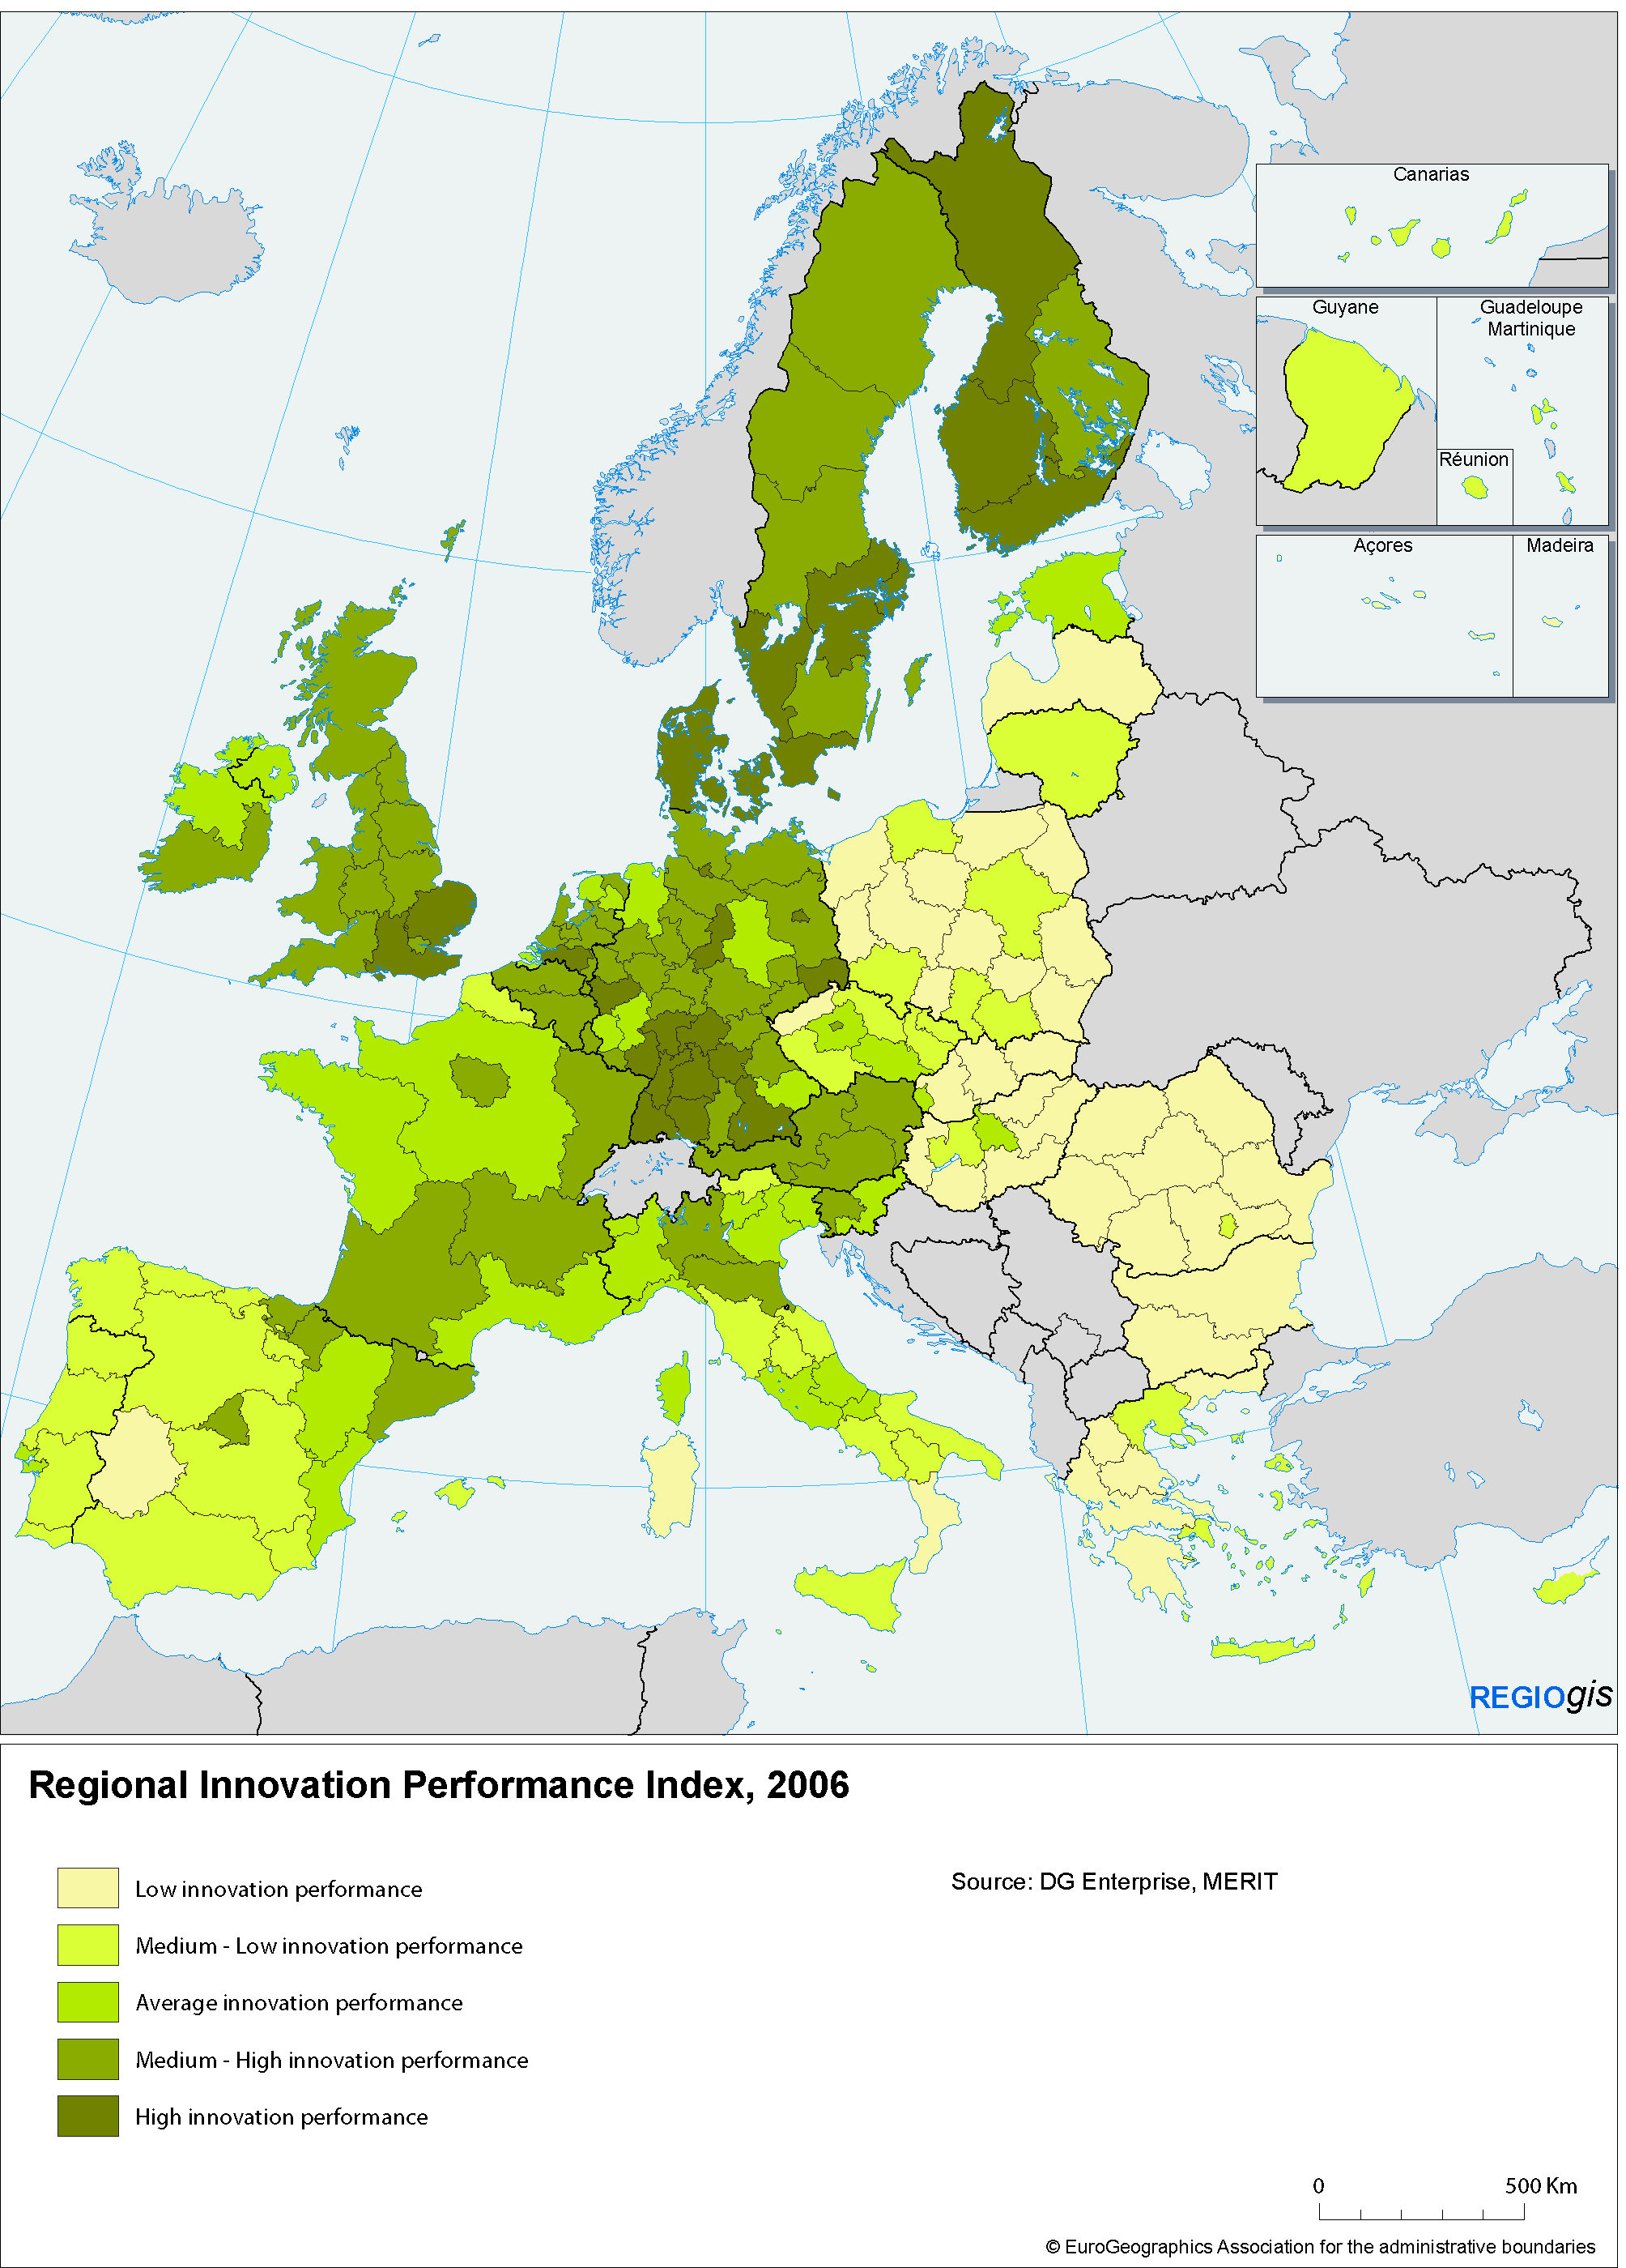
The knowledge and innovation capacity of regions depends on many factors – the business culture, work force skills, education and training institutions, innovation support services, technology transfer mechanisms, R&D and ICT infrastructure, the mobility of researchers, business incubators, new sources of finance and the local creative potential. Good governance is also crucial. Performance in R&D and innovation varies markedly across the EU as shown by the Regional Innovation Performance Index (see Map 1), a composite indicator of many of these factors.
Equally, the gap to the target of R&D expenditure of 3% of GDP varies greatly across regions: only 27 regions in the EU, around one in ten have reached that target (see Map 2) Agglomeration effects lead to R&D resources concentrating in a few leading-edge regions (e.g. in Braunschweig (Germany) where R&D spending is nearly 7% of GDP) and being very low in others (e.g. Severen tsentralen (Bulgaria) where it is under 1%).
Map 2: R&D expenditure
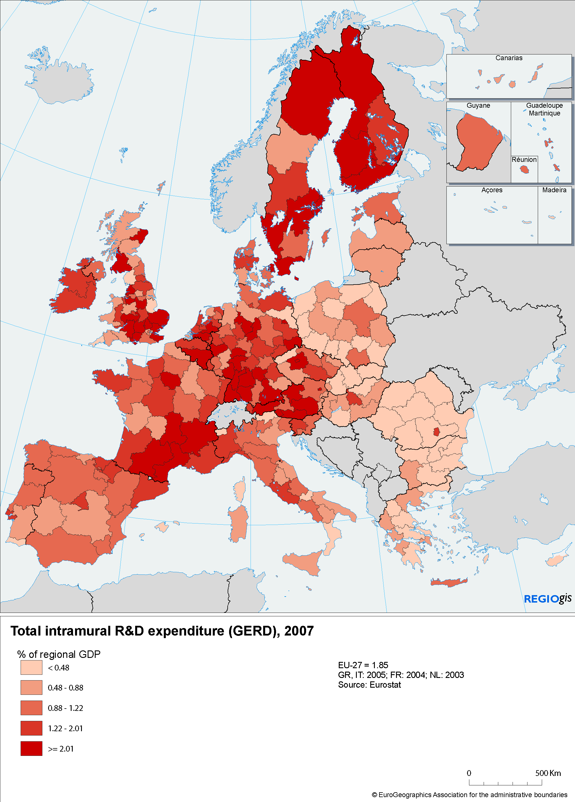

Regional Policy supports smart growth in all regions
Member States and regions are already committed to support smart growth despite the unfavourable economic conditions. Almost EUR 86 billion are allocated to these policy areas, three quarters financed by the ERDF (EUR 65 billion).
However, the support given to research and innovation by Regional Policy varies greatly across regions (see Map 3). It tends to be larger in more advanced regions reinforcing a virtuous circle of innovation-driven growth. The policy has to work in close coordination with the Community Innovation Programme (CIP) and the 7th Research Framework Programme (FP7). While the latter should continue to focus on supporting excellence, mutual learning and EU-wide cooperation of researchers and enterprises, Regional Policy should continue to focus support on ensuring that all regions are capable of absorbing and putting to effective use innovation, so that its benefits spread throughout the EU, helping maximise the Union’s knowledge-based potential.
Map 3: Cohesion Policy Funding for RTD and innovation, 2007-2013
As of September 2009 only EUR 22 billion or 26% of the EUR 86 billion initially planned under EU Regional Policy for research and innovation, including entrepreneurship and ICT are currently allocated to projects (see Chart 1)
Chart 1: Rate of Progress in innovation project selection by Member State,
2007-2013
There is therefore a need for accelerating implementation, optimising the impact of interventions, re-orienting activities towards areas which give regions the best chance of developing competitive advantage, and maximising synergy between the different sources of Community funding for innovation.

Europe 2020: Reinforcing the contribution of EU Regional Policy
Strategic intelligence is needed to identify the high value-added activities which offer the best chance of strengthening a region’s competitiveness. To have most impact, R&D and innovation resources need to reach a critical mass and to be accompanied by measures to increase skills, education levels and knowledge infrastructure.
National and regional governments should, accordingly, develop smart specialisation strategies to maximise the impact of Regional Policy in combination with other Union policies.
Smart specialisation strategies can ensure a more effective use of public funds and can stimulate private investment. They can help regions to concentrate resources on few key priorities rather than spreading investment thinly across areas and business sector. They can also be a key element in developing multi-level governance for integrated innovation policies. Moreover they have to be closely linked with other policy domains and require an understanding of regional strengths relative to other regions and of the possible gain for inter-regional and trans-national cooperation.
Rather than being a strategy imposed from above, smart specialisation involves businesses, research centres and universities working together to identify a region’s most promising areas of specialisation, but also the weaknesses that hamper innovation. It takes account of the differing capacities of regional economies to innovate. While leading regions can invest in advancing a generic technology or service innovation, for others, investing in its application to a particular sector or related sectors is often more fruitful.
The sustainability of the strategy will depend on the timeliness and coordination of policy measures, and on governance, including ways of engaging stakeholders. It must include mechanisms for policy learning, in particular through peer reviews, involving public officials, practitioners and regional stakeholders. Smart specialisation needs to exploit regional diversity, stimulate cooperation across national and regional borders and open up new opportunities, by avoiding fragmentation and ensuring that knowledge flows more freely across the EU.
What should be the main elements of such strategies? Without the ambition to be exhaustive, some key ideas are listed below, which regions can use in different combination to design their strategy in order to reflect their specific situation.

Innovation clusters for regional growth
Clusters - geographic concentrations of companies, often SMEs, which interact with each other and with clients and suppliers and often share a pool of specialist labour, business and financial services, R&D and training facilities – are an important element in smart specialisation strategies. They provide a favourable environment to foster competitiveness and drive innovation. Support for their development needs to be concentrated on areas of comparative advantage.

Innovation-friendly business environments for SMEs
A thriving SME sector is essential for growth, jobs and innovation and so for cohesion. SMEs are central to the EU economy: some 20 million of them account for almost 60% of value-added and two-thirds of employment in the private sector. Over 92% are micro firms employing fewer than 10 people. Regional and national authorities should thus support innovation-friendly business environments to assist SMEs, R&D intensive ones especially, and the creation of new firms. The ex-post evaluation of the ERDF in 2000-2006 found that though support allowed creating at least one million jobs and increasing investment in research and innovation, there is a need to make more extensive use of loans, equity finance and other forms of financial engineering.

Lifelong learning in research and innovation
Many universities in the EU are helping to commercialise research by increasing the entrepreneurial mindset of students and by collaborating with regional firms in innovation, so becoming more strongly involved in regional economic development. More cases of this kind are needed.
The European Institute of Innovation and Technology is the first initiative aiming to boost the EU's competitiveness by fully integrating higher education, research and business (the Knowledge Triangle) to generate and promote innovation of world-class level and impact. The EIT has thus an important contribution to play in the European innovation landscape.
Education, training and lifelong learning, as referred to in the Europe 2020 flagship 'Youth on the Move' and in the "New skills for new jobs" initiative, are vital to developing regional capacity to innovate. Focussing school, vocational and higher education curricula on transversal competences like creativity, entrepreneurship and initiative will help young people to develop their full potential for innovation. More projects to support effective cooperation between all types of education, training institutions and businesses should be promoted by the ERDF.

Attractive regional research infrastructure and centres of competence
Research infrastructure is central to knowledge-based innovation systems. A three-pronged approach is needed to help regions to realise their full potential: (i) develop world-class research and ICT infrastructure, building on existing regional scientific excellence through Structural Fund support, (ii) establish networks of research facilities for less research-intensive countries and (iii) develop Regional Partner Facilities (RPF). The further development and use of ICT-based e-infrastructure to interconnect and facilitate collaboration between geographically dispersed research teams and the sharing of scientific resources and knowledge is a key means of doing this.
National and regional authorities should consider, in particular, how EU Regional Policy can contribute to the 2015 objective of the Innovation Union flagship of completing or initiating 60% of the research infrastructure currently identified by the European Strategy Forum on Research Infrastructures (ESFRI).

Creativity and cultural industries
The capacity of the EU to recover from the crisis and meet longer-term challenges rests not only on a strong industrial base but on the creativity and skills of people, governance and strong social values – solidarity, respect for the environment, openness and cultural diversity.
Cultural and creative industries, which flourish at the local and regional level, are in a strategic position to link creativity and innovation. They can help to boost local economies, stimulate new activities, create new and sustainable jobs, have important spill-over effects on other industries and enhance the attractiveness of regions and cities. Creative industries are therefore catalysts for structural change in many industrial zones and rural areas with the potential to rejuvenate their economies and contribute to a change of the public image of regions.
They should be integrated into regional development strategies in order to ensure an effective partnership between civil society, businesses and public authorities at regional, national and European levels.

Digital Agenda
The Digital Agenda aims to deliver sustainable economic and social benefits from a digital single market based on fast internet applications and open up acess to content on line.
Regional Policy support for broadband in 2000-2006 and 2007-2013 has helped to reduce the gap in take-up between sparsely and densely populated regions from 67% in 2004 to 24% in 2008 and the gap in broadband coverage between rural and urban regions from 33% in 2004 to 28% in 2007. But gaps still remain particularly in rural areas: 94% of Europeans are covered by broadband networks but only 80% of the rural population.
Many regions are still struggling to invest ERDF funding allocated to ICT (around 4.4% of the total) due partly to a lack of planning capacity. Greater leverage of private investment in ICT is also needed to offset budget constraints on public expenditure. With regard to the significance of ICT for the innovation system, member states should consider how to better use the ERDF to accelerate achievement of the EU 2020 objectives for broadband access including total coverage, making use of the different technologies (fibre, adsl, wireless, satellite) available to suit the diverse geographical needs and challenges of different regions across the EU.

Public procurement
Public procurement is a key driver of innovation since it can help innovative firms speed up market introduction of innovations and return on investment. Innovative public procurement means the public sector taking on the role and risks of a lead customer, while improving the quality of its services and productivity.
Procurement budgets should include pre-commercial type procurement as well as Innovation Partnerships. The Commission will provide guidance and support to stimulate the process, including a legal framework to facilitate joint procurement between contracting bodies from different Member States.
Such processes are developing in regions included in the 'Regions for Economic Change' initiative and need to be mainstreamed into the Operational Programmes.

Regional Policy addressing the grand challenges through European Innovation Partnerships
Some societal challenges make a major co-ordinated approach at EU level necessary in order to find and deploy effective solutions. Those identified in Europe 2020 include climate change, energy and resource efficiency, raw material scarcity and demographic ageing.
The Innovation Union includes a number of European Innovation Partnerships to tackle specific challenges by providing the means of pooling resources and bringing together all key actors as well as relevant policy instruments at EU and national level in pursuit of common goals.
Regional Policy should continue to address these challenges and ways need to be found of integrating the Partnerships concerned into its implementation.

Increasing synergies between policy instruments
The Council and the European Parliament stressed the importance of strengthening synergy between EU support policies in the area of research and innovation. They called on the Commission to explore further ways of harmonising and simplifying the rules and procedures for the measures concerned and to examine the inter-linkages between them, in order to provide guidance and to foster cooperation with national and regional bodies involved in their implementing.
Since then, a number of steps have been taken to support both those directly involved in innovation and public bodies responsible for designing regional innovation systems and providing support services. For the former, the Commission has published a "Practical guide" for researchers and enterprises. For policy-makers at national and regional level, efforts are being made to inform them of local recipients of EU funding to increase the potential for synergy between the activities concerned.
The Commission services are exploring, with Member States and regional authorities, how far the co-funded programmes can provide complementary financial support to FP7 for:
- the construction of research infrastructure foreseen in the ESFRI Roadmap
- projects under the FP7 Research Potential action which were positively evaluated but could not be funded due to lack of resources.
A further possibility is for Member States and regions to adopt best practices from the management of FP7 projects and, through the use of international peer review, to identify funding priorities for research and innovation in EU Regional Policy programmes.
Science and technology parks, as well as business incubators, are important in facilitating innovation and stimulating regional development. The Commission has recently produced a 'Smart Guide to Innovation-Based Incubators' for regional policy makers.
The Enterprise Europe Network is anchored in local and regional business and innovation support bodies, many of which are responsible for managing the ERDF. The Network promotes SME participation in FP7 and CIP projects and fosters technology transfer and business partnerships, so helping companies to get connected to trans-national innovation and knowledge networks. The Network also increases the capacity of local and regional partner organisations to offer support services adapted to the increasingly global value chains.
Moreover, at EU level, support for transnational programmes (e.g. the Baltic Sea Strategy) and inter-regional cooperation (e.g. FP7 Regions of Knowledge, CIP cluster initiatives and INTERREG IVC and URBACT, including the Regions for Economic Change initiative) helps regions to participate more in research of global excellence and increase learning opportunities.

Conclusions
This Communication calls on Member States and regions to help attain the smart growth objectives of Europe 2020 through Regional Policy and its funding, the ERDF.
Major changes in the way Regional Policy operates can only be envisaged in the next multiannual financial framework. However, in the last three years of the current programming period, Member States and regions can already start refocusing their practice. The annex to this communication suggests ways of building on regional diversity and ensuring an efficient use of scarce resources by exploiting synergies between funding sources and between the research and innovation systems in different regions. These actions should be seen in the context of and be complementary to the "Innovation Union" flagship initiative.
Annex 1 – Actions to attain the smart growth objectives of EU 2020 through regional policy and its funding
Action 1: Develop smart specialisation strategies
This action aims at concentrating resources on the most promising areas of comparative advantage, e.g. on clusters, existing sectors and cross-sectoral activities, eco-innovation, high value-added markets or specific research areas. The development of such strategies can start immediately, drawing on support for technical assistance and subjecting them to international peer review.
If this action is retained, it must be accompanied by two flanking measures:
- Reinforce ERDF support for education, research and innovation in the current period to boost investment in these areas, including by drawing on complementary funding from FP7 and CIP. The framework conditions for research and innovation and a knowledge-based economy should be improved by aligning ERDF support with the National Reform Programme priorities (linked to Guideline 4 of the Integrated Economic and Employment Policy Guidelines).
- Make full use of the flexibility in the EU Regional Policy programmes to redirect funding to this end. The Commission will support requests for such redirection that accords with a smart specialisation approach and speed-up their approval.
Action 2: making more extensive use of financial engineering instruments in support of innovation, including soft loans, guarantees and venture capital, according to the type and size of firm and risk involved. The expansion of lending and equity financing for innovation through existing instruments, including the EIB group, and particularly to SMEs should be a policy priority;
Action 3: pursuing the possibility (under Article 37 (6)(b) of Regulation EC No 1083/2006) to finance interregional cooperation to promote research and innovation under the Convergence and Regional Competitiveness Objectives and better access to international research and innovation networks under FP7 and CIP;
Action 4: ensuring coherence between supply push and demand pull research and innovation policy, by making use of the opportunities offered by public procurement co-financed by the ERDF to increase the innovation content of products, processes and services;
Action 5: using international peer review by independent experts for research projects more systematically to enhance the effectiveness of support;
Action 6: considering the use of the ERDF for financing suitable shortlisted FP7 and CIP projects;
Action 7: exploiting the possibilities for improving regional innovation policy through the peer learning offered by FP7, CIP and INTERREG IV C platforms and networks.
The implementation of the above actions should be set out in a dedicated section of the implementation reports and discussed by Programme Monitoring Committees.

Annex 2- List of actions to be undertaken by the Commission
To support the action mentioned in Annex 1 in the case they are retained by the Member States, the Commission will:
- Facilitate the formulation and implementation of smart specialisation strategies by national and regional governments through:
- developing a ‘Smart Specialisation Platform’ before 2012, bringing together expertise from universities, research centres, regional authorities, businesses and Commission services so as to help identify needs, strengths and opportunities;
- data, policy analysis and information on research and innovation performance and specialisation from an EU-wide perspective (in particular the European Cluster Observatory, the Regional Innovation Scoreboard and Monitor and the Sectoral Innovation Watch);
- platforms for mutual learning on the design and implementation of such strategies (including the CIP-funded “European Cluster Cooperation Forum” and the European Cluster Alliance and the FP7-funded ‘Regions of Knowledge’ and Research Potential projects).
- Assist Member States and regions to implement education, research and innovation projects through knowledge transfer and diffusion of good practice, with the help of the 'Regions for Economic Change' initiative (including 'RegioStars') and by providing technical support to innovation-based Fast Track regional networks as well as to inter-regional collaboration supported e.g. under INTERREG IVC, Regions of Knowledge and CIP-funded cluster activities.
- Work closely with financial institutions to leverage funding and maximise the use of existing financial instruments, as appropriate, including by possibly establishing a RSFF window/facility dedicated to Convergence Regions, more intensive use of JEREMIE to provide risk finance and guarantees to stimulate innovation in SMEs and technology-based start ups; as well as by examining ways of extending the scope of existing financial engineering instruments to new research and innovation activities.
- Facilitate business opportunities for SMEs' through consolidating and reinforcing the Enterprise Europe Network (EEN), the partners of which should, in turn, help organisations to make better use of ERDF financing for innovation.
- Improve the coherence and complementarity of EU policies for education, research and innovation, with the aim of:
- identifying and promoting the take-up of examples of good practice for policy-makers and innovation support providers; expanding and upgrading the 'Practical Guide on EU funding opportunities' in this area and establishing a single web-based portal on Commission support for research and innovation, linked to, or included in, the FP7 Participant Portal to facilitate access of innovating bodies to EU funding.

COM (2010)2020 'Europe 2020: a strategy for smart sustainable and inclusive growth'.
Council of the EU EUCO 13/10, 17th June 2010.
R. Wintjes, H. Hollanders, "The regional impact of technological change in 2020".
COM (2010)110 Cohesion policy: Strategic Report 2010 on the implementation of the programmes 2007-2013
Belgian Presidency input to informal competitiveness council, July 2010.
"Innovation policy at regional level: Crafts and SME priorities for the new Innovation Strategy" – Discussion paper from UEAPME secretariat (2010).
COM(2010)183 “Unlocking the potential of cultural and creative industries' .
Conclusions of 17 May 2010
EP Resolution (EP:A7-0138/2010, P7_TA(2010) 0189; May 2010).
http://cordis.europa.eu/eu-funding-guide/home_en.html
EESC CCMI/072 (July2010), 'Technology, Industrial innovation and Science Parks'.
http://ec.europa.eu/regional_policy/sources/docoffic/working/sf2000_en.ht
To be established under the European Cluster Observatory in 2011
Risk-Sharing Finance Facility (RSFF) is a debt-financing facility co-developed by the EC and the EIB in order to foster private investment in research, technological development and innovation.
Article 44 of Regulation 1083/2006

