EN
EUROPEAN COMMISSION
Brussels, 18.10.2010
SEC(2010) 1202 final

COMMISSION STAFF WORKING DOCUMENT
Accompanying document to the
REPORT FROM THE COMMISSION TO THE EUROPEAN PARLIAMENT, THE COUNCIL, THE EUROPEAN ECONOMIC AND SOCIAL COMMITTEE AND THE COMMITTEE OF THE REGIONS
SAPARD ANNUAL REPORT – YEAR 2009
(COM(2010) 567 )
ANNEX A – Financial Execution 2009
Table 1 - Execution of commitment appropriations available in the 2009 budget
by 31.12.2009 (million EUR)
Budget  lines | Budget  2009 | transfers | total  available | executed | % | comments
1 | 2 | 3 | 4 | 5 | 6=5/4 | 7
05.050101 | - | - | - | - | -
05.050102 | - | - | - | - | -
05.010403 | 0,2 | - | 0,2 | 0 | 0
TOTAL | 0,2 | 0 | 0,2 | 0 | 0
Table 2 - Execution of payment appropriations available in the 2009 budget
by 31.12.2009 (million EUR)
Budget  lines | Budget  2009 | transfers | total  available | executed | % | comments
1 | 2 | 3 | 4 | 5 | 6=5/4 | 7
05.050101 | 390,7 | - | 390,7 | 254,1 | 65,0 | Additional appropriations of EUR 165,3 million available at 31.12.2008 have been carried over to the 2009 budget.
05.050102 | - | - | - | - | - | No payments from the Commission (programmes closed, last final payments made in 2008).
05.010403 | 0,2 | - | 0,2 | 0 | 0
TOTAL | 390,9 | - | 390,9 | 254,1 | 65,0

ANNEX A – Financial Execution 2009
Table 3 - Commitments, payments and RAL by 31.12.2009
 | Commitments | Payments from the Commission  (advances and reimbursements) |  |  | Financial execution | "Reste à liquider" (RAL)
Country | Total AFAs  2000-2006 (including de-commitments for Bulgaria) | Total  payments  made  until  31.12.2008 | Payments  made  in 2009 | Payments  made until  31.12.2009  since start | in % of  available  funds
1 | 2 | 3 | 4 | 5=3+4 | 6=5/2 | 7=2-5
Bulgaria | 371.409.686 | 265.183.315 | 62.430.464 | 327.613.779 | 88,2 | 43.795.907
Romania | 1.159.785.692 | 843.538.370 | 187.195.446 | 1.030.733.816 | 88,9 | 129.051.876
Croatia | 25.000.000 | 9.483.059 | 4.477.174 | 13.960.233 | 55,8 | 11.039.767
Total 05.050101 | 1.556.195.378 | 1.118.204.744 | 254.103.084 | 1.372.307.828 | 88,2 | 183.887.550

 | Commitments | Payments from the Commission (programmes closed, final payments made) |  |  | Financial execution | De-commitment at closure
Country | Total AFAs  2000-2003* | Total  payments  made  until  31.12.2008 | Payments  made  in 2009 | Payments  made until  31.12.2009  since start | in % of  available  funds | (of which: * made in 2008  and ** made before 2008)
1 | 2 | 3 | 4 | 5=3+4 | 6=5/2
Czech Rep. | 92.787.704 | 92.778.479 | 0 | 92.778.479 | 100,0 | 9.225 | **
Estonia | 51.043.119 | 50.647.873 | 0 | 50.647.873 | 99,2 | 395.246 | **
Hungary | 160.039.127 | 159.962.208 | 0 | 159.962.208 | 100,0 | 76.919 | **
Lithuania | 125.448.234 | 125.338.243 | 0 | 125.338.243 | 99,9 | 109.991 | *
Latvia | 91.883.502 | 87.289.326 | 0 | 87.289.326 | 95,0 | 4.594.176 | *
Poland | 709.409.786 | 708.655.558 | 0 | 708.655.558 | 99,9 | 754.228 | *
Slovenia | 26.650.758 | 26.648.593 | 0 | 26.648.593 | 100,0 | 2.165 | **
Slovakia | 76.915.845 | 76.904.471 | 0 | 76.904.471 | 100,0 | 11.374 | **
Total 05.050102 | 1.334.178.075 | 1.328.224.751 | 0 | 1.328.224.751 | 99,6 | 5.953.324

ANNEX B
Table B.1
Table B.2
ANNEX B
Table B.3
Table B.4
ANNEX B
Table B.5
ANNEX C.1 – BULGARIA
Table C.1.1
ANNEX C.1 – BULGARIA
Table C.1.2
Table C.1.3
ANNEX C.1 – BULGARIA
Table C.1.4
Table C.1.5
ANNEX C.2 – ROMANIA
Table C.2.1
ANNEX C.2 – ROMANIA
Table C.2.2
Table C.2.3
ANNEX C.2 – ROMANIA
Table C.2.4
Table C.2.5
ANNEX C.3 – CROATIA
Table C.3.1
ANNEX C.3 – CROATIA
Table C.3.2
Table C.3.3
ANNEX C.3 - CROATIA
Table C.3.4
ANNEX D – Modifications of Sapard Programmes
 | Bulgaria | Croatia | Czech Rep. | Estonia | Hungary | Latvia | Lithuania | Poland | Romania | Slovakia | Slovenia
Commission Decision approving the Sapard programme on | 20.10.2000 | 08.02.2006 | 26.10.2000 | 17.11.2000 | 18.10.2000 | 25.10.2000 | 27.11.2000 | 18.10.2000 | 12.12.2000 | 17.11.2000 | 27.10.2000
1ST modification of the programme adopted by the Commission on | 21.05.2002 | 19.10.2007 | 26.02.2002 | 19.12.2002 | 26.11.2002 | 28.11.2001 | 23.12.2002 | 22.04.2002 | 11.07.2002 | 5.03.2002 | 24.11.2003
2ND modification of the programme adopted by the Commission on | 27.05.2003 | 14.08.2008 | 12.04.2002 | 13.02.2004 | 21.08.2003 | 31.07.2002 | 09.09.2003 | 05.12.2002 | 27.5.2003 | 31.07.2002 | 20.7.2005
3RD modification of the programme adopted by the Commission on | 23.12.2004 |  | 31.07.2002 | 12.07.2005 | 25.02.2004 | 18.02.2003 | 27.05.2005 | 11.07.2003 | 01.08.2003 | 20.03.2003
4TH modification of the programme adopted by the Commission on | 07.06.2005 |  | 23.12.2002 |  | 19.09.2005 | 17.07.2003 |  | 01.08.2003 | 17.09.2004 | 21.08.2003
5TH modification of the programme adopted by the Commission on | 09.09.2005 |  | 14.07.2005 |  |  | 13.02.2004 |  | 13.02.2004 | 04.07.2005 | 13.02.2004
6TH modification of the programme adopted by the Commission on | 24.03.2006 |  | 23.12.2005 |  |  | 14.07.2005 |  | 03.11.2004 | 11.04.2006 | 09.09.2005
7TH modification of the programme adopted by the Commission on | 05.07.2006 |  |  |  |  |  |  |  | 05.07.2006
8TH modification of the programme adopted by the Commission on | 27.12.2006 |  |  |  |  |  |  |  | 27.12.2006
9TH modification of the programme adopted by the Commission on | 26.06.2008
10TH modification of the programme adopted by the Commission on | 21.11.2008
11TH modification of the programme adopted by the Commission on | 30.11.2009

ANNEX E – Sapard Conferral of Management
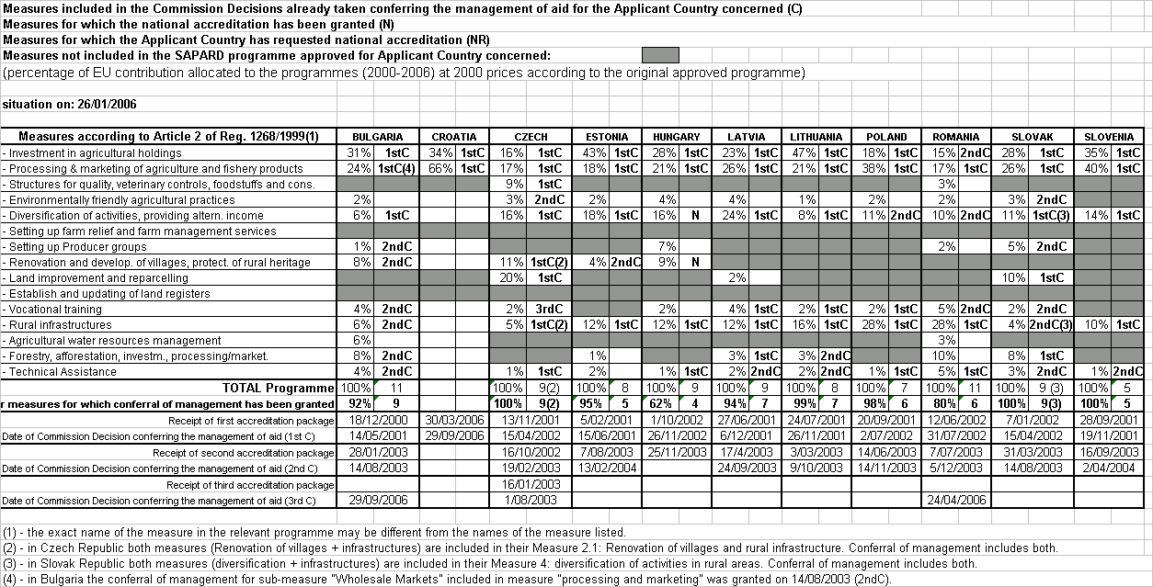
ANNEX F – Sapard irregulatiry reports by Member States
Number of first communications

