EN
EUROPEAN COMMISSION
Brussels, 10.11.2010
SEC(2010) 1346 final

COMMISSION STAFF WORKING DOCUMENT
State of play in the EU energy policy
Accompanying document to the
COMMUNICATION FROM THE COMMISSION TO THE COUNCIL, THE EUROPEAN PARLIAMENT, THE EUROPEAN ECONOMIC AND SOCIAL COMMITTEE AND THE COMMITTEE OF THE REGIONS
Energy 2020
A strategy for competitive, sustainable and secure energy
{COM(2010) 639}

Recent milestone developments:

The past five years have significantly accelerated the construction of a comprehensive EU energy policy based on mutually complementing pillars of competitiveness, sustainability and security of supply. These developments go back to October 2005 when the European Council, gathered at the Informal Summit in Hampton Court, concerned by the pressing need to address the climate change challenge and to react to oil price increase which approached $70 per barrel, requested the Commission to develop a long term and coherent energy policy.

The first step in this process was the Commission's Green Paper ''A European Strategy for Sustainable, Competitive and Secure Energy''.

Next, in October 2006, the Commission adopted a comprehensive Energy Efficiency Action Plan to create a coherent framework of legislation, policies and measures for achieving the 20% energy efficiency objective compared to what was expected to happen under business as usual scenario.

In January 2007, the Commission issued the first EU Energy Action Plan which was endorsed by the European Council in March 2007. At present, most of the Action Plan measures have been largely executed through new legislation and ongoing proposals that will soon be agreed.

In September 2007, in order to complete the integration of the EU gas and electricity market, the Commission proposed further energy market liberalisation measures, the so called 'third package'. This legislation was agreed by the Council and the Parliament in July 2009.

The Strategic Energy Technology (SET) Plan, presented by the Commission in November 2007 and agreed in March 2008, introduced priorities for future energy technologies.

In January 2008, the Commission proposed the Energy and Climate package with "20-20-20 by 2020" goals: reduction in greenhouse gas emissions to 20% below 1990 levels, 30% in the context of a global agreement on climate; 20% share of renewables in the final energy consumption; reduction in primary energy use to 20% below the baseline projection for 2020, which were subsequently translated into legally-binding frameworks for greenhouse gas emissions and renewable energy. As part of the Energy and Climate package, the legal framework for CO₂ capture and storage (CCS) technology was also created.

In 2008, an action plan to strengthen EU energy security was put forward in the Second Strategic Energy Review. It emphasized the importance of infrastructure links needed to strengthen energy security and solidarity between Member States, as well as introduced the perspective of low carbon economy to be achieved by 2050, which will necessitate a major shift towards low carbon energy technologies.

To speed up and secure investments in infrastructure and technology projects in the energy sector, the European Energy Programme for Recovery was agreed in July 2009 allocating €3.98 billion to finance mature energy infrastructure and technology - CCS and offshore wind - projects during 2010 and 2011. This unprecedented financing stimulus package was added to the various existing energy financing instruments.

Also in the framework of the European Economic Recovery Plan, the European Regional Development Fund (ERDF) Regulation was amended in May 2009, expanding the scope for sustainable energy investments in buildings. Whereas Regional Policy has traditionally financed energy efficiency investments only in public and commercial buildings, it is now possible to use these funds to improve resource efficiency in the residential sector in all Member States. Up to 4% of the national ERDF allocations are now available for energy investments in housing, thus adding a potential EUR 8 billion total throughout the EU. In addition, to encourage greater use of market instruments, another regulatory amendment was approved in June 2010, extending the use of financial engineering instruments to investments in energy efficiency and renewable energy in buildings, including existing housing.

Further measures to strengthen EU internal energy supply security have been adopted. A legally binding framework for nuclear safety was agreed in June 2009.

Finally, the aim of a resource efficient and low-carbon economy that is efficient in the way it uses all resources and the aim to decouple EU economic growth from resource and energy use, reduce CO₂ emissions, enhance competitiveness and promote greater energy security are integral parts of the Europe 2020 Strategy for smart, sustainable and inclusive growth, and notably the Flagship Initiative 'Resource efficient Europe'.

This evaluation report aims to present in a comprehensive manner main achievements under the above mentioned EU energy policy initiatives, structured around four sectors: (i) energy efficiency and savings; (ii) internal energy market, including consumers' rights, and infrastructures' development; (iii) actions for a sustainable, secure and competitive energy supply within the EU; and (iv) external supply security and promotion of sustainable use of energy worldwide. For each of the sector, an overview is given for already achieved results as well as for identified shortcomings which require further action during the Energy 2020 period to achieve the 2020 EU binding targets and to prepare transition towards low carbon economy by 2050.

I - Reducing energy demand and promoting energy savings

Energy efficiency and savings is the most immediate and cost-effective way of addressing the EU's strategic energy and climate policy objectives of fighting climate change, ensuring security of energy supply and establishing competitive and resource efficient economies, while creating jobs and making citizens benefit from lower energy bills and better living conditions. It is widely recognized that at least 20% of EU's primary energy demand (or 368 Mtoe) can be reduced by 2020 compared to business-as-usual PRIMES scenario of 2007 with cost-effective measures.

Though a number of initiatives were undertaken at EU level since the mid-1990s, the European Energy Efficiency Action Plan (EEAP) adopted by the Commission in October 2006 created a coherent framework of legislation, policies and measures on energy efficiency and savings with a view to intensify the process of realising the 20% energy efficiency and saving objective. It identified six key areas with the highest potential for energy saving and proposed 85 actions and measures to be taken at EU, national and local level. EU Heads of States and of Governments endorsed, at the Spring 2007 Council, the EEAP and the 20% EU objective.

After years of growth, the EU primary energy consumption has stabilized in 2005 and 2006 around 1 825 Mtoe and slightly decreased in 2007 and 2008 to reach around 1 800 Mtoe. Although the economic crisis contributed to this decrease in energy consumption in the EU, the recorded stabilisation provides a certain confirmation of the decoupling of energy consumption and economic growth. In addition, EU-27 energy intensity, measured as the ratio of gross inland energy consumption and the gross domestic product, has kept improving, decreasing from 187.3 in 2003 to 167.4 in 2008 kgoe / EUR 1000 (see Annex I: EU–27 energy intensity in kgoe/EUR 1000, 2000 – 2008).

The latest business-as-usual scenario projections (PRIMES 2009) for the first time show a break in the trend of ever increasing energy demand.

However, EU is far from reaching its 20% objective. The projections indicate that with the rates of implementation of the current energy efficiency policies in Member States (until December 2009), a bit more than 8.9% primary energy consumption reduction will be achieved in 2020.
20% energy saving objective
vs. expected achievements of some major EEAP energy efficiency policies
adopted until 2009 as projected by the energy model PRIMES

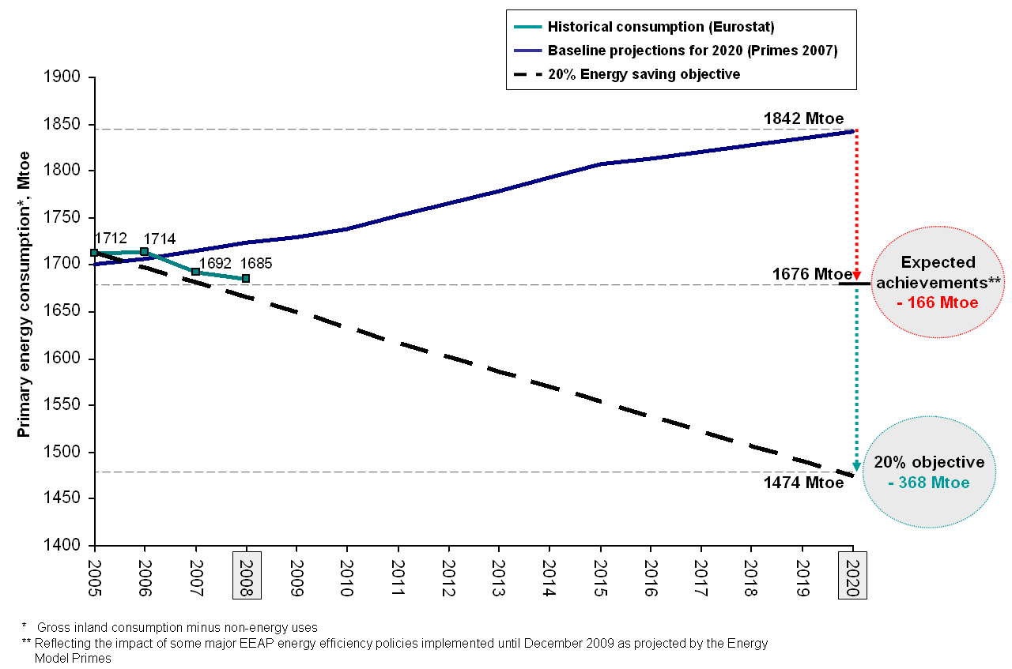

The above projections do not take fully into account policies in the pipeline, especially the forthcoming Eco-design implementing measures and the recast Energy Performance of Buildings Directive, which could provide further decrease in the consumption. Nevertheless, these projections give a good indication of the probable gap in reaching the EU's energy saving objective. Furthermore, while the economic crisis contributed to this decrease in energy consumption, it has also negatively impacted energy efficiency investment decisions at all levels - public, commercial and private.

The European EEAP has given a considerable impetus to the adoption of a number of legislative and soft-law tools to capture energy savings potential. To date, progress has been achieved on most measures, with only a very limited number seeing little progress or facing delays (see Annex II: Main achievements for the six EEAP key areas). Due to the overlapping effects and the early stages of the EEAP's implementation it is not possible to make concrete quantitative evaluation of its' overall impact. However, individual ex-ante quantitative impact assessments of some already adopted measures are available and Commission is currently preparing a progress report on the current implementation status of the EEAP. Considering the insufficient uptake of the energy savings potential, it is clear that more actions in this area are needed. In fact, EEAP was conceived as a first step towards reaching the 20% objective and its revision was foreseen for 2009.

Despite the measures taken at EU and national levels, the existing cost-effective opportunities for energy savings and the related social, geopolitical and environmental benefits are yet not fully used in all economic sectors. This can be explained by the prevailing market failures, such as asymmetric information, split incentives, missing or incomplete markets, as well as regulatory failures, including missing norms or poor implementation of the existing ones that in many cases do not allow for the legislation to have the expected impact. Therefore, in addition to full implementation of the current policy framework as set out in the EEAP of 2006, further concerted action is needed to eliminate the barriers in each sector. New action should take into account what has been achieved so far and the needs of particular sectors in order to establish a coherent policy mix, keeping in mind that many studies indicate that best results in energy savings are reached only via a set of parallel policy measures. Priorities should focus on energy performance requirements for products, buildings and services, on strengthening energy efficiency in the utility and transport sectors, on reviewing financing mechanisms and addressing pricing aspects, as well as on changing energy use behaviour.

II – Deepening the internal energy market integration, strengthening consumers' rights and developing infrastructures

- Integrating the EU internal energy market

The competitive, integrated and fluid internal energy market is a strategic instrument in order to secure energy supply, give EU consumers a choice between different companies supplying gas and electricity at reasonable prices, and to make the market accessible for all suppliers, especially the smallest and those investing in renewable forms of energy. The integrated internal market is also crucial for the proper functioning of CO₂ emission trading mechanism. Over the coming two decades, the EU - like other parts of the world - has to address the need for major investments in all types of energy infrastructure which will be crucial to overcome the longstanding fragmentation of EU energy markets. However, only a properly functioning internal electricity and gas market can send the right price signals to encourage investments. The integration of the EU energy market is set to continue but it may take some time because the planning and building of relevant infrastructure requires long time-horizons.

The process of opening the EU energy markets to competition started ten years ago. It has allowed EU citizens and industries to gain many benefits, such as more choice, more competition for better service and improved security of supply. Since July 2004, small-business customers in all EU countries have been free to switch their supplier for gas and electricity. In July 2007 all remaining consumers gained the same freedom (see Annex III on market opening for gas and electricity).

Independent national regulatory authorities have been established in each EU country to ensure that suppliers and network companies operate correctly and actually provide the services promised to their customers. Since 2003, heads of the national energy regulatory authorities meet in the European Regulators Group for electricity and gas (ERGEG) set up by the Commission. ERGEG acts as an advisory group, assisting the Commission in consolidating the internal market for electricity and gas. Based on yearly reports by the national regulators, the European Commission is monitoring the market closely, identifying obstacles and shortcomings. In 2008, the Market Observatory for Energy of the European Commission started its activities aimed at better monitoring developments on energy markets, in particular gas and electricity markets, and further increasing transparency.

A comprehensive inquiry into the electricity and gas sectors published in January 2007 revealed that too many barriers to competition and too many differences across the Member States remain. The Commission subsequently came forward with the third internal energy market liberalisation package, which foresees, among others, the effective separation of supply and production activities to make the market accessible for all suppliers, harmonization of the powers of national regulators, better cross-border regulation to promote new investments and cross-border trade, effective transparency, as well as assuring that EU and third country companies compete in the EU on an equal footing. These proposals were agreed by the Council and the Parliament in July 2009 and should be implemented by 2011.

In parallel, the Commission adopted in March 2009 the Benchmarking Report assessing the implementation of the then existing internal energy market legislation. It revealed a mixed picture of the accomplishment of the internal market. Besides the incomplete implementation of the legislation by the Member States that the Commission will continue addressing through infringement procedures, the Benchmarking Report highlighted the impact of the financial and economic crisis on the internal energy market. Reduced economic activity resulted in a significant fall in the consumption of gas and electricity. This lower consumption has had an important impact on the international oil prices, which in turn influenced gas and electricity prices. However, the fall witnessed in international oil prices has not been entirely reflected in end user gas and electricity prices. The Report also indicated that there are still high levels of concentration on the retail and wholesale market (see Annex IV on Electricity and Gas market indicators).

The current work of national regulatory authorities is shifting the focus towards the consumer, including the roll-out of smart meters as the key component to introduction of smart grids in the internal energy market. This is a welcome trend that can lead to a more active participation by customers in the internal energy market, increased energy efficiency and large-scale integration of renewables, as well as additional energy services, increased market transparency and easier supplier switching. Additionally, cooperation between European power exchanges and the increasing levels of trade are a promising sign of functioning markets. This has resulted in spreading the efficient methods for cross-border trade, namely implicit auctions, in particular in the Northern and Western parts of Europe. A further challenge is to spread this method to areas, which are not yet applying it.

In 2007 and 2008 a great deal of effort was put into enhancing competition on the wholesale market; significant progress was made through the regional initiatives such as Baltic, Central-East, Central-South, Central-West, North, South-West and the France-UK-Ireland regions for electricity and North-West, South and South-South East regions for gas. With respect to market concentration, progress has generally been slow. A number of wholesale markets, in particular, still suffer from limited competition and the lack of liquidity. There are signs that the situation on the retail market is about to improve. Member States should put even more effort into providing comprehensive data for supplier switching.

While short-term solutions, such as regulated prices, might appear to be advantageous in the light of rapidly increasing energy prices, the likely consequences of such measures are that investor confidence is undermined, market entry is deterred and the full benefits of the internal energy market are placed at risk.

- Actions to strengthen consumers' rights in a liberalised energy market

Since the 1990's, opening up retail markets to competition has aimed to improve the services available to consumers and to allow free choice of supplier for consumers. Under EU legislation, customers have clear rights to choose their supplier, receive clear, detailed contracts and energy bills.

In 2003, the Electricity and Gas Directives for an internal energy market recognised electricity provision as a universal public service, thus establishing the right to be supplied with electricity and gas (subject to network provision) at reasonable, easily and clearly comparable and transparent prices. This legislation introduced the concept of protection of customers in general, and of vulnerable customers in particular, by Member States.

The 2003 internal market legislation placed obligations on energy suppliers requiring them to achieve levels of supply quality and network security performance. In 2008, the European regulators carried out a benchmarking exercise on the quality of electricity supply. The survey noted that overall the continuity of electricity supply in Europe is improving with customer minutes lost per year decreasing almost continually since 2002.

In order to effectively benefit from offers available on the market, the limit on switching supplier has been reduced to six weeks. Switching levels vary considerably across Member States, with some mature markets experiencing relatively high rates and a number of others showing little or no activity.

The third package on the internal market of 2009 increases the levels of protection for consumers and improves the operation of the retail energy market. The legislation provides additional protection for vulnerable groups which have to be defined as well as redress mechanisms. It also places new duties on energy companies, for example, to inform consumers about such issues as the provenance of their electricity, or ways of saving energy. Member States are required to ensure that there are adequate safeguards to protect vulnerable customers, including the non-disconnection of electricity in "critical times". It is important to note that any mechanism adopted to protect vulnerable consumers must not interfere with the operation of the market and must take into account other social policy measures in the Member State. It is in the interest of governments to help vulnerable consumers by improving their energy efficiency, and not only subsidizing their energy bills.

National energy regulators have the task of ensuring that consumers get the best prices, the widest choice of supplier and the best quality of service possible. The creation of a European Agency for the Cooperation of Energy Regulators will help strengthen regulators.

To inform consumers about their rights and how to use them, the 2009 legislation introduces a European Energy Consumer Checklist. The EU has also brought together national consumers groups, European umbrella groups, such as BEUC (the European Consumers’ organisation), and representatives of the energy industry to help raise awareness of consumers' rights within the energy industry and vice-versa.

Issues of concern to consumers, such as transparency, clear billing, fair contracts and a fair dispute settlements procedure, are discussed and monitored at the Citizens' Energy Forum (London Forum), launched in 2008. The Forum brings together the national and European consumer associations, representatives of the Member States, national energy regulators and representatives of the electricity and gas industry to discuss ways of improving consumer service.

One of the main complaints from consumers is inaccurate or incomplete billing; the introduction of communication technology will significantly remove this as an issue for consumers. The introduction of bi-directional communication will allow the consumer to get a fair value for electricity that they generate as well, thus facilitating the use of micro and renewable generation. Member States are to have an active role in any rollout by ensuring that the systems that are implemented are interoperable and adhere to the relevant international standards and best practice.

In addition, new provisions on the introduction of Smart Metering is a key advance in the operation of retail markets that will result in improved retail market competition. The new devices have the potential to improve information for consumers and therefore provide for tariff innovation. Consumers will be able to respond to the price signals that are provided to them, which may be to decrease consumption, but it may also be to increase consumption (for example by electric vehicles) depending on network conditions. Consumers can therefore become a more active player in the market with the use of smart meters featuring the right functionalities to provide them with the services they need, want and understand, for their own benefit.

Nevertheless, there are still gaps between the intention of the EU legislation, to improve services to energy consumers, and its delivery. Poor implementation or ineffective regulation reduces the benefits to consumers. The Commission is pursuing a number of Member States for not fully implementing EU rules for consumers. It will also produce its first Benchmarking report on energy consumers in November 2010.

- Developing infrastructures

In the EU internal energy market, a key tool to promote interconnections is the trans-European energy networks (TEN-E) programme. Following a review in 2006, the current objectives of the TEN-E policy are to: (1) support the completion of the EU internal energy market, (2) reduce the isolation of less-favoured and island regions, (3) secure and diversify the EU's energy supplies also through co-operation with third countries, (4) contribute to sustainable development and protection of the environment.

Over the past years, the TEN-E programme has positively contributed to the development and operation of the internal energy market. In particular, the eleven completed cross-border electricity projects accelerated by the TEN-E policy framework have permitted increased energy trade and more competition, contributing to the convergence of average energy prices and stimulating market integration and thus the development of a true internal energy market.

Security of supply has also been reinforced through increased transmission capacity between as well as within Member States, both for electricity and gas, as well as the three LNG terminal and gas storage projects. In this respect, TEN-E has contributed to greater diversity in gas supplies.

Progress has been more mitigated as regards the objectives to reduce the isolation of peripheral regions and islands. Four out of nine projects are under construction. The uncertainty over the future electricity generation mix (imported gas versus renewables) is a brake on infrastructure developments in isolated markets.

TEN-E contribution on sustainable development and the protection of the environment, a relatively new addition to TEN-E, has thus far been limited. There are a number of projects adapting the networks to increased availability of renewable energy, in the electricity as well as in the gas sector.

In terms of political impact, TEN-E has been most effective in those projects that were selected for first priority funding, namely projects of European interests, and that had considerable political support as well as commercial potential. It has made a positive contribution to selected projects by giving them political visibility and helping leverage funds from the financial market. The "TEN-E label" given to projects with the highest European interest and the creation of European Coordinators in 2006 have been conducive in delivering results. In view of these objectives some progress has been achieved in the implementation of the TEN-E during the past years (see Annex V presenting a statistical overview of the TEN-E implementation programme).

The Second Strategic Energy Review in 2008 already streamlined several infrastructure initiatives as energy security priorities for the EU: the Baltic Interconnections Plan, a Southern Gas corridor for gas supply from Caspian and the Middle – Eastern sources, LNG capacity expansion, a Mediterranean energy ring, North – South gas and electricity interconnections within Central and South-East Europe, a North Sea offshore grid. In relation to the first, in June 2009, the Baltic Sea Region States reached an agreement on the Baltic Energy Market Interconnections Plan identifying a number of steps to improve energy security in the region.

Despite the progress achieved, the dramatic changes the EU energy policy framework has undergone in the recent years call for a thorough review of both the concept and rationale of the TEN-E framework. The programme has responded too slowly to the major energy and climate goals of today, and is poorly equipped to deal with the growing challenges that will arise from the 2020 and 2050 ambitions. As examined in the November 2008 reflection exercise about a possible new EU Energy Security and Infrastructure Instrument (EESII) and identified in the TEN-E Implementation report, the major shortcomings of the current TEN-E framework include the lack of focus and definition of European priorities, lack of coordination between TEN-E and other energy infrastructure activities and instruments (such as structural funds, EIB interventions, as well as IPA and ENPI/NIF instruments for third countries), the challenge of lengthy authorisation procedures, lack of coordination and cooperation on trans-border projects, as well as limited TEN-E budget (i.e., EUR 155 million for the period 2007-2013, mainly awarding grants for studies and only to a minor extent for works).

Some of the shortcomings have already been tackled, paving the way for the forthcoming EESII. In 2009, as the financial and economic crisis unfolded, public expenditure interventions to facilitate investments in energy networks became necessary. EU institutions agreed on the creation of the European Energy Programme for Recovery (EEPR). The EEPR is a financial instrument whose overall objective is to stimulate recovery from the downturn affecting the EU economy while enhancing the achievement of the EU's energy and climate policy objectives.

The EEPR was endowed with a €3,980 million financial envelope in support of three sub-programmes. For gas and electricity interconnection projects, the Regulation allocated respectively €2,365 million; and additional €565 million to offshore wind electricity projects; as well as €1,050 million to carbon capture and storage projects (CCS).

In order to maximise the impact in terms of both energy policy and economic recovery objectives, the EEPR focuses on a relatively small number of highly strategic projects. The identification of the projects was driven by the EU energy policy orientations set out in the Second Strategic Energy Review, taking into account progress made in the implementation of the TEN-E programme and an adequate geographical balance, and consultations with stakeholders in the areas covered by the programme. Other key award criteria were the extent to which lack of access to finance was delaying the implementation of the action; the extent to which the Community grant would stimulate public and private investments; and the social, economic and environmental impact.

The EEPR has been from the beginning an accelerator of infrastructure investments. Indeed, the selected projects although they were technically mature, however, the perspective of the Community financial support for capital expenditure has proven to be decisive in enhancing the actual realisation of the projects. In particular, EEPR funding has proven to have a catalytic effect in attracting co-financers and encouraging them to make investment commitments. This has made possible the setting in motion of projects that otherwise could be delayed or abandoned due to funding constraints, particularly severe under the current economic circumstances. The EU contribution will have an important leverage effect. The expectation is that the €2.3 billion EEPR grants will help to lever up to €22 billion of private sector investment over the next 3 to 5 years.

III – Acting for a sustainable, secure and competitive energy supply within the EU

The EU primary energy consumption represents 1800 Mtoe (2008 data). EU indigenous energy production covered 850 Mtoe.

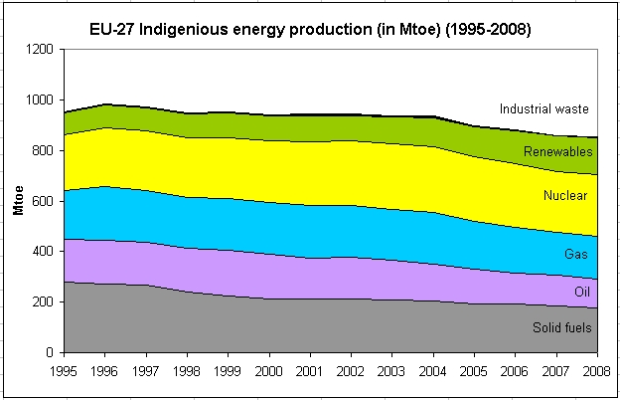
Source: Eurostat

Therefore, energy imports, representing 1015 Mtoe, made the EU dependent on external energy supplies to the level of 54.8% all fuels taken together (see Annex VI on EU-27 energy demand developments and total final energy consumption by sectors; Annex VII on EU-27 energy imports dependency).

- Promoting renewable energy

Renewable energy sources (RES) have an important role to play in securing diversified, mainly indigenous, energy supplies and in combating climate change. Moreover, further deployment of renewable energy technologies has a potential to create hundreds of thousands of jobs in the EU.

Renewable energy production has grown rapidly in the last ten years, especially in a few key Member States with stable supportive policies. Over 1997 - 2007 the RES and waste generation park grew by around 80 GW whereas over 1990 – 1997 developments in this area represented just 15 GW. The RES and waste additionally installed capacity amounted to 64.4 GW over 2000-2007 while it was only 41.9 GW for thermal power plants. Wind power now forms the highest share of new production capacity and in 2007, it accounted for 25% of the net RES installed capacities.

Source: Eurostat

(See Annex VIII for further details on renewable energy sources developments.)

EU level initiatives such as the so called "Green electricity Directive" (2001/77) and the "Biofuels Directive" (2003/30) have tried to stimulate an increase in the consumption of renewable energy. The first one established an overall EU target of 21% and individual national indicative targets for the RES shares in the final electricity consumption to be realised by 2010. The second required that all Member States ensure at least 5.75% of their total transport fuel consumption comes from biofuels and other renewable fuels. Despite the significant growth achieved in the use of renewable energy over the last couple of years, the latest EUROSTAT data on RES shares available for 2008 (16,6% for green electricity and 3,5% for renewable fuels) indicate that 2010 targets will not be met. A few Member States were close to reaching their renewable electricity targets and a handful of them had already met their biofuels targets ahead of 2010 reference date. Most EU countries however were lagging behind in their efforts to increase the share of renewables. Next assessment of the Member States' progress will be issued before the end of 2010.

The new legal framework established by the Renewable Energy Directive agreed in December 2008 for the first time sets out binding targets for all Member State in order to achieve the overall 20% renewable energy target for the EU by 2020. In addition, the directive also includes a mandatory 10% target for the share of renewable energy in transport for all Member States and requires establishment of National Renewable Energy Action Plans for the fulfilment of these targets. The new EU framework legislation for renewable energy also addresses the problems of administrative hindrances to the development of renewables and their integration in the grids, as well as sustainability requirements for biofuels. By setting a longer term regulatory framework, it can be expected to deliver a significantly higher rate of increase in the consumption of renewable energy and create investor confidence over the period of the Energy Action Plan 2011-2020.

The table below gives an insight in renewable energy developments and defined targets.

share of renewable energy in… | 2001 | most recent data | target 2010 (indicative) | target 2020 (binding)
electricity generation | 13.4% (36 Mtoe) | 16.1% (47 Mtoe - 2007) | 21% | no sectoral target
road transport | 0.3% (1 Mtoe) | 3.4% (10 Mtoe - 2008) | 5.75% | 10%
heating | 9.1% (52 Mtoe) | 11.5% (63 Mtoe - 2007) | no target | no sectoral target
final energy consumption | 7.6% (89 Mtoe) | 9.8% (118 Mtoe - 2007) | no target | 20%

Key issues for a further successful progress with renewable energy are related to cost-effectiveness, technological development and sustainability.

The use of renewable energy still generally costs more than conventional energy, although cost differences are falling. To achieve the targets, support systems are therefore needed. Responsibility for support falls mainly on Member States.

The so called "cooperation mechanisms", set up by the Directive, will contribute to cost-effectiveness by allowing cheaper renewable energy that is produced and consumed in one Member State, perhaps with high potential, to contribute to the target of another – perhaps with less potential, more expensive resources but a higher target. The functioning of the cooperation mechanisms will have to be evaluated by 2014.

National support schemes for the renewable energy currently do not cover projects with a strong cross-border component, such as electricity grid development and offshore wind. Even at national level, more work is needed to improve the integration of renewable energy (electricity, biogas and biofuels) in energy distribution networks. Such integration and the increase in the number of market players will increase competition in all three energy sectors. In the electricity sector it should also reduce balancing costs. Overall, it should result in cost savings from increased trade in energy.

The EU framework also includes guarantees of origin as a tool to help stimulate the retail market for renewable energy products. As the Commission turns to improving the cost effectiveness and efficiency of the retail market for all elements of the energy sector, this framework will also need attention.

Most of today's renewable energy is supplied by a few technologies: large hydropower, onshore wind, biomass and first-generation biofuels. Progress towards energy decarbonisation after 2020 will be easier and cheaper if more advanced technologies, such as offshore wind, solar power, renewable electricity use in transport, second-generation biofuels and biomass can also make a significant contribution. These promising technologies have been known for some time. Some, such as offshore wind and second-generation biofuels, are beginning to show signs of good progress. Others, such as electric cars, are developing more slowly.

The Commission's renewable energy policy during 2011-2020 needs to lay the foundation for new technologies to make a major contribution in the decades that follow. On the research and development side, arrangements are being put in place in the framework of the SET Plan. On the implementation side, technological development is encouraged by a possibility to differentiate the support systems in favour of more promising technologies. The use of advanced technologies such as renewable electricity in transport and second generation biofuels also broadens the diversity of our energy supply and helps prepare our energy sector for evolving into a low carbon sector. It remains to be seen whether more will need to be done to increase the pace of development of new technologies.

Sustainability scheme for biofuels and bioliquids set up by Renewable Energy Directive was the first of its type in the world and is still the most stringent. The criteria it lays down apply to all biofuels whether domestically produced or imported. Voluntary certification schemes, recognised by the Commission and subject to independent auditing, will play an important role.

For other types of biomass (solid and gaseous biomass in heating and electricity), a review in early 2010 concluded that sustainability performance is presently sufficient to avoid the need for the introduction of a binding European sustainability scheme. The Commission recommended that Member States choosing to introduce such a scheme at national level should use an approach that is consistent with each other and with the approach for biofuels. This issue will be further examined at the end of 2011.

- Demonstrating CO₂ capture and storage on an industrial scale

CO₂ capture and storage (CCS) has become an integral part of European Union (EU) energy policy in recent years. In most future scenarios the deployment of CCS is deemed to be a necessity for achieving GHG reduction targets. Analysis by the International Energy Agency suggests that without CCS, overall costs to reduce emissions to 2005 levels by 2050 increase globally by 70%. However, CCS is not currently an economically viable climate change mitigation option and some de-risking of the technology is required to enable commercial deployment before CCS can contribute to these climate goals. Consequently, the European Commission has identified the need for a Europe-wide programme of CCS demonstration projects.

The first Communication from the Commission regarding CCS, entitled "Sustainable power generation from fossil fuels: aiming for near-zero emissions from coal after 2020", was published in January 2007. The Commission undertook to determine the most suitable way to support the design, construction and operation by 2015 of up to 12 large-scale demonstrations of sustainable fossil fuel technologies in commercial power generation. Since then, all actions related to CCS and designed by the Commission take this objective into account. The second CCS communication entitled "Supporting early demonstration of sustainable power generation from fossil fuels" confirmed the Commission's commitment to make the technology commercially viable by 2020.

A CCS Directive was adopted in April 2009 as part of the Energy and Climate Package and entered into force in June 2009. It establishes a comprehensive legal framework to manage the environmental risks of capture, transport and the geological storage of CO₂ and at the same time removes existing legal barriers in EU legislation. Whilst the Directive itself focuses on the regulation of storage, risks related to capture and transport of CO₂ are dealt with through amendments of related EU legislation.

A CCS Project Network was established in 2010 to facilitate knowledge sharing, assist with public engagement to raise awareness of the potential of CCS and international co-operation in knowledge sharing. It additionally provides participating members - large-scale demonstration projects - with a common European identity.

CCS was also included in the scope of the revised ETS Directive. It ensures that stored CO₂ is not regarded as emitted and provides therefore a financial incentive for CCS. In addition 300 m allowances from the New Entrants Reserve (NER) shall be available to support commercial-scale CCS and innovative RES demonstration projects in the territory of the Union. The projects to be supported under the NER300 programme will be selected in a competitive procedure to be launched in 2010.

Six large-scale CCS demonstration projects have already secured some funding from the European Energy Programme for Recovery (EEPR). A total of €1 billion has been allocated to projects in the UK, Germany, the Netherlands, Poland, Spain and Italy. The NER300 funding mechanism will provide complementary financing for CCS demonstration project. The opening of a call for proposals is expected in autumn 2010.

Key issues for successful CCS progress are related to timely deployment of the demonstration plants, implementation of the legal framework by Member States, and addressing the issues of optimal infrastructure deployment and the current low levels of public awareness. The European Infrastructure Package, scheduled for the end of 2010, will consider future needs of CO₂ infrastructure.

The most urgent priority remains the deployment of large-scale CCS demonstration projects by 2015 to prove the technology can be economically and environmentally viable around 2020. Both EEPR and NER 300 support schemes constitute a solid base but in order to deploy a successful demonstration exercise in Europe more is needed. The CCS Industrial Initiative under the SET Plan referred to below shall be a driver for addressing the outstanding needs of industry and governments with respect to refinement of the technologies.

- Completing the Community safety, security and non-proliferation framework for nuclear energy

Alongside renewable energy sources, nuclear energy contributes to combating climate change and strengthening security of supply, by reducing EU's external dependence on oil and gas. As one of the cheapest low carbon energy sources, nuclear energy also contributes to the EU competitiveness. Over the last years, there has been a renewed and growing interest in nuclear energy which is not only visible at global level, but also in EU Member States. A majority of Member States have chosen to use nuclear energy for power generation. The EU-27 has the largest number of commercial nuclear power stations in the world: some 150 nuclear reactors are in operation, providing around one third of EU's electricity and two thirds of low carbon electricity.

Based on the broad set of competences entrusted to the Community by the Euratom treaty, a wide range of initiatives have been launched over the last years with the objective to develop the most advanced framework for nuclear safety, security and non-proliferation.

Nuclear safety is and will remain one of the absolute priorities of the EU. In this field, the Commission – with the support of the European Council – brought together all national nuclear regulators in a European High Level Group on nuclear safety and waste management. A fundamental step was the adoption in June 2009 of a Directive establishing the basic framework for nuclear safety. This new common EU framework provides binding legal force to the main international nuclear safety standards (IAEA fundamental safety principles and Nuclear Safety Convention - CNS - obligations) and reinforces the independence and resources of the nuclear energy regulatory bodies in all EU Member States. When this Directive will be implemented the EU will be the first major nuclear player having common binding nuclear safety rules. Since the Euratom Community is a Contracting Party to the CNS, the Commission presents the Euratom Report on behalf of Euratom and takes part in the CNS Review Meetings, alongside the EU Member States.

In the context of enlargement of the EU, the Commission monitored and helped with the safe decommissioning of nuclear power plants in Bulgaria, Lithuania and Slovakia, with substantial financing being provided, in cooperation with the EBRD. In 2006, the Commission published recommendation on the management of financial resources for the decommissioning of nuclear installations, spent fuel and radioactive waste.

The Commission also made full use of all key Community instruments under the Euratom Treaty, in particular in the field of nuclear investments by providing Commission opinions on new build, radiation protection, research and technology, nuclear safeguards and international relations. The framework for nuclear safeguards has also been strengthened through the introduction of integrated safeguards in all EU non-nuclear weapons states with significant nuclear installations.

Taking into account the importance that public acceptance and transparency play in relation to nuclear energy, the Commission launched in 2007 the European Nuclear Energy Forum (ENEF) to debate risks, opportunities and transparency of nuclear energy.

In parallel, Commission's activities were focusing on investment aspects and technological developments. Nuclear Illustrative Programme, the so called 'PINC report', giving a factual overview of investment projects was adopted and revised respectively in 2007 and 2008.

In relation to technologies, in 2007, the Sustainable Nuclear Energy Technology Platform (SNETP; www.snetp.eu) was launched with the endorsement of the EC. Its objective is to develop and implement a Strategic Research Agenda covering continued safe operation of current and new-build light water reactors (Generation II & III), the cogeneration of electricity and heat for industrial processes using High / Very High Temperature Reactors, and the development of Generation IV Fast Neutron Reactors (FNR) and closed fuel cycles for greatly increased sustainability. In particular, SNETP has established a Task Force of key industrial and research players to implement the European Sustainable Nuclear Industrial Initiative (ESNII) under the SET Plan. ESNII will design and construct Gen-IV FNR prototypes and demonstrators in order to demonstrate the technical, industrial and economic feasibility, increased sustainability through more efficient use of uranium resources, and reduction of waste volumes and lifetimes. Then, in November 2009, the Technology Platform for Implementing Geological Disposal of nuclear waste (IGDTP; www.igdtp.eu) was launched with the objective of coordinating the remaining R&D in the lead up to the construction and operation by 2025 of Europe’s (and the world’s) first deep geological repositories for high-level and long-lived radioactive waste.

Furthermore, Statutes of the Euratom Supply Agency (ESA) were reviewed in 2008. In addition to its traditional role of ensuring supply security of nuclear materials to users in the Community by diversifying supply sources, the Agency has now been required to monitor nuclear market developments and issues regular publications.

In the current context of renewed development of nuclear energy in the EU, the need for stronger EU nuclear policy actions is becoming even more evident. The EU should – in the interest of all Member States – complete the legal framework for nuclear energy. This should cover in particular the area of nuclear waste management: a proposal for a directive has been adopted on 3 November 2010. A more harmonized approach could be introduced towards design certification and licensing, as well as in relation to civil liability and education and training aspects. Moving towards harmonization in pre-licensing of nuclear power plants and nuclear liability regimes would bring benefits in terms of increased nuclear safety, better protection and equal treatment of EU citizens, and a level playing field for the industry with more legal and regulatory certainty.

- Guiding investments into smart and low carbon energy technologies

To accelerate the development of low carbon technologies, in November 2007 the Commission presented the Strategic Energy Technology Plan (SET Plan). Endorsed by the Council in March 2008, the SET Plan proposes to launch six European Industrial Initiatives (EIIs) in the areas of wind energy, solar energy, CO₂ capture and storage, advanced nuclear fission, electricity grid as well as bio-energy. More Industrial Initiatives are actually in the development phase. The objective of the Industrial Initiatives is to pool together all stakeholders to define and implement ambitious technology programmes with the aim to support the reaching of the 20-20-20 targets. In addition, the SET Plan also proposed the setting up of the European Energy Research Alliance (EERA), pooling together major European research organisations and asking them to perform Joint Programming in areas related to energy technologies.

During 2008-2009, extensive work has been undertaken by stakeholders, in particular the European Technology Platforms (ETPs), to draft technology roadmaps for the European Industrial Initiatives, describing the scope of actions and defining an overall budget. This work has served as the basis for the Communication on Investing in Low Carbon Technology issued by the Commission in October 2009, with EP Resolution and Council Conclusions in March 2010. The overall required budget for the six initial Industrial Initiatives, now complemented by a few others (i.e., Smart cities) has been evaluated at €80 billion over ten years which roughly means a three fold increase from the current level of investment (see Annex IX for Estimation of the financing needs for key technology and actions proposed in the SET-Plan, 2010 – 2020). The financing will have to come from different coordinated sources and combining diverse funding mechanisms: national/EU/corporate sources, public/private, and grants/loans/other financing engineering tools. The EIB will certainly be a major player to ensure the success of this endeavour and specific dedicated tools might have to be designed. In June 2010, four European Industrial Initiatives on Wind, Solar, CCS and Grid have been officially launched in Madrid. At the same time as the launch of the four first Industrial Initiatives, four Joint Programmes under EERA have also been launched on Wind, Solar, Grid and Geothermal energy. Two other Industrial Initiatives on Advanced Nuclear Fission and Bioenergy are expected to be launched in November 2010 in Brussels. The preparation of the Initiative on Smart Cities has also started.

Moreover, the energy demonstration part of the 7th research Framework Programme was radically changed. All new demonstration projects have to fulfil very severe conditions which are derived from the SET plan. Now all projects have to focus on the SET plan priorities; they have to have a very significant impact on energy efficiency and low carbon energy technologies; industry has to commit itself to deploy the demonstrated technologies at large scale before 2020; all projects have to be clearly linked to the energy and climate change policy; about one third of the budget is spent on the electricity grid in order to solve bottlenecks for rapid deployment of renewables. In 2010 projects are on average about 10 times larger in budget and about 50 to 100 times larger in impact than in 2006.

Now that the research, development and technology innovation agenda of the EU energy policy is well defined, the key challenge is related to the urgency to increase investments in research, technology development and demonstration in all SET-Plan initiatives.

- Taking specific measures to strengthen supply security within the EU:

Gas supply interruptions that the EU witnessed in early 2006, 2008, 2009 and 2010, as well as EU's strong dependence on imports of petroleum products and the geopolitical uncertainty in many producer regions, accelerated the revision of security of supply related legislation.

Since 1968, EU legislation imposes an obligation on Member States to maintain minimum stocks of crude oil and/or petroleum products that can be used in the event of a supply crisis to replace all or part of the shortfall. In order to strengthen the Community's capacity to face a supply disruption, the Commission initiated in November 2008 the revision of the oil stockholding system. Adopted in September 2009, the new directive aligns the stockholding obligation and the calculation methodology with those of the International Energy Agency (IEA), enables the EU – both IEA and non-IEA Member States – to contribute better to an IEA action and improves the availability of stocks. Member States have to transpose the new directive into national legislation by the end of 2012. A new reporting system is under development to satisfy the requirements of the directive.

Security of gas supply is addressed in several legal acts. The Gas Directive (2009/73/EC) recognizes the right of Member States to regard security of supply as a public service obligation. This Directive has established common rules for the internal market in natural gas that enable Member States to take the requisite measures to safeguard supply in the event of a sudden crisis in the energy market. The Directive 2004/67/EC established a Gas Coordination Group to facilitate coordination of security of supply measures by the Community in the event of a major supply disruption. This group could also assist Member States in coordinating measures taken at national level.

In 2009, the Commission came forward with a proposal for a Regulation concerning measures to safeguard security of gas supply with the objective to guarantee the permanent functioning of the internal market for gas and to establish a common legal and technical framework for tackling the effects of supply disruptions. This proposal defines the responsibilities of all relevant actors, for instance natural gas undertakings, competent authorities of the Member States and the European Commission in the area of security of supply. The competent authority designated by each Member State is responsible for carrying out a Risk Assessment and establishing a Preventive Action Plan with the measures to reduce the high risks identified. This Plan lays down national measures how the Member State plans to fulfill the commonly defined infrastructure and supply standards, evaluates the risks, draws up preventive measures and provides information on public service obligations. The competent authority is also required to establish an Emergency Plan defining the measures to be taken in a crisis situation to mitigate the impact of a gas supply disruption. If the Plans are inconsistent, or national measures endanger the security of supply in another Member State, the Commission will have the opportunity to require the modification of the Plans or measures. The infrastructure standard shall contribute to infrastructure development through the so-called N-1 standard, which ensures that the network is capable of compensating the loss of the single largest gas supply infrastructure, and the obligation to establish gas flows in both directions on interconnections. The supply standard shall provide a common level of minimum obligations for the market to enable gas flows to protected customers even in extreme climatic conditions. These, and other additional public service obligations shall be made public thus further enhancing the level of transparency on the gas market. Cooperation among Member States and the Commission is strengthened both in the preventive and in the crisis management stage. Declaration of Union or regional emergency shall be made by the Commission.

Electricity blackouts in the EU in November 2006 have highlighted the need to define clear operational standards for transmission networks and for correct maintenance and development of the network. Therefore, in order to ensure the functioning of the internal energy market, the EU established obligations for the Member States to safeguard security of electricity supply and undertake significant investment in electricity networks. These requirements define the adequate level of interconnection between Member States, an adequate level of generation capacity and balance between supply and demand.

Given the massive investments in all types of energy infrastructure needed in the EU in order to meet the security of supply as well as the climate challenges of the EU energy policy, the Commission proposed in 2009 a monitoring of investment projects. In June 2010, the Council adopted a new Regulation which lays down the framework for a regular monitoring of investment projects in energy infrastructure within the EU. This should increase transparency on the structural evolution of the EU energy system and enhance the ability of EU institutions to anticipate problems.

In addition, a network of energy security correspondents (NESCO) of the EU Member States was created in 2007 to serve as a system for an early exchange of information in case of signals of potential supply disruptions.

IV - Acting for EU's external supply security and sustainable use of energy worldwide

Given global challenges of energy security, slow progress globally on combating climate change, EU’s rising external supply dependence, the emergence of large new energy consumers, volatile energy prices and other factors, external dimension has become an integral part of the EU's developing energy policy.

Over the years, successive European Councils, echoed by the European Parliament, stressed the need for a common approach to external energy policy. The Energy Action Plan of 2007 called for enhancing relations with EU's main supplier, consumer and transit countries, identifying main partners as well as areas for action. The second Strategic Energy Review of November 2008 called for incorporating energy in the EU's international relations and its agreements and external assistance programmes. It pointed particularly to the need for more robust international legal frameworks based on balance of commitments and benefits and highlighted the role of energy infrastructure, including that from third countries, in the EU's efforts to enhance energy security.

In line with these orientations, the Commission over the last several years has established or enhanced cooperation dialogues with the world's major energy players, mainly in the forms of Memoranda of Understanding or energy dialogues. Often, energy cooperation takes place within the context of a broader multi-sector bilateral agreements and instruments, for example, in the energy chapters of the European Neighbourhood Policy (ENP) Action Plans, Partnership and Cooperation agreements, Energy Partnership with Africa, and the Euromed cooperation. Moreover, energy cooperation with EU's partners is typically comprehensive in scope, encompassing issues from regulatory cooperation, infrastructure development, and promotion of sustainable policies to joint projects.

Where possible, the attempt is being made to underpin these relations with solid legal provisions. For example, it is foreseen that the bilateral agreements currently under negotiation (such as the new EU-Russia Agreement, and Free Trade Agreement and Partnership and Cooperation Agreement with Ukraine) will include specific energy provisions, based on the EU energy acquis and the principles of the Energy Charter Treaty, as well as other existing international commitments on energy such as in the framework of the WTO.

The EU coordination in international organizations such as the International Energy Agency, the Energy Charter and the G8/G20 has strengthened, allowing for a greater input into global energy discussions.

Out of the notable achievements over the last several years are the efforts to extend the Energy Community Treaty beyond Southeast Europe. Moldova became a full member in May 2010. The recent adoption of a new gas law in Ukraine paved the way for the signature in September 2010 of a Protocol on the accession of Ukraine to the Energy Community. Negotiations with Turkey are ongoing.

Efforts are also progressing to diversify the EU's suppliers and supply routes. EU cooperation with the Central Asia/Caspian region is pursued through regional cooperation (Baku Initiative) and the implementation of bilateral Memoranda of Understanding (Azerbaijan – November 2006, Kazakhstan – December 2006, Turkmenistan – May 2008). At the same time, the Commission has been engaging the countries in the region on establishing a Southern Gas Corridor, including a trans-Caspian gas link, the importance of which was underlined in the Second Strategic Energy Review. An important milestone was set in 2009 with the signature of an Intergovernmental Agreement on the Nabucco gas pipeline project. The Commission, European Investment Bank and the World Bank are currently investigating the feasibility and possible structure of a mechanism for the purchase of Caspian gas, a "Caspian Development Corporation" (CDC), which would also examine infrastructure aspects (across the Caspian).

The gas supply disruption in January 2009 was unprecedented event in the EU energy history. The EU response, including mediation efforts between Russia and Ukraine and facilitating a monitoring mission, showed the benefit of coordinated European action. Following the crisis, the Commission worked closely with Russia and Ukraine on bilateral basis to take steps that could help prevent a similar supply interruption in the future. This included, for example, bringing together a number of international financial institutions with the aim of supporting Ukraine in modernising the gas transit system and the agreement on an Early Warning Mechanism with Russia, with objective to set up operational procedures for notification, consultation and implementation of solutions in case of potential or actual oil, gas or electricity supply interruptions.

A high priority in the EU's external relations is given to the objective of promoting sustainable and safe energy use, the uptake of energy efficiency and low carbon technologies worldwide.

Having identified the need for global action on energy efficiency, the Commission has proposed and worked closely with the G8 partners on the establishment of the International Partnership on Energy Efficiency Cooperation (IPEEC). Agreed by the G8 countries, China, India and South Korea in 2008, IPEEC is a high level forum to facilitate actions that yield high energy efficiency gains and improvements.

The Commission has supported the efforts to advance the uptake of renewable energy worldwide, including through the efforts of the new international organization in this field – the International Renewable Energy Agency (IRENE), which will promote the widespread and increased adoption and sustainable use of all forms of renewable energy.

In the nuclear field, international cooperation has been strengthened through Euratom agreements with key partners (revised agreements are being negotiated with major EU suppliers of nuclear materials – Australia and Canada, while an agreement with the Russian Federation is under preparation), as well as with the International Atomic Energy Agency (IAEA). The right of scrutiny of the Commission to any draft agreement concluded by a Member State and a third Country ensures coordination of national and EU level approaches in this area. Moreover, the achieved results in terms of nuclear safety and security at the EU level make a good case for the EU to encourage and convince third countries to make international nuclear safety, security and non-proliferation standards legally binding. In the area of nuclear research, two major multilateral frameworks - the International Thermonuclear Experimental Reactor (ITER) for fusion technologies and the Generation IV International Forum for advanced fission technologies – contribute to the international dimension of the nuclear component of the EU SET-plan.

Despite these developments and improved channels of cooperation, the EU still does not leverage an influence commensurate with its size as a regional player, particularly vis-à-vis supplier countries, even if it is often seen by external partners as a frontrunner in energy policy development and an attractive partner due to its size and the degree of market integration.

There is thus both a need and an opportunity for the EU to assert itself more effectively in bilateral relations with key partners and in global discussions, pursuing its diversification objectives and contributing to global debate in a way that promotes understanding of key supply and demand drivers, well-functioning, open, transparent and competitive energy markets, good governance, and comprehensive and sustainable energy policies.

Effective planning and coordination at the Community and Member State level, which is necessary to harness the EU collective weight and to avoid situations of multiple dialogues and contradicting messages with the same cooperation partner, is not yet in place. Further work is required to reinforce synergies between the external dimension of the EU energy policy, as newly defined in Article 194 TFEU, and other EU policies (trade, development, climate change, etc.) and their instruments. Finally, there is still a need to fine-tune priorities and strategies for cooperation with EU's main partners as well as to focus the efforts on a limited number of concrete cooperation areas to maximise mutual interest and benefit.
- ANNEXES -

Annex I

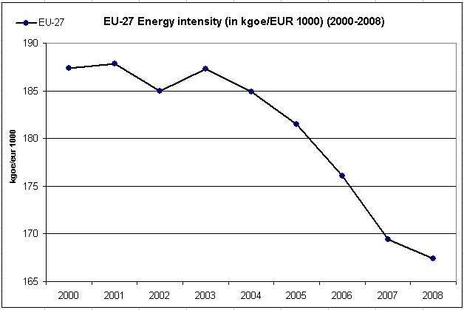
Source: Eurostat

Annex II

Main achievements for the six key areas of the Energy Efficiency Action Plan (EEAP):

- Energy performance requirements for products, buildings and services:
Among the biggest successes of the current EEAP is the setting of an ambitious legal framework for buildings and products. The existing Energy Performance of Buildings Directive (2002/91/EC) and its recast go a long way for introducing ambitious but realizable energy performance requirements for buildings and increase consumers' awareness.
The Eco-Design (2005/32/EC) and Energy Labelling (92/75/EEC) framework Directives and their recasts are significant steps with regard to product policy. The adopted nine implementing measures in 2008 (e.g. for electric motors, TVs and domestic, street and office lighting) and the forthcoming 15 (e.g. water heaters, air-conditioning and ventilation) will bring very important savings.
The Energy End-Use Efficiency and Energy Services Directive (ESD) has set the general framework for many saving actions, including national, indicative, quantitative energy saving targets and National Energy Efficiency Action Plans (NEEAPs). However, its soft wording led to unsatisfactory progress as regards some of its provisions.
- Energy efficiency in the utility sector:
This has not been sufficiently tackled, and the progress in the sector will mainly result from the implementation of the CHP Directive. Certain improvements due to the inclusion of energy generation in the ETS are also be noted but the full potential is not achieved.
- Transport:
Energy consumption in the sector is still increasing. Nevertheless, a number of measures and initiatives were adopted tackling the CO₂ emissions from new passenger cars and light commercial vehicles, increased fuel efficiency and improved sustainability, especially in the urban areas, of the sector. Aviation was included in the ETS and a Sesar Joint Undertaking was established in 2007 to promote energy efficiency in this sector.
- Financing and pricing:
Some progress has been made but there are still failures that prevent the investments in energy efficiency. Innovative financing instruments are being developed by EIB, EBRD, national promotional banks and private banks. Investments in energy efficiency in the residential sector were made eligible for support in all Member States under Cohesion Policy in May 2009 (at the outset of the 2007-2013 period, they were eligible only in EU-12) and the thematic scope of Financial Engineering Instruments was extended in June 2010, now offering an additional opportunity to support also repayable investments in energy efficiency in buildings, including in existing housing. In order to mobilize the sustainable energy investments in cities and regions, 'ELENA' technical assistance facility has been launched by the Commission and EIB in late 2009. Investments in excess of €1 billion have been enabled by the facility so far.
- Changing energy behaviour:
Some progress has been made to implement the EEAP 2006 measures but user behaviour still a challenge. A number of projects to study and address this aspect were supported under the Intelligent Energy Europe Programme. Another initiative that stemmed out of the current EEAP is the 'Covenant of Mayors' which has been a major success with more than 1900 cities, covering more than 120 million EU citizens, committing to go beyond the 20% greenhouse gas reduction target through development and implementation of their Sustainable Energy Action Plans (SEAPs). More than 85 regions, provinces and networks have joined the initiative so far as supporting structures. The Commission has developed and implemented a methodology for development and monitoring of the SEAPs, including GHG baseline emission inventories of participating cities. Further, the extension of the Covenant of Mayors concept towards the EU Neighbourhood countries has been launched by the Commission.
- International Partnership:
Some progress achieved with the launching of the International Partnership for Energy Efficiency (IPEEC) and a number of bilateral discussions.

Annex III

Market opening gas & electricity: Proportion of market open to competition
Eligible consumption TWh/ GWh by annual consumption in the country
Source: SEC(2010)251 final
% Market opening

 | Electricity |  | Gas
 | 2007 | 2008 | 2007 | 2008
Austria | 100 | 100 | 100 | 100
Belgium | 100 | 100 | 100 | 100
Bulgaria | 100 | 100 | 100 | 100
Cyprus | 31,8 | 31,8 | 0 | 0
Czech Republic | 100 | 100 | 100 | 100
Denmark | 100 | 100 | 100 | 100
Estonia | 13 | 13 | 100 | 100
Finland | 100 | 100 | 0 | 0
France | 100 | 100 | 100 | 100
Germany | 100 | 100 | 100 | 100
Great Britain | 100 | 100 | 100 | 100
Greece | 90,1 | 90,1 | 73 | 90
Hungary | 22,29 | 64,4 | 24,96 | 34,04
Ireland | 100 | 100 | 100 | 100
Italy | 100 | 100 | 100 | 100
Latvia | 100 | 100 | NAP | NAP
Lithuania | 74 | 100 | 100 | 100
Luxembourg | 100 | 100 | 100 | 100
Malta | NA | NA | NA | NA
Northern Ireland | NA | 100 | NA | 100
Norway | 100 | 100 | : | :
Poland | 100 | 100 | 100 | 100
Portugal | 100 | 100 | 42,9 | 42,9
Romania | 100 | 100 | 100 | 100
Slovak Republic | 100 | 100 | 100 | 100
Slovenia | 100 | 100 | 100 | 100
Spain | 100 | 100 | 100 | 100
Sweden | 100 | 100 | 100 | 100
The Netherlands | 100 | 100 | 100 | 100

Annex IV-1

Electricity market indicators: degree of concentration

 | Electricity (generation)
Very highly concentrated  [HHI above 5000] | BE, FR, EL, LV, LU, SK, CY
Highly concentrated  [HHI 1800-5000] | CZ, DE, LT, PT, SI, RO, HU, DK, NO
Moderately concentrated  [HHI 750-1800] | FI, PL, UK, ES, IT, NL, AT

Source: Regulators’ submissions, DG TREN calculations, SEC(2010)251 final

(HHI by capacity – sum of squared shares of individual companies)

Annex IV – 2

Wholesale Market Position Electricity – 2007/2008
ELECTRICITY | Number of companies with more than 5 % share of generation capacity (%) |  |  | Share of 3 biggest companies (by capacity) (%) |  |  | HHI (by capacity)
ELECTRICITY | 2007 | 2008 | ∆ | 2007 | 2008 | ∆ | 2007 | 2008 | ∆
Austria | 5 | 6 | 1 | 51,2 | 50 | -1,2 | NA | NA
Belgium | 2 | 2 | 0 | 99,9 | 97,5 | -2,4 | 8390 | 7206 | -1184
Bulgaria | 6 | 6 | 0 | 56,4 | 56,4 | 0 | NA | NA
Cyprus | 1 | 1 | 0 | 100 | 100 | 0 | 1 | 1 | 0
Czech Republic | 1 | 1 | 0 | 76,85 | 75,31 | -1,54 | NA | NA
Denmark | 2 | 2 | 0 | 75 | 75 | 0 | NA | NA
Estonia | 1 | 1 | 0 | 99 | 99 | 0 | NA | NA
Finland | 4 | 4 | 0 | 68 | 68 | 0 | NA | NA
France | 1 | 1 | 0 | 93 | 93 | 0 | 6960 | NA
Germany | 4 | 4 | 0 | 85,4 | 84,7 | -0,7 | NA | 2008
Great Britain | 8 | 8 | 0 | 41 | 42 | 1 | 986 | 901 | -85
Greece | 1 | 1 | 0 | NA | NA |  | 10000 | 10000 | 0
Hungary | 5 | 5 | 0 | 67 | 67,9 | 0,9 | 2119 | 1911 | -208
Ireland | 5 | 4 | -1 | 71 | 86 | 15 | NA | NA
Italy | 5 | 5 | 0 | 61,2 | 57,6 | -3,6 | 2126 | 1351 | -775
Latvia | 1 | 1 | 0 | 93 | 94 | 1 | 8110 | 8110 | 0
Lithuania | 3 | 3 | 0 | 84 | 85 | 1 | 3160 | 3095 | -65
Luxembourg | 3 | 3 | 0 | 80 | 79 | -1 | 5843 | 5682 | -161
Malta | 1 | 1 | 0 | NA | NA | 0 | NA | NA
Northern Ireland | NA | 4 |  | NA | 86 |  | NA | 4096
Norway | 6 | 6 | 0 | 40 | 43 | 3 | NA | 1826
Poland | 5 | 5 | 0 | 50,9 | 52,5 | 1,6 | 1312,7 | 1363,3 | 50,6
Portugal | 2 | 2 | 0 | 72,5 | 72,2 | -0,3 | 4472 | 4521 | 49
Romania | 5 | 5 | 0 | 63,7 | 70,98 | 7,28 | 1813 | 2116 | 303
Slovak Republic | 1 | 1 | 0 | 85,2 | 83,9 | -1,3 | 6930 | 5019,922 | -1910,08
Slovenia | 3 | 3 | 0 | 92,7 | 92,5 | -0,2 | 7208 | 4369 | -2839
Spain | 5 | 5 | 0 | 76 | 72,9 | -3,1 | 1827 | 1716 | -111
Sweden | 3 | 3 | 0 | 78 | 74,7 | -3,3 | NA | NA
The Netherlands | 6 | 4 | -2 | 61 | 69,9 | 8,9 | 1592 | 1551 | -41
Source: Regulators data, ∆ calculations DG TREN, SEC(2010)251 final

Annex IV – 3

Retail Market position Electricity – 2007/2008
ELECTRICITY | Number of nationwide suppliers | Companies with market share over 5% in the whole retail market (%) |  |  | Market share of three largest companies in whole retail market (%)
ELECTRICITY | 2008 | 2007 | 2008 | ∆ | 2007 | 2008 | ∆
Austria | 10 | 7 | 6 | -1 | 64 | 62 | -2
Belgium | 12 | 4 | NA | 1 | NA | NA | NA
Bulgaria | 1 | 3 | 3 | 0 | 97,5 | 97,5 | 0
Cyprus | 1 | 1 | 1 | 0 | 100 | 100 | 0
Czech Republic | 310 | 3 | 3 | 0 | 99 | 99 | 0
Denmark | 16 | 7 | 7 | 0 | NA | NA
Estonia | 3 | 1 | 1 | 0 | 99 | 99 | 0
Finland | 25 | 4 | 4 | 0 | 40 | 40 | 0
France | 17 | 1 | 1 | 0 | 94 | 97 | 3
Germany | 17 | 3 | 3 | 0 | 46,1 | 52 | 5,9
Great Britain | 17 | NA | NA |  | NA | NA
Greece | 37 | 1 | 1 | 0 | 100 | 100 | 0
Hungary | 78 | 4 | 4 | 0 | 87,18 | 80,73 | -6,45
Ireland | 9 | 4 | 4 | 0 | 85 | 84 | -1
Italy | 23 | 3 | 3 | 0 | 60 | 59 | -1
Latvia | 2 | 1 | 1 | 0 | 100 | 100 | 0
Lithuania | 2 | 1 | 1 | 0 | 100 | 100 | 0
Luxembourg | 7 | 3 | 4 | 1 | 93 | 94 | 1
Malta | 1 | 1 | 1 | 0 | NA | NA
Northern Ireland | 18 | NA | 4 |  | NA | 90
Norway | 26 | 5 | 5 | 0 | 31,2 | 36 | 4,8
Poland | 19 | 6 | 6 | 0 | 44,9 | 44,3 | -0,6
Portugal | 4 | 2 | 2 | 0 | 99,6 | 99,6 | 0
Romania | 138 | 5 | 5 | 0 | 44 | 48 | 4
Slovak Republic | 176 | 3 | 3 | 0 | 35 | 60 | 25
Slovenia | 13 | 7 | 7 | 0 | 68 | 58 | -10
Spain | 75 | 4 | 4 | 0 | 83,9 | 84,8 | 0,9
Sweden | 104 | 3 | 3 | 0 | NA | NA
The Netherlands | 21 | 4 | 4 | 0 | NA | NA
Source: Regulators data, ∆ calculations DG TREN, SEC(2010)251 final
Annex IV – 4

Market Structure in Import and Production of Gas
GAS | Number of companies with more than 5 % share of available gas (%) |  |  | Share of 3 biggest companies by available gas (%) |  |  | HHI
GAS | 2006 | 2008 | ∆ | 2007 | 2008 | ∆ | 2008
Austria | 4 | 4 | 0 | 80 | 86 | 6 | 4290
Belgium | 2 | 4 | 2 | 99,4 | 92 | -7,4 | 5438
Bulgaria | 1 | 1 | 0 | 32,47 | 89 | 56,53 | NA
Cyprus | NA | NA |  | NA | NA |  | NA
Czech Republic | 1 | 2 | 1 | NA | NA |  | NA
Denmark | 3 | 3 | 0 | NA | NA |  | NA
Estonia | 2 | 2 | 0 | 99 | 99 | 0 | NA
Finland | 1 | 1 | 0 | 100 | 100 | 0 | NA
France | 2 | 2 | 0 | 88,97 | 88 | -0,97 | 6324
Germany | NA | 7 |  | 58,65 | 61,82 | 3,17 | 1706
Great Britain | NA | NA |  | 28 | NA |  | NA
Greece | 1 | 1 | 0 | 100 | 100 | 0 | 10000
Hungary | 4 | 4 | 0 | 92,8 | 86,9 | -5,9 | 3066
Ireland | NA | 5 |  | NA | 81,64 |  | 2499
Italy | 3 | 3 | 0 | 86,7 | 85,2 | -1,5 | 4336
Latvia | 1 | 1 | 0 | 100 | 100 | 0 | 10000
Lithuania | 2 | 2 | 0 | 100 | 100 | 0 | 5800
Luxembourg | 1 | 2 | 1 | 100 | 100 | 0 | 9057
Malta | NA | NA |  | NA | NA |  | NA
Northern Ireland | NA | 5 |  | NA | 82,7 |  | 10000
Norway
Poland | 1 | 1 | 0 | 100 | 100 | 0 | 9624
Portugal | 0 | 0 | 0 | 0 | 0 | 0 | NA
Romania | 4 | 3 | -1 | 74 | 83,19 | 9,19 | NA
Slovak Republic | 1 | 1 | 0 | 100 | 100 | 0 | 10000
Slovenia | 1 | 2 | 1 | 100 | 100 | 0 | 8981
Spain | 4 | 4 | 0 | 75 | 66 | -9 | 1887
Sweden | 5 | NA |  | NA | NA |  | NA
The Netherlands | 4 | 1 | -3 | NA | 87,8 |  | 6841,24
Source: Regulators data, ∆ calculations DG TREN, SEC(2010)251 final

Annex IV – 5

Structure of Gas retail market
GAS | Number of nationwide suppliers | Companies with market share over 5% in the whole retail market (%) |  |  | Market share of three largest companies in whole retail market (%)
GAS | 2008 | 2007 | 2008 | ∆ | 2007 | 2008 | ∆
Austria | 5 | 5 | 5 | 0 | NA | 80
Belgium | 8 | NA | NA | 0 | 92,3 | NA
Bulgaria | 32 | 5 | 4 | -1 | 32,47 | 12,87 | -19,6
Cyprus | 1 | NA | NA |  | NA | NA
Czech Republic | 14 | 7 | 8 | 1 | NA | 47,35
Denmark | 2 | 4 | 4 | 0 | NA | NA
Estonia | 0 | 1 | 1 | 0 | 99 | 99 | 0
Finland | 1 | 6 | 6 | 0 | NA | NA
France | 13 | 3 | 2 | -1 | 98,5 | NA
Germany | NA | 4 | 4 | 0 | 26,3 | 35,2 | 8,9
Great Britain | 24 | NA | NA |  | 72 | 72 | 0
Greece | 1 | 1 | 1 | 0 | 100 | 100 | 0
Hungary | 14 | 7 | 7 | 0 | 75 | 72,6 | -2,4
Ireland | 5 | 2 | 2 | 0 | 100 | 100 | 0
Italy | 4 | 3 | 4 | 1 | 66,5 | 63,4 | -3,1
Latvia | 2 | 1 | 1 | 0 | 100 | 100 | 0
Lithuania | 2 | 2 | 2 | 0 | 100 | 100 | 0
Luxembourg |  | 4 |  |  | 88,5
Malta | NA | NA | NA |  | NA | NA
Northern Ireland | 0 | NA | 4 |  | NA | 86
Norway
Poland | 1 | 1 | 1 | 0 | 100 | 100 | 0
Portugal | 0 | 0 | 0 | 0 | 0 | 0 | 0
Romania | 24 | 4 | 6 | 2 | 83 | 59,11 | -23,89
Slovak Republic | 1 | 1 | 1 | 0 | 100 | 100 | 0
Slovenia | 3 | 2 | 4 | 2 | 86 | 82 | -4
Spain | 34 | 5 | 5 | 0 | 74 | 71 | -3
Sweden | 0 | 5 | 5 | 0 | NA | NA
The Netherlands | 14 | 4 | 3 | -1 | NA | NA
Source: Regulators data, ∆ calculations DG TREN, SEC(2010)251 final

Annex V

Statistical overview of TEN-E programme achievements
according to project classification

Progress with the implementation of projects of European interest, electricity lines (32 projects)
Progress with the implementation of projects of European interest, gas pipelines (10 projects)

Annex VI

EU-27 energy demand developments and final energy consumption by sectors

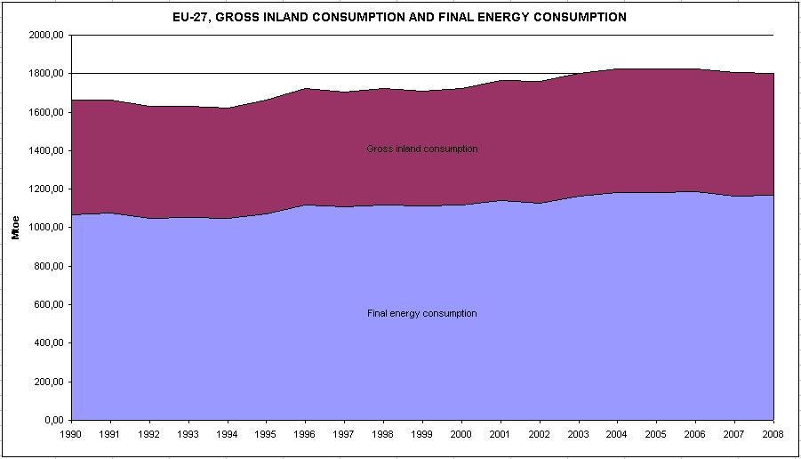
Source: Eurostat

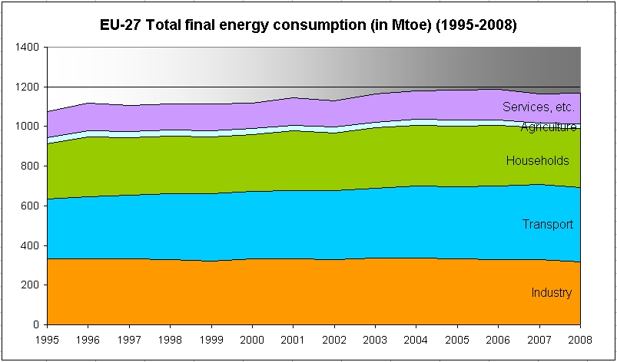
Source: Eurostat

Annex VII

EU-27 energy imports dependency

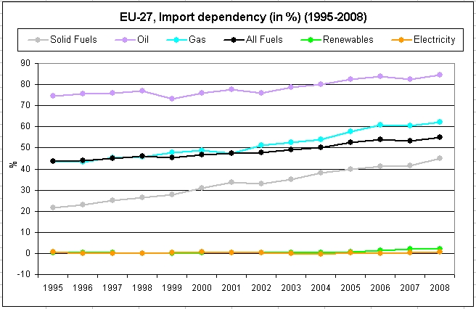
Source: Eurostat

EU-27 net imports of energy

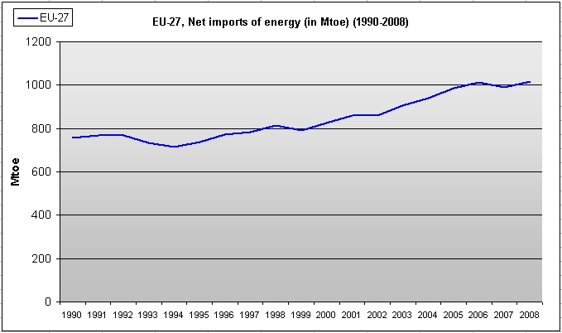
Source: Eurostat
Annex VIII

Source: Eurostat

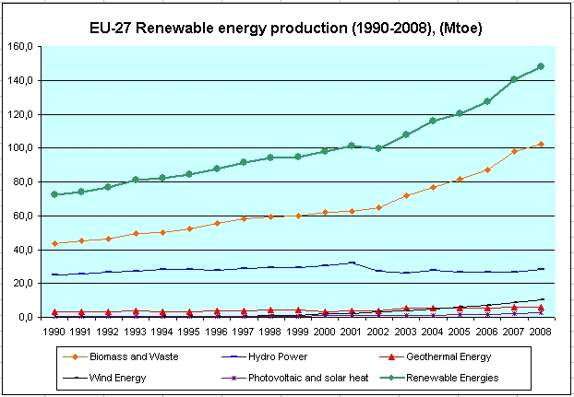
Source: Eurostat
Annex IX

Estimation of the financing needs for key technology and actions proposed in the SET-Plan (2010-2020)

Sector | Estimated investment needed for the next 10 years  (B€) | Justification for the estimation
Hydrogen and fuel cells | 5 | Updated estimation of resources needed made by stakeholders – 'Implementation Plan' of the hydrogen and fuel cell technology platform (Study by the JRC)
Wind | 5.5 | Estimation of resources needed made by stakeholders – Costing of the Wind Industrial Initiative
Solar | 16 | Estimation of resources needed made by stakeholders – Costing of the Solar Industrial Initiative
CCS | 10.5 - 16.5 | Estimation of resources needed made by stakeholders – Costing of the CCS EII (including the 7-12 B€ CCS demonstration projects - Study by McKinsey)
Bio-energy | 8.5 | Estimation of resources needed made by stakeholders– Costing of the Bio-fuels Industrial Initiative
Smart Grids | 2 | Estimation of resources needed made by stakeholders for transmission and by Commission for distribution – Costing of the Smart Grid Industrial Initiative
Nuclear Fission | 5 - 10 | Estimation of resources needed made by stakeholders – Costing of the Nuclear fission Industrial Initiative
Smart Cities | 10 - 12 | Estimation based on experience from CIVITAS and CONCERTO initiatives and reviewed by the JRC
European Energy Research Alliance (EERA) | 5 | Estimation of resources needed made by the Commission in consultation with EERA – Based on input from EERA assuming that 30% of their future activities are jointly planned and implemented.
Total | 67.5 - 80.5
Current investment contributing to these objectives | 14 - 20 | The Commission estimates that 50 to 70% of the current investment can be directed to these objectives.
Additional financial needs | 47.5 – 60.5

COM(2006) 105.
COM(2007) 1.
Directive 2009/72/EC, Directive 2009/73/EC, Regulation (EC) No 714/2009, Regulation (EC) No 715/2009, Regulation (EC) No 713/2009.
COM(2007) 723.
Directive on the Promotion of the use of energy from renewable sources (2009/28/EC), Emission Trading Scheme Directive (2009/29/EC) and the Effort Sharing Decision (406/2009/EC) covering non-ETS sectors
Directive on the geological storage of carbon dioxide (2009/31/EC).
COM(2008) 781.
Regulation (EC) No 663/2009 of the European Parliament and of the Council establishing a programme to aid economic recovery by granting Community financial assistance to projects in the field of energy.
COM(2008) 800 , 26.11.2008.
REGULATION (EC) No 397/2009 OF THE EUROPEAN PARLIAMENT AND OF THE COUNCIL of 6 May 2009 amending Regulation (EC) No 1080/2006 on the European Regional Development Fund as regards the eligibility of energy efficiency and renewable energy investments in housing.
REGULATION (EU) No 539/2010 OF THE EUROPEAN PARLIAMENT AND OF THE COUNCIL of 16 June 2010 amending Council Regulation (EC) No 1083/2006 laying down general provisions on the European Regional Development Fund, the European Social Fund and the Cohesion Fund as regards simplification of certain requirements and as regards certain provisions relating to financial management.
COM(2010) 2020.
COM(2010) 639 [''A strategy for competitive, sustainable and secure energy''].
For example SEC(2006) 1174 and Fraunhofer et al. 2009. Study for the ESD.
COM(2006) 545.
7224/1/07 REV 1.
2008 Eurostat data are the latest official data.
See SEC(2008) 2871 and SEC(2009) 1734, Annual reports of the Market Observatory of the European Commission.
The scenarios of the "Energy trends 2030" (update 2009) are accessible at the following address: http://ec.europa.eu/energy/observatory/trends_2030/doc/trends_to_2030_update_2009.pdf
Impact assessment reports: http://ec.europa.eu/governance/impact/ia_carried_out/cia_2010_en.htm
As for electricity for e.g., according to ENTSO for Electricity, investment costs of transmission projects of European significance to be completed (in order to reach the objectives of the further integration of the internal market, RES integration and Security of supply) within the period 2010-2014 range between EUR 23 to 28 billion. See ENTSO-E’s pilot Ten-Year Network Development Plan.
COM(2006) 851.
Some provisions will have to be implemented by 2012 and 2013.
COM(2010) 84.
For detailed analyses, see the Quarterly reports on electricity and gas markets of the Market Observatory for Energy of the European Commission, accessible at the following address: http://ec.europa.eu/energy/observatory/index_en.htm
The consumption of electricity was down by more than 5 % in the first semester of 2009 compared to the same period in 2008. In this period of time, the consumption of natural gas declined by 10%. Gross inland consumption for oil fell by 1.5% in 2008 compared to 2007 and by almost 6% in the first semester of 2009 compared to the same period in 2008.
The crude oil price (Dated Brent) fell from approximately US$ 140 per barrel in mid July 2008 to around $70 per barrel by the end of June 2009. Between January 2008 and June 2009, the gas price decreased by 57% on the NBP spot market and by 25% on the year-ahead NBP forward market while the electricity price decreased by 45% on the spot market (Platts PEP) and by 6% on the forward market (DE Y+2).
4th Benchmarking Report on Electricity Quality of Supply Ref. C08-EQS-24-04, 10 December 2008.
Report on retail electricity markets being prepared by Commission (SANCO) in 2010.
Directive 2009/72/EC of the European Parliament and of the Council of 13 July 2009 concerning common rules for the internal market in electricity. Directive 2009/73/EC of the European Parliament and of the Council of 13 July 2009 concerning common rules for the internal market in natural gas.
This Checklist is established to have practical answers to questions such as: who are the active suppliers in my area?, or where should I go if I have a complaint about my supplier?, etc.
Decision No 1364/2006/EC.
SEC(2010) 505.
Identified as being of common interest in the TEN-E framework.
COM(2008) 782.
COM(2010) 203.
Regulation (EC) No 663/2009 of the European Parliament and of the Council of 13 July 2009 establishing a programme to aid economic recovery by granting Community financial assistance to projects in the field of energy.
COM(2010)191, Annex to the Report from the Commission to the Council and the European Parliament on the implementation of the European Energy Programme for Recovery.
Classification category used by ESTAT.
COM(2009) 192, The renewable energy progress report.
2009/28.
The 2020 target can be fulfilled through the use of renewable energy in all types of transport. Energy use in maritime and air transport counts only for the numerator, not the denominator.
"Heating" is a catch-all term for energy consumption that is neither for transport nor in the form of electricity.
A 1997 White Paper established an indicative target of 12% of primary energy consumption in 2020, but this was not translated into legislation.
JRC analysis and IEA analysis ''Projected costs of generating electricity: 2010 edition''.
The Directive's targets are based on a flat-rate element and an element related to GDP per capita. They do not take into account potential.
COM(2010) 11, Report from the Commission on sustainability requirements for the use of solid and gaseous biomass sources in electricity, heating and cooling.
Council Directive 2009/71/Euratom of 25 June 2009 establishing a Community framework for the nuclear safety of nuclear installations.
2006/851/Euratom.
COM(2007) 565.
COM(2008) 776.
FNRs can produce 50-100 more energy than current nuclear reactors from a given quantity of uranium.
Established by the Euratom Treaty, Art. 52.
2008/114/EC, Euratom, Council decision of 12 February 2008, establishing Statutes for the Euratom Supply Agency.
Council Directive 2009/119/EC of 14 September 2009 imposing an obligation on Member States to maintain minimum stocks of crude oil and / or petroleum products.
COM(2009) 363 repealing the Directive 2004/67/EC; the Regulation is expected to be adopted in autumn 2010.
Directive 2005/89/EC of the EP and of the Council of 18 January 2006 concerning measures to safeguard security of electricity supply and infrastructure investment.
Council Regulation (EC, Euratom) Nr 617/2010 concerning the notification to the Commission of Investment projects in energy infrastructure within the EU and repealing Regulation (EC) No 736/1996.
Article 103 of the Euratom treaty.
COM(2008) 780.
2006/32/EC.
Note: No answer to this question was required in 2007.
Numbers include only those projects for which feedback was provided in the context of the TEN-E Survey 2010, previous stakeholder consultations and data provided by project promoters.

