EN
EUROPEAN COMMISSION
Brussels, 16.8.2010
SEC(2010) 984 final

COMMISSION STAFF WORKING DOCUMENT
accompanying the
REPORT FROM THE COMMISSION TO THE COUNCIL AND THE EUROPEAN PARLIAMENT
on the implementation of the remote sensing applications and on the use of the financial resources made available to it under Council Regulation (EC) No 78/2008 (interim report)
{COM(2010) 436 final}
COMMISSION STAFF WORKING DOCUMENT
accompanying the
report from the Commission to the Council and the European Parliament
on the implementation of the remote sensing applications and on the use of the financial resources made available to it under Council Regulation (EC) No 78/2008 (interim report)
Background information in the form of graphs and maps on the Mars Crop Yield Forecasting System and details on the outputs made available
The purpose of the present document is to provide additional information on the functioning of the Mars Crop Yield Forecasting System (MCYFS) and the different outputs prepared by this activity. It accompanies the Report from the Commission to the Council and the European Parliament on the implementation of Council Regulation (EC) No 78/2008 and provides in the form of illustrations, graphs and maps, additional information on the architecture and the functioning of the system together with information on the various outputs and reference to websites.

General system set-up and work flow
Figure 1. MCYFS: sketch showing the main input data and the main tasks carried out by the analysts
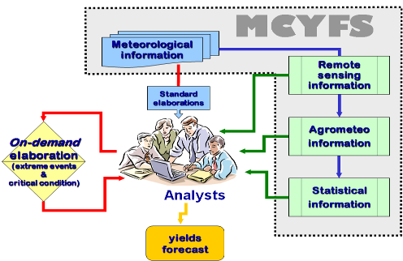

Figure 2. Main building blocks of the system. The system consists of four main building blocks which are integrated to monitor crop behaviour and produces yield forecasts
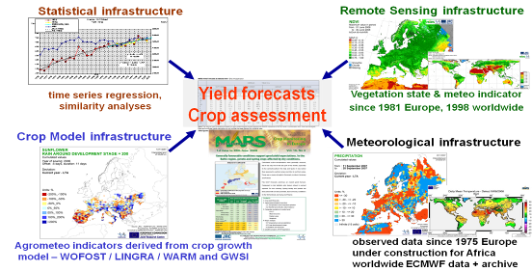
Figure 3. Countries covered by the European window of the MCYFS (in green) for the crop yield forecasts and agro-meteorological analysis

Meteorological infrastructure
Figure 4. Overview of meteorological infrastructure: input data; indicators; database extraction; information extraction over space and time
Figure 5. Meteorological station network with daily data reception (e.g. rainfall, temperature). The data is stored in the system and further interpolated to a grid with a resolution of 25km x 25 km
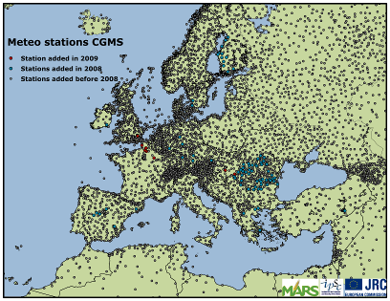

Figure 6. Outputs from the meteorological infrastructure used for the analysis. Example of maps and graphs on minimum daily temperature and rainfall compared to the long-term average and graphs based on observed meteorological parameters from the station network
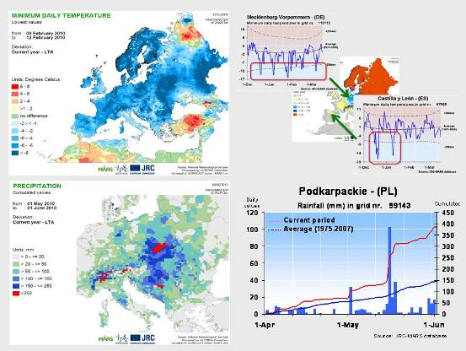
Figure 7. Outputs from the meteorological infrastructure used for the analysis. Examples of maps based on weather forecast data: average daily temperature; longest heat wave period; numbers of days with rain; cumulated precipitation
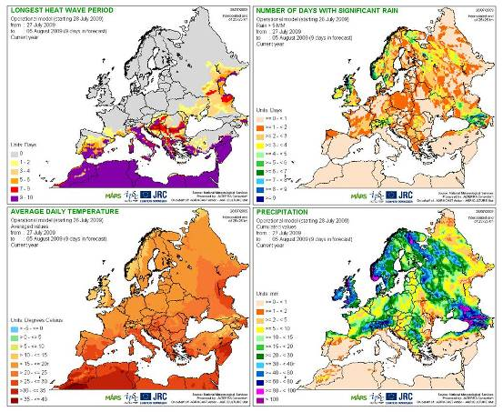

Crop model infrastructure for the simulation of crop growth
Figure 8. Overview of the crop model infrastructure: input data; crop growth simulation; indicators; information extraction over space and time
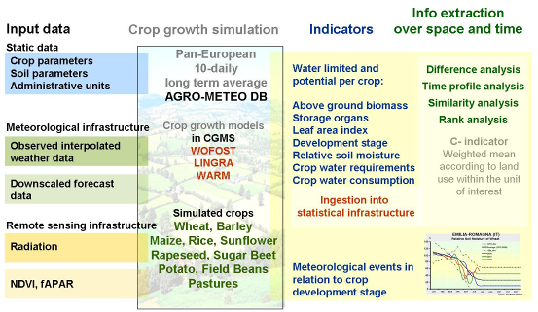
Figure 9. Examples of outputs from the crop model infrastructure used for the analysis in the form of maps and graphs: crop development stage; heat waves around crop maturity dates; crop specific relative soil moisture; potential storage organ
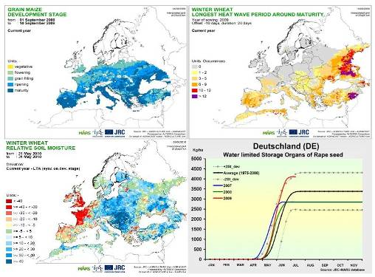

Low resolution satellite data
Figure 10. Overview of remote-sensing infrastructure: satellite sensors used as input data; pre processing and computation of vegetation state; meteorological indicators; information extraction over space and time
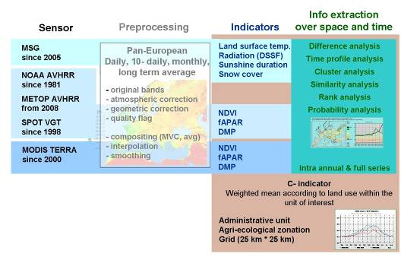
Figure 11. Examples of meteorological indicators produced by the remote-sensing infrastructure: mean temperature; solar radiation; frost days; snow cover
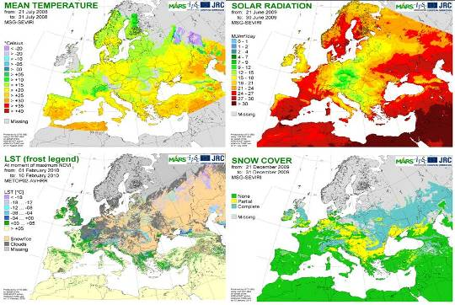

Figure 12. Examples of vegetation state parameters used for the analysis and the crop yield forecasting process: the Normalized Difference Vegetation Index (NDVI) as an indicator for biomass
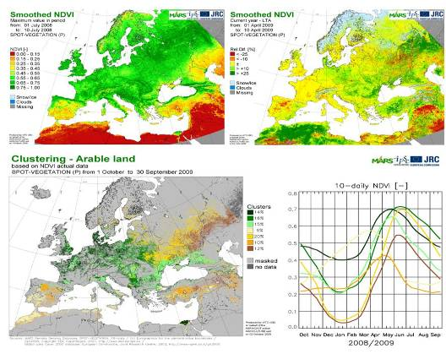

Statistical analysis
Figure 13. Overview of the statistical infrastructure used to produce the yield forecasts: input data, tools and methods applied
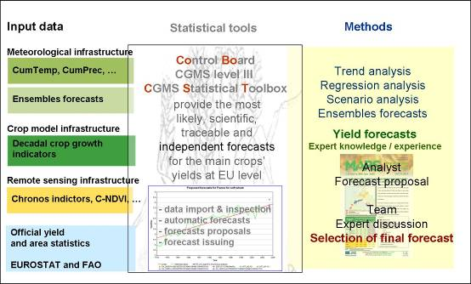

Figure 14. Example of crop yield forecast estimates provided at EU 27 level
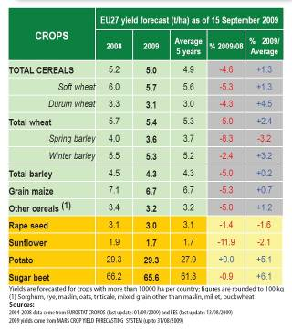

Information dissemination
Figure 15. Crop monitoring bulletins for Europe
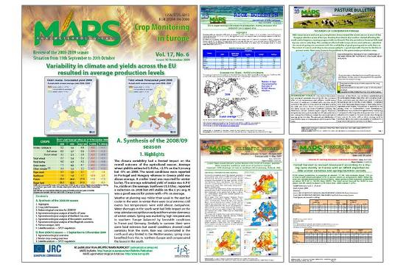

Figure 16. Screen shot from the existing web portal offering weather indicators, crop indicators and vegetation indices based on remote-sensing data
Internet resources
- Web portal for information dissemination and links to the bulletins and distribution of meteorological data upon registration:
http://www.marsop.info/marsop3/

- Access to the crop monitoring bulletin for Europe, the European pasture bulletin, the European rice bulletin, climatic updates and forecasts updates:
http://mars.jrc.ec.europa.eu/mars/About-us/AGRI4CAST/MARS-Bulletins-for-Europe

- Access to remote-sensing imagery for vegetation monitoring:
http://cidportal.jrc.ec.europa.eu/home/idp/thematic-portals/agri4cast-imageserver/

- General information concerning the activity and related work:
http://mars.jrc.ec.europa.eu/mars/About-us/AGRI4CAST

