EN
EUROPEAN COMMISSION
Brussels, 8.12.2010
COM(2010) 717 final
2010/0348 (COD)
Proposal for a
DIRECTIVE OF THE EUROPEAN PARLIAMENT AND OF THE COUNCIL
on the installation, location, operation and identification of the controls of wheeled agricultural or forestry tractors
(Codification)
EXPLANATORY MEMORANDUM
1. In the context of a people’s Europe, the Commission attaches great importance to simplifying and clarifying the law of the Union so as to make it clearer and more accessible to the citizens, thus giving them new opportunities and the chance to make use of the specific rights it gives them.
This aim cannot be achieved so long as numerous provisions that have been amended several times, often quite substantially, remain scattered, so that they must be sought partly in the original instrument and partly in later amending ones. Considerable research work, comparing many different instruments, is thus needed to identify the current rules.
For this reason a codification of rules that have frequently been amended is also essential if the law is to be clear and transparent.
2. On 1 April 1987 the Commission decided to instruct its staff that all acts should be codified after no more than ten amendments, stressing that this is a minimum requirement and that departments should endeavour to codify at even shorter intervals the texts for which they are responsible, to ensure that their provisions are clear and readily understandable.
3. The Conclusions of the Presidency of the Edinburgh European Council (December 1992) confirmed this, stressing the importance of codification as it offers certainty as to the law applicable to a given matter at a given time.
Codification must be undertaken in full compliance with the normal procedure for the adoption of acts of the Union.
Given that no changes of substance may be made to the instruments affected by codification, the European Parliament, the Council and the Commission have agreed, by an interinstitutional agreement dated 20 December 1994, that an accelerated procedure may be used for the fast-track adoption of codification instruments.
4. The purpose of this proposal is to undertake a codification of Council Directive 86/415/EEC of 24 July 1986 on the installation, location, operation and identification of the controls of wheeled agricultural or forestry tractors. The new Directive will supersede the various acts incorporated in it; this proposal fully preserves the content of the acts being codified and hence does no more than bring them together with only such formal amendments as are required by the codification exercise itself.
5. The codification proposal was drawn up on the basis of a preliminary consolidation, in 22 official languages, of Directive 86/415/EEC and the instruments amending it, carried out by the Publications Office of the European Union, by means of a data-processing system. Where the Articles have been given new numbers, the correlation between the old and the new numbers is shown in a table contained in Annex VII to the codified Directive.

ê 86/415/EEC (adapted)
2010/0348 (COD)
Proposal for a
DIRECTIVE OF THE EUROPEAN PARLIAMENT AND OF THE COUNCIL
on the installation, location, operation and identification of the controls of wheeled agricultural or forestry tractors
(Codification)
(Text with EEA relevance)
THE EUROPEAN PARLIAMENT AND THE COUNCIL OF THE EUROPEAN UNION,
Having regard to the Treaty on the Functioning of the European Union, and in particular Article Ö 114 Õ thereof,
Having regard to the proposal from the European Commission,
After transmission of the draft legislative act to the national Parliaments,
Having regard to the opinion of the European Economic and Social Committee,
Acting in accordance with the ordinary legislative procedure,
Whereas:

ê
- Council Directive 86/415/EEC of 24 July 1986 on the installation, location, operation and identification of the controls of wheeled agricultural or forestry tractors has been substantially amended several times. In the interests of clarity and rationality, the said Directive should be codified.

ê 86/415/EEC recital 1 (adapted)
- Ö Directive 86/415/EEC is one of the separate Directives of the EC type-approval system provided for in Council Directive 74/150/EEC, as replaced by Directive 2003/37/EC of the European Parliament and of the Council of 26 May 2003 on type-approval of agricultural or forestry tractors, their trailers and interchangeable towed machinery, together with their systems, components and separate technical units and repealing Directive 74/150/EEC, and lays down technical prescriptions concerning the installation, location, operation and identification of controls. Those technical prescriptions concern the approximation of the laws of the Member States to enable the EC type-approval procedure provided for in Directive 2003/37/EC to be applied in respect of each type of tractor. Consequently, the provisions laid down in Directive 2003/37/EC relating to agricultural and forestry tractors, their trailers and interchangeable towed machinery, together with their systems, components and separate technical units, apply to this Directive. Õ

ê
- This Directive should be without prejudice to the obligations of the Member States relating to the time-limits for transposition into national law and application of the Directives set out in Annex VI, Part B,

ê 86/415/EEC (adapted)
è1 97/54/EC Art. 1
HAVE ADOPTED THIS DIRECTIVE:
Article 1
1. ‘Agricultural or forestry tractors’ means any motor vehicle fitted with wheels or endless tracks Ö and Õ having at least two axles, the main function of which lies in its tractive power and which is specially designed to tow, push, carry or power certain tools, machinery or trailers intended for agricultural or forestry use. It may be equipped to carry a load or passengers.
2. This Directive shall apply only to the tractors defined in paragraph 1 which are fitted with pneumatic tyres and have a maximum design speed of between 6 and è1 40 km/h ç.
Article 2
Member States may not refuse to grant EC type-approval or national type-approval in respect of a tractor or refuse Ö its registration Õ or prohibit its sale, entry into service or use on grounds relating to the installation, location, operation and identification of controls if the latter satisfy the requirements set out in Annexes I to IV.

ê 86/415/EEC
Article 3
This Directive shall not affect the right of Member States to specify, with due observance of the Treaty, the requirements they deem necessary to ensure that workers are protected when using the tractors in question, provided this does not mean that the tractors are modified in a way unspecified in this Directive.
Article 4

ê 86/415/EEC (adapted)
Any amendments necessary to adapt Annexes I to V to technical progress shall be adopted in accordance with the procedure Ö referred to Õ in Article 20(3) of Directive 2003/37/EC.
Article 5
Member States shall Ö communicate to the Commission Õ the text of the main provisions of national law which they adopt in the field covered by this Directive .

ê
Article 6
Directive 86/415/EEC, as amended by the Directives listed in Annex VI, Part A, is repealed, without prejudice to the obligations of the Member States relating to the time-limits for transposition into national law and application of the Directives set out in Annex VI, Part B.
References to the repealed Directive shall be construed as references to this Directive and shall be read in accordance with the correlation table in Annex VII.
Article 7
This Directive shall enter into force on 1 May 2011.

ê 86/415/EEC
Article 8
This Directive is addressed to the Member States.
Done at […],
For the European Parliament For the Council
The President The President

ê 86/415/EEC (adapted)
ANNEX I
DEFINITIONS, APPLICATION FOR ECTYPE-APPROVAL, EC TYPE-APPROVAL

1. DEFINITIONS

1.1. Tractor type
‘Tractor type as regards the installation, location, operation and identification of controls’ means tractors which do not differ in such essential respects as regards those internal fittings which may affect the location and identification of controls.

1.2. Control
‘Control’ means any part which, when directly actuated, enables the state or functioning of the tractor or of any equipment coupled to it to be changed.

2. APPLICATION FOR EC TYPE-APPROVAL
2.1. The application for type-approval of a tractor type, Ö as regards Õ the installation, location, operation and identification of controls, must be submitted by the tractor manufacturer or by his authorised representative.
2.2. The application must be accompanied by three copies of a description (photos or drawings) of the tractor parts covered by the requirements of this Directive.
2.3. A tractor representative of the type to be approved or such part or parts of the tractor as are considered to be essential for carrying out the checks laid down in this Directive must be submitted to the technical service responsible for conducting the type-approval test.

3. EC TYPE-APPROVAL
A certificate conforming to the model in Annex V should be attached to the EECtype-approval certificate.
_____________
ANNEX II
TECHNICAL REQUIREMENTS

1. GENERAL REQUIREMENTS
1.1. The controls must be easily accessible and must not constitute a danger to the operator, who must be able to actuate them without difficulty or risk; they must be so designed and laid out, or protected, as to preclude any inadvertent switching operation or any unintentional triggering of a movement or any other operation which might be dangerous.
1.2. For identification of the controls by means of symbols, the symbols used must conform to those shown in Annex III.
1.3. Symbols other than those shown in Annex III may be used for other purposes, provided that there is no danger of confusion with those shown in that Annex.
1.4. Symbols are deemed to conform if the proportionality of the dimensions shown in Annex IV is respected.
1.5. The symbols must appear on or in the immediate proximity of the controls.
1.6. The symbols must stand out clearly against the background.
1.7. The controls must satisfy whatever particular requirements, insofar as they apply, are set out in section 2 as regards the installation, location, operation and identification of controls. Other arrangements are permitted, should a manufacturer provide evidence that they have an effect at least equivalent to the requirements specified in this Directive.

2. SPECIAL REQUIREMENTS

2.1. Starter control
It must not be possible to start the engine if there is a risk that this might cause an uncontrolled movement of the tractor.
This requirement is deemed to be fulfilled if the engine cannot be started unless:
- the gear change lever is in neutral position or in neutral gear, or
- the gear ratio selection lever is in neutral position or in neutral gear, or
- the clutch mechanism is disengaged, or
- the hydrostatic device is in neutral position or depressurised, or
- where hydraulic transmission is fitted, the engagement device reverts automatically to a neutral position.

2.2. Engine shut-off control
Actuating this device must stop the engine without sustained manual effort; it must not be possible for the engine to start again automatically.
Should the engine shut-off control not be combined with the starter control, it must be of a colour contrasting clearly with the background and the other controls. If the shut-off control is a button, it must be coloured red.

2.3. Differential lock control
Identification of the control, where fitted, is mandatory. The functioning of the differential lock must be clearly indicated, if this is not apparent from the position of the control.

2.4. Three-point lifting mechanism control
2.4.1. Either the three-point lifting mechanism controls must be fitted in such a way as to ensure that lifting and lowering manœuvres can be carried out safely, and/or automatic coupling parts should be fitted on the attachment devices of the lifting equipment so that the presence of an operator between the tractor and the equipment is not required. The presence of such a control, where fitted, must be indicated.
2.4.2. The safety requirements for the lifting and lowering of the tools being carried are deemed to be fulfilled where the following conditions are met:

2.4.2.1. Main controls
The main controls and any linkage are arranged or protected in such a way that the operator is unable to reach them if he is standing on the ground between the tractor and the mounted implement, or external controls must be fitted;

2.4.2.2. External controls
2.4.2.2.1. The controls must be laid out in such a way that the operator can actuate them from a non-dangerous spot, for instance where the three-point hydraulic lift controls or the additional controls for the lifting mechanism are located outside the vertical planes formed by the internal walls of the mudguards,
and
2.4.2.2.2. The three-point hydraulic lifting mechanism is actuated by means of controls which restrict the amount of movement to a maximum of 100 millimetres each time the control is actuated. The measurement points in this case are formed by the coupling points on the lower arms of the three-point coupling,
or

ê 2010/22/EU Art. 3 and Annex III pt. 1(a)
2.4.2.2.3. The three-point hydraulic lifting mechanism is actuated by means of controls which operate on the ‘hold-to-run principle’;

ê 86/415/EEC

2.4.2.3. Narrow tractors
In the case of tractors with one driven axle having a fixed or adjustable minimum track not exceeding 1 150 millimetres, the main controls must be located in front of the vertical plane passing through the seat reference point, the seat being in a central position;
2.4.2.4. Other arrangements are permitted if the manufacturer provides evidence that they have an effect at least equivalent to the requirements set out in points 2.4.2.1., 2.4.2.2. and 2.4.2.3.

ê 2010/22/EU Art. 3 and Annex III pt. 1(b)

2.5. Power Take-Off (PTO) control(s)
2.5.1. It shall not be possible to start the engine with the PTO engaged.

2.5.2. External controls
2.5.2.1. The controls must be laid out in such a way that the operator can actuate them from a safe place.
2.5.2.2. The control(s) shall be designed in a way which avoids unintentional actuation.
2.5.2.3. The start control shall work according to the ‘hold-to-run principle’ for at least the first three seconds of actuation.
2.5.2.4. After actuating the control(s) the time delay to the intended operation shall not be more than the time for the technical engage/disengage system to operate. If this delay time is exceeded, an automatic deactivation of the PTO drive shall occur.
2.5.2.5. It shall always be possible to shut off the PTO(s) from the operator's seat position as well as from the associated external control(s). The shut off is always an override control.
2.5.2.6. Interaction between external PTO control and operator’s seat position PTO control shall not be permitted.
_____________

ê 86/415/EEC
ANNEX III
SYMBOLS
1. Starter control
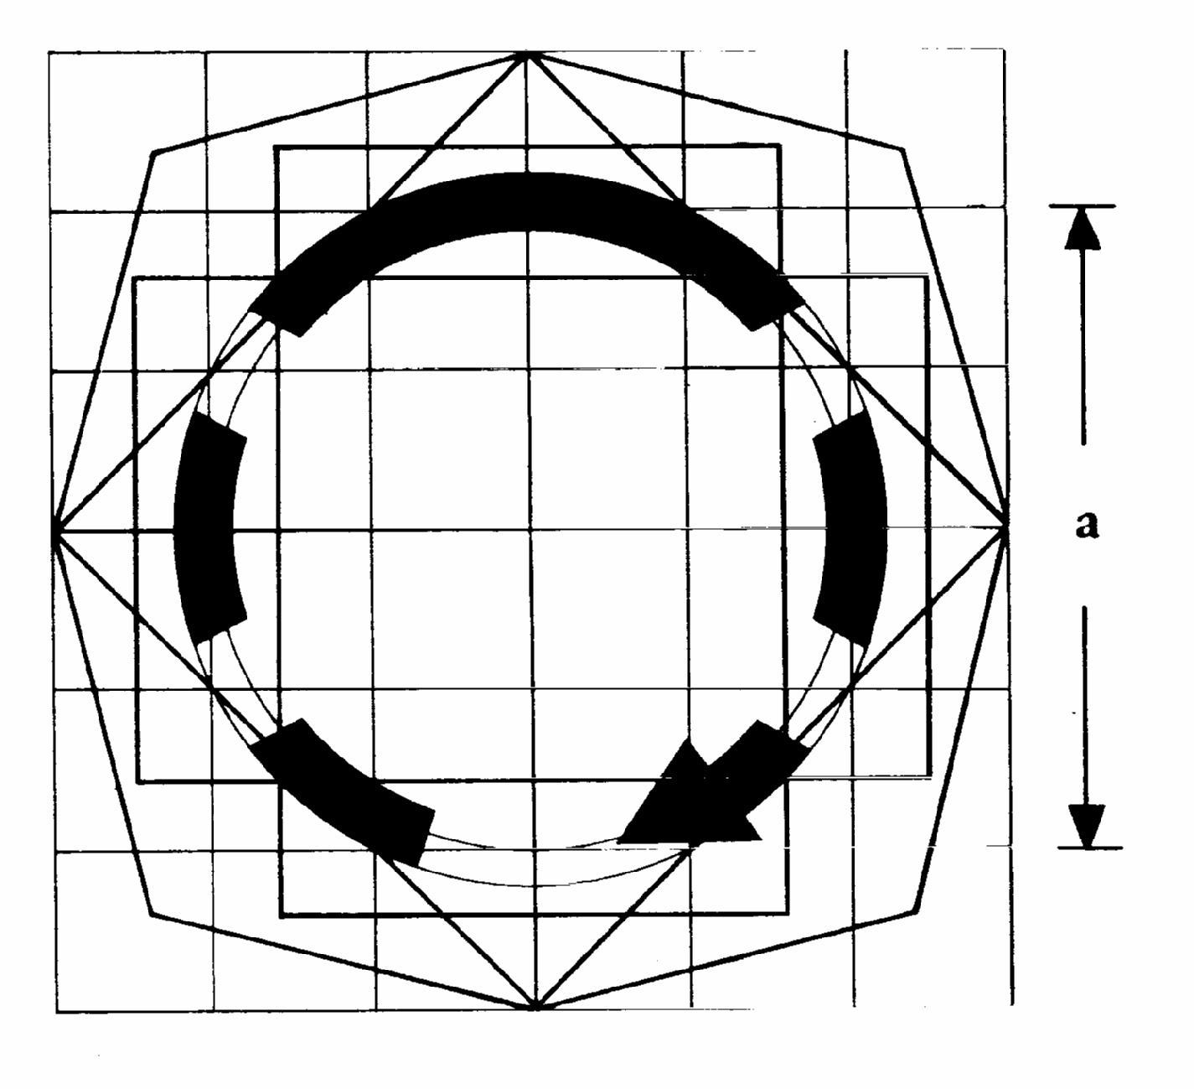
ê 2010/22/EU Art. 3 and Annex III pt. 2
ISO 3767-1:1998, symbol 8.18 may be used as alternative.

ê 86/415/EEC
2. Engine speed control
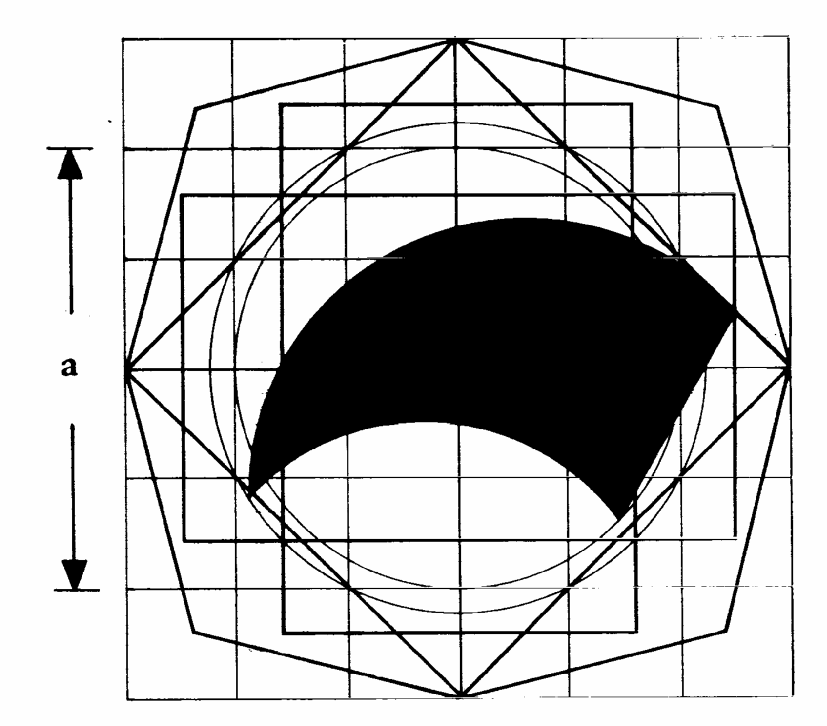  Signification: continuous rotary variation | 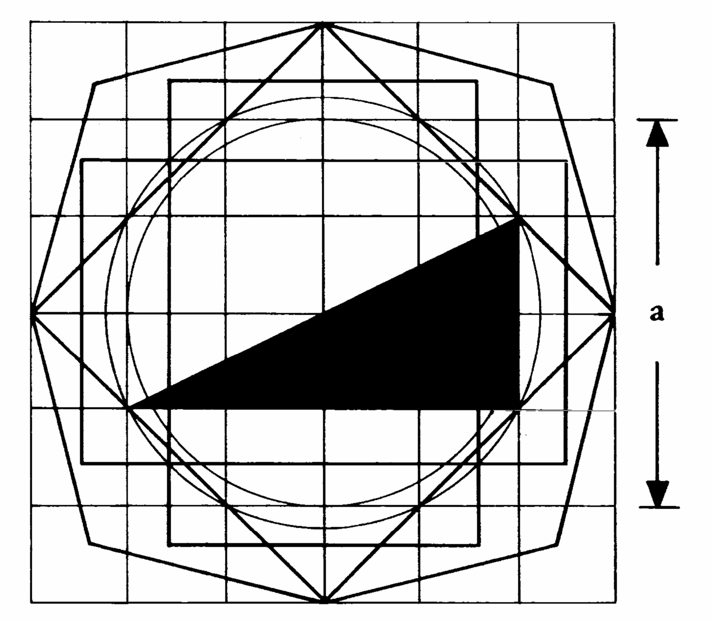  continuous linear variation
3. Engine shut-off control
(Spark ignition engine and compression ignition engine)
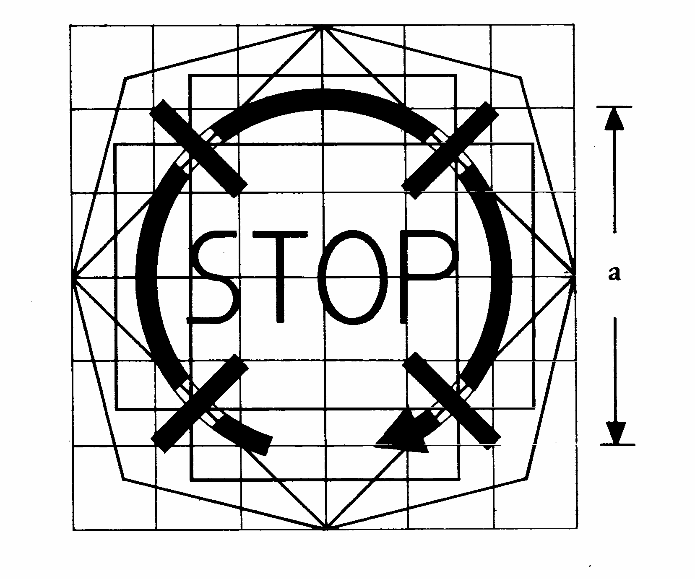

ê 2010/22/EU Art. 3 and Annex III pt. 2
ISO 3767-1:1998, symbol 8.19 may be used as alternative.

ê 86/415/EEC
4. Parking brake control
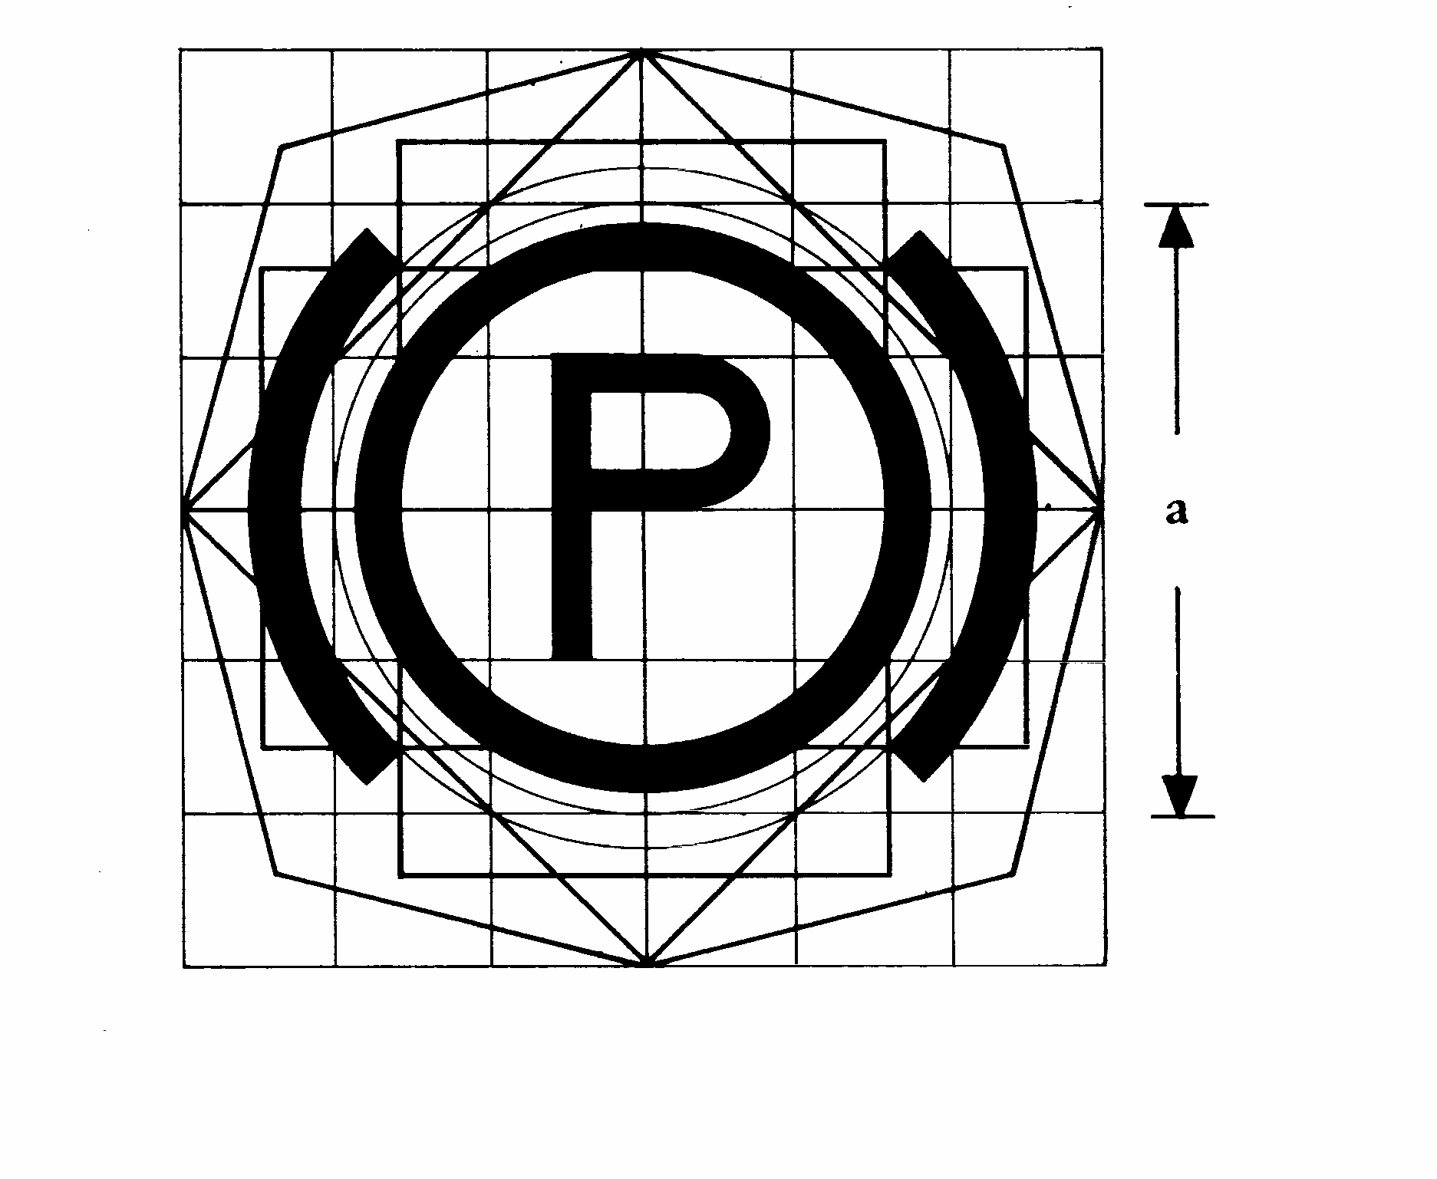
5. Differential lock control
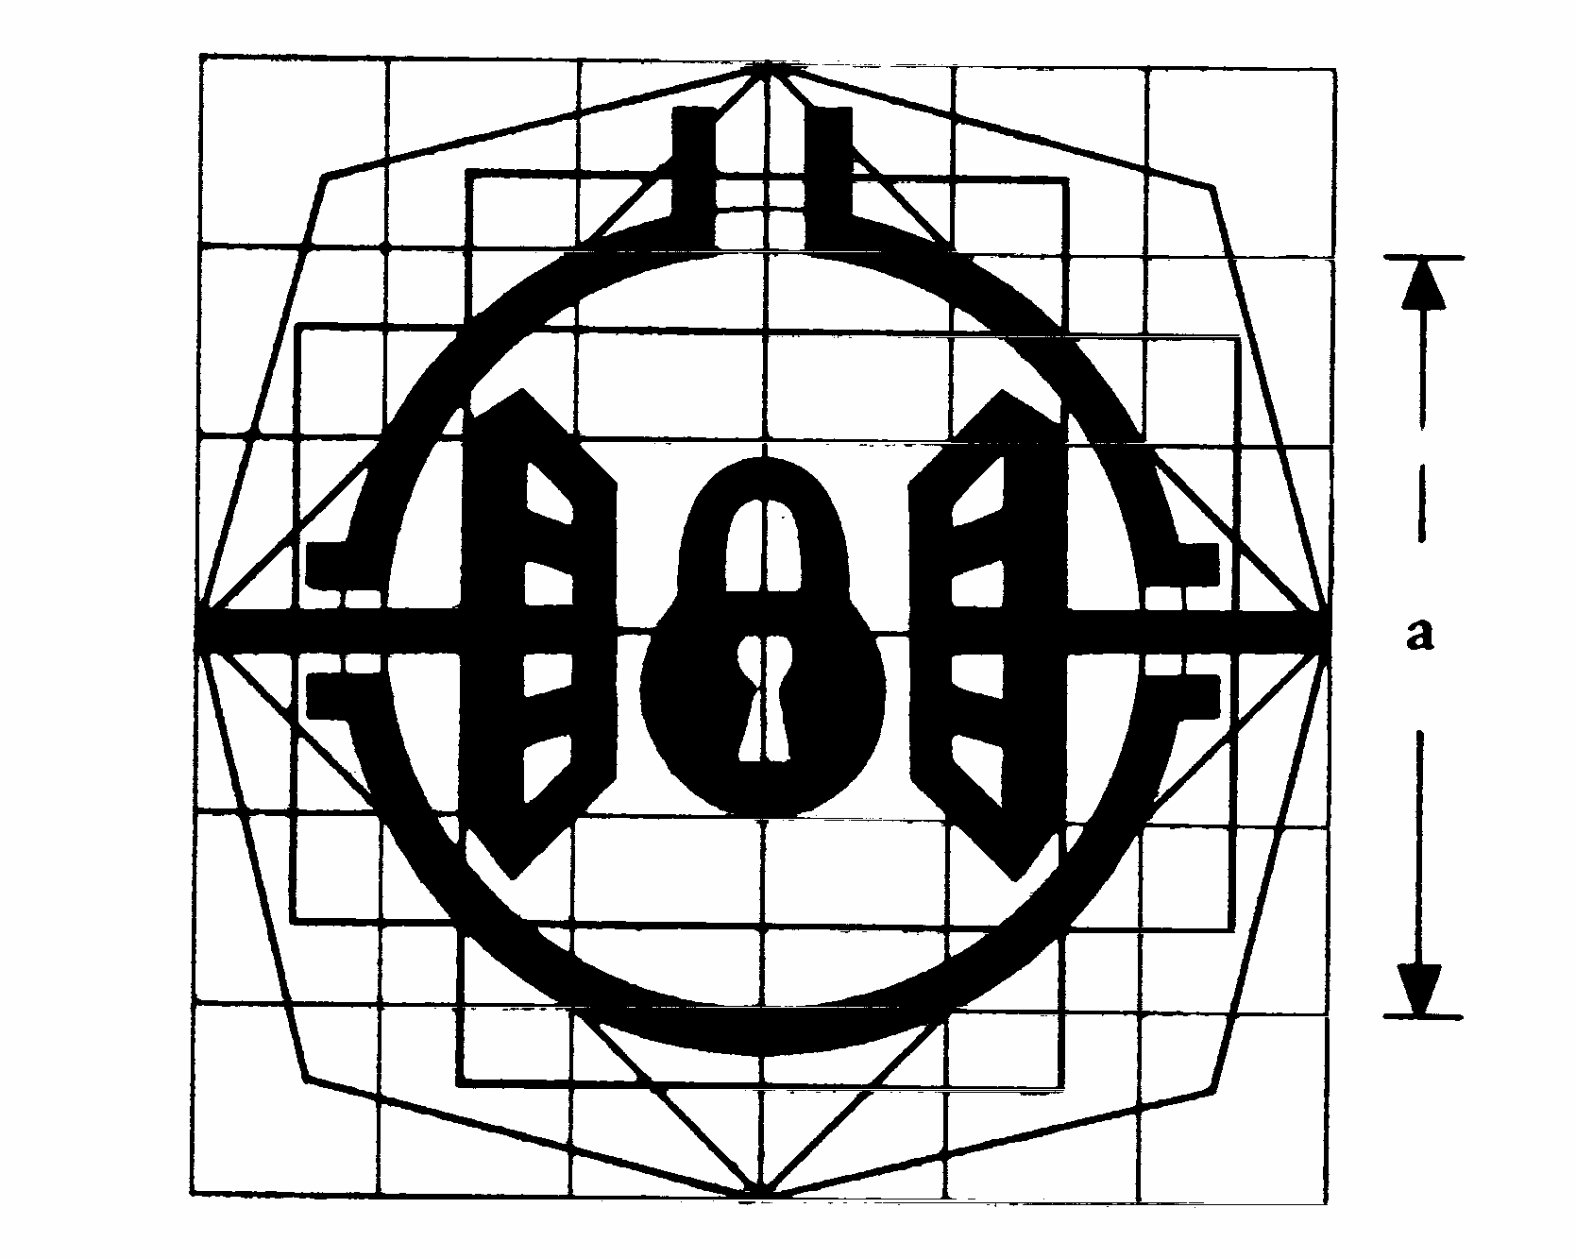
6. Power take-off clutch control
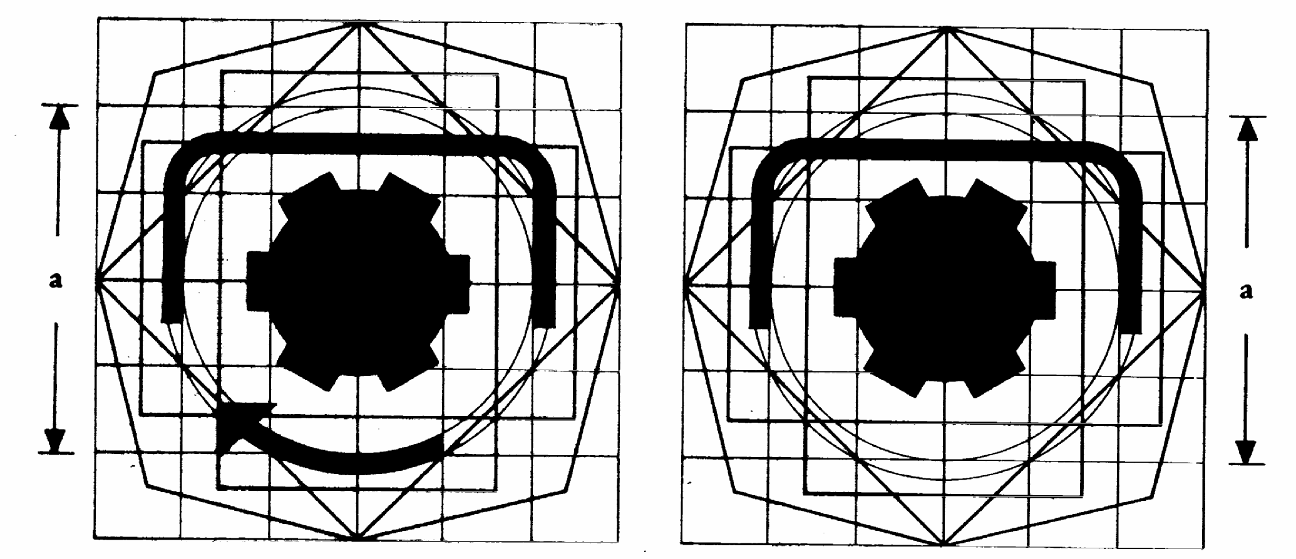
Signification: ‘on’ position | ‘off’ position

ê 2010/22/EU Art. 3 and Annex III pt. 2
ISO 3767-2:1991, symbol 7.11 combined with ISO 3767-1:1998, symbol 7.1 to 7.5 may be used as alternative.

ê 86/415/EEC
7. Power take-off actuator and/or rotational-speed selector
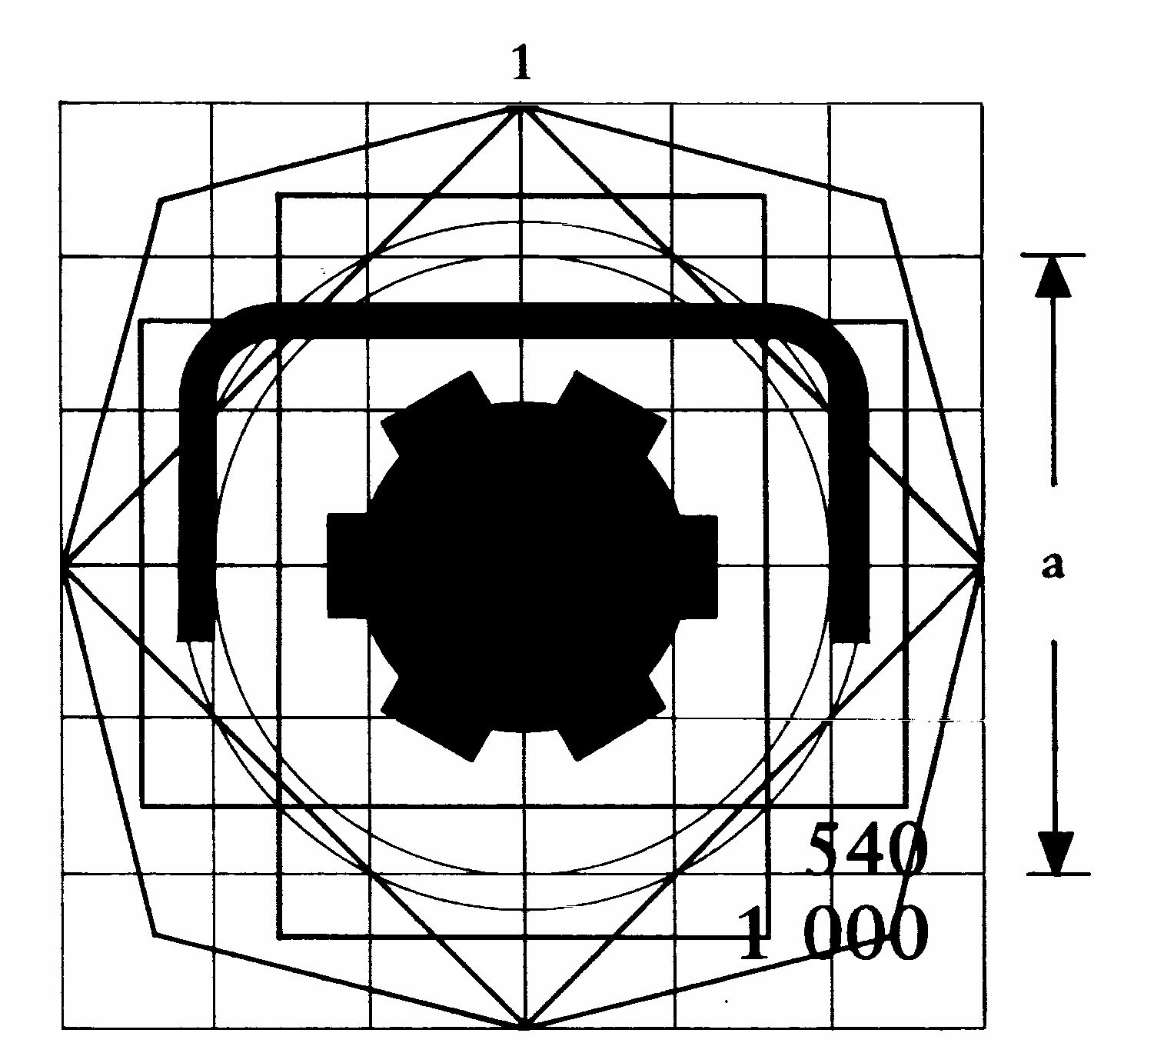
Signification: unit disengaged and not actuated
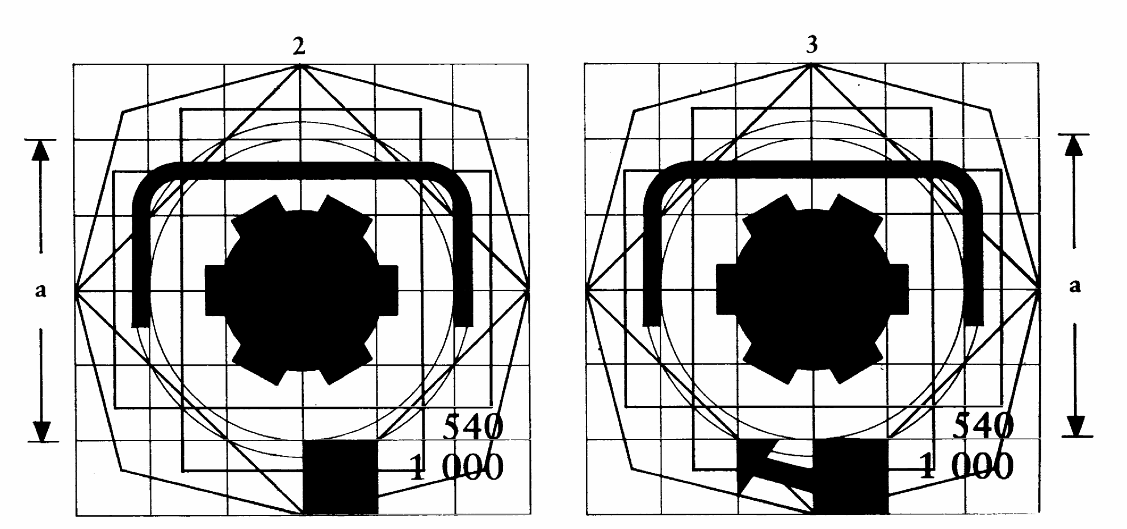
Signification: unit actuated but not engaged | unit engaged and actuated

ê 2010/22/EU Art. 3 and Annex III pt. 2
ISO 3767-2:1991, symbol 7.12 PTO display combined with ISO 3767-1:1991, symbol 7.1 to 7.5 may be used as alternative.

ê 86/415/EEC
NB: These symbols relate to the actuator and rotational-speed selector of a two-speed power take-off. In Symbol No 1 the selector is shown in neutral and disengaged; in Symbol No 2 the power take-off is seen to be set to rotate at 1 000 rpm, but not engaged, and in Symbol No 3 it is engaged and actuated at the rotational speed of 1 000 rpm.
8. Lifting mechanism control
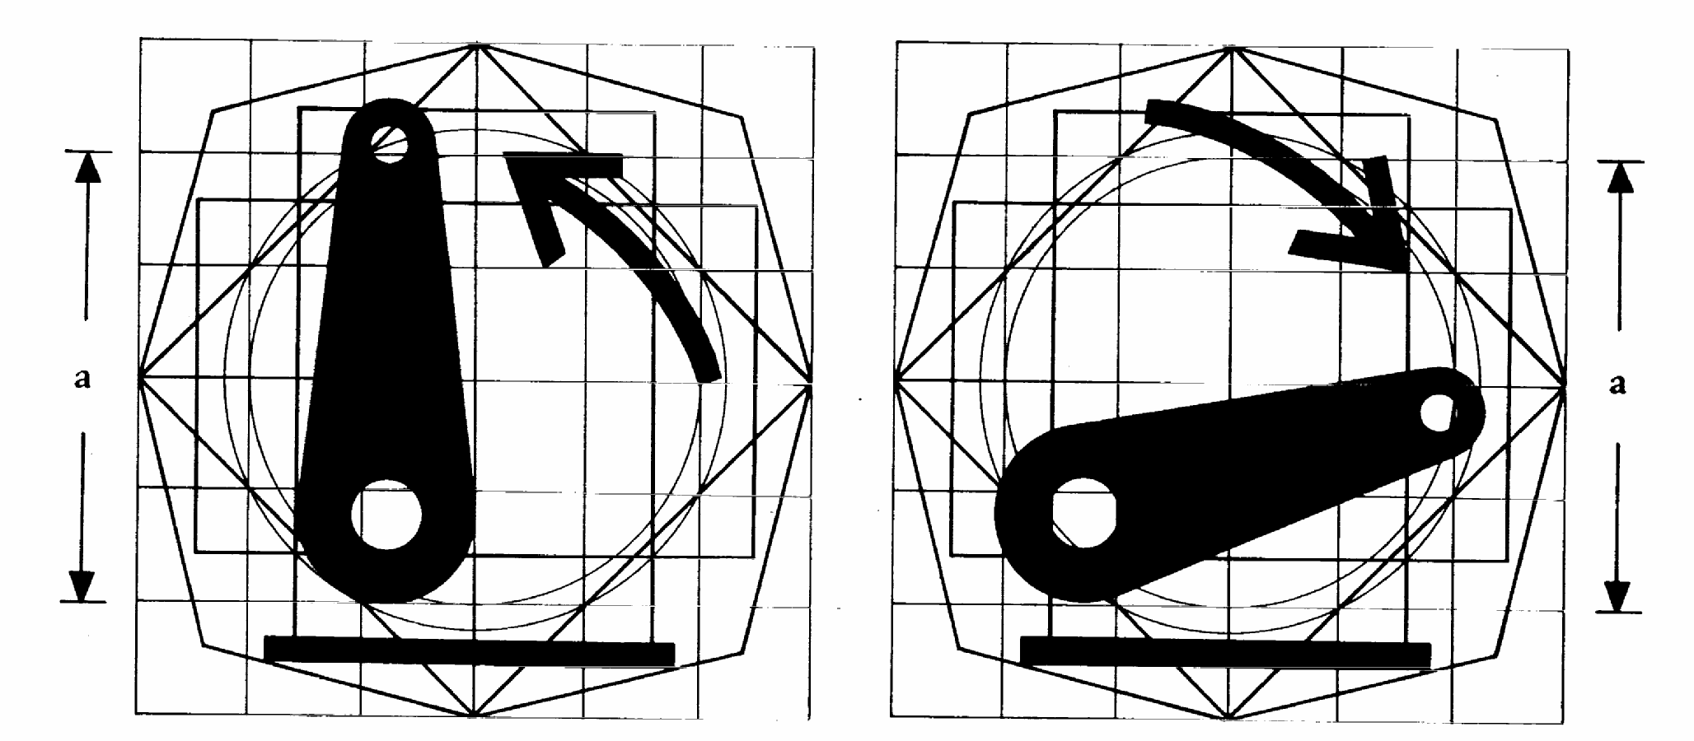
Signification: raised position | lowered position
9. Switch for remote control of external services
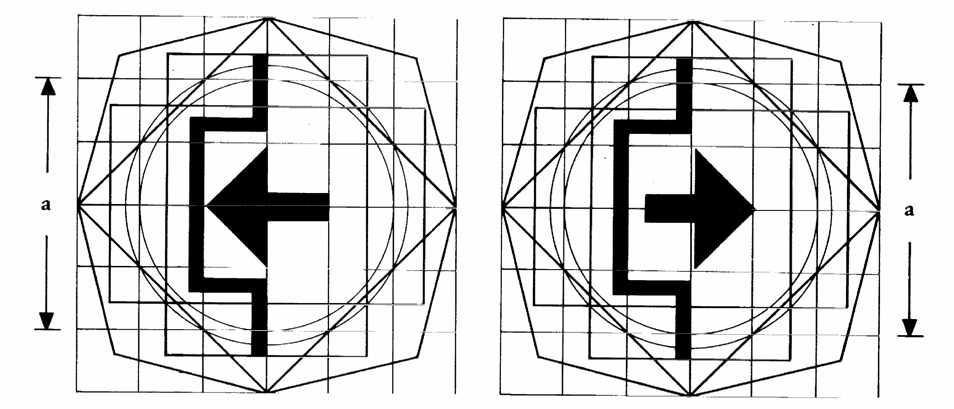
Signification: ‘on’ position | ‘off’ position
10. Dipped-beam headlamps control
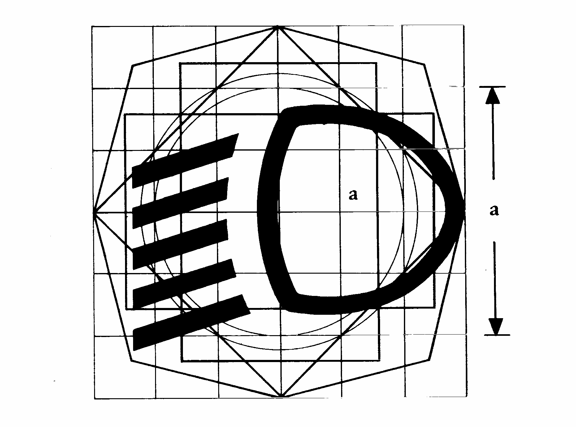
11. Direction-indicator lamp control
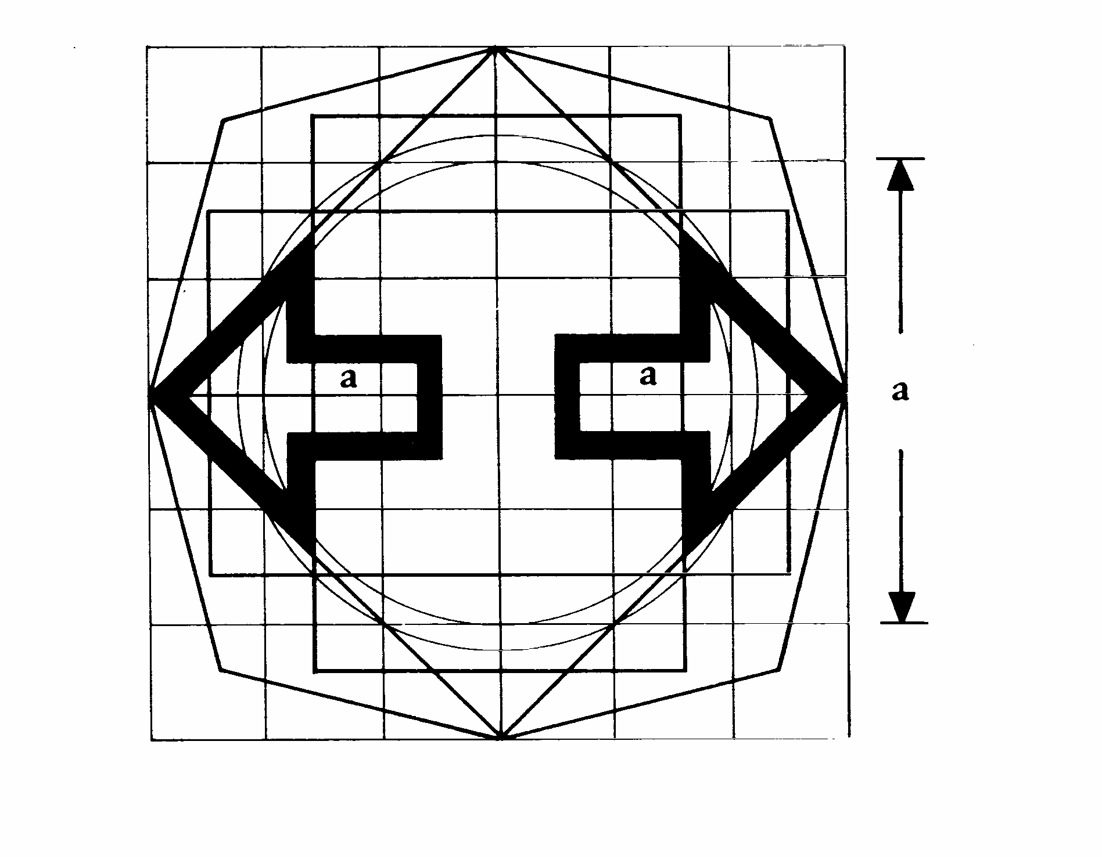
12. Hazard-warning control
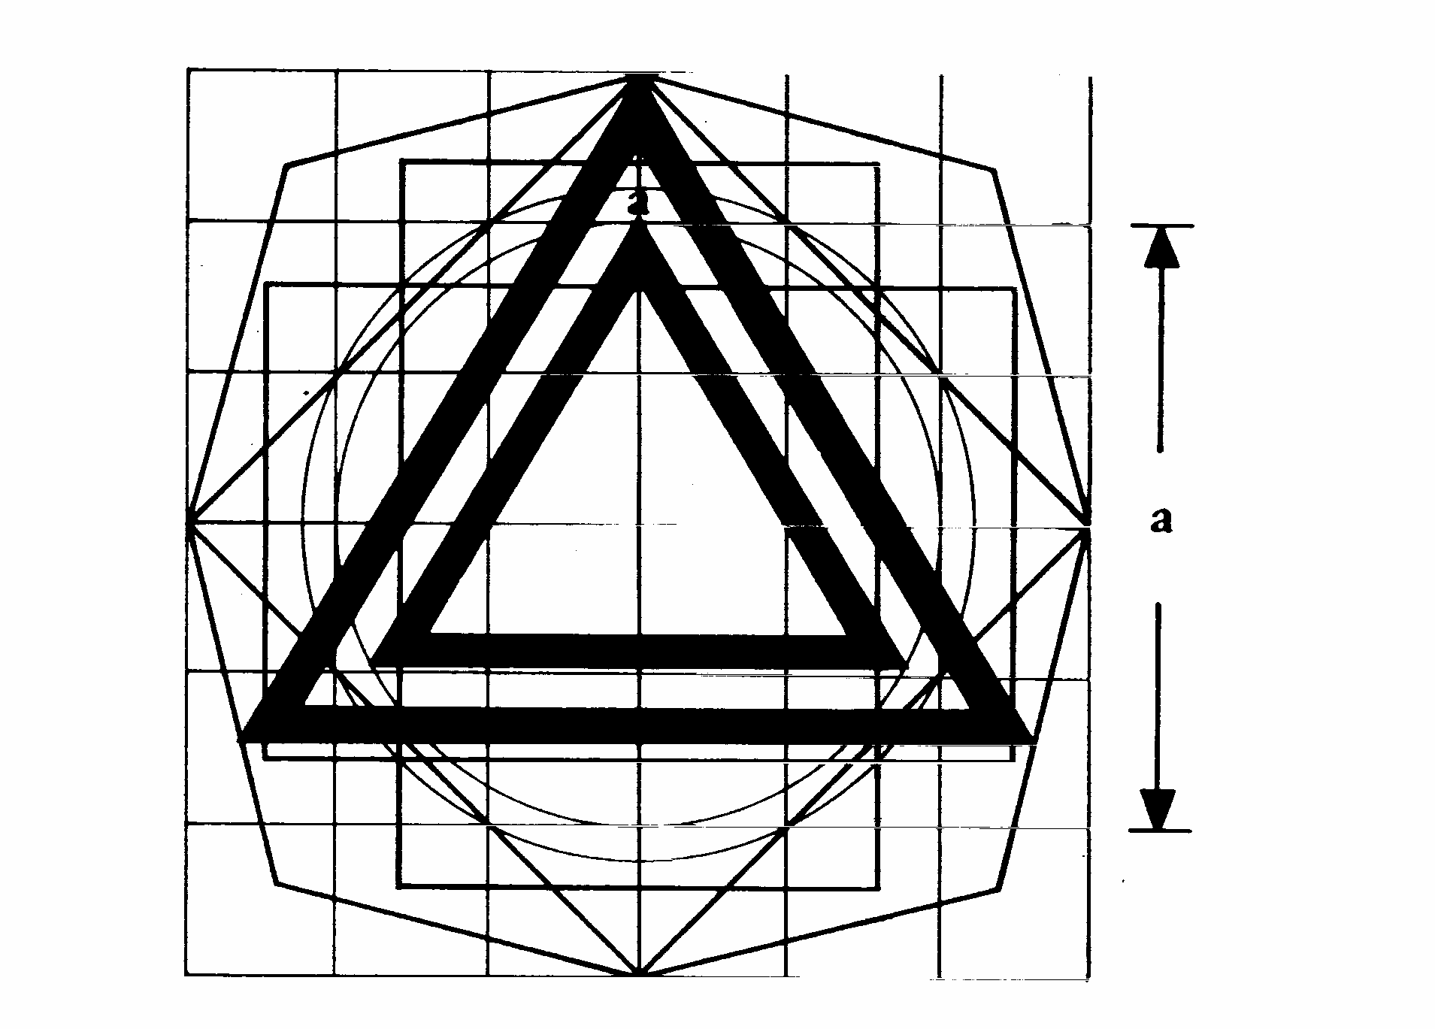
13. Master lighting switch
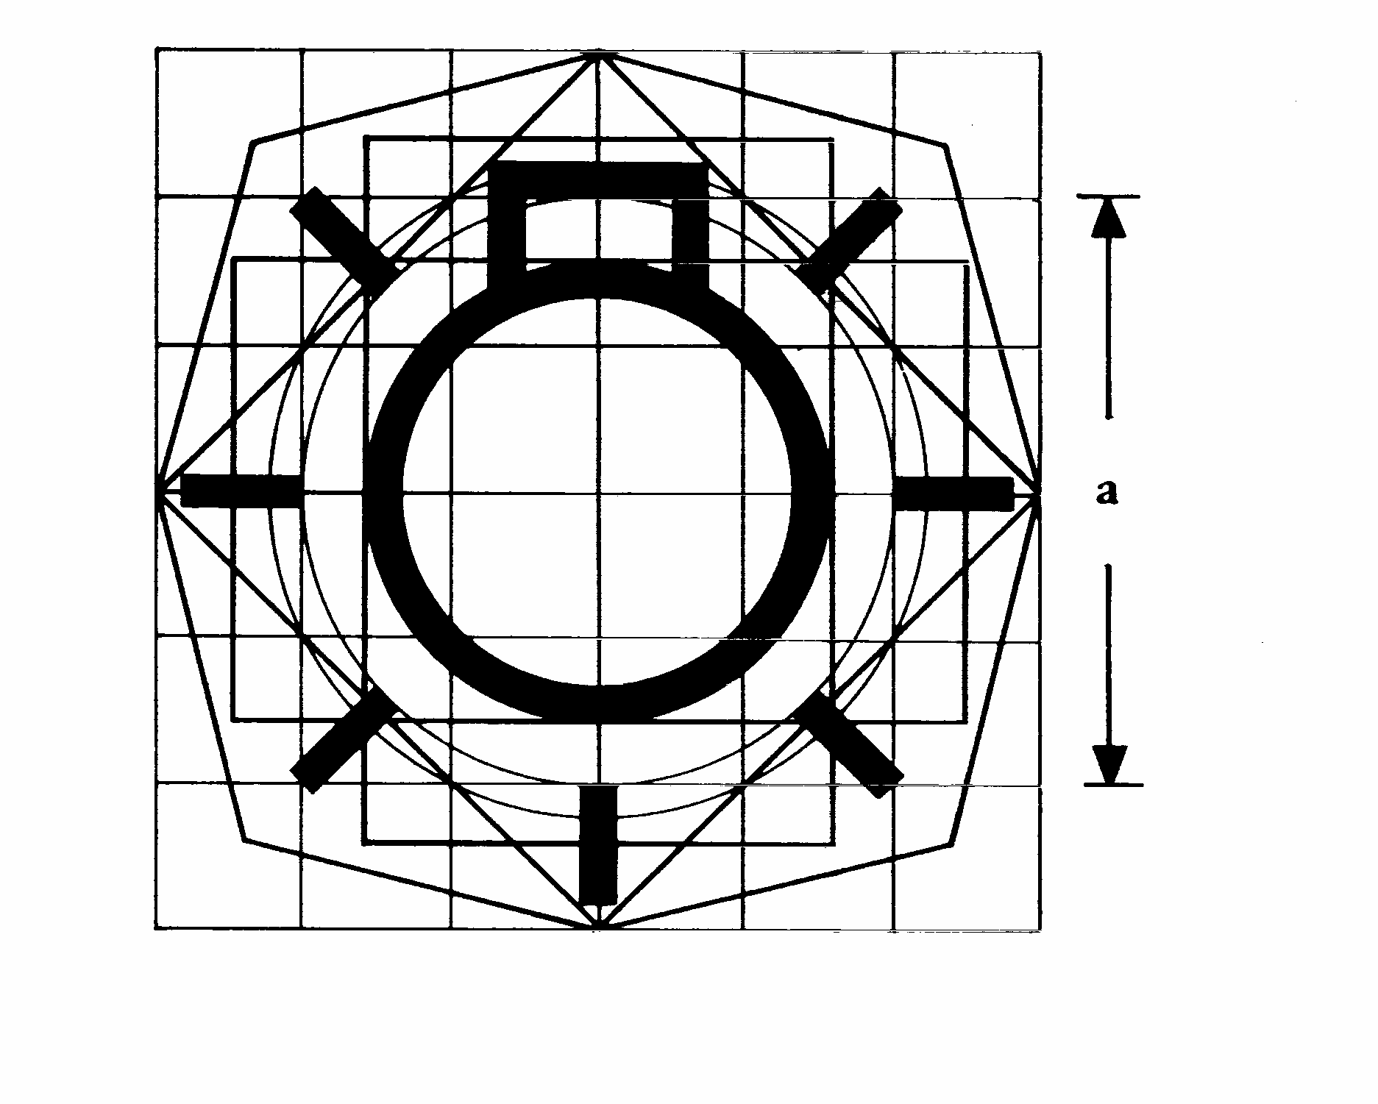
14. Front position (side) lamps control
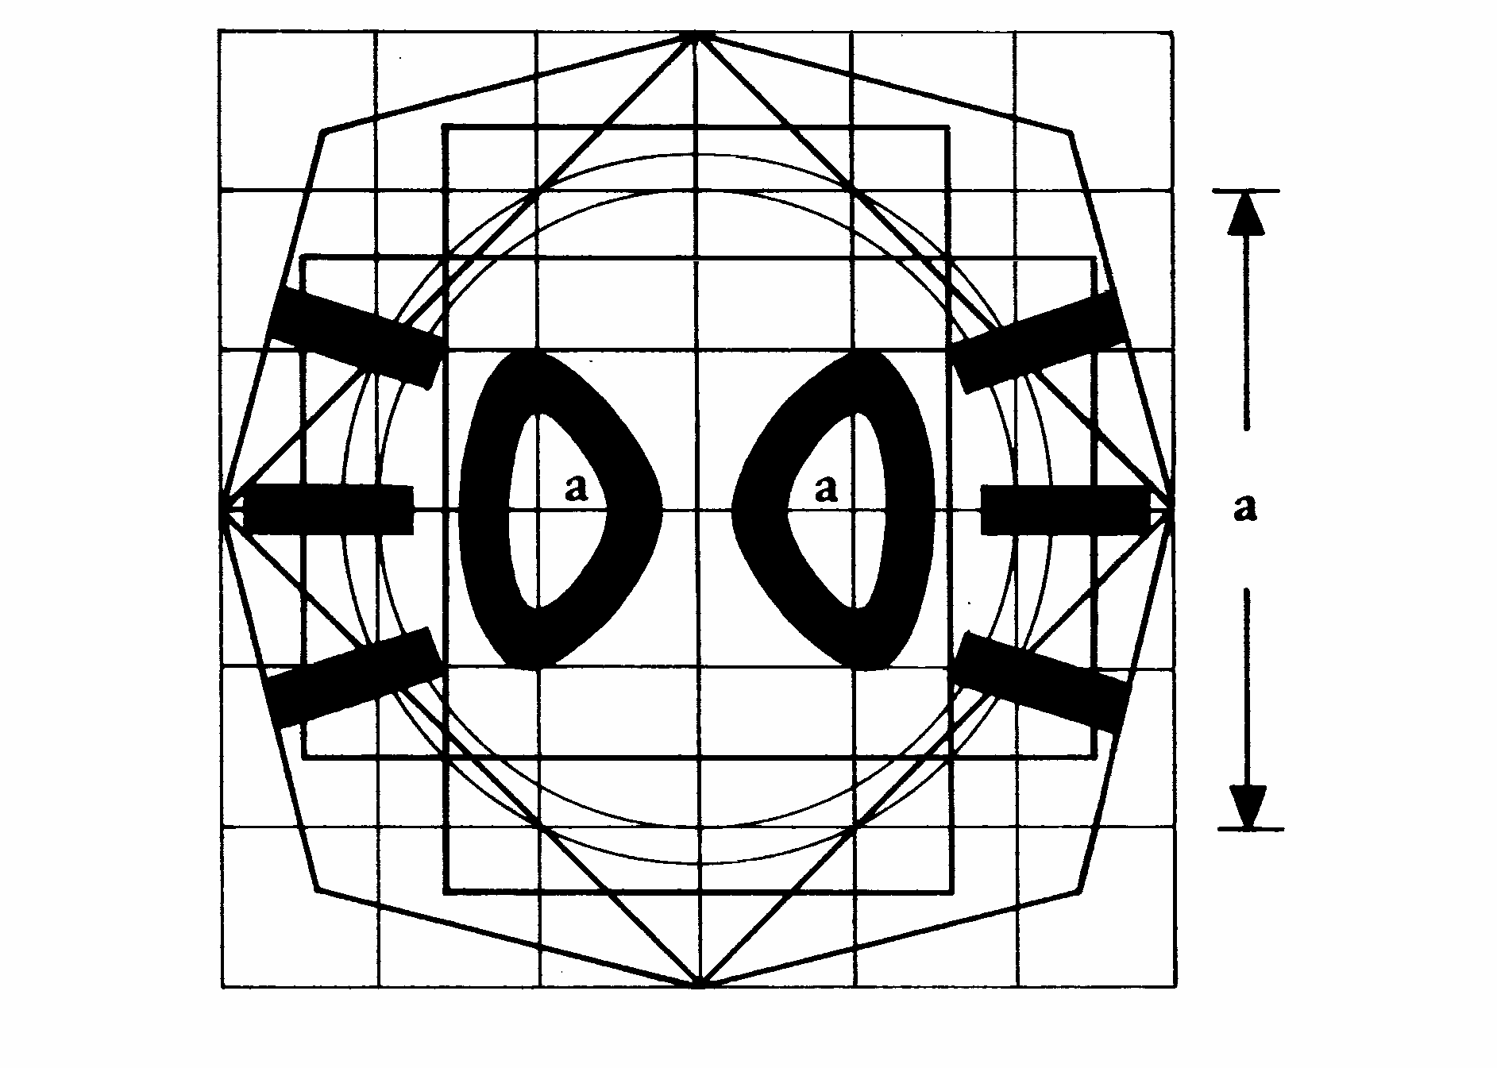
15. Main-beam headlamps control
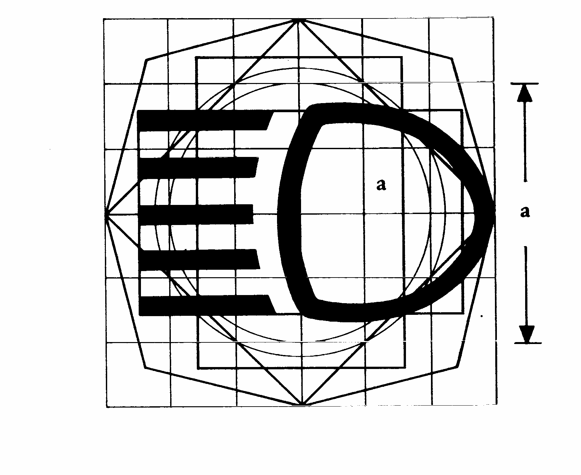
16. Front fog lamp control
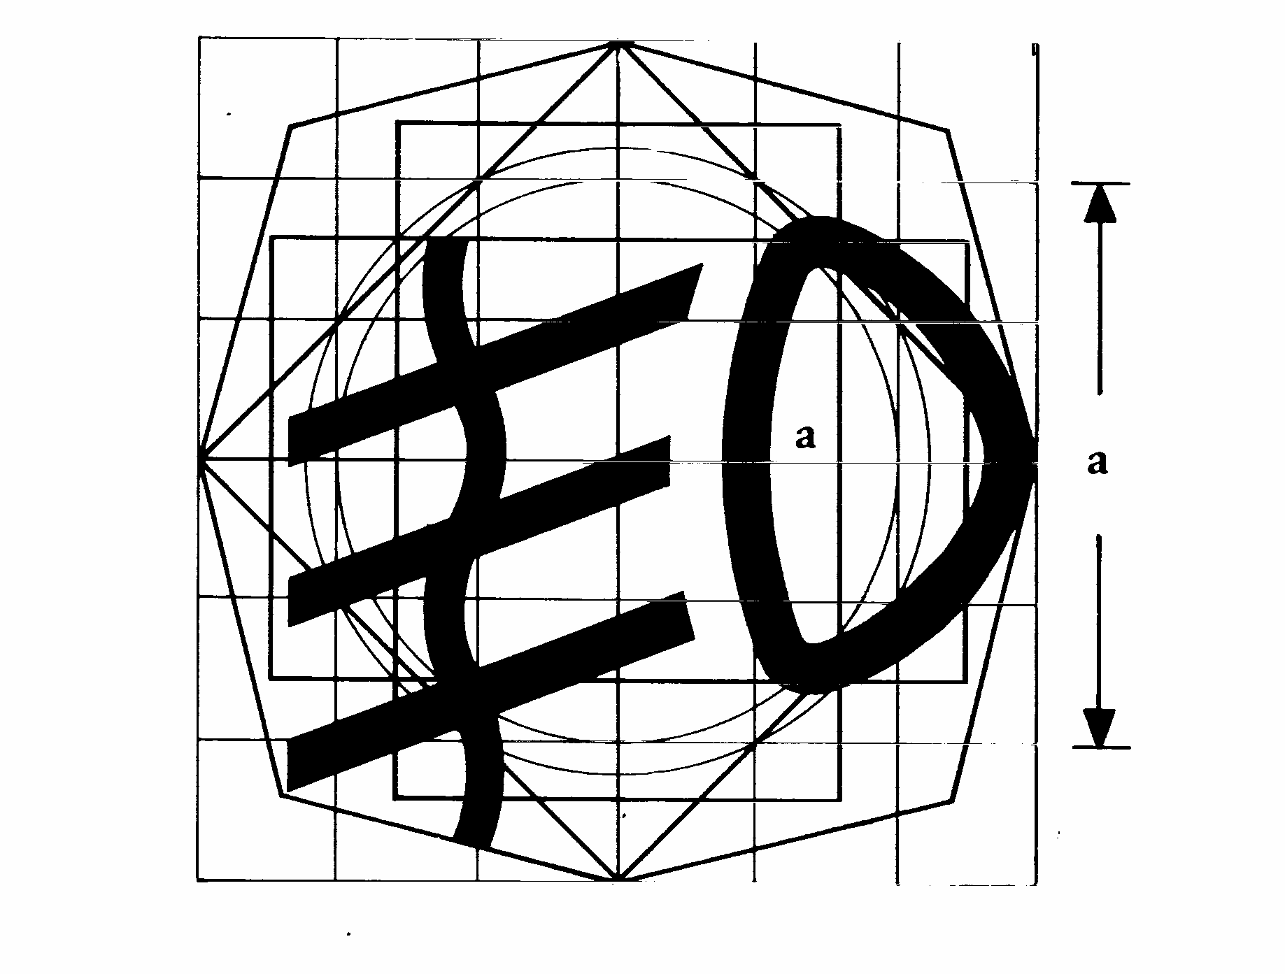
17. Rear fog lamp(s) control
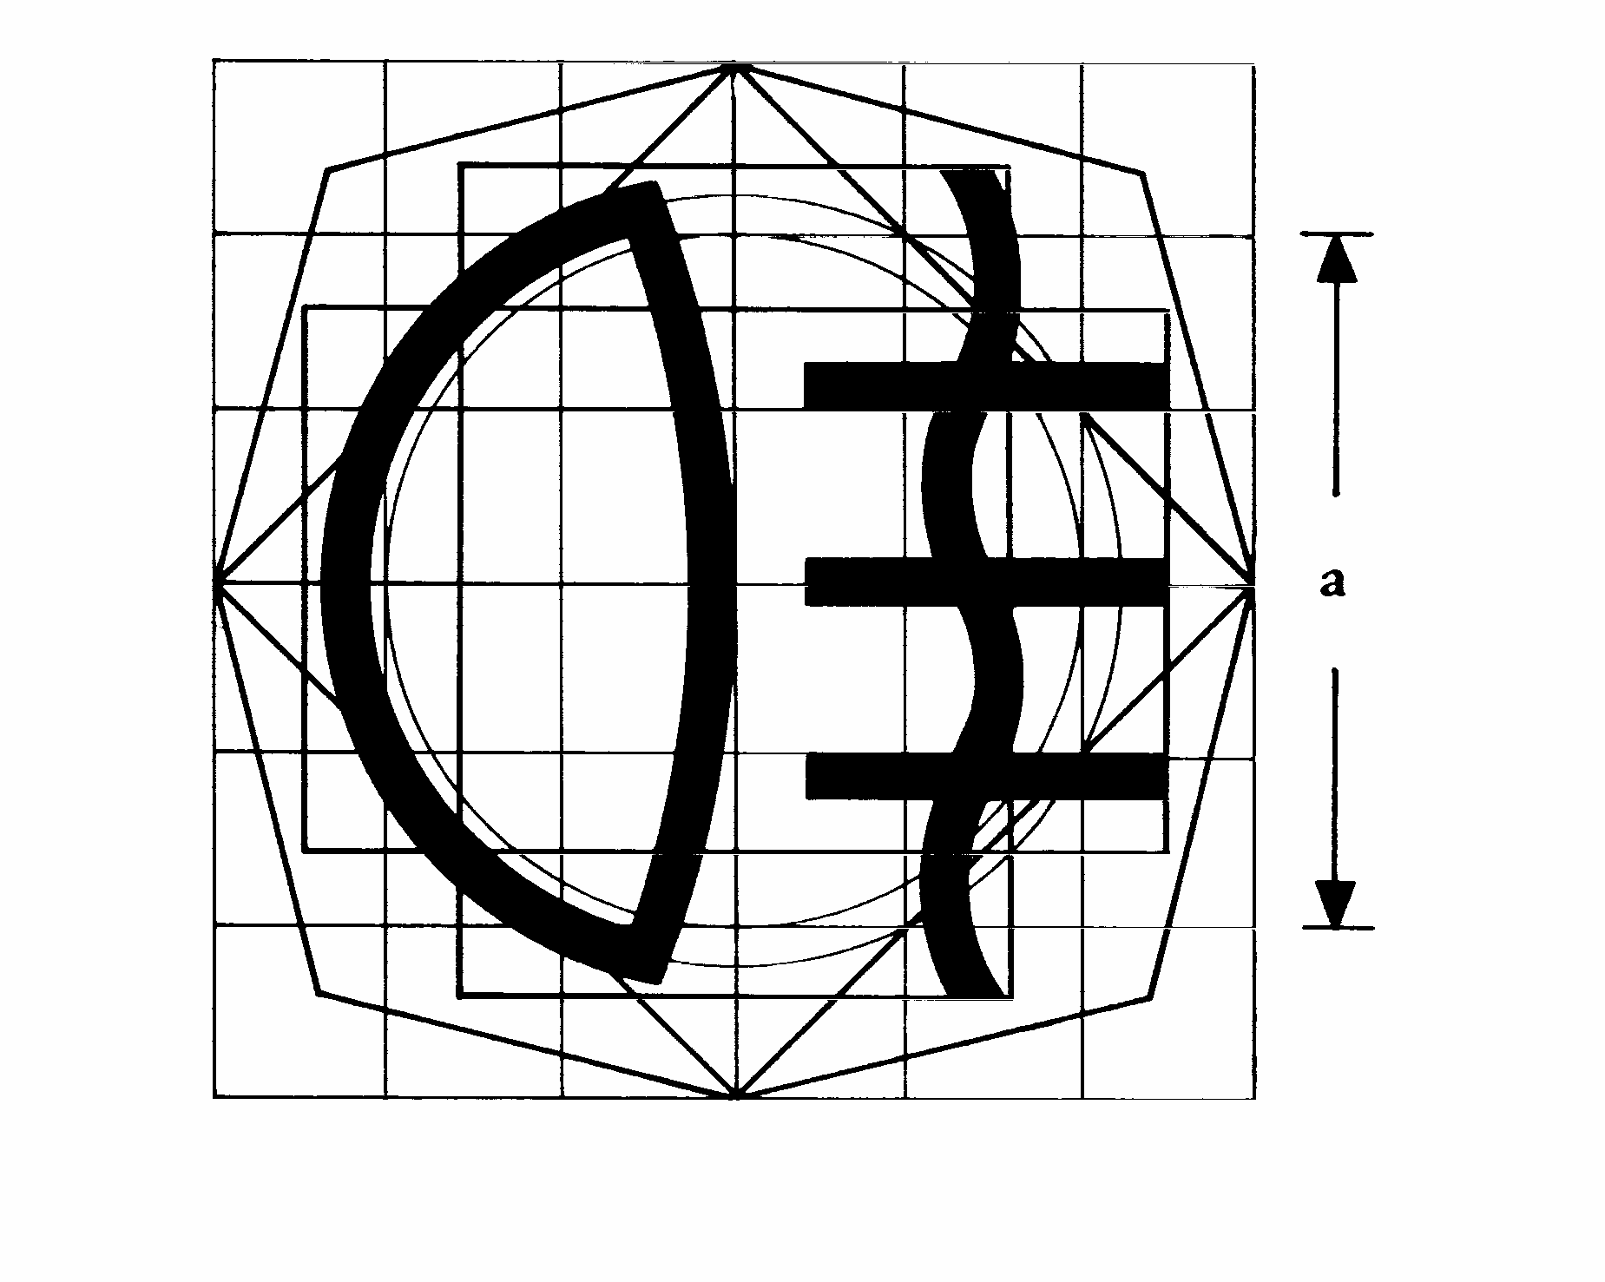
18. Parking lamp(s) control
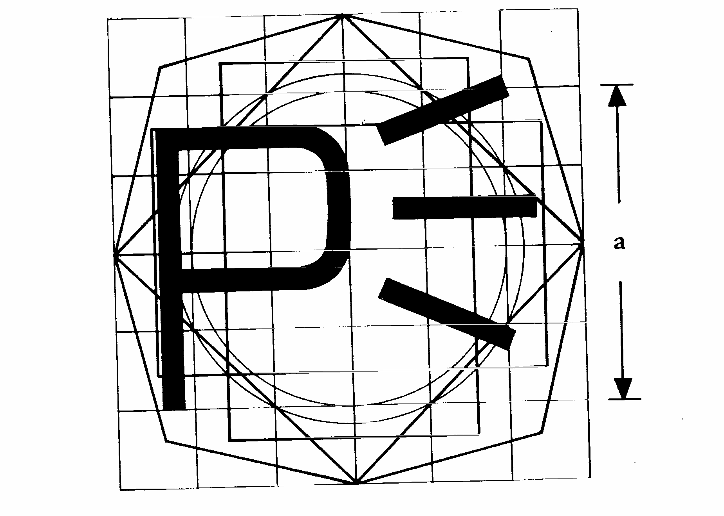
19. Working light control
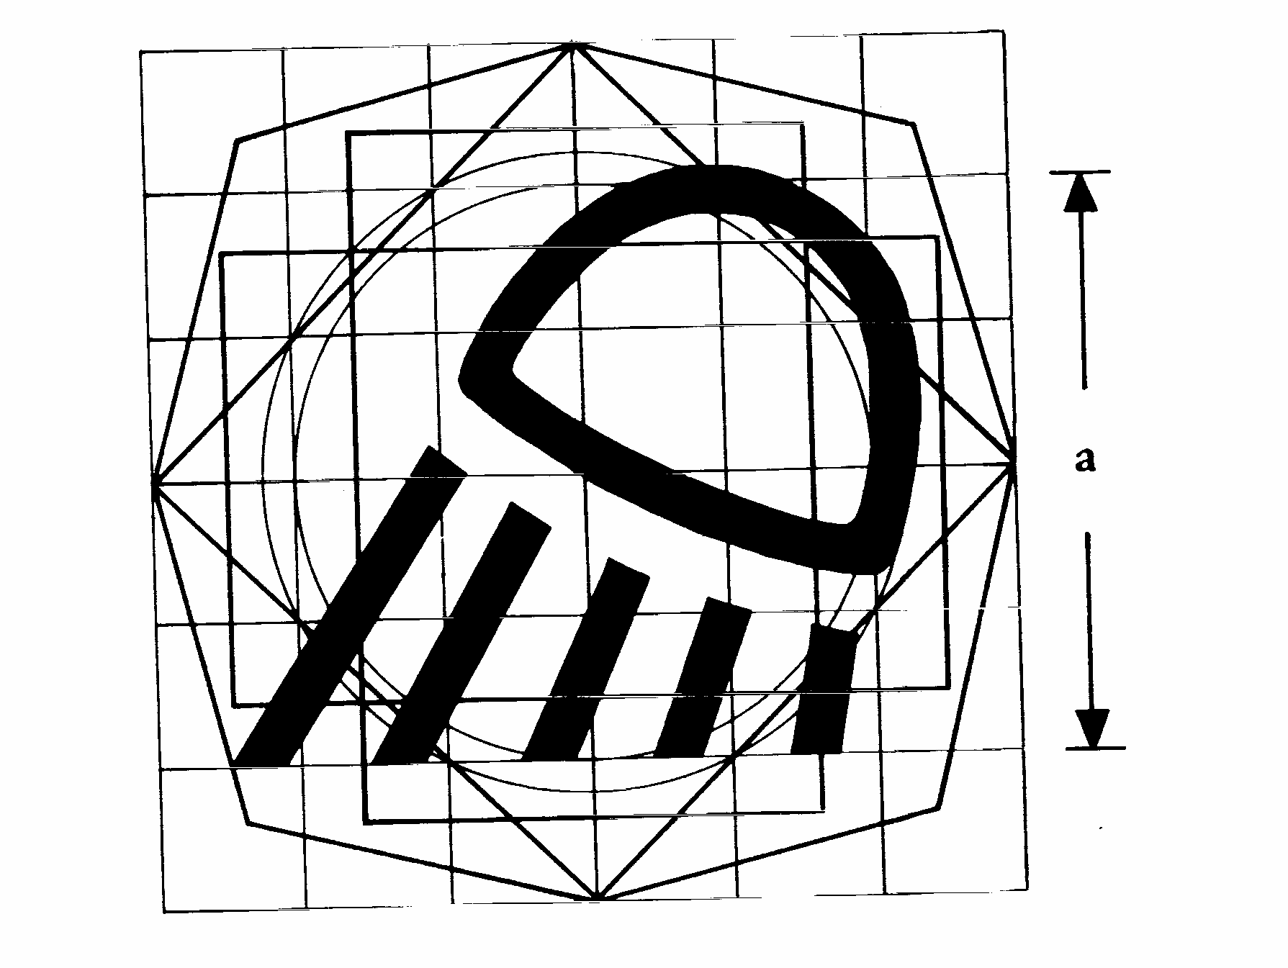
20. Windscreen wiper control
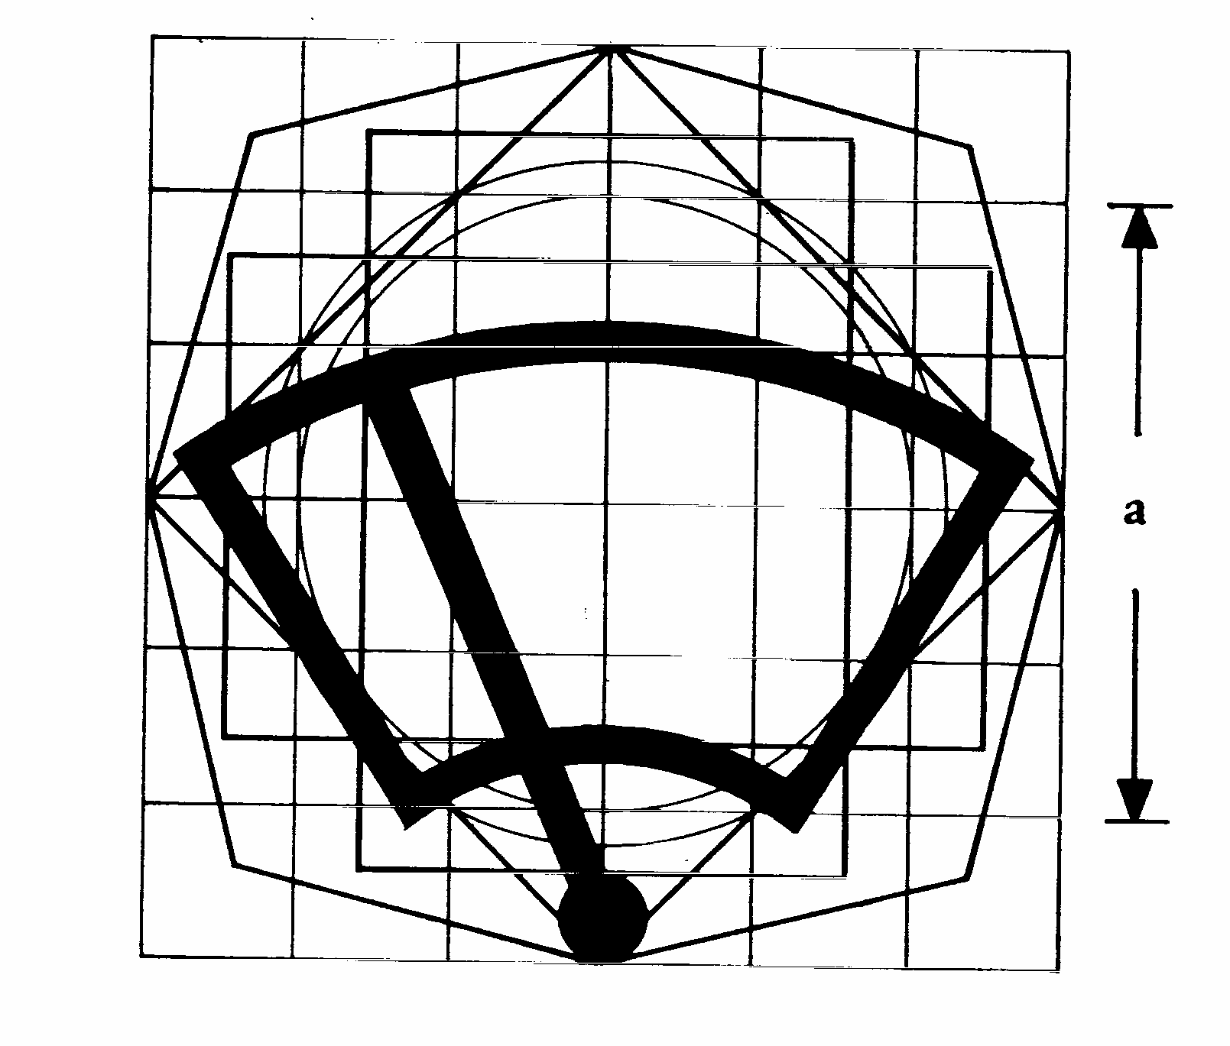
21. Audible warning device control
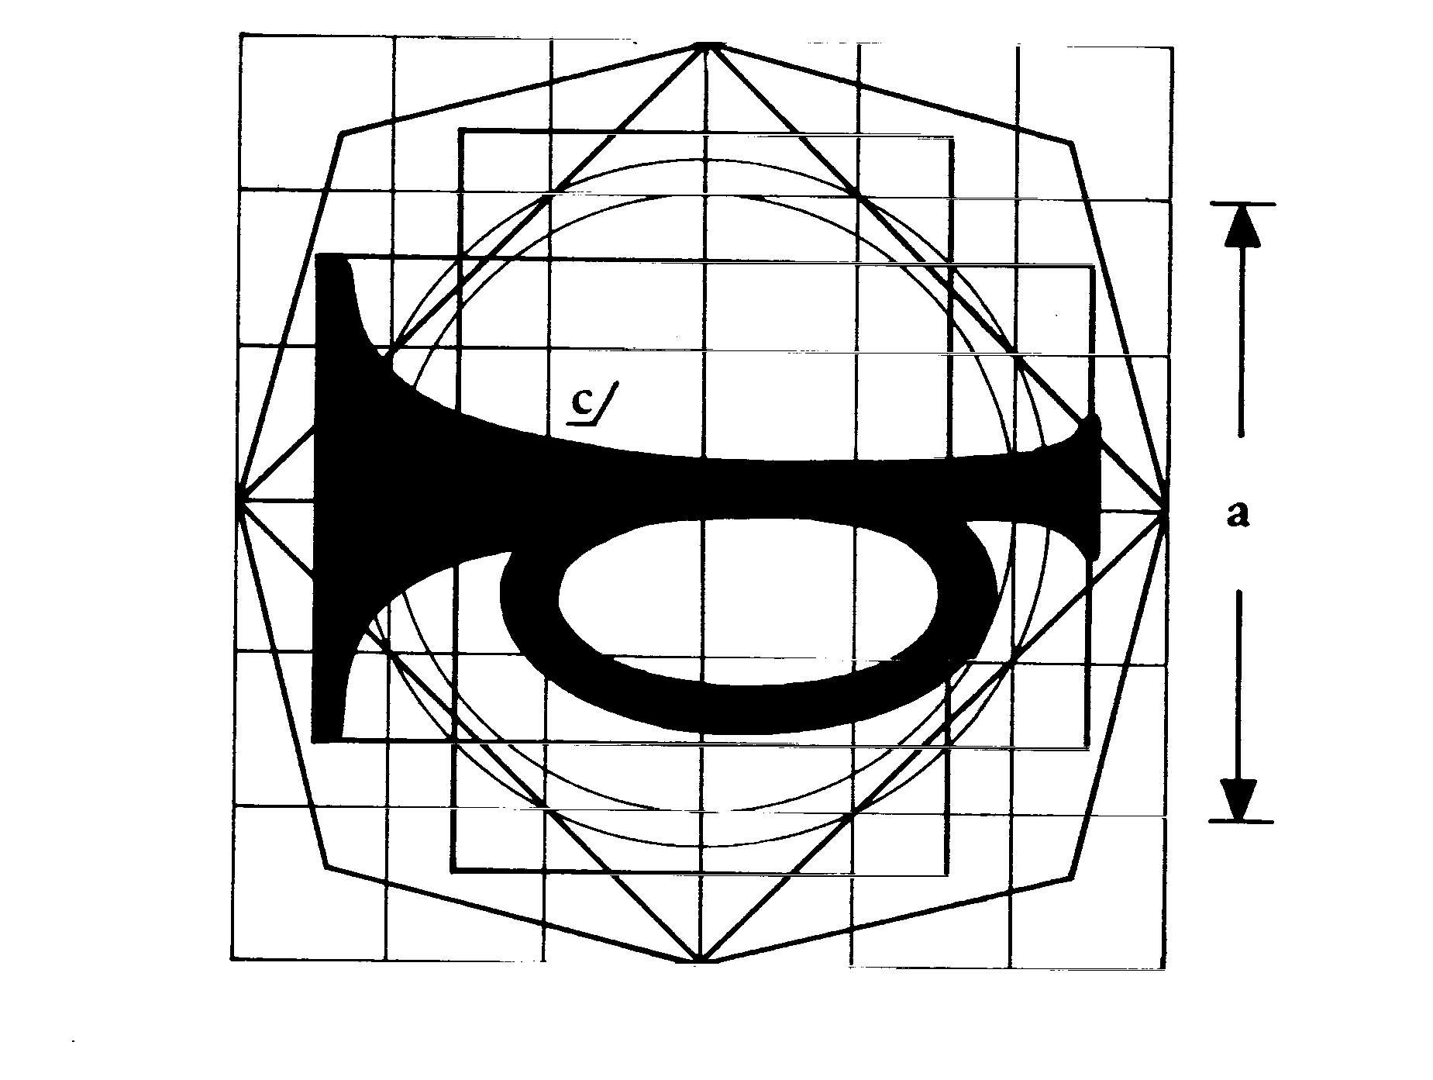
_____________

ê 86/415/EEC
ANNEX IV
CONSTRUCTION OF THE BASIC MODEL FOR THE SYMBOLS SHOWN IN ANNEX III
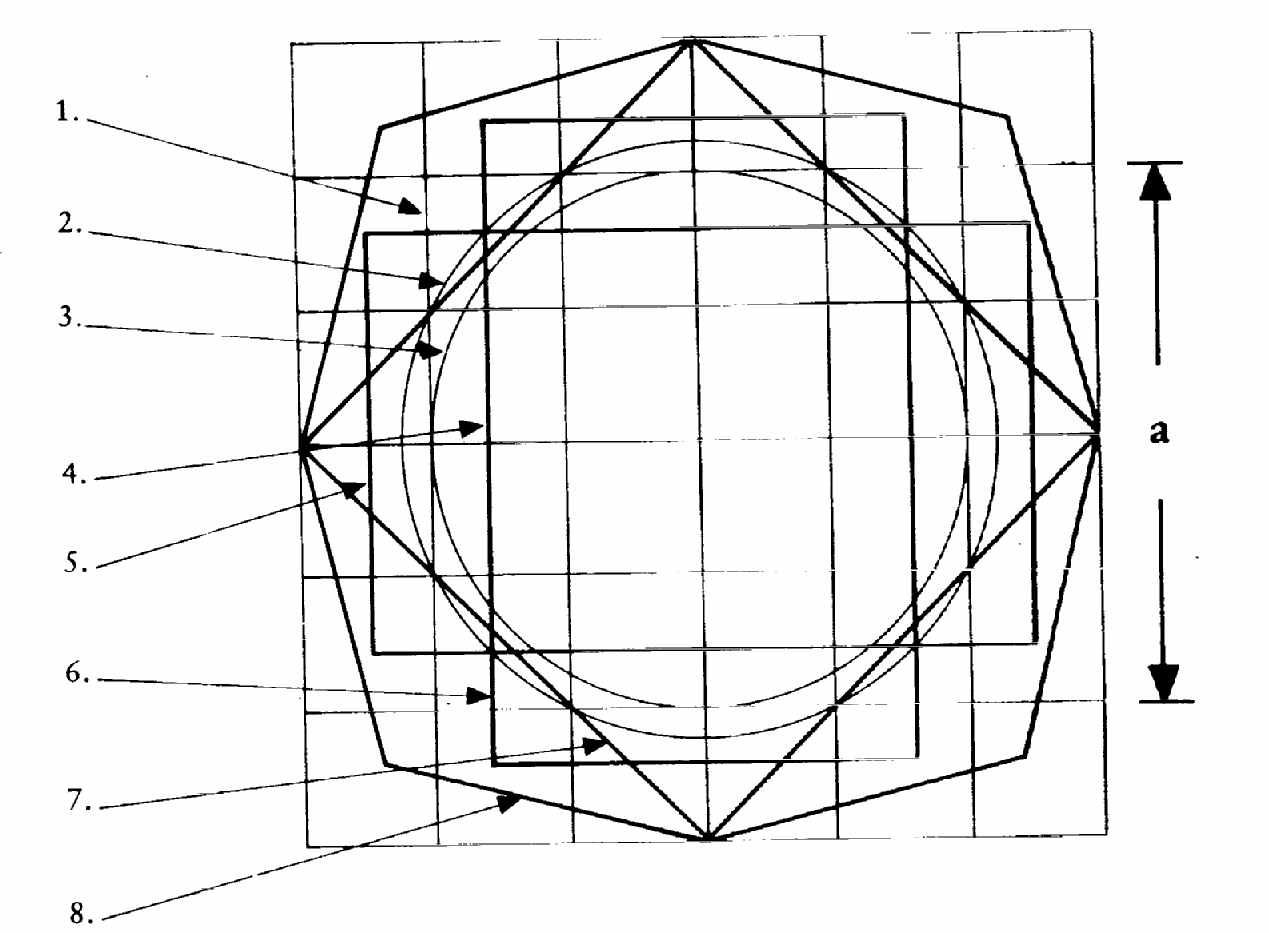
Figure 1
Basic model
The basic model consists of:
1. a basic square measuring 50 × 50 mm, the dimension (a) being equal to the nominal dimension (a) of the original;
2. a basic circle, 56 mm in diameter, having approximately the same surface area as the basic square (1);
3. a second circle, 50 mm in diameter, inscribed within the basic square (1);
4. a second square whose right angles are situated on the basic circle (2) and whose sides are parallel to the sides of the basic square (1);
5. and 6. two rectangles having the same surface area as the basic square (1); their respective sides are perpendicular and each of them is constructed in such a way as to intersect the opposite sides of the basic square at symmetrical points;
7. a third square whose sides pass through the points of intersection of the basic square (1) and of the basic circle (2) and are inclined at an angle of 45°, thus giving the largest horizontal and vertical dimensions of the basic model;
8. an irregular octagon formed by lines inclined at an angle of 30° to the sides of the square (7).
The basic model is situated on a 12,5 mm gauge grid which coincides with the basic square (1).
_____________

ê 86/415/EEC (adapted)
ANNEX V
MODEL
Maximum format: DIN A4 (210 × 297 mm)
Name of administration

ANNEX TO THE EC TYPE-APPROVAL CERTIFICATE FOR A TRACTOR TYPE Ö AS REGARDS Õ THE INSTALLATION, LOCATION, OPERATION AND IDENTIFICATION OF CONTROLS
(Article 4 of Directive 2003/37/EC of the European Parliament and of the Council of 26 May 2003 on type-approval of agricultural or forestry tractors, their trailers and interchangeable towed machinery, together with their systems, components and separate technical units)
EC type-approval No …………………………………………………………………………………………….
4. Where applicable, name and address of manufacturer’s authorised representative ……………………….
5. Brief description of the tractor type Ö as regards Õ the installation, location, operation and identification of controls ……………………………………………………..…………..
6. Date tractor submitted for Ö EC Õ type-approval ……………………………………………………
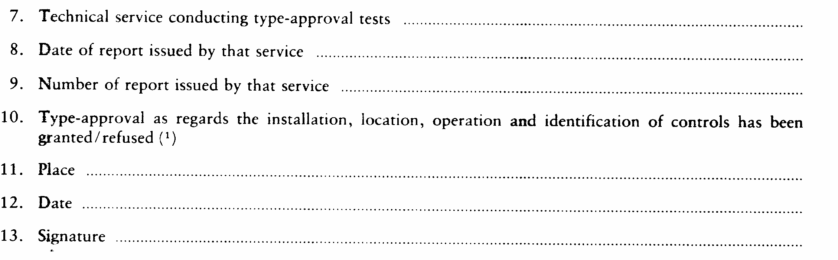
14. The following drawings, bearing the above-mentioned type-approval number, are attached to this communication:
A set of drawings of the controls and of the tractor components regarded as relevant for the purposes of Directive […] of the European Parliament and of the Council of […] on the installation, location, operation and identification of the controls of wheeled agricultural or forestry tractors.
These drawings will be supplied to the competent authorities of the other Member States at their express request.
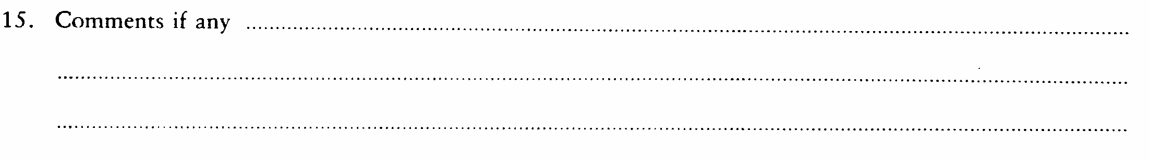
_____________

é
ANNEX VI
Part A
Repealed Directive with list of its successive amendments
(referred to in Article 6)
Council Directive 86/415/EEC
(OJ L 240, 26.8.1986, p. 1)
 | Directive 97/54/EC of the European Parliament and of the Council  (OJ L 277, 10.10.1997, p. 24) |  | Only as regards the reference to Directive 86/415/EEC in the first indent of Article 1
 | Commission Directive 2010/22/EU  (OJ L 91,10.4.2010, p. 1) |  | Only Article 3 and Annex III
Part B
List of time-limits for transposition into national law and application
(referred to in Article 6)
Directive | Time-limit for transposition | Date of application
86/415/EEC | 1 October 1987 | -
97/54/EC | 22 September 1998 | 23 September 1998
2010/22/EU | 30 April 2011 | 1 May 2011
_____________
ANNEX VII

Correlation Table
Directive 86/415/EEC | This Directive
Articles 1 to 4 | Articles 1 to 4
Article 5(1) | -
Article 5(2) | Article 5
- | Article 6
- | Article 7
Article 6 | Article 8
Annexes I to V | Annexes I to V
- | Annex VI
- | Annex VII
_____________

COM(87) 868 PV.
See Annex 3 to Part A of the Conclusions.
Carried out pursuant to the Communication from the Commission to the European Parliament and the Council – Codification of the Acquis communautaire, COM(2001) 645 final.
See Annex VI, Part A, of this proposal.
OJ C […], […], p. […].
OJ L 240, 26.8.1986, p. 1.
See Annex VI, Part A.
OJ L 171, 9.7.2003, p. 1.

