EN
EUROPEAN COMMISSION
Brussels, 10.12.2010
COM(2010) 729 final
2010/0349 (COD)
Proposal for a
DIRECTIVE OF THE EUROPEAN PARLIAMENT AND OF THE COUNCIL
on braking devices of wheeled agricultural or forestry tractors
(Codification)
EXPLANATORY MEMORANDUM
1. In the context of a people’s Europe, the Commission attaches great importance to simplifying and clarifying the law of the Union so as to make it clearer and more accessible to the citizens, thus giving them new opportunities and the chance to make use of the specific rights it gives them.
This aim cannot be achieved so long as numerous provisions that have been amended several times, often quite substantially, remain scattered, so that they must be sought partly in the original instrument and partly in later amending ones. Considerable research work, comparing many different instruments, is thus needed to identify the current rules.
For this reason a codification of rules that have frequently been amended is also essential if the law is to be clear and transparent.
2. On 1 April 1987 the Commission decided to instruct its staff that all acts should be codified after no more than ten amendments, stressing that this is a minimum requirement and that departments should endeavour to codify at even shorter intervals the texts for which they are responsible, to ensure that their provisions are clear and readily understandable.
3. The Conclusions of the Presidency of the Edinburgh European Council (December 1992) confirmed this, stressing the importance of codification as it offers certainty as to the law applicable to a given matter at a given time.
Codification must be undertaken in full compliance with the normal procedure for the adoption of acts of the Union.
Given that no changes of substance may be made to the instruments affected by codification, the European Parliament, the Council and the Commission have agreed, by an interinstitutional agreement dated 20 December 1994, that an accelerated procedure may be used for the fast-track adoption of codification instruments.
4. The purpose of this proposal is to undertake a codification of Council Directive 76/432/EEC of 6 April 1976 on the approximation of the laws of the Member States relating to the braking devices of wheeled agricultural or forestry tractors. The new Directive will supersede the various acts incorporated in it; this proposal fully preserves the content of the acts being codified and hence does no more than bring them together with only such formal amendments as are required by the codification exercise itself.
5. The codification proposal was drawn up on the basis of a preliminary consolidation, in 22 official languages, of Directive 76/432/EEC and the instruments amending it, carried out by the Publications Office of the European Union, by means of a data-processing system. Where the Articles have been given new numbers, the correlation between the old and the new numbers is shown in a table contained in Annex VII to the codified Directive.

ê 76/432/EEC (adapted)
2010/0349 (COD)
Proposal for a
DIRECTIVE OF THE EUROPEAN PARLIAMENT AND OF THE COUNCIL
on braking devices of wheeled agricultural or forestry tractors
(Codification)
(Text with EEA relevance)
THE EUROPEAN PARLIAMENT AND THE COUNCIL OF THE EUROPEAN UNION,
Having regard to the Treaty on the Functioning of the European Union, and in particular Article Ö 114 Õ thereof,
Having regard to the proposal from the European Commission,
After transmission of the draft legislative act to the national Parliaments,
Having regard to the opinion of the European Economic and Social Committee,
Acting in accordance with the ordinary legislative procedure,
Whereas:

ê
- Council Directive 76/432/EEC of 6 April 1976 on the approximation of the laws of the Member States relating to the braking devices of wheeled agricultural or forestry tractors has been substantially amended several times. In the interests of clarity and rationality, the said Directive should be codified.

ê 76/432/EEC recital 1 (adapted)
- Ö Directive 76/432/EEC is one of the separate Directives of the EC type-approval system provided for in Council Directive 74/150/EEC, as replaced by Directive 2003/37/EC of the European Parliament and of the Council of 26 May 2003 on type-approval of agricultural or forestry tractors, their trailers and interchangeable towed machinery, together with their systems, components and separate technical units and repealing Directive 74/150/EEC, and lays down Õ technical Ö prescriptions concerning Õ braking devices. Ö Those technical prescriptions concern the approximation of the laws of the Member States to enable the EC type-approval procedure provided for in Directive 2003/37/EC to be applied in respect of each type of tractor. Consequently, the provisions laid down in Directive 2003/37/EC relating to agricultural and forestry tractors, their trailers and interchangeable towed machinery, together with their systems, components and separate technical units, apply to this Directive. Õ

ê
- This Directive should be without prejudice to the obligations of the Member States relating to the time-limits for transposition into national law and application of the Directives set out in Annex VI, Part B,

ê 76/432/EEC
è1 Corrigendum 76/432/EEC (OJ L 226, 18.8.1976, p. 16)
HAVE ADOPTED THIS DIRECTIVE:
Article 1
1. ‘Agricultural or forestry tractor’ means any motor vehicle fitted with wheels or è1 endless tracks ç and having at least two axles, the main function of which lies in its tractive power and which is specially designed to tow, push, carry or power certain tools, machinery or trailers intended for agricultural or forestry use. It may be equipped to carry a load and passengers.

ê 82/890/EEC Art. 1(1) (adapted)
è1 97/54/EC Art. 1
2. This Directive shall apply only to tractors defined in paragraph 1 which are equipped with pneumatic tyres and have a maximum design speed of between 6 and è1 40 km/h ç.

ê 96/63/EC (adapted)
Article 2
1. Ö With respect to tractors which comply with the requirements laid down in this Directive, Õ Member States may not Ö, on grounds relating to braking devices, Õ:
(a) refuse, in respect of a type of tractor, to grant EC type-approval or to grant national type-approval; or
(b) Ö refuse Õ the registration Ö or prohibit the Õ sale or entry into service of tractors.
2. Member States
may refuse to grant national type-approval
for a type of tractor on grounds relating to braking devices, if the requirements Ö laid down in Õ this Directive are not complied with.

ê 76/432/EEC (adapted)
Article 3
Member States may not prohibit the use of tractors on grounds relating to their braking devices if those tractors are fitted with the devices specified in Annexes I to IV and if those devices satisfy the requirements set out therein.
Article 4
A Member State which has granted Ö EC Õ type-approval of a tractor shall take the necessary measures to ensure that it is informed of any modification to a component or characteristic mentioned in point 1.1 of Annex I. The competent authorities of that Member State shall decide whether fresh tests should be carried out on the modified type of tractor and a fresh report drawn up. If such tests reveal failure to comply with the requirements of this Directive, the modification shall not be approved.
Article 5
The amendments necessary for adapting the requirements of Annexes I to V to take account of technical progress shall be adopted in accordance with the procedure Ö referred to Õ in Article 20(3) of Directive 2003/37/EC.
Article 6
Ö Member States shall communicate to the Commission the texts of the main provisions of national law which they adopt in the field covered by this Directive. Õ

ê
Article 7
Directive 76/432/EEC, as amended by the Directives listed in Annex VI, Part A, is repealed, without prejudice to the obligations of the Member States relating to the time-limits for transposition into national law and application of the Directives set out in Annex VI, Part B.
References to the repealed Directive shall be construed as references to this Directive and shall be read in accordance with the correlation table in Annex VII.
Article 8
This Directive shall enter into force on the twentieth day following that of its publication in the Official Journal of the European Union.
It shall apply from […].

ê 76/432/EEC
Article 9
This Directive is addressed to the Member States.
Done at
For the European Parliament For the Council
The President The President

ê 76/432/EEC (adapted)
ANNEX I
DEFINITIONS, APPLICATION FOR EC TYPE-APPROVAL, EC TYPE-APPROVAL, CONSTRUCTION AND FITTING REQUIREMENTS

ê 76/432/EEC

1. DEFINITIONS

1.1. Type of tractor with respect to the braking devices
‘Type of tractor with respect to the braking devices’ means tractors which do not differ in such essential respects as:

ê 76/432/EEC (adapted)
1.1.1. unladen Ö mass Õ , as defined in point 1.18,
1.1.2. maximum Ö mass Õ , as defined in point 1.16,
1.1.3. distribution of the Ö mass Õ between the axles,
1.1.4. technically permissible maximum Ö mass Õ on each axle,

ê 76/432/EEC
1.1.5. maximum design speed,
1.1.6. different type of braking device (with particular reference to the presence or otherwise of devices for braking a trailer),
1.1.7. number and arrangement of the braked axles,
1.1.8. type of engine,
1.1.9. overall transmission ratio corresponding to maximum speed,
1.1.10. tyre dimensions (braked axles).

1.2. Braking device
‘Braking device’ means a combination of parts whose function is progressively to reduce the speed of a moving tractor or to bring it to a halt, or to keep it stationary if already halted. These functions are specified in point 4.1.2. A device shall consist of the control, the transmission and the brakes themselves.

1.3. Graduated braking
‘Graduated braking’ means braking during which, on either the application or release of the brakes, within the normal range of operation of the device:
1.3.1. the driver can at any time increase or reduce the braking force through action on the control,
1.3.2. the braking force acts in the same direction as the action on the control (monotonic function),
1.3.3. it is easy to make a sufficiently fine adjustment to the braking force.

1.4. Control
‘Control’ means the part actuated directly by the driver to supply to the transmission the energy required for braking or controlling it. That energy may be the muscular energy of the driver, or energy from another source controlled by the driver, or a combination of these various kinds of energy.

1.5. Transmission
‘Transmission’ means the combination of components situated between the control and the brake and connecting the two operationally. The transmission may be mechanical, hydraulic, pneumatic, electrical, or mixed. Where the braking power is derived from or assisted by a source of energy independent of the driver but controlled by him, the reserve of energy in the device shall likewise be regarded as part of the transmission.

1.6. Brake
‘Brake’ means the component in which the forces opposing the movement of the tractor develop. It may be a friction brake (when the forces are generated by the friction between the two parts of the tractor moving relatively to one another), an electrical brake (when the forces are generated by electro-magnetic action between two parts of the tractor moving relatively to but not in contact with one another), a fluid brake (when the forces are generated by the action of a fluid situated between two parts of the tractor moving relatively to one another), or an engine brake (when the forces are derived from a controlled increase in the braking action of the engine transmitted to the wheels).
A device which mechanically locks the tractor's transmission but which cannot be used when the tractor is in motion shall be regarded as a parking brake.

1.7. Different types of braking devices
‘Different types of braking devices’ means equipment which differs in such essential respects as:
1.7.1. the characteristics of one or more components, for example the material, shape or size,
1.7.2. the arrangement of the components.

1.8. Braking system component
‘Braking system component’ means one of the individual parts which, when assembled, constitute the braking device.

1.9. Continuous braking
‘Continuous braking’ means the braking of combinations of vehicles through an installation having the following characteristics:
1.9.1. a single control which the driver actuates progressively, by a single movement, from his driving seat,
1.9.2. the energy used for braking the vehicles constituting the vehicle combination is supplied from the same source (which may be the muscular energy of the driver),
1.9.3. the braking installation ensures simultaneous or suitably phased braking of each of the constituent vehicles of the combination, whatever their relative positions.

1.10. Semi-continuous braking
‘Semi-continuous braking’ means the braking of combinations of vehicles through an installation having the following characteristics:
1.10.1. a single control which the driver can actuate progressively, by a single movement, from his driving seat,
1.10.2. the energy used for braking the vehicles constituting the vehicle combination is supplied from several different sources (one of which may be the muscular energy of the driver),
1.10.3. the braking installation ensures simultaneous or suitably phased braking of each of the constituent vehicles of the combination, whatever their relative positions.

1.11. Independent power-operated braking
‘Independent power-operated braking’ means the braking of combinations of vehicles by means of devices having the following characteristics:
1.11.1. a tractor brake control which is independent of the towed vehicle brake control; the latter being in all cases mounted on the tractor in such a way as to be easily actuated by the driver from his driving seat,
1.11.2. the muscular energy of the driver is not the energy used for braking the towed vehicles.

1.12. Independent braking
‘Independent braking’ means the braking of combinations of vehicles by means of devices having the following characteristics:
1.12.1. a tractor brake control which is independent of the trailer brake control, the latter being in all cases mounted on the tractor in such a way as to be easily actuated by the driver from his driving seat,
1.12.2. the muscular energy of the driver is the energy used for braking the towed vehicles.

1.13. Automatic braking
‘Automatic braking’ means braking of the towed vehicle or vehicles occurring automatically in the event of separation of components of the combination of coupled vehicles, including such separation through coupling breakage, without the braking effectiveness of the remainder of the combination being substantially reduced.

1.14. Inertia braking
‘Inertia braking’ means braking by utilising the forces generated by the trailer closing up on the tractor.

ê 76/432/EEC (adapted)

1.15. Laden tractor
‘Laden tractor’ means, except where otherwise stated, a tractor laden to its ‘maximum Ö mass Õ ’.

1.16. Maximum Ö mass Õ
‘Maximum Ö mass Õ ’ means the maximum technically permissible Ö mass Õ stated by the manufacturer (this Ö mass Õ may be higher than the ‘authorized maximum Ö mass Õ ’).

1.17. Unladen tractor
‘Unladen tractor’ means the tractor in running order, with full tanks and radiators, with a driver of a mass of 75 kg, but without passengers, optional accessories or load.

1.18. Unladen Ö mass Õ
‘Unladen Ö mass Õ ’ means the Ö mass Õ of the unladen tractor.

2. APPLICATION FOR EC TYPE-APPROVAL
2.1. An application for EC type-approval for a type of tractor with respect to the braking devices shall be submitted by the manufacturer or by his authorized representative.

ê 76/432/EEC
2.2. It shall be accompanied by the following documents in triplicate:
2.2.1. a description of the type of tractor as regards the points mentioned in points 1.1.1 to 1.1.10. The numbers and/or symbols given by the manufacturer or his authorized representative to the type of tractor must be supplied,
2.2.2. a list of parts, each properly identified, which make up the braking device,
2.2.3. a diagram of the braking device showing the position of each of the parts on the tractor, in order to enable the various components to be located and identified.
2.3. The following must also be provided:
2.3.1. a tractor, representative of the type of tractor to be approved,
2.3.2. such drawings as may be requested of maximum A4 size (210 × 297 mm), or folded to this size and drawn to the appropriate scale.

ê 76/432/EEC (adapted)

3. EC TYPE-APPROVAL
The form as illustrated in Annex V shall be completed and attached to the EC type-approval certificate.

ê 76/432/EEC
è1 96/63/EC Art. 1 and Annex, pt 1

4. CONSTRUCTION AND FITTING REQUIREMENTS

4.1. General

4.1.1. Braking device
4.1.1.1. The braking device must be so designed, constructed and installed as to enable the tractor in normal use to comply with the undermentioned requirements, despite any vibration to which it may be subjected.
4.1.1.2. In particular, the braking device must be so designed, constructed and installed as to resist corrosion and the effects of ageing during service, which could lead to a sudden loss of braking efficiency.

4.1.2. Functions of the braking device
The braking device defined in point 1.2 must meet the following conditions:

4.1.2.1. Service brakes
4.1.2.1.1. The service brake must enable the motion of the tractor to be controlled and the tractor to be stopped safely, quickly and efficiently, at any design speed and with the authorized load on both up and down gradients. It must be possible to regulate its action. These conditions are deemed to be fulfilled if the requirements of Annex II are satisfied.
The driver must be able to apply the service brake from his seat and retain control of the steering device on the tractor with at least one hand. The service brake of the tractor may comprise right and left hand devices. It must be possible to connect them up so that they can be actuated in a single operation, and possible to disconnect them again.
Each device, right or left hand, must have a system of adjustment, which may be either manual or automatic, enabling the balance of the brakes to be easily restored.

4.1.2.2. Parking brakes
4.1.2.2.1. The parking brake must enable the tractor to be held stationary on an up or down gradient even in the absence of the driver, the working parts being then held in the locked position by a purely mechanical device. This may be achieved by means of a brake acting on the transmission. The driver must be able to apply the parking brake from his seat; a repeated action to obtain the required performance is permitted.

4.2. Characteristics of braking devices
4.2.1. The set of braking devices with which a tractor is equipped must satisfy the requirements laid down for the service and parking brakes.
4.2.2. The service and parking brake devices may have common components, provided that they fulfil the following conditions:
4.2.2.1. there must be at least two controls, independent of each other and readily accessible to the driver from the driving seat; it must be possible for this requirement to be met even when the driver is wearing a safety belt,
4.2.2.2. in the event of a breakage of any component of the braking device other than the brakes (as defined in point 1.6) or of any other failure of the service braking device (malfunction, partial or total exhaustion of an energy reserve), it must be possible to slow the tractor to a halt with a deceleration equal to at least 50 % of the value laid down in point 2.1.1 of Annex II.
These conditions shall be fulfilled when residual braking is achieved on wheels located on both sides of the median longitudinal plane (without the tractor deviating from its course).
For the purposes of this Section, the lever and cam assemblies, or similar assemblies, by means of which the brakes are applied, shall not be regarded as liable to failure.
4.2.3. Where use is made of energy other than the muscular energy of the driver, there need not be more than one source of such energy (such as hydraulic pump, air compressor, etc.) provided the requirements of point 4.2.2 are fulfilled.
4.2.4. The service braking device must act on both wheels of at least one axle.
4.2.5. The action of the service braking device must be distributed between the wheels of the same axle symmetrically in relation to the median longitudinal plane of the tractor.
4.2.6. The service braking device and the parking braking device must act on braking surfaces permanently connected to the wheels through components of adequate strength. It must not be possible to uncouple a braking surface from the wheels.è1 When more than one axle is normally subject to braking, one axle may be decoupled provided that activation of the service brake automatically recouples this axle and that, if the recoupling device fails, this is done automatically. ç
When one axle is subject to braking, the differential must not be mounted between the service brake and the wheels of that axle; when two axles are subject to braking, the differential may be mounted between the service brake and the wheels on one of the two axles.
4.2.7. Wear on the brakes must be easily compensated for by means of a system of manual or automatic adjustment. In addition, the control and the components of the transmission and the brakes must possess a reserve of travel such that, when the brakes become heated or when the brake linings have reached a certain degree of wear, effective braking is ensured without an immediate adjustment being necessary.
4.2.8. In hydraulic braking devices, the filling ports of the fluid reservoirs must be readily accessible; in addition, the containers of reserve fluid must be so made that the level of the reserve fluid can be easily checked without the containers having to be opened.
4.2.9. Every tractor fitted with a brake activated from an energy reservoir must, where the prescribed braking performance is impossible without the use of stored energy, be fitted with a warning device, in addition to the pressure gauge, giving a signal which can be seen or heard when the energy, in any part of the installation up to the control valve, falls to 65 % or less of its normal value. That device must be directly and permanently connected to the circuit.
4.2.10. Without prejudice to the requirements of point 4.1.2.1, where the use of an auxiliary energy source is essential for the operation of a braking device, the energy reserve must be such as to ensure that, should the engine stop, the braking performance remains sufficient to bring the tractor to a halt under the prescribed conditions.
4.2.11. Any auxiliary equipment shall draw its energy only in such a way that its operation, even in the event of damage to the energy source, cannot cause the reserves of energy feeding the braking devices to fall below the level indicated in point 4.2.9.
_____________
ANNEX II
BRAKING TESTS AND PERFORMANCE OF BRAKING DEVICES

1. BRAKING TESTS

1.1. General

ê 76/432/EEC (adapted)
è1 96/63/EC Art. 1 and Annex, pt 2
1.1.1. è1 The effectiveness of a service brake is based on the Ö stopping Õ distance calculated according to the formula set out in point 2.1.1.1. ç The stopping distance shall be the distance covered by the tractor from the moment when the driver begins to actuate the control of the device until the moment when the tractor stops.

ê 76/432/EEG
The performance prescribed for parking braking devices shall be based on the ability to hold the tractor stationary on an up or down gradient.
1.1.2. For the type-approval of any tractor, the braking performance shall be measured during road tests conducted under the following conditions:

ê 76/432/EEC (adapted)
1.1.2.1. the tractor's condition as regards Ö mass Õ must be as prescribed for each type of test and be specified in the test report,

ê 76/432/EEC
1.1.2.2. during the tests the force applied to the brake control in order to obtain the prescribed performance must not exceed 60 daN on the pedal controls and 40 daN on the hand-operated controls,
1.1.2.3. the road must have a surface affording good adhesion,
1.1.2.4. the tests must be performed when there is no wind liable to affect the results,
1.1.2.5. at the start of the tests the tyres must be cold and at the pressure prescribed for the load actually borne by the wheels when the tractor is stationary,
1.1.2.6. the prescribed performance must be obtained without locking of the wheels, without deviation of the tractor from its course, and without abnormal vibration.
1.1.3. During the tests, the tractor shall be fitted with any parts intended by the manufacturer for the operation of the towed vehicle braking devices as referred to in points 1.9 to 1.12 of Annex I.

1.2. Type 0 test
(ordinary performance test with brakes cold)

1.2.1. General
1.2.1.1. The brakes must be cold at the beginning of the test. A brake is deemed to be cold if any one of the following conditions is met:
1.2.1.1.1. the temperature measured on the disc or on the outside of the drum must be below 100 °C,
1.2.1.1.2. in the case of totally enclosed brakes, including oil immersed brakes, the temperature measured on the outside of the housing must be below 50 °C,
1.2.1.1.3. the brakes must not have been actuated for one hour.
1.2.1.2. During the braking test, an unbraked axle, when capable of being declutched, must not be connected with a braked axle.
1.2.1.3. The test must be conducted under the following conditions:

ê 76/432/EEC (adapted)
1.2.1.3.1. the tractor must be laden to its maximum Ö mass Õ , with an unbraked axle also loaded to its technically permissible maximum Ö mass Õ ; the braked axle wheels must be fitted with the largest tyres intended for that tractor type by the manufacturer. For tractors braking on all wheels, the front axle must be laden to its technically permissible maximum Ö mass Õ ,

ê 76/432/EEC
1.2.1.3.2. the test must be repeated on an unladen tractor carrying only the driver and if necessary a person responsible for monitoring the results of the test; the tractor must be fitted with the largest tyres recommended by the manufacturer,
1.2.1.3.3. the limits prescribed for minimum performance, both for tests with the tractor unladen and for tests with it laden, shall be those laid down in point 2.1.1,
1.2.1.3.4. the road must be level.

1.2.2. The type 0 test must be carried out:
1.2.2.1. at the maximum design speed with the transmission in neutral,
1.2.2.2. the minimum prescribed performance must be attained.

1.3. Type I test
(fade test)
1.3.1. Laden tractors shall be tested in such a manner that the energy input is equivalent to that recorded in the same period of time with a laden tractor driven at a steady speed of 80 % ± 5 % of that laid down for type 0 tests on a 10 % down gradient for a distance of 1 km, with the transmission in neutral.
1.3.2. At the end of the test, the residual performance of the service braking device shall be measured under the same conditions as for the type 0 test with the transmission in neutral (under different temperature conditions of course).

2. PERFORMANCE OF BRAKING DEVICES

2.1. Service braking devices

2.1.1. The service brakes of tractors must:

ê 96/63/EC Art. 1 and Annex, pt 2
2.1.1.1. under type 0 test conditions, achieve a stopping distance which is calculated as follows:
S_{max}≤0,15 V + (V²/116)
where
V is the maximum design speed in km/h, and
S_{max} is the maximum stopping distance in metres,

ê 76/432/EEC
2.1.1.2. after the type I test, produce a residual performance not less than 75 % of that prescribed, and not less than 60 % of the value recorded during the type 0 test (with transmission in neutral).

2.2. Parking braking devices
2.2.1. The parking braking device must be capable of holding a laden tractor stationary on an 18 % up or down gradient, even if it is combined with one of the other braking devices.

ê 76/432/EEC (adapted)
2.2.2. On tractors to which the coupling of one or more trailers is authorized, the parking braking device of the tractor must be capable of holding the vehicle combination, comprising an unladen tractor and an unbraked trailer of the same Ö mass Õ (not exceeding three metric tons), stationary on a 12 % up or down gradient.

ê 76/432/EEC
2.2.3. A parking braking device which has to be actuated several times before attaining the prescribed performance is permissible.
_____________
ANNEX III
SPRING BRAKES

1. DEFINITION
‘Spring brakes’ are braking devices for which the energy required for braking is supplied by one or more springs acting as an energy accumulator.

2. SPECIAL REQUIREMENTS
2.1. A spring brake must not be used as a service brake.
2.2. A small variation in any of the pressure limits which may occur in the brake compression chamber feed circuit must not cause a significant variation in the braking force.
2.3. The feed circuit to the spring compression chamber must include an energy reserve which does not supply any other device or equipment. This requirement shall not apply if the springs can be maintained in the compressed state by using two or more independent systems.
2.4. The device must be so designed that it is possible to apply and release the brakes at least three times starting with an initial pressure in the spring compression chamber equal to the maximum design pressure. This requirement must be met when the brakes are adjusted as closely as possible.
2.5. The pressure in the compression chamber below which the springs begin to actuate the brakes, with the latter adjusted as closely as possible, must not be greater than 80 % of the minimum level of the normal available pressure.
2.6. When the pressure in the spring compression chamber falls to the level at which the brake parts begin to move, a warning signal which can be seen or heard must be activated. Provided this requirement is met, the warning device may be that specified in point 4.2.9 of Annex I.
2.7. On tractors fitted with spring brakes and authorized to draw trailers with continuous or semi-continuous brakes, automatic application of the spring brakes must cause the trailer brakes to be applied.

3. RELEASE SYSTEM
3.1. Spring brakes must be so designed that, in the event of failure, it is possible to release them without using their normal control. This may be achieved by the use of an auxiliary device (pneumatic, mechanical, etc.).
3.2. If the operation of the auxiliary device referred to in point 3.1 requires the use of a tool or spanner, the tool or spanner must be kept on the tractor.
_____________
ANNEX IV
PARKING BRAKING BY MECHANICAL LOCKING OF THE BRAKE CYLINDERS (LOCK ACTUATORS)

1. DEFINITION
‘Mechanical locking of the brake cylinders’ means a device for ensuring the operation of the parking brake by mechanical wedging of the brake piston rod.
Mechanical locking occurs when the locking chamber is emptied of compressed air; the mechanical locking device shall be designed in such a way that it can be released when the locking chamber is again subjected to pressure.

2. SPECIAL REQUIREMENTS
2.1. When the pressure in the locking chamber approaches the level corresponding to mechanical locking, an optical or acoustic warning system must be activated.
2.2. In the case of brake actuators fitted with a mechanical locking device, the brake actuator must be capable of being actuated by either of two energy reserves.
2.3. The locked brake cylinder may only be released if it is certain that the brake can be operated again after such release.
2.4. In the event of a failure of the source of energy supplying the locking chamber, an auxiliary unlocking device (mechanical or pneumatic, for instance) using, for example, the air in one of the tyres of the tractor, must be provided.
_____________

ê 76/432/EEC (adapted)
ANNEX V
MODEL
Name of administration

ANNEX TO THE EC TYPE-APPROVAL CERTIFICATE
APPROVAL OF BRAKING DEVICES OF WHEELED AGRICULTURAL OR FORESTRY TRACTORS
(Article 4 of Directive 2003/37/EC of the European Parliament and of the Council of 26 May 2003 on type-approval of agricultural or forestry tractors, their trailers and interchangeable towed machinery, together with their systems, components and separate technical units)
EC type-approval No ………………………………………………………………………………………….
8. Distribution of the maximum Ö mass Õ of the tractor on each axle as referred to in point 1.2.1.3.1 of Annex II ……………………………………………………………………………………………
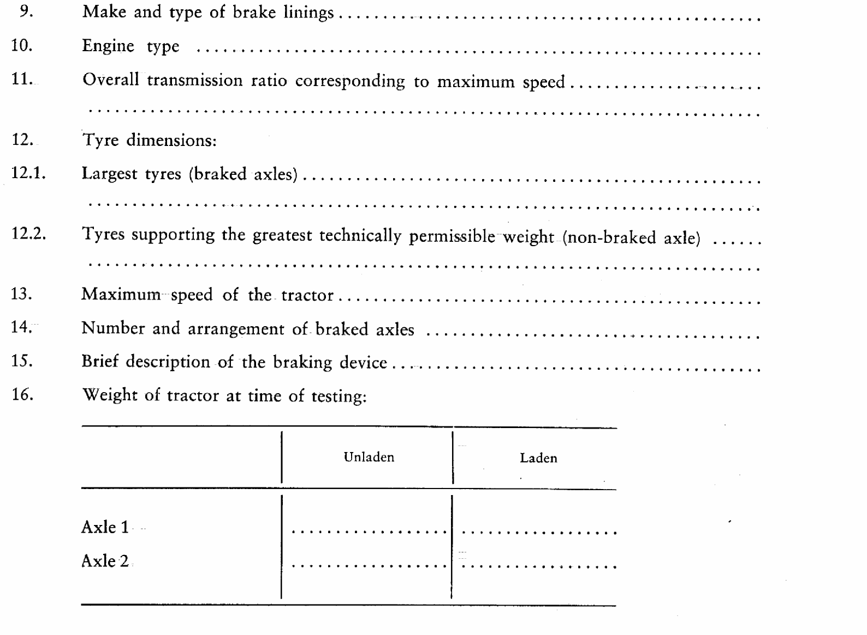
Ö mass Õ (non-braked axle)
Ö Mass Õ of tractor at time of testing:
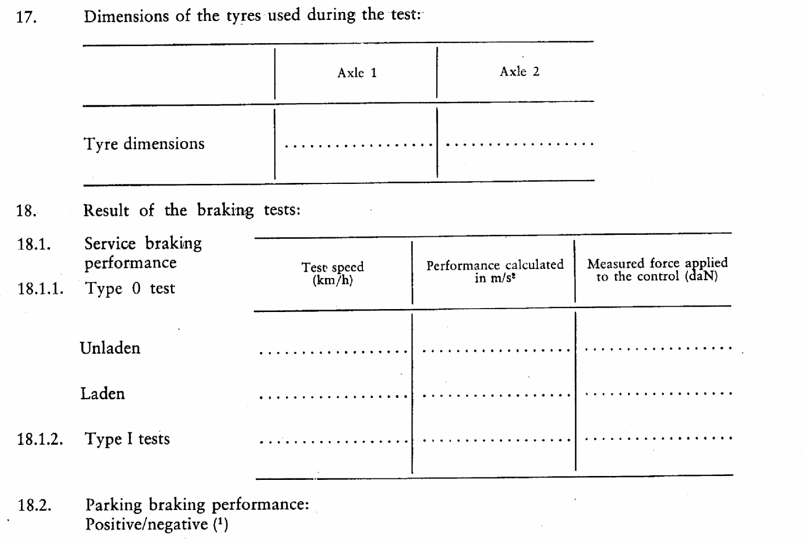
19. Tractor submitted for EC type-approval on ………………………………………………………
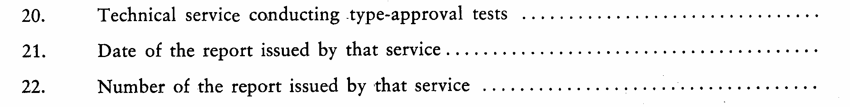
23. EC-type approval in respect of braking is granted/refused (¹).
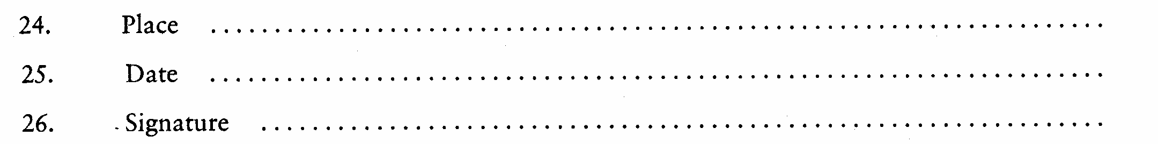
27. The documents referred to in points 2.2.1, 2.2.2 and 2.2.3 of Annex I are annexed hereto.
_______________

é
ANNEX VI
Part A
Repealed Directive with list of its successive amendments
(referred to in Article 7)
Council Directive 76/432/EEC
(OJ L 122, 8.5.1976, p. 1)
 | Council Directive 82/890/EEC  (OJ L 378, 31.12.1982, p. 45) |  | Only Article 1(1)
Commission Directive 96/63/EC
(OJ L 253, 5.10.1996, p. 13)
 | Directive 97/54/EC of the European Parliament and of the Council  (OJ L 277, 10.10.1997, p. 24) |  | Only as regards the reference to Directive 76/432/EEC in the first indent of Article 1
Part B
List of time-limits for transposition into national law and application
(referred to in Article 7)
Directive | Time-limit for transposition | Date of application
76/432/EEC | 1 January 1977 | 1 October 1977
82/890/EEC | 21 June 1984 | -
96/63/EC | 1 October 1997(*) | -
97/54/EC | 22 September 1998 | 23 September 1998
____________
(*) In accordance with Article 2 of Directive 96/63/EC:
‘1. With effect from 1 October 1997 Member States may not:
- refuse, in respect of a type of tractor, to grant EC type-approval, to issue the document referred to in the last indent of Article 10 (1) of Directive 74/150/EEC or to grant national type-approval, or
- prohibit the registration, sale or entry into service of tractors,
on grounds relating to braking devices, if the tractors comply with the requirements of Directive 76/432/EEC as amended by this Directive.
2. With effect from 1 March 1998 Member States:
- shall no longer grant EC type-approval or issue the document referred to in the last indent of Article 10 (1) of Directive 74/150/EEC, and
- may refuse to grant national type-approval
for a type of tractor on grounds relating to braking devices, if the requirements of Directive 76/432/EEC as amended by this Directive are not complied with.’
_____________
ANNEX VII

Correlation Table
Directive 76/432/EEC | Directive 96/63/EC | This Directive
Article 1 |  | Article 1
Article 2 |  | -
- | Article 2(1), introductory wording | Article 2(1), introductory wording
- | Article 2(1), first indent | Article 2(1)(a)
- | Article 2(1), second indent | Article 2(1)(b)
- | Article 2(1), final wording | Article 2(1), introductory wording
- | Article 2(2), introductory wording | Article 2(2)
 | Article 2(2), first indent | -
 | Article 2(2), second indent | Article 2(2)
 | Article 2(2), final wording | Article 2(2)
Article 3 |  | Article 3
Article 4 |  | Article 4
Article 5 |  | Article 5
Article 6(1) |  | -
Article 6(2) |  | Article 6
- |  | Article 7
- |  | Article 8
Article 7 |  | Article 9
Annexes I to V |  | Annexes I to V
- |  | Annex VI
- |  | Annex VII
_________________

COM(87) 868 PV.
See Annex 3 to Part A of the Conclusions.
Carried out pursuant to the Communication from the Commission to the European Parliament and the Council – Codification of the Acquis communautaire, COM(2001) 645 final.
See Annex VI, Part A of this proposal.
OJ C […], […], p. […].
OJ L 122, 8.5.1976, p. 1.
See Annex VI, Part A.
OJ L 171, 9.7.2003, p. 1.

