EN
EUROPEAN COMMISSION
Bruxelles, le 16.12.2010
COM(2010) 744 final
Annex 1

Annex 1
to the
Communication from the Commission to the European Parliament, the Council, the European Economic and Social Committee and the Committee of Regions 'Towards interoperability for European public services'

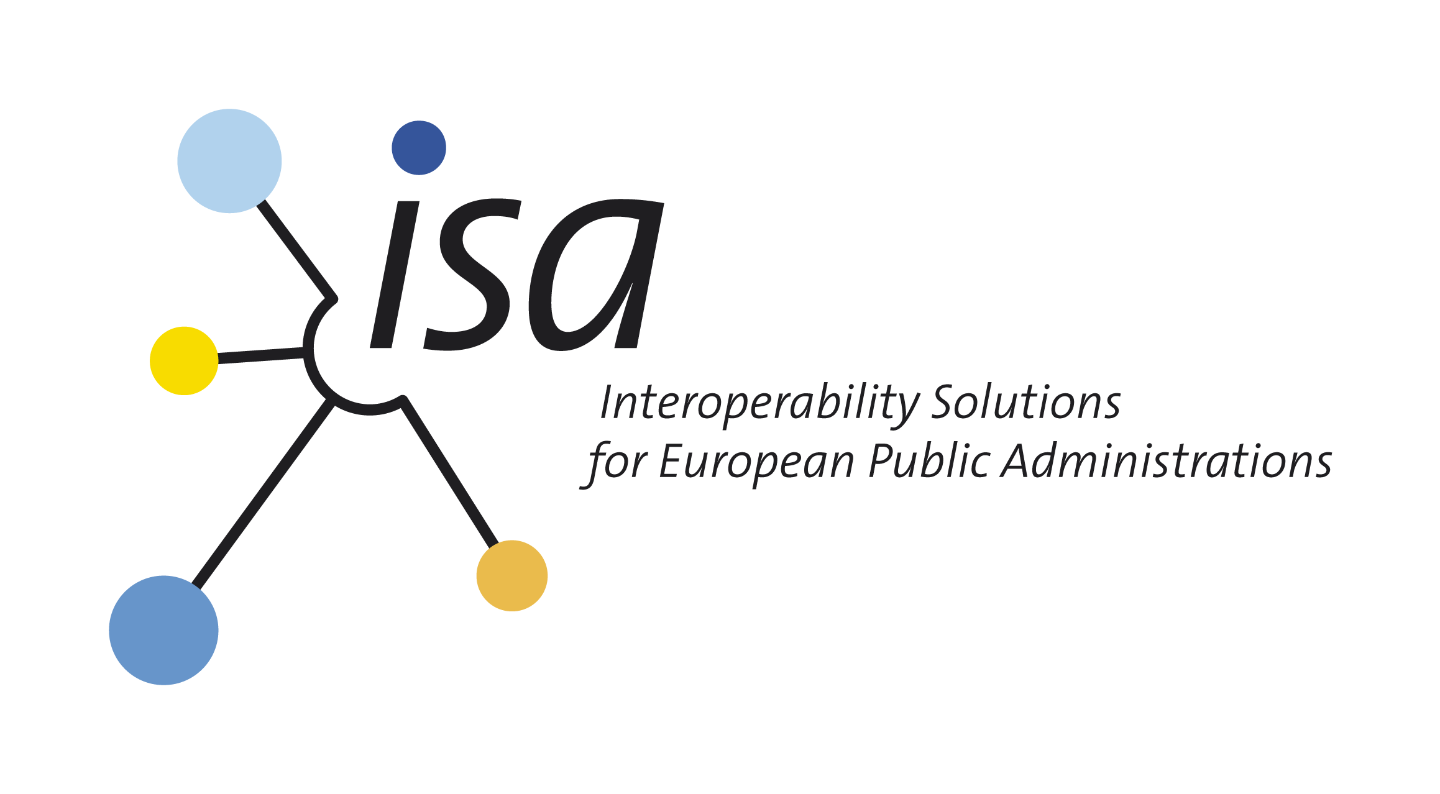

European Interoperability Strategy (EIS)
for
European public services

Introduction and BACKGROUND
- This document provides an overview of the European Interoperability Strategy (EIS) developed by the European Commission’s Directorate-General for Informatics. The EIS aims to provide guidance and to prioritise the actions needed to improve interaction, exchange and cooperation among European public administrations across borders and across sectors for the delivery of European public services. The strategy was prepared during the IDABC programme and finalised after a public consultation under the ISA programme which maintains it.
- The goal of this document is to:
- provide a brief overview of the approach and method used for preparing the EIS to reflect Member States’ priorities;
- present the recommendations made on the basis of the two reports issued during the preparation of the EIS:
  - the final report on the first phase, issued in May 2009 and presented at the meeting of Member State Chief Information Officers (CIOs) on 26 June 2009, which summarised the conclusions reached at the end of this first phase: a common vision, problem statements, focus areas, priorities and objectives for interoperability, and a possible method for developing scenarios during the second phase of the project;
  - the final report on the second phase, issued in May 2010, which focused on the EIS itself and presented the different levels of the EIS (global, cluster and focus area levels) along with a set of actions derived from an assessment of scenarios, which, together, form the basis of the future strategy;
- present the overall strategic approach proposed by the Commission for the EIS and agreed by the Member State CIOs.
- Interoperability between public administrations is crucial for achieving European integration and concerns core aims of the European Union. Member States and end-users have a great interest in overcoming barriers to easy delivery of public services across borders and sectors. While end-users are the final recipients of these services, the prime partners for the EIS are the European public administrations. Increased cooperation and commitment on the part of these key players are therefore essential for the development of the EIS.

- Interoperability issues are not only technological, but also cover a wide range of aspects, such as: lack of a cross-border and cross-sector legal basis for interoperability, insufficient awareness and political will, or lack of agreement on the governance structures required.

- Without a comprehensive approach to interoperability, there is a risk that Member States might opt for mutually incompatible solutions that, rather than boosting efficiency and savings, will only build new barriers to the delivery of European public services in the internal market.

- In order to overcome these challenges, in June 2008 during their second annual meeting the Member State CIOs and European Commission representatives agreed that a European Interoperability Strategy would be developed under the IDABC programme to address the drive needed to improve interoperability for European public services.

- Once fully adopted, the EIS will become the key driving force for the EU’s new ISA programme from 2010 to 2015 and possibly other EU initiatives. The EIS will also have an impact on interoperability activities undertaken by the Member States.

- The final report on the first phase (see point 2) presented the vision statement approved by the Member State CIOs. This reads as follows:

‘In 2015, interoperability has significantly fostered European public service delivery through:
- appropriate governance organisation and processes in line with European Union policies and objectives;
- trusted information exchange enabled by commonly agreed, cohesive and coordinated interoperability initiatives, including completion of the legal environment, development of interoperability frameworks, and agreements on interoperability standards and rules.’

- Following the third meeting of the Member State CIOs in June 2009, this vision was refined into a set of objectives for nine focus areas. Based on a Commission proposal, it was decided to group the nine focus areas under three different clusters — Trusted Information Exchange, Interoperability Architecture and Assessment of the ICT Implications of new EU Legislation — and two accompanying measures — Raising Interoperability Awareness and Sharing Best Practices.

- The final report on the second phase (see point 2) proposed for each cluster and each accompanying measure an action plan in the form of a set of scenarios or concrete actions.

- The Commission produced a synthesis focusing on the main strategic directions in order to steer the cluster activities and the accompanying measures. Based on this synthesis, the Commission proposed an overall strategic approach for the EIS together with specific strategic directions at cluster and accompanying measure level.

- The Commission proposed to combine top-down and bottom-up approaches, with the aim of generating cross-fertilisation by testing and continuously improving existing frameworks and guidelines against concrete needs and by developing additional services and tools based on clearly defined needs.

- At their fourth meeting, in November 2009, the Member State CIOs expressed their agreement with the approach and method adopted for the second phase of the EIS project and with the Commission's proposal.

- The Commission’s proposal and the conclusions reached at the fourth meeting of the CIOs constitute the overall strategic approach on which the ISA programme — and possibly other EU initiatives — will base its work programme for the coming years.

EIS overall strategic APPROACH
The Commission proposes to combine two approaches to drive European interoperability activities within the three clusters and the two accompanying measures mentioned above:
  - Top-down (or global) approach:
        - The political context and its evolution are taken into account: the Europe 2020 strategy and the Digital Agenda for Europe.
        - Development of various frameworks such as the EIS, the European Interoperability Framework (EIF), architecture guidelines and other methods and guidelines.
        - Assessment of the ICT implications of new EU legislation proposed.
  - Bottom-up (or sectoral) approach:
        - Working via sectoral projects on relevant specific topics (e.g. semantics, trust and privacy or architecture) providing an opportunity to tackle real interoperability challenges. This approach will allow existing frameworks and guidelines to be tested against concrete needs and will furthermore ensure that new services and tools are developed based on clearly defined needs.
        - When developing new services and tools in a specific sector, the potential for reusing such solutions in other sectors should be kept in mind.
After applying those combined approaches to the objectives under each cluster, the Commission proposes to focus on the following activities:

  - For the cluster ‘Trusted Information Exchange’:
        - To work via a limited number of politically relevant and concrete sectoral projects at EU and Member State levels;
        - To continue supporting, at EU level, efforts towards the interoperability of key enablers such as eID, eSignature, etc.;
        - To continue the SEMIC approach and its methodology;
        - To work towards opening up base registers, taking into account associated best practices, the possible related risks and opportunities, as well as the various needs and expectations of the main stakeholders.
        - To work towards the establishment of a federated catalogue of services offered by public administrations in the EU.
Some challenges identified for this cluster are:
Firstly, how to involve industry, standardisation organisations and other stakeholders in the activities?
Secondly, before taking any initiatives to develop a catalogue of services, the Commission proposes to assess the readiness of the Member States to be involved and the extent to which such a catalogue would support increased interoperability between Member States. Furthermore, existing cases of best practice in this area need to be identified and studied.

  - For the cluster ‘Interoperability Architecture’:
        - To develop a joint vision on interoperability architecture by first defining its scope and the needs for common infrastructure services and common interface standards;
        - To provide guidance on architecture domains where Member States share a common interest;
        - To ensure the systematic reuse of architectural building blocks by the Commission when developing services to be used by the Member States. Here, existing infrastructure service components (EIIS) along with generic applications (IMI, early alert systems, grant management, etc.) could be reused and rationalised. Additionally, a catalogue of architectural building blocks available for reuse by the Member States and the Commission could be set up with contributions from the EU and Member States.

  - For the cluster ‘Assessment of the ICT implications of new EU Legislation’:
        - To develop guidelines and methodologies at Commission and Member State level;
        - To test the usefulness of these guidelines by applying them to concrete cases involving policy-makers and legal and ICT experts;
        - To ensure continuous improvement of the guidelines and methodologies based on the lessons learned from experience;
        - To ensure general application of the practice of assessing ICT implications towards a more systematic approach whenever changes occur in legislation (e.g. amendments or additions to ICT-related legislation).

  - For the accompanying measure ‘Raising Interoperability Awareness’:
        - To develop an overall communication approach;
        - To organise communication campaigns, initially targeting decision-makers but then gradually shifting to more operational and technical levels;
        - To develop a self-assessment tool/model for public administrations to assess their interoperability maturity level.

  - For the accompanying measure ‘Sharing Best Practices’:
        - To work towards the convergence of existing EU collaborative platforms and to ensure the sustainability of the platforms used;
        - To maintain, where relevant, the existing communities at EU level around sharing best practices and reusing common solutions;
        - To support the creation of potential new communities resulting from other interoperability activities.
A challenge identified for this accompanying measure is: how to collaborate with similar initiatives elsewhere?
  - Potential risks and opportunities identified so far are:
- Stakeholders’ support, commitment and buy-in are essential when following a project-based approach to interoperability. In order to realise the EIS successfully, sectoral experts and interoperability experts will have to work together, at both EU and Member State level;
- Setting up fruitful collaboration with industry and other stakeholders;
- The effect of disruptive technologies (e.g. cloud computing, etc.) on the EIS and its implementation.

Next Steps
- The next challenge is to convert the EIS into a set of concrete projects and results. The projects will mostly constitute the ISA work programme.

- During establishment of the ISA work programme, various actions will be defined and initiated to implement the EIS. Project managers will be identified and objectives for individual actions will be drawn up to make significant progress towards the goals set for each interoperability cluster.

- Adequate project monitoring and reporting will support implementation of the interoperability initiatives, which will entail defining suitable metrics for each action, e.g. key performance indicators (KPIs). Monitoring and reporting will allow performance to be tracked against targets and actions to be assessed to see if they are on track to meet their objectives.

- A comprehensive portfolio management framework will be used to generate a common view and to produce a roadmap of every action under way or planned. Portfolio management will produce a multidimensional view of the project portfolio, in order to assess each action in the light of the EIS, and will clearly highlight which actions are adding value to the interoperability vision. Based on the overall picture, the relative cost of each action can be balanced against its potential to create value. For example, some actions might have high potential value but a prohibitive risk. Others might be redefined to modify their risk profiles.

- Adequate portfolio management will ensure the necessary tradeoffs between finite resources, risks, scopes and timing against expected outcomes as the environment changes (including political and other stakeholder priorities reflected in updated strategy objectives). Other key action related to project management governance will be communication with stakeholders on the project portfolio.

-------------------

Interoperability, for European public service delivery, is the ability of disparate and diverse organisations to interact towards mutually beneficial and agreed common goals, involving the sharing of information and knowledge between the organisations, through the business processes they support, by means of the exchange of data between their respective ICT systems.
A European public service means ‘a cross-border public sector service supplied by public administrations, either to one another or to European businesses and citizens’.
Interoperable delivery of pan-European eGovernment services to public administrations, businesses and citizens, adopted by the European Parliament and the Council on 21 April 2004.
Interoperability Solutions for European Public Administrations, adopted by the European Parliament and the Council on 16 September 2009.
EIIS stands for European Interoperability Infrastructure Services.
IMI stands for Internal Market Information system.

