EN
EUROPEAN COMMISSION
Brussels, 20.12.2010
COM(2010) 774 final
Annex A/Chapter 22

ANNEX A to the
Proposal for a
REGULATION OF THE EUROPEAN PARLIAMENT AND OF THE COUNCIL
on the European System of national and regional accounts in the European Union
ANNEX A
Chapter 22: Satellite accounts

Introduction
22.01 This chapter provides a general introduction to satellite accounts. It describes and discusses how the central framework can be used as a building-block-system to serve many important specific data needs.
22.02 Satellite accounts elaborate or modify the tables and accounts in the central framework to serve specific data needs.
22.03 The central framework consists of the following:
a) The integrated economic accounts (institutional sector accounts) providing an overview of all economic flows and stocks;
b) The input-output framework providing an overview of the supply and use of goods and services in current and constant prices;
c) Tables linking the industry information in the input-output framework with the institutional sector accounts;
d) Tables on expenditure by function of government, households and corporations;
e) Tables on population and employment.
These accounts and tables can be on an annual or quarterly basis, and be national or regional.
22.04 Satellite accounts can meet specific data needs by providing more detail, by rearranging concepts from the central framework or by providing supplementary information, such as non-monetary flows and stocks. They may deviate from the central concepts. Changing the concepts can improve the link with economic theoretic concepts such as welfare or transactions costs, administrative concepts such as taxable income or profits in the business accounts, and policy concepts such as strategic industries, the knowledge economy and business investments used in national or European economic policy. In such cases, the satellite system will contain a table showing the link between its major aggregates and those in the central framework
22.05 Satellite accounts can range from simple tables to an extended set of accounts. Satellite accounts can be compiled and published on an annual or quarterly basis. For other satellite accounts, production at more extended intervals such as once every five years is appropriate.
22.06 Satellite accounts can have various characteristics:
a) Links to functions, as in functional satellite accounts;
b) Links to industries or products, which is one type of special sector accounts);
c) Links to institutional sectors, a second type of special sector accounts;
d) Extension with physical or other non-monetary data;
e) Extra detail;
f) Use of supplementary concepts;
g) Modification of some basic concepts;
h) Use of modelling or inclusion of experimental results.
For a specific satellite account, one or more of the characteristics above can apply. This is illustrated in table 22.1.
Table 22.1 Overview of satellite accounts and their major characteristics
 | Eight characteristics of satellite accounts
 |  | Special sector accounts
 | Function-al accounts | Links to industries or products | Links to institut-ional sectors | Inclusion of non-monetary data | Extra detail | Supple-mentary concepts | Different basic concepts | Experimental results and more use of modelling | Part of EU transmission programme
1. Satellite accounts described in this chapter
Agricultural |  | X |  |  | X | X |  |  | X
Environmental | X | X |  | X | X | X | X | X | X
Health | X | X |  | X | X |  | X |  | X
Household ,production |  |  | X | X | X |  | X | X
Labour and SAM |  | X | X | X | X
Productivity and growth |  | X |  | X | X | X | X | X | X
R & D | X | X |  | X | X |  | X | X
Social protection | X |  |  | X | X |  |  |  | X
Tourism | X | X |  | X | X | X
2. Satellite accounts described in other chapters
Balance of payments |  |  | X |  | X |  |  |  | X
Government finance |  |  | X |  | X | X |  |  | X
Monetary and financial statistics, and flow of funds |  |  | X |  | X | X |  |  | X
Supplementary pension table |  |  | X |  | X | X | X | X | X
3. Examples of other satellite accounts with international guidelines, or in the EU data transmission programme
Corporate activity |  |  | X |  | X
Informal sector |  |  |  |  | X |  |  | X
Non-profit institutions |  |  | X |  | X |  |  | X
Public sector |  |  | X |  | X
Tax revenue tables |  |  | X |  | X |  |  |  | X
22.07 In this chapter, characteristics of satellite accounts will be discussed and the following nine different satellite accounts described briefly:
a) Agricultural accounts;
b) Environmental accounts;
c) Health accounts;
d) Household production accounts;
e) Labour accounts and social accounting matrices;
f) Productivity and growth accounts;
g) R&D accounts;
h) Social protection accounts;
i) Tourism accounts.
Other chapters hold descriptions of other satellite accounts such as balance of payments, government finance statistics, monetary and financial statistics and the supplementary pension table.
In the SNA 2008, several satellite accounts are described at length which are covered to a limited extent in ESA 2010. Examples are as follows:
a) SNA 2008 Chapter 21 Corporate activity accounts;
b) SNA 2008 Chapter 22 Public sector accounts;
c) SNA 2008 Chapter 23 Non-profit institutions accounts; and
d) SNA 2008 Chapter 25 Informal Sector Accounts.
For international comparison of the level and composition of taxes, national tax revenue statistics are reported to the OECD, IMF and Eurostat. The concepts and data are fully linked to those in the national accounts. Tax revenue statistics is an example of a national accounts’ satellite.
These examples are of well-established satellite accounts, as they are subject to international guidelines or are already part of an international transmission programme. Satellite accounts developed in various countries illustrate the importance and usefulness of satellite accounts, and examples are:
a) Cultural and creative sector accounts, illustrating the economic importance of the culture and creative sectors;
b) Education accounts, showing the economic importance of the supply, use and financing of education;
c) Energy accounts, showing the economic importance of the various types of energy and their link to imports, exports and government taxes and subsidies;
d) Fishery and forestry accounts, showing their economic importance for the nation and regions;
e) Information and communication technology (ICT) accounts, showing the supply and use of major ICT products and their producers;
f) Redistribution by public expenditure account, showing which income groups benefit from public expenditure on education, health care, culture and housing;
g) Residential building accounts, showing the economic importance of residential building for the nation and regions;
h) Safety accounts, showing public and private expenditure on safety;
i) Sport accounts, showing the economic importance of sports;
j) Water accounts, showing the interaction between the physical water system and the economy at national and river basin level.
22.08 A major group of satellite accounts have a functional approach. The various functional classifications are described in this chapter.
22.09 The wide range of satellite accounts illustrates that the national accounts serve as a frame of reference for a variety of statistics. They also illustrate the merits and limitations of the central framework. By applying the concepts, classifications and presentations such as the supply and use tables of the central framework to a wide range of topics, the flexibility and relevance of the satellite accounts approach for these topics is demonstrated. At the same time, additions, rearrangements and conceptual modifications illustrate the limitations of the central framework for the study of these topics. For example, the environmental accounts extend the central framework to take account of environmental externalities and the household production accounts extend the production boundary to include unpaid household services. In this way, they demonstrate that the central framework’s concepts of product, income and consumption are not complete measures of welfare.
22.10 Major advantages of satellite accounts include the following:
a) Based on a set of clear definitions;
b) Application of a systematic accounting approach. Examples are the breakdown of one total into various dimensions, for example the supply and use of goods and services by product and by industry; who produces, who pays and who benefits from a service; systematic stock-flow accounting; and consistent accounting in monetary and non-monetary terms. The accounting approach features consistency and coherence. It also enables bookkeeping analyses based on decomposition, where change in the total is explained in terms of changes in the parts, change in the value is explained by changes in volume and price, and changes in stocks are accounted for by the corresponding flows and constant ratios used in input-output analysis. These bookkeeping analyses can be supplemented with modelling in which economic behaviour is taken into account.
c) Linkage to the basic national accounting concepts. Examples are the concepts of specific stocks and flows like production, compensation of employees, taxes, social benefits and capital formation, the concepts in the classifications by industry and by institutional sector such as the industries agriculture and manufacturing or the sector government, and major balancing items such as value added, domestic product, disposable income and net worth. These basic national accounting concepts are well-established throughout the world, stable over time and whose measurement is relatively immune to political pressure.
d) Linkage to national accounts statistics: these are readily available, comparable over time, compiled to common international standards, and place the satellite accounts measures in the context of the national economy and its major components, such as the relationship with economic growth and public finance.

Functional classifications
22.11 Functional classifications classify expenditure by sector, and by the purpose of the expenditure. They illustrate the behaviour of consumers, government, non-profit institutions and producers.
22.12 The four different functional classifications that exist in the ESA are as follows:
a) Classification of Individual Consumption by Purpose (COICOP);
b) Classification of the Functions of Government (COFOG);
c) Classification of the Purposes of Non-Profit Institutions (COPNI);
d) Classification of Outlays of Producers by Purpose (COPP).
22.13 In COICOP 14 main categories are distinguished:
1 Food and non-alcoholic beverages;
2 Alcoholic beverages, tobacco and narcotics;
3 Clothing and footwear;
4 Housing, water, electricity, gas and other fuels;
5 Furnishings, household equipment and routine household maintenance;
6 Health;
7 Transport;
8 Communication;
9 Recreation and culture;
10 Education;
11 Restaurants and hotels;
12 Miscellaneous goods and services.
13 Individual consumption expenditure of non-profit institutions serving households; and
14 Individual consumption expenditure of general government.
The first 12 categories sum to total individual consumption expenditure by households. The last two identify individual consumption expenditure by the sectors non-profit institutions serving households (NPISHs) and general government, i.e. their social transfers in kind. Together all 14 items represent actual final consumption by households.
22.14 The individual consumption expenditure of NPISHs and general government is broken down into five common sub-categories reflecting major policy issues: housing, health, recreation and culture, education and social protection. These are also COICOP functions for the individual consumption expenditure by households; social protection is a sub-category of 12 Miscellaneous goods and services. As a consequence, COICOP also shows for each of these five common sub-categories, the role of private households, government and non-profit institutions serving households. For example, it can reveal the role of government in providing housing, health and education.
22.15 COICOP also serves other major uses such as using the sub-categories to show expenditure by households on consumer durables. Household budget surveys frequently use a classification scheme based on COICOP to collect household expenditure information. This can then be allocated to products for a supply and use table.
22.16 The classification of government expenditure by function (COFOG) is a major tool for describing and analysing government finance. The ten major categories distinguished are:
1 General public services;
2 Defence;
3 Public order and safety;
4 Economic affairs;
5 Environmental protection;
6 Housing and community amenities;
7 Health;
8 Recreation, culture and religion;
9 Education; and
10 Social protection.
The classification can be used to classify individual and collective consumption expenditure by the government. However, it also serves to illustrate the role of other types of expenditure such as subsidies, investment grants and social assistance in cash, for pursuing policy purposes.
22.17 For describing and analysing the expenditure of private non-profit institutions serving households, COPNI is used. The nine major categories distinguished are:
1 Housing;
2 Health;
3 Recreation and culture;
4 Education;
5 Social protection;
6 Religion;
7 Political parties, labour and professional organisations;
8 Environmental protection; and
9 Services n.e.c.
22.18 For describing and analysing the behaviour of producers, COPP can be used. Six main categories are distinguished:
1 Outlays on infrastructure;
2 Outlays on Research and Development;
3 Outlays on environmental protection;
4 Outlays on marketing;
5 Outlays on human resource development;
6 Outlays on current production programmes, administration and management.
In combination with information by transaction, COPP can provide information on the “out-sourcing” of business services, i.e. the substitution of ancillary activities by purchases of corresponding services from other producers such as cleaning, catering, transport and research.
22.19 COFOG and COPP show expenditure on environmental protection by the government and producers. This information is used to describe and analysie the interaction between economic growth and environment.
22.20 Some expenditure, like final consumption expenditure and intermediate consumption, can be classified by function and by product group. The product classification shows which products are involved and gives a description of the different production processes and their links with the supply and use of products. This contrasts with the functional classifications as follows:
a) Expenditure on different products can serve one function;
b) Expenditure on one product can serve different functions;
c) Some expenditure are not transactions in products, but can be very important for a functional classification, e.g. subsidies and social security benefits in cash for the classification of expenditure by general government.

MAJOR CHARACTERISTICS OF SATELLITE ACCOUNTS

Functional satellite accounts
22.21 Functional satellite accounts focus on describing and analysing the economy for a function, such as environment, health, and research and development. For each function they provide a systematic accounting framework. They do not provide an overview of the national economy, but focus on what is relevant for the function. To that end, they show detail not visible in the aggregated central framework, rearrange information, add information on non-monetary flows and stocks, ignore what is irrelevant for the chosen function and define functional aggregates as the key concepts.
22.22 The central framework is mainly institutional in nature. A functional satellite account can combine a functional approach with an activity and product analysis. Such a combined approach is useful for many fields, such as culture, sport, education, health, social protection, tourism, environmental protection, research and development (R&D), development aid, transportation, safety and housing. Most of these fields refer to services; they generally spread over a number of activities and they correspond in many cases to subjects that are related to questions of economic growth or of social concern.
22.23 A key concept in functional satellite accounts is national expenditure on the function as shown in Table 22.2. This key concept is also useful in defining the coverage of the functional satellite account.
22.24 To analyse the uses for a function amounts to asking questions such as “How many resources are devoted to education, transportation, tourism, environmental protection, and data processing?” In order to answer such questions, decisions have to be made on:
a) Which products are relevant for this field. National expenditure includes all the current uses of these products and capital formation in these products.
b) For which activities will capital be recorded;
c) Which transfers are relevant for this field.
Table 22.2 National expenditure on a function or product
Annual data series
Actual final consumption of the products chosen
Market products
Non-market products
Individual
Collective
Intermediate consumption
Actual
Internal
Capital formation
in the chosen products
other
Chosen current transfers
Chosen capital transfers
Uses of resident units financed by the rest of the world
National expenditure
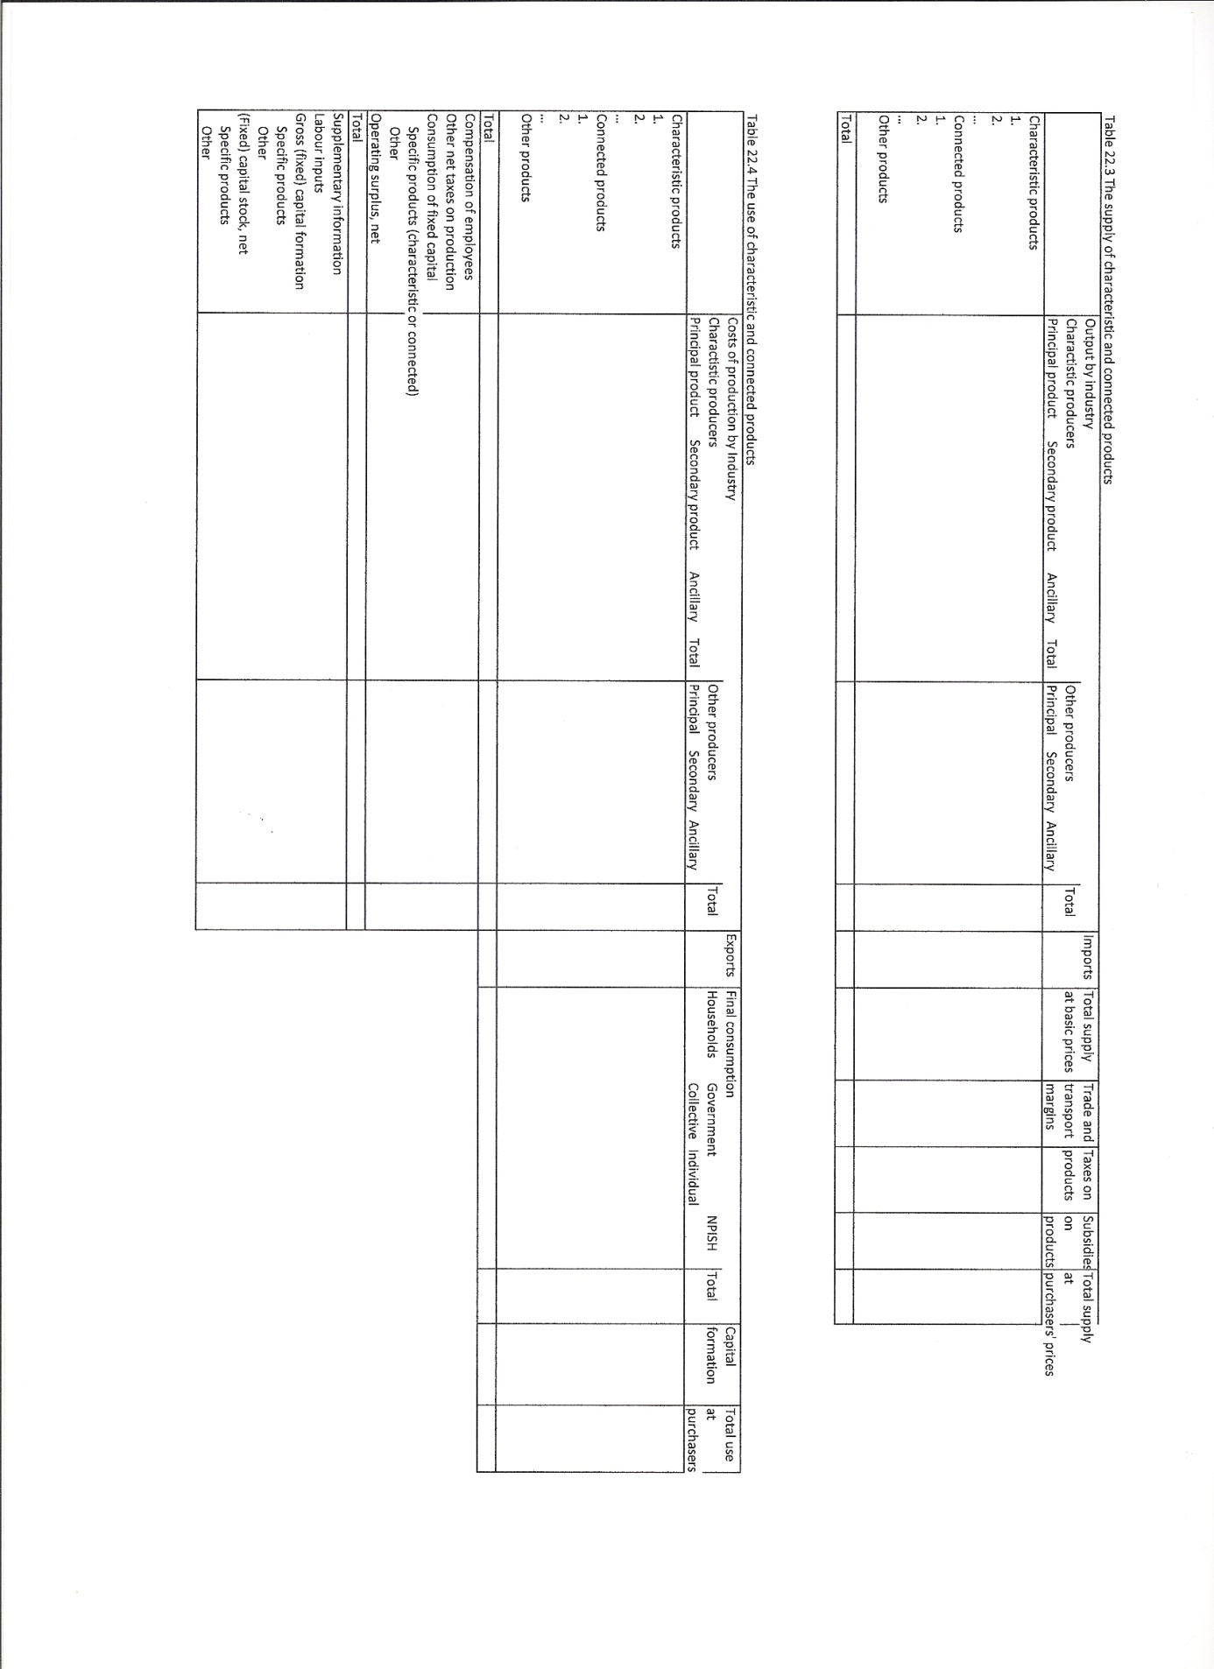
22.25 Depending on the field, the design of a satellite account will emphasise the following:
a) The detailed analyses of the production and uses of the specific goods and services, such as R&D, ICT or transport;
b) The detailed analysis of transfers, such as for social protection;
c) Production, uses and transfers equally, such as for education and health;
d) Uses as such, in areas such as tourism and environmental protection.
e) The financing of social protection and health by government and non-profit-institutions.
22.26 Two types of products can be distinguished: characteristic products and connected products. The first category covers the products which are typical for the field under study. For such products, the satellite account can show how these products are produced, what kinds of producers are involved, what kinds of labour and fixed capital they use and the efficiency of the production process. For example, for health, characteristic products are health services, public administration services, education and R&D services in health.
22.27 Connected products are relevant for a function without being typical, either by nature or because they are classified in broader categories of products. For example, for health, transport of patients is a connected service. Other examples of connected products are pharmaceutical products and other medical goods, like glasses. For these products, the satellite account does not show the features of production. The precise borderline between characteristic and connected products depends on the economic organisation in a country and the purpose of a satellite account.
22.28 Some services may appear in two or more satellite accounts. For example, research in health services in higher education institutions is a product relevant for satellite accounts on Research and Development, as well as education and health. This also implies that the national expenditure on various functions may partly overlap; simple aggregation of these expenditure to arrive at a total as a percentage of GDP may involve double-counting.
22.29 The concepts in the satellite account may deviate from those in the central framework. For example, voluntary work may be included in satellite accounts on education and health. For a satellite account on transport, the ancillary transport services can be shown separately. For a satellite account on development aid, the loans which are given at preferential conditions are accounted for. Benefits or costs resulting from rates of interest lower than the market ones are recorded as implicit transfers.
22.30 For satellite accounts on social protection and development aid, specific transfers are the most important components of national expenditure. In other fields, such as education and health, the major part of the transfers, most of which are in kind, are a means of financing the acquisition by users. This implies that they are already included in expenditure on final consumption, intermediate consumption and capital formation and should not be recorded twice. However, this does not apply to all the transfers, e.g. student grants may serve to finance various outlays in addition to tuition fees or school books; this residual part should then be recorded as a transfer in the satellite account.
22.31 The functional satellite account can provide an overview of the users or beneficiaries. The classification of users and beneficiaries can be based on the classification of institutional sectors and types of producers, e.g. market producers, non-market producers, government as a collective consumer, households as consumers and rest of the world. Various sub-categories may be distinguished, e.g. by industry and by institutional subsector.
22.32 In many satellite accounts, households or individuals are the most important type of users and beneficiaries. In order to be useful for social policy and analysis, a further breakdown of households is necessary. Various criteria may be used according to different purposes, such as income, age, gender, location, etc. For policy and analysis, knowledge of the number of people concerned in each category is needed in order to calculate the average consumption or transfer, or the number of people who do not benefit.

Special sector accounts
22.33 Special sector accounts provide an overview focused on one industry or product, a regrouping of various industries or products, one subsector or a regrouping of various subsectors. Three types of special sector accounts can be distinguished:
a) Those linked to industries or products;
b) Those linked to institutional sectors;
c) Those combining both approaches.
Examples of special sector accounts linked to industries or products are agricultural accounts, forestry and fishery accounts, tourism accounts, ICT accounts, energy accounts, transport accounts, residential building accounts and accounts for the creative sector.
Examples of special sector accounts linked to institutional sectors are government finance statistics, monetary and financial statistics, balance of payments, public sector accounts, accounts for non-profit institutions, household accounts and accounts on corporate activity. Tax revenue statistics can be regarded as supplementary tables to government finance statistics.
22.34 The special sector accounts can also focus on an integrated analysis of economic activities within one or more institutional sectors. For example, accounts for subsectors of non-financial corporations may be established by grouping according to their principal economic activity. The analysis may cover the full economic process, from production to accumulation. This can be done systematically at a fairly aggregated level of the standard industry classification. It can also be carried out for selected industries of special interest to a country. Similar analyses can be made for household production activities, at least up to the point where entrepreneurial income is calculated. It can also be useful to emphasise activities that play a predominant role in the economy’s external transactions. These key activities may include the petroleum sector, banking, mining activities, activities linked to specific crops, food products and beverages such as coffee, flowers, wine and whiskey, and tourism. They can play a vital role in the national economy, by accounting for an important part of exports, employment, foreign exchange assets and government resources. Key sectors may also include sectors that deserve special attention from the point of view of social economic policy. Examples of this are agricultural activities receiving subsidies and other transfers from central, local or European government, or that are protected by substantial import duties.
22.35 The first step in drawing up special sector accounts is defining the key activities and their corresponding products. For this, items of the International Standard Industrial Classification (ISIC) or the corresponding national classification may need to be grouped together. The extension of the key sector depends on the economic circumstances and the requirements for policy and analysis.
22.36 A goods and services account for the key products is established showing the resources and uses of these products. A production account and a generation of income account for the key industries are built up. For the key industries and products, detailed classifications are used for a full understanding of the economic process and the related valuation procedures in this field. There generally exists a combination of market and administered prices, and a complex system of taxes and subsidies.
22.37 The key products and key industries may be analysed in the context of a supply and use table, as shown in tables 22.5 and 22.6. Key industries are shown in detail in columns, and other industries may be aggregated. In the rows, key products are similarly shown in detail, and other products aggregated. At the bottom of the use table, rows show labour inputs, gross fixed capital formation and stocks of fixed assets. When the key activity is carried out by very heterogeneous types of producers, such as small farmers and big plantations owned and operated by corporations, the two groups of producers are distinguished, as they have different cost structures and behave differently.
22.38 A set of accounts is compiled for the key sector. To this end, the key sector has to be delimited. In the case of oil and mining activities, the key sector generally consists of a limited number of big corporations. All transactions of the latter are covered, even when they carry out secondary activities. The distinction between public, foreign controlled and private corporations can also be fundamental when dealing with a key sector. The business accounts themselves have to be carefully studied for each big corporation involved to carry out an integrated analysis. Part of mining activities may be carried out by small corporations or unincorporated enterprises. These units must be included in the key sector, even if it is necessary to rely on partial information coming from statistical surveys or administrative data.
22.39 In many cases, government plays an important role in connection with key activities, either via taxes and property income receipts, or via regulatory activity and subsidies. Accordingly, the detailed study of transactions between the key sector and general government is important. The classification of transactions may be extended to identify those flows connected with the key activity, including the relevant taxes on products. These flows are received, in addition to the general budget itself, by various government agencies, such as ministries for special purposes, universities, funds and special accounts. For analysis, it can be very useful to indicate what uses are made by the government of these funds. This calls for an analysis by purpose of this part of government expenditure.
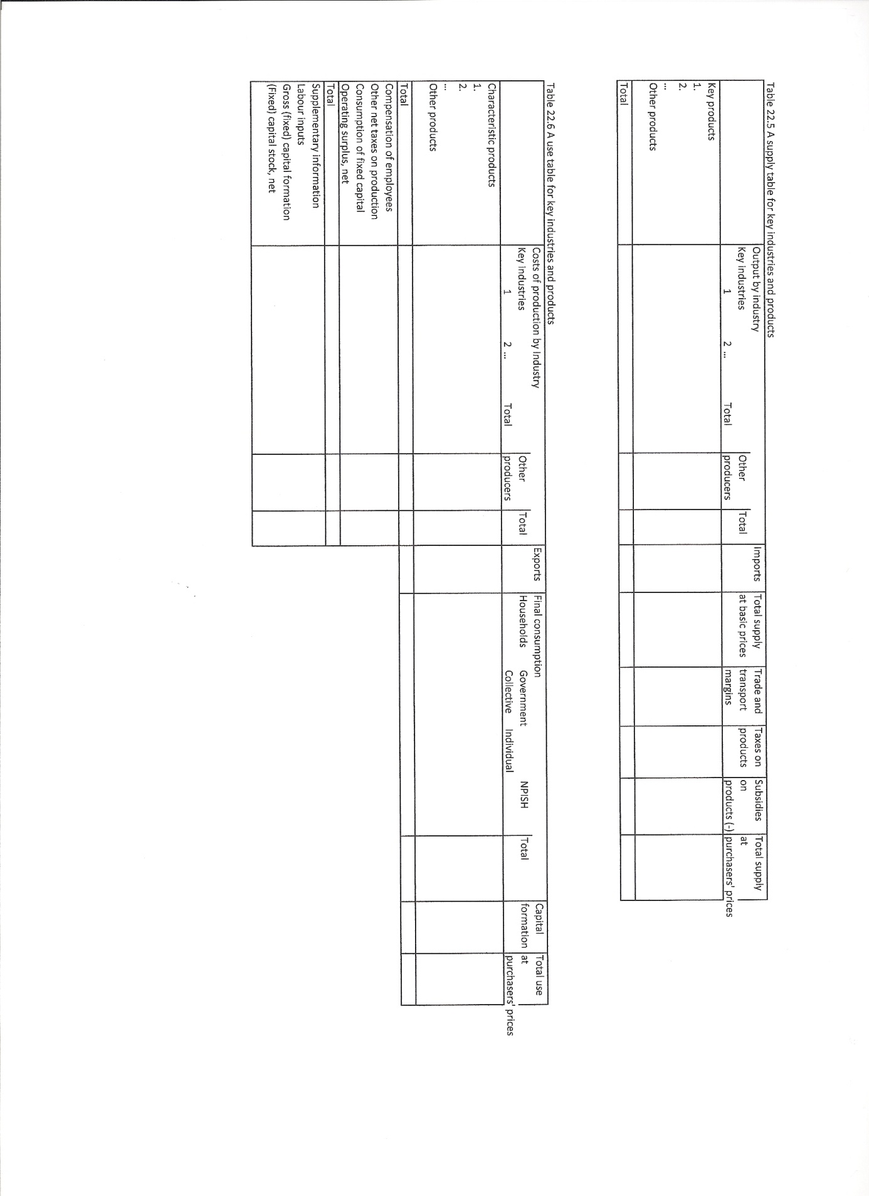
22.40 When the key activities are based on natural non-renewable resources such as subsoil resources, the key sector accounts record the changes in these resources through new discoveries and depletion, in the other changes in volume of assets account and holding gains and losses on them in the revaluation account. These data are crucial for assessing the economic performance of the economy. More broadly, the key sector accounts may be extended to environmental accounting.
22.41 The key sector accounts can be presented in the framework of integrated economic accounts. A column or group of columns is introduced for key sectors and other columns are renamed where relevant, such as “other non-financial corporations” or “other households”. This makes it possible to see the respective shares of the key sector and other sectors in transactions and balancing items. The precise format of such a tables depends on the objectives pursued. One more step may consist in showing in additional tables the “from whom to whom” relationship between the key sector and other sectors, including the rest of the world.

Inclusion of non-monetary data
22.42 A major characteristic of many satellite accounts is the inclusion of non-monetary data, such as data on CO₂ emission by industry in the environmental accounts or number of treatments by type of health care in the health accounts. The linkage of such non-monetary data with monetary data can provide key ratios, such as CO₂ emission per billions of euro of value added or the costs per treatment. Table 22.7 provides a wide range of examples.

Extra detail and supplementary concepts
22.43 Two other major characteristics of satellite accounts are extra detail and supplementary concepts. A wide range of examples are provided in tables 22.8 and 22.9.
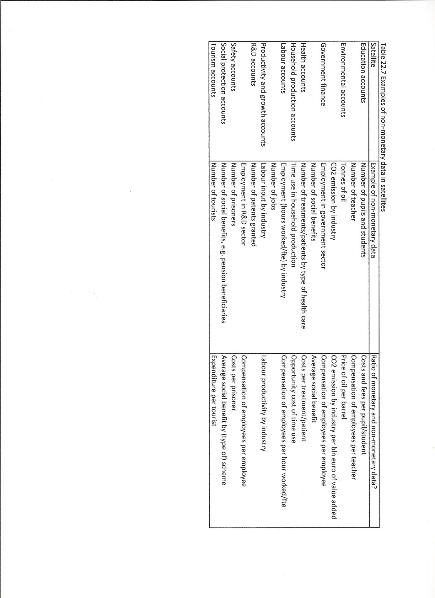
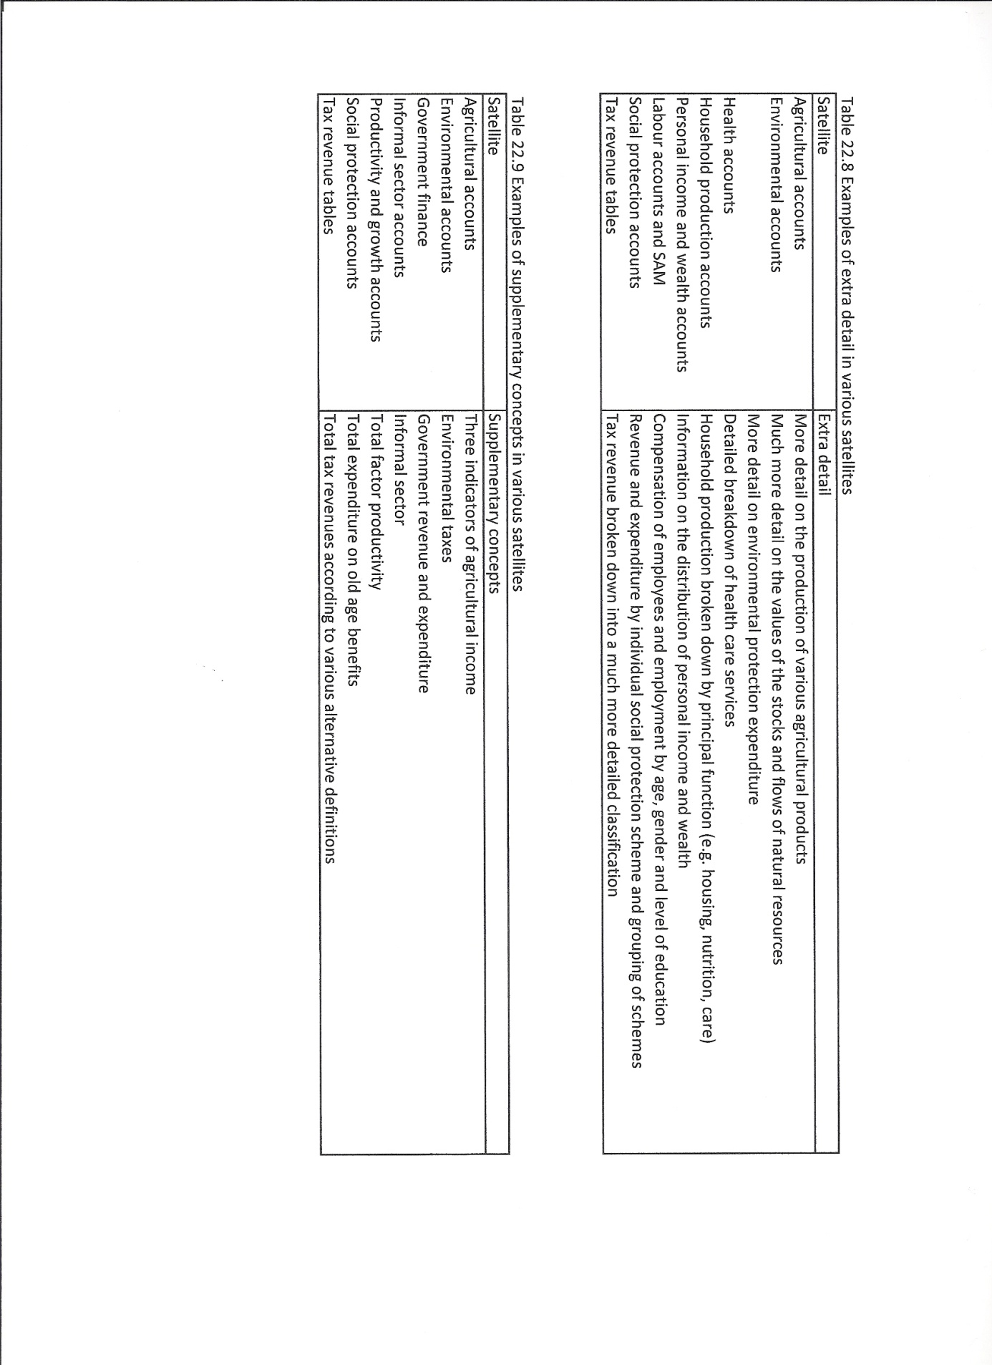

Different basic concepts
22.44 The use of different basic concepts is not common in satellite accounts. A relatively minor variation is that for various satellite accounts some services are not treated as ancillary, e.g. for a transport satellite account, transport service is not treated as ancillary. However, for some satellite accounts, major changes in the basic concepts can be required, e.g. in the environmental account domestic product could be adjusted for depletion of natural resources. Examples are provided in table 22.10.

Use of modelling and inclusion of experimental results
22.45 Some satellite accounts may be characterised by the inclusion of experimental results or the use of modelling; the figures in the satellite account are less reliable than those in the core accounts. However, compiling the core accounts also involves the use econometric or mathematical models and the inclusion of experimental results. This is therefore not a fundamental difference between the core accounts framework and satellite accounts. These issues are illustrated by the examples in table 22.11.
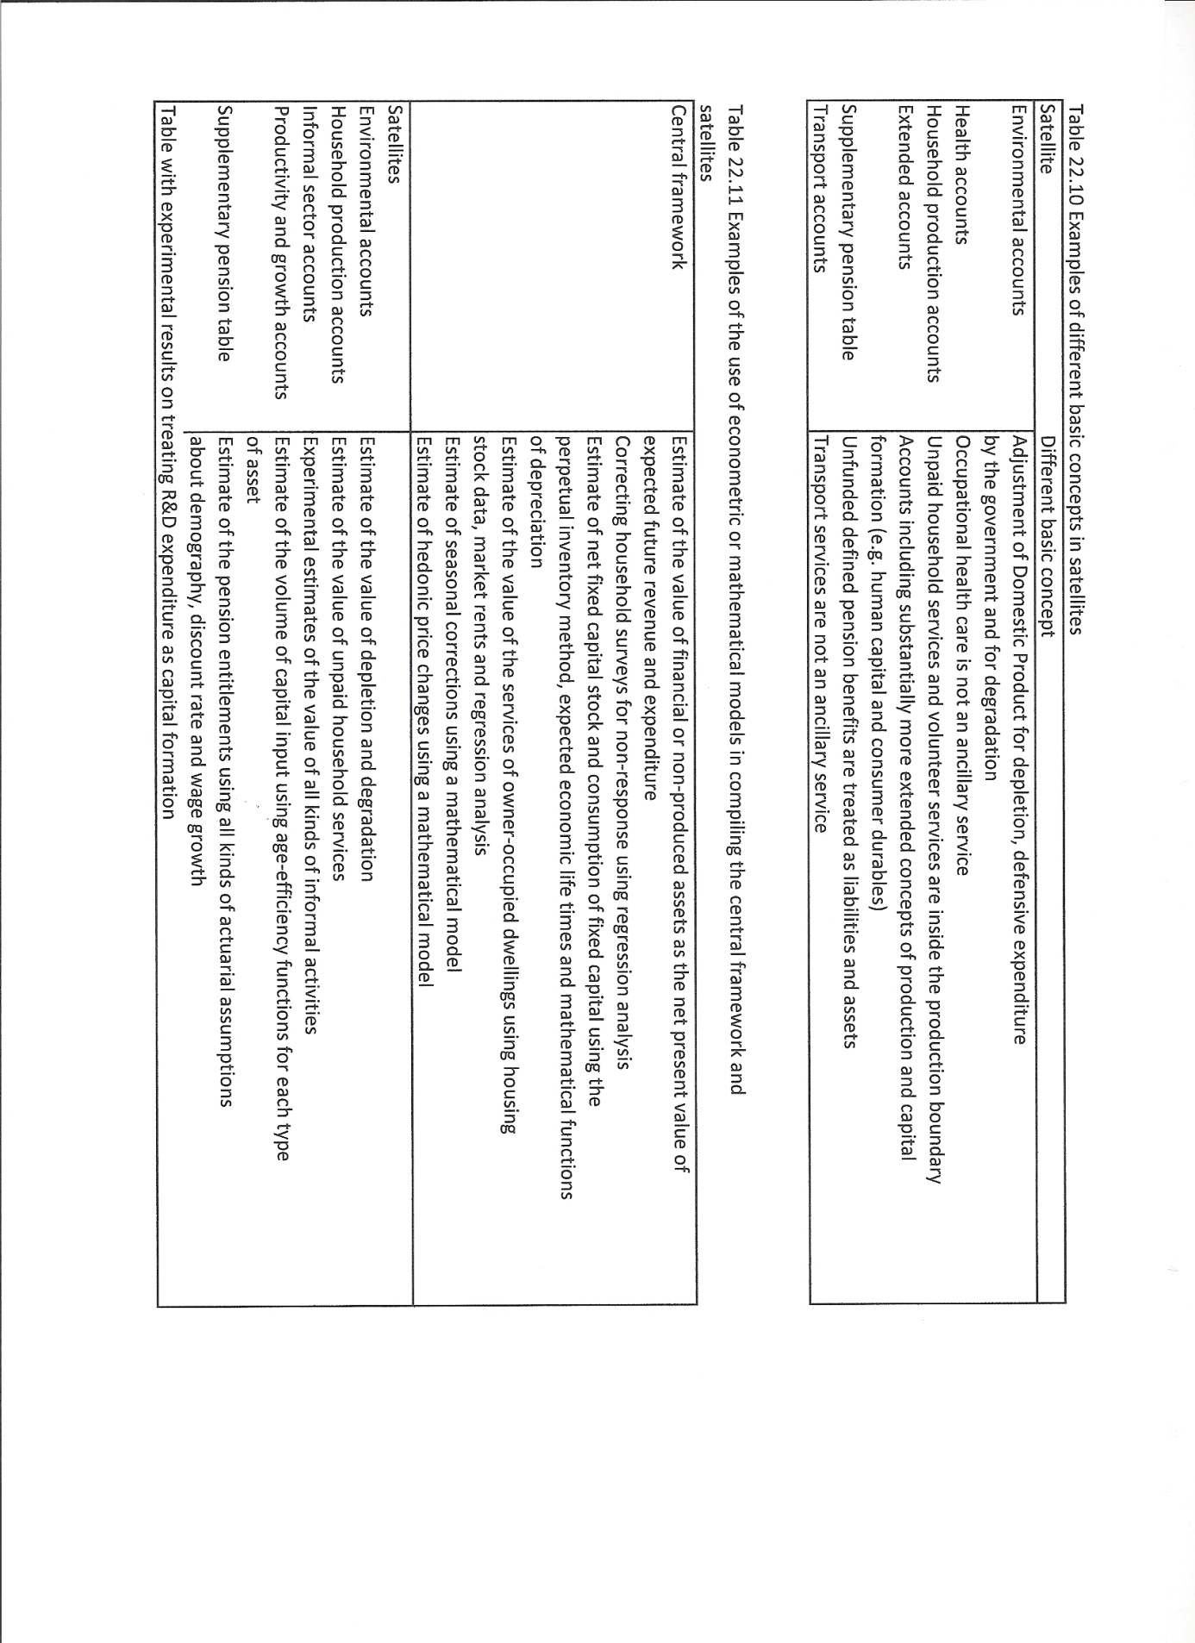

Designing and compiling satellite accounts
22.46 Designing and compiling a satellite account consists of four steps:
a) Define the purposes, uses and requirements;
b) Select what is relevant from the national accounts;
c) Select relevant supplementary information, e.g. from various specific statistics or administrative data sources;
d) Combine both sets of concepts and figures into one set of tables and accounts.
22.47 Designing and compiling satellite accounts for the first time often reveals unexpected results during the four steps. As a consequence, drawing up satellite accounts is work-in-progress. Only after experience of compiling and using the satellite and making modifications where necessary, can an experimental set of tables be transformed into a mature statistical product.
22.48 In selecting what is relevant from the national accounts, three aspects can be distinguished: the international national accounting concepts, the operational concepts used in the national account statistics of a country, and the reliability of the national accounts statistics.
22.49 In designing and compiling a satellite account, applying the concepts of the central framework for a purpose often reveals features. From the point of view of the purpose, these can be helpful as well as unexpected limitations. For example, in designing and compiling a Research and Development account for the first time, problems such as the overlap with R&D on software and health care, or the role of multinationals in importing and exporting R&D, may be revealed.
22.50 A similar process applies to the operational concepts used in compiling national accounts statistics. Essential detail may turn out to be absent due to a too aggregate level of compilation or publication, or the universal concepts may not have been applied strictly. For example, the R&D activities by some major multinationals may be included in the industry of their major activities and not in the industry R&D services.
22.51 The reliability of parts of the national accounts statistics may be a problem. The national accounts statistics were compiled and published without the purpose of the satellite account in mind. Simply selecting the relevant figures out of the official national accounts statistics will often reveal that the size, composition or development over time is not plausible for the purpose. As a consequence, current data sources and compilation methods have to be checked and enhanced by additional data sources or improved compilation methods.
22.52 Selecting relevant information from other sources than the national accounts such as other official statistics or administrative data sources, will generate similar problems in terms of concepts and figures: the concepts officially used may reveal unexpected flaws in terms of the specific purpose of the satellite, the actual concepts used may differ from the official concepts and the reliability, detail, timing and frequency may pose problems. All these problems should be tackled, either through making additional estimates to overcome the difference in concepts, by classifying flows in non-monetary terms by industry or sector, or by adjusting the concepts used in the satellite account.
22.53 Combining the national accounts information and the other information into one set of tables or accounts, requires additional work: omissions, overlaps and numerical inconsistencies should be resolved and the plausibility of the results assessed. Preferably a fully balanced set of tables will result. However, it may be necessary to show discrepancies between data sources and alternative approaches.
22.54 Transforming a consistent satellite account into a product for data users may involve additional steps. An overview table with key indicators for a number of years may be introduced. These key indicators could focus on describing the size, components and developments of the specific issue involved, or may show the links to the national economy and its major components. Extra detail or classifications relevant for political and analytical purposes may be added. Detail with little value added or compiled at relatively high costs may be dropped. Efforts could also focus on reducing the complexity of the tables, increase simplicity and transparency for data users and include standard bookkeeping decompositions in a separate table.

Nine specific satellite accounts
22.55 In the remainder of this chapter, the following satellite accounts are discussed briefly:
a) Agricultural accounts;
b) Environmental accounts;
c) Health accounts;
d) Household production accounts;
e) Labour accounts and SAMs;
f) Productivity and growth accounts;
g) R&D accounts;
h) Social protection accounts;
i) Tourism satellite accounts.

Agricultural accounts
22.56 An example of an agricultural account is the European Accounts for Agriculture (EAA). Its purpose is to describe agricultural production and the development of agricultural income. This information is used for analysing the economic situation of a European country’s agriculture and for monitoring and evaluating the common agricultural policy in Europe.
22.57 The EAA consist of a production account, a generation of income account, a entrepreneurial income account and a capital account for agricultural production. The production account contains an elaborate breakdown showing output for a range of agricultural products, as well as non-agricultural secondary activities; substantial detail is also presented for intermediate consumption and capital formation. Data for the production account and gross fixed capital formation are at both current and constant prices. In addition, three agricultural income indicators are presented as follows:
a) Index of the real income of factors in agriculture per annual work unit, which is taken as the full-time equivalent;
b) Index of real net agricultural entrepreneurial income per non-salaried annual work unit, which is taken as the full-time equivalent;
c) Net entrepreneurial income of agriculture.
The indices and changes in real terms of the values of the income indicators are obtained by deflating the corresponding nominal data with the implicit price index of GDP.
22.58 The agricultural industry in the EAA closely resembles the agricultural industry in the central framework. However, there are some differences. For example, units engaged in seed production for research or certification or units for which the agricultural activity represents solely a leisure activity, are left out. But most of the agricultural activities of units whose principal activity is not agricultural are included in the agricultural industry.
22.59 The EAA focus on the production process and the income derived from it. However, in principle a satellite account on agriculture need not correspond fully to the EAA. Agricultural accounts could also include a supply and use table providing a systematic overview of the supply and use of agricultural products. This would provide information on the role of imports including the role of import duties, and developments in the demand for agricultural products such as exports and final consumption by households, and the role of related taxes and subsidies. The agricultural accounts could also be expanded by including secondary non-agricultural activities, such as those for leisure activity. This can reveal important trends and substitution mechanisms. The interaction with the government can be made explicit by adding a table showing all income and capital transfers by local, central, or European government to the agricultural industry; this may also include special treatments in the tax system. Agricultural accounts could also be designed like a special sector account and include a full sequence of accounts including balance sheets and financial accounts, for farmers and corporations engaged in agriculture.

Environmental accounts
22.60 In the international guidelines on environmental accounts (System of Environmental and Economic Accounting, SEEA, 2003), an elaborate accounting framework is presented for describing and analysing the environment and its interactions with the economy. The environmental accounts are a satellite account of the national accounts. This implies that the same classifications and concepts are used; modifications are introduced only where it is necessary for the purpose of environmental accounts.
22.61 The integrated set of accounts for economic and environmental information permits an analysis of the contribution of the environment to the economy and the impact of the economy on the environment. It meets the needs of policy makers by providing indicators and descriptive statistics to monitor the interaction between the environment and the economy. It can also serve as a tool for strategic planning and policy analysis to identify more sustainable development paths. For example, policy makers determining the development of industries making extensive use of environmental resources either as inputs or sinks, need to be aware of the long-term environmental effects. Policy makers setting environmental standards also need to be aware of the likely consequences for the economy, e.g. which industries are likely to suffer and what are the consequences for employment and purchasing power. Alternative environmental strategies can be compared by taking into account the economic consequences.
22.62 In the central framework, various aspects of environmental accounting have been taken into account. In particular, many cost and capital items of accounting for natural resources are identified separately in the classifications and accounts dealing with stocks and other volume changes of assets. For example, the classification of non-produced assets shows separate items for subsoil assets like oil reserves, mineral reserves, non-cultivated biological resources and water resources. These features facilitate the use of the central framework as a point of departure for environmental accounting. However, several elements of the central framework, particularly those in the account for other volume changes, are broken down further and reclassified in the satellite account, and other elements are added.
22.63 From an environmental point of view, there are two major drawbacks with the central framework and its key aggregates such as GDP, capital formation and saving. First, the depletion and scarcity of natural resources has limited coverage, and these factors can threaten the sustained productivity of the economy. Second, the central framework does not cover the degradation of environmental quality and the consequences for human health and welfare.
22.64 In the central framework, only produced assets are taken into account in the calculation of net value added. The cost of their use is reflected in intermediate consumption and consumption of fixed capital. Non-produced natural assets –such as land, mineral reserves and forests– are included in the asset boundary insofar as they are under the effective control of institutional units. However, their use is not accounted for in the costs of production. This implies either that the price of the products does not reflect such costs, or in case of depletion costs, that such costs are included with other unidentified elements in the residual derivation of operating surplus. Environmental accounts allow such costs to be explicitly recognised and estimated.
22.65 The SEEA2003 environmental accounting framework comprises five categories:
a) Physical and hybrid flow accounts;
b) Economic accounts for environmental transactions;
c) Environmental asset accounts in physical and monetary terms;
d) Accounts for defensive expenditure and depletion;
e) Modifying aggregates from the central framework to account for degradation.
22.66 Physical and hybrid flow accounts record four different types of flows:
a) Natural resources: mineral, energy resources, water, soil and biological resources. At the moment they are sold on markets, they enter the economic sphere and can be characterised as products.
b) Ecosystem inputs: oxygen necessary for combustion and water through rainfall or natural watercourses and other natural inputs like nutrients and carbon dioxide required by plants for growth; this excludes water, nutrients or oxygen supplied as products by the economy.
c) Products: goods and services produced within the economic sphere and used within it, including flows of goods and services between the national economy and the rest of the world. This includes cultivated biological assets, natural resources sold or bought such as oil, wood and water, and scrap materials with an economic value.
d) Residuals: incidental and undesired outputs from the economy that have a zero or negative value to the generator. Residuals cover solid, liquid and gaseous wastes. They may be recycled or re-used, or discharged into the environment. Residuals may have a positive value for a unit other than the generation. For example, household waste collected for recycling has no value to the household but may have some value to the recycler. Scrap materials that have a value realizable by the generator, like discarded equipment, are treated as products and not as residuals.
22.67 Physical flows are measured in units of quantity, which reflect the physical characteristics of the material, energy or residuals in question. A physical flow can be measured in alternative units depending on the physical characteristic that is taken into consideration. The appropriateness of one particular unit depends on the purpose and intended use of the flow account. For physical flow accounting, weight and volume are the most frequently used physical characteristics. In case of energy flows, joules or tonnes of oil equivalent are the most common unit used. The quantity units in the physical flow accounts differ from the volumes used in the central framework. For example, in the central framework the volume of a computer is not its weight, but is a weighted mix of the characteristics desired by the user, such as speed of calculation.
22.68 Physical flow accounts can be presented as supply and use tables. This is shown in tables 22.12 and 22.13.
22.69 Hybrid flow accounts is a single matrix presentation containing both national accounts in monetary terms and physical flow accounts. An important type of hybrid accounts are hybrid supply and use tables; they combine information from the physical supply and use tables with that of supply and use tables in monetary terms.
22.70 The information in the hybrid flow accounts can be linked to environmental themes addressing particular environmental concerns, like the Greenhouse effect, ozone layer depletion and acidification. This requires conversion factors to translate the figures for specific substances into aggregated indicators for environmental themes. This can then result in an overview table showing the contribution of consumption and the production of various industries to the various environmental themes and GDP as in Table 22.14.
Table 22.12 Physical supply and use table
Physical supply table Millions of tons
 |  |  | Industries |  |  |  | Consumption |  |  | Capital | Rest of the world |  |  |  | National environment | Total material supply
 |  |  | Agriculture, fishing and mining | Manufacturing electricity and construction | Services | Total industries | Own account transport | Other consumption | Total consumption | Capital formation, changes in inventories, waste storage | Imports of products | Natural resources and ecosystem inputs supplied by non-residents in national territory | Residuals by non-residents in ROW | Cross-boundary inflows from ROW by environmental media |  | Total material supply
 |  |  | I1 | I2 | I3 | I | C1 | C2 | C | CF | M2 | M1 | M1 | M3 | E | Total material supply
Products | P1 | Animal and vegetable products | 66.000 | 49.000 | 1.000 | 116.000 |  |  |  |  | 16.000 |  |  |  |  | 132.000
Products | P2 | Stone, gravel and building materials | 112.000 | 163.000 |  | 275.000 |  |  |  |  | 13.000 |  |  |  |  | 288.000
Products | P3 | Energy | 65.000 | 59.000 |  | 124.000 |  |  |  |  | 95.000 |  |  |  |  | 219.000
Products | P4 | Metals, machinery etc. |  | 10.000 |  | 10.000 |  |  |  |  | 10.000 |  |  |  |  | 20.000
Products | P5 | Plastic and plastic products |  | 2.000 |  | 2.000 |  |  |  |  | 2.000 |  |  |  |  | 4.000
Products | P6 | Wood, paper etc. | 7.000 | 7.000 |  | 14.000 |  |  |  |  | 1.000 |  |  |  |  | 15.000
Products | P7 | Other commodities |  | 9.000 | 1.000 | 10.000 |  |  |  |  | 13.000 |  |  |  |  | 23.000
Products |  | All products | 250.000 | 299.000 | 2.000 | 551.000 |  |  |  |  | 150.000 |  |  |  |  | 701.000
Residuals | To national territory
Residuals | R1 | CO₂ | 19.020 | 111.398 | 29.930 | 160.348 | 16.908 | 25.080 | 41.988 | 0.990 |  |  | 4.172 |  |  | 207.498
Residuals | R2 | N₂O | 0.007 | 0.042 | 0.012 | 0.061 | 0.003 | 0.004 | 0.007 |  |  |  | 0.001 |  |  | 0.069
Residuals | R3 | CH₄ | 0.073 | 0.452 | 0.125 | 0.650 | 0.004 | 0.020 | 0.024 | 0.477 |  |  | 0.001 |  |  | 1.152
Residuals | R4 | NO_{X} | 0.061 | 0.275 | 0.151 | 0.487 | 0.084 | 0.026 | 0.110 |  |  |  | 0.025 | 0.117 |  | 0.739
Residuals | R5 | SO₂ | 0.023 | 0.139 | 0.030 | 0.192 | 0.003 | 0.001 | 0.004 |  |  |  | 0.001 | 0.087 |  | 0.284
Residuals | R6 | NH₃ | 0.020 | 0.123 | 0.038 | 0.181 |  | 0.007 | 0.007 |  |  |  |  | 0.019 |  | 0.207
Residuals | R7 | Other to air | 0.010 | 0.061 | 0.015 | 0.086 |  | 0.012 | 0.012 |  |  |  |  | 0.002 |  | 0.100
Residuals | R8 | P | 0.070 | 0.020 | 0.004 | 0.094 |  | 0.011 | 0.011 | 0.003 |  |  | 0.001 | 0.014 |  | 0.123
Residuals | R9 | N | 0.590 | 0.210 | 0.098 | 0.898 |  | 0.117 | 0.117 | 0.024 |  |  | 0.006 | 0.323 |  | 1.368
Residuals | R10 | Other to water | 0.030 | 0.021 | 0.006 | 0.057 |  | 0.021 | 0.021 | 0.001 |  |  | 0.001 | 0.003 |  | 0.083
Residuals | R11 | Mining waste | 7.233 | 2.320 |  | 9.553 |  |  |  |  |  |  |  |  |  | 9.553
Residuals | R12 | Other solid waste | 8.103 | 71.619 | 22.929 | 102.651 | 0.100 | 5.060 | 5.160 | 71.100 |  |  | 1.548 | 7.656 |  | 188.115
Residuals | Total to national territory |  | 35.240 | 186.680 | 53.338 | 275.258 | 17.102 | 30.359 | 47.461 | 72.595 |  |  | 5.756 | 8.221 |  | 409.291
Residuals | To ROW territory
Residuals |  | To air
Residuals | R1 | CO₂ |  |  | 4.569 | 4.569 | 0.739 |  | 0.739 |  |  |  |  |  |  | 5.308
Residuals | R4 | NO_{X} |  |  | 0.010 | 0.010 | 0.004 |  | 0.004 |  |  |  |  |  |  | 0.014
Residuals | R5 | SO₂ |  |  | 0.008 | 0.008 | 0.002 |  | 0.002 |  |  |  |  |  |  | 0.010
Residuals | Total to ROW territory |  |  |  | 4.587 | 4.587 | 0.745 |  | 0.745 |  |  |  |  |  |  | 5.332
Residuals | Total residuals |  | 35.240 | 186.680 | 57.925 | 279.845 | 17.847 | 30.359 | 48.206 | 72.595 |  |  | 5.756 | 8.221 |  | 414.623
Total material supply |  |  | 285.240 | 485.680 | 59.925 | 830.845 | 17.847 | 30.359 | 48.206 | 72.595 | 150.000 |  | 5.756 | 8.221 |  | 1 115.623
 |  |  |  |  |  |  | Net increase by consumption (consumer durables) |  |  | Net increase in capital | Net export of products | Net extraction by non-residents | Net residuals by residents in ROW | Net cross-boundary outflow of residuals by environmental media | Net accumulation of residuals in the national environment | Net balance
Net accumulation of all materials (use less supply) |  |  |  |  |  |  | 1.153 | 15.641 | 16.794 | 72.215 | -49.000 | 3.000 | -0.424 | -4.302 | 372.717 | 411.000
Source: SEEAland data set.
Table 22.13. Physical supply and use table (continued)
Physical use table Millions of tons
 |  |  | Industries |  |  |  | Consumption |  |  | Capital | Rest of the world |  |  |  | National environment | Total material use
 |  |  | Agriculture, fishing and mining | Manufacturing electricity and construction | Services | Total industries | Own account transport | Other consumption | Total consumption | Capital formation, changes in inventories, waste storage | Exports | Resources and ecosystem inputs used by non-residents in national territory | Residuals by residents in ROW | Cross-boundary outflows to ROW by environmental media |  | Total material use
 |  |  | I1 | I2 | I3 | I | C1 | C2 | C | CF | X2 | X1 | X1 | X3 | E | Total material use
Products | P1 | Animal and vegetable products | 23.000 | 60.000 | 4.000 | 87.000 |  | 16.000 | 16.000 | 3.000 | 26.000 |  |  |  |  | 132.000
Products | P2 | Stone, gravel and building materials | 12.000 | 148.000 | 2.000 | 162.000 |  | 2.000 | 2.000 | 114.000 | 10.000 |  |  |  |  | 288.000
Products | P3 | Energy | 34.000 | 101.000 | 20.000 | 155.000 | 7.000 | 10.000 | 17.000 |  | 47.000 |  |  |  |  | 219.000
Products | P4 | Metals, machinery etc. |  | 11.000 |  | 11.000 | 1.000 |  | 1.000 | 1.000 | 7.000 |  |  |  |  | 20.000
Products | P5 | Plastic and plastic products |  | 2.000 |  | 2.000 |  |  |  |  | 2.000 |  |  |  |  | 4.000
Products | P6 | Wood, paper etc. |  | 7.000 | 4.000 | 11.000 |  | 1.000 | 1.000 |  | 3.000 |  |  |  |  | 15.000
Products | P7 | Other commodities | 5.000 | 8.000 | 1.000 | 14.000 |  | 2.000 | 2.000 | 1.000 | 6.000 |  |  |  |  | 23.000
Products |  | All products | 74.000 | 337.000 | 31.000 | 442.000 | 8.000 | 31.000 | 39.000 | 119.000 | 101.000 |  |  |  |  | 701.000
Natural resources | National natural resources
Natural resources | N1 | Oil | 38.000 |  |  | 38.000 |  |  |  |  |  |  |  |  |  | 38.000
Natural resources | N2 | Gas | 27.000 |  |  | 27.000 |  |  |  |  |  |  |  |  |  | 27.000
Natural resources | N3 | Other | 118.000 | 55.000 |  | 173.000 |  |  |  |  |  |  |  |  |  | 173.000
Natural resources | N4 | Wood | 7.000 | 1.000 |  | 8.000 |  | 1.000 | 1.000 |  |  |  |  |  |  | 9.000
Natural resources | N5 | Fish | 1.000 |  |  | 1.000 |  |  |  |  |  | 1.000 |  |  |  | 2.000
Natural resources | N6 | Other |  | 2.000 |  | 2.000 |  |  |  |  |  |  |  |  |  | 2.000
Natural resources | N7 | Water | 1.000 | 6.000 |  | 7.000 |  |  |  |  |  |  |  |  |  | 7.000
Natural resources | Total national natural resources |  | 192.000 | 64.000 |  | 256.000 |  | 1.000 | 1.000 |  |  | 1.000 |  |  |  | 258.000
Natural resources | ROW natural resources
Natural resources | N5 | Fish | 4.000 |  |  | 4.000 |  |  |  |  |  |  |  |  |  | 4.000
Natural resources | N7 | Water |  | 1.000 |  | 1.000 |  | 1.000 | 1.000 |  |  |  |  |  |  | 2.000
Natural resources | Total ROW natural resources |  | 4.000 | 1.000 |  | 5.000 |  | 1.000 | 1.000 |  |  |  |  |  |  | 6.000
Natural resources | Total natural resources |  | 196.000 | 65.000 |  | 261.000 |  | 2.000 | 2.000 |  |  | 1.000 |  |  |  | 264.000
Ecosystem Inputs |  | National ecosystem inputs | 15.000 | 81.000 | 22.000 | 118.000 | 10.000 | 13.000 | 23.000 |  |  | 2.000 |  |  |  | 143.000
Ecosystem Inputs |  | ROW ecosystem inputs |  |  | 3.000 | 3.000 | 1.000 |  | 1.000 |  |  |  |  |  |  | 4.000
Ecosystem Inputs | Total ecosystem inputs |  | 15.000 | 81.000 | 25.000 | 121.000 | 11.000 | 13.000 | 24.000 |  |  | 2.000 |  |  |  | 147.000
Residuals | From national territory
Residuals | R1 | CO₂ |  |  |  |  |  |  |  |  |  |  |  |  | 207.498 | 207.498
Residuals | R2 | N₂O |  |  |  |  |  |  |  |  |  |  |  |  | 0.069 | 0.069
Residuals | R3 | CH₄ |  |  |  |  |  |  |  |  |  |  |  |  | 1.152 | 1.152
Residuals | R4 | NO_{X} |  |  |  |  |  |  |  |  |  |  |  | 0.669 | 0.070 | 0.739
Residuals | R5 | SO₂ |  |  |  |  |  |  |  |  |  |  |  | 0.196 | 0.088 | 0.284
Residuals | R6 | NH₃ |  |  |  |  |  |  |  |  |  |  |  | 0.099 | 0.108 | 0.207
Residuals | R7 | Other from air |  |  |  |  |  |  |  |  |  |  |  | 0.002 | 0.098 | 0.100
Residuals | R8 | P |  |  | 0.020 | 0.020 |  |  |  |  |  |  |  | 0.010 | 0.093 | 0.123
Residuals | R9 | N |  |  | 0.115 | 0.115 |  |  |  |  |  |  |  | 0.543 | 0.710 | 1.368
Residuals | R10 | Other from water |  |  | 0.010 | 0.010 |  |  |  |  |  |  |  | 0.002 | 0.071 | 0.083
Residuals | R11 | Mining waste |  |  |  |  |  |  |  |  |  |  |  |  | 9.553 | 9.553
Residuals | R12 | Other solid waste | 0.240 | 2.680 | 3.780 | 6.700 |  |  |  | 25.810 |  |  |  | 2.398 | 153.207 | 188.115
Residuals | Total from national territory |  | 0.240 | 2.680 | 3.925 | 6.845 |  |  |  | 25.810 |  |  |  | 3.919 | 372.717 | 409.291
Residuals | From ROW territory
Residuals | R1 | CO₂ |  |  |  |  |  |  |  |  |  |  | 5.308 |  |  | 5.308
Residuals | R4 | NO_{X} |  |  |  |  |  |  |  |  |  |  | 0.014 |  |  | 0.014
Residuals | R5 | SO₂ |  |  |  |  |  |  |  |  |  |  | 0.010 |  |  | 0.010
Residuals | Total from ROW territory |  |  |  |  |  |  |  |  |  |  |  | 5.332 |  |  | 5.332
Residuals | Total |  | 0.240 | 2.680 | 3.925 | 6.845 |  |  |  | 25.810 |  |  | 5.332 | 3.919 | 372.717 | 414.623
Total material use |  |  | 285.240 | 485.680 | 59.925 | 830.845 | 19.000 | 46.000 | 65.000 | 144.810 | 101.000 | 3.000 | 5.332 | 3.919 | 372.717 | 1 526.623

Table 22.14 Net contribution of consumption and production to GDP
and to six environmental themes in the Netherlands, 1993
Percentage
 |  |  | Economy | Environment
 |  |  |  | Greenhouse effect | Ozone layer depletion | Acidification | Eutrophication | Solid waste
Total |  |  |  | 100 | 100 | 100 | 100 | 100
 |  | Consumption |  | 19 | 2 | 15 | 9 | 31
 |  | Industry |  | 79 | 97 | 85 | 91 | 66
 |  | Capital and other sources |  | 2 | 1 | - | - | 3
Consumption |  |  | 100 | 100 | 100 | 100 | 100 | 100
 |  | Own transport | 8 | 38 | - | 88 | 21 | 1
 |  | Other consumption | 92 | 62 | 100 | 12 | 79 | 99
Production |  |  | 100 | 100 | 100 | 100 | 100 | 100
 | Agriculture, hunting, forestry, fishing |  | 3 | 15 | 2 | 47 | 91 | 7
 | Mining and quarrying |  | 3 | 2 | - | 1 | - | 1
 | Manufacturing
 |  | Petroleum industry | 1 | 7 | - | 11 | -
 |  | Chemical industry | 2 | 14 | 27 | 6 | 2 | 16
 |  | Metal products and machinery industry | 3 | 2 | 9 | 1 | - | 2
 |  | Other manufacturing | 12 | 12 | 20 | 7 | 6 | 25
 | Public utilities |  | 2 | 26 | - | 9 | 1 | 2
 | Transport and storage |  | 6 | 8 | 6 | 12 | 1 | 5
 | Other services |  | 68 | 14 | 36 | 6 | -1 | 42
Source: de Haan (1997).
Note: A dash (-) indicates that the amount is nil.
22.71 The economic accounts for environmental transactions consist of environmental protection accounts and accounts for other environmentally related transactions, such as taxes, subsidies, investment grants, property income and the acquisition of emission and property rights.
22.72 For describing environmental protection, a functional approach combined with a kind of activity and product analysis is very useful. Environmental protection covers a wide range of economic activities and products. Examples are investment in clean technologies, restoring the environment after it has been polluted, recycling, the production of environmental goods and services, conservation and the management of natural assets and resources. A national aggregate of environmental protection expenditure can be defined to include ancillary activities and connected products.
22.73 In the environmental asset accounts, three different types of environmental assets are distinguished: natural resources; land and surface water; and ecosystems. Several of these environmental assets are not recorded in the central framework. This applies to environmental assets over which ownership right cannot be established. These include elements of the environment such as air, major water bodies and ecosystems that are so vast or uncontrollable that effective ownership rights cannot be enforced. Likewise, resources whose existence has not been clearly established by exploration and development such as speculative oil deposits, or that are currently inaccessible such as remote forests, are not considered assets in the central framework. The same is true for resources that have been established geologically or are readily accessible but that bring no current economic benefit because they cannot yet be profitably exploited.
22.74 Environmental asset accounts in physical and monetary terms describe the stocks of the various environmental assets and their changes While such an account can be drawn up in monetary terms for some of the assets, for some others only physical accounts are possible. For ecosystems assets, it is unlikely that sufficient information is available to draw up stocks or changes during a year in exactly the same manner as for the other environmental assets. For these assets, it is more useful to concentrate on measuring changes in quality, most of which will relate to degradation, e.g. acidification of land and water and defoliation of timber.
22.75 The aggregates in the central framework can be modified to better account for the environmental issues. Three types of adjustments are commonly recommended: for depletion, for defensive expenditure by the government, and for degradation.
22.76 From an environmental point of view, the adjustment for depletion should be made because GDP and its growth rate do not make an allowance for the depletion of various environmental assets, such as oil and non-cultivated fish and forests. How to account for depletion is not straightforward, and many different options are available. One extreme option is to regard the whole use of these non-produced natural assets as depletion and therefore not as income from production. The other extreme option is to regard all the revenues from selling these assets as income contributing to domestic income. All the other options split the use of these assets into a component for depletion and a component for income. Different principles and different assumptions for life times and discount rates result in different figures for the adjustment for depletion.
22.77 Defensive expenditure on the environment does not consist only of environmental protection expenditure. It may be for the administration to establish and monitor fishing quotas or health expenditure related to atmospheric pollution or a nuclear disaster. An adjustment for defensive expenditure by the government is recommended in order to avoid that these increase GDP: they are intended to mitigate or undo negative environmental externalities of production or consumption not at all recorded in GDP. In terms of net domestic product, a solution can be to record all defensive expenditure by the government as capital formation and simultaneously as capital consumption. However, in terms of the more commonly used GDP, this makes no difference.
22.78 Domestic product, saving and other key aggregates can be adjusted for degradation, such as the impact of pollution in air and water. However, incorporating the effects of degradation is more difficult, less certain and more controversial than making adjustments to the accounts for either depletion or defensive expenditure. For example, how to account for damage to human health or for plants or animals growing more slowly, reproduce less and die earlier because of environmental pollution? Should disasters be recorded as being the result of human economic activity and therefore be deducted from GDP?

Health accounts
22.79 The health accounts (see OECD, 2000, A System of Health Accounts) are an international framework for health data aimed to serve analysis and policy needs, national as well as European and international. The framework is designed for countries with a wide range of different models of organizing their national health systems. The framework is a major tool for monitoring fast changing and increasingly complex health care systems. It measures and presents structural changes, such as shifts from in-patient to out-patient care and the emergence of multi-functional providers.
22.80 The health accounts provide answers to three basic questions:
a) What kind of services and goods are purchased for health purposes?
b) Who is the provider of these services and goods?
c) What are the sources of funding?
22.81 Health care goods and services are split by function. Three categories are distinguished: personal health care services and goods; collective health care services; and health related functions.
22.82 The major types of personal health care services and goods distinguished are: services of curative care; services of rehabilitative care; services of long-term nursing care; ancillary services to health care; and medical goods dispensed to out-patients. For these personal services, a subdivision by mode of production is very useful: in-patient care, day care, out-patient care and home care. Also many other dimensions for classifying personal health care are important, such as by age, gender and income level for major categories of health care or by major disease groups, which is useful for cost of illness studies.
22.83 In comparison to the central framework, the production boundary is extended in two respects:
a) Occupational health care such as medical check-ups of employees or emergency health care services on or off business premises, is not recorded as ancillary services;
b) Cash transfers to households for home care for the sick and disabled are treated as paid household production of health care; however, all such care with no link to cash transfers, are still excluded.
22.84 Two types of collective health services are distinguished:
a) Prevention and public health service;
b) Health administration and health insurance.
22.85 Seven types of health related functions are distinguished:
a) Capital formation of health care provider institutions;
b) Education and training of health personnel;
c) Research and development in health;
d) Food, hygiene and drinking water control;
e) Environmental health;
f) Administration and provision of social services in kind to assist living with disease and impairment; and
g) Administration and provision of health-related cash-benefits.
22.86 For the providers of health care, a detailed industry classification has been developed; for this purpose, the International Standard Industrial Classification was refined and modified.
22.87 Basically, health care financing can be recorded from two different perspectives. The first perspective gives a breakdown of expenditure on health into the complex range of third-party-payment arrangements plus the direct payments by households or other direct funders such as government provided health care. The second perspective seeks the ultimate burden of financing born by source of finance. This implies that the sources of financing of intermediary sources of funding are traced back to their origin. Additional transfers such as inter-governmental transfers, tax deductions, subsidies to providers and financing by the rest of the world are included to complete the picture.
22.88 Simple overview tables showing the importance of health in the national economy can be derived from the health accounts, as in Table 22.15.
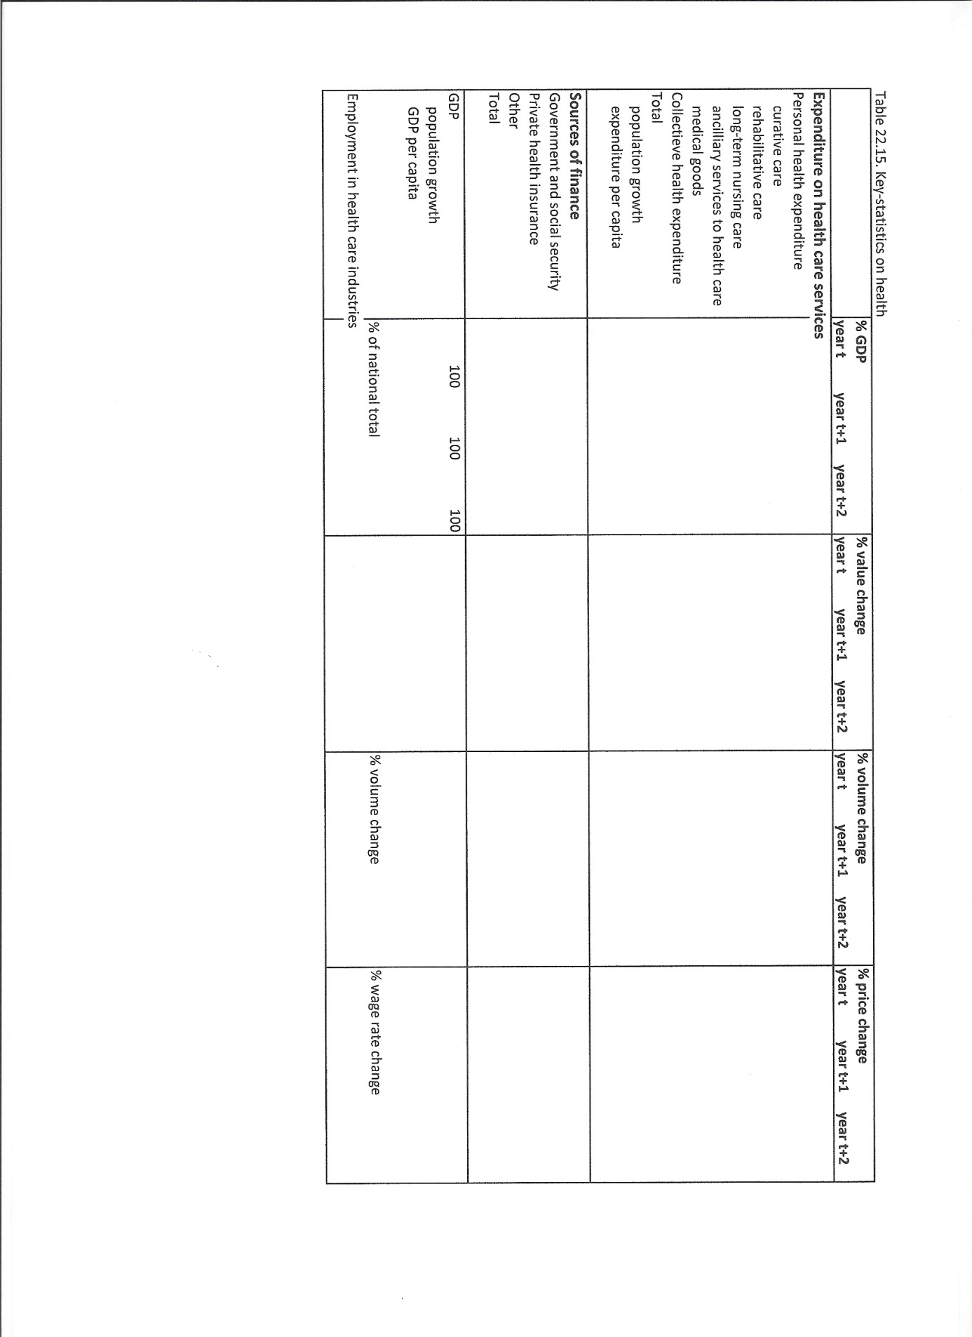

Household production accounts
22.89 In the central framework, household activities such as the services of owner-occupied dwellings; the production of agricultural production for own consumption; and own-account construction of dwellings; are recorded as production. However, two major types of household activity, unpaid services by household members consumed within the same household, and volunteer services, are not recorded as production. Even in the context of a satellite account, the issues of unpaid and voluntary household services raise difficult conceptual and measurement problems. They are an area of ongoing research. The purpose of a satellite account for household production is to provide a complete picture of household production; to show income, consumption and saving of different types of households; and the interactions with the rest of the economy.
Major questions addressed are as follows:
a) Which services are provided?
b) Who is providing these services?
c) What is the value of these services?
d) What are the capital inputs and what happens to productivity?
e) What are the implications for the size and distribution of income, consumption and saving over various types of households and over the life cycle?
f) Are there shifts between paid and unpaid household services, due to structural economic and social developments, business cycle effects or government policy such as taxation issues or subsidies for paid child care?
22.90 Household production accounts may be of particular interest for the analysis of long-term economic developments and for the international comparison of levels of production, income and consumption. The major data sources used for compiling household production accounts are household budget surveys and time use surveys, and annual aggregates from these sources are distorted by sampling errors, which prevents the calculation of accurate annual growth rates. Household production accounts are therefore compiled on a regular but not annual basis, such as at five-yearly intervals and linked to an extensive time use survey.
22.91 Household production includes only services that can be delegated to someone other than the person benefiting from it, and this is known as the third party principle. As a consequence, personal care for oneself, studying, sleeping and leisure time activities are excluded.
22.92 For household production, different principal functions can be distinguished: housing, nutrition, clothing, care of children, adults and pets, and volunteer work which is by definition consumed in another household. For each of these principal functions, main or characteristic activities can be defined. This allows the allocation of expenditure or time use on these activities to these principal functions. However, some activities, like shopping, travel and household management, refer to various functions. As a consequence, the expenditure or time use of these activities is split over these functions.
22.93 In the central framework, expenditure on consumer durables are part of final consumption expenditure. However, in the household production accounts, expenditure such as expenditure on vehicles, refrigerators and equipment for construction and repair, is recorded as capital formation. The capital services of these assets are inputs to household production.
22.94 The output and value added of household production can be valued using an input or an output method. The output method is that household production is valued at market prices, i.e. at the price observed for similar services sold on the market. For the input method, valuing output as the sum of costs, the choice of valuation method for labour inputs is crucial. The possibilities include valuing wages including or excluding social security contributions, and different choices of reference group - average wages over all workers, wages of specialist workers or wages of housekeepers.
22.95 A major issue for the household production accounts is the size and composition of household production and the links with the central framework. This is shown in the form of a use table as in Table 22.16.
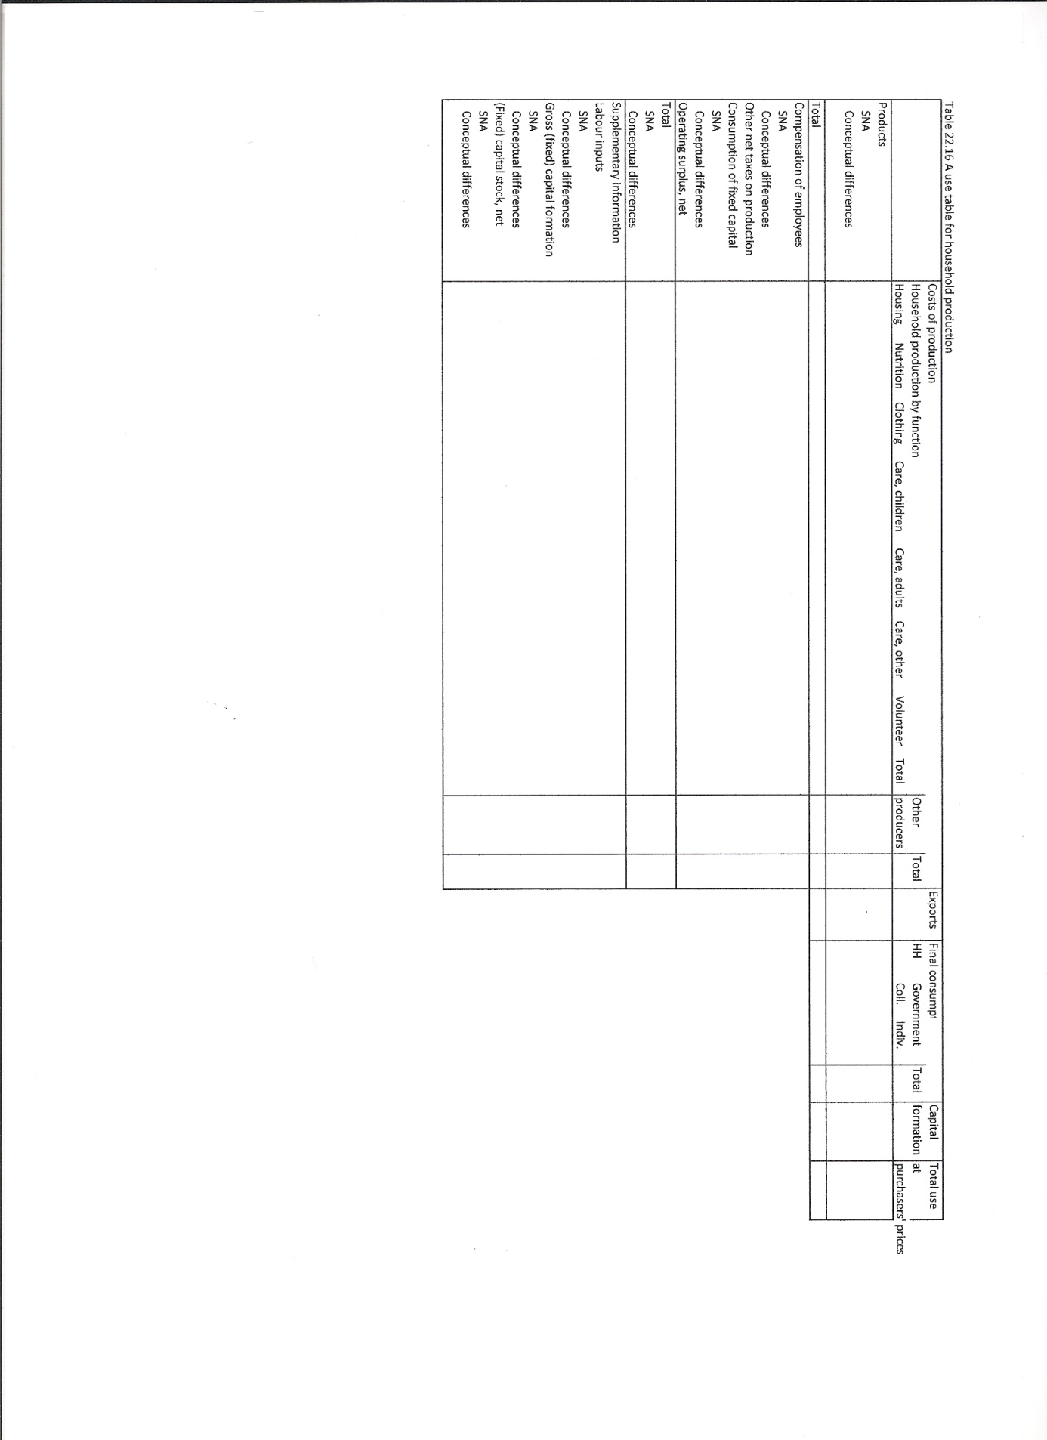

Labour accounts and SAM
22.96 In many countries, a wide range of labour market data are collected. Population and establishment censuses, household and enterprise surveys on the labour force, hours of work, earnings and labour costs, as well as registers of population, taxes and social security provide data for monitoring and analysing labour market developments on a regular basis. Despite the availability of a large amount of such statistical information, they do not provide a complete and reliable picture of the labour market. The major measurement problems are as follows:
a) Contradictory results between different data sources;
b) Many different concepts without a clear linkage;
c) Incomplete coverage;
d) Limitations in describing labour market dynamics;
e) Absence of links between labour market statistics and national accounts, demographic data, and other social and economic statistics such as education and social security.
A system of labour accounts can resolve these problems by combining all information on the labour market and showing the links with the major concepts and classifications of the labour market in the national accounts, such as the concepts of compensation of employees and classification by industry. A strong link with the national accounts improves the compilation of both national accounts and labour accounts, and is helpful in describing the relationship between the labour market and the rest of the economy.
22.97 A simple system of labour accounts is shown in Table 22.17. It exploits accounting identities between compensation of employees, hours worked, number of jobs, persons employed and the active and potential labour force. It is a simple system in that it shows a limited breakdown by socio-economic characteristics such as gender, but not age or level of education, and a simple breakdown by only three industries, with no cross-border workers.
22.98 A Social Accounting Matrix (SAM) is a matrix presentation which shows the links between the supply and use tables and the institutional sector accounts. A SAM commonly provides additional information on the level and composition of employment, via a subdivision of compensation of employees and mixed income by type of person employed. This subdivision applies both to the use of labour by industry, as shown in the use tables, and the supply of labour by socio-economic subgroup, as shown in the allocation of primary income account for subsectors of the sector households. In this way, the supply and use of paid labour is shown systematically. A SAM can be thought of as an expanded system of labour accounts put in a matrix-format. Like the labour accounts and the national accounts, a SAM shows aggregates and allows analysis only in terms of aggregates and averages. Therefore, for many socio-economic analyses, the preferred models use an extended micro-data base with information on socio-economic characteristics per person and household.
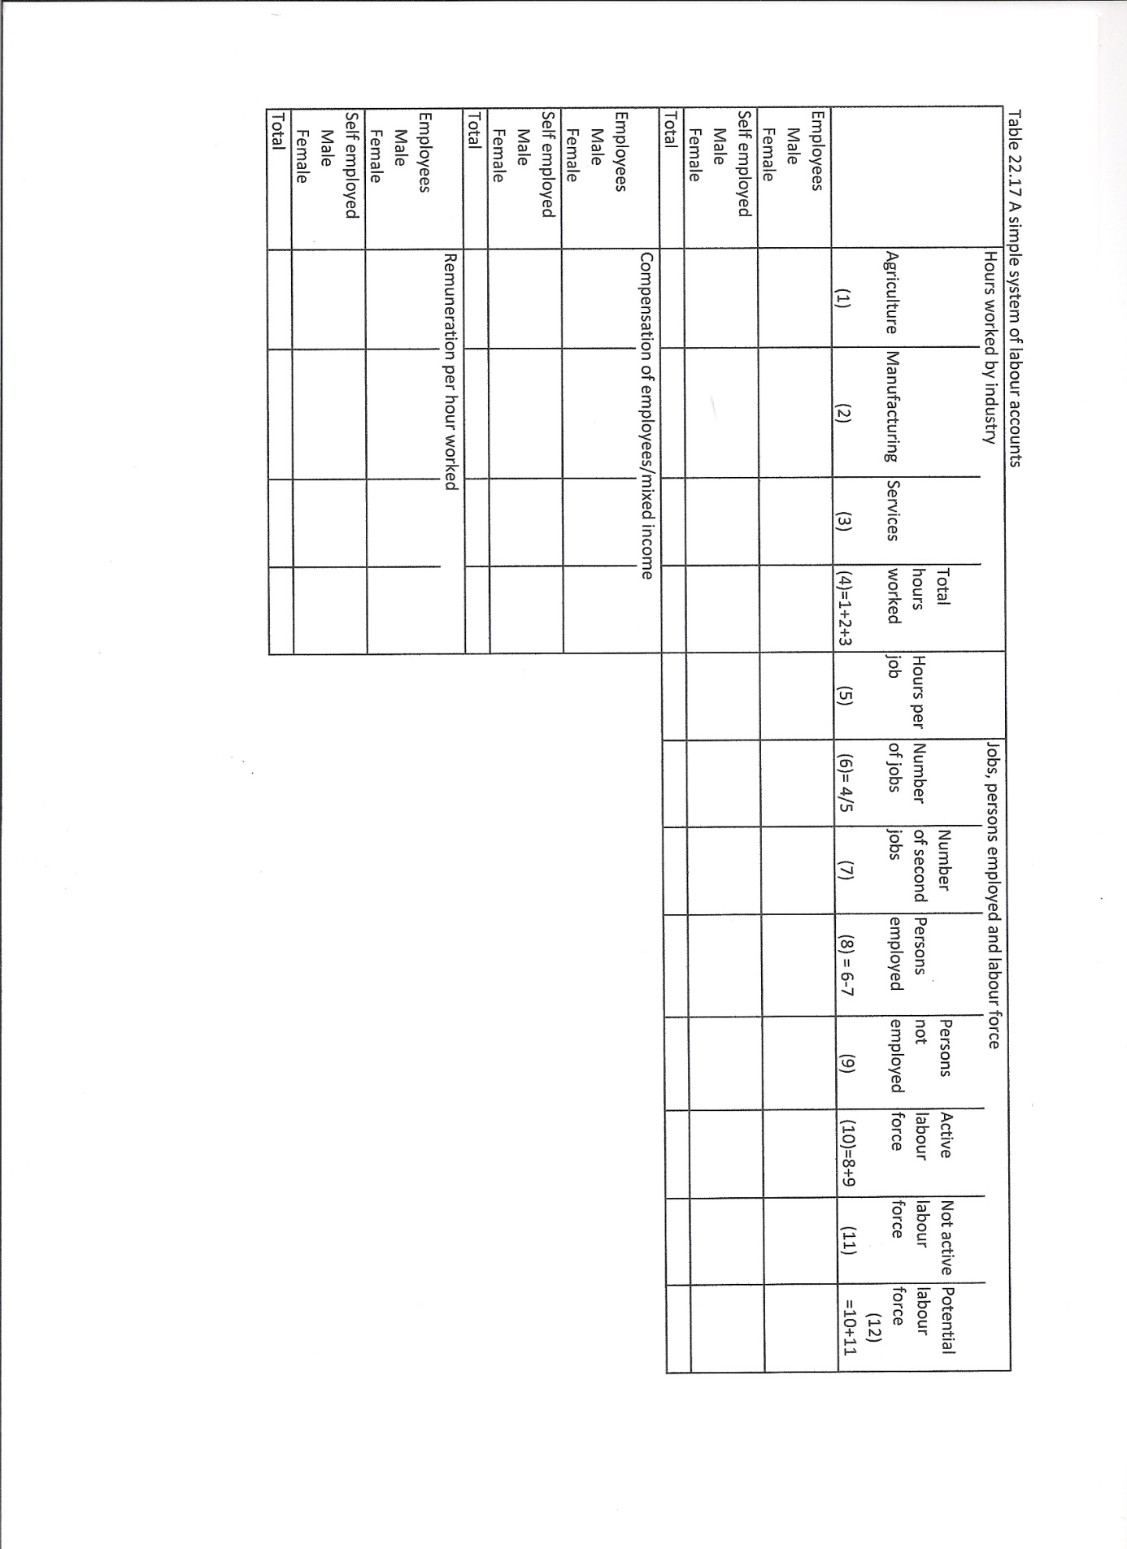

Productivity and growth accounts
22.99 A major use of the national accounts is to describe, monitor and analyse productivity growth (for an extended overview on productivity analysis, see OECD, 2001, OECD Manual Measuring Productivity: Measurement of Aggregate and Industry-level Productivity Growth). Measuring and analysing productivity growth is used in understanding the major changes in industry structure and the rise in living standards during the past century in many countries. Measuring and analysing productivity growth is also used to form policies that stimulate productivity growth and raise prosperity, while also taking into account other policy considerations such as equity and environmental issues.
22.100 Economic growth in national accounts terms is the volume growth of GDP, and this can be decomposed into components including changes in labour productivity, the productivity per unit of labour, and changes in the volume of labour. The same breakdown can be made for the volume change of value added by industry. This simple approach provides a framework for monitoring and analysing economic growth by industry. More homogeneous figures on labour inputs obtained by using not just the number of employed, but full time equivalents or hours worked and distinguishing between various qualities of labour, will result in more detailed labour productivity figures.
22.101 This simple approach omits the role of other inputs, such as capital services and intermediate products. This can be very misleading. For example, labour productivity may apparently increase substantially due to much higher capital intensity but may also increase due to efficiency gains while using the same amount of capital. By also accounting for other inputs, multifactor productivity is measured and the sources of productivity growth can be better understood. Measuring multifactor productivity amounts to decomposing the change in the volume of output into changes in the various volumes of all inputs plus a residual: multifactor productivity growth. Multifactor productivity growth reflects all that is not explained by the various inputs, i.e. the role of other inputs. However, it may also reflect measurement errors in the outputs or inputs.
22.102 The volume of capital input from the fixed capital stock can be measured in various ways. There are three crucial choices to be made:
a) The form of the age-efficiency or age-price function for each type of asset; common options are straight-line, geometric or hyperbolic;
b) The nature of the weights that are used to aggregate across different types of assets: user cost weights or market prices;
c) The index number formula by which this aggregation takes place. Options are a base weighted index number such as Laspeyres, or a mixed weighted index number such as Fisher and Törnqvist.
22.103 Multifactor productivity measurement helps to identify the direct growth contributions of labour, capital, intermediate inputs and multifactor productivity change. It is used in reviewing past growth patterns and for assessing the potential for future economic growth. However, for analysis and policy, in interpreting multifactor productivity measures, the following must be considered:
a) Not all technical changes translate into multifactor productivity growth. Embodied technological change may be accounted for via the volumes of capital and intermediate inputs. Embodied technological change represents advances in the design and quality of new vintages of capital and intermediate inputs and its effects are attributed to the respective factors as long as the factor is remunerated accordingly. In contrast, disembodied technical change is considered to be “costless”, for example in the form of general knowledge, blueprints, network effects or spillovers from other factors of production including better management and organisational change. Such technical change ends up by definition in the residual, i.e. multifactor productivity growth.
b) Multifactor productivity growth is not necessarily caused by technological change: other non-technology factors will also be picked up by the residual. This includes adjustment costs, scale effects, business cycle effects, pure changes in efficiency and measurement errors.
c) Multifactor productivity growth is a static measure and fails to explicitly measures feedback effects between productivity change and capital, e.g. extra output per person may lead to additional savings and investment and to a rise in the capital-labour ratio. As a consequence, it tends to understate the eventual importance of productivity change in stimulating the growth of output.
d) Multifactor productivity measurement helps to identify the relative importance of different sources of productivity growth. However, it has to be complemented by institutional, historical and case studies to explore the underlying causes of growth, innovation and productivity change.
22.104 For better measuring, analysing and monitoring growth and productivity, KLEMS Growth and Productivity Accounts have been developed all over the world. A key objective is to move beneath the aggregate economy level and examine the productivity performance of individual industries and their contributions to economic growth. In order to reveal the enormous heterogeneity in output and productivity growth across industries, a many different industries are distinguished and in Europe, EU-KLEMS distinguishes seventy two. The accounts include quantities and prices of output, capital (K), labour (L), energy (E), material (M) and services (S) inputs at the industry level. Output and productivity measures are provided in terms of growth rates and relative levels. Additional measures on knowledge creation such as R&D, patents, embodied technological change, other innovation activity and co-operation are under development. These measures are developed for individual European Union member states, and linked with KLEMS databases across the rest of the world.
22.105 The accounts consist of three interdependent modules: an analytical module and two statistical modules.
22.106 The analytical module provides a research data base for use in the academic world and by policy makers. It uses “best practice” techniques in growth accounting, focuses on international comparability, and aims at full coverage in terms of number of countries, industries and variables. It can also adopt alternative or pioneering assumptions with regard to statistical conventions, such as how to treat ICT goods, non-market services and the measurement of capital services.
22.107 The statistical modules of the data base are developed parallel to the analytical module. They include data which are broadly consistent with those published by national statistical institutes. Its methods correspond to those in the central framework of the national accounts, e.g. supply and use tables are used as the coordinating framework for productivity analysis and chain indices are applied. The statistical module includes not only national accounts data, but also supplementary information, such as employment statistics on the quantity (persons and working hours) and quality (distribution of quantities by age, gender and education level) of labour input per industry.

Research & Development accounts
22.108 In the central framework, Research and Development expenditure is treated as intermediate consumption, i.e. as current expenditure benefiting production for the current period only. This runs counter to the nature of R&D, the aim of which is to improve production for future periods. In order to resolve the conceptual and practical issues of recording R&D as capital formation, R&D satellite tables recognising R & D as capital formation will be drawn up by EU Members States. This will enable Member States to develop robust and comparable methods and estimates. In a second stage, when a sufficiently high level of reliability and comparability has been achieved, R&D will be capitalised in the core accounts of the Member States.
22.109 In addition to this supplementary experimental table, a set of Research & Developments accounts can be drawn up. The purpose of these Research & Development accounts is to show the role of R&D in the national economy. Questions answered include the following:
a) Who is producing R&D?
b) Who is financing R&D?
c) Who is using R&D?
d) What is the value of R&D assets in comparison to the various other assets?
e) What are the consequences for productivity and economic growth?
A supply and use table provides an overview of who is producing and using R&D, and this is shown in Tables 22.17 and 22.18.
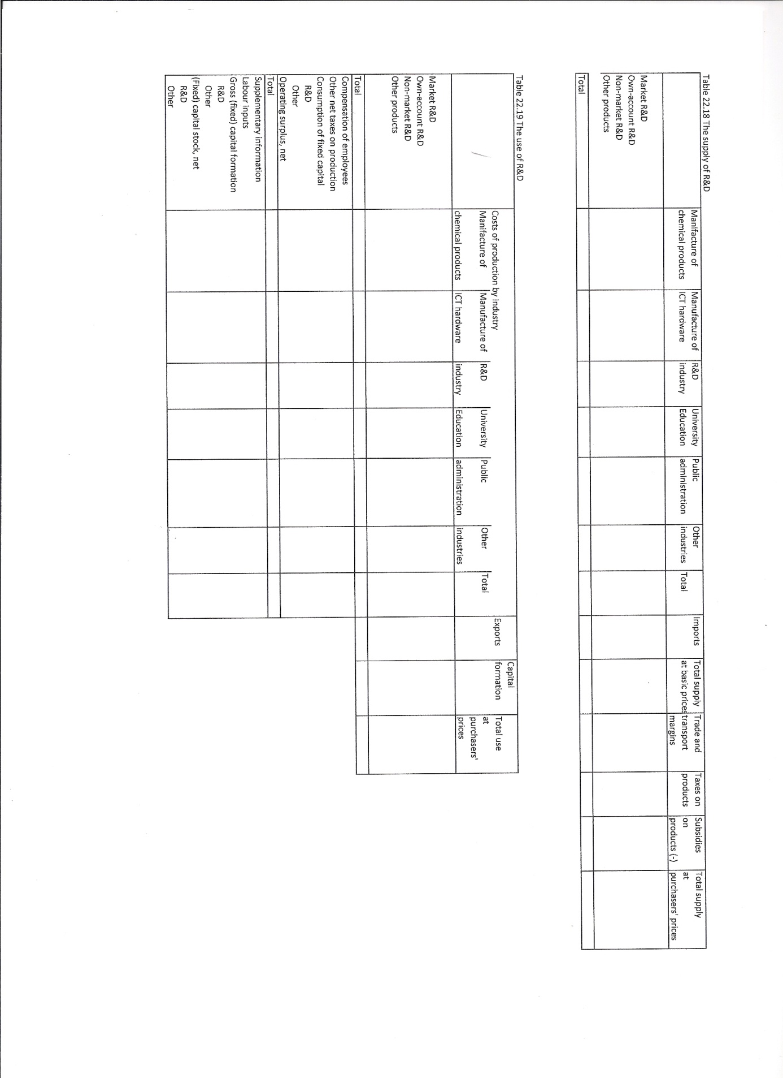

Social protection accounts
22.110 Social protection and its interaction with issues such as ageing, health care and social exclusion is a major issue for national and European economic and social policy. For monitoring, forecasting, analysing, and discussing social protection issues, detailed, comparable and up-to-date information on the organisation, current standing and developments of social protection in the Member States and beyond is required.
22.111 Social protection benefits are transfers to households or individuals, in cash or kind intended to relieve them from a number of risks or needs. The risks or needs of social protection refer to the functions: disability, sickness/health care, old age, survivors, family/children, unemployment, housing and social exclusion not elsewhere classified. In principle, education is not included as a risk or need unless it is a support to indigent families with children.
22.112 Social protection benefits are made through social protection schemes. These are administered and organised by public or private bodies, such as social security funds, government agencies, insurance companies, public or private employers and private welfare and social assistances institutions. The schemes do not necessarily refer to specific institutions, regulations or laws; although they do in many cases. All schemes that are solely based on individual arrangements or where simultaneous reciprocal agreements exist are not regarded as social protection.
22.113 Where the reciprocal arrangement from the employee is not simultaneous, the expenditure is classified as social protection. This applies to retirement and survivors’ pensions paid by an employer and free housing offered to retired employees. The continued payment of wages and salaries while an employee is unable to work during sickness, maternity, disability, redundancy and so on is regarded as social protection benefits provided by the employer.
22.114 Government-controlled schemes are where the government takes all the principal decisions about the level of benefits, the terms on which they are paid and the ways in which the scheme is financed. Government-controlled social protection is usually established by law or regulation. It includes schemes that provide social protection to public servants on the same lines as that provided to the general population by government-controlled schemes. However, it excludes schemes that government may set up in its role of employer without government-controlled counterparts in the private sector.
22.115 Examples of government-controlled schemes are as follows:
a) Non-contributory schemes set up by government to meet is general social responsibility, such as an income support scheme for destitute people or a rent benefit scheme;
b) Schemes run by social security funds;
c) Schemes originally established in the private sector and for which the government has later assumed responsibility.
22.116 Examples of non-government-controlled schemes are as follows:
a) Schemes run by non-profit institutions, like mutual benefits societies, friendly societies and institutions co-administered by the social partners;
b) Schemes administered by commercial insurance companies;
c) Non-autonomous schemes run by employers; this covers both funded schemes where there are separate reserves in the balance sheet to cover the liability to pay benefits in the future, and unfunded schemes with no such separate reserves.
22.117 Using information on specific individual schemes, the accounts for social protection provide a multi-dimensional overview of social protection, as described in “The European System of Integrated and Social Protection Statistics”, ESSPROS, Eurostat, 2008. The accounts describe the size and composition of social protection benefits, their financing and the administrative costs involved. Social protection benefits are classified by function such as sickness and old age, by type such as in cash and in kind, and whether they are means tested. Underlying schemes are classified according to whether they are government-controlled schemes or not, or whether they are basic versus supplementary schemes.
22.118 For each individual social protection scheme, information is provided on revenue and expenditure and a whole range of qualitative information, such as the scope, financing, history and major modifications over time.
22.119 The standard information on the various individual social protection schemes is known as the core social protection system, and is supplemented by various modules. Possible modules are as follows:
a) A module covering the number of pension beneficiaries;
b) A module on net social protection benefits. This covers the influence of taxes and social contributions paid on benefits by beneficiaries and the extent to which social benefits are provided in the form of tax rebates or tax reductions.
22.120 The concepts and classifications in the accounts for social protection are closely linked to those in the central framework. The major difference between social protection benefits and social benefits in the central framework is that the latter cover also expenditure on education; another difference is that social protection benefits may include capital transfers with a social purpose. A simple overview table as given in Table 22.18, shows these links and at the same time provide an overview of the size and composition of social protection benefits in a country.
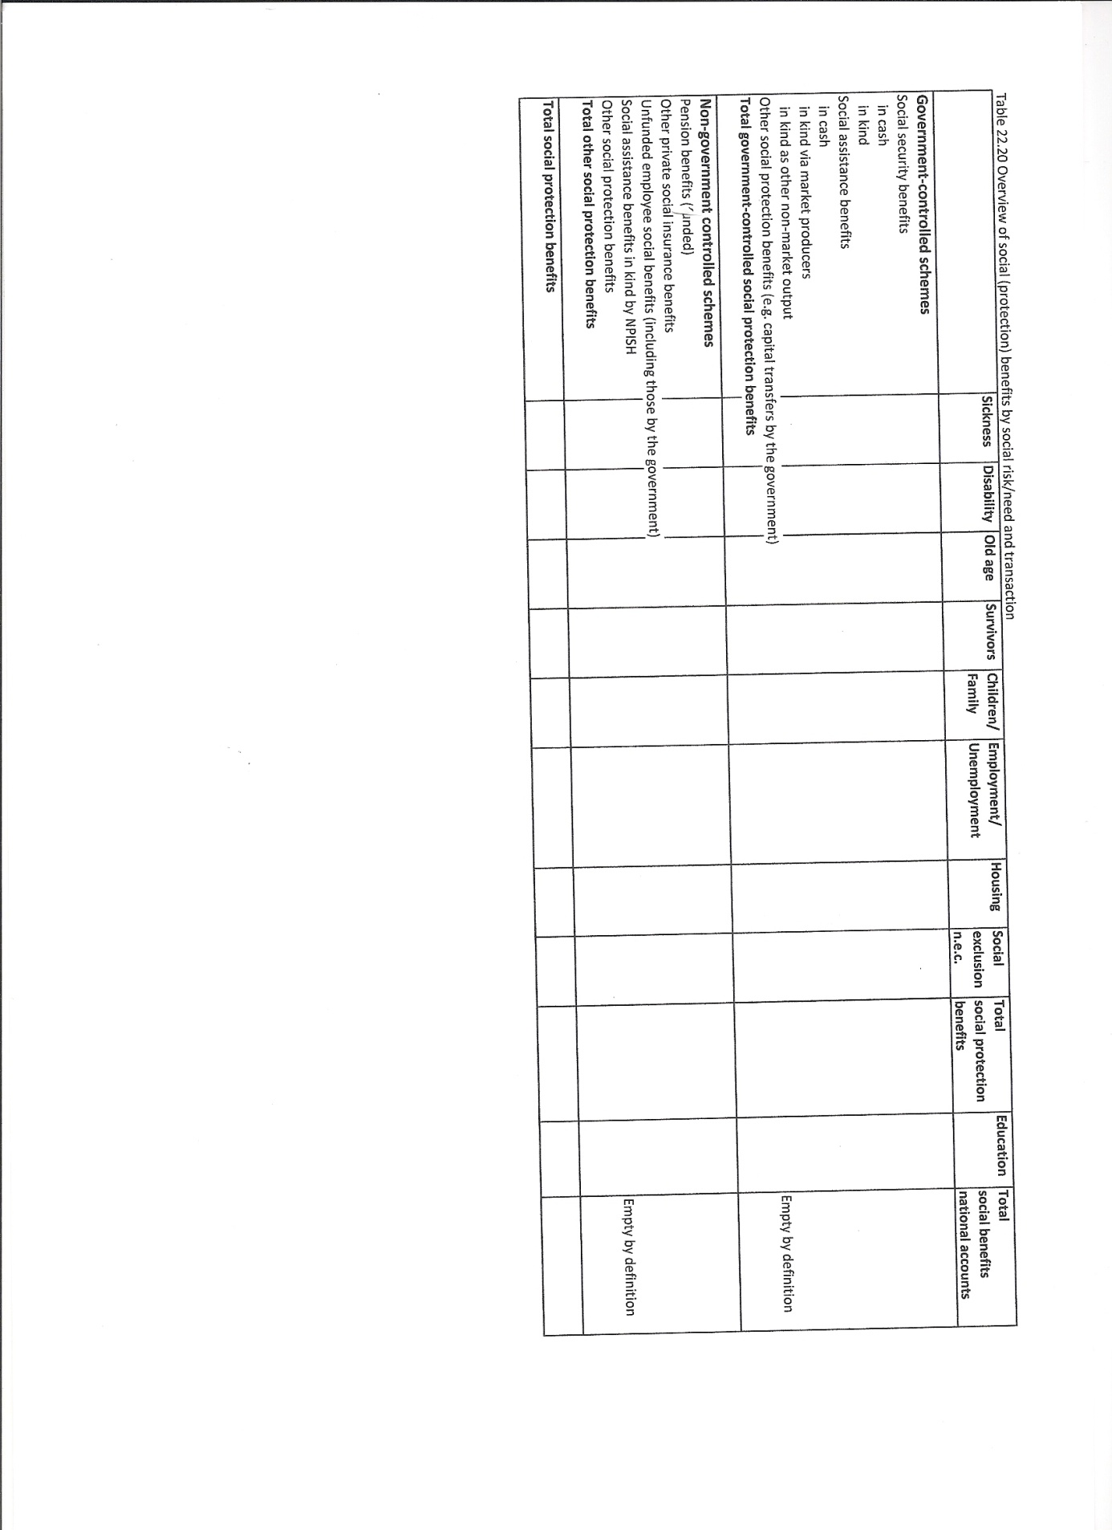
22.121 The close linkage between standard national accounts statistics and social protection statistics provides opportunities for both types of statistics. From the point of view of social protection statistics, they can be related to the official statistics on the national economy such as on economic growth and public finance. National accounts statistics broken down by social protection scheme can also serve as a check on the completeness and reliability of social protection statistics. The compilation processes of both statistics can also be linked, saving compilation costs, increasing reliability and providing new opportunities, such as making social protection statistics as timely as national accounts statistics. Similar advantages apply to the national accounts. The accounts for social protection are relatively easy to derive from the sector accounts and the table on government expenditure by COFOG function and are used in forming economic and social policy. Furthermore, they serve as a check on the reliability and completeness of the standard national accounts figures, such as social benefits and contributions.
22.122 The OECD also publishes data on social expenditure by individual scheme, in the Social Expenditure Database, SOCX. It collects the data for non-EU-countries, while Eurostat provides the OECD with the data on the social protection expenditure for the EU-member states. A specific feature of the OECD work on social expenditure is its focus on international comparison of net social expenditure; this includes an adjustment for the impact on household consumption of differences in taxes on production and imports.

Tourism satellite accounts
22.123 The tourism satellite account (see Tourism satellite account: recommended methodological framework, 2008, publication under the joint responsibility of the European Commission Eurostat, OECD, World Tourism Organisation, United Nations Statistics Division) provides an overview of the supply and use of goods and services for the various types of tourism and their importance for domestic employment, balance of payments, government finance and personal and business income.
22.124 “Tourism” comprises the activities of persons travelling to and staying in places outside their usual environment for less than a year and for a main purpose other than to be employed by a resident entity in the place visited. These activities encompass all that visitors do for a trip or while on a trip. It is not restricted to typical tourism activities such as sightseeing, sunbathing and visiting sites. Travelling for the purpose of conducting business and for education and training can also be part of tourism.
22.125 The demand generated by tourism covers a variety of goods and services, in which transportation, accommodation and food services figure prominently. In order to obtain international comparability, tourism characteristic products are defined as products which, in the absence of visitors, in most countries would probably not exist in meaningful quantities or for which the level of consumption would be significantly reduced, and for which it seems possible to obtain statistical information. Tourism-connected products are a residual category, including those that have been identified as tourism-specific in a given country but for which this attribute has not been acknowledged on a worldwide basis.
22.126 Some of the services for tourism purposes, such as accommodation in second homes or transportation in individual motor vehicles, can be produced in significant amounts on own account. However, in the central framework, unlike own account housing services, transportation services produced within households for their own benefit are not regarded as production. It is recommended to follow that convention in the tourism satellite account. But for countries in which own account transportation services are significant, they can show them separately in the tourism satellite account.
22.127 The key measure for describing the demand for tourism is visitor consumption by households, government, non-profit institutions serving households and business. It consists of the following components:
a) Visitor final consumption expenditure in cash;
b) Visitor final consumption expenditure in kind, such as own account housing services;
c) Tourism social transfers in kind such as individual non-market services absorbed by visitors, including health services of a spa and the non-market services of a museum;
d) Tourism business expenses. This includes tourism expenses classified as intermediate consumption and does not include other expenses corresponding to employees on business trips paid by businesses, such as payments for meals treated as remuneration in kind. As a consequence, tourism business expenses do not represent total consumption of visitors on business trips.
e) In addition, in order to underline the economic importance of the actions undertaken by public authorities to create a favourable environment for the development of tourism, specific measurement of the aggregate value of tourism collective consumption is suggested. This refers to activities such as the promotion of tourism by a government unit, the maintenance of order and security and the maintenance of public space.
22.128 The supply and use of goods and services for tourism purposes, as well as value added and employment generated by tourism, can be shown in a supply and use table distinguishing its characteristic products and industries and the tourism-connected products.
22.129 In their tourism satellite account, countries can further disaggregate and typify their markets, based on duration of stay, purpose of the visit, features of the visitors such as whether they are international or domestic visitors.

See Regulation (EC) No. 138/2004 of the European Parliament and of the Council of 5 December 2003 on the economic accounts for agriculture in the Community (Official Journal of the European Union, L33, volume 47, 5 February 2004). Commission Regulations 306 of 24 February 2005, 909 of 20 June 2006 and 212 of 7 March 2008 have introduced some amendments.
The Handbook was published under the joint responsibility of the United Nations, the European Commission, the International Monetary Fund, the OECD and the World Bank. A revised version is due to be approved by the UNSC in 2012.
See e.g. Eurostat, 2003, Household production and consumption; proposal for a methodology of household satellite accounts; J. Varjonen and K. Aalto, 2006, Household production and consumption in Finland, household satellite account, Statistics Finland& National consumer research centre; S. Holloway, S. Short, S. Tamplin, 2002, Household Satellite account, ONS London ; S.J. Landefeld and S.H. McCulla, 2000, Accounting for nonmarket household production within a national accounts framework, Review of Income and Wealth.
The ESSPROS dissemination timetable is defined by EC-regulation nr 458/2007 of the European Parliament and of the Council of 25 April 2007.

