 | 
COUNCIL OF  THE EUROPEAN UNION |  |  | Brussels, 14 February 2011
 | Interinstitutional File:  2010/0365 (COD) |  | 6415/11
AGRI 102
AGRIFIN 13
CODEC 212
INST 91
PARLNAT 47

COVER NOTE
from: | The Assembly of the Republic of Portugal
date of receipt: | 10 February 2011
to: | Viktor Orbán, President of the Council of the European Union
Subject: | Regulation (EU) No/…of the European Parliament and of the Council of …amending Council Regulation (EC) No 1290/2005 on the financing of the common agricultural policy and repealing Council Regulation (EC) No 165/94 and Council Regulation (EC) No 78/2008  [doc. 17979/10 AGRI 553 AGRIFIN 42 CODEC 1544- COM (2010) 745 final]  - Opinion on the application of the Principles of Subsidiarity and Proportionality

Delegations will find attached a copy of the above letter.

________________________

ANNEX

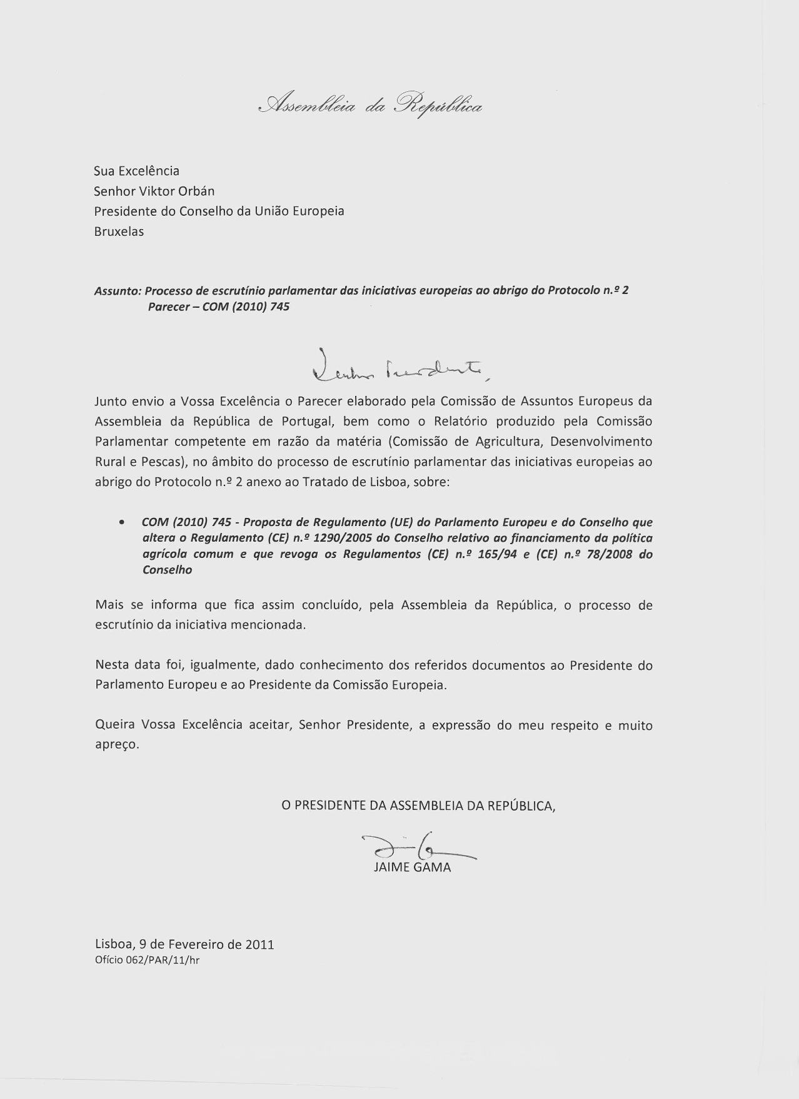
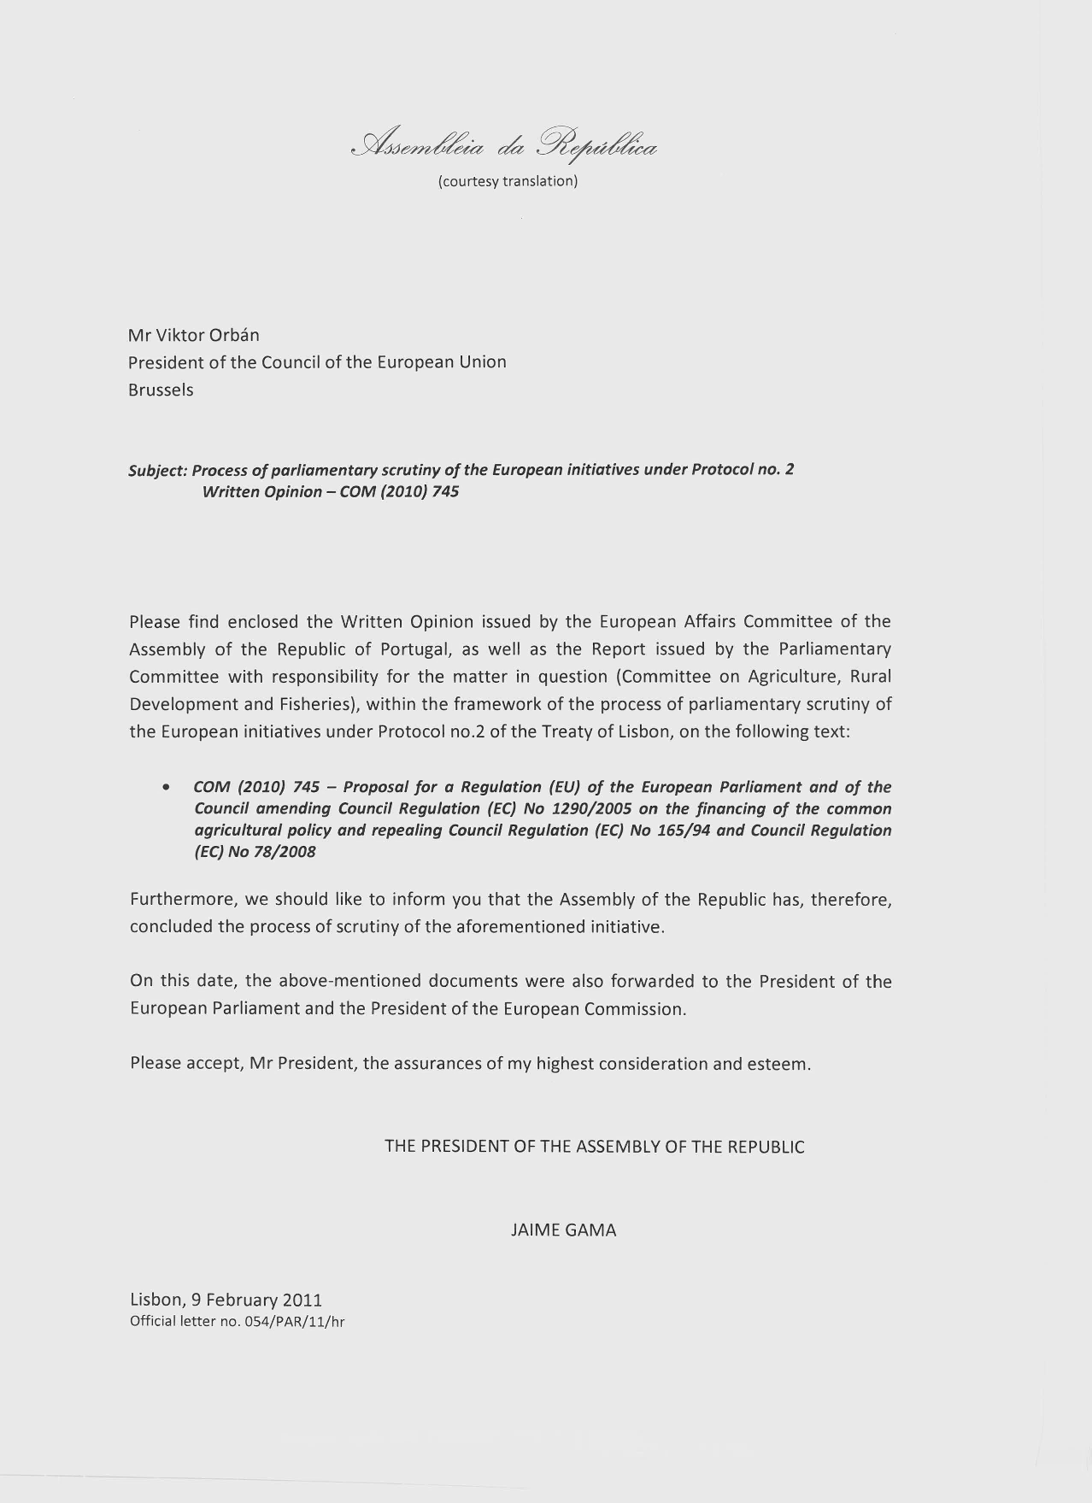

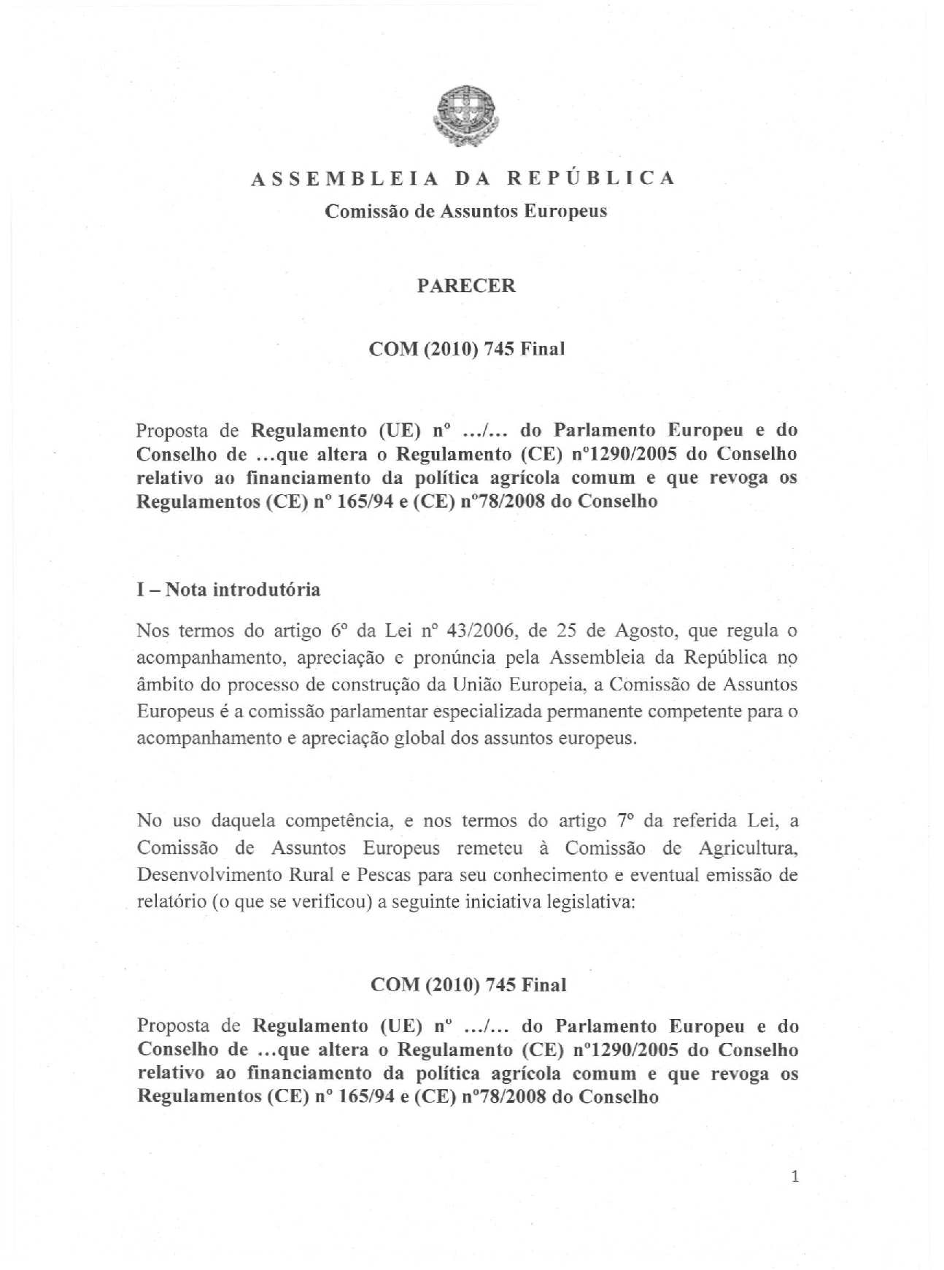

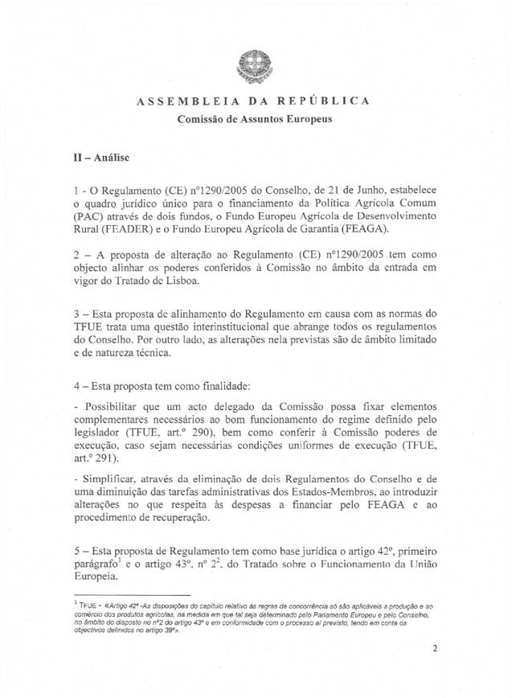

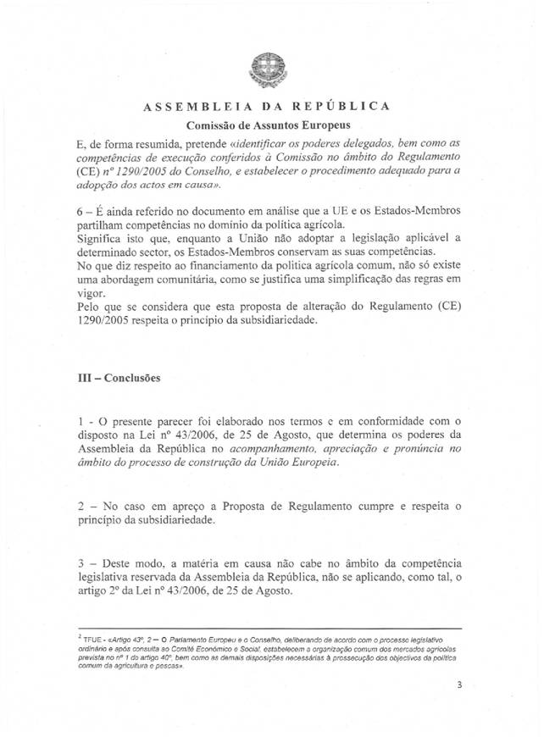

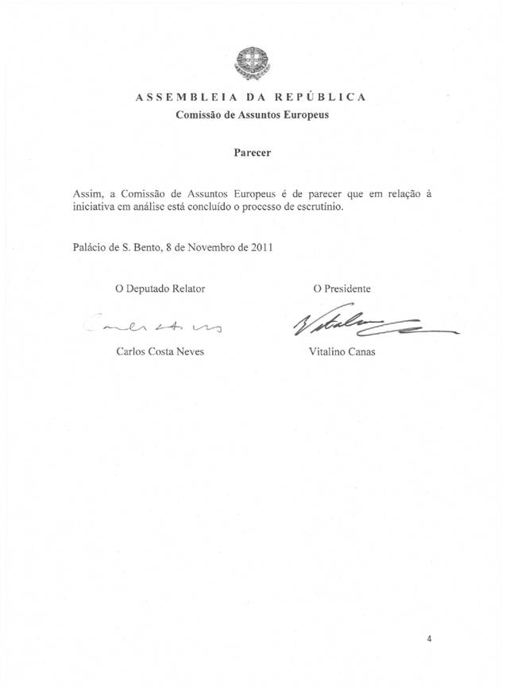

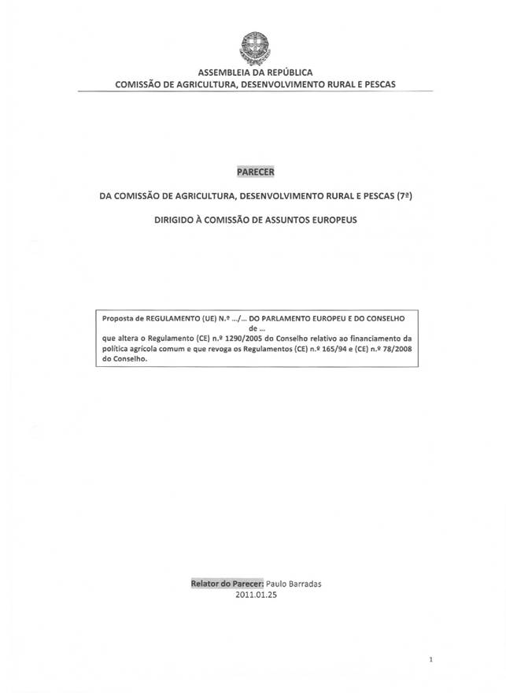

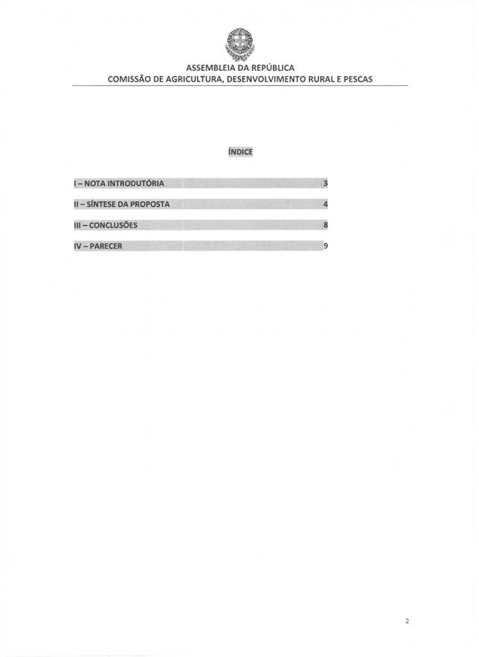

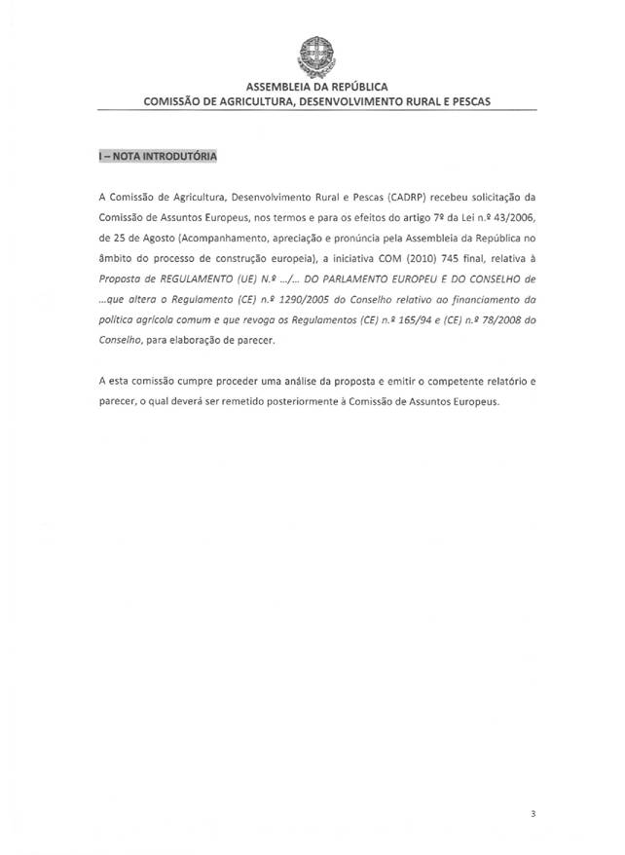

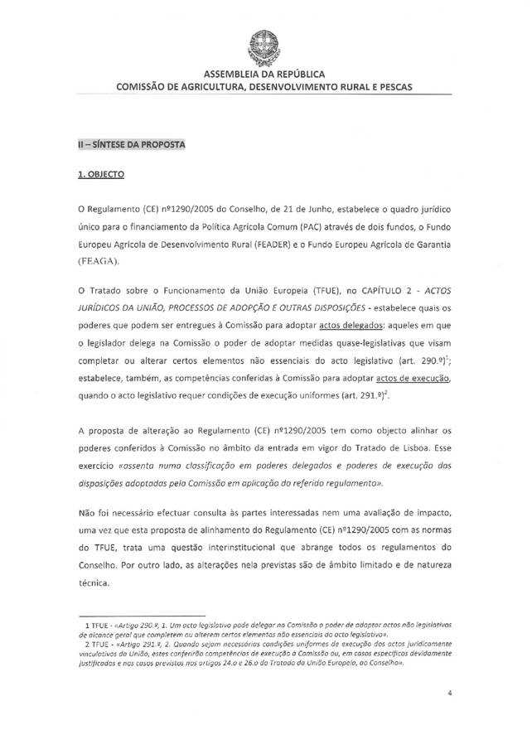

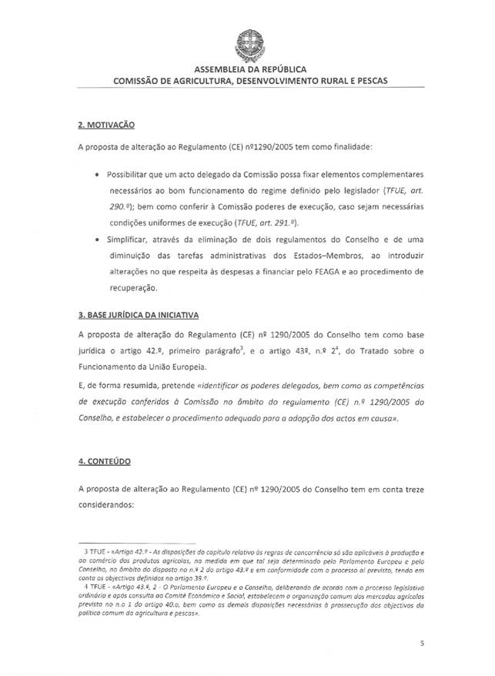

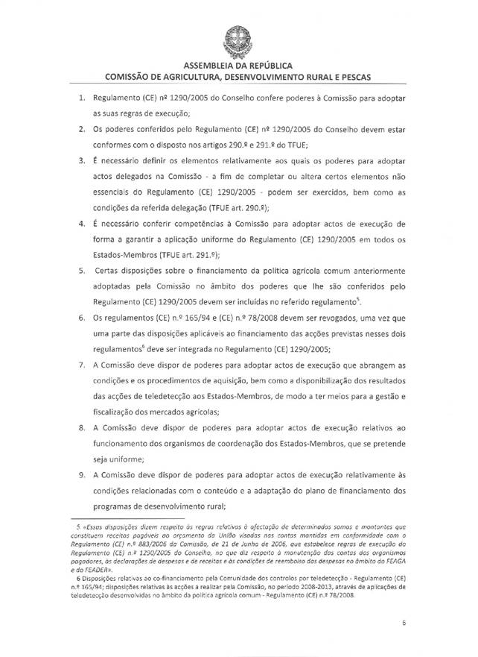

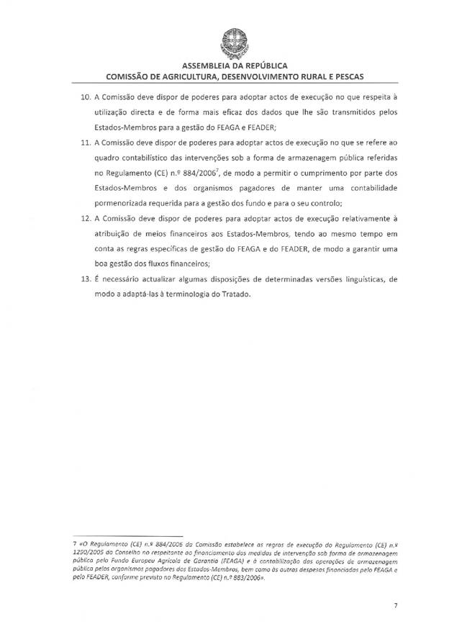

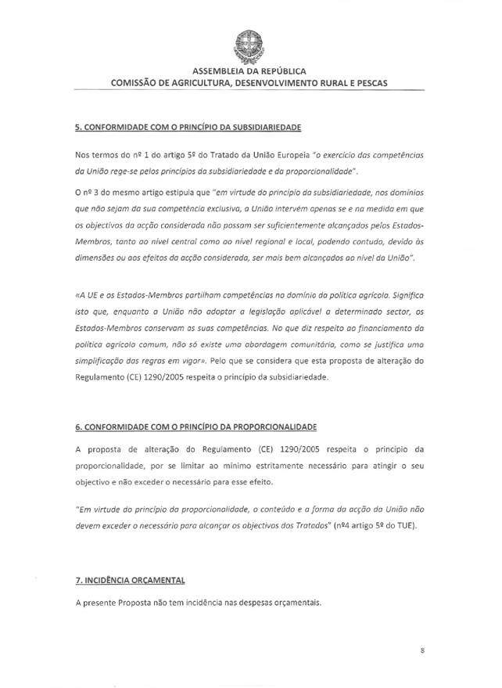

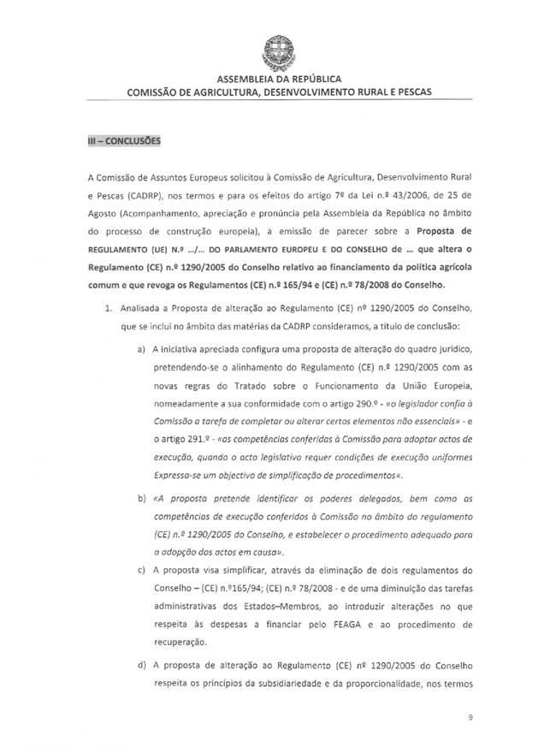
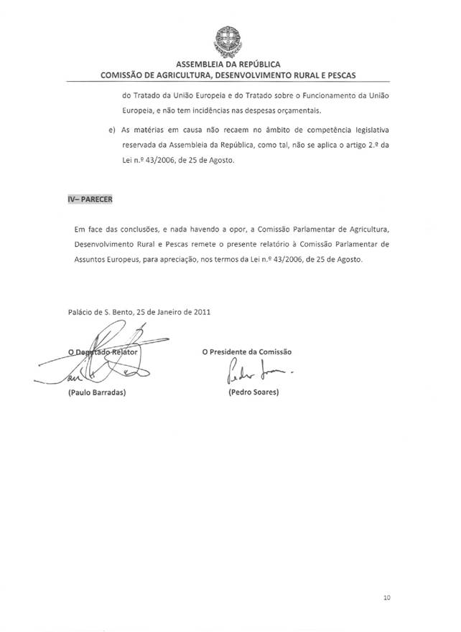

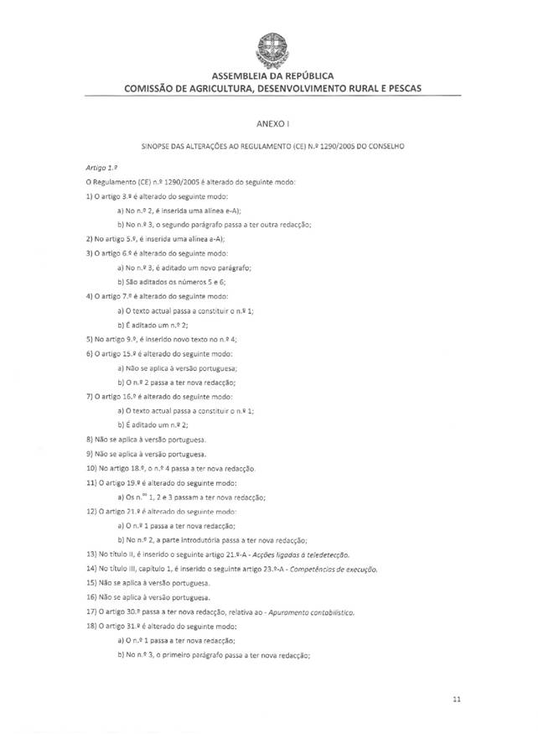

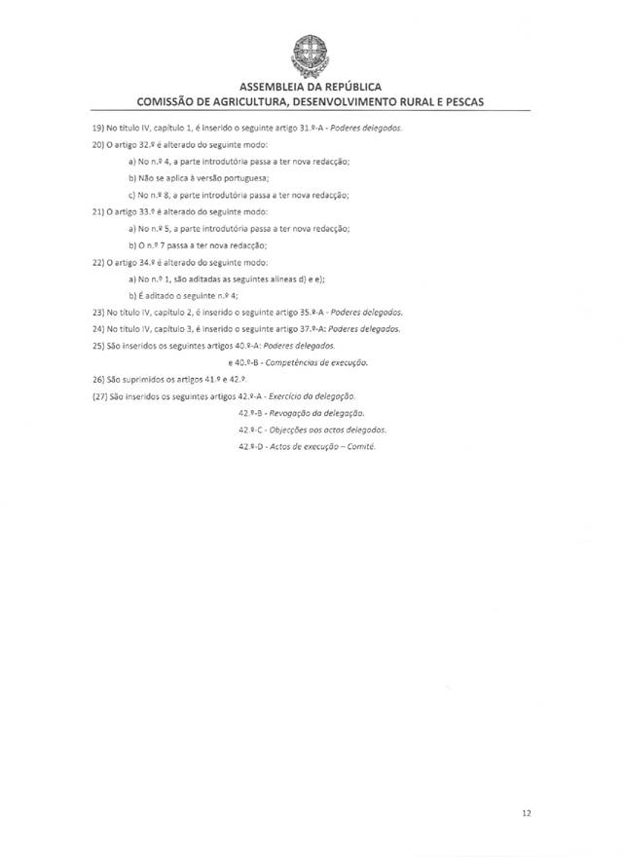

This opinion is available in English on the Interparliamentary EU information exchange Internet site (IPEX) at the following address: http://www.ipex.eu/ipex/cms/home/Documents/pid/10

