EN
EUROPEAN COMMISSION
Brussels, 21.2.2011
SEC(2011) 206 final

COMMISSION STAFF WORKING PAPER
Background information related to the strategy for expanding and developing the Internal Market Information System (‛IMI’)
Accompanying document to the Communication on better governance of the Single Market through greater administrative cooperation:
A strategy for expanding and developing the Internal Market Information System (‛IMI’)
Text with EEA relevance
(COM(2011) 75 final)

INTRODUCTION
This Commission staff working document contains background information relevant to the Commission Communication "Better governance of the Single Market through greater administrative cooperation – A strategy for expansion and further development of the Internal Market Information System (IMI)".

SECTION I – How IMI works
IMI has been designed as a reusable tool which can be easily customised to support new legislative areas. In order to reuse the IMI information exchange workflow for a new legislative area, the only effort required is to import a new set of translated question and answer pairs (derived from the relevant legislative provisions) into the IMI database and to ensure that any competent authorities who wish to exchange this information are registered in IMI and have access to the new legislative area.
Competent authorities need only register once in the IMI database and may be granted access to multiple legislative areas, depending on their sphere of competence. Registration in IMI is open to national, regional and local authorities in the EU, Iceland, Liechtenstein and Norway who deal with the specific legislation it supports.
IMI helps its users to:
- find the right authority to contact in another country;
- communicate with them using pre-translated sets of standard questions and answers;
- follow the progress of the information request through a tracking mechanism.
Because Member States have been closely involved in devising the system, IMI offers uniform working methods agreed by every EU country.
For more information on IMI, please see the IMI website: http://ec.europa.eu/internal_market/imi-net/index.html
The screenshots below illustrate how a Polish competent authority that needs information about a British pharmacist can send a request in Polish to its counterpart in the UK. The UK authority can view and reply to the questions in English.
Screenshot 1- Polish authority’s view of the request
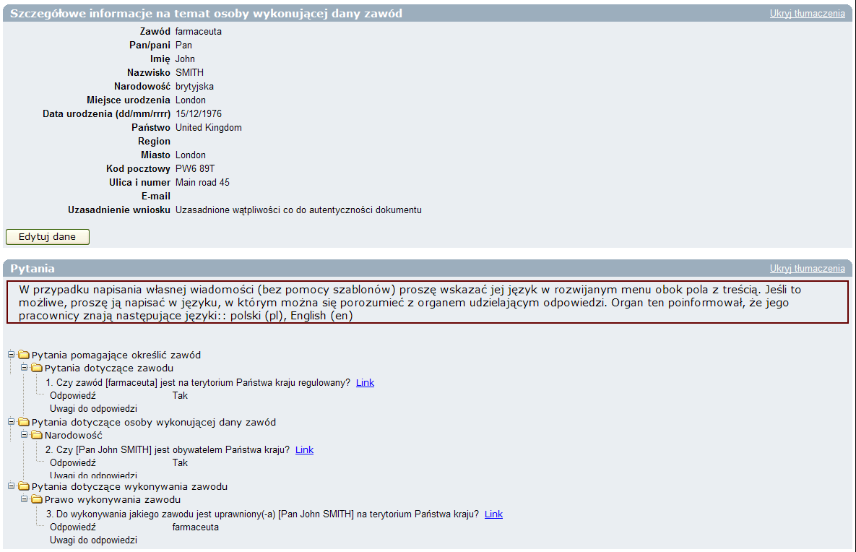
Screenshot 2- U.K authority’s view of the same request
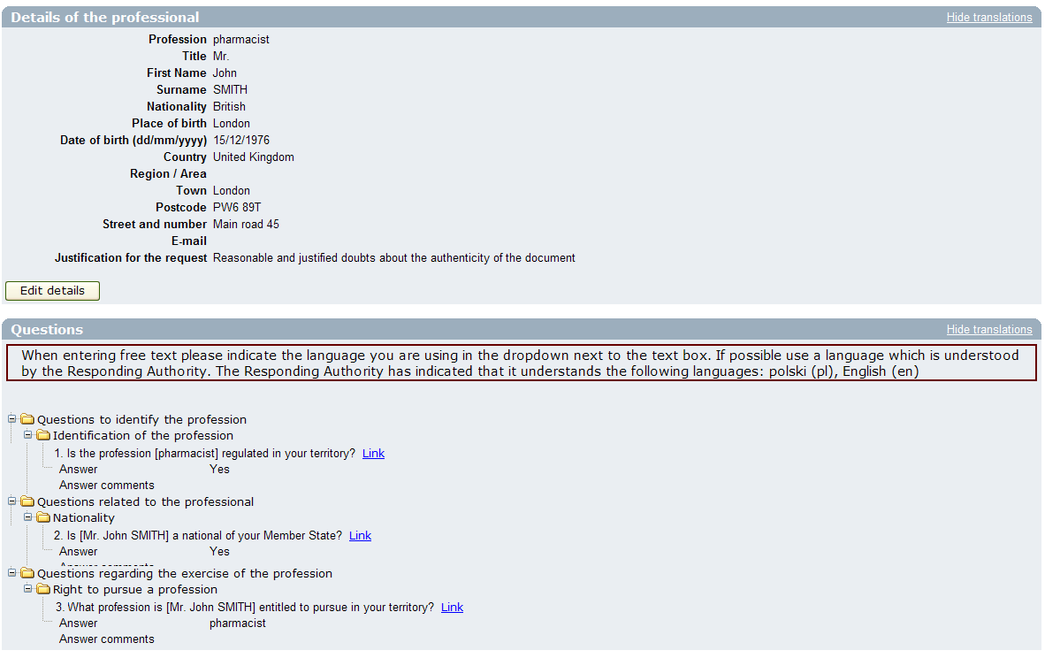
SECTION II - Financial expenditure
A. Overall expenditure on IMI to date
Table (A) below provides an overview of total expenditure on IMI to date and estimated expenditure for the period 2011-2012.
Table A
 | 2006-2009  (actual €) | 2010  (actual €) | 2011  planned | 2012  planned | Total (€)
(1) Development | 2 195 000 | 950 000 | 650,000 | 650,000 | 4 445 000
(2) Maintenance & support services | - | 400 000 | 350 000 | 350 000 | 1 100 000
(3) Hosting | 118 000 | 237 000 | 237 000 | 237 000 | 829 000
(4) Training & promotion | 200 000 | 100 000 | 200 000 | 200 000 | 700 000
Total | 2 513 000 | 1 687 000 | 1 437 000 | 1 437 000 | 7 074 000

B. Financial advantages of a reusable IT system
The original concept of IMI as a reusable tool which could be easily customised to support new legislative areas has been successfully proven with the expansion from a single module covering the Professional Qualifications area to three current modules (Professional Qualifications, Services, Posting of Workers).
While examining the feasibility of using a specific module of the IMI system to be used in the area of posting of workers in order to further enhance administrative cooperation foreseen under Directive 96/71/EC (concerning the posting of workers in the framework of the provision of services), an analysis of the expected costs and benefits carried out showed that no further technical development was required and therefore no development cost would be incurred. A separate and specific application for Posting of Workers has been created in IMI without any IT cost and will be used as a pilot following the adoption of Council Conclusions (foreseen for EPSSCO Council in March 2011).
It is possible to appreciate the potential savings offered by a reusable system, by comparing the cost of developing an electronic information exchange tool from scratch versus adapting or reusing an existing tool.
Table (B) below shows:-
- the actual cost of developing the first (information exchange) workflow from scratch, including common system features (row 1);
- the incremental cost of reusing this information exchange workflow in a separate and specific application to support the Posting of Workers directive (row 2);
- the cost of adapting IMI to develop a second (alert) workflow, reusing the existing common system features (row 3).
Please note that Table B deals with the portion of total development cost associated with the initial development of the two IMI workflows. Subsequent development of IMI has taken place in response to user requests for improvement and in 2010 a new searchable database of registers was developed. These additional costs (included in Table A) are excluded from Table B below.
Table B
IMI feature | Cost to develop
- Cost of developing first IMI workflow  - Common features (competent authority database, multilingual support, registration of authorities and users, user management, authentication)  - First workflow (one-to-one information exchange, used for both Professional Qualifications and Services directives) | €1 417 000
- Incremental cost of re-using the existing information exchange workflow (and common features of IMI) to support the administrative cooperation requirements of the Posting of Workers Directive | €0
- Incremental cost of developing a new workflow to support the alert mechanism foreseen in the Services Directive, reusing the existing common features of IMI  - Second workflow(one-to-many alert) | €973 500
The cost of development is just one aspect of the total cost of an IT system. Annual costs for hosting, maintenance, second-line support and training as shown in rows 2-4 of Table (A) above should also be factored in. Re-using an existing IT system generates synergies as these costs are not incurred many times over for separate systems.

SECTION III – Essential building blocks for further developing IMI
Building block | Function | Elements already in IMI
Authentication | Verifies whether someone who tries to access the system is an authorised user | Internal user name, password and digital code
Competent authority management and authorisation | Enables the authorising actor to give others access to the system and to define their user profile (rights to act within the system) | Self-registration module (by invitation)
Multilingual user interface | Enables the user to work in their language of choice | 23-language interface and machine translation
Information Exchange workflows | A pre-structured sequence of interactions between authorities in the system (content may be questions/answers, structured forms, free text, attached files, etc.)  - Information request  - Alert  - Notification | Information request  Alert
Interface with external systems | Enables uploading, sending, storing, receiving and downloading of pre-structured information sets (transfer of information to/from external systems) | None
Information repository | Structured storage capacity for data exchanged or uploaded within the system | Competent authorities database  Registers database
Search | Capacity to find specific information within any data or within defined categories of data within a database | Various searches  Further improvement needed
Report and statistics | Generates structured reports and statistics on activities and data within the application | External, Business Objects
Webform for external supply and retrieval of data | Technical means, which can be used by existing networks for administrative cooperation to allow citizens, enterprises and organisations to interact with the competent authorities in order to supply information and retrieve data | Not available yet
SECTION IV - Indicative list of potential areas that could benefit from IMI
(as identified and (partially) examined by the Commission services and Member States in 2010)
TOPIC | Related texts and initiatives
Internal Market
Gambling | - No specific legal instrument on gambling  - Council Conclusions 10 December 2010 mentioning IMI  - Public consultation on on-line gambling to be launched in the first quarter of 2011
e-Commerce | - Ongoing evaluation of 2000/31/EC  - Article 3.4 on the notification procedure and Article 19 on cooperation between contact points  - Public consultation completed on 5 November 2010  - Communication planned for first semester in 2011
Intellectual property rights | - Directive 2004/48/EC requires designation of national correspondents  - 2008 Communication and Council conclusions: mentions setting up a network for exchanging information
Professional qualifications | - European professional card, alert system for health professions  - To be examined as part of the review of the Professional Qualifications Directive
Services | - Notification procedure (Articles 15.7 and 39.5 of Services Directive 2006/123/EC)
e-Procurement | - Public procurement package: Directives 2004/18/EC and 2004/17/EC  - e-CERTIS database to help companies and contracting organisations cope with the documentation demands encountered when tendering for public contracts in the EU
Postal Services | - Directive 2008/6/EC on internal market of postal services  - Article 22 on collaboration and mutual assistance of national regulatory authorities
Business registers | - Forthcoming proposal for a directive on creating links between company registers
Auditing | - Directive 2006/43/EC on Statutory Audit. Article 33 on cooperation between public oversight systems  - Green Paper on audit policy (October 2010) deals with closer cooperation between ‘the national audit oversight systems’ and mentions the idea of a European pass for auditors
Assets Management | - UCITS: Directive 2009/65/EC. Article 34 concerns the need to set up a central system to store a database of all UCITS and related information, including the documentation referred to in Article 93(3) of Directive 2009/65/EC  - AIFM: Proposal for a Directive on Alternative Investment Fund Managers currently in discussions. Chapter VIII, Section 2 concerns cooperation between Competent Authorities
Insurance and pensions | - Revision of 2002/92/EC on insurance mediation  - Article 9 on exchanging information between Member States  - Ongoing public consultation until end of January 2011
Employment and Social Affairs
Posting of workers | - A separate and specific application of IMI to be used as a pilot following the adoption of Council Conclusions (foreseen for EPSSCO Council in March 2011)
Coordination of social security systems | - Regulation (EC) 883/2004 and its Implementing Regulation (EC) 987/2009  - Potential synergies with IMI
Enterprise and Industry
Marketing of products | - Regulation (EC) 765/2008 setting out the requirements for accreditation and market surveillance relating to the marketing of products  - Article 23 on a general archiving and exchange of information system, using electronic means
Free movement of goods  Product Contact Points | - Regulation (EC) No 764/2008 laying down procedures relating to the application of certain national technical rules to products lawfully marketed in another Member State  - Article 11: The Commission may establish a Telematic Network for the exchange of information between Product Contact Points and/or the competent authorities of the Member States
Approval of vehicles | - Directives on approval of motor vehicles (2007/46/EC), tractors (2003/37/EC) and three-wheel motor vehicles (2002/24/EC)  - Article 12 (2007/46/EC), Article 13 (2003/37/EC) and Article 4 (2002/24/EC) mention cooperation between approval authorities
Marketing of construction products | - Proposal for a regulation on harmonised conditions for the marketing of construction products (repealing Directive 89/106/EEC)  - Chapter VII on notification authorities, including provisions on exchanging experience between authorities (Article 44) and coordination of notified bodies (Article 45)
Economic Affairs
Cross-border cash in transit | - Draft regulation on cross-border transportation of euro cash presented in July 2010  - Article 11 on mutual information and National Contact Points  - Articles 20, 22, 23 (notification, alerts)
Justice
Public documents and Civil status documents | - Green paper – Less bureaucracy for citizens: promoting free movement of public documents and recognition of the effects of civil status records was adopted on 14/12/2010
Contract Law | - Cooperation between judicial authorities in the context of a possible future instrument on European contract law
Transport
Passenger rights | - Regulations EU 261/2004, EU 1107/2006, EU 1370/2007, EU 1177/2010 and future Regulation on passenger rights for transport by sea and inland waterways; draft Regulation on Rights of Passengers in bus and coach transport.  - Article 31 of 1371/2007/EC about cooperation between National Enforcement Bodies (for the purposes of the passenger rights regulations, it would be necessary to include opening of registration in IMI to Switzerland and other European third countries which apply EU Law through bilateral agreements)
Vehicle procurement | - Directive 2009/33/EC of the European Parliament and of the Council of 23 April 2009 on the promotion of clean and energy-efficient road transport vehicles.  - The Directive requires that energy and environmental impacts linked to the operation of vehicles over their whole lifetime are taken into account in purchase decisions.
Maritime transport policy: ports and inland waterways | - New directive which obliges MS to have a single information point for maritime issues (Single Window). The most likely platform to exchange data between ports and authorities is SafeSeaNet, but there may be potential synergies between this system and IMI
Health
Patients rights | - Proposal for a directive on patients' rights in cross-border healthcare  - Article 6.2 about cooperation between National Contact Points for cross-border healthcare; Article 10(1) about the exchange of information between MS on standards and guidelines on quality and safety and supervision; Article 10 (2) (b) about the exchange of information on the right to practice of health professionals
Medicinal products | - Proposal for a directive on falsified medicinal products currently discussed in first reading
Media
Audiovisual & Media services  (AVMSD) | - Audiovisual Media Services Directive (AVMS): 2010/13/EU  - Article 30 on cooperation and exchange of information between regulators
Education
Europass | - Europass Decision 2241/2004/EC
Energy
Energy Efficiency and Intelligent Energy | - Labelling Directives  - Energy Star Regulation  - Ecodesign Directive: exchange of information on product testing results between energy performance auditors

SECTION V: IT tools for administrative cooperation (non-exhaustive list)
IT Tool | EU policy area | Short description | Operational since | Multilingual | Exchange volume | No of registered public authorities
CIRCABC | All policy areas | CIRCABC (‘Communication and Information Resource Centre for Administrations, Businesses and Citizens’) is used to create collaborative workspaces where communities of users can work together over the web and share information and resources. It is intended to replace CIRCA (Communication and Information Resource Centre for Administrations), an e-government solution supporting the online collaborative activities of the European Union’s public administrations. Since 1997, CIRCA has operated as an IDA(BC) service and has been used by more than 30 Directorates-General, in particular by the committees and consultative bodies established to support collaboration between the Member States and the EU institutions. More than 100 national administrations have received a free licence and use it for their own needs. The CIRCABC groupware enhances the performance of CIRCA in terms of capacity, security, availability and interoperability. Its user interface will be available in 23 languages. | 2007 | Yes
CPCS: Consumer Protection Cooperation System | Consumer protection | The aim is to enable information exchange between national authorities and serve as an information repository to improve EU cooperation in the field of consumer protection enforcement. National enforcement authorities are able to exchange information and cooperate with counterparts in other Member States working together to stop rogue traders or any other cross-border breach of consumer protection laws. It tackles breaches in a variety of areas such as misleading advertising, package holidays, timeshares and distance selling. CPCS is used as the IT tool to support the ECC-NET network of European consumer centres. | 2006 | Interfaces yes. Translation of information exchanged is the responsibility of the MS | 1500 over last 4 years | 3000
EESSI (Electronic Exchange of Social Security Information) | Social Affairs | The EESSI system will support information exchanges that take place between the social security institutions of the Member States to implement EU social security coordination rules. The objective is to ensure that all the information exchanges currently taking place through the use of paper E (European) forms will be undertaken by electronic means. | Directory services operational since 2010, system for exchanging info will be fully operational in May 2012 | The structured electronic messages exchanged in the system are translated in 22 official languages of the EU but the translation of information exchanges and software interfaces is the responsibility of the MS. | No data available yet | 10, 000 - 16 000
ERRU | Transport | ERRU stands for European Registers of Road Transport Undertakings. The system interconnects national electronic registers for road transport undertakings in order to enable Member States to exchange information on infringements and about transport managers in a fully automated mode. The exchange of information is based on Regulation (EC) No 1071/2009 establishing common rules concerning the conditions to be complied with to pursue the occupation of road transport operator, Regulation (EC) No 1072/2009 on common rules for access to the international road haulage market and Regulation (EC) No 1073/2009 on common rules for access to the international market for coach and bus services. | will be operational in early 2013 | Almost all content of the messages is predefined and therefore multilingual |  | Competent Authorities of EU and EFTA countries (one contact point per country)
EUCARIS  (Not managed by Commission) | Transport | EUCARIS stands for EUropean CAR and driving licence Information System. The system has been developed by and for national authorities and is operated by a national organisation (RDW). With EUCARIS countries can connect their registries and communicate directly. In 2008 the EUCARIS application was introduced by Council Decisions 2008/615/JHA and 2008/616/JHA (formerly known as the Prüm Treaty) for combating crime and is supposed to connect all EU MS by mid 2011. Currently several Member States are involved in EUCARIS for the exchange of information on vehicle registration (11 Member States) and on driving licences (7 Member States). The exchange is based on different legal frameworks. | partly operational in 7 countries ( supposed to be fully operational in 2011)
EUDAMED | Health | Eudamed is a secure web-based portal acting as a central repository for information exchange between national competent authorities and the Commission. It is not publicly accessible. Eudamed is currently being used by a number of Member States on a voluntary basis and will be obligatory as from May 2011. The aim of Eudamed is to strengthen market surveillance and transparency in the field of medical devices by providing Member State competent authorities with fast access to information on manufacturers and authorised representatives, on devices and certificates and on vigilance and clinical investigation data. It also contributes to a uniform application of the Directives, in particular for registration requirements. | 2004 | No, just EN | Approx. 1 Million medical advice messages are being exchanged | Approx. 30
European Computerised System for Exchanging Information on Criminal Convictions (ECRIS) | Justice | ECRIS is a decentralised information technology system based on criminal record databases in Member States. It consists of an interconnection software that allows exchanges of information between national databases and a common communication infrastructure, which will initially be the Trans-European Services for Telematics between Administrations (S-TESTA) network. | 2012 | Yes | 100 000 messages per month estimated | Not known yet
IMI | Internal Market | IMI is a single information system designed to support administrative cooperation obligations under various Directives in the field of the internal market. Currently it is being used to support the Professional Qualifications Directive (2005/36/EC) and the Services Directive (2006/123/EC) and in 2011 a pilot project to support the Posting of Workers Directive (1996/71/EC) is due to begin (still to be confirmed). | February 2008 | Yes | 1404 in 2009 | 5700 public authorities, 10 000 users
RAPEX | Health and Consumer protection | RAPEX is the EU rapid alert system for all dangerous consumer products, with the exception of food, pharmaceutical and medical devices. It allows Member States via central contact points and the Commission to rapidly exchange information on measures taken to prevent or restrict the marketing or use of products posing a serious risk to the health and safety of consumers in accordance with article 22 of Regulation 765/2008. | Current version since 2004 | No Notifications are only being translated into EN. Interfaces will be multilingual in Spring 2011 | 1993 in 2009 | not known
RASFF | Health and Consumer protection | The Rapid Alert System for Food and Feed (RASFF) was put in place to provide food and feed control authorities with an effective tool to exchange information on measures taken responding to serious risks detected in relation to food or feed. This exchange of information helps Member States act more rapidly and in a coordinated manner in response to a health threat caused by food or feed. | Since 1979 | No, information is only translated into EN. Interfaces will become multi-lingual in 2011. | 8000 for 2009 | 109
RESPER | Transport | RESPER interconnects national electronic registers for Driving licences in order to enable the Member States Driving Licence issuing authorities an automatic exchange of information in accordance with Directive 126/2006/EC. | Will be operational as of 19 Jan 2013 | Standardised question sets are available in all languages, free text is not necessary | 30 Mio messages per anno | Likely that it will include CAs outside the EU and EFTA
SOLVIT | Internal Market | SOLVIT is an on-line problem solving network in which EU Member States work together to solve without legal proceedings problems caused by the misapplication of Internal Market law by public authorities. | July 2002 | Yes | 1540 SOLVIT cases were submitted in 2009 | One Solvit centre per EEA state (30)
Tachonet | Transport | Tachonet interconnects national electronic registers for Driver-cards for the Digital Tachograph in order to enable Member States Driver card issuing authorities an automatic exchange of information as stated in Regulation (EEC) n°3821/85 | 2005 | Standardised question sets are available in all languages, free text is not necessary | 7 Mio messages between Jan - Nov 2010 | Currently 33 countries (EU Member States and AETR countries); 50 participating States when all AETR countries are connected
TRACES | Health and Consumer protection | TRACES is an internet-based network between veterinary authorities in EU countries and business operators. The system makes it possible to produce and exchange information on all animal health and welfare and public health certificates accompanying animals, semen, embryos and products of animal origin. It speeds up administrative procedures - business operators can make requests online, for imports as well as trade within the EU. | 2004 | Interfaces yes. Documents are already available in all languages before they are uploaded to the system. | 1300 in October 2010 | 1000
TRIS | Enterprise and Industry | In the field of products and information society services, Directive 98/34/EC obliges Member States to notify to the Commission and to other Member States their technical regulations (rules on information society services) at a draft stage. TRIS contains a database of notifications which can be searched by country, number, date, keyword, etc. | 1990 | Draft text is translated into all languages if document is less than 30 pages | 3099 in 2009 | 31

The decision to begin the Posting of Workers pilot is awaiting adoption of Council conclusions (foreseen for EPSSCO Council in March 2011).
Following the judgment of the General Court of the European Union in case number T-19/07 on 16 December 2010, the use of ECMT has been suspended
Such a means of interaction will avoid duplication with existing e-Government portals such as the Points of Single Contact of the Services Directive (PSCs) and e-Government projects such as SPOCS (Simple Procedures Online for Cross-border Services) and PEPPOL (Pan-European Public Procurement Online), instead seeking to reuse existing tools and establish synergies where possible.

