15 April 2011 PR 150411 E
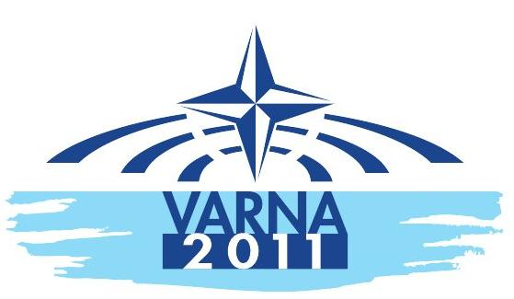
NATO Parliam entary Assembly
Spring Session 2011
27-30 May 2011

General

The Parliament of Bulgaria will host the NATO Parliamentary Assembly's Spring Session In Varna from Friday 27 May to Monday 30 May 2011. The Session will bring together some 250 parliamentarians from the 28 NATO member countries from North America and Europe as well as delegates from partner countries and observers to discuss common international security concerns and reports to be adopted during the Annual Session in Bucharest in October 2011.

The NATO Parliamentary Assembly President, Dr Karl A. Lamers, the Head of the Bulgarian Delegation to the NATO PA, Dobroslav Dimitrov, and the NATO PA Secretary General, David Hobbs will welcome media representatives and answer questions during a press briefing on Friday 27 May at 12:15.

Saturday 28 and Sunday 29 May will be devoted to the meetings of the NATO PA’s five Committees: Political, Defence and Security, Science and Technology, Civil Dimension of Security and Economics and Security. Each Committee will discuss Reports on a broad range of security and defence topics and will be addressed by prestigious speakers from government, academia, NGO’s and NATO.

The Plenary session on Monday 30 May will be addressed by NATO Parliamentary Assembly’s President, Dr Karl. A. Lamers, Mr Boyko BORISSOV, Bulgarian Prime Minister, Mrs Tsetska TSACHEVA, Speaker of the Bulgarian National Assembly, Mr Anders Fogh Rasmussen, NATO Secretary General and Admiral Samuel Locklear Commander, Allied Joint Force Command.

ProGramme FOR THE MEDIA

A draft programme for the media with the names and timings of the speakers and the discussion of the Committee reports is available and regularly updated on the NATO PA web site at http://www.nato-pa.int/default.asp?SHORTCUT=2333

All meetings indicated in the press programme are open to the press.

Session VENUES

Melia Grand Hermitage  1 Melia Alley Golden Sands  9007 Varna, Bulgaria | Imperial Hotel  Riviera Holiday Club  9007 Varna, Bulgaria | Riviera Beach Hotel  Riviera Holiday Club  9007 Varna, Bulgaria

Access to the session venues is from the main entrances of each hotel. Badges should be collected from the registration area located on level C of the Melia Grand Hermitage Hotel.

Transportation will be provided from the session hotels for the meetings as necessary.

The Melia Hotel and the Riveria Holiday Club are situated within 1.5 km of each other.

There will be a constant shuttle service between the three session hotels every 15 minutes during meeting times and the lunch break.

Participants are required to wear their identity badge when using transportation organised for the session.

Transport schedules will be available at all session hotels.

The location of each meeting is specified in the press programme.

Only registered press will be able to access the session venues.

Press BRIEFING

Dr Karl A. Lamers NATO Parliamentary Assembly President, Dobroslav Dimitrov, the Head of the Bulgarian delegation to the NATO PA, and David Hobbs, NATO PA Secretary General will give a press briefing on Friday 27 May at 12:15 in the Lisimah Room, Melia Grand hermitage Hotel, Level C.

Media accreditation - REGISTRATION - FACILITIES

Media representatives wishing to cover the session, to attend the press briefing and other media events must request accreditation.

The accreditation form, the procedure for accreditation and registration as well as more practical information for the media is available on the session page of the NATO PA

Additional questions concerning the media facilities, broadcast facilities, uplink trucks etc should also be addressed to:
Elena Kamenova
The Press Centre Directorate of the National Assembly of Bulgaria
2 "Narodno Sabranie" sq.
1169 SOFIA
E-mail: ekamenova@parliament.bg
Tel:

NATO PARLIAMENTARY ASSEMBLY PRESS AND MEDIA RELATIONS SERVICE

Questions on the Session programme or the NATO Parliamentary Assembly should be addressed to:

Roberta Calorio
NATO Parliamentary Assembly
Head of the Press service and Media Relations
Place du Petit Sablon 3,
B - 1000 BRUSSELS
Switchboard: + 32 (0) 2 513 28 65
Direct line: + 32 2 (0) 50 48 154 | Email: press@nato-pa.int

REQUESTS FOR INTERVIEWS
Requests for interviews with Members of Parliament and Committee guest speakers should be directed to the NATO PA’s press and media information office or directly to the delegates or guest speakers. The point of contact is Mrs Roberta Calorio (press@nato-pa.int)

Session News and information is routinely placed on the NATO PA website:
http://www.nato-pa.int

The NATO Parliamentary Assembly brings together legislators from NATO member and non-member countries to consider security-related issues of common interest and concern. The Assembly is an interparliamentary organisation and is independent from NATO. For more information contact the Press and Media Relations Service (phone: + 32 (0) 2 50 48 154 – email: press@nato-pa.int)

